Bioregional Assessment - Aboriginal Water Dependent Cultural Values

Subregions – Gwydir, Central West, Namoi, Maranoa-Balonne-Condamine and Hunter
Bioregions – Clarence-Moreton (NSW) and Sydney Basin
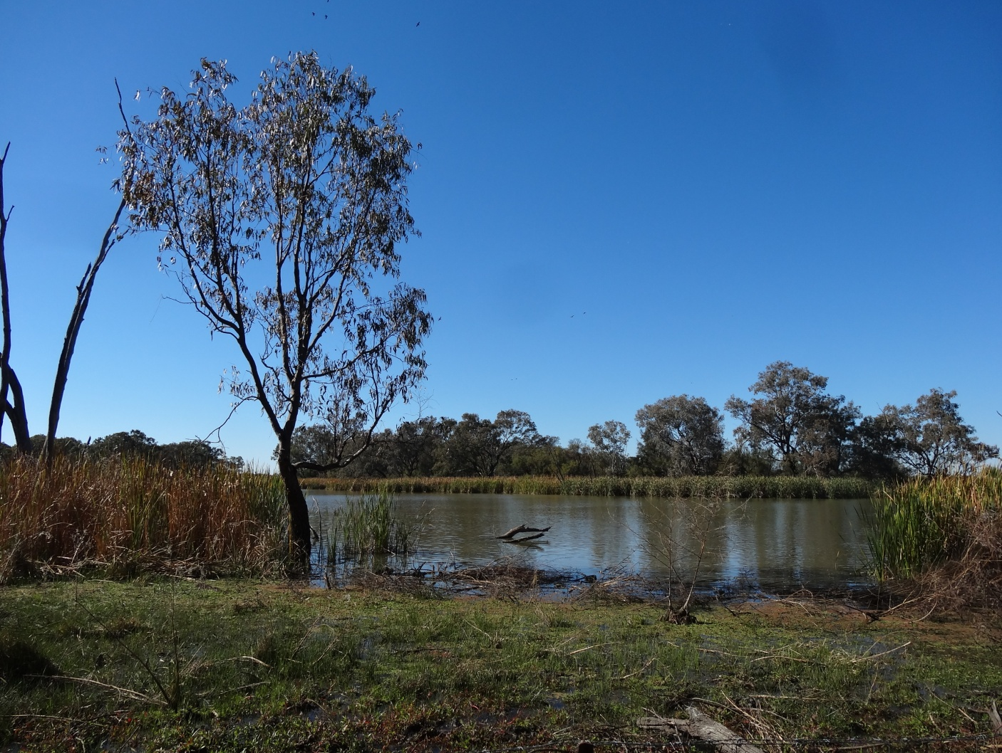

Report by the NSW Department of Primary Industries, Office of Water
Bioregional Assessment - Water Dependent Aboriginal Cultural Values
Subregions – Gwydir, Central West, Namoi, Maranoa-Balonne-Condamine and Hunter
Bioregions – Clarence-Moreton and Sydney Basin
Second DRAFT published 1 March 2016
More information
NSW Office of Water - Aboriginal Water Initiative
www.dpi.nsw.gov.au
Acknowledgments
Office of Water Science within the Department of the Environment, Canberra
[Cover image: B. Moggridge 2014 Gwydir Wetlands]
© State of New South Wales through the Department of Trade and Investment, Regional Infrastructure and Services, 2016. You may copy, distribute and otherwise freely deal with this publication for any purpose, provided that you attribute the NSW Department of Primary Industries as the owner.
Disclaimer: The information contained in this publication is based on knowledge and understanding at the time of writing (March 2016). However, because of advances in knowledge, users are reminded of the need to ensure that information upon which they rely is up to date and to check currency of the information with the appropriate officer of the Department of Primary Industries or the user’s independent adviser.

Contents
Introduction 1
Methodology 2
AWI Engagement Strategy 3
Site Types 4
Bioregional Assessment Areas 4
Clarence-Moreton bioregion 4
Community Engagement 5
Gwydir subregion 6
Community Engagement 6
Namoi subregion 7
Community Engagement 8
Central West subregion 9
Community Engagement 9
NSW Maranoa/Balonne/Intersecting Streams 10
Community Engagement 11
Sydney Basin Bioregion 12
Community Engagement 12
Hunter subregion 13
Community Engagement 13
References 14
Appendices 15
Appendix 1 16
Appendix 2 20

Introduction
We wish to pay our respects to the traditional Aboriginal people of this country, and to acknowledge Aboriginal peoples past and present as the original natural resource managers of this land. For tens of thousands of years Aboriginal people utilised all aspects of our land and water to sustain their lifestyles, working cohesively with the environment, and keeping themselves and the ecosystem fit and healthy. (NSW Office of Water 2012)
Australia’s First Peoples – its Indigenous people - rely on surface water and groundwater, waters that convey knowledge, meaning and life. This has been the case for thousands of generations primarily to ensure survival in a dry landscape. Indigenous people place protecting water landscapes as a high priority as it is a cultural obligation to do so, as well as a necessary practice in the sustainability of everyday life. The continued survival of Australia’s First Peoples’ in a continent known to be the driest inhabited continent on earth is based on knowledge of how to find and then re-find water.
The First People’s Water Engagement Council’s advice to the National Water Commission (NWC) (FPWEC, 2012) states:
Water is central to life and is connected to all things. It is sacred to Australia’s First Peoples, essential to their identity and must be respected for its spiritual significance and its life-giving properties.
This report is provided by the New South Wales Aboriginal Water Initiative (AWI) to inform the Bioregional Assessment Programme of water dependent Aboriginal cultural values in the Gwydir, Central West, Namoi, Maranoa and Hunter subregions and the Clarence-Moreton and Sydney bioregions. The AWI was engaged by the Department of the Environment’s Office of Water Science to work with Aboriginal communities in a number of bioregional assessment regions to collect and collate data on water dependent cultural values (also referred to as assets).
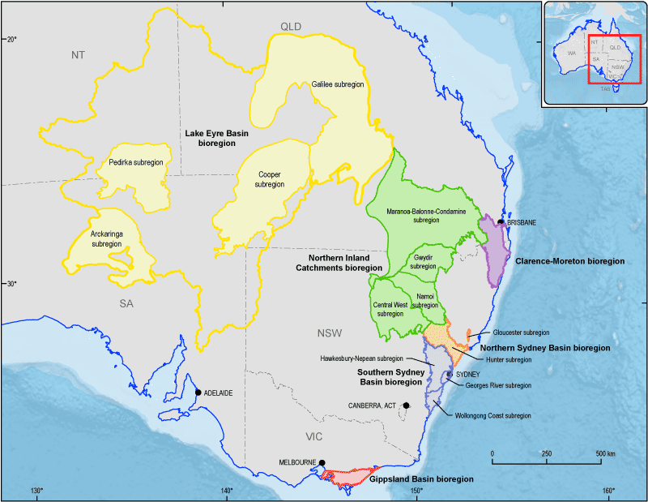
Figure 1. The current bioregions of the Bioregional Assessment Programme
(Bioregional Assessment Programme: www.bioregionalassessments.gov.au)

The AWI aims to improve Aboriginal involvement and representation in water planning and management within New South Wales. It also allows the New South Wales Office of Water to monitor the success of water sharing plans in meeting their statutory requirements for Aboriginal specific performance indicators.
The Australian Government is undertaking a programme of bioregional assessments in order to better understand the potential impacts of coal seam gas and large coal mining developments on water resources and water-dependent assets. The Bioregional Assessment Programme draws on the best available scientific information and knowledge from many sources, including government, industry and regional communities, to produce bioregional assessments that are independent, scientifically robust, relevant and meaningful at a regional scale.
The Programme is a collaboration between the Department of the Environment, the Bureau of Meteorology, CSIRO and Geoscience Australia. The Programme is seeking input from the Aboriginal community on water-dependent cultural values (also referred to as assets). For more information, visit http://www.bioregionalassessments.gov.au.
Considering the AWI’s core role and Department of the Environment’s data requirement, an ideal partnership was created where the AWI were engaged to collate water dependent cultural values for bioregional assessment areas. Under the funding agreement the AWI was able to employ an Aboriginal Community Water Facilitator on a short contract to work with the current AWI team of Facilitators.
This report also provides relevant information regarding protocols, organisations (who we cannot thank enough for their time) and places for 25 water-dependent values provided by Aboriginal communities in the Clarence-Moreton bioregion, Central West and Namoi subregions only.

Methodology
It has been identified through the previous consultations conducted by New South Wales Office of Water that there is a need for specific engagement and consultation processes to ensure that Aboriginal communities have been effectively engaged and consulted in the water management and planning processes. Protocols developed by AWI staff require information to be presented in line with Aboriginal community needs and in appropriate timeframes.
The AWI had undertaken previous engagement with Aboriginal communities within some of the areas covered by the Bioregional Assessment Programme, which then required the AWI to re-engage communities and introduce them to bioregional assessments. In other bioregional assessment areas, the AWI was required to establish new relationships with communities with which the AWI had not previously engaged. This occurred between November 2014 and
June 2015.
An Information Use Agreement (information use agreement) (refer Appendix 1) is a document that allows for recorded data to be stored and used for the purposes of the AWI and includes its use for the purposes of the Bioregional Assessment Programme. This document is legally binding and is completed prior to data collection onto a Report Card (refer Appendix 2) and storage, and provides knowledge holders and Aboriginal communities’ with security around the storage and use of their cultural knowledge. These agreements are negotiated with Knowledge Holders, Traditional Owners, Local Aboriginal Land Councils, Native Title holders, Elders and other relevant or interested organisations.

AWI Engagement Strategy
Our basic model of engagement
Stages of AWI Engagement
1. Reconnecting and Promote
2. Workshops
3. Follow-up
4. Information Use Agreement (Protection of IP)
5. Collect Values on Country
6. Value upload to AWIS database
7. Monitoring
- Reconnecting and Promote AWI - Establish Protocols
  - This can be a short or a longer process, depending on a number of factors, our existing networks and connections, the politics of the community, the size of the catchment and how much capacity the community has to engage with AWI.
  - Protocols are established early with each community and key people, we allow the community to determine how they wish to be engaged.
- Number of workshops run by AWI staff.
  - The AWI run workshops with a community once the key people are identified.
  - The information is delivered in a number of ways depending on the community, venue and resources. The workshops can involve PowerPoint presentations, demonstration of the contents of Our Water Our Country manual, use of Google Earth to show country, maps and some one-on-one interviews.
- Follow-up
  - Once a relationship is established and the Knowledge Holders are identified, the AWI staff returns to commence more detailed work. AWI uses Google Earth to show them their country and ask a series of questions prior to heading out on Country.
- Information Use Agreements (information use agreement)
  - The contractual agreement between AWI and the Knowledge Holder is negotiated between the two parties, it can be signed by individuals or a selected representative person (e.g. Chief Executive Officer or Chairperson) to protect their intellectual property and allows AWI to access certain information that is water dependent. (information use agreement at APPENDIX 1)

- Collect Values on Country - Report Cards
  - The template is completed by AWI staff in conjunction with Knowledge Holders or representative groups to collect the relevant information for water dependent cultural values. (AWI Report Card at APPENDIX 2)
- Upload information onto AWIS
  - The AWI has built a secure database - Aboriginal Water Initiative System (AWIS). All information and data collected is stored on this database. The database has a number of secure features including login protection and ‘men’s and women’s business’ protection for all stored data.

Site Types
The AWI has focussed on identifying cultural values that are water dependent on either surface water and/or groundwater. Note however that the information we are seeking is not always available for a number of reasons, such as knowledge being lost, it is culturally inappropriate to record, the community is not willing to share the details or there is no access available.
The values include:
    - Creation sites and cultural hero stories linking with spiritual significance along a song line/dreaming tracks - non-tangible (“Dreaming Sites”);
    - Contemporary cultural stories, sites or places;
    - Language (connects culture to place);
    - Resource sites for traditional bush foods and medicines;
    - Resource sites for artefacts, tools, art and crafts;
    - Gender specific sites – men’s and women’s business;
    - Ceremonial sites;
    - Burial places/sites;
    - Teaching sites;
    - Massacre sites where frontier battles occurred with traditional groups;
    - Cultural specific environmental conditions to sustain totemic species;
    - Sites required to sustain a cultural economy; and
    - Sites that contain physical/tangible evidence of occupation: e.g. middens, campsites, scarred and carved trees, stone arrangements and fish traps.

Bioregional Assessment Areas

Clarence-Moreton bioregion
The Clarence–Moreton bioregion comprises the eastward-draining part of the Clarence–Moreton Basin (based on surface water flow delineation) in northern New South Wales and south-east Queensland and covers an area of approximately 24,292 km².
It adjoins the Northern Inland Catchments bioregion in the north–west and includes the Brisbane, Logan-Albert, South Coast, Tweed, Brunswick, Richmond and Clarence river basins. (Bioregional Assessment Programme: www.bioregionalassessments.gov.au)
The AWI were already in the process of engaging the communities in the Clarence-Moreton bioregion as the Clarence, Brunswick, Richmond and Coastal Sands are priority areas for the preparation of water sharing plans.
The process of introducing the concept of bioregional assessments proved a challenge as the team had to re-present a new model and information collection process to meet the Bioregional Assessment Programme requirements. The communities in this region were somewhat sceptical with coal based projects and our role in collecting values.
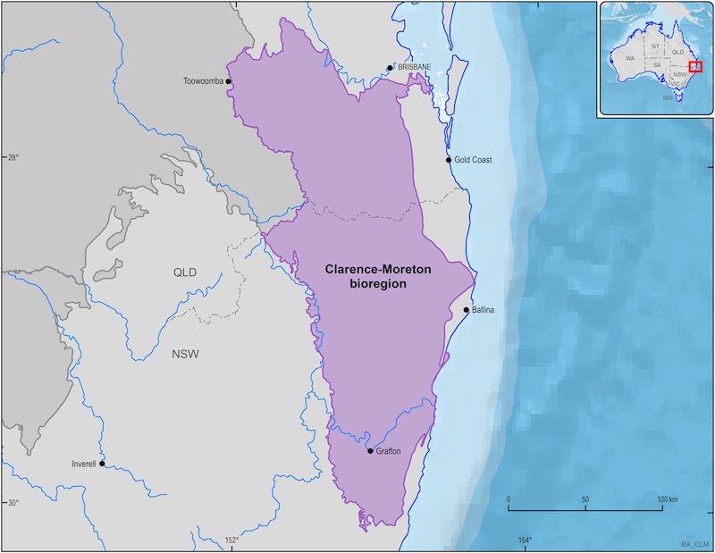

Figure 2. The Clarence-Moreton bioregion of the Bioregional Assessment Programme
(Bioregional Assessment Programme: www.bioregionalassessments.gov.au)

Community Engagement
The AWI staff have made considerable effort and committed significant resources beyond the bioregional assessment funding agreement to introduce the bioregional assessment programme to the communities and to collate the information on water dependent cultural values in the bioregion.
The water sharing planning related activity of the AWI was either under way or complete at the time of introducing Indigenous water values for the bioregional assessments. Many communities in the region had concerns with regard to coal mining and coal seam gas projects. This issue did impact the AWI’s effort in collecting water dependent cultural values for this bioregion.
Following a series of many meetings, workshops, site visits, re-visits, the AWI was able to secure information use agreements for data collection, including for the Bioregional Assessment Programme, for the following areas:
- Coraki
- Jali,
- Tweed Byron, and
- Malabugilmah

Unfortunately the AWI was unable to reach agreement with the following communities to use their data in the bioregional assessment process: Baryulgil, Mulli Mulli, Casino, Grafton, Ngulingah and Kyogle Local Aboriginal Land Council (LALC).

Gwydir subregion
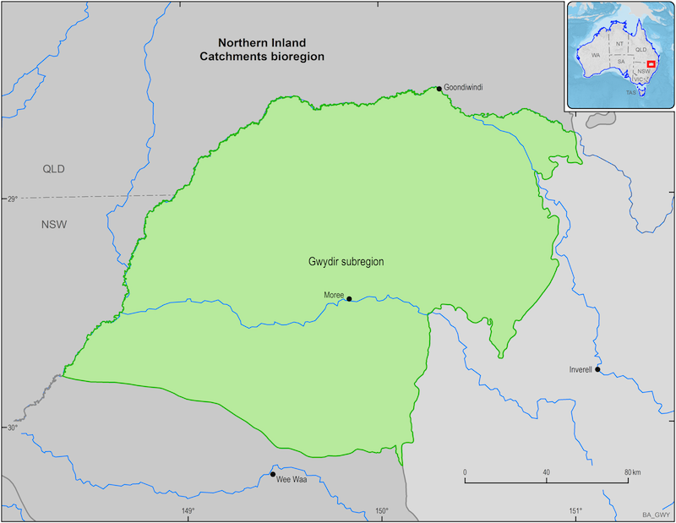
The Gwydir subregion is located within the Murray–Darling Basin in northern New South Wales. It spans an area of 28,109 km², extending westward from the lower slopes of the New England Tablelands onto the low-lying riverine plains of the Barwon-Darling river system. The subregion extends from near Mount Kaputar in the south to near Collarenebri in the west. The main rivers draining the subregion are the Gwydir and Macintyre-Barwon rivers. Moree is the major population centre for the subregion. (Bioregional Assessment Programme: www.bioregionalassessments.gov.au)
Figure 3. The Gwydir subregion of the Bioregional Assessment Programme
(Bioregional Assessment Programme: www.bioregionalassessments.gov.au)

Community Engagement
The AWI staff have made considerable effort and committed extra resources to introduce the Bioregional Assessment programme and to collate the information on water dependent cultural values in the subregion. As the AWI had work related to flood plain management planning already under way, further introducing bioregional assessments was undertaken.

Moree
On 17 February 2015 the AWI met with senior people from Moree Local Aboriginal Land Council and arranged to present to the Board on 10 March 2015.

On 18 February 2015 the AWI met with Toomelah Local Aboriginal Land Council, and Mungindi to liaise on AWI business and organise workshops.

On 11 March 2015 the Moree Local Aboriginal Land Council Board agreed in principle to the information use agreement and to return in two weeks to sign the information use agreement. However the Local Aboriginal Land Council end of financial governance priorities dominated the Local Aboriginal Land Council business and the information use agreement was not been tabled for signing.

Collarenebri
Collarenebri Local Aboriginal Land Council was not functioning at the time of AWI engagement (February 2015). On 17 February 2015 the AWI met the chairperson at ‘Eurool’ Aboriginal property. The concept of the AWI processes and the Bioregional Assessment Programme was discussed and well received, however a fee for service for engagement was tabled to move forward (this is outside of AWI business and was explained accordingly). The chairperson advised the community would attend the Walgett workshop/s.

Namoi subregion
The Namoi subregion lies within the Namoi river basin, which is based around the Namoi, Peel and Manilla rivers. It is bounded by the Great Dividing Range in the east, the Liverpool and Warrumbungle ranges in the south, and the Nandewar Range and Mount Kaputar in the north.
The main surface water resource of the Namoi subregion is the Namoi River. There are three large dams and a few small dams that supply water to agricultural, domestic and municipal users in the Namoi river basin. The major tributaries of the Namoi River are the Peel River, Manilla River, McDonalds River, Mooki River, Coxs Creek, Pian Creek (anabranch), Gunidgera Creek (anabranch), Bohena Creek and Baradine Creek. Lake Goran is the largest inland surface water body in the subregion, occupying up to 82 km².
The Namoi subregion covers approximately 29,300 km². The Namoi subregion is smaller than the Namoi river basin because the eastern part of the river basin does not overlie a coal-bearing geological basin. (Bioregional Assessment Programme: www.bioregionalassessments.gov.au)
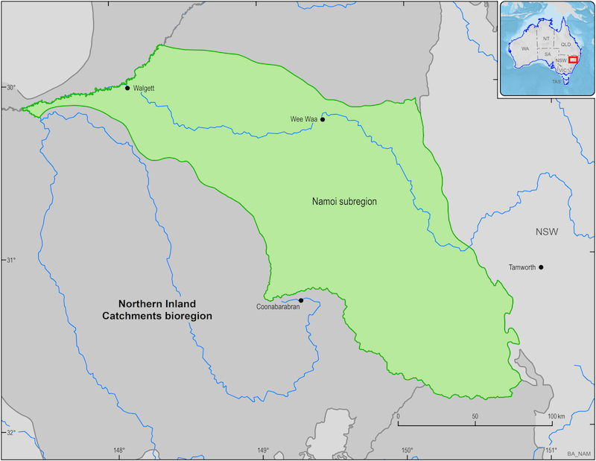
Figure 4. The Namoi subregion of the Bioregional Assessment Programme
(Bioregional Assessment Programme: www.bioregionalassessments.gov.au)

Community Engagement
The Bioregional Assessment Programme subregion for Namoi starts to the west of Tamworth and the community was interested to engage. The AWI have made considerable effort and committed extra resources to introduce the programme and collate water dependent cultural values in the subregion. The AWI had work related to flood plain management under way at the time of introducing Indigenous water values for the bioregional assessments.

Tamworth
AWI met with board members on 8 December 2014 at the Local Aboriginal Land Council, information use agreement would be sent and AWI would organise workshops.

Gunnedah
Met with the Chief Executive Officer for the Red Chief Local Aboriginal Land Council, where a date and workshop was organised for 27 February 2015. On 25 March 2015 a workshop was held with Red Chief Local Aboriginal Land Council. Post workshop community members have been engaged further and one information use agreement has been completed for some values within the Namoi Bioregional Assessment subregion.
Wallhollow
The AWI engaged the Wallhollow Local Aboriginal Land Council and have been invited to present to the Local Aboriginal Land Council Board on 2 March 2015. AWI have not been able to negotiate a date to meet with the Board as the end of financial year governance issues dominated Local Aboriginal Land Council business and the AWI needed to reconnect in
July 2015 to arrange a date.
Quirindi Aboriginal Corporation meeting
On 2 March 2015 the AWI met with the Chief Executive Officer of Quirindi Local Aboriginal Land Council and provided information regarding the AWI and Bioregional Assessment Programme. The Chief Executive Officer declined an opportunity for the AWI to present to the Board citing it was not core business of the Corporation.
Nungaroo Local Aboriginal Land Council
On 3 March 2015 the AWI met with the Chief Executive Officer of Nungaroo Local Aboriginal Land Council and discussed the AWI and the Bioregional Assessment Programme. The Chief Executive Officer declined an opportunity to present to the Board/members, however suggested some members may attend a Wallhollow presentation.
Walgett
Dharriwa Elders Group indicated that may seek to contact the Department of the Environment directly with regard to the Bioregional Assessment Programme.
AWI also met with Walgett Local Aboriginal Land Council Chief Executive Officer 25 February 2015, leaving brochures for the Executive Committee, whose next meeting is on 24 March 2015.
Goodooga
A meeting was held on 25 February 2015 with Elders with the AWI travelling to Goodooga to meet the Local Aboriginal Land Council Chief Executive Officer and a Board member who indicated an interest in an AWI workshop. AWI also met with an Officer with Murdi Paaki Regional Enterprise Corporation (whilst in Goodooga), who is based in Bourke, and obtained a community contact for Weilmoringle.

Lightning Ridge
The Lightning Ridge Local Aboriginal Land Council has not responded to attempts to get back in contact with the AWI.
Wee Waa
In late March 2015 a workshop was held in Wee Waa. The Chief Executive Officer of the Local Aboriginal Land Council indicated an interest in the AWI and Bioregional Assessment Programme. The AWI are negotiating a date to return for further engagement.

Central West subregion
The Central West subregion is located within the Murray–Darling Basin in central New South Wales. It spans an area of 46,735 km², extending from the plains around Dubbo across the low-lying alluvial plains of the Macquarie and Castlereagh river systems north-west to the Barwon River floodplains. Maximum and minimum elevations for the subregion itself are 1235 and 95 mAHD in the Warrumbungle Ranges and near Brewarrina, respectively.
The main rivers draining the subregion are the Macquarie, Castlereagh and Bogan rivers.
Dubbo is the major population centre for the subregion. Coonabarabran, Coonamble, Gilgandra and Nyngan are smaller population centres within the subregion. (Bioregional Assessment Programme: www.bioregionalassessments.gov.au)
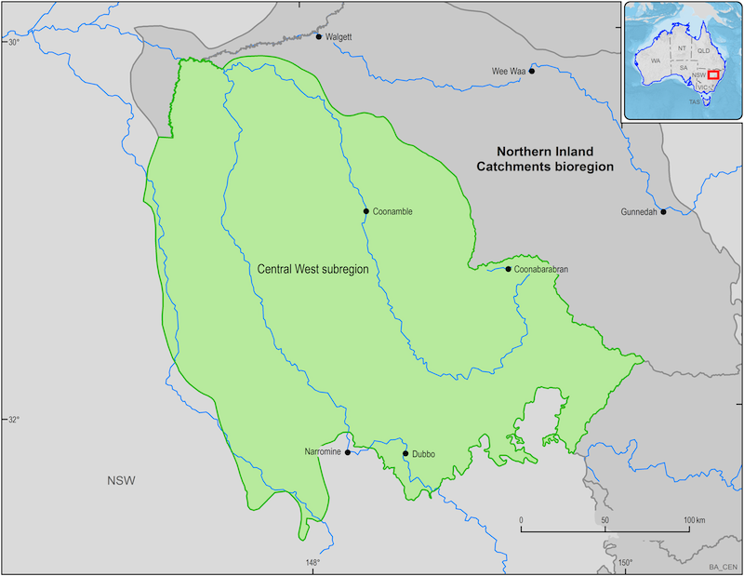
Figure 5. The Central West subregion of the Bioregional Assessment Programme
(Bioregional Assessment Programme: www.bioregionalassessments.gov.au)

Community Engagement
The AWI made considerable effort and committed extra resources outside of the bioregional assessment funding agreement to introduce the programme and collate water dependent cultural values in the region. The AWI had only begun flood plain management work in the subregion which allowed AWI to further introduce bioregional assessments.
Mudgee
The AWI was invited by the Local Land Service to attend an Aboriginal Services meeting on
24 November 2014, where the Bioregional Assessment Programme was introduced.

Dubbo
Met on 16 June 2015 with a senior Wiradjuri man in (Dubbo) to establish the signing of the information use agreement. AWI received a copy of the signed information use agreement post that meeting, and the values were added to the list and identified along the Macquarie River at Wellington, Geurie and Dubbo.

Discussed with the Traditional Owner who has strong connection and knowledge to the Macquarie Marshes on 17 June 2015 to sign a new information use agreement to release pre-recorded cultural values identified by the New South Wales Office of Water in previous water sharing planning process but with the timeframe were unsuccessful.

NSW Maranoa/Balonne/Intersecting Streams
There is only a small portion of this subregion in New South Wales, with the majority of the subregion being in Queensland.
The Maranoa-Balonne-Condamine subregion is located predominantly within the north, central and eastern part of the Queensland Murray–Darling Basin, with a small extension into New South Wales, west of the western margins of the three other Northern Inland Catchments subregions. It spans an area of 144,890 km², extending from the headwaters of the Condamine River in the east and the Maranoa River in the north-west to floodplains of the Upper Darling Plains, where the river system fans out into a number of distributary channels, which discharge into the Barwon-Darling river system and the Narran Lakes system. The main population centres are Toowoomba, Warwick, Dalby, Chinchilla, Roma, St George and Goondiwindi. (Bioregional Assessment Programme: www.bioregionalassessments.gov.au)
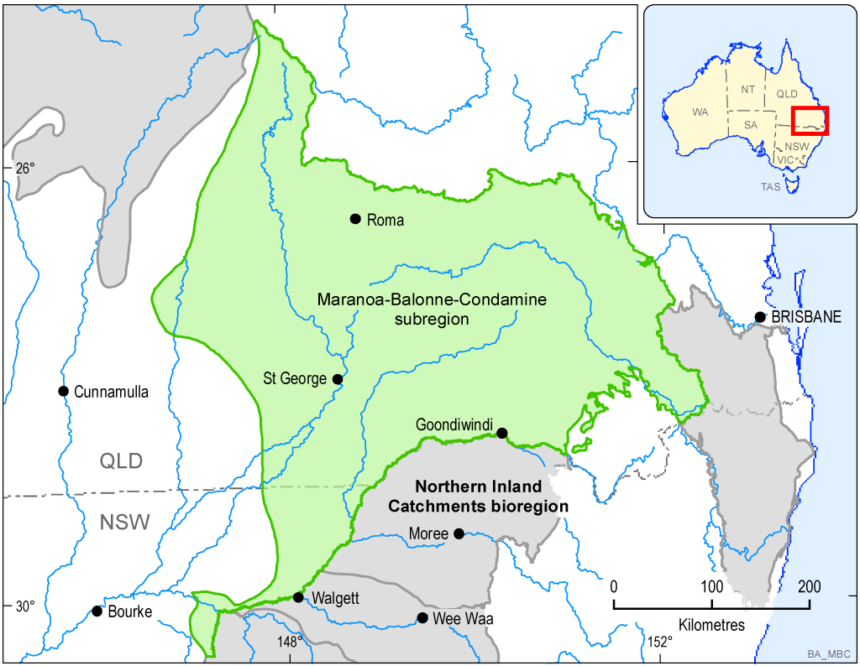
Figure 2. The Maranoa-Balonne-Condamine subregion of the Bioregional Assessment Programme (Bioregional Assessment Programme: www.bioregionalassessments.gov.au)

Community Engagement
AWI began the engagement process but was unable to collect any values for this bioregion within the Bioregional Assessment Programme timeframes.
Walgett
Dharriwa Elders Group indicated that they may seek to contact the Department of the Environment directly with regard to the Bioregional Assessment Programme. AWI met with Walgett Local Aboriginal Land Council Chief Executive Officer on 25 February 2015, leaving brochures for the Executive Committee, whose next meeting was on the 24 March 2015.

Weilmoringle
On 5 March 2015 the AWI met with Weilmoringle Local Aboriginal Land Council and were invited to return to the community for targeted discussions with additional representatives. The AWI are negotiating a date to return.

Brewarrina
On 6 March 2015 the AWI met with Chief Executive Officer of Brewarrina Local Aboriginal Land Council and discussed with AWI how they could best liaise with the community and present water sharing planning and Bioregional Assessment Programme in the future. A workshop was discussed for mid June 2015 however it was postponed and a future date is yet to be identified.
Lightning Ridge
The Lightning Ridge Local Aboriginal Land Council has not responded to attempts to get back in contact with the AWI.

Sydney Basin Bioregion
The Sydney Basin bioregion covers an area of approximately 25,000 km². It adjoins the Northern Sydney Basin bioregion, and extends from Cooks Gap and the Putty River in the north to Durras on the south coast of New South Wales.
The Sydney Basin bioregion spans 74 local government areas and includes Australia’s largest city, Sydney, as well as the cities and towns of Wollongong, Ulladulla and Lithgow. It includes significant parts of the Blue Mountains, Wollemi and Moreton national parks.
Major rivers in the Sydney Basin bioregion include the Hawkesbury River and its main tributary the Nepean River, as well as the Georges River and the Shoalhaven River. Other water resources in the bioregion include the Parramatta, Cooks, Woronora, Cataract, Cordeaux, Avon, and Kangaroo rivers, and the Burragorang, Burrill and Conjola lakes. (Bioregional Assessment Programme: www.bioregionalassessments.gov.au)
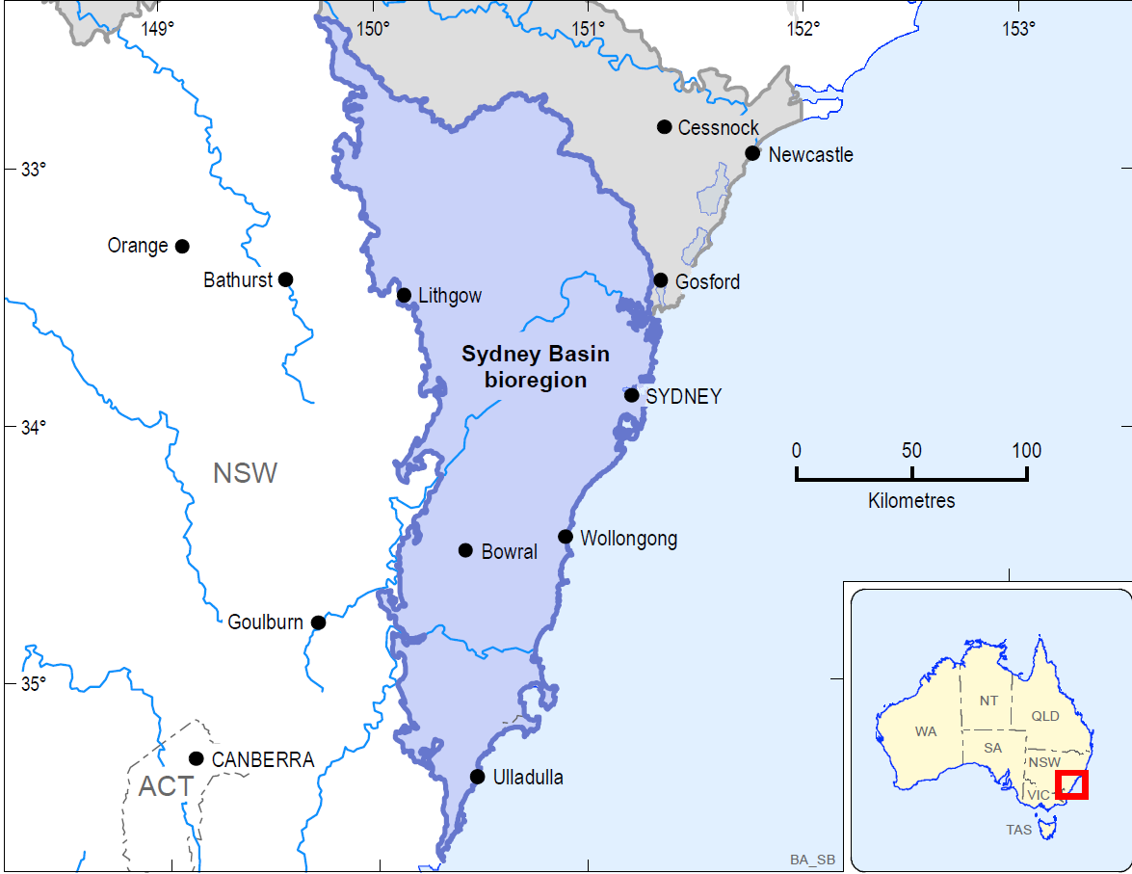
Figure 7. The Sydney Basin bioregion of the Bioregional Assessment Programme
(Bioregional Assessment Programme: www.bioregionalassessments.gov.au)

Community Engagement
AWI was unable to undertake engagement activities in the Sydney bioregion within the Bioregional Assessment Programme timeframes.

Hunter subregion
The Hunter subregion covers an area of about 17,045 km². On the coast, it extends north from the northern edge of Broken Bay on the New South Wales Central Coast to just north of Newcastle. The subregion is bordered in the west and north–west by the Great Dividing Range and in the north by the towns of Handford, Scone and Muswellbrook.
The Hunter is the major river in the subregion, rising in the Liverpool plains and draining east to Lake Glenbawn before it enters the Tasman Sea at Newcastle.
The Hunter subregion includes effectively all of the New South Wales local government areas (LGAs) of Wyong, Lake Macquarie, Newcastle and Muswellbrook as well as most of Maitland, Cessnock, Port Stephens and Upper Hunter Shire. The LGAs of Singleton, Gosford and Mid-Western Regional also have a significant proportion of their area within the Hunter subregion. (Bioregional Assessment Programme: www.bioregionalassessments.gov.au)
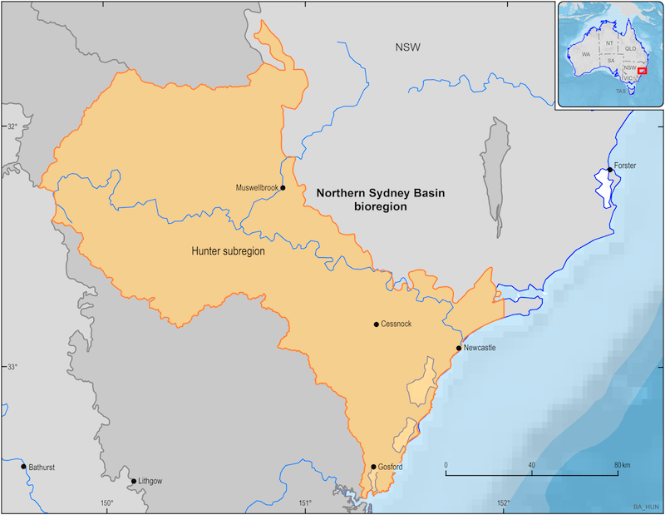
Figure 8. The Hunter subregion of the Bioregional Assessment Programme
(Bioregional Assessment Programme: www.bioregionalassessments.gov.au)

Community Engagement
AWI was unable to undertake engagement activities in the Hunter subregion within the Bioregional Assessment Programme timeframes.

References
Bioregional Assessment Programme: www.bioregionalassessments.gov.au

FPWEC (2012). First Peoples Water Engagement Council - Advice to the National Water Commission. http://www.nwc.gov.au/__data/assets/pdf_file/0004/22576/FPWEC-Advice-to-NWC-May-2012.pdf.

NSW Office of Water (2012). Our Water Our Country: An information manual for Aboriginal people and communities about the water reform process. Edition 2.0. NSW Department of Primary Industries, Office of Water, Sydney, NSW.

Appendices

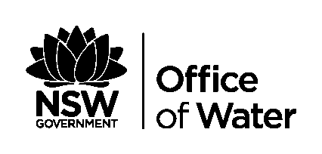
Appendix 1

Aboriginal Water Initiative
Information Use Agreement

THIS AGREEMENT is made the day of 2015.
BETWEEN XXXX

AND NSW OFFICE OF WATER (NOW), DEPARTMENT OF PRIMARY INDUSTRIES of
Level 10, Macquarie Tower
Locked Bag 5123
Parramatta NSW 2124
Background
- The Aboriginal Water Initiative (AWI) was established by NOW in June 2012 to improve Aboriginal involvement and representation in water planning and manage within NSW. The AWI has 3 permanent positions but the program is funded until June 30 2016.
- The AWI program is aware that there are culturally appropriate processes and protocols that need to be followed to maintain community confidence.
- The AWI will allow NOW to monitor the success of water sharing plans, floodplain management plans and meet Aboriginal specific objectives under the NSW Water Management Act 2000 (WM Act) including recognising spiritual, social, customary and economic values of water to Aboriginal people.
- NOW has invited XXX to voluntary provide Information in relation to Water Dependent Cultural Values in your area. This information will support in the deliberation of the appropriate protection and management rules for the cultural values under the water reform and planning regime including Water Sharing Plans, Water Resource Plans, Floodplain Management and Bioregional Assessment.
- XXX agrees to participate in the AWI on a voluntary basis on the terms set out in this Agreement including, amongst others, that NOW keeps Cultural Information confidential but releases water dependency information of the cultural value to the NOW Water Planners and the Federal Environment departments Office of Water Science for the Bioregional Assessment programme.
- Definitions
In this Agreement unless the context requires otherwise:
AWI means the program described in the brochure published by the NSW Department of Primary Industries NSW Office of Water attached to this Agreement and marked ‘A’.
AWIS Database means a secure database with login restrictions and access, which holds water dependent cultural values and information/data relevant to the operation of the AWI program.
Bioregional Assessment means a programme of bioregional assessments in order to better understand the potential impacts of coal seam gas and large coal mining developments on water resources and water-related assets including water dependent Aboriginal cultural values. The NSW targeted areas include Hunter, Central West, Gwydir, Namoi, Clarence-Moreton, Maranoa-Balonne, Hawkesbury-Nepean River, Georges River and Wollongong Coast Bioregional Areas. The bioregional assessments are being delivered through collaboration between the Department of the Environment (Office of Water Science), the Bureau of Meteorology, CSIRO and Geoscience Australia. This information then informs the Independent Expert Scientific Committee on Coal Seam Gas and Large Coal Mining Development (the IESC) which provides scientific advice to decision makers on the impact that coal seam gas and large coal mining development may have on Australia's water resources.
Cultural Community Protocols means the relevant Aboriginal community or group engaging with the AWI is able to negotiate culturally appropriate protocols to work together.
Cultural Information means any information provided by XXX, or its employees, representatives and members, to NOW in relation to Water Dependent Cultural Values.
Floodplain Management or Healthy Floodplains: to improve understanding of the relationship between floodplain flows, flood risks, extractions and wetland health. Floodplain means any area designated as floodplain under the WMAct 2000 or the Water Act 1912.
Identification Report Card means the ‘Aboriginal Water Dependent Cultural Values Identification Report Card’ prepared by NOW and attached to this Agreement and marked ‘B’ as amended by written agreement of the parties.
Security Access Levels means the AWIS Database will have levels of access, starting at login – Aboriginal staff access, and down to cultural sensitivities and gender.
Water Dependent Cultural Value means the list of places, areas and sites listed at Schedule 1 to this Agreement as amended by XXX and assessed for its relevance under the AWI program by NOW in accordance with this Agreement.
WM Act means the Water Management Act 2000 (NSW).
- NOW’s AWI Obligations
  - The NOW, including its’ employees, representatives and agents, must comply with the following obligations in carrying out the AWI:
    - The parties acknowledge that NOW and the AWI has an obligation to consult all relevant Aboriginal people in NSW to recognise their spiritual, social, customary and economic values of water. NOW and the AWI will not record Water Dependent Cultural Values or Cultural information from non-Aboriginal people.
    - That the AWI Team will work in partnership with XXX in the identification of their Water Dependent Cultural values, and will work on country with the consent of the Members and Elders.
    - That the Water Dependent Cultural Values listed at Schedule 1 will be assessed by AWI staff and note that some may be determined as not water dependent under the AWI program and XXX will be advised that the information regarding this value will not be recorded and will be removed from this agreement.
    - record and maintain all Cultural Information on the AWIS Database;
    - record and maintain information for delivery to the Office of Water Science where the cultural values fall into Bioregional Assessment regions. XXX will determine what information is to be provided to the Office of Water Science as some of this information can become public.
    - use all reasonable endeavours to ensure that Cultural Information recorded on the AWIS Database is subject to Security Access Levels to keep the Cultural Information secure;
    - prior to obtaining any Cultural Information, NOW must consult with XXX and explain the Security Access Levels that the NOW will implement in relation to Cultural Information;
    - consult with XXX prior to making any changes to the security access level of the AWIS Database;
    - comply with Cultural Community Protocols when using and accessing the Water Dependent Cultural Values for the purpose of the AWI;
    - comply with any reasonable direction given by XXX, and members, in relation to access to the Water Dependent Cultural Values and the methodology to collect Cultural Information;
    - use the Identification Report Card to record Cultural Information;
    - subject to clause 2.1 (k) above, gather and record Cultural Information by methods including, but not limited to, interviews, workshops, verbal discussions, written documents, photos, GPS locations and videos.

- XXX Participation in AWI is Voluntary
  - The parties acknowledge and agree that the participation of XXX, its’ employees, representatives and members, in the AWI is on a voluntary basis to assist NOW meet the Aboriginal specific objectives under the WM Act.
  - No provision of this Agreement is to be construed to legally oblige XXX, its employees, representatives or members to participate in the AWI.
  - XXX may amend for any reason the list at Schedule 1 of Water Dependent Cultural Values by serving written notice on NOW.
  - Where there is overlap in the location of a Water Dependent Cultural Values between two or more parties then agreement must be met between those parties on decision and management actions with regard to those Water Dependent Cultural Values.
- Confidential Information
  - NOW acknowledges and agrees that as advised by XXX that restricted Cultural Information is confidential.
  - NOW, including its representatives, employees and agents must comply with the following obligations in relation to the Cultural Information:
    - keep Cultural Information confidential;
    - not disclose Cultural Information to any other person, group, agency or government authority without the written consent of XXX;
    - NOW must consult with XXX in accordance with the Government Information (Public Access) Act 2009 in relation to any application under that Act to access Cultural Information; and
    - not use the Cultural Information for any purpose other than to meet Aboriginal specific objectives under the WM Act and the objectives of the Aboriginal Water Initiative.
    - record and maintain information for delivery to the Office of Water Science where the negotiated cultural values fall into Bioregional Assessment regions.
  - If XXX provides its written consent to Cultural Information being disclosed by NOW to members of the public, NOW must comply with any reasonable direction given by XXX in relation to the form and method of disclosure of the Cultural Information.
- Access to Cultural Information
  - NOW must comply with any direction from XXX to rectify any errors or mis-description of Cultural Information on the AWIS Database.
  - NOW must provide XXX, its employees, representatives and members with reasonable access free of cost to Cultural Information collected under this Agreement held by NOW.
  - The XXX must apply in writing to NOW to determine a time and place to access the Cultural information collected under this Agreement.
- Termination
  - Notwithstanding any other provision of this Agreement, XXX can terminate this Agreement at any time, and for any reason, by providing written notice to NOW’s contact as specified in clause 7. Execution of this Agreement.
  - If XXX terminates this agreement, NOW must return all Cultural Information held by NOW in AWIS to XXX within a reasonable period of time.
  - NOW’s obligations in relation to confidential information as set out in clause 4 of this Agreement survives any termination of this Agreement.
AWI Contacts:
  - NOW’s contacts for the purposes of the AWI are:
Senior Aboriginal Water Planning Coordinator (North) - email: marcus.leslie@dpi.nsw.gov.au

Senior Aboriginal Water Planning Coordinator (South) - email: lillian.moseley@dpi.nsw.gov.au

  - The XXX contact for the purposes of the AWI is:

Execution
Where a common seal of XXX is fixed, there must be two (2) authorised signatures who are not party to this Agreement, in accordance with section 22 of the Associations Incorporation Act 2009 (NSW)

Name of authorised person ______________________________________

____________________________________________________/___/____
Signature of authorised person Date

____________________________________________________/___/____
Witnessed by signed Date

____________________________________________________/___/____
Witnessed by signed Date

Executed as a binding Agreement for and on behalf of NOW
Signed by delegate of the Deputy Director General – NOW:

____________________________________________________/___/____
Sign Date

____________________________________________________________
Address and contact number

____________________________________________________/___/____
Witnessed by signed Date

SCHEDULE 1

Water Dependent Cultural Value Sites pending assessment by AWI

The Water Dependent Cultural Values Sites for the purposes of this Agreement are as follows:

Appendix 2
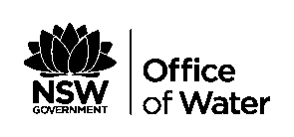

Aboriginal Water Dependent Cultural Values Identification Report Card

WATER DEPENDENT CULTURAL VALUES IDENTIFICATION DETAILS
NAME OF WATERDEPENDENT CULTURAL VALUE/S
LOCATION OF WATER DEPENDENT VALUE
RECORDING OFFICER’S NAME/S
BIOREGIONAL ASSESSMENT AREA (If relevant)
KEY CONTACT PERSONS DETAILS
Name:
Address:
Phone/ Mobile:
Email:
NATION /LANGUAGE GROUP:
LOCAL ABORIGINAL LAND COUNCIL AND REGION
DATE RECORDED |  |  | LAND TENURE | - PRIVATE – LALC Owned  - CROWN  - NATIONAL PARKS  - OTHER
WATER SHARING PLAN
WATER RESOURCE PLAN
FLOODPLAIN MANAGEMENT PLAN
STATUTORY PROTECTED AREA
( e.g. AP or IPA)
NAME OF WATER SOURCE (S)
(GL notes may cover more than one water source)
NAME OF MANAGEMENT ZONE(S)
HISTORY OF CULTURAL WATER DEPENDENT VALUE
Record Traditional and contemporary history and use.

ENVIRONMENTAL DESCRIPTION AND CHARACTERISTICS OF CULTURAL WATER DEPENDENT VALUES
WATER DEPENDENT CULTURAL SITES TYPES/FEATURES  (this will indicate how the site is and /or was used and the practices carried out ) |  | - Cultural/Traditional  - Ceremonial and dreaming  - Resource and gathering  - Implement making/manufacturing  - Women’s business  - Men’s Business  - Fish traps  - Fishing  - Hunting and gathering  - Native plant /animal species  - Site management  - Environmental/biodiversity conservation management  - Lore  - Social/customary  - Ceremonial and dreaming  - Women’s business  - Men’s Business  - Camp site  - Learning and passing on knowledge  - Connection back to country  - Recording sharing memories  - Fishing  - Hunting and gathering  - Resource and gathering  - Community/capacity building  - Others specify  - Spiritual  - Ceremonial and dreaming  - Economic  - trade/bartering
WATER SOURCE DEPENDANCY Surface water  - Ground water  - Surface Water  - Floodplain  - Other |  | - In-stream  - off –stream  - both
LANDFORM/ LANDSCAPE |  | - Wetland  - Floodplain  - Lagoons  - Soak  - Spring  - Water hole  - Billabong
CULTURAL VALUES DESCRIPTION) (geology, soils, landscape)
CULTURAL WATER DEPENDENT FAUNA AND FLORA
CURRENT CONDITION of VALUE

GOOD / AVERAGE / POOR
KNOWN RISKS AND THREATS
(E.G. water extraction to the asset and others - Current conditions of asset)
HIGH / MEDIUM / LOW
SPECIFIC ACTIVITIES CARRIED OUT AT THE SITE AND /OR WITH CULTURAL ASSETS.
RARITY AND COMPARITIVE VALUES OF CULTURAL VALUES
RARE / COMMON
WATER QUALITY
GOOD / AVERAGE / POOR

REPORT OR STUDIES BEEN WRITEN ON THE CULTURAL VALUES (S)

ACCESS RESTRICTIONS TO THE CULTURAL VALUES (S)
WATER REQUIREMENTS

MANAGEMENT CONSIDERATIONS
RULES OR LICENSES

MAP ATTACHMENTS

MAP

Easting: | Northing:

PHOTO ID

