Aboriginal Cultural Water Values
– Maranoa-Balonne-Condamine subregion
A report for the Bioregional Assessment Programme
Researched and prepared by Corporate Culcha for
the Department of the Environment

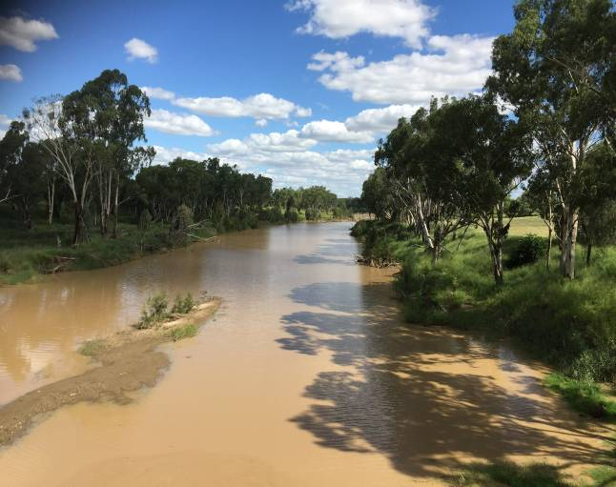

Corporate Culcha
Corporate Culcha is an Aboriginal owned and operated consultancy practice specialising in engagement with Aboriginal and Torres Strait Islander organisations and communities. Corporate Culcha works with a range of Indigenous and non-Indigenous consultants, many of whom are leaders in their individual fields. Access to this pool of expertise allows Corporate Culcha to deliver a diverse range of services to their clients including research and evaluation, cultural capability programs and education, mentoring and capacity building.

About the Authors
Janis Constable is a well-regarded Indigenous research consultant with extensive social research and program evaluation expertise, built on senior policy and research roles for federal and state governments. Janis has been a senior advisor to two federal Aboriginal and Torres Strait Islander Social Justice Commissioners on Indigenous human rights issues where she led a number of national research projects. As a freelance research consultant, Janis has undertaken a number of key strategic research projects focussing on improved social and economic outcomes for Aboriginal and Torres Strait Islander peoples.

Karen Love has extensive experience in ecological restoration, specialising in high conservation areas with bio-diverse vegetation. Her roles have incorporated advanced flora and fauna monitoring, ecological assessments and spatial mapping. Working alongside state and within local government agencies Karen has delivered a range of services, including scientific monitoring, program evaluation, strategy development and water education advice.

Citation
Constable, J. & Love, K. (2015) Aboriginal water values Maranoa-Balonne-Condamine subregion (Qld), a report for the Bioregional Assessment Programme.
Copyright
 © Commonwealth of Australia 2015
All material in this publication except for information sourced from the Native Title Report 2008, is provided under a Creative Commons Attribution 3.0 Australia Licence <http://www.creativecommons.org/licenses/by/3.0/au/deed.en

Disclaimer
The views and opinions expressed in this publication are those of the authors and do not necessarily reflect those of the Australian Government or the Minister for the Environment.
While reasonable efforts have been made to ensure that the contents of this publication are factually correct, the Commonwealth does not accept responsibility for the accuracy or completeness of the contents, and shall not be liable for any loss or damage that may be occasioned directly or indirectly through the use of, or reliance on, the contents of this publication.
Cover photograph – Maranoa River, Mitchell, Qld (Source: J. Constable, 2015)

Acknowledgement of Traditional Owners
Acknowledgement is paid to Aboriginal and Torres Strait Islander peoples past, present and future. We acknowledge the unique relationship that Aboriginal and Torres Strait Islander people have with their traditional lands and waters, as well as their history and diverse cultures and customs. We thank all Aboriginal people who have shared their knowledge and time so generously, without their participation this report would not have been possible.

Terms for Aboriginal and Torres Strait Islander
For the purposes of this report, the terms ‘Aboriginal people’, ‘Aboriginal and Torres Strait Islander people’ and ‘Indigenous’ are used interchangeably to refer to Aboriginal and Torres Strait Islander peoples of Australia. However, we recognise that this approach is not without contention. Aboriginal and Torres Strait Islander people generally prefer the use of Aboriginal as opposed to Indigenous. Indigenous is deemed a formal term often used by governments as inclusive of all Aboriginal and Torres Strait Islander peoples.

As this report is focussed on the relationship of Aboriginal people of the Maranoa-Balonne-Condamine subregion, we will refer to either Aboriginal people or their distinct groups i.e. Gunggari, Mandandanji. The report also employs the term Indigenous when referring to relevant government programmes, policies or resources.

1.Introduction 6
2. Methodology 7
2.1 Desktop research 7
2.2 Community Engagement 8
2.3 Mapping Methodology 8
3.Aboriginal people of the Maranoa-Balonne-Condamine 9
Bigambul 11
Native Title 11
Gunggari 11
Native Title 12
Githabul 11
Native Title 12
Jarowair 11
Native Title 12
Kambuwal 11
Native Title 12
Kooma 11
Native Title 12
Mandandanji 12
Native Title 12
3.1 Major rivers of the subregion 12
Figure 3: Map of stream networks in the Maranoa-Balonne-Condamine subregion 13
3.1.1 The Maranoa River 13
3.1.2 The Condamine Balonne Catchment 14
4. Consultation outcomes – values and assets 15
4.1 Categorising cultural assets 16
4.1.1 Cultural Heritage Sites 12
4.2 Cultural Water Assets Identified 17
4.3 Accompanying narratives 29
Weir River (MBC10) 30
Welltown Station (MBC11) 30
Rock well (MBC13) 30
Wild Orange (Capparis mitchelli) (MBC14) 31
Rocky Creek (MBC16) 32
Womalilla Creek (MBC17) 32
Amby Creek (MBC18) 33
Maranoa River (MBC19) 33
Top Yumba (MBC23) 34
Bottom Yumba (MBC21) 35
Twenty Two Mile (MBC20) 36
Kurrajong tree (MBC22) 38
Umbie Umbie (MBC24) 38
Cooranga Creek (MBC3) 39
Tool Making site (MBC4) 39
5. Summary 40
6. References 41
6. Appendix 42

Appendix 1 – Consultation participants 42

List of tables and figures

Table 1: Aboriginal Population of the Maranoa-Balonne-Condamine subregion 10
Table 2: Local Aboriginal words for water and related assets 12
Table 3: Aboriginal Cultural Water Assets - Customary 17
Table 4: Aboriginal Cultural Water Assets – Spiritual 21
Table 5: Aboriginal Cultural Water Assets - Ecological 22
Table 6: Aboriginal Cultural Water Assets - Economic 25

Figure 1: Maranoa-Balonne-Condamine subregion 9
Figure 2: Map of Aboriginal language groups in Maranoa-Balonne-Condamine subregion 12
Figure 3: Maranoa River 12
Figure 4: Balonne River 12
Figure 5: Condamine River 12
Figure 6: Weir River (Source: unknown) 30
Figure 7: Rock well near St. George (Source: K. Love 2015) 31
Figure 8: Bumble Tree aka Wild Orange (Capparis mitchelli) (Source: unknown) 31
Figure 9: Rocky Creek (Source: K. Love 2015) 32
Figure 10: Womalilla Creek, near St.George (Source: K. Love 2015) 32
Figure 11: Top Yumba - on the banks of the Maranoa River near Mitchell (Source: J. Constable 2015) 34
Figure 12: Doctor Tree, Top Yumba (Source: K. Love 2015) 35
Figure 13: Bottom Yumba, Interpretive Trail (Source: K. Love 2015) 36
Figure 14: Bottom Yumba, Interpretive Trail (Source: K. Love 2015) 36
Figure 15: Twenty-Two Mile - outside Mitchell (Source: J. Constable 2015) 37
Figure 16: Twenty-two Mile, confluence of Womalilla (left) and Amby Creeks (right) at the Maranoa River (Source: K. Love 2015) 37
Figure 17: Kurrajong Tree (Source: K. Love 2015) 38
Figure 18: Umbie Umbie (Source: K. Love 2015) 38
Figure 19: Cooranga Creek, near Bell (Source: J. Constable 2015) 39
Figure 20: Tool making rock (Source K. Love 2015) 39

Introduction
The term ‘Aboriginal water values’ is used to describe the relationship between Aboriginal and Torres Strait Islander peoples and water and the importance of water and water dependent resources. Aboriginal and Torres Strait Islander people’s relationship with water is intrinsic in nature, with water not only being fundamental for survival, but an indivisible, interwoven and central element of cultural and spiritual life.

Tom Calma, former Aboriginal and Torres Strait Islander Social Justice Commissioner wrote:

Indigenous peoples are connected to and responsible for our lands and waters and in turn, Indigenous peoples obtain and maintain our spiritual and cultural identity, life and livelihoods from our lands, waters and resources. These cultural and customary rights and responsibilities include:

- a spiritual connection to lands, waters and natural resources associated with water places
- management of significant sites located along river banks, on and in the river beds, and sites and stories associated with the water and natural resources located in the rivers and their tributaries, and the sea
- protection of Indigenous cultural heritage and knowledge associated with water and water places
- access to cultural activities such as hunting and fishing, and ceremony.

As custodians of water resources on country, Aboriginal people have a significant interest in the way water is shared and used on country, and an important role in monitoring potential impacts of activities that may affect water quality and/or the health of flora and fauna that rely on specific water resources.

This report provides the data collected through community consultation for the Aboriginal Water Values Project, which will be used to inform the bioregional assessment for the Maranoa-Balonne-Condamine subregion. The report includes a description of the methodology employed; an overview of the Indigenous peoples of the Maranoa-Balonne-Condamine subregion; description of the data collected, including narratives associated with each identified water asset. An Asset Register, which provides spatial data; aligned cultural values; associated Aboriginal language groups and a brief description for each identified water and water dependent asset was compiled.

The Australian Government is undertaking a programme of bioregional assessments in order to better understand the potential impacts of coal seam gas and large coal mining developments on water resources and water-dependent assets. The Bioregional Assessment Programme draws on the best available scientific information and knowledge from many sources, including government, industry and regional communities, to produce bioregional assessments that are independent, scientifically robust, relevant and meaningful at a regional scale.

The Programme is a collaboration between the Department of the Environment, the Bureau of Meteorology, CSIRO and Geoscience Australia. The Programme is seeking input from the Aboriginal community on water-dependent cultural values (also referred to as assets). For more information, visit http://www.bioregionalassessments.gov.au.

2. Methodology
This section provides details on the following methodology employed throughout the project.

The methodology for this project included:

- Desktop research:
  - Relevant reports
  - Investigate current discourse on Aboriginal Cultural Water Values
  - Identify relevant Aboriginal people and organisations
- Contact above identified individuals and organisations:
  - Introduce the project and the researchers
  - Discuss involvement in project
  - Arrange visit
- Initial field visits:
  - Face to face discussions and provide information
  - Identify other potential participants (Elders, knowledge holders)
  - Arrange next visit
- Second field visit:
  - Obtain consent
  - Commence data collection on site
    - Identifying locations of assets
    - Record special data (GPS mapping)
    - Interview knowledge holder
- Third field visit:
  - Continue and finalise data collection on site
  - Record spatial data
- Analyse data:
  - Record location data on asset register
  - Document associated narratives for assets
- Write report and obtain endorsement from participants.

2.1 Desktop research
Desktop research was undertaken to gain an initial understanding of, and to identify:
- publically available data
- current discourse on Aboriginal cultural water values
- key stakeholders (organisations and individuals)

Publications were identified which assisted in understanding relevant issues pertinent to the region and Aboriginal cultural water values generally. The reports and websites sourced indicate significant activity in relation to Aboriginal communities and water – specifically in relation to conservation and water sharing plans. These resources are listed at Chapter 5 – References, and will be explored in more detail in the final summary report.

2.2 Community Engagement
Initial discussions were held with Traditional Owner groups providing an opportunity to discuss the objectives of the project with key stakeholders. These meetings also provided an opportunity to obtain contact details for other significant community members, with face-to-face or telephone meetings being arranged with those people soon thereafter.

Stakeholders were assured the process for gathering the data would be undertaken respectfully, with cultural safety as a priority. Information about the impetus of the broader Bioregional Assessment Programme, and the proposed use of the data collected through it, including the Aboriginal cultural water values mapping, was described as forming but one layer, of many layers of baseline data that will be assembled, to develop a comprehensive map of the Maranoa-Balonne-Condamine subregion. The results will enable improved decision making in relation to coal mining and coal seam gas. Stakeholders were advised that maps and reports developed, as a result of this research, would be available to them as a community resource.

Stakeholders were also advised their participation was voluntary and no adverse action would occur if the group chose not to participate, and they could withdraw consent at any stage of the research process.

Unstructured interviews were undertaken with participants, as well as note taking by the interviewer. In some instances photographs were taken, with permission, of the sites.

Aboriginal organisations and communities consulted:

- Queensland Murray Darling Aboriginal Advisory Committee
- Northern Basin Aboriginal Nations (NBAN)
- Gunggari Native Title Aboriginal Corporation
- Members of the Jarowair community
- Members of the Kooma community
- Members of the Mandandanji community
- Members of the Bidjara community
- Members of the Bigambul community
- Members of the Githabul community

Other key groups consulted about the research were:

- Condamine Alliance
- Queensland South Native Title Services
- Department of Aboriginal and Torres Strait Islander Partnerships, Cultural Heritage Unit

2.3 Mapping Methodology
In all instances mapping on country utilised Motion X-GPS and coordinates were cross-referenced with maps downloaded into the Avenza Maps PDF application. Maps used were Geoscience Australia and State of Queensland Wetland maps with datum GDA94. Remote mapping was done using the same system with GPS coordinates obtained on country as the reference point.

Aboriginal people of the Maranoa-Balonne-Condamine
The Maranoa-Balonne-Condamine subregion (Figure 1) includes the Border Rivers, Maranoa-Balonne and Condamine natural resource management regions over the extent of the coal-bearing Surat and Clarence-Moreton geological basins. The subregion also extends west to include part of the eastern edge of the Queensland South West natural resource management region, and south to include part of the New South Wales North West Local Land Services region. The Maranoa-Balonne-Condamine subregion covers a smaller area than the combined Border Rivers, Moonie and Condamine- Balonne river basins; it does not extend beyond the coal-bearing geological basins.

Figure 1: Maranoa-Balonne-Condamine subregion

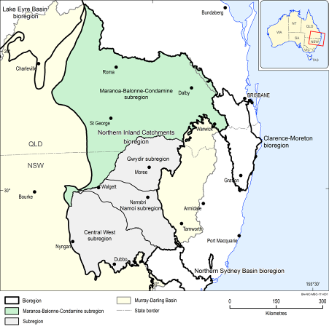
The number of Aboriginal people inhabiting the area prior to European colonisation is unknown. However, it has been estimated that at the time of European settlement the Indigenous population across Australia was somewhere between 500,000 to 1 million (ABS). As at the 2011 Census, the Aboriginal and Torres Strait Islander population of Australia is estimated at 669,900 people, or approximately 3% of the total Australian population (ABS).

The Indigenous population of the Maranoa-Balonne-Condamine subregion is approximately 6647 or 3.7 per cent (Table 1) of the approximate total population (177,837) of the subregion, with the largest Indigenous community residing in Toowoomba.

Table 1: Aboriginal Population of the Maranoa-Balonne-Condamine subregion
Region | Indigenous Pop. | Total Pop. | Indigenous people as % of total population
Balonne-St George-Dirranbandi | 131 | 891 | 14.7
Kingaroy | 387 | 13552 | 2.8
Maranoa (excl. Roma & Mitchell) | 194 | 5258 | 3.6
Roma & Mitchell | 958 | 13074 | 7.3
Toowoomba | 4734 | 140220 | 3.3
Wondai | 243 | 4842 | 5.0
Total | 6647 | 177837 | 3.7

Aboriginal groups whose traditional lands exist within the Maranoa-Balonne-Condamine subregion include Kooma, Gunggari, Barrunggam, Bigambul, Githabul, Jarowair, Mandandanji, Kambuwal and Kamilaroi peoples.

Bigambul
The Bigambul people’s traditional lands are situated in the border region of Queensland (Qld) and New South Wales (N.S.W). The Bigambul people originally inhabited a 26,500 square kilometer area east of Nindigully, Qld., on Weir and Moonie rivers, north to Tara; at Talwood, Qld.; on MacIntyre River from east of Boomi to Texas; at Yetman, Boggabilla, and at Middle Creek, N.S.W. The Bigambul have a cultural connection with the Northern Kamilaroi people and these tribes regularly participated in joint ceremonies at Boobera Lagoon.

Native Title
On 23 February 2001 the Bigambul people lodged a successful native title claim over 24,188 square kilometers of land in South Western Queensland.

Gunggari
The Gunggari people’s traditional lands are situated north to Morven and Mungallala, west to just beyond Mitchell, east towards Roma and south along the Maranoa River.

Gunggari are the holders of two native titles, both achieved by consent determination. The first being determined on 22 June, 2012 the second on
5 December, 2014. The Gunggari peoples traditional lands takes in the watershed of the Maranoa River.

Further, Gunggari and Kooma have a Shared Country Agreement where their traditional boundaries meet around the lower Mungallala/Nebine Creek.

Githabul
The Githabul people traditional lands are situated around the Warwick, Killarney and Woodenbong (New South Wales) region.

Jarowair
Jarowair country includes the western slopes of Great Dividing Range from Crows Nest to Dalby; north to Bell and south to Oakey. It includes the towns of Bell, Crows Nest, Dalby and Oakey.

Kambuwal
The Kambuwal people’s traditional lands are found around the towns of Inglewood, Stanthorpe and Wallangarra (south to New South Wales).

Kooma
The Kooma people traditional lands sit just outside of the Maranoa-Balonne-Condamine subregion, being situated west of St George to Cunnamulla, north towards Gunggari and Bidjara country (Charleville and Mitchell) and south to just over the New South Wales border.

Mandandanji
The Mandandanji people’s traditional lands are located in the Roma and St George areas, and south towards Toowoomba.

Table 2: Local Aboriginal words for water and related assets

Language | Word | English Meaning
Bigambul | gulli | water
 | warril | creek/river
 | warroo | flood
 | goaggul | grass growing in lagoon
Jarowair | goong | water
 | warril | river
 | gool | fish
 | cumboogie | crayfish
 | dalbugon | turtle
 | jandowae | waterhole
 | cambooya | water reed
Gunggari | balbara | river bank
 | barbara | river
 | barbaragu | in the creek
 | barraguriny | down the river
 | baru | river/creek/waterhole
 | bugili | crayfish
 | gamu | water/rain
 | gi ja | freshwater shrimp
 | gujarra | swimming
 | guyun | flood
 | guyar | big water/flood

3.1 Major rivers of the subregion
The following section provides a brief summary of the main rivers of the subregion, including tributaries and the towns they flow through. It is provided to show how the rivers flow through the traditional lands of Aboriginal groups in the Maranoa-Balonne-Condamine subregion.

Figure 3: Map of stream networks in the Maranoa-Balonne-Condamine subregion
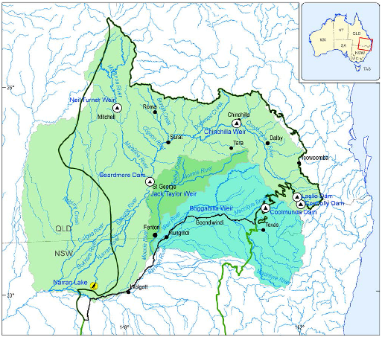

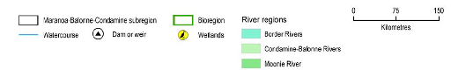

3.1.1 The Maranoa River
The Maranoa River starts in the Carnarvon National Park and flows through the town of Mitchell before joining the Balonne River at Lake Kajarabie (E J Beardmore Dam) above St George (Figure 3). Water travels quickly down the Maranoa during floods, with recent floods being some of the largest on record.

Thirty-one creeks and rivers flow into the Maranoa River. The five longest tributaries are: Merivale River, Womalilla Creek, Amby Creek, Maranoa River (West Branch) and Billin Creek.

Aboriginal traditional lands located along the Maranoa are the Gunggari, Mandandanji, Bidjara, Nguri, Kooma and Bigambul.

3.1.2 The Condamine Balonne Catchment
The Condamine-Balonne region is located in southern Queensland and northern New South Wales.

The Condamine-Balonne catchment covers 150,101km² or 14.4 per cent of the Murray Darling basin area. Tributaries include the Maranoa River, which flows southward from the Carnarvon Range into the Beardmore Dam, near St George. The Nebine Creek in the west of the region flows south and meets the Culgoa River in northern New South Wales upstream of Collerina.

The following 11 creeks and rivers flow into the Balonne River (ordered by descending elevation): Dogwood Creek, Condamine, Yuleba Creek, Lynn Creek, Kangaroo Creek, Tartulla Creek, Maranoa River, Thuraggi Channel, St Helena Creek, Bullabala Creek and Quart Pot Creek.

The Condamine River starts in the Great Dividing Range in Queensland and flows north-west past Dalby and Chinchilla and then south-west to where it meets the Dogwood Creek and becomes the Balonne River (Figure 3), near Surat. Downstream of St. George, the Balonne becomes a braided network incorporating the channels, waterholes and floodplains of the Narran, Bokhara/Birrie, Ballandool and Culgoa rivers, and the Briarie Creek.

Aboriginal traditional lands located along the Balonne River (Queensland side) belong to the Bigambul, Kooma and Mandandanji peoples.

4. Consultation outcomes – values and assets

Preliminary discussions were held with representatives from all Traditional Owner groups of the region. Follow up consultations were sought with all groups with a view to undertaking fieldwork ‘on country’ with Elders and knowledge holders. Follow-up field visits were undertaken with representatives from Bigambul, Jarowair and Gunggari, with Corporate Culcha researchers spending several days with each group on country. For other groups, the project’s timeframe impacted on the availability of Elders and knowledge holders to accompany researchers undertake fieldwork.

While undertaking fieldwork, Corporate Culcha researchers recorded spatial coordinates of the assets, and documented the associated cultural values, which included dreamtime stories and song lines, historical and contemporary uses for water resources, and knowledge and uses of water reliant flora and fauna. Where appropriate, and with consent, photographs were taken of the asset.

This report has also benefited from previous work undertaken by the Gunggari in documenting sources and uses of medicinal plants. The details provided in this report have been sourced from participating Elders as well as from the book Bush Flowers, Bush Medicine, Bush Tucker and Bush Poems from Gunggari Country. The book is a valuable community resource and thanks are given to the Gunggari Elders for allowing us to use the book for this report.

The following section summarises the fieldwork undertaken with Elders and knowledge holders from the Bigambul, Jarowair and Gunggari groups. The cultural values identified pertain to customary and spiritual associations, ecological value - relating to fish and animal species, or economic value in terms of fishing, water-reliant bush foods and current or potential economic development opportunities. However, the overarching cultural value is based on the principle that water is vital to the wellbeing of every living thing – people, animals, plants, earth and air.

Although the mapping component of the research had been completed by the time consultations with the Githabul were able to take place, Uncle Sam Bonner (Githabul Elder) wanted the report to note the Githabul peoples’ commitment to the cultural and environmental management of the whole of the Condamine River, the creeks and other waterways and wetlands existing on Githabul country.

For example, Githabul people have been involved in a project funded and managed in partnership with Condamine Alliance, Queensland Parks and Wildlife Service, Department of Main Roads and relevant local councils which aimed to protect the endangered Bulloack Jewel Butterfly, as well as raise awareness of this endangered species to both the local and wider community. The project saw on-ground works along the Condamine River, near the township of Warwick. The work included weed control (mainly tree pear and tiger pear), walking track construction, and a general tidy up of riverbanks. Interpretative signage was erected along the walking track, which provides information on the butterfly and the protection of its habitat to visitors.

Uncle Sam Bonner also emphasized the importance of restoring indigenous plant and tree species to the Condamine riverbanks. He noted that although there had been plant regeneration projects, some of the flora that had been planted is not indigenous to the region. This he says “will impact on the symbiotic relationships between plants, insects and animals.” He noted the special relationship between the Bulloack Jewel butterfly, the tree it lives on, the Bulloak Allocasuarina luehmannii, and an ant Anonychomyrma sp. He described how the caterpillar larvae uses the tree to create its cocoon, and then once the butterfly emerges, the ant eats the remnants of the cocoon. He said there is further work (that requires funding) to eradicate weeds along the Condamine including Broom Cotton (aka Scotch Broom, English Broom), Tiger Pear, Crofton weed (Ageratina adenophora ), Moss Vine and Morning Glory.

Uncle Sam Bonner laments that no Traditional Owners are currently protecting water on country since much of the funding that was once available to undertake this work has diminished. He also is concerned that the small amount of funding that is still available is managed by non-Indigenous agencies that do not include Traditional Owners in their day-to-day activities. Sam is currently seeking funding opportunities to establish activities to continue the work of river and riverbank regeneration and conservation, and hopes to be able to employ young Aboriginal people from the region to undertake this work. He considers this an important way forward to reconnect young Aboriginal people with land, water and culture.

4.1 Categorising cultural assets
The assets identified here are of cultural significance to the Aboriginal people of the Maranoa-Balonne-Condamine subregion, the values, purpose and meaning attached to each asset has been identified through consultation. Most assets have more than one value attached, for example a creek bed being a place of ceremony as well as a place where food can be harvested.

The purpose and meaning of cultural water assets have been categorised into the following groups:

- Customary – ceremony, meeting place, men’s business, women’s business, totems, dance, rites, song, birth, death)
- Spiritual (dreaming, stories, song lines)
- Ecological (flora and fauna)
- Economic (trade routes, food source – fishing/hunting, employment/income – tourism, farming)
- Recreational – family gatherings, swimming holes

The total number of Aboriginal cultural water assets in the Maranoa-Balonne-Condamine subregion detailed in this report is not exhaustive. A sample of the cultural assets and their associated value to Aboriginal people of the region were compiled.

4.2 Cultural Water Assets Identified
The following tables contain data collected through consultation with Elders and knowledge holders - Aboriginal people with knowledge and connection to the Maranoa-Balonne-Condamine subregion. The tables have been divided by group i.e. Customary (Table 3), Spiritual (Table 4), Economic (Table 5) and Ecological (Table 6). Assets possessing multiple cultural values will appear in each value table i.e. some assets will appear in more than one table.

* Indicates – data sourced from Mitchell, S. & Ryder, I. (2012) Bush Flowers, Bush Medicine, Bush Tucker and Bush Poems from Gunggari Country, self-published by Gunggari community, Mitchell, Qld.

Table 3: Aboriginal Cultural Water Assets - Customary
ID | Name | Aboriginal name | Type | Group | Value | Description
MBC1 | Bunya Mountain | Boobarran Ngummin | Site | Jarowair | Customary | Known as place where the creator of all the land and living things lives/Gathering place for Aboriginal tribes/festival/food resources (every three years when nuts ripened Jarowair would call other tribes together for a feast/festival)
MBC2 | Araucaria bidwilli | Bunya nut | Tree | Jarowair | Customary | Important local harvesting every three years. The harvest would culminate in a gathering of all surrounding tribes – a significant cultural and ceremonial event.
MBC3 | Cooranga Creek |  | Creek | Jarowair | Customary | Part of traditional walking route from Bunya Mountains to Jimbour Station to Condamine River/Tool making site.
MBC4 | Tool Making Ground |  | Site | Jarowair | Customary | Near Cooranga river and Jimbour Station – meeting place for Jarowair people. Traditional site for making tools – evidence of with grinding rocks, ochre paint and large area of Xanthorrhoea for spear making.
MBC5 | Xanthorrhoea |  | Tree | Jarowair | Customary | The large stems were used to make spears for hunting. The flowers provide a sweet drink.
MBC6 | Cherbourg Mission | Barambah | Site | Jarowair | Customary | Prior to this site becoming an Aboriginal mission it was known to local Aboriginal people as 'Barambah' (Blue water). Now a DOGIT community, it continues to be home to a significant Aboriginal community.
MBC7 | The Rocks | Barambah | Creek | Jarowair | Customary | Barambah Creek was a critical resource for those in Cherbourg for fishing and plants used
MBC8 | Callistemon viminalis | Bottlebrush | Tree | Jarowair | Customary | The root from this tree is known as 'Gulli Root' and is used for smoking.
MBC9 | Bun Bum Spring |  | Spring | Jarowair | Customary | This spring is renowned for its clear clean water
MBC10 | Weir River |  | River | Bigambul | Customary | Women's place/birthing place
MBC11 | Welltown Station |  | River | Bigambul | Customary | Birthplace for many Bigambul people
MBC12 | Balonne River | Aboriginal word for Pelican | River | Bigambul | Customary | Used for fishing and also plants found on the banks used for medicinal purposes
MBC13 | Rockwell |  | Spring | Bigambul | Customary | Series of Artesian rock wells from the Balonne River across country to Toowoomba/Bunya mountains. Important water resources on walking/trading routes.
MBC14 | Capparis mitchelli | Wild Orange | Tree | Bigambul & Gunggari | Customary | Known as a medicinal plant - it has antiseptic and antibiotic uses.*
MBC15 | Bonus Downs |  | Site | Gunggari | Customary | This site was the place where the last big ceremony was held. Important cultural site with artefacts.
MBC16 | Rocky Creek |  | Creek | Gunggari | Customary | Waterhole - fishing and recreation resource
MBC17 | Womalilla Creek |  | Creek | Gunggari | Customary | Important resource creek / trail from Bonus Downs / meets the Maranoa & Amby at 22 mile
MBC18 | Amby Creek |  | Creek | Gunggari | Customary | Cultural heritage listed - sighting of Mundagatta at Amby on this creek. Meets at 22 mile
MBC19 | Maranoa River | Illmargan | River | Gunggari | Customary | Creation story / Women's place / Resources / Medicinal plants
MBC20 | 22 mile |  | Creek/River | Gunggari | Customary | Meeting of 3 water sources / Important meeting place & resource gathering site - still used
MBC21 | Bottom Yumba | Bottom Yumba | Site | Gunggari | Customary | Occupational site next to the Maranoa / Interpretive trail / art work / Sacred Tree
MBC23 | Top Yumba | Top Yumba | Site | Gunggari | Customary | Occupational site next to the Maranoa with sites named by family / site of Doctor tree/Umbie Umbie
MBC24 | Pittosporum angustifolium | Umbie Umbie | Tree | Gunggari | Customary | This tree is used in a range of medicinal conditions and well known in this region as well.*
MBC25 | Eremophila longifolia | Emu Bush | Plant | Gunggari | Customary | Medicinal plant for colds and cough / sores, bites, stings etc.*
MBC26 | Psydrax oleifolia | Lemon Myrtle | Plant | Gunggari | Customary | Medicinal plant for respiratory illness
MBC27 | Santalum lanceolatum | Sandalwood | Tree | Gunggari | Spiritual | Spiritual plant used for smoking ceremony / used for range of medicinal conditions*
MBC28 | Capparis lasiantha | Maypan | Plant | Gunggari | Customary | Medicinal plant for bites, stings, swellings, lesions and boils*
MBC29 | Eucalyptus camaldulensis | River Red Gum | Tree | Gunggari | Customary | Medicinal plant used for wounds and colds and fever*
MBC30 | Petalostigma pubescens | Quinine tree | Plant | Gunggari | Customary | Medicinal plant used for antiseptic wash, toothache and contraception*
MBC31 | Carissa ovata | Blackcurrant bush | Plant | Gunggari | Customary | Medicinal plant used for rheumatism and colds*
MBC32 | Grevillea striata | Beefwood | Tree | Gunggari | Customary | Medicinal plant used for burns, boils and minor wounds*
MBC33 | Owenia acidula | Emu apple | Tree | Gunggari | Customary | Medicinal plant used for sore joints and muscles/rheumatism and arthritis*
MBC34 | Callitris glaucophylla | White cypress pine | Tree | Gunggari | Customary | Medicinal plant for bronchial infections and skin rashes*
MBC35 | Xylomelum cunninghamianum | Native pear | Tree | Gunggari | Customary | Medicinal plant used for internal pains*
MBC36 | Santalum lanceolatum | Commercial sandalwood | Tree | Gunggari | Customary | Medicinal plant used for skin conditions/chest illness/tiredness/itching/boils/rheumatis*
MBC37 | Apophyllum anomalum | Broom bush | Plant | Gunggari | Customary | Medicinal plant used for ringworm and other skin disease*
MBC38 | Dodonaea viscosa | Sticky hopbush | Plant | Gunggari | Customary | Medicinal plant used for stings/sore ears and respiratory tract infections*
MBC39 | Ficus opposita | Sandpaper fig | Tree | Gunggari | Customary | Medicinal plant used for diarrhoea, ringworm and other tinea form lesions*
MBC40 | Alphitonia excelsa | Red ash | Tree | Gunggari | Customary | Medicinal plant used in a variety of medical conditions-upset stomach/skin disease/sore eyes/toothache*
MBC41 | Clerodendrum floribundum | Lolly bush | Plant | Gunggari | Customary | Medicinal plant used for infected/itchy skin complaints*
MBC42 | Ventilago viminalis | Vine tree | Tree | Gunggari | Customary | Medicinal plant used for toothache/rheumatism/swelling/cuts & sores/hair restorative*
MBC43 | Exocarpos cupressiformis | Native cherry | Plant | Gunggari | Customary | Medicinal plant used for snake bite treatment/astringent for stopping infection*
MBC44 | Dendrophthoe glabrescens | Mistletoe | Plant | Gunggari | Customary | Medicinal plant used for treatment of fevers/sores/boils*
MBC45 | Eremophila dutonii | Red poverty bush | Plant | Gunggari | Customary | Medicinal plant used as a wash for sick people - relieves aching body*
MBC46 | Eremophila freelingii | Rock fuchsia bush | Plant | Gunggari | Customary | Medicinal plant used for aches/flu & chest infections*
MBC47 | Eremophila latrobei | Crimson turkey bush | Plant | Gunggari | Customary | Medicinal plant used for aches & headaches*
MBC 48 | Typha domingensis | Bulrush | Plant | Gunggari | Customary | Food plant
MBC49 | Marsdenia australis | Maypan/Bush Banana | Plant | Gunggari | Customary | Food plant
MBC50 | Cherax destructor | Bugili (Crayfish) | Crustacean | Gunggari | Customary | Traditional food source/current food source
MBC51 | Macquaria sp. | Yellow belly | Fish | All above | Customary | Traditional food source/current food source

Table 4: Aboriginal Cultural Water Assets – Spiritual

ID | Name | Aboriginal Name | Type | Group | Value | Description
MBC1 | Bunya Mountain | Boobarran Ngummin | Site | Jarowair | Spiritual | Known as place where the creators of all the land and living things lived/Gathering place for Aboriginal tribes/festival/food resources (every three years when nuts ripened Jarowair would call other tribes together for a feast
MBC10 | Weir River |  | River | Bigambul | Spiritual | Women's place/birthing place
MBC15 | Bonus Downs |  | Site | Gunggari | Spiritual | This site was the place where the last big ceremony was held. Important cultural site with artefacts.
MBC18 | Amby Creek |  | Creek | Gunggari | Spiritual | Cultural heritage listed - sighting of Mundagatta at Amby on this creek. Meets at 22 mile
MBC19 | Maranoa River | Mundagatta and Illmargan | River | Gunggari | Spiritual | Creation stories Mundagatta – rainbow serpent, the creator of all things and protector of water/Illmargan
MBC20 | 22 mile |  | Creek/River | Gunggari | Spiritual | Meeting of 3 water sources / Important meeting place & resource gathering site - still used
MBC21 | Bottom Yumba | Bottom Yumba | Site | Gunggari | Spiritual | Occupational site next to the Maranoa / Interpretive trail / art work / Sacred Tree
MBC22 | Brachychiton populneus | Kurrajong | Tree | Gunggari | Spiritual | Spiritual tree important to Gunggari
MBC23 | Top Yumba | Top Yumba | Site | Gunggari | Spiritual | Occupational site next to the Maranoa with sites named by family / site of Doctor tree/Umbie Umbie
MBC27 | Santalum lanceolatum | Sandalwood | Tree | Gunggari | Spiritual | Spiritual plant used for smoking ceremony / used for range of medicinal conditions
MBC52 | Morelia spilota metcalfei | Bumbari (Carpet snake) | Reptile | Gunggari | Spiritual | Totem
MBC53 | Dromaius novaehollandise | Nuriyn (Emu) | Bird | Gunggari | Spiritual | Totem

Table 5: Aboriginal Cultural Water Assets - Ecological
ID | Name | Aboriginal name | Type | Group | Value | Description
MBC2 | Araucaria bidwilli | Bunya | Tree | Jarowair | Ecological | Nut is harvested as important food resource/ripens every three years
MBC5 | Xanthorrhoea |  | Tree | Jarowair | Ecological | Used to make spears. Flowers have a sweet drink.
MBC7 | The Rocks | Barambah | Creek | Jarowair | Ecological | Barambah Creek is was a critical food and recreational resource for the Cherbourg community
MBC8 | Callistemon viminalis | Bottlebrush | Tree | Jarowair | Ecological | The root from this tree is known as 'Gulli Root' and is used for smoking.
MBC9 | Bun Bum Spring |  | Spring | Jarowair | Ecological | This spring is renowned for it's clear clean water
MBC12 | Balonne River | Aboriginal word for Pelican | River | Bigambul | Ecological | Resource for fishing and harvesting riparian plants for food and medicinal use
MBC13 | Rock well |  | Spring | Bigambul | Ecological | Series of Artesian rock wells from the Balonne River across country to Toowoomba/Bunya mountains. Important water resources on walking/trading routes.
MBC14 | Capparis mitchelli | Wild Orange | Tree | Bigambul & Gunggari | Ecological | Known as a medicinal plant - it has antiseptic and antibiotic uses.
MBC16 | Rocky Creek |  | Creek | Gunggari | Ecological | Waterhole - fishing and recreation resource
MBC17 | Womalilla Creek |  | Creek | Gunggari | Ecological | Important resource creek / trail from Bonus Downs / meets the Maranoa & Amby at 22 mile
MBC20 |  | 22 Mile | Creek/River | Gunggari | Ecological | Meeting of 3 water sources / Important meeting place & resource gathering site. Continues to be used for these purposes.
MBC22 | Brachychiton populneus | Kurrajong | Tree | Gunggari | Ecological | Spiritual tree important to Gunggari
MBC24 | Pittosporum angustifolium | Umbie Umbie | Tree | Gunggari | Ecological | Used for a range of medical conditions*
MBC25 | Eremophila longifolia | Emu Bush | Plant | Gunggari | Ecological | Medicinal plant for colds and cough / sores, bites, stings etc*
MBC26 | Psydrax oleifolia | Lemon Myrtle | Plant | Gunggari | Ecological | Medicinal plant for respiratory illness*
MBC27 | Santalum lanceolatum | Sandalwood | Tree | Gunggari | Ecological | Spiritual plant used for smoking ceremony / used for range of medicinal conditions*
MBC28 | Capparis lasiantha | Maypan | Plant | Gunggari | Ecological | Medicinal plant for bites, stings, swellings, lesions and boils*
MBC29 | Eucalyptus camaldulensis | River Red Gum | Tree | Gunggari | Ecological | Medicinal plant used for wounds and colds and fever*
MBC30 | Petalostigma pubescens | Quinine tree | Plant | Gunggari | Ecological | Medicinal plant used for antiseptic wash, toothache and contraception*
MBC31 | Carissa ovata | Blackcurrant bush | Plant | Gunggari | Ecological | Medicinal plant used for rheumatism and colds*
MBC32 | Grevillea striata | Beefwood | Tree | Gunggari | Ecological | Medicinal plant used for burns, boils and minor wounds*
MBC33 | Owenia acidula | Emu apple | Tree | Gunggari | Ecological | Medicinal plant used for sore joints and muscles/rheumatism and arthritis*
MBC34 | Callitris glaucophylla | White cypress pine | Tree | Gunggari | Ecological | Medicinal plant for bronchial infections and skin rashes*
MBC35 | Xylomelum cunninghamianum | Native pear | Tree | Gunggari | Ecological | Medicinal plant used for internal pains*
MBC36 | Santalum lanceolatum | Commercial sandalwood | Tree | Gunggari | Ecological | Medicinal plant used for skin conditions/chest illness/tiredness/itching/boils/rheumatis*
MBC37 | Apophyllum anomalum | Broom bush | Plant | Gunggari | Ecological | Medicinal plant used for ringworm and other skin disease*
MBC38 | Dodonaea viscosa | Sticky hopbush | Plant | Gunggari | Ecological | Medicinal plant used for stings/sore ears and respiratory tract infections*
MBC39 | Ficus opposita | Sandpaper fig | Tree | Gunggari | Ecological | Medicinal plant used for diarrhoea, ringworm and tinea*
MBC40 | Alphitonia excelsa | Red ash | Tree | Gunggari | Ecological | Medicinal plant used in a variety of medical conditions-upset stomach/skin disease/sore eyes/toothache*
MBC41 | Clerodendrum floribundum | Lolly bush | Plant | Gunggari | Ecological | Medicinal plant used for infected/itchy skin complaints*
MBC42 | Ventilago viminalis | Vine tree | Tree | Gunggari | Ecological | Medicinal plant used for toothache/rheumatism/swelling/cuts & sores/hair restorative*
MBC43 | Exocarpos cupressiformis | Native cherry | Plant | Gunggari | Ecological | Medicinal plant used for snake bite treatment/astringent for stopping infection*
MBC44 | Dendrophthoe glabrescens | Mistletoe | Plant | Gunggari | Ecological | Medicinal plant used for treatment of fevers/sores/boils*
MBC45 | Eremophila dutonii | Red poverty bush | Plant | Gunggari | Ecological | Medicinal plant used as a wash for those experiencing illness - relieves aching body*
MBC46 | Eremophila freelingii | Rock fuchsia bush | Plant | Gunggari | Ecological | Medicinal plant used for aches/flu & chest infections*
MBC47 | Eremophila latrobei | Crimson turkey bush | Plant | Gunggari | Ecological | Medicinal plant used for aches & headaches*
MBC48 | Typha domingensis | Bulrush | Plant | Gunggari | Ecological | Food plant
MBC49 | Marsdenia australis | Maypan/Bush Banana | Plant | Gunggari | Ecological | Food plant
MBC50 | Cherax destructor | Bugili (Crayfish) | Crustacean | Gunggari | Ecological | Traditional food source/current food source
MBC51 | Macquaria sp. | Yellow belly | Fish | All above | Ecological | Traditional food source/current food source
MBC52 | Morelia spilota metcalfei | Bumbari (Carpet snake) | Reptile | Gunggari | Ecological | Totem
MBC53 | Dromaius novaehollandise | Nuriyn (Emu) | Bird | Gunggari | Ecological | Totem

Table 6: Aboriginal Cultural Water Assets - Economic
ID | Name | Aboriginal name | Type | Group | Value | Description
MBC2 | Araucaria bidwilli | Bunya | Tree | Jarowair | Economic | Important local harvesting every three years/Critical traditional food source
MBC7 | The Rocks | Barambah | Creek | Jarowair | Economic | Barambah Creek is a critical fishing and plant resource the Cherbourg community
MBC8 | Callistemon viminalis | Bottlebrush | Tree | Jarowair | Economic | The root from this tree is known as 'Gulli Root' and is used for smoking
MBC12 | Balonne River | Aboriginal word for Pelican | River | Bigambul | Economic | Used for fishing/Riparian plants harvested for medicinal purposes
MBC14 | Capparis mitchelli | Wild Orange | Tree | Bigambul & Gunggari | Economic | Medicinal plant - has antiseptic and antibiotic uses.
MBC16 | Rocky Creek |  | Creek | Gunggari | Economic | Waterhole - fishing and recreational resource
MBC17 | Womalilla Creek |  | Creek | Gunggari | Economic | Important resource creek / trail from Bonus Downs / meets the Maranoa & Amby at 22 mile
MBC20 | 22 mile |  | Creek/River | Gunggari | Economic | Meeting of 3 water sources / Important meeting place & resource gathering site - still used
MBC21 | Bottom Yumba | Bottom Yumba | Site | Gunggari | Economic | Occupational site next to the Maranoa / Interpretive trail / art work / Sacred Tree (Tourism)
MBC24 | Pittosporum angustifolium | Umbie Umbie | Tree | Gunggari | Economic | This tree is used for a range of medicinal conditions
MBC25 | Eremophila longifolia | Emu Bush | Plant | Gunggari | Economic | Medicinal plant for colds and cough / sores, bites, stings etc*
MBC26 | Psydrax oleifolia | Lemon Myrtle | Plant | Gunggari | Economic | Medicinal plant for respiratory illness*
MBC27 | Santalum lanceolatum | Sandalwood | Tree | Gunggari | Economic | Spiritual plant used for smoking ceremony / used for range of medicinal conditions*
MBC28 | Capparis lasiantha | Maypan | Plant | Gunggari | Economic | Medicinal plant for bites, stings, swellings, lesions and boils*
MBC29 | Eucalyptus camaldulensis | River Red Gum | Tree | Gunggari | Economic | Medicinal plant used for wounds and colds and fever*
MBC30 | Petalostigma pubescens | Quinine tree | Plant | Gunggari | Economic | Medicinal plant used for antiseptic wash, toothache and contraception*
MBC31 | Carissa ovata | Blackcurrant bush | Plant | Gunggari | Economic | Medicinal plant used for rheumatism and colds*
MBC32 | Grevillea striata | Beefwood | Tree | Gunggari | Economic | Medicinal plant used for burns, boils and minor wounds*
MBC33 | Owenia acidula | Emu apple | Tree | Gunggari | Economic | Medicinal plant used for sore joints and muscles/rheumatism and arthritis*
MBC34 | Callitris glaucophylla | White cypress pine | Tree | Gunggari | Economic | Medicinal plant for bronchial infections and skin rashes*
MBC35 | Xylomelum cunninghamianum | Native pear | Tree | Gunggari | Economic | Medicinal plant used for internal pains*
MBC36 | Santalum lanceolatum | Commercial sandalwood | Tree | Gunggari | Economic | Medicinal plant used for skin conditions/chest illness/tiredness/itching/boils/rheumatism*
MBC37 | Apophyllum anomalum | Broom bush | Plant | Gunggari | Economic | Medicinal plant used for ringworm and other skin disease*
MBC38 | Dodonaea viscosa | Sticky hopbush | Plant | Gunggari | Economic | Medicinal plant used for stings/sore ears and respiratory tract infections*
MBC39 | Ficus opposita | Sandpaper fig | Tree | Gunggari | Economic | Medicinal plant used for diarrhoea, ringworm and other tinea form lesions*
MBC40 | Alphitonia excelsa | Red ash | Tree | Gunggari | Economic | Medicinal plant used in a variety of medical conditions-upset stomach/skin disease/sore eyes/toothache*
MBC41 | Clerodendrum floribundum | Lolly bush | Plant | Gunggari | Economic | Medicinal plant used for infected/itchy skin complaints
MBC42 | Ventilago viminalis | Vine tree | Tree | Gunggari | Economic | Medicinal plant used for toothache/rheumatism/swelling/cuts & sores/hair restorative*
MBC43 | Exocarpos cupressiformis | Native cherry | Plant | Gunggari | Economic | Medicinal plant used for snake bite treatment/astringent for stopping infection*
MBC44 | Dendrophthoe glabrescens | Mistletoe | Plant | Gunggari | Economic | Medicinal plant used for treatment of fevers/sores/boils*
MBC45 | Eremophila dutonii | Red poverty bush | Plant | Gunggari | Economic | Medicinal plant used as a wash for those who are ill - relieves aching body*
MBC46 | Eremophila freelingii | Rock fuchsia bush | Plant | Gunggari | Economic | Medicinal plant used for aches/flu & chest infections*
MBC47 | Eremophila latrobei | Crimson turkey bush | Plant | Gunggari | Economic | Medicinal plant used for aches & headaches*
MBC48 | Typha domingensis | Bulrush | Plant | Gunggari | Economic | Food plant
MBC49 | Marsdenia australis | Maypan/Bush Banana | Plant | Gunggari | Economic | Food plant
MBC50 | Cherax destructor | Bugili (Crayfish) | Crustacean | Gunggari | Economic | Traditional food source/current food source
MBC51 | Macquaria sp. | Yellow belly | Fish | All above | Economic | Traditional food source/current food source

4.3 Accompanying narratives
Elders and knowledge holders provided the following stories and details about the corresponding water assets. The narratives were provided either orally or through existing written documentation.

The waterways are very important to me. I call the Maranoa River the 'river of love' because it flows through the heart of Gunggari country; it is refreshing, cleansing and healing. Its banks are showered with the spirits of my ancestors, without its blessing I would have no source of soul. Sandalwood will heal my Spirit and make me strong (smoking ceremony); however river water will cleanse the soul, just as the rain cleanses the Rivers. We give life to everything by means of water and for me to live by the Maranoa River, is to live in the heart of love. I draw strength from being on country. (Saraeva Mitchell, Gunggari woman)

The connection Aboriginal people have with water is grounded firmly in their spiritual beliefs. The Far South West Aboriginal Natural Resource Management Group explain:

… water spirit who freely travels around the countryside in the underground rivers. There needs to be sufficient water for this spirit to live and travel to the numerous water sites that make up the catchments in south west Queensland.

Aunty Irene Ryder tells the following story of Mundaggatta, the rainbow serpent.

The Mundagatta is a snake that made all the water holes and lives in the rivers. He is the protector of our rivers. Our old people would say to us, “if you don’t behave yourself, the Mundagatta will come and get you”. So we knew that the Mundagatta lived in the rivers where we would go to play all the time, and we would always be well behaved and not do anything that was dangerous or we might get dragged under water.

Another story that is told by people of the Maranoa River is the dreaming story of the Emu sisters. Uncle Teddy Martin provided a Gunggari man from Mitchell the following story.

The Emu sisters were being chased by the Dingo Men who wanted to marry them. The sisters hid amongst the boulders and caves along the Maranoa River to hide from the Dingo Men. The Dingo Men tried to coax them out by lighting a fire. The smoke drove the Emu sisters out, but the fire burned their wings so they could not fly. However, with their long legs the Emu sisters were able to run fast, and ran through the fire to safety. This is the story of how the emu lost the power to fly.

Weir River (MBC10)
There is a secret woman’s place on the Weir River near Toobeah. The Weir River (Figure 5) is also home to ‘Turtle’s Bend’ – a special place for turtles.

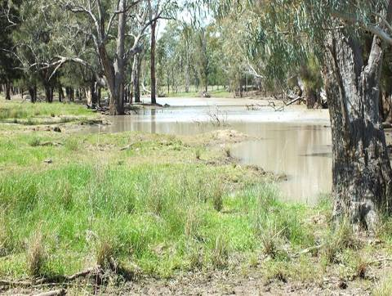
Figure 2: Weir River (Source: unknown)

Welltown Station (MBC11)
The part of the river near Welltown Station is an important food source. The Bigambul people catch yabbies, yellowbelly, cod etc here. Wild Orange can also be found here, which is used as an antiseptic and antibiotic.

Rock well (MBC13)
A series of rock wells start near the Balonne and head east just past Toowoomba. Spaced approximately 15 to 20 kilometers apart the wells form part of a trade and walking route used by Aboriginal people, a number of which are now listed on the Queensland cultural heritage register. Some wells were built by hand - the one below (Figure 6) being about 3 meters deep. Grinding grooves can be seen in the photo below, made by either a stone axe or spears. Other rock wells started as a spring and were made deeper to form part of the trade or walking route.

According to the North West Natural Resources Management Cultural Heritage Strategy (1998) rock wells:

“are located along Dreaming paths and at other sites of mythological significance. Many of the wells and rock holes are associated with other evidence of human occupation, including artefact scatters, scarred trees, grinding grooves and quarries. The wells represented significant quantities of water, especially for small groups, which may have stayed in any one location for only short periods. Water supplies were often protected by placing a rock or branches over the opening. People in the Charleville area said Aboriginal people used to walk from Charleville to Maranoa Downs, sinking wells along the tracks they made.

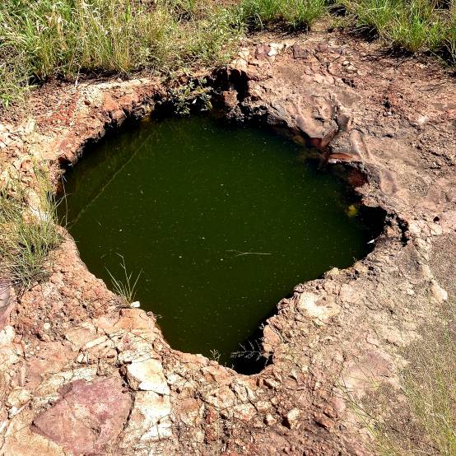
Figure 3: Rock well near St. George (Source: K. Love 2015)

Wild Orange (Capparis mitchelli) (MBC14)
Wild orange (Figure 7) is used as an antiseptic and an antibiotic. Known by both Bigambul and Gunggari people it is used for sores, chicken pox and boils etc and is found along riverbanks of the Maranoa.

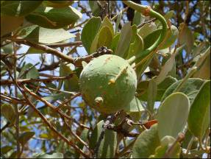
Figure 4: Bumble Tree aka Wild Orange (Capparis mitchelli) (Source: unknown)

Rocky Creek (MBC16)
Rocky creek (Figure 8) feeds into Womalilla Creek, which meets the Maranoa River at Twenty Two Mile – a significant meeting place for the Gunggari. Traditionally used as a food resource as well as a trail to the Maranoa.

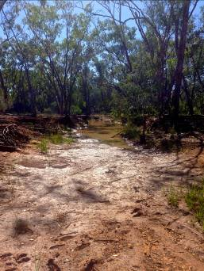
Figure 5: Rocky Creek (Source: K. Love 2015)

Womalilla Creek (MBC17)
Womalilla (Figure 9) is an important resource creek, and is also used as a trail to the Twenty Two Mile, where it meets the Maranoa River and Amby Creek.
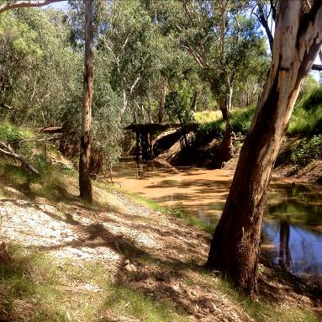
Figure 6: Womalilla Creek, near St.George (Source: K. Love 2015)

Amby Creek (MBC18)
Along the Amby Creek (just outside the town of Amby) is a registered cultural heritage site. This is where Mundagatta (see below) was sighted. This creek also meets the Maranoa at the Twenty Two Mile.

Maranoa River (MBC19)
The Maranoa River is the subject of the creation story of Illmargan – the river (see below). This river has important spiritual significance for the Gunggari people. Riverbanks along the Maranoa are places for women’s business and its waters are used for blessing. Local Elders say that “the water is healing, this river water cleanses the soul”. The whole river remains an important spiritual and ceremonial place for the Gunggari people. Local Gunggari women in particular, continue to use healing places and birthing spots.

The Maranoa River is also an important source for bush medicine, bush tucker, fish and crayfish (Bugili).

Illmargan

Illmargan is the big bar-roo (river);
it is the most precious baroo in all the land
The most precious baroo has a bucka (spear) in it.
If you take the bucka out of the baroo,
a big flood will come and wash everything away.

Many years ago, a long time ago,
Bumbarra (snake) and mundagatta were travelling all over the country,
Creating all the baroo and waterholes.
Leaving their spirits behind them.

Then one day it started to rain. Umu and uncarn (rain and cloud)
Said it was time to make plenty umu (water)
to fill the baroo up

The umu came down from bandara (sky) for many days
Baroo ran very fast and strong
Everything began to wash away.
The animals, trees, the land become covered in umu.

Murdi (Gungarri man) said,
“I have to stop the big flood before everything is destroyed.
Illmargan is very angry; I must ask what needs to be done”
Murdi asked, “What should I do”

A soft voice from the spirit world said “You must put bucka right in the middle of Illmargan; this will make the raging waters slow down”.

Murdi threw his bucka with all his might right in the middle of Illmargan
The raging umu began to slow down at once.

After the big flood Illmargan was so full of Umu and fish and birds.
It became the most precious baroo in all the land.

Bucka is still standing in the middle of Illmargan
We must never pull bucka out
If we do Illmargan will call on bandara and get uncarn and umu to flood the land again.

Source: Aunty Irene Ryder, Gunggari Elder

Top Yumba (MBC23)
The Top Yumba (camp) was where Gunggari, Kooma, Bidjara, Jarowair and several other neighbouring tribes lived prior to being moved to the Bottom Yumba.

The late 1800s saw many Aboriginal people forcibly relocated to missions, largely not on their own country. For those who remained on country, the splitting of the larger stations coupled with a diminishing willingness to support large Aboriginal camps on pastoral properties led to an increasing convergence by local Aboriginal people on the town of Mitchell. In the 1920s and 1930s, the Top Yumba, a fringe settlement on the Maranoa River, housed a large number of Gunggari families who had managed to avoid institutionalisation.

The top Yumba (Figure 10), located on the banks of the Maranoa just north of the township of Mitchell became a place for Gunggari.

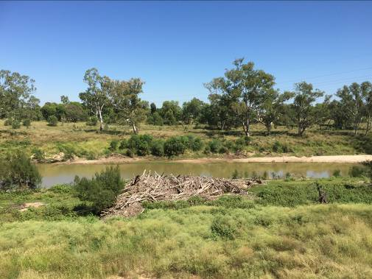
Figure 7: Top Yumba - on the banks of the Maranoa River near Mitchell (Source: J. Constable 2015)

The Top Yumba today is a still a place of importance to the Gunggari people, a place of quiet contemplation and remembrance. It is also a place where medicinal plants are to be located.

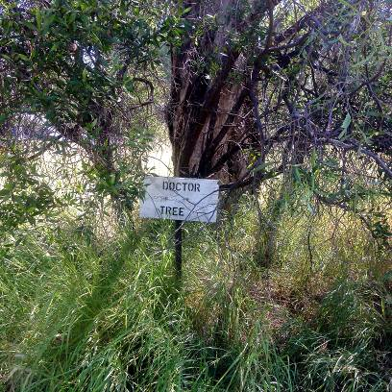
Figure 8: Doctor Tree, Top Yumba (Source: K. Love 2015)

In particular there is an important tree - the ‘Doctor Tree’ (Figure 11), which is a traditional place for spiritual healing.

Bottom Yumba (MBC21)
The Bottom Yumba (camp) is where the Gunggari were forcibly relocated from the Top Yumba in 1932.

Our mothers and fathers were up the top Yumba. They were fighting with the white people and the white people bought us down here in 1932. They fenced it off as a mission. They sent us down here out of sight, out of mind... that's what we say.
We were quite happy. This was my best time. (Aunty Irene Ryder, Gunggari Elder)

The Bottom Yumba remained home to the Gunggari until local authorities bulldozed it in 1967. The community was dispersed, with some Gunggari people moving into the town. After a reunion in 1985 the Gunggari decided they should try and get their land back. The Department of Lands granted a lease for the land where the Bottom Yumba is situated, and today it is community resource, and a gathering place, with a caretaker's cottage and the old school house is now a museum. There is also an interpretive trail exhibiting stories and artwork informing about Gunggari history and culture, which has been created along the banks of the river. The Bottom Yumba is a place where everyone is welcome to come and learn more about Gunggari history and culture.

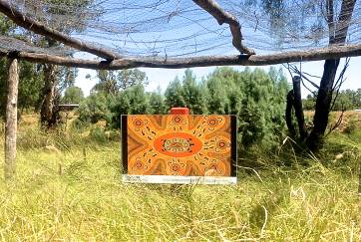
Figure 9: Bottom Yumba, Interpretive Trail (Source: K. Love 2015)

The above painting (Figure 12) depicts the following story:
High up in the beggeribong (a big gum tree near the river) sits a didhayn (koala) among the yarrawullai (gum tree blossoms) feeding on cuboogle (sweet scented gum leaves) it is a girraween (quiet place with many flowers).

The painting below (Figure 13) depicts the following story:
Mapiyal (Platypus) has left her young ones safely in the mingka (living burrow) while she swims around in the pirr (mountain stream) searching for little yarras (freshwater crabs). She has to hurry because she can’t leave her young alone for too long. Water rats are also looking for food.

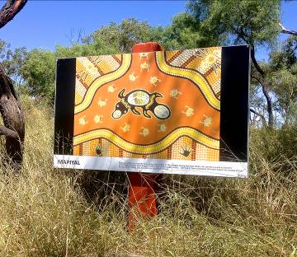

Figure 10: Bottom Yumba, Interpretive Trail (Source: K. Love 2015)

Twenty Two Mile (MBC20)
Twenty-Two Mile (Figure 14 & 15) is where the Womalilla and Amby Creeks meet the Maranoa River – named aptly as it is twenty-two miles south from the town of Mitchell. The Womalilla and Amby Creeks have permanent water during dry spells, both are naturally dammed up by the sand wall of the Maranoa where they both meet at near the exact point on the river. The Amby Creek on the east side and the Womalilla is to the west, with the Maranoa flowing through the centre.
This site is an important traditional meeting place for the Gunggari and continues to be used today for family gatherings. Families would meet here on special occasions, such as Christmas Day and other significant cultural days to swim and catch fish and yabbies. One Elder noted, “Here you can always find a good supply of fish, turtle and crustaceans not to mention echidnas, snakes and kangaroos.”

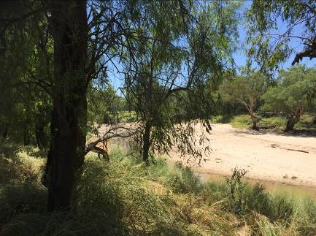
Figure 11: Twenty-Two Mile - outside Mitchell (Source: J. Constable 2015)

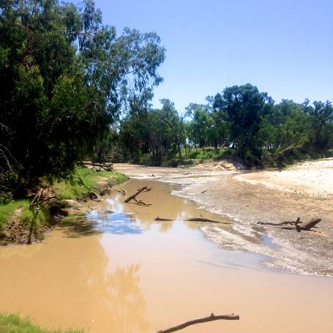
Figure 12: Twenty-two Mile, confluence of Womalilla (left) and Amby Creeks (right) at the Maranoa River (Source: K. Love 2015)

Kurrajong tree (MBC22)
The Kurrajong tree (Figure 16) is an important spiritual tree for pregnant women. It grows along the river.
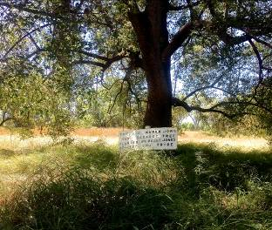

Figure 13: Kurrajong Tree (Source: K. Love 2015)

Umbie Umbie (MBC24)
Umbie Umbie (Figure 17) is used for a range of medicinal purposes and is vitally important throughout this region as well (center tree).

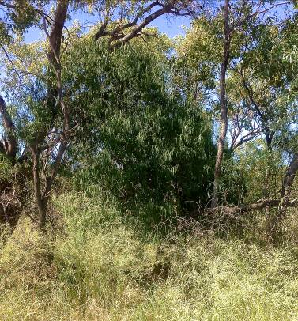

Figure 14: Umbie Umbie (Source: K. Love 2015)

Cooranga Creek (MBC3)
Cooranga Creek (Figure 18) forms part of a traditional route from Jimbour Station to the Condamine River. This particular part of creek was used for tool making (with evidence of such activity all along the creek bed).
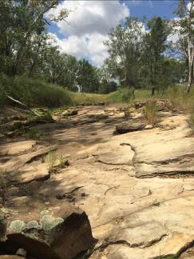
Figure 15: Cooranga Creek, near Bell (Source: J. Constable 2015)

Tool Making site (MBC4)
Close to Cooranga Creek there is a site with evidence of a meeting place and tool making ground. The Jarowair people would meet here to meet as well as to prepare for conflict, as the site is abundant with Xanthorrhoea plants, which were used for making spears. The photograph (Figure 19) below shows a rock used for making tools and spears.

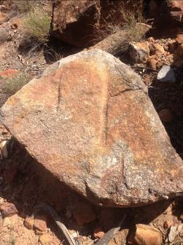
Figure 16: Tool making rock (Source K. Love 2015)

5. Summary

This report provides some rich examples of Aboriginal cultural water values existing in the Maranoa-Balonne-Condamine subregion. The information was collated with the generous assistance of the Aboriginal people of the region. However, although rich, it is not exhaustive, as a comprehensive mapping of Aboriginal cultural water values for the whole subregion will require more time and funding. It is the expressed hope of the Aboriginal groups of the subregion that the project will be extended to provide those groups unable to participate in this report, an opportunity to contribute to future research.

Nevertheless, what is provided in this report exemplifies the relationship the Jarowair, Bigambul and Gunggari people have with the rivers and creeks on country. It provides an overview of the understanding and significance of water resources, and how the valuing of water continues to nourish and provide Aboriginal people with an ongoing connection to land and culture. Water is an intrinsic part of creation, as the stories of Mundagatta, Ilmargen and the Emu sisters represent.

Traditional owners spoke of the importance of healthy water is to the life of flora and fauna. For example, the Gunggari people still rely on fishing and harvesting of plants for bush medicine and food. Elders also told of important places on the river where families have gathered for many years, and continue to gather today. The information provided by Gunggari Elders in relation to bush food and medicine has greatly enhanced this report. The use of the book Bush Flowers, Bush Medicine, Bush Tucker and Bush Poems from Gunggari Country has also made a significant contribution to this report. The inclusion of significant water reliant flora broadens the understanding of cultural values associated with water and provides a contemporary economic value for such assets.

The report has also documented important archaeological assets that were (and to an extent, still are) reliant on water to illustrate their value. Rock wells that are considered part of a songline or that form part of a trade route, can be found throughout the subregion. Important meeting places located along river banks are not only the sites of Aboriginal artefacts, but continue to hold important cultural significance for present day members of Aboriginal communities as places of remembrance and spiritual connection to ancestors.

As one Gunggari Elders writes:

We come from the rivers, and the creeks
For our grandparents and their parents have been there and left their spirit there
They speak, we must listen.
(Source: Aunty Lynette Nixon, Gunggari Elder)

6. References

Australian Bureau of Statistics (2011) Census of Population and Housing, Aboriginal and Torres Strait Islander Peoples (Indigenous) Profile (Catalogue number 2002.0) - Balonne exc. St George and Dirranbandi (ILOC30600101); Kingaroy (ILOC30601301); Maranoa - Roma - Mitchell (IARE306008); Maranoa exc. Roma and Mitchell (ILOC30600801); Toowoomba (317); Wondai (ILOC30601302).

Commonwealth Environmental Water Office, Department of Environment, Condamine-Balonne Catchment. http://www.environment.gov.au/water/cewo/northern/condamine-balonne (information downloaded 20 April, 2015).

Condamine Alliance (2015) Language Resource, http://www.condaminealliance.com.au/aboriginal-languages-project (information accessed 22 April, 2015).

Horton, David R. (1996) Aboriginal Language Map of Australia. Aboriginal Studies Press, AIATSIS, and Auslig/Sinclair, Knight, Merz.

Mitchell, S. & Ryder, I. (2102) Bush Flowers, Bush Medicine, Bush Tucker and Bush Poems from Gunggari Country, self-published by Gunggari community, Mitchell, Qld.

North West Natural Resource Management, Cultural Strategy (1998), p4 – downloaded 1 August 2014 http://www.southwestnrm.org.au/ihub/cultural-heritage-strategy-98.

Welsh W, Herron N, Rohead-O’Brien H, Ransley T, Aryal S, Mitchell P, Buckerfield S and Marshall S (2014) Context statement for the Maranoa-Balonne-Condamine subregion. Product 1.1 for the Maranoa-Balonne-Condamine from the Northern Inland Catchments Bioregional Assessment. Department of the Environment, Bureau of Meteorology, CSIRO and Geoscience Australia, Australia.

6. Appendices

Appendix 1 – Consultation participants

Name | Group/Organisation
Uncle Mick Speedy | Kooma Elder
Marshall Foster | President - Gunggari Native Title Aboriginal Corporation
Margaret Finlay | Gunggari
Aunty Lynette Nixon | Gunggari
Aunty Irene Ryder | Gunggari
Uncle Teddy Martin | Gunggari
Saraeva Mitchell | Gunggari
Aunty Debbie Miller (nee Jerome) | Jarowair
Jason Miller | Jarowair
Phillip Miller | Jarowair
Brett Leavy | Kooma
Robert Turnbull | Bigambul
Sam Bonner | Githabul
Tim Knox | Regional Coordinator, Queensland Murray Darling Committee/Aboriginal Advisory Group
Aunty Sarah Trindall | Mandandanji (QMDC RAAG)
Clinton Mailman | Bidjara (QMDC RAAG)
Floyd Robinson | Bidjara
Executive Committee | Northern Murray Darling Basin Aboriginal Nations
Carl Mitchell | Condamine Alliance - Manager, Water
Jayne Thorpe | Condamine Alliance - Aboriginal Programs
Alexandra Kennedy | Condamine Alliance - Project Officer, Community
Jana Marschall | SEQ Water - Team Leader Community

Calma T. (2008) Aboriginal and Torres Strait Islander Social Justice Commissioner, Native Title Report 2008, Chapter 6 – Indigenous Peoples and Water, Human Rights and Equal Opportunity Commission, Sydney.
The final summary report will be prepared at the conclusion of all sub region research and subsequent reports. It will provide an overarching analyses of the project.
Welsh W, Herron N, Rohead-O’Brien H, Ransley T, Aryal S, Mitchell P, Buckerfield S and Marshall S (2014) Context statement for the Maranoa-Balonne-Condamine subregion. Product 1.1 for the Maranoa-Balonne-Condamine from the Northern Inland Catchments Bioregional Assessment. Department of the Environment, Bureau of Meteorology, CSIRO and Geoscience Australia, Australia, p.8
ibid, p.9
ABS (2011) Census of Population and Housing, Aboriginal and Torres Strait Islander Peoples (Indigenous) Profile (Catalogue number 2002.0) - Balonne exc. St George and Dirranbandi (ILOC30600101); Kingaroy (ILOC30601301); Maranoa - Roma - Mitchell (IARE306008); Maranoa exc. Roma and Mitchell (ILOC30600801); Toowoomba (317); Wondai (ILOC30601302).
Bunya Mountains Elders Council and Burnett Mary Regional Group, Bunya Mountains, Aboriginal Aspirations and Caring for Country Plan (2010), p7
The Kooma people’s traditional lands are outside of the PAE for Maranoa-Balonne-Condamine sub-region and therefore no water assets are included in the MBC asset register.
Condamine Alliance, Language Resource, information accessed 22 April, 2015 http://www.condaminealliance.com.au/aboriginal-languages-project
Welsh W, Herron N, Rohead-O’Brien H, Ransley T, Aryal S, Mitchell P, Buckerfield S and Marshall S (2014) Context statement for the Maranoa-Balonne-Condamine subregion. Product 1.1 for the Maranoa-Balonne-Condamine from the Northern Inland Catchments Bioregional Assessment. Department of the Environment, Bureau of Meteorology, CSIRO and Geoscience Australia, Australia, p.88
Commonwealth Environmental Water Office, Department of Environment, Condamine-Balonne Catchment – information downloaded 20 April, 2015 http://www.environment.gov.au/water/cewo/northern/condamine-balonne
See Appendix 1 for full list of consultation participants.
Mitchell, S. (2102) Bush Flowers, Bush Medicine, Bush Tucker and Bush Poems from Gunggari Country, self-published by Gunggari community, Mitchell, Qld.
In 1988 Cherbourg became a Deed of Grant in Trust Community (DOGIT) and in 1991 the first independent Cherbourg Council was elected. Source downloaded 10 April, 2015 http://rationshed.com.au/about-cherbourg/
The text was sourced from the Registration test decision Gunggari People #3, Subsection 190B(5) Factual basis for claimed native title.
North West Natural Resource Management, Cultural Strategy (1998), p4 – downloaded 1 August 2014 http://www.southwestnrm.org.au/ihub/cultural-heritage-strategy-98
Information sourced from Queensland South Native Title Services, submission on behalf of the Gunggari native title claim applicant, 22 June 2012.

