Aboriginal Cultural Water Values
– Gloucester subregion
A report for the Bioregional Assessment Programme
Researched and prepared by Corporate Culcha for the Department of the Environment
for The Department for the Environment, CSIRO and Geoscience Australia

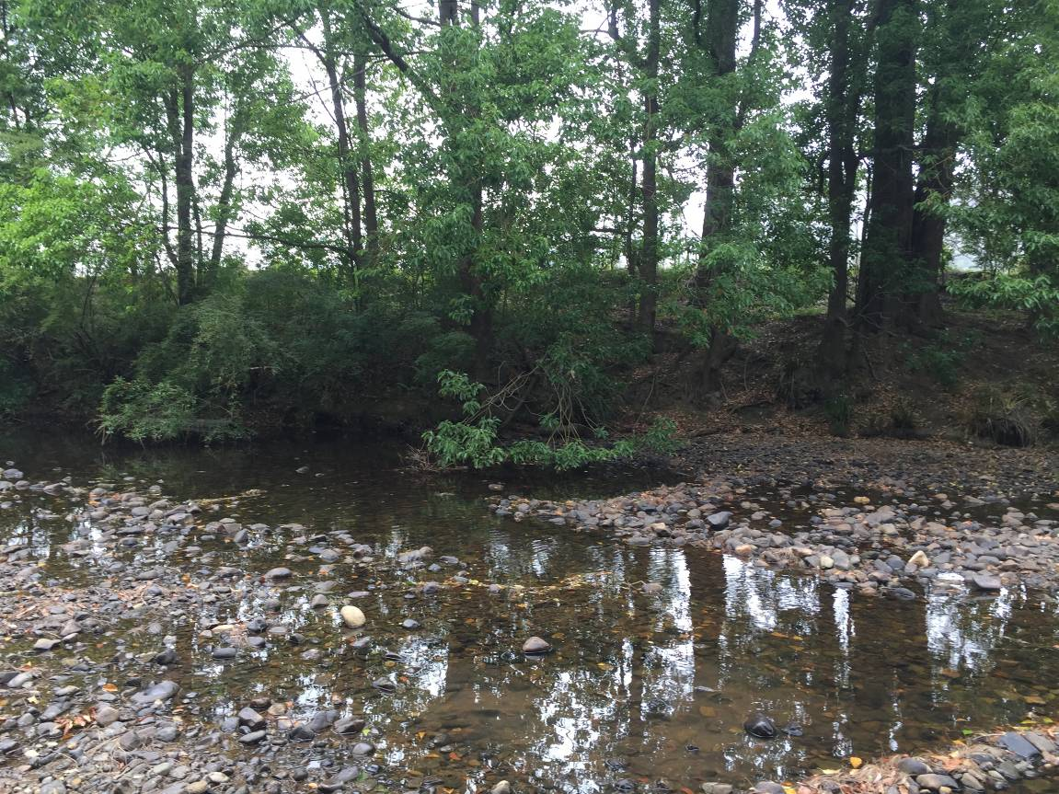
Corporate Culcha
Corporate Culcha is an Aboriginal owned and operated consultancy practice specialising in engagement with Aboriginal and Torres Strait Islander organisations and communities. Corporate Culcha works with a range of Indigenous and non-Indigenous consultants, many of whom are leaders in their individual fields. Access to this pool of expertise, allows Corporate Culcha to deliver a diverse range of services to their clients including research and evaluation, cultural capability programs and education, mentoring and capacity building.

About the Authors
Janis Constable is a well-regarded Indigenous research consultant with extensive social research and program evaluation expertise, built on senior policy and research roles for federal and state governments. Janis has been a senior advisor to two federal Aboriginal and Torres Strait Islander Social Justice Commissioners on Indigenous human rights issues where she led a number of national research projects. As a freelance research consultant Janis has undertaken a number of key strategic research projects focussing on improved social and economic outcomes for Aboriginal and Torres Strait Islander peoples.

Karen Love has extensive experience in ecological restoration, specialising in high conservation areas with bio-diverse vegetation. Her roles have incorporated advanced flora and fauna monitoring, ecological assessments and spatial mapping. Working alongside state and within local government agencies Karen has delivered a range of services, including scientific monitoring, program evaluation, strategy development and water education advice. Karen is a proud Maori woman, now an Australian citizen living on the North Coast of NSW.

Citation
Constable, J and Love, K. (2015) Aboriginal water values Gloucester subregion (NSW), a report for the Bioregional Assessment Programme.
Copyright
 © Commonwealth of Australia 2015
With the exception of the information provided in section 1.3 of this report, all material in this publication is provided under a Creative Commons Attribution 3.0 Australia Licence <http://www.creativecommons.org/licenses/by/3.0/au/deed.en>.
Disclaimer
The views and opinions expressed in this publication are those of the authors and do not necessarily reflect those of the Australian Government or the Minister for the Environment.
While reasonable efforts have been made to ensure that the contents of this publication are factually correct, the Commonwealth does not accept responsibility for the accuracy or completeness of the contents, and shall not be liable for any loss or damage that may be occasioned directly or indirectly through the use of, or reliance on, the contents of this publication.
Cover photograph
Gloucester River, Gloucester, NSW, 2014
Credit: Janis Constable
1. Introduction 4
1.1 Acknowledgement of Traditional Owners 4
1.2 Terms for Aboriginal and Torres Strait Islander 4
1.3 Aboriginal people of the Gloucester subregion 4
Map 1: Gloucester subregion map 6
1.4 Aboriginal population 6
Chart 1: Aboriginal Population of the Gloucester subregion and surrounds 7
1.5 Governance 7
2. Methodology 8
2.1 Desktop research 8
2.2 Community Engagement 9
2.2.2 Gloucester Worimi 9
2.2.3 Karuah Worimi 9
2.2.3 Forster Worimi 10
2.2.4 Biripi – Taree/Purphleet 10
2.2.5 Wonnarua 10
3. Cultural Water Values and Assets 11
3.2 Cultural assets 11
3.3 Cultural Water Assets Identified - Karuah Worimi 12
Table 4: Aboriginal Cultural Water Assets, Karuah Worimi - Customary 12
Table 5: Aboriginal Cultural Water Assets, Karuah Worimi - Ecological 12
Table 6: Aboriginal Cultural Water Assets, Karuah Worimi - Economic 13
4. Conclusion 14
5. References 15
6. Appendices 16
Appendix 1: NSWand ACT Native Title Determinations map 16
Appendix 2: Interview question for participants 17

1. Introduction

The Australian Government is undertaking a programme of bioregional assessments in order to better understand the potential impacts of coal seam gas and large coal mining developments on water resources and water-dependent assets. The Bioregional Assessment Programme draws on the best available scientific information and knowledge from many sources, including government, industry and regional communities, to produce bioregional assessments that are independent, scientifically robust, relevant and meaningful at a regional scale.

The Programme is a collaboration between the Department of the Environment, the Bureau of Meteorology, CSIRO and Geoscience Australia. The Programme is seeking input from the Aboriginal community on water-dependent cultural values (also referred to as assets). For more information, visit http://www.bioregionalassessments.gov.au.

This report provides the data collected through community consultation for the Aboriginal Water Values Project, which will be used to inform the bioregional assessment of the Gloucester subregion. The report includes an overview of the Indigenous population of the Gloucester subregion and surrounds; description of the methodology employed; issues arising throughout the consultations; and details of the data collected.

1.1 Acknowledgement of Traditional Owners
Acknowledgement is paid to Aboriginal and Torres Strait Islander peoples past, present
and future. We acknowledge the unique relationship that Aboriginal and Torres Strait Islander people have with their traditional lands and waters, as well as their history and diverse cultures and customs. We thank all Aboriginal people who have shared their knowledge and time so generously, without their participation this report would not have been possible.

1.2 Terms for Aboriginal and Torres Strait Islander
For the purposes of this report, the terms ‘Aboriginal people’, ‘Aboriginal and Torres Strait Islander people’ and ‘Indigenous’ are used interchangeably to refer to Aboriginal and Torres Strait Islander peoples of Australia. However, we recognise that this approach is not without contention. Aboriginal and Torres Strait Islander people generally prefer the use of Aboriginal as opposed to Indigenous. Indigenous is deemed a formal term often used by governments as inclusive of all Aboriginal and Torres Strait Islander peoples.

As this report is focussed on the relationship of Aboriginal people of the Gloucester subregion, we will refer to either Aboriginal people or their distinct groups i.e. Worimi. The report also employs the term Indigenous when referring to relevant government programmes, policies or resources.

1.3 Aboriginal people of the Gloucester subregion
The Gloucester subregion is located in the upper Hunter Valley and on the inland edge of the Great Lakes district of NSW. The Gloucester subregion, for the purposes of bioregional assessment programme, is shown in Map 1. An area larger than this however is considered for assessment of potential water-related impacts of coal resource development on water assets. The reach of Karuah River that flows south from the Gloucester subregion boundary to the western end of Port Stephens is included in this larger assessment area.

Pre-colonisation, two distinct Indigenous groups inhabited the region - the Worimi, who inhabited the land between Barrington Tops and Forster in the north, and Maitland and the Hunter River in the south, and the Biripi, who inhabited the area between Tuncurry, Taree and Gloucester. Neighbouring groups include the Wonnarua, Awabakal, and Kamilaroi.

The Worimi were divided into a number of nurras (local groups within a tribe, each occupying a definite locality within the tribal territory). European settlement in the region, more specifically the establishment of cedar logging in the area, saw the Worimi and Biripi people moved from their lands onto missions.

Anthropological studies have revealed the following nurras in the Worimi tribe:

- Garuagal (between the mouth of the Hunter River and Maitland)
- Maiangal (along the southern side of Port Stephens)
- Gamipingal (along the northern side of Port Stephens and the Karuah River to Tea Gardens)
- Garrawerrigal (between the Myall River and the seashore)
- Buraigal (between Karuah River and Paterson)
- Warringal (between Telegherry River near Barrington Tops and Pipeclay Creek near Nabiac)
- Birroongal (on the Myall River)
- Birrimbai (around Bungwahl)
- Yeerungal (around the Myall Lakes)
- Wallamba (in the Wallis Lake area)

The Worimi and Biripi tribes both spoke dialects of the Kattang language.

Map 1: Gloucester subregion map

1.4 Aboriginal population
The number of Aboriginal people inhabiting the region prior to European colonisation is unknown. However, the national Indigenous population has been estimated between 500,000 to 1 million by various sources. The 2011 Census results count the Aboriginal and Torres Strait Islander population of Australia, at 30 June 2011, at 669,900 people, or 3% of the total Australian population.

The total Indigenous population of the Gloucester region (including surrounding regions) is 4319 (or 4.5 per cent of the total population of the region), with 229 Indigenous people residing in the Gloucester Local Government Area, and a further 263 residing in the Dungog Local Government Area, which covers the southern part of the subregion.

The number of Worimi, Biripi or Wonnarua people included in these figures is unknown, as tribal identities are not counted in the Census. The diaspora of Aboriginal people post-colonisation has resulted in many Aboriginal people not living on traditional country (especially on the east coast of Australia, where European settlement was rapid and vast).

Chart 1: Aboriginal population of the Gloucester subregion and surrounds
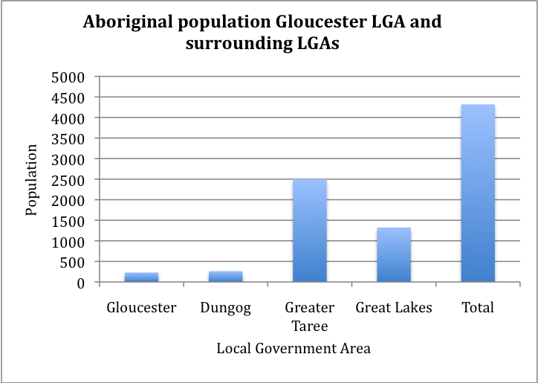
Source data: ABS 2011

1.5 Governance
The Local Aboriginal Land Councils (LALCs) in the region are:

- Worimi Local Aboriginal Lands Council (Karuah)
- Forster Local Aboriginal Lands Council (Forster)
- Taree/Purphleet Local Aboriginal Lands Council (Purphleet)
- Wonnarua Local Aboriginal Lands Council (Muswellbrook)

Another significant organisation representing Worimi interests is the Worimi Conservation Lands. The organisation is jointly managed by the Aboriginal Traditional Owners, the Worimi people, and the NSW National Parks and Wildlife Service through a Board of Management established under the National Parks and Wildlife Act.

There have been no Native Title determinations made in the Gloucester subregion. The Worimi have made claim to land along the coastal region of Forster and Karuah, but Native title was found not to exist in the determination areas. However, the Worimi and the Biripi successfully claimed Native Title further to the east on coastal lands.

2. Methodology
This section provides details on the following methodology employed throughout the project.

The methodology for this project included:

- Desktop research
  - Relevant reports
  - Investigate current discourse on Aboriginal Cultural Water Values
  - Identify relevant organisations
- Contact by telephone individuals and organisations identified as being potential participants
  - Introduce the project and the researchers
  - Discuss possibility of involvement in project
  - Arrange visit
- Visit with stakeholders
  - Discuss the project in detail and provide information
  - Identify other potential participants (Elders, knowledge holders)
  - Arrange next visit
- Second visit with stakeholders
  - Obtain consent
  - Commence data collection on site
    - Identifying locations of assets (GPS mapping)
    - Interviewing
- Third visit with stakeholders
  - Continue and finalise data collection on site
- Analyse data
  - Record location data on asset register
  - Record associated narratives for assets
- Write report

2.1 Desktop research
Initial desktop research was undertaken to gain an understanding of and identify :
- publically available data
- current discourse on Aboriginal cultural water values
- key stakeholders (organisations and individuals)

A range of reports were identified that assisted in identifying important groups and individuals relevant to this project. The reports and websites sourced indicated significant activity in relation to Aboriginal communities and water – specifically in relation to conservation and water sharing plans.

In addition to information about water related community activities there were also a number of Aboriginal Heritage Study Impact reports undertaken by mining companies. However, these reports did not identify specific water assets.

2.2 Community Engagement
Initial discussions were held with the following local Aboriginal Land Councils and known Elder Groups.

- CEO, Wonnarua Local Aboriginal Land Council (Muswellbrook)
- CEO, Taree/Purphleet Local Aboriginal Land Council (Purphleet)
- CEO, Foster Aboriginal Land Council (Forster)
- CEO, Karuah Local Aboriginal Land Council
- Gloucester Worimi group

Initial meetings provided an opportunity to discuss the objectives of the project, as well as to disseminate information flyers to be distributed to relevant people in the community. Contact details for other significant community members was sought, with face-to-face or telephone follow up meetings being arranged with those people soon thereafter.

Second and third visits saw the collection of data. Unstructured interviews were undertaken with participants. The participants did not wish to be recorded. In some instances, and with the permission of the participant, photographs were taken of the assets. However, as the groups did not wish to provide exact geographical locations of the water assets, no GPS data was collated. The data that has been collected for the Gloucester region is the cultural value narratives associated with the water assets.

2.2.2 Gloucester Worimi
The Gloucester Worimi group are the only group identified that reside in the Gloucester subregion. Researchers met with the group twice, as well as having several telephone and email communications with group members.

The group’s involvement in the project was limited due to the recent passing of a significant Elder, who was the chief knowledge holder of the community. Community members consulted were grieving the loss of this important Elder, which significantly impacted on their ability to participate in the project. After several conversations and meetings the group decided not to be involved in the project.

However, the time that was spent with Gloucester Worimi, did yield information that indicates that water, especially the rivers, continues to hold an important function in the lives of local Aboriginal people.

2.2.3 Karuah Worimi
The Karuah Worimi has a history of land and water conservation and while being predominantly concerned with the coastal area, there has been some focus on the rivers and other water assets that cross from the coast into the Gloucester subregion. The water related assets identified through the consultations are largely concerned with fishing and river trade routes.

2.2.3 Forster Worimi
Initial discussions with a Worimi member in Forster were positive. However, the member advised that permission would need to be sought from the appropriate Elder, prior to any further participation. We were later advised that the Elder was ill, and that no permission was being sought, and unfortunately the Forster Worimi could not participate in the project.

2.2.4 Biripi – Taree/Purphleet
Several telephone discussions and face-to-face meetings were held with members of the Taree Aboriginal community. The community was initially interested in participating, but later indicated that there were local issues, which they could not discuss, which meant they could no longer participate.

2.2.5 Wonnarua
Meetings with the Wonnarua initially indicated there were assets within the Gloucester subregion, however, a follow up meeting with a Wonnarua elder and a local Indigenous anthropologist confirmed the assets are not within the Gloucester subregion.

3. Cultural Water Values and Assets
Water is an intrinsic and inseparable element in the physical and spiritual existence of Aboriginal people. Water sustains and nourishes all living creatures, it carries the past and the future, it holds knowledge and secrets.

Community consultations revealed that the water assets identified largely pertained to customary history and usage, ecological value relating to fish and animal species, or economic value in terms of fishing and other water-reliant bush foods.

3.2 Cultural assets
The number of Aboriginal cultural water assets located in the Gloucester subregion, and identified in the report, is far from exhaustive. What was provided was a small sample of the water assets of cultural value to Aboriginal people of the region. The number of assets identified has been limited due to the limited participation of community and the time constraints of the project timeline.

The assets identified here are of cultural significance to the Aboriginal people of the Gloucester subregion, the values, purpose and meaning attached to each asset has been identified through consultation. The purpose and meaning of cultural water assets have been categorised into the following groups:

- Customary – ceremony, meeting place, men’s business, women’s business, totems, dance, rites, song, birth, death)
- Spiritual (dreaming, stories, songlines)
- Ecological (flora and fauna)
- Economic (trade routes, food source – fishing/hunting, employment/income – tourism, farming)
- Recreational – family gatherings, swimming holes

3.3 Cultural Water Assets Identified - Karuah Worimi
The following assets identified through consultation with the Karuah Worimi are not located within the Gloucester subregion, however they are located in the preliminary assessment extent of the Gloucester subregion.

Table 4: Aboriginal Cultural Water Assets, Karuah Worimi - Customary
Group | Subgroup | Common name |  | Location | Aboriginal Group/Language | Identifier | Water dependence | Justification
Customary | Meeting place | Karuah River |  | Entire river | Worimi | GLA1 | High | The river is essential for conducting a range of traditional activities
Customary | Lore | Tribal boundary |  | Allworth | Worimi | GLA3 | High/Critical | Tribal Boundary for Ethel Creek tribe
Customary | Meeting Place | River bank |  | Tahlee | Worimi | GLA4 | High | Meeting Place/corroboree/artefacts
Customary | Lore | Tribal boundary |  | Seal Rocks | Worimi | GLA5 | High | Tribal boundary for Karuah

Table 5: Aboriginal Cultural Water Assets, Karuah Worimi - Ecological
Group | Subgroup | Common name | Scientific name | Location | Aboriginal Group/Language | Identifier | Water dependence | Justification
Ecology | Flora | Sea Grass | Posidinia australis | River Estuary | Worimi | GLA7 | High | Sanctuary for several fish species
Ecology | Fauna (fish) | Mullet | Mugilidae sp. | River Estuary | Worimi | GLA11 | High | Fish habitat
Ecological | Fauna (fish) | Perch | Perca fluviatilis | River Estuary | Worimi | GLA12 | High | Fish habitat
Ecological | Fauna (fish) | Bream | Acanthopagrus australis | River Estuary | Worimi | GLA12 | High | Fish habitat
Ecological | Fauna | Turtle | Chelonia mydas | River Estuary | Worimi | GLA14 | High | Turtle habitat/vulnerable species
Ecological | Fauna | Crab | Scylla serrata | River Estuary | Worimi | GLA15 | High | Crab habitat
Ecological | Fauna (Mollusca) | Cobra | Bankia australis calman | River Estuary/banks | Worimi | GLA16 | High | Habitat
Ecological | Flora | Mangroves | Aegiceras corniculatum | River Estuary | Worimi | GLA6 | High | Resources used for making boomerangs, spears, shields
Ecological | Fauna | Oysters | Crassostrea gigas | River Estuary | Worimi | GL8 | High | Food resource and Oyster farming by Worimi/income and employment

Table 6: Aboriginal Cultural Water Assets, Karuah Worimi - Economic
Group | Subgroup | Description | Location | Aboriginal Group/Language | Identifier | Water dependence | Justification
Economic | Employment/Income | Oyster farming | River Estuary | Worimi | GLA8 | High | Oyster farming provides jobs and income for Worimi people

4. Conclusion

The data provided in this report is only a small fraction of Aboriginal Water Assets existing in the Gloucester subregion. What is provided here is a glimpse of the rich cultural history of the subregion, and the ongoing value it continues to hold for local Aboriginal people. Stories of trading routes along the rivers, provides insight into the way Aboriginal communities conveyed a variety of fresh food from neighbouring regions. These routes also allowed contact and communication between tribes. Additionally, the information provided about the fauna species, which rely on healthy rivers, is but a small example of the knowledge held by local Aboriginal people.

Local issues between different Aboriginal groups of the region, impacted on the research insofar as it was difficult to get agreement from each group about who had the right to provide information, some of which is considered sensitive and secret. Navigating and respecting community protocol and the positions of each group resulted in little information being provided in the time allocated for the research.

Nevertheless, those that did participate provided as much information as they felt comfortable imparting, and we thank them for that. As discussed above, the Gloucester Worimi were experiencing the loss of a significant Elder, which impacted on their level of participation.

The Karuah Worimi were very gracious with their time, and happy to share their stories, however the water assets identified by them, are not directly located within the Gloucester subregion. The assets identified by the Karuah Worimi, are located in the preliminary assessment extent of the Gloucester subregion and will be considered in the bioregional assessment for the Gloucester subregion.

5. References

Australian Bureau of Statistics http://www.abs.gov.au/ausstats/abs@.nsf/0/415B7843ACA11A17CA25773700169C5F?opendocument (accessed 1 December 2014).

Australian Bureau of Statistics, 3238.0.55.001 - Estimates of Aboriginal and Torres Strait Islander Australians, June 2011.

Australian Bureau of Statistics, 2011 Census of Population and Housing, Aboriginal and Torres Strait Islander People (Indigenous) Profile (Catalogue number 2002.0) – Gloucester A (LGA 13050); Dungog A (LGA12700); Great Lakes A (LGA 13320); Greater Taree A (LGA 13380).

Australian Museum http://australianmuseum.net.au/Indigenous-Australia-Introduction, accessed 1 December, 2014; Australian Institute of Aboriginal and Torres Strait Islander Studies, http://lryb.aiatsis.gov.au/people-health-and-homes.html, (accessed 3 December, 2014).

Duralie Coal Mine Heritage Management Plan, March 2012Document No. HMP-R02-B 00438865.Docx.

Leon, M. The History of the Worimi, date and publisher unknown, http://www.2tlp.com.au/Worimi.pdf, (downloaded 23 October 2014).

Marr, N. Great Lakes Council Community Profile – Aboriginal People of the Great Lakes, http://www.greatlakes.nsw.gov.au/Community/Indigenous_Communities, downloaded 23 October 2014.

National Native Title Tribunal - http://www.nntt.gov.au/assistance/Geospatial/Pages/Maps.aspx (accessed 9 December 2014).

NSW Office of Water 2012. Our Water Our Country: An information manual for Aboriginal people and communities about the water reform process. Edition 2.0. NSW Department of Primary Industries, Office of Water, Sydney, NSW. Page 3.5.

Syme, L. Hubschmann, C. Dunk, M. Stratford Extension Project – Aboriginal Cultural Heritage Assessment, Gloucester Shire Government Area, Feb 2012.

6. Appendices

Appendix 1: NSW and ACT Native Title Determinations map

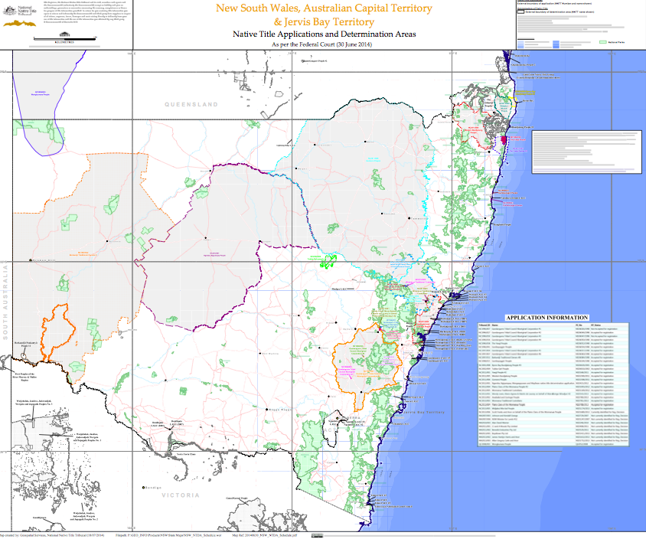

Appendix 2: Interview question for participants

Aboriginal Water Values Project
Interview Questions for Traditional Owners

- What is the traditional use of this particular water resource?
- How is it connected to other water resources?
- Is it significant to the whole of your people, or just a particular group or family?
- Do you know if other language groups have a relationship with this particular water resource?
- Does it hold special meaning to:
  - Women
  - Men
  - Old people
  - Young people
- Is the water resource important or significant to any particular flora or fauna species?
  - If so, what are they?
- Is there any economic value (or potential economic value) associated with this water resource? i.e. fishing, aquaculture, tourism, bush food etc.
- Are there any particular Dreamtime stories associated with this water resource?
- How does the knowledge of this water resource get transferred from one generation to the next?
- In your opinion, what impact would it have on the community if this water resource was damaged by mining or other development?

Leon, M. The History of the Worimi, date and publisher unknown; Marr, N. Great Lakes Council Community Profile – Aboriginal People of the Great Lakes, http://www.greatlakes.nsw.gov.au/Community/Indigenous_Communities, downloaded 23 October 2014
ibid
ibid
Australian Bureau of Statistics http://www.abs.gov.au/ausstats/abs@.nsf/0/415B7843ACA11A17CA25773700169C5F?opendocument (accessed 1 December 2014); Australian Museum http://australianmuseum.net.au/Indigenous-Australia-Introduction, accessed 1 December, 2014; Australian Institute of Aboriginal and Torres Strait Islander Studies, http://lryb.aiatsis.gov.au/people-health-and-homes.html, (accessed 3 December, 2014)
Australian Bureau of Statistics, 3238.0.55.001 - Estimates of Aboriginal and Torres Strait Islander Australians, June 2011
Australian Bureau of Statistics, 2011 Census of Population and Housing, Aboriginal and Torres Strait Islander People (Indigenous) Profile (Catalogue number 2002.0) – Gloucester A (LGA 13050); Dungog A (LGA12700); Great Lakes A (LGA 13320); Greater Taree A (LGA 13380).
Appendix 2 – Native Title Determinations map
See NSW Office for Water, Aboriginal Water Initiative http://www.water.nsw.gov.au/Water-management/Water-sharing-plans/Aboriginal-communities; Murray Darling Basin Authority, A Yarn on the River - http://www.mdba.gov.au/media-pubs/publications/yarn-river-getting-aboriginal-voices-basin-plan
The interview questions can be found at Appendix 2.

