Aboriginal Cultural Water Values
– Gippsland Basin bioregion
A report for the Bioregional Assessment Programme
Researched and prepared by Corporate Culcha for the Department of the Environment
for The Department for the Environment, CSIRO and Geoscience Australia

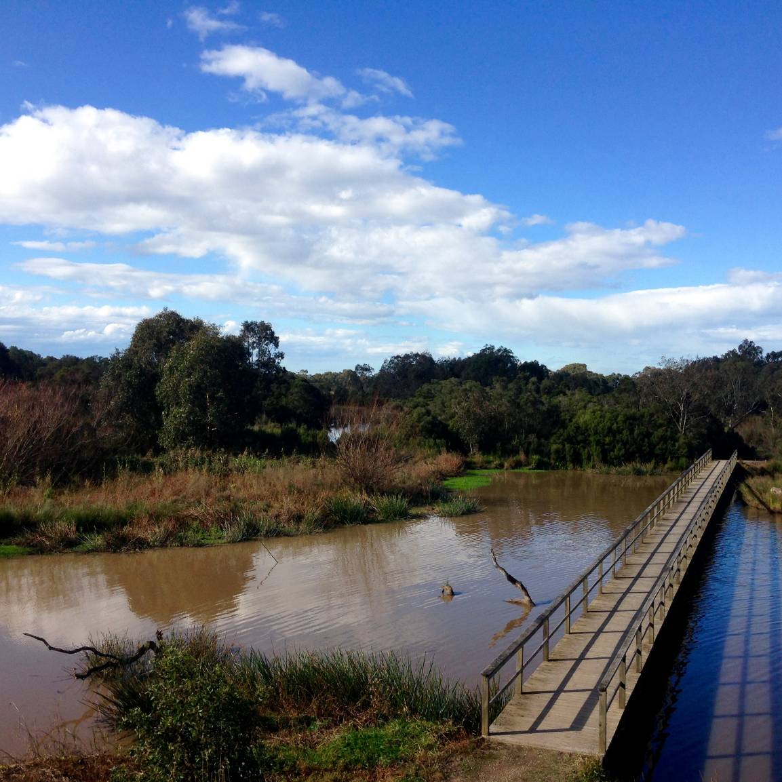

Corporate Culcha
Corporate Culcha is an Aboriginal owned and operated consultancy practice specialising in engagement with Aboriginal and Torres Strait Islander organisations and communities. Corporate Culcha works with a range of Indigenous and non-Indigenous consultants, many of whom are leaders in their individual fields. Access to this pool of expertise, allows Corporate Culcha to deliver a diverse range of services to their clients including research and evaluation, cultural capability programs and education, mentoring and capacity building.

Lead Researcher and Author
Janis Constable is a well-regarded Indigenous research consultant with extensive social research and program evaluation expertise, built on senior policy and research roles for federal and state governments. Janis has been a senior advisor to two federal Aboriginal and Torres Strait Islander Social Justice Commissioners on Indigenous human rights issues where she led a number of national research projects. As a freelance research consultant Janis has undertaken a number of national research projects focussing on improved social and economic outcomes for Aboriginal and Torres Strait Islander peoples.

Mapping
Karen Love has extensive experience in ecological restoration, specialising in high conservation areas with bio-diverse vegetation. Her roles have incorporated advanced flora and fauna monitoring, ecological assessments and spatial mapping. Working alongside state and within local government agencies Karen has delivered a range of services, including scientific monitoring, program evaluation, strategy development and water education advice.

Citation
Constable, J. & Love, K. (2015) Aboriginal Water Values Gippsland Basin bioregion, a report for the Bioregional Assessment Programme.
Copyright
 © Commonwealth of Australia 2015
All material in this publication, except for content sourced from third party documents and websites other than information sourced from www.bioregionalassessments.gov.au, is provided under a Creative Commons Attribution 3.0 Australia Licence <http://www.creativecommons.org/licenses/by/3.0/au/deed.en>.

Disclaimer
The views and opinions expressed in this publication are those of the authors and do not necessarily reflect those of the Australian Government or the Minister for the Environment.
While reasonable efforts have been made to ensure that the contents of this publication are factually correct, the Commonwealth does not accept responsibility for the accuracy or completeness of the contents, and shall not be liable for any loss or damage that may be occasioned directly or indirectly through the use of, or reliance on, the contents of this publication.
Cover photograph: Sale Wetlands (Source. K. Love 2015)

Acknowledgement of Traditional Owners
Acknowledgement is paid to Aboriginal and Torres Strait Islander peoples past, present
and future. We acknowledge the unique relationship that Aboriginal and Torres Strait Islander people have with their traditional lands and waters, as well as their history and diverse cultures and customs. We thank all Aboriginal people who have shared their knowledge and time so generously, without their participation this report would not have been possible.

Terms for Aboriginal and Torres Strait Islander
For the purposes of this report, the terms ‘Aboriginal people’, ‘Aboriginal and Torres Strait Islander people’ and ‘Indigenous’ are used interchangeably to refer to Aboriginal and Torres Strait Islander peoples of Australia. However, we recognise that this approach is not without contention. Aboriginal and Torres Strait Islander people generally prefer the use of Aboriginal as opposed to Indigenous. Indigenous is deemed a formal term often used by governments as inclusive of all Aboriginal and Torres Strait Islander peoples.

As this report is focussed on the relationship of Aboriginal people of the Gippsland Basin, we will refer to either Aboriginal people or their distinct groups i.e. Gunaikurnai, Bidhwal etc. The report also employs the term Indigenous when referring to relevant government programmes, policies or resources.

1. Introduction 6
1.1 Gippsland Basin bioregion 7
2. Methodology 7
2.1 Desktop research 8
2.2 Community Engagement 8
2.3 Mapping Methodology 9
3. Aboriginal people of the Gippsland Basin region 9
3.1 Gunaikurnai peoples 10
3.1.1.Governance 10
3.1.2 Native Title 11
3.1.3 Joint management 11
4. Consultation outcomes 12
4.1 Categorising cultural assets 13
4.2 Cultural Water Assets Identified 14
4.3 Accompanying narratives 18
Tarrawarrackel 19
White Woman’s Water Hole, Wonwron State Reserve 19
Warrigal Creek 19
Sale Wetlands (GP6) 19
Bulrush also known as Doora, Cumbunji 20
Murnong/Yam Daisy 21
Knob Reserve 21
Den of Nargan 22
Legend Rock, Metung 23
The Lakes National Park 23
Buchan Caves 24
Tarra Bulga National Park 24
5. Summary 25
6. References 26
7. Appendix 27
Appendix 1 – Consultation participants 27

List of Figures
Figure 1: Gippsland Basin bioregion 7
Figure 2: Map of Gunaikurnai Traditional Lands 12
Figure 3: Bataluk Cultural Trail 18
Figure 4: Sale Wetlands 20
Figure 5: Scar Tree, Sale Wetlands 20
Figure 6: Technique for making nets made from the reeds of bulrush 20
Figure 7: Murnong/Yam Daisy - staple food source 21
Figure 8: Knob Reserve – overlooking the Avon River 22
Figure 9: Knob Reserve Meeting Place 22
Figure 10: Den of Nargan 23
Figure 11: Legend Rock, Metung 23

Introduction
Aboriginal water values is a term used to describe the relationship between Aboriginal and Torres Strait Islander peoples and water. Aboriginal and Torres Strait Islander people’s relationship with water is intrinsic in nature, with water not only being fundamental for survival, but an indivisible, interwoven and intrinsic element of cultural and spiritual life.

Tom Calma, the former Aboriginal and Torres Strait Islander Social Justice Commissioner wrote:
Indigenous peoples are connected to and responsible for our lands and waters and in turn, Indigenous peoples obtain and maintain our spiritual and cultural identity, life and livelihoods from our lands, waters and resources. These cultural and customary rights and responsibilities include:
- a spiritual connection to lands, waters and natural resources associated with water places
- management of significant sites located along river banks, on and in the river beds, and sites and stories associated with the water and natural resources located in the rivers and their tributaries, and the sea
- protection of Indigenous cultural heritage and knowledge associated with water and water places
- access to cultural activities such as hunting and fishing, and ceremony.

As the custodians of water resources on country, Aboriginal people have a significant interest in the way water is shared and used on country, and an important role in monitoring potential impacts of activities that may affect water quality and/or the health of flora and fauna that rely on specific water resources.

This report provides the data collected through community consultation for the Aboriginal Water Values Project, which will be used to inform the bioregional assessment for the Gippsland Basin bioregion. The report includes an overview of the Aboriginal population of the Gippsland Basin bioregion; description of the methodology employed; description of the data collected, including narratives associated with identified water assets. An Asset Register, providing asset characteristics, including spatial data accompanies this report.

The Australian Government is undertaking a programme of bioregional assessments in order to better understand the potential impacts of coal seam gas and large coal mining developments on water resources and water-dependent assets. The Bioregional Assessment Programme draws on the best available scientific information and knowledge from many sources, including government, industry and regional communities, to produce bioregional assessments that are independent, scientifically robust, relevant and meaningful at a regional scale.

The Programme is a collaboration between the Department of the Environment, the Bureau of Meteorology, CSIRO and Geoscience Australia. The Programme is seeking input from the Aboriginal community on water-dependent cultural values (also referred to as assets). For more information, visit http://www.bioregionalassessments.gov.au.

Gippsland Basin bioregion
Situated in the eastern and south-eastern half of Victoria, the Gippsland Basin bioregion, covers approximately 14,636 km². This bioregion is defined by the on-shore extent of the geological Gippsland Basin and includes the brown coal mines of the Latrobe Valley in the vicinity of Morwell and Traralgon (see figure 1). Key river basins include the South Gippsland, La Trobe, Thomson, Mitchell, and Tambo river basins. All these river basins drain seaward, many via Ramsar-listed wetlands including Gippsland Lakes and Corner Inlet.

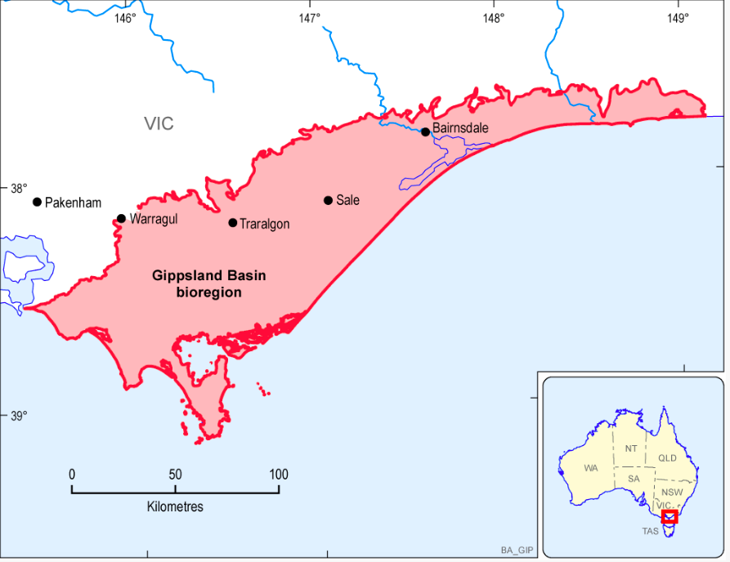
Figure 1: Gippsland Basin bioregion

2. Methodology
This section provides details on the following methodology employed throughout the project.

The methodology for this project included:

- Desktop research:
  - Relevant reports
  - Investigate current discourse on Aboriginal Cultural Water Values in the region
  - Identify relevant organisations
- Contact by telephone individuals and organisations identified as being potential participants:
  - Introduce the project and the researchers
  - Discuss possibility of involvement in project
  - Arrange visit
- Initial field visits:
  - Face to face discussions and provide information
  - Identify other potential participants (Elders, knowledge holders)
  - Arrange next visit
- Second field visit:
  - Obtain consent
  - Commence data collection on site
    - Identifying locations of assets
    - Record special data (GPS mapping)
    - Interview knowledge holder
- Third field visit:
  - Continue and finalise data collection on site
  - Record spatial data
- Analyse data:
  - Record location data on asset register
  - Document associated narratives for assets
- Write report and obtain endorsement from participants.

2.1 Desktop research
Desktop research was undertaken to gain an initial understanding of, and to identify:
- publically available data
- current discourse on Aboriginal cultural water values
- key stakeholders (organisations and individuals)

A range of publications were identified which assisted in understanding relevant issues pertinent to the region and Aboriginal cultural water values generally. The reports and websites sourced indicate significant activity in relation to Aboriginal communities and water – specifically in relation to conservation and water sharing plans.

2.2 Community Engagement
The Gunaikurnai Land and Waters Aboriginal Corporation (GLaWAC) was identified as the main traditional owner organisation in the region. Initial meetings provided an opportunity to discuss the objectives of the project with traditional owners, as well as providing an opportunity to identify other significant community members. Consultations and field visits were subsequently organised with identified key people to commence the data collection phase of research.

Stakeholders were assured the process for gathering the data would be undertaken respectfully, with cultural safety as a priority. Information about the impetus of the broader Bioregional Assessment Programme, and the proposed use of the data collected through it, including the Aboriginal cultural water values mapping, was described as forming but one layer, of many layers of baseline data assembled to develop a comprehensive map of the Gippsland Basin bioregion. These results would enable improved decision making in relation to coal mining and coal seam gas. Stakeholders were advised that maps and reports developed as a result of this research would be available to them as a community resource.

Stakeholders were also advised their participation was voluntary and no adverse action would occur if the group chose not to participate, and they could withdraw consent at any stage of the research process.

Aboriginal organisations and communities consulted:

- Gunaikurnai Land and Waters Aboriginal Corporation
- Gunaikurnai Traditional Owners Land Management Board
- Krowathunkooloong Keeping Place

Other key groups consulted about the research were:

- Eastern Gippsland Catchment Management Authority
- Parks Victoria

Although the Bidhwal and Boonwurrung and Woiwurrung peoples also have traditional lands in the Gippsland Basin bioregion, the key water assets (i.e. rivers, wetlands) were identified as being located on Gunaikurnai lands, and therefore the focus of the research and mapping concentrated on working with the Gunaikurnai. Nevertheless, attempts were made to contact the other groups to inform them of the bioregional assessment process, however no consultations could be arranged with these groups within the project’s timeframe.

2.3 Mapping Methodology
In all instances mapping on country utilised Motion X-GPS and coordinates were cross-referenced with maps downloaded into the Avenza Maps PDF application. Maps used were Geoscience Australia maps with datum GDA94. Remote mapping was done using the same system with GPS coordinates obtained on country as the reference point.

3. Aboriginal people of the Gippsland Basin region
At the 2011 Census there were 1,936 Indigenous people living in the Gippsland region. This represents 2.3 per cent of the total population of Gippsland (83,635).

There are three Aboriginal traditional owner groups whose lands exist across the Gippsland Basin bioregion. Those groups are:
- the Gunaikurnai peoples;
- the Bidhwal peoples; and
- the Boonwurrung and Woiwurrung peoples.

The Gunaikurnai traditional lands extend across most of eastern Victoria, from Drouin in west Gippsland to the Lakes Entrance on the Victorian east coast, north to Hotham Heights and Mount Bulla (including the Alpine National Park) and south to Welshpool and Port Albert. The Gunaikurnai also have a current Native Title claim over Wilson’s Promontory.

The Bidhwal people’s lands exist in the very north-eastern part of Victoria to (and just over) the New South Wales border – however no Native Title currently exists. The Boonwurrung and Woiwurrung people’s traditional lands are in the very far south-western section of the Gippsland bioregion. They have several current native title claims, but no determination has been made at the time of writing.

As stated above at 2.2, although the Bidhwal and Boonwurrung and Woiwurrung peoples also have traditional lands in the Gippsland Basin bioregion, the key water assets (i.e. rivers, wetlands) were identified as being located on Gunaikurnai lands, and therefore the focus of the research and mapping concentrated on working with the Gunaikurnai.

3.1 Gunaikurnai peoples
The Gunaikurnai traditional lands extend along the eastern coast of Victoria and inland to the southern slopes of the Victorian Alps. Gunaikurnai people are made up of five major clans:

- Brabralung people in Central Gippsland. Mitchell, Nicholson, and Tambo rivers; south to about Bairnsdale and Bruthen
- Brataualung people in South Gippsland. From Cape Liptrap and Tarwin Meadows east to the mouth of Merriman Creek; inland to near Mirboo; at Port Albert and Wilsons Promontory.
- Brayakaulung people around the current site of Sale. Providence Ponds, Avon and Latrobe rivers; west of Lake Wellington to Mounts Saw Saw and Howitt
- Krauatungalung people near the Snowy River. Cape Everard (Point Hicks) to Lakes Entrance; on Cann, Brodribb, Buchan, and Snowy rivers; inland to about Black Mountain
- Tatungalung people near Lakes Entrance on the coast. Along Ninety Mile Beach
and about Lakes Victoria and Wellington from Lakes Entrance southwest to mouth of Merriman Creek, also on Raymond Island in Lake King.

3.1.1.Governance
Gunaikurnai Land and Waters Corporation (GLaWAC) represents Gunaikurnai Traditional Owners and Native Title Holders. It manages the implementation of the Gunaikurnai native title settlement agreements by providing policy advice; strategic leadership by developing and leading key initiatives; and continuously improving the capacity, integrity and independence of the Gunaikurnai.

It works under the guidance of the Board of Directors and Elders Council to represent all Gunaikurnai people in native title, cultural heritage, land, water and natural resource management and related employment aspirations and issues.

3.1.2 Native Title
In 2010 the Gunaikurnai people were recognised by the Federal Court as the Traditional Owners of the greater part of the Gippsland region. ) The Gunaikurnai people also entered into an agreement with the Victorian Government under the Traditional Owner Settlement Act 2010 (Vic), which formally recognises them as the traditional owners of the area extending from West Gippsland near Warragul, east to the Snowy River and north to the Great Dividing Range and includes 200m of sea country offshore.(Figure 2)

The Gunaikurnai have a current native title claim application over Wilson’s Promontory, however both the Gunaikurnai and Boonwurrung Woiwurrung peoples have a cultural and historical connection to Wilson’s Promontory. The Gunaikurnai have signed a Memorandum of Understanding with Parks Victoria and the Bunurong and Boon Wurrung people over Wilson Prom National Park which, according to Native Title Services Victoria (NTSV), “is a vital step in progressing the aspirations, common goals, cultural heritage, park management and management of country over that area.”

3.1.3 Joint management
The Gunaikurnai native title agreement included a consent determination and an Indigenous Land Use Agreement. In addition, there were a number of agreements under the Traditional Owner Settlement Act 2010 (Vic) and Conservation Forests and Lands Act 1987 (Vic) which included a Recognition and Settlement Agreement (RSA), a Land Agreement and a Traditional Owner Land Management Agreement.

The Agreements saw the transfer of ownership of ten National Parks and reserves to the Gunaikurnai people, which are now jointly managed with the Victorian Government (Parks Victoria). Under the Aboriginal Heritage Act 2006, the Gunaikurnai Land and Waters Aboriginal Corporation (GLaWAC) is recognised as the Registered Aboriginal Party (RAP) for the Gunaikurnai native title area. The parks and reserves jointly managed are:

- The Knob Reserve, Stratford
- New Guinea Cave (within Snowy River National Park)
- Tarra Bulga National Park
- Lake Tyers Catchment Area
- Mitchell River National Park
- Buchan Caves Reserve
- Lakes National Park
- Gippsland Lakes Reserve at Raymond Island
- Gippsland Lakes Coastal Park
- Corringle Foreshore Reserve

Joint management is a term used to describe a formal partnership arrangement between Traditional Owners and the State where both share their knowledge to manage specific national parks and other protected areas. The joint management is overseen by a Traditional Owner Land Management Board, comprised of a majority of Gunaikurnai community members and representatives from the broader community.

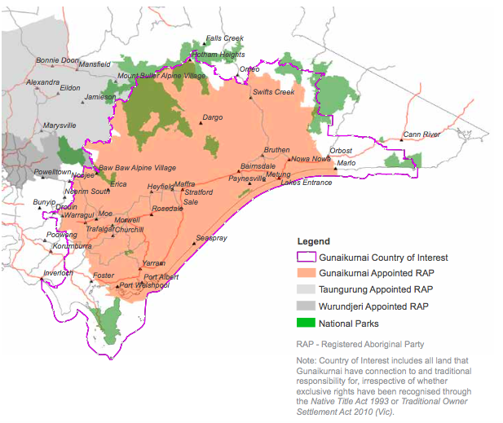
Figure 2: Map of Gunaikurnai Traditional Lands

4. Consultation outcomes
Consultations with Gunaikurnai peoples provided this report with abundant and rich data. The Gunaikurnai people have an ongoing cultural connection with the Gippsland region, demonstrated through an array of natural resource programs and activities managed through GLaWAC. GLaWAC have developed a draft Whole of Country Plan that articulates the Gunaikurnai’s connection to land and water, as well as establishing the ways in which the identified resources will be managed and cared for.

The Whole of Country Plan declares:

As Gunaikurnai, we see our land (Wurruk), waters (Yarnda), air (Watpootjan) and every living thing as one. All things come from Wurruk, Yarnda and Watpootjan and they are the spiritual life-giving resources, providing us with resources and forming the basis of our cultural practices. We have a cultural responsibility to ensure that all of it is looked after. (Gunaikurnai Whole of Country Plan)

The section of the report outlines information gathered through the consultations and field trips to culturally significant water dependent sites.

4.1 Categorising cultural assets
The assets identified in this report are of cultural significance to the Aboriginal people of the Gippsland Basin bioregion, the values, purpose and meaning attached to each asset has been identified through consultation. Most assets have more than one value attached, for example a creek bed being a place of ceremony as well as a place where food can be harvested.

The purpose and meaning of cultural water assets have been categorised into the following groups:

- Customary – ceremony, meeting place, men’s business, women’s business, totems, dance, rites, song, birth, death)
- Spiritual (dreaming, stories, songlines)
- Ecological (flora and fauna)
- Economic (trade routes, food source – fishing/hunting, employment/income – tourism, farming)
- Recreational – family gatherings, swimming holes

The total number of Aboriginal cultural water assets in the Gippsland Basin bioregion detailed in this report is not exhaustive. A sample of the cultural assets and their associated value to Aboriginal people of the region was compiled.

4.2 Cultural Water Assets Identified
The following table contains the data collected through consultation with the Gunaikurnai people with knowledge and connection to the Gippsland Basin bioregion.

ID | Name | Traditional name | Type | Country | Value | Summary
GP1 | Port Albert | Tarrawarrackel | Estuary | Gunaikurnai | Spiritual | Creation story of Gunaikurnai
GP2 | Tarra River |  | River | Gunaikurnai | Spiritual | Songline part of the creation story
GP3 | Yarram | Yerrem Yerrem | River | Gunaikurnai | Spiritual/Customary | Songline part of creation story. Yarrem Yarrem (meaning - plenty of water)
GP4 | Wonwron State Reserve | White woman's water hole | State Forest | Gunaikurnai | Spititual/Customary | Story (probably mythical) of shipwrecked white woman captured by local Aboriginal tribe. Local white settlers responded to unconfirmed story by hunting and massacring Aboriginal people.
GP5 | Warrigal Creek |  | Creek | Gunaikurnai | Spiritual/Customary | Massacre site (see above story)
GP6 | Sale Wetlands | Wayput | Wetlands | Gunaikurnai | Customary/Ecological/ Economic | Wayput (meaning - the heart) - Important food and material resource site for the region
GP7 | Thomson River |  | River | Gunaikurnai | Ecological | Major river feeds into the wetlands
GP8 | La Trobe River |  | River | Gunaikurnai | Ecological | Major river feeds into the wetlands
GP9 | Melaleuca ericifolia | Swamp paperbark | Tree | Gunaikurnai | Customary/Ecological/Economic | Bark used for baby wrap and fishing floats. Stems for spears, clubs, digging sticks. Nectar used in drinks.
GP10 | Typha domingensis | Doora, Cumbungi | Plant | Gunaikurnai | Customary/Ecological/ Economic | Important food source, fibre made string/leaves made baskets, fish & eel traps.
GP11 | Poa labillardieri | Tussock grass | Plant | Gunaikurnai | Customary/Ecological/ Economic | Seeds ground to make flour / leaf & stem to make string
GP12 | Juncus ingens | Rush | Plant | Gunaikurnai | Customary/Ecological/ Economic | Leaves split and used for making baskets (still used as a resource today).
GP13 | Phragmites australis | Reed | Plant | Gunaikurnai | Customary/ Ecological/ Economic | Used for bags, baskets, spear shafts & necklaces. Edible tuber and stem used as a snorkel for hunting
GP14 | Triglochin procerum | Lumbray | Plant | Gunaikurnai | Customary/Ecological/Economic | Starchy tubers were eaten raw or roasted in the asshes of a fire
GP15 | Microseris lanceolata | Murnong/Yam Daisy | Plant | Gunaikurnai | Customary/Ecological/ Economic | Major food source throughout the region
GP16 | Eucalyptus tereticornis subsp. mediana | Gippsland Redgum | Tree | Gunaikurnai | Customary/Ecological/Economic | Wood for making boomerangs, shields and weapons/bark used for canoes/seeds eaten/sap used medicinally
GP17 | The Knob Reserve | Nuntin | Site | Gunaikurnai | Spiritual/Customary/Ecological/Economic | Important gathering and camping site. Location wehere Native Title Agreement was signed in 2010.
GP18 | Avon River | Dooyeedang | River | Gunaikurnai | Customary, Ecological & Economic | Major travel route and resource site for all the tribes in the region
GP19 | Ramahyuck Cemetery |  | Site | Gunaikurnai | Customary & Spiritual | Originally a mission site now site of cemetery. Ramah is Hebrew for 'home' & yuck Aboriginal for 'our'
GP20 | Den of Nargan | Nurung-a Narguna | River Cave | Gunaikurnai | Spiritual, Customary | Critically important site for women's business/still used today.
GP21 | Woolshed Creek |  | Creek | Gunaikurnai | Spiritual | The whole gully where this creek runs is forbidden to men - women's business
GP22 | Mitchell River National Park |  | Park | Gunaikurnai | Customary/ Spiritual/Ecological/ Economic | History of tribal conflict, ceremonies, food gathering, community life and local spirits.
GP23 | Mitchell River | Wahyand | River | Gunaikurnai | Customary/Economic | This river runs through Bairnsdale (Wy Yung) and beside Howitt Park where food resources were harvested
GP24 | Metung | Metung | Estuary | Gunaikurnai | Spiritual | There is a story relating to the "Legend Rock" found at Metung
GP25 | Lake Tyers | Bung Yarnda | Lake | Gunaikurnai | Customary/Spiritual/Ecological/ Economic | Bung Yarnda = "Big Waters" - Traditional meeting place/neutral territory/resource site
GP26 | Burnt Bridge Reserve |  | Creek | Gunaikurnai | Customary/Economic | Local resource site
GP27 | Acacia melanoxylon | Blackwood | Tree | Gunaikurnai | Customary/Ecological/Economic | The hard wood was prized for spear throwers & shields/bark used for rheumatism/fibres for fishing lines
GP28 | Xanthorrhoea sp. | Grass tree | Tree | Gunaikurnai | Customary/Ecological/Economic | Resin collected was used for fastening axe heads and spear points
GP29 | Cape Conran | Kerlip | Cape | Gunaikurnai | Customary/Economic | A border area for Gunaikurnai & Bidhawal people/shell middens/meeting place
GP30 | Wilsons Promontory National Park |  | Cape | Gunaikurnai | Customary/Spiritual/Ecological & Economic | Spirit place/resource area/ceremonies/middens = 323 Cultural Heritage Sites (see map)
GP31 | Tarra-Bulga National Park |  | National Park | Gunaikurnai | Ecological/Economic | Virgin bushland jointly managed with Parks VIC & GLaWAC
GP32 | Gippsland Lakes Coastal Park |  | Lakes System | Gunaikurnai | Customary/Spiritual/Ecological/Economic | Burial and massacre sites throughout park, camp sites and gathering sites; artefacts scattered throughout-jointly managed with Parks VIC & GLaWAC
GP33 | The Lakes National Park |  | Wetland System | Gunaikurnai | Customary/Spiritual/Ecological/ Economic | Burial and massacre sites throughout park, camp sites and gathering sites; artefacts scattered throughout-jointly managed with Parks VIC & GLaWAC
GP34 | Gippsland Lakes Reserve on Raymond Island | Gragin | Island | Gunaikurnai | Spiritual/Customary/Ecological/ Economic | Burial and massacre sites throughout park, camp sites and gathering sites; artefacts scattered throughout-jointly managed with Parks VIC & GLaWAC
GP35 | Lake Tyers State Park | Bung Yarnda | State Park | Gunaikurnai | Spiritual/Customary/ Ecological/Economic | Creation story of the sea (Narkabungdha)/crucial resource site, women's business, men's business, meeting place & burials
GP36 | Corringle Foreshore Reserve |  | Reserve | Gunaikurnai | Customary/Ecological/Economic | Crucial resource site & meeting place used before & after displacement. Jointly managed by Parks VIC & GLaWAC
GP37 | Snowy River |  | River | Gunaikurnai | Customary/Ecological | River feeds the Corringle Reserve & is adjacent to the New Guinea Cave in Snowy River National Park
GP38 | Buchan Caves Reserve |  | Reserve | Gunaikurnai | Customary/Spiritual/Ecological/ Economic | Meeting place, resource site, ceremonial rings, artefacts, art work, massacre site - jointly managed by Parks VIC & GLaWAC
GP39 | New Guinea Cave |  | Cave | Gunaikurnai | Spiritual/Customary/Ecological/ Economic | One of the oldest inhabited caves in the world with cave art, camp site, resource site, artefacts, tool making, massacre site-jointly managed by Parks VIC & GLaWAC

4.3 Accompanying narratives
Gunaikurnai knowledge holders provided the following stories and information. Some additional data was sourced from publically available information such as the Bataluk Cultural Trail and the Krowathunkooloong Keeping Place. Gunaikurnai culture has a strong presence in the Gippsland region, exemplified by the Bataluk Cultural Trail (Figure 3), a public trail following significant traditional routes used by the Gunaikurnai for over 30,000 years. Additionally, the Krowathunkooloong Keeping Place in Bairnsdale, is a museum holding significant cultural artefacts and their associated history and stories.

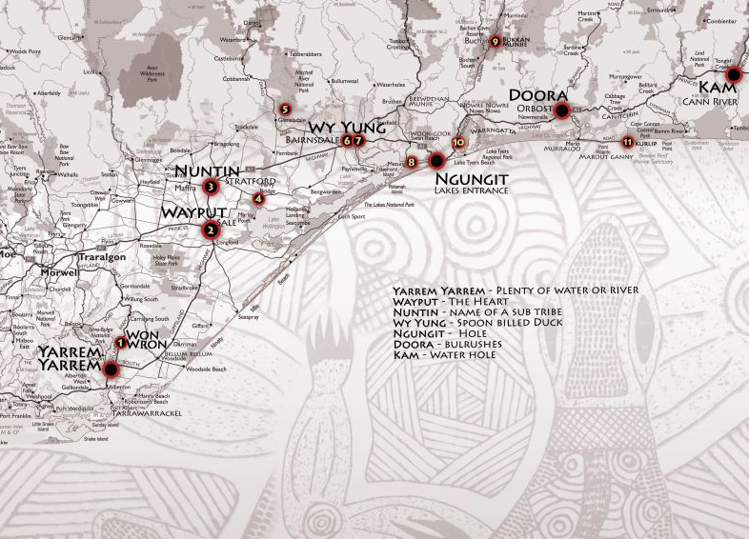
Figure 3: Bataluk Cultural Trail

Each story below is aligned with an identification number cited in the above tables except for the story highlighted in a text box below, which while having no specific location associated with it, is provided because it is significant storyline associated with water.

The story of Jiddelek
Long ago there was a big frog and his name was Jiddelek. He went to the river to have a drink. He began to drink the water from the water hole, then from the creek, then the river, ‘til there was nothing left.
All the animals were thirsty. There was no water anywhere. The animals called a meeting; they decided that one of them should try to make Jiddelek laugh. Turtle and platypus played leapfrog. That didn’t make Jiddelek laugh. Duck and bird flew around. That didn’t make Jiddelek laugh. Bataluk strutted to and fro puffing out his stomach. Jiddelek was nearly asleep.
Snake said, ‘Let me try’. He started a wiggly, squiggly dance. He twisted and nearly tied himself in a knot. Then came a rumbling noise from Jiddelek and it grew louder and louder. His mouth opened and he began to laugh. A mighty gush of water came out of his mouth; all the water came back to the water holes and the rivers.
Gunai/Kurnai Traditional Custodians

Tarrawarrackel (GP1)
In dreaming terms, the first Gunaikurnai came down from the mountains in Victoria's northwest carrying his canoe on his head. He was Borun, the pelican. He crossed over the river at what is now Sale, and walked on alone to Tarra Warackel (Port Albert) in the west. As he walked, he heard a constant tapping sound but could not identify it. When he reached the deep water of the inlets, Borun put down his canoe and, much to his surprise, there was a woman in it. She was Tuk, the musk duck. He was very happy to see her and she became his wife and the mother of the Gunaikurnai people - they are the parents of the five Gunaikurnai clans.

White Woman’s Water Hole, Wonwron State Reserve (GP4)
Local legend has it that in the 1840s, a young woman, the sole survivor of a shipwreck off the nearby Ninety Mile Beach was taken and held captive by the local tribe of Bratwoloong, who inhabited this part of Gippsland. The story of the captive white woman developed a life of its own spawning numerous myths with various versions even claiming a sighting of a white woman being hurried away.

Attempting to rescue her, settler search parties pursued the Gunaikurnai. The woman, if she ever existed, was never found. A ship’s figurehead however, was recovered, leading to speculation that it may have been mistaken for the white women. This White Woman of Gippsland story is believed to have justified the killings of many Gunaikurnai people. Massacres of the Gunaikurnai occurred at Nuntin, Boney Point, Butchers Creek, Maffra and at other unspecified locations throughout Gippsland. A massacre at nearby Warrigal Creek is recognised as one of the worst in Australian settlement history. The White Woman’s Waterhole commemorates the tragedy of this story.

Warrigal Creek (GP5)
Associated with the story of the White Woman’s Waterhole, Warrigal Creek is the site of a large massacre of Aboriginal people, and today holds important historical and spiritual significance.

Sale Wetlands (GP6)
The wetlands were like a supermarket for the Gunaikurnai people of the area. A walk around Lake Guthridge to the Sale Common boardwalks reveals numerous plants and birds, which were sources of food and other important raw materials (Figure 4 and 5).
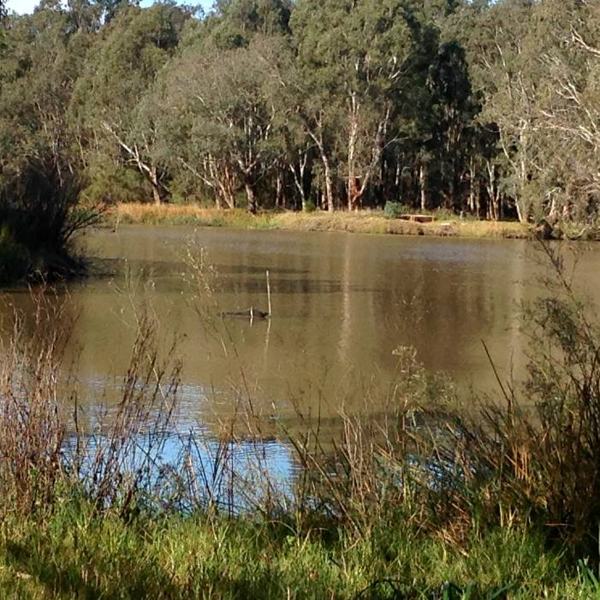
Figure 4: Sale Wetlands (Source: K. Love 2015)

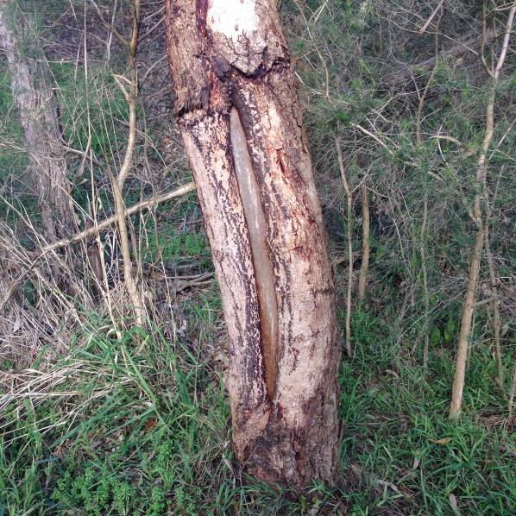
Figure 5: Scar Tree, Sale Wetlands (Source: K. Love 2015)

Bulrush also known as Doora, Cumbunji (GP10)
Gunaikurnai people used the Cumbunji to make fishing nets. The plant is also an important food source. After steaming, the roots can be chewed to remove the starch and the remaining fibre used to make string.
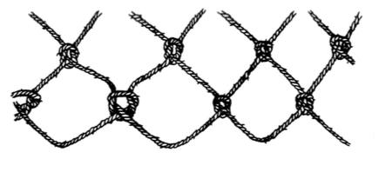
Figure 6: Technique for making nets made from the reeds of bulrush

Murnong/Yam Daisy (GP15)
Found near water, the Murnong (or the Yam Daisy) (Figure 7) is an important food resource. Women dug the roots with digging sticks and then roasted the yams in an earth oven. Aboriginal people believed that the roots of ‘Murnong’ should not be collected before the plants flowered. This was probably because during the drier winter period before springtime flowering, the roots would not be fully developed.

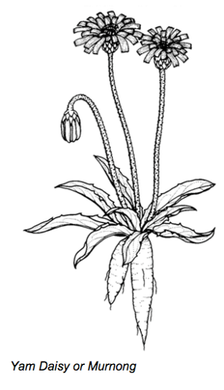
Figure 7: Murnong/Yam Daisy - staple food source (Source: Australian National Botanic Gardens)

Knob Reserve (GP17)
On the banks of the Avon River (Figure 8) people fished for eels, bream, flathead and prawns which were an important part of the food supply. Spears, nets and hooks made from kangaroo bone were used to catch the fish. The bluff above the Dooyeedang was a major campsite and meeting place for the Gunaikurnai people who have lived in this region for thousands of years.

As well as being an important source of food, the Dooyeedang was a major transport route for the Gunaikurnai people. Bark canoes were used for fishing and travelling up and down the river between the mountains and the lakes. This was a well sheltered campsite, close to the river and fertile river flats that supplied plenty of good food and water and would have allowed large gatherings of clans from the Gunaikurnai nation to meet for feasting, corroborees and other ceremonies.

In 2010, the Gunaikurnai Native Title Agreement was signed at the Knob Reserve (Figure 9).

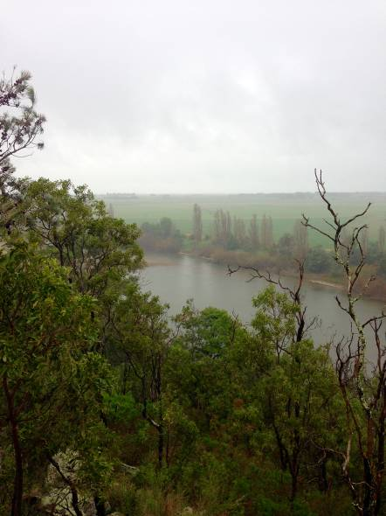
Figure 8: Knob Reserve – overlooking the Avon River (Source: K. Love 2015)

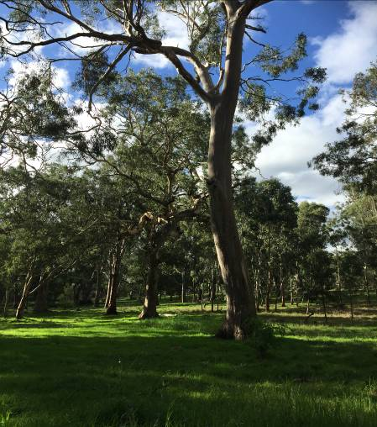
Figure 9: Knob Reserve Meeting Place (Source: J. Constable 2015)

Den of Nargan (GP20)
The Nargan is a large female creature who lives in a cave behind the waterfall. The Den of Nargan (Figure 10) is of great spiritual importance to the Gunaikurnai people. More significantly, it is a woman’s place, where initiation and learning ceremonies were held for Gunaikurnai women.

Stories of the Nargan who could not be harmed by boomerang or spears, tell of her abducting children who wandered off on their own. The story serves not only to protect children, but to ensure people stayed way from the sacred cave.
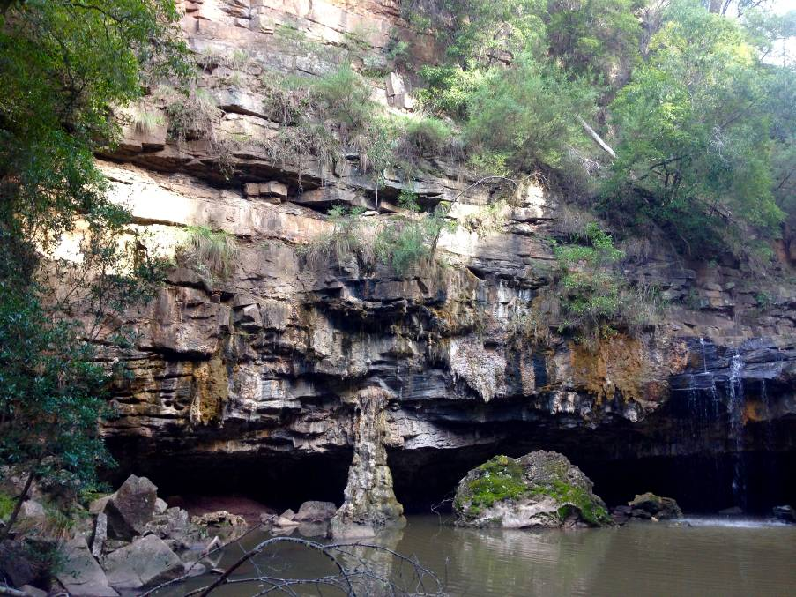
Figure 10: Den of Nargan (Source: K. Love 2015)

Legend Rock, Metung (GP24)
According to Gunaikurnai legend, one day some fishermen, who had hauled in many fish with their nets, ate their fish around a campfire. The women, guardians of social lore, saw the men had eaten more than enough but had not fed their dogs. As punishment for their greed, the fishermen were turned into stone. This is one of the many stories told to show how greed would bring punishment.

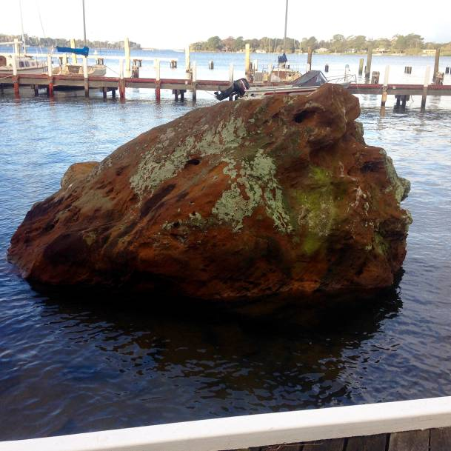
Figure 11: Legend Rock, Metung (Source: K. Love 2015)

The Lakes National Park (GP33)
The Lakes National Park is an internationally recognised wetland, which plays an important role in providing habitat for migratory bird species. The marsh and wetland between the park and the coast are also very significant, abundant in wildlife and rare and endangered species. The region is home to several of Gunaikurnai totem species as well as a number of rare and endangered flora and fauna.

The park is also a very important spiritual and cultural site for the Gunaikurnai as it holds the sites of Aboriginal human remains (where people were wrapped in bark and buried upright in hollowed out possum holes as is customary to the Gunaikurnai). Numerous shell middens can be found all along the sand dunes.

Buchan Caves (GP38)
Traditionally, the Gunaikurnai people did not venture deep into the limestone caves at Buchan. There were however, many stories about the wicked and mischievous Nyols who lived in the caves below the earth. One story tells of a group of children who lived in the area when there was known to be a land south of what is now known as Gippsland and there is now a sea. When playing they found a sacred object, which they took home and against traditional law, they showed it to the women. Immediately, the earth crumbled away and water took its place and many people drowned.

Tarra Bulga National Park (GP31)
Within the Tarra Bulga National Park exists Gunaikurnai creation storylines, where Borun travelled carrying his canoe from the mountains to the sea. The park is also the site of walking and trading routes linking Gunaikurnai country from the mountains to the sea at Wilsons Promontory.

The area’s old growth forests are characteristic of a time when only Aboriginal people inhabited the land, and are therefore an important reminder to the Gunaikurnai about what country was like in the time prior to European settlement. The forests contain many water dependent species of flora and fauna.

5. Summary
The Gunaikurnia’s traditional lands extend across most of the Gippsland Basin bioregion. The Bidhwal and Boonwurrung and Woiwurrung peoples also have traditional lands in the Gippsland Basin bioregion, however the key water assets (i.e. rivers, wetlands) were identified as being located on Gunaikurnai lands, and therefore the focus of the research and mapping concentrated on working with the Gunaikurnai. The data presented in this report is publically available information and has been sourced through consultation with Gunaikurnai knowledge holders, as well as through undertaking the Batulak Cultural Trail and visiting the Krowathunkooloong Keeping Place.

The Gunaikurnai native title agreement included a consent determination and an Indigenous Land Use Agreement. In addition there were a number of agreements under the Traditional Owner Settlement Act 2010 (Vic) and Conservation Forests and Lands Act 1987 (Vic) which included a Recognition and Settlement Agreement (RSA), a Land Agreement and a Traditional Owner Land Management Agreement. This sees the Gunaikurnai people assuming shared responsibility, or joint management of ten national parks and reserves.

The Gunaikurnai have a strong historical and ongoing connection to the Gippsland region and many of their significant sites are associated with water resources. Plant and animal species, some rare, are also important cultural and economic assets to the Gunaikurnai people. It is a testament to the Gunaikurnai people’s relationship with their country that the Gippsland Basin bioregion is home to some of Australia’s most pristine waterways. Through their ongoing involvement in the formal management of waterways, alongside Parks Victoria and the relevant catchment management authorities, the region’s water resources will remain pristine. Sites such as the Den of Nargan, the Sale Wetlands and Gippsland Lakes not only exemplify Gunaikurnai people’s spiritual and cultural connection with country, but their ongoing protection illustrates the role of the Gunaikurnai as custodians.

Accordingly, considerable concerns about the impacts of coal seam gas in the Gippsland region were expressed by some of the consultations participants. Gunaikurnai Land and Waters Aboriginal Corporation, through the work they undertake with mainstream water and land management, are well placed to provide the community with information about the potential impacts of coal seam gas and other mining exploration activities. Further, the Gunaikurnai expressed an interest in continuing cultural asset mapping to achieve a comprehensive knowledge bank of all water dependent assets on Gunaikurnai land.

6. References

Australian Bureau of Statistics, 2011 Census of Population and Housing, Aboriginal and Torres Strait Islander (Indigenous) Profile, Cat.No. 2002.0, Gippsland (IARE202007), 31758.3 sq Kms, Table 1A – Selected Person Characteristics by Indigenous Status by Sex.

Australian National Botanic Gardens, (2004) Aboriginal Plant Use in South-Eastern Australia, Information Resources, Australian Government, Canberra.

Calma T. (2008) Aboriginal and Torres Strait Islander Social Justice Commissioner, Native Title Report 2008, Chapter 6 – Indigenous Peoples and Water, Human Rights and Equal Opportunity Commission, Sydney.

Commonwealth of Australia, Bioregional Assessment Programme, Gippsland Basin Bioregion, downloaded 14 June 2015 http://www.bioregionalassessments.gov.au/bioregions/gip.shtml.

Gunaikurnai Land and Waters Aboriginal Corporation (2015), Whole of Country Plan, GLaWAC, unpublished.

Native Title Services Victoria (2013), Annual Report 2012-2013, NTSV, Melbourne.

West Gippsland Catchment Management Authority (2013) West Gippsland Waterway Strategy: Traditional Owner and Indigenous Community Priorities, WGCMA.

Victorian Aboriginal Corporation for Languages and Arts Victoria (2014), Nyernila-Listen Continuously, VACLAV, Melbourne.

7. Appendix

Appendix 1 – Consultation participants

Gippsland Basin bioregion Consultation List
Ricky Mullet | Chair, GLaWAC Board
Aunty Beryl Booth | Gunaikurnai Elder
Grattan Mullet | Manager, Join Management
Kirstie Pearce | General Manager, GLaWAC
Joanne Andrews | Natural Resources Manager GLaWAC
Charmaine Singleton | Gunaikurnai Elder
Margaret Donnelly | Gunaikurnai Elder
Fay Voss | Gunaikurnai Elder
Lee-Anne Eddington | GLaWAC Board Member
Robert Critch | GLaWAC Board Member (Former Chair)
Luke Johnson | Aboriginal Ranger - Wilson's Promontory National Park
Rex Candy | NRM Strategy & Planning Manager, East Gippsland Catchment Management Authority
Ken Judd | Manager - Water Programs, East Gippsland Catchment Management Authority
Rob Willersdorf | Manager - Land Programs

Calma T. (2008) Aboriginal and Torres Strait Islander Social Justice Commissioner, Native Title Report 2008, Chapter 6 – Indigenous Peoples and Water, Human Rights and Equal Opportunity Commission, Sydney.
Commonwealth of Australia, Bioregional Assessment Programme, Gippsland Basin Bioregion, downloaded 14 June 2015 http://www.bioregionalassessments.gov.au/bioregions/gip.shtml
ibid
Australian Bureau of Statistics, 2011 Census of Population and Housing, Aboriginal and Torres Strait Islander (Indigenous) Profile, Cat.No. 2002.0, Gippsland (IARE202007), 31758.3 sq Kms, Table 1A – Selected Person Characteristics by Indigeous Status by Sex
West Gippsland Catchment Management Authority (2013) West Gippsland Waterway Strategy: Traditional Owner and Indigenous Community Priorities, WGCMA, p.2
Information sourced from interviews and the GLaWAC website www.glawac.com.au
The determination agreement is only applicable to Crown land within that area and does not affect existing rights and interests on Crown land (such as leases and licences). The native title agreement includes rights for Gunaikurnai people to access and use Crown land for traditional purposes, including hunting, fishing, camping and gathering in accordance with existing laws.
Native Title Services Victoria (2013) Annual Report 2012-2013, p.27.
Consent determinations aim to provide an efficient and resourceful means of settling native title which encourages relationship building between Indigenous communities and others; less intrusive on Aboriginal culture than litigated determinations. Definition sourced from Agreements, Treaties and Negotiated Settlements project (an ARC Research Linkage project) website www.atns.net.au (accessed 18 June 2015).
http://parkweb.vic.gov.au/park-management/aboriginal-joint-management
Map sourced from Gunaikurnai Whole of Country Plan (2015)
Gunaikurnai Land and Waters Aboriginal Corporation (2015), Draft Whole of Country Plan, unpublished, GLaWAC, Bairnsdale, p9.
Development of the Bataluk Cultural trail is a joint initiative of the Far East Gippsland Aboriginal Corporation, Gippsland and East Gippsland Aboriginal Co-operative, Lake Tyers Aboriginal Trust, Moogji Aboriginal Council, Ramahyuck Aboriginal Corporation, East Gippsland Shire Council and Wellington Shire Council.
Map sourced from www.batalukculturaltrail.com.au (downloaded 20 June, 2015)
Victorian Aboriginal Corporation for Languages and Arts Victoria (2014), Nyernila-Listen Continously, (Gunaikurnai Traditional Custodians), p.19
Australian National Botanic Gardens, (2004) Aboriginal Plant Use in South-Eastern Australia, Information Resources, Australian Goverment , Canberra, p3.
Ibid, p15
ibid
. Information sourced from http://batalukculturaltrail.com.au/buchan_caves.php (29 May 2015)

