The GBA Program

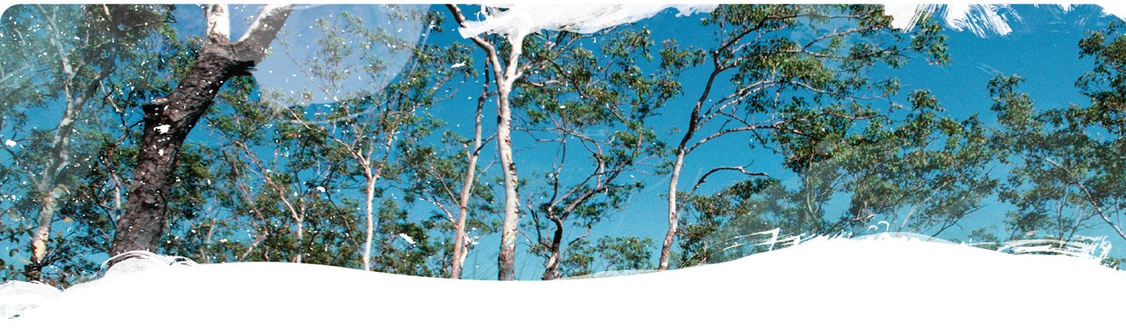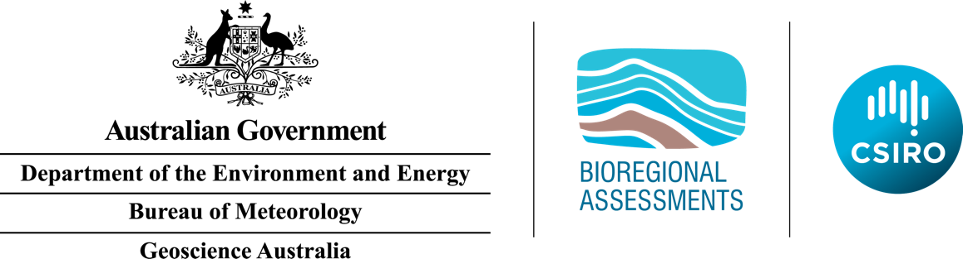

Geological and Bioregional Assessment Program

The Geological and Bioregional Assessment (GBA) Program is assessing the potential environmental impacts of shale and tight gas development to inform regulatory frameworks and appropriate management approaches. The geological and environmental knowledge, data and tools produced by the GBA Program will assist governments, industry, landowners and the community by informing decision making and enabling the coordinated management of potential impacts.

A series of independent scientific studies in three geological basins – the Cooper Basin in Queensland and SA, the Isa Superbasin in Queensland and the Beetaloo Sub-basin in NT – are being conducted by CSIRO and Geoscience Australia, supported by the Bureau of Meteorology and managed by the Department of the Environment and Energy. These scientific studies aim to provide baseline information that:

|  |  |
| --- | --- |
|  | identifies and evaluates areas of high potential for shale and tight gas for future development and any potential connections with water resources |
|  | collates and summarises key information about geological structure, groundwater movement through geological layers, surface water systems and ecological systems |
|  | evaluates possible ways that unconventional gas resource development might impact the things we value, such as the safety of communities, groundwaters, protected species, as well as culturally and ecologically important matters. |

|  |
| --- |
|  |
| **Locations of the proposed seismic monitoring stations in the greater Beetaloo GBA region.** |

Beetaloo GBA region

The Beetaloo GBA region covers an area of over 28,000 km2 (pictured at right) and includes deep (greater than 1 km) geological formations that potentially host commercial quantities of hydrocarbons.

Seismic Monitoring Project

Geoscience Australia are partnering with the GBA Program to undertake seismic monitoring in the Beetaloo GBA region of Northern Territory starting late 2019. This monitoring project aims to gather new information about natural seismic (i.e., earthquake) activity in the region and monitor any seismic events that may be associated with future hydraulic fracturing activities in the region.

Email [ClientServices@ga.gov.au](mailto:ClientServices@ga.gov.au) for more information.

|  |  |
| --- | --- |
|  | **Find out more:** <https://www.bioregionalassessments.gov.au/geological-and-bioregional-assessment-program>  <http://www.ga.gov.au/BeetalooSeismicMonitoring> |