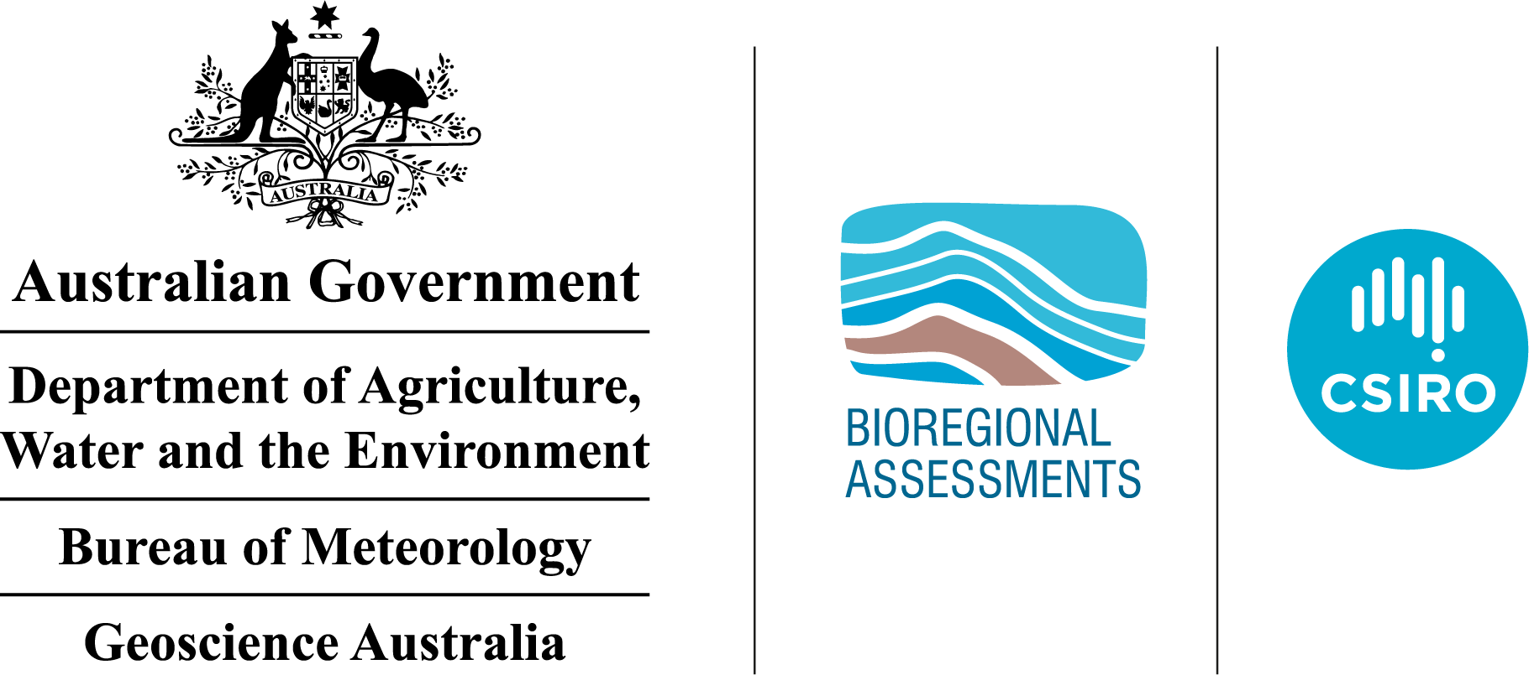The GBA Program

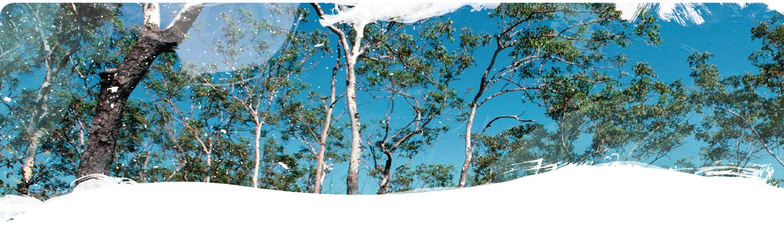

Geological and Bioregional Assessment Program

The $35.4 million Geological and Bioregional Assessment (GBA) Program is assessing the potential environmental impacts of shale and tight gas development to inform regulatory frameworks and appropriate management approaches. The geological and environmental knowledge, data and tools produced by the GBA Program will assist governments, industry, landowners and the community by informing decision making and enabling the coordinated management of potential impacts.

A series of independent scientific studies in three geological basins – the Cooper Basin in Queensland and South Australia, the Isa Superbasin in Queensland and the Beetaloo Sub-basin in the Northern Territory – are being conducted by CSIRO and Geoscience Australia, supported by the Bureau of Meteorology and managed by the Department of Agriculture, Water and the Environment. These scientific studies aim to provide baseline information that:

|  |  |
| --- | --- |
|  | identifies and evaluates areas of high potential for shale and tight gas for future development and any potential connections with water resources |
|  | collates and summarises key information about geological structure, groundwater movement through geological layers, surface water systems and ecological systems |
|  | evaluates possible ways that unconventional gas resource development might impact the things we value such as groundwaters, protected species, as well as culturally and ecologically important matters. |

User panels

Each assessment is informed by a user panel, where user needs and Program findings are discussed, and information is shared. The user panel for the Isa GBA region includes people from local government, natural resource management bodies, Queensland state government, Traditional Owner groups, pastoralists, industry and other land user groups. The assessments will inform and support future regulatory frameworks and appropriate management approaches.

The Isa GBA region

The Isa GBA region covers about 8223 km2 and is centred on the area around the remote township of Doomadgee in north-west Queensland (Figure 1). Defined specifically for GBA purposes, the region includes known shale gas systems of the geological Isa Superbasin.

At a glance: The geological and environmental baseline assessment for the Isa GBA region

The geological and environmental baseline assessment for the Isa GBA region compiles and analyses available data, forming a baseline and identifying key gaps where collection of additional data is needed.

|  |  |  |
| --- | --- | --- |
|  | **Geology and gas resources:** Areas of higher prospectivity for the main shale gas plays include the River Supersequence over most of the Isa GBA region and the Lawn Supersequence over the central and western parts of the region (Figure 1). | Figure 1 Isa GBA region |
|  | **Groundwater*:*** There are two broad and potentially connected groundwater systems that occur at different depths. The deeper groundwater system contains the targets for shale gas extraction. The shallower system, including part of the Great Artesian Basin, hosts the region’s most readily accessible groundwater resources. Groundwater-dependent ecosystems occur along many streams and on nearby floodplains, and also as environmentally and culturally important springs in the south-west of the region. |
|  | Surface water: The Nicholson River, which rises to the west of the region in the NT and passes near the remote township of Doomadgee, is the major river of interest. Discharging into the Gulf of Carpentaria, it flows through the nationally listed wetlands of the Nicholson Delta and Southern Gulf aggregations. | |
|  | Water availability: A future shale gas industry will need authorisation to take water from aquifers, watercourses, or lakes through the relevant Queensland Government water plans. Produced water from shale gas reservoirs could possibly be used for drilling and hydraulic fracturing, although the volumes available and the economic viability of this are uncertain. | Potential hydrological connections: There is some evidence of potential existing connectivity between deep and shallow groundwater systems. Considerably more information is needed to understand these potential hydrological connections. Research questions have been devised to address the most important data and knowledge gaps. |
|  | **Protected matters:** Matters of national and state environmental significance include threatened species (plants, reptiles, birds and mammals) and ecological communities and wetlands. Two landscape classes dominate the region: ‘floodplain and alluvium’ (36% of the region) and ‘loamy and sandy plains’ (33%). | Eleven Matters of National Environmental Significance and two Matters of State Environmental Significance are recommended for further assessment because of their importance (priority 1). This includes five endangered species and eight vulnerable species, as well as an endangered regional ecosystem and four nationally important wetlands. |
|  | **Potential impacts:** Over 200 individual hazards were systematically identified by considering all the possible ways that activities associated with shale gas development may cause impacts. Hazards were grouped into 14 causal pathways, and then aggregated into three causal pathway groups. Causal pathways connect hazards associated with shale gas development with the values to be protected for each landscape class. | The three causal pathway groups are: (i) landscape management, (ii) subsurface flow paths and (iii) water and infrastructure management. A variety of potential effects were identified across these causal pathway groups, with the highest priority effects including habitat fragmentation and loss, cultural heritage damage or loss, introduction of invasive species, changed groundwater quality and changed surface water flows. |

|  |  |
| --- | --- |
|  | **Find out more**  <https://www.bioregionalassessments.gov.au/geological-and-bioregional-assessment-program> |