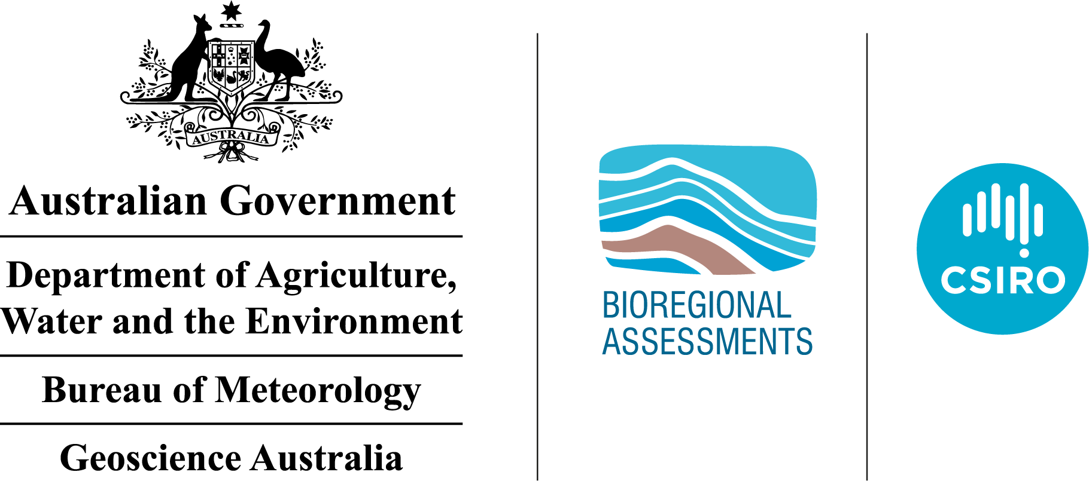

Shale gas prospectivity of the Isa GBA region
Technical appendix for the Geological and Bioregional Assessment: Stage 2
2020

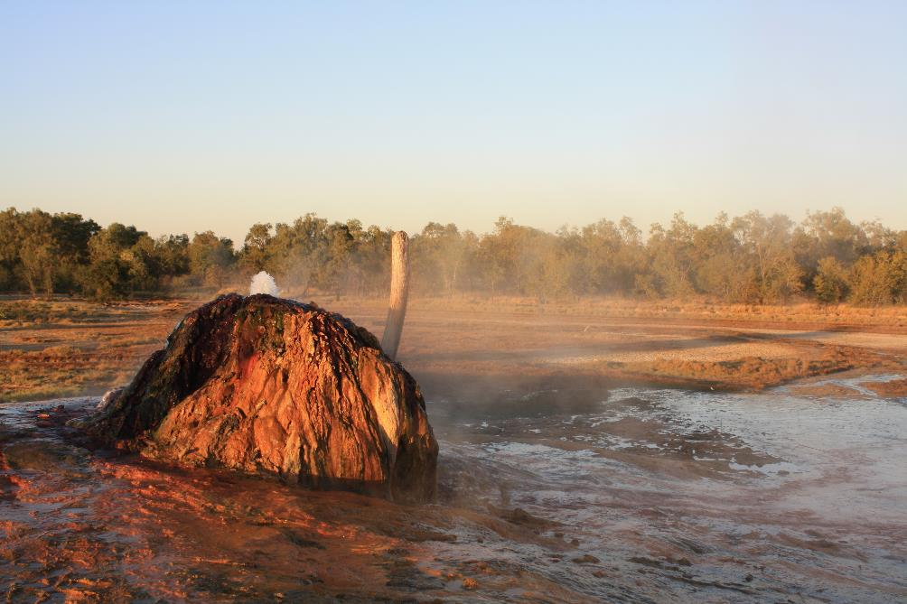
The Geological and Bioregional Assessment Program
The Geological and Bioregional Assessment Program will provide independent scientific advice on the potential impacts from shale and tight gas projects on the environment. The geological and environmental data and tools produced by the Program will assist governments, industry, landowners and the community to help inform decision making and enhance the coordinated management of potential impacts.
The Program is funded by the Australian Government Department of the Environment and Energy. The Department of the Environment and Energy, Bureau of Meteorology, CSIRO and Geoscience Australia are collaborating to undertake geological and bioregional assessments. For more information, visit http://www.bioregionalassessments.gov.au.
Department of the Environment and Energy
The Australian Government Department of the Environment and Energy is strengthening the regulation of unconventional gas and large coal mining development by ensuring that future decisions are informed by substantially improved science and independent expert advice about the potential environmental impacts of those developments. For more information, visit https://www.environment.gov.au.
Bureau of Meteorology
The Bureau of Meteorology is Australia’s national weather, climate and water agency. Under the Water Act 2007, the Bureau is responsible for compiling and disseminating Australia's water information. The Bureau is committed to increasing access to water information to support informed decision making about the management of water resources. For more information, visit http://www.bom.gov.au/water/.
CSIRO
Australia is founding its future on science and innovation. Its national science agency, CSIRO, is a powerhouse of ideas, technologies and skills for building prosperity, growth, health and sustainability. It serves governments, industries, business and communities across the nation. For more information, visit http://www.csiro.au.
Geoscience Australia
Geoscience Australia is Australia’s national geoscience agency and exists to apply geoscience to Australia’s most important challenges. Geoscience Australia provides geoscientific advice and information to the Australian Government to support current priorities. These include contributing to responsible resource development; cleaner and low emission energy technologies; community safety; and improving marine planning and protection. The outcome of Geoscience Australia’s work is an enhanced potential for the Australian community to obtain economic, social and environmental benefits through the application of first class research and information. For more information, visit http://www.ga.gov.au.
ISBN-PDF 987-1-921069-27-7
Citation
Bailey AHE, Bradshaw BE, Palu TJ, Wang L, Jarrett AJM, Orr ML, Lech M, Evenden C, Arnold D, Reese B, Skeers N, Woods M, Dehelean A, Lawson C and Hall LS (2020) Shale gas prospectivity of the Isa GBA region. Technical appendix for the Geological and Bioregional Assessment Program: Stage 2. Department of the Environment and Energy, Bureau of Meteorology, CSIRO and Geoscience Australia, Australia.
Authorship is listed in relative order of contribution.
On 1 February 2020 the Department of the Environment and Energy and the Department of Agriculture merged to form the Department of Agriculture, Water and the Environment. Work for this document was carried out under the then Department of the Environment and Energy. Therefore, references to both departments are retained in this report.
Copyright
 © Commonwealth of Australia 2020
With the exception of the Commonwealth Coat of Arms and where otherwise noted, all material in this publication is provided under a Creative Commons Attribution 4.0 Australia Licence https://creativecommons.org/licenses/by/4.0/.
The Bioregional Assessment Programme requests attribution as ‘© Commonwealth of Australia (Bioregional Assessment Programme http://www.bioregionalassessments.gov.au)’.
Disclaimer
The information contained in this report is based on the best available information at the time of publication. The reader is advised that such information may be incomplete or unable to be used in any specific situation. Therefore, decisions should not be made based solely on this information or without seeking prior expert professional, scientific and technical advice.
The Geological and Bioregional Assessment Program is committed to providing web accessible content wherever possible. If you are having difficulties with accessing this document please contact bioregionalassessments@awe.gov.au.
Cover photograph
The Burketown Bore, drilled in 1897 by the Queensland Government, is a naturally flowing bore that taps the artesian Gilbert River Formation aquifer at a depth of about 700 m below surface. Groundwater within this aquifer naturally contains a variety of dissolved chemical compounds that have deposited around the bore as the hot water (around 68 °C) has evaporated over the years, leading to the formation of a distinctive multi-coloured mound.
Credit: Steven Lewis, Geoscience Australia, July 2018 Element: GBA-ISA-2-264

Executive summary
Assessing the regional prospectivity of shale gas resources of the Isa Superbasin is an integral component of the Australian Government’s Geological and Bioregional Assessment Program, which aims to encourage exploration and understand the potential impacts of resource development on water and the environment.
This appendix presents a review of the regional petroleum prospectivity, exploration history, and the characterisation and analysis of shale gas in the Paleoproterozoic Isa Superbasin in the northern Lawn Hill Platform region of north-west Queensland. While the Geological and Bioregional Assessment Program is focused on shale, tight, and deep coal gas play types, the prospectivity of the latter two unconventional play types are not addressed in this report due to lack of data and the age of the basin.
This appendix limits its prospectivity review to the Isa GBA region, which is defined on the basis of a) tectonic and stratigraphic suitability for hosting shale gas plays, and, b) data availability (see the geology technical appendix (Orr et al., 2020)). An additional area of hydrocarbon potential where Isa Superbasin sediments or their lateral equivalents are likely to be preserved is also discussed; however, the lack of data currently precludes an assessment of this broader area.
The Isa Superbasin is an underexplored onshore hydrocarbon province with the potential to provide domestic gas to the East Coast Gas Market. Recent exploration for unconventional hydrocarbons in the northern Lawn Hill Platform identified gas in the organic-rich shale units of the Lawn and River supersequences, demonstrating significant unconventional potential. The sole operating company, Armour Energy, booked 2C contingent resources of 154 Bcf and a P50 prospective resource of 22.1 Tcf at their Egilabria prospect in 2015.
Play fairway maps were generated for the two sequences of interest, the River Supersequence (Riversleigh Siltstone) and the Lawn Supersequence (Lawn 4 Sequence, Lower Pmh4 Member of the Lawn Hill Formation). Results from the play fairway mapping highlight that the River Supersequence is potentially prospective for shale gas exploration over most of the assessment area, while the Lawn Supersequence (Lawn 4 Sequence) is most likely to be prospective over the central and eastern assessment areas.
Play fairway maps are relative, and only make an assessment on whether or not certain play criteria are present. A high rating does not necessarily equate to a high probability of exploration success for a particular formation or play.
The outputs of this regional prospectivity assessment identify areas warranting more detailed investigation for exploration and the assessment of potential impacts of resource development on water and the environment. The results also have the potential to encourage further exploration investment in the underexplored Isa Superbasin, particularly within the Isa GBA region addressed in this assessment.

Contents
Executive summary i
Contributors to the Program viii
Acknowledgements ix
Abbreviations and acronyms x
Units xi
The Geological and Bioregional Assessment Program xii
1 Introduction 1
2 Conventional and unconventional gas 5
3 Petroleum prospectivity of the Isa Superbasin 9
3.2 Regional petroleum systems 17
4 Shale gas play characterisation 25
4.1 Introduction to characterising shale gas plays 25
4.2 Characteristics by sequence 26
4.3 Burial and thermal history modelling 43
4.4 Regional stress regime 51
5 Play fairway analysis 61
5.1 List of plays assessed 61
5.2 Criteria 61
5.3 Results 63
5.4 Summary 65
6 Conclusions 71
6.1 Key findings 71
6.2 Gaps, limitations and opportunities 71
References 74
Glossary 85

Figures
Figure 1 Structural elements map for the northern Lawn Hill Platform superimposed over the Geological Survey of Queensland’s depth to basement image 2
Figure 2 Sequence stratigraphy, lithostratigraphy, hydrostratigraphy and hydrocarbon occurences of the Isa Superbasin 3
Figure 3 The different types of conventional and unconventional hydrocarbons 5
Figure 4 Schematic showing some of the typical types of oil and gas accumulations. Shale gas accumulations have the greatest potential in the Isa Superbasin to bring gas to market within a 10-year time frame 6
Figure 5 Petroleum resources nomenclature in terms of chemical composition, commercial product, physical state in the subsurface and physical state at the surface 7
Figure 6 Key petroleum wells in the Isa GBA region and surrounds 12
Figure 7 Permit map of the Isa GBA region and surrounds as of December 2018 13
Figure 8 Isa Superbasin region infrastructure 17
Figure 9 Unconventional petroleum systems events chart for prospective intervals of the Isa Superbasin, South Nicholson Basin, and Carpentaria Basin within the Isa GBA region 23
Figure 10 (a) Top River Supersequence depth-structure map (metres below ground level) and (b) River Supersequence true vertical thickness map (contour intervals = 250 m) 29
Figure 11 Rock-Eval pyrolysis data plots for the River Supersequence: a) Tmax (°C) vs HI (Hydrogen Index; mg/g TOC), b) TOC (wt. %) vs HI (mg/g TOC) 30
Figure 12 Rock-Eval pyrolysis data plots for the River Supersequence: a) PI (Production Index; S1/S1+S2) vs Tmax (°C), b) oxygen index (mg/g CO₂) vs Hydrogen Index (mg/g TOC) 31
Figure 13 (a) Top Lawn 4 Sequence depth-structure map (metres below ground level) and (b) Lawn 4 Sequence true vertical thickness map (contour intervals = 250 m) 36
Figure 14 Rock-Eval pyrolysis data plots for the Lawn Supersequence: a) Tmax (°C) vs HI (Hydrogen Index; mg/g TOC), b) TOC (wt. %) vs HI (mg/g TOC) 38
Figure 15 Rock-Eval pyrolysis data plots for the Lawn Supersequence: a) PI (Production Index; S1/S1+S2) vs Tmax (°C), b) oxygen index (mg/g CO₂) vs Hydrogen Index (mg/g TOC) 38
Figure 16 Desert Creek 1 modelled burial history to total well depth (Loretta Supersequence) 47
Figure 17 Desert Creek 1 burial history (100 Ma to present) with paleomaturity calibration data and Horner-corrected bottom-hole temperature data (calibration plots) 48
Figure 18 Egilabria 1 modelled burial history to total well depth (Lawn 3 Sequence) 49
Figure 19 Egilabria 1 burial history (100 Ma to present) with paleomaturity calibration data and Horner-corrected bottom-hole temperature data (calibration plots) 50
Figure 20 Tectonic stress regimes as defined by Anderson (1951), highlighting the relative magnitudes of the three principle stresses. Vertical stress is shown in green, maximum horizontal stress in red, and minimum horizontal stress in brown 52
Figure 21 Stress orientations from the Australian Stress Map (ASM) project in the Isa GBA region and area of hydrocarbon potential 53
Figure 22 Australian Stress Map 2016 55
Figure 23 One-dimensional mechanical earth models (1D MEMs) constructed for the Armour Energy Limited wells Egilabria 2 and Egilabria 4, displayed alongside correlated Isa Superbasin supersequences, third-order sequences, and younger overlying basins 56
Figure 24 Schematic mechanical earth model showing lithology, mechanical stratigraphy, and calculated stress profiles 57
Figure 25 Proxies for pore pressure in Isa Superbasin northern Lawn Hill Platform wells, plotted over hydrostatic gradients for groundwater at densities of 1 g/cc (red dashed line), 1.025 g/cc (green dashed line), and 1.05 g/cc (blue dashed line) 60
Figure 26 Input parameter maps for (a) thermal maturity and (b) net shale thickness of the River Supersequence. Also shown is (c) the interpretation confidence map for the assessment area 66
Figure 27 River Supersequence shale gas play fairway presence map 67
Figure 28 Input parameter maps for (a) thermal maturity and (b) net shale thickness of the Lawn 4 Sequence. Also shown is (c) the interpretation confidence map for the assessment area 68
Figure 29 Lawn 4 Sequence shale gas play fairway presence map 69

Tables
Table 1 Isa Superbasin petroleum prospectivity summary 9
Table 2 Summary of exploration status of the Isa Superbasin on the northern Lawn Hill Platform 10
Table 3 Total reported Isa Superbasin gas resources 14
Table 4 Industry reported unconventional gas contingent resources for the Isa Superbasin 15
Table 5 Industry reported unconventional gas prospective resources for the Isa Superbasin 15
Table 6 Estimated recoverable industry reported unconventional gas prospective resources for the Isa Superbasin 15
Table 7 Summary of market access and infrastructure 16
Table 8 Summary of regional petroleum systems elements 18
Table 9 Summary of shale gas plays 26
Table 10 Key features of the River Supersequence 27
Table 11 Net organically rich ratio (NORR) for the River Supersequence as calculated from Egilabria 4 and Desert Creek 1 31
Table 12 Laboratory measured shale rock properties on as-received samples from Egilabria 4 32
Table 13 Desorption tests on the air dry shale samples from Egilabria 4 32
Table 14 Averaged compositions and geomechanical properties of the River Supersequence in Egilabria 4 33
Table 15 Key features of the Lawn Supersequence 34
Table 16 Net organically rich ratio (NORR) based on TOC (wt. %) profiles derived from well log data 37
Table 17 Laboratory measured shale rock properties on as-received samples from Egilabria 4 39
Table 18 Desorption tests on the air dry shale samples from Egilabria 2 and Egilabria 4 40
Table 19 Gas peak records in the Lawn Supersequence in Egilabria 2DW1 40
Table 20 Averaged compositions of the Lawn Supersequence in the Isa GBA region 41
Table 21 Averaged mineral content and brittleness index of the Lawn Supersequence in Egilabria 2 41
Table 22 Averaged dynamic Young’s modulus, Poisson’s ratio and brittleness index of the Lawn Supersequence in the Isa Superbasin 42
Table 23 Gas analyses for samples recovered from the Lawn Supersequence 42
Table 24 Data type and source of all modelling inputs for burial and thermal history models for Desert Creek 1 and Egilabria 1 wells of the northern Lawn Hill Platform, Isa Superbasin 44
Table 25 Amounts of erosion for major unconformities of the Lawn Hill Platform of the Isa Superbasin for the Egilabria 1 and Desert Creek 1 well locations 45
Table 26 Summary of shale gas play input parameters and classification criteria used to develop play fairway maps 62

Contributors to the Program
The following individuals have contributed to the Geological and Bioregional Assessment Program.
Role or team | Contributor(s)
Program Director | Department of the Environment and Energy: Anthony Swirepik
Program Implementation Board | Department of the Environment and Energy: Beth Brunoro, Nicholas Post  Bureau of Meteorology: Kirsten Garwood, Kate Vinot  CSIRO: Jane Coram, Warwick MacDonald  Geoscience Australia: Stuart Minchin, Richard Blewett
Basin Leader | CSIRO: Kate Holland, Cameron Huddlestone-Holmes, Paul Wilkes  Geoscience Australia: Steven Lewis
Program management | CSIRO: Karen Barry, Emanuelle Frery, Linda Merrin, Ruth Palmer  Department of the Environment and Energy: Mitchell Bouma, Rod Dann,  Andrew Stacey, David Thomas, Alex Tomlinson
Product integration and stakeholder engagement | CSIRO: Clare Brandon, Justine Lacey, Michelle Rodriquez, Sally Tetreault-Campbell
Analysis and visualisation | CSIRO: Dennis Gonzalez, Steve Marvanek  Geoscience Australia: Adrian Dehelean, Chris Evenden, Chris Lawson, Bianca Reese, Nigel Skeers, Murray Woods
Basin geology and prospectivity | Geoscience Australia: Lisa Hall (Discipline Leader), Adam Bailey, George Bernardel, Barry Bradshaw, Donna Cathro, Merrie-Ellen Gunning, Amber Jarrett, Megan Lech, Meredith Orr, Ryan Owens, Tehani Palu, Martin Smith, Liuqu Wang
Chemical assessment | CSIRO: Jason Kirby (Discipline Leader), Simon Apte, Lisa Golding, Rai Kookana,  Dirk Mallants, Michael Williams
Data management and transparency | Bureau of Meteorology: Andre Zerger (Discipline Leader), Derek Chen,  Trevor Christie-Taylor, Donna Phillips  CSIRO: Nicholas Car, Philip Davies, Matt Stenson  Geoscience Australia: Matti Peljo
Hydrogeology | Geoscience Australia: Tim Ransley (Discipline Leader), Sam Buchanan, Scott Cook, Prachi Dixon-Jain, Bex Dunn, Tim Evans, Éamon Lai, Bruce Radke,  Baskaran Sundaram
Impact analysis | CSIRO: David Post (Discipline Leader), Brent Henderson, Dane Kasperczyk,  James Kear, Regina Sander
Impacts on protected matters | CSIRO: Anthony O'Grady (Discipline Leader), Alexander Herr, Craig MacFarlane, Justine Murray, Chris Pavey, Stephen Stewart
Spatial analysis | CSIRO: Dennis Gonzalez, Steve Marvanek  Geoscience Australia: Adrian Dehelean, Murray Woods, Nigel Skeers
Water quantity | CSIRO: Russell Crosbie (Discipline Leader), Jorge Martinez Praveen Kumar Rachakonda, Matthias Raiber, Yongqiang Zhang, Hongxing Zheng

Acknowledgements
This Isa Stage 2 technical product was reviewed by several groups:
- Internal Peer Review Group: Geoscience Australia –Merrie-Ellen Gunning, Robert Langford, Steven Lewis, David Robinson
- Technical Peer Review Group: Peter McCabe
- State Government Science Technical Review: This group includes scientists with expertise in geology and unconventional gas resources from the Queensland Government.
Valuable comments were also provided by Justin Gorton, Laurie Hutton, Alison Troup (Geological Survey of Queensland), Luke Titus (Armour Energy) and Andrew Stacey (Department of the Environment and Energy).

Abbreviations and acronyms
Abbreviation/acronym | Definition
3D | Three dimensional
AER | Australian Energy Regulator
ASM | Australian Stress Map
ASX | Australian Securities Exchange
ATP | Authority to prospect
BI | Brittleness index
BIF | Banded iron formation
BMR | Bureau of Mineral Resources
CSG | Coal seam gas
DST | Drill stem test
DW | Deviated well
ED-XRF | Energy-dispersive x-ray fluorescence
EqVR | Equivalent vitrinite reflectance
Ga | Giga-annum (I billion years), billions of years before present
GBA | Geological and Bioregional Assessment
HI | Hydrogen index
LL model | Lawrence Livermore Model
LNG | Liquefied natural gas
Ma | Millions of years before present
MD | Measured depth along borehole
MEM | Mechanical earth model
NORR | Net organically rich ratio
PI | Production index
SHRIMP | Sensitive high-resolution ion microprobe
SNB | South Nicholson Basin
TD | Total depth
TOC | Total organic carbon
Vr | Vitrinite reflectance
WMS | Web map server
XRD | X-ray diffraction

Units
Unit | Description
Bcf | Billions of cubic feet
%BV | Percentage bulk rock volume
°C | Degrees Celsius
ft | Feet
GPa | Gigapascals
g/cc | Grams per cubic centimetre
km | Kilometres
m | Metres
mD | Millidarcys
mg | Milligrams
mMD | Metres measured depth
mg/g | Milligrams per gram
mg HC/g | Milligrams of volatile hydrocarbon content per gram of rock
MPa | Megapascals
MPa/km | Megapascals per kilometre
mRT | Metres below rotary table
PJ | Petajoules
psi | Pounds per square inch
psi/ft | Pounds per square inch per feet
ppm | Parts per million
%PV | Percentage pore volume
% EqVR | Measured percentage of reflected light from a maceral sample, equivalent to vitrinite reflectance
scc | Standard cubic centimetres per gram
TCF | Trillions of cubic feet
TJ | Terajoules
µm | Micrometre
wt. % | Weight percent

The Geological and Bioregional Assessment Program
The $35.4 million Geological and Bioregional Assessment (GBA) Program is assessing the potential environmental impacts of shale and tight gas development to inform regulatory frameworks and appropriate management approaches. The geological and environmental knowledge, data and tools produced by the Program will assist governments, industry, landowners and the community by informing decision making and enabling the coordinated management of potential impacts.
In consultation with state and territory governments and industry, three geological basins were selected based on prioritisation and ranking in Stage 1: Cooper Basin, Isa Superbasin and Beetaloo Sub-basin. In Stage 2, geological, hydrological and ecological data were used to define ‘GBA regions’: the Cooper GBA region in Queensland, SA and NSW; the Isa GBA region in Queensland; and the Beetaloo GBA region in NT.
The Program will assess the potential impacts of selected shale and tight gas development on water and the environment and provide independent scientific advice to governments, landowners, the community, business and investors to inform decision making. Geoscience Australia and CSIRO are conducting the assessments. The Program is managed by the Department of the Environment and Energy and supported by the Bureau of Meteorology.
The Program aims to:
- inform government and industry and encourage exploration to bring new gas supplies to the East Coast Gas Market within five to ten years
- increase understanding of the potential impacts on water and the environment posed by development of shale, tight and deep coal gas resources
- increase the efficiency of assessment and ongoing regulation, particularly through improved reporting and data provision/management approaches
- improve community understanding of the industry.
The Program commenced in July 2017 and comprises three stages:
- Stage 1 Rapid regional basin prioritisation identified and prioritised geological basins with the greatest potential to deliver shale and/or tight gas to the East Coast Gas Market within the next five to ten years.
- Stage 2 Geological and environmental baseline assessments is compiling and analysing available data for the three selected regions to form a baseline and identify gaps to guide collection of additional baseline data where needed. This analysis includes a geological basin assessment to define structural and stratigraphic characteristics and an environmental data synthesis.
- Stage 3 Impact analysis and management will analyse the potential impacts to water resources and matters of environmental significance to inform and support Commonwealth and State management and compliance activities.
The PDF of this report and the supporting technical appendices are available at https://www.bioregionalassessments.gov.au/geological-and-bioregional-assessment-program.
About this report
Presented in this technical appendix is the regional prospectivity of shale gas resources of the Isa GBA region. It provides more detailed information about the regional petroleum prospectivity, exploration history, and the characterisation and analysis of shale gas in the Paleoproterozoic Isa Superbasin in the northern Lawn Hill Platform region of north-west Queensland. The structure and focus of the synthesis report and technical appendices for the Isa GBA region reflect the needs of government, industry, landowners and community groups.
Technical appendices
Other technical appendices that support the geological and environmental baseline assessment for the Isa GBA region are:
- Orr ML, Bradshaw BE, Bernardel G, Palu TJ, Hall LS, Bailey AHE, Skeers N, Dehelean A, Reese B and Woods M (2020) Geology of the Isa GBA region.
- Buchanan S, Dixon-Jain P, Martinez J, Raiber M, Kumar P, Woods M, Arnold D, Dehelean A and Skeers N (2020) Hydrogeology and groundwater systems of the Isa GBA region.
- MacFarlane CM, Herr A, Merrin LE, O’Grady AP and Pavey C (2020) Protected matters for the Isa GBA region.
- Kear J and Kasperczyk D (2020) Hydraulic fracturing and well integrity review for the GBA regions.
- Kirby JK, Golding L, Williams M, Apte S, Mallants D and Kookana R (2020) Qualitative (screening) environmental risk assessment of drilling and hydraulic fracturing chemicals for the Isa GBA region.
All maps for the Isa GBA region use the Map Grid of Australia (MGA) projection (zone 54) and the Geocentric Datum of Australia 1994 (GDA 1994).

Introduction
The Isa Superbasin is a Paleoproterozoic to Mesoproterozoic Superbasin (approximately 1670 to 1575 Ma), primarily identified and described in north-west Queensland. Although its full extent remains undefined, the superbasin extends under cover for potentially several hundred kilometres across the North Australian Craton.
The Isa Superbasin is a frontier onshore hydrocarbon province with the potential to provide domestic gas to the East Coast Gas Market. Recent exploration for shale gas in the northern Lawn Hill Platform region of the Isa Superbasin has identified gas in the organic-rich shale units of the Lawn and River supersequences, and 2C contingent resources of 154 Bcf and a P50 prospective resource of 22.1 Tcf have been reported (Armour Energy, 2015).
This study focuses on the Isa GBA region, the area of Isa Superbasin in north-west Queensland containing identified shale gas plays, where future development of these resources could result in delivery of gas to the East Coast Gas Market within five to ten years. The Isa GBA region has existing geological data available of the type, quality and density to enable this baseline assessment to be undertaken. The location, extent and major structural elements of the Isa GBA region are shown in Figure 1.
This appendix presents a review of the regional petroleum prospectivity, exploration history, and the characterisation and analysis of shale gas plays hosted in the Paleoproterozoic sedimentary rocks of the Isa Superbasin within the Isa GBA region (Figure 2). Although the Geological and Bioregional Assessment Program is focused on shale, tight, and deep coal gas play types, the prospectivity of the latter two unconventional play types are not addressed in this report. This is because of the current lack of supporting data for potential tight gas plays in the region, and the Proterozoic age of the basin removing the possibility of coal intervals being present.
The regional geological context of Isa GBA region and surrounds that underpin this prospectivity review are described in the accompanying report Geology of the Isa GBA Region: Technical appendix for Geological and Bioregional Assessment: Stage 2 (Orr et al., 2020).
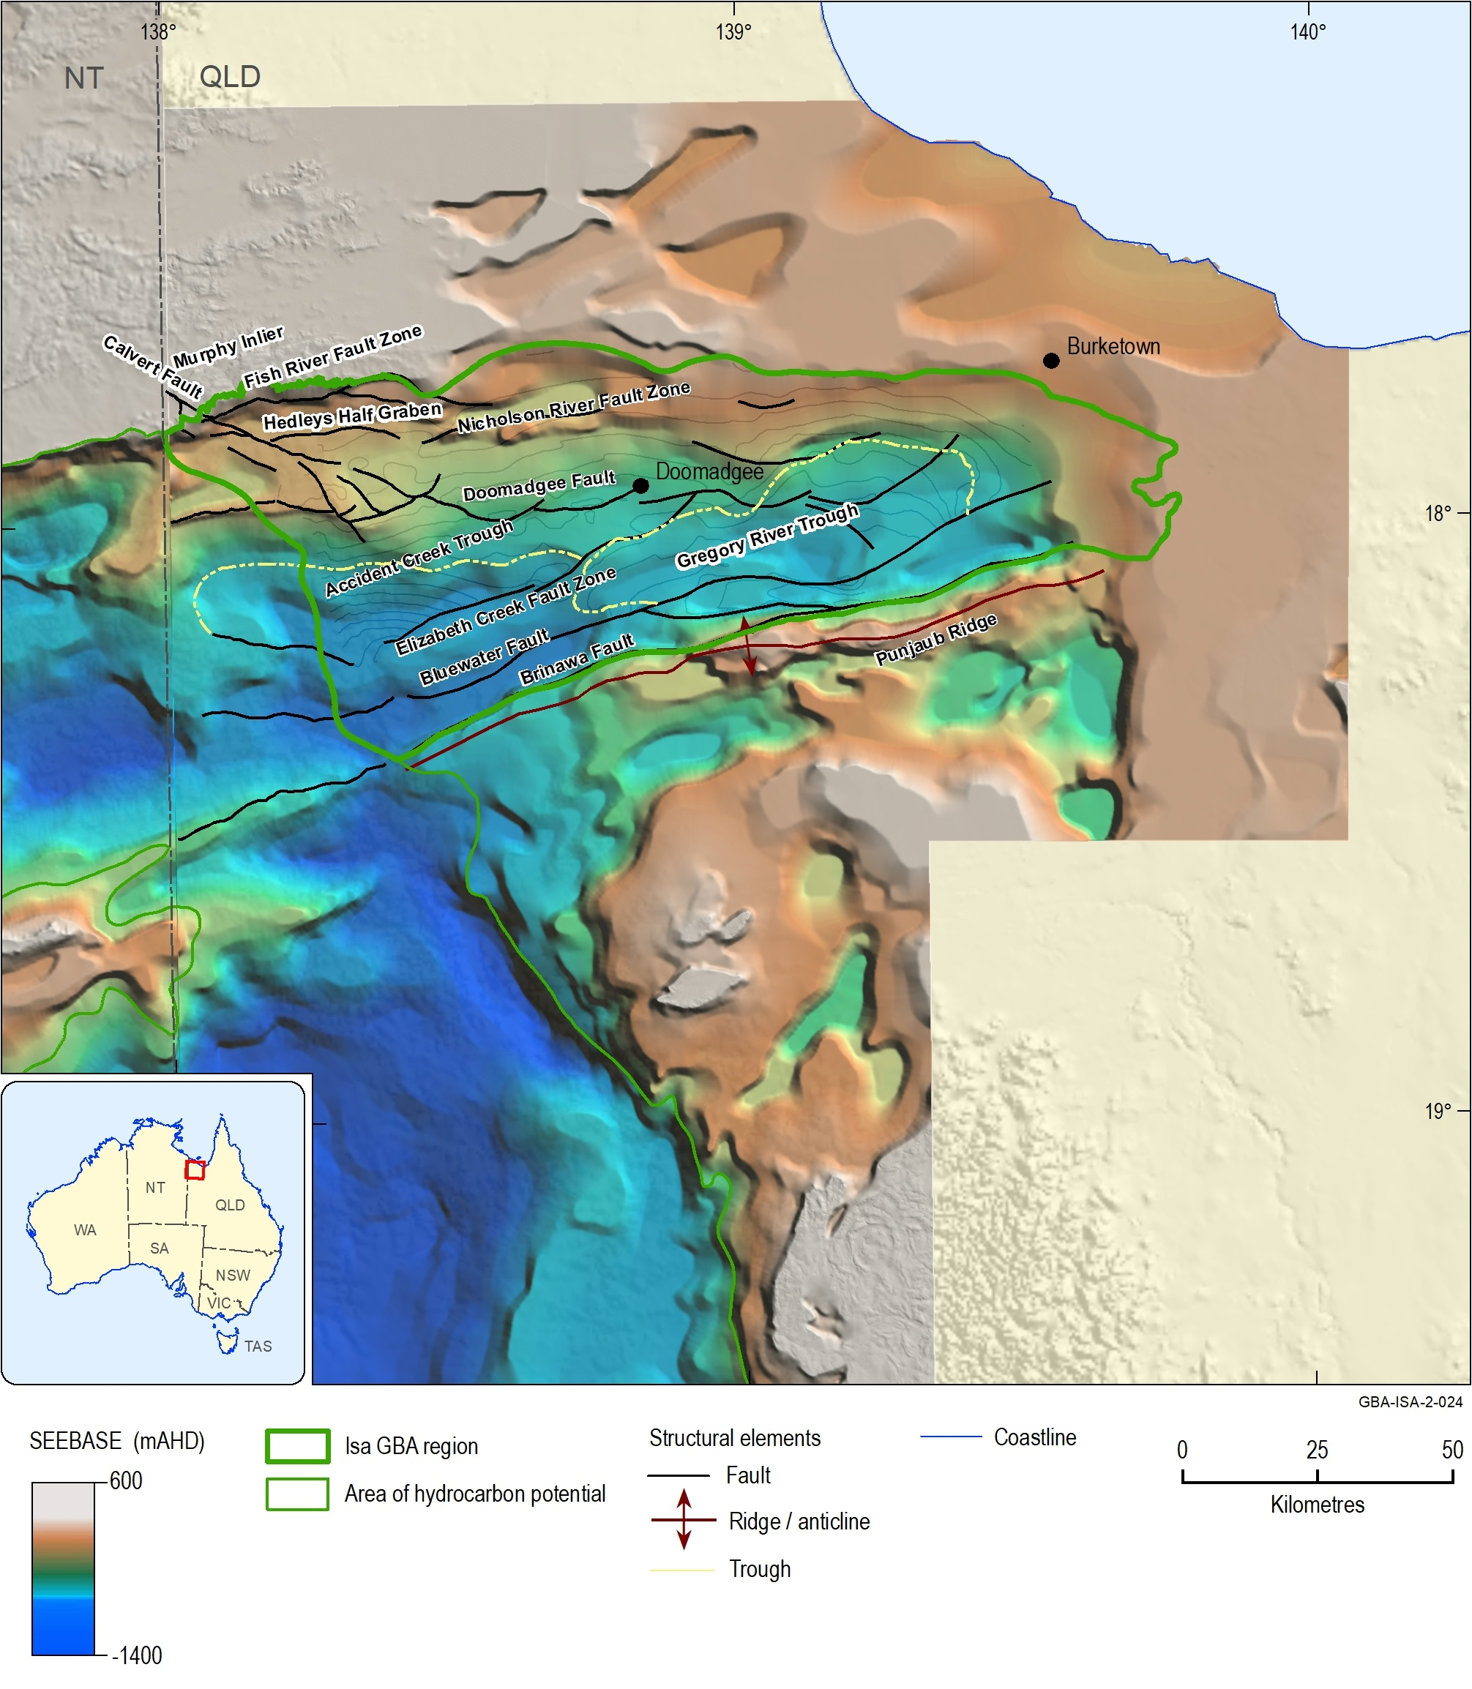
Figure 1 Structural elements map for the northern Lawn Hill Platform superimposed over the Geological Survey of Queensland’s depth to basement image
Source: Structural elements are derived from the base River Supersequence and Base Term Supersequence depth-structure maps of Bradshaw et al. (2018b). Queensland SEEBASE® image sourced from Frogtech Geoscience (2018a). NT SEEBASE® image sourced from Frogtech Geoscience (2018b). See also Orr et al. (2020)
Data: Bradshaw et al. (2018c); Frogtech Geoscience (2018a); Frogtech Geoscience (2018b)
Element: GBA-ISA-2-024
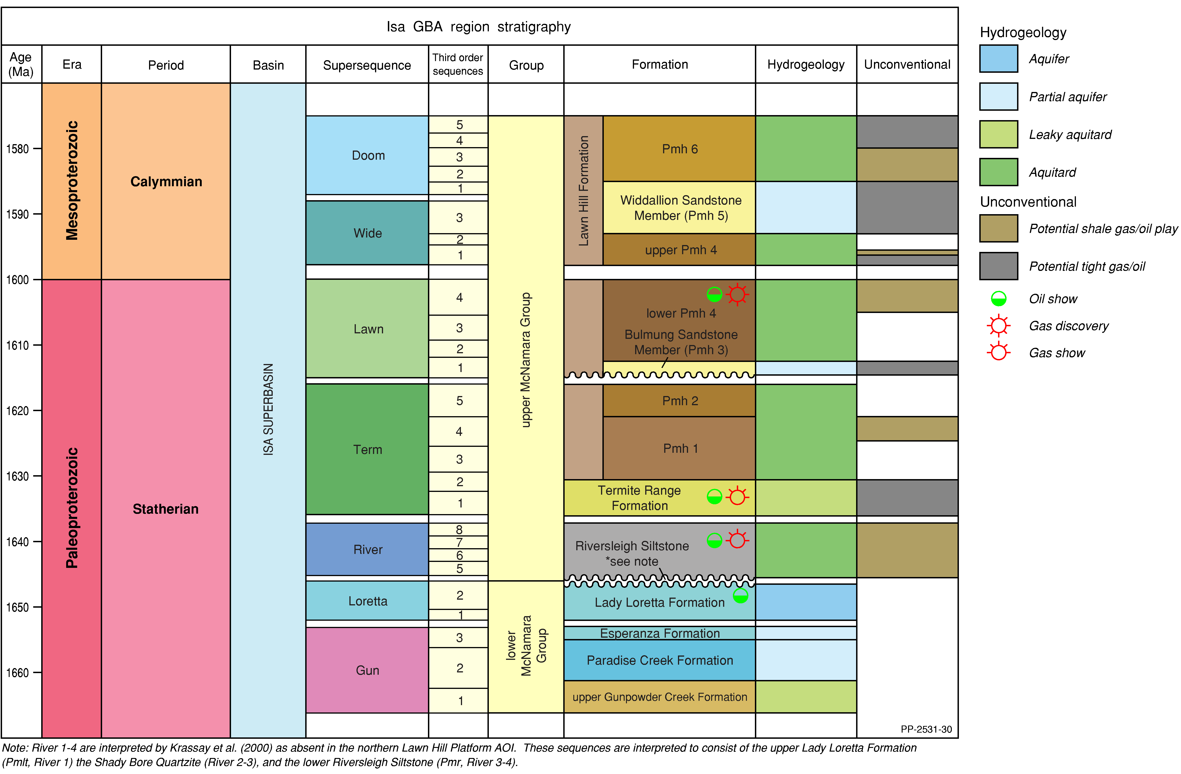
Figure 2 Sequence stratigraphy, lithostratigraphy, hydrostratigraphy and hydrocarbon occurences of the Isa Superbasin
Potential play types (shale gas/oil plays and tight gas/oil plays) are as indicated by Gorton and Troup (2018) and are, in most part, speculative based on present data and untested. Only the shale gas plays of the River and Lawn supersequences have been confirmed as prospective and have undergone limited testing through drilling.
Source: Isa Superbasin after Gorton and Troup (2018); hydrostratigraphic units – see the hydrogeology technical appendix (Buchanan et al., 2020). This is an extract of Figure 24 from the geology technical appendix, for stratigraphy of the overlying basins, see Orr et al. (2020).
Element: GBA-ISA-2-113

Conventional and unconventional gas
Naturally occurring oil and gas accumulations may be differentiated by the terms ‘conventional’ and ‘unconventional’, depending on how the petroleum is trapped in the geological formation (Figure 3).
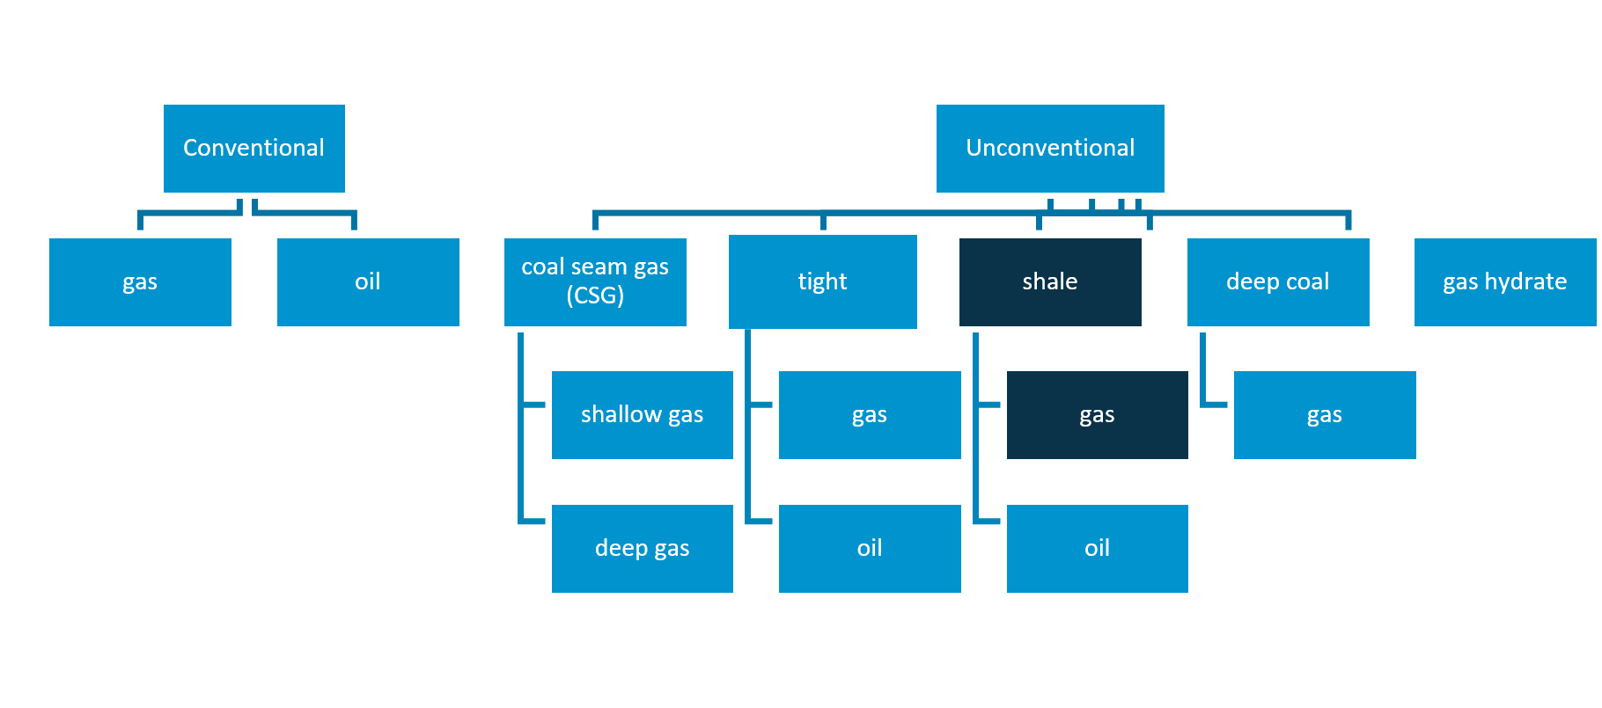
Figure 3 The different types of conventional and unconventional hydrocarbons
Unconventional play types considered for the Isa GBA region are shown in dark blue. Possible tight gas, tight oil and shale oil plays were suggested by Gorton and Troup (2018) but are not assessed in this study due to insufficient data availability.
Source: Cook et al. (2013)
Element: GBA-ISA-2-202
Conventional petroleum accumulations (Figure 3 and Figure 4) are so called because they have the longest association with petroleum exploration and production, and are considered the norm (i.e. conventional) by the industry. These accumulations were the first to be exploited historically as they are relatively easy to find and develop, and have produced the majority of oil and gas worldwide to date. However, they comprise a relatively small part of the petroleum continuum.
Conventional petroleum accumulations occur as discrete accumulations (Figure 4) trapped by a geological structure and/or stratigraphic feature, typically bounded by a down-dip water contact and capped by impermeable rock (Schmoker, 2002; Schmoker et al., 1995) (Figure 4). The petroleum was not formed in situ; but migrated from the source rocks into a trap containing porous and permeable reservoir rocks.
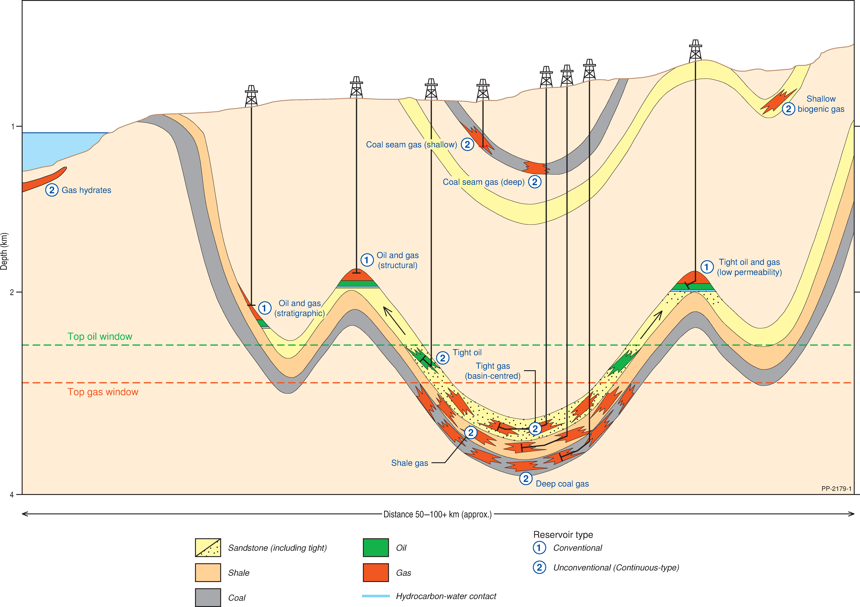
Figure 4 Schematic showing some of the typical types of oil and gas accumulations. Shale gas accumulations have the greatest potential in the Isa Superbasin to bring gas to market within a 10-year time frame
The ‘oil window’ refers to the maturity range in which oil is generated from oil-prone organic matter. Below is the ‘gas window’, which refers to the maturity range in which gas is generated from organic matter.
Source: Cook et al. (2013), Schenk and Pollastro (2002) and Schmoker et al. (1995). See also Lech et al. (2020)
Element: GBA-ISA-2-205
The term ‘unconventional’ is used to refer to the collection of petroleum accumulations that are characterised by low permeability and require reservoir stimulation to develop. They include shale oil and gas, oil shales, tight sands, basin-centred gas, coal seam gas, deep coal gas, methane hydrates and biogenic gas (Figure 3 and Figure 4). While, ‘unconventional' and 'conventional' petroleum accumulations can form from the same source rocks (Schmoker, 2002; Schmoker et al., 1995), due to differences in expulsion, transport, and trap mechanisms, different extraction methods are required. In Australia, the types of known unconventional gas accumulations include tight gas, shale gas and coal seam gas (Geoscience Australia, 2018); however, exploration in the Isa Superbasin is currently only focused on shale gas.
Shale gas is natural gas hosted in sedimentary rocks (commonly shales) with low to moderate porosity (with a pore size of 0.005–0.1 μm) (Nelson, 2009) and very low permeability. Shales are a common petroleum source rock and may retain more petroleum than they expel during the thermal maturation process of organic matter. Once the gas has generated it remains trapped in the shale, either absorbed onto the organic matter or in a free state in the pores and fractures of the rock. Shale gas plays usually occur at depths greater than 1000 to 1500 m below the earth’s surface (Cook et al., 2013). Shale reservoirs occur with significant (10–100 km) lateral continuity and can be of considerable thickness (>100 m). Where shales act as both the petroleum source and reservoir rock, they are sometimes referred to as ‘self-sourcing reservoirs’.
Tight gas plays have been suggested for the Isa Superbasin (Gorton and Troup, 2018), though to date no exploration or testing of these play concepts has occurred. Tight gas is natural gas trapped in siltstone and sandstone reservoirs characterised by low porosity (<8–10%) and permeability (<0.1 mD). Tight gas reservoirs have been exploited for several decades in Australia. Tight gas may occur in discrete reservoirs, where migrated gas accumulates in rocks with low porosity and permeability, in a similar manner to conventional accumulations (e.g. Shanley and Robinson, 2004). Alternatively, tight gas may occur in distributed gas accumulations which have been referred to in the United States as basin-centred tight gas (Law and Curtis, 2002; Schmoker et al., 1995). They are low permeability gas reservoirs which are commonly abnormally overpressured, lack an apparent down-dip water contact and are pervasively gas saturated (Fall et al., 2002; Law and Curtis, 2002).
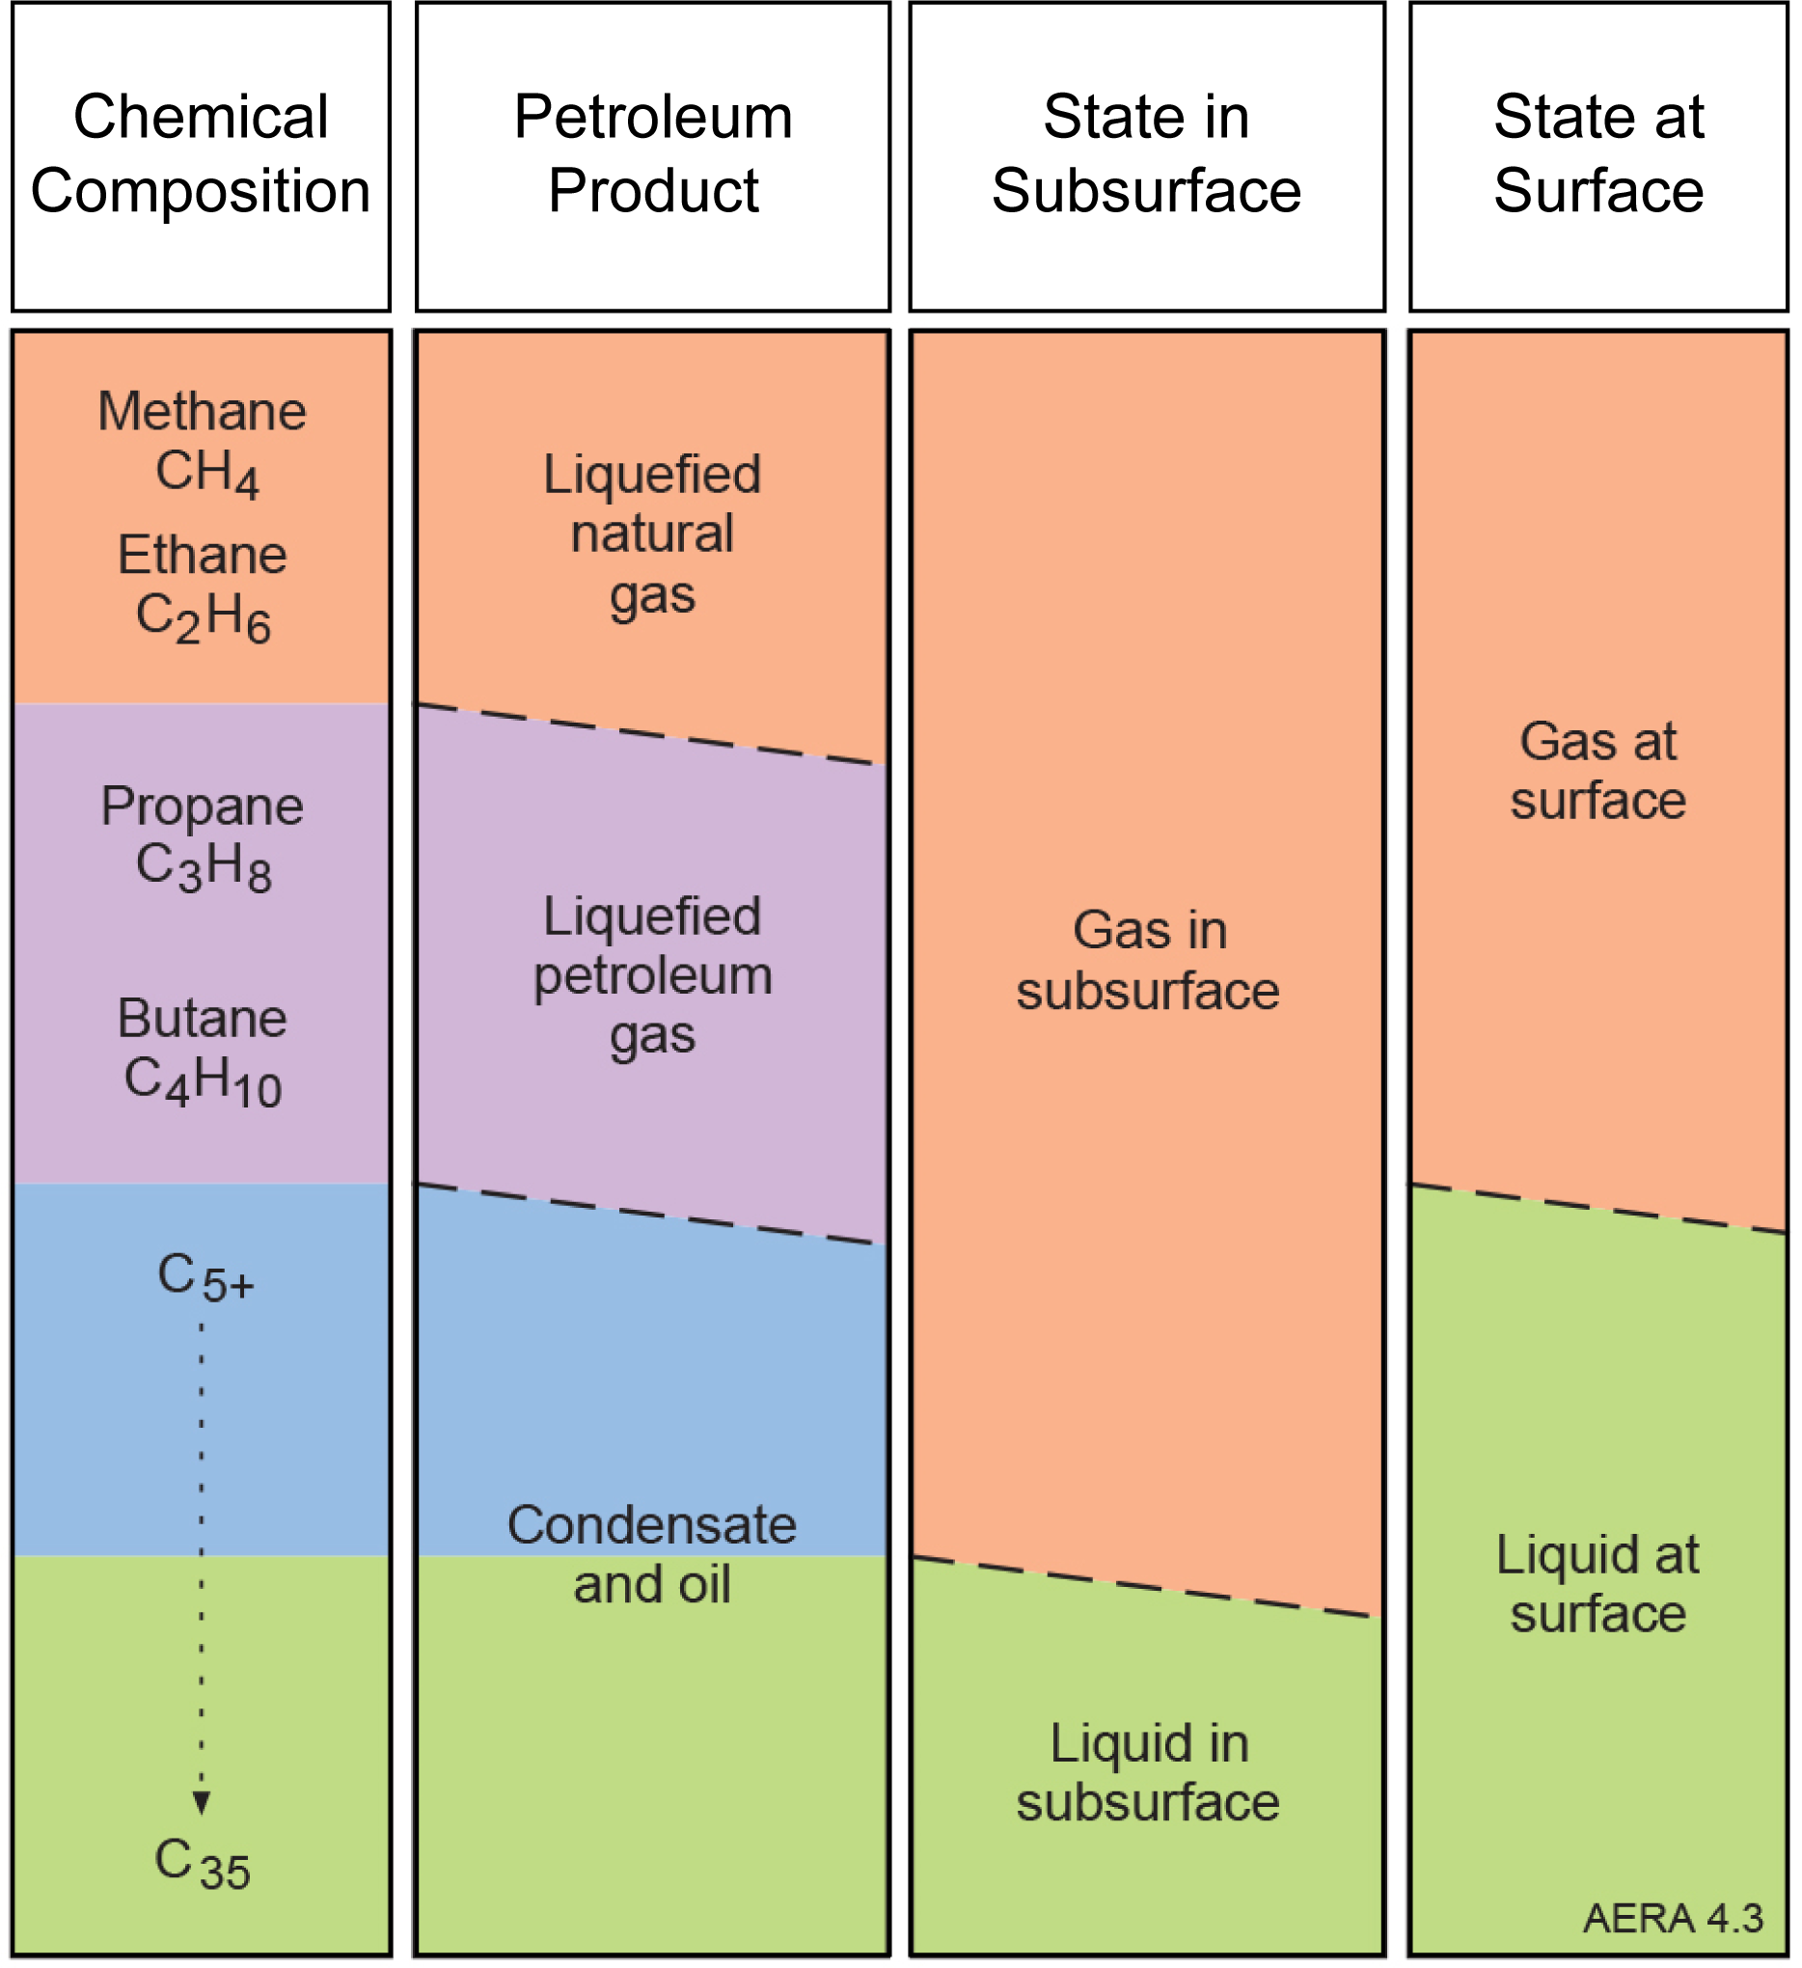
Figure 5 Petroleum resources nomenclature in terms of chemical composition, commercial product, physical state in the subsurface and physical state at the surface
Source: Geoscience Australia et al. (2018)
Element: GBA-BEE-2-195
Gas may be referred to as dry gas or liquids-rich gas depending on its composition. Dry gas is natural gas that is dominated by methane (greater than 95% by volume) with little or no condensate or liquid hydrocarbons. Liquids-rich gas (also known as wet gas) contains less methane than dry gas and more ethane and other more complex hydrocarbons (propane, butane, pentane, hexane and heptane).
The composition of the gas is important for understanding future industry development scenarios in the Isa Superbasin, as liquids-rich gas resources are currently more favourable to develop from an economic perspective. Figure 5 shows petroleum resources nomenclature in terms of chemical composition, commercial product and physical state in both the subsurface and at the surface.

Petroleum prospectivity of the Isa Superbasin
The Isa Superbasin is a frontier basin in which numerous hydrocarbon shows have been reported, though to date no commercial accumulations of conventional petroleum have been discovered. There have been several petroleum exploration campaigns undertaken in the Isa Superbasin, and the overlying Carpentaria and South Nicholson basins, since the 1960s. The most recent of these focused on the unconventional potential of the Lawn and River supersequences as a shale gas play, identifying contingent (2C) resources of 154 Bcf (148 PJ) within the Lawn Supersequence in the Lawn Hill Platform (Table 1) (Armour Energy, 2015).
The Isa Superbasin is located approximately 300 km from existing infrastructure which has the potential to feed into the East Coast Gas Market. Other potential avenues to market include a proposal to export gas from an LNG terminal in the Gulf of Carpentaria (Armour Energy, 2014).
Table 1 Isa Superbasin petroleum prospectivity summary
Petroleum prospectivity - general
Petroleum systems | Proven Paleoproterozoic (Statherian) system
Prospectivity | High
Conventional discoveries | None
Hydrocarbon production – total to date | None
2P Reserves – total | None
2C Resources – total | 0.154 Tcf
Prospective resources – total | 22.1 Tcf of shale gas in the River and Lawn supersequences (at P50)
Petroleum prospectivity–shale/tight gas
Unconventional play types | Shale gas
Number of wells targeting shale/tight gas plays | 3 (two vertical, one horizontal)
Production – shale/tight gas | None
2P Reserves – shale/tight gas | None
2C Resources – shale/tight gas | 0.154 Tcf
Prospective resources – shale/tight | 22.1 Tcf of shale gas in the River and Lawn supersequences (at P50)
Hydrocarbon shows, tests- shale/tight gas | Significant gas peaks through petroleum wells Egilabria 2 and Egilabria 4, post-frac gas flows to surface from Egilabria 2 DW1
Tcf = trillions of cubic feet

Exploration history
Table 2 Summary of exploration status of the Isa Superbasin on the northern Lawn Hill Platform
EXPLORATION STATUS
Seismic lines | 1141 line km two-dimensional seismic
Number of petroleum wells | 14 vertical, 1 horizontal
Exploration status – conventional | Underexplored
Exploration status – coal seam gas | Not applicable
Exploration status – shale/ tight gas | Underexplored
Number of petroleum wells includes BMR Westmoreland 1 and BMR Westmoreland 2, both of which are stratigraphic wells. The wells Lawn Hill DDH 83-1, Lawn Hill DDH 83-2 and Lawn Hill DDH 83-5 are located outside of the Isa GBA region but are included in the above total. The petroleum exploration well Armraynald 1 did not penetrate to the Isa Superbasin succession and is outside the Isa GBA region, and is not included in the above total. See Figure 6 for well locations.

Conventional petroleum exploration
Geological exploration of the Lawn Hill Platform began in 1856, when the explorer A.C. Gregory observed granites, basalts and sandstones in the region. Lead-silver mineralisation was discovered in the late 1880s, which drew further interest in the area. Numerous investigations of the Burketown Minerals Field are noted throughout the 19th and 20th century (Dorrins et al., 1983), however, the first concerted effort to explore for hydrocarbons in the Isa Superbasin was not until 1983.
While there was earlier exploration within the Carpentaria Basin (which overlies the Isa Superbasin across most of the region), notably the drilling of Karumba 8 by Associated Australian Oilfields in 1958 and Burketown 1 by Mid Eastern Oil in 1964, the first structured exploration program within the Lawn Hill Platform was undertaken by the Amoco Australia Petroleum Company in 1983. Amoco was granted ATP 327P on September 13, 1982 and drilled five shallow exploration drillholes in 1983. The permit ATP 327P covered 16,750 km2 of the Lawn Hill Platform and was considered to contain Proterozoic sediments with structural and stratigraphic similarities to the McArthur Basin. Amoco drilled a total of 2959 m over five wells aiming to test the source and reservoir quality of the McNamara, Fickling, and South Nicholson groups (Dorrins et al., 1983; Orr et al., 2020). The drillholes were sited without seismic control and none were located on known structures (Dunster et al., 1993b). Notably, oil bleeds were observed within core from the Walford Dolomite in the drillhole Lawn Hill DDH 83 4, and high TOC black shales in the Lawn Hill and Riversleigh formations were intersected in Lawn Hill DDH 83 1 and Lawn Hill DDH 83 2.
In 1986, a joint venture of Comalco Aluminium Limited and Bridge Oil Limited was granted ATP 373P, an immense exploration permit covering almost all of the onshore Carpentaria Basin, and a consolidation of the previously existing ATP344P and ATP361P permits. Phoenix Resources Co. (Aust.) Inc. bought into this new permit in 1988, but their involvement was short-lived and they pulled out of the joint venture the following year. In 1989, the Burketown Block of ATP 373P was surrendered, along with another permit (ATP 405P) and these were combined to form ATP 423P. While most of the work in ATP 373P was in the Lawn Hill Platform area, two of the seven wells drilled in the permit were within or near the current Isa GBA region. These were Armraynald 1, drilled in September 1988, and Beamesbrook 1, drilled in October 1988. Armraynald 1 failed to penetrate Isa Superbasin sediments, although Beamesbrook 1 intersected at least 800 m of Isa Superbasin succession (Figure 6). Notably, the Lawn Supersequence was penetrated, noted as an excellent source rock, and produced drill gas at up to 40 times the background level (ATP 373P relinquishment report). Despite several indications of active petroleum systems within the Carpentaria Basin, or the underlying basins, the Comalco-led joint venture opted to relinquish ATP 373P in 1992 due to a perceived lack of prospectivity (Dunster and Barlow, 1992).
In the early nineties, an expanded Comalco-led joint venture, now including Monument Resources (Aust.) Limited and Bridge Oil Limited, drilled three petroleum exploration wells within ATP 423P. Comalco was interested in finding a local source of oil with a view to providing cheap energy to their bauxite and kaolin mine at Weipa. A favourable location relative to the existing energy market in Mount Isa and the surrounding mines helped provide further justification (Dunster et al., 1993c). The three wells drilled in 1992, Desert Creek 1, Argyle Creek 1, and Egilabria 1, aimed to assess the possibility that early generated Proterozoic oil and gas remained in commercial quantities within the Isa Superbasin succession (Dunster et al., 1993c). While not intersecting any oil- or gas-bearing zones, high gas levels were recorded in the McNamara Group (see Figure 26, geology technical appendix (Orr et al., 2020)) in all three wells, with oil shows in Argyle Creek 1 and Egilabria 1. This was not enough for the joint venture to justify further exploration, and represents the end of conventional petroleum exploration within the Isa Superbasin. In total, 1090 line km of two-dimensional seismic data was acquired over the course of the Comalco-led joint venture programs between 1988 and 1991.

Unconventional petroleum exploration
In December 2012, Armour Energy Limited were granted exploration tenement ATP 1087P (Figure 7) by the Queensland Government. ATP 1087 covers 7138 km2 and coincides with much of the area covered by the previous ATP 423P licence that Comalco Aluminium Limited explored in the early 1990s. Armour Energy Limited were interested in the potential of the Lawn Supersequence and the River Supersequence as potential shale gas targets, following significant gas shows recorded across those intervals during previous exploration of the basin by Amoco Australia Petroleum Company and Comalco Aluminium Limited. Armour Energy Limited considered the results of Beamesbrook 1 and Egilabria 1 to be encouraging for the presence of significant volumes of unconventional gas (Armour Energy, 2012). Armour Energy Limited began their exploration program in 2013 by reprocessing the vintage Comalco seismic grid, and by contracting CGG Aviation (Australia) Pty. Ltd. to undertake an airborne gravity gradiometer and high-sensitivity aeromagnetic survey of ATP 1087P. This aerial survey was undertaken in August 2013, and resulted in acquisition of a combined total of 8892 line km of potential field data (CGG Aviation, 2013).
Armour Energy Limited carried out a drilling program from June 2013, beginning with the drilling of Egilabria 2. This well was located approximately 600 m north of the Comalco well Egilabria 1 in order to evaluate the Lawn Supersequence. Following gas shows within the Lawn Supersequence, a sub-horizontal directional well, Egilabria 2 DW1, was extended 567 m from the vertical pilot Egilabria 2 to further assess the hydrocarbon potential of the Lawn Supersequence as well as serve as a test-bed for hydraulic stimulation of the formation (Longdon, 2014a). Before shutting the well in, Johnson and Titus (2014) reported that fracturing fluid was flowing back into the well unassisted and gas was flaring at low surface flowing pressures. These authors reported Egilabria 2 DW1 as the first successful, post-frac gas flow from a multi-stage, fracture stimulated, lateral shale gas well in Australia (Johnson and Titus, 2014). Gas shows were also recorded in the South Nicholson Group, and the Doom and Wide supersequences in Egilabria 2 (see Figure 26, geology technical appendix) (Longdon, 2014b; Orr et al., 2020).
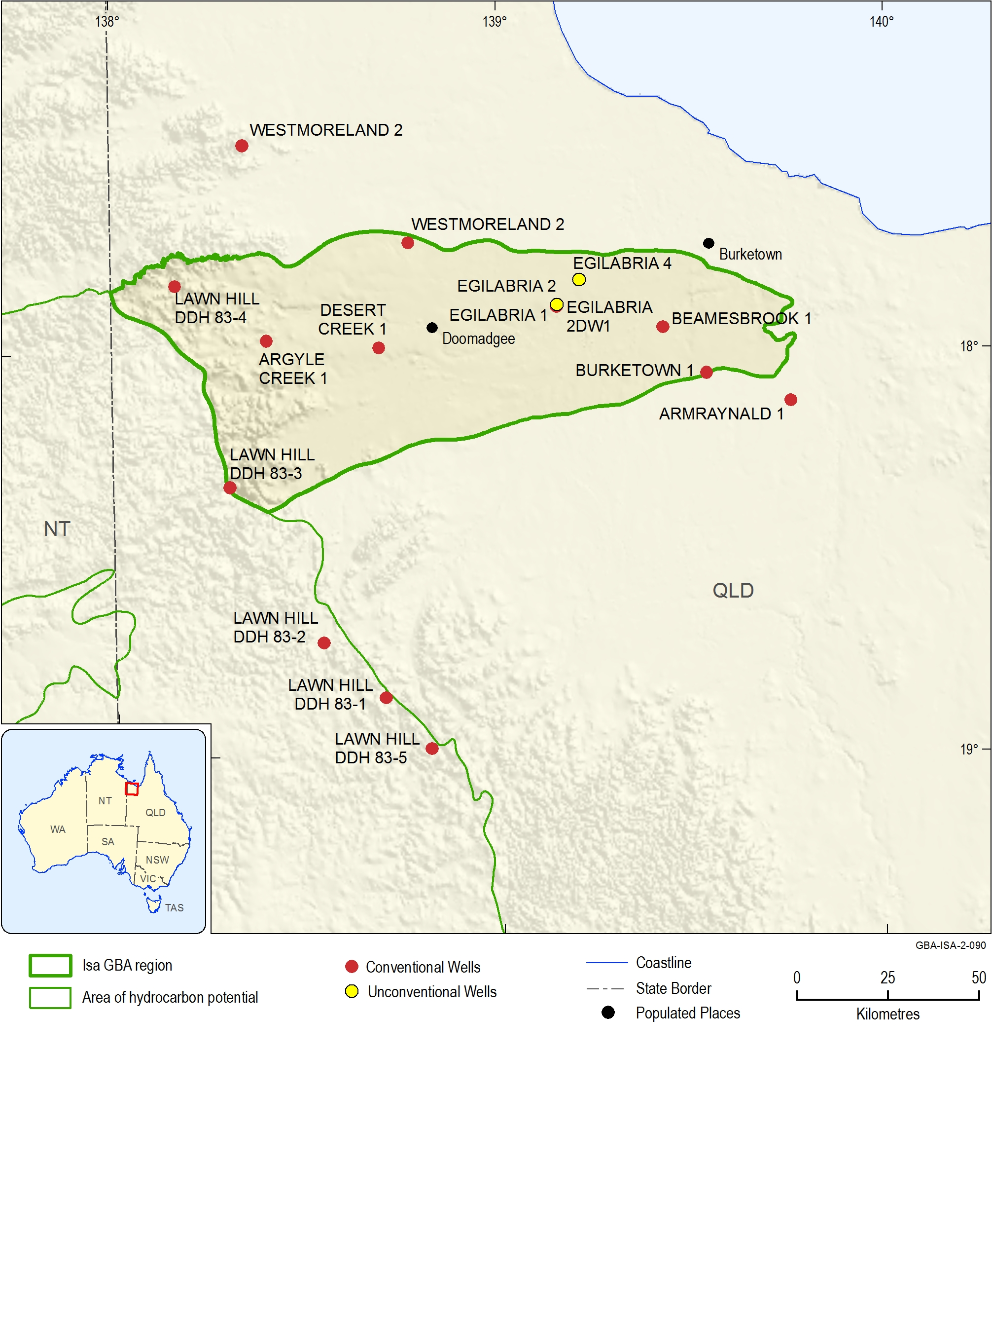
Figure 6 Key petroleum wells in the Isa GBA region and surrounds
Conventional wells are primarily petroleum exploration wells with the exception of BMR Westmoreland 1 and BMR Westmoreland 2 which are stratigraphic holes. Egilabria 2/2DW1 and Egilabria 4 are the only unconventional petroleum exploration wells drilled to date.
Data: Petroleum Well Locations – Queensland (Department of Natural Resources, 2017)
Element: GBA-ISA-2-090
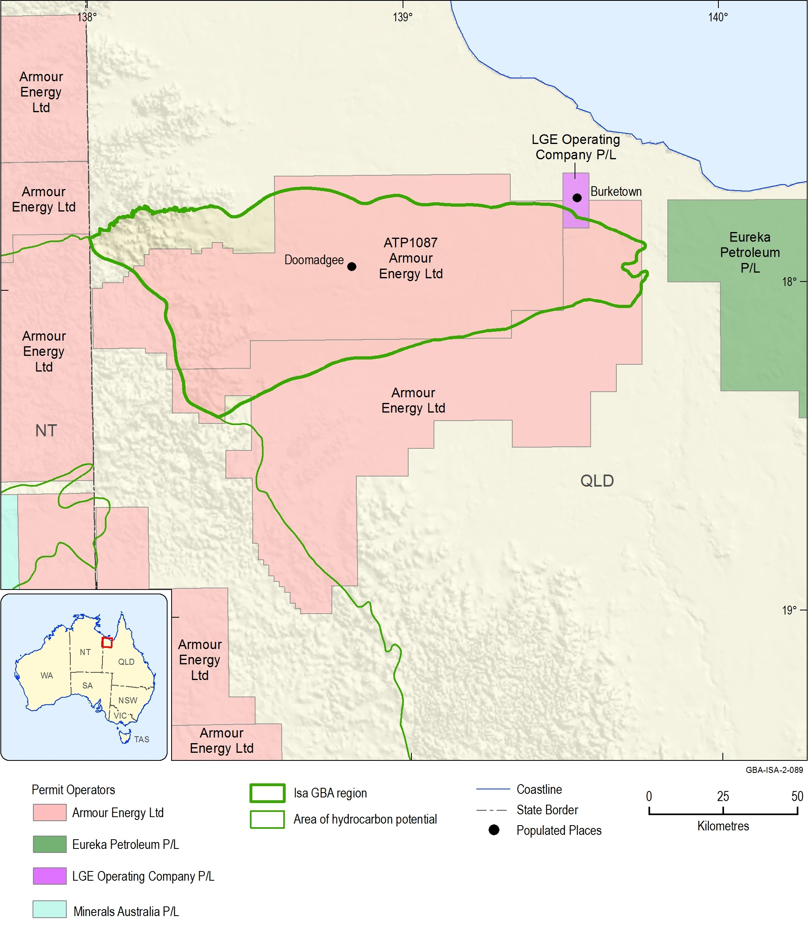
Figure 7 Permit map of the Isa GBA region and surrounds as of December 2018
LGE Operating Company P/L, currently trading as Peak Services, have EPG 2011 under application. This permit is an approximately 164 km2 geothermal exploration permit surrounding Burketown.
Data: Permit locations from the GPInfo petroleum database, a PBS Pty Ltd product (PBS Pty Ltd, 2018)
Element: GBA-ISA-2-089
The final well drilled in ATP 1087 by Armour Energy Limited was Egilabria 4 (there is no Egilabria 3), spudded in August 2013 approximately 5 km north-east of Egilabria 2. Egilabria 4 was intended to further test the hydrocarbon potential of the Lawn Supersequence, as well as to assess the potential of both the River Supersequence and the Loretta Supersequence. The well encountered numerous gas shows through to its total depth at 1839 mMD, primarily within the River and Lawn supersequences, as well as the Doom Supersequence. Gas was also encountered within the base of the Mesozoic units indicating hydrocarbon migration since the deposition of the Carpentaria Basin (Longdon, 2014c). Gas peaks in Egilabria 4 are noted as being far smaller than in Egilabria 2 due to the fact that Egilabria 4 was deliberately drilled off-structure in order to test shale tightness, whereas Egilabria 2 targets the same structure Comalco Limited were interested in with Egilabria 1 (Longdon, 2014c). Since 2013, no further appraisal wells have been drilled within ATP 1087 by Armour Energy Limited, and no other companies have undertaken any other hydrocarbon exploration activity in the region.

Reserve and resource estimates

Unconventional reserves and resources
There are currently no confirmed unconventional gas reserves reported for the Isa Superbasin. However, Armour Energy Limited has reported contingent resources for the Lawn Supersequence as well as prospective resources for the Lawn and River supersequences as outlined in Table 3. Note the Petroleum Resources Management System (PRMS, 2007) is used for classification of oil and gas resources for companies registered on the Australian Securities Exchange (ASX (Australian Securities Exchange), 2014; RISC, 2013).
Table 3 Total reported Isa Superbasin gas resources
Gas resource type | 2P Reserves (Tcf) | Remaining resources (reserves + contingent resources) (Tcf) | Prospective resources (Tcf)
Conventional | 0 | 0 | 0
Shale | 0 | 0.154 | 22.1
Tight | 0 | 0 | 0
Total | 0 | 0.154 | 22.1
2C contingent resources are for the Lawn Supersequence as reported and contingent resources have not been assessed for the River Supersequence. There has been no assessment of the tight gas potential of the Isa Superbasin. Gas volumes are reported in trillions of cubic feet (Tcf).
Source: McConachie (2015b, 2015a)

Reserves
Only three wells targeting shale gas plays in the Isa Superbasin have been drilled, with Egilabria 2 DW1 flowing gas to surface. There has also been no exploration targeting tight gas within the Isa Superbasin or the overlying Carpentaria and South Nicholson basins of north-west Queensland.

Identified resources
Table 4 lists the reported contingent resources for shale gas within the Isa Superbasin. Armour Energy Limited reported a 2C contingent resource of 154.4 Bcf (148.5 PJ) within the Lawn Supersequence within ATP 1087P. No contingent resources have been reported for the River Supersequence and no other company has explored for unconventional gas within the Isa Superbasin.
Table 4 Industry reported unconventional gas contingent resources for the Isa Superbasin
State | Assessment area | Operator | Contingent resources (Tcf) |  |  | Play type | Reservoir | Source
 |  |  | 1C | 2C | 3C
Qld | Egilabria 2 DW1 Lawn Hill Shale | Armour | 0.033 | 0.154 | 0.364 | Shale gas | Lawn 4 Shale (Lawn Hill Formation) | McConachie (2015a)
Refer to the source reference for further details on assessment area, methodology and associated uncertainties. Gas volumes are reported in trillions of cubic feet (Tcf).
Source: McConachie (2015a)

Prospective resources
Table 5 lists all of the reported prospective resources that have been reported in the Isa Superbasin as gas-in-place figures. Table 6 shows the same prospective resources as estimated recoverable gas.
Table 5 Industry reported unconventional gas prospective resources for the Isa Superbasin
State | Assessment area | Operator | Prospective resources  (Tcf gas-in-place) |  |  | Play type | Reservoir | Source
 |  |  | P90 | P50 | P10
Qld | ATP 1087P (Lawn Hill Platform) | Armour | 32.395 | 61.236 | 111.788 | Shale gas | Lawn 4 Shale (Lawn Hill Formation) | McConachie (2015a)
Qld | ATP 1087P (Lawn Hill Platform) | Armour | 42.107 | 107.930 | 239.032 | Shale gas | Riversleigh Siltstone | McConachie (2015b)
Refer to the source references for further details on assessment area, methodology and associated uncertainties. Gas volumes are reported in trillions of cubic feet (Tcf).
Source: McConachie (2015b, 2015a)
Table 6 Estimated recoverable industry reported unconventional gas prospective resources for the Isa Superbasin
State | Assessment area | Operator | Prospective resources (Tcf estimated recoverable) |  |  | Play type | Reservoir | Source
 |  |  | P90 | P50 | P10
Qld | ATP 1087P (Lawn Hill Platform) | Armour | 2.729 | 8.109 | 19.576 | Shale gas | Lawn 4 Shale (Lawn Hill Formation) | McConachie (2015a)
Qld | ATP 1087P (Lawn Hill Platform) | Armour | 3.876 | 13.985 | 39.448 | Shale gas | Riversleigh Siltstone | McConachie (2015b)
Total estimated prospective resource: |  |  | 6.605 | 22.094 | 59.024 | Armour Energy (2015); McConachie (2015b, 2015a)
Refer to the source references for further details on assessment area, methodology and associated uncertainties. Gas volumes are reported in trillions of cubic feet (Tcf).
Source: McConachie (2015b, 2015a)

Gas market access and infrastructure
The Isa GBA region is approximately 300 km north-north-west of the city of Mount Isa, an urban centre of approximately 19,000 people. There are four small gas-fired power plants in Mount Isa: the Mica Creek plant (367.9 MW); the Diamantina plant (270 MW); the Leichhardt plant (65 MW); and the Xstrata plant (65 MW). These four power plants are not part of the National Energy Market, and currently source gas through the Carpentaria Gas Pipeline from Ballera which sources gas from the Cooper and Eromanga basins.
A summary of market access and infrastructure is provided in Table 7 and Figure 8. The Carpentaria Gas Pipeline potentially provides access from Mount Isa to the East Coast Gas Market through the Ballera compression plant, however, the pipeline does not currently allow for reverse flow (Australian Energy Regulator (AER), 2017). The Northern Gas Pipeline was completed in late 2018 and connects Mount Isa to Tennant Creek in the Northern Territory (NT). Not only does the Northern Gas Pipeline connect Mount Isa to the East Coast Gas Market, but also to the NT gas market. The NT gas market consists of several pipelines linking the producing gas fields of the Amadeus Basin in the south and the offshore fields of the Bonaparte Basin with population centres in Alice Springs, Tennant Creek, Daly Waters and Darwin. There is significant gas infrastructure in Darwin, including two liquefied natural gas (LNG) export terminals and the Darwin Helium Plant. There are also several large base metal mining operations that rely on gas for energy generation nearby, such as Century, Cannington, and Osborne.
Table 7 Summary of market access and infrastructure
INFRASTRUCTURE
Gas market | Proximal to Mount Isa, connections to East Coast Gas Market and NT gas market
Proximity to gas pipelines | Carpentaria Pipeline (Ballera to Mount Isa) – capacity 119 TJ/ Day  Northern Gas Pipeline (Tennant Creek to Mount Isa) – capacity 90 TJ/Day
Gas processing facilities | None
Approximate distance from existing pipelines to area prospective for shale gas and/or tight gas | >200 km
Road and rail access | Poorly serviced
Approximate development time frame | 10–20 years
Source: Hall et al. (2018)
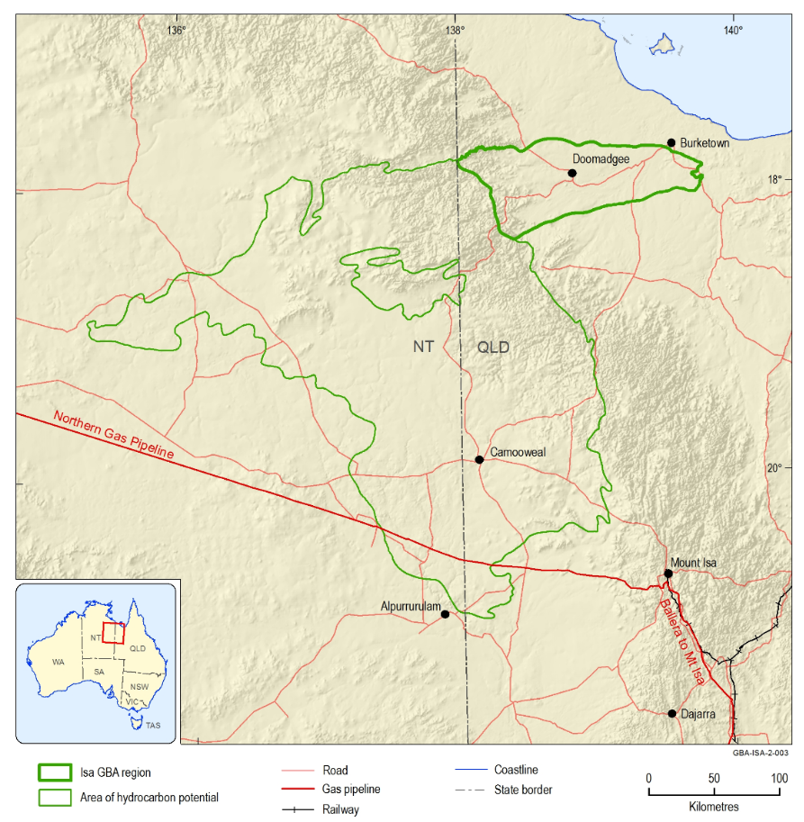
Figure 8 Isa Superbasin region infrastructure
Although there is a recognised resource at Egilabria 2 (located between Doomadgee and Burketown) the full extent of the Isa Superbasin remains unknown (see Orr et al., 2020 for further discussion). There are presently no gas production facilities in the region. The Northern Gas Pipeline from Tennant Creek to Mount Isa was completed in December 2018. The Carpentaria pipeline connects from Ballera in the Cooper Basin to Mount Isa.
Data: Australian Topographic Base Map (Web Mercator) Web Map Server (WMS), (Geoscience Australia, 2017a); National Oil and Gas Infrastructure WMS, (Geoscience Australia, 2017b), Isa GBA region and area of hydrocarbon potential outlines from Geological and Bioregional Assessment Program (2018)
Element: GBA-ISA-2-003

Regional petroleum systems

Introduction
Proterozoic sedimentary basins with proven petroleum systems are prevalent across northern Australia, the most well-known of which is the Beetaloo Sub-basin in the Greater McArthur Basin of the NT (Revie and Edgoose, 2015). Recent exploration and appraisal in the Beetaloo Sub-basin has identified significant volumes of gas hosted in Proterozoic aged unconventional shale reservoirs (Gorton and Troup, 2018). The Isa Superbasin is related in age and depositional history to the Greater McArthur Basin, however, stratigraphic correlation and the extent of units between the basins has generally been poorly defined (see Orr et al. (2020) and discussion therein).
The Isa Superbasin is known to host excellent source rocks which have previously produced significant volumes of hydrocarbons (Table 8) (Figure 9) (Gorton and Troup, 2018). Several potential reservoirs are known, though timing of hydrocarbon generation, expulsion, and migration is a significant issue for the preservation of hydrocarbon accumulations over such a long time-span (Figure 9). Shale gas accumulations are likely within the organic-rich mudstones of the Lawn and River supersequences, where Armour Energy Limited has identified an estimated 22.1 Tcf of prospective resources (Figure 9). The regional petroleum systems of the Isa GBA region are summarised in Table 8, and the interpreted components of potential conventional and unconventional petroleum systems are discussed below. A petroleum systems event chart for potential unconventional plays in the Isa GBA region is presented in Figure 9.
Table 8 Summary of regional petroleum systems elements
Play types - conventional | Timing of generation, expulsion, and preservation over more than a billion years, paired with a poor understanding of exhumation, diagenesis, and hydrothermal events over that interval, results in a low potential for conventional clastic reservoirs (structural and stratigraphic traps) and carbonate reservoirs.
Play types - unconventional | Unconventional gas targets are likely, with self-sourcing organic-rich sediments. Basin-centred gas may be trapped in tight sandstones but is yet to be investigated.
Reservoirs | Potential conventional reservoirs exist through the Isa Superbasin; the Loretta Supersequence (Lady Loretta Formation) and sands of the Term (Termite Range Formation), Lawn (Bulmung Sandstone), Wide and Doom supersequences (Widdallion Sandstone Member) are all candidates. The Lawn and River supersequence are considered unconventional reservoirs.
Seals | Highstand mudstone units at the top of third-order sequences and supersequences may act as seals; regional seals are likely to be provided by the latter.
Source rocks | Lawn Supersequence, River Supersequence, Term Supersequence (Termite Range Formation - Potential), Gun Supersequence (Esperanza Formation - Potential)
Hydrocarbon shows | Numerous hydrocarbon shows are observed:  - significant gas shows in the Lawn and River supersequences, minor gas shows through most intersected units in Isa Superbasin  - oil bleeds and bitumen in the Loretta Supersequence (Walford Creek Dolomite, a lateral equivalent to the Lady Loretta Formation)  - bitumen in the Term Supersequence (Termite Range Formation), the Lawn Supersequence and River Supersequence  - the best oil shows are in the Constance Sandstone of the South Nicholson Basin.
Source: Gorton and Troup (2018)
Methods snapshot: comparing Proterozoic Earth and Phanerozoic Earth
Earth in the Proterozoic was completely alien to the present-day Phanerozoic Earth. The beginning of the Proterozoic is roughly defined as the time where the planet had cooled to the point where modern-day plate tectonic processes became dominant, allowing for stable continents to form and accrete (Ogg et al., 2016). The oldest era of the Proterozoic, the Paleoproterozoic, features four periods whose names are derived from the dominant geological processes that occurred at that time (Ogg et al., 2016):
Siderian (‘iron’, 2.50 - 2.30 Ga): The majority of iron precipitates from the oceans during the Great Oxidation Event (GOE: ca 2.4–2.0 Ga) (Holland, 2006)
Rhyacian (‘stream of lava’: 2.30–2.05 Ga): Large layered igneous complexes formed
Orosirian (‘mountain range’: 2.05–1.80 Ga): Episode of Orogeny on all continents
Statherian (‘stable, firm’: 1.80–1.60 Ga): New platforms form (e.g. north Australia).
Atmospheric oxygen began accumulating during the Proterozoic GOE, which was only possible once oceanic reserves of unoxidised sulfur and iron were depleted. The earliest Proterozoic is recognised for the deposition of banded iron formations, which peaked just after the Archean–Proterozoic boundary and continued until around 1.9 Ga. By this point, atmospheric oxygen had increased from less than 0.0001% to about 15% of present atmospheric concentrations (Stanley, 2005). Increased atmospheric oxygen during the GOE led to progressive oxygenation of the shallow oceans, however, the deep oceans remained anoxic until ca. 1.8 Ga (Holland, 2006). The change in atmospheric composition allowed advanced single-celled eukaryotes to evolve and compete with prokaryotic life; by the Neoproterozoic multicellular life was thriving (Ogg et al., 2016). The Proterozoic to Phanerozoic (‘visible life’) boundary is about 541 Ma, where the first animal skeletons appear in the fossil record (Ogg et al., 2016). The Phanerozoic is the eon of abundant animal and plant life, as opposed to the cyanobacteria and basic eukaryotes of the Proterozoic (Ogg et al., 2016).
The Isa Superbasin was formed during the Statherian, a period characterised on most continents by the formation of new platforms (Ogg et al., 2016). These continents were not the same as Phanerozoic continents; no land plants had yet evolved, meaning erosion rates would have been significantly higher, organic matter would have been composed primarily of cyanobacteria, and the oceans remained primarily anoxic (Holland, 2006). While basic precursors to fungi appeared at about 1.3 Ga, it wasn’t until about 850 Ma that multicellular photosynthetic eukaryotes had colonised the continents (Knauth and Kennedy, 2009). The first embryohytes (land plants) were very basic plants that evolved during the Ordovician. True vascular plants had evolved by the Silurian, and by the Late Devonian woody plants had formed forests of tall trees. By the Carboniferous, land plants had evolved the wood fibre lignin and the waxy substance suberin; allowing for the accumulation and preservation of dead plant material and ushering in a period of significant coal deposition. By the Carboniferous, the Earth was similar to present day; insects and tetrapods roamed heavily vegetated continents that experienced tectonic and climactic processes similar to the current day (Ogg et al., 2016).

Petroleum systems elements

Source rocks
Isa Superbasin source rocks consist primarily of highstand sediments near the end of each supersequence (Gorton and Troup, 2018). The organic-rich mudstones of the River and Lawn supersequences (the Riversleigh Siltstone and the lower Pmh4 unit of the Lawn Hill Formation, respectively; Figure 2) are noted as being the best developed source intervals within the Isa Superbasin succession, however, additional source rocks may be present within fourth and third-order highstand sediments (Gorton and Troup, 2018).
Organic richness of these formations is fair to good (Chinn, 1991; Gorton and Troup, 2018) and mean TOC exceeds 2% and is up to 11%. Burial-maturity relationships are difficult to establish due to thermal overprinting by several interpreted hydrothermal events. However, thermal indicators suggest that while these source rocks are classified as type II to type I and were initially oil-prone, they are now within the peak to dry gas generation window (Gorton and Troup, 2018; Largeau et al., 1980).

Reservoirs and seals
Initial exploration in the Isa Superbasin was for conventional petroleum accumulations and was halted based on the failure to identify any petroleum accumulations, presumed as being due to lack of an effective reservoir-seal pair. However, it remains possible that conventional accumulations may be found.
Potential conventional reservoirs are identified in the thick-bedded platform carbonates of the Loretta Supersequence, as well as in lowstand sandstones overlying regional unconformities such as within the Lawn (Bulmung Sandstone), Wide and Doom supersequences (Widdallion Sandstone Member) (Figure 2) (Gorton and Troup, 2018). Turbiditic sandstones within the Term Supersequence (Termite Range Formation) may form conventional or tight reservoirs but are untested for both. Highstand mudstones within third-order sequences are identified as potential seals, with supersequence level highstand mudstones potential regional seals (Gorton and Troup, 2018). McConachie (1993) suggested intraformational seals to be common and widespread, with good lateral continuity. The Lawn and River supersequences are both unconventional shale gas play reservoir-seal couplets and are discussed in more detail in Section 4 of this appendix. Additionally, while this report focusses on the unconventional shale reservoirs of the River and Lawn supersequences in the Proterozoic succession, it is also possible that generation from these or other Proterozoic source rocks (Figure 9) have charged conventional or tight reservoirs within the Isa Superbasin succession, or within Mesoproterozoic or Mesozoic reservoirs in the overlying successions (Gorton and Troup, 2018).

Petroleum geochemistry
The Isa Superbasin is not a currently a producing petroleum province and so samples of formation hydrocarbons from prospective intervals are limited. To date, hydrocarbon samples available for analysis have primarily been those oil and gas shows preserved in core and cuttings recovered during exploratory drilling. However, samples of Lawn Supersequence gas were recovered from the wellhead during drilling of Egilabria 2 and a single isotube sample was recovered from Egilabria 2 DW1, which flowed gas to surface. To date, no detailed analysis of Isa Superbasin hydrocarbons has been undertaken (Gorton and Troup, 2018), however, efforts to define potential source intervals have been made (Jarrett et al., 2018; McConachie, 1993). Hence, oil compositions are unknown. Egilabria 2 DW1 gas, from the self-sourcing shale gas source-reservoir couplet of the Lawn Supersequence, is reported as consisting of 89.8% methane, 6.5% nitrogen, 2.1% carbon dioxide, and 0.9% helium (Weatherford Laboratories (Australia), 2014). Boreham et al. (2018) considered high helium as being greater than 0.5%, making the high concentrations of associated helium present in Lawn Supersequence gas a potentially economically attractive by-product (Gorton and Troup, 2018).

Play types
This report focusses on the identified prospective shale intervals within the River and Lawn supersequences which are discussed in detail in Section 4 of this appendix. However, the majority of exploratory drilling has targeted conventional reservoirs and attempted to build an understanding of conventional petroleum systems in the Isa Superbasin, and these are often the first resources exploited in a frontier basin. While no conventional plays have been confirmed in the Isa Superbasin, Gorton and Troup (2018) built on the petroleum system components identified by McConachie (1993) and suggested several possible conventional play concepts:
- Loretta Supersequence (Figure 2): Secondary porosities developed through diagenetic chemical dissolution may reservoir hydrocarbons generated from algal mats in the underlying Gun Supersequence (Esperanza Formation). Secondary cracking of oils into gas may have resulted from hydrothermal events and later burial (Davies and Smith Jr, 2006; Gorton and Troup, 2018; Hutton and Sweet, 1982; McConachie, 1993).
- River and Term supersequences (Figure 2): Hydrocarbon generation is suggested to have occurred in deeper parts of the basin as these supersequences were being deposited, and continued into early Lawn Supersequence deposition; however, maximum burial and peak maturity are noted as being unclear due to a lack of understanding of exhumation and erosion. Generation in the thinner northern part of the succession is interpreted as occurring later. Lowstand sandstones are suggested as carrier beds for northward migration into both structural and stratigraphic traps. However, later faulting may have led to upwards migration (resulting in either loss of the hydrocarbons at the surface, or trapping in younger sediments) or further migration towards the northern basin margin, where stratigraphic pinch-outs provide another potential play (Gorton and Troup, 2018).
- Lawn to Doom supersequences (Figure 2): The rich source rocks of the Lawn Supersequence likely did not enter the oil window until the latter part of Doom Supersequence deposition. Lowstand sandstones at the base of the Lawn and Wide supersequences could have served as carrier beds, transporting hydrocarbons to structural traps formed as a result of wrench-faulting. Secondary cracking of oil trapped in deeper structures within the underlying Term Supersequence (and older) rocks would have occurred during deposition of the Lawn to Doom supersequences, as this interval was pushed into the gas window. Gas may have migrated upwards following this, or, potentially been trapped in basin troughs as a basin-centred gas play (Gorton and Troup, 2018).
Conventional hydrocarbon plays are currently considered less likely in the Isa Superbasin succession than unconventional plays, and recent exploration reflects this. While there is no potential for coal seam gas due to the Proterozoic age of the sediments, several reservoirs within the Isa Superbasin have potential as tight gas or basin-centred gas plays (Gorton and Troup, 2018) (Figure 9). The technical requirements of these play types mean that targets would likely be deeper, where sandstones of low porosity and permeability are proximal to gas-charged source rocks. Gorton and Troup (2018) suggested likely candidate intervals to be sandstones of the Term Supersequence (the Termite Range Formation, a turbiditic formation consisting of interbedded source rocks and sandstones), or the sandstones within the Doom Supersequence and the Lawn Supersequence (Bulmung Sandstone Member of the Lawn Hill Formation, Pmh3) and Wide Supersequence (Widdallion Sandstone Member of the Lawn Hill Formation, Pmh5). Minor gas shows are recorded in all of these formations, however, no overpressured intervals have yet been intersected and the presence of an up-dip water contact, common to basin-centred gas plays, is unknown. Hence, targets are likely to be at greater depths than so far drilled, where reservoirs are less permeable and overpressures more likely (Gorton and Troup, 2018).
Unconventional shale gas plays are currently considered to be the most promising prospect in the Isa Superbasin successions, highlighted by Armour Energy Limited’s exploratory drilling program on the northern Lawn Hill Platform to test the viability of two Isa Superbasin shale plays. These are: (1) the organic-rich shales of the Lawn Supersequence; and, (2) the equally organic-rich shales of the River Supersequence (Figure 9) (Gorton and Troup, 2018; Johnson and Titus, 2014). While flowing gas to surface and booking contingent resources from the Lawn Supersequence in the Egilabria prospect, the River Supersequence play remains mostly untested (Gorton and Troup, 2018). The current understanding of these unconventional Proterozoic shale gas plays are outlined in the following section; unconventional petroleum systems elements are summarised in Figure 9.
Previously published source rock geochemistry (see Section 4.2) and play concepts (Gorton and Troup, 2018) imply that there may be potential for associated wet gas and/or oil from the River and Lawn supersequences. The River Supersequence is noted as being immature to overmature while largely sitting within the oil zone, whereas Lawn Supersequence maturities are noted as corresponding to peak oil to dry gas zones. Modelling of these source intervals suggests that liquids have been generated (Figure 9); however, this is the extent of supporting data and, hence, these concepts require extensive study and the acquisition of new data to further verify.
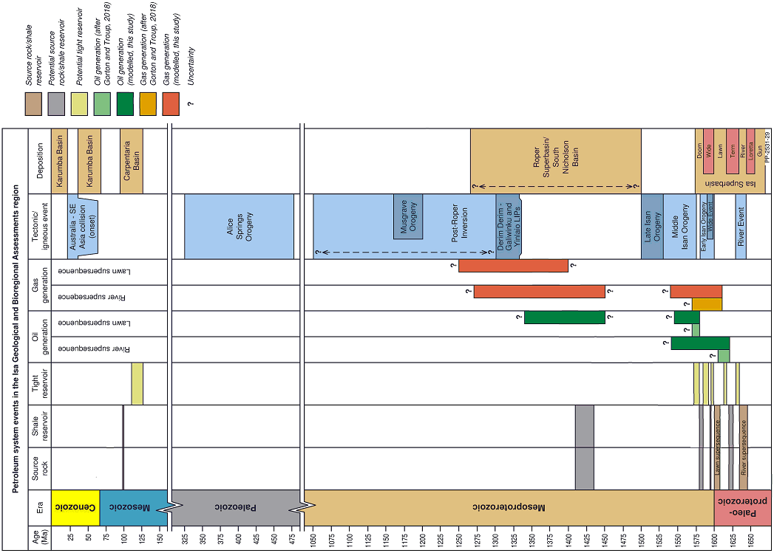
Figure 9 Unconventional petroleum systems events chart for prospective intervals of the Isa Superbasin, South Nicholson Basin, and Carpentaria Basin within the Isa GBA region
Hydrocarbon generation timing is based on the work of Gorton and Troup (2018) and derived from the burial and thermal history modelling outlined in Section 4.3 of this study. See Orr et al. (2020) for more detail on tectonic events and basin evolution. Time breaks from 1040 to 485 Ma and from 310 to 160 Ma are illustrative only.
Element: GBA-ISA-2-249

Shale gas play characterisation
As specified in the geology technical appendix (Orr et al., 2020) published stratigraphic frameworks for basins in the Isa GBA region vary between the sub-disciplines of sequence stratigraphy and lithostratigraphy. The Isa Superbasin is described using sequence stratigraphy, whereas the overlying Carpentaria and Karumba basins are described using lithostratigraphy. Both approaches are applied to the South Nicholson Basin.
Methods snapshot: sequence stratigraphy vs lithostratigraphy
In sequence stratigraphy, supersequences and sequences are composed of genetically linked strata related in time. Supersequences are controlled by the periodicity of tectonic evolution; third-order sequences encompass conformable lowstand tract to highstand tract sedimentation (that is, sedimentation controlled by relative sea level change from the initial marine flooding surface to the maximum marine flooding surface); and sediment types vary not only temporally but laterally for the sequences to encompass these cycles. The boundaries between sequences are time-correlative, usually based on surfaces of erosion or non-deposition that indicate a time gap. The implication of sequence stratigraphy is that the lithological characteristics of sediments assigned to a sequence in one area may be different from those of the same sequence and age in another area. Accordingly, the descriptions provided here for the Isa Superbasin describe locations and lateral variations in the lithology of sediments within each of the supersequences as well as changes over time.
By contrast, units in lithostratigraphy are defined on mappable units of comparable lithology or similar properties, in which a formation is the unit based on primary lithology. Formations may be sub-divided into members or beds or aggregated with other formations into groups. The descriptions provided here for the South Nicholson Basin, Carpentaria and Karumba basins refer to the primary lithological characteristics of the formations, beds and groups in the region, and as the classification is based on these characteristics there is not the same requirement to describe lateral variations.
The shale gas plays discussed within this report are constrained to the Isa Superbasin successions and, hence, are defined using the sequence stratigraphic framework rather than the lithostratigraphic approach. Correlations between these two nomenclatures are provided in Figure 2.

Introduction to characterising shale gas plays
The Geological and Bioregional Assessment Program is focused on shale gas, tight gas and deep coal gas resources which may be developed to bring additional gas to Australia’s East Coast Gas Market within the next five to ten years.
The Lawn Supersequence and River Supersequence shale gas plays assessed in this study were chosen primarily based on maturity, TOC, source rock performance, thickness and spatial extent (Table 9). No tight gas plays are assessed in this study, despite noted potential for their existence, as there is insufficient information with which to assess tight gas within the Isa Superbasin. As the Isa Superbasin is Proterozoic in age, there is no potential for deep coal resources.
This report limits its assessment to the areal extent of the Isa GBA region as defined in the Geology technical appendix (Orr et al., 2020). There is an additional area referred to as the area of hydrocarbon potential, where it is likely that Isa Superbasin sediments (or lateral equivalents) are preserved and may constitute valid shale and/or tight gas plays. However, there is presently insufficient data coverage available to undertake any realistic assessment of potential prospectivity in this broader area. For more information on the criteria used to define these two areas, see the Geology technical appendix (Orr et al., 2020).
Table 9 Summary of shale gas plays
Supersequence | Equivalent formation | Age | Depositional environment | Top depth  (m) | Thickness (m) | Source rock TOC (mean wt. %) | Source rock maturity
Lawn | Lawn Hill Formation | Paleoproterozoic | Marine shelf-deep-water marine | 1610.8 (Egilabria 2) | 265–488 | 3.3 | Peak oil – overmature
River | Riversleigh Siltstone | Paleoproterozoic | Shoreface-deep-water marine-turbidite | 1443.72  (Egilabria 4) | 800–3200 | 2.2 | Wet gas – overmature
This table provides detail on shale gas plays only, as no tight gas plays are currently recognised within the Isa Superbasin.
Source: Longdon (2014b) and Longdon (2014c)

Characteristics by sequence

River Supersequence
The River Supersequence on the central Lawn Hill Platform consists of eight third-order sequences In contrast, in the Isa GBA region the River Supersequence is interpreted (Krassay et al., 2000b) to only consist of the third-order sequences River 5–8. River 1 (upper Lady Loretta Formation), River 2–3 (Shady Bore Quartzite), and River 3–4 (lower Riversleigh Siltstone) are interpreted as absent over the Isa GBA region (Figure 2; see also Orr et al. (2020) and references therein).
Key features of the River Supersequence are summarised in Table 10.
Table 10 Key features of the River Supersequence
Unconventional play type | Shale gas
Age | Paleoproterozoic (Statherian), 1644 ± 8 Ma
Extent | ~5100 (km2)
Top depth | 1443.72 m (Egilabria 4)
Gross formation thickness | 800–3200 m
Lithology | Laminated siltstone, fine-grained sandstone, carbonaceous shale, dolomite and dolomitic siltstone
Depositional environment | Marine shelf, mainly below wave base
Main kerogen type | Type II to type I, bitumen to pyrobitumen with alginite precursor
Total organic carbon (present day) | Up to 11.3 wt. %, average 2.2 wt. %
Hydrogen index (present day) | 21 mg HC/g TOC (Jarrett et al., 2018)
Thermal Maturity (% EqVR) | 1.5 to 5% EqVR (Immature–overmature) (Jarrett et al., 2018)
Average permeability | 1.13*10-5 mD
Average total porosity | 0.0375 (fraction)
Average total water saturation | 0.573 (fraction)
Average brittleness | 0.561
Pressure regime | Hydrostatic, possibly overpressured at >2000 m depth/locally
Exploration status | Under assessment/current exploration target
TOC = Total organic carbon, HC/g = volatile hydrocarbon content per gram of rock, %EqVR = measured percentage of reflected light from a maceral sample equivalent to vitrinite reflectance, mD = millidarcys

Age and stratigraphic relationships
The River Supersequence (Figure 2; see also Orr et al. (2020) and references therein) on the southern flanks of the Murphy Inlier is composed of the third-order sequences River 5, 6, 7, and 8 where it unconformably rests on carbonate rocks of the Loretta Supersequence. Elsewhere in the Lawn Hill Platform, these third-order sequences conformably rest upon the lower sequences of the River Supersequence: River 3–4 (lower Riversleigh Siltstone), River 2–3 (Shady Bore Quartzite), and River 1 (upper Lady Loretta Formation) (Page et al., 2000; Withnall and Hutton, 2013).
SHRIMP age determinations indicate that the River Supersequence was likely deposited between 1645 and 1630 Ma (Krassay et al., 2000b). The overlying Term Supersequence (Termite Range Formation) is dated to circa 1635 Ma, providing a lower age constraint on the River Supersequence. Page et al. (2000) provided SHRIMP derived zircon crystallisation ages for tuffaceous siltstones in the lower River Supersequence (River 3–4, lower Riversleigh Siltstone) of 1647 (± 8) Ma and in the middle to upper River Supersequence (River 6–7, upper Riversleigh Siltstone) of 1644 (± 8) Ma. These provide a reasonable age constraint for the deposition of the River Supersequence, and agree with ages from correlative units in the McArthur Basin and from the Mount Les Siltstone of the Fickling Group (Page et al., 2000).
The Term Supersequence (Termite Range Formation) was initially interpreted as conformably overlying the River Supersequence (Sweet and Hutton, 1982). However, subsequent research indicates that it has an unconformable contact with the River Supersequence (Gorton and Troup, 2018; Krassay et al., 2000a; Withnall and Hutton, 2013). The base of the Term Supersequence, which is also the base of the Termite Range Formation (Term 1.1), is marked by a sudden transition from the fine-grained siltstones of the River Supersequence (Riversleigh Siltstone) to thick- to very thick-bedded turbidite and hemipelagic deposits (Armour Energy, 2015; Bradshaw et al., 2018b; Page, 1978; Roberts et al., 1963; Smart et al., 1980; Spampinato et al., 2015).

Extent, depth and gross formation thickness
The River Supersequence forms a thick and regionally extensive stratigraphic unit over much of the northern Lawn Hill Platform, covering an area of about 5100 km2 in the Isa GBA region. It is absent due to truncation over the eastern, south-eastern and northern-most parts of the assessment area, and is subaerially exposed over the southern flanks of the Murphy Inlier where it correlates to the Mount Les Siltstone. The River Supersequence shows a broad down-to-the-south tilt block geometry across the northern Lawn Hill Platform (Scott and Bradshaw, 1999). Maximum depths to the top of the River Supersequence range from 3600 m in the Gregory River Trough, to 5000 m in the Accident Creek Trough (Figure 10). Farther south, compressional inversion of the Isa Superbasin brings the top of the River Supersequence close to the surface, where it correlates to the Riversleigh Siltstone.
The River Supersequence thins overall from south to north, although locally thickens across a series of syn-depositional extensional fault systems (Bradshaw et al., 2018b; Scott and Bradshaw, 1999). The average thickness across the northern Lawn Hill Platform is about 750 m. However, maximum thicknesses of 2500 to 3500 m occur within the Accident Creek Trough and Gregory River Trough, respectively (Figure 10).

Lithology and paleoenvironment
The River Supersequence is relatively poorly understood, having been the subject of only a handful of studies to date. However, it is interpreted as an upwards-deepening sequence representing a period of continual basin subsidence (Krassay et al., 2000b). Although composed primarily of siltstone and shale, the River Supersequence incorporates several sandstone and quartzite lowstand deposits (Krassay et al., 2000b; Withnall and Hutton, 2013), comprising fluvial channels, shoreface deposits, deeper marine turbidites and sand-rich submarine fans (Krassay et al., 2000b). The black shales of the upper River Supersequence are interpreted as having been deposited in a deep-water euxinic environment as highstand sediments near the end of the River Supersequence. Where it outcrops adjacent to the Termite Range Fault, the River Supersequence is identified as thinly laminated deep-water shales and siltstones, with laterally persistent packages of turbiditic sandstones.
The River Supersequence was interpreted by McConachie (1993) as having formed during a period of general basin subsidence from a high-energy shallow water to low-energy deep-water setting. There is an interpreted lack of shallow water current structures, with evidence noted for vertical accretion as a distal turbidite in a deep-water marine setting. Withnall and Hutton (2013) are in general agreement, suggesting deposition of the River Supersequence was during the most dynamic phase of basin development. Having only been intersected at depth in two wells, there is little information available from which to build a detailed understanding of facies variations and changes in depositional environment.
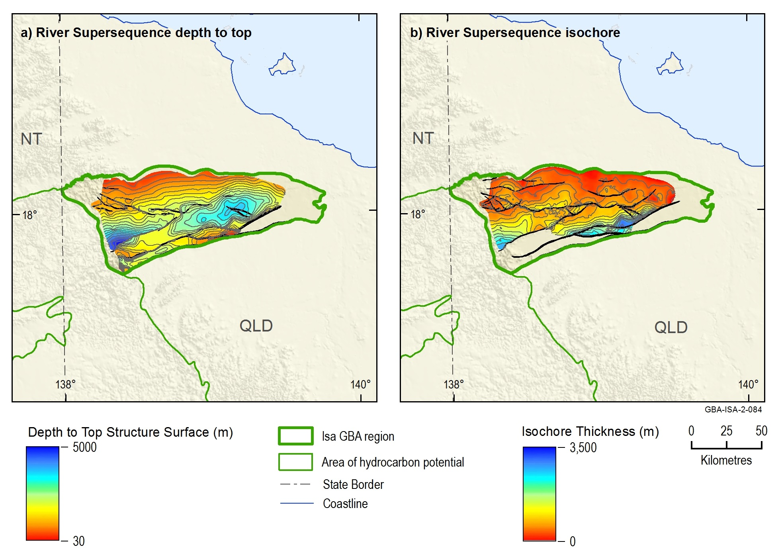
Figure 10 (a) Top River Supersequence depth-structure map (metres below ground level) and (b) River Supersequence true vertical thickness map (contour intervals = 250 m)
Source: Bradshaw et al. (2018a)
Data: Bradshaw et al. (2018c)
Element: GBA-ISA-2-084

Source rock distribution, geochemistry and maturity
Jarrett et al. (2018) carried out a detailed geochemical analysis of available River Supersequence samples, describing an organic-rich sequence of sediments with good to excellent source potential. To date, where the River Supersequence has been intersected it consists of high TOC, potentially gas-prone source rocks (Figure 11 and Figure 12).
The mean TOC of all samples from the River Supersequence is 2.2 wt. %, reaching a maximum of 11.3 wt. % and a minimum of 0.1 wt. % (Figure 11). This is derived from a collection of 177 samples covering the River Supersequence in both the McNamara and Fickling groups; samples are from the Riversleigh Siltstone and its Fickling Group equivalent, the Mount Les Siltstone (Jarrett et al., 2018). It is currently unknown whether TOC and, hence, source rock quality, varies with thickness of the River Supersequence due to lack of available data.
Hydrogen indices are low at less than or equal to 50 mg/g TOC (Figure 11), reflecting high maturity and indicating that the remaining generative potential is poor. Gorton and Troup (2018) suggested considerable loss of hydrogen would have occurred early in the thermal history of the River Supersequence due to the generation of large volumes of hydrocarbons (Figure 9). This is supported by Jarrett et al. (2018), who stated that the kerogens in these sediments have effectively expelled hydrocarbons in the areas studied. They suggested that more samples should be acquired over a larger geographical extent to target immature to mature intervals to kinetically determine the hydrocarbon potential and prospectivity of the River Supersequence.
Tmax ranges from 390 °C to 567 °C, with an average of 465 °C, indicating the River Supersequence is immature to overmature while largely sitting within the oil zone; however, significant variations are observed down core and are attributed to hydrothermal alteration events (Glikson et al., 2000; Jarrett et al., 2018) (Figure 11). Reflectance studies on the alginite content of the sediments showed measurements that vary from 1.5 to 5% EqVR, indicating higher thermal maturity and placing the River Supersequence within the wet gas to overmature zones (Gorton and Troup, 2018; Jarrett et al., 2018; Palu et al., 2018) (Figure 11).
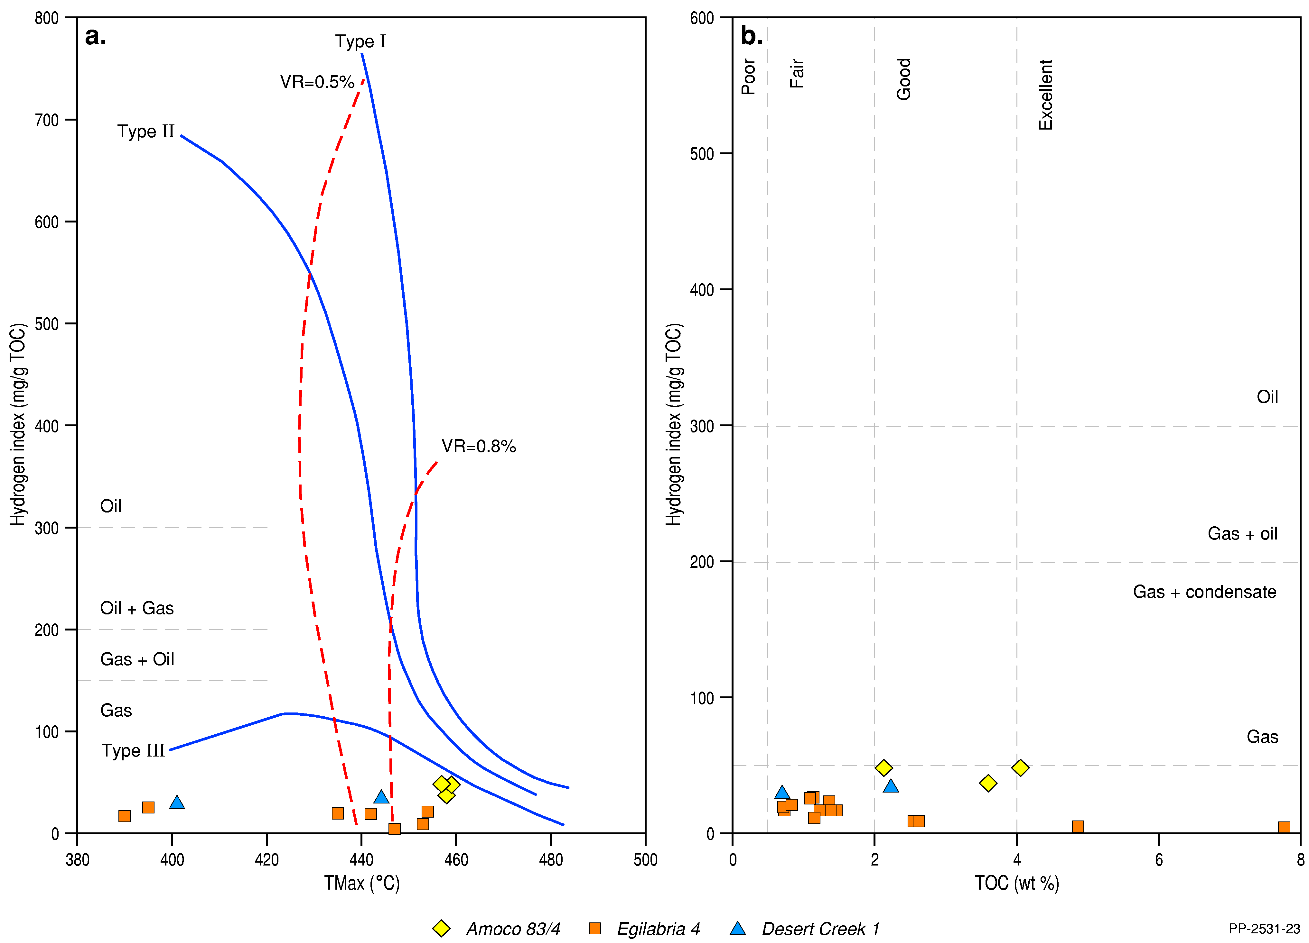
Figure 11 Rock-Eval pyrolysis data plots for the River Supersequence: a) Tmax (°C) vs HI (Hydrogen Index; mg/g TOC), b) TOC (wt. %) vs HI (mg/g TOC)
Data: Jarrett et al. (2018)
Element: GBA-ISA-2-125
TOC profiles through the River Supersequence were derived by multivariate regression using the laboratory measured TOC and well log data in Egilabria 4 and Desert Creek 1 (Bailey et al., 2019). The net thickness of organically rich shales was calculated for the River Supersequence using the product of net organically rich ratio (NORR) with TOC greater than 2 wt. % and gross formation thickness (US EIA, 2011, 2013). An average NORR for the River Supersequence of 0.534 is calculated; Table 11 presents the NORRs of the River Supersequence in Egilabria 4 and Desert Creek 1 (Bailey et al., 2019).
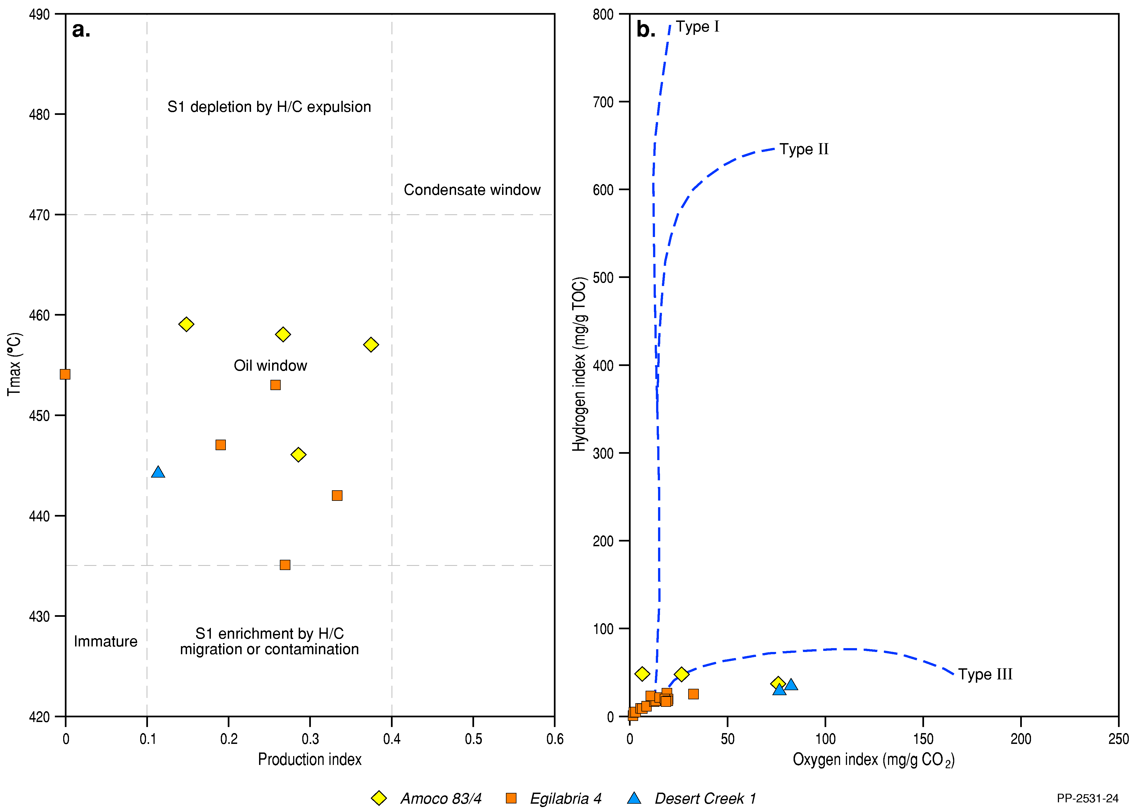
Figure 12 Rock-Eval pyrolysis data plots for the River Supersequence: a) PI (Production Index; S1/S1+S2) vs Tmax (°C), b) oxygen index (mg/g CO2) vs Hydrogen Index (mg/g TOC)
Data: Jarrett et al. (2018)
Element: GBA-ISA-2-126
Table 11 Net organically rich ratio (NORR) for the River Supersequence as calculated from Egilabria 4 and Desert Creek 1
Well | Net organically rich ratio (fraction)
Egilabria 4 | 0.415
Desert Creek 1 | 0.652
Average | 0.534
Source: Bailey et al. (2019)

Shale reservoir characteristics
Porosity, permeability and fluid saturation are three of the key petrophysical input parameters required for characterising shale gas plays. The average shale rock properties of the River Supersequence shown in Table 12 are based on laboratory tests undertaken on an as-received basis. Four shale samples from the River Supersequence were tested from the well Egilabria 4 by Armour Energy Limited (Longdon, 2014c), resulting in an average total porosity of 3.75%, average gas saturation of 42.39% and average permeability of 1.13*10-5mD. Jarvie (2012) considers that shale porosity values of 4 to 7% are characteristic of productive shale gas systems. In the River Supersequence, two of three samples have porosities of 4% or greater.
Table 12 Laboratory measured shale rock properties on as-received samples from Egilabria 4
Sequence | Bulk density (g/cc) | Water saturation (%PV) | Oil saturation (%PV) | Gas saturation (%PV) | Gas-filled porosity (%BV) | Total porosity (fraction) | Permeability (mD)
River Supersequence | 2.55 | 60.6 | 0 | 39.4 | 1.3 | 3.2 | 7.16*10-6
 | 2.48 | 52.8 | 0.9 | 46.3 | 1.9 | 4 | 2.07*10-5
 | 2.42 | 54 | 0.1 | 45.9 | 2.4 | 5.2 | 1.20*10-5
Average | 2.51 | 57.33 | 0.28 | 42.39 | 1.62 | 3.75 | 1.13*10-5
g/cc = grams per cubic centimetre; PV = Pore Volume; BV = Bulk Rock Volume
Source: Longdon (2014c)
Gas in shale is stored as adsorbed gas on the organic matter, free gas stored in the pore spaces, and dissolved gas in the formation water. Gas desorption tests on as-received samples have not been carried out on any River Supersequence samples, however, measurable gas content was assessed from laboratory desorption tests on air dry shale samples from Egilabria 4. The average air dry measurable gas content for River Supersequence samples from Egilabria 4 is 1.143 scc/g (Table 13) (Longdon, 2014c).
Table 13 Desorption tests on the air dry shale samples from Egilabria 4
Depth interval  (mMD) | Days on test | Air dry measurable gas content  (scc/g)
1495-1505 | 93 | 1.755
1610-1620 | 93 | 0.530
Average |  | 1.143
mMD = metres measured depth, scc/g = standard cubic centimetres per gram
Source: Longdon (2014c)

Mineralogy and brittleness
The elemental assemblage of the River Supersequence was described using energy-dispersive x-ray fluorescence (ED-XRF) analyses from 46 test samples from the well Egilabria 4, resulting in the identification of four distinct packages within Egilabria 4. Packages were defined on the basis of chemical composition combinations, which indicate the mineral assemblage of rocks (Longdon, 2014c). Table 14 presents the averaged compositions of the identified packages in Egilabria 4.
A change in lithofacies from the Lawn Supersequence to the base of the River Supersequence is observed. The general trend is from shale to calcareous/dolomitic shale, calcareous/dolomitic marl, and to argillaceous limestone at the base of the River Supersequence. Additionally, the River Supersequence is less pyritic and is also less organically rich than the Lawn Supersequence in Egilabria 4 (Longdon, 2014c).
Bailey et al. (2019) calculated average Brittleness Indices (BI) from the normalised dynamic Young’s modulus and Poisson’s ratio (Gray et al., 2012), which were in turn estimated from compressional and shear wave slowness logs and from logged bulk density. Table 14 presents the averaged dynamic Young’s modulus, Poisson’s ratio and BI (fraction) of the Riversleigh Siltstone in Egilabria 4 (Bailey et al., 2019). Perez Altamar and Marfurt (2014) defined brittleness based on a case study of the Barnett Shale of the Bend Arch-Fort Worth Basin of the USA, where shales are classified as ductile in cases where BI is less than 0.16, less ductile where BI is 0.16 to 0.32, less brittle where BI is 0.32 to 0.48 and brittle where BI is greater than 0.48. Overall, the Riversleigh Siltstone is classified as ‘brittle’, with a total average brittleness index estimated from geomechanical properties of 0.561 (Perez Altamar and Marfurt, 2014).
Table 14 Averaged compositions and geomechanical properties of the River Supersequence in Egilabria 4
 | Package 4 | Package 3 | Package 2 | Package 1 | Average
Top (mMD) | 1430 | 1505 | 1600 | 1660 | 1430
Bottom (mMD) | 1505 | 1600 | 1660 | 1700 | 1700
SiO2 (%) | 65.1 | 56.6 | 52.2 | 53.4 | 56.1
Al2O3 (%) | 16.4 | 12.8 | 11.5 | 12.3 | 13.1
Fe2O3 (%) | 4.7 | 3.1 | 3.1 | 2.6 | 3.3
MgO (%) | 2.0 | 3.9 | 5.8 | 6.1 | 4.5
CaO (%) | 0.3 | 5.2 | 7.7 | 7.6 | 5.5
U (ppm) | 9.5 | 14.5 | 7.9 | 6.4 | 10.7
Young's modulus (GPa) | 33.3 | 41.9 | 55.9 | 64.7 | 45.9
Poisson's ratio | 0.253 | 0.235 | 0.255 | 0.252 | 0.246
Brittleness index (fraction) | 0.407 | 0.526 | 0.622 | 0.695 | 0.561
mMD = metres measured depth, GPa = gigapascal. Poisson’s ratio is unitless.
Source: (Longdon, 2014c)

Gas composition
Gas samples from the River Supersequence have, to date, only been obtained from the well Egilabria 4 in the form of desorbed gas from drill cuttings. While exhibiting atmospheric contamination and having been exposed to wellbore fluids, the desorbed gas nonetheless demonstrated a high percentage of methane after removal of nitrogen and oxygen; gas from 1495 m depth consisted of 86.5% methane and 10.2% ethane, while gas from 1610 m depth consisted of 97.5% methane and 2.1% ethane. However, these percentages may not be reflective of reservoir gas compositions. For comparison, gas sampled from the Lawn Supersequence in Egilabria 2 DW1 was composed of 0.9% helium, 0.4% carbon dioxide, and 9.5% nitrogen in addition to the methane and ethane components.

Lawn Supersequence
The Lawn Supersequence on the Lawn Hill Platform consists of four third-order sequences (Figure 2; see also Orr et al. (2020) and references therein), and all four are interpreted as present within the Isa GBA region. Lawn 1 contains significant sand bodies (the Bulmung Sandstone Member, Pmh3) as opposed to Lawn 2, 3 and 4 (the Lawn Hill Formation, lower Pmh4) which all contain very similar fine-grained facies. Lawn 4 is of most interest for hydrocarbon prospectivity as it is composed of organic-rich mudstones (Gorton and Troup, 2018) and, hence, is the sequence assessed in this study for its petroleum prospectivity. However, available data are not always provided so that it can be assigned to a third-order sequence, and so much of the discussion that follows focusses on the Lawn Supersequence as a whole rather than the Lawn 4 Sequence.
Key features of the Lawn Supersequence are summarised in Table 15.
Table 15 Key features of the Lawn Supersequence
Unconventional play type | Shale gas
Age | Paleoproterozoic (Statherian), 1611 ± 4 Ma
Extent | 3400 km2 (Lawn 4 Sequence) and 4500 km2 (Lawn Supersequence)
Top depth | 1611 m (Egilabria 2)
Gross formation thickness | 265–488 m
Lithology | Black shale, siltstones, fine-grained sandstones and dolomitic silts
Depositional environment | Marine shelf, mainly below wave base
Main kerogen type | Type II to type I, bitumen to pyrobitumen with alginite precursor
Total organic carbon (present-day) | Up to 7.1 wt. %, average 3.3 wt. %
Hydrogen index (present-day) | 4 mg HC/g TOC (Jarrett et al., 2018)
Thermal maturity (% EqVR) | Immature – overmature
Average permeability | 1.01*10-5 mD
Average total porosity | 0.0379 (fraction)
Average total water saturation | 0.608 (fraction)
Average brittleness | 0.518
Pressure regime | Hydrostatic, possibly overpressured at >2000 m depth/locally
Exploration status | Under assessment/current exploration target
TOC = Total organic carbon, HI = Hydrogen index, HC/g = volatile hydrocarbon content per gram of rock, %EqVR = measured percentage of reflected light from a maceral sample equivalent to vitrinite reflectance, mD = millidarcys

Age and stratigraphic relationships
Tuffs and reworked tuffs occur intermittently within the Lawn Supersequence, and have been subject to several zircon age studies. Depositional age of a tuff intersected within drillcore from the Century Zinc Mine, interpreted as being within the Wide Supersequence (Lawn Hill Formation, Upper Pmh4), is dated at 1595 ± 6 Ma (Page et al., 2000; Page and Sweet, 1998) and, thus, provides an upper age constraint above the Lawn Supersequence. The stratigraphically lower Term Supersequence (Lawn Hill Formation, Pmh2) has been dated to 1616 ± 5 Ma and 1611 ± 4 Ma, which is in line with the reported ages for the Wide Supersequence (Page et al., 2000).
Tuffs present in a black shale intersected in the drillhole DD94LH539 located to the east of Century Mine have been dated to 1593 ± 8 Ma (Page et al., 2000), however, this shale has been alternately correlated to both the Term Supersequence (Lawn Hill Formation, Pmh1) (Andrews, 1998) and the Lawn Supersequence (Lawn Hill Formation, lower Pmh4) (Krassay et al., 2000a) (Andrews, 1998; Krassay et al., 2000a; Page et al., 2000). If the correlation to Term Supersequence is correct, then this forms a significant conflict with the ages reported for Lawn and Wide Supersequence higher in the stratigraphy. If the correlation with the Lawn Supersequence is correct, as sequence stratigraphic correlations suggest (Page and Sweet, 1998), then the 1593 ± 8 Ma agrees well with the 1595 ± 6 Ma age provided for the Wide Supersequence (Page et al., 2000). The Fickling Group equivalent to the Lawn Supersequence, the Doomadgee Formation, hosts tuffs in the upper interval which are dated as 1613 ± 5 Ma and this date agrees with ages determined for equivalent strata from the McArthur Basin (Jackson et al., 2000; Krassay et al., 2000a; Page and Sweet, 1998). Based on the age of the Wide Supersequence, Krassay et al. (2000a) suggested a likely age range for the Lawn Supersequence as ca 1600 to 1615 Ma.
The Lawn, Wide, and Doom supersequences represent tectonically driven sedimentary accommodation packages stacked to form depositional wedges separated by the Elizabeth Creek Fault Zone, and bound by disconformities or low-angle unconformities (Krassay et al., 2000a; Withnall and Hutton, 2013). A minor disconformity separates the base Lawn from the top Term Supersequence (Gorton and Troup, 2018). A disconformity within the Lawn Hill Formation, within the Pmh4 unit, demarcates the break between the Lawn and Wide supersequences and is interpreted as being due to a regional extension event that resulted in deformation, uplift and erosion of the underlying Lawn Supersequence (Krassay et al., 2000a; Page et al., 2000; Withnall and Hutton, 2013).

Extent, depth and gross formation thickness
The Lawn 4 Sequence as defined and mapped by Scott and Bradshaw (1999) and Bradshaw et al. (2018b) correlates to the Lower Pmh4 shale gas interval within the Lawn Hill Formation. It extends over an area of about 3400 km2, and is well preserved over the eastern part of the Isa GBA region, but is truncated by the base Wide Supersequence unconformity to the north and west. Consequently, there are no stratigraphic equivalents of the Lawn 4 Sequence within the Fickling Group over the southern flanks of the Murphy Inlier (Bradshaw et al., 2000). The Lawn 4 Sequence is relatively shallow (<1000 m) across the western part of the region, and deepens to a maximum of 2600 m in the Gregory River Trough (Figure 13).
The Lawn 4 Sequence has an average thickness of 150 m across the Isa GBA region, and reaches a maximum thickness of 450 m within the Gregory River Trough (Figure 13). The sequence is significantly thinner (less than 200 m thick) across the western part of the region due to truncation by the base Wide Supersequence unconformity (Bradshaw et al., 2018b).
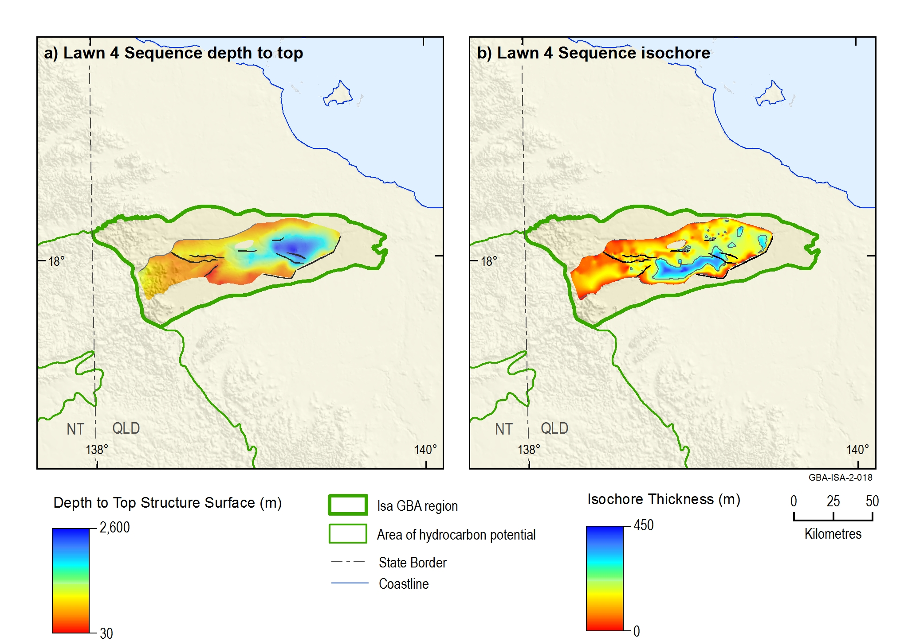
Figure 13 (a) Top Lawn 4 Sequence depth-structure map (metres below ground level) and (b) Lawn 4 Sequence true vertical thickness map (contour intervals = 250 m)
Source: Bradshaw et al. (2018a)
Data: Bradshaw et al. (2018c)
Element: GBA-ISA-2-018

Lithology and paleoenvironment
The Lawn Supersequence is relatively poorly understood, having been the subject of only a handful of studies to date. However, it is interpreted as a dominantly fine-grained sediment package that coarsens upwards following the Lawn–Wide disconformity (Withnall and Hutton, 2013). It consists of siltstones, shales, minor sandstones and dolomites with several notable tuff interbeds and tuffaceous siltstones.
Two main tectonostratigraphic phases are identified in the Lawn Supersequence: initial low accommodation conditions in the lowstand systems tract of Lawn 1, followed by rapid subsidence and transgression into deep marine carbonaceous shales in upper Lawn 1, continuing into further deepening and increased sediment starvation during the Lawn 2 to 4 sequences (Krassay et al., 1999). Lawn 1 (Bulmung Sandstone Member, Pmh3) is a coarse-grained sand body representing a shallower, higher energy marine setting (Page et al., 2000), similar to that within the Wide Supersequence (Widdallion Sandstone Member, Lawn Hill Formation Pmh5) which comprises thick lithic and feldspathic sandstone interpreted either as high-energy, marine shelfal deposits (Hutton and Sweet, 1982) or sandy turbidites. The upper Lawn 1 sequence is defined by a transgressive systems tract that marks the change from sand bodies to progressively finer grained and more carbonaceous sediments (Krassay et al., 2000a). Page et al. (2000) noted Lawn 2, 3 and 4 (Lawn Hill Formation, Pmh4) as dominantly fine-grained, carbonaceous sediments formed in quiet, deep subaqueous environments in contrast with Lawn 1 which is interpreted as higher energy (Andrews, 1998; Hutton and Sweet, 1982; Krassay et al., 2000a; McConachie, 1993; Page et al., 2000).
The Lawn 4 Sequence (black shales of the Lower Pmh4 unit of the Lawn Hill Formation) is dominated by thick transgressive systems tracts which thin to the north (Bradshaw and Scott, 1999; Krassay et al., 2000a). It is considered the most prospective shale gas source rock as it is composed of organic-rich mudstones where it has been intersected (Gorton and Troup, 2018; Jarrett et al., 2018). While noted as exhibiting little variation in facies or depositional environment over much of the Lawn Hill platform (Gorton and Troup, 2018), gamma ray logs suggest that the Lawn 4 sequence as intersected in the west part of the Isa GBA Region in Argyle Creek 1 and Desert Creek 1 is sandier than where intersected in the Egilabria wells in the east (McConachie, 2015a).

Source rock distribution, geochemistry and maturity
According to Jarrett et al. (2018), the Lawn Supersequence contains high-quality source rocks with TOC ranging from 0.22 wt. % to 7.10 wt. % with an average TOC of 3.3 wt. %. The highest TOC values are identified in drillcores Amoco DDH 83-2 and Egilabria 4 (Figure 14 and Figure 15) (Jarrett et al., 2018). Measured organic reflectance ranges from 0.7% to 3.3% EqVR , corresponding to peak oil to dry gas maturity zones (Jarrett et al., 2018) (Figure 14). It is currently unknown whether TOC and, hence, source rock quality, varies with thickness of the Lawn Supersequence due to lack of available data.
The TOC profiles through the Lawn Supersequence were derived by multivariate regression using the laboratory measured TOC and well log data in Egilabria 2 and Egilabria 4 (Bailey et al., 2019). The net thickness of organically rich shales was calculated for the Lawn Supersequence using the product of NORR with TOC greater than2 wt. % and gross formation thickness (US EIA, 2011, 2013). An average NORR for the Lawn Supersequence of 0.563 is calculated; Table 16 presents the net organically rich ratios of Lawn Supersequence in Egilabria 2 and Egilabria 4 (Bailey et al., 2019).
Table 16 Net organically rich ratio (NORR) based on TOC (wt. %) profiles derived from well log data
Well | Net organically rich ratio (fraction)
Egilabria 2 | 0.542
Egilabria 4 | 0.584
Average | 0.563
Source: Bailey et al. (2019)
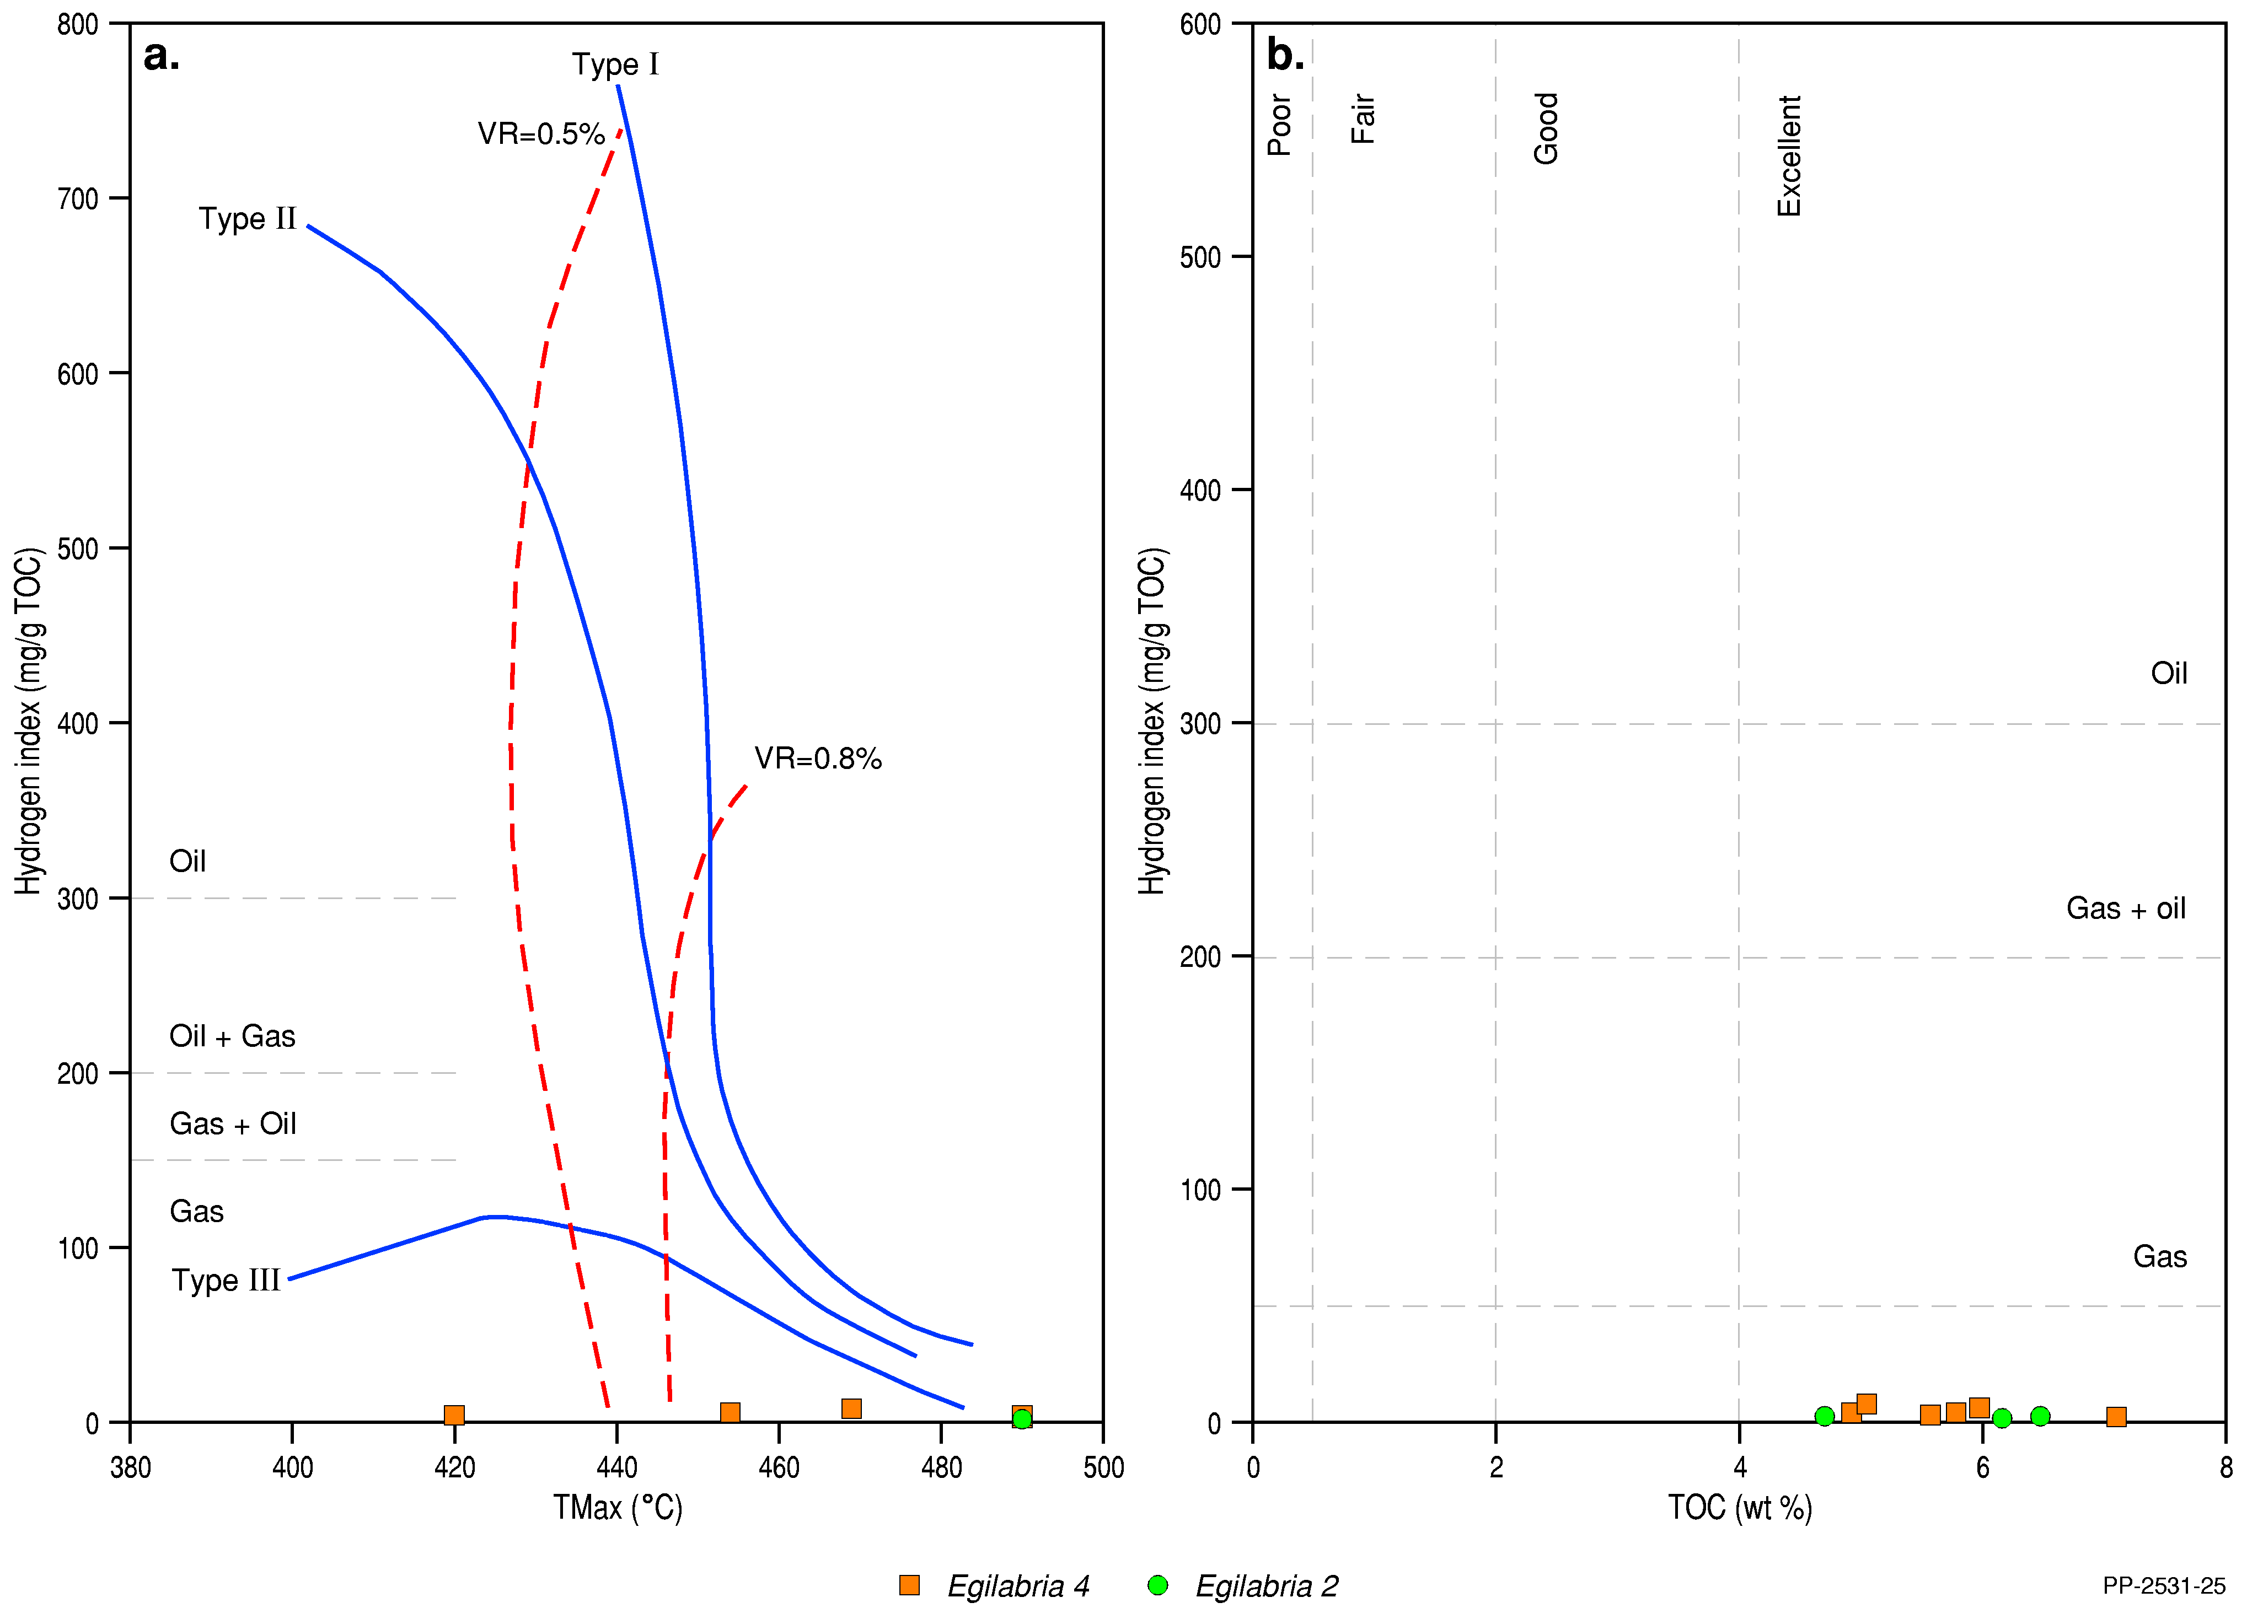
Figure 14 Rock-Eval pyrolysis data plots for the Lawn Supersequence: a) Tmax (°C) vs HI (Hydrogen Index; mg/g TOC), b) TOC (wt. %) vs HI (mg/g TOC)
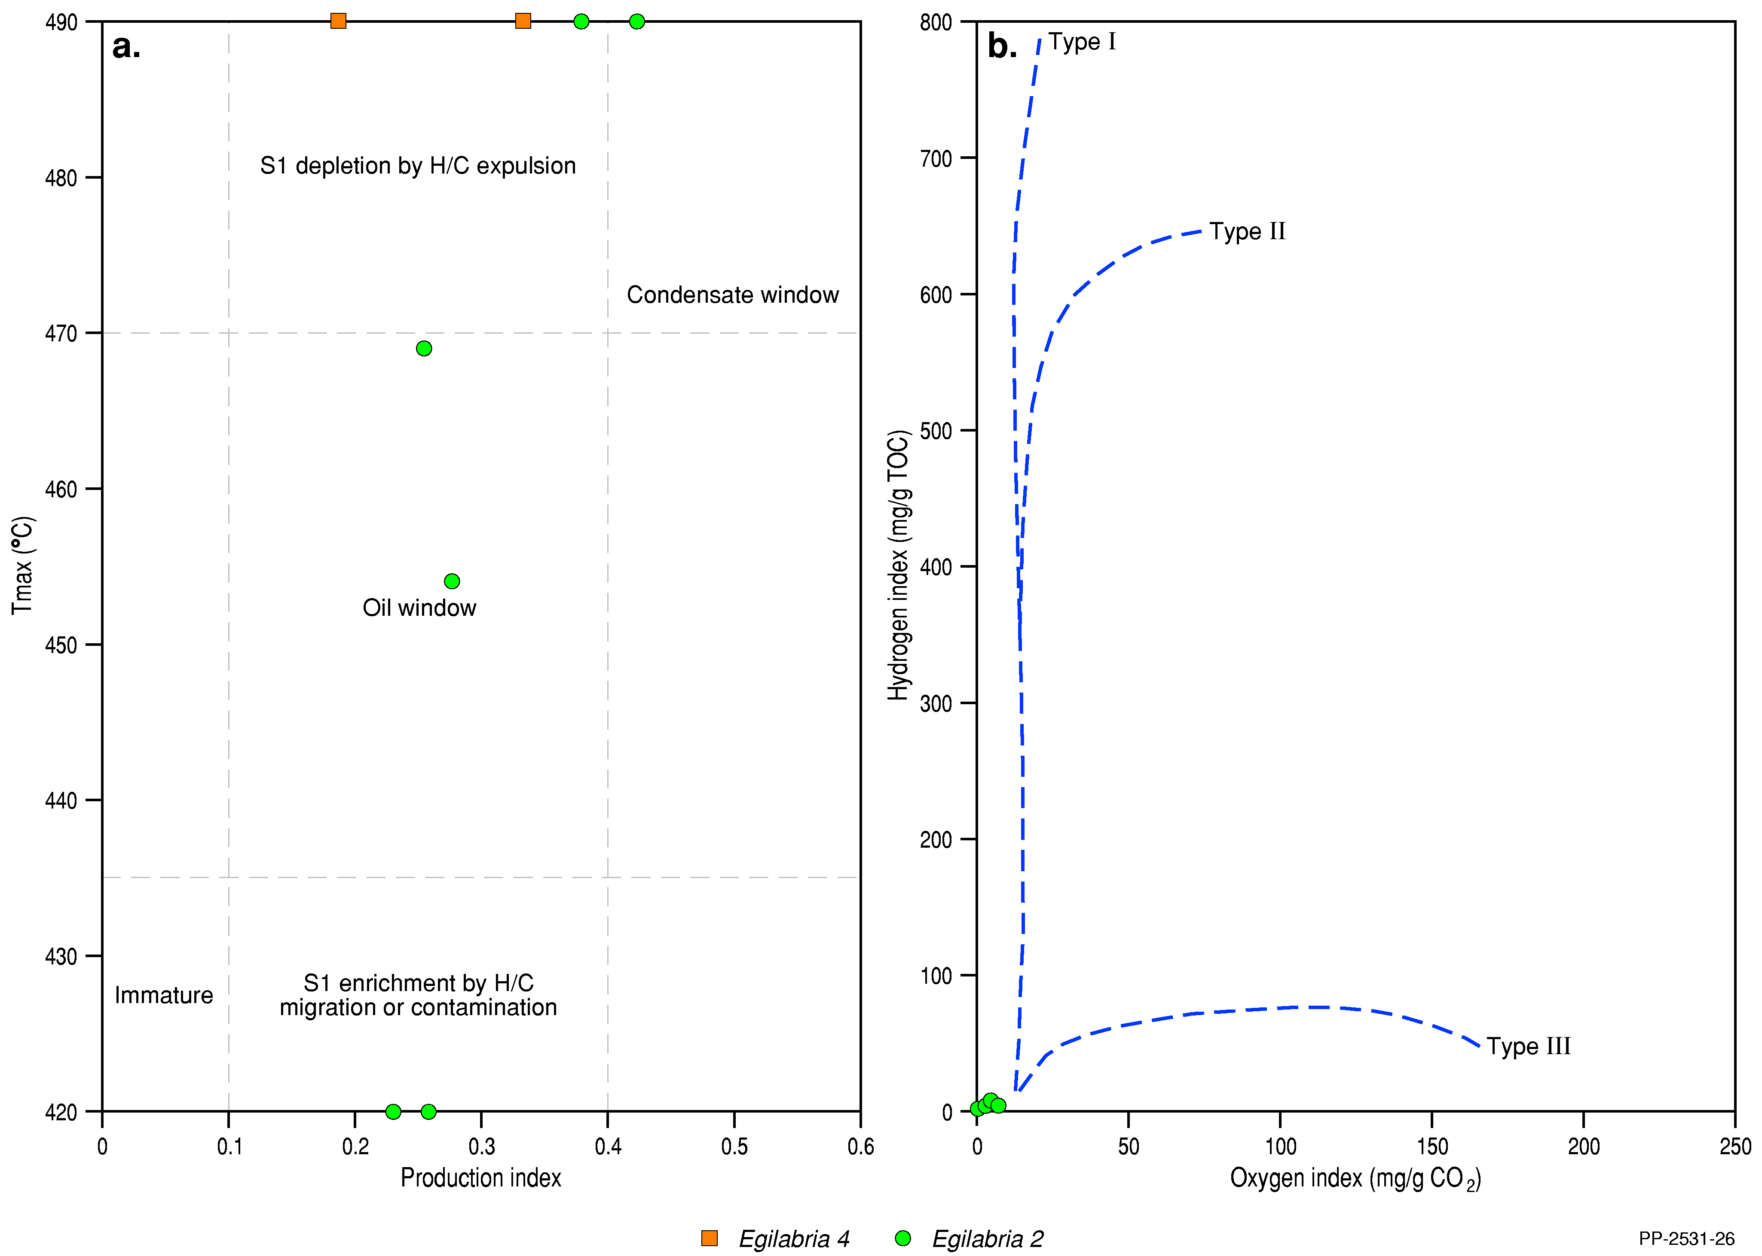
TOC = Total organic carbon, HI = Hydrogen index
Data: Jarrett et al. (2018)
Element: GBA-ISA-2-127

Figure 15 Rock-Eval pyrolysis data plots for the Lawn Supersequence: a) PI (Production Index; S1/S1+S2) vs Tmax (°C), b) oxygen index (mg/g CO2) vs Hydrogen Index (mg/g TOC)
TOC = Total organic carbon, HI = Hydrogen index
Data: Jarrett et al. (2018)
Element: GBA-ISA-2-128

Shale reservoir characteristics
Porosity, permeability and fluid saturation are three of the key petrophysical input parameters required for characterising shale plays. The average shale rock properties of the Lawn Supersequence shown in Table 17 are based on laboratory tests undertaken on an as-received basis. Three as-received shale samples from the Lawn Supersequence were tested from the well Egilabria 4 by Armour Energy Limited (Longdon, 2014c), resulting in an average total porosity of 3.79%, average gas saturation of 38.91% and average permeability of 1.01*10-5 mD. Jarvie (2012) considers that shale porosity values of 4 to 7% are characteristic of productive shale gas systems. In the Lawn Supersequence, two of three samples have porosities of 4% or greater. Additionally, a log-derived total shale porosity of 6.7% has been demonstrated for the Lawn Supersequence from 1605 m to 1642 m in Egilabria 1; this interval has a continuous gas cut associated with elevated gas readings during drilling (Johnson and Titus, 2014).
Table 17 Laboratory measured shale rock properties on as-received samples from Egilabria 4
Sequence | Bulk density  (g/cc) | Water saturation  (%PV) | Oil saturation  (%PV) | Gas saturation  (%PV) | Gas-filled porosity  (%BV) | Total porosity (fraction) | Permeability  (mD)
Lawn Supersequence | 2.61 | 45.0 | 0.1 | 54.9 | 2.5 | 4.6 | 1.34*10-5
 | 2.54 | 46.5 | 0.2 | 53.3 | 2.6 | 4.9 | 1.58*10-5
 | 2.68 | 90.8 | 0.7 | 8.5 | 0.2 | 1.9 | 1.01*10-5
Average | 2.61 | 60.76 | 0.33 | 38.91 | 1.77 | 3.79 | 1.31*10-5
PV = Pore Volume; BV = Bulk Rock Volume
Source: after Longdon (2014c)
Gas in shale is stored as: (i) adsorbed gas on the organic matter, (ii) free gas stored in the pore spaces and (iii) dissolved gas in the formation water. Gas desorption tests on as-received samples have not been carried out on any Lawn Supersequence samples, however, measurable gas content was assessed from laboratory desorption tests on air dry shale samples from Egilabria 2 and Egilabria 4 (Table 18) (Longdon, 2014b, 2014c); a measure of adsorbed gas on organic matter.
The Lawn 4 shale of the Lawn Supersequence was the primary target of Armour Energy’s shale gas exploration well Egilabria 2. Qualitative and semi-quantitative data from hydrocarbon gas detectors record the level of natural gas brought up in drilling muds as part of the mud logging process; in Egilabria 2 a gas peak of 32.85 units (predominantly methane) was recorded over the interval 1839.90 to 1847.70 mMD (Longdon, 2014b). While Egilabria 2 was drilled on the Egilabria structure, Egilabria 4 was deliberately sited off-structure and a gas peak of 6 units was recorded over the interval 1060 to 1105 mMD (Longdon, 2014c). Table 19 shows the gas records in Egilabria 2DW1 (Longdon, 2014a), notably the peak of 58 units recorded from 1630 to 1645 mMD.

Table 18 Desorption tests on the air dry shale samples from Egilabria 2 and Egilabria 4
Well | Depth interval  (mMD) | Days on test | Air dry measurable gas content  (scc/g)
Egilabria 2 | 1720–1730 | 92 | 0.670
 | 1730–1740 | 92 | 0.532
 | 1740–1750 | 92 | 0.629
 | 1790–1795 | 92 | 2.540
 | 1795–1800 | 92 | 0.407
Egilabria 4 | 1495–1505 | 93 | 1.755
 | 1610–1620 | 93 | 0.530
Average |  |  | 0.909
mMD = metres measured depth, scc/g = standard cubic centimetres per gram
Source: Longdon (2014b) and Longdon (2014c)
Table 19 Gas peak records in the Lawn Supersequence in Egilabria 2DW1
Interval [mRT] | Peak (units) | Background (units)
1590.0–1600.2 | 38 | 4
1605.0–1615.0 | 31 | 9
1630.0–1645.0 | 58 | 10
1645.0–1651.0 | 57 | 5
1857.0–1862.0 | 20 | 5
mRT = metres below rotary table (Egilabria 2DW1 Rotary Table height = 24.71 m above sea level)
Source: Longdon (2014a)

Mineralogy and brittleness
The elemental assemblage of the Lawn Supersequence was described using energy-dispersive x-ray fluorescence (ED-XRF) analyses from 46 test samples from Egilabria 2 (30 test points) and Egilabria 4 (16 test points), resulting in the identification of two distinct packages within Egilabria 2 and three packages in Egilabria 4. Packages were defined on the basis of chemical composition combinations, which indicate the mineral assemblage of rocks (Longdon, 2014b, 2014c). Table 20 presents the averaged compositions of the identified packages in these two wells. The shallower packages contain lower SiO2 alongside elevated U in comparison to the deeper packages. These shallower packages correspond to the organic-rich, high TOC shales within the Lawn Supersequence (Lawn 4 or Lower Pmh4). These shales are also less brittle than the deeper packages.
The mineral assemblage of the Lawn Supersequence was described using X-ray diffraction (XRD) analyses from 46 samples from Egilabria 2, and show that the Lawn Supersequence shales consist primarily of quartz (41.7%), clay minerals (35.2%), feldspar (12.4%), carbonate minerals (5.4%) and pyrite (5.2%) (Table 21), defining lithofacies mainly characterised by shales and small amounts of calcareous/dolomitic shale.
Table 20 Averaged compositions of the Lawn Supersequence in the Isa GBA region
 |  | Top  (mMD) | Bottom  (mMD) | SiO2  (%) | Al2O3  (%) | Fe2O3  (%) | MgO  (%) | CaO  (%) | U  (ppm)
Egilabria 2 | Package 2 | 1610 | 1750 | 58.1 | 13.5 | 5.6 | 2.6 | 4.1 | 14.5
 | Package 1 | 1750 | 1895 | 66.3 | 14.5 | 4.5 | 2.0 | 1.3 | 8.0
 | Average |  |  | 62.3 | 13.8 | 4.9 | 2.3 | 2.8 | 11.8
Egilabria 4 | Package 7 | 1045 | 1105 | 59.2 | 14.6 | 5.9 | 2.6 | 2.2 | 15.5
 | Package 6 | 1105 | 1170 | 59.1 | 13.1 | 5.9 | 2.8 | 3.0 | 16.4
 | Package 5 | 1170 | 1210 | 63.1 | 12.9 | 5.0 | 2.6 | 2.5 | 9.4
 | Average |  |  | 60.4 | 13.7 | 5.7 | 2.6 | 2.4 | 14.0
Average |  |  |  | 61.3 | 13.7 | 5.3 | 2.5 | 2.6 | 12.9
mMD = metres measured depth, ppm = parts per million
Source: Longdon (2014b) and Longdon (2014c)
Bailey et al. (2019) calculated average brittleness indices (BI) from mineral composition using the method of Jarvie et al. (2007). Perez Altamar and Marfurt (2014) defined brittleness based on a case study of the Barnett Shale of the Bend Arch-Fort Worth Basin of the USA, where shales are classified as ductile in cases where BI is less than 0.16, less ductile where BI is 0.16 to 0.32, less brittle where BI is 0.32 to 0.48 and brittle where BI is greater than 0.48. For the Lawn Supersequence, BI was estimated to be 0.506 based on the average quartz, carbonate and clay mineral content (Table 21). Besides the mineralogical assemblage method Bailey et al. (2019) also estimated the average brittleness indices from the normalised dynamic Young’s modulus and Poisson’s ratio (Gray et al., 2012), which were in turn estimated from compressional and shear wave slowness logs and from logged bulk density (Bailey et al., 2019).
Table 21 Averaged mineral content and brittleness index of the Lawn Supersequence in Egilabria 2
 | Package 2 | Package 1 | Average
Top (mMD) | 1610 | 1750 | 1610
Bottom (mMD) | 1750 | 1895 | 1895
Quartz content (wt. %) | 37.1 | 47.1 | 41.7
(Quartz + Feldspar) (wt. %) | 46.9 | 62.1 | 54.1
Carbonate (wt. %) | 8.7 | 1.9 | 5.4
Clay minerals (wt. %) | 36.0 | 34.1 | 35.2
Brittleness index (fraction) | 0.453 | 0.567 | 0.506
mMD = metres, measured depth
Source: Longdon (2014b)
Table 22 presents the averaged dynamic Young’s modulus, Poisson’s ratio and brittleness index (fraction) of the Lawn Supersequence in Egilabria 2 and Egilabria 4 (Bailey et al., 2019). The average brittleness index estimated from geomechanical properties is 0.518 (Bailey et al., 2019). The Lawn Supersequence shales are identified as brittle (Perez Altamar and Marfurt, 2014).
Table 22 Averaged dynamic Young’s modulus, Poisson’s ratio and brittleness index of the Lawn Supersequence in the Isa Superbasin
 |  | Top  (mMD) | Bottom  (mMD) | Young's modulus  (GPa) | Poisson's ratio | Brittleness index (fraction)
Egilabria 2 | Package 2 | 1610 | 1750 | 36.7 | 0.263 | 0.439
 | Package 1 | 1750 | 1895 | 48.4 | 0.252 | 0.579
 | Average | 1610 | 1895 | 42.4 | 0.258 | 0.508
Egilabria 4 | Package 7 | 1045 | 1105 | 28.0 | 0.242 | 0.391
 | Package 6 | 1105 | 1170 | 30.2 | 0.230 | 0.435
 | Package 5 | 1170 | 1210 | 42.7 | 0.222 | 0.565
 | Average | 1045 | 1210 | 39.8 | 0.236 | 0.528
Average |  | 1045 | 1210 | 41.3 | 0.247 | 0.518
mMD = metres, measured depth, GPa = Gigapascal
Source: Bailey et al. (2019)

Gas composition
Several gas samples were recovered from Egilabria 2 and the lateral extension Egilabria 2 DW1, as well as from Egilabria 4, as both isotube samples and desorbed gas from collected cuttings. Generally, these demonstrate very high levels of methane with low carbon dioxide and relatively high levels of helium. Desorbed gas samples have high levels of atmospheric contamination, though analysis of these gases broadly matches with analysis of isotube samples. The most pertinent analyses were derived from a sample acquired from the Egilabria 2 wellhead and another from gas flowed following fracture stimulation of Egilabria 2 DW1 (Table 23). Samples flowed from the Egilabria 2 wellhead are composed of approximately 90% methane, 10% or less of nitrogen, 2% or less of carbon dioxide, almost 1% of helium and less than 1% ethane. Very low concentrations of propane were detected in the analysis of desorbed gas from cuttings.
Table 23 Gas analyses for samples recovered from the Lawn Supersequence
Gas composition | Egilabria 2: sample #1 (%) | Egilabria 2: sample #2 (%) | Egilabria 2: sample #3 (%) | Egilabria 2: sample (side outlet) (%) | Egilabria 2 DW1: isotube #1 (%) | Egilabria 4: Desorbed gas from cuttings (oxygen and nitrogen set to zero) (%)
Helium | 0.89 | 0.89 | 0.91 | 0.92 | 0.88 | -
Carbon dioxide | 0.50 | 0.44 | 0.39 | 0.45 | 2.12 | -
Nitrogen | 10.14 | 9.72 | 9.48 | 9.01 | 6.53 | -
Methane | 87.88 | 88.35 | 88.63 | 89.06 | 89.82 | 80.10
Ethane | 0.59 | 0.6 | 0.59 | 0.57 | 0.64 | 13.87
Propane | 0 | 0 | 0 | 0 | 0 | 0.94
Source: Longdon (2014b); Longdon (2014c)
As well as being composed primarily of methane, Lawn Supersequence gas may contain a secondary resource of helium. Boreham et al. (2018) considered high helium as being greater than 0.5%, making high concentrations of associated helium a potentially economically attractive by-product (Gorton and Troup, 2018). Lawn Supersequence gas as sampled is composed of approximately 0.9% helium and, hence, is present in economically exploitable concentrations.

Burial and thermal history modelling

Introduction
Burial-thermal history relationships in the Isa Superbasin are complex. Uplift and erosion of the Isa Superbasin sediments post deposition is poorly constrained; no direct vitrinite reflectance data are available as a paleomaturity indicator due to the Paleoproterozoic sediment age and the region has experienced multiple hydrothermal events, resulting in erratic, and occasionally inverted, maturity reflectance profiles (Glikson, 1993; Gorton and Troup, 2018).
Palu et al. (2018) modelled two 1-dimensional burial and thermal history models in the Isa GBA region (Desert Creek 1 and Egilabria 1; Figure 6). Burial and thermal history modelling was calibrated using paleomaturity data, which is poorly constrained for this basin. Alginite and bitumen reflectance values were used for modelling due to the age of organic matter in the Isa Superbasin, and these are not always comparable to the standard vitrinite reflectance profiles typically used for calibration of burial and thermal history models. Palu et al. (2018) attempted to overcome this problem by applying a published conversion equation (Jacob, 1989; Liu et al., 1994) and used Horner-corrected bottom-hole temperature as an additional calibration tool.
Gorton and Troup (2018) highlighted that there has been significant erosion of sediment from the northern Lawn Hill Platform (potentially up to 6500 m), where multiple deposition, followed by significant erosion events are likely to have occurred between the time interval of 1200 to about 65 Ma. This marks a time gap of over a billion years where there is little evidence of the geological history of those missing sediments in terms of deposition, burial, erosion, and fluid flow. There is no way to build an understanding or predict exactly what processes occurred in this area for the missing time period; hence, the impact of any significant events that occurred during this period cannot be taken fully into account in burial and thermal history models. Palu et al. (2018) account for this by estimating the amount of sediments deposited and eroded to account for maximum depth of burial at each well location.

Model set up
The model inputs used by Palu et al. (2018) are shown in Table 24. The thermal model used for burial and thermal history modelling was ‘transient, fixed temperature at base lithosphere’ using a temperature of 1330 °C and a constant surface temperature of 33 °C. The Lawrence Livermore (LL) Model (Burnham and Sweeney, 1989) was used as the best representation of the basin history (Palu et al., 2018). Well models by Palu et al. (2018) are displayed to total depth (TD) of the drilled well; however, data on sequence depth and thickness were available to model to basement (after Bradshaw et al., 2018b). No significant difference to the maturity of the source rock intervals is apparent when comparing the two models (i.e. sediment thickness from TD to basement, extracted from the three-dimensional geological model, is not significant enough for crustal and/or lithosphere heat properties to effect the thermal maturity of the source rocks).
Table 24 Data type and source of all modelling inputs for burial and thermal history models for Desert Creek 1 and Egilabria 1 wells of the northern Lawn Hill Platform, Isa Superbasin
Input data | Data source
Location information | Dunster et al. (1993c), Dunster et al. (1993b)
KB | Dunster et al. (1993c), Dunster et al. (1993b)
Well picks | Dunster et al. (1993c), Dunster et al. (1993b), Krassay and Bradshaw (1999), Bradshaw et al. (2018b)
Ages | Krassay and Bradshaw (1999)
Lithology | Dunster et al. (1993c), Dunster et al. (1993b)
Depth to Moho for crustal thickness estimation | Kennett et al. (2013)
Upper crust heat production estimate | Frogtech Geoscience (2018a)
Bitumen/alginite reflectance data | Dunster et al. (1993c), Dunster et al. (1993b), Jarrett et al. (2018)
Tmax data | Dunster et al. (1993c), Dunster et al. (1993b), Jarrett et al. (2018)
Bottom-hole temperature data | Holgate and Gerner (2010)
Estimated historical sea level | Bradshaw et al. (1999)
Erosion estimates | See below for description
Source: Palu et al. (2018)
Methods snapshot: converting bitumen reflectance to vitrinite reflectance equivalent
Due to the Proterozoic age of the sedimentary rocks in the Isa Superbasin, vitrinite, derived from plant material, is not a component of source rock organic matter. Therefore, reflectance data are from either bitumen or alginite reflectance, which are not directly comparable to vitrinite as a maturity indicator for thermal history modelling (Jacob, 1989; Liu et al., 1994; Landis and Castaño, 1995; Schoenherr et al., 2007).
Several studies have published recommended relationships to convert bitumen reflectance to an equivalent vitrinite reflectance, however, some result in higher maturities than observed from bitumen samples (Landis and Castaño, 1995; Schoenherr et al., 2007) while others result in lower maturities than observed from bitumen samples (Jacob, 1989; Liu et al., 1994). Determining which relationship is best suited for any given study is difficult, with the possibility that the relationship most suited to any given scenario may be basin, or even source rock, specific.
As bitumen/alginite maturities are already naturally elevated in the Isa GBA region, likely due to hydrothermal events, Palu et al. (2018) utilised the Jacob (1989) and Liu et al. (1994) equations (as an average) to correct all reflectance data to a vitrinite equivalent. This resulted in a slightly reduced maturity in comparison to the raw bitumen/alginite reflectance values. Error was estimated using 2 standard deviations, and was derived from the results of all four equations (Figure 17 and Figure 19). Due to difficulty in defining which samples were bitumen and which were alginite reflectance, all samples were treated the same (Palu et al., 2018).
Palu et al. (2018) determined rates of erosion estimated for the two wells of interest using available seismic and well data (Bradshaw et al., 2018b). At Egilabria 1, Gun Supersequence erosion is estimated at about 1000 m and erosion of the Loretta Supersequence at about 600 m (Table 25). Erosion at Desert Creek 1 was estimated to be about 1000 m for both the Gun and Loretta supersequences (Bradshaw et al., 2018b) (Table 25). Erosion at the boundaries between the other supersequences in the Isa Superbasin would be minimal, and would not be significant enough to influence burial history results (Palu et al., 2018). For the purpose of modelling thermal history, these older and smaller erosion events are over-printed by the large erosion events of the South Nicholson and Carpentaria basins (Palu et al., 2018) (Figure 16 and Figure 18).
Post-Isa Superbasin erosion rates are significant and make a large contribution to the maximum depth of burial (Palu et al., 2018). Due to the large time gap (about 1400 Ma to present) and very little preservation of sedimentation elsewhere in the area, it is very difficult to estimate true amounts of deposition, erosion and, hence, determine depositional environments. Gorton and Troup (2018) stipulated a minimum age of the South Nicholson Basin at 1400 Ma, with up to 6500 m of braided fluvial to shallow marine deposits making up most of the South Nicholson Basin. Using this as a guide, and calibrating using paleomaturity data (Figure 17 and Figure 19), Palu et al. (2018) estimated erosion in the modelled wells (Table 25). In Egilabria 1, they estimate that about 5500 m of South Nicholson Basin sediments and about 1500 m of overlying Carpentaria Basin sediments have been lost to erosion (note, there is no significant erosion of the Doom Supersequence at this location). In Desert Creek 1 they estimate that about 700 m of the Doom Supersequence, about 4000 m of South Nicholson Basin sediments, and about 1000 m of Carpentaria Basin sediments have been lost to erosion.
Table 25 Amounts of erosion for major unconformities of the Lawn Hill Platform of the Isa Superbasin for the Egilabria 1 and Desert Creek 1 well locations
Erosion event | Egilabria 1 erosion amount | Desert Creek 1 erosion amount
Gun Supersequence | ~1000 m | ~1000 m
Loretta Supersequence | ~600 m | ~1000 m
Doom Supersequence | Not significant | ~700 m
South Nicholson Basin sediments | ~5500 m | ~4000 m
Carpentaria Basin | ~1500 m | ~1000 m
Source: Palu et al (2018)
Hydrothermal fluid events have also resulted in erratic and often inverted maturity profiles (Golding et al., 2006; Glikson et al., 2006), however are too complex and poorly constrained to be included in the modelling. These hydrothermal events may be responsible for generating hydrocarbons at low temperatures, but may also be responsible for their destruction (Gorton and Troup, 2018).

Results and implications for play fairway analysis
Burial and thermal history modelling results for Desert Creek 1 (Figure 16 and Figure 17) and Egilabria 1 (Figure 18 and Figure 19) (Palu et al., 2018) indicate that both the Lawn and River supersequences are mature or overmature for gas generation with maturities over 1.2% EqVR and 2% EqVR for the Lawn Supersequence at Desert Creek 1 and Egilabria 1 respectively. The River Supersequence is modelled as overmature with >2% EqVR at both wells. The models indicates that the shale source rocks of the Lawn and River supersequences are likely to have generated most or all possible hydrocarbons during the Paleo-Mesoproterozoic (Figure 9, Figure 16, Figure 18), and these may be contained within the sequences given the right conditions for unconventional hydrocarbon preservation. Secondary hydrocarbon cracking could be considered and hydrocarbon phase conditions may also play a role in the type of hydrocarbons that may be present. The results of Palu et al. (2018) suggest that the gas window (greater than about 1.2% EqVR for gas) is reached at a minimum depth of approximately 500 m and that any source rock below this depth is likely to have reached sufficient maturity to have generated gas (Figure 17, Figure 19). Conversely, extrapolation of interpreted maturity curves for the wells Desert Creek 1 and Egilabria 1 suggest that source rocks are overmature, and preserved gas is likely to have been destroyed, at a depth of approximately 4000 m (greater than about 4.0% EqVR for gas) (Figure 17, Figure 19). Any source rock below this depth is unlikely to host preserved hydrocarbons.
Figure 17 shows an example from Desert Creek 1, demonstrating how erratic the paleomaturity profile can be, with higher maturities in both the Lawn and River supersequences than the current model is able to predict (after Palu et al., 2018). These ‘spikes’ in maturity are most likely due to hydrothermal fluids moving through these formations (Palu et al., 2018). As both the River and Lawn supersequences show evidence of being affected by hydrothermal events, modelling results are considered to be conservative (Palu et al., 2018). Hence, results represent the minimum possible maturities for these supersequences.
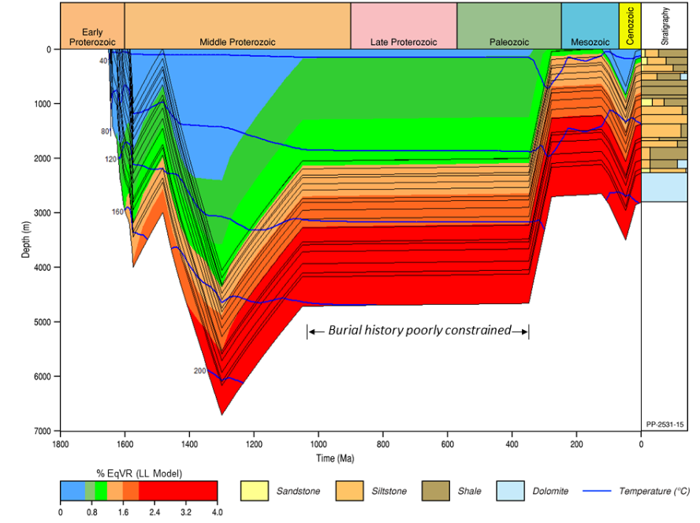
Figure 16 Desert Creek 1 modelled burial history to total well depth (Loretta Supersequence)
Zetaware Inc. Genesis (version 5.6x) software was used for modelling. See Figure 22 for a more detailed view of thermal maturity for 100 Myr to present with calibration data. Ro = reflectivity of a maceral sample, LL model = Lawrence Livermore model
Source: Palu et al. (2018)
Element: GBA-ISA-2-133

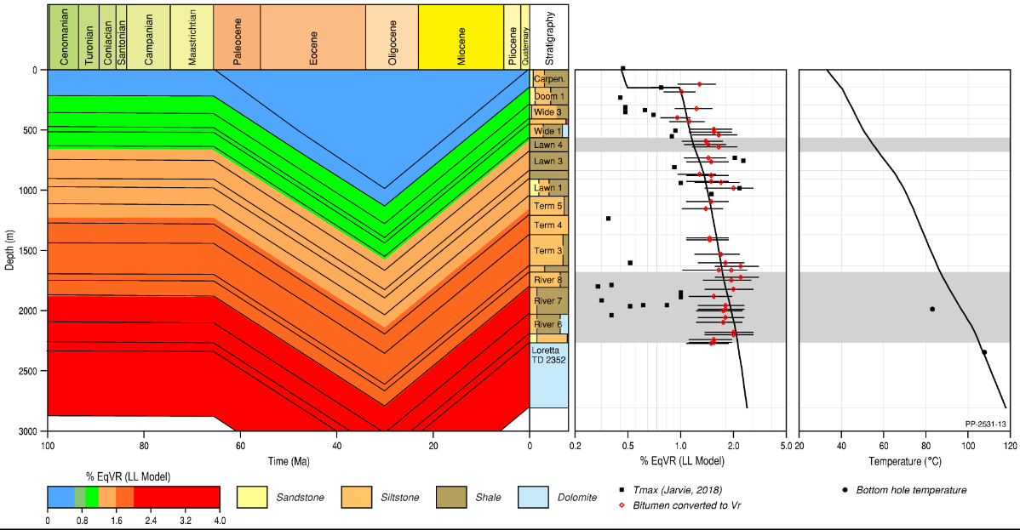
Figure 17 Desert Creek 1 burial history (100 Ma to present) with paleomaturity calibration data and Horner-corrected bottom-hole temperature data (calibration plots)
Grey transparency shows Lawn 4 Sequence and River Supersequence.
Ro = reflectivity of a maceral sample, LL model = Lawrence Livermore model, Vr = Vitrinite reflectance
Source: Palu et al. (2018)
Element: GBA-ISA-2-134

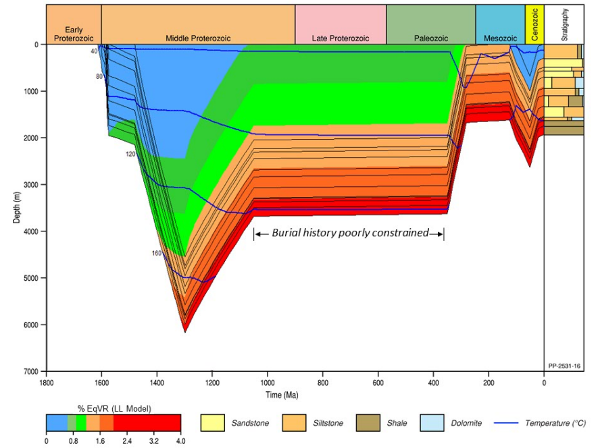
Figure 18 Egilabria 1 modelled burial history to total well depth (Lawn 3 Sequence)
See Figure 23 for a more detailed view of thermal maturity for 100 Myr to present with calibration data.
Ro = reflectivity of a maceral sample, LL model = Lawrence Livermore model
Source: Palu et al. (2018)
Element: GBA-ISA-2-135

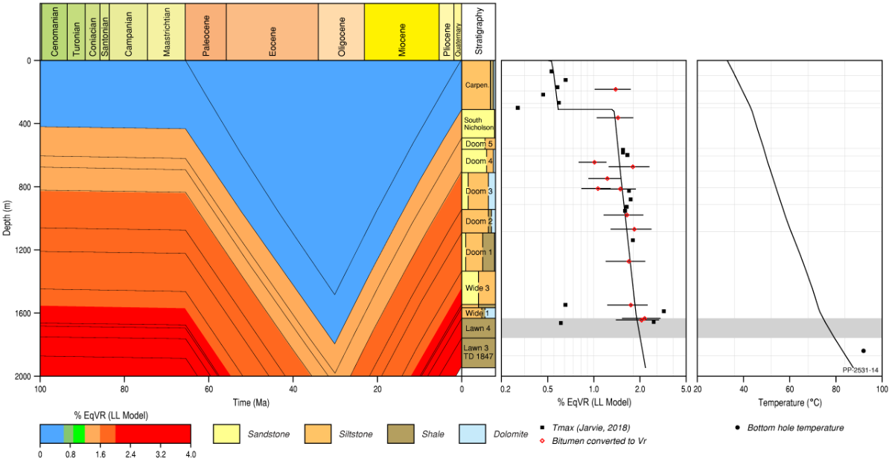
Figure 19 Egilabria 1 burial history (100 Ma to present) with paleomaturity calibration data and Horner-corrected bottom-hole temperature data (calibration plots)
Grey transparency shows Lawn 4 Sequence.
Ro = reflectivity of a maceral sample, LL model = Lawrence Livermore model, Vr = Vitrinite reflectance
Source: Palu et al. (2018)
Element: GBA-ISA-2-136

Regional stress regime

Introduction to stresses
Contemporary patterns of tectonic stress in the brittle crust act as a control over neotectonic deformation and seismicity, and are a primary control over both the formation and propagation of natural fractures and of hydraulically induced fractures (Bailey et al., 2017; Bell, 1996b, 2006; Fisher and Warpinski, 2012; Hillis et al., 2008; King et al., 2010; Lund Snee and Zoback, 2016; Olsen et al., 2007; Palano, 2014; Palmer, 2010; Pitcher and Davis, 2016; Rajabi et al., 2017; Sandiford et al., 2004; Seeber and Armbruster, 2000; Sibson, 1992; Sibson et al., 2012; Sibson et al., 2011; Stein, 1999). The extraction of fluids from tight reservoirs, such as shales and low permeability sandstones, typically requires the creation of fracture pathways through hydraulic stimulation, to enable adequate flows from the reservoir to the well (Bell, 1990; Bell and Babcock, 1986).
Tectonic stress regimes are defined by the relative orientation and magnitude of three orthogonal principal stresses, namely a maximum (σ1), minimum, (σ3), and intermediate (σ2) stress. One stress is generally vertical due to the mass of overburden (σv), constraining the two remaining stresses to the horizontal plane (Anderson, 1951; Bell, 1996a; Sibson, 1977; Zoback, 2007). These are referred to as the maximum (σH) and minimum (σh) horizontal stresses (Bell, 1996a) (Figure 20), and are usually expressed in terms of stress gradients at a given depth (e.g. MPa/km or psi/ft).
Under a given stress regime, the type of failure defined by that regime will typically dominate, though pre-existing structures can exhibit hybrid failure modes (Heidbach and Höhne, 2008; Sibson, 1977). For further information regarding the definition of lithospheric stresses, see: Bell (1996a, 1996b); Chan et al. (2014); Couzens-Schultz and Chan (2010); Plumb et al. (2000); Zoback (2007). Stress patterns in the Isa Superbasin are investigated to determine what impact the present-day stress regime may have on potential hydraulic stimulation of formations for shale gas exploration.
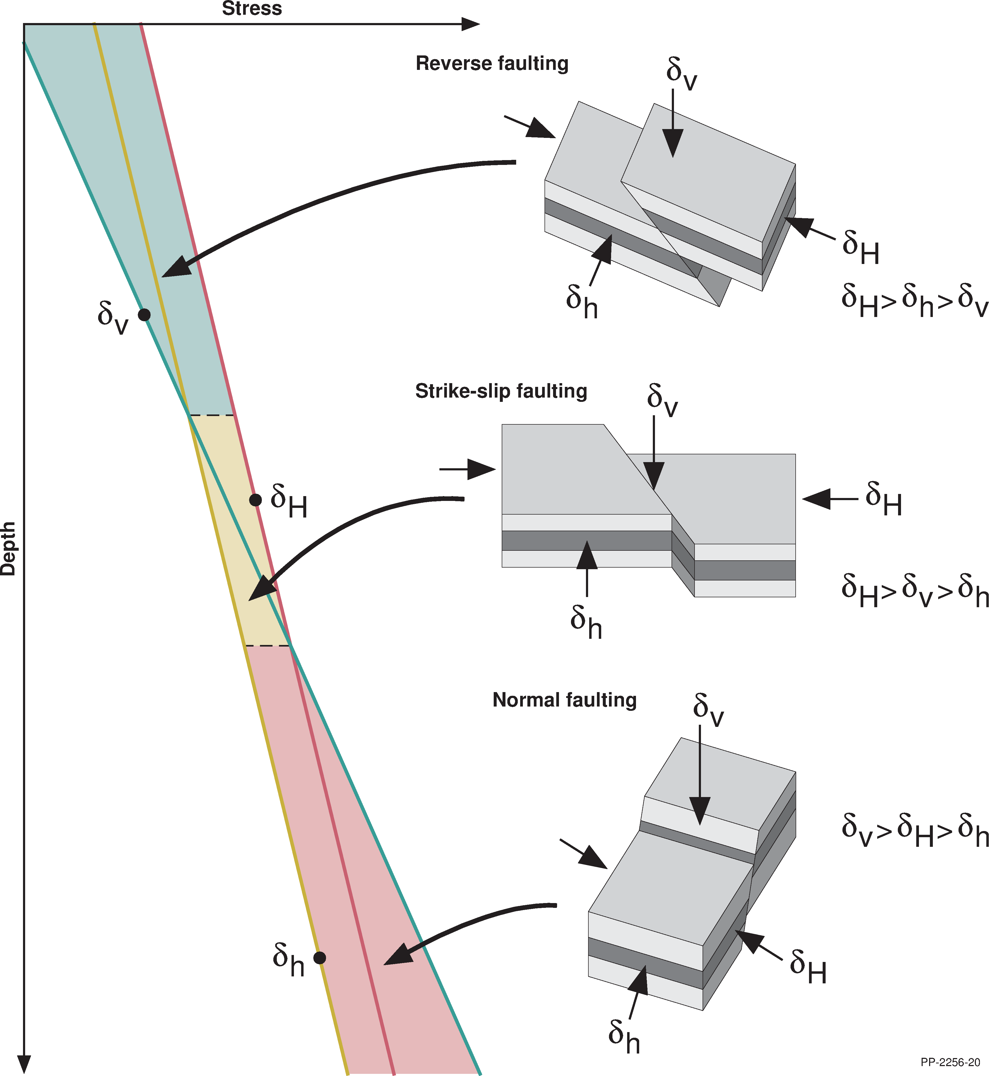
Figure 20 Tectonic stress regimes as defined by Anderson (1951), highlighting the relative magnitudes of the three principle stresses. Vertical stress is shown in green, maximum horizontal stress in red, and minimum horizontal stress in brown
Source: After Brooke‐Barnett et al. (2015)
Element: GBA-ISA-2-129

Present-day stress in the Isa Superbasin
Currently, there is no basin-wide understanding of present-day stresses within the Isa Superbasin and only limited information on stress azimuths is available from the Australian Stress Map (Figure 21). The Isa Superbasin has to date been neglected from consideration in continent-scale stress studies, primarily due to the lack of data, as only two wells have been drilled where relatively complete sets of modern wireline logs were acquired (Egilabria 2 and Egilabria 4). There have been two studies that investigate aspects of the stress regime of the Isa Superbasin, both of which broadly describe a strike-slip faulting stress regime (Bailey et al., 2019; Johnson and Titus, 2014). These studies are both constrained to the Egilabria prospect on the northern Lawn Hill Platform and present one-dimensional mechanical earth models (one-dimensional MEMs) that in part describe stress conditions.
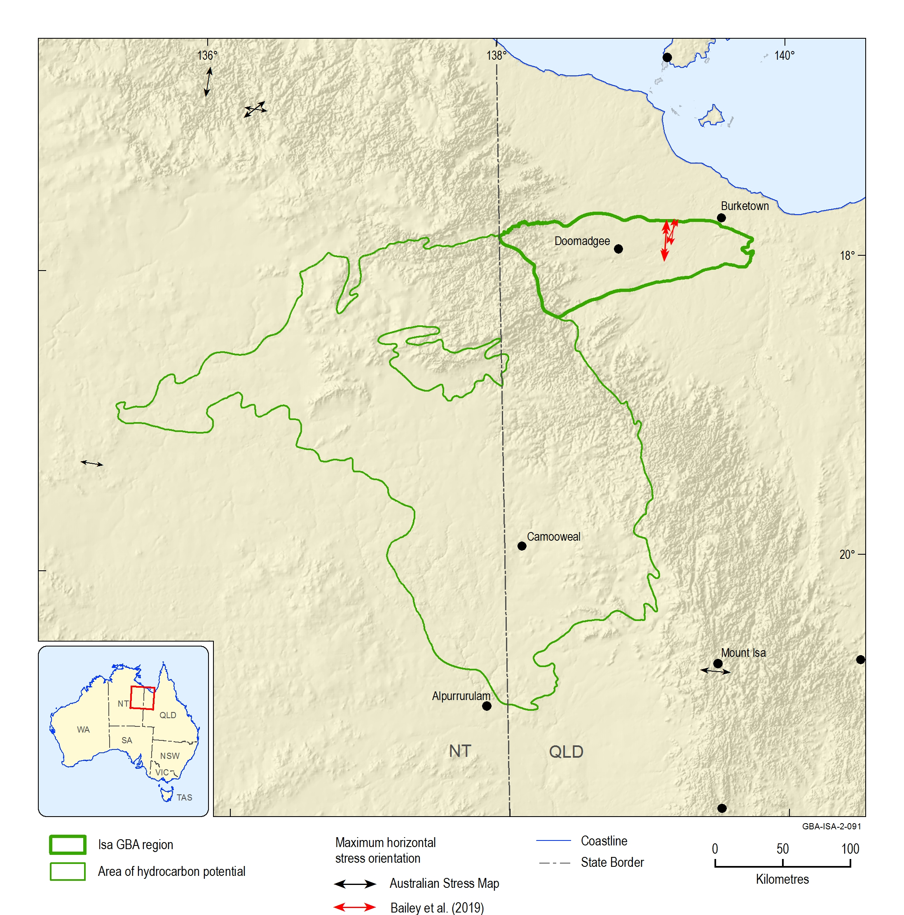
Figure 21 Stress orientations from the Australian Stress Map (ASM) project in the Isa GBA region and area of hydrocarbon potential
The general east to west stress azimuth of points in the southern half of the area, and the north to south to north-east to south-west azimuth of points in the northern half of the area. New data points not yet represented in the ASM are presented in red (after Bailey et al., 2019).
Source: after Rajabi et al. (2017) and Bailey et al. (2019)
Element: GBA-ISA-2-091
One consideration in defining a stress regime is the magnitude of σv, as significant variations can result in disparate stress regimes. In the northern Lawn Hill Platform, variations in σv magnitude are reportedly due to changes in the thickness of Phanerozoic sedimentary basins overlying the Paleo- to Mesoproterozoic sediments (Bailey et al., 2019). Due to the highly indurated nature of the older Proterozoic sediments, they are significantly denser than the sediments of the younger basins; hence, lower σv gradients are interpreted where Phanerozoic overburden is present (Bailey et al., 2019). Calculated σv magnitudes range from 22.68 MPa/km to 25.69 MPa/km at 1 km depth, to 23.7 MPa/km to 25.91 MPa/km at 1.5 km depth. A mean σv gradient of 23.0 MPa/km (at 1 km depth the standard deviation is 0.3 MPa/km) is reported for wells which feature thick intervals of Phanerozoic sediments, and this increases to a σv gradient of 25.5 MPa/km (at 1 km depth the standard deviation is 0.2 MPa/km) for wells where the Phanerozoic sediments are thin or absent (Bailey et al., 2019).
Horizontal stress magnitudes are constrained by the one-dimensional MEMs created for Egilabria 2 and Egilabria 4 by Bailey et al. (2019) (Figure 23). At 1 km depth, modelled σh magnitude varies from 18.7 to 18.9 MPa and σH magnitude varies from 28.3 to 35.3 MPa (Figure 23). However, due to lithology based variation observed in the MEMs, point values should be analysed contextually and not assumed to be representative.

Maximum horizontal stress azimuth
The Australian Stress Map project does not include the Isa Superbasin within any of the 30 defined stress provinces for continental Australia and Papua New Guinea (Figure 22) as no data for this area has been catalogued to date, however, modelled stress trajectories from the ASM predict an approximately north-east to south-west striking σH azimuth throughout the Isa GBA region (Rajabi et al., 2017) (Figure 22). Johnson and Titus (2014) reported that Armour Energy Limited drilled Egilabria 2DW1, the side-tracked lateral to Egilabria 2, towards 173° south-south-east and note that this was perpendicular to their interpretation of σH azimuth. However, their diagnosis of σH azimuth is heavily reliant on the azimuth of fast shear sonic waves, and that this azimuth was orthogonal to breakout derived σH azimuths (Johnson and Titus, 2014). Bailey et al. (2019) reinterpreted the electrical resistivity-based image logs from Egilabria 2 and Egilabria 4, and suggested a σH azimuth of 09.7° north derived from observations of borehole breakouts and drilling induced tensile fractures. This conflicts with the fast shear azimuth of Johnson and Titus (2014), however, broadly agrees with the modelled stresses of the ASM (Rajabi et al., 2017) (Figure 21 and Figure 22). Bailey et al. (2019) suggested that the Isa Superbasin may constitute an extension of the McArthur Basin stress province of the ASM due to similar σH orientations.
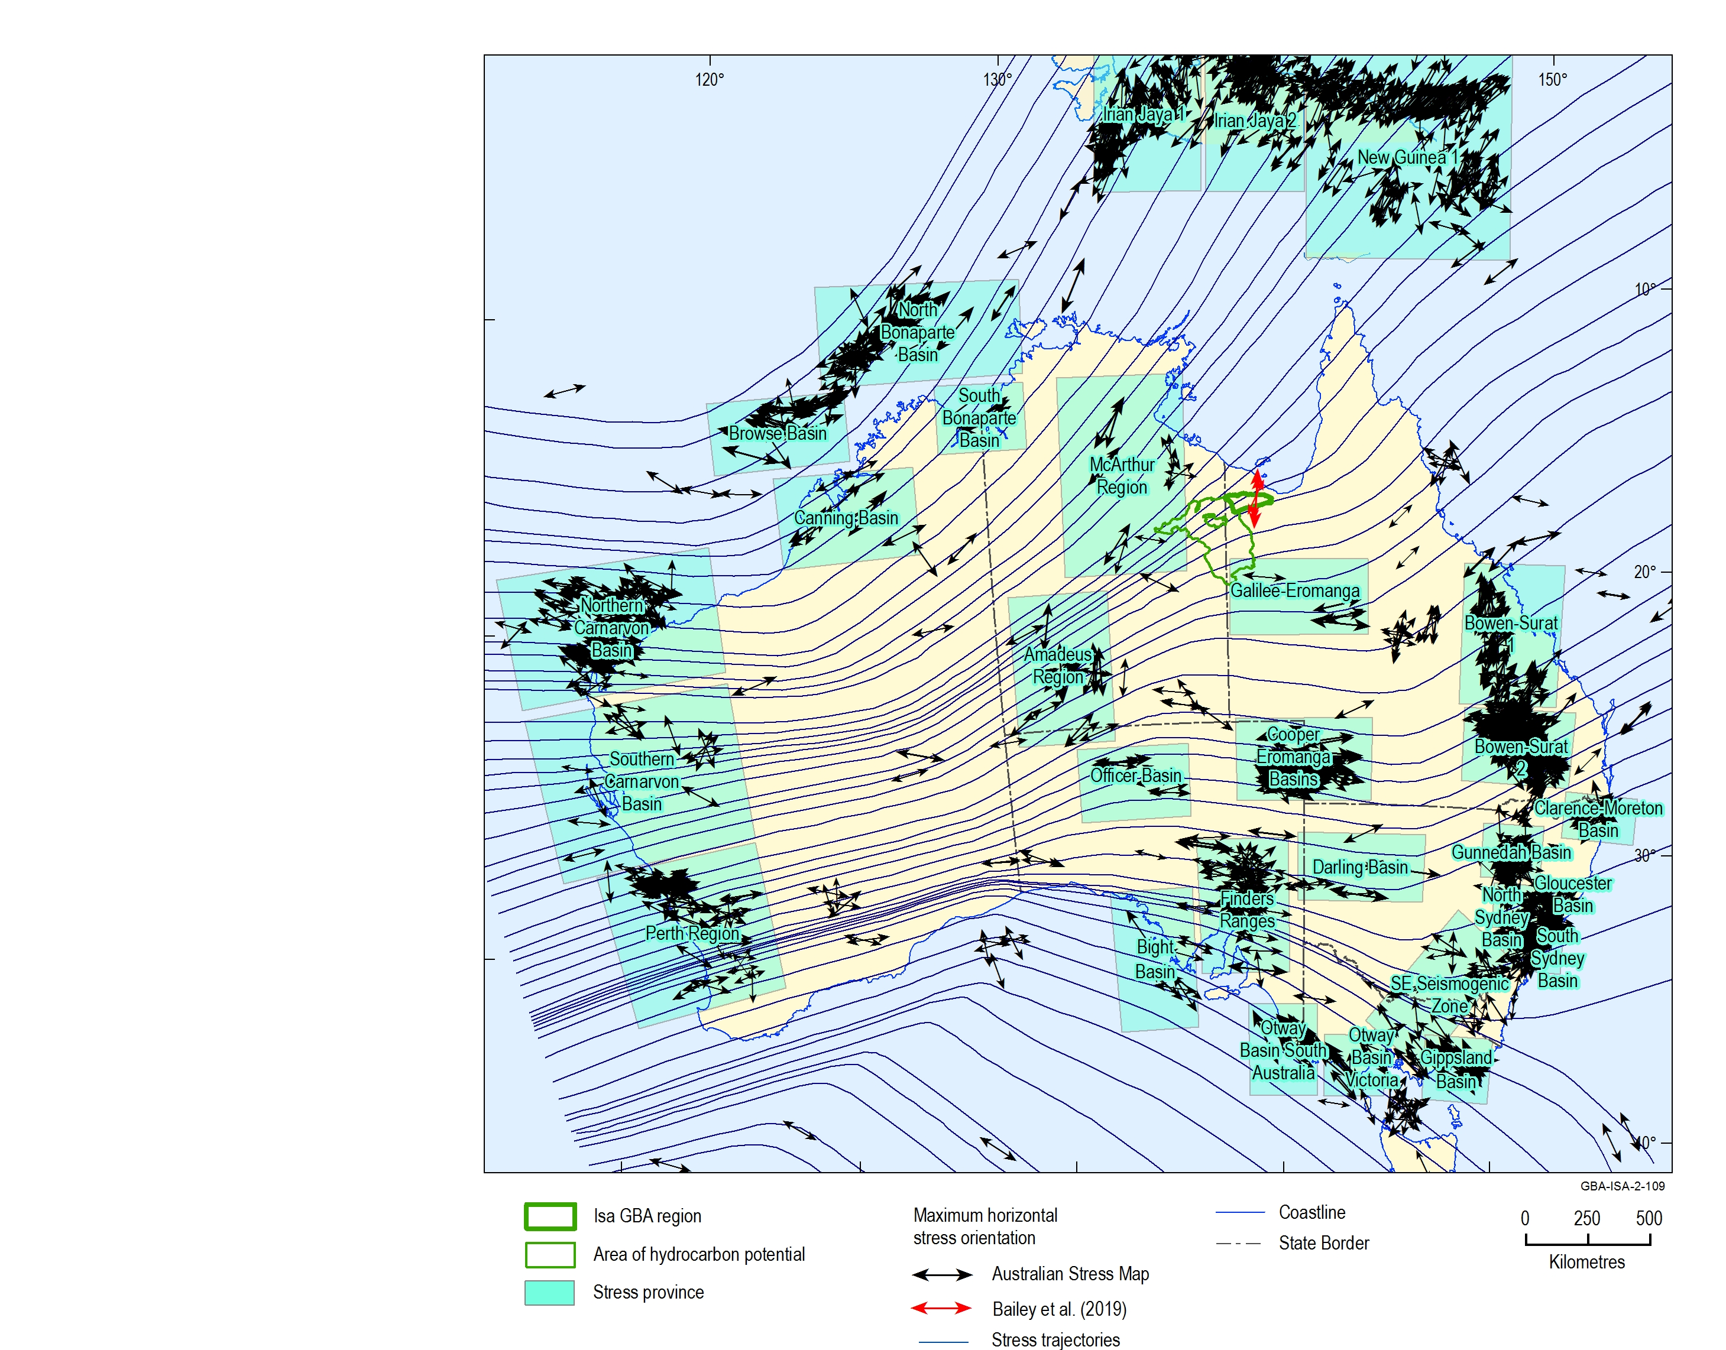
Figure 22 Australian Stress Map 2016
Location of Isa GBA region and area of hydrocarbon potential are highlighted and can be seen in relation to the 30 continental stress provinces defined for Australia and Papua New Guinea. Modelled continental scale maximum horizontal stress azimuths are plotted and are noted both for their complexity, and the fact they do not parallel absolute plate motion as is the case in most continental settings (Hillis and Reynolds, 2003). Interpreted stress azimuths from the Australian Stress Map are provided in black (Rajabi et al., 2017), and interpreted stress azimuths from Bailey et al. (2019) are provided in red.
Source: After Rajabi et al. (2017) and Bailey et al. (2019)
Element: GBA-ISA-2-109
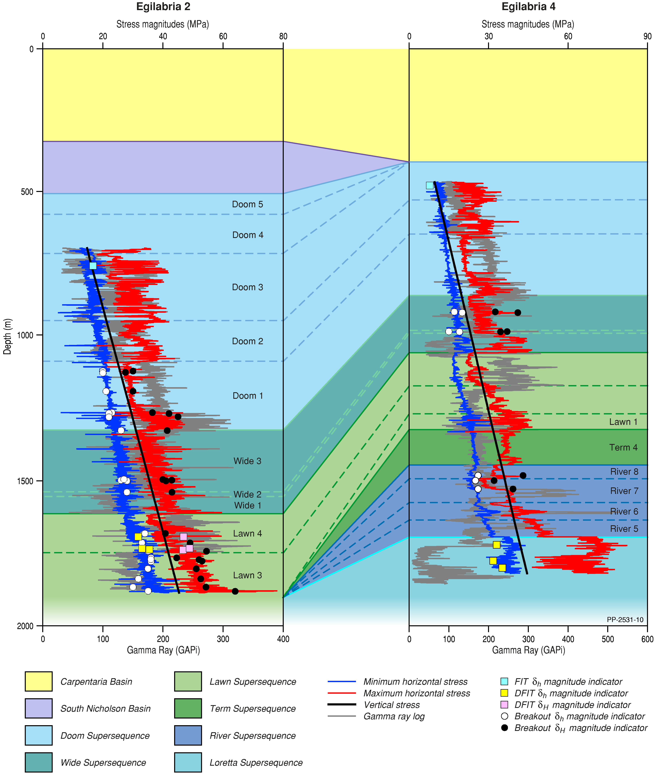
Figure 23 One-dimensional mechanical earth models (1D MEMs) constructed for the Armour Energy Limited wells Egilabria 2 and Egilabria 4, displayed alongside correlated Isa Superbasin supersequences, third-order sequences, and younger overlying basins
Source: Bailey et al. (2019)
Element: GBA-ISA-2-130

Implications for fracture propagation
Mechanical properties control the amount of stress which can be supported by a given lithology (Figure 24). The concept of mechanical stratigraphy, where variation in rock properties of a given lithology can be defined by discrete mechanical properties, is noted as a significant control over the formation and propagation of fractures within the subsurface (Laubach et al., 2009). Where there are contrasts between these mechanical units, natural barriers to fracture propagation are formed (Zoback, 2007). Typically a significant change in stresses from unit to unit will result in the termination of fracture propagation. Fundamentally, low Poisson’s ratio rocks with a high Young’s modulus support anisotropic horizontal stresses (i.e. lower magnitudes in the minimum horizontal stress direction and elevated magnitudes in the maximum horizontal stress direction), whereas rocks with a high Poisson’s ratio and low Young’s modulus are incapable of supporting those anisotropies and so tend towards more isotropic stresses (i.e. higher magnitudes in the minimum horizontal stress direction and lower magnitudes in the maximum horizontal stress direction) (Plumb et al., 2000) (Figure 24). Typically, it is grain-supported facies such as sandstones or carbonates that exhibit anisotropic horizontal stresses, clay supported facies such as mudstones and shales that approach isotropic stress conditions (Plumb et al., 2000; Zoback, 2007) (Figure 24). An understanding of mechanical stratigraphy, and the variation of in situ stress magnitudes that results from varying mechanical properties, allows for induced fractures to be naturally constrained.
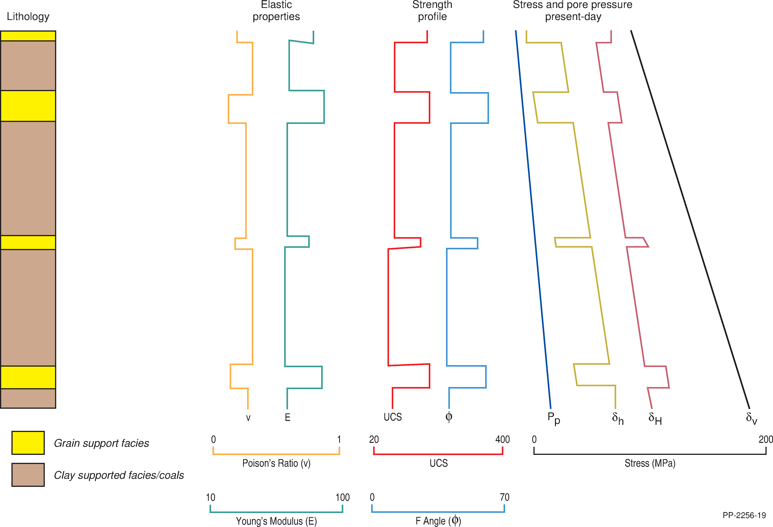
Figure 24 Schematic mechanical earth model showing lithology, mechanical stratigraphy, and calculated stress profiles
Source: Plumb et al. (2000)
Element: GBA-ISA-2-131
In the Isa Superbasin, significant variation of stress magnitudes, and possibly of stress regime, with depth is likely to act as an impediment to fracture propagation. Within the two units of interest, the Lawn Supersequence’s Lawn 4 shale (Lawn Hill Formation, lower Pmh4) and the River Supersequence (Riversleigh Siltstone), stress variations exist which should result in local containment of induced fractures. For example, Figure 23 shows one-dimensional MEMs for the Isa Superbasin wells Egilabria 2 and Egilabria 4, where the Lawn 4 Sequence shale gas target has depressed σH magnitudes which result in a normal to strike-slip faulting stress regime. This is in contrast to the overlying Wide Supersequence and underlying Lawn 3 Sequence, where elevated σH magnitudes result in a strike-slip faulting stress regime. The upper interval of the River Supersequence as intersected in Egilabria 4 has similarly depressed σH magnitudes resulting in a normal to strike-slip faulting stress regime. While fractures propagate vertically under both of these faulting regimes, the significant increase in σH magnitude likely will exert a natural control over fracture propagation. Hence, fracture growth is likely to be controlled by stress contrasts between mechanically distinct units (Anderson, 1951; Baumgärtner and Zoback, 1989; Hossain et al., 2000; Hubbert and Willis, 1957; Sibson, 1990; Zoback, 2007).
Johnson and Titus (2014) discussed their observations and some implications following the solitary fracture stimulation undertaken in the horizontal well Egilabria 2 DW1 as part of Armour Energy Limited‘s exploration program. A multi-stage ‘plug-and-perf’ style fracture treatment was employed, and resulted in the unassisted recovery of significant volumes of fracture fluids and low surface pressure gas flows (Johnson and Titus, 2014). Post-frac, and on the basis of petrophysical and stress analysis, the intervals 1605 to 1642 m and 1642 to 1704 m depth in Egilabria 2 are identified as both the lowest stress and highest prospectivity shale intervals. This corresponds to the upper interval of the Lawn 4 shale identified as prospective within this study, and it is these intervals that are suggested as the target of potential future lateral wells by the authors. Johnson and Titus (2014) suggested that multi-stage transverse fractures are both achievable and likely to intersect natural fractures, aiding total fracture length and building fracture network complexity. However, they also noted that fracture initiation and propagation is difficult in these rocks due to their high rock strength. Based on the lessons learned in fracture stimulation of Egilabria 2 DW1, the authors make several technical recommendations for lower fracture initiation pressures and maintaining fracture connectivity in future wells targeting the Lawn 4 shale (Johnson and Titus, 2014).

Overpressure
Knowledge of overpressure and accurate pore-pressure prediction is essential to petroleum exploration and production in order to ensure safe drilling and proper well design, and is an essential input for reservoir planning and reserve estimation (Tingate et al., 2001; Tingay et al., 2009). Overpressure additionally forms a potential control over seal integrity, fracture reactivation, reservoir quality, and the effective magnitude of in situ stresses (van Ruth et al., 2004; Zoback, 2007).
The term overpressure describes an in situ pore fluid pressure that exceeds the hydrostatic value (Tingate et al., 2001), which ranges from 9.8 MPa/km for fresh water to 11.3 MPa/km for completely salt saturated water. Typically, formation water produced in the Isa Superbasin has salt concentrations of 1492 mg/L, though are observed to range from 350 to 4614 mg/L (see the hydrogeology technical appendix (Buchanan et al., 2020)). Hence, a reasonable estimate of hydrostatic pore pressure within the Isa Superbasin is 9.8 to 10.1 MPa/km (0.433 to 0.446 psi/ft). However, it must be noted that sample density is quite low and significant variations might occur. In order to exceed this hydrostatic gradient, a mechanism other than the buoyancy force of a continuous column of static fluid is required (Osborne and Swarbrick, 1997). The most common mechanisms through which this is achieved are: a) disequilibrium compaction, b) generation of hydrocarbons, c) fluid expansion, and, d) tectonic loading (Bowers, 1995; Grauls and Baleix, 1994; Tingay et al., 2003; Tingay et al., 2007, 2009; Wangen, 2001).
To date, there have been no studies of formation pressure within the Isa Superbasin. Of the petroleum wells drilled within the province, there is only one well where a formation test was carried out; a single drill-stem test (DST) was run in Beamesbrook 1, which failed to recover hydrocarbons and indicated hydrostatic formation pressures within the Mesozoic Gilbert River Formation of the overlying Carpentaria Basin (Dunster et al., 1989a). Drilling fluids are designed to balance formation pressure and, hence, can be used as a rough proxy. This proxy should not be relied upon as it may be misleading; most wells are drilled overbalanced (where mud pressure exceeds formation pressure) to increase wellbore stability.
Drilling mud weight data are available for seven hydrocarbon wells drilled in the Isa Superbasin, and are presented on Figure 25 alongside the Beamesbrook 1 DST data. Several wells were drilled with mud weights exceeding the hydrostatic envelope. Overbalanced mud weights were used in these wells upon encountering the Isa Superbasin sequence and are not associated with any reported direct or indirect indications of overpressure (Figure 25). Additionally, well completion reports stress the difficulties encountered in drilling due to severe induration, particularly in Desert Creek 1 where the retrospective recommendation for harder drill bits is reported. This in turn is associated with reported issues of maintaining mud weights in Desert Creek 1, as slow drilling rates through the indurated sediments resulted in the creation of very fine cuttings, which in turn increased mud weights and required constant dilution and modification in an attempt to maintain balance (Dunster et al., 1993c). It is likely that the overbalance observed is due to both poor mud weight control and a cautious approach to drilling in a poorly understood pressure environment. This assumption is supported by the fluids used in the drilling of the only two modern wells in the Isa Superbasin, Egilabria 2 and Egilabria 4. These two wells not only maintained mud weights in a hydrostatic range, but also relied on under-balanced, air-cooled, hammer drilling to penetrate particularly difficult sections within the overlying South Nicholson Basin, and within the Isa Superbasin itself (Longdon, 2014b, 2014c). Interpretation of the diagnostic fracture injection test undertaken in Egilabria 2 DW1 in preparation for fracture stimulation suggests a reservoir pressure gradient within the Lawn Hill Formation of 10.2 MPa/km or 0.452 psi/ft (Johnson and Titus, 2014). Gorton and Troup (2018) noted that at around 1700 m depth, there are no observations of overpressure within the Egilabria structure, however, they suggested that overpressures may exist at depths greater than 2000 m.
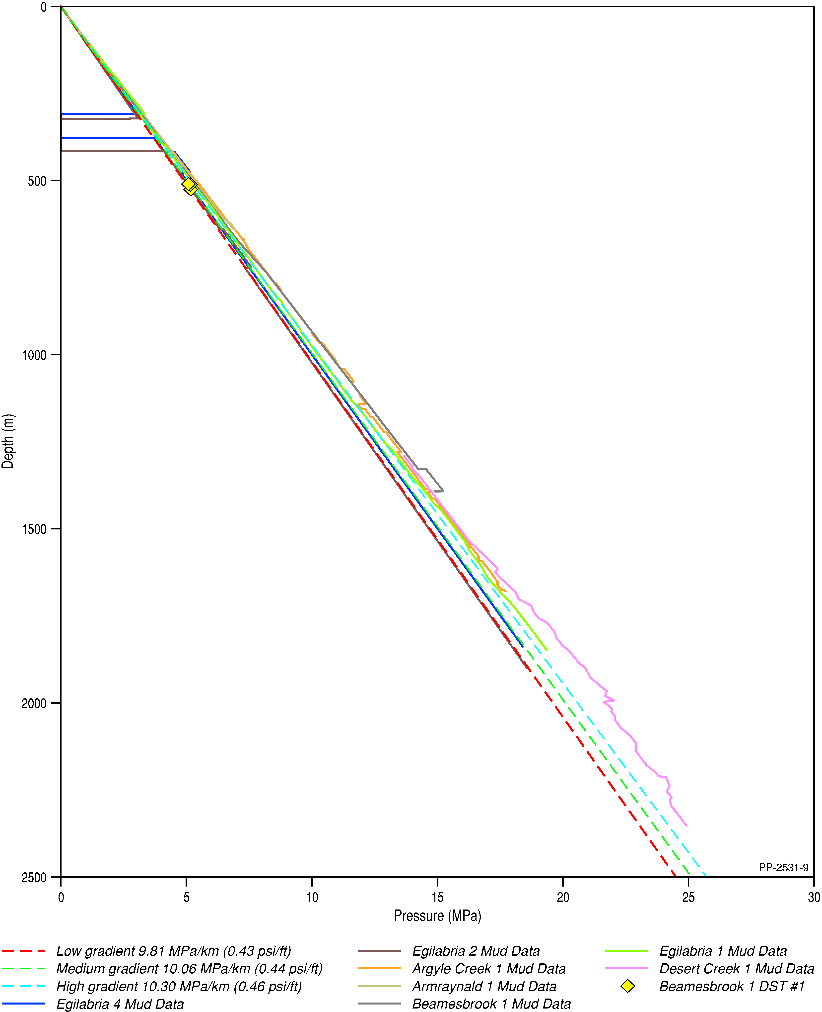
Figure 25 Proxies for pore pressure in Isa Superbasin northern Lawn Hill Platform wells, plotted over hydrostatic gradients for groundwater at densities of 1 g/cc (red dashed line), 1.025 g/cc (green dashed line), and 1.05 g/cc (blue dashed line)
MPa = megapascals, psi = pounds per square inch
Data: Dunster et al. (1993c, 1993a, 1993b); Dunster et al. (1989a); Dunster et al. (1989b); Longdon (2014b, 2014c)
Element: GBA-ISA-2-132

Play fairway analysis
Prospectivity confidence mapping, sometimes referred to as ‘chance of success’ or ‘common risk segment’ mapping is often used to map the distribution of a basin’s key petroleum plays through a data-driven approach. However, a data-driven process is heavily reliant on the availability of high-quality, spatially representative datasets and is, therefore, not a process which can be applied in all areas. The Isa Superbasin is considered to be a frontier petroleum province, with limited exploration activities resulting in limited data availability (see Section 1). As a result, it is not possible to undertake a meaningful process of relative prospectivity confidence mapping within the Isa Superbasin. Instead, play fairway analysis is here used to map the distribution of the Isa Superbasin’s key unconventional shale gas plays.
Play fairway analysis, sometimes referred to as play fairway mapping, is used to identify areas where a specific play may potentially be successful, and where additional work on a finer-scale is warranted in order to further develop an understanding of a prospect. The phrasing ‘fairway’ is used as prospective areas on the map are often visually similar to fairways on a golf course. Play fairway maps are created at a regional scale, often tens to hundreds of kilometres in scale, from multiple input sources that vary based on what information is available and relevant to the requirements of the creator.
In creating play fairway maps for conventional petroleum plays, each major risk element (reservoir, source, and seal) is mapped to demonstrate its likely presence or absence, before these maps are combined to display an overall likelihood of all major play elements being present. In unconventional plays, particularly shale gas plays, the one formation typically forms a self-sourcing, self-sealing reservoir and, hence, fewer inputs are required. These inputs are typically shale extent, net shale thickness, and source rock maturity though other datasets such as pore pressure regime, average porosity and/or permeability, and gas saturations may be included where they are available. This produces a more detailed overview of shale prospectivity than simply mapping shale extent and thickness.

List of plays assessed
The play types and formations included in this assessment are outlined below. Reasoning for selecting only the shale gas plays of the following formations are described in Section 4.
- River Supersequence (Riversleigh Siltstone)
- Lawn Supersequence (Lawn 4 Sequence, Lower Pmh4 Lawn Hill Formation).

Criteria
Criteria to map play fairways within each of the analysed shale gas plays were developed based on datasets available over the Isa GBA region. While criteria for analysing the relative prospectivity of shale gas plays is available (Charpentier and Cook, 2011; US EIA, 2013), the restricted data availability within the Isa Superbasin limits their usefulness in this frontier basin. Consequently, the input data which can be leveraged to create play fairway maps are limited to the datasets listed in Table 26.
Table 26 Summary of shale gas play input parameters and classification criteria used to develop play fairway maps
Parameter | Classified input parameter thresholds |  |  | Comments | Data source | Description/assumptions | Limitations | Reference for threshold criteria
 | None (0) | Medium (0.5) | High (1)
Net shale thickness | < 15 m | ≥ 15 to  < 30 m | ≥ 30 m | Minimum requirements by Charpentier and Cook (2011) | Gross shale thickness sourced from isochore maps by Bradshaw et al. (2018a). See Section 4 for net organic-rich ratios | Derived from sequence/supersequence isochore (true vertical thickness) maps multiplied by net organically rich ratio | Variable coverage and quality of seismic and velocity data for constraining isochore maps; limited well data for determining net organically rich shale ratios | Charpentier and Cook (2011)
Thermal maturity | Formation not present | ≤ 500 m  (oil) | > 500 m  (wet/dry gas) | Modified from minimum requirement by Charpentier and Cook (2011) | Depth-structure maps by Bradshaw et al. (2018a). One-dimensional burial history models by Palu et al. (2018) | Based on depth proxies for thermal maturity in the middle of the sequence/supersequence derived using one-dimensional burial history models. Some manual input is required in areas where originally deeply buried sediments have been inverted to shallow depths | Thermal maturity is very difficult to predict due to the degree of uplift and erosion across the Isa GBA region, and the effect of hydrothermal events on thermal maturity, which often produce inverted maturity profiles. Variable coverage and quality of seismic and velocity data for constraining depth-structure maps; limited well data for constraining burial history models | Palu et al. (2018)
Associated data sources, assumptions, limitations and references are provided.
Input parameter maps were created for net shale thickness and thermal maturity criteria using the Petrosys software (Petrosys Pty. Ltd., Version 17.7sp6), with each input parameter assigned a ranking between zero and one (zero 0; medium 0.5; high 1) as outlined in Table 26. The two input parameter maps were then combined to create a composite play fairway presence map using the following equation:
Play fairway presence map = net shale thickness parameter map x thermal maturity parameter map
The play fairway presence map is then sub-divided into three classes:
- Likely: A play fairway is likely to be present as determined by the high net shale thickness and sufficient subsurface depths for gas generation.
- Unlikely: A play fairway is unlikely to be present based on either only medium net shale thicknesses and/or uncertain thermal maturity for gas generation.
- Absent: The shale gas play fairway is determined to be absent based on either the low net shale thickness (<15 m), or the shale gas interval being mapped as not present.
Non-mappable criteria were not integrated into the play fairway mapping but were used to better understand the geological characteristics of the units. Faults and natural fracture zones were not included in the criteria, though are visually represented on the developed play fairway maps. In the Isa Superbasin, Armour Energy Limited reported gas kicks in natural fracture zones associated with faulting that they intersected in their Egilabria drilling program, and additionally reported that the presence of natural fractures assisted in lower fracture initiation and propagation pressures during stimulation of Egilabria 2 DW1 (Johnson and Titus, 2014; Longdon, 2014b, 2014c, 2014a). It is, therefore, considered that rather than limiting shale gas prospectivity, the presence of faults may in fact be beneficial from a prospectivity point of view (Johnson and Titus, 2014). The interpretation confidence for each play interval, which are determined by the data coverage and quality across the assessment area, are also shown but are not integrated into the play fairway maps.

Results

River Supersequence (Riversleigh Siltstone)
The River Supersequence net shale thickness and thermal maturity parameter maps were created based on the recently published depth-structure and isochore maps of Bradshaw et al. (2018b) (Figure 10). As these maps do not extend to the western limits of the Isa GBA region, it was necessary to manually input some parameter cut-offs based on locally available data:
- Mineral drillhole data over the southern flank of the Murphy Inlier show that the River Supersequence forms a relatively thick (about 120 to 250 m) carbonaceous shale interval, with thermal maturities close to or just exceeding the threshold cut-off for gas generation (Glikson et al., 2006; Krassay et al., 1999). Thermal maturity was therefore mapped as medium (0.5) over the southern Murphy Inlier, with the zero cut-off mapped along the northern outcrop limit for the Mount Les Siltstone (i.e. along the River Supersequence zero edge).
- Net shale thickness was mapped as high (1) up to the subsurface extents of the River Supersequence, as the minimum thickness in interpreted drillholes by Krassay et al. (1999) falls within this classification. Outcrop areas for the Mount Les Siltstone were classified with net shale thickness as medium (0.5) to capture the thinning of the supersequence towards the zero edge.
- Thermal maturity and net shale thickness parameter maps were manually adjusted in the south-eastern assessment area, where Bradshaw et al. (2018b) infer that the River Supersequence is present outside of seismic data control. In this area, both parameters are mapped as medium (0.5) to highlight the uncertain presence of the shale gas play. Input parameter maps are shown in Figure 26.
The River Supersequence play fairway presence map (Figure 27) highlights that the shale gas play is likely to be present over much of the Isa GBA region. The likely widespread extent of the shale gas fairway reflects the very thick, well preserved nature of the River Supersequence. Shale gas prospectivity for the River Supersequence may be further enhanced by the numerous major fault systems that intersect the interval, provided that the associated fracture networks were not mineralised during the River extension event or subsequent hydrothermal events. The River Supersequence is less likely to be prospective around its shallower northern margins due to the more marginal gas generation thermal maturity over the southern Murphy Inlier (Glikson et al., 2006). It is uncertain how far the River Supersequence shale gas fairway extends south-east of the seismic data control between the Brinawa and Bluewater fault systems (Figure 1).

Lawn 4 Sequence (Lower Pmh4 Lawn Hill Formation)
The Lawn 4 Sequence net shale and thermal maturity parameter maps were derived from the recently published depth-structure and isochore maps of Bradshaw et al. (2018a) (Figure 13). These maps show that the Lawn 4 Sequence has a limited extent across the western Isa GBA region due to truncation by the overlying Wide Supersequence unconformity, and is absent at Argyle Creek 1 and over the southern Murphy Inlier. Input parameter maps are derived entirely from the previously published grids as shown in Figure 28.
The Lawn 4 Sequence play fairway presence map (Figure 29) highlights the likely presence of this play across the eastern and central parts of the Isa GBA region. However, the play is less likely to occur over the western part of the region due to uncertain maturity and reduced net shale thicknesses where the sequence has been inverted and truncated beneath the Wide Supersequence unconformity. Inversion and truncation is particularly focused along the footwall block of the Doomadgee Fault System and above the Elizabeth Creek Fault Zone (Figure 1). Faulting will therefore not necessarily enhance the prospectivity of the Lawn 4 Sequence in the west of the region due to its association with increased likelihood of truncation and reduced net shale thickness in the footwall blocks. Faulting and associated inversion and erosion of the Lawn 4 Sequence is less pervasive in the central and eastern region.

Summary
Play fairway analysis has been used to map the more prospective areas for exploring for shale gas resources within the River Supersequence (Riversleigh Siltstone) and the Lawn 4 Sequence (Lower Pmh4 Member of the Lawn Hill Formation) within the Isa GBA region. Criteria used to map the play fairways are limited to thermal maturity (based on current depth below the surface) and net shale thickness due to the lack of data available over the northern Lawn Hill Platform.
Simple geological criteria were used to assess where shale gas intervals are likely to occur, as well data is limited in its coverage and available seismic reflection data is both sporadic and relatively old (mostly late 1980s and early 1990s). Very few of the wells drilled to date intersected the prospective shale gas intervals of the River and Lawn supersequences, very little core has been recovered, and limited data was acquired through well testing and wireline logging. Available well data are not sufficient for regional application and several large data gaps remain in the seismic data which limits the confidence in mapping of shale gas fairways over the assessment area. As a result, it is only possible to build a limited understanding of the properties of these reservoir-source couplets. No consideration is given in this assessment to economic or accessibility factors that may inform the viability of developing the identified plays.
The resultant play fairway maps show that the River Supersequence is prospective for shale gas exploration over most of the Isa GBA region, with the Lawn 4 Sequence more prospective over the central and eastern parts of the region. Exploration for shale gas resources is less likely to occur over the southern flanks of the Murphy Inlier due to the decreased thermal maturity of the River Supersequence and the absence of the Lawn 4 Sequence.
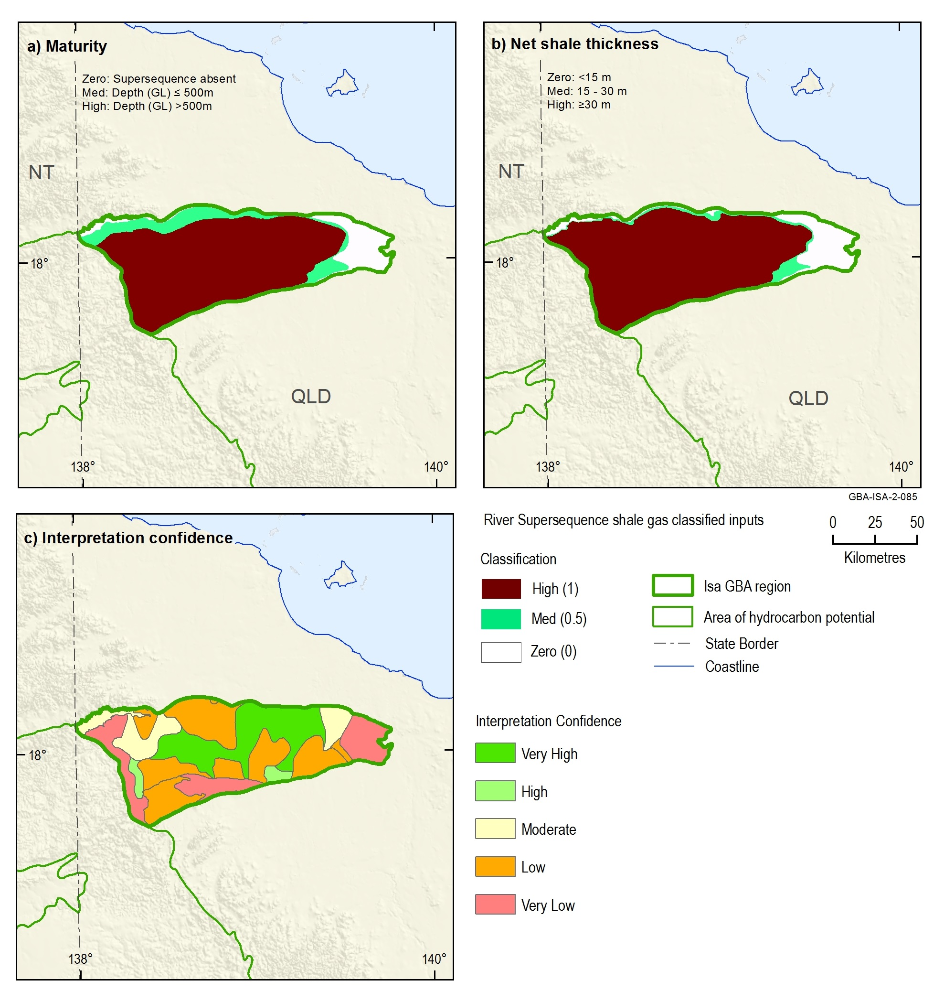
Figure 26 Input parameter maps for (a) thermal maturity and (b) net shale thickness of the River Supersequence. Also shown is (c) the interpretation confidence map for the assessment area
Depth (GL) = depth below ground level
Data: Bradshaw et al. (2018c)
Element: GBA-ISA-2-085
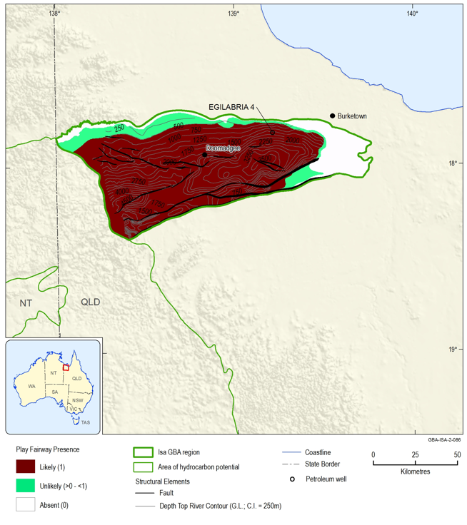
Figure 27 River Supersequence shale gas play fairway presence map
Where the River Supersequence is deeper than approximately 4000 m, sediments are likely to be unprospective for shale gas resources (based on extrapolation of interpreted maturity curves from the wells Desert Creek 1 and Egilabria 1).
Depth to River Supersequence is presented as relative to ground level (G.L.), with a contour interval (C.I.) of 250 m.
Data: Bradshaw et al. (2018c)
Element: GBA-ISA-2-086
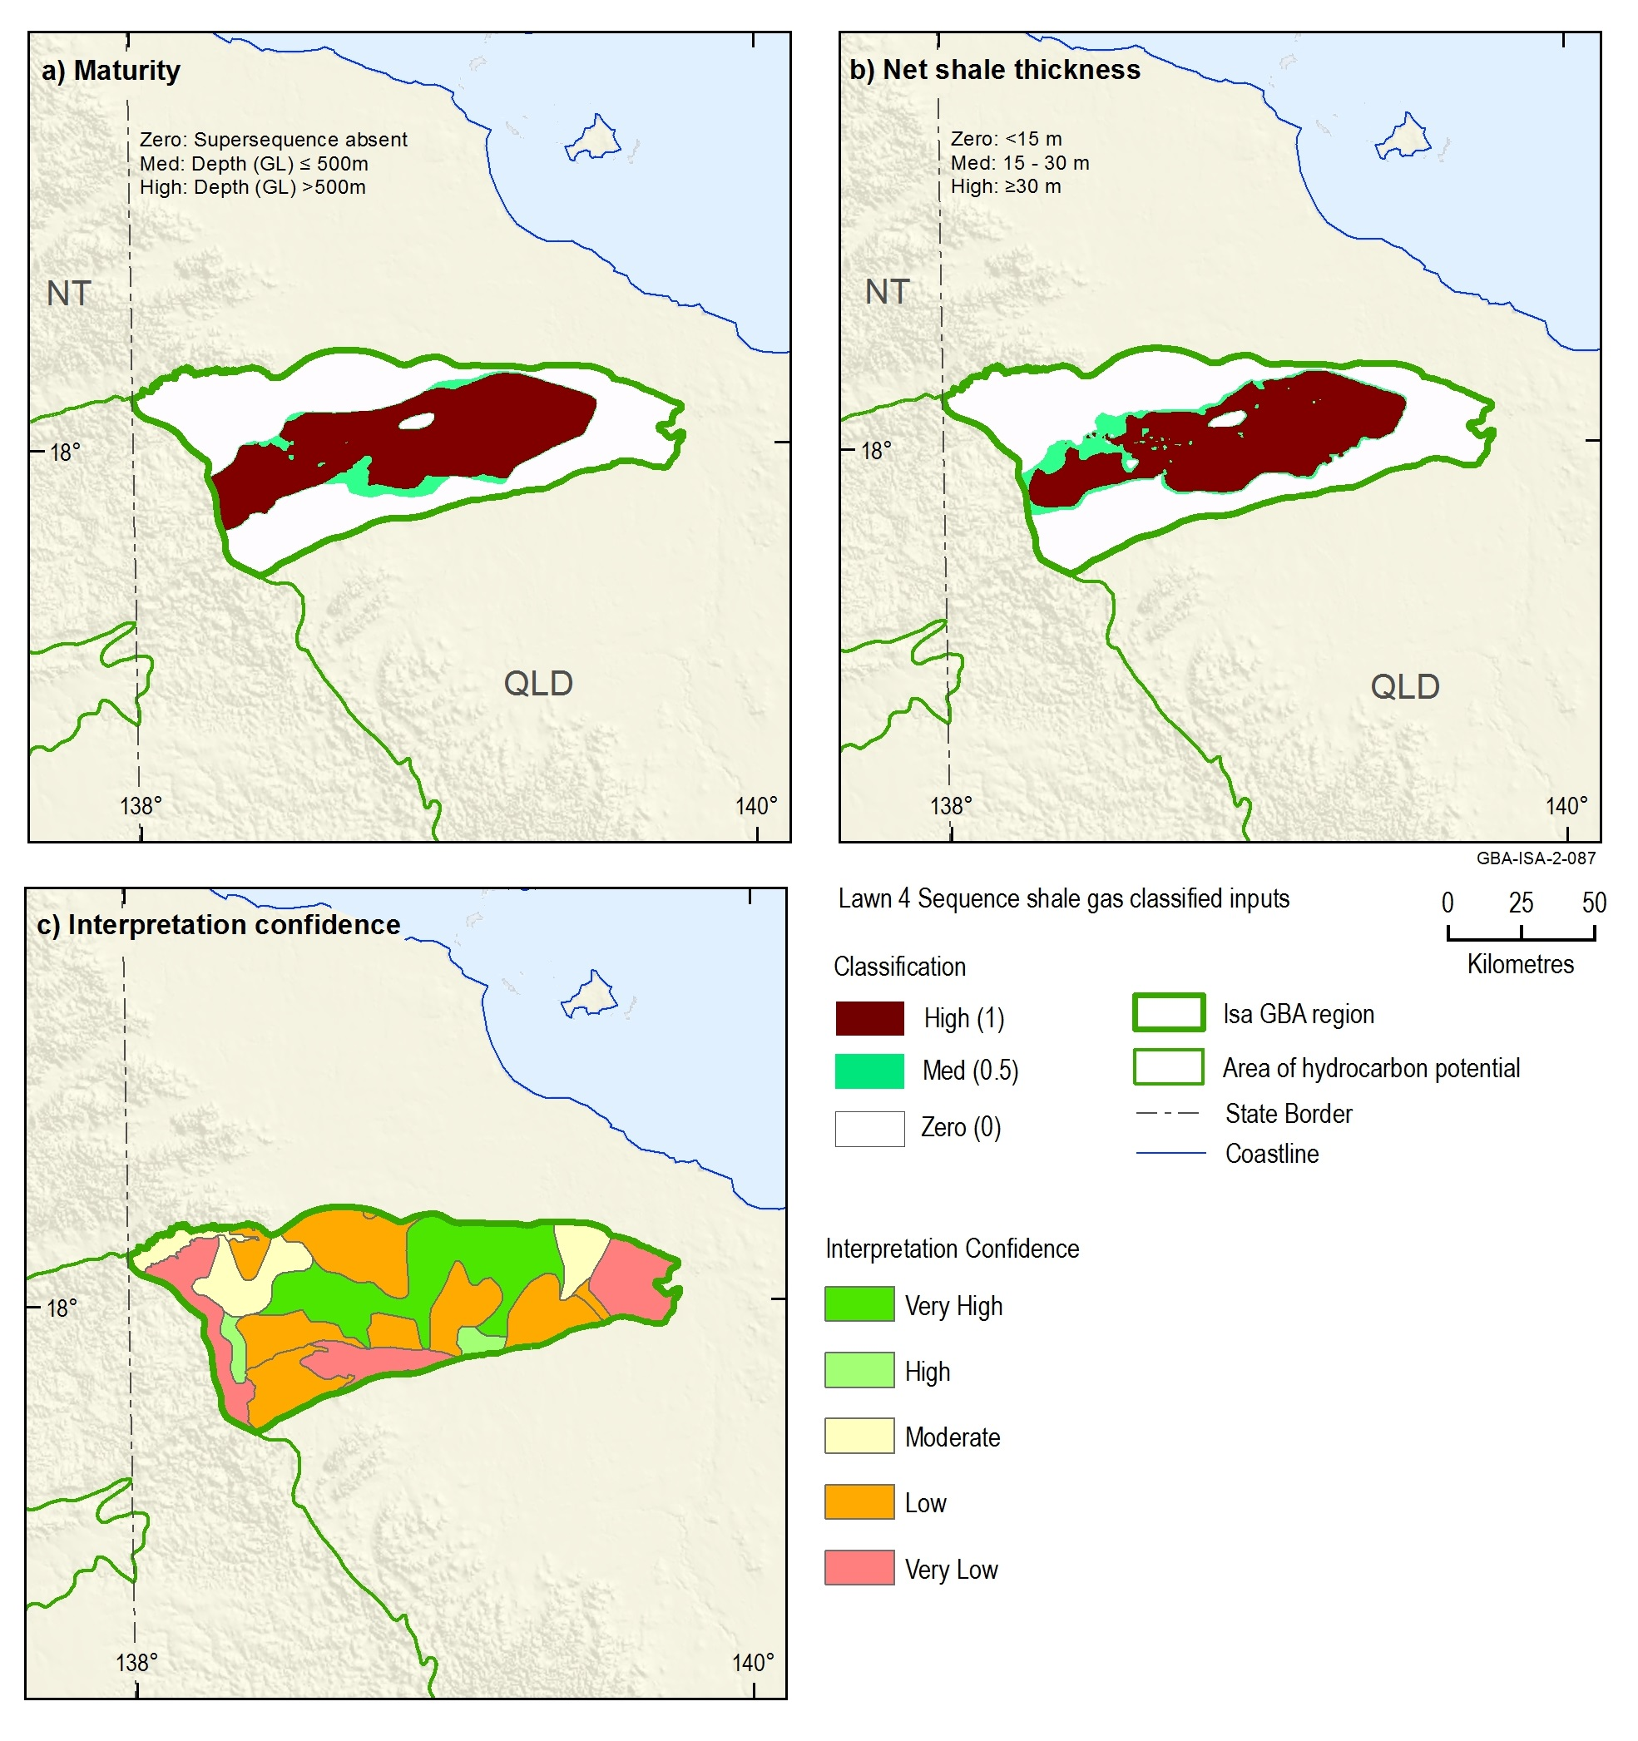
Figure 28 Input parameter maps for (a) thermal maturity and (b) net shale thickness of the Lawn 4 Sequence. Also shown is (c) the interpretation confidence map for the assessment area
Depth (GL) = depth below ground level
Data: Bradshaw et al. (2018c)
GBA-ISA-2-087
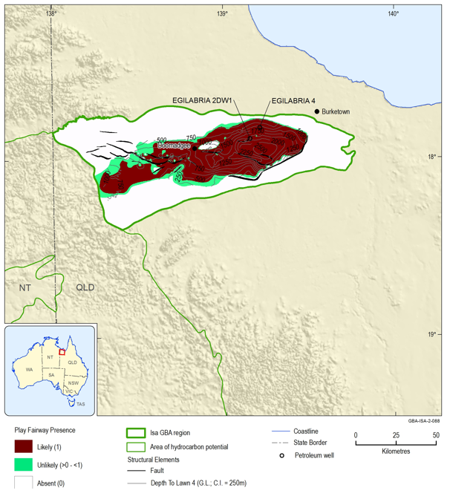
Figure 29 Lawn 4 Sequence shale gas play fairway presence map
Depth to Lawn 4 Sequence is presented as relative to ground level (G.L.), with a contour interval (C.I.) of 250 m.
Data: Bradshaw et al. (2018c)
GBA-ISA-2-088

Conclusions

Key findings
This report presents a review of the regional petroleum prospectivity, exploration history, and the characterisation and analysis of shale gas plays hosted in the Paleoproterozoic sequences of the Isa Superbasin.
Key findings are:
- The Lawn Supersequence in the central and eastern Isa GBA region, and the River Supersequence over most of region are likely to host prospective shale gas plays as identified via play fairway mapping.
- Areas identified as being part of a likely shale gas play fairway correspond to areas being actively targeted for exploration, and those with encouraging exploration results to date.
- The shales in both the Lawn and River supersequences are rich in organic matter and have high potential in shale gas resources based on TOC, thermal maturity, porosity, gas saturation and gas content.
- Both the Lawn and River supersequence shales are brittle based on analyses of mineralogical assemblages and well log data, which is favourable for future reservoir stimulation for gas production.
- The shale gas from both the Lawn and River supersequences primarily consists of methane with small amounts of ethane and carbon dioxide. Besides the hydrocarbon gas, an economically significant percentage of helium (about 0.9%) exists in the Lawn Supersequence (Egilabria 2). However, the distribution of helium throughout the basin is unknown.
- Overpressure and in situ stress, two prime factors controlling shale gas prospectivity, are poorly defined.
The extents of shale gas plays defined by the play fairway mapping inform where the plays are most likely to occur which aids assessment of potential connectivity to overlying surface water–groundwater systems and environmental assets.

Gaps, limitations and opportunities
A number of limitations and assumptions were identified as part of the shale gas prospectivity assessment. Those associated with the play fairway mapping assessment criteria are outlined in Section 5.2. The recognised data and knowledge gaps, as well as the potential opportunities for further work, are outlined below:
- The northern Lawn Hill Platform is a frontier area for shale gas exploration with limited well data and sporadic coverage of relatively old (mostly late 1980s and early 1990s) seismic data. Although there are areas where the seismic data has sufficient coverage and quality to confidently map the shale gas intervals, several large data gaps remain which limit the confidence in mapping of shale gas fairways over the entire Isa GBA region. Infill surveys over existing gaps in the seismic data coverage would allow the extent of the River Supersequence and Lawn 4 shale gas fairways to be better constrained.
- Only a limited number of petroleum exploration or stratigraphic wells have been drilled in the Isa Superbasin. The available well data, including wireline data, laboratory and field tests, are not sufficient for regional applications. Future application of new well data, including full wireline suites as well as geochemical, petrophysical and gas content properties will increase confidence in shale gas prospectivity in the Isa Superbasin.
- Due to the limited well and seismic coverage, lateral variations within the River and Lawn supersequences due to changes in depositional processes are poorly understood. Consequently, facies variations, changes in TOC, source rock maturity and paleoenvironments are poorly defined. Further data acquisition would help in building an understanding of these factors and will increase confidence in shale gas prospectivity in the Isa Superbasin.
- Of the wells that have been drilled, very few recovered core suitable for modern testing. Acquisition of core covering the River and Lawn supersequences at targeted depths would allow for a more detailed understanding to be developed of the properties of these reservoir-source couplets.
- Very little regional stress information is available to contextualise the Isa Superbasin within the Australian continent. Acquisition of new data appropriate for assessing the regional stress regime would allow for both a more detailed understanding of in situ stresses within the Isa Superbasin and as a broader region within the Australian continent.
- Detailed stress information is available only from a pair of proximal wells, and so should not be extrapolated throughout the region. Acquisition of suitable wireline data and laboratory and field tests as suggested above would allow for formation-by-formation assessment of stress magnitudes and, hence, increase the reliability of fracture growth and propagation models and assist in understanding natural fracture barriers within the subsurface.
- To date, very little information on pore pressure has been collected. As a significant component in unconventional hydrocarbon systems, it is essential to understand formation pressures within potential shale gas plays. This is a limiting factor on understanding the prospectivity of shale gas plays in the Isa Superbasin, as the presence of overpressure can influence shale gas prospectivity.
- Fault systems over the assessment area are poorly understood, complex structures that have undergone multiple fluid flow events and phases of reactivation. Consequently, the role of faults in either locally enhancing shale gas prospectivity through generating zones of enhanced fracture permeability, or reducing permeability through producing conduits for mineralisation of organic-rich shales is unknown and not incorporated into the assessment. Acquisition of three-dimensional seismic data over key major fault systems (Doomadgee Fault System, Elizabeth Creek Fault Zone, Bluewater Fault System, Brinawa Fault System) within the shale gas play fairways would help to better understand the influence of faults on prospectivity. In addition, three-dimensional seismic imaging of fault systems may help to identify areas where these structures form potential leakage pathways into overlying aquifers.
- This Stage 2 Isa GBA region assessment is limited to the northern Lawn Hill Platform, which is the only part of the Isa Superbasin currently being explored for shale gas resources. There is potential for the River and Lawn supersequence shale gas fairways and/or additional shale gas play intervals to extend west and south over the area of hydrocarbon potential (defined in Orr et al., 2020). Currently, there is insufficient data acquired over this area to undertake a meaningful assessment of potential shale gas fairways. New regional seismic data has been acquired over parts of the area of hydrocarbon potential for Geoscience Australia’s Exploring for the Future Program and is currently being interpreted. Further acquisition of additional seismic data together with drillholes designed to test the potential presence of key stratigraphic intervals may allow future studies to extend the assessment of unconventional gas resources in the Isa Superbasin beyond the northern Lawn Hill Platform.
- Petroleum systems analysis in the region is currently very limited and preliminary. Play fairway mapping would be greatly enhanced with further work to better understand the petroleum potential of the source rocks. This could include building a more detailed understanding of maturity data and post-depositional erosion rates, developing more detailed maturity profiles to account for hydrothermal fluid movements through the system, and assessing deposition and erosion characteristics. In particular, collection and analysis of kerogen kinetic data would allow better interpretation of regional source rock characteristics to help assess possible timing of hydrocarbon generation and expulsion.
- The play fairway maps use simple geological criteria (minimum depth for shale gas source maturity, net shale thickness, play interval presence or absence) to assess where shale gas intervals are likely to occur. No consideration is given in this assessment to economic or accessibility factors that may limit the viability of developing the identified plays. To inform future development scenarios, associated hazards and impacts, it is essential to consider development of each play in the context of likely economic outcomes. While the prospectivity maps presented in this report inform where the plays are most likely to occur, they do not provide economic context and hence are insufficient to effectively inform future development scenarios alone. To place this work in an economic context, the following additional work is required:
  - resource assessments to estimate total volume of gas-in-place for priority play types, based on the geological understanding of the plays (as outlined in this report)
  - estimation of the proportion of gas-in-place that is technically recoverable
  - economic analyses to understand what would be economic to produce, based on market conditions.

References
Anderson EM (1951) The dynamics of faulting and dike formation with application to Britain. Oliver and Boyd, Edinburgh.
Andrews SJ (1998) Stratigraphy and Depositional Setting of the Upper McNamara Group, Lawn Hill Region, Northwest, Northwest Queensland. Economic Geology 93(8), 1132-1152.
Armour Energy (2012) ASX Announcement: Armour Energy granted ATP1087 in North Queensland. Armour Energy Limited. Viewed 13 November 2019, https://wcsecure.weblink.com.au/pdf/AJQ/01369459.pdf.
Armour Energy (2014) Preparing for the next wave of investment in oil and gas exploration: Armour Energy 2014 AGM Presentation. Viewed 14 March 2018, https://wcsecure.weblink.com.au/pdf/AJQ/01579796.pdf.
Armour Energy (2015) ASX Announcement: 66% increase in Prospective Gas Resources in Northern Australia. Maiden Prospective Gas Resources in the Tawallah Group, McArthur Basin (NT) and in the Riversleigh Shale Formation (QLD). Armour Energy Limited. Viewed, https://www.asx.com.au/asxpdf/20150921/pdf/431g7fg0r64nb7.pdf
ASX (Australian Securities Exchange) (2014) Chapter 5 - Additional reporting on mining and oil and gas production and exploration activities. Viewed 22 October 2018, http://www.asx.com.au/documents/rules/Chapter05.pdf.
Australian Energy Regulator (AER) (2017) State of the energy market, May 2017. Viewed 16 January 2018, https://www.aer.gov.au/publications/state-of-the-energy-market-reports/state-of-the-energy-market-may-2017.
Bailey A, Tenthorey E and Ayling B (2017) Characterising the present-day stress regime of the Georgina Basin. Australian Journal of Earth Sciences 64(1), 121-136.
Bailey AHE, Wang L, Henson PA and Hall L (2019) Rock properties and in-situ stress state of the Egilabria prospect, Lawn Hill Platform, Queensland. APPEA Journal 59, 383-393.
Baumgärtner J and Zoback M (1989) Interpretation of hydraulic fracturing pressure-time records using interactive analysis methods. International Journal of Rock Mechanics and Mining Sciences & Geomechanics Abstracts 26, 461-469. Doi: 10.1016/0148-9062(89)91422-8.
Bell J and Babcock E (1986) The stress regime of the Western Canadian Basin and implications for hydrocarbon production. Bulletin of Canadian Petroleum Geology 34(3), 364-378.
Bell J (1990) Investigating stress regimes in sedimentary basins using information from oil industry wireline logs and drilling records. Geological Society, London, Special Publications 48(1), 305-325.
Bell J (1996a) Petro Geoscience 1. In situ stresses in sedimentary rocks (part 1): measurement techniques. Geoscience Canada 23(2), 85-100.
Bell J (1996b) Petro Geoscience 2. In situ stresses in sedimentary rocks (part 2): applications of stress measurements. Geoscience Canada 23(3), 135-153.
Bell J (2006) In-situ stress and coal bed methane potential in Western Canada. Bulletin of Canadian Petroleum Geology 54(3), 197-220.
Boreham CJ, Edwards DS, Poreda RJ, Darrah TH, Zhu R, Grosjean E, Main P, Waltenberg K and Henson PA (2018) Helium in the Australian liquefied natural gas economy. The APPEA Journal 58(1), 209-237.
Bowers GL (1995) Pore pressure estimation from velocity data: Accounting for overpressure mechanisms besides undercompaction. SPE Drilling & Completion 10(02), 89-95.
Bradshaw BE, Scott DL, Southgate PN, Krassay AA, Lindsay JF, Page RW, Sami TT and Jackson MJ (1999) Evolution of contemporaneous depositional systems in the Isa Superbasin. In: Bradshaw BE and Scott DL (eds), Integrated basin analysis of the Isa Superbasin using seismic, well log and geopotential data: An evaluation of the economic potential of the Northern Lawn Hill Platform. Australian Geological Survey Organisation (AGSO) Record 1999/19, Canberra, 128-162.
Bradshaw BE and Scott DL (1999) Integrated basin analysis of the Isa Superbasin using seismic, well log and geopotential data: An evaluation of the economic potential of the Northern Lawn Hill Platform. Australian Geological Survey Organisation (AGSO) Record 1999/19. Canberra.
Bradshaw BE, Lindsay JF, Krassay AA and Wells AT (2000) Attenuated basin‐margin sequence stratigraphy of the Palaeoproterozoic Calvert and Isa Superbasins: The Fickling Group, southern Murphy Inlier, Queensland. Australian Journal of Earth Sciences 47(3), 599-623. Doi: 10.1046/j.1440-0952.2000.00794.x.
Bradshaw BE, Orr ML, Bailey AHE, Palu TJ and Hall LS (2018a) Northern Lawn Hill Platform Depth Structure and Isochore Mapping Update: data release. GBA data repository GUID: 14042057-ACF5-48DA-8B68-28219FE561A9.
Bradshaw BE, Orr ML, Bailey AHE, Palu TJ and Hall LS (2018b) Northern Lawn Hill Platform Depth Structure and Isochore Mapping Update. Geoscience Australia (GA) Record 2018/47. Doi: 10.11636/Record.2018.047.
Bradshaw BE, Orr ML, Bailey AHE, Palu TJ and Hall LS (2018c) Isa GBA region sub-surface mapping data set. GBA data repository GUID: GUID38661A8A-5FC0-44BD-A979-AE48B3726D25.
Brooke‐Barnett S, Flottmann T, Paul PK, Busetti S, Hennings P, Reid R and Rosenbaum G (2015) Influence of basement structures on in situ stresses over the Surat Basin, southeast Queensland. Journal of Geophysical Research: Solid Earth 120(7), 4946-4965.
Buchanan S, Dixon-Jain P, Martinez J, Raiber M, Kumar P, Woods M, Arnold D, Dehelean A and Skeers N (2020) Hydrogeology and groundwater systems of the Isa GBA region. Technical appendix for the Geological and Bioregional Assessment: Stage 2. Department of the Environment and Energy, Bureau of Meteorology, CSIRO and Geoscience Australia, Australia.
Burnham AK and Sweeney JJ (1989) A chemical kinetic model of vitrinite maturation and reflectance. Geochimica et Cosmochimica Acta 53(10), 2649-2657. Doi: 10.1016/0016-7037(89)90136-1.
CGG Aviation (2013) FALCON Airborne Gravity Gradiometer Survey Logistics and Processing Report (For Armour Energy Pty Ltd): Argyle Creek & Desert Creek Exploration Areas, ATP1087, Queensland. CGG Aviation (Australia) Pty Ltd.
Chan A, Hauser M, Couzens-Schultz B and Gray G (2014) The role of shear failure on stress characterization. Rock mechanics and rock engineering 47(5), 1641-1646.
Charpentier RR and Cook TA (2011) USGS methodology for assessing continuous petroleum resources. U.S. Geological Survey Open-File Report 2011–1167, 75.
Chinn EW (1991) The role of organic geochemistry in petroleum exploration. Basin Research Institute Bulletin, Louisiana State University, Baton Rouge, LA, 15-23.
Cook P, Beck V, Brereton D, Clark R, Fisher B, Kentish S, Toomey J and Williams J (2013) Engineering energy: unconventional gas production - a study of shale gas in Australia, final report. Australian Council of Learned Academics (ACOLA). Viewed 13 November 2019, https://acola.org.au/wp/PDF/SAF06FINAL/Final%20Report%20Engineering%20Energy%20June%202013.pdf.
Couzens-Schultz BA and Chan AW (2010) Stress determination in active thrust belts: An alternative leak-off pressure interpretation. Journal Of Structural Geology 32(8), 1061-1069.
Davies GR and Smith Jr LB (2006) Structurally controlled hydrothermal dolomite reservoir facies: An overview. AAPG Bulletin 90(11), 1641-1690.
Department of Natural Resources, Mines and Energy (Qld) (2017) Petroleum Well Locations – Queensland. Viewed 06 April 2018, http://qldspatial.information.qld.gov.au/catalogue/custom/search.page?q=%22Petroleum%20well%20locations%20-%20Queensland%22. GBA data repository GUID: F2E516E4-5FC6-44FC-A70A-C45A1288AE83.
Dorrins PK, Humphreville RG and Womer MB (1983) Results of the 1983 field program, Lawn Hill Area, ATP 327P, Queensland. Amoco Australia Petroleum Company.
Dunster JN, McConachie BA and Brown MG (1989a) PRC Beamesbrook-1 Well Completion Report, ATP 373P, Carpentaria Basin, Queensland. Comalco Aluminium Limited.
Dunster JN, McConachie BA and Brown MG (1989b) Armraynald-1 well completion report, ATP 373P, Carpentaria Basin, Queensland. Comalco Aluminium Limited.
Dunster JN and Barlow MG (1992) A-P 373P, Carpentaria Basin, Relinquishment Report. Comalco Aluminium Limited.
Dunster JN, Barlow MG, McConachie BA and Stainton PW (1993a) Argyle Creek-1 Well Completion Report, ATP 423P, Queensland. Comalco Aluminium Limited.
Dunster JN, Barlow MG, McConachie BA and Stainton PW (1993b) Egilabria-1 Well Completion Report, ATP 423P, Queensland. Comalco Aluminium Limited.
Dunster JN, Barlow MG, McConachie BA and Stainton PW (1993c) Desert Creek-1 Well Completion Report, ATP 423P, Queensland. Comalco Aluminium Limited.
Fall A, Eichhubl P, Cumella SP, Bodnar RJ, Laubach SE and Becker SP (2002) Testing the basin-centered gas accumulation model using fluid inclusion observations: Southern Piceance Basin, Colorado. AAPG Bulletin 96(12), 2297–2318.
Fisher MK and Warpinski NR (2012) Hydraulic-fracture-height growth: Real data. SPE Production & Operations 27(01), 8-19.
Frogtech Geoscience (2018a) North West Queensland SEEBASE study and GIS. Queensland Geological Record 2018/03, Geological Survey of Queensland. GBA data repository GUID: B8F94284-278A-4F0F-8215-802FFBE972DB.
Frogtech Geoscience (2018b) SEEBASE® study and GIS for greater McArthur Basin. Northern Territory Geological Survey, Digital Information Package DIP 017 (ESRI file format, March 2018). Viewed 25 May 2018, https://geoscience.nt.gov.au/gemis/ntgsjspui/handle/1/87064. GBA data repository GUID: 563A5349-DC7F-42B8-B6CC-892B3B4C3C3F.
Geological and Bioregional Assessment Program (2018) Isa GBA region and area of hydrocarbon potential. GBA data repository GUID: 18F6E2B1-F59C-4176-812A-B5E813A33F38.
Geoscience Australia (2017a) Australian Topographic Base Map (Web Mercator) Web Map Server. Viewed 05 November 2018, https://data.gov.au/dataset/australian-topographic-base-map-web-mercator-wms. GBA data repository GUID: BCA7C9F6-6639-45C4-ABC8-5027EFA14B40.
Geoscience Australia (2017b) National Oil and Gas Infrastructure WMS. Viewed 05 November 2018, https://data.gov.au/dataset/national-oil-and-gas-infrastructure-wms. GBA data repository GUID: C6A944CC-3FFE-46C3-8CE8-86FDBDC7FCC5, 0A207978-0A06-4105-B881-2A215AB43734.
Geoscience Australia, Department of the Environment and Energy and Australian Renewable Energy Agency (2018) Australian Energy Resources Assessment (AERA). Geoscience Australia. Viewed 16 January 2018, http://www.ga.gov.au/aera.
Geoscience Australia (2018) Australian Energy Resources Assessment (AERA) interim report. Geoscience Australia. Viewed 16 January 2018, https://aera.ga.gov.au/.
Glikson M (1993) A petroleum source rock study of the Mt Isa Basin. Unpublished exploration report CR24911, Geological Survey of Queensland.
Glikson M, Mastalerz M, Golding SD and McConachie BA (2000) Metallogenesis and hydrocarbon generation in northern Mount Isa Basin, Australia. Kluwer Academic Publishers, Dordrecht, Netherlands.
Glikson M, Golding SD and Southgate P (2006) Thermal Evolution of the Ore-Hosting Isa Superbasin: Central and Northern Lawn Hill Platform. Economic Geology 101, 1211-1229. Doi: 10.2113/gsecongeo.101.6.1211.
Golding SD, Uysal IT, Glikson M, Baublys KA and Southgate PN (2006) Timing and chemistry of fluid-flow events in the Lawn Hill platform, northern Australia. Economic Geology 101(6), 1231-1250.
Gorton J and Troup A (2018) Petroleum systems of the Proterozoic in northwest Queensland and a description of various play types. The APPEA Journal 58(1), 311-320. Doi: 10.1071/AJ17115.
Grauls D and Baleix J (1994) Role of overpressures and in situ stresses in fault-controlled hydrocarbon migration: A case study. Marine and Petroleum Geology 11(6), 734-742.
Gray D, Anderson P, Logel J, Delbecq F, Schmidt D and Schmid R (2012) Estimation of stress and geomechanical properties using 3D seismic data. first break 30(3), 59-68.
Hall LS, Buchanan S, Totterdell JM, Lai ÉCS, Langford RP, Sundaram B, Ransley TR, Glenn KC, Heugh A, Inskeep C, Zhu R, Skeers N and Stewart G (2018) Rapid regional prioritisation for tight and shale gas potential of eastern and northern Australian basins. Geological and Bioregional Assessment Program: Stage 1. Prepared by Geoscience Australia for the Department of the Environment and Energy. Australia. Viewed 06 August 2018, https://www.bioregionalassessments.gov.au/assessments/geological-and-bioregional-assessment-program/rapid-regional-prioritisation/rapid-regional-prioritisation-report.
Heidbach O and Höhne J (2008) CASMI—a visualization tool for the World Stress Map database. Computers & Geosciences 34(7), 783-791.
Hillis R and Reynolds SD (2003) In situ stress field of Australia. Geological Society of Australia Special Publication 22, 43-52.
Hillis RR, Sandiford M, Reynolds SD and Quigley MC (2008) Present-day stresses, seismicity and Neogene-to-Recent tectonics of Australia's ‘passive’ margins: intraplate deformation controlled by plate boundary forces. Geological Society, London, Special Publications 306(1), 71-90.
Holgate FL and Gerner EJ (2010) OZTemp Well Temperature Data. Viewed 17 April 2018, https://data.gov.au/dataset/c03020d8-0d4e-4236-bd20-67b1e9fcff90. GBA data repository GUID: 88F95B03-AB4F-42D9-8A83-218A87BB9F28.
Holland HD (2006) The oxygenation of the atmosphere and oceans. Philosophical Transactions of the Royal Society B: Biological Sciences 361(1470), 903-915.
Hossain M, Rahman M and Rahman S (2000) Hydraulic fracture initiation and propagation: roles of wellbore trajectory, perforation and stress regimes. Journal of Petroleum Science and Engineering 27(3-4), 129-149.
Hubbert MK and Willis DG (1957) Mechanics of Hydraulic Fracturing. Petroleum Transactions 210, 153-168.
Hutton L and Sweet I (1982) Geological evolution, tectonic style, and economic potential of the Lawn Hill Platform cover, Northwest Queensland. BMR Journal of Australian Geology & Geophysics 7(2), 125-134.
Jackson MJ, Scott DL and Rawlings DJ (2000) Stratigraphic framework for the Leichhardt and Calvert Superbasins: review and correlations of the pre-1700 Ma successions between Mt Isa and McArthur River. Australian Journal of Earth Sciences 47(3), 381-403.
Jacob H (1989) Classification, structure, genesis and practical importance of natural solid oil bitumen (“migrabitumen”). International Journal of Coal Geology 11(1), 65-79. Doi: 10.1016/0166-5162(89)90113-4.
Jarrett AJM, Hall L, Carr L, Anderson J, Orr ML, Bradshaw BE and Henson P (2018) Source rock geochemistry of the Isa Superbasin and South Nicholson Basin, northern Australia: Baseline regional hydrocarbon prospectivity. Geoscience Australia (GA) Record 2018/032. Canberra.
Jarvie DM, Hill RJ and Ruble TE (2007) Unconventional shale-gas systems: The Mississipian Barnett Shale of north-central Texas as one model for thermogen ic shale-gas assessment. AAPG Bulletin 91(475-499).
Jarvie DM (2012) Shale resource systems for oil and gas: Part 1—Shale-gas resource systems. In: Breyer JA (ed), Shale reservoirs – Giant resources for the 21st century. American Association of Petroleum Geologists, 69-87.
Johnson RL and Titus L (2014) Observations and recommendations from a hydraulic fracturing case in the Pre-Cambrian Lawn Hill Shale, Isa Superbasin, Australia. SPE Asia Pacific Oil & Gas Conference and Exhibition. Society of Petroleum Engineers.
Kennett BLN, Fichtner A, Fishwick S and Yoshizawa K (2013) Australian Seismological Reference Model (AuSREM): mantle component. Geophysical Journal International 192(2), 871-887. Doi: 10.1093/gji/ggs065.
King RC, Neubauer M, Hillis RR and Reynolds SD (2010) Variation of vertical stress in the Carnarvon Basin, NW Shelf, Australia. Tectonophysics 482(1-4), 73-81.
Knauth LP and Kennedy MJ (2009) The late Precambrian greening of the Earth. Nature 460(7256), 728.
Krassay AA, Bradshaw BE, Domagala J, McConachie BA, Lindsay JF, Jackson MJ, Southgate PN, Barnett KW and Zeilinger I (1999) Measured Sections and Sequence Stratigraphic Interpretations: Upper McNamara and Fickling Groups. Australian Geological Survey Organisation (AGSO) Record 1999/15. Canberra.
Krassay AA and Bradshaw BE (1999) Well log sequence stratigraphy. In: Bradshaw BE and Scott DL (eds), Integrated basin analysis of the Isa Superbasin using seismic, well log and geopotential data: An evaluation of the economic potential of the Northern Lawn Hill Platform. Australian Geological Survey Organisation (AGSO) Record 1999/09, Canberra, 109-126.
Krassay AA, Domagala J, Bradshaw BE and Southgate PN (2000a) Lowstand ramps, fans and deep‐water Palaeoproterozoic and Mesoproterozoic facies of the Lawn Hill Platform: The Term, Lawn, Wide and Doom Supersequences of the Isa Superbasin, northern Australia. Australian Journal of Earth Sciences 47(3), 563-597. Doi: 10.1046/j.1440-0952.2000.00791.x.
Krassay AA, Bradshaw BE, Domagala J and Jackson MJ (2000b) Siliciclastic shoreline to growth‐faulted, turbiditic sub‐basins: The Proterozoic River Supersequence of the upper McNamara Group on the Lawn Hill Platform, northern Australia. Australian Journal of Earth Sciences 47(3), 533-562. Doi: 10.1046/j.1440-0952.2000.00790.x.
Landis CR and Castaño JR (1995) Maturation and bulk chemical properties of a suite of solid hydrocarbons. Organic Geochemistry 22(1), 137-149. Doi: 10.1016/0146-6380(95)90013-6.
Largeau C, Casadevall E, Berkaloff C and Dhamelincourt P (1980) Sites of accumulation and composition of hydrocarbons in Botryococcus braunii. Phytochemistry 19(6), 1043-1051.
Laubach SE, Olson JE and Gross MR (2009) Mechanical and fracture stratigraphy. AAPG Bulletin 93(11), 1413-1426.
Law BE and Curtis JB (2002) Introduction to unconventional petroleum systems. AAPG Bulletin 86(11), 1851-1852.
Lech M, Wang L, Hall L, Bailey A, Palu T, Owens R, Skeers N, Woods M, Dehelean A, Orr M, Cathro D and Evenden C (2020) Shale, tight and deep coal gas prospectivity for the Cooper Basin. Technical appendix for the Geological and Bioregional Assessment: Stage 2. Department of the Environment and Energy, Bureau of Meteorology, CSIRO and Geoscience Australia, Australia.
Liu DH, Shi JY and Zheng XM (1994) A discussion on the geochemical characteristics and unconventional evaluation method of high altered carbonate rocks. Natural Gas Industry 14 (Suppl.), pp. 62-66.
Longdon N (2014a) Well Completion Report, Egilabria 2 DW1, ATP 1087 Queensland. Armour Energy Limited.
Longdon N (2014b) Well Completion Report, Egilabria 2, ATP 1087, Queensland. Armour Energy Limited.
Longdon N (2014c) Well Completion Report, Egilabria 4, ATP 1087, Queensland. Armour Energy Limited.
Lund Snee JE and Zoback MD (2016) State of stress in Texas: Implications for induced seismicity. Geophysical Research Letters 43(19), 10208-10214.
McConachie BA (1993) Basin analysis and economic geology of the northern Mount Isa Basin. Doctor of Philosophy thesis. Queensland University of Technology, Brisbane.
McConachie BA (2015a) Lawn Hill Formation Prospective Gas Resources ATP 1087. SRK Consulting (Australasia) Pty Ltd.
McConachie BA (2015b) Riversleigh Siltstone Formation Prospective Gas Resources ATP 1087. SRK Consulting (Australasia) Pty Ltd.
Nelson P (2009) Pore-throat sizes in sandstones, tight sandstones and shales. AAPG Bulletin 93(3), 329-340.
Ogg JG, Ogg G and Gradstein FM (2016) A concise geologic time scale: 2016. Elsevier.
Olsen TN, Bratton TR, Tanner KV and Koepsell R (2007) Application of indirect fracturing for efficient stimulation of coalbed methane. In: Rocky Mountain Oil & Gas Technology Symposium, Society of Petroleum EngineersDoi: 10.2118/107985-MS.
Orr ML, Bradshaw BE, Bernardel G, Palu TJ, Hall LS, Bailey AHE, Skeers N, Dehelean A, Reese B and Woods M (2020) Geology of the Isa GBA region. Technical appendix for the Geological and Bioregional Assessment: Stage 2. Department of the Environment and Energy, Bureau of Meteorology, CSIRO and Geoscience Australia, Australia.
Osborne MJ and Swarbrick RE (1997) Mechanisms for generating overpressure in sedimentary basins: A reevaluation. AAPG Bulletin 81(6), 1023-1041.
Page RW (1978) Response of U-Pb zircon and Rb-Sr total-rock and mineral systems to low-grade regional metamorphism in Proterozoic igneous rocks, Mount Isa, Australia. Journal of the Geological Society of Australia, 25, 141-164.
Page RW and Sweet IP (1998) Geochronology of basin phases in the western Mt Isa Inlier, and correlation with the McArthur Basin. Australian Journal of Earth Sciences 45(2), 219-232. Doi: 10.1080/08120099808728383.
Page RW, Jackson MJ and Krassay AA (2000) Constraining sequence stratigraphy in north Australian basins: SHRIMP U-Pb zircon geochronology between Mt Isa and McArthur River. Australian Journal of Earth Sciences 47(3), 431-459. Doi: 10.1046/j.1440-0952.2000.00797.x.
Palano M (2014) On the present-day crustal stress, strain-rate fields and mantle anisotropy pattern of Italy. Geophysical Journal International 200(2), 969-985.
Palmer I (2010) Coalbed methane completions: a world view. International Journal of Coal Geology 82(3-4), 184-195.
Palu TJ, Jarrett AJM, Boreham C, Hall LS, Bradshaw BE and Orr M (2018) Challenges and possible solutions for burial and thermal history modelling of the Lawn Hill Platform, Isa Superbasin. In: 2018 Australian Organic Geochemistry Conference (AOGC) Proceedings
PBS Pty Ltd (2018) Oil and gas pipelines, Encom GPinfo V6.0 GBA data repository GUID: 0BC08E3D-71BC-4EA3-ACC0-00FDE2BE2E8C.
Perez Altamar R and Marfurt K (2014) Mineralogy-based brittleness prediction from surface seismic data: Application to the Barnett Shale. Interpretation 2(4), T255-T271.
Pitcher T and Davis TL (2016) Geomechanical analysis of in-situ stress and its influence on hydraulic fracturing at the Wattenberg Field, Colorado. first break 34(3), 45-50.
Plumb R, Edwards S, Pidcock G, Lee D and Stacey B (2000) The mechanical earth model concept and its application to high-risk well construction projects. In: IADC/SPE Drilling Conference. Society of Petroleum Engineers. Viewed 16 November 2018, https://www.onepetro.org/conference-paper/SPE-59128-MS.
PRMS (2007) Petroleum Resources Management System (PRMS). Society of Petroleum Engineers, American Association of Petroleum Geologists, World Petroleum Council, and Society of Petroleum Evaluation Engineers. Viewed 23 August 2018, http://www.spe.org/industry/docs/Petroleum_Resources_Management_System_2007.pdf.
Rajabi M, Tingay M, Heidbach O, Hillis R and Reynolds S (2017) The present-day stress field of Australia. Earth-Science Reviews 168, 165-189.
Revie D and Edgoose CJ (2015) Unlocking potential for unconventional petroleum resources in the frontier McArthur Basin, Northern Territory, Australia. AAPG/SEG International Conference & Exhibition 2015. Melbourne, Australia.
RISC (2013) ASX reserves and resources reporting for oil and gas companies. Public seminar, July 2013. Viewed 23 October 2018, http://www.asx.com.au/documents/asx-compliance/asx-oil-and-gas-risc-presentation-july-2013_2.pdf.
Roberts HG, Rhodes JH and Yates KR (1963) Calvert Hills, Northern Territory, 1:250 000 geological map series explanatory notes. Bureau of Mineral Resources, Canberra.
Sandiford M, Wallace M and Coblentz D (2004) Origin of the in situ stress field in south‐eastern Australia. Basin Research 16(3), 325-338. Doi: 10.1111/j.1365-2117.2004.00235.x.
Schenk CJ and Pollastro RM (2002) Natural gas production in the United States. Viewed 13 April 2018, http://pubs.usgs.gov/fs/fs-0113-01/.
Schmoker JW, Crovelli RA and Balay RH (1995) Potential additions to technically recoverable resources for each continuous-type (unconventional) play of the U.S. Geological Survey 1995 National Assessment of United States Oil and Gas Resources; graphical and tabular presentations. US Geological Survey.
Schmoker JW (2002) Resource assessment perspectives for unconventional gas systems. AAPG Bulletin 86(11), 1993-1999.
Schoenherr J, Littke R, Urai JL, Kukla PA and Rawahi Z (2007) Polyphase thermal evolution in the Infra-Cambrian Ara Group (South Oman Salt Basin) as deduced by maturity of solid reservoir bitumen. Organic Geochemistry 38(8), 1293-1318. Doi: 10.1016/j.orggeochem.2007.03.010.
Scott DL and Bradshaw BE (1999) Seismic sequence stratigraphy and basin evolution. In: Bradshaw BE and Scott DL (eds), Integrated basin analysis of the Isa Superbasin using seismic, well-log and geophysical data: an evaluation of the economic potential of the Northern Lawn Hill Platform. Australian Geological Survey Organisation (AGSO) Record 1999/19, 61-85.
Seeber L and Armbruster JG (2000) Earthquakes as beacons of stress change. Nature 407(6800), 69.
Shanley KW and Robinson JW (2004) Factors controlling prolific gas production from low-permeability sandstone reservoirs: Implications for resource assessment, prospect development, and risk analysis. AAPG Bulletin 88(8), 1083–1121.
Sibson R (1977) Fault rocks and fault mechanisms. Journal of the Geological Society 133(3), 191-213.
Sibson R (1992) Implications of fault-valve behaviour for rupture nucleation and recurrence. Tectonophysics 211(1-4), 283-293.
Sibson R, Ghisetti F and Ristau J (2011) Stress control of an evolving strike-slip fault system during the 2010–2011 Canterbury, New Zealand, earthquake sequence. Seismological Research Letters 82(6), 824-832.
Sibson R, Ghisetti F and Crookbain R (2012) Andersonian wrench faulting in a regional stress field during the 2010–2011 Canterbury, New Zealand, earthquake sequence. Geological Society, London, Special Publications 367(1), 7-18.
Sibson RH (1990) Conditions for fault-valve behaviour. Geological Society, London, Special Publications 54(1), 15-28.
Smart J, Grimes KG, Doutch HF and Pinchin J (1980) The Carpentaria and Karumba Basins, North Queensland. Bureau of Mineral Resources (BMR) Bulletin 202. Canberra.
Spampinato GPT, Betts PG, Ailleres L and Armit RJ (2015) Structural architecture of the southern Mount Isa terrane in Queensland inferred from magnetic and gravity data. Precambrian Research 269, 261-280. Doi: 10.1016/j.precamres.2015.08.017.
Stanley SM (2005) Earth system history. Macmillan.
Stein RS (1999) The role of stress transfer in earthquake occurrence. Nature 402(6762), 605.
Sweet IP and Hutton L (1982) Lawn Hill Region 1: 100 000 geology map commentary. Bureau of Mineral Resources, Canberra.
Tingate P, Khaksar A, Van Ruth P, Dewhurst D, Raven M, Young H, Hillis R and Dodds K (2001) Geological controls on overpressure in the Northern Carnarvon Basin. The APPEA Journal 41(1), 573-594.
Tingay MR, Hillis RR, Morley CK, Swarbrick RE and Okpere EC (2003) Pore pressure/stress coupling in Brunei Darussalam—implications for shale injection. Geological Society, London, Special Publications 216(1), 369-379.
Tingay MR, Hillis RR, Swarbrick RE, Morley CK and Damit AR (2007) ‘Vertically transferred’ overpressures in Brunei: Evidence for a new mechanism for the formation of high-magnitude overpressure. Geology 35(11), 1023-1026.
Tingay MR, Hillis RR, Swarbrick RE, Morley CK and Damit AR (2009) Origin of overpressure and pore-pressure prediction in the Baram province, Brunei. AAPG Bulletin 93(1), 51-74.
US EIA (2011) World shale gas resources: an initial assessment of 14 regions outside the United States. US Energy Information Administration, US Department of Energy.
US EIA (2013) Technically recoverable shale oil and shale gas resources: an assessment of 137 shale formations in 41 countries outside the United States. US Energy Information Administration, US Department of Energy.
van Ruth P, Hillis R and Tingate P (2004) The origin of overpressure in the Carnarvon Basin, Western Australia: Implications for pore pressure prediction. Petroleum Geoscience 10(3), 247-257.
Wangen M (2001) Communication between overpressured compartments. Geofluids 1(4), 273-287.
Weatherford Laboratories (Australia) (2014) Gas Analysis - Final Report - Egilabria 2 DW1 January 2014. Armour Energy Limited.
Withnall IW and Hutton L (2013) Chapter 2: North Australian Craton. In: Jell PA (ed), Geology of Queensland. Geological Survey of Queensland, Brisbane, 23-111.
Zoback M (2007) Reservoir geomechanics: Earth stress and rock mechanics applied to exploration. Cambridge Press.

Glossary
The register of terms and definitions used in the Geological and Bioregional Assessment Program is available online at https://w3id.org/gba/glossary (note that terms and definitions are respectively listed under the 'Name' and 'Description' columns in this register). This register is a list of terms, which are the preferred descriptors for concepts. Other properties are included for each term, including licence information, source of definition and date of approval. Semantic relationships (such as hierarchical relationships) are formalised for some terms, as well as linkages to other terms in related vocabularies. Many of the definitions for these terms have been sourced from external glossaries – several from international sources; spelling variations have been preserved to maintain authenticity of the source.
2C: best estimate of contingent resources
accumulation: in petroleum geosciences, an ‘accumulation’ is referred to as an individual body of moveable petroleum
activity: for the purposes of Impact Modes and Effects Analysis (IMEA), a planned event associated with unconventional gas resource development. For example, activities during the exploration life-cycle stage include drilling and coring, ground-based geophysics and surface core testing. Activities are grouped into ten major activities, which can occur at different life-cycle stages.
adsorbed gas: the gas accumulated on the surface of a solid material, such as a grain of a reservoir rock, or more particularly the organic particles in a shale reservoir. Measurement of adsorbed gas and free gas, which is the gas contained in pore spaces, allows calculation of gas in place in a reservoir.
aquifer: rock or sediment in a formation, group of formations, or part of a formation that is saturated and sufficiently permeable to transmit quantities of water to bores and springs
as-received: a sample (e.g. rock, gas, water) as it is received by the laboratory analysing the sample
asset: an entity that has value to the community and, for the purposes of geological and bioregional assessments, is associated with a GBA region. An asset is a store of value and may be managed and/or used to maintain and/or produce further value. An asset may have many values associated with it that can be measured from a range of perspectives; for example, the values of a wetland can be measured from ecological, sociocultural and economic perspectives.
basement: the oldest rocks in an area; commonly igneous or metamorphic rocks of Precambrian or Paleozoic age that underlie other sedimentary formations. Basement generally does not contain significant oil or gas, unless it is fractured and in a position to receive these materials from sedimentary strata.
basin-centred gas: a type of tight gas that occurs in distributed basin-centred gas accumulations, where gas is hosted in low permeability reservoirs which are commonly abnormally overpressured, lack a down dip water contact and are continuously saturated with gas. This is also sometimes referred to as 'continuous' and 'pervasive' gas.
bed: in geosciences, the term 'bed' refers to a layer of sediment or sedimentary rock, or stratum. A bed is the smallest stratigraphic unit, generally a centimetre or more in thickness. To be labeled a bed, the stratum must be distinguishable from adjacent beds.
biogenic gas: hydrocarbon gases (which are overwhelmingly (greater than or equal to 99%) methane) produced as a direct consequence of bacterial activity
bore: a narrow, artificially constructed hole or cavity used to intercept, collect or store water from an aquifer, or to passively observe or collect groundwater information. Also known as a borehole or piezometer.
brittleness: a material is brittle if, when subjected to stress, it breaks without significant plastic deformation
brittleness index: brittleness index (BI) is used to calculate the ease at which a shale rock breaks. It can be estimated from the normalised Young’s modulus and Poisson’s ratio
burial history: the depth of a sedimentary layer versus time, usually corrected for compaction
carbonaceous shale: organic-rich shales that contain less total organic carbon (TOC) than coals (50 wt.% TOC)
charge: in petroleum geoscience, a 'charge' refers to the volume of expelled petroleum available for entrapment
coal: a rock containing greater than 50 wt.% organic matter
coal seam gas: coal seam gas (CSG) is a form of natural gas (generally 95% to 97% pure methane, CH₄) extracted from coal seams, typically at depths of 300 to 1000 m. Also called coal seam methane (CSM) or coalbed methane (CBM).
compression: lateral force or stress (e.g. tectonic) that tends to decrease the volume of, or shorten, a substance
condensate: condensates are a portion of natural gas of such composition that are in the gaseous phase at temperature and pressure of the reservoirs, but that, when produced, are in the liquid phase at surface pressure and temperature
context: the circumstances that form the setting for an event, statement or idea
contingent resources: those quantities of petroleum which are estimated, on a given date, to be potentially recoverable from known accumulations but which are not currently considered to be commercially recoverable
conventional gas: conventional gas is obtained from reservoirs that largely consist of porous sandstone formations capped by impermeable rock, with the gas trapped by buoyancy. The gas can often move to the surface through the gas wells without the need to pump.
Cooper Basin: the Cooper Basin geological province is an Upper Carboniferous – Middle Triassic geological sedimentary basin that is up to 2500 m thick and occurs at depths between 1000 and 4400 m. It is overlain completely by the Eromanga and Lake Eyre basins. Most of the Cooper Basin is in south-west Queensland and north-east SA, and includes a small area of NSW at Cameron Corner. It occupies a total area of approximately 130,000 km², including 95,740 km² in Queensland, 34,310 km² in SA and 8 km² in NSW.
craton: the old, geologically stable interior of a continent. Commonly composed of Precambrian rocks at the surface or covered only thinly by younger sedimentary rocks.
crust: the outer part of the Earth, from the surface to the Mohorovicic discontinuity (Moho)
dataset: a collection of data in files, in databases or delivered by services that comprise a related set of information. Datasets may be spatial (e.g. a shape file or geodatabase or a Web Feature Service) or aspatial (e.g. an Access database, a list of people or a model configuration file).
deep coal gas: gas in coal beds at depths usually below 2000 m are often described as ‘deep coal gas’. Due to the loss of cleat connectivity and fracture permeability with depth, hydraulic fracturing is used to release the free gas held within the organic porosity and fracture system of the coal seam. As dewatering is not needed, this makes deep coal gas exploration and development similar to shale gas reservoirs.
deformation: folding, faulting, shearing, compression or extension of rocks due to the Earth’s forces
deposition: sedimentation of any material, as in the mechanical settling of sediment from suspension in water, precipitation of mineral matter by evaporation from solution, and accumulation of organic material
depositional environment: the area in which, and physical conditions under which, sediments are deposited. This includes sediment source; depositional processes such as deposition by wind, water or ice; and location and climate, such as desert, swamp or river.
development: a phase in which newly discovered oil or gas fields are put into production by drilling and completing production wells
disconformity: see unconformity
discovered: the term applied to a petroleum accumulation/reservoir whose existence has been determined by its actual penetration by a well, which has also clearly demonstrated the existence of moveable petroleum by flow to the surface or at least some recovery of a sample of petroleum. Log and/or core data may suffice for proof of existence of moveable petroleum if an analogous reservoir is available for comparison.
dolomite: a rhombohedral carbonate mineral with the formula CaMg(CO₃)₂
dome: a type of anticline where rocks are folded into the shape of an inverted bowl. Strata in a dome dip outward and downward in all directions from a central area.
drill bit: a drilling tool that cuts through rock by a combination of crushing and shearing
drilling fluid: circulating fluid that lifts rock cuttings from the wellbore to the surface during the drilling operation. Also functions to cool down the drill bit, and is a component of well control.
dry gas: natural gas that is dominated by methane (greater than 95% by volume) with little or no condensate or liquid hydrocarbons
effect: for the purposes of Impact Modes and Effects Analysis (IMEA), a change to water or the environment, such as changes to the quantity and/or quality of surface water or groundwater, or to the availability of suitable habitat. An effect is a specific type of an impact (any change resulting from prior events).
erosion: the wearing away of soil and rock by weathering, mass wasting, and the action of streams, glaciers, waves, wind, and underground water
exploration: the search for new hydrocarbon resources by improving geological and prospectivity understanding of an area and/or play through data acquisition, data analysis and interpretation. Exploration may include desktop studies, field mapping, seismic or other geophysical surveys, and drilling.
expulsion: the process of primary migration, whereby oil or gas escapes from the source rock due to increased pressure and temperature. Generally involves short distances (metres to tens of metres).
extraction: the removal of water for use from waterways or aquifers (including storages) by pumping or gravity channels. In the oil and gas industry, extraction refers to the removal of oil and gas from its reservoir rock.
facies: the characteristics of a rock unit that reflect the conditions of its depositional environment
fairway: a term used in geology to describe a regional trend along which a particular geological feature is likely to occur, such as a hydrocarbon fairway. Understanding and predicting fairways can help geologists explore for various types of resources, such as minerals, oil and gas.
fault: a fracture or zone of fractures in the Earth’s crust along which rocks on one side were displaced relative to those on the other side
field: in petroleum geoscience, a 'field' refers to an accumulation, pool, or group of pools of hydrocarbons or other mineral resources in the subsurface. A hydrocarbon field consists of a reservoir with trapped hydrocarbons covered by an impermeable sealing rock, or trapped by hydrostatic pressure.
fluvial: sediments or other geologic features formed by streams
footwall: the underlying side of a fault, below the hanging wall
formation: rock layers that have common physical characteristics (lithology) deposited during a specific period of geological time
formation water: water that occurs naturally in sedimentary rocks
fracture: a crack or surface of breakage within rock not related to foliation or cleavage in metamorphic rock along which there has been no movement. A fracture along which there has been displacement is a fault. When walls of a fracture have moved only normal to each other, the fracture is called a joint. Fractures can enhance permeability of rocks greatly by connecting pores together, and for that reason, fractures are induced mechanically in some reservoirs in order to boost hydrocarbon flow. Fractures may also be referred to as natural fractures to distinguish them from fractures induced as part of a reservoir stimulation or drilling operation. In some shale reservoirs, natural fractures improve production by enhancing effective permeability. In other cases, natural fractures can complicate reservoir stimulation.
free gas: the gaseous phase present in a reservoir or other contained area. Gas may be found either dissolved in reservoir fluids or as free gas that tends to form a gas cap beneath the top seal on the reservoir trap. Both free gas and dissolved gas play important roles in the reservoir-drive mechanism.
gas-in-place: the total quantity of gas that is estimated to exist originally in naturally occurring reservoirs
gas saturation: the relative amount of gas in the pores of a rock, usually as a percentage of volume
geological formation: stratigraphic unit with distinct rock types, which is able to mapped at surface or in the subsurface, and which formed at a specific period of geological time
granite: an intrusive igneous rock with high silica (SiO₂) content typical of continental regions
groundwater: water occurring naturally below ground level (whether stored in or flowing through aquifers or within low-permeability aquitards), or water occurring at a place below ground that has been pumped, diverted or released to that place for storage there. This does not include water held in underground tanks, pipes or other works.
groundwater system: see water system
hazard: an event, or chain of events, that might result in an effect (change in the quality and/or quantity of surface water or groundwater)
hydraulic fracturing: also known as ‘fracking’, ‘fraccing’ or ‘fracture simulation’. This is a process by which geological formations bearing hydrocarbons (oil and gas) are ‘stimulated’ to increase the flow of hydrocarbons and other fluids towards the well. In most cases, hydraulic fracturing is undertaken where the permeability of the formation is initially insufficient to support sustained flow of gas. The process involves the injection of fluids, proppant and additives under high pressure into a geological formation to create a conductive fracture. The fracture extends from the well into the production interval, creating a pathway through which oil or gas is transported to the well.
hydrocarbon show: a surface observation of hydrocarbons, usually observed as fluorescent liquid on cuttings when viewed with an ultraviolet or black light (oil show) or increased gas readings from the mud logger's gas-detection equipment (gas show)
hydrocarbons: various organic compounds composed of hydrogen and carbon atoms that can exist as solids, liquids or gases. Sometimes this term is used loosely to refer to petroleum.
hydrogeology: the study of groundwater, including flow in aquifers, groundwater resource evaluation, and the chemistry of interactions between water and rock
immature: a hydrocarbon source rock that has not fully entered optimal conditions for generation of hydrocarbons
impact: the difference between what could happen as a result of activities and processes associated with extractive industries, such as shale, tight and deep coal gas development, and what would happen without them. Impacts may be changes that occur to the natural environment, community or economy. Impacts can be a direct or indirect result of activities, or a cumulative result of multiple activities or processes.
injection: the forcing or pumping of substances into a porous and permeable subsurface rock formation. Examples of injected substances can include either gases or liquids.
kerogen: insoluble (in organic solvents) particulate organic matter preserved in sedimentary rocks that consists of various macerals originating from components of plants, animals, and bacteria. Kerogen can be isolated from ground rock by extracting bitumen with solvents and removing most of the rock matrix with hydrochloric and hydrofluoric acids.
likelihood: probability that something might happen
lithology: the description of rocks, especially in hand specimen and in outcrop, on the basis of characteristics such as colour, mineralogic composition and grain size
lithosphere: the outermost shell of the solid Earth, consisting of approximately 100 km of crust and upper mantle
marl: a sedimentary rock containing calcareous clay
mature: a hydrocarbon source rock that has started generating hydrocarbons
methane: a colourless, odourless gas, the simplest parafin hydrocarbon, formula CH₄. It is the principal constituent of natural gas and is also found associated with crude oil. Methane is a greenhouse gas in the atmosphere because it absorbs long-wavelength radiation from the Earth's surface.
migration: the process whereby fluids and gases move through rocks. In petroleum geoscience, 'migration' refers to when petroleum moves from source rocks toward reservoirs or seep sites. Primary migration consists of movement of petroleum to exit the source rock. Secondary migration occurs when oil and gas move along a carrier bed from the source to the reservoir or seep. Tertiary migration is where oil and gas move from one trap to another or to a seep.
mudstone: a general term for sedimentary rock made up of clay-sized particles, typically massive and not fissile
natural gas : the portion of petroleum that exists either in the gaseous phase or is in solution in crude oil in natural underground reservoirs, and which is gaseous at atmospheric conditions of pressure and temperature. Natural gas may include amounts of non-hydrocarbons.
net thickness: the accumulated thickness of a certain rock type of a specified quality which is found within a specific interval of formation
oil: a mixture of liquid hydrocarbons and other compounds of different molecular weights. Gas is often found in association with oil. Also see petroleum.
oil-prone: organic matter that generates significant quantities of oil at optimal maturity
oil shale: organic-rich shale that contains significant amounts of oil-prone kerogen and liberates crude oil upon heating, as might occur during laboratory pyrolysis or commercial retorting
oil window: the maturity range in which oil is generated from oil-prone organic matter
organic matter: biogenic, carbonaceous materials. Organic matter preserved in rocks includes kerogen, bitumen, oil and gas. Different types of organic matter can have different oil-generative potential.
outcrop: a body of rock exposed at the surface of the Earth
overmature: a hydrocarbon source rock that has generated as much hydrocarbon as possible and is becoming thermally altered
overpressure: occurs when the pore pressure is higher than the hydrostatic pressure, caused by an increase in the amount of fluid or gas in the rock, or changes to the rock that reduce the amount of pore space. If the fluid cannot escape, the result is an increase in pore pressure. Overpressure can only occur where there are impermeable layers preventing the vertical flow of water, otherwise the water would flow upwards to equalise back to hydrostatic pressure.
P50: in terms of petroleum resource classification, P50 indicates a 50% probability that this volume of oil and gas will be found or exceeded
permeability: the measure of the ability of a rock, soil or sediment to yield or transmit a fluid. The magnitude of permeability depends largely on the porosity and the interconnectivity of pores and spaces in the ground.
petroleum: a naturally occurring mixture consisting predominantly of hydrocarbons in the gaseous, liquid or solid phase
petroleum system: the genetic relationship between a pod of source rock that is actively producing hydrocarbon, and the resulting oil and gas accumulations. It includes all the essential elements and processes needed for oil and gas accumulations to exist. These include the source, reservoir, seal, and overburden rocks, the trap formation, and the hydrocarbon generation, migration and accumulation processes. All essential elements and processes must occur in the appropriate time and space in order for petroleum to accumulate.
play: a conceptual model for a style of hydrocarbon accumulation used during exploration to develop prospects in a basin, region or trend and used by development personnel to continue exploiting a given trend. A play (or group of interrelated plays) generally occurs in a single petroleum system.
play fairway analysis: sometimes referred to as play fairway mapping, play fairway analysis is used to identify areas where a specific play is likely to be successful, and where additional work on a finer scale is warranted in order to further develop an understanding of a prospect. The phrasing 'fairway' is used as prospective areas on the map are often visually similar to fairways on a golf course. Play fairway maps are created at a regional scale, often tens to hundreds of kilometres in scale, from multiple input sources that vary based on what information is available and relevant based on the requirements of the creator.
plug: a mechanical device or material (such as cement) placed within a well to prevent vertical movement of fluids
porosity: the proportion of the volume of rock consisting of pores, usually expressed as a percentage of the total rock or soil mass
producing: a well or rock formation from which oil, gas or water is produced
production: in petroleum resource assessments, 'production' refers to the cumulative quantity of oil and natural gas that has been recovered already (by a specified date). This is primarily output from operations that has already been produced.
prospective resources: estimated volumes associated with undiscovered accumulations. These represent quantities of petroleum which are estimated, as of a given date, to be potentially recoverable on the basis of indirect evidence but have not yet been drilled. This class represents a higher risk than contingent resources since the risk of discovery is also added.
prospectivity assessment: the assessment of an area to determine the likelihood of discovering a given resource (e.g. oil, gas, groundwater) by analysing the spatial patterns of foundation datasets. The key objective is to identify areas of increased likelihood of discovering previously unrecognised potential. Sometimes referred to as ‘chance of success’ or ‘common risk segment’ analysis.
prospectivity confidence: the relative certainty of hydrocarbons being found (on a scale of zero to one) based on prospectivity mapping
regression: the retreat or contraction of the sea from land areas, and the consequent evidence of such withdrawal (such as enlargement of the area of deltaic deposition). Also, any change (such as fall of sea level or uplift of land) that brings nearshore, typically shallow-water environments to areas formerly occupied by offshore, typically deep-water conditions, or that shifts the boundary between marine and nonmarine deposition (or between deposition and erosion) toward the center of a marine basin.
reserves: quantities of petroleum anticipated to be commercially recoverable in known accumulations from a given date forward under defined conditions. Reserves must further satisfy four criteria: they must be discovered, recoverable, commercial and remaining (as of the evaluation date) based on the development project(s) applied.
reserves, possible: the sum of proved reserves plus probable reserves plus possible reserves. Those unproved reserves, which analysis of geological and engineering data suggests are less likely to be recoverable than probable reserves (probability 10 to 50%). Often referred to as P3.
reserves, proved: those quantities of petroleum, which by analysis of geological and engineering data, can be estimated with reasonable certainty (greater than 90% probability) to be commercially recoverable, from a given date forward, from known reservoirs and under current economic conditions, operating methods, and government regulations. Often referred to as P1.
reservoir: a subsurface body of rock having sufficient porosity and permeability to store and transmit fluids and gases. Sedimentary rocks are the most common reservoir rocks because they have more porosity than most igneous and metamorphic rocks and form under temperature conditions at which hydrocarbons can be preserved. A reservoir is a critical component of a complete petroleum system.
reservoir rock: any porous and permeable rock that contains liquids or gases (e.g. petroleum, water, CO₂), such as porous sandstone, vuggy carbonate and fractured shale
ridge: a narrow, linear geological feature that forms a continuous elevated crest for some distance (e.g. a chain of hills or mountains or a watershed)
risk: the effect of uncertainty on objectives (ASNZ ISO 3100). This involves assessing the potential consequences and likelihood of impacts to environmental and human values that may stem from an action, under the uncertainty caused by variability and incomplete knowledge of the system of interest.
sandstone: a sedimentary rock composed of sand-sized particles (measuring 0.05–2.0 mm in diameter), typically quartz
seal: a relatively impermeable rock, commonly shale, anhydrite or salt, that forms a barrier or cap above and around reservoir rock such that fluids cannot migrate beyond the reservoir. A seal is a critical component of a complete petroleum system.
sediment: various materials deposited by water, wind or glacial ice, or by precipitation from water by chemical or biological action (e.g. clay, sand, carbonate)
sedimentation: the process of deposition and accumulation of sediment (unconsolidated materials) in layers
seismic survey: a method for imaging the subsurface using controlled seismic energy sources and receivers at the surface. Measures the reflection and refraction of seismic energy as it travels through rock.
sensitivity: the degree to which the output of a model (numerical or otherwise) responds to uncertainty in a model input
shale: a fine-grained sedimentary rock formed by lithification of mud that is fissile or fractures easily along bedding planes and is dominated by clay-sized particles
shale gas: generally extracted from a clay-rich sedimentary rock, which has naturally low permeability. The gas it contains is either adsorbed or in a free state in the pores of the rock.
shear: a frictional force that tends to cause contiguous parts of a body to slide relative to each other in a direction parallel to their plane of contact
siltstone: a sedimentary rock composed of silt-sized particles (0.004 to 0.063 mm in diameter)
source rock: a rock rich in organic matter which, if heated sufficiently, will generate oil or gas. Typical source rocks, usually shales or limestones, contain about 1% organic matter and at least 0.5% total organic carbon (TOC), although a rich source rock might have as much as 10% organic matter. Rocks of marine origin tend to be oil-prone, whereas terrestrial source rocks (such as coal) tend to be gas-prone. Preservation of organic matter without degradation is critical to creating a good source rock, and necessary for a complete petroleum system. Under the right conditions, source rocks may also be reservoir rocks, as in the case of shale gas reservoirs.
spring: a naturally occurring discharge of groundwater flowing out of the ground, often forming a small stream or pool of water. Typically, it represents the point at which the watertable intersects ground level.
stratigraphy: the study of the history, composition, relative ages and distribution of stratified rock strata, and its interpretation to reveal Earth’s history. However, it has gained broader usage to refer to the sequential order and description of rocks in a region.
stress: the force applied to a body that can result in deformation, or strain, usually described in terms of magnitude per unit of area, or intensity
strike-slip fault: a type of fault whose surface is typically vertical or nearly so. The motion along a strike-slip fault is parallel to the strike of the fault surface, and the fault blocks move sideways past each other. A strike-slip fault in which the block across the fault moves to the right is described as a dextral strike-slip fault. If it moves left, the relative motion is described as sinistral.
structure: a geological feature produced by deformation of the Earth’s crust, such as a fold or a fault; a feature within a rock, such as a fracture or bedding surface; or, more generally, the spatial arrangement of rocks
subsidence: the sudden sinking or gradual downward settling of the Earth's surface with little or no horizontal motion. The movement is not restricted in rate, magnitude, or area involved.
surface water: water that flows over land and in watercourses or artificial channels and can be captured, stored and supplemented from dams and reservoirs
tectonic stress regime: defined by the relative orientations and magnitude of three principal stresses that are orthogonal (at right angles to each other), namely a maximum (σ1), minimum, (σ3) and intermediate (σ2). These are referred to as the maximum (σH) and minimum (σh) horizontal stresses and are usually expressed in terms of stress gradients at a given depth (e.g. MPa/km or psi/ft).
tectonostratigraphic: relating to the correlation of rock formations with each other in terms of their connection with a tectonic event
tenement: an area of land held by an authority holder. May be an authority to prospect, a petroleum lease, a petroleum facilities lease or a petroleum pipeline lease.
thermal maturity: the degree of heating of a source rock in the process of transforming kerogen (derived from organic matter) into hydrocarbon. Thermal maturity is commonly evaluated by measuring vitrinite reflectance or by pyrolysis.
tight gas: tight gas is trapped in reservoirs characterised by very low porosity and permeability. The rock pores that contain the gas are minuscule, and the interconnections between them are so limited that the gas can only migrate through it with great difficulty.
total organic carbon: the quantity of organic matter (kerogen and bitumen) is expressed in terms of the total organic carbon (TOC) content in mass per cent. The TOC value is the most basic measurement for determining the ability of sedimentary rocks to generate and expel hydrocarbons.
total porosity: total porosity is the total void space in the rock whether or not it contributes to fluid flow (i.e.the total pore volume per unit volume of rock). It is measured in volume/volume, percent or porosity units. The total porosity is the total void space and as such includes isolated pores and the space occupied by clay-bound water. It is the porosity measured by core analysis techniques that involve disaggregating the sample. It is also the porosity measured by many log measurements, including density, neutron porosity and nuclear magnetic resonance logs.
transgression: any change (such as rise of sea level or subsidence of land) that brings offshore, typically deep-water environments to areas formerly occupied by nearshore, typically shallow-water conditions, or that shifts the boundary between marine and nonmarine deposition (or between deposition and erosion) outward from the center of a marine basin.
trap: a geologic feature that permits an accumulation of liquid or gas (e.g. natural gas, water, oil, injected CO₂) and prevents its escape. Traps may be structural (e.g. domes, anticlines), stratigraphic (pinchouts, permeability changes) or combinations of both.
unconformity: a surface of erosion between rock bodies that represents a significant hiatus or gap in the stratigraphic succession. Some kinds of unconformities are (a) angular unconformity – an unconformity in which the bedding planes above and below the unconformity are at an angle to each other; and (b) disconformity – an unconformity in which the bedding planes above and below the stratigraphic break are essentially parallel.
unconventional gas: unconventional gas is generally produced from complex geological systems that prevent or significantly limit the migration of gas and require innovative technological solutions for extraction. There are numerous types of unconventional gas such as coal seam gas, deep coal gas, shale gas and tight gas.
vitrinite: one of the primary components of coal and most sedimentary kerogen. Vitrinite is a type of maceral, where 'macerals' are organic components of coal analogous to the 'minerals' of rocks. It is derived from the cell-wall material or woody tissue of plants.
vitrinite reflectance: a maturation parameter for determining organic matter in fine-grained rocks
water system: a system that is hydrologically connected and described at the level desired for management purposes (e.g. subcatchment, catchment, basin or drainage division, or groundwater management unit, subaquifer, aquifer, groundwater basin)
well: typically a narrow diameter hole drilled into the earth for the purposes of exploring, evaluating, injecting or recovering various natural resources, such as hydrocarbons (oil and gas), water or carbon dioxide. Wells are sometimes known as a ‘wellbore’.
well integrity: maintaining full control of fluids (or gases) within a well at all times by employing and maintaining one or more well barriers to prevent unintended fluid (gas or liquid) movement between formations with different pressure regimes, or loss of containment to the environment

www.bioregionalassessments.gov.au


