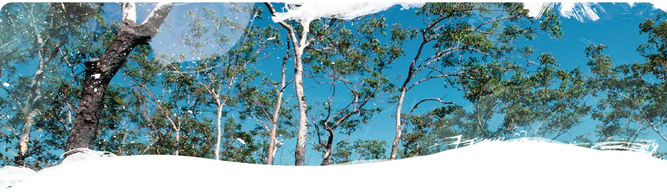
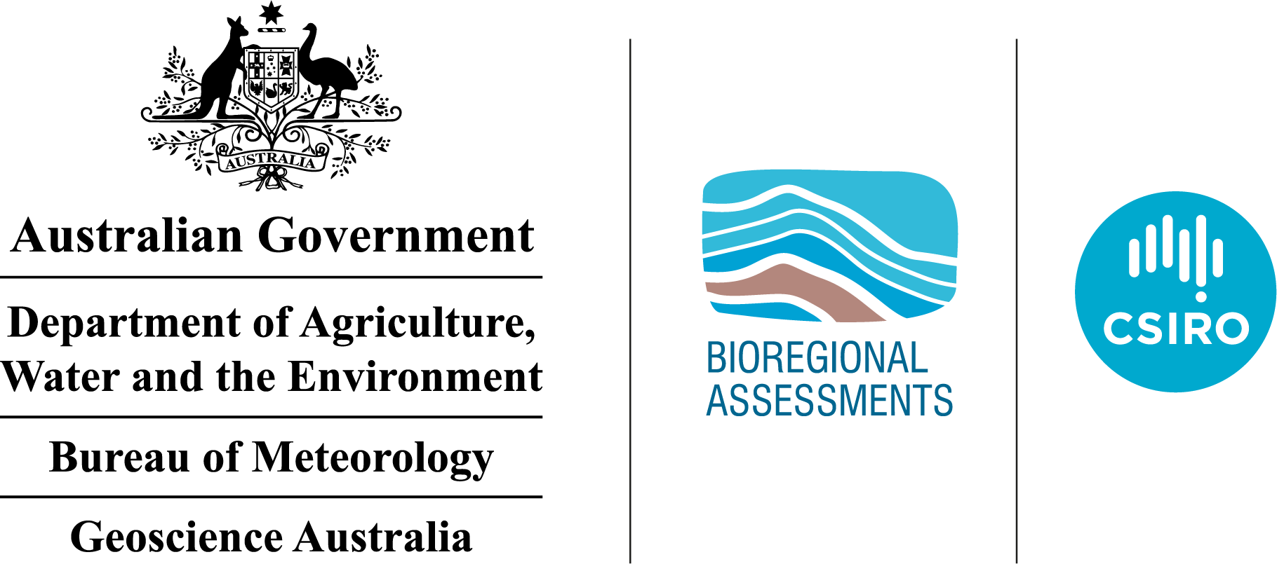

Protected matters for the Isa GBA region
Technical appendix for the Geological and Bioregional Assessment: Stage 2
2020

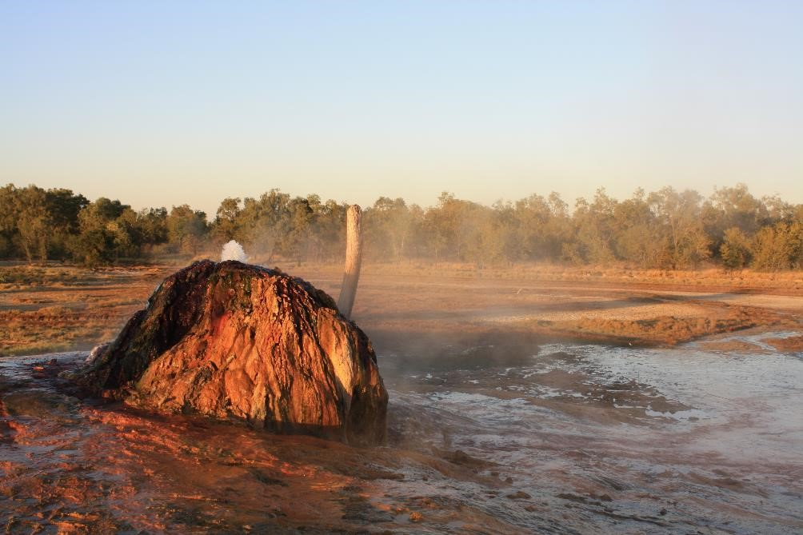
The Geological and Bioregional Assessment Program
The Geological and Bioregional Assessment Program will provide independent scientific advice on the potential impacts from shale and tight gas projects on the environment. The geological and environmental data and tools produced by the program will assist governments, industry, landowners and the community to help inform decision making and enhance the coordinated management of potential impacts.
The Program is funded by the Australian Government Department of the Environment and Energy. The Department of the Environment and Energy, Bureau of Meteorology, CSIRO and Geoscience Australia are collaborating to undertake geological and bioregional assessments. For more information, visit http://www.bioregionalassessments.gov.au.
Department of the Environment and Energy
The Department designs and implements Australian Government policy and programs to protect and conserve the environment, water and heritage, promote climate action, and provide adequate, reliable and affordable energy. For more information visit http://www.environment.gov.au.
Bureau of Meteorology
The Bureau of Meteorology is Australia’s national weather, climate and water agency. Under the Water Act 2007, the Bureau is responsible for compiling and disseminating Australia's water information. The Bureau is committed to increasing access to water information to support informed decision making about the management of water resources. For more information, visit http://www.bom.gov.au/water/.
CSIRO
Australia is founding its future on science and innovation. Its national science agency, CSIRO, is a powerhouse of ideas, technologies and skills for building prosperity, growth, health and sustainability. It serves governments, industries, business and communities across the nation. For more information, visit http://www.csiro.au.
Geoscience Australia
Geoscience Australia is Australia’s national geoscience agency and exists to apply geoscience to Australia’s most important challenges. Geoscience Australia provides geoscientific advice and information to the Australian Government to support current priorities. These include contributing to responsible resource development; cleaner and low emission energy technologies; community safety; and improving marine planning and protection. The outcome of Geoscience Australia’s work is an enhanced potential for the Australian community to obtain economic, social and environmental benefits through the application of first class research and information. For more information, visit http://www.ga.gov.au.
ISBN-PDF 987-1-921069-29-1
Citation
Macfarlane CK, Herr A, Merrin LE, O’Grady AP and Pavey CR (2020) Protected matters for the Isa GBA region. Technical appendix for the Geological and Bioregional Assessment: Stage 2. Department of the Environment and Energy, Bureau of Meteorology, CSIRO and Geoscience Australia, Australia.
Authorship is listed in relative order of contribution.
On 1 February 2020 the Department of the Environment and Energy and the Department of Agriculture merged to form the Department of Agriculture, Water and the Environment. Work for this document was carried out under the then Department of the Environment and Energy. Therefore, references to both departments are retained in this report.
Copyright
 © Commonwealth of Australia 2020
With the exception of the Commonwealth Coat of Arms and where otherwise noted, all material in this publication is provided under a Creative Commons Attribution 4.0 Australia Licence https://creativecommons.org/licenses/by/4.0/. The Geological and Bioregional Assessments Program requests attribution as ‘© Commonwealth of Australia (Geological and Bioregional Assessments Program http://www.bioregionalassessments.gov.au)’.
Disclaimer
The information contained in this report is based on the best available information at the time of publication. The reader is advised that such information may be incomplete or unable to be used in any specific situation. Therefore, decisions should not be made based solely on this information or without seeking prior expert professional, scientific and technical advice.
The Geological and Bioregional Assessments Program is committed to providing web accessible content wherever possible. If you are having difficulties with accessing this document, please contact bioregionalassessments@awe.gov.au.
Cover photograph
The Burketown Bore, drilled in 1897 by the Queensland Government, is a naturally flowing bore that taps the artesian Gilbert River Formation aquifer at a depth of about 700 m below surface. Groundwater within this aquifer naturally contains a variety of dissolved chemical compounds that have deposited around the bore as the hot water (around 68 °C) has evaporated over the years, leading to the formation of a distinctive multi-coloured mound.
Credit: Steven Lewis, Geoscience Australia, July 2018 Element: GBA-ISA-2-264

Executive summary
Expansion of shale and tight gas industries in Australia has potential to impact on environmental matters. A strategic assessment process examines impacts on Matters of National Environmental Significance (MNES) (i.e. Environment Protection and Biodiversity Conservation Act 1999 (EPBC Act) listed matters) at a regional level and enables regulators to assess cumulative impacts of development on these matters. MNES in the Isa GBA region include 2 subspecies of bar-tailed godwit and 24 other vertebrate species (fish, reptiles, birds and mammals) listed nationally as threatened (critically endangered, endangered or vulnerable). There are also 32 species that are listed as migratory and 11 species that are both threatened and migratory. Additionally, four nationally important wetlands are in the Isa GBA region (Bluebush Swamp, Musselbrook Creek Aggregation, Nicholson Delta Aggregation and the Southern Gulf Aggregation).
Matters of State Environmental Significance in the Isa GBA region include two species of birds and one plant species that are listed under Queensland legislation but are not listed as threatened nationally. Two state reserves (Lawn Hill (Widdallion) and Lawn Hill (Arthur Creek) protected areas) partially occur in the south-west of the Isa GBA region. The Gulf Rivers strategic environmental area designated precinct covers 1480 km² within the Isa GBA region. There are 65 regional ecosystems in the Isa GBA region, of which one is ‘Endangered’, 27 are ‘Of concern’ and the remainder ‘No concern at present’.
The Isa GBA region contains many groundwater-dependent ecosystems (GDEs) that shale gas development may impact and that fall outside of the national and state matters of environmental significance. These include the Boodjamulla complex located near Lawn Hill in the south-west of the region, which is located outside of the region, but is potentially hydrologically connected.
There are no world heritage properties or national heritage places within the Isa GBA region. However, about 50 km south of the region, the Australian Fossil Mammal Sites (Riversleigh) is both a world heritage property and a national heritage place. There are no state-listed cultural heritage areas in the Isa GBA region.
To determine how impacts due to shale gas development may affect ecosystems at a landscape scale in the Isa GBA region, ten landscape classes have been identified. The landscape classification was developed to provide a basis for systematic assessment of the potential impacts on landscape function and the protected matters nested in each landscape class. The Isa GBA region is dominated by floodplain and alluvium, loamy and sandy plains, clay plains, and tablelands and duricrusts. There are smaller areas of hills and lowlands on metamorphic rocks, and undulating country on fine-grained sedimentary rocks. There are only traces of other landscape classes.
There are two springs associated with sandstone in the south-west of the Isa GBA region, located near other springs outside the margins of the region. These springs are not associated with groundwater discharge from the Great Artesian Basin.

Contents
Executive summary i
Contributors to the Program vii
Acknowledgements viii
Abbreviations and acronyms ix
Units x
The Geological and Bioregional Assessment Program xi
1 Protected matters 1
1.1 Matters of National Environmental Significance 1
1.2 Other matters protected by the EPBC Act 9
1.3 Species accounts 11
1.4 Listed threatening processes 58
1.5 Matters of State Environmental Significance 58
1.6 Nationally important wetlands 63
1.7 Groundwater-dependent ecosystems 63
2 Cultural baseline synthesis 65
3 Landscape classification and ecohydrological conceptualisation 67
3.1 Description of landscape classes 72
4 Protected matters prioritisation and screening 83
4.1 Approach to prioritising and screening 83
4.2 Screening protected matters in the Isa GBA region 89
5 Knowledge gaps 95
References 96
Glossary 101

Figures
Figure 1 Distribution and Atlas of Living Australia observations of Macroderma gigas 13
Figure 2 Distribution of Saccolaimus s. nudicluniatus 15
Figure 3 Distribution of Xeromys myoides 17
Figure 4 Distribution and Atlas of Living Australia observations of the Dasyurus hallucatus 19
Figure 5 Distribution and Atlas of Living Australia observations of Amytornis dorotheae 21
Figure 6 Distribution and Atlas of Living Australia observations of Erythrura gouldiae 23
Figure 7 Distribution and Atlas of Living Australia observations of Grantiella picta 25
Figure 8 Distribution and Atlas of Living Australia observations of Erythrotriorchis radiatus 27
Figure 9 Distribution and Atlas of Living Australia observations of Numenius madagascariensis 29
Figure 10 Distribution and Atlas of Living Australia observations of Calidris ferruginea 31
Figure 11 Distribution of Limosa lapponica baueri 33
Figure 12 Distribution of Limosa lapponica menzbieri 34
Figure 13 Distribution of Tyto novaehollandiae kimberli 36
Figure 14 Distribution and Atlas of Living Australia observations of Rostratula australis 38
Figure 15 Distribution of Acanthophis hawkei 40
Figure 16 Distribution and Atlas of Living Australia observations of the Elseya lavarackorum 42
Figure 17 Distribution of Caretta caretta 44
Figure 18 Distribution of Chelonia mydas 45
Figure 19 Distribution of Dermochelys coriacea 46
Figure 20 Distribution and Atlas of Living Australia observations of Eretmochelys imbricata 47
Figure 21 Distribution and Atlas of Living Australia observations of Lepidochelys olivacea 48
Figure 22 Distribution and Atlas of Living Australia observations of Natator depressus 49
Figure 23 Distribution of Glyphis glyphis 51
Figure 24 Distribution of Pristis pristis 53
Figure 25 Distribution of Pristis zijsron 55
Figure 26 Distribution of Pristis clavata 57
Figure 27 Nationally important wetlands and protected areas in the Isa GBA region 59
Figure 28 The Gulf Rivers strategic environmental area and high ecological significance wetlands 60
Figure 29 Cultural assets near the Isa GBA region 66
Figure 30 Landscape classes within the Isa GBA region 70
Figure 31 Interim Biogeographic Regionalisation for Australia (IBRA) subregions within the Isa GBA region 71
Figure 32 Floodplain and alluvium conceptual models showing dry-season and wet-season phases 74
Figure 33 Sandy plains conceptual model 76
Figure 34 Clay plains ecohydrological conceptual model 78
Figure 35 Exclusion zones ecohydrological conceptual model 79
Figure 36 Ecohydrological conceptualisation for the tidal flats and beaches landscape class 81
Figure 37 Springs landscape class conceptual model 82

Tables
Table 1 Species classified as Matters of National Environmental Significance under the Commonwealth’s Environment Protection and Biodiversity Conservation Act 1999 (EPBC Act) that occur, or potentially occur, in the Isa GBA region 2
Table 2 List of species classified as other matters protected by the Commonwealth’s Environment Protection and Biodiversity Conservation Act 1999 that occur, or potentially occur, in the Isa GBA region 10
Table 3 Regional ecosystems that are ‘Endangered’ or ‘Of concern’ in the Isa GBA region 61
Table 4 Queensland threatened species identified in the Isa GBA region from WildNet data 62
Table 5 Land zones (Queensland) in the Isa GBA region 68
Table 6 Landscape classes within the Isa GBA region and corresponding Queensland Land Zones 69
Table 7 Interim Biogeographic Regionalisation for Australia (IBRA) subregions in the Isa GBA region 72
Table 8 National matters of environmental significance, and other national matters considered by the GBA Program 84
Table 9 State Matters of Environmental Significance 85
Table 10 Initial categorisation of national and state matters 87
Table 11 Significant impact guidelines for assessing Matters of National Environmental Significance 88
Table 12 Matters of National Environmental Significance with potential to be impacted by shale gas development in the Isa GBA region 90
Table 13 Area of landscape class intersecting with the area deemed likely and unlikely to contain shale gas play fairways within the Isa GBA region, or deemed to be potentially hydrologically connected 91
Table 14 Association of Matters of National Environmental Significance with Isa GBA region landscape classes 92

Contributors to the Program
The following individuals have contributed to the Geological and Bioregional Assessment Program.
Role or team | Contributor(s)
Program Director | Department of the Environment and Energy: Anthony Swirepik
Program Implementation Board | Department of the Environment and Energy: Beth Brunoro, Nicholas Post  Bureau of Meteorology: Kirsten Garwood, Kate Vinot  CSIRO: Jane Coram, Warwick MacDonald  Geoscience Australia: Stuart Minchin, Richard Blewett
Basin Leader | CSIRO: Kate Holland, Cameron Huddlestone-Holmes, Paul Wilkes  Geoscience Australia: Steven Lewis
Program management | CSIRO: Karen Barry, Emanuelle Frery, Linda Merrin, Ruth Palmer  Department of the Environment and Energy: Mitchell Bouma, Rod Dann,  Andrew Stacey, David Thomas, Alex Tomlinson
Product integration and stakeholder engagement | CSIRO: Clare Brandon, Justine Lacey, Michelle Rodriquez, Sally Tetreault-Campbell
Analysis and visualisation | CSIRO: Dennis Gonzalez, Steve Marvanek  Geoscience Australia: Adrian Dehelean, Chris Evenden, Chris Lawson, Bianca Reese, Nigel Skeers, Murray Woods
Basin geology and prospectivity | Geoscience Australia: Lisa Hall (Discipline Leader), Adam Bailey, George Bernardel, Barry Bradshaw, Donna Cathro, Merrie-Ellen Gunning, Amber Jarrett, Megan Lech, Meredith Orr, Ryan Owens, Tehani Palu, Martin Smith, Liuqu Wang
Chemical assessment | CSIRO: Jason Kirby (Discipline Leader), Simon Apte, Lisa Golding, Rai Kookana,  Dirk Mallants, Michael Williams
Data management and transparency | Bureau of Meteorology: Andre Zerger (Discipline Leader), Derek Chen,  Trevor Christie-Taylor, Donna Phillips  CSIRO: Nicholas Car, Philip Davies, Matt Stenson  Geoscience Australia: Matti Peljo
Hydrogeology | Geoscience Australia: Tim Ransley (Discipline Leader), Sam Buchanan, Scott Cook, Prachi Dixon-Jain, Bex Dunn, Tim Evans, Éamon Lai, Bruce Radke,  Baskaran Sundaram
Impact analysis | CSIRO: David Post (Discipline Leader), Brent Henderson, Dane Kasperczyk,  James Kear, Regina Sander
Impacts on protected matters | CSIRO: Anthony O'Grady (Discipline Leader), Alexander Herr, Craig MacFarlane, Justine Murray, Chris Pavey, Stephen Stewart
Spatial analysis | CSIRO: Dennis Gonzalez, Steve Marvanek  Geoscience Australia: Adrian Dehelean, Murray Woods, Nigel Skeers
Water quantity | CSIRO: Russell Crosbie (Discipline Leader), Jorge Martinez Praveen Kumar Rachakonda, Matthias Raiber, Yongqiang Zhang, Hongxing Zheng

Acknowledgements
This technical product was reviewed by several groups:
- Internal Peer Review Group:
  - CSIRO: Justine Murray
  - Geoscience Australia: Steven Lewis.
- Technical Peer Review Group: Andrew Boulton.
- State Government Science Technical Review: This group includes scientists from the Queensland Government.

Abbreviations and acronyms
Abbreviation/acronym | Definition
ABS | Australian Bureau of Statistics
AIBTSIS | Australian Institute of Aboriginal and Torres Strait Islander Studies
CSG | Coal seam gas
DIWA | Directory of Important Wetlands
EPBC Act | Environment Protection and Biodiversity Conservation Act 1999
GAB | Great Artesian Basin
GBA | Geological and Bioregional Assessment
IBRA | Interim Biogeographic Regionalisation of Australia
ILUA | Indigenous Land Use Agreement
IMEA | Impact Modes and Effects Analysis
IPA | Indigenous Protected Area
IUCN | International Union for Conservation of Nature
MNES | Matters of National Environmental Significance
MSES | Matters of State Environmental Significance
LGA | Local government area
Surface geology
K | Unnamed Undifferentiated Cretaceous rocks
Knw | Winton Formation
Knw1 | Unnamed Shale; siltstone; sandstone
Qhr | Unnamed Undifferentiated Holocene colluvial/regolith sediments
Qp\gy | Unnamed Undifferentiated Pleistocene gypcrete
T | Unnamed Undifferentiated Tertiary rocks
TQ | Unnamed Undifferentiated Tertiary to Pleistocene rocks
Knh | Mount Howie Sandstone
T\si | Unnamed Undifferentiated Tertiary silcrete
Tem\si | Unnamed Regionally older silcrete

Units
Unit | Description
cm | centimetres
g | grams
ha | hectares
kg | kilograms
m | metres
mm | millimetres

The Geological and Bioregional Assessment Program
The $35.4 million Geological and Bioregional Assessment (GBA) Program is assessing the potential environmental impacts of shale and tight gas development to inform regulatory frameworks and appropriate management approaches. The geological and environmental knowledge, data and tools produced by the Program will assist governments, industry, landowners and the community by informing decision making and enabling the coordinated management of potential impacts.
In consultation with state and territory governments and industry, three geological basins were selected based on prioritisation and ranking in Stage 1: Cooper Basin, Isa Superbasin and Beetaloo Sub-basin. In Stage 2, geological, hydrological and ecological data were used to define ‘GBA regions’: the Cooper GBA region in Queensland, SA and NSW; the Isa GBA region in Queensland; and the Beetaloo GBA region in NT.
The Program will assess the potential impacts of selected shale and tight gas development on water and the environment and provide independent scientific advice to governments, landowners, the community, business and investors to inform decision making. Geoscience Australia and CSIRO are conducting the assessments. The Program is managed by the Department of the Environment and Energy and supported by the Bureau of Meteorology.
The Program aims to:
- inform government and industry and encourage exploration to bring new gas supplies to the East Coast Gas Market within five to ten years
- increase understanding of the potential impacts on water and the environment posed by development of shale, tight and deep coal gas resources
- increase the efficiency of assessment and ongoing regulation, particularly through improved reporting and data provision/management approaches
- improve community understanding of the industry.
The Program commenced in July 2017 and comprises three stages:
- Stage 1 Rapid regional basin prioritisation identified and prioritised geological basins with the greatest potential to deliver shale and/or tight gas to the East Coast Gas Market within the next five to ten years.
- Stage 2 Geological and environmental baseline assessments is compiling and analysing available data for the three selected regions to form a baseline and identify gaps to guide collection of additional baseline data where needed. This analysis includes a geological basin assessment to define structural and stratigraphic characteristics and an environmental data synthesis.
- Stage 3 Impact analysis and management will analyse the potential impacts to water resources and matters of environmental significance to inform and support Commonwealth and state management and compliance activities.
The PDF of this report and the supporting technical appendices are available at https://www.bioregionalassessments.gov.au/geological-and-bioregional-assessment-program.
About this report
Presented in this technical appendix are the environmental and cultural protected matters under federal and state legislation for the Isa GBA region. It provides more detailed information regarding environmental and cultural protected matters, landscape classification, ecohydrological conceptualisation, and the prioritisation and screening process for protected matters in the Isa GBA region. The structure and focus of the synthesis report and technical appendices reflect the needs of government, industry, landowners and community groups.
Technical appendices
Other technical appendices that support the geological and environmental baseline assessment for the Isa GBA region are:
- Orr ML, Bradshaw BE, Bernardel G, Palu TJ, Hall LS, Bailey AHE, Skeers N, Dehelean A, Reese B and Woods M (2020) Geology of the Isa GBA region.
- Bailey AHE, Bradshaw BE, Palu TJ, Wang L, Jarrett AJM, Orr ML, Lech M, Evenden C, Arnold D, Reese B, Skeers N, Woods M, Dehelean A, Lawson C and Hall LS (2020) Shale gas prospectivity of the Isa GBA region.
- Buchanan S, Dixon-Jain P, Martinez J, Raiber M, Kumar PR, Woods M, Arnold D, Dehelean A and Skeers N (2020) Hydrogeology and groundwater systems of the Isa GBA region.
- Kear J and Kasperczyk D (2020) Hydraulic fracturing and well integrity review for the GBA regions.
- Kirby JK, Golding L, Williams M, Apte S, Mallants D and Kookana R (2020) Qualitative (screening) environmental risk assessment of drilling and hydraulic fracturing chemicals for the Isa GBA region.
All maps for the Isa GBA region use the Map Grid of Australia (MGA) projection (zone 54) and the Geocentric Datum of Australia 1994 (GDA 1994).

Protected matters

Matters of National Environmental Significance
Matters of National Environmental Significance (MNES) are Australia’s national environmental assets as defined in the Environment Protection and Biodiversity Conservation Act (1999) (EPBC Act). MNES, other protected matters and Matters of State Environmental Significance that occur or potentially occur in the Isa GBA region are identified in this report. These matters may potentially be impacted due to future shale gas development.
The matters considered in this report were identified in the Isa GBA region based on the EPBC Act protected matters reports run by the Department of the Environment and Energy on 24 August 2018. This search was re-run on 15 March 2019 to confirm the results of the initial search.

World heritage properties and national heritage places
There are no world heritage properties or national heritage places within the Isa GBA region. However, about 50 km south of the Isa GBA region (within the broader area of hydrocarbon potential, see the geology technical appendix for further details (Orr et al., 2020)), the Australian Fossil Mammal Sites (Riversleigh) is both a world heritage property and a national heritage place.

Nationally listed threatened species
Two subspecies of bar-tailed godwit (Limosa lapponica) and 24 other vertebrate species listed nationally as threatened (critically endangered, endangered or vulnerable) were identified as occurring or potentially occurring within the Isa GBA region (Table 1). These species/subspecies comprise fish (4), reptiles (8), birds (10) and mammals (4). No plants, invertebrates or frogs listed as threatened under the EPBC Act occur or potentially occur within the Isa GBA region. Over half of the taxa (17) that are threatened and occur or potentially occur in the Isa GBA region are aquatic or semi-aquatic.
The list of protected matters under the EPBC Act is dynamic over time and the status of individual matters can change. As an example, the Carpentaria antechinus (Pseudantechinus mimulus) was listed as a threatened species during a search on 24 August 2018 but was removed as a threatened species by the time the search was re-run on 15 March 2019.
Each nationally threatened species is discussed in detail in an individual account at the end of this section. The account provides an overview of the ecology, distribution and status of the taxon, followed by an assessment of water dependency and a comment on the potential hazards associated with shale gas development that may impact the conservation status of the taxon. A summary of relevant information for these threatened species appears in Table 1.

Nationally listed migratory species
Twenty-one species that occur or potentially occur within the Isa GBA region are listed as migratory under the EPBC Act but are not listed nationally as threatened (Table 1). This list includes the bar-tailed godwit (Limosa lapponica), which is listed as migratory at the species level; however, two subspecies of bar-tailed godwit are listed separately as threatened under the EPBC Act: one is critically endangered (L. l. menzbieri), the other is vulnerable (L. l. baueri) (Table 1).
Migratory species are those that are protected under bilateral international agreements. The EPBC Act list of migratory species is assembled from four bilateral agreements:
- China–Australia Migratory Bird Agreement (CAMBA)
- Japan–Australia Migratory Bird Agreement (JAMBA)
- Republic of Korea–Australia Migratory Bird Agreement (ROKAMBA)
- Bonn Convention (Convention on Conservation of Migratory Species of Wild Animals).
The International Union for Conservation of Nature’s (IUCN) classification of the global conservation status of the 21 migratory species that are not classified as threatened in Australia under the EPBC Act is given in Table 1. Many of these species have both a large global population size and a large population size in Australia. All except six of the 21 species have a global conservation status of least concern – the status with the lowest level of concern in the IUCN classification system. The six species that are exceptions in having a status other than least concern are: narrow sawfish (Anoxypristis cuspidata), streaked shearwater (Calonectris leucomelas), reef manta ray (Mobula alfredi), giant manta ray (Mobula birostris), Irrawaddy dolphin (Orcaella brevirostris) and Indo-Pacific humpback dolphin (Sousa chinensis). Each of these species is marine and does not use terrestrial or freshwater environments on the Australian mainland.
Table 1 Species classified as Matters of National Environmental Significance under the Commonwealth’s Environment Protection and Biodiversity Conservation Act 1999 (EPBC Act) that occur, or potentially occur, in the Isa GBA region
For those species that are migratory but not threatened, information is also provided on IUCN global conservation status and global population trend (IUCN, 2019).
EPBC Act status | Scientific name | Common name | Summary of biology, distribution and habitat
Critically endangered | Calidris ferruginea^{M} | Curlew sandpiper | Migratory shorebird. Breeds mainly in the Arctic region of northern Siberia. Non-breeding migrant during Austral summer across Africa, Asia and Australasia. Large numbers visit Australia where they mostly occupy intertidal mudflats in sheltered coastal areas (estuaries, bays, inlets, lagoons). Occurs less commonly inland occupying lakes, dams and bore drains. Global population estimated at between 1.085 and 1.285 million birds. Numbers declining globally.
 | Limosa lapponica menzbieri^{A} | Bar-tailed godwit (menzbieri) | Migratory shorebird. Breeds in northern Siberia. Non-breeding migrant during Austral summer in Australia and south-east Asia. Most birds visiting Australia are in north and north-west WA. Occurs mainly in coastal areas including intertidal sandflats, mudflats and estuaries. Numbers declining globally.
 | Numenius madagascariensis^{M} | Eastern curlew | Migratory shorebird. Breeds in Siberia, Kamchatka and Mongolia. Non-breeding migrant during Austral summer in coastal East Asia, mostly in Australia (where up to 28,000 of the global population of 36,000 occur). Occurs on sheltered intertidal mudflats and sandflats and other coastal habitats. Numbers declining globally.
 | Glyphis glyphis | Speartooth shark | Moderate-sized fish (grows to 2 m). Occurs in northern Australia in three discrete populations in Queensland and NT. Also in PNG. Lives in large tropical river systems when neonate, juvenile and sub-adult, migrating to coastal, marine environments for the entire adult life stage. Population trend is unclear.
Endangered | Amytornis dorotheae | Carpentarian grasswren | Passerine bird. Endemic to the Gulf of Carpentaria region from Tawallah Range/Limmen Bight River in the NT to the Mount Isa district in Queensland. Occurs in rocky environments with long-unburnt spinifex hummock grassland. Numbers have declined in the past 10 years.
 | Erythrura gouldiae | Gouldian finch | Passerine bird. Endemic to northern Australia from inland north Queensland across the Top End of the NT to the Kimberley region of WA. Occupies open woodland that is relatively close to water; it feeds on seeding grasses and nests in hollows in eucalypts. Mounting evidence that numbers recovering (Garnett et al. 2011).
 | Rostratula australis | Australian painted snipe | Resident shorebird. Endemic to Australia where it occupies shallow freshwater wetlands. Although recorded across the mainland, its area of occupancy is comparatively small being estimated at about 2000 km² by Garnett et al. (2011). Numbers appear to be stable.
 | Dasyurus hallucatus | Northern quoll | Medium-sized carnivorous marsupial. Nocturnal. Endemic to northern Australia from eastern Queensland across Top End of NT to Kimberley and Pilbara regions in WA. Occupies savannah woodland and patches of rainforest and favour rocky escarpments. Numbers declining.
 | Caretta caretta^{M} | Loggerhead turtle | Marine turtle. Occurs in Indian, Atlantic and Pacific Oceans. Pelagic most of their lives. Only contact with land is when females come ashore to nest in the sand of beaches above the high tide mark. Forages in all coastal states and the NT, nests in Queensland and WA. Numbers declining globally.
 | Dermochelys coriacea^{M} | Leatherback turtle | Marine turtle. Occurs in Indian, Atlantic and Pacific Oceans. Pelagic most of their lives. Only contact with land is when females come ashore to nest in the sand of beaches above the high tide mark. Forages most commonly along the east coast of Australia and Bass Strait. Nests on the Cobourg Peninsula (NT) and possibly along the WA coast. Numbers declining globally.
 | Elseya lavarackorum | Gulf snapping turtle | Freshwater turtle. Endemic to northern Australia with limited range covering upper and middle reaches of the Nicholson and Gregory Rivers in north-west Queensland/north-east NT and the upper reaches of the Calvert River in NT. Occurs in deep-water pools of permanent spring-fed rivers. Numbers stable and not considered threatened in the NT (where listed as near threatened).
 | Lepidochelys olivacea^{M} | Olive ridley turtle | Marine turtle. Occurs in portions of the Indian, Atlantic and Pacific Oceans. Pelagic most of their lives. Only contact with land is when females come ashore to nest in the sand of beaches above the high tide mark. Forages in waters off northern Australia remaining on Australian continental shelf and off Indonesia. Nests on beaches in the NT, western Cape York (Queensland) and the Kimberley (WA). Numbers declining globally.
Vulnerable | Erythrotriorchis radiatus | Red goshawk | Bird of prey. Endemic to Australia with wide but patchy range across coastal and interior regions of Queensland, NT and north-east of WA. Also in north-east NSW. Occurs in open forest and woodland and along rainforest edges. Numbers appear to be stable.
 | Grantiella picta | Painted honeyeater | Passerine bird. Specialised on fruit of mistletoes. Wide distribution across eastern Australia extending to the tropics in north-west Queensland and north-east NT. Exhibits seasonal movement in response to food availability. Occupies acacia-dominated woodlands preferring those with mature trees. Numbers appear to be stable.
 | Limosa lapponica baueri^{A} | Bar-tailed godwit (baueri) | Migratory shorebird. Breeds in north-east Siberia and in west Alaska. Non-breeding migrant during Austral summer to New Zealand and Australia. Most birds visiting Australia are in northern and eastern Australia. Occurs mainly in coastal areas including intertidal sandflats, mudflats and estuaries. Numbers declining globally.
 | Tyto novaehollandiae kimberli | Masked owl (northern) | Large owl. The subspecies occurs across northern Australia from the coast of north Queensland across the Top End to the Kimberley region in WA. Forages in tall open eucalypt forest and along margins of agricultural fields. Nests and roosts in hollows in large trees within forest patches. Numbers appear to be stable.
 | Macroderma gigas | Ghost bat | Insectivorous bat (largest insectivorous bat in Australia with body mass of up to 165 g). Endemic to tropical northern Australia from Rockhampton, central Queensland across the Top End of NT to Kimberley and Pilbara regions in WA. Spends day in caves and disused mines and forages in woodland. Recent declines in numbers. Listed as threatened in 2016.
 | Saccolaimus saccolaimus nudicluniatus | Bare-rumped sheath-tailed bat | Insectivorous bat. Occurs in northern Australia (Townsville to Iron Range in Queensland and Top End of NT) and in New Guinea, Timor, Indonesia and elsewhere in south-east Asia. Forages in open space above woodland and roosts during day in colonies of up to 100 bats in tree hollows. Recent status change from critically endangered because of new information on distribution.
 | Xeromys myoides | Water mouse | Small rodent. Semi-aquatic. Endemic to northern Australia occurring in coastal areas of south-east and central Queensland and in the Top End of the NT. Occupies mangrove forest, saltmarsh flats, sedgeland in lakes near foredunes and freshwater swamps. Feeds on aquatic invertebrates. Population trend is unclear.
 | Acanthophis hawkei | Plains death adder | Elapid snake. Small (length of about 60 cm) and stout-bodied. Endemic to northern Australia from the extreme north-east of WA, across Top End and Barkly Tableland of NT/Queensland border and the Mitchell Grass Downs in south-west Queensland. Occurs on floodplains with cracking clay soils. Numbers may be declining because of consumption of cane toads.
 | Chelonia mydas^{M} | Green turtle | Marine turtle. Occurs in Indian, Atlantic and Pacific Oceans. Pelagic most of their lives. Only contact with land is when females come ashore to nest in the sand of beaches above the high tide mark. Forages mostly in waters off WA, Queensland and the NT. Nests on beaches in these regions. Numbers declining globally.
 | Eretmochelys imbricata^{M} | Hawksbill turtle | Marine turtle. Occurs in Indian, Atlantic and Pacific Oceans. Pelagic most of their lives. Only contact with land is when females come ashore to nest in the sand of beaches above the high tide mark. Forages mostly in waters off WA, Queensland and the NT. Nests on beaches in these regions. Numbers declining globally.
 | Natator depressus^{M} | Flatback turtle | Marine turtle. Pelagic most of their lives. Only contact with land is when females come ashore to nest in the sand of beaches above the high tide mark. Forages across continental shelf of Australia and continental waters of Indonesia and PNG. Nests only in Australia; Queensland, NT and WA. Population trend unknown.
 | Pristis clavata^{M} | Dwarf sawfish | Marine fish. Although formerly more widespread it is now confined to Australian waters from Cairns in Queensland north across the NT to the Pilbara coast. Occurs in shallow coastal and estuarine environments with high turbidity and low dissolved oxygen (does not occupy purely freshwater habitat). Numbers appear to be declining.
 | Pristis pristis^{M} | Freshwater sawfish | Freshwater fish (largest freshwater fish in Australia reaching maximum body length of 5.82 m). Occupies river (up to 400 km inland) and estuarine environments and up to 100 km offshore in northern and western Australia as well as in North and South America, Africa, Asia and New Guinea. In Australian rivers during dry-season habitat is a series of isolated waterholes. Numbers appear to be declining.
 | Pristis zijsron^{M} | Green sawfish | Large fish (maximum length of 7.3 m). Widespread from Australia through New Guinea, Indonesia, Malaysia, Kenya and Persian Gulf. In Australia occurs from central Queensland across NT to Shark Bay in WA. Occupies coastal environments including estuaries, river mouths and beaches. Numbers appear to be declining.
Migratory | Actitis hypoleucos | Common sandpiper | Migratory shorebird. Global population estimated at 2.6 to 3.2 million birds. Breeds in Europe and Asia. Non-breeding migrant in Austral summer in large numbers along all coastlines and in many inland areas of Australia. Mapped extent of potential habitat covers entire Australian continent. IUCN global status is least concern; however, numbers may be decreasing.
 | Anoxypristis cuspidata | Narrow sawfish | Marine fish. Widespread global range including Australia, PNG, Indonesia through Asia to Iran. In Australia restricted to the north coast from western Cape York (Queensland) across the NT to the Kimberley coast (WA). IUCN status is endangered with numbers declining.
 | Apus pacificus | Fork-tailed swift | Migratory swift. Breeds in south-east China and adjacent countries. Non-breeding migrant in Austral summer across Australia. Exclusively aerial. Mapped extent of potential habitat covers most of Australia. IUCN global status is least concern and numbers are stable.
 | Calonectris leucomelas | Streaked shearwater | Seabird. It is a trans-equatorial migrant that breeds on offshore islands in the western Pacific Ocean. It occurs off the coast of northern and eastern Australia in the Austral summer. Does not occur inland. Global population estimate of 3 million birds. IUCN global status is near threatened with numbers declining.
 | Calidris acuminata | Sharp-tailed sandpiper | Migratory shorebird. Breeds in northern Siberia. Non-breeding migrant in Austral summer in large numbers along all coastlines and in many inland areas of Australia where population estimated at up to 140,000 birds (global population estimate is >160,000 birds). Mapped extent of potential habitat covers entire continent. IUCN global status is least concern and numbers are stable.
 | Calidris melanotos | Pectoral sandpiper | Migratory shorebird. Breeds in northern Russia and North America. Non-breeding migrant in Austral summer in low numbers along coastlines and inland areas of Australia. Global population estimate is 25,000 to 100,000 birds. Mapped extent of potential habitat covers entire continent. IUCN global status is least concern and numbers are stable.
 | Charadrius veredus | Oriental plover | Migratory shorebird. Breeds in Mongolia and adjacent Russia. Approximately 90% of global population migrates to Australia in Austral summer occupying coastal and inland areas. Non-breeding in Australia. 144,000 birds at Eighty Mile Beach, WA, in February 2010. Occupies a wide range of marine, freshwater and terrestrial habitats. IUCN global status is least concern. The population trend is unclear.
 | Crocodylus porosus | Saltwater crocodile | Large aquatic reptile. Occurs in Bangladesh, Brunei, Cambodia, India, Sri Lanka, Malaysia, Myanmar, Papua New Guinea, Philippines, Solomon Islands, Vanuatu, Vietnam, Timor and Indonesia. Occupies inland lakes, swamps and marshes and coastal brackish waters and tidal sections of rivers. In Australia occupies rivers and estuarine areas from the Kimberley region across northern Australia to southern coastal Queensland. IUCN global status of least concern with numbers increasing.
 | Cuculus optatus | Oriental cuckoo | Migratory cuckoo. Large global distribution including breeding range across the Palearctic region. Non-breeding migrant to the Top End of the NT and eastern Australia in the Austral summer. Global population is estimated at between 5 and 15 million birds. IUCN global status is least concern and numbers are stable.
 | Glareola maldivarum | Oriental pratincole | Migratory shorebird. Breeds in eastern China and Russia and parts of south-east Asia. Non-breeding migrant in Austral summer mainly in the north of WA and across the Top End of the NT to north-west Queensland. Occupies a wide range of marine, freshwater and grassland habitats. IUCN global status is least concern; however, numbers may be decreasing.
 | Hirundo rustica | Barn swallow | Passerine bird. One of the world’s most widespread birds (global population estimate between 290 and 500 million) occurring across all continents except for Antarctica. Rare summer visitor across north of Australia. IUCN global status is least concern.
 | Limosa lapponica^{A} | Bar-tailed godwit | Refer to accounts for subspecies (above).
 | Mobula alfredi | Reef manta ray | Marine fish. Inhabits warm tropical or subtropical waters in the Indian and eastern Pacific Ocean. In Australia occurs north from the Queensland/NSW border to the central coast of WA. Resident in or along productive nearshore waters. IUCN global status is vulnerable, and numbers are decreasing.
 | Mobula birostris | Giant manta ray | Marine fish. Widespread in tropical, subtropical and temperate waters of the Atlantic, Pacific and Indian oceans. Occupies wide range of habitats and appears to undergo seasonal migrations. Occurs across northern Australia waters. IUCN global status is vulnerable, and numbers are decreasing.
 | Motacilla cinerea | Grey wagtail | Passerine bird. Widespread in the Northern Hemisphere and tropics with some populations breeding in Europe and Asia then migrating to tropical Africa and Asia. Global population estimate of 6.9 million to 19.8 million birds. A non-breeding vagrant in Australia. Occupies riverine areas. IUCN global status is least concern and numbers are stable.
 | Motacilla flava | Yellow wagtail | Passerine bird. Extremely large range from Europe to Siberia to west Asia and China south to Egypt. Global population estimate of 64 to 107 million birds. A non-breeding vagrant in Australia. Occupies terrestrial and freshwater habitat. IUCN global status is least concern.
 | Orcaella brevirostris | Irrawaddy dolphin | Marine mammal. Now classified as the Australian snubfin dolphin (Orcaella heinsohni). Inshore species; inhabits a narrow strip of shallow coastal water in tropical and subtropical Australia and along the south coast of the island of New Guinea. In Australia, extends from the Brisbane River, Queensland to Roebuck Bay, WA. Occurs within 20 km of the coast and within 20 km of river estuaries. IUCN global status is vulnerable with numbers decreasing.
 | Pandion haliaetus | Osprey | Bird of prey. Occurs in all continents except Antarctica. Breeding resident along the entire coast of mainland Australia (but not Tasmania). The global population is between 100,000 and 499,999 birds and is increasing. IUCN global status is least concern and numbers are increasing.
 | Rhipidura rufifrons | Rufous fantail | Passerine bird. Occurs in eastern Australia, the island of New Guinea, Timor-Leste and the Solomon Islands. Occurs in forest and shrubland where forages on invertebrates. IUCN global status is least concern; however, numbers may be decreasing.
 | Sousa chinensis | Indo-Pacific humpback dolphin | Marine mammal. Now classified as the Australian humpback dolphin (Sousa sahulensis). Inshore species in tropical and subtropical waters of the Sahul Shelf from northern Australia to the southern waters of the island of New Guinea. In Australia, extends from approximately the Queensland–NSW border to western Shark Bay, WA. Occurs within 20 km of the coast. IUCN status of vulnerable with numbers decreasing.
 | Tringa nebularia | Common greenshank | Migratory shorebird. Breeds in Scandinavia and across Russia. Non-breeding migrant in Austral summer in small numbers along most coastlines and in many inland areas of Australia. Australian population estimated at 18,000 to 19,000 birds (global population estimate of 440,000 to 1.5 million). Occupies a range of wetland types. IUCN global status is least concern with numbers stable.
^{M}Also listed as migratory
^{A} Bar-tailed godwit is listed at the species level as migratory whereas two subspecies are recognised separately as threatened
Source: Australian Government (2018); IUCN (2019)

Other matters protected by the EPBC Act
The EPBC Act protected matters search of the Isa GBA region identified the occurrence, or potential occurrence, of two categories of other matters that are protected by the EPBC Act. First, there are 31 species of birds and reptiles that are ‘listed marine species’. Of the 31 species, eight species are also listed as both threatened and migratory, one species is also listed as threatened and 15 species are also listed as migratory. Second, two species are listed in the category ‘whales and other cetaceans’.

Listed marine species
Listed marine species are those that occur in Commonwealth marine areas. Among the other matters protected under the EPBC Act, seven species are listed as marine but are not migratory or threatened or both (i.e. they are not MNES). A brief profile of each of these seven listed marine species is given in Table 2 together with information on each species’ biology, distribution, habitat, IUCN global conservation status and global population trend.
The seven species are composed of six birds and one reptile. Each species has a global conservation status of least concern. Global population size of five of the species is stable or increasing (Table 2).
Table 2 List of species classified as other matters protected by the Commonwealth’s Environment Protection and Biodiversity Conservation Act 1999 that occur, or potentially occur, in the Isa GBA region
Species that are also Matters of National Environmental Significance are not covered in this list. Information is sourced from: (IUCN, 2019). Refer to Table 1 for a listing of threatened and migratory species.
Status | Scientific name | Common name | Species profile
Listed marine species | Anseranas semipalmata | Magpie goose | Large waterbird. Occurs in Australia and southern regions of the island of New Guinea. Nomadic, congregating in large numbers in wetlands or wet grasslands. In Australia it occurs from the Kimberley region of WA across the Top End of the NT down the east coast to northern NSW. Also recorded from southern Victoria and SA. Populations appear to be stable and IUCN global conservation status is least concern.
 | Ardea alba | Great egret | Waterbird. Massive global distribution including North and South America, Africa, Asia and Europe. Global population estimated at 41.5 to 69.9 million birds. Occupies wide range of inland and coastal wetlands. Mapped extent of potential habitat covers entire Australian continent. IUCN global conservation status is least concern.
 | Ardea ibis | Cattle egret | Waterbird. Massive global distribution including North and South America, Africa, Asia and Europe. Global population estimated at 4 to 9.85 million birds. Occupies open grassy areas and some wetlands. Mapped extent of potential habitat covers most of Australian continent. Populations appear to be increasing and IUCN global conservation status is least concern.
 | Chrysococcyx osculans | Black-eared cuckoo | Cuckoo. Breeding resident in Australia, southern regions of the island of New Guinea and in Timor and Indonesian islands. Occupies woodland and shrubland, mostly in inland Australia although mapped extent of potential habitat covers most of Australian continent. Populations appear to be stable and IUCN global conservation status is least concern.
 | Haliaeetus leucogaster | White-bellied sea-eagle | Bird of prey. Occurs in coastal India, Sri Lanka, south-east Asia, Philippines, Indonesia and Papua New Guinea. In Australia, occurs along coast and extends inland along some of the larger rivers. Australian population size estimated at >500 pairs. Populations appear to be decreasing but IUCN global conservation status is least concern.
 | Merops ornatus | Rainbow bee-eater | Bee-eater. Outside Australia occurs in Indonesia, Timor-Leste, Papua New Guinea and Solomon Islands. The population is estimated to number at least 1 million birds. Mapped extent of potential habitat covers entire Australian continent. Populations appear to be stable and IUCN global conservation status is least concern.
 | Crocodylus johnstoni | Freshwater crocodile | Large reptile. Endemic to northern Australia where it occurs from the Kimberley region of WA across the Top End of the NT and in northern Queensland. It occupies freshwater wetlands. Populations appear to be stable and IUCN conservation status is least concern.
Source: Australian Government (2018); IUCN (2019)

Whales and other cetaceans
Two species of inshore dolphin have been identified as potentially occurring in the Isa GBA region. These are the Irrawaddy dolphin (Orcaella brevirostris) and Indo-Pacific humpback dolphin (Sousa chinensis). Both species are MNES listed as migratory (Table 5).

Species accounts
Species accounts have been assembled based on a variety of published information sources. These include conservation advice available from the Department of the Environment and Energy (2019a), as well as information held at IUCN (2019). These two information sources were used for most of the species accounts provided in this section, although specific references are detailed for individual accounts.
The following species accounts are arranged so that the mammal species are presented initially, followed by the bird species, then reptile species and finally the fish species relevant to the Isa GBA region.

Ghost bat, Macroderma gigas
Overview
The ghost bat is the largest species of microchiropteran bat that occurs in Australia. It has a head-body length of 10 to 13 cm, a wingspan of up to 60 cm and a body mass of up to 165 g. The ghost bat is a spectacular-looking animal with a prominent noseleaf and large ears. The species is confined to the tropical north of Australia although formerly (till the 1960s) it was patchily distributed in central Australia and, historically when the climate was warmer and wetter, it occurred as far south as the Nullarbor Plain (Figure 1).
The ghost bat spends the day in subterranean roosts, usually caves, rocky overhangs and disused mine adits and shafts. Therefore, it has distinct roosting and foraging sites. Foraging takes place in woodland with individuals foraging over an area of up to 61 ha.
The species has recently (over the past 4 to 5 years) undergone decreases in population size. The exact causes are unclear at this stage. The conservation status of the ghost bat was elevated to vulnerable nationally in 2016.
Water dependency
The ghost bat is not considered to be water dependent. It is likely to access surface water to drink while foraging at night when it is available.
Potential impacts from shale gas development
The key areas of the landscape for this bat are likely to be subterranean (caves, disused mines) roost sites (which may suffer unintentional disturbance) and surface water (used for drinking). Extensive foraging habitat in eucalypt forest and woodland exists for this species.
Potential effects likely to be experienced by this species include:
- exposure to soil, groundwater and/or surface water contamination
- changed surface water quality and/or flows
- changed groundwater quality and/or levels (which may impact roost trees and foraging habitat)
- vegetation clearing.
Likelihood of being impacted by shale gas development in the Isa GBA region
Yes. Assessment is based on a high likelihood of its occurrence in the region and potential of activities to disrupt breeding and decrease size of the population.
Information sources
- Conservation advice at: Department of the Environment and Energy (2019a)

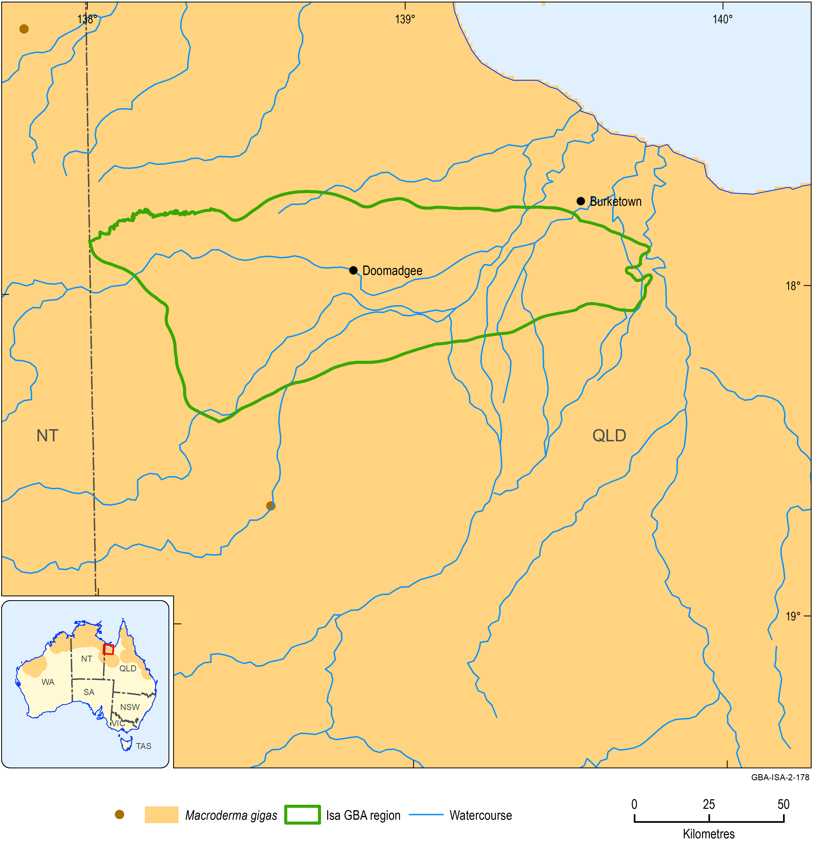
Figure 1 Distribution and Atlas of Living Australia observations of Macroderma gigas
The location of the Atlas of Living Australia observations are shown by the brown dots on the main map. The inset map shows the species distribution across Australia.
Data: Department of the Environment and Energy (2018a); Atlas of Living Australia (2019)
Element: GBA-ISA-2-178

Bare-rumped sheath-tailed bat, Saccolaimus s. nudicluniatus
Overview
The bare-rumped sheath-tailed bat is a large microchiropteran bat that occurs in northern Australia and New Guinea, Timor, Indonesia and elsewhere in south-east Asia. It has a body mass up to 55 g and a head-body length of up to 95 mm. The species feeds on insects at night that it captures while foraging in open space. It has a fast, direct flight. During the day, the bare-rumped sheath-tailed bat roosts in colonies of up to 100 individuals located in tree hollows.
Until recently listed as critically endangered, the species is now classified nationally as vulnerable. In Australia it has been recorded along the east coast of Queensland from Townsville up to Iron Range on Cape York Peninsula and across the Top End of the NT (Milne et al., 2009) (Figure 2).
Water dependency
The bare-rumped sheath-tailed bat is not considered to be water dependent. It is likely to access surface water to drink while foraging at night.
Potential impacts from shale gas development
The key areas of the landscape for this bat are likely to be roosts in hollows of large trees and surface water (used for drinking). Extensive foraging habitat in eucalypt forest and woodland exists for this species.
Potential effects likely to be experienced by this species include:
- exposure to soil, groundwater and/or surface water contamination
- changed surface water quality and/or flows
- changed groundwater quality and/or levels (which may impact roost trees and foraging habitat)
- bank instability and erosion (which may impact roost trees)
- vegetation clearing.
Likelihood of being impacted by shale gas development in Isa GBA region
No. Assessment is based on a low likelihood of occurrence in the region based on available knowledge.
Information sources
- Conservation advice: Department of the Environment and Energy (2019a)
- Milne et al. (2009)
- Schulz and Thomson (2007)
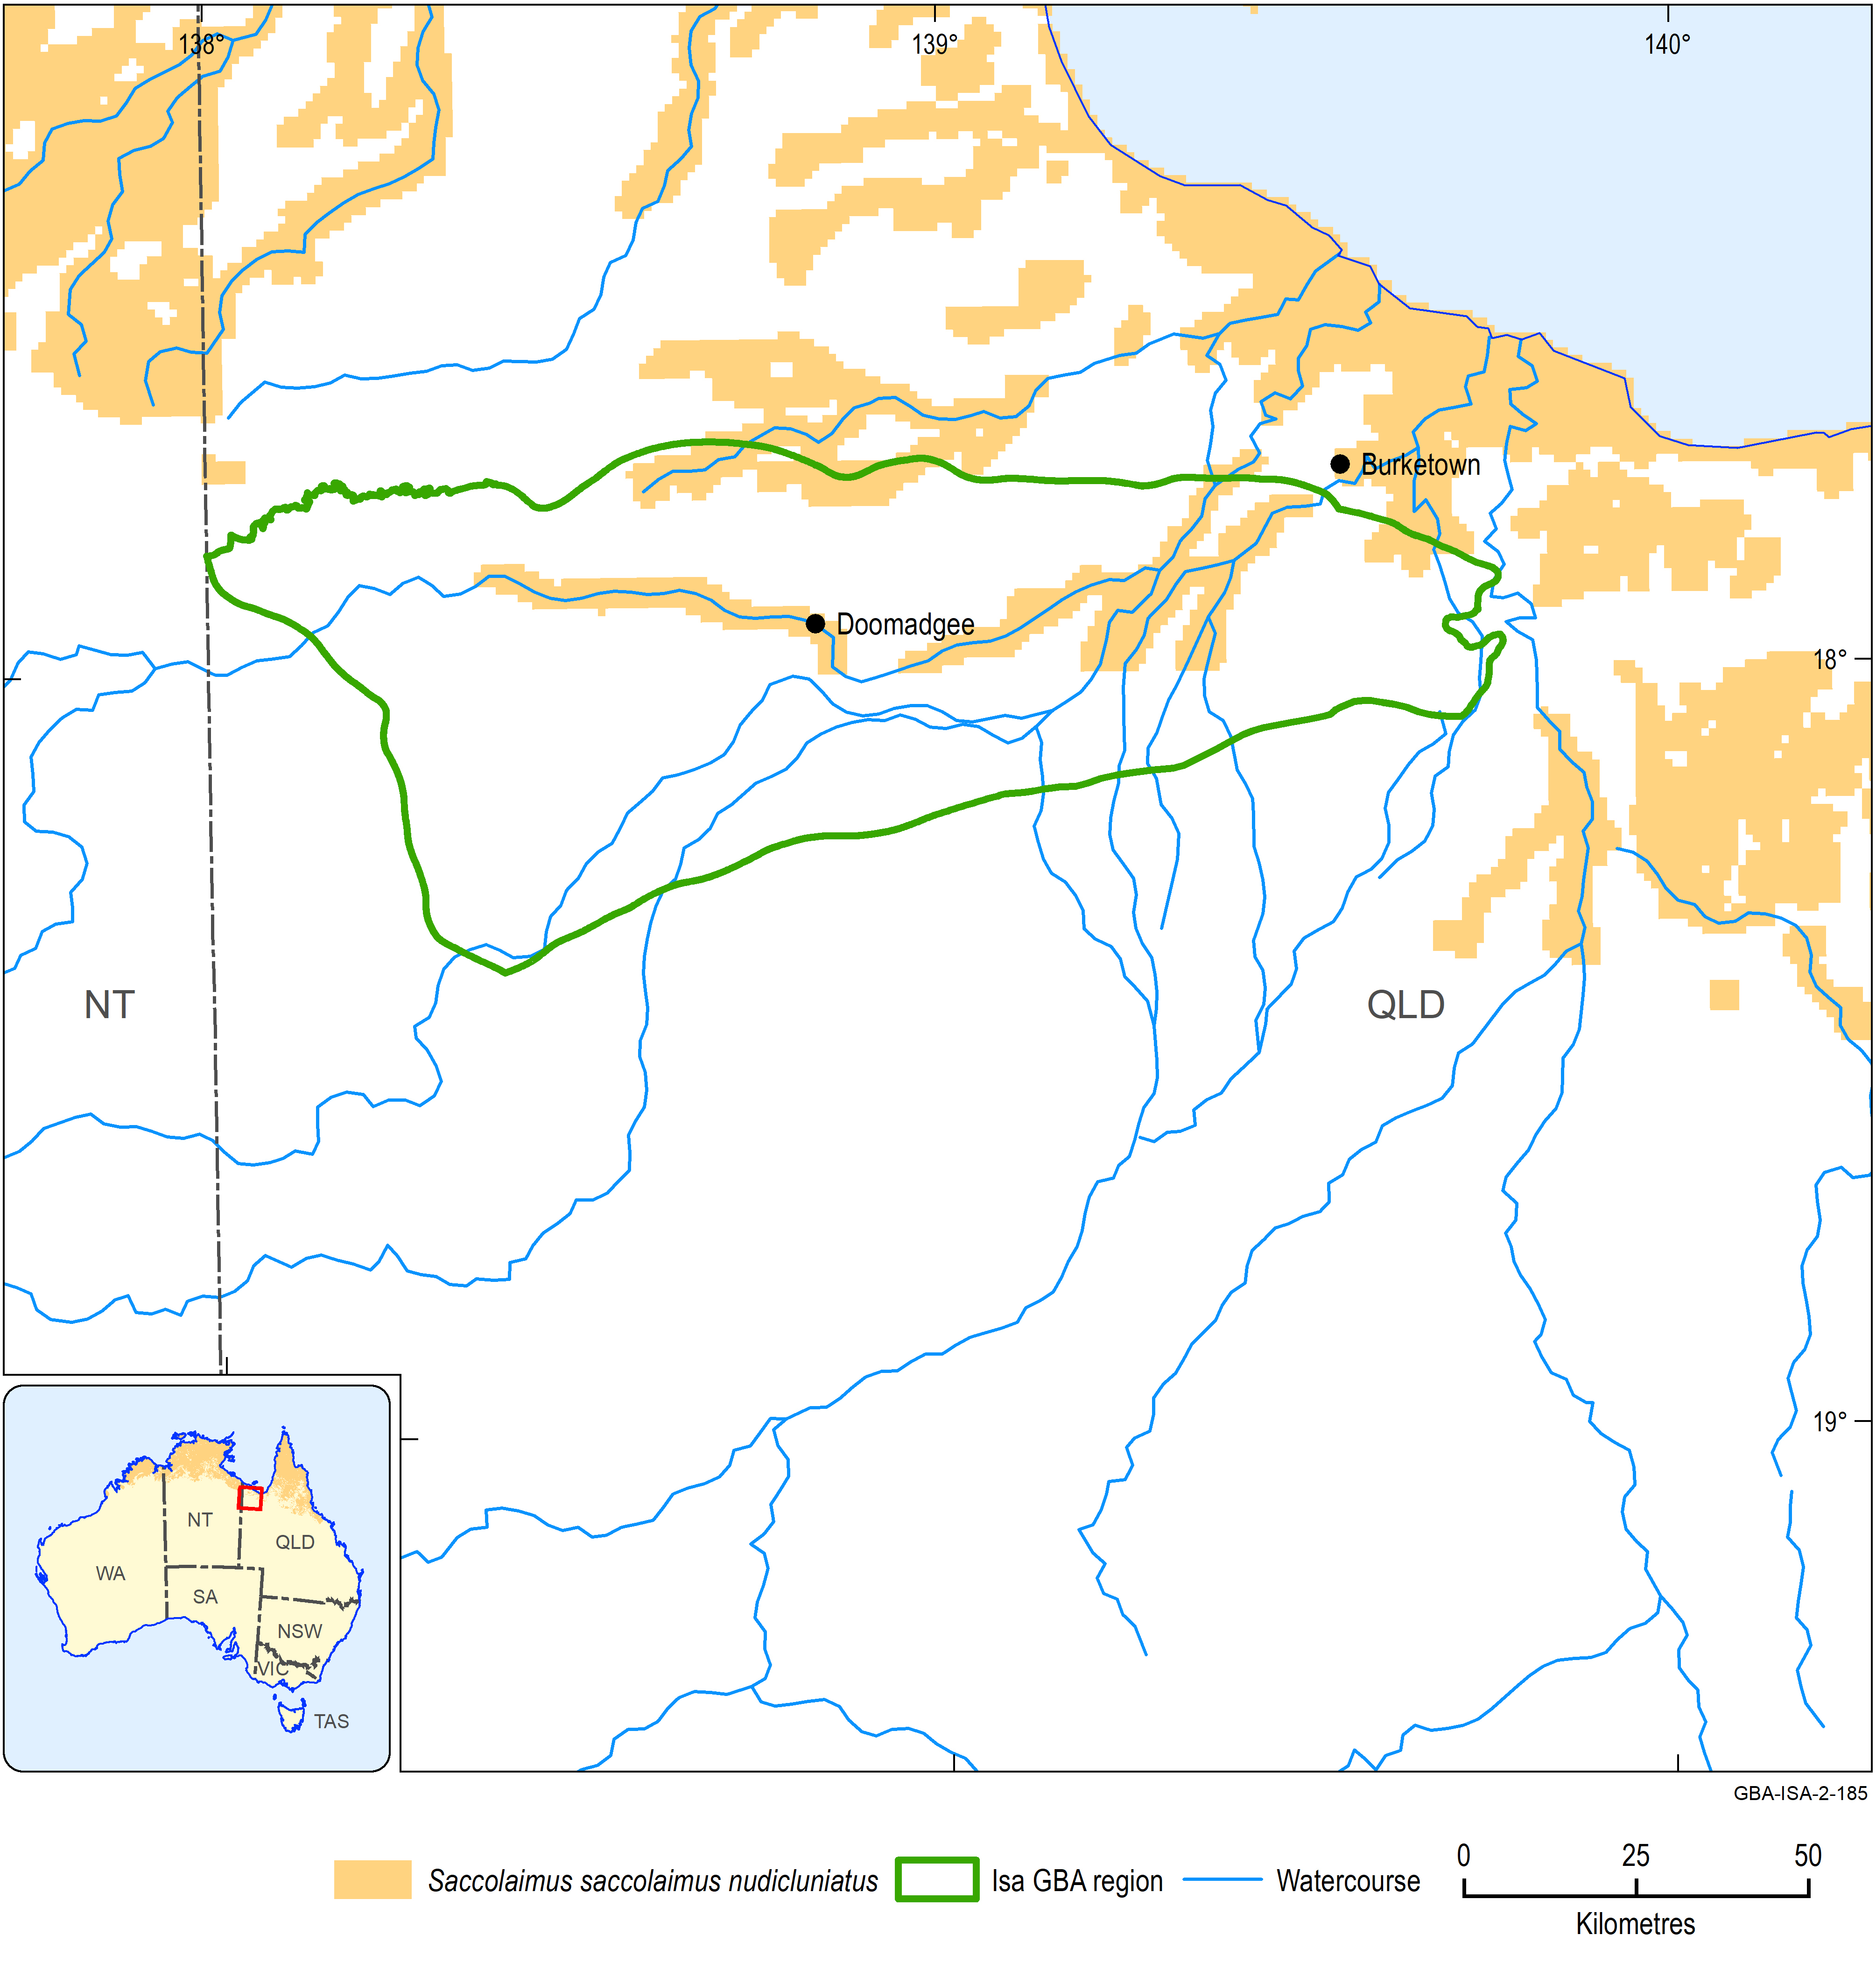
Figure 2 Distribution of Saccolaimus s. nudicluniatus
Data: Department of the Environment and Energy (2018a); Atlas of Living Australia (2019)
Element: GBA-ISA-2-185

Water mouse, Xeromys myoides
Overview
The water mouse is a small native rodent with a body mass to 64 g. The species is semi-aquatic, occurring only in coastal and nearshore areas where it forages at night in the littoral zone when substrate is exposed between high tides. It occupies mangrove forest, salt marsh flats, sedgeland in lakes near foredunes and freshwater swamps where it feeds on a variety of aquatic invertebrates. During the day, it shelters either in nesting mounds that it constructs or in natural or artificial hollows.
The water mouse is listed nationally as vulnerable. It occurs along the Australian coast in south-east and central Queensland and then is absent until the NT where it occupies several coastal regions (Figure 3).
Water dependency
The water mouse is water dependent. It forages in the littoral zone of coastal environments.
Potential impacts from shale gas development
The key areas of the landscape for the species are coastal mangroves, freshwater swamps and adjacent environments.
Potential effects likely to be experienced by this species include:
- exposure to soil, groundwater and/or surface water contamination
- changed surface water quality and/or flows
- changed groundwater quality and/or levels
- contamination of estuarine waters
- altered groundwater flows to coastal habitats.
Likelihood of being impacted by shale gas development in Isa GBA region
No. Assessment is based on a low likelihood of occurrence in the region based on available knowledge.
Information sources
- Department of Environment and Resource Management (2010)
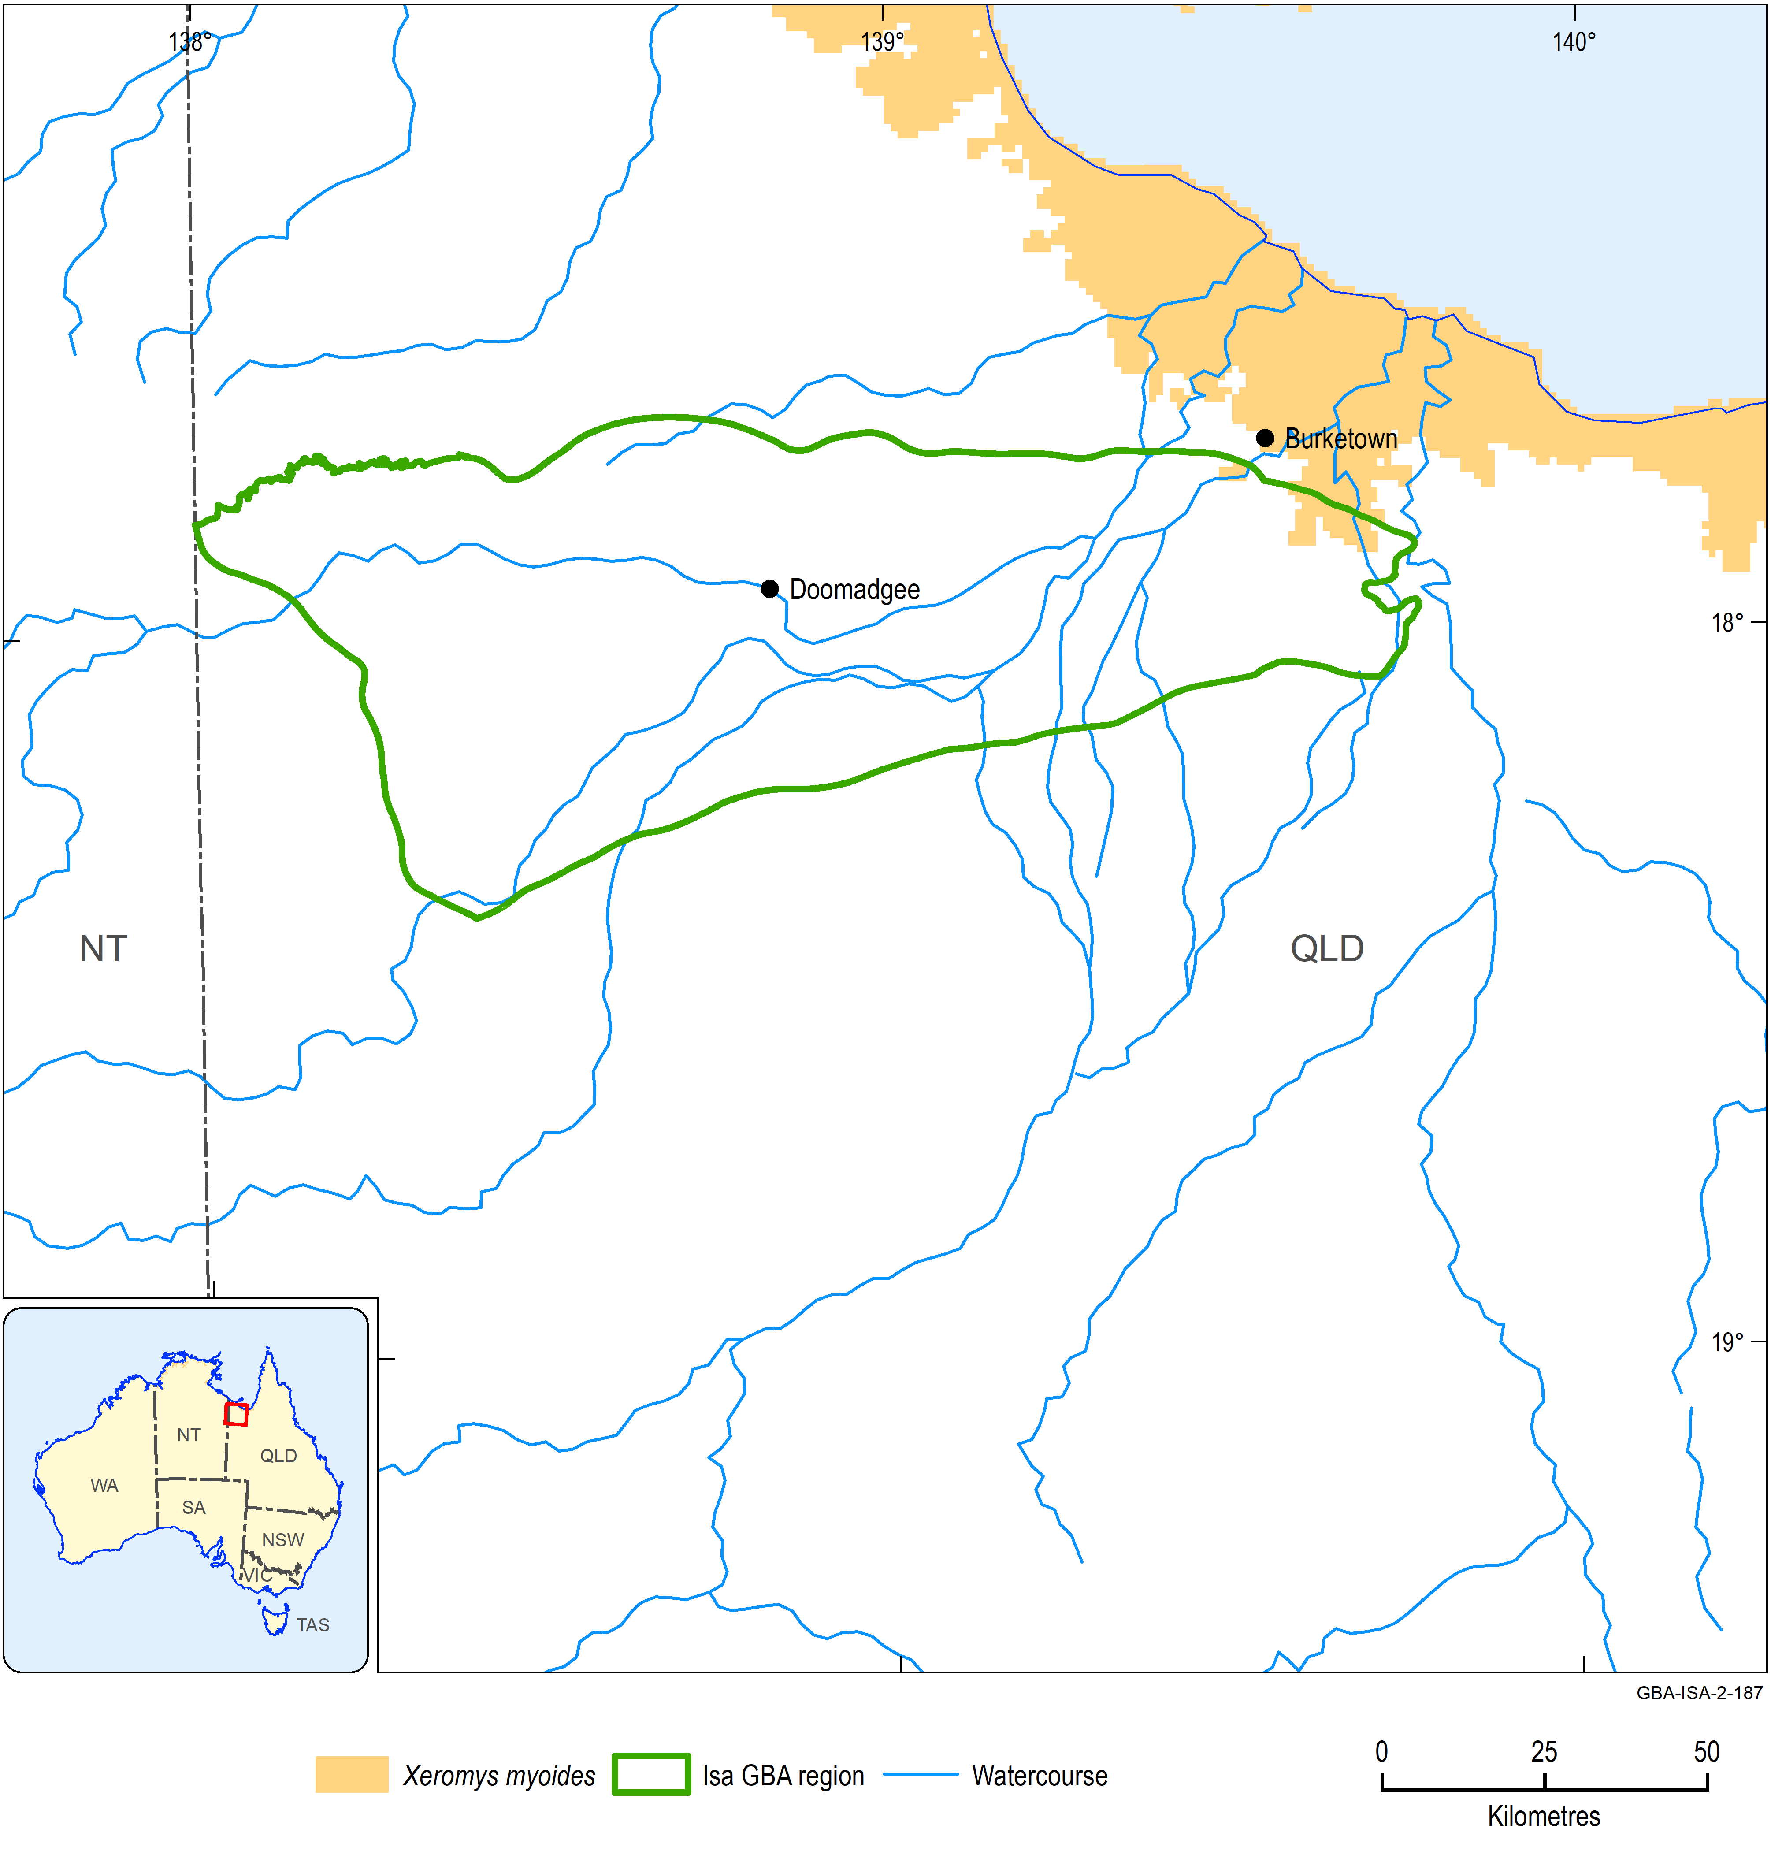
Figure 3 Distribution of Xeromys myoides
Data: Department of the Environment and Energy (2018a); Atlas of Living Australia (2019)
Element: GBA-ISA-2-187

Northern quoll, Dasyurus hallucatus
Overview
The northern quoll is a medium-sized carnivorous marsupial. The sexes differ in size; males attain a maximum body mass of 1.12 kg compared to a maximum body mass of 0.69 kg for females. The species is an omnivore feeding on fruits, invertebrates and some vertebrates including mammals, birds, reptiles and frogs. Northern quolls shelter during the day in rock crevices, tree hollows, termite mounds and similar structures. At night, they forage both on the ground and in trees in savannah woodland and patches of rainforest and appear to favour rocky escarpments.
The northern quoll is the largest remaining carnivorous marsupial in most of northern Australia. The range of the species includes eastern and northern Queensland, the Top End of the NT and the Kimberley and Pilbara regions of WA (Figure 4). The northern quoll is listed nationally as endangered.
Water dependency
The northern quoll is not considered to be water dependent. It will drink water when it is available but appears able to obtain sufficient moisture from its food when surface water sources dry up towards the later stages of the dry season in northern Australia (van Dyck and Strahan 2008).
Potential impacts from shale gas development
The species has broad habitat requirements in terms of foraging and shelter sites. Rocky habitats are of importance. The northern quoll is known to be at risk from predation by cats and dingoes and by ingesting cane toads. Therefore, it is imperative that activities undertaken as part of the development of a potential shale gas industry do not encourage these species. Specifically, sources of resource subsidies for predators of quolls (such as open rubbish dumps and accessible sources of water) should be avoided.
Potential effects likely to be experienced by this species include:
- habitat loss and fragmentation
- exposure to soil, groundwater and/or surface water contamination
- changed surface water quality and/or flows.
Likelihood of being impacted by shale gas development in Isa GBA region
Yes. Assessment is based on a high likelihood of occurrence in the region based on available knowledge and potential of activities to disrupt breeding and decrease size of the population.
Information sources
- Hill and Ward (2010)
- van Dyck and Strahan (2008)

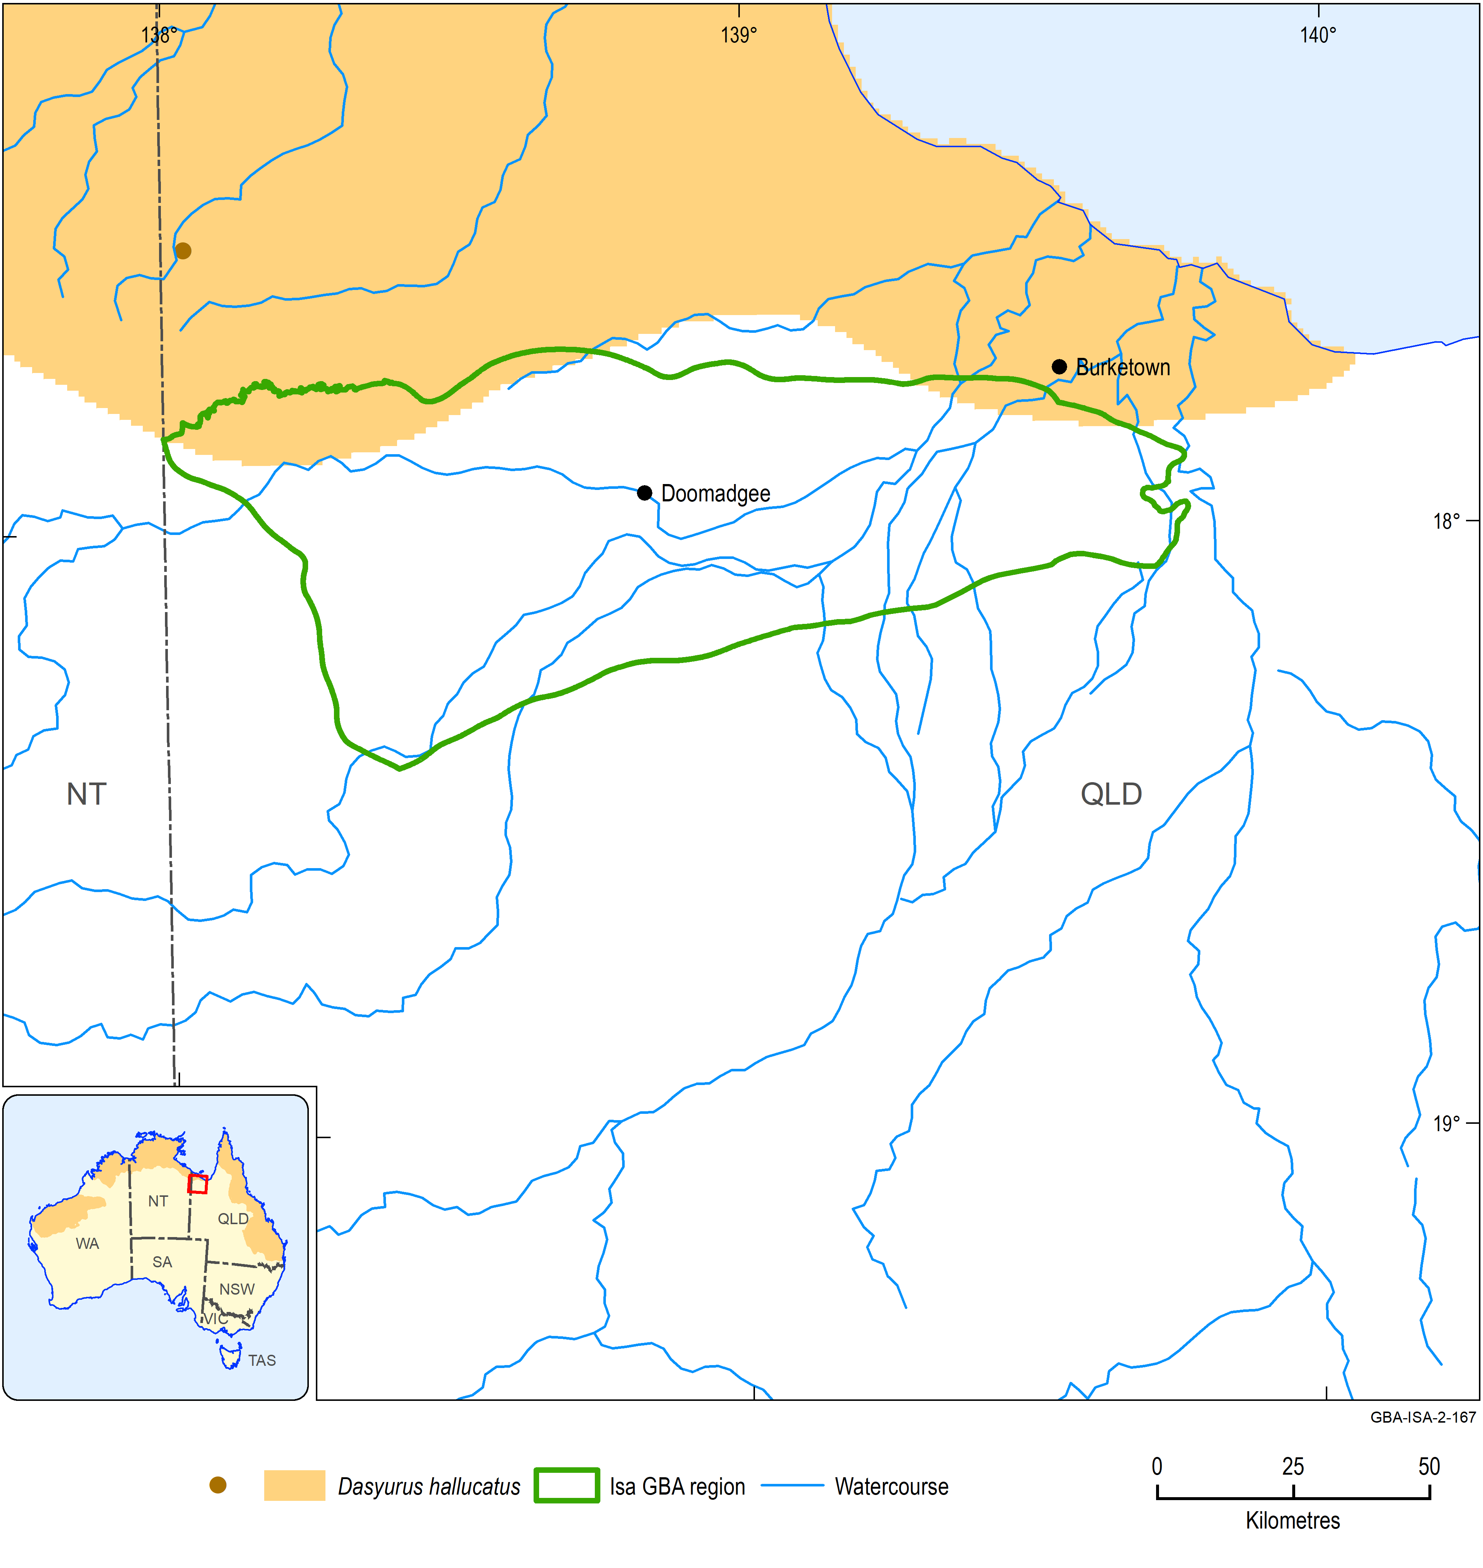
Figure 4 Distribution and Atlas of Living Australia observations of the Dasyurus hallucatus
The location of the Atlas of Living Australia observations are shown by the brown dots on the main map. The inset map shows the species distribution across Australia.
Data: Department of the Environment and Energy (2018a); Atlas of Living Australia (2019)
Element: GBA-ISA-2-167

Carpentarian grasswren, Amytornis dorotheae
Overview
The Carpentarian grasswren is a small bird with a body length of up to 17.5 cm and a body mass of up to 25 g. It occurs in pairs or small groups in rocky environments with an understorey of long-unburnt spinifex (Triodia) hummock grassland. The species feeds on both invertebrates and seeds.
The Carpentarian grasswren is endemic to the Gulf of Carpentaria being found in an area from Tawallah Range/Limmen Bight River (NT) to the Mount Isa district (Queensland; Figure 5). The species appears to have undergone severe declines in population size and area of occupancy in the past 10 years and it is now classified nationally as endangered.
Water dependency
The Carpentarian grasswren is not considered to be dependent on water.
Potential impacts from shale gas development
The key areas of the landscape for the species are rocky habitats including rocky ranges and tablelands.
Potential effects likely to be experienced by this species include:
- habitat loss and fragmentation
- exposure to soil, groundwater and/or surface water contamination.
Likelihood of being impacted by shale gas development in Isa GBA region
Yes. Assessment is based on a high likelihood of occurrence in the region based on available knowledge and potential of activities to fragment populations, negatively affect habitat, disrupt breeding and decrease size of the population.
Information sources
- Department of the Environment and Energy (2019a)

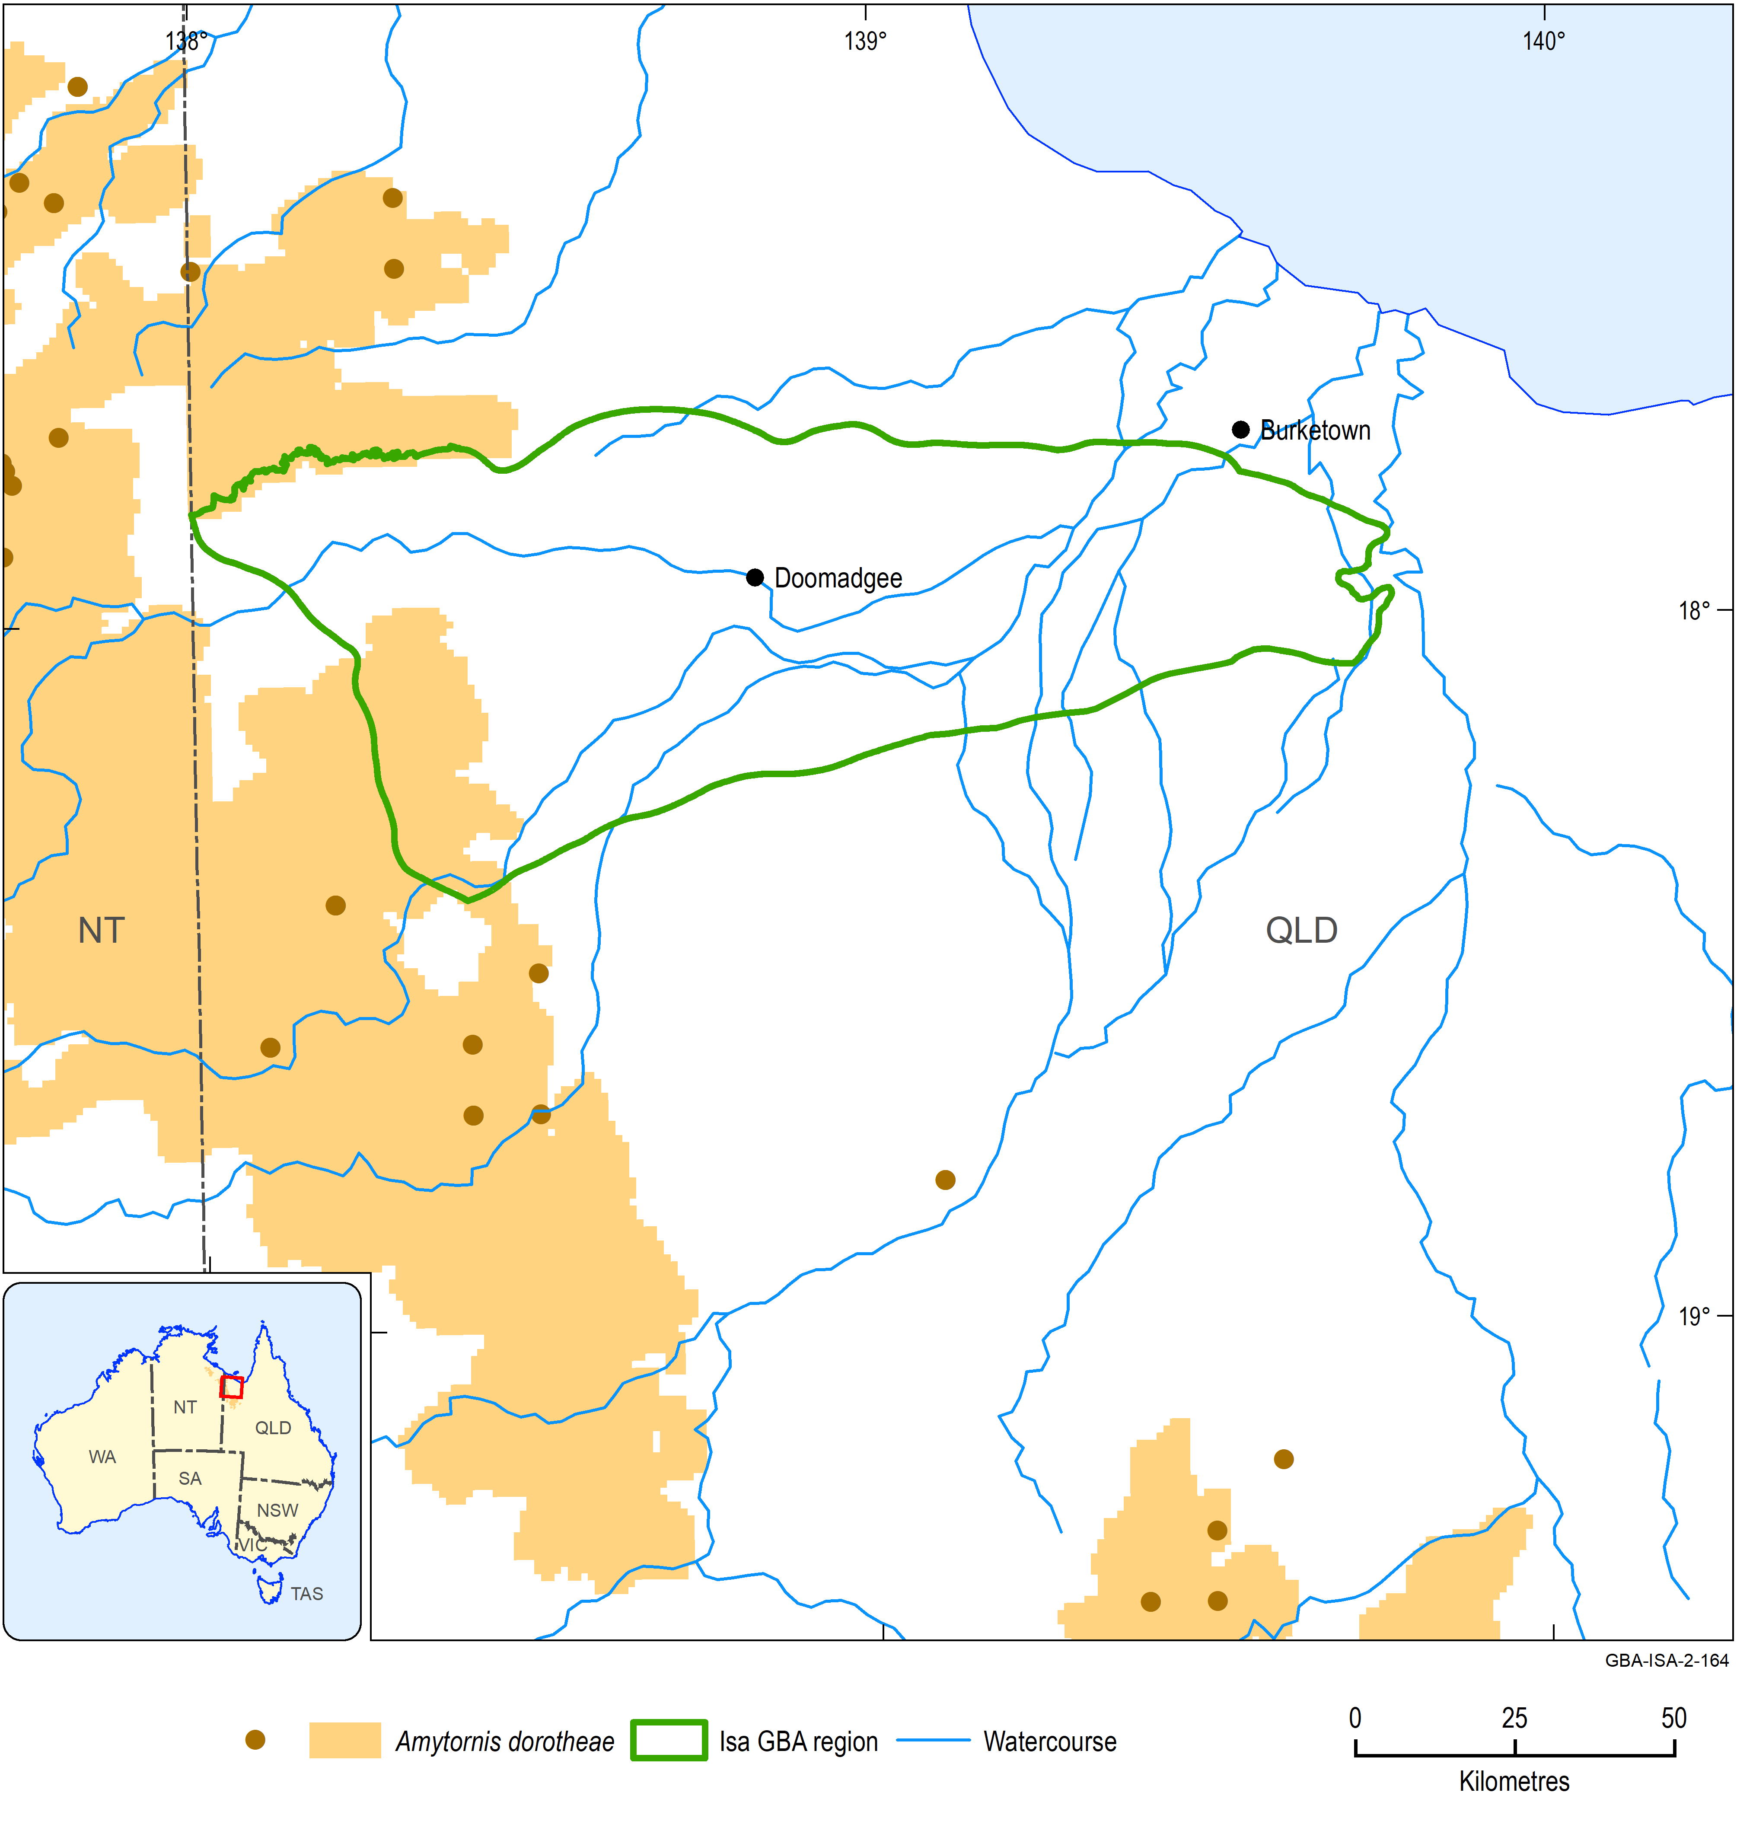
Figure 5 Distribution and Atlas of Living Australia observations of Amytornis dorotheae
The location of the Atlas of Living Australia observations are shown by the brown dots on the main map. The inset map shows the species distribution across Australia.
Data: Department of the Environment and Energy (2018a); Atlas of Living Australia (2019)
Element: GBA-ISA-2-164

Gouldian finch, Erythrura gouldiae
Overview
The Gouldian finch is an iconic bird species that occurs across northern Australia from inland north Queensland across the Top End of the NT to the Kimberley of WA (Figure 6). The species is multi-coloured with a combination of vivid colours. It is small with a body mass of 14 to 15 g. The Gouldian finch occupies open woodland that is relatively close to water; it feeds on seeding grasses and nests in hollows in eucalypts.
Water dependency
The Gouldian finch is water dependent. It relies on surface water sources which it will visit daily. These typically occur in waterholes in creeks. Birds breed within 2 to 4 km of perennial waterholes or springs.
Potential impacts from shale gas development
The key areas of the landscape for the species are waterholes and springs (on which it relies for water) and hollow-bearing trees in which it nests.
Potential effects likely to be experienced by this species include:
- habitat loss and fragmentation
- introduction of invasive plants
- exposure to soil, groundwater and/or surface water contamination
- changed surface water quality and/or flows
- bank instability and erosion.
Likelihood of being impacted by shale gas development in Isa GBA region
Yes. Assessment is based on known occurrence in the region and potential of activities to negatively affect habitat, disrupt breeding and decrease size of the population.
Information sources
- Department of the Environment and Energy (2019a)
- Garnett et al. (2011)
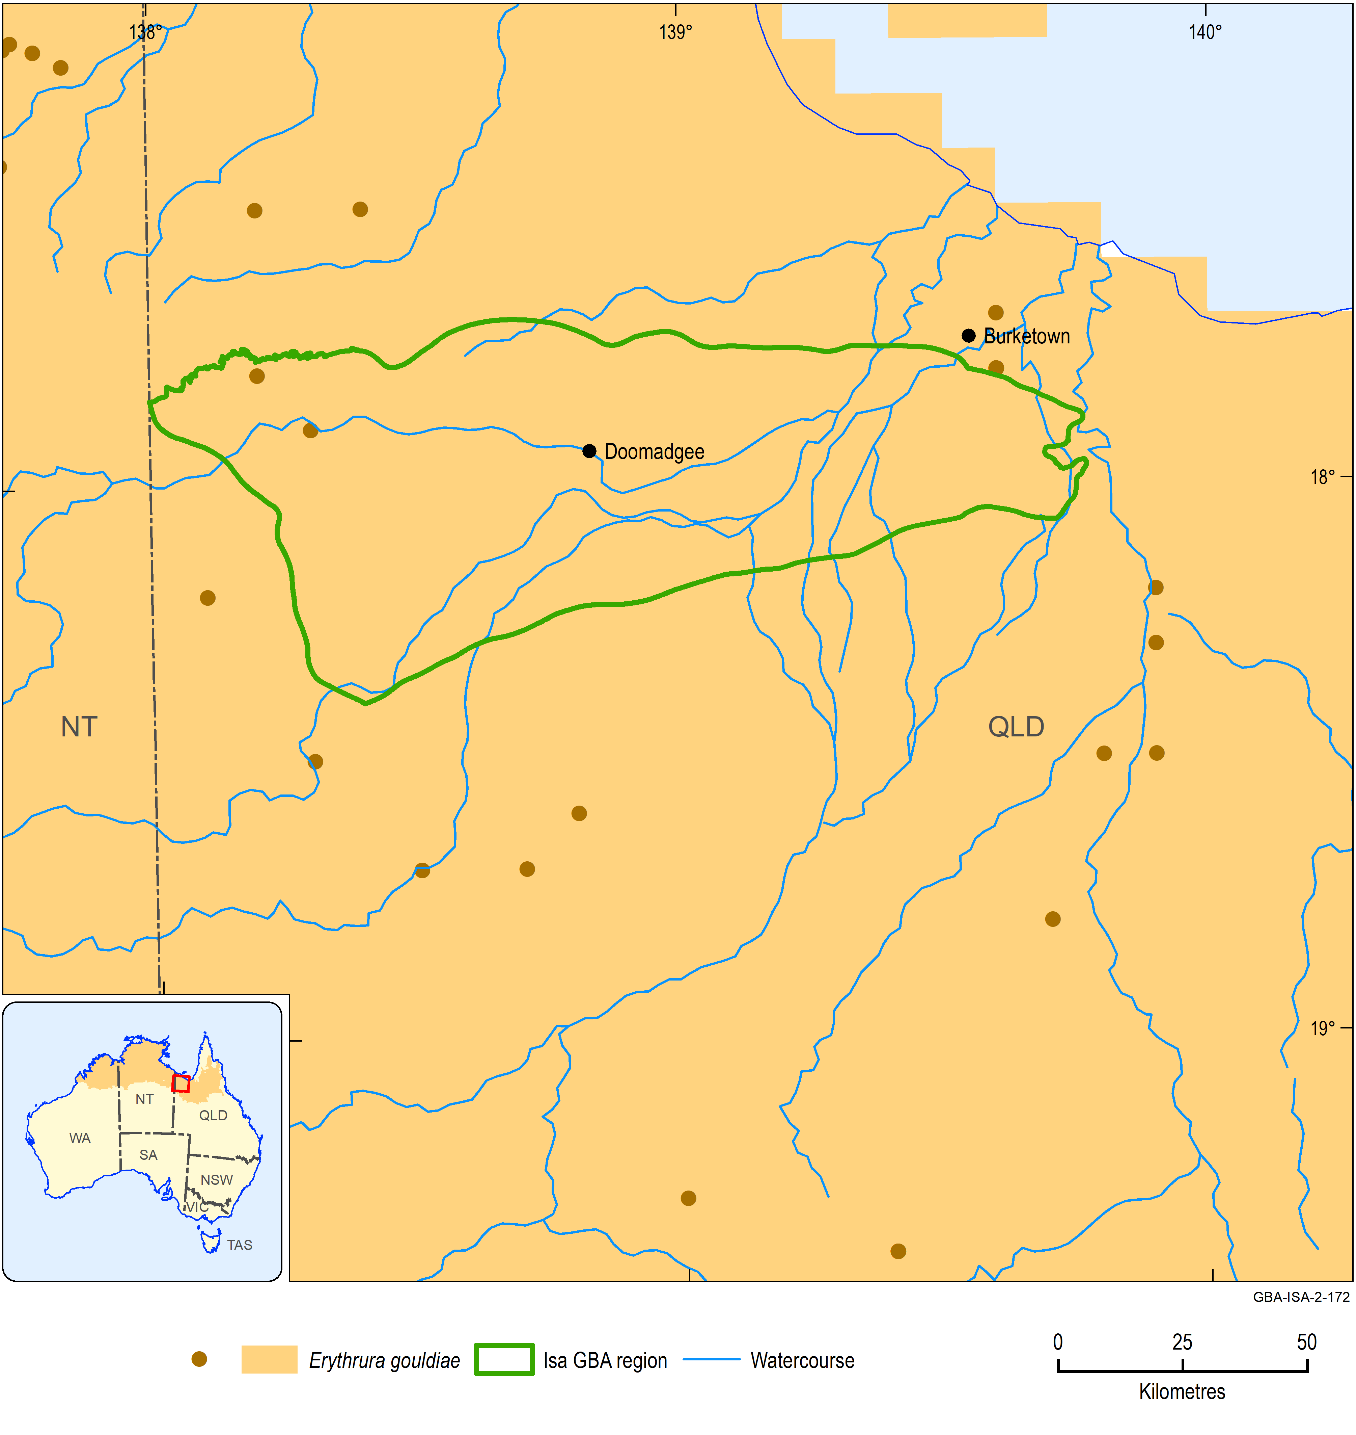
Figure 6 Distribution and Atlas of Living Australia observations of Erythrura gouldiae
The location of the Atlas of Living Australia observations are shown by the brown dots on the main map. The inset map shows the species distribution across Australia.
Data: Department of the Environment and Energy (2018a); Atlas of Living Australia (2019)
Element: GBA-ISA-2-172

Painted honeyeater, Grantiella picta
Overview
The painted honeyeater is a relatively small species of bird that has a wide distribution across eastern Australia extending to the tropics in north-west Queensland and north-east NT (Figure 7). It is a specialised bird feeding mainly on the fruit of mistletoes and exhibits seasonal movements in response to food availability. The painted honeyeater occupies acacia-dominated woodlands showing a preference for those with mature trees (Garnett et al., 2011). Many birds move to semi-arid regions in northern Australia following the completion of breeding in late summer/early autumn.
The painted honeyeater is listed nationally as vulnerable.
Water dependency
The painted honeyeater is likely to be water dependent, requiring daily access to surface water to drink.
Potential impacts from shale gas development
The key areas of the landscape for the species are those that support mature trees with good numbers of mistletoes.
Potential effects likely to be experienced by this species include:
- exposure to soil, groundwater and/or surface water contamination
- changed surface water quality and/or flows.
Likelihood of being impacted by shale gas development in Isa GBA region
No. Assessment is based on a low likelihood of occurrence in the region based on available knowledge and, if present, low numbers and non-breeding status.
Information sources
- Department of the Environment and Energy (2019a)
- Garnett et al. (2011)
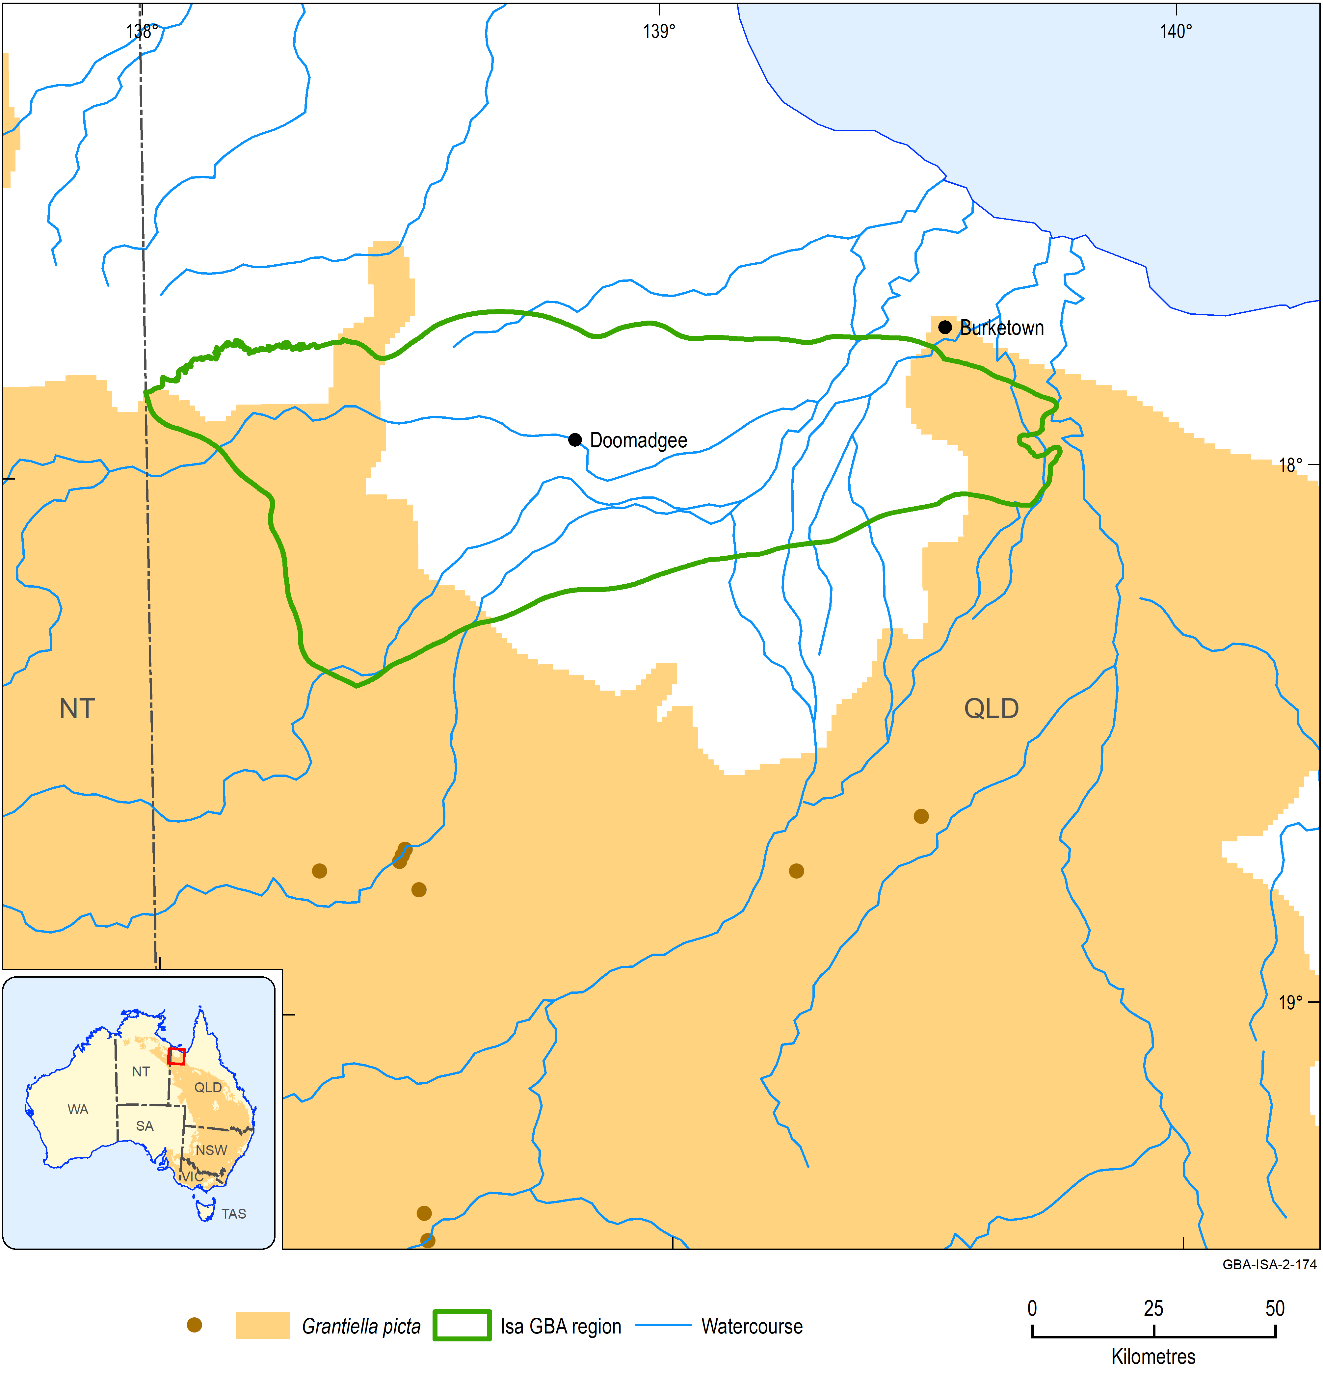
Figure 7 Distribution and Atlas of Living Australia observations of Grantiella picta
The location of the Atlas of Living Australia observations are shown by the brown dots on the main map. The inset map shows the species distribution across Australia.
Data: Department of the Environment and Energy (2018a); Atlas of Living Australia (2019)
Element: GBA-ISA-2-174

Red goshawk, Erythrotriorchis radiatus
Overview
The red goshawk is a large hawk that has a wingspan of up to 1.35 m and a length of 45 to 60 cm. The sexes differ in size; females attain a maximum body mass of 1.1 kg compared to maximum body mass of 0.6 kg for males. The red goshawk has a wide but patchy distribution across coastal and interior regions of Queensland, the NT and the north-east of WA. It also occurs in north-east NSW (Figure 8). The species mainly occurs in open forest and woodland but also is present along the edges of rainforest. Its diet consists mostly of medium to large birds.
Water dependency
The species is classed here as water dependent because of the likely water dependency of its nest sites. Nests are constructed in tall trees (mean height of 31 m) that are located within 1 km of, and commonly besides, permanent water. Water sources include rivers, swamps and pools (Department of Environment and Resource Management, 2012).
Potential impacts from shale gas development
The key areas of the landscape for the species are likely to be riverine/gallery forest that support mature trees suitable for breeding.
Potential effects likely to be experienced by this species include:
- exposure to soil, groundwater and/or surface water contamination
- changed surface water quality and/or flows
- changed groundwater quality and/or levels
- bank instability and erosion.
Likelihood of being impacted by gas development in Isa GBA region
Yes. Assessment is based on known occurrence in the region and potential of activities to negatively affect habitat and disrupt breeding.
Information sources
- Department of the Environment and Energy (2019a)
- Department of Environment and Resource Management (2012)
- Garnett et al. (2011)
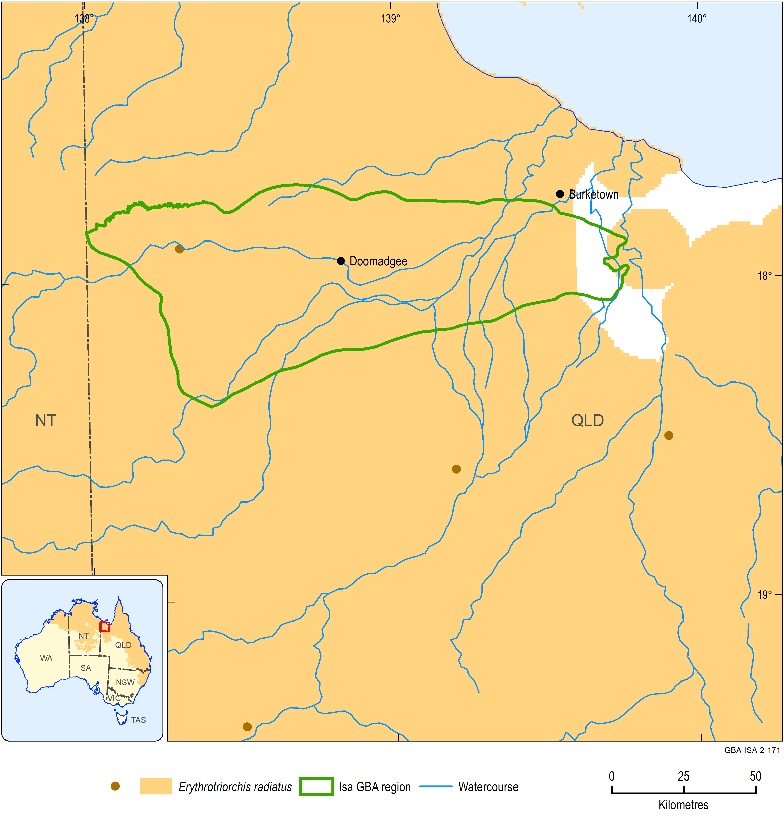
Figure 8 Distribution and Atlas of Living Australia observations of Erythrotriorchis radiatus
The location of the Atlas of Living Australia observations are shown by the brown dots on the main map. The inset map shows the species distribution across Australia.
Data: Department of the Environment and Energy (2018a); Atlas of Living Australia (2019)
Element: GBA-ISA-2-171

Eastern curlew, Numenius madagascariensis
Overview
The eastern curlew is listed nationally as endangered and as a migratory and marine species under the EPBC Act. The eastern curlew is a migratory shorebird that breeds in Siberia, Kamchatka and Mongolia and spends the Austral summer in a non-breeding phase distributed in coastal East Asia, mostly in Australia (Figure 9). The main staging area for birds migrating between breeding and non-breeding areas is the Yellow Sea. The species does not breed in Australia but significant numbers spend the non-breeding season here; an estimate in 2006 indicated that this number was 28,000 individuals of the global population of 38,000.
In Australia, the eastern curlew occurs on the coast, particularly sheltered intertidal mudflats and sandflats, saltflats, saltmarshes, and on ocean beaches. Here, it feeds mostly on marine invertebrates.
Water dependency
The eastern curlew is water dependent. It will not occur in an area unless suitable foraging habitat in the form of wetlands with bare edges of mud or sand with water is available.
Potential impacts from shale gas development
The eastern curlew does not use freshwater wetlands, estuarine environments are of major importance.
Potential effects likely to be experienced by this species include:
- exposure to soil, groundwater and/or surface water contamination
- changed surface water quality and/or flows
- contamination of estuarine waters.
Likelihood of being impacted by shale gas development in Isa GBA region
No. Assessment is based on a low likelihood of occurrence in the region based on available knowledge and, if present, low numbers and small proportion of Australian range.
Information sources
- Department of the Environment and Energy (2019a)
- IUCN (2019)
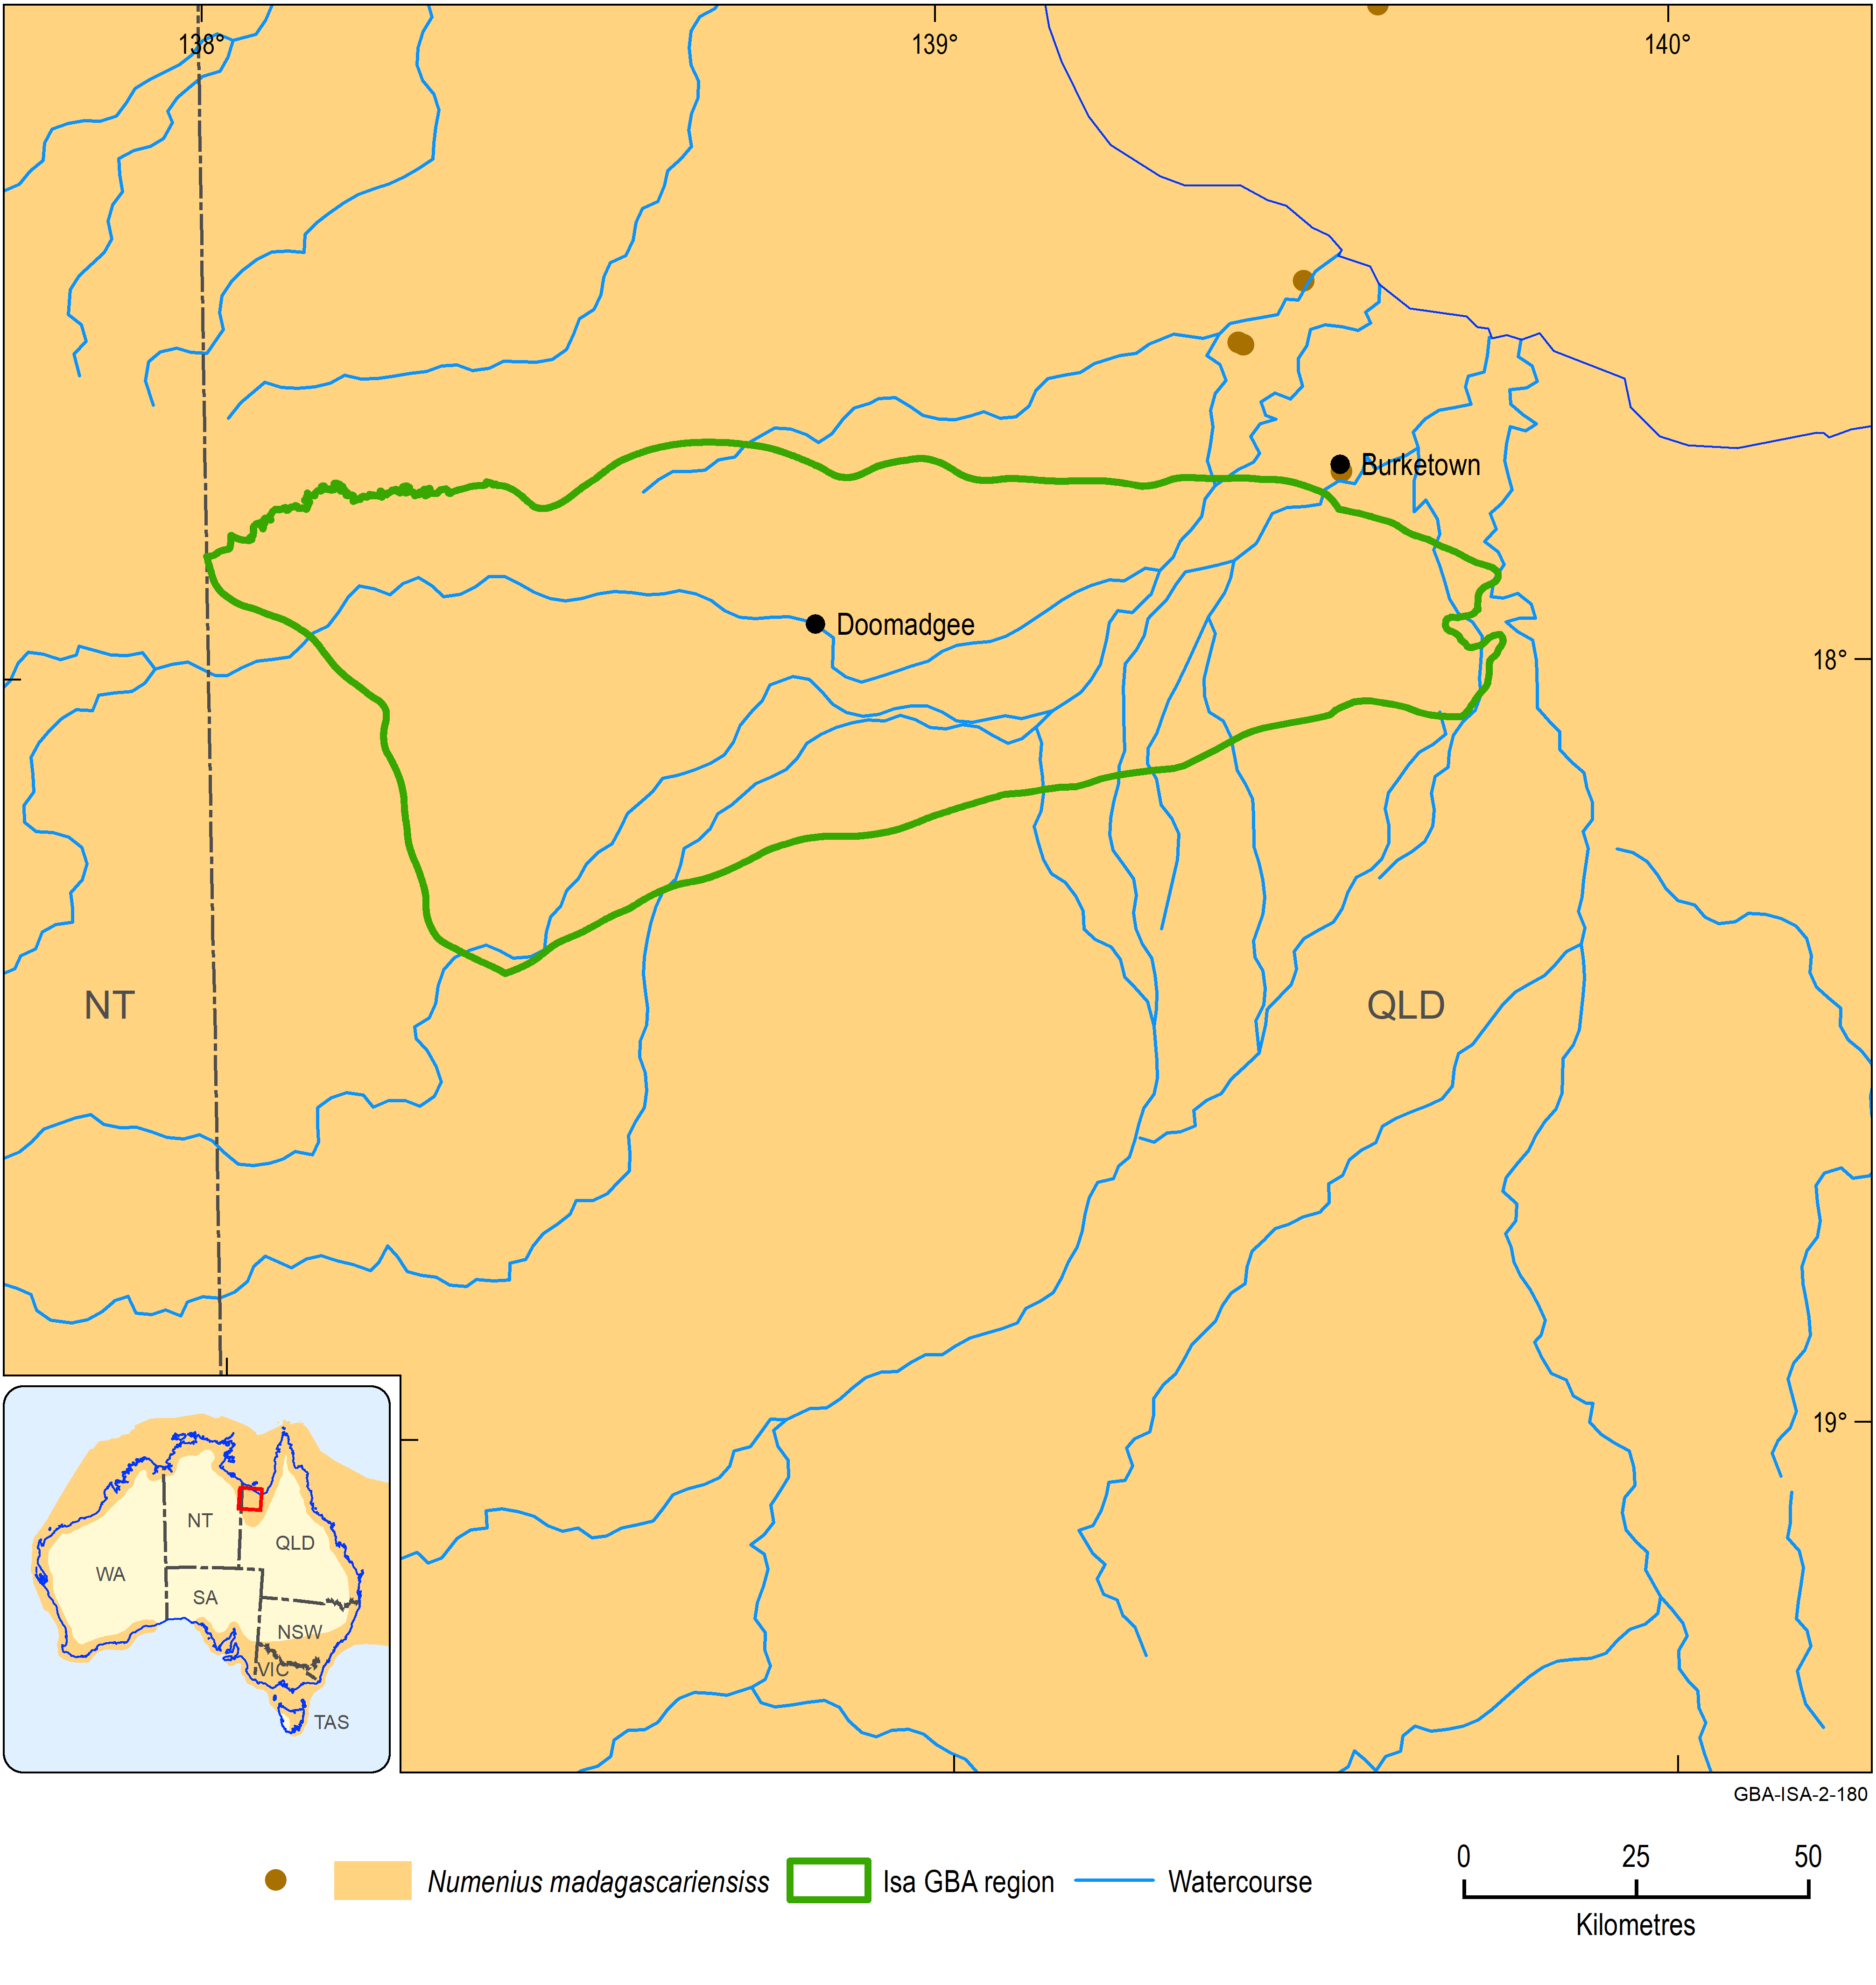
Figure 9 Distribution and Atlas of Living Australia observations of Numenius madagascariensis
The location of the Atlas of Living Australia observations are shown by the brown dots on the main map. The inset map shows the species distribution across Australia.
Data: Department of the Environment and Energy (2018a); Atlas of Living Australia (2019)
Element: GBA-ISA-2-180

Curlew sandpiper, Calidris ferruginea
Overview
The curlew sandpiper is listed as critically endangered and as a migratory and marine species under the EPBC Act. The curlew sandpiper is a migratory shorebird that breeds mainly in the Arctic region of northern Siberia and spends the Austral summer in a non-breeding phase distributed across Africa, Asia and Australasia (Figure 10). The species does not breed in Australia, but significant numbers spend the non-breeding season here. In Australia, the curlew sandpiper mainly occurs on the coast particularly intertidal mudflats in sheltered coastal areas such as estuaries, bays, inlets and lagoons. Non-tidal coastal areas include swamps, lakes and lagoons and ponds in sewage farms and saltworks. The curlew sandpiper occurs less commonly inland. Here, it occupies lakes, dams and bore drains.
The global population of the curlew sandpiper is estimated to number between 1.085 million and 1.285 million.
Water dependency
The curlew sandpiper is water dependent. It will not occur in an area unless suitable foraging habitat in the form of wetlands with bare edges of mud or sand with water to a depth up to 60 mm is available.
Potential impacts from shale gas development
The key areas of the landscape are shallow freshwater wetlands and estuarine environments.
Potential effects likely to be experienced by this species include:
- exposure to soil, groundwater and/or surface water contamination
- changed surface water quality and/or flows
- contamination of estuarine waters.
Likelihood of being impacted by shale gas development in Isa GBA region
No. Assessment is based on a moderate likelihood of occurrence in the region based on available knowledge and, if present, low numbers and small proportion of Australian range.
Information sources
- Department of the Environment and Energy (2019a)
- IUCN (2019)
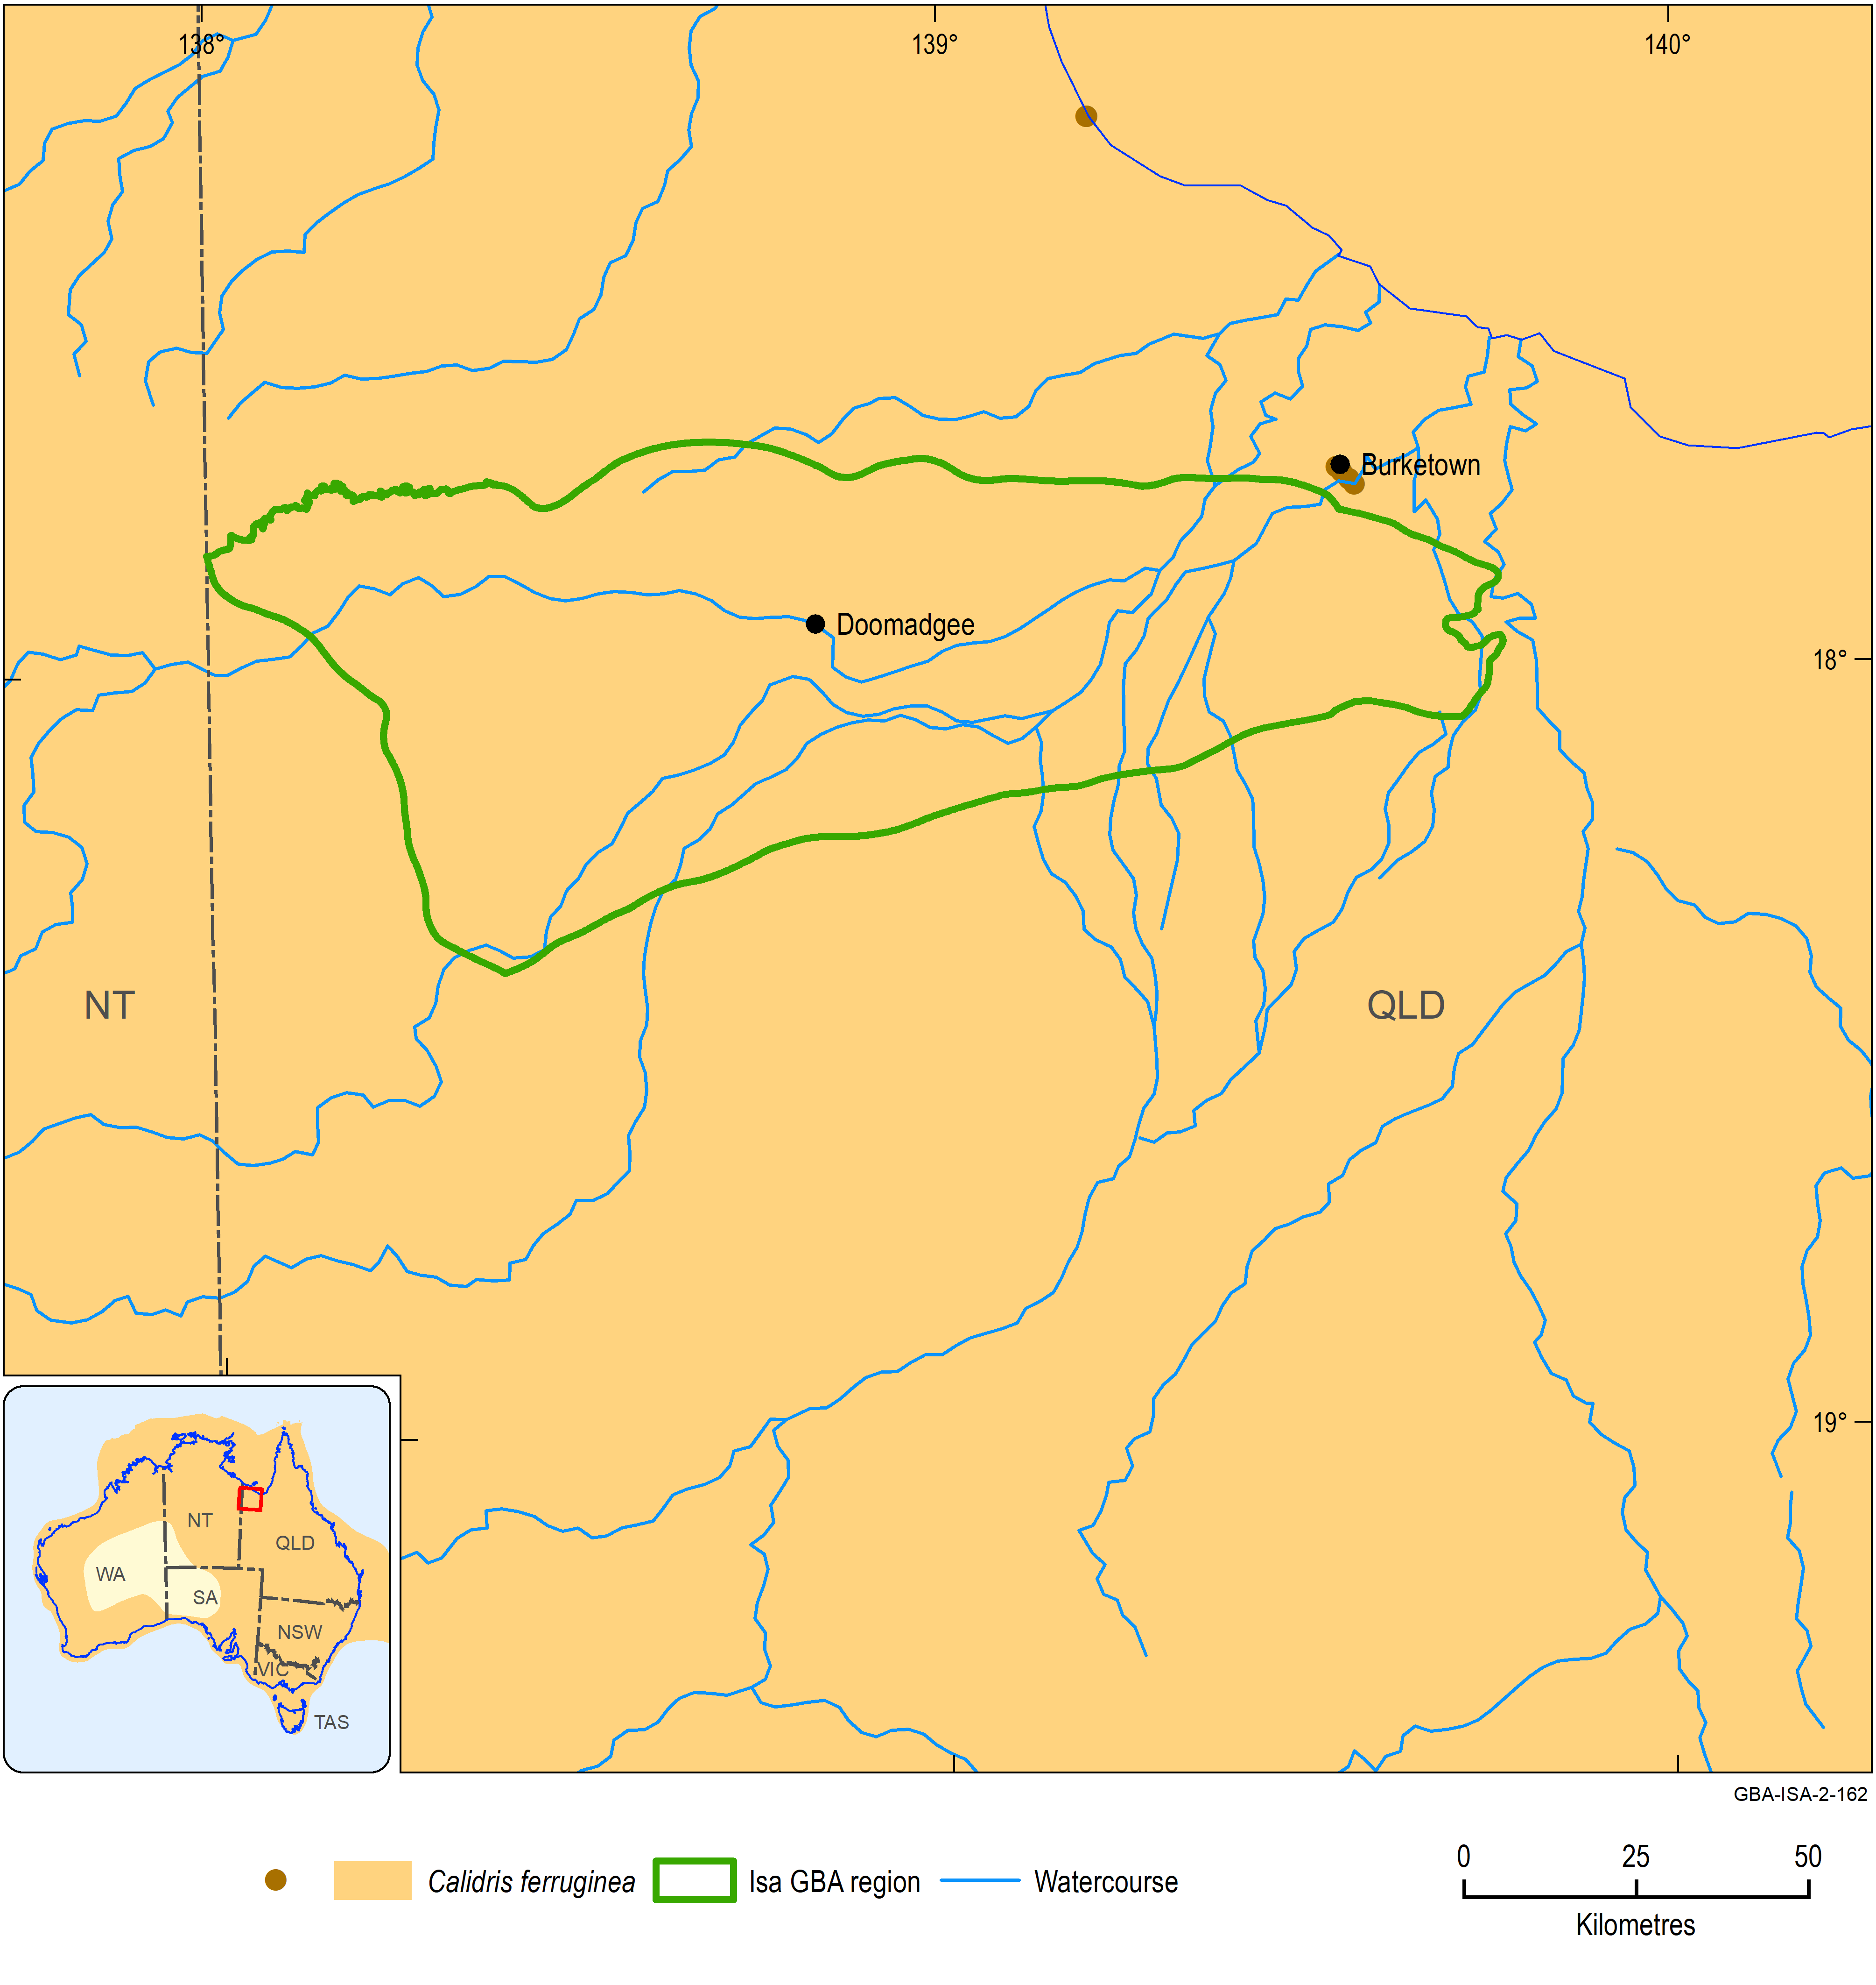
Figure 10 Distribution and Atlas of Living Australia observations of Calidris ferruginea
The location of the Atlas of Living Australia observations are shown by the brown dots on the main map. The inset map shows the species distribution across Australia.
Data: Department of the Environment and Energy (2018a); Atlas of Living Australia (2019)
Element: GBA-ISA-2-162

Bar-tailed godwit, Limosa lapponica
Overview
Two subspecies of the bar-tailed godwit, L. l. baueri and L. l. menzbieri, are listed as threatened, whereas the species as a whole is classed as migratory under the EPBC Act. The bar-tailed godwit is a migratory shorebird that breeds in the north of Scandinavia and Russia and in north-west Alaska. It spends the Austral summer in a non-breeding phase distributed across western Europe, Africa, Asia, islands of the Pacific Ocean and Australia (Figure 11 and Figure 12). The species does not breed in Australia, but significant numbers spend the non-breeding season here. In Australia, the bar-tailed godwit mainly occurs on the coast, particularly intertidal mudflats and sandflats in sheltered coastal areas such as estuaries, bays, inlets and lagoons. It is rarely found on inland wetlands.
The subspecies L. l. baueri breeds in north-east Siberia and west Alaska. In Australia, it occurs mainly along the north and east coast. The subspecies L. l. menzbieri breeds in northern Siberia. In Australia, it occurs mainly in the north of WA.
Water dependency
The bar-tailed godwit is water dependent. It will not occur in an area unless suitable foraging habitat in the form of wetlands with bare edges of mud are available.
Potential impacts from shale gas development
The key areas of the landscape are shallow freshwater wetlands and estuarine environments.
Potential effects likely to be experienced by this species include:
- exposure to soil, groundwater and/or surface water contamination
- changed surface water quality and/or flows
- contamination of estuarine waters.
Likelihood of being impacted by shale gas development in Isa GBA region
No. Assessment is based on a low likelihood of occurrence in the region based on available knowledge and, if present, very low numbers and small proportion of Australian range.
Information sources
- Department of the Environment and Energy (2019a)
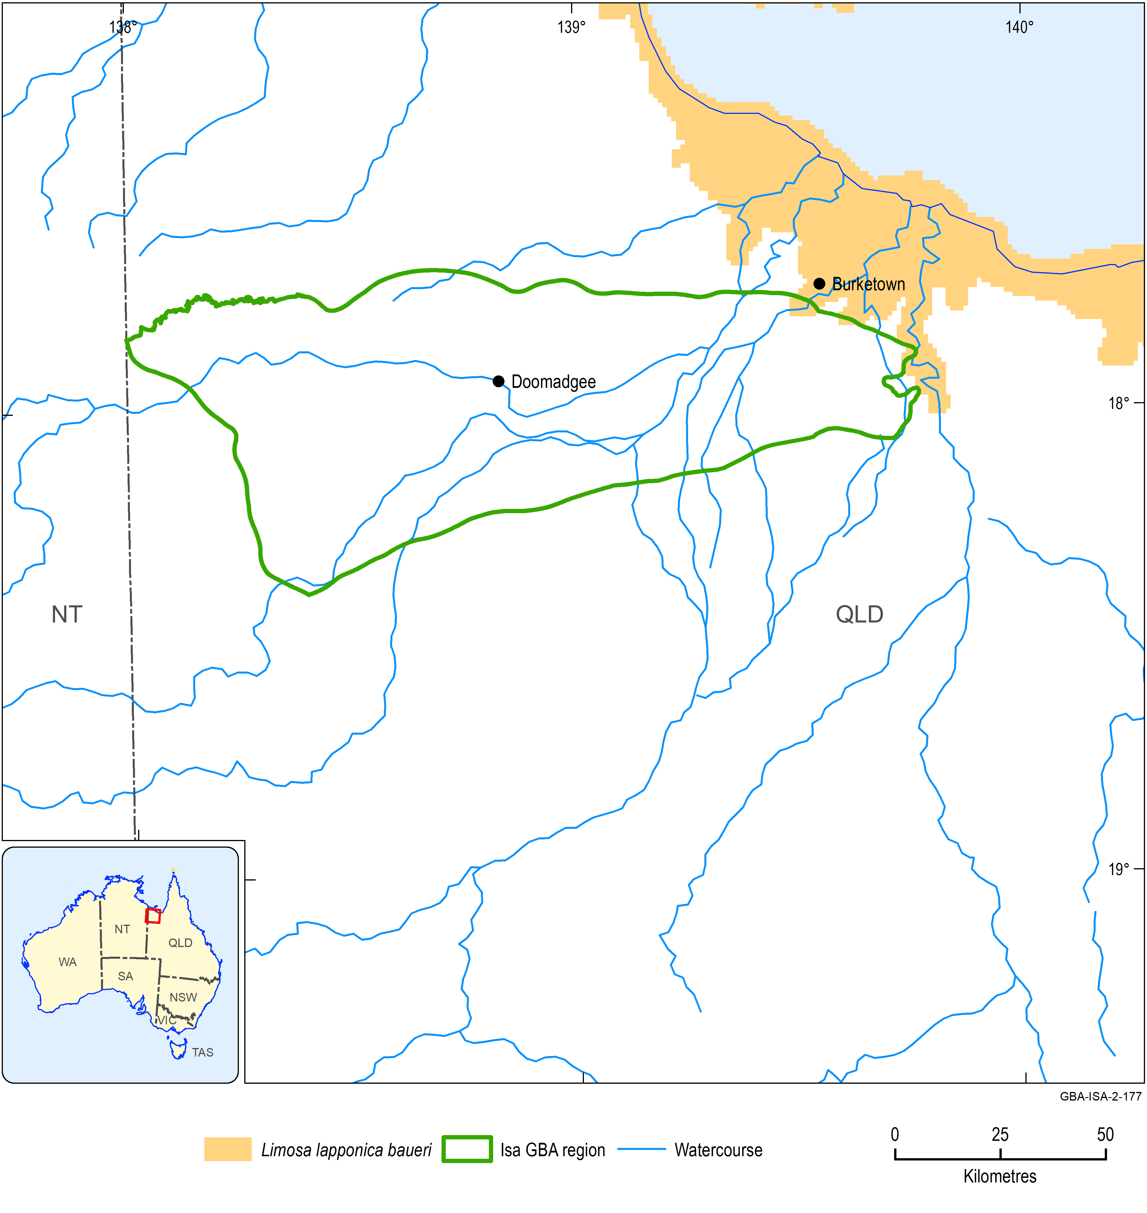
Figure 11 Distribution of Limosa lapponica baueri
Data: Department of the Environment and Energy (2018a); Atlas of Living Australia (2019)
Element: GBA-ISA-2-177

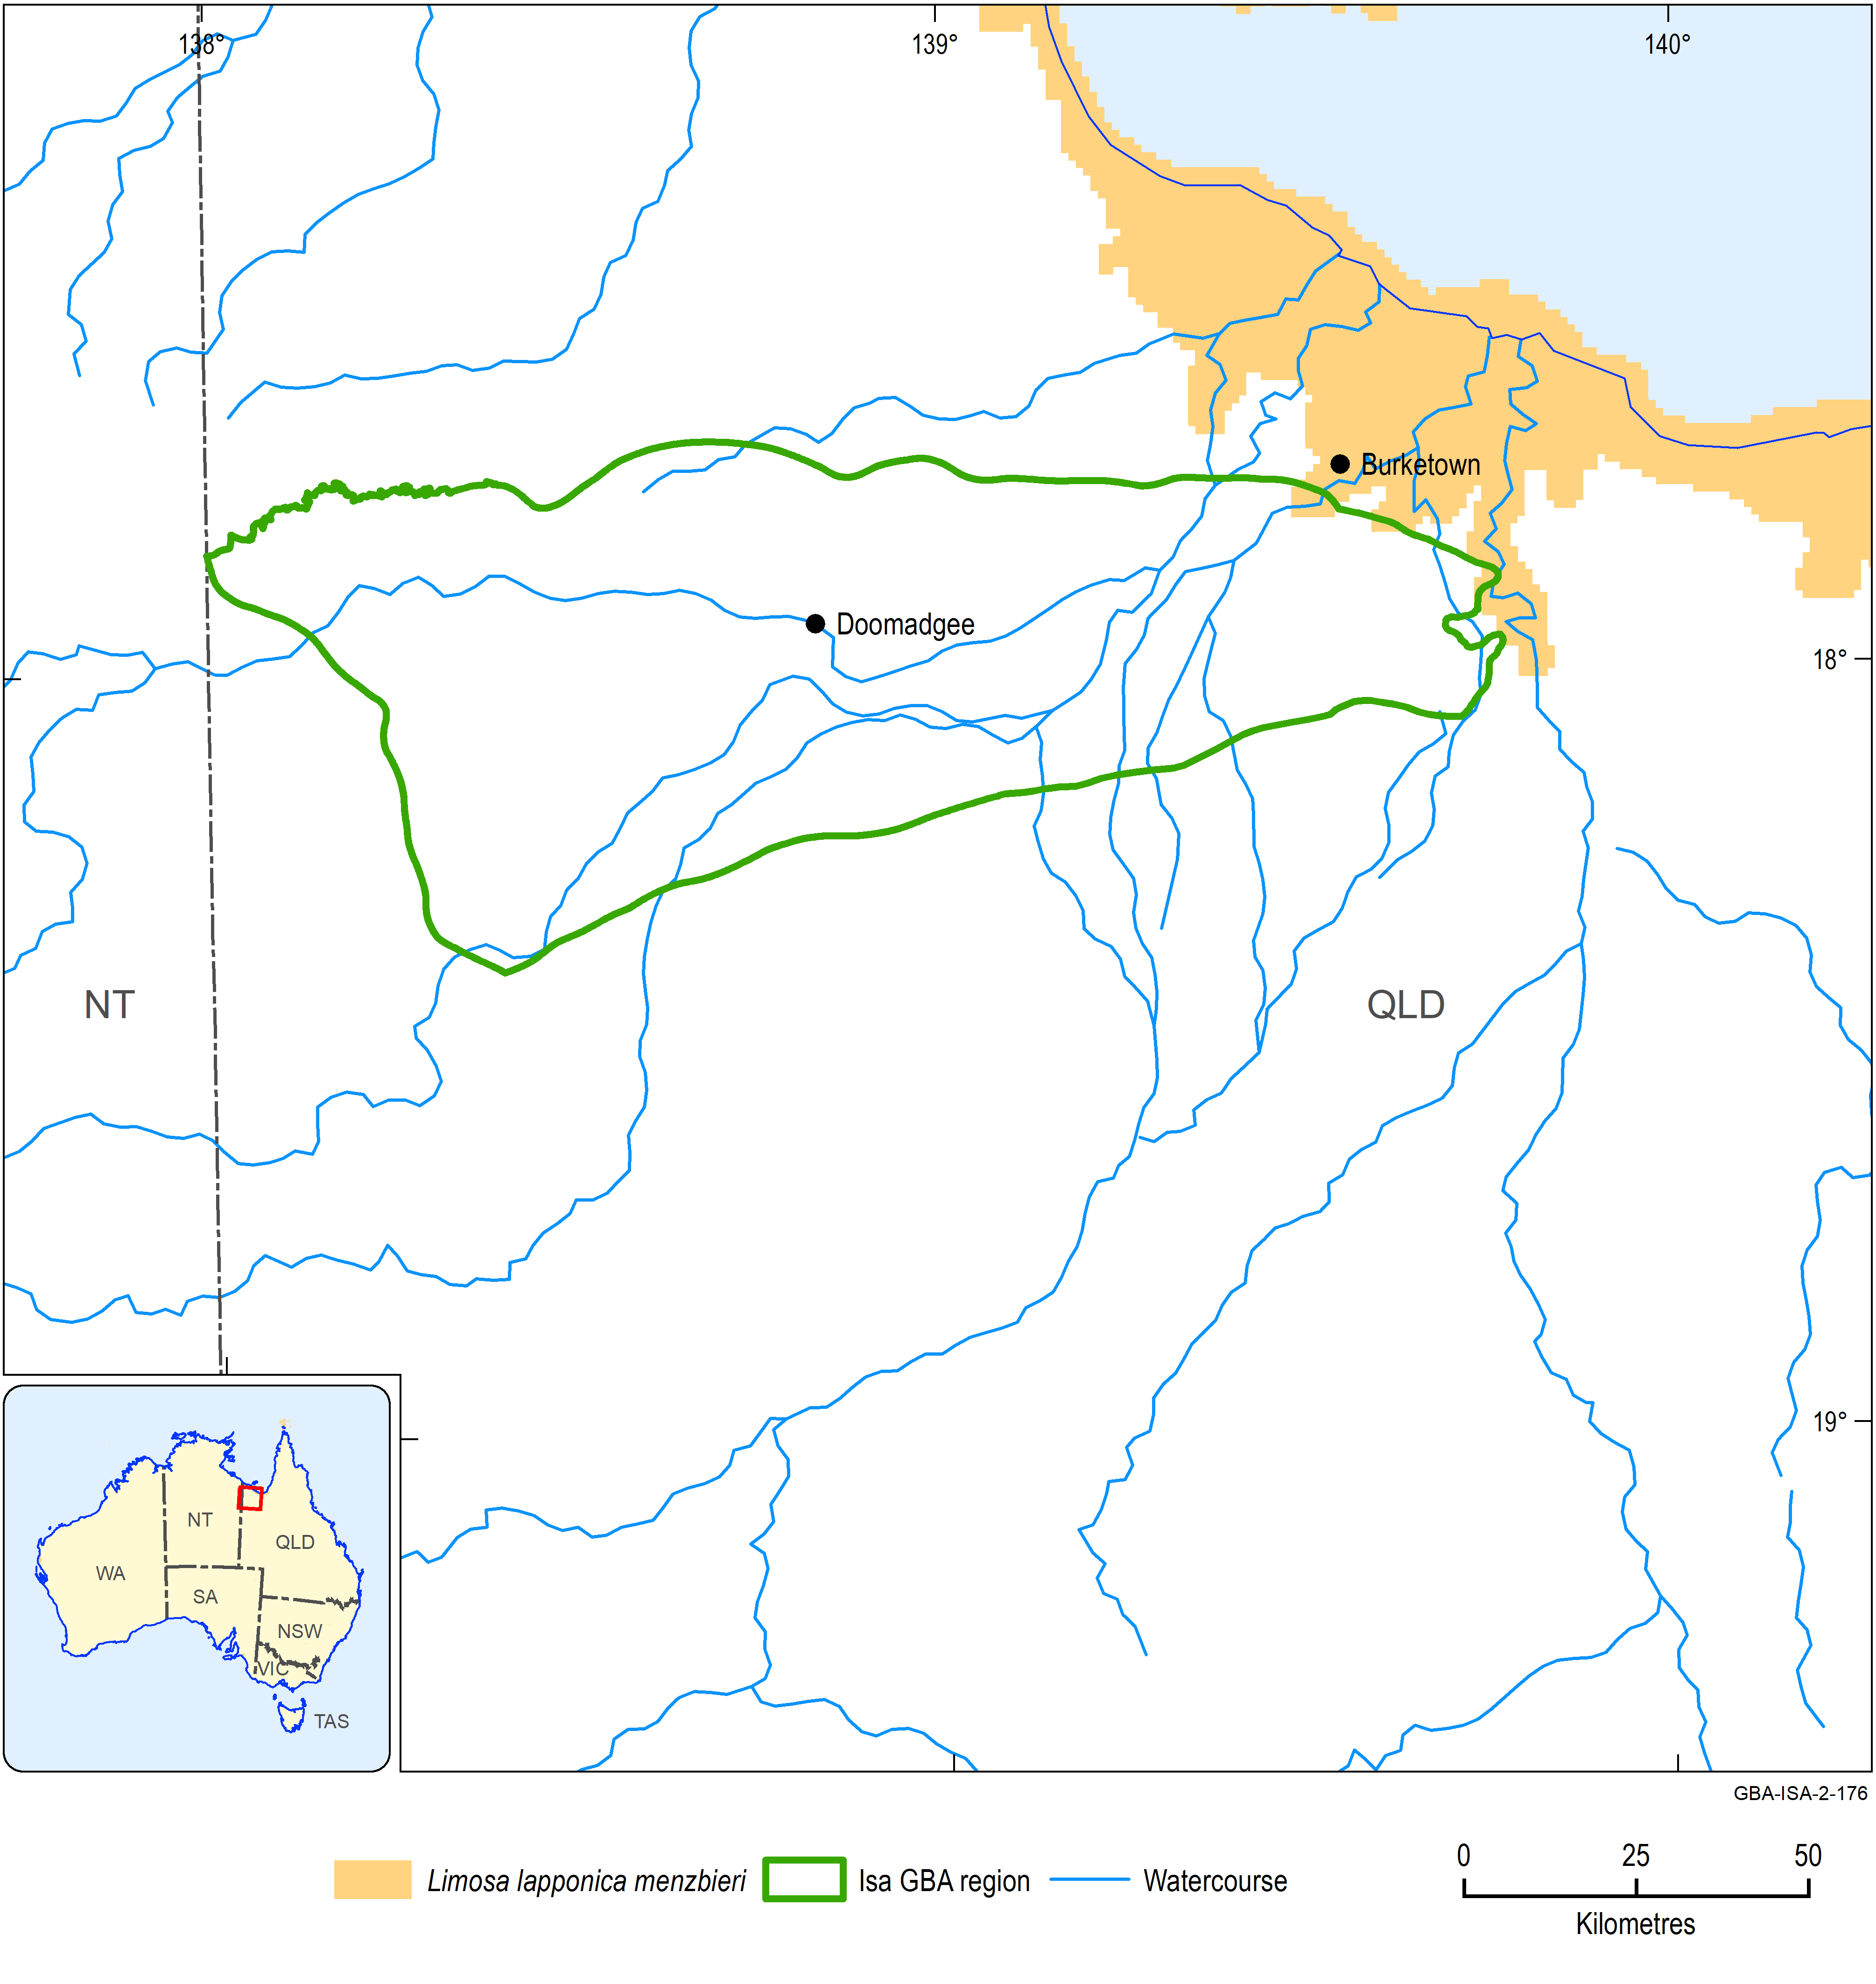
Figure 12 Distribution of Limosa lapponica menzbieri
Data: Department of the Environment and Energy (2018a); Atlas of Living Australia (2019)
Element: GBA-ISA-2-176

Masked owl, Tyto novaehollandiae kimberli
Overview
The northern subspecies of the masked owl occurs across northern Australia from the coast of north Queensland across the Top End to the Kimberley region in WA (Figure 13). It is a large bird with a distinctive heart-shaped facial disc. The masked owl (northern) typically forages in tall open forests of eucalypts and along the margins of agricultural fields. Here, it captures rodents and other small mammals. Masked owls nest and roost in hollows in large trees within forest patches.
The northern subspecies of the masked owl is listed nationally as vulnerable.
Water dependency
The masked owl is not considered to be water dependent.
Potential impacts from shale gas development
The key areas of the landscape for the species are likely to be forest patches that support mature trees with hollows that are used for breeding and roosting.
Potential effects likely to be experienced by this species include:
- exposure to soil, groundwater and/or surface water contamination
- changed surface water quality and/or flows
- changed groundwater quality and/or levels (which may affect roost tress and foraging habitat)
- bank instability and erosion.
Likelihood of being impacted by shale gas development in Isa GBA region
Yes. Assessment is based on high likelihood of occurrence in the region (Garnett et al., 2011) and potential of activities to negatively affect habitat and disrupt breeding.
Information sources
- Department of the Environment and Energy (2019a)
- Garnett et al. (2011)
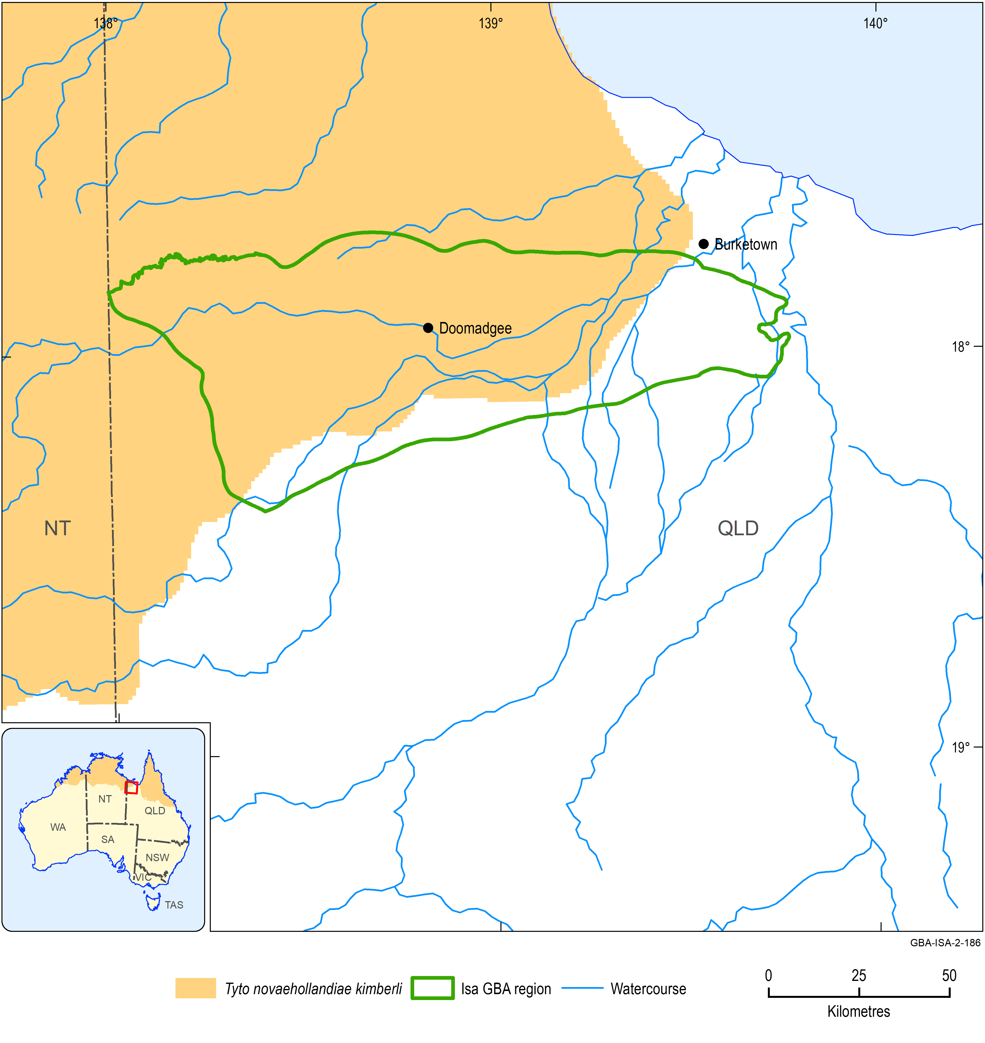
Figure 13 Distribution of Tyto novaehollandiae kimberli
Data: Department of the Environment and Energy (2018a); Atlas of Living Australia (2019)
Element: GBA-ISA-2-186

Australian painted snipe, Rostratula australis
Overview
The Australian painted snipe is a species endemic to Australia that occupies shallow freshwater wetlands. It is listed as endangered and as a marine species under the EPBC Act. Although the species has been recorded across the Australian continent, the area of occupancy is comparatively small and was estimated at about 2000 km² by Garnett et al. (2011) (Figure 14).
Water dependency
The Australian painted snipe is a water-dependent species. The main habitat of this species is shallow freshwater wetlands. Suitable habitat includes lakes, swamps, claypans, inundated or waterlogged grassland and saltmarsh and artificial wetlands including dams, rice crops, sewerage farms and bore drains.
Potential impacts from shale gas development
The key areas of the landscape are shallow freshwater wetlands.
Potential effects likely to be experienced by this species include:
- exposure to soil, groundwater and/or surface water contamination
- changed surface water quality and/or flows.
Likelihood of being impacted by shale gas development in Isa GBA region
Yes. Assessment is based on high likelihood of occurrence in the region (Garnett et al., 2011) and potential of activities to negatively affect habitat and disrupt breeding.
Information sources
- Department of the Environment and Energy (2019a)
- Garnett et al. (2011)

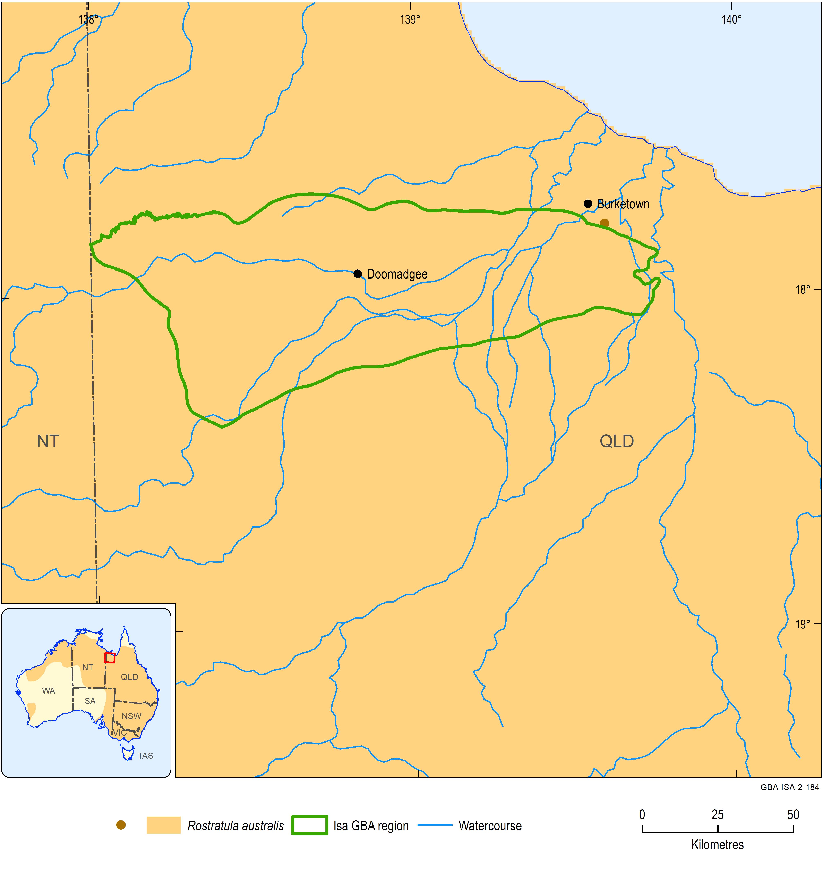
Figure 14 Distribution and Atlas of Living Australia observations of Rostratula australis
The location of the Atlas of Living Australia observations are shown by the brown dots on the main map. The inset map shows the species distribution across Australia.
Data: Department of the Environment and Energy (2018a); Atlas of Living Australia (2019)
Element: GBA-ISA-2-184

Plains death adder, Acanthophis hawkei
Overview
The plains death adder is a relatively small (body length of about 0.6 m), stout-bodied terrestrial snake. It occurs across northern Australia from the extreme north-east of WA, across the Top End and Barkly Tableland of the NT/Queensland border and the Mitchell Grass Downs in south-west Queensland (Figure 15). The plains death adder occurs on floodplains that have cracking clay soils. The conservation status of this species is vulnerable. Populations have declined because of cane toad invasion into northern Australia; the species readily captures toads but is highly susceptible to the toad’s toxins.
The plains death adder feeds on reptiles, frogs and small mammals, especially rodents. Reptiles and frogs are taken when the snakes are young. The species is like other death adders in being an ambush predator.
Water dependency
The water dependency of the species is poorly understood but it is not considered to be water dependent.
Potential impacts from shale gas development
The key areas of the landscape for this species are likely to be floodplains that have cracking clay soils.
Potential effects likely to be experienced by this species include:
- habitat loss and fragmentation
- exposure to soil, groundwater and/or surface water contamination
- changed surface water quality and/or flows.
Likelihood of being impacted by shale gas development in Isa GBA region
Yes. Assessment is based on moderate likelihood of occurrence in the region and potential of activities to negatively affect habitat and potentially fragment populations.
Information sources
- Department of the Environment and Energy (2019a)
- Ward and Phillips (2012)
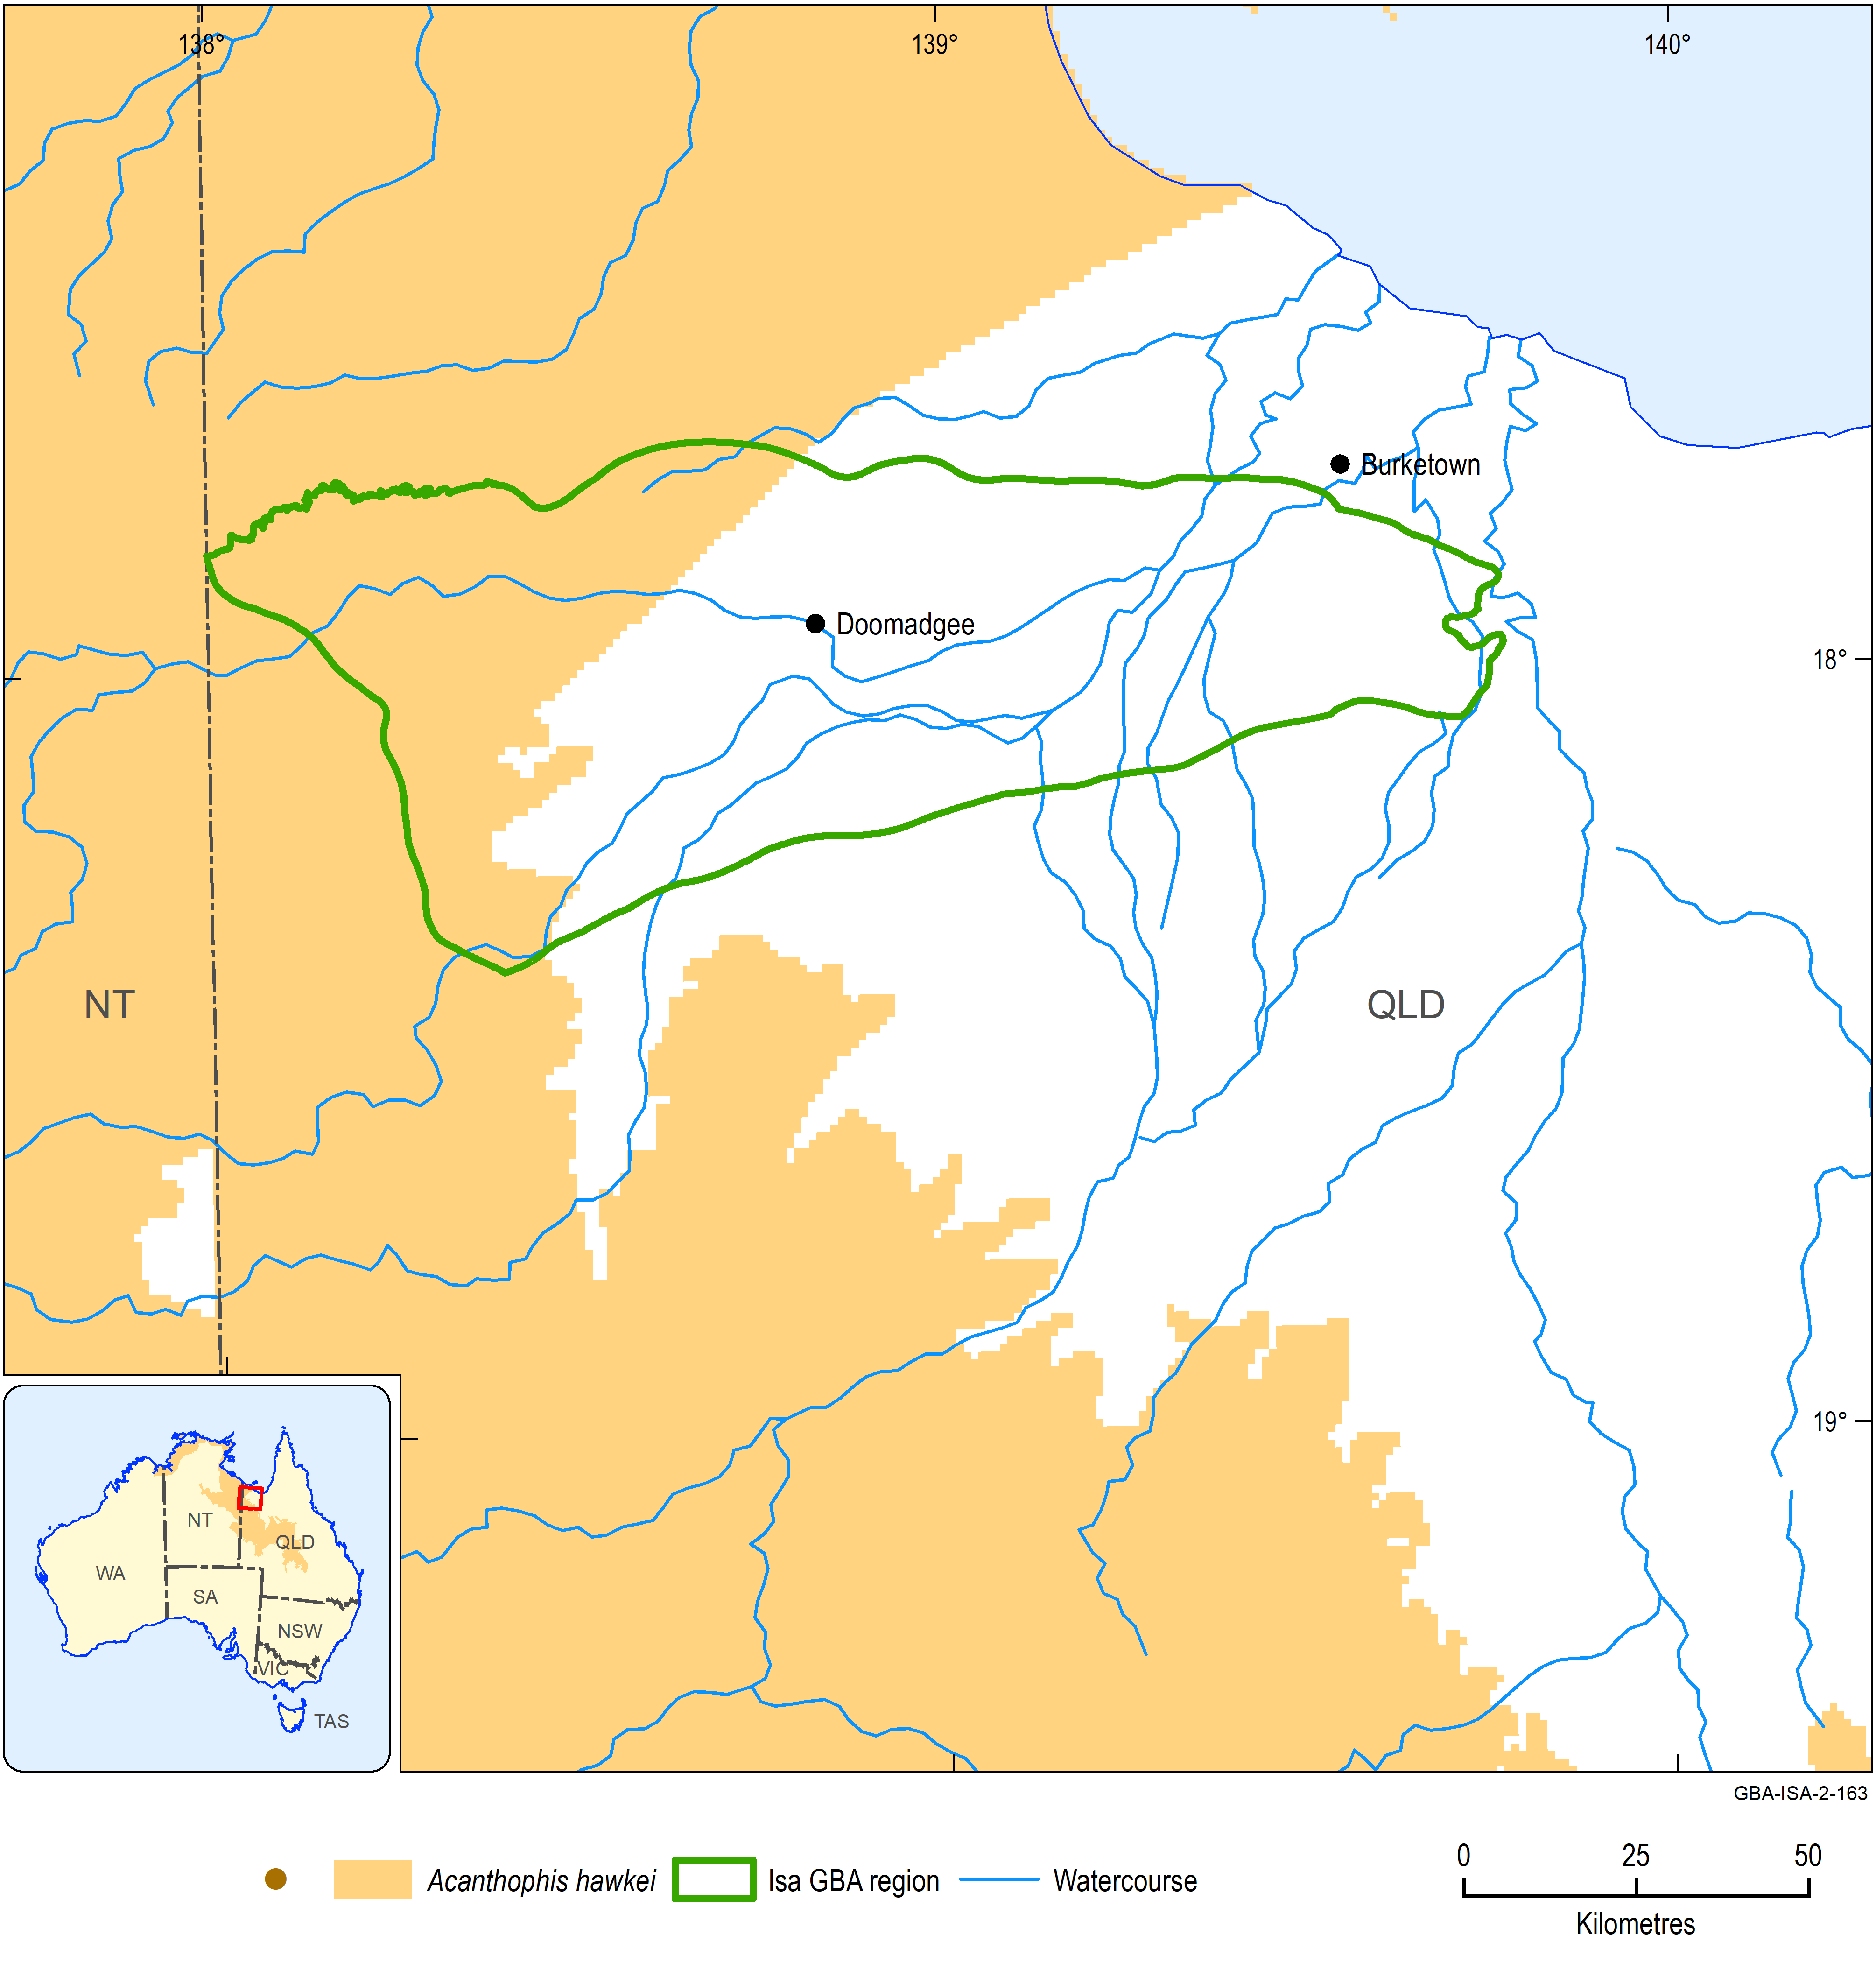
Figure 15 Distribution of Acanthophis hawkei
Data: Department of the Environment and Energy (2018a); Atlas of Living Australia (2019)
Element: GBA-ISA-2-163

Gulf snapping turtle, Elseya lavarackorum
Overview
The Gulf snapping turtle is a species of freshwater turtle that was first described from fossils found at Riversleigh Station and was subsequently discovered to be extant. The Gulf snapping turtle has a short neck and grows to a maximum length of 35 cm. It is an aquatic species that is entirely herbaceous and is confined to riverine habitat. It nests by laying eggs in the soil near the edge of the water.
The species has a limited distribution that encompasses the upper and middle reaches of the Nicholson and Gregory Rivers in north-west Queensland and north-east NT and the upper reaches of the Calvert River in the NT (Freeman et al., 2014) (Figure 16). These areas are characterised by stony hills and escarpments. The Gulf snapping turtle occurs in deep-water pools of permanently flowing spring-fed rivers and occurs in highest densities where the riparian vegetation is undisturbed (Freeman et al., 2014). The Gulf snapping turtle is listed nationally as endangered. However, in the NT it is listed as being of least concern.
Water dependency
This species is water dependent throughout its life.
Potential impacts from shale gas development
Key areas for the Gulf snapping turtle are deep-water pools of permanently flowing spring-fed rivers especially where the riparian vegetation is largely undisturbed.
Potential effects likely to be experienced by this species include:
- exposure to soil, groundwater and/or surface water contamination
- changed surface water quality and/or flows
- changed groundwater quality and/or levels
- bank instability and erosion
- changed groundwater composition.
Likelihood of being impacted by shale gas development in Isa GBA region
Yes. Assessment is based on known occurrence in the region and potential of activities to decrease population size, reduce area of occupancy and negatively affect habitat.
Information sources
- Department of the Environment and Energy (2019a)
- Woinarski (2006)
- Freeman et al. (2014)
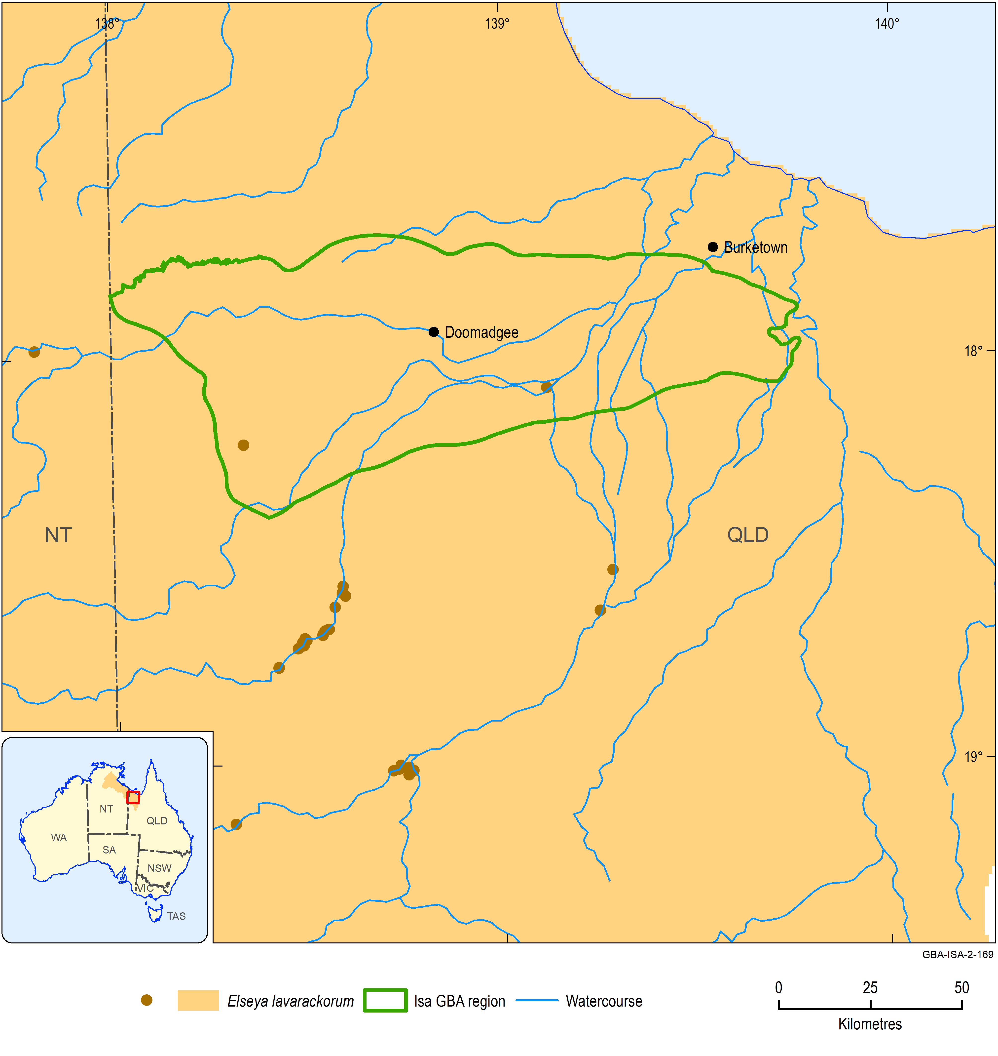
Figure 16 Distribution and Atlas of Living Australia observations of the Elseya lavarackorum
The location of the Atlas of Living Australia observations are shown by the brown dots on the main map. The inset map shows the species distribution across Australia.
Data: Department of the Environment and Energy (2018a); Atlas of Living Australia (2019)
Element: GBA-ISA-2-169

Marine turtles (six species)
- Loggerhead turtle (Caretta caretta)
- Green turtle (Chelonia mydas)
- Leatherback turtle (Dermochelys coriacea)
- Hawksbill turtle (Eretmochelys imbricata)
- Olive Ridley turtle (Lepidochelys olivacea)
- Flatback turtle (Natator depressus)
Overview
The six species of marine turtle are pelagic for most of their lives occurring in the ocean. Their only contact with land is when the adult females come ashore to lay eggs in the sand of beaches above the high-water mark. They do this on average two to six times per breeding season. Females spend the period between nesting (known as the inter-nesting period) in shallow water adjacent to the nesting beach (Commonwealth of Australia, 2017). Further details on individual species are provided in Table 1.
The distribution of each of the species is shown in Figure 17 to Figure 22.
Water dependency
Each of the six species of marine turtle is aquatic.
Potential impacts from shale gas development
None of the six species of marine turtle use freshwater wetlands or estuaries. Therefore, impacts from development of a shale gas industry would have to be catastrophic events affecting either nesting beaches or adjacent shallow marine habitats.
There are no clear potential effects.
Likelihood of being impacted by shale gas development in Isa GBA region
No. Assessment is based on absence of each species from the region and, therefore, very low likelihood of intersection of each of the six species with gas development.
Information sources
- Commonwealth of Australia (2017)

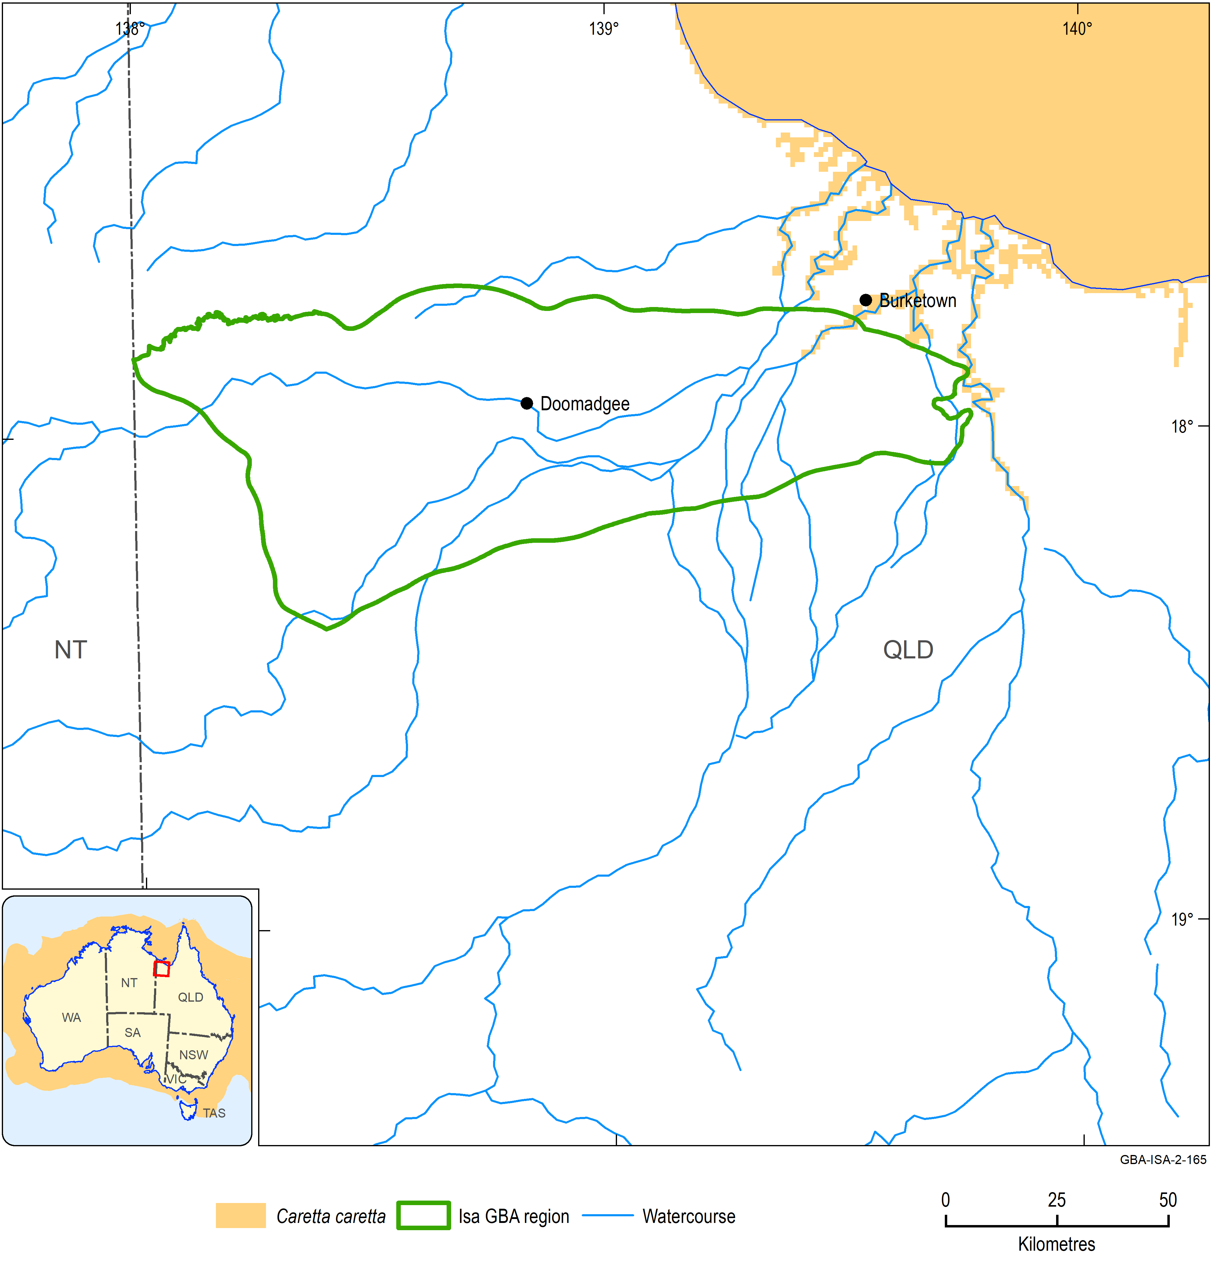
Figure 17 Distribution of Caretta caretta
Data: Department of the Environment and Energy (2018a); Atlas of Living Australia (2019)
Element: GBA-ISA-2-165
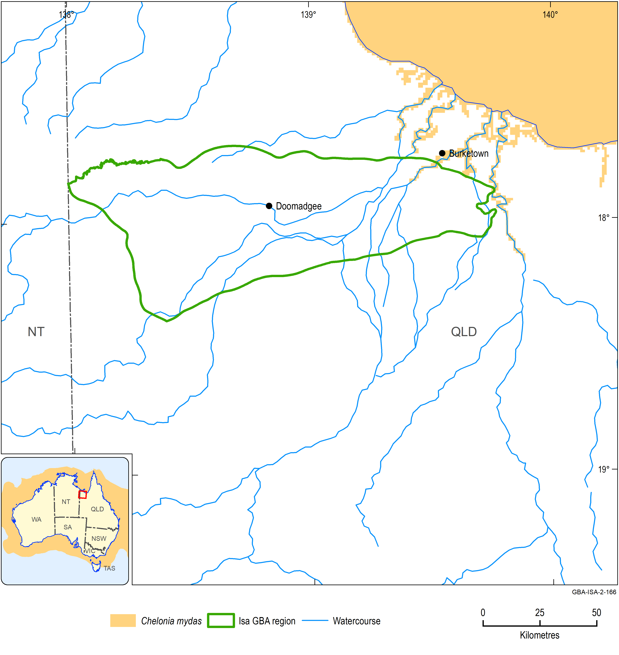
Figure 18 Distribution of Chelonia mydas
Data: Department of the Environment and Energy (2018a); Atlas of Living Australia (2019)
Element: GBA-ISA-2-166
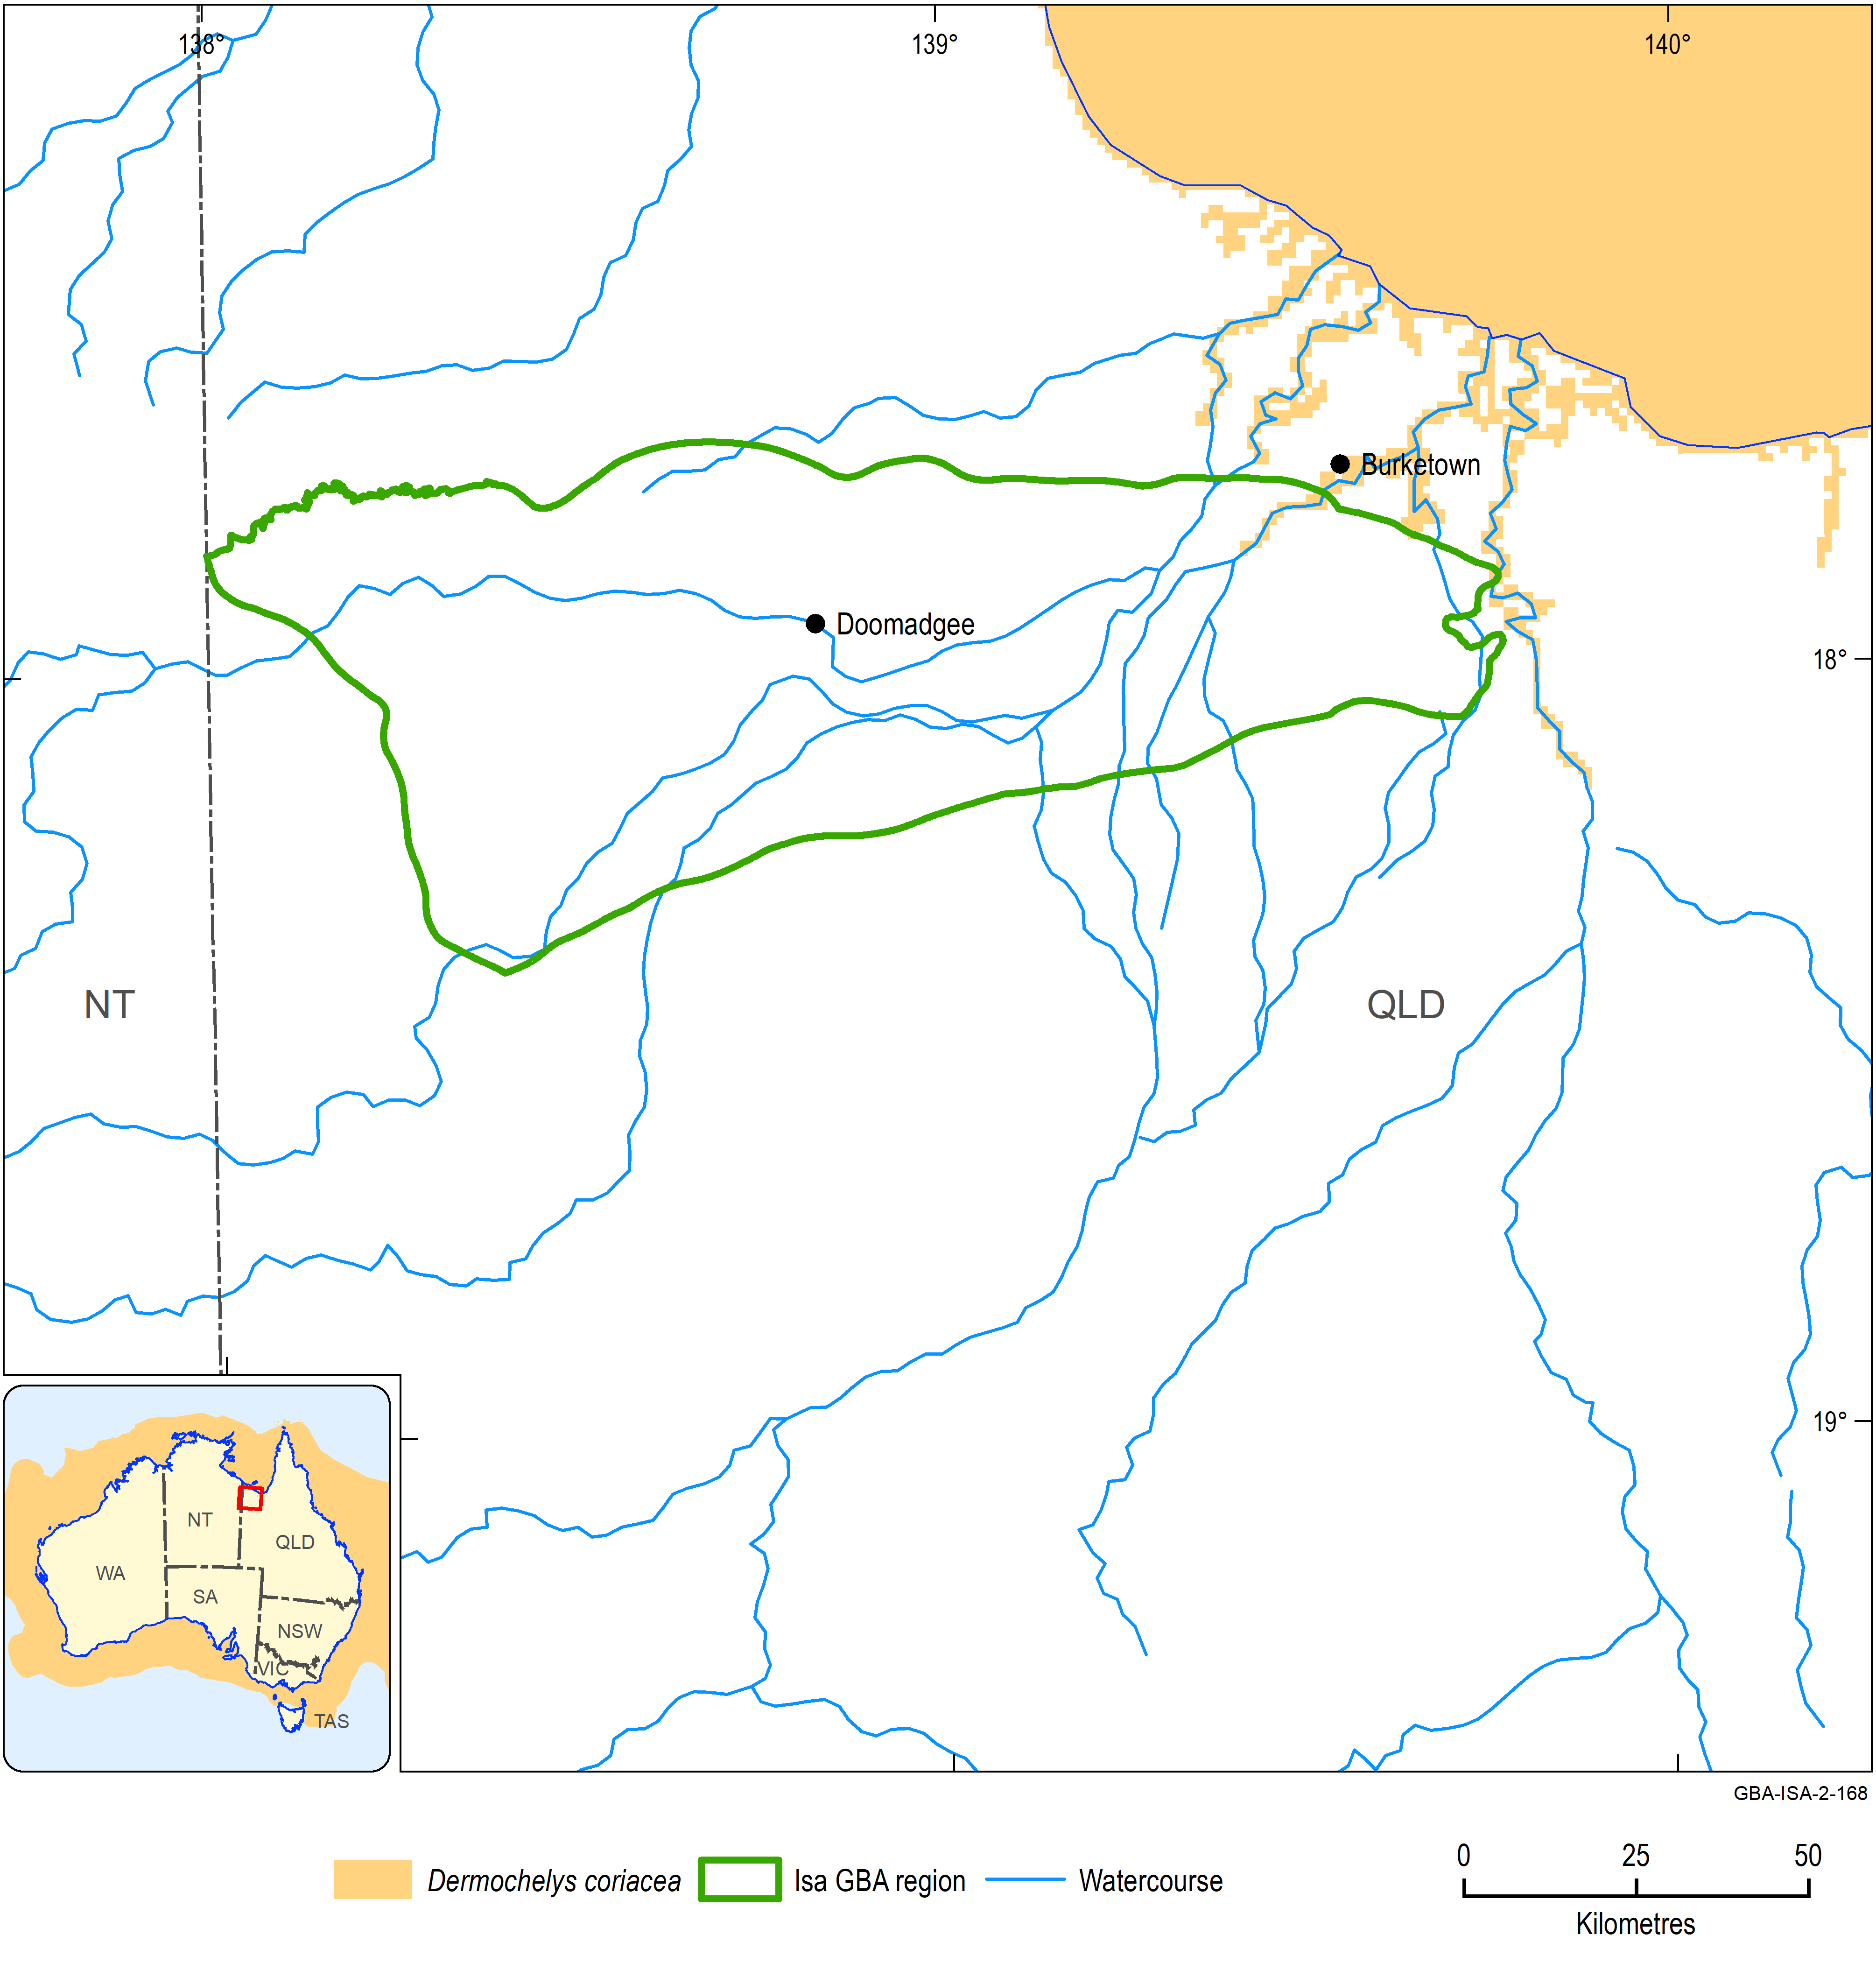
Figure 19 Distribution of Dermochelys coriacea
Data: Department of the Environment and Energy (2018a); Atlas of Living Australia (2019)
Element: GBA-ISA-2-168
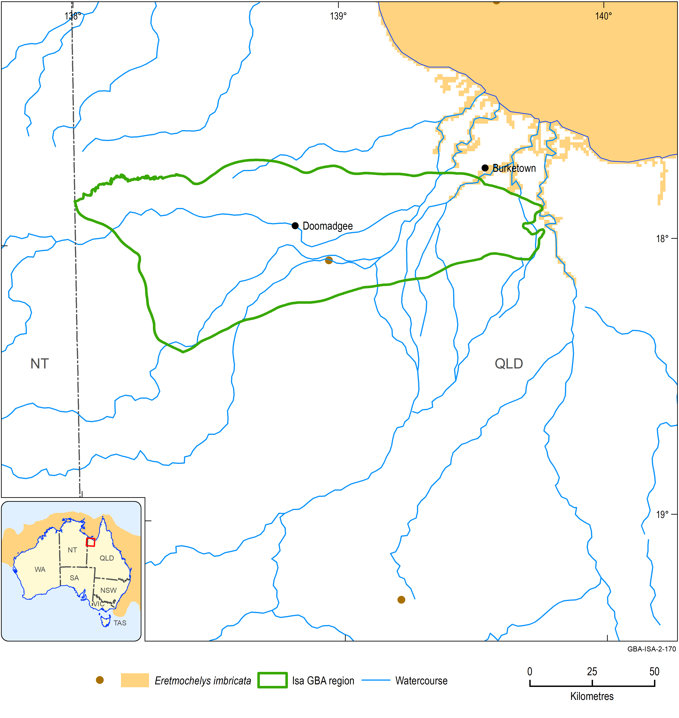
Figure 20 Distribution and Atlas of Living Australia observations of Eretmochelys imbricata
The location of the Atlas of Living Australia observations are shown by the brown dots on the main map. The inset map shows the species distribution across Australia.
Data: Department of the Environment and Energy (2018a); Atlas of Living Australia (2019)
Element: GBA-ISA-2-170
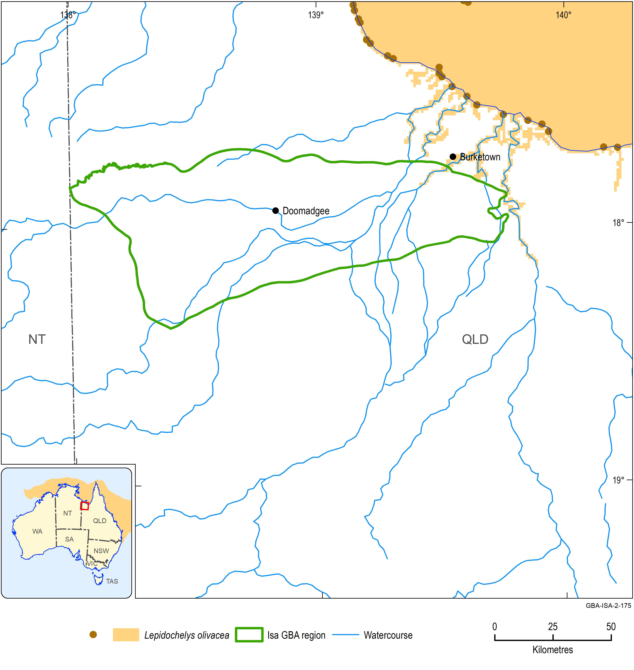
Figure 21 Distribution and Atlas of Living Australia observations of Lepidochelys olivacea
The location of the Atlas of Living Australia observations are shown by the brown dots on the main map. The inset map shows the species distribution across Australia.
Data: Department of the Environment and Energy (2018a); Atlas of Living Australia (2019)
Element: GBA-ISA-2-175
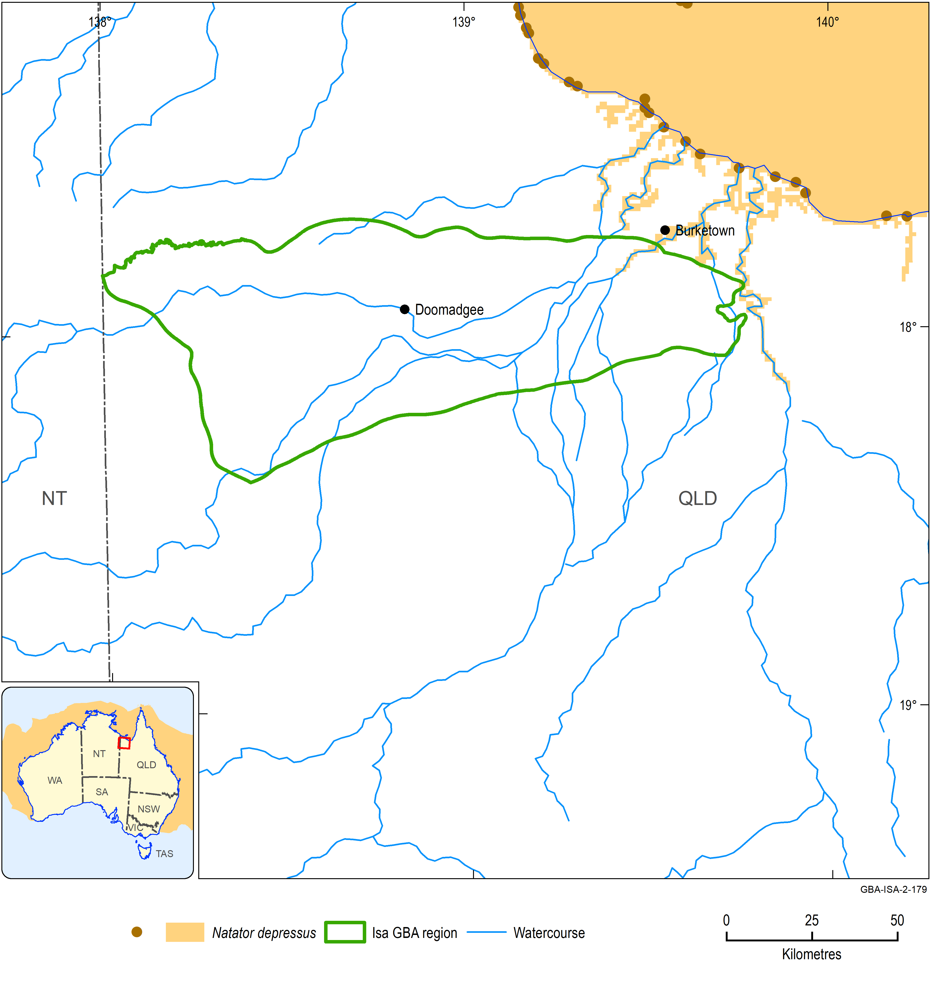
Figure 22 Distribution and Atlas of Living Australia observations of Natator depressus
The location of the Atlas of Living Australia observations are shown by the brown dots on the main map. The inset map shows the species distribution across Australia.
Data: Department of the Environment and Energy (2018a); Atlas of Living Australia (2019)
Element: GBA-ISA-2-179

Speartooth shark, Glyphis glyphis
Overview
The speartooth shark is a species of whaler shark that is approximately 50 to 60 cm at birth but grows to be over 2 m long when mature. The species lives in large tropical river systems when neonate, juvenile and sub-adult but then migrates to the coastal marine environment for the entire adult stage. In river systems, speartooth sharks show a preference for highly turbid, tidally influenced water with fine muddy substrate. Juveniles capture a range of fish species and freshwater crustaceans.
The species is classified as critically endangered in Australia. It also occurs in Papua New Guinea. Three distinct populations occur in Australia:
- Van Diemen Gulf drainage in the NT, including the Adelaide River, South, East and West Alligator Rivers, and Murganella Creek
- Port Musgrave in Queensland, including the Wenlock and Ducie Rivers
- Princess Charlotte Bay area of eastern Cape York in Queensland (Figure 23).
Water dependency
This species is aquatic.
Potential impacts from shale gas development
Key areas in tropical rivers for speartooth sharks are likely to be those with highly turbid, tidally influenced water with fine muddy substrate.
Potential effects likely to be experienced by this species include:
- exposure to soil, groundwater and/or surface water contamination
- changed surface water quality and/or flows
- bank instability and erosion
- contamination of estuarine waters.
Likelihood of being impacted by shale gas development in Isa GBA region
No. Assessment is based on low likelihood of occurrence in the region and general lack of suitable habitat within the region resulting in low likelihood of overlap of the species with areas of prospective shale gas development.
Information sources
- Commonwealth of Australia (2015a)
- Commonwealth of Australia (2015b)
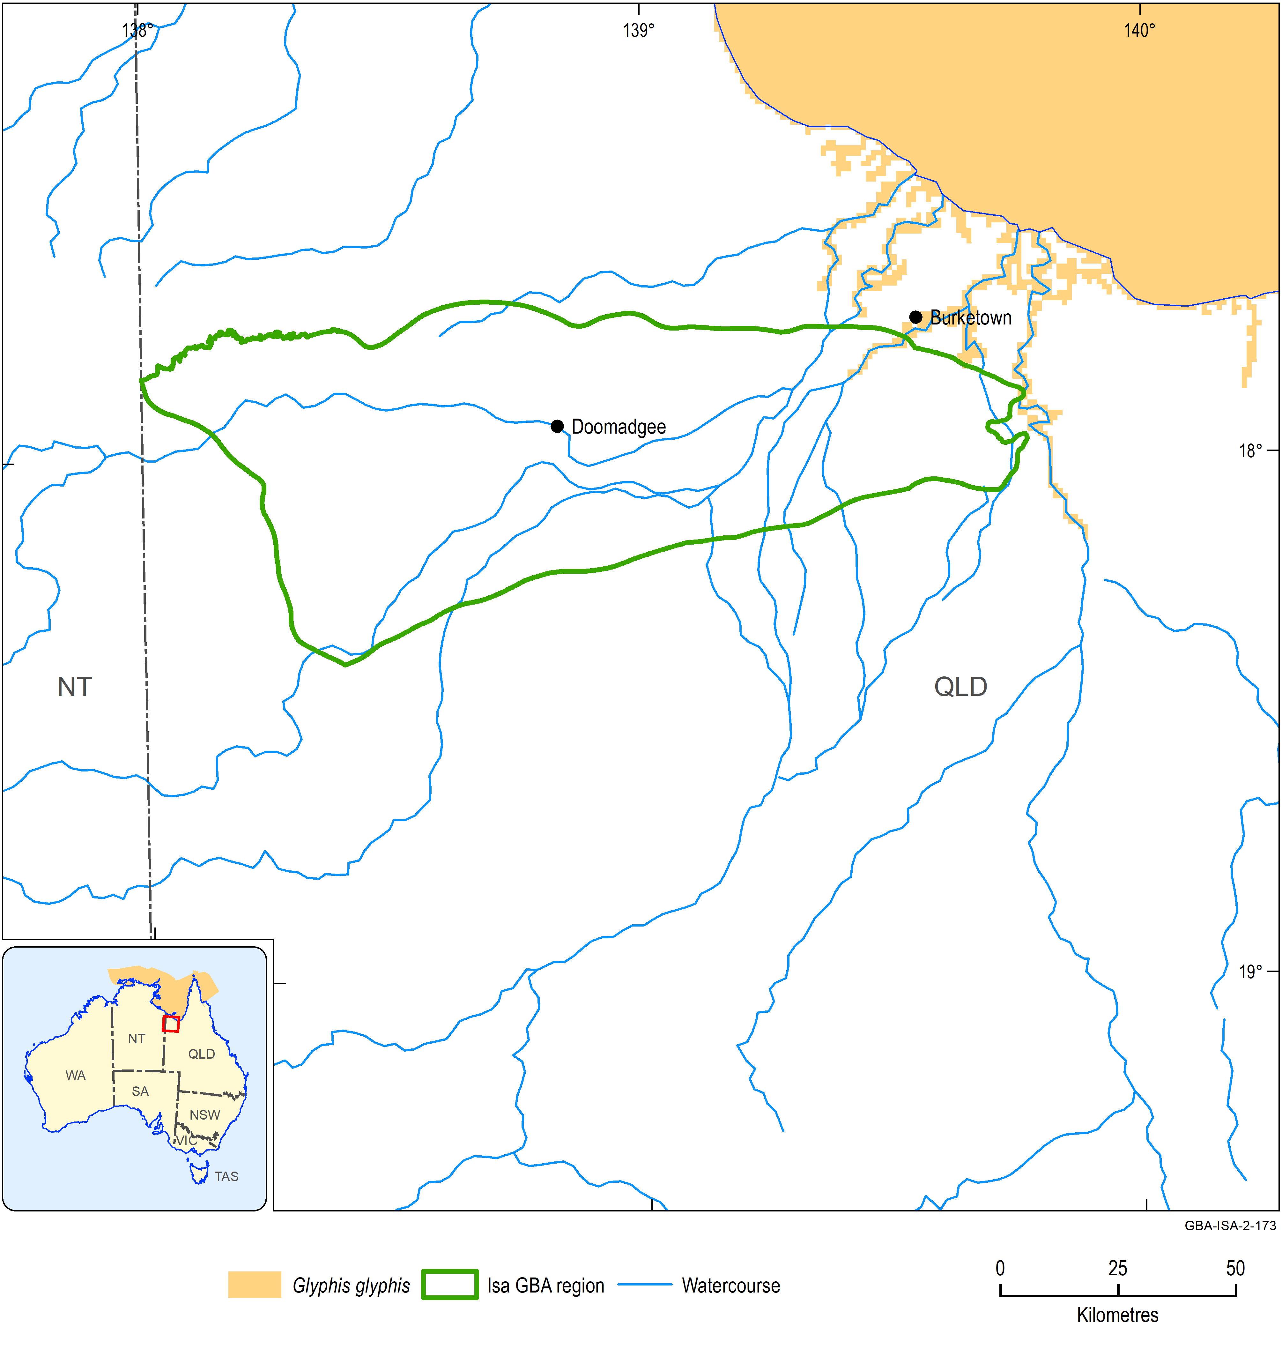
Figure 23 Distribution of Glyphis glyphis
Data: Department of the Environment and Energy (2018a); Atlas of Living Australia (2019)
Element: GBA-ISA-2-173

Freshwater sawfish, Pristis pristis
Overview
The freshwater sawfish is a large, slender sawfish. It is the largest freshwater fish found in Australia, reaching a maximum body length of 5.82 m (Commonwealth of Australia 2015a). The species lives in river and estuarine environments and up to 100 km offshore in northern and western Australia as well as in North and South America, Africa, Asia and New Guinea (Figure 24). The species is classified as vulnerable nationally and is also listed as migratory under the EPBC Act.
Freshwater sawfish inhabit the sandy or muddy floors of shallow coastal waters, estuaries and river mouths and also have been recorded up to 400 km inland in the central and upper reaches of freshwater rivers and in isolated waterholes. Freshwater and estuaries are occupied by neonates and juveniles whereas adults occur mainly in estuaries and coastal marine environments. In Australian rivers, nursery areas fragment during the dry season and turn into a series of isolated waterholes.
Water dependency
This species is aquatic.
Potential impacts from shale gas development
Key areas in tropical rivers for freshwater sawfish are likely to be the central and upper reaches of freshwater rivers and isolated waterholes.
Potential effects likely to be experienced by this species include:
- exposure to soil, groundwater and/or surface water contamination
- changed surface water quality and/or flows
- changed groundwater quality and/or levels
- bank instability and erosion
- changed groundwater composition
- contamination of estuarine waters.
Likelihood of being impacted by shale gas development in Isa GBA region
Yes. Assessment is based on high likelihood of occurrence in the region (depending on the influence of water infrastructure) and the potential for shale gas development activities to decrease population size, reduce area of occupancy and negatively affect habitat.
Information sources
- Commonwealth of Australia (2015a)
- Commonwealth of Australia (2015b)
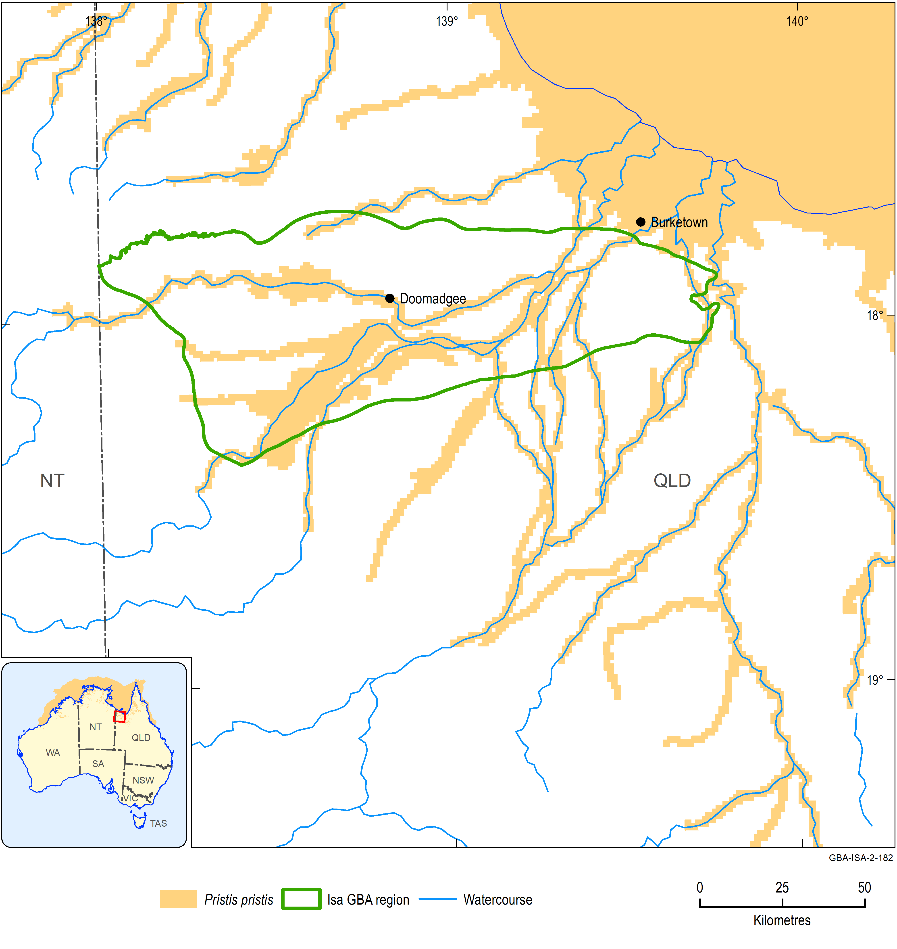
Figure 24 Distribution of Pristis pristis
Data: Department of the Environment and Energy (2018a)
Element: GBA-ISA-2-182

Green sawfish, Pristis zijsron
Overview
The green sawfish is a very large, slender fish with a shark-like body. The maximum length recorded is 7.3 m (Commonwealth of Australia 2015a). This sawfish occurs in inshore coastal environments, including estuaries, river mouths and along sandy and muddy beaches. The species does not use freshwater environments.
The species is classified as vulnerable nationally and is also listed as migratory under the EPBC Act. In Australia, the green sawfish occurs from the Whitsunday Islands in central Queensland across the north to Shark Bay in WA (Figure 25). It also occurs in New Guinea, Indonesia, Malaysia, Kenya, Eritrea, Sudan and the Persian Gulf.
Water dependency
This species is aquatic.
Potential impacts from shale gas development
The green sawfish does not occur in freshwater. It is restricted to estuarine and inshore coastal environments.
Potential effects likely to be experienced by this species are:
- contamination of estuarine waters.
Likelihood of being impacted by shale gas development in Isa GBA region
No. Assessment is based on general lack of suitable habitat within the region resulting in low likelihood of overlap of the species with shale gas development.
Information sources
- Commonwealth of Australia (2015a)
- Commonwealth of Australia (2015b)
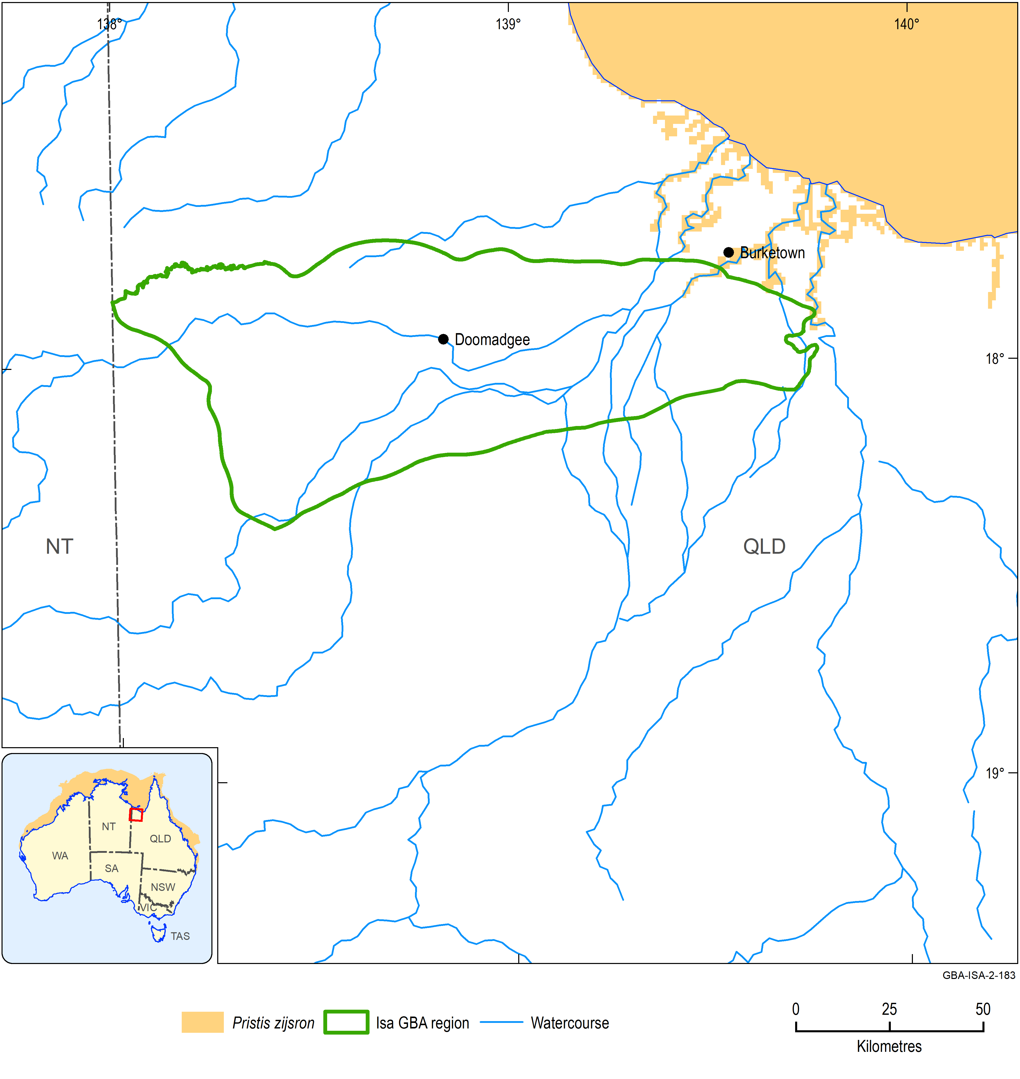
Figure 25 Distribution of Pristis zijsron
Data: Department of the Environment and Energy (2018a)
Element: GBA-ISA-2-183

Dwarf sawfish, Pristis clavata
Overview
The dwarf sawfish is a relatively small fish species with a maximum recorded length of 3.1 m. It inhabits inshore coastal environments, including estuaries in relatively shallow water (<3 m deep). The species occupies fully marine water with high turbidity and low dissolved oxygen. The species does not use freshwater environments.
The species is classified as vulnerable nationally and is also listed as migratory under the EPBC Act. In Australia, the range of the dwarf sawfish extends north from Cairns around the Cape York Peninsula in Queensland, across northern Australian waters to the Pilbara coast in WA (Figure 26).
Water dependency
This species is aquatic.
Potential impacts from shale gas development
The dwarf sawfish does not occur in freshwater. It is restricted to estuarine and inshore coastal environments.
Potential effects likely to be experienced by this species are:
- contamination of estuarine waters.
Likelihood of being impacted by shale gas development in Isa GBA region
No. Assessment is based on general lack of suitable habitat within the region resulting in low likelihood of overlap of the species with gas development.
Information sources
- Commonwealth of Australia (2015a)
- Commonwealth of Australia (2015b)
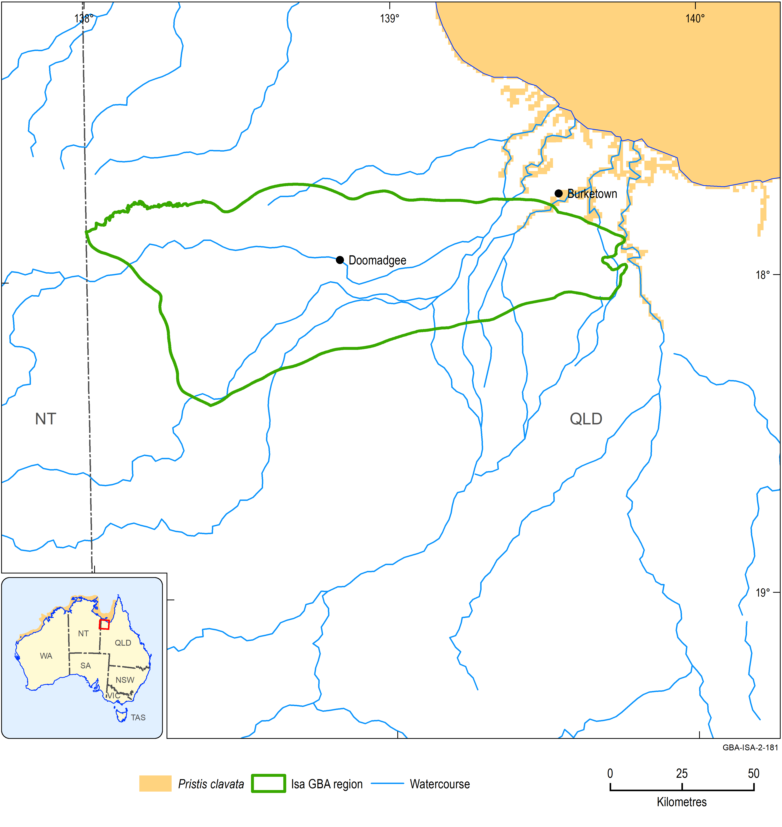
Figure 26 Distribution of Pristis clavata
Data: Department of the Environment and Energy (2018a)
Element: GBA-ISA-2-181

Listed threatening processes
The EPBC Act identifies key threatening processes for MNES. In the Isa GBA region, nine key threatening processes have been identified that may affect the listed species. These are all existing threatening processes that may occur irrespective of shale gas development, and include:
- loss of climatic habitat caused by anthropogenic emissions of greenhouse gases
- injury and fatality to vertebrate marine life caused by ingestion of, or entanglement in, harmful marine debris
- incidental catch (bycatch) of sea turtle during coastal otter-trawling operations within Australian waters north of 28 degrees south
- land clearance
- invasion of northern Australia by Gamba Grass and other introduced grasses
- novel biota and their impact on biodiversity (e.g. feral horse, donkey, camel)
- predation, habitat degradation, competition and disease transmission by feral pigs
- predation by feral cats
- biological effects, including lethal toxic ingestion, caused by cane toads (Rhinella marina).

Matters of State Environmental Significance
Queensland’s state planning policy July 2017 (State of Queensland (Department of Infrastructure Local Government and Planning), 2017) lists a range of matters of environmental significance, such as important wetlands, ecologically important habitats and threatened wildlife, that are relevant to the Isa GBA region. These Matters of State environmental Significance (MSES) include:
- protected area estates e.g. national parks
- designated precinct of strategic environmental areas
- important regional ecosystems
- threatened species
- high ecological significance wetlands and high ecological value waters
- cultural heritage areas including Queensland heritage places, archaeological state heritage places, places of local cultural heritage significance and heritage areas.
A summary of the MSES identified and their data sources is given in Table 9 of Section 4.1, as well as groundwater-dependent ecosystems.

Protected area estates
Two state reserves in Queensland partially occur in the south-west of the Isa GBA region. These two reserves are Lawn Hill (Widdallion) and Lawn Hill (Arthur Creek) protected areas (Department of the Environment and Energy, 2016). An area of 56 km² of these reserves is within the Isa GBA region (Figure 27).
The Ganalanga–Mindibirrina Indigenous Protected Area (IPA) in the NT, a Category VI managed resource protected area under IUCN criteria, is adjacent to the north-west of the Isa GBA region.
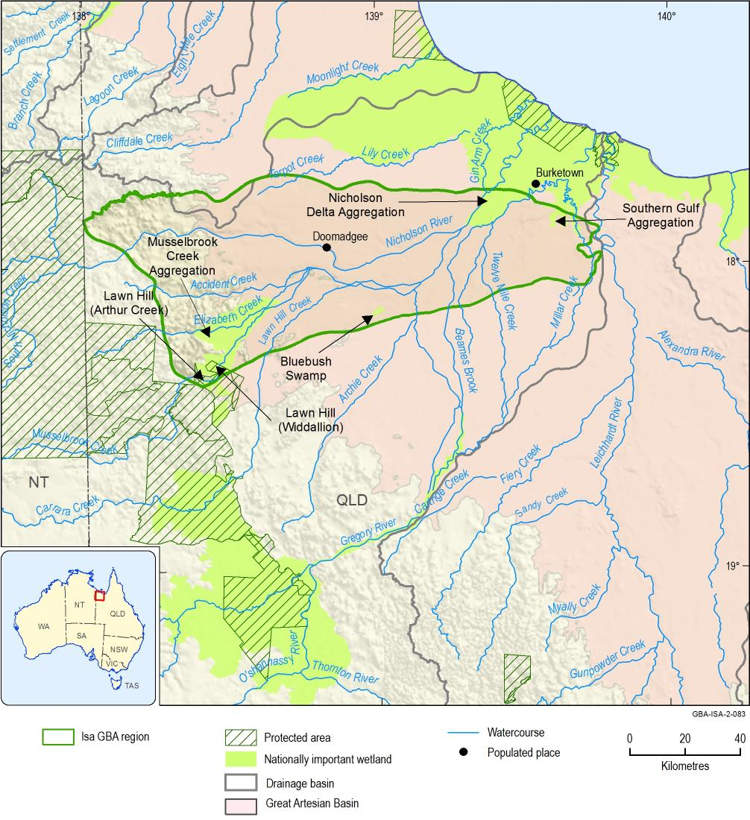
Figure 27 Nationally important wetlands and protected areas in the Isa GBA region
Data: (Department of the Environment and Energy, 2010, 2016)
Element: GBA-ISA-2-083

Designated precinct of strategic environmental areas
Strategic environmental areas identify designated precincts where a planned activity will not have a widespread or irreversible impact on the attributes of the area. The attributes include natural hydrological processes and geomorphological processes, riparian processes, wildlife corridors and water quality in watercourses and aquifers, as outlined in Queensland’s Regional Planning Interests Regulation 2014. The Gulf Rivers strategic environmental area designated precinct covers 1480 km² within the Isa GBA region, and is associated with several streams including Accident Creek, Elizabeth Creek and Lawn Hill Creek, as well as the Gregory River (Figure 28).
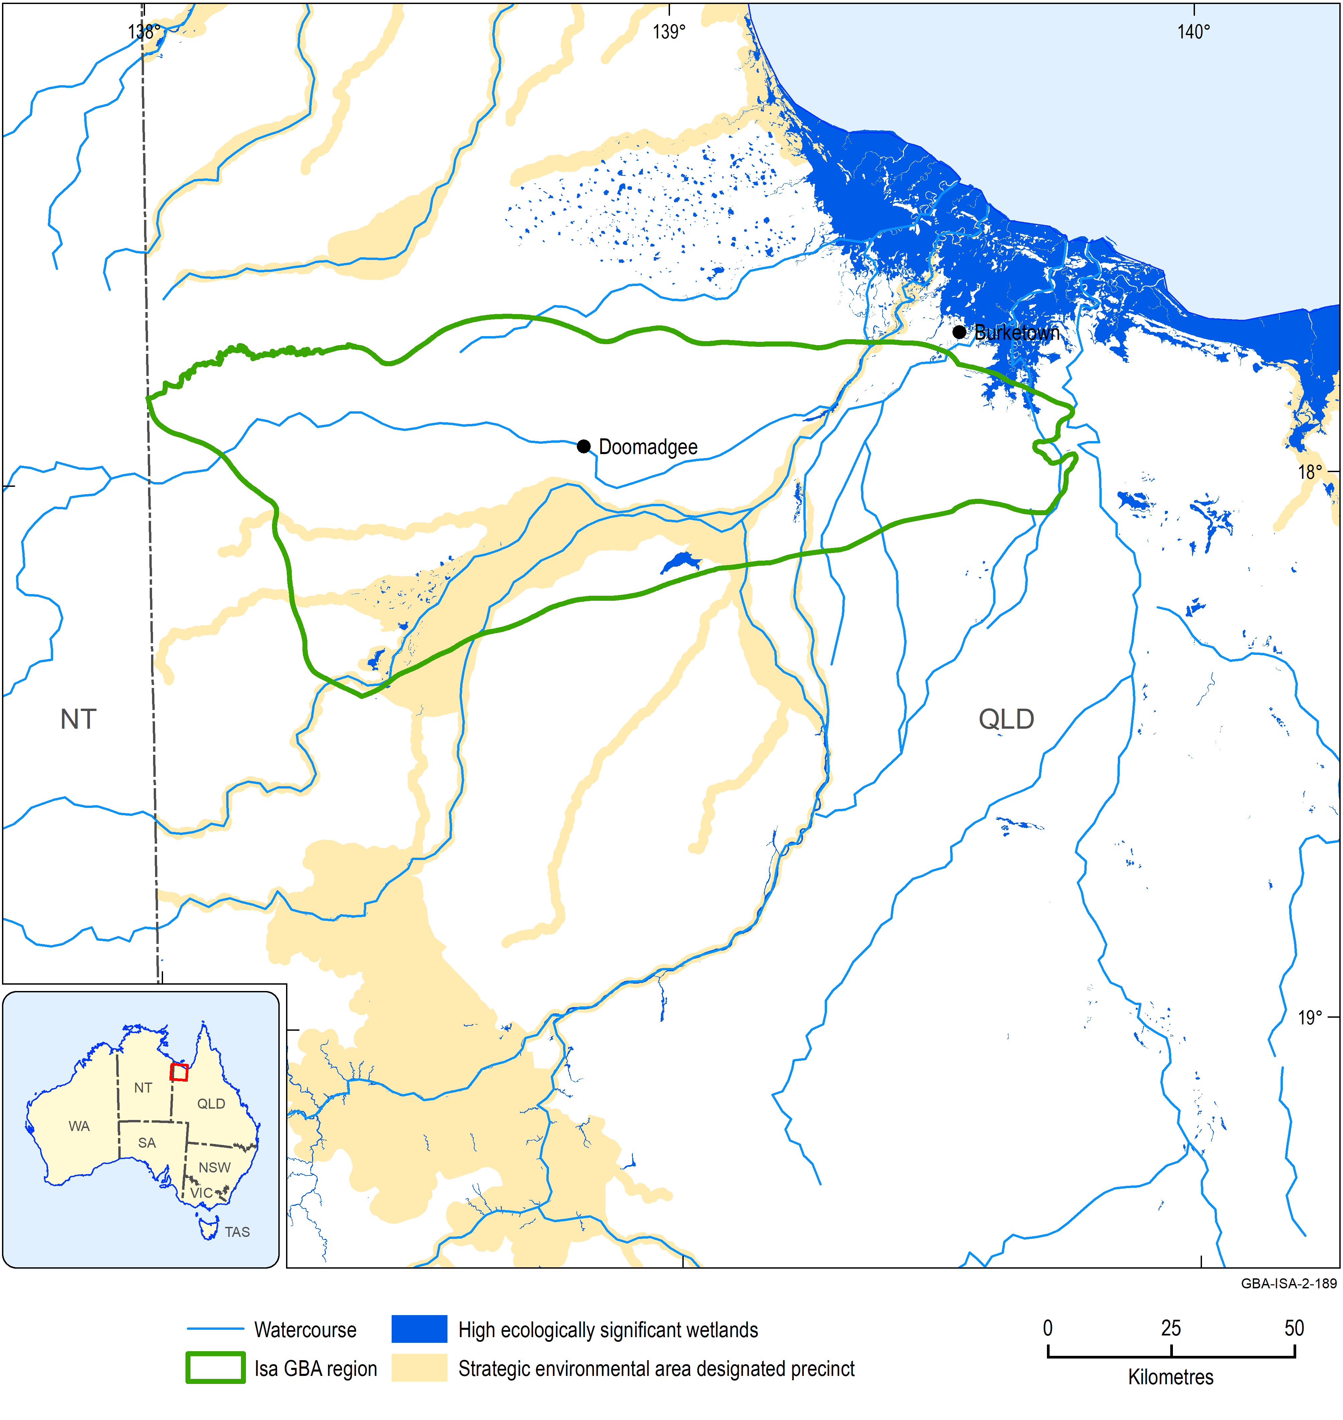
Figure 28 The Gulf Rivers strategic environmental area and high ecological significance wetlands
Data: State of Queensland (Department of State Development‚ Manufacturing‚ Infrastructure and Planning) (2019); Department of Environment and Science (Qld) (2019)
Element: GBA-ISA-2-189

‘Endangered’ and ‘of concern’ regional ecosystems
The Queensland Government uses the biodiversity status of remnant vegetation for land management under the Vegetation Management Act 1999 to determine environmentally sensitive areas in the mining regulation context under provisions in the Environmental Protection Act 1994. The biodiversity status has four classes (Queensland Government, 2017):
- Endangered, which relates to the amount of vegetation relative to its pre-clearing extent (less than 10%), patch size (10,000 ha, 10 to 30% of pre-clearing extent), degradation, biodiversity loss, rarity and exposure to a threatening process
- Of concern, which relates to 10 to 30% of pre-clearing vegetation extent, patch size (10,000 ha, more than 30% pre-clearing) or degradation/biodiversity loss affects 70 to 90% of pre-clearing extent
- Least concern, which is vegetation above 10,000 ha patch size and is over 30% of its pre-clearing extent
- No concern at present, which includes all remnants that are not subject to the degradation criteria defined under endangered or of concern.
There are 65 regional ecosystems in the Isa GBA region, of which one is ‘Endangered’ (1.3.7), 27 are ‘Of concern’ and the remainder ‘No concern at present’. The relevant ‘Endangered’ and ‘Of concern’ regional ecosystems are described in Table 3.
Table 3 Regional ecosystems that are ‘Endangered’ or ‘Of concern’ in the Isa GBA region
Regional ecosystem | Description
1.3.7¹ | Eucalyptus camaldulensis woodland on channels and levees
1.10.2 | Eucalyptus miniata woodland on sandstone plateaus
1.10.6 | Springs mostly associated with quartzose sandstone
1.10.9 | Acacia spp. and/or Calytrix exstipulata open shrubland on rock pavement
1.3.12 | Terminalia bursarina open woodland on recent levees
1.3.9 | Forest or woodland fringing perennial watercourses and on associated alluvium
1.5.10 | Mixed shrubland on older sandy alluvium
2.3.12 | Eucalyptus microtheca and/or Excoecaria parvifolia open woodland on seasonally flooded plains/depressions with numerous distributary channels
2.3.13 | Acacia stenophylla low open forest in seasonal swamps on active Quaternary alluvial plains
2.3.15 | Eucalyptus microtheca woodland to low open woodland with Sarga spp. in seasonally flooded depressions on gleyed podsolics
2.3.16 | Billabongs (abandoned channels) on active Quaternary alluvial plains, fringed with Eucalyptus spp., Corymbia spp., and Melaleuca spp.
2.3.17 | Eucalyptus microtheca +/- Excoecaria parvifolia, Lysiphyllum cunninghamii, Atalaya hemiglauca woodland fringing channels in fine-textured alluvial systems
2.3.18 | Atalaya hemiglauca, Grevillea striata, Vachellia sutherlandii and Eucalyptus microtheca in mixed low woodlands on active Quaternary alluvial plains
2.3.19 | Eucalyptus tectifica +/- Corymbia confertiflora woodland on old alluvial plains (recent Pleistocene surface)
2.3.20 | Corymbia bella, Eucalyptus pruinosa, C. terminalis, Lysiphyllum cunninghamii in mixed woodlands on active levees and alluvial plains in the west
2.3.26 | Eucalyptus camaldulensis +/- Melaleuca spp. woodland fringing sandy, seasonal channels
2.3.42 | Eucalyptus microtheca +/- Excoecaria parvifolia, Lysiphyllum cunninghamii, Melaleuca spp. open woodland on Quaternary alluvial plains with coarse-grained parent material
2.3.5 | Lysiphyllum cunninghamii woodland on plains of calcareous clays
2.3.50 | Waterholes, bare sand and rock in the channels of major watercourses
2.3.52 | Melaleuca spp., Eucalyptus camaldulensis, Lophostemon grandiflorus and Livistona rigida in mixed woodlands fringing major spring-fed watercourses
2.3.58 | Eriachne glauca var. glauca, Oryza australiensis and Eulalia aurea tussock grassland in shallow alluvial depressions in the Doomadgee Plains subregion
2.3.59 | Excoecaria parvifolia, Melaleuca spp., Grevillea striata and Hakea pedunculata in mixed tall open shrublands on coastal alluvial surfaces
2.3.62 | Eucalyptus camaldulensis +/- Corymbia polycarpa, Melaleuca viridiflora woodland on abandoned stream channels and upper drainage areas in lateritic landscapes
2.3.63 | Eucalyptus microtheca +/- Excoecaria parvifolia, Atalaya hemiglauca woodland on scroll plains associated with meanders of major watercourses
2.3.69 | Dichanthium spp., Iseilema spp., Aristida spp. and Brachyachne convergens in mixed tussock grasslands on active Quaternary alluvial deposits derived from coarse-grained parent material in the west
2.3.70 | Eucalyptus pruinosa low woodland on old alluvial plains (recent Pleistocene surface)
2.4.5 | Atalaya hemiglauca, Grevillea striata, Acacia victoriae and Vachellia sutherlandii in mixed low open woodlands on Tertiary clay plains
2.5.27 | Acacia torulosa, Corymbia setosa and A. platycarpa in mixed tall shrublands on degraded residuals of inland sand dunes
¹Endangered. All others ecosystems listed here are ‘Of Concern’
Data: Queensland Herbarium (2018)

State-listed threatened species
The process of identifying species in the Isa GBA region used published WildNet wildlife records, which is a Queensland-vetted dataset to remove errors and confidential records (to protect sensitive species) and has an accuracy of at least 10 km (Department of Environment and Science (Qld), 2018a).
There are two birds and one plant (Solanum carduiforme) species listed under Queensland legislation that occur in the Isa GBA region (Table 4) which are not listed as threatened nationally. The oriental pratincole (Glareola maldivarum) is a matter of national environmental significance being listed as migratory under the EPBC Act.
Table 4 Queensland threatened species identified in the Isa GBA region from WildNet data
Taxon | Scientific name | Common name | Conservation status | EPBC status
Birds | Glareola maldivarum | Oriental pratincole | Special least concern | Migratory
Birds | Malurus coronatus | Purple-crowned fairy-wren | Vulnerable | Not listed
Plants | Solanum carduiforme | NA | Vulnerable | Not listed
Data: Department of Environment and Science (Qld) (2018a)

High ecological significance wetlands and high ecological value waters
There are no high ecological value waters in the Isa GBA region. The 77 km² of high ecological value wetlands (Department of Environment and Science (Qld), 2019) (Figure 28) correspond closely to the distribution of nationally important wetlands (Figure 27).

Cultural heritage areas
There are no state-listed cultural heritage areas in the Isa GBA region.

Nationally important wetlands
In addition to matters of national and state environmental significance, the GBA Program also considers nationally important (DIWA) wetlands. In the Isa GBA region, there are four nationally important wetlands with a total combined area of 612km2 listed in the directory of important wetlands database (Department of the Environment and Energy, 2010). These overlap in large part with some of the Queensland MSES (Figure 27). The four DIWA wetlands are Bluebush Swamp (8.8 km2), Musselbrook Creek Aggregation (389.1 km2), Nicholson Delta Aggregation (167.5 km2) and the Southern Gulf Aggregation (46.5 km2).

Groundwater-dependent ecosystems
In addition to matters of national and state environmental significance, the GBA Program also considers groundwater-dependent ecosystems (GDE). The Isa GBA region contains many GDEs that shale gas development may impact and that may fall outside the matters of national and state environmental significance outlined above. The Queensland GDE mapping for example identifies surface expression GDEs located near Lawn Hill in the south-west of the region. These are part of the Boodjamulla complex, which is located outside of the region, but is potentially hydrologically connected (Figure 27). Further, Figure 43 in the hydrogeology technical appendix shows the location of known and potential GDEs (as mapped using the Bureau of Meteorology’s GDE Atlas dataset) including springs that shale gas resource development may impact (Buchanan et al., 2020).

Cultural baseline synthesis
Australian Fossil Mammal Sites (Riversleigh) is both a world heritage property (listed in 1994) and a national heritage place (listed in 2007). It is not within the Isa GBA region; however, it is nearby within the broader area of hydrocarbon potential (Figure 29). It is in north-western Queensland close to the NT border, about 250 km north-west of Mount Isa and 200 km south of the Gulf of Carpentaria.
The Australian Fossil Mammal Sites (Riversleigh) possesses an outstanding collection of Australia’s mammal fauna from the Oligocene to the Miocene (approximately 10 to 30 million years ago). The site records a changing fauna as the environment transitioned from moist lowland rainforest to dry eucalypt forest and woodland.
The Riversleigh site is important also for its human history. The Traditional Owners, the Waanyi people, continue to live in the region. Significant sites for rock art, middens, and artefacts and other important areas occur in the region.
Australian Fossil Mammal Sites (Riversleigh) is managed with the assistance of the Riversleigh Management Strategy (Queensland Environmental Protection Agency et al., 2002). A Riversleigh Community and Scientific Advisory Committee has been established, with representation from the scientific community including the Queensland Museum; the tourism sector; Waanyi Traditional Owners; and local, Queensland and Australian governments. In addition, a Waanyi Advisory Committee provides advice on Indigenous issues.
Apart from the Riversleigh area, the entire Isa GBA region has supported Indigenous cultures for many thousands of years. Indigenous people continue to maintain a strong and ongoing connection to the region.
Cultural assets listed by the EPBC Act were identified in two EPBC Act protected matters database searches (one for the Isa GBA region and the other for the area of hydrocarbon potential) undertaken on 24 August 2018.
No places were identified within the Isa GBA region from the Queensland Heritage Register.
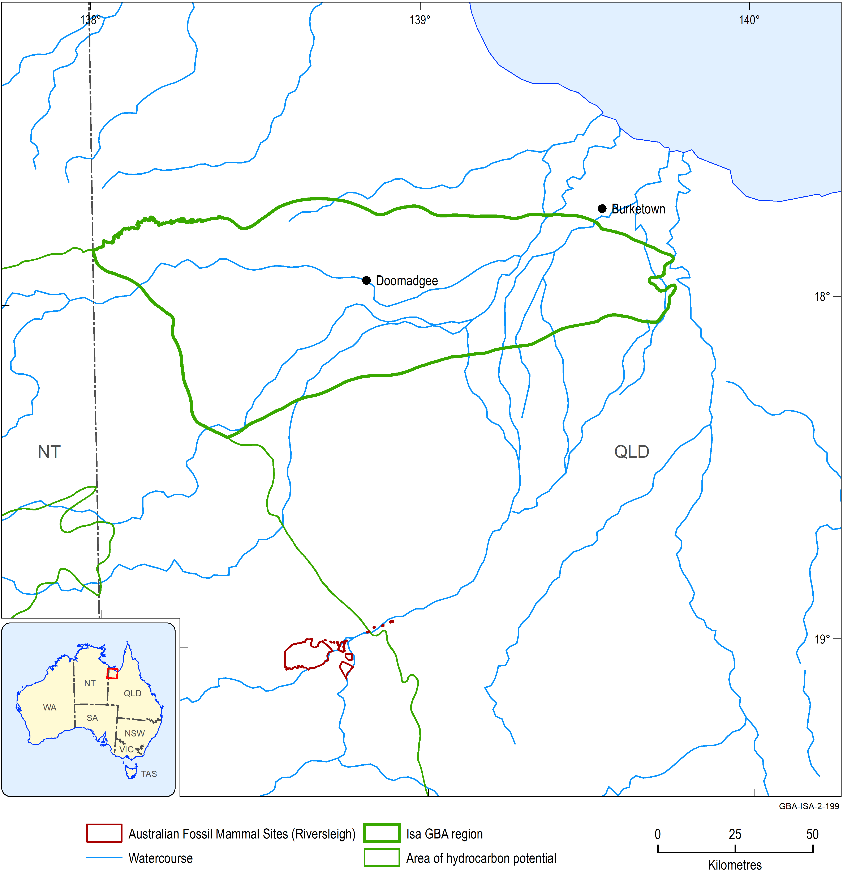
Figure 29 Cultural assets near the Isa GBA region
Data: Department of the Environment and Energy (2008)
Element: GBA-ISA-2-199

Landscape classification and ecohydrological conceptualisation
Conceptually, landscape classes can be considered as bundles of ecosystem assets (Bureau of Meteorology, 2013; United Nations et al., 2014) that produce a flow of ecosystem services that provide benefit to humanity. Landscape classification aims to:
- reduce ecosystem and landscape complexity to a limited number of regional-scale landscape classes that are mutually exclusive and comprehensive
- guide the development and review of conceptual models, including their spatial and temporal scope
- where possible, use existing data sources and existing classifications or typologies
- provide a natural aggregation for reporting potential impacts
- be applicable to data-poor regions.
Inputs into the landscape classification were based on existing classification schemes wherever possible and can be purely physical, biological or predictive (Linke et al., 2011). Choice of approach depends on the availability of data at an appropriate scale, as well as the expertise and resources for undertaking the assessment. Landscape classifications should be credible, transparent, logical and consistently applied and, where possible, match other classifications (or at least some of their classes).
The landscape classification developed for the Isa GBA region is based on Queensland Land Zones (Wilson and Taylor, 2012). Consistent with the principles outlined above, it sought to use existing data sources and classifications, and to leverage the extensive effort already expended to develop highly relevant conceptual models at both landscape and wetland scales by the Queensland Government as part of its Wetlands Program (Queensland Government, 2013).
Detailed land zones within the Isa GBA region were supplied by the Queensland Government (State of Queensland (Department of Environment and Science), 2018) and assigned to corresponding landscape classes (Figure 30). The main land zones in the Isa GBA region are described in Table 5, with the relationship between land zones and the GBA landscape classification developed in Table 6. Landscapes in the Isa GBA region can also be classified using the Interim Biogeographic Regionalisation of Australia (IBRA) (Table 7 and Figure 31).

Table 5 Land zones (Queensland) in the Isa GBA region
Name | Detailed description
Deposits subject to periodic tidal inundation | Quaternary estuarine and marine deposits subject to periodic inundation by marine waters. Includes mangroves, saltpans, offshore tidal flats and tidal beaches. Soils are predominantly Hydrosols (saline muds, clays and sands) or beach sand.
Recent Quaternary alluvial systems | Recent Quaternary alluvial systems, including closed depressions, paleo-estuarine deposits currently under freshwater influence, inland lakes and associated wave-built lunettes. Excludes colluvial deposits such as talus slopes and pediments. Includes a diverse range of soils, predominantly Vertosols and Sodosols; also with Dermosols, Kurosols, Chromosols, Kandosols, Tenosols, Rudosols and Hydrosols; and Organosols in high rainfall areas.
Tertiary-early Quaternary clay deposits | Tertiary-early Quaternary clay deposits, usually forming level to gently undulating plains not related to recent Quaternary alluvial systems. Excludes clay plains formed in-situ on bedrock. Mainly Vertosols with gilgai microrelief but includes thin sandy or loamy surfaced Sodosols and Chromosols with the same paleo-clay subsoil deposits.
Tertiary-early Quaternary loamy and sandy plains and plateaus | Tertiary-early Quaternary extensive, uniform near-level or gently undulating plains with sandy or loamy soils. Includes dissected remnants of these surfaces. Also includes plains with sandy or loamy soils of uncertain origin, and plateau remnants with moderate to deep soils usually overlying duricrust. Excludes recent Quaternary alluvial systems, exposed duricrust, and soils derived from underlying bedrock. Soils are usually Tenosols and Kandosols, also minor deep sandy-surfaced Sodosols and Chromosols. There may be a duricrust at depth.
Cainozoic duricrusts | Cainozoic duricrusts formed on a variety of rock types, usually forming mesas or scarps. Includes exposed ferruginous, siliceous or mottled horizons and associated talus and colluvium, and remnants of these features. Soils are usually shallow Rudosols and Tenosols, with minor Sodosols and Chromosols on associated pediments, and shallow Kandosols on plateau margins and larger mesas.
Fine-grained sedimentary rocks | Fine-grained sedimentary rocks, generally with little or no deformation and usually forming undulating landscapes. Siltstones, mudstones, shales, calcareous sediments, and labile sandstones are typical rock types although minor interbedded volcanics may occur. Includes a diverse range of fine-textured soils of moderate to high fertility, predominantly Vertosols, Sodosols, and Chromosols.
Coarse-grained sedimentary rocks | Medium- to coarse-grained sedimentary rocks, with little or no deformation, forming plateaus, benches and scarps. Includes siliceous (quartzose) sandstones, conglomerates and minor interbedded volcanics, and springs associated with these rocks. Excludes overlying Cainozoic sand deposits. Soils are predominantly shallow Rudosols and Tenosols of low fertility, but include sandy-surfaced Kandosols, Kurosols, Sodosols and Chromosols.
Metamorphic rocks | Metamorphosed rocks, forming ranges, hills and lowlands. Primarily lower Permian and older sedimentary formations which are generally moderately to strongly deformed. Includes low- to high-grade and contact metamorphics such as phyllites, slates, gneisses of indeterminate origin and serpentinite, and interbedded volcanics. Soils are mainly shallow, gravelly Rudosols and Tenosols, with Sodosols and Chromosols on lower slopes and gently undulating areas. Soils are typically of low to moderate fertility.
Mesozoic to Proterozoic igneous rocks | Mesozoic to Proterozoic igneous rocks, forming ranges, hills and lowlands. Acid, intermediate and basic intrusive and volcanic rocks such as granites, granodiorites, gabbros, dolerites, andesites and rhyolites, as well as minor areas of associated interbedded sediments. Excludes serpentinites and younger igneous rocks. Soils are mainly Tenosols on steeper slopes with Chromosols and Sodosols on lower slopes and gently undulating areas. Soils are typically of low to moderate fertility.
Source: adapted from Wilson and Taylor (2012)
Table 6 Landscape classes within the Isa GBA region and corresponding Queensland Land Zones
Landscape class (GBA) | Land Zones (Queensland)ª | Area  (km2) | % of total GBA region
Floodplain and alluvium | Recent Quaternary alluvial systems | 2925 | 36
Loamy and sandy plains | Tertiary-early Quaternary loamy and sandy plains and plateaus | 2689 | 33
Clay plains | Tertiary-early Quaternary clay deposits | 1218 | 15
Tablelands and duricrusts | Cainozoic duricrusts | 1000 | 12
Hills and lowlands on metamorphic rocks | Metamorphic rocks | 190 | 2.3
Undulating country on fine-grained sedimentary rocks | Fine-grained sedimentary rocks | 117 | 1.4
Sandstone ranges | Coarse-grained sedimentary rocks | 58 | 0.7
Tidal flats and beaches | Deposits subject to periodic tidal inundation | 23 | 0.3
Hills and lowlands on granitic rocks | Mesozoic to Proterozoic igneous rocks | 3 | 0.04
Total |  | 8223 | 100
The springs landscape class is not listed in this table, see Section 3.1.10.
ª Typology and punctuation are consistent with Queensland Land Zones (Wilson and Taylor, 2012) who refer to Cainozoic and Tertiary-aged sediments.
Dataset: Geological and Bioregional Assessment Program (2018)
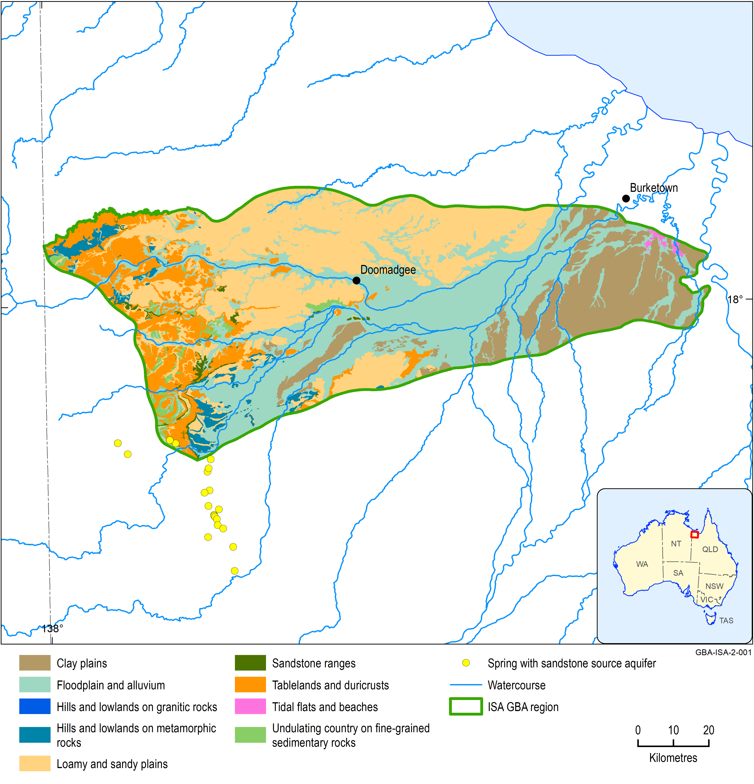
Figure 30 Landscape classes within the Isa GBA region
Data: Geological and Bioregional Assessment Program (2018)
Element: GBA-ISA-2-001
The total area of landscape classes in the Isa GBA region is 8223 km2 (Table 6). It is dominated by floodplain and alluvium (2925 km2) associated with the Albert and Nicholson rivers on the Doomadgee Plains and Armraynald Plains (Figure 30), as well as loamy and sandy plains (2689 km2) on the Doomadgee Plains. There are substantial areas of clay plains (1218 km2) in the east of the Isa GBA region on the Armraynald Plains. The tablelands and duricrusts (1000 km2) in the west of the Isa GBA region intersect the McArthur IBRA subregion (Figure 31) of the North-west Highlands. There are also smaller areas of undulating country on sedimentary rocks (175 km2), hills and lowlands on metamorphic rocks (190 km2) and hills and lowlands on granitic rocks (3 km2) associated with the McArthur IBRA subregion. There are 23 km2 of tidal flats and beaches in the extreme north-east of the Isa GBA region associated with the upper reaches of Saltwater Arm River overlying the Karumba Plains IBRA subregion (Figure 31).
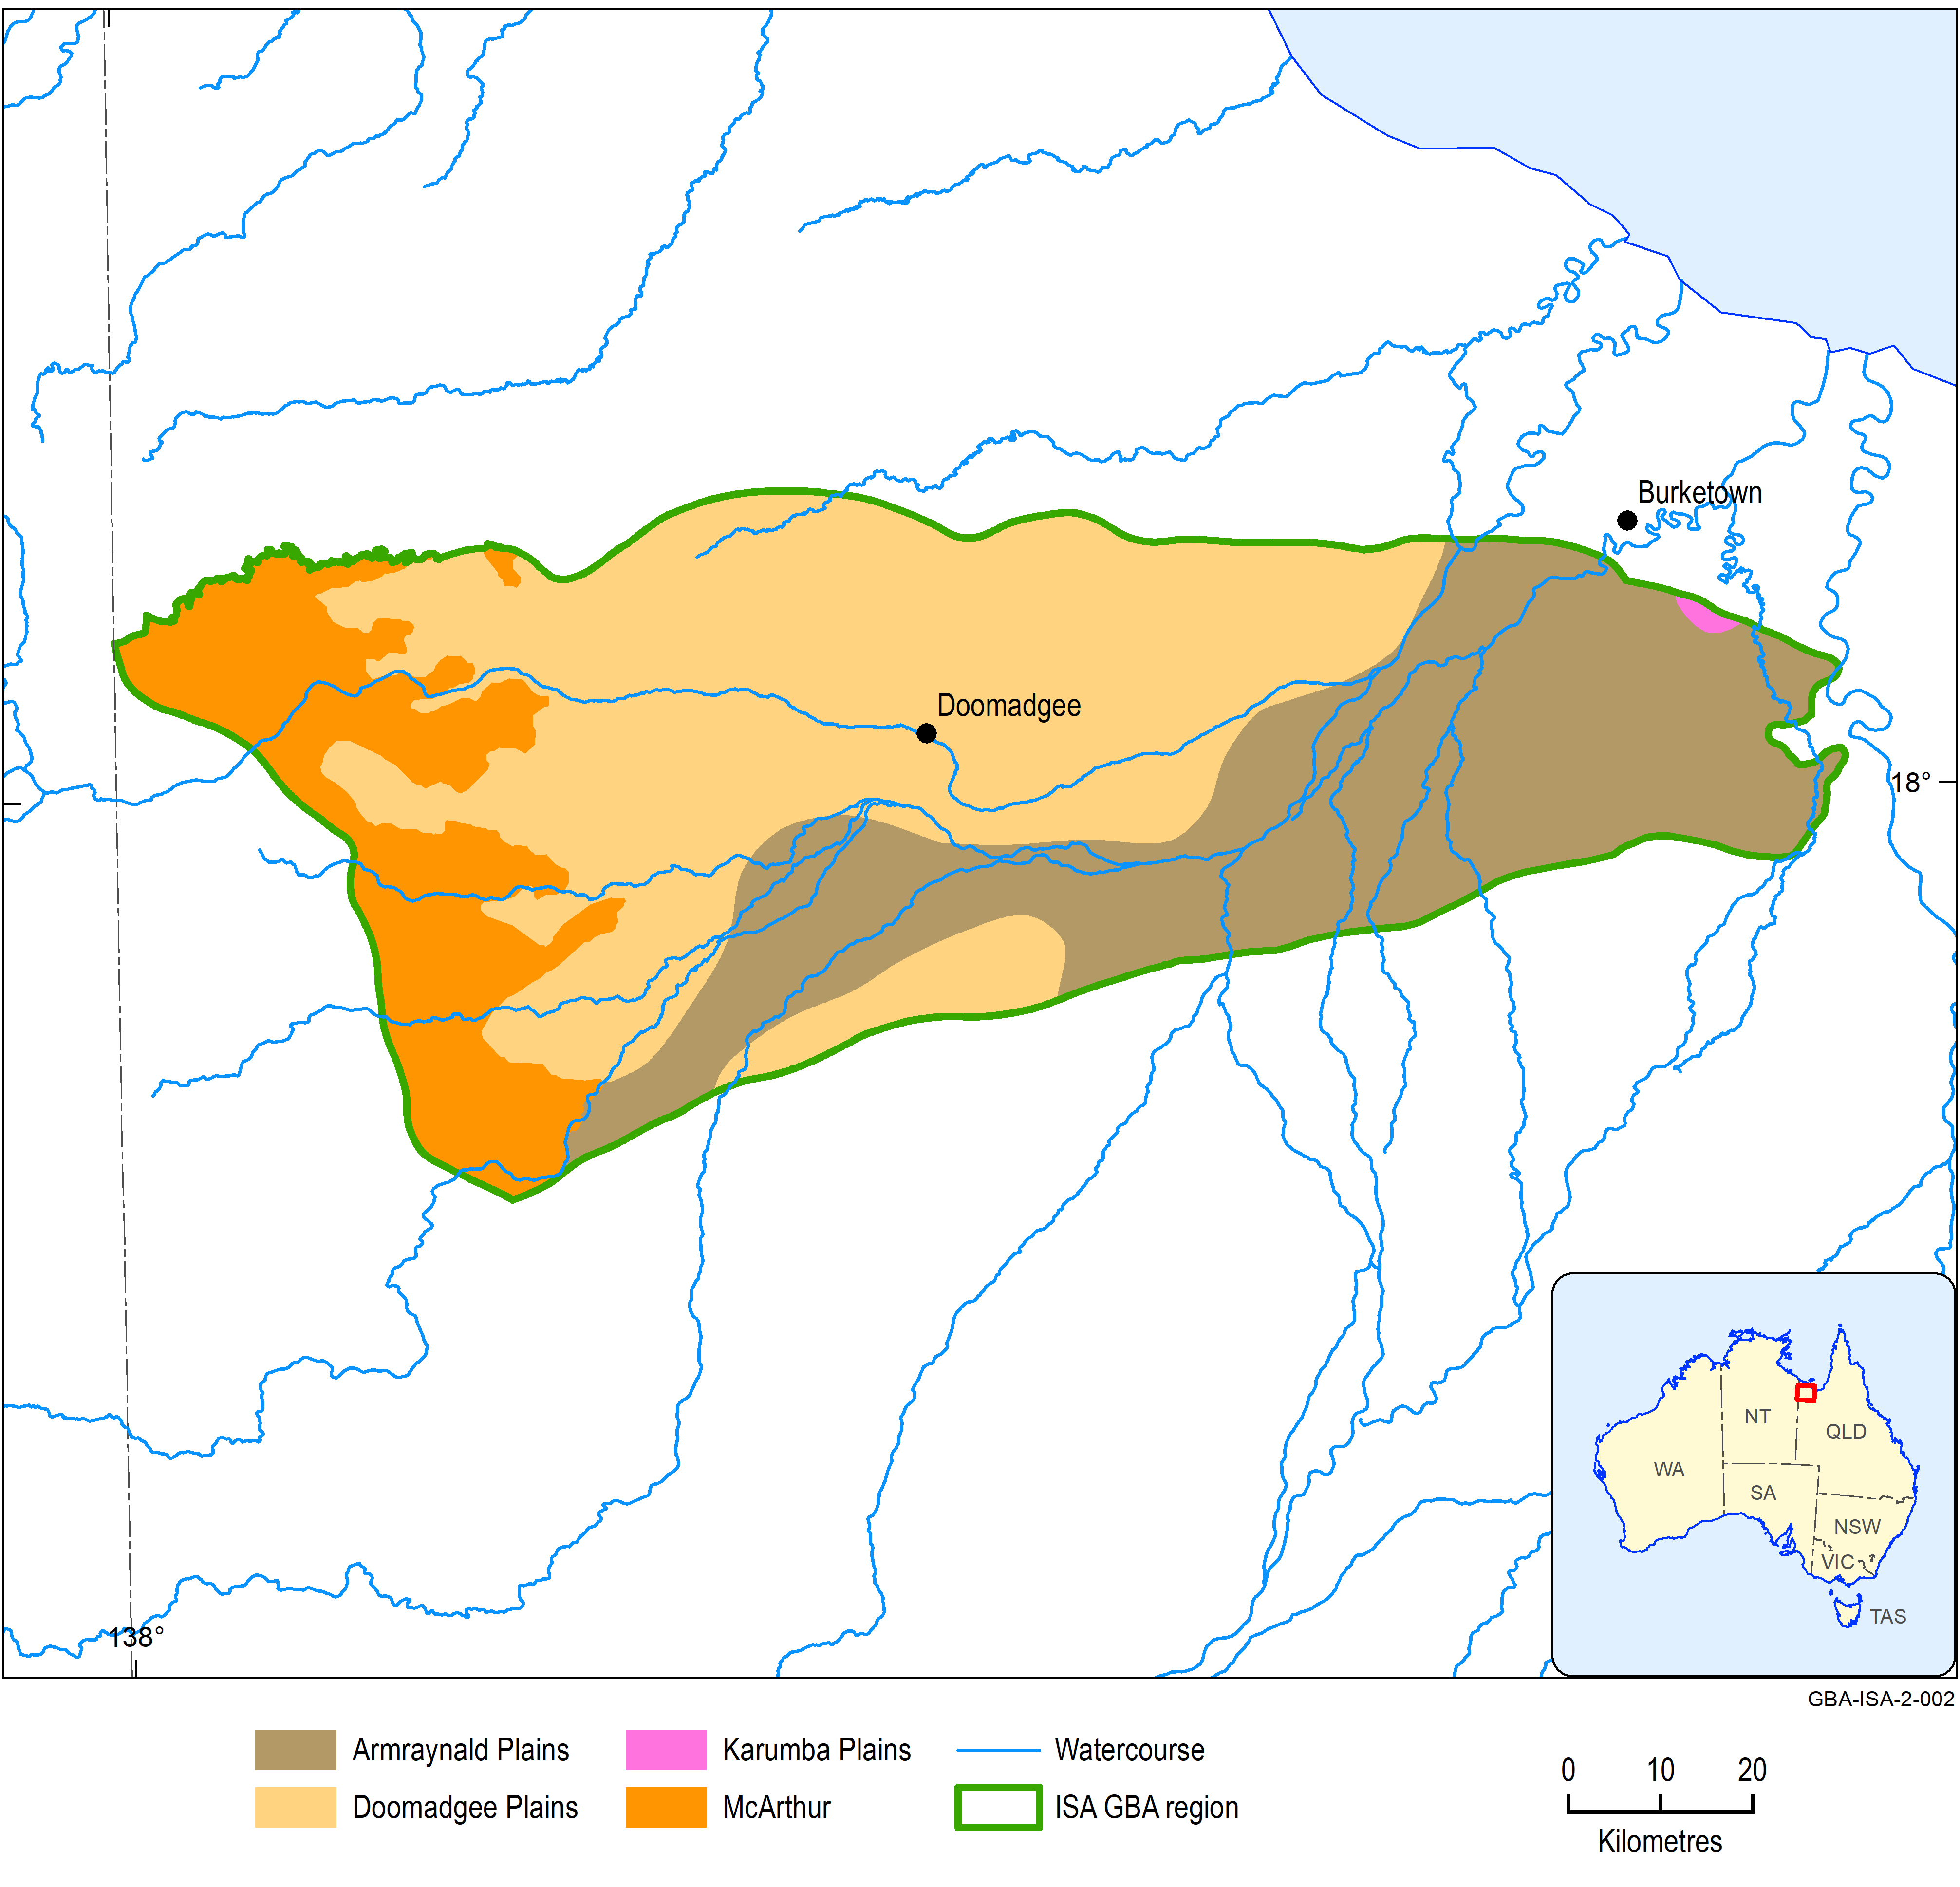
Figure 31 Interim Biogeographic Regionalisation for Australia (IBRA) subregions within the Isa GBA region
Source: Department of the Environment and Energy (2018b)
Element: GBA-ISA-2-002

Table 7 Interim Biogeographic Regionalisation for Australia (IBRA) subregions in the Isa GBA region
IBRA subregion | Description | Area in Isa GBA region  (km²)
Doomadgee Plains | Doomadgee Plains subregion, in the Gulf Plains IBRA region, lies in the far north-western corner of the Gulf Plains bioregion, and extends into the NT. These lowlands extend between the Northwest Highlands and the Karumba Plains north of the Nicholson River, but remnants of the surface continue around the north-eastern margin of the Highlands as far as the Leichhardt River. The subregion is characterised by laterised Tertiary surfaces that have been partly overlain by sandy outwash from the adjacent ranges. | 4014
Armraynald Plains | Armraynald Plains subregion, in the Gulf Plains IBRA region, contains the extensive grasslands and low open grassy woodlands on the clay plains associated with the major rivers entering the southern Gulf. The subregion is dominated by clay plains, with extensive, older and higher plains channelled by younger braided watercourses. Seasonal and permanent wetlands are associated with the watercourses and back plains, and near the coast where the alluvia meet the marine plains. There are also areas of sandier alluvium, especially where major watercourses enter the Gulf Plains from the Northwest Highlands. Small areas of sand sheet overlie the clays, usually as outliers of adjacent provinces. In the far west, there are low hills that are outliers of the Mount Isa Inlier province of the Northwest Highlands. | 2839
McArthur | McArthur subregion, in the Gulf Fall and Uplands IBRA region, is composed almost entirely of low hills and plateaus on gently deformed pre-Cambrian sedimentary rocks, overlain in places by Mesozoic sedimentary rocks of the Carpentaria Basin forming residual plateaus and scarps. Folded pre-Cambrian rocks underlie most of the subregion, and outcrop mainly along its eastern margin. These low hills are essentially outliers of the Mount Isa Inlier subregion. Sandy alluvium is common along the larger watercourses. Sandstone areas sometimes contain springs and other areas of permanent or near-permanent water. This is a remote subregion and its biology is poorly known. It drains largely into the Nicholson River and the lower reaches of Lawn Hill Creek, and then into the Gulf of Carpentaria. | 1354
Karumba Plains | Karumba Plains subregion, in the Gulf Plains IBRA region, contains all areas subject to coastal influences including dunes, saline mudflats and mangrove-lined estuaries. It extends around the entire seaward margin of the Gulf Plains bioregion. The major watercourses of the Gulf Plains bioregion have their headwaters in four other bioregions. The estuaries of these large and diverse river systems are contained within the Karumba Plains subregion. Between these estuaries are the most extensive marine plains in Australia. Sand dunes are prominent throughout, but particularly in the west, and north of Karumba. The marine plains receive runoff from adjacent subregions. | 16
Total area |  | 8223
Source: Department of the Environment and Energy (2018b), after Sattler and Williams (1999)

Description of landscape classes

Floodplain and alluvium
Floodplain and alluvium, associated with the Albert and Nicholson rivers on the Doomadgee and, especially, the Armraynald Plains IBRA subregion, are prevalent in the Isa GBA region (2925 km²). Young, braided watercourses pass through the old clay, loamy and sandy plains. These and the back plains are associated with seasonal and permanent wetlands (Morgan, 1999).
Floodplain and alluvium comprise a variety of landforms including, but not limited to, fans, plains, flats, banks, benches, bars, channels and streams, depressions, lakes, playa, swamps and terraces (Wilson and Taylor, 2012). In all these landforms, there may be frequent active erosion and aggradation by channelled and overbank streamflow, or the landforms may be relicts from these processes (National Committee on Soil and Terrain, 2009).
Floodplain and alluvium landforms are mostly flat to gently undulating with levees, bars, streambeds and banks creating minor local relief (Wilson and Taylor, 2012). Soils are very diverse and are dominated by Vertosols and Sodosols but include a range of other soils. They are usually fertile and may have been cleared or developed for agriculture or pastoralism. Riparian vegetation adjacent to watercourses is generally more biodiverse than that of the surrounding landscape and is commonly denser due to greater water availability.
The floodplain and alluvium landscape class is associated with many wetlands classified within Queensland’s Regional Ecosystem Framework (Nelder et al., 2017) as either ‘Floodplain (other than floodplain wetlands)’, ‘Frequently inundated areas (not wetlands or floodplains)’, ‘Palustrine wetland (e.g. vegetated swamp)’, or ‘Riverine wetland or fringing riverine wetland’.
Dominant regional ecosystems that contain wetlands include E. microtheca +/- Excoecaria parvifolia, Atalaya hemiglauca, Grevillea striata low woodland on active Quaternary alluvial plains with cracking clay soils, Eulalia aurea, Panicum decompositum, Astrebla pectinata and Dichanthium spp. in mixed tussock grasslands on active Quaternary alluvial plains within Tertiary clay deposits, Corymbia bella, E. pruinosa, C. terminalis, Lysiphyllum cunninghamii in mixed woodlands on active levees and alluvial plains in the west, and E. microtheca +/- Excoecaria parvifolia, Lysiphyllum cunninghamii, Melaleuca spp. open woodland on Quaternary alluvial plains with coarse-grained parent material.
This landscape class (Figure 32) is represented by the ‘alluvium’ conceptual model (Queensland Government, 2017a).
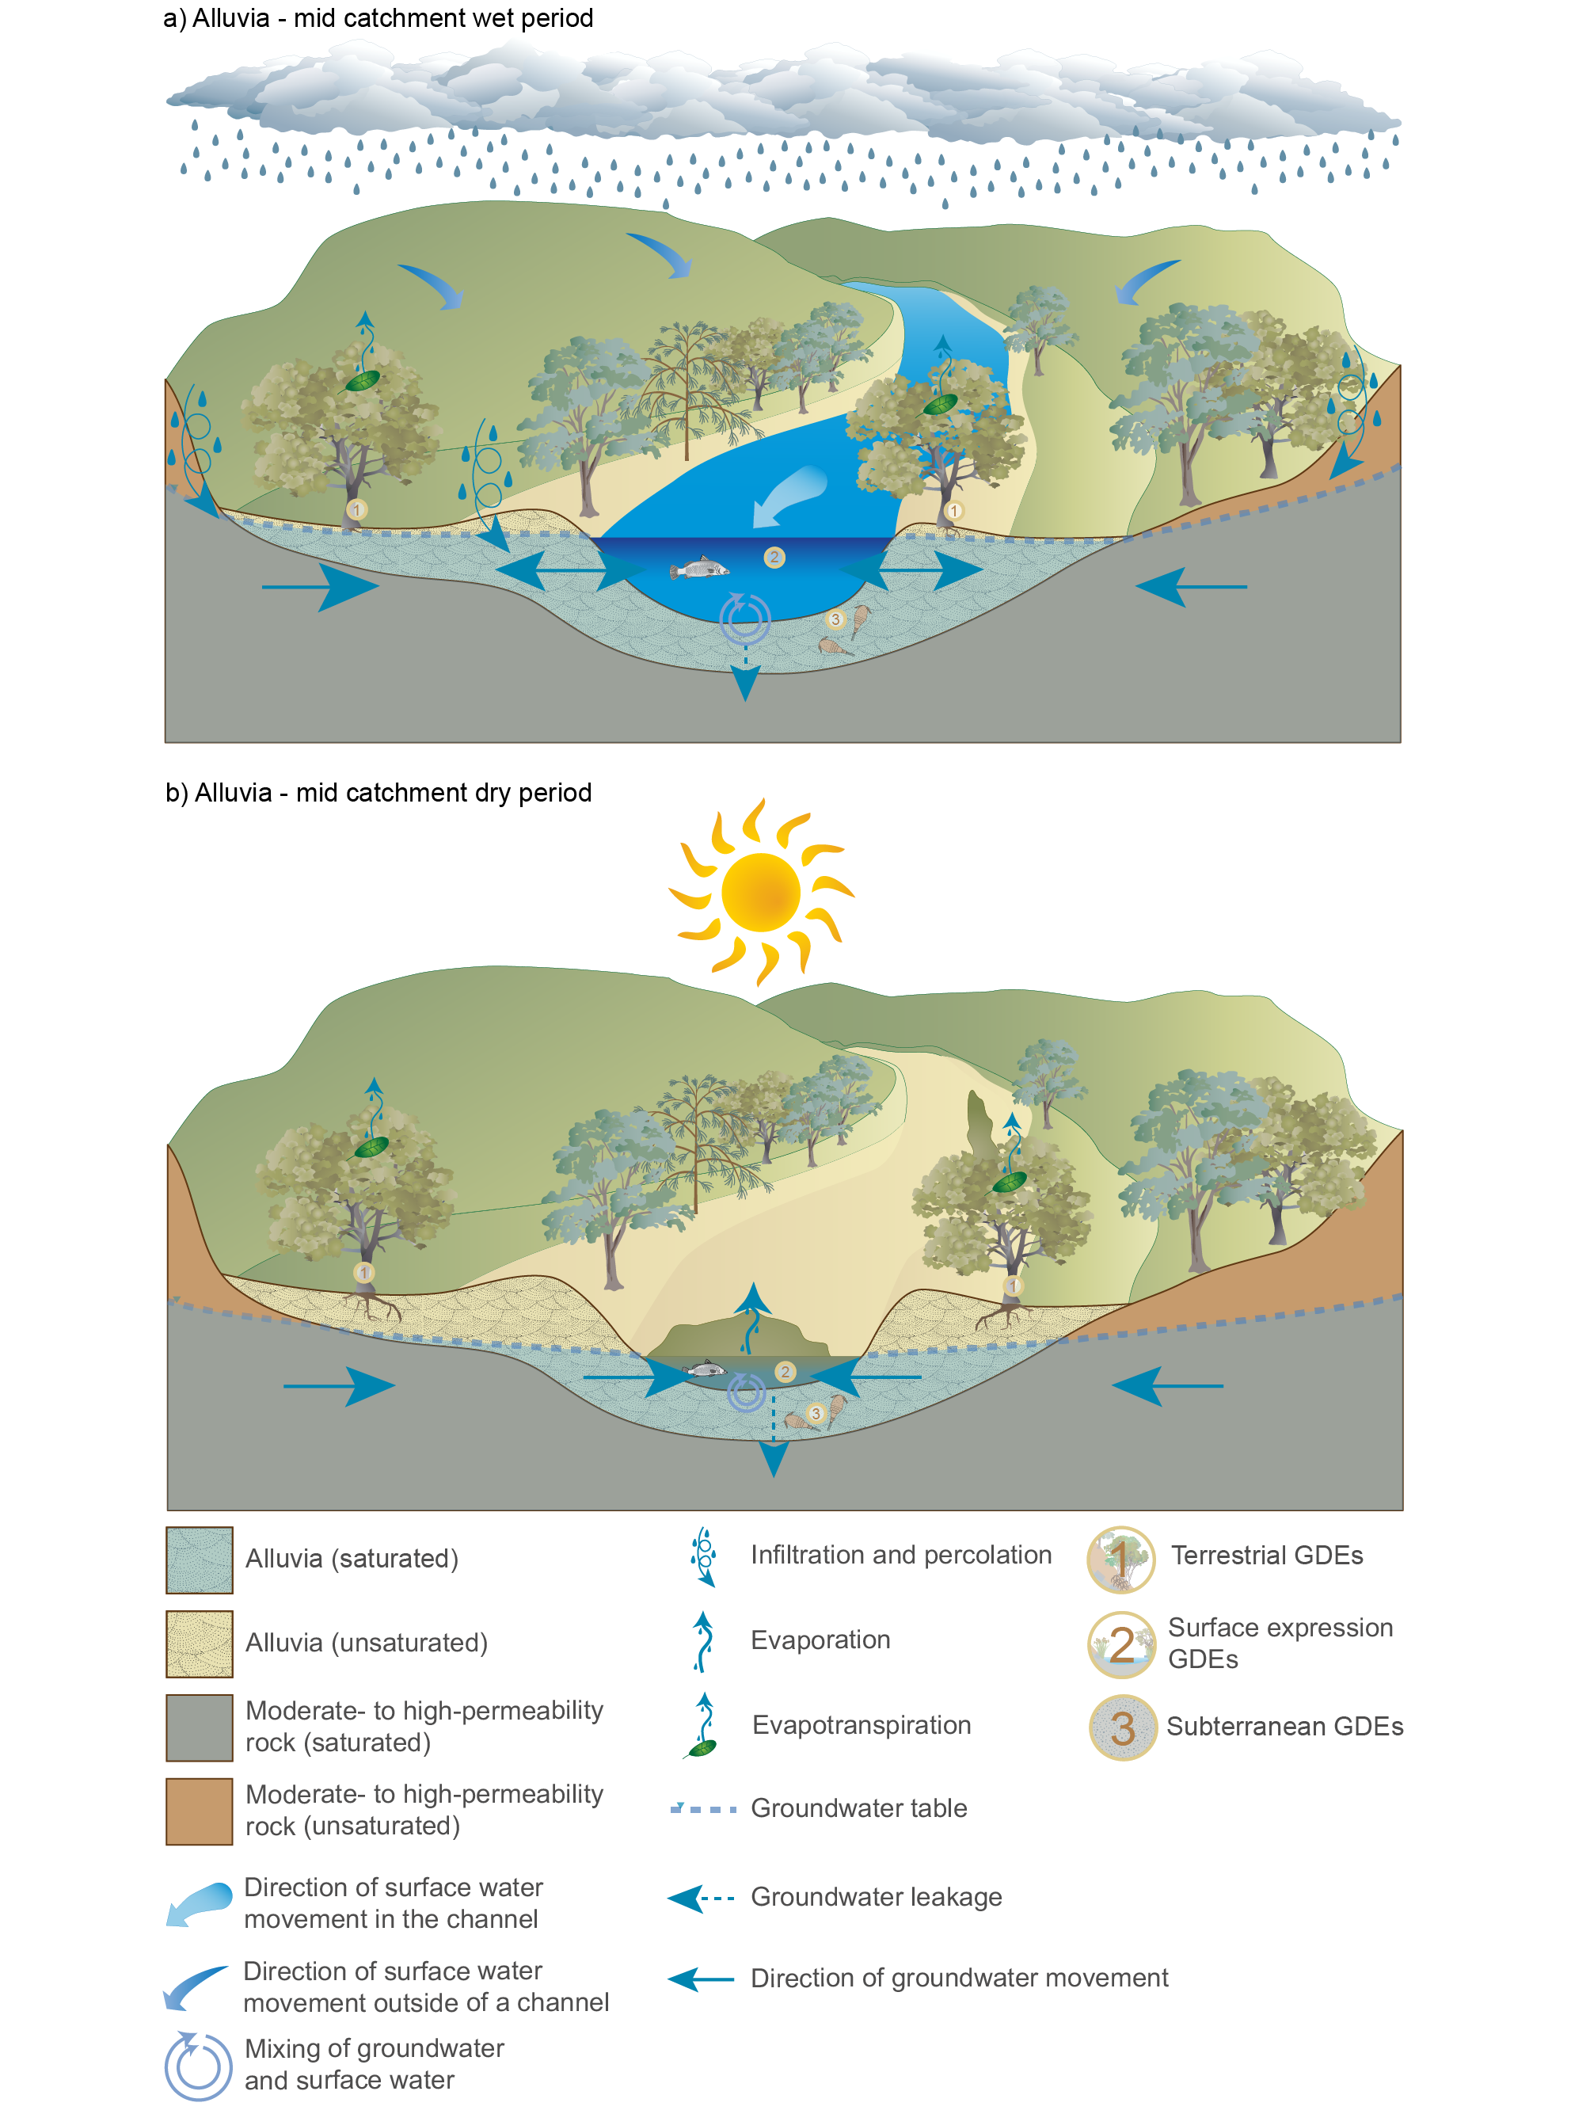
Figure 32 Floodplain and alluvium conceptual models showing dry-season and wet-season phases
Source: Adapted from the alluvia–mid-catchment conceptual model (Queensland Government, 2017a)
Element: GBA-ISA-2-190

Loamy and sandy plains
There are extensive areas (2689 km2) of loamy and sandy plains within the Isa GBA region, mainly associated with the Doomadgee Plain IBRA subregion, which is characterised by laterised Tertiary surfaces that have been partly overlain by sandy outwash from the adjacent ranges (Figure 30).
Loamy and sandy plains may be formed by redeposition of colluvium or be formed in-situ from ‘old’ alluvial processes (Wilson and Taylor, 2012). They may also result from prolonged, intense, deep weathering of parent rock material high in iron and/or aluminium oxides and kaolin clays. Landforms are flat to gently undulating plains, plateaus and dissected tablelands. A variety of regional ecosystems exist within this landscape class, depending on local climate and soil factors, but the major regional ecosystems (Queensland Government, 2017b) are Eucalyptus pruinosa, Lysiphyllum cunninghamii, E. chlorophylla and Corymbia setosa in mixed low open woodlands, and Melaleuca spp. +/- E. pruinosa, Asteromyrtus symphyocarpa, Terminalia canescens low open woodland.
This landscape class (Figure 33) is represented by the ‘sandy plains’ conceptual model (Queensland Government, 2015).
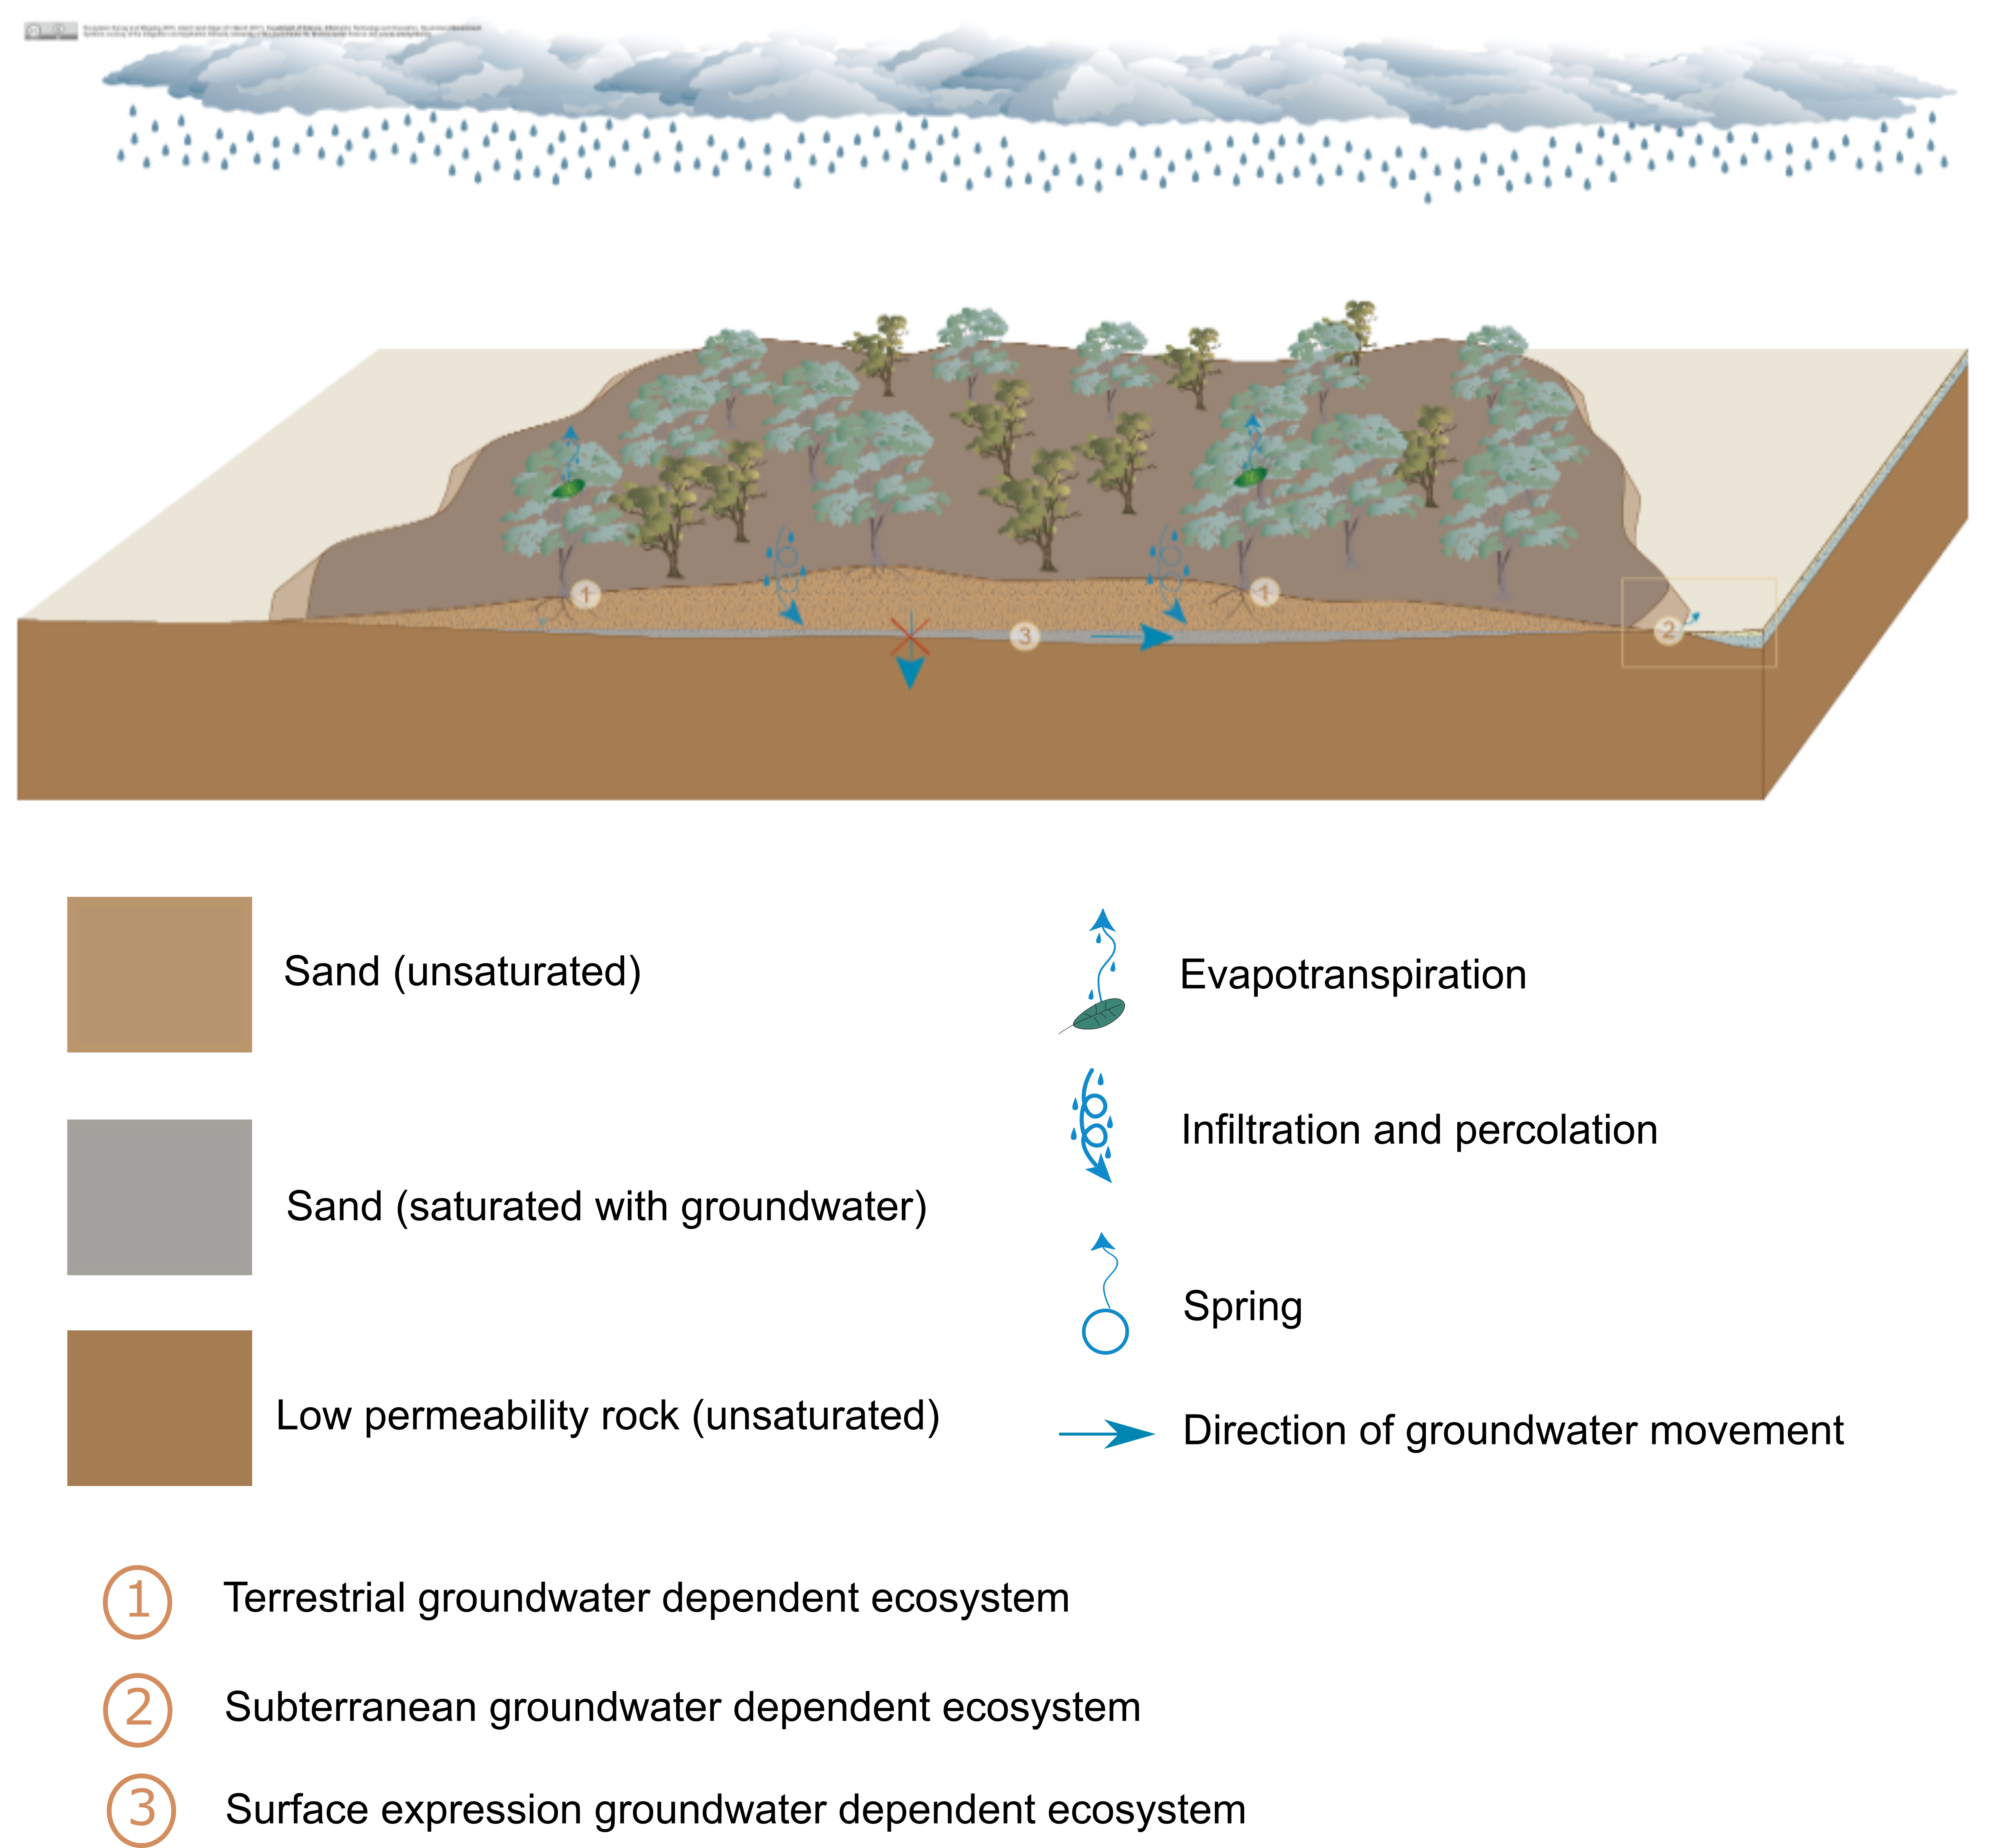
Figure 33 Sandy plains conceptual model
Source: Adapted from the sandy plains conceptual model (Queensland Government, 2015)
Element: GBA-ISA-2-191

Clay plains
In the east of the Isa GBA region, 1218 km2 is classified as clay plains. These are typically gently undulating plains, with clay soils and texture-contrast soils derived from fine-grained sediments. Clay plains include paleo-clay unconsolidated sediments originating from ‘old’ alluvial processes and aeolian clays forming predominantly level to gently undulating plains, but includes lesser rises and low hills – particularly in arid areas. These paleo-clay deposits are now elevated above and usually isolated from the alluvial valleys and floodplains (Wilson and Taylor, 2012). As a result, this is now an erosional landscape with poorly defined drainage. These clay soils have been extensively cleared for introduced pastures and cropping in higher rainfall areas due to their relatively high soil moisture availability and high fertility. Soils are dominated by Vertosols with gilgai microrelief. Larger gilgai may provide ephemeral wetland habitat as a result of ponding of rainfall. Soils usually have restricted rooting depth due to the adverse effects of high sodium levels.
Dominant regional ecosystems (Queensland Government, 2017b) within the Gulf Plains IBRA region include Dichanthium spp., Eulalia aurea, Chrysopogon fallax and Themeda avenacea in mixed tussock grasslands, and Eucalyptus microtheca +/- Excoecaria parvifolia low open woodland.
This landscape class (Figure 34) is represented by the ‘high-level alluvia’ conceptual model (Queensland Government, 2017a). The term 'high-level' alluvia refers to alluvia deposited in ancestral valleys that are located above the channels in the current landscape in a form of inverted relief. Overtime, a channel will erode through older alluvial deposits resulting in older alluvia appearing in the banks above the channel.
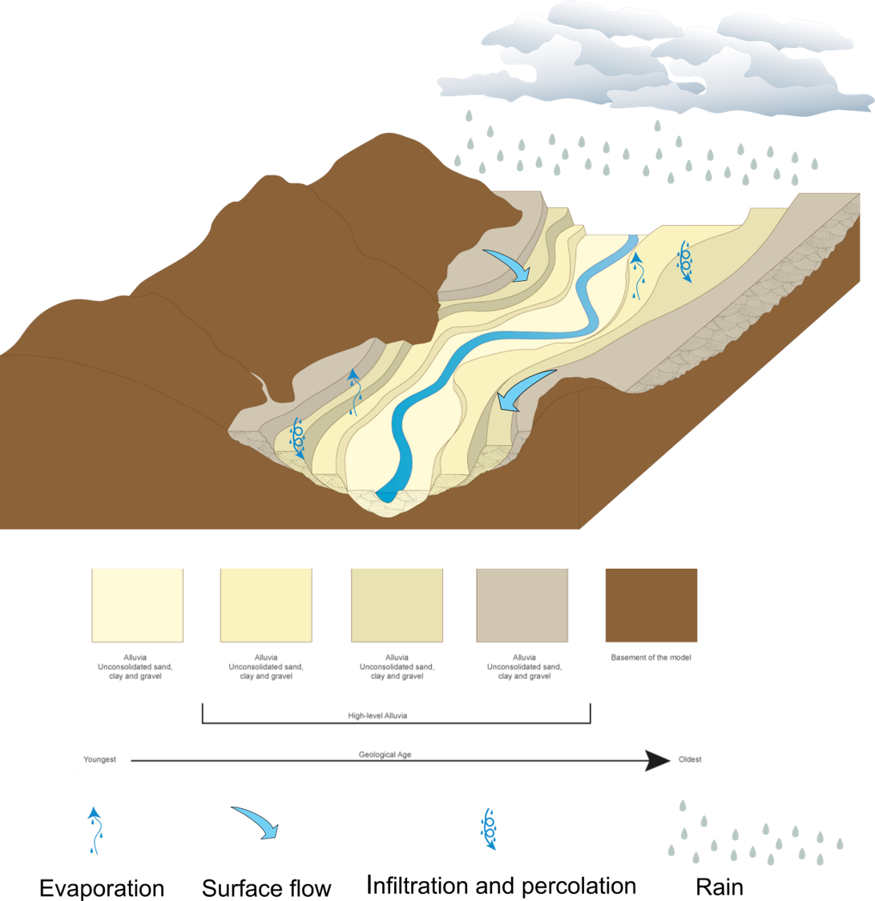
Figure 34 Clay plains ecohydrological conceptual model
Source: Adapted from high-level alluvia’ conceptual model (Queensland Government, 2017a)
Element: GBA-ISA-2-192

Tablelands and duricrusts
The tablelands and duricrusts landscape class is common in the west of the Isa GBA region and covers about 1000 km2. This landscape occurs mainly in the McArthur IBRA subregion (Figure 31), which is composed almost entirely of low hills and plateaus on gently deformed pre-Cambrian sedimentary rocks, overlain in places by Mesozoic rocks of the Carpentaria Basin forming residual plateaus and scarps (Figure 30).
Tableland and duricrust areas are also known as dissected residuals, breakaways or ironstone jump-ups. They are characterised by a silcrete or ferricrete surface that has eroded to form low but steep escarpments, mesas and buttes (Santos, 2015) with colluvial slopes (talus) with shallow soils (less than 0.5 m) over deeply weathered rock (Wilson and Taylor, 2012). Soils are either absent (exposed rock) or dominated by shallow (less than 0.5 m thick) Rudosols and Tenosols, with Kandosols on plateau and tableland margins. They may have gibber-covered foot slopes. Permanent surface water is scarce in elevated areas of tablelands (Santos, 2015).
Vegetation is extremely variable depending on climate conditions, depth of soil and position in the landscape (Wilson and Taylor, 2012). The absence of vegetation on the bare rock and scarp areas is typical. The dominant regional ecosystem (Queensland Government, 2017b) is Corymbia capricornia +/- Eucalyptus leucophloia or E. miniata low open woodland.
This landscape class (Figure 35) is best represented by the ‘exclusion zones’ conceptual model (Queensland Government, 2017c).
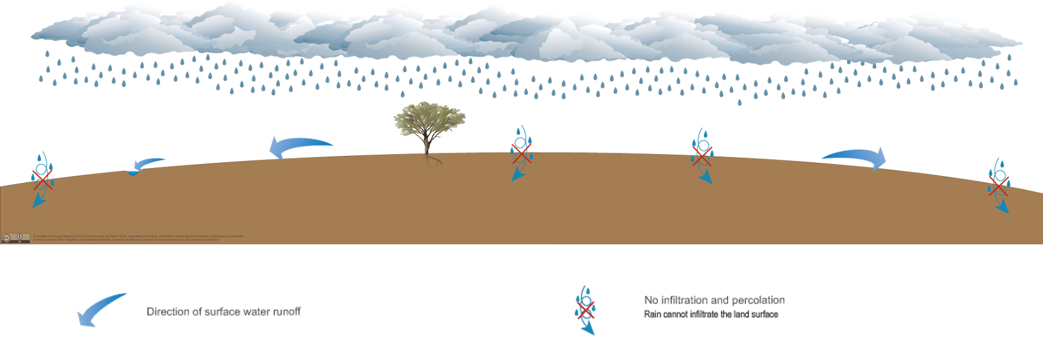
Figure 35 Exclusion zones ecohydrological conceptual model
Source: Adapted from the exclusion zones conceptual model (Queensland Government, 2017c)
Element: GBA-ISA-2-193

Hills and lowlands on metamorphic rocks
Hills and lowlands on metamorphic rocks consist of undulating to steep hills, ranges and mountains, and associated gently undulating colluvial slopes and pediments (Wilson and Taylor, 2012). This landscape class (190 km2) in the Isa GBA region (Table 6) is associated with both the McArthur and Doomadgee IBRA subregions, where it is considered an outlier of the Mount Isa IBRA subregion (Wilson and Taylor, 2012). Dominant regional ecosystems include Eucalyptus leucophloia and E. pruinosa low open woodlands.
This landscape class (Figure 35) is represented by the ‘exclusion zones’ conceptual model (Queensland Government, 2017c).

Undulating country on fine-grained sedimentary rocks
Undulating country on fine-grained sedimentary rocks in the Isa GBA region is associated with the McArthur IBRA subregion, which is composed almost entirely of low hills and plateaus on gently deformed pre-Cambrian sedimentary rocks, overlain in places by Mesozoic rocks of the Carpentaria Basin forming residual plateaus and scarps. The area of the landscape class in the Isa GBA region is 117 km2 (Table 6).
Fine-grained sedimentary rocks include siltstones, mudstones and shales. Depending on the lithology (mineral composition) of the lithic fragments, these fine-grained sedimentary rocks form clayey soils or soils with clay subsoils (Wilson and Taylor, 2012). Due to the general ‘soft’ nature of the sedimentary rocks and the readily weathered nature of the lithology, the landforms are dominated by gently undulating plains and rises, many of which have been extensively developed or cleared for pasture. The dominant regional ecosystem within the Isa GBA region is Eucalyptus leucophloia low open woodland on limestone.
This landscape class (Figure 35) is represented by the ‘exclusion zones’ conceptual model (Queensland Government, 2017c).

Sandstone ranges
Areas of sandstone range are sporadically scattered throughout the McArthur IBRA subregion in the Isa GBA region (58 km2). Medium- to coarse-grained sedimentary rocks composed predominantly of resistant quartz form undulating to steep rises and hills, plateaus, and precipitous cliffs and scarps, and talus. Rock outcrops are typical of the cliffs and immediate edges (Wilson and Taylor, 2012).
Vegetation communities on sandstone ranges are driven by climate and the low fertility sandy soils, and occasionally the micro-climates within gorges. Dominant regional ecosystems include Eucalyptus miniata woodland and Corymbia aspera low open woodland on rocky soils. Springs (which are a separate landscape class) associated with quartzose sandstone are also present.
This landscape class (Figure 35) is represented by the ‘exclusion zones’ conceptual model (Queensland Government, 2017c).

Hills and lowlands on granitic rocks
Hills and lowlands on granitic rocks form extensive gently undulating rises to steep mountains (Wilson and Taylor, 2012). There are only small areas (Table 6) of this landscape class along the north-west margin of the Isa GBA region (3 km2) associated with the McArthur IBRA subregion. The dominant regional ecosystem is Eucalyptus leucophloia low open woodland.
This landscape class (Figure 35) is represented by the ‘exclusion zones’ conceptual model (Queensland Government, 2017c).

Tidal flats and beaches
The ‘tidal flats and beaches’ landscape class includes the sands and/or muds deposited by wind and waves in the intertidal zone and higher supratidal areas under the periodic influence of sea water (Wilson and Taylor, 2012). The 23 km2 of tidal flats and beaches in the Isa GBA region are dominated by periodically inundated, saline clay plains (Morgan, 1999). These are largely unvegetated but include some areas of Tecticornia (Halosarcia) spp., Salicornia spp. and Suaeda spp. There are lesser areas of margins and levees of channels that are subjected to tidal inundation and covered by saline muds and mangroves. These areas are classified by Nelder et al. (2017) as estuarine wetlands (e.g. mangroves) and are seasonally important for waterbird breeding, feeding and roosting.
This landscape class (Figure 36) is represented by the OzCoasts conceptual model for tidal creeks (OzCoasts, 2018).
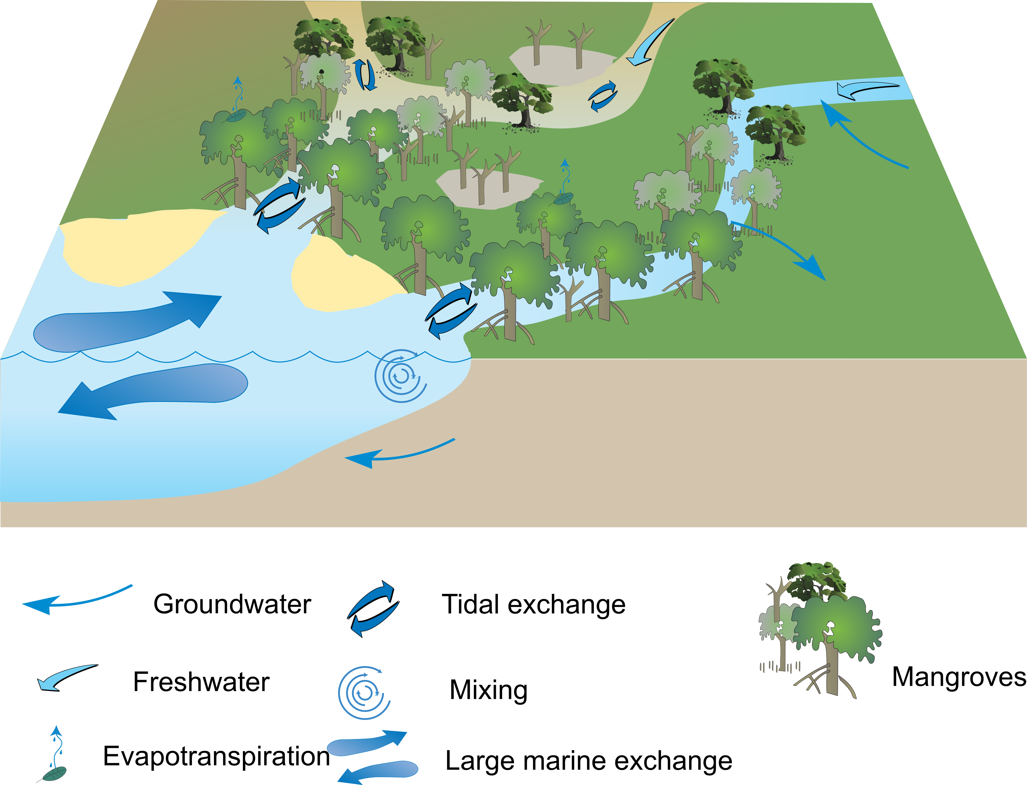
Figure 36 Ecohydrological conceptualisation for the tidal flats and beaches landscape class
Source: Adapted from the OzCoasts tidal creeks conceptual model (OzCoasts, 2018)
Element: GBA-ISA-2-194

Springs
There are two springs associated with sandstone in the south-west of the Isa GBA region, located near other springs associated with sandstone outside the margins of the region. These springs are not associated with the Great Artesian Basin, but occur within areas of outcropping Proterozoic rocks such as those of the South Nicholson Basin and the Isa Superbasin. Regional ecosystem 1.10.6 (springs mostly associated with quartzose sandstone) is classified by Nelder et al. (2017) as palustrine wetland (e.g. vegetated swamp).
This landscape class (Figure 37) is represented by the ‘permeable rocks (rocks with predominantly primary porosity)’ conceptual model (Queensland Government, 2017d).
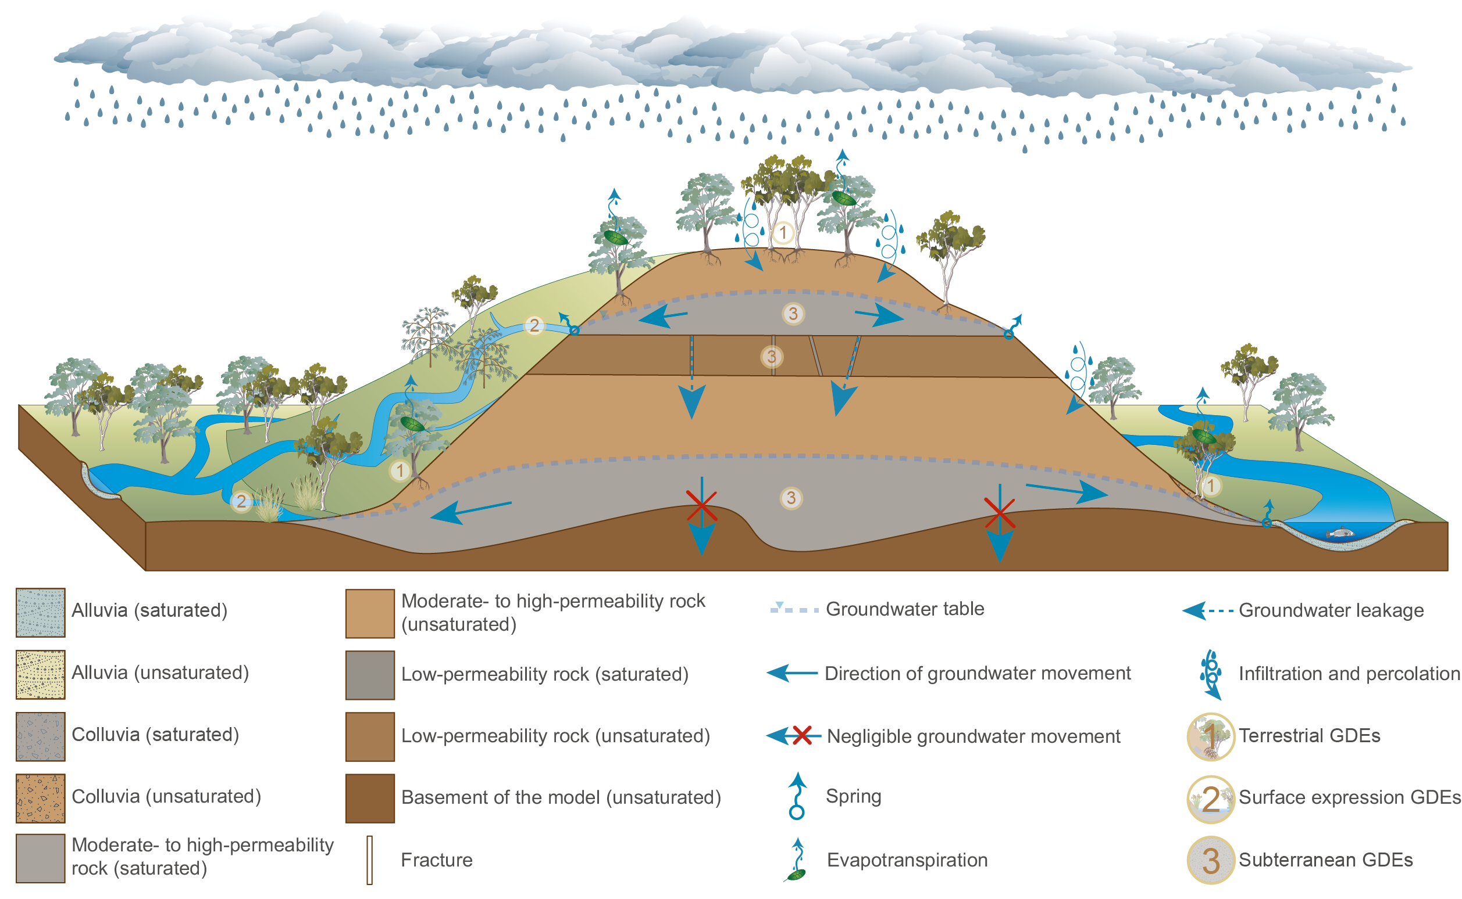
Figure 37 Springs landscape class conceptual model
Source: Adapted from the permeable rocks (rocks with predominantly primary porosity) conceptual model (Queensland Government, 2017d)
Element: GBA-ISA-2-195

Protected matters prioritisation and screening

Approach to prioritising and screening
The steps for identifying and categorising national and state matters of environmental significance within the Isa GBA region are described below.
Step one: Identify matters
There are five categories of Matters of National Environmental Significance (MNES) identified under the EPBC Act of which the following are potentially relevant to the Isa GBA region:
- world heritage properties
- national heritage places
- wetlands of international importance (listed under the Ramsar Convention)
- listed threatened species and ecological communities
- migratory species protected under international agreements.
Another three categories protected by the EPBC Act were also included:
- listed marine species
- whales and other cetaceans
- Commonwealth lands.
These matters were identified from the Protected Matters Search Tool (PMST). In addition, the landscape classes defined by the GBA Program were also included, although these are not protected by the EPBC Act (Department of the Environment and Energy, 2019b). A summary of the MNES identified and their data sources is in Table 8.
Table 8 National matters of environmental significance, and other national matters considered by the GBA Program
 | Data source
Matters of National Environmental Significance
World heritage properties | PMST
National heritage places | PMST
Wetlands of international significance (Ramsar) | PMST
Nationally listed threatened species | PMST
Nationally listed threatened ecological communities | PMST
Migratory species protected under international agreements | PMST
Other matters protected by the EPBC Act
Listed marine species | PMST
Whales and other cetaceans | PMST
Commonwealth lands | PMST
Matters not protected by the EPBC Act
Landscape classes | GBA
Source: Department of the Environment and Energy (2019b)
Six categories of Matters of State Environmental Significance (MSES) that are classified under Queensland legislation (State of Queensland (Department of Environment and Heritage Protection), 2014) are also potentially relevant to the Isa GBA region. These include:
- protected area estates e.g. national parks
- designated precincts of strategic environmental areas
- important regional ecosystems
- threatened species
- high ecological significance wetlands and high ecological value waters
- cultural heritage areas including Queensland heritage places, archaeological state heritage places, places of local cultural heritage significance and heritage areas.
A summary of the state matters identified from the Queensland Spatial Catalogue (State of Queensland (Department of Natural Resources‚ Mines and Energy), 2018) is in Table 9.
In addition to MNES and MSES, the GBA Program also considered nationally important (DIWA) wetlands (Department of the Environment and Energy, 2010) and groundwater-dependent ecosystems (Department of Environment and Science (Qld), 2018b).
Table 9 State Matters of Environmental Significance
Feature name | Description | Dataset name
Protected areas:  a. Protected area (estate)  b. Protected area (nature refuge).  (Nature Conservation Act 1992) | Protected areas under the Nature Conservation Act 1992, except coordinated conservation areas | - Protected areas and other estate lands  - Nature refuges and coordinated conservation areas.
Areas of regional interest – designated precincts (Regional Planning Interests Act) | Designated precincts of strategic environmental areas under the Regional Planning Interests Act 2014 | Strategic environmental areas
Regional ecosystems | Remnant and high-value regrowth regional ecosystems regulated under the VMA. | Vegetation management regional ecosystem and remnant map
Threatened species  (Nature Conservation Act 1992) | Habitat for threatened wildlife under Nature Conservation Act 1992 including: endangered and vulnerable species | WildNet – Queensland Wildlife Data
'High ecological significance' wetlands on the map of referable wetlands (Environmental Protection Act 1994) | - Include: All natural wetlands that are 'high ecological significance' (HES) on the map of referable wetlands  - Exclude: any amendments to the map of referable wetlands. | - Wetland Protection Area HES-Wetland  - Wetland Management Area  - WPA wetland amendments.
High ecological value (HEV) wetlands and waterways (Environmental Protection Act 1994) | Natural wetlands and waterways that occur in HEV (maintain) freshwater and estuarine areas under the Environmental Protection (Water) Policy | EPP Water Policy Intention
State heritage | - Queensland heritage places  - archaeological state heritage places  - places of local cultural heritage significance heritage areas. | Heritage register boundaries - Queensland
Source: Department of the Environment and Energy (2010); Department of Environment and Science (Qld) (2018b)
Step two: Prioritise matters
To identify individual matters that were likely to be impacted by potential shale gas development within the Isa GBA region, each matter was reviewed in relation to its extent and distribution within the region. Landscape classes were also included. Matters were assigned to one of three priorities:
Priority 1 – Importance of the region to the matter warrants a detailed level of assessment. Assessment will endeavour to provide:
- spatial extent and quantification of possible impacts (where possible)
- scale of impact relative to national and State values (e.g. EPBC significant impact guidelines)
- field or remote sensing data validation of occurrence and areas of impact
- details of direct and indirect impact causes and effects that may result
- evaluation of standard and model (ideal) conditions to control impacts
- recommended specific and standard mitigation measures.
Priority 2 – Importance of the region to the matter warrants a high-level assessment. Assessment will endeavour to provide:
- spatial extent of possible impacts (where possible)
- description of possible direct and indirect impact causes and effects
- evaluation of standard and model conditions to suitably control impacts.
Priority 3 – Importance of the region to the matter does not warrant further assessment.
- Impacts to these matters are not recommended for further assessment, but it is anticipated that general mitigation and avoidance measures will provide some level of protection to biodiversity.
MNES, MSES and other matters were initially categorised as shown in Table 10.
Table 10 Initial categorisation of national and state matters
 | Priority
MNES
World heritage properties | Not present
National heritage places | Not present
Internationally important (Ramsar) wetlands | Not present
Nationally listed threatened species | 1
Nationally listed threatened ecological communities | Not present
Migratory species protected under international agreements | 1
Other matters protected by the EPBC Act
Listed marine species | 1
Whales and other cetaceans | 1
Commonwealth lands | Not present
Matters not protected by the EPBC Act
Landscape classes | 2
MSES
High ecological significance wetlands | 1
High ecological value waters (wetland and watercourse) | Not present
Designated precincts of strategic environmental areas | 1
Heritage areas | Not present
Regional ecosystems - Endangered | 1
Regional ecosystems - Of concern | 2
Regional ecosystems - Other | 3
Threatened species - Endangered or Vulnerable | 1
Threatened species - Other | 3
Other matters
Nationally important (DIWA) wetlands | 1
Groundwater-dependent ecosystems | 1
Data: Geological and Bioregional Assessment Program (2019b)
Step three: Further screening of Priority 1 and 2 matters
Following the initial categorisation, matters categorised as priority 1 or 2 were further screened using the significant impact guidelines (Commonwealth of Australia, 2013) (Table 11). Where the protected matter was a place, e.g. a wetland of national significance, the matter was retained as Priority 1 or 2 if the area:
- partially or wholly intersected with areas licenced for exploration and within areas deemed to be prospective for shale gas development
- could be deemed to be hydrologically connected to these areas from a surface water or groundwater perspective
- was thought to contain habitat for an identified species protected matter.
Matters that were not retained were assigned to Priority 3. Landscape classes were assessed using the same criteria as for place protected matters.
Where the protected matter was a species, including whales and other cetaceans, an assessment of the species’ exposure to causal pathways associated with development of shale gas resources was made with reference to likelihood of occurrence in the region, listed threatening processes and existing literature, which included species recovery plans, conservation advice and threat abatement plans.
The proportion of each species’ occurrence (known records and predicted distributions) within the Isa GBA region was assessed in relation to its national distribution. Within the Isa GBA region, the spatial data were assessed in relation to the extent of the protected matter within areas deemed likely to be prospective for shale gas development, i.e. the shale gas play fairways defined in the prospectivity technical appendix (Bailey et al., 2020). If in conjunction with an understanding of the species habitat requirements, the species or its habitat was likely to occur in the region, then that species was retained as Priority 1. Matters that were not retained were assigned to Priority 3.
Table 11 Significant impact guidelines for assessing Matters of National Environmental Significance
Class | status | Criteria
Listed threatened species and ecological communities | Critically endangered or endangered species | An action is likely to have a significant impact on a critically endangered or endangered species if there is a real chance or possibility that it will:  - lead to a long-term decrease in the size of a population  - reduce the area of occupancy of the species  - fragment an existing population into two or more populations  - adversely affect habitat critical to the survival of a species  - disrupt the breeding cycle of a population  - modify, destroy, remove, isolate or decrease the availability or quality of habitat to the extent that the species is likely to decline  - result in invasive species that are harmful to a critically endangered or endangered species becoming established in the endangered or critically endangered species’ habitat  - introduce disease that may cause the species to decline  - interfere with the recovery of the species.
Listed threatened species and ecological communities | Vulnerable species | An action is likely to have a significant impact on a vulnerable species if there is a real chance or possibility that it will:  - lead to a long-term decrease in the size of an important population of a species  - reduce the area of occupancy of an important population  - fragment an existing important population into two or more populations  - adversely affect habitat critical to the survival of a species  - disrupt the breeding cycle of an important population  - modify, destroy, remove or isolate or decrease the availability or quality of habitat to the extent that the species is likely to decline  - result in invasive species that are harmful to a vulnerable species becoming established in the vulnerable species’ habitat  - introduce disease that may cause the species to decline  - interfere substantially with the recovery of the species.
Listed threatened species and ecological communities | Extinct in the wild species | N/A¹
Listed threatened species and ecological communities | Critically endangered or endangered communities | N/A¹
Listed migratory species |  | An action is likely to have a significant impact on a migratory species if there is a real chance or possibility that it will:  - substantially modify (including by fragmenting, altering fire regimes, altering nutrient cycles or altering hydrological cycles), destroy or isolate an area of important habitat for a migratory species  - result in an invasive species that is harmful to the migratory species becoming established in an area of important habitat for the migratory species, or  - seriously disrupt the life cycle (breeding, feeding, migration or resting behaviour) of an ecologically significant proportion of the population of a migratory species.
Wetlands of international importance (Ramsar) |  | N/A¹
Commonwealth marine environment |  | N/A¹
World heritage properties |  | N/A¹
National heritage places |  | N/A¹
¹for the sake of brevity and clarity, guidelines (Commonwealth of Australia, 2013) are only reproduced for matters that are present in the Isa GBA region.
Data: Geological and Bioregional Assessment Program (2019b)

Screening protected matters in the Isa GBA region
The spatial extent of the area for potential impact arising from the development of shale gas resources in the Isa GBA region was defined as the union of the play fairways for the River and Lawn supersequences that were deemed likely and unlikely for future development (Bailey et al., 2020). Based on the screening process outlined above, 11 species of national environmental significance were identified as being potentially at risk from shale gas resource development. It is recommended that these species be considered for further assessment. The area of the predicted potential distribution as well as the number of observations within the Atlas of Living Australia intersecting the Isa GBA region, the area deemed likely and the area deemed unlikely are shown in Table 12. Overall, the number of observed records for each of these species is very low and reflects the poorly surveyed nature of the Isa GBA region. In addition to these species, two of the species identified as Matters of State Environmental Significance (the purple-crowned fairy-wren (Malurus coronatus) and the plant Solanum carduiforme) will be considered further in the assessment. Both of these species are listed as vulnerable under Queensland legislation.
Table 12 Matters of National Environmental Significance with potential to be impacted by shale gas development in the Isa GBA region
Status | Species | Likely (ha) | Unlikely (ha) | Area in Isa GBA region
Endangered | Amytornis dorotheae (Carpentaria grasswren) | 68871 (0) | 133 (0) | 78662 (0)
 | Erythrura gouldiae (Gouldian finch) | 607386 (2) | 94474 (1) | 821936 (3)
 | Rostratula australis (Australian painted snipe) | 607386 (0) | 94474 (0) | 821936 (0)
 | Dasyurus hallucatus (Northern quoll) | 11682 (0) | 32591 (0) | 79598 (0)
 | Elseya lavarackorum (Gulf snapping turtle) | 607386 (3) | 94474 (0) | 821936 (3)
Vulnerable | Erythrotriorchis radiatus (Red goshawk) | 607386 (1) | 94474 (0) | 790925 (1)
 | Tyto novaehollandiae kimberli (Masked owl (northern)) | 496480 (0) | 74234 (0) | 609324 (0)
 | Macroderma gigas (Ghost bat) | 607386 (0) | 94474 (0) | 821935 (0)
 | Saccolaimus saccolaimus nudicluniatus (Bare-rumped sheath-tailed bat) | 74969 (0) | 17263 (0) | 108838 (0)
 | Acanthophis hawkei (Plains death adder) | 176290 (0) | 57453 (0) | 256663 (0)
 | Pristis pristis (Freshwater sawfish, Largetooth sawfish, River sawfish, Leichhardt's sawfish Northern sawfish) | 217676 (0) | 12414 (0) | 243497 (0)
Numbers in the brackets represent the number of records in the Isa GBA region for each species in the Atlas of Living Australia.
Data: Geological and Bioregional Assessment Program (2019c)
Of the 11 landscape classes in the Isa GBA region, only nine intersect the area most likely for shale gas resource development (Table 13). The landscape class ‘Hills and lowlands on granitic rocks’ (and its associated regional ecosystems) does not intersect the area where resource development is likely, and there is little evidence to suggest that this landscape class would be hydrologically connected; thus it is unlikely to require additional assessment. However, springs are recommended for further assessment due to their potential connection to groundwater systems. The landscape class ‘Tidal flats and beaches’ also has potential surface water and groundwater connections to the broader region and would benefit from further analysis, even though there is no overlap of this landscape class with the area where shale gas resource development is likely.
The area of the predicted distribution for each species (MNES only) within each landscape class is shown in Table 14. It should be noted that the predicted distribution is not a surrogate of species habitat and thus the numbers reported in Table 14 give a broad overview of distribution of the species across the landscape only. More detailed habitat assessment is required to better assess impacts of shale gas resource development within the region.
All other matters in Priority 1 and 2, including wetlands of national significance, are recommended for further assessment.
Table 13 Area of landscape class intersecting with the area deemed likely and unlikely to contain shale gas play fairways within the Isa GBA region, or deemed to be potentially hydrologically connected
Landscape class | Likely (ha) | Unlikely (ha)
Floodplain and alluvium | 256603 | 11675
Loamy and sandy plains | 201996 | 50814
Clay plains | 40878 | 16334
Tablelands and duricrusts | 79156 | 9308
Hills and lowlands on metamorphic rocks | 12744 | 5103
Undulating country on fine-grained sedimentary rocks | 10381 | 1157
Sandstone ranges | 5628 | 84
Tidal flats and beaches | 0 | 0
The springs landscape class also occurs within the Isa GBA region, although they are defined as point locations rather than polygons and thus do not have an associated areal extent.
Data: Geological and Bioregional Assessment Program (2019d)

Table 14 Association of Matters of National Environmental Significance with Isa GBA region landscape classes
Species | Landscape class | Predicted distribution (ha) | Number of ALA records
Amytornis dorotheae | Floodplain and alluvium | 8,563 | 0
 | Loamy and sandy plains | 14,195 | 0
 | Clay plains | 0 | 0
 | Tablelands and duricrusts | 39,805 | 0
 | Hills and lowlands on metamorphic rocks | 5,570 | 0
 | Undulating country on fine-grained sedimentary rocks | 6,776 | 0
 | Sandstone ranges | 3,472 | 0
 | Tidal flats and beaches | 0 | 0
Erythrura gouldiae | Floodplain and alluvium | 292,338 | 0
 | Loamy and sandy plains | 268,727 | 0
 | Tablelands and duricrusts | 99,876 | 2
 | Clay plains | 121,759 | 0
 | Hills and lowlands on metamorphic rocks | 19,158 | 0
 | Undulating country on fine-grained sedimentary rocks | 11,660 | 0
 | Sandstone ranges | 5,824 | 1
 | Tidal flats and beaches | 2,289 | 0
Rostratula australis | Floodplain and alluvium | 292,338 | 0
 | Loamy and sandy plains | 268,727 | 0
 | Tablelands and duricrusts | 99,876 | 0
 | Clay plains | 121,759 | 0
 | Hills and lowlands on metamorphic rocks | 19,158 | 0
 | Undulating country on fine-grained sedimentary rocks | 11,660 | 0
 | Sandstone ranges | 5,824 | 0
 | Tidal flats and beaches | 2,289 | 0
Dasyurus hallucatus | Floodplain and alluvium | 13,360 | 0
 | Loamy and sandy plains | 29,825 | 0
 | Tablelands and duricrusts | 23,244 | 0
 | Clay plains | 6,336 | 0
 | Hills and lowlands on metamorphic rocks | 5,768 | 0
 | Undulating country on fine-grained sedimentary rocks | 0 | 0
 | Sandstone ranges | 180 | 0
 | Tidal flats and beaches | 635 | 0
Elseya lavarackorum | Floodplain and alluvium | 292,338 | 3
 | Loamy and sandy plains | 268,727 | 0
 | Tablelands and duricrusts | 99,876 | 0
 | Clay plains | 121,759 | 0
 | Hills and lowlands on metamorphic rocks | 19,158 | 0
 | Undulating country on fine-grained sedimentary rocks | 11,660 | 0
 | Sandstone ranges | 5,824 | 0
 | Tidal flats and beaches | 2,289 | 0
Erythrotriorchis radiatus | Floodplain and alluvium | 284,468 | 0
 | Loamy and sandy plains | 268,727 | 0
 | Tablelands and duricrusts | 99,876 | 1
 | Clay plains | 100,848 | 0
 | Hills and lowlands on metamorphic rocks | 19,151 | 0
 | Undulating country on fine-grained sedimentary rocks | 11,660 | 0
 | Sandstone ranges | 5,824 | 0
 | Tidal flats and beaches | 59 | 0
Tyto novaehollandiae kimberli | Floodplain and alluvium | 218,268 | 0
 | Loamy and sandy plains | 247,173 | 0
 | Tablelands and duricrusts | 93,973 | 0
 | Clay plains | 21,334 | 0
 | Hills and lowlands on metamorphic rocks | 11,233 | 0
 | Undulating country on fine-grained sedimentary rocks | 11,634 | 0
 | Sandstone ranges | 5,402 | 0
 | Tidal flats and beaches | 0.5 | 0
Macroderma gigas | Floodplain and alluvium | 292,338 | 0
 | Loamy and sandy plains | 26,826 | 0
 | Tablelands and duricrusts | 99,876 | 0
 | Clay plains | 121,758 | 0
 | Hills and lowlands on metamorphic rocks | 19,158 | 0
 | Undulating country on fine-grained sedimentary rocks | 11,660 | 0
 | Sandstone ranges | 5,824 | 0
 | Tidal flats and beaches | 2,289 | 0
Saccolaimus saccolaimus nudicluniatus | Floodplain and alluvium | 65,776 | 0
 | Loamy and sandy plains | 28,546 | 0
 | Tablelands and duricrusts | 2,716 | 0
 | Clay plains | 10,224 | 0
 | Hills and lowlands on metamorphic rocks | 0 | 0
 | Undulating country on fine-grained sedimentary rocks | 0 | 0
 | Sandstone ranges | 0 | 0
 | Tidal flats and beaches | 1,576 | 0
Acanthophis hawkei | Floodplain and alluvium | 37,160 | 0
 | Loamy and sandy plains | 103,509 | 0
 | Tablelands and duricrusts | 87,652 | 0
 | Clay plains | 0 | 0
 | Hills and lowlands on metamorphic rocks | 14,081 | 0
 | Undulating country on fine-grained sedimentary rocks | 9,286 | 0
 | Sandstone ranges | 4,672 | 0
 | Tidal flats and beaches | 0 | 0
Pristis pristis | Floodplain and alluvium | 170,663 | 0
 | Loamy and sandy plains | 28,352 | 0
 | Tablelands and duricrusts | 14,585 | 0
 | Clay plains | 22,464 | 0
 | Hills and lowlands on metamorphic rocks | 3,830 | 0
 | Undulating country on fine-grained sedimentary rocks | 1,353 | 0
 | Sandstone ranges | 919 | 0
 | Tidal flats and beaches | 1,331 | 0
ALA=Atlas of Living Australia
Data: Geological and Bioregional Assessment Program (2019a)

Knowledge gaps
Overall, the ecology of the Isa GBA region is poorly understood in the science, regulatory and management institutions. There is only limited scientific knowledge that is of local relevance to the area where future shale gas development may occur. A lack of knowledge of how additional impacts associated with future shale gas resource development may interact with existing threatening processes will constrain an understanding of cumulative impacts. The capacity to assess the potential impacts of shale gas resource development on the protected matters will be constrained by this lack of knowledge.
The lack of accurate records of the distribution of MNES, particularly for threatened species and migratory species, is an important knowledge gap for the Isa GBA region. Currently, a number of these species are identified as ‘likely to occur’ or ‘may occur’ rather than ‘known to occur’ within the Isa GBA region and the numbers of observed records in the Atlas of Living Australia for the region is low. Resolving whether individual species occur (or did not occur) within the Isa GBA region and, if so, when and where, is necessary to identify those species that may be impacted by future gas resource development. Furthermore, for many of the species there is limited knowledge of basic aspects of their ecology, for example habitat preferences, diet and water dependencies. Establishing this knowledge is likely to require ground-based surveys and input from local land custodians.
Most species not listed nationally but listed under Queensland legislation have not had known or potential threatening processes identified. The general lack of knowledge about the habitat and dietary preferences of many of the MNES and MSES listed species hinders the identification of threatening processes and will limit the development of mitigation options. This information is pertinent to understanding the potential impacts of environmental change on the species and the potential for changes associated with the development of a shale gas industry to act in a cumulative manner with other threats. Similarly, the low number of species identified in the area through state legislation points to the low level of ecological surveying. Based on existing data, it is not possible to understand how accurately these lists of species (MNES or MSES) reflect the current biodiversity status of the region.
The landscape classification is limited by the quality of available datasets, including surface geology, elevation, vegetation and landform mapping, and extent and quality of ground observations. In particular, the distribution of clay plains is not clearly indicated in geological mapping. Reference to additional land resource data, particularly geomorphology data, together with interpretation of satellite imagery, aerial photographs and soil information is necessary to identify clay plains. Similarly, determining the extent and nature of unconsolidated sediment deposits can be problematic and can only be accurately determined with the aid of soil cores.

References
Atlas of Living Australia (2019) Atlas of Living Australia. [spatial]. Viewed 18 February 2019, https://www.ala.org.au/. GBA data repository GUID: 439ADC37-762E-47A0-809B-91021F3DDC36.
Australian Government (2018) Environment Protection and Biodiversity Conservation Act 1999. In: Energy Ea (ed.). Canberra.
Bailey AHE, Bradshaw BE, Palu TJ, Wang L, Jarrett AJM, Orr M, Lech M, Evenden C, Arnold D, Reese B, Skeers N, Woods M, Dehelean A, Lawson C and Hall L (2020) Shale gas prospectivity for the Isa GBA region. Technical appendix for the Geological and Bioregional Assessment: Stage 2. Department of the Environment and Energy, Bureau of Meteorology, CSIRO and Geoscience Australia, Australia.
Buchanan S, Dixon-Jain P, Martinez J, Raiber M, Kumar PR, Woods M, Arnold D, Dehelean A and Skeers N (2020) Hydrogeology and groundwater systems of the Isa GBA region. Technical appendix for the Geological and Bioregional Assessment: Stage 2. Department of the Environment and Energy, Bureau of Meteorology, CSIRO and Geoscience Australia, Australia.
Bureau of Meteorology (2013) Guide to environmental accounting in Australia. Environmental Information Programme Publication Series no. 3. Bureau of Meteorology, Canberra, Australia.
Commonwealth of Australia (2013) Matters of National Environmental Significance. Significant impact guidelines 1.1. Environment Protection and Biodiversity Conservation Act 1999. Department of the Environment. Viewed 15 August 2019, http://www.environment.gov.au/epbc/publications/significant-impact-guidelines-11-matters-national-environmental-significance.
Commonwealth of Australia (2015a) Sawfish and river sharks multispecies issues paper.
Commonwealth of Australia (2015b) Sawfish and river sharks multispecies recovery plan.
Commonwealth of Australia (2017) Recovery plan for marine turtles in Australia.
Department of Environment and Resource Management (2010) National recovery plan for the water mouse (false water rat) Xeromys myoides. Brisbane.
Department of Environment and Resource Management (2012) National recovery plan for the red goshawk Erythrotriorchis radiatus. Brisbane.
Department of Environment and Science (Qld) (2018a) WildNet wildlife records. [spatial]. Viewed 28 February 2019, https://data.qld.gov.au/dataset/wildnet-wildlife-records-published-queensland/resource/4fb305f7-18e9-4bc1-903b-34c0959a4731. GBA data repository GUID: A9AA35A3-528E-4D2E-BBC7-8825FD08A88F.
Department of Environment and Science (Qld) (2018b) Groundwater dependent ecosystems and potential aquifer mapping - Queensland. [spatial]. Viewed 07 March 2019, http://qldspatial.information.qld.gov.au/catalogue/custom/detail.page?fid={2DF30B15-FA92-47EC-BD2F-5FF1F311DC69}. GBA data repository GUID: 0C401C96-F61E-4911-83AB-457088D5C47D.
Department of Environment and Science (Qld) (2019) Matters of state environmental significance - High ecological significant wetlands. GBA data repository GUID: 3DE029C1-9D4B-4695-A654-86360FD144C2.
Department of the Environment and Energy (2008) Australia, Register of the National Estate (RNE) – Spatial Database (RNESDB). [spatial]. Viewed 04 December 2018, http://www.environment.gov.au/fed/catalog/search/resource/details.page?uuid=%7B5DA85AC0-1543-4FB2-8885-71BBC8951806%7D. GBA data repository GUID: 9DBFB64A-CF44-4A99-928C-C0B40E8B5D08.
Department of the Environment and Energy (2010) A Directory of Important Wetlands in Australia (DIWA) Spatial Database. [spatial]. Viewed 08 December 2018, https://www.environment.gov.au/water/wetlands/australian-wetlands-database. GBA data repository GUID: F424C2FF-836B-4B3D-A55C-88FDF1BCDE3B.
Department of the Environment and Energy (2016) Collaborative Australian Protected Area Database (CAPAD). Viewed 05 March 2019, http://www.environment.gov.au/land/nrs/science/capad.
Department of the Environment and Energy (2018a) Species of National Environmental Significance. [spatial]. Viewed 15 February 2019, http://www.environment.gov.au/science/erin/databases-maps/snes. GBA data repository GUID: A4D5CC88-AFF5-4E63-9725-330F93723767.
Department of the Environment and Energy (2018b) Interim Biogeographic Regionalisation for Australia (IBRA), Version 7 (Subregions) - States and Territories. [spatial]. Viewed 30 April 2019, https://repo.bioregionalassessments.gov.au/metadata/F83F319E-C369-4548-BBEC-3AAD7AB40AE8. GBA data repository GUID: F83F319E-C369-4548-BBEC-3AAD7AB40AE8.
Department of the Environment and Energy (2019a) Conservation advice. Viewed 01 March 2019, https://www.environment.gov.au/biodiversity/threatened/conservation-advices.
Department of the Environment and Energy (2019b) Protected matters search tool. Australian Government. Viewed 14 August 2019, https://www.environment.gov.au/epbc/protected-matters-search-tool.
Freeman A, Thomson S and Cann J (2014) Elseya lavarackorum (White and Archer 1994) – Gulf Snapping Turtle, Gulf Snapper, Riversleigh Snapping Turtle, Lavarack’s Turtle. In: Rhodin AGJ et al. (eds), Conservation biology of freshwater turtles and tortoises: a compilation project of the IUCN/SSC tortoise and freshwater turtle specialist group. Chelonian Research Foundation.
Garnett ST, Szabo JK and Dutson G (2011) The action plan for Australian birds 2011. CSIRO Publishing, Collingwood.
Geological and Bioregional Assessment Program (2018) GBA-ISA-LandscapeClasses. Viewed 24 October 2018, https://repo.bioregionalassessments.gov.au/metadata/6514E839-526A-4730-BD2B-C34A484E01BE. GBA data repository GUID: 6514E839-526A-4730-BD2B-C34A484E01BE.
Geological and Bioregional Assessment Program (2019a) Isa: Species (distribution and occurrence) by landscape classes. GBA data repository GUID: AF0A9A9F-E09F-4D87-8A7A-9062829BD793.
Geological and Bioregional Assessment Program (2019b) Shale gas prospectivity maps for the Kyalla Formation and Amungee Member of the Velkerri Formation, Beetaloo Sub-basin. Viewed 08 October 2019, https://repo.bioregionalassessments.gov.au/metadata/F469F595-51BA-4459-AC4C-08A7F5A6AB02. GBA data repository GUID: F469F595-51BA-4459-AC4C-08A7F5A6AB02.
Geological and Bioregional Assessment Program (2019c) Isa: Species (distribution and occurrence) by prospective resources. GBA data repository GUID: A5CE7ADB-4CFB-4F2B-803E-2E5D97C83576.
Geological and Bioregional Assessment Program (2019d) Isa: Landscape classes by prospective resources. GBA data repository GUID: C83A2472-F9AF-4D2E-B8B9-A2B86F02A219.
Hill BM and Ward SJ (2010) National recovery plan for the northern quoll Dasyurus hallucatus. Darwin.
IUCN (2019) The IUCN Red List of threatened species. Version 2019-2. Viewed 18 July 2019, http://www.iucnredlist.org.
Linke S, Turak E and Nel J (2011) Freshwater conservation planning: the case for systematic approaches. Freshwater Biology 56(1), 6–20. Doi: 10.1111/j.1365-2427.2010.02456.x.
Milne DJ, Jackling FC, Sidhu M and Appleton BR (2009) Shedding new light on old species identifications: morphological and genetic evidence suggest a need for conservation status review of the critically endangered bat, Saccolaimus saccolaimus. Wildlife Research 36, 496–508.
Morgan G (1999) Gulf Plains. In: Sattler PS and Williams RD (eds), The conservation status of Queensland's bioregional ecosystems. Environmental Protection Agency, Brisbane.
National Committee on Soil and Terrain (2009) Australian soil and land survey field handbook. CSIRO Publishing, Melbourne.
Nelder VJ, Wilson BA, Dillewaard HA, Ryan TS and Butler DW (2017) Methodology for survey and mapping of regional ecosystems and vegetation communities in Queensland. Version 4.0. Updated May 2017. Queensland Herbarium, Queensland Department of Science, Information Technology and Innovation, Brisbane.
Orr M, Bradshaw B, Bernardel G, Palu T, Hall L, Bailey A, Skeers N, Dehelean A, Reese B and Woods M (2020) Geology of the Isa GBA region. Technical appendix for the Geological and Bioregional Assessment: Stage 2. Department of the Environment and Energy, Bureau of Meteorology, CSIRO and Geoscience Australia, Australia.
OzCoasts (2018) Tidal creeks. OzCoasts. Viewed 07 November 2018, https://ozcoasts.org.au/conceptual-diagrams/science-models/geomorphic/tc/.
Queensland Environmental Protection Agency, Queensland Parks and Wildlife Service and Environment Australia (2002) The Riversleigh Management Strategy. Viewed 16 August 2019, https://www.environment.gov.au/system/files/resources/0c9dbd87-8522-4719-9660-46378389e722/files/riverstrategy.pdf.
Queensland Government (2015) Groundwater dependent ecosystem pictorial conceptual model ‘sandy plains’: version 1.5. Queensland Government, Brisbane. Viewed 27 March 2018, https://wetlandinfo.des.qld.gov.au/resources/static/pdf/ecology/gde/170303-gde-pcm-sandy-plains.pdf.
Queensland Government (2017a) Groundwater dependent ecosystem pictorial conceptual model ‘alluvia’: version 1.5. Queensland Government, Brisbane. Viewed 27 March 2018, https://wetlandinfo.des.qld.gov.au/resources/static/pdf/ecology/gde/170303-gde-pcm-alluvia.pdf.
Queensland Government (2017b) Regional ecosystem descriptions. State of Queensland. Viewed 23 October 2018, https://www.qld.gov.au/environment/plants-animals/plants/ecosystems/descriptions.
Queensland Government (2017c) Groundwater dependent ecosystem pictorial conceptual model ‘exclusion zones’: version 1.5. Queensland Government, Brisbane. Viewed 27 March 2018, https://wetlandinfo.des.qld.gov.au/resources/static/pdf/ecology/gde/170303-pcm-exclusion-zones.pdf.
Queensland Government (2017d) Groundwater dependent ecosystem pictorial conceptual model ‘permeable rocks (rocks with predominantly primary porosity’: version 1.5. Viewed 27 March 2018, https://wetlandinfo.des.qld.gov.au/resources/static/pdf/ecology/gde/170303-gde-pcm-permeable-rocks.pdf.
Queensland Herbarium (2018) Regional Ecosystem Description Database (REDD), Version 11. Brisbane. Viewed 26 March 2019, https://www.qld.gov.au/environment/plants-animals/plants/ecosystems/descriptions/download.
Santos (2015) South Australian Cooper Basin. Environmental impact report: drilling, completions and well operations Final report November 2015. Santos Ltd, Adelaide.
Sattler PS and Williams RD (1999) The conservation status of Queensland's bioregional ecosystems. Enivronmental Protection Agency, Brisbane.
Schulz M and Thomson B (2007) National recovery plan for the bare-rumped sheathtail bat Saccolaimus saccolaimus nudicluniatus. Brisbane.
State of Queensland (Department of Environment and Heritage Protection) (2014) Method for mapping. Matters of State environmental significance for use in land use planning and development assessment Version 4.1.
State of Queensland (Department of Infrastructure Local Government and Planning) (2017) State Planning Policy July 2017. Brisbane Qld, https://planning.dsdmip.qld.gov.au/planning/spa-system/plan-making-under-spa/state-planning-under-spa/state-planning-policy.
State of Queensland (Department of Natural Resources‚ Mines and Energy) (2018) Queensland Spatial Catalogue - QSpatial. Viewed 01 March 2019, http://qldspatial.information.qld.gov.au/catalogue/custom/index.page.
State of Queensland (Department of State Development‚ Manufacturing‚ Infrastructure and Planning) (2019) Queensland Gov other MSES - Strategic env area - designated precinct. GBA data repository GUID: D9B14210-EB2E-4976-9F3C-161650C54115.
United Nations, European Commission, Food and Agriculture Organization of the United Nations, Organisation for Economic Co-Operation and Development and World Bank Group (2014) System of environmental–economic accounting 2012: experimental ecosystem accounting. United Nations, New York.
van Dyck S and Strahan R (2008) The mammals of Australia. Reed New Holland, Sydney.
Ward S and Phillips B (2012) Plains death adder, Acanthopsis hawkei. In: Woinarski JCZ, Pavey C, Kerrigan R, Cowie I and Ward S (eds), Lost from our landscapes: threatened species of the Northern Territory. Northern Territory Department of Natural Resources, the Environment and The Arts, Darwin, 284.
Wilson P and Taylor P (2012) Land Zones of Queensland. Queensland Herbarium, Queensland Department of Science, Information Technology, Innovation and the Arts, Brisbane. Viewed 01 March 2019, https://environment.des.qld.gov.au/assets/documents/plants-animals/ecosystems/land-zones-queensland.pdf.
Woinarski JCZ (2006) Gulf snapping turtle, Elseya lavarackorum. In: Woinarski JCZ, Pavey C, Kerrigan R, Cowie I and Ward S (eds), Lost from our landscapes: threatened species of the Northern Territory. Deapartment of Natural Resources, Environment and The Arts, Darwin.

Glossary
The register of terms and definitions used in the Geological and Bioregional Assessment Program is available online at https://w3id.org/gba/glossary (note that terms and definitions are respectively listed under the 'Name' and 'Description' columns in this register). This register is a list of terms, which are the preferred descriptors for concepts. Other properties are included for each term, including licence information, source of definition and date of approval. Semantic relationships (such as hierarchical relationships) are formalised for some terms, as well as linkages to other terms in related vocabularies. Many of the definitions for these terms have been sourced from external glossaries – several from international sources; spelling variations have been preserved to maintain authenticity of the source.
accumulation: in petroleum geosciences, an ‘accumulation’ is referred to as an individual body of moveable petroleum
aeolian: relating to or arising from the action of wind
anticline: an arch-shaped fold in rock in which rock layers are upwardly convex. The oldest rock layers form the core of the fold and, outward from the core, progressively younger rocks occur.
aquifer: rock or sediment in a formation, group of formations, or part of a formation that is saturated and sufficiently permeable to transmit quantities of water to bores and springs
aquitard: a saturated geological unit that is less permeable than an aquifer, and incapable of transmitting useful quantities of water. Aquitards commonly form a confining layer over an artesian aquifer.
artesian aquifer: an aquifer that has enough natural pressure to allow water in a bore to rise to the ground surface
asset: an entity that has value to the community and, for the purposes of geological and bioregional assessments, is associated with a GBA region. An asset is a store of value and may be managed and/or used to maintain and/or produce further value. An asset may have many values associated with it that can be measured from a range of perspectives; for example, the values of a wetland can be measured from ecological, sociocultural and economic perspectives.
basement: the oldest rocks in an area; commonly igneous or metamorphic rocks of Precambrian or Paleozoic age that underlie other sedimentary formations. Basement generally does not contain significant oil or gas, unless it is fractured and in a position to receive these materials from sedimentary strata.
bed: in geosciences, the term 'bed' refers to a layer of sediment or sedimentary rock, or stratum. A bed is the smallest stratigraphic unit, generally a centimetre or more in thickness. To be labeled a bed, the stratum must be distinguishable from adjacent beds.
bore: a narrow, artificially constructed hole or cavity used to intercept, collect or store water from an aquifer, or to passively observe or collect groundwater information. Also known as a borehole or piezometer.
causal pathway: for the purposes of geological and bioregional assessments, the logical chain of events ‒ either planned or unplanned ‒ that link unconventional gas development and potential impacts on water and water-dependent assets
charge: in petroleum geoscience, a 'charge' refers to the volume of expelled petroleum available for entrapment
cleat: the vertical cleavage of coal seams. The main set of joints along which coal breaks when mined.
coal: a rock containing greater than 50 wt.% organic matter
coal seam gas: coal seam gas (CSG) is a form of natural gas (generally 95% to 97% pure methane, CH₄) extracted from coal seams, typically at depths of 300 to 1000 m. Also called coal seam methane (CSM) or coalbed methane (CBM).
conceptual model: an abstraction or simplification of reality that describes the most important components and processes of natural and/or anthropogenic systems, and their response to interactions with extrinsic activities or stressors. They provide a transparent and general representation of how complex systems work, and identify gaps or differences in understanding. They are often used as the basis for further modelling, form an important backdrop for assessment and evaluation, and typically have a key role in communication. Conceptual models may take many forms, including descriptive, influence diagrams and pictorial representations.
confined aquifer: an aquifer saturated with confining layers of low-permeability rock or sediment both above and below it. It is under pressure so that when the aquifer is penetrated by a bore, the water will rise above the top of the aquifer.
context: the circumstances that form the setting for an event, statement or idea
conventional gas: conventional gas is obtained from reservoirs that largely consist of porous sandstone formations capped by impermeable rock, with the gas trapped by buoyancy. The gas can often move to the surface through the gas wells without the need to pump.
Cooper Basin: the Cooper Basin geological province is an Upper Carboniferous – Middle Triassic geological sedimentary basin that is up to 2500 m thick and occurs at depths between 1000 and 4400 m. It is overlain completely by the Eromanga and Lake Eyre basins. Most of the Cooper Basin is in south-west Queensland and north-east SA, and includes a small area of NSW at Cameron Corner. It occupies a total area of approximately 130,000 km², including 95,740 km² in Queensland, 34,310 km² in SA and 8 km² in NSW.
crust: the outer part of the Earth, from the surface to the Mohorovicic discontinuity (Moho)
cumulative impact: for the purposes of geological and bioregional assessments, the total environmental change resulting from the development of selected unconventional hydrocarbon resources when all past, present and reasonably foreseeable actions are considered
dataset: a collection of data in files, in databases or delivered by services that comprise a related set of information. Datasets may be spatial (e.g. a shape file or geodatabase or a Web Feature Service) or aspatial (e.g. an Access database, a list of people or a model configuration file).
deep coal gas: gas in coal beds at depths usually below 2000 m are often described as ‘deep coal gas’. Due to the loss of cleat connectivity and fracture permeability with depth, hydraulic fracturing is used to release the free gas held within the organic porosity and fracture system of the coal seam. As dewatering is not needed, this makes deep coal gas exploration and development similar to shale gas reservoirs.
deformation: folding, faulting, shearing, compression or extension of rocks due to the Earth’s forces
delta: a low, nearly flat area near the mouth of a river, commonly forming a fan-shaped plain that can extend beyond the coast into deep water. Deltas form in lakes and oceans when sediment supplied by a stream or river overwhelms that removed by tides, waves, and currents
deposition: sedimentation of any material, as in the mechanical settling of sediment from suspension in water, precipitation of mineral matter by evaporation from solution, and accumulation of organic material
development: a phase in which newly discovered oil or gas fields are put into production by drilling and completing production wells
discovered: the term applied to a petroleum accumulation/reservoir whose existence has been determined by its actual penetration by a well, which has also clearly demonstrated the existence of moveable petroleum by flow to the surface or at least some recovery of a sample of petroleum. Log and/or core data may suffice for proof of existence of moveable petroleum if an analogous reservoir is available for comparison.
dome: a type of anticline where rocks are folded into the shape of an inverted bowl. Strata in a dome dip outward and downward in all directions from a central area.
ecosystem: a dynamic complex of plant, animal, and micro-organism communities and their non-living environment interacting as a functional unit. Note: ecosystems include those that are human-influenced such as rural and urban ecosystems.
ecosystem asset: an ecosystem that may provide benefits to humanity. It is a spatial area comprising a combination of biotic and abiotic components and other elements which function together.
effect: for the purposes of Impact Modes and Effects Analysis (IMEA), a change to water or the environment, such as changes to the quantity and/or quality of surface water or groundwater, or to the availability of suitable habitat. An effect is a specific type of an impact (any change resulting from prior events).
erosion: the movement of unconsolidated materials at the Earth’s surface by wind, water or glacial ice
extraction: the removal of water for use from waterways or aquifers (including storages) by pumping or gravity channels. In the oil and gas industry, extraction refers to the removal of oil and gas from its reservoir rock.
fairway: a term used in geology to describe a regional trend along which a particular geological feature is likely to occur, such as a hydrocarbon fairway. Understanding and predicting fairways can help geologists explore for various types of resources, such as minerals, oil and gas.
fault: a fracture or zone of fractures in the Earth’s crust along which rocks on one side were displaced relative to those on the other side
field: in petroleum geoscience, a 'field' refers to an accumulation, pool, or group of pools of hydrocarbons or other mineral resources in the subsurface. A hydrocarbon field consists of a reservoir with trapped hydrocarbons covered by an impermeable sealing rock, or trapped by hydrostatic pressure.
floodplain: a flat area of unconsolidated sediment near a stream channel that is submerged during or after high flows
fold: a curve or bend of a formerly planar structure, such as rock strata or bedding planes, that generally results from deformation
formation: rock layers that have common physical characteristics (lithology) deposited during a specific period of geological time
fracking: see hydraulic fracturing
fracture: a crack or surface of breakage within rock not related to foliation or cleavage in metamorphic rock along which there has been no movement. A fracture along which there has been displacement is a fault. When walls of a fracture have moved only normal to each other, the fracture is called a joint. Fractures can enhance permeability of rocks greatly by connecting pores together, and for that reason, fractures are induced mechanically in some reservoirs in order to boost hydrocarbon flow. Fractures may also be referred to as natural fractures to distinguish them from fractures induced as part of a reservoir stimulation or drilling operation. In some shale reservoirs, natural fractures improve production by enhancing effective permeability. In other cases, natural fractures can complicate reservoir stimulation.
free gas: the gaseous phase present in a reservoir or other contained area. Gas may be found either dissolved in reservoir fluids or as free gas that tends to form a gas cap beneath the top seal on the reservoir trap. Both free gas and dissolved gas play important roles in the reservoir-drive mechanism.
geological formation: stratigraphic unit with distinct rock types, which is able to mapped at surface or in the subsurface, and which formed at a specific period of geological time
gilgai: a small ephemeral lake formed from a depression in the soil surface in expanding clay soils
groundwater: water occurring naturally below ground level (whether stored in or flowing through aquifers or within low-permeability aquitards), or water occurring at a place below ground that has been pumped, diverted or released to that place for storage there. This does not include water held in underground tanks, pipes or other works.
groundwater-dependent ecosystem: ecosystems that require access to groundwater on a permanent or intermittent basis to meet all or some of their water requirements
groundwater recharge: replenishment of groundwater by natural infiltration of surface water (precipitation, runoff), or artificially via infiltration lakes or injection
groundwater system: see water system
hazard: an event, or chain of events, that might result in an effect (change in the quality and/or quantity of surface water or groundwater)
hydraulic fracturing: also known as ‘fracking’, ‘fraccing’ or ‘fracture simulation’. This is a process by which geological formations bearing hydrocarbons (oil and gas) are ‘stimulated’ to increase the flow of hydrocarbons and other fluids towards the well. In most cases, hydraulic fracturing is undertaken where the permeability of the formation is initially insufficient to support sustained flow of gas. The process involves the injection of fluids, proppant and additives under high pressure into a geological formation to create a conductive fracture. The fracture extends from the well into the production interval, creating a pathway through which oil or gas is transported to the well.
hydrocarbons: various organic compounds composed of hydrogen and carbon atoms that can exist as solids, liquids or gases. Sometimes this term is used loosely to refer to petroleum.
hydrogeology: the study of groundwater, including flow in aquifers, groundwater resource evaluation, and the chemistry of interactions between water and rock
hydrostatic pressure: equal pressure in all direction, equivalent to the pressure which is exerted on a portion of a column of water as a result of the weight of the fluid above it
impact: the difference between what could happen as a result of activities and processes associated with extractive industries, such as shale, tight and deep coal gas development, and what would happen without them. Impacts may be changes that occur to the natural environment, community or economy. Impacts can be a direct or indirect result of activities, or a cumulative result of multiple activities or processes.
impact cause: an activity (or aspect of an activity) that initiates a hazardous chain of events
impact mode: the manner in which a hazardous chain of events (initiated by an impact cause) could result in an effect (change in the quality and/or quantity of surface water or groundwater). There might be multiple impact modes for each activity or chain of events.
Impact Modes and Effects Analysis: a systematic hazard identification and prioritisation technique based on Failure Modes and Effects Analysis
injection: the forcing or pumping of substances into a porous and permeable subsurface rock formation. Examples of injected substances can include either gases or liquids.
landscape class: for the purposes of geological and bioregional assessments (GBA), a collection of ecosystems with characteristics that are expected to respond similarly to changes in groundwater and/or surface water due to unconventional gas resource development. Note that there is expected to be less heterogeneity in the response within a landscape class than between landscape classes. They are present on the landscape across the entire GBA region and their spatial coverage is exhaustive and non-overlapping. Conceptually, landscape classes can be considered as types of ecosystem assets.
likelihood: probability that something might happen
lithology: the description of rocks, especially in hand specimen and in outcrop, on the basis of characteristics such as colour, mineralogic composition and grain size
mantle: the region of the Earth composed mainly of solid silicate rock that extends from the base of the crust (Moho) to the core–mantle boundary at a depth of approximately 2900 km
material: pertinent or relevant
mature: a hydrocarbon source rock that has started generating hydrocarbons
metamorphic rock : a rock formed from pre-existing rock due to high temperature and pressure in the Earth’s crust, but without complete melting
migration: the process whereby fluids and gases move through rocks. In petroleum geoscience, 'migration' refers to when petroleum moves from source rocks toward reservoirs or seep sites. Primary migration consists of movement of petroleum to exit the source rock. Secondary migration occurs when oil and gas move along a carrier bed from the source to the reservoir or seep. Tertiary migration is where oil and gas move from one trap to another or to a seep.
Moho: the Mohorivicic discontinuity (seismic reflector) at the base of the crust
mudstone: a general term for sedimentary rock made up of clay-sized particles, typically massive and not fissile
oil: a mixture of liquid hydrocarbons and other compounds of different molecular weights. Gas is often found in association with oil. Also see petroleum.
organic matter: biogenic, carbonaceous materials. Organic matter preserved in rocks includes kerogen, bitumen, oil and gas. Different types of organic matter can have different oil-generative potential.
outcrop: a body of rock exposed at the surface of the Earth
permeability: the measure of the ability of a rock, soil or sediment to yield or transmit a fluid. The magnitude of permeability depends largely on the porosity and the interconnectivity of pores and spaces in the ground.
petroleum: a naturally occurring mixture consisting predominantly of hydrocarbons in the gaseous, liquid or solid phase
petroleum system: the genetic relationship between a pod of source rock that is actively producing hydrocarbon, and the resulting oil and gas accumulations. It includes all the essential elements and processes needed for oil and gas accumulations to exist. These include the source, reservoir, seal, and overburden rocks, the trap formation, and the hydrocarbon generation, migration and accumulation processes. All essential elements and processes must occur in the appropriate time and space in order for petroleum to accumulate.
play: a conceptual model for a style of hydrocarbon accumulation used during exploration to develop prospects in a basin, region or trend and used by development personnel to continue exploiting a given trend. A play (or group of interrelated plays) generally occurs in a single petroleum system.
porosity: the proportion of the volume of rock consisting of pores, usually expressed as a percentage of the total rock or soil mass
potential effect: specific types of impacts or changes to water or the environment, such as changes to the quantity and/or quality of surface water or groundwater, or to the availability of suitable habitat
production: in petroleum resource assessments, 'production' refers to the cumulative quantity of oil and natural gas that has been recovered already (by a specified date). This is primarily output from operations that has already been produced.
production well: a well used to remove oil or gas from a reservoir
proppant: a component of the hydraulic fracturing fluid system comprising sand, ceramics or other granular material that 'prop' open fractures to prevent them from closing when the injection is stopped
recharge: see groundwater recharge
reserves: quantities of petroleum anticipated to be commercially recoverable in known accumulations from a given date forward under defined conditions. Reserves must further satisfy four criteria: they must be discovered, recoverable, commercial and remaining (as of the evaluation date) based on the development project(s) applied.
reservoir: a subsurface body of rock having sufficient porosity and permeability to store and transmit fluids and gases. Sedimentary rocks are the most common reservoir rocks because they have more porosity than most igneous and metamorphic rocks and form under temperature conditions at which hydrocarbons can be preserved. A reservoir is a critical component of a complete petroleum system.
reservoir rock: any porous and permeable rock that contains liquids or gases (e.g. petroleum, water, CO₂), such as porous sandstone, vuggy carbonate and fractured shale
riparian: within or along the banks of a stream or adjacent to a watercourse or wetland; relating to a riverbank and its environment, particularly to the vegetation
risk: the effect of uncertainty on objectives (ASNZ ISO 3100). This involves assessing the potential consequences and likelihood of impacts to environmental and human values that may stem from an action, under the uncertainty caused by variability and incomplete knowledge of the system of interest.
runoff: rainfall that does not infiltrate the ground or evaporate to the atmosphere. This water flows down a slope and enters surface water systems.
sandstone: a sedimentary rock composed of sand-sized particles (measuring 0.05–2.0 mm in diameter), typically quartz
seal: a relatively impermeable rock, commonly shale, anhydrite or salt, that forms a barrier or cap above and around reservoir rock such that fluids cannot migrate beyond the reservoir. A seal is a critical component of a complete petroleum system.
sediment: various materials deposited by water, wind or glacial ice, or by precipitation from water by chemical or biological action (e.g. clay, sand, carbonate)
sedimentary rock : a rock formed by lithification of sediment transported or precipitated at the Earth’s surface and accumulated in layers. These rocks can contain fragments of older rock transported and deposited by water, air or ice, chemical rocks formed by precipitation from solution, and remains of plants and animals.
sedimentation: the process of deposition and accumulation of sediment (unconsolidated materials) in layers
shale: a fine-grained sedimentary rock formed by lithification of mud that is fissile or fractures easily along bedding planes and is dominated by clay-sized particles
shale gas: generally extracted from a clay-rich sedimentary rock, which has naturally low permeability. The gas it contains is either adsorbed or in a free state in the pores of the rock.
shear: a frictional force that tends to cause contiguous parts of a body to slide relative to each other in a direction parallel to their plane of contact
siltstone: a sedimentary rock composed of silt-sized particles (0.004 to 0.063 mm in diameter)
source rock: a rock rich in organic matter which, if heated sufficiently, will generate oil or gas. Typical source rocks, usually shales or limestones, contain about 1% organic matter and at least 0.5% total organic carbon (TOC), although a rich source rock might have as much as 10% organic matter. Rocks of marine origin tend to be oil-prone, whereas terrestrial source rocks (such as coal) tend to be gas-prone. Preservation of organic matter without degradation is critical to creating a good source rock, and necessary for a complete petroleum system. Under the right conditions, source rocks may also be reservoir rocks, as in the case of shale gas reservoirs.
spring: a naturally occurring discharge of groundwater flowing out of the ground, often forming a small stream or pool of water. Typically, it represents the point at which the watertable intersects ground level.
structure: a geological feature produced by deformation of the Earth’s crust, such as a fold or a fault; a feature within a rock, such as a fracture or bedding surface; or, more generally, the spatial arrangement of rocks
surface water: water that flows over land and in watercourses or artificial channels and can be captured, stored and supplemented from dams and reservoirs
terrane: an area of crust with a distinct assemblage of rocks (as opposed to terrain, which implies topography, such as rolling hills or rugged mountains)
tight gas: tight gas is trapped in reservoirs characterised by very low porosity and permeability. The rock pores that contain the gas are minuscule, and the interconnections between them are so limited that the gas can only migrate through it with great difficulty.
trap: a geologic feature that permits an accumulation of liquid or gas (e.g. natural gas, water, oil, injected CO₂) and prevents its escape. Traps may be structural (e.g. domes, anticlines), stratigraphic (pinchouts, permeability changes) or combinations of both.
unconfined aquifer: an aquifer whose upper water surface (watertable) is at atmospheric pressure and does not have a confining layer of low-permeability rock or sediment above it
unconventional gas: unconventional gas is generally produced from complex geological systems that prevent or significantly limit the migration of gas and require innovative technological solutions for extraction. There are numerous types of unconventional gas such as coal seam gas, deep coal gas, shale gas and tight gas.
water system: a system that is hydrologically connected and described at the level desired for management purposes (e.g. subcatchment, catchment, basin or drainage division, or groundwater management unit, subaquifer, aquifer, groundwater basin)
watertable: the upper surface of a body of groundwater occurring in an unconfined aquifer. At the watertable, pore water pressure equals atmospheric pressure.
weathering: the breakdown of rocks and other materials at the Earth’s surface caused by mechanical action and reactions with air, water and organisms. Weathering of seep oils or improperly sealed oil samples by exposure to air results in evaporative loss of light hydrocarbons.
well: typically a narrow diameter hole drilled into the earth for the purposes of exploring, evaluating, injecting or recovering various natural resources, such as hydrocarbons (oil and gas), water or carbon dioxide. Wells are sometimes known as a ‘wellbore’.

www.bioregionalassessments.gov.au

