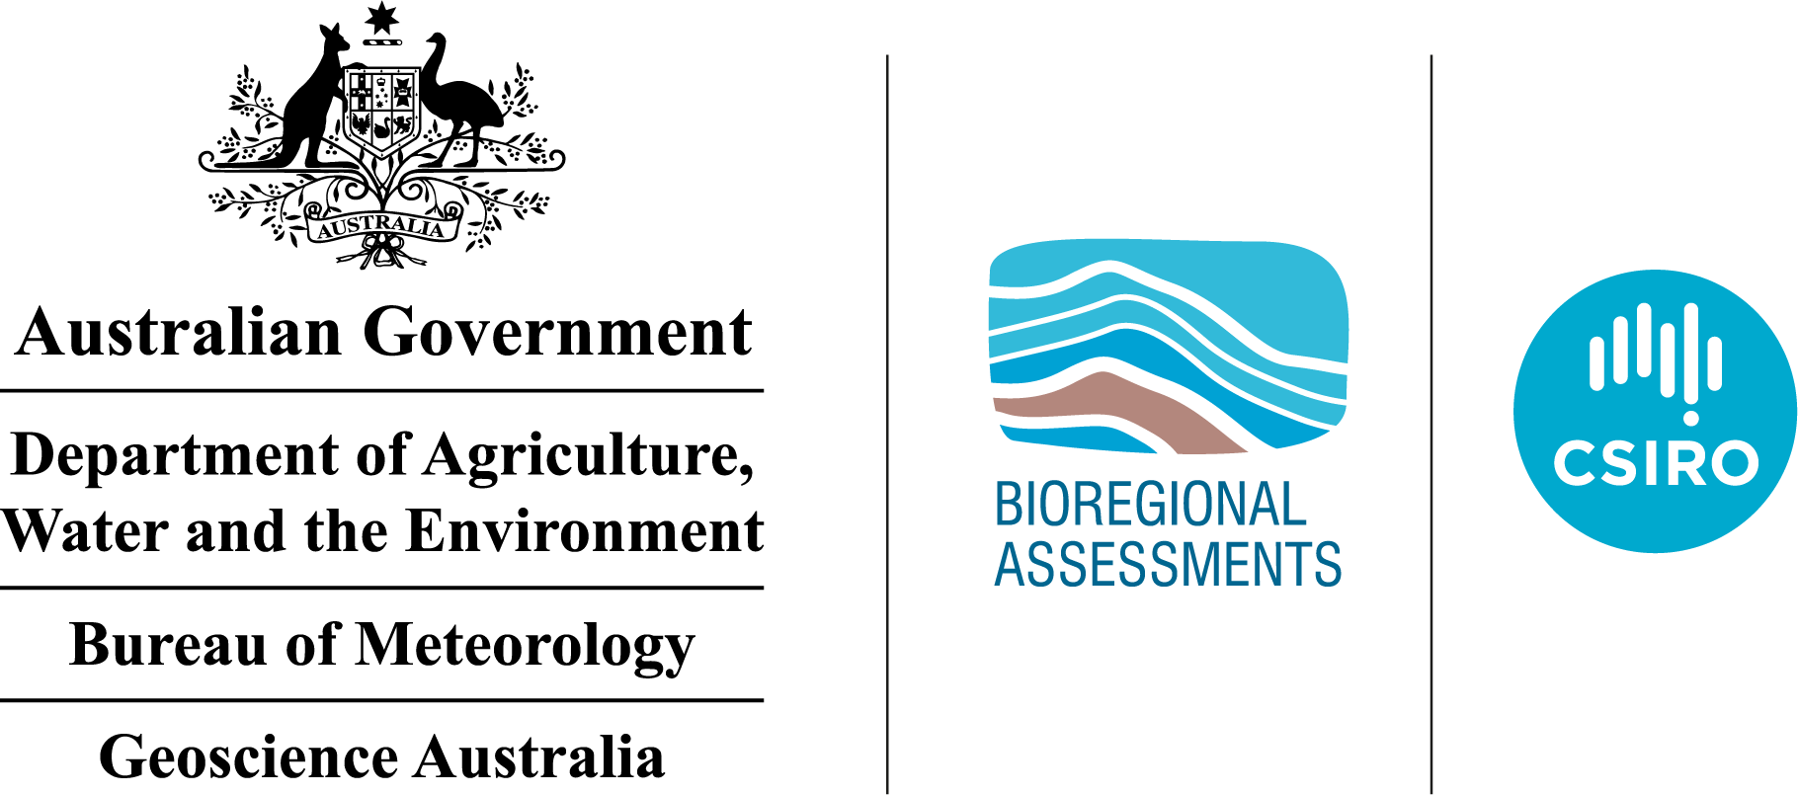The GBA Program

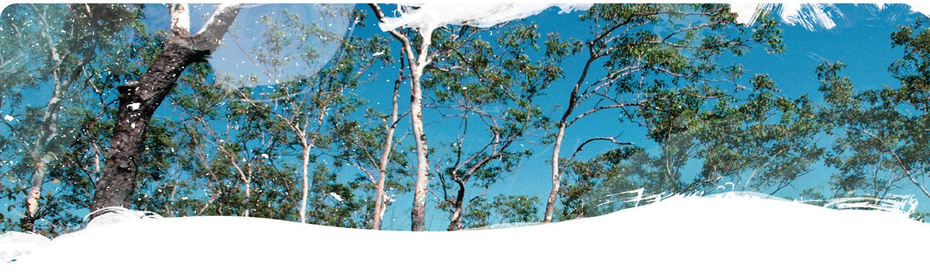

Geological and Bioregional Assessment Program

The $35.4 million Geological and Bioregional Assessment (GBA) Program is assessing the potential environmental impacts of shale and tight gas development to inform regulatory frameworks and appropriate management approaches. The geological and environmental knowledge, data and tools produced by the GBA Program will assist governments, industry, landowners and the community by informing decision making and enabling the coordinated management of potential impacts.

A series of independent scientific studies in three geological basins – the Cooper Basin in Queensland and SA, the Isa Superbasin in Queensland and the Beetaloo Sub-basin in NT – are being conducted by CSIRO and Geoscience Australia, supported by the Bureau of Meteorology and managed by the Department Agriculture, Water and the Environment. These scientific studies aim to provide baseline information that:

|  |  |
| --- | --- |
|  | identifies and evaluates areas of high potential for shale and tight gas for future development and any potential connections with water resources |
|  | collates and summarises key information about geological structure, groundwater movement through geological layers, surface water systems and ecological systems |
|  | evaluates possible ways that unconventional gas resource development might impact the things we value, such as the Cooper Creek floodplain, groundwaters, protected species, as well as culturally and ecologically important matters |

User panels

Each assessment is informed by a user panel, where user needs and Program findings are discussed, and information is shared. The user panel for the Cooper GBA region includes people from local government, natural resource management bodies, Queensland and SA state governments, Traditional Owner groups, pastoralists, industry and other land user groups. The assessments will inform and support future regulatory frameworks and appropriate management approaches.

The Cooper GBA region

The Cooper GBA region covers an area of over 130,000 km2. The Cooper GBA region (Figure 1) is in south-west Queensland and in the north-east of South Australia. It is primarily located in the Cooper Creek catchment, which extends from north of Windorah in Queensland to south of Innamincka in South Australia. Although conventional production has been underway for over 50 years, the region continues to yield new onshore gas discoveries.

At a glance: The geological and environmental baseline assessment for the Cooper GBA region

The geological and environmental baseline assessment for the Cooper GBA region (Stage 2) integrates data, knowledge and conceptual models that are the building blocks for the Stage 3 impact analysis and management.

|  |  |  |
| --- | --- | --- |
|  | **Geology and gas resources:** Areas of higher prospectivity for shale, tight and deep coal gas plays include the Nappamerri, Patchawarra, Windorah troughs (Figure 1), which is consistent with the location of recent exploration activity. | **Figure 1 The Cooper GBA region**  Element: GBA-COO-2-318 |
|  | **Groundwater*:*** Most (90%) of the 2137 registered bores that access the Eromanga and Lake Eyre basins are less than 300 m deep. The deeper Cooper Basin is not a groundwater source. |
|  | **Surface water:** Cooper Creek supports the Ramsar-listed Coongie Lakes and many waterholes and terminal lakes. Waterholes are sustained by localised freshwater lenses recharged by floods. There is no evidence of connectivity between deeper groundwaters, gas plays and waterholes. |
|  | **Water availability:** Surface water is an unreliable potential water source for a future shale, tight and deep coal gas industry. Groundwater and produced water extracted during conventional oil and gas development are likely water sources. | **Potential hydrological connections:** Stage 3 will assesspotential impacts from possible hydrological connections between deep unconventional gas plays or water source aquifers and environmental assets (including groundwater-dependent ecosystems). |
|  | **Protected matters:** Matters of national and state environmental significance include threatened species (plants, reptiles, birds and mammals) and ecological communities, wetlands, and heritage places.  Most of the Cooper GBA region is classified as floodplain and alluvium, inland dunefields or undulating country on fine-grained sedimentary rocks. Conceptual models for each landscape class will underpin assessments in Stage 3. | In Stage 3, 12 protected species and 18 protected areas will be assessed in greater detail (priority 1). This includes ten threatened species, one threatened ecological community and one Ramsar-listed wetland listed under the *Environment Protection and Biodiversity Conservation Act 1999* (Cth). A further nine protected areas will be assessed at a regional scale using landscape classes (priority 2). Further assessment is not warranted for the remaining 131 protected matters (priority 3). |
|  | **Potential impacts:** Over 200 individual hazards were systematically identified by considering all the possible ways an activity may impact ecological, economic and social values. Hazards were classified into 14 causal pathways – the logical chain of events that link unconventional gas resource development with potential impacts on water and the environment – and then aggregated in three groups. | Stage 3 will assess how each causal pathway might impact on the suite of endpoints – ecological, economic and/or social values to be protected. Seven causal pathways will be assessed in greater detail (priority 1). Important potential impacts to be assessed in Stage 3 are changes to groundwater quality; surface water flows; cultural heritage damage or loss; habitat fragmentation and loss; introduction of invasive species; and contamination of soil, groundwater and/or surface water. |

|  |  |
| --- | --- |
|  | **Find out more**  <https://www.bioregionalassessments.gov.au/geological-and-bioregional-assessment-program> |