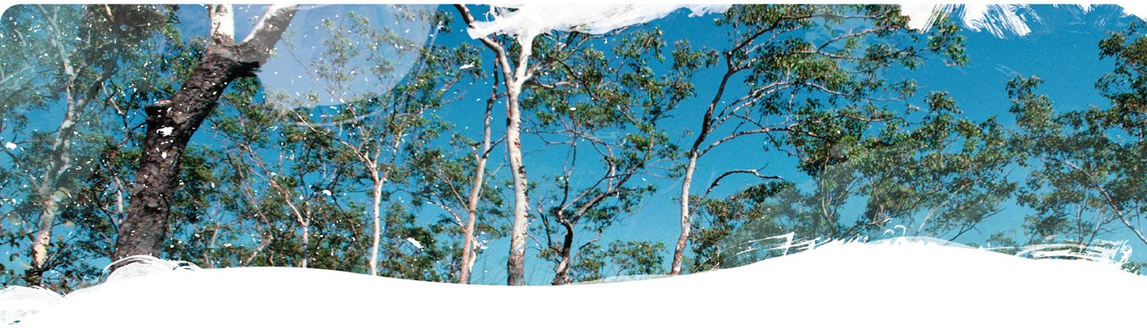The GBA Program

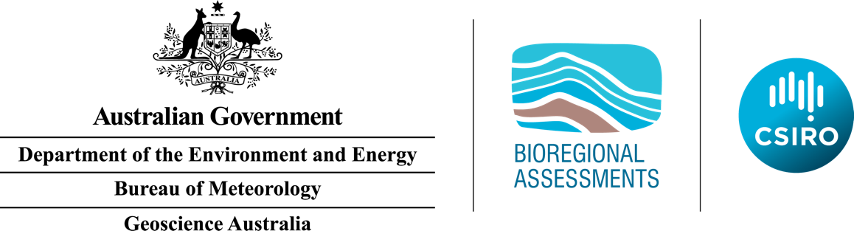

Geological and Bioregional Assessment Program

The $35.4 million Geological and Bioregional Assessment (GBA) Program is assessing the potential environmental impacts of shale and tight gas development to inform regulatory frameworks and appropriate management approaches. The geological and environmental knowledge, data and tools produced by the GBA Program will assist governments, industry, landowners and the community by informing decision making and enabling the coordinated management of potential impacts.

A series of independent scientific studies in three geological basins – the Cooper Basin in Queensland and SA, the Isa Superbasin in Queensland and the Beetaloo Sub-basin in NT – are being conducted by CSIRO and Geoscience Australia, supported by the Bureau of Meteorology and managed by the Department of the Environment and Energy. These scientific studies aim to provide baseline information that:

|  |  |
| --- | --- |
|  | Identifies and evaluates areas of high potential for shale and tight gas for future development and any potential connections with water resources |
|  | Collates and summarises key information, such as their geology, how groundwater moves through geological layers, the nature of the surface water and ecological systems |
|  | Evaluates possible ways that unconventional gas resource development might impact the things we value, such as Cooper Creek floodplain, groundwaters, protected species, as well as culturally and ecologically important ecosystems. |

User panels

Each assessment is informed by a user panel, where user needs and Program findings are discussed and information is shared. The user panel for the Cooper GBA region includes people from local government, natural resource management bodies, state governments, Traditional Owner groups, pastoralists, industry and other land user groups. The assessments will inform and support future Commonwealth, State and Territory regulatory and management approaches.

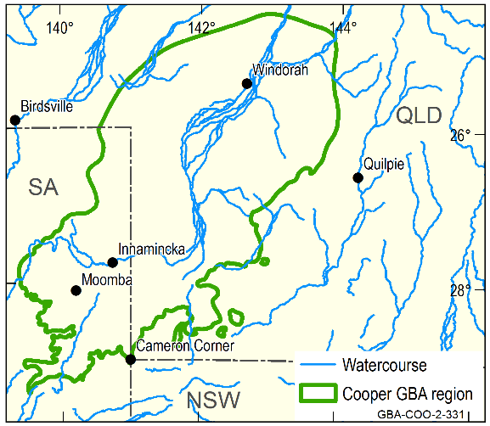Cooper GBA region

The Cooper GBA region covers an area of approximately 130,000 km2 (pictured at right). It is primarily located in the Cooper Creek catchment, which extends from north of Windorah in Queensland to south of Innamincka in SA. This factsheet explains the aim of fieldwork in the Cooper GBA region. Fieldwork is a vital part of the GBA Program, providing new knowledge and data to inform analyses of the potential impacts of unconventional gas extraction activities on water and the environment. This new information will increase our overall knowledge of the Cooper GBA region and leave behind data will be available for all users for future applications such as the management of water resources, cultural heritage and biodiversity conservation.

**Location of the Cooper GBA region**

Fieldwork and modelling

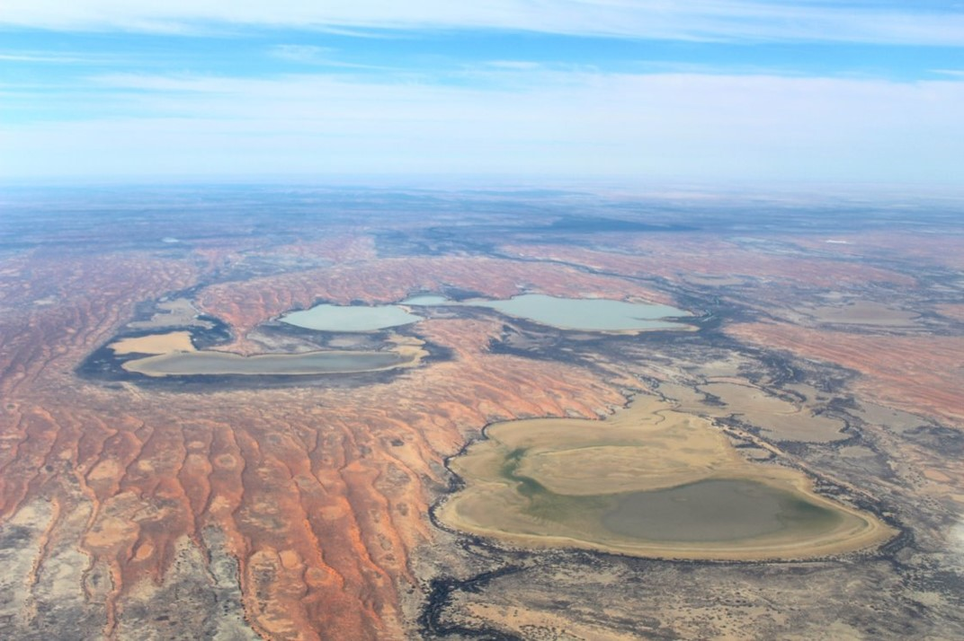

Coongie Lakes is a Ramsar-listed wetland, highlighting that it is a wetland of national and international significance

Credit: Geological and Bioregional Assessment Program, Alex Tomlinson (Department of the Environment and Energy), September 2018

Given the remote nature and vast area of the Cooper GBA region, it is crucial that new regional-scale information is collected to help inform decisions about future water resource planning, investment and management.

Field observations and measurements of surface waters and groundwaters from properties across the Cooper GBA region will help the GBA Program to better understand water resources and their connection to the environment.

Fieldwork and modelling, planned for late 2019, will address knowledge gaps related to floods, floodplains, waterholes and groundwater in the underlying aquifers of the Lake Eyre geological Basin, Great Artesian Basin and the Cooper geological basins.

The sampling will contribute new information linked with three activities:

|  |  |
| --- | --- |
|  | **Floods and floodplains:** Build a model to show how water moves over floodplains when Cooper Creek floods. This will help us to better understand water connections between floodplains, wetlands and river channels and to assess how roads and infrastructure affect water movement. |
|  | **Waterholes and shallow groundwater:** Take samples from waterholes and shallow groundwater to analyse the chemical composition. This will help us to better understand any possible connections between shallow groundwater on the floodplain (less than 30 m deep) and deeper aquifers (greater than 300 m deep). Soil and water samples from near waterholes, as well as remotely sensed satellite data, will help us to better understand groundwater-dependent ecosystems that rely on shallow groundwater under the Cooper Creek floodplain. |
|  | **Deeper groundwater:** Take samples from groundwater bores installed in aquifers in the Lake Eyre, Eromanga (part of the Great Artesian Basin) and Cooper geological basins. This will help us answer questions about groundwater quality; how and when groundwater was recharged; and to better understand possible connections between the aquifers. |

We need your help

With help from the Cooper GBA user panel and local landholders and custodians, the GBA Program is seeking permission to sample selected waterholes and groundwater bores across the region.

|  |  |
| --- | --- |
|  | **Find out more**  <https://www.bioregionalassessments.gov.au/geological-and-bioregional-assessment-program> |