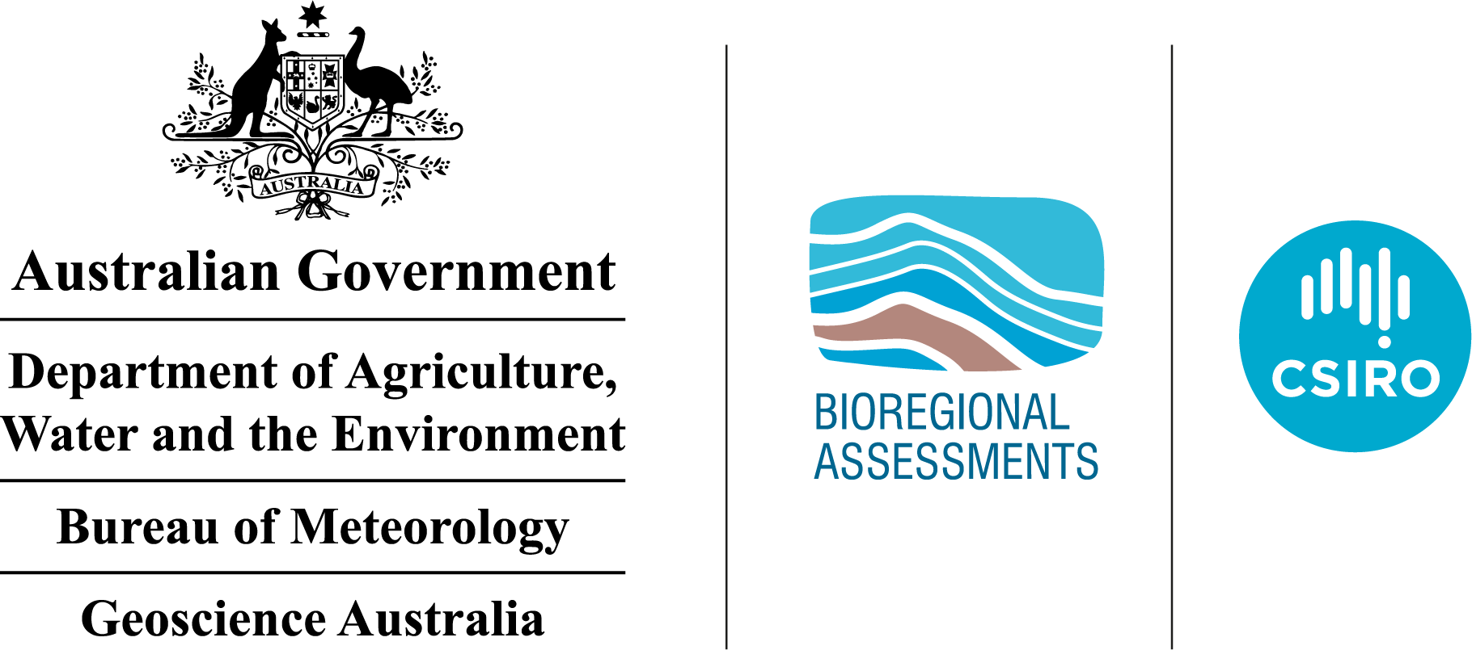The GBA Program

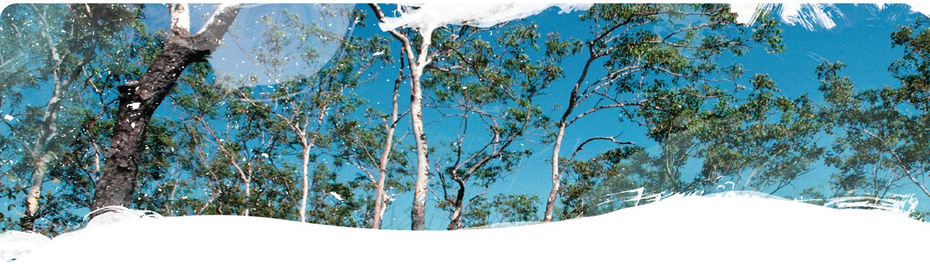

Geological and Bioregional Assessment Program

The $35.4 million Geological and Bioregional Assessment (GBA) Program is assessing the potential environmental impacts of shale and tight gas development to inform regulatory frameworks and appropriate management approaches. The geological and environmental knowledge, data and tools produced by the GBA Program will assist governments, industry, landowners and the community by informing decision making and enabling the coordinated management of potential impacts.

A series of independent scientific studies in three geological basins – the Cooper Basin in Queensland and SA, the Isa Superbasin in Queensland and the Beetaloo Sub-basin in NT – are being conducted by CSIRO and Geoscience Australia, supported by the Bureau of Meteorology and managed by the Department Agriculture, Water and the Environment. These scientific studies aim to provide baseline information that:

|  |  |
| --- | --- |
|  | identifies and evaluates areas of high potential for shale and tight gas for future development and any potential connections with water resources |
|  | collates and summarises key information about geological structure, groundwater movement through geological layers, surface water systems and ecological systems |
|  | evaluates possible ways that unconventional gas resource development might impact the things we value, such as the Cambrian Limestone Aquifer (CLA), groundwater dependent ecosystems, surface water, protected species, as well as culturally and ecologically important matters |

User panels

Each assessment is informed by a user panel, where user needs and Program findings are discussed, and information is shared. The user panel for the Beetaloo GBA region includes people from local, territory and federal governments, Land Councils, farmers, pastoralists, environmental NGO’s, industry and other land user groups. The assessments will inform and support future regulatory frameworks and appropriate management approaches.

The Beetaloo GBA region

The Beetaloo GBA region coincides with extent of the Beetaloo Sub-basin and covers an area of about 28,000 km2. The Beetaloo GBA region (Figure 1) is located about 500 kilometres south of Darwin and includes a substantial proportion of the Cambrian Limestone Aquifer, the principal water resource in the region. The region is sparsely populated, with Daly Waters and Elliott the most populated settlements in the region. The Beetaloo Sub-basin is one of the most prospective areas for shale gas in Australia, as well as having potential for liquid hydrocarbons.

At a glance: The Geological and environmental baseline assessment for the Beetaloo GBA region

The geological and environmental baseline assessment for the Beetaloo GBA region (Stage 2) integrates data, knowledge and conceptual models that are the building blocks for the Stage 3 impact analysis and management.

|  |  |  |
| --- | --- | --- |
|  | **Geology and gas resources:** Areas of higher prospectivity for shale gas, tight gas and shale oil include the Kyalla and Velkerri formations within the Mesoproterozoic Roper Group and the Hayfield mudstone (Figure 1). This is consistent with the location of recent exploration activity. | Figure 1 The Beetaloo GBA region and extended GBA region |
|  | **Groundwater*:*** The Cambrian Limestone Aquifer (CLA) is an important groundwater resource with water quality suitable for agricultural, domestic and industrial uses. The Mesoproterozoic Roper Group, prospective for oil and gas, is not accessed for groundwater due to its depth and poor water quality. |
|  | **Surface water:** Most streams in the region are ephemeral and only flow in response to wet season rains. Groundwater from the region supports the Roper River and important wetlands such as Mataranka Thermal Pools and Limmen Bight (Port Roper) Tidal Wetlands System. |
|  | **Water availability:** NT legislation prohibits the use of surface water for unconventional petroleum industry activities and groundwater extraction must be licensed. Groundwater and re-use of produced water from future unconventional resource extraction are possible water sources that need further investigation. | Potential hydrological connections: The characteristics of the Kyalla and Velkerri formations within the Roper Group are likely to impede connections between the petroleum resource and groundwater. Possible connections between the Hayfield mudstone and overlying groundwater systems will be investigated in Stage 3. |
|  | **Protected matters:** National and NT protected matters were documented and prioritised based on the importance of the Beetaloo GBA extended region to the matter. Stage 3 will assess in greater detail (priority 1) five protected species (four nationally listed, one territory listed), two nationally important wetlands and groundwater-dependent ecosystems. | Regional-scale assessment (priority 2) will focus on landscape classes based on conceptual models of how landscapes function ecologically. The Beetaloo GBA region was categorised into six landscape classes, dominated by the ‘loamy and sandy plains’ and ‘clay plains’ landscape classes. |
|  | **Potential impacts:** The impact and risk assessment approach uses hazard identification as a first step, with about 180 individual hazards identified. Using causal pathways – the logical chain of events that links unconventional gas resource development with potential impacts on water and the environment – 13 causal pathways were identified and aggregated into three groups. | In Stage 3 the links between the causal pathways and potential impacts will be investigated. For example, do unconventional petroleum resource development activities change groundwater quality and availability, fragment habitats and/or introduce invasive species? Eleven causal pathways will be assessed for these and other impacts in Stage 3. |

|  |  |
| --- | --- |
|  | **Find out more**  <https://www.bioregionalassessments.gov.au/geological-and-bioregional-assessment-program> |