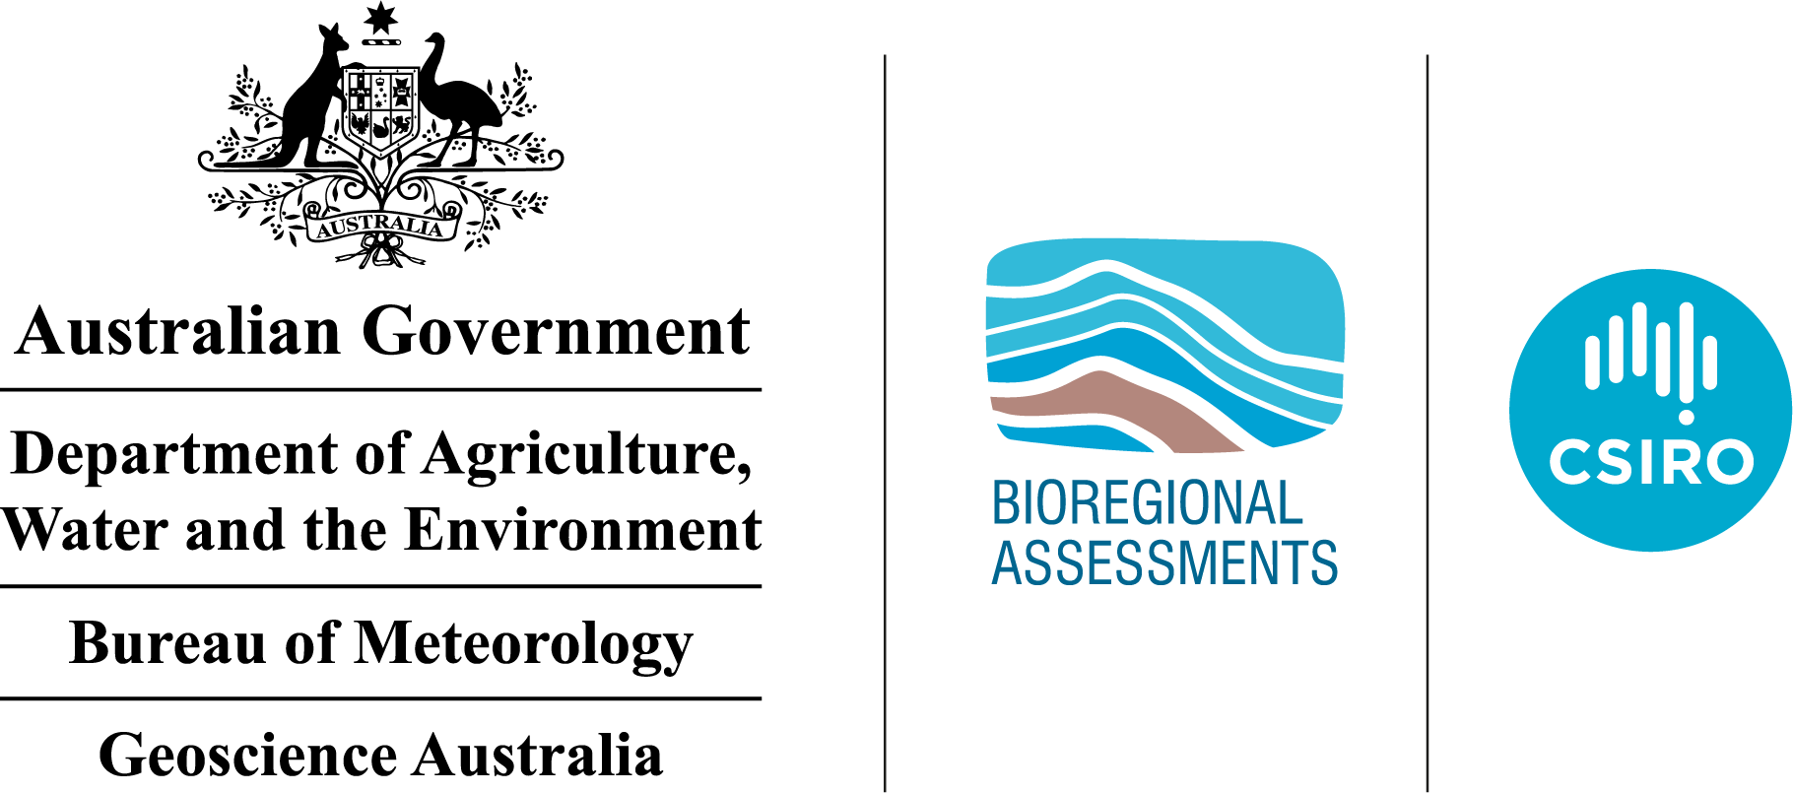


Petroleum prospectivity of the Beetaloo Sub-basin
Technical appendix for the Geological and Bioregional Assessment: Stage 2
2020

The Geological and Bioregional Assessment Program will provide independent scientific advice on the potential impacts from development of selected unconventional hydrocarbon plays on water and the environment. The geological and environmental data and tools produced by the Program will assist governments, industry, landowners and the community to help inform decision making and enhance the coordinated management of potential impacts.
The Program is funded by the Australian Government Department of the Environment and Energy. The Department of the Environment and Energy, Bureau of Meteorology, CSIRO and Geoscience Australia are collaborating to undertake geological and bioregional assessments. For more information, visit http://www.bioregionalassessments.gov.au.
Department of the Environment and Energy
The Department designs and implements Australian Government policy and programs to protect and conserve the environment, water and heritage, promote climate action, and provide adequate, reliable and affordable energy. For more information visit http://www.environment.gov.au.
Bureau of Meteorology
The Bureau of Meteorology is Australia’s national weather, climate and water agency. Under the Water Act 2007, the Bureau is responsible for compiling and disseminating Australia's water information. The Bureau is committed to increasing access to water information to support informed decision making about the management of water resources. For more information, visit http://www.bom.gov.au/water/.
CSIRO
Australia is founding its future on science and innovation. Its national science agency, CSIRO, is a powerhouse of ideas, technologies and skills for building prosperity, growth, health and sustainability. It serves governments, industries, business and communities across the nation. For more information, visit http://www.csiro.au.
Geoscience Australia
Geoscience Australia is Australia’s national geoscience agency and exists to apply geoscience to Australia’s most important challenges. Geoscience Australia provides geoscientific advice and information to the Australian Government to support current priorities. These include contributing to responsible resource development; cleaner and low emission energy technologies; community safety; and improving marine planning and protection. The outcome of Geoscience Australia’s work is an enhanced potential for the Australian community to obtain economic, social and environmental benefits through the application of first-class research and information. For more information, visit http://www.ga.gov.au.
ISBN-PDF 978-1-76003-273-9
Citation
Hall LS, Wang L, Bailey AHE, Orr ML, Owens R, Jarrett AJM, Lech ME, Skeers N, Reese, B and Woods M (2020) Petroleum prospectivity of the Beetaloo Sub-basin. Technical appendix for the Geological and Bioregional Assessment Program: Stage 2. Department of the Environment and Energy, Bureau of Meteorology, CSIRO and Geoscience Australia, Australia.
Authorship is listed in relative order of contribution.
On 1 February 2020 the Department of the Environment and Energy and the Department of Agriculture merged to form the Department of Agriculture, Water and the Environment. Work for this document was carried out under the then Department of the Environment and Energy. Therefore, references to both departments are retained in this report.
Copyright
 © Commonwealth of Australia 2020
With the exception of the Commonwealth Coat of Arms and where otherwise noted, all material in this publication is provided under a Creative Commons Attribution 4.0 International Licence https://creativecommons.org/licenses/by/4.0/. The Geological and Bioregional Assessment Program requests attribution as ‘© Commonwealth of Australia (Geological and Bioregional Assessment Program http://www.bioregionalassessments.gov.au)’.
Disclaimer
The information contained in this report is based on the best available information at the time of publication. The reader is advised that such information may be incomplete or unable to be used in any specific situation. Therefore, decisions should not be made based solely on this information or without seeking prior expert professional, scientific and technical advice.
The Geological and Bioregional Assessment Program is committed to providing web accessible content wherever possible. If you are having difficulties with accessing this document, please contact BioregionalAssessments@awe.gov.au.
Cover photograph
Mataranka Thermal Pools, Beetaloo GBA extended region, October 2018
Credit: Alf Larcher (CSIRO)
Element: GBA-BEE-2-381

Executive summary
An assessment of petroleum plays in the Beetaloo Sub-basin likely to be developed in a five to ten year time frame has been undertaken as part of the Australian Government’s Geological and Bioregional Assessment Program. This aims to both encourage exploration and to understand the potential impacts of petroleum resource development on water resources and the environment.
The Beetaloo Sub-basin is a structural component of the greater McArthur Basin in the NT, located about 500 km south-east of Darwin. It covers an area of approximately 28,000 km² and contains a succession of Mesoproterozoic Roper Group sediments more than 5000 m thick. The Beetaloo Sub-basin represents a broad depression bounded by several prominent structural highs, and it is divided into eastern and western elements by the Daly Waters High. The outline of the Beetaloo Sub-basin used in this study is that defined by the Northern Territory Government (Department of Primary Industry and Resources (NT), 2017a). Overlying sedimentary basins include the Neoproterozoic to Paleozoic Georgina, Wiso and Daly basins and the Mesozoic Carpentaria Basin.
The Beetaloo Sub-basin is prospective for unconventional hydrocarbons, and is estimated to contain significant technically recoverable shale and tight gas resources. Plays most likely to be developed in a five to ten year time frame in the Beetaloo Sub-basin include shale plays in the Kyalla Formation and the Amungee Member of the Velkerri Formation. In 2017, following completion of extended production testing at the Amungee NW-1H exploration well, Origin booked 2C contingent resources of 6.6 Tcf for the “B shale” interval in the Amungee Member of the Velkerri Formation. An additional play in the Beetaloo GBA region most likely to be developed in a five to ten year time frame is a tight sandstone play in the Hayfield sandstone member of the Hayfield mudstone. This play occurs in the Neoproterozoic units overlying the Beetaloo Sub-basin.
The volume of hydrocarbons present within a play, as well as the proportion of gas and liquids that can be produced, depends on the play type and the specific geological characteristics of both the source and reservoir rocks. To underpin further work on understanding likely development scenarios, the physical formation properties required for each play to be successful were characterised and play fairway analysis used to map the relative prospectivity of each play across the Beetaloo GBA region. Results show that the Amungee Member of the Velkerri Formation is potentially prospective for either liquids-rich or dry gas over most of the Beetaloo Sub-basin. The Kyalla Formation liquids-rich gas play and Hayfield sandstone member liquids-rich gas/oil play are primarily restricted to the eastern sub-basin area.
Although the extent of the plays mapped here inform the assessment of potential impacts on associated assets at the surface and overlying surface water – groundwater systems, this analysis is based on geological constraints only. Considering the development of each play in the context of likely economic outcomes is important for any future analysis.

Contents
Executive summary i
Contributors to the Program xi
Acknowledgements xii
Abbreviations and acronyms xiii
Units xv
The Geological and Bioregional Assessment Program xvii
1 Introduction 1
2 Conventional and unconventional petroleum 5
3 Petroleum prospectivity of the Beetaloo Sub-basin 9
3.1 Exploration history 11
3.2 Reserves and resources 14
3.3 Market access and infrastructure 15
3.4 Regional petroleum systems 17
4 Petroleum play characterisation 23
4.1 Introduction to petroleum play characterisation 23
4.2 Characteristics by formation 24
4.3 Source rock maturity 78
4.4 Regional stress and overpressure 89
5 Prospectivity mapping 99
5.1 Plays to be assessed 99
5.2 Workflow 99
5.3 Results 102
6 Conclusions 109
6.1 Key findings 109
6.2 Gaps, limitations and opportunities 110
References 112
Glossary 126

Figures
Figure 1 Geological setting of the Beetaloo Sub-basin 1
Figure 2 Stratigraphy of the greater McArthur Basin (Beetaloo Sub-basin), the Georgina, Wiso and Daly basins, and Carpentaria Basin in the Beetaloo GBA region 3
Figure 3 Structural elements map of the Beetaloo Sub-basin showing major faults, overlain on the total sediment thickness from the base of the Mesoproterozoic Roper Group 4
Figure 4 The different types of conventional and unconventional petroleum accumulations 5
Figure 5 Schematic showing some of the typical types of oil and gas accumulations. These types of conventional and unconventional petroleum accumulations are commonly observed in sedimentary basins, except for gas hydrates, which are located in sediments on the deep continental shelf 7
Figure 6 Petroleum resources nomenclature in terms of chemical composition, commercial product, physical state in the subsurface and physical state at the surface 8
Figure 7 Beetaloo Sub-basin exploration, retention and production permit operators 9
Figure 8 Wells targeting shale and/or tight gas plays in the Beetaloo Sub-basin and adjacent areas of the greater McArthur Basin 12
Figure 9 Two-dimensional seismic data coverage across the Beetaloo Sub-basin and surrounding areas 13
Figure 10 Beetaloo Sub-basin infrastructure and pipelines 16
Figure 11 Petroleum systems element chart for the Beetaloo Sub-basin 19
Figure 12 Schematic and type sections of the identified plays within and over the Beetaloo Sub-basin. GR= gamma ray. TGAS= total mud gas 20
Figure 13 Formal sub-division of Velkerri Formation displayed on composite gamma ray and resistivity logs from Pacific Oil and Gas Ltd drillholes in the Beetaloo Sub-basin 21
Figure 14 Velkerri Formation top depth (m MSL) 26
Figure 15 Velkerri Formation total vertical thickness (m) 27
Figure 16 Velkerri Formation source rock characteristics in the a) Amungee NW1 and b) Beetaloo W1 wells in the eastern Beetaloo Sub-basin 31
Figure 17 Velkerri Formation source rock characteristics in the a) Birdum Creek 1 and b) Tarlee 2 wells in the western Beetaloo Sub-basin 32
Figure 18 Velkerri Formation TOC distribution shown over the depth to base Roper Group 33
Figure 19 Rock-Eval pyrolysis data plots for the Velkerri Formation: (a) TOC carbon vs S2 yield; (b) Tmax vs present day HI 34
Figure 20 a) Net organically rich ratios of the Velkerri Formation shales and b) net Velkerri Formation source rock thickness in the Beetaloo Sub-basin and surrounds 35
Figure 21 Kalala Member (Velkerri Formation) TOC distribution show over the depth to base Roper Group 36
Figure 22 Rock-Eval pyrolysis data plots for the Kalala Member of the Velkerri Formation, modified from Jarrett et al. (2019): (a) TOC content vs S2 yield; (b) Tmax vs HI 37
Figure 23 Amungee Member (Velkerri Formation) TOC distribution shown over the depth to base Roper Group 39
Figure 24 Rock-Eval pyrolysis data plots for the Amungee Member of the Velkerri Formation: (a) TOC content vs S2 yield; (b) Tmax vs HI 40
Figure 25 a) Net organically rich ratios of the Amungee Member shales and b) net Amungee Member source rock thickness in the Beetaloo Sub-basin 41
Figure 26 Wyworrie Member of the Velkerri Formation TOC (wt%) distribution show over the depth to base Roper Group 43
Figure 27 Rock-Eval pyrolysis data plots for the Wyworrie Member of the Velkerri Formation: (a) TOC content vs S2 yield; (b) Tmax vs HI 44
Figure 28 Petrophysical properties of the Velkerri Formation: (a) Averaged dry helium porosity, (b) as-received oil saturation, (c) gas saturation and (d) pressure decay permeability (PDPM) 48
Figure 29 Ternary plot of mineral content (wt% fraction) for shales of the Amungee Member, previously known as the middle Velkerri Formation (Revie, 2017c) 53
Figure 30 Velkerri Formation mud gas data for a) Amungee NW-1 and b) Beetaloo W1 55
Figure 31 Kyalla Formation top depth (m) 59
Figure 32 Kyalla Formation total vertical thickness (m) 60
Figure 33 Kyalla Formation source rock characteristics in the a) Amungee NW 1 and b) Beetaloo W1 wells in the eastern Beetaloo Sub-basin 62
Figure 34 Kyalla Formation source rock characteristics in the a) Birdum Creek 1 and b) Tarlee 2 wells in the western Beetaloo Sub-basin 63
Figure 35 Total organic carbon distribution of the Kyalla Formation 64
Figure 36 Rock-Eval pyrolysis data plots for the Kyalla Formation: (a) TOC content vs S2 yield; (b) Tmax vs HI 65
Figure 37 Petrophysical properties of the Kyalla Formation: (a) averaged dry helium porosity, (b) as-received oil saturation, (c) gas saturation and (d) pressure decay permeability 67
Figure 38 Ternary plot of XRD mineral content (wt% fraction) for shales of the Kyalla Formation in the Beetaloo Sub-basin 71
Figure 39 Kyalla Formation mud gas data for a) Amungee NW-1 and b) Beetaloo W1 73
Figure 40 Jamison sandstone top depth (m), equivalent to base of the Hayfield mudstone 76
Figure 41 Location of wells used for the burial and thermal history modelling review 79
Figure 42 Transformation ratio (TR) curves calculated using bulk kinetics. A) TR plotted against maturity (calculated vitrinite reflectance equivalent; %VR) and B) TR plotted against temperature (°C) 82
Figure 43 Modelled burial history for Tarlee 3 a) burial history, showing temperature contours and coloured by thermal maturity; b) modelled present day temperature-depth profile, with bottom hole temperature measurement; c) modelled maturity-depth profile. Bitumen reflectance data converted to equivalent vitrinite reflectance values using the conversion equation of Jacob (1989) 84
Figure 44 Modelled burial history for Birdum Creek 1 a) burial history, showing temperature contours and coloured by thermal maturity; b) modelled present day temperature-depth profile, with corrected bottom hole temperature measurement; c) modelled maturity-depth profile, with measured bitumen reflectance data converted to equivalent vitrinite reflectance values using the conversion equation of Jacob (1989) 85
Figure 45 Modelled burial history for Jamison 1 a) burial history, showing temperature contours and coloured by thermal maturity; b) modelled present day temperature-depth profile, with correct bottom hole temperature measurement; c) modelled maturity-depth profile, with measured bitumen reflectance data converted to equivalent vitrinite reflectance values using the conversion equation of Jacob (1989) 86
Figure 46 Source rock maturity map for the mid-depth of the Amungee Member of the Velkerri Formation 87
Figure 47 Source rock maturity map for the mid-depth of the Kyalla Formation 88
Figure 48 Tectonic stress regimes as defined by Anderson (1951), highlighting the relative magnitudes of the three principle stresses. Vertical stress is shown in green, maximum horizontal stress in red, and minimum horizontal stress in brown 90
Figure 49 Australian Stress Map data (Rajabi et al., 2017) showing the 30 defined stress provinces and continent-scale stress orientations. The location of the Beetaloo Basin, as well as local stress orientations not currently provided in the ASM, are also displayed 92
Figure 50 Schematic mechanical earth model showing lithology, mechanical stratigraphy, and calculated stress profiles 93
Figure 51 One-dimensional mechanical earth model (1D MEM) constructed for the Santos well Tanumbirini 1 by Santos Ltd., highlighting variations in stress regime within the subsurface as well as significant stress containment boundaries likely to act as natural barriers to induced fracture propagation 95
Figure 52 Pore pressure measurements from drill stem tests (DSTs – blue circles) plotted alongside mud weight data from 13 Beetaloo Sub-basin petroleum wells 97
Figure 53 Schematic workflow for combining classified prospectivity confidence input parameter maps to obtain the overall combined relative prospectivity of a formation or play 101
Figure 54 Classified input parameters maps used to generate the Amungee Member shale dry gas play relative prospectivity map 102
Figure 55 Play fairway map showing the variation in relative prospectivity of the Amungee Member shale dry gas play across the Beetaloo Sub-basin 103
Figure 56 Classified input parameters maps used to generate the Amungee Member shale liquids-rich gas play relative prospectivity map 104
Figure 57 Play fairway map showing the variation in relative prospectivity of the Amungee Member shale liquids-rich gas play across the Beetaloo Sub-basin 105
Figure 58 Classified input parameters maps for the Kyalla Formation shale liquids-rich gas play 106
Figure 59 Play fairway map showing the variation in relative prospectivity of the Kyalla Formation shale liquids-rich gas play across the Beetaloo Sub-basin 107
Figure 60 Hayfield sandstone member play extent 108

Tables
Table 1 Beetaloo GBA region petroleum prospectivity summary 10
Table 2 Summary of market access and infrastructure 16
Table 3 Petroleum systems elements 17
Table 4 Key features of the Velkerri Formation 24
Table 5 Velkerri Formation source rock properties. Statistics are based on the analysis of 2734 TOC samples and 741 Rock-Eval pyrolysis samples. Rock-Eval pyrolysis data was quality controlled prior to calculating statistics using the screening criteria defined in Jarrett et al. (2018) 33
Table 6 Net organically rich ratio (NORR) of the Velkerri Formation shales in the Beetaloo Sub-basin 34
Table 7 Kalala Member source rock properties. Statistics are based on the analysis of 505 TOC samples and 75 Rock-Eval pyrolysis samples. Rock-Eval pyrolysis data was quality controlled prior to calculating statistics using the screening criteria defined in Jarrett et al. (2018) 36
Table 8 Net organically rich ratio (NORR) of the Kalala Member shales in the Beetaloo Sub-basin 37
Table 9 Amungee Member source rock properties. Statistics based on analysis of 1520 TOC samples and 525 Rock-Eval pyrolysis samples. Rock-Eval pyrolysis data was quality controlled prior to calculating statistics using the screening criteria defined in Jarrett et al. (2018) 38
Table 10 Net organically rich ratio (NORR) of the Amungee Member shales in the Beetaloo Sub-basin 40
Table 11 Wyworrie Member source rock properties. Statistics are based on the analysis of 669 TOC samples and 117 Rock-Eval pyrolysis samples. Rock-Eval pyrolysis data was quality controlled prior to calculating statistics using the screening criteria defined in Jarrett et al. (2018) 42
Table 12 Net organically rich ratio (NORR) of the Wyworrie Member shales in the Beetaloo Sub-basin 44
Table 13 Average laboratory measured as-received shale rock properties of the entire Velkerri Formation for key wells in the Beetaloo Sub-basin and surrounds 45
Table 14 Average laboratory measured as-received shale rock properties of the Wyworrie Member of the Velkerri Formation for key wells in the Beetaloo Sub-basin and surrounds 46
Table 15 Average laboratory measured as-received shale rock properties of the Amungee Member of the Velkerri Formation for key wells in the Beetaloo Sub-basin and surrounds 46
Table 16 Average laboratory measured as-received shale rock properties of the Kalala Member of the Velkerri Formation for key wells in the Beetaloo Sub-basin and surrounds 47
Table 17 Desorbed gas content test results of the shale samples from the Amungee Member in Shendandoah 1/1A (“B Shale”), Tarlee 1 and Tarlee 2 49
Table 18 Averaged methane isotherm test data of 23 samples from the Amungee Member in the Beetaloo Sub-basin and surrounds 50
Table 19 Averaged gas storage capacities of different storage mechanisms of two Amungee Member shale samples from Shenandoah 1/1A in the Beetaloo Sub-basin 51
Table 20 Main mineral assemblage statistics of the Wyworrie, Amungee and Kalala members analysed by XRD and average brittleness indices estimated from mineral assemblages using the method of Jarvie et al. (2007) 52
Table 21 Integrated contaminant-corrected gas composition of the Amungee Member B shale from Shenandoah 1/1A 54
Table 22 Averaged hydrocarbon (gas) compositions (mol%) of the whole Velkerri Formation derived from mud logging data in the Beetaloo Sub-basin 55
Table 23 N₂ and O₂ set to zero gas compositions of the desorbed gas samples from the Amungee Member shales in Tarlee 1 (Pangaea NT Pty Ltd, 2019) 56
Table 24 Key features of the Kyalla Formation 57
Table 25 Kyalla Formation source rock properties. Statistics are based on analysis of 960 TOC samples and 520 Rock-Eval pyrolysis samples. Rock-Eval pyrolysis data was quality controlled prior to calculating statistics using the screening criteria defined in Jarrett et al. (2018) 64
Table 26 Present day net organically rich ratio (NORR) of the Kyalla Formation shales in the Beetaloo Sub-basin and surrounds 65
Table 27 Average laboratory measured as-received shale rock properties of Kyalla Formation for key wells in the Beetaloo Sub-basin 66
Table 28 Desorbed gas content test results of the lower Kyalla Formation shales in Shendandoah 1/1A and Tarlee 1 68
Table 29 Methane isotherm test data of 7 Kyalla Formation shale samples from Shenandoah 1/1A, Tanumbirini 1 and Tarlee 1 in the Beetaloo Sub-basin and surrounds 69
Table 30 Averaged gas storage capacities of different storage mechanisms of two Kyalla Formatino shale samples from Shenandoah 1/1A in the Beetaloo Sub-basin 69
Table 31 Main mineral assemblage statistics of the Kyalla Formation analysed by XRD and average brittleness indices estimated from mineral assemblages using the method of Jarvie et al. (2007) 70
Table 32 Integrated contaminant-corrected gas composition of Kyalla Formation shale 72
Table 33 Averaged hydrocarbon (gas) compositions (mole %) of the whole Kyalla Formation derived from mud logging data in the Beetaloo Sub-basin 73
Table 34 N₂ and O₂ set to zero gas compositions of the desorbed gas samples from the Kyalla Formation shales in Tarlee 1 74
Table 35 Key features of the Hayfield sandstone member 75
Table 36 Main mineral assemblage statistics of the Hayfield sandstone member analysed by XRD and average brittleness indices estimated from mineral assemblages using the method of Jarvie et al. (2007) 77
Table 37 Averaged hydrocarbon (gas) compositions (mole %) of the Hayfield mudstone derived from mud logging data in the Beetaloo Sub-basin 78
Table 38 Amounts of erosion for major unconformities of the Beetaloo Sub-basin at modelled well locations 80
Table 39 Thermal maturity windows 83
Table 40 Summary of shale gas play specific input parameters and classifying criteria used to develop play fairway maps. 100

Contributors to the Program
The following individuals have contributed to the Geological and Bioregional Assessment Program.
Role or team | Contributor(s)
Program Director | Department of the Environment and Energy: Anthony Swirepik
Program Implementation Board | Department of the Environment and Energy: Beth Brunoro, Nicholas Post  Bureau of Meteorology: Kirsten Garwood, Kate Vinot  CSIRO: Jane Coram, Warwick MacDonald  Geoscience Australia: Stuart Minchin, Richard Blewett
Basin Leader | CSIRO: Kate Holland, Cameron Huddlestone-Holmes, Paul Wilkes  Geoscience Australia: Steven Lewis
Program management | CSIRO: Karen Barry, Emanuelle Frery, Linda Merrin, Ruth Palmer  Department of the Environment and Energy: Mitchell Bouma, Rod Dann,  Andrew Stacey, David Thomas, Alex Tomlinson
Product integration and stakeholder engagement | CSIRO: Clare Brandon, Justine Lacey, Michelle Rodriquez, Sally Tetreault-Campbell
Analysis and visualisation | CSIRO: Dennis Gonzalez, Steve Marvanek  Geoscience Australia: Adrian Dehelean, Chris Evenden, Chris Lawson, Bianca Reese, Nigel Skeers, Murray Woods
Basin geology and prospectivity | Geoscience Australia: Lisa Hall (Discipline Leader), Adam Bailey, George Bernardel, Barry Bradshaw, Donna Cathro, Merrie-Ellen Gunning, Amber Jarrett, Megan Lech, Meredith Orr, Ryan Owens, Tehani Palu, Martin Smith, Liuqu Wang
Chemical assessment | CSIRO: Jason Kirby (Discipline Leader), Simon Apte, Lisa Golding, Rai Kookana,  Dirk Mallants, Michael Williams
Data management and transparency | Bureau of Meteorology: Andre Zerger (Discipline Leader), Derek Chen,  Trevor Christie-Taylor, Donna Phillips  CSIRO: Nicholas Car, Philip Davies, Stacey Northover, Matt Stenson  Geoscience Australia: Matti Peljo
Hydrogeology | Geoscience Australia: Tim Ransley (Discipline Leader), Sam Buchanan, Scott Cook, Prachi Dixon-Jain, Bex Dunn, Tim Evans, Éamon Lai, Bruce Radke,  Baskaran Sundaram
Impact analysis | CSIRO: David Post (Discipline Leader), Brent Henderson, Dane Kasperczyk,  James Kear, Regina Sander
Impacts on protected matters | CSIRO: Anthony O'Grady (Discipline Leader), Alexander Herr, Craig MacFarlane, Justine Murray, Chris Pavey, Stephen Stewart
Spatial analysis | CSIRO: Dennis Gonzalez, Steve Marvanek  Geoscience Australia: Adrian Dehelean, Murray Woods, Nigel Skeers
Water quantity | CSIRO: Russell Crosbie (Discipline Leader), Jorge Martinez Praveen Kumar Rachakonda, Matthias Raiber, Yongqiang Zhang, Hongxing Zheng

Acknowledgements
This technical product was reviewed by several groups:
- Internal Peer Review Group: CSIRO: Mohinudeen Faiz - Geoscience Australia: Susannah MacFarlane, Merrie-Ellen Gunning
- Technical Peer Review Group: Andrew Boulton, Peter McCabe, Catherine Moore, Jenny Stauber
- State and Territory Government Science Technical Review: This group includes scientists and engineers from the Northern Territory Government.
Valuable comments were also provided by Dot Close, Tim Munson, Ben Williams (Northern Territory Geological Survey), Todd Hoffman (Pangaea Resources), David Close, Angus McIntyre (Santos), Alexander Côté, Brenton Richards and Elizabeth Baruch (Origin Energy).

Abbreviations and acronyms
Abbreviation/acronym | Definition
AER | Australian Energy Regulator
AERA | Australian Energy Resources Assessment
API | American Petroleum Institute
A-R | as received
BI | brittleness index
BV | bulk volume
CSIRO | Commonwealth Scientific and Industrial Research Organisation
CO2 | carbon dioxide
CSG | coal seam gas
DOM | dispersed organic matter
DST | drill stem test
EIA | United States Energy Information Administration
GBA | Geological and Bioregional Assessment
GIP | gas-in-place
GOR | gas-to-oil ratio
HI | Hydrogen Index
Ma | million years before the present
MD | measured depth along borehole
MEM | mechanical earth model
MSL | mean sea level
NORR | net organically rich ratio
NSW | New South Wales
NT | Northern Territory
PDPM | pressure decay permeability
PRMS | Petroleum Resources Management System
PV | pore volume
SA | South Australia
SPE | Society of Petroleum Engineers
TOC | total organic carbon
TR | transformation ratio
USGS | United States Geological Survey
WMS | web map service
wt | weight
XRD | X-ray Diffraction

Units
Unit | Description
bbl | barrels
bbl/mmscf | barrels per million standard cubic feet
Bcm | billion cubic metres
%EqVR | vitrinite reflectance equivalent (as a percentage)
g/cc | grams per cubic centimetre
km | kilometres
kPa | kilopascals
MPa | megapascals
MPa/km | megapascals per kilometre
m | metres
m³ | metres cubed
mD | milliDarcy
mg HC/g TOC | milligrams of hydrocarbons per gram of total organic carbon
mg CO₂/g TOC | milligrams of CO₂ per gram of total organic carbon
mg/g | milligrams per gram
mg/L | milligrams per litre
mm/y | millimetres per year
mmbbl | million barrels
mmcfd | million cubic feet per day
mmscf | million standard cubic feet
mS/cm | millisiemens per centimetre (= 1000 uS/cm)
mole% | mole (as a percentage)
PJ | petajoules - 10¹⁵ joules
psi | pounds per square inch
psi/ft | pounds per square inch per foot
scc/g | standard cubic centimetres per gram
scf | standard cubic foot
scfd | standard cubic foot per day
scf/stb | standard cubic foot per stock tank barrel
stb | stock tank barrel
t | tonne (1,000 kg)
%TOC | total organic carbon (as a percentage)
Tcf | trillion - 1012 cubic feet
TJ | terrajoules
%Ro | vitrinite reflectance in oil (as a percentage)
vol% | volume (as a percentage)
wt% | weight (as a percentage)

The Geological and Bioregional Assessment Program
The $35.4 million Geological and Bioregional Assessment (GBA)Program is assessing the potential environmental impacts of shale and tight gas development to inform regulatory frameworks and appropriate management approaches. The geological and environmental knowledge, data and tools produced by the Program will assist governments, industry, landowners and the community by informing decision making and enabling the coordinated management of potential impacts.
In consultation with state and territory governments and industry, three geological basins were selected based on prioritisation and ranking in Stage 1: Cooper Basin, Isa Superbasin and Beetaloo Sub-basin. In Stage 2, geological, hydrological and ecological data were used to define ‘GBA regions’: the Cooper GBA region in Queensland, SA and NSW; the Isa GBA region in Queensland; and the Beetaloo GBA region in NT. In early 2018, deep coal gas was added to the assessment for the Cooper GBA region, as this play is actively being explored by industry.
The Program will assess the potential impacts of selected shale and tight gas development on water and the environment and provide independent scientific advice to governments, landowners and the community, business and investors to inform decision making. Geoscience Australia and CSIRO are conducting the assessments. The Program is managed by the Department of the Environment and Energy and supported by the Bureau of Meteorology.
The Program aims to:
- inform government and industry and encourage exploration to bring new gas supplies to the East Coast Gas Market within five to ten years
- increase understanding of the potential impacts on water and the environment posed by development of shale and tight gas resources
- increase the efficiency of assessment and ongoing regulation, particularly through improved reporting and data provision/management approaches
- improve community understanding of the industry.
The Program commenced in July 2017 and comprises three stages:
- Stage 1 Rapid regional basin prioritisation identified and prioritised geological basins with the greatest potential to deliver shale and/or tight gas to the East Coast Gas Market within the next five to ten years.
- Stage 2 Geological and environmental baseline assessments is compiling and analysing available data for the three selected regions to form a baseline and identify gaps to guide collection of additional baseline data where needed. This analysis includes a geological basin assessment to define structural and stratigraphic characteristics and an environmental data synthesis.
- Stage 3 Impact analysis and management will analyse the potential impacts to water resources and matters of environmental significance to inform and support Commonwealth and Territory management and compliance activities.
The PDF of this report and the supporting technical appendices are available at https://www.bioregionalassessments.gov.au/geological-and-bioregional-assessment-program.
About this report
Presented in this technical appendix is the regional prospectivity of the shale and tight gas resources of the Beetaloo GBA region. It provides more detailed information of the regional petroleum prospectivity, exploration history, and the characterisation and analysis of shale and tight gas in the Beetaloo Sub-basin, a structural component of the greater McArthur Basin in the NT. The structure and focus of the synthesis report and technical appendices reflect the needs of government, industry, landowners and community groups.
Technical appendices
Other technical appendices that support the geological and environmental baseline assessment for the Beetaloo GBA region are:
- Orr ML, Bernardel G, Owens R, Hall LS, Skeers N, Reese B and Woods M (2020) Geology of the Beetaloo GBA region.
- Evans TJ, Radke BM, Martinez J, Buchanan S, Cook SB, Raiber M, Ransley TR, Lai ÉCS, Skeers N, Woods M, Evenden C, Cassel R and Dunn B (2020) Hydrogeology of the Beetaloo GBA region.
- Pavey C, Herr A, MacFarlane CM, Merrin LE and O’Grady AP (2020) Protected matters for the Beetaloo GBA region.
- Kirby JK, Golding L, Williams M, Apte S, Mallants D, King J, Otalega I and Kookana R (2020) Qualitative (screening) environmental risk assessment of drilling and hydraulic fracturing chemicals for the Beetaloo GBA region.
- Kear J and Kasperczyk D (2020) Hydraulic fracturing and well integrity review for the GBA regions.
All maps for the Beetaloo GBA region use the Map Grid of Australia (MGA) projection (zone 53) and the Geocentric Datum of Australia 1994 (GDA 1994)

Introduction
The Beetaloo Sub-basin is located wholly within the NT, centred about 500 km south-east of Darwin (Figure 1) (Department of Primary Industry and Resources (NT), 2017a). It covers an area of approximately 28,000 km² and is a structural component of the Paleoproterozoic to Mesoproterozoic greater McArthur Basin. It is entirely under the cover of younger basin sediments and only the upper part of its stratigraphy has been intersected by petroleum wells.
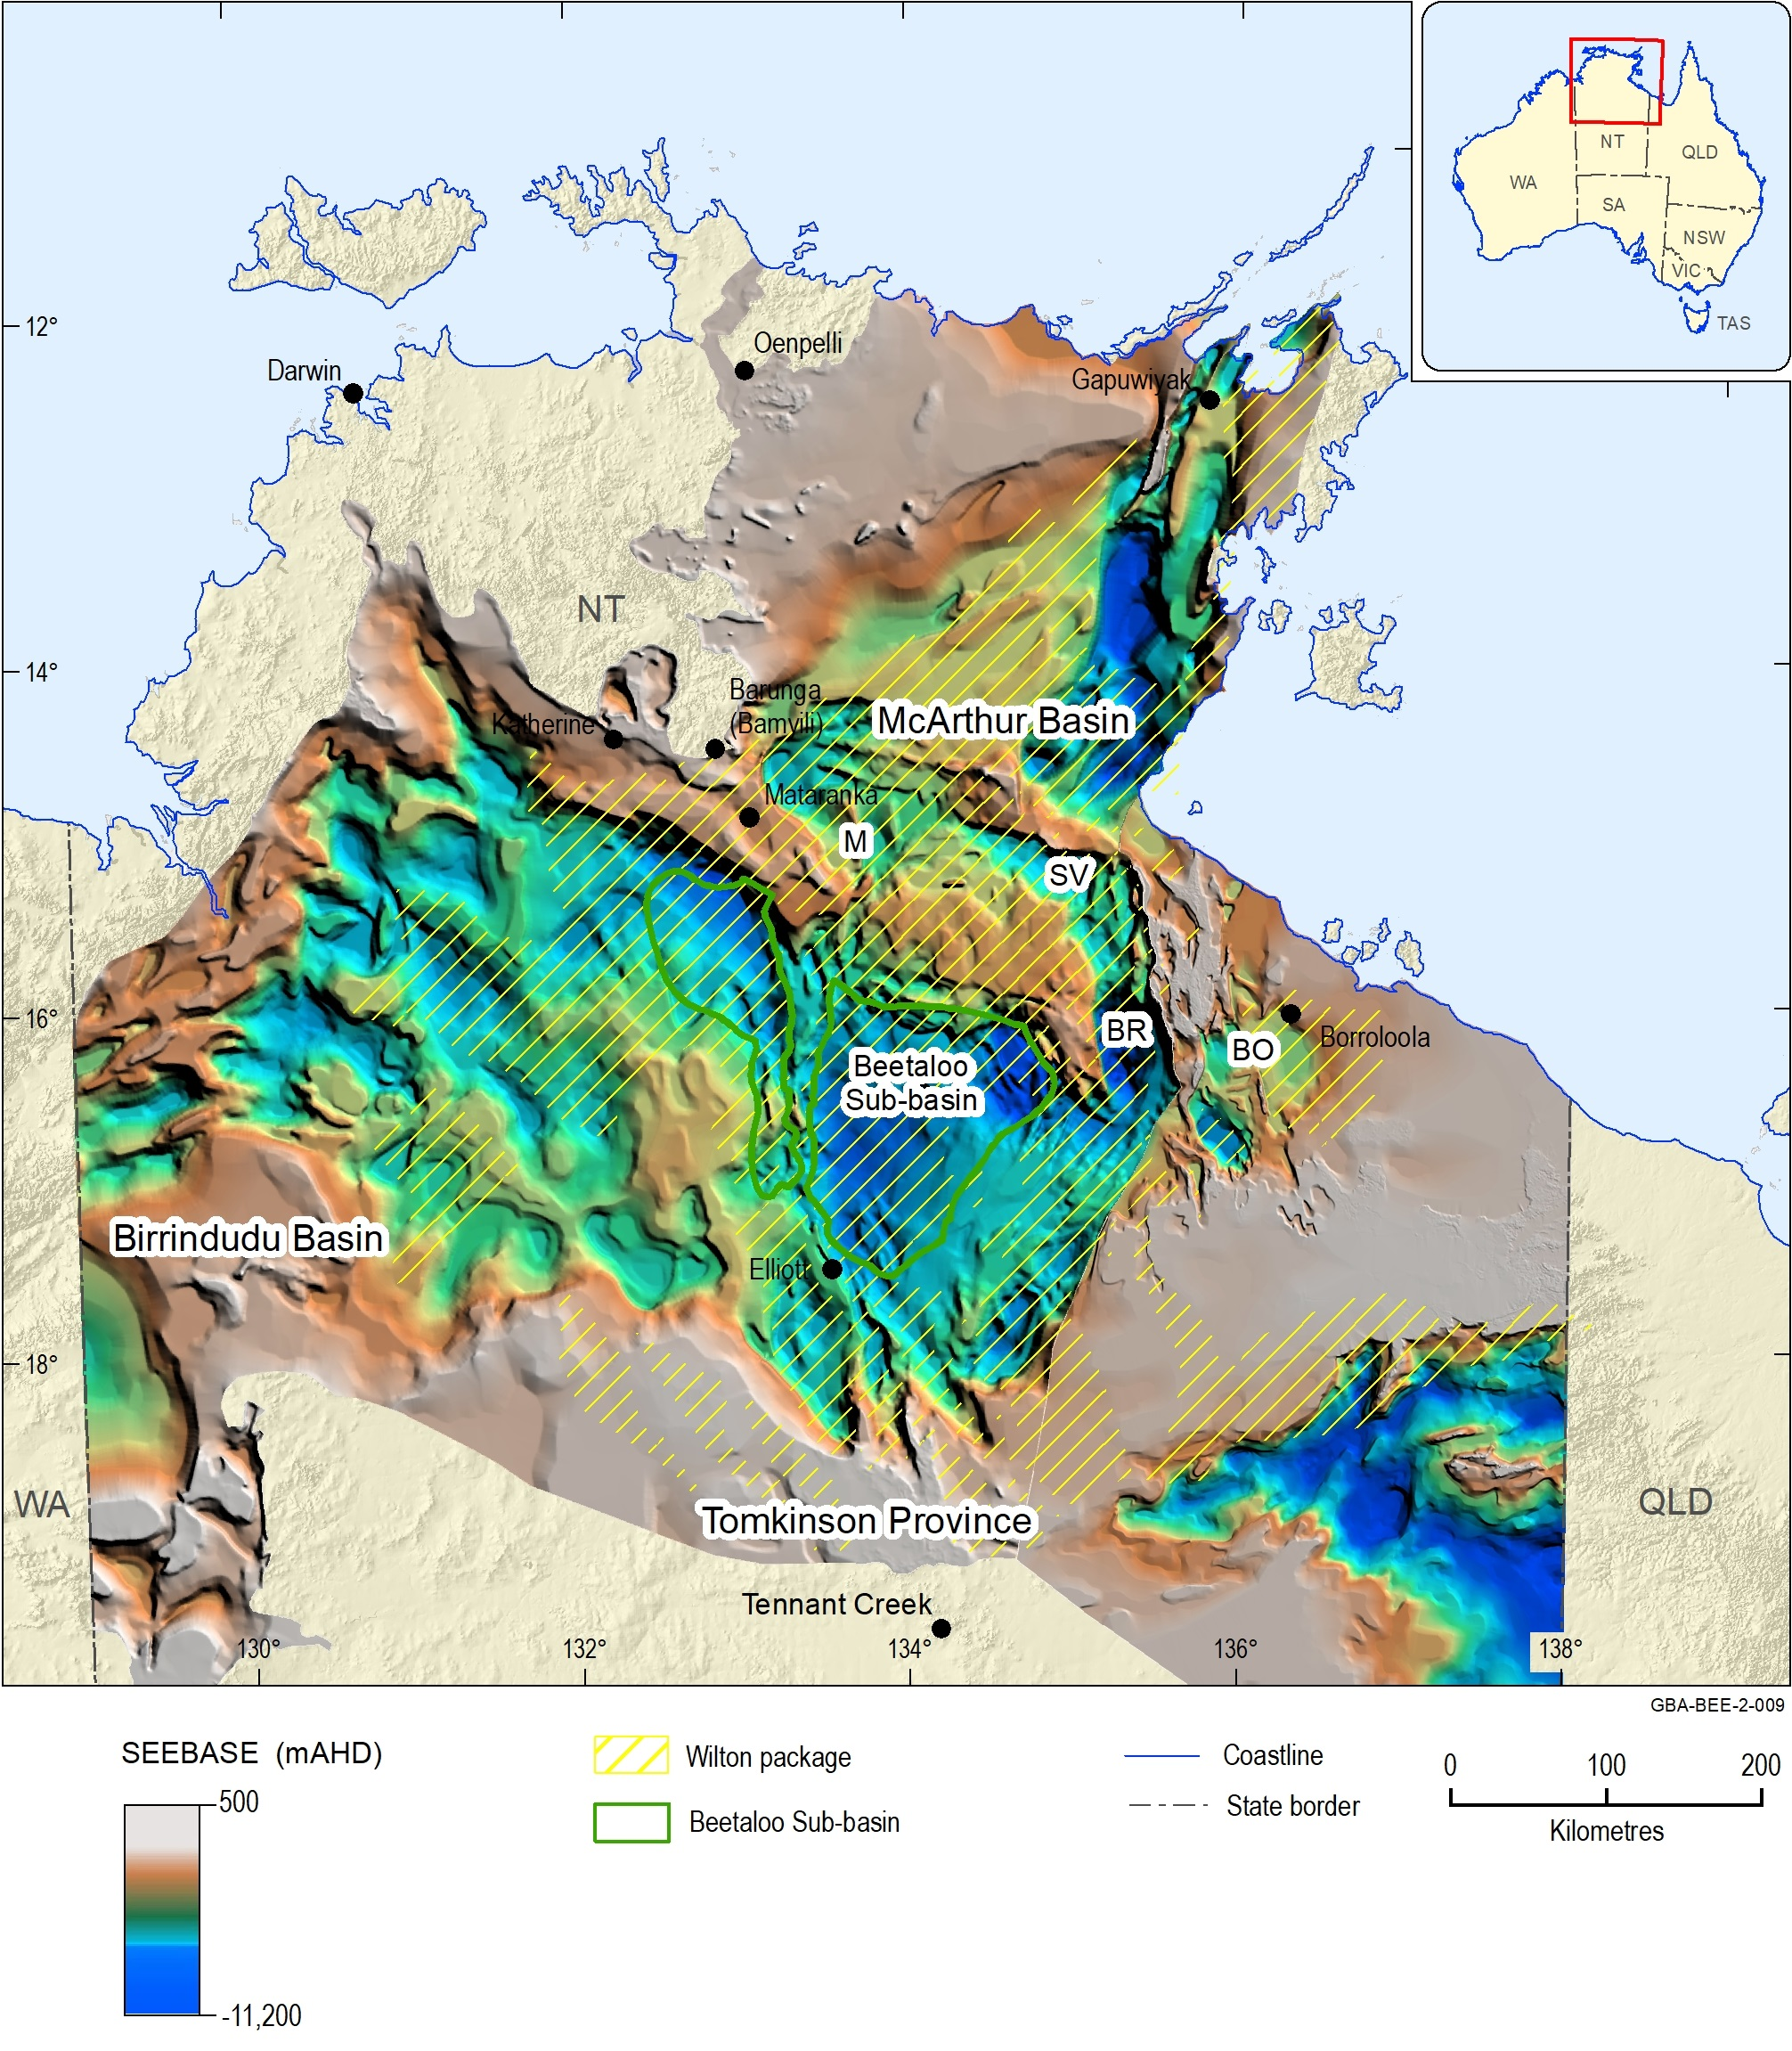
Figure 1 Geological setting of the Beetaloo Sub-basin
M = Maiwok Sub-basin, SV = Saint Vidgeon Sub-basin, BR = Broadmere Sub-basin, BO = Borroloola Sub-basin
Source: Depth to basement SEEBASE® model image sourced from Frogtech Geoscience (2018); Mesoproterozoic Roper Group (Wilton package) distribution from Betts et al. (2015)
Element: GBA-BEE-2-009
The Beetaloo Sub-basin is prospective for petroleum and is estimated to contain significant technically recoverable gas and liquids resources, particularly from shale gas plays within the Kyalla Formation and Amungee Member of the Velkerri Formation of the Mesoproterozoic Roper Group (Revie, 2017c). In 2017, following completion of extended production testing at the Amungee NW-1H exploration well, Origin Energy reported 2C contingent resources of 6.6 Tcf for the “B shale” member of the Velkerri Formation (Origin Energy, 2017, 2016b). With further exploration, resource assessment and infrastructure development, shale gas production is feasible in the Beetaloo Sub-basin within five to ten years (Department of Primary Industry and Resources (NT), 2017a).
The Beetaloo Sub-basin has existing geological, hydrogeological and environmental data available of the type, quality and density to enable a baseline geological and bioregional assessment to be undertaken. This appendix presents a review of the regional petroleum prospectivity, exploration history, and the characterisation and analysis of petroleum plays hosted in the Mesoproterozoic aged sediments of the Beetaloo GBA region (Figure 2). This process aims to address the technical factors likely to assist in identifying whether a viable petroleum play is likely to be present, and makes no attempt to factor economical, political, or social factors into the assessment.
For assessment purposes, the Beetaloo GBA region extent is based on the formal definition of the Beetaloo Sub-basin given by the NT Department of Primary Industry and Resources (Department of Primary Industry and Resources (NT), 2017a) (Figure 3).
The regional geology context of the Beetaloo GBA region and adjacent areas underpinning this prospectivity review are described in the accompanying geology technical appendix (Orr et al., 2020).

Figure 2 Stratigraphy of the greater McArthur Basin (Beetaloo Sub-basin), the Georgina, Wiso and Daly basins, and Carpentaria Basin in the Beetaloo GBA region
Source: Orr et al. (2020) and references therein
Element: GBA-BEE-2-053
This figure has been optimised for printing on A3 paper (297 mm x 420 mm).
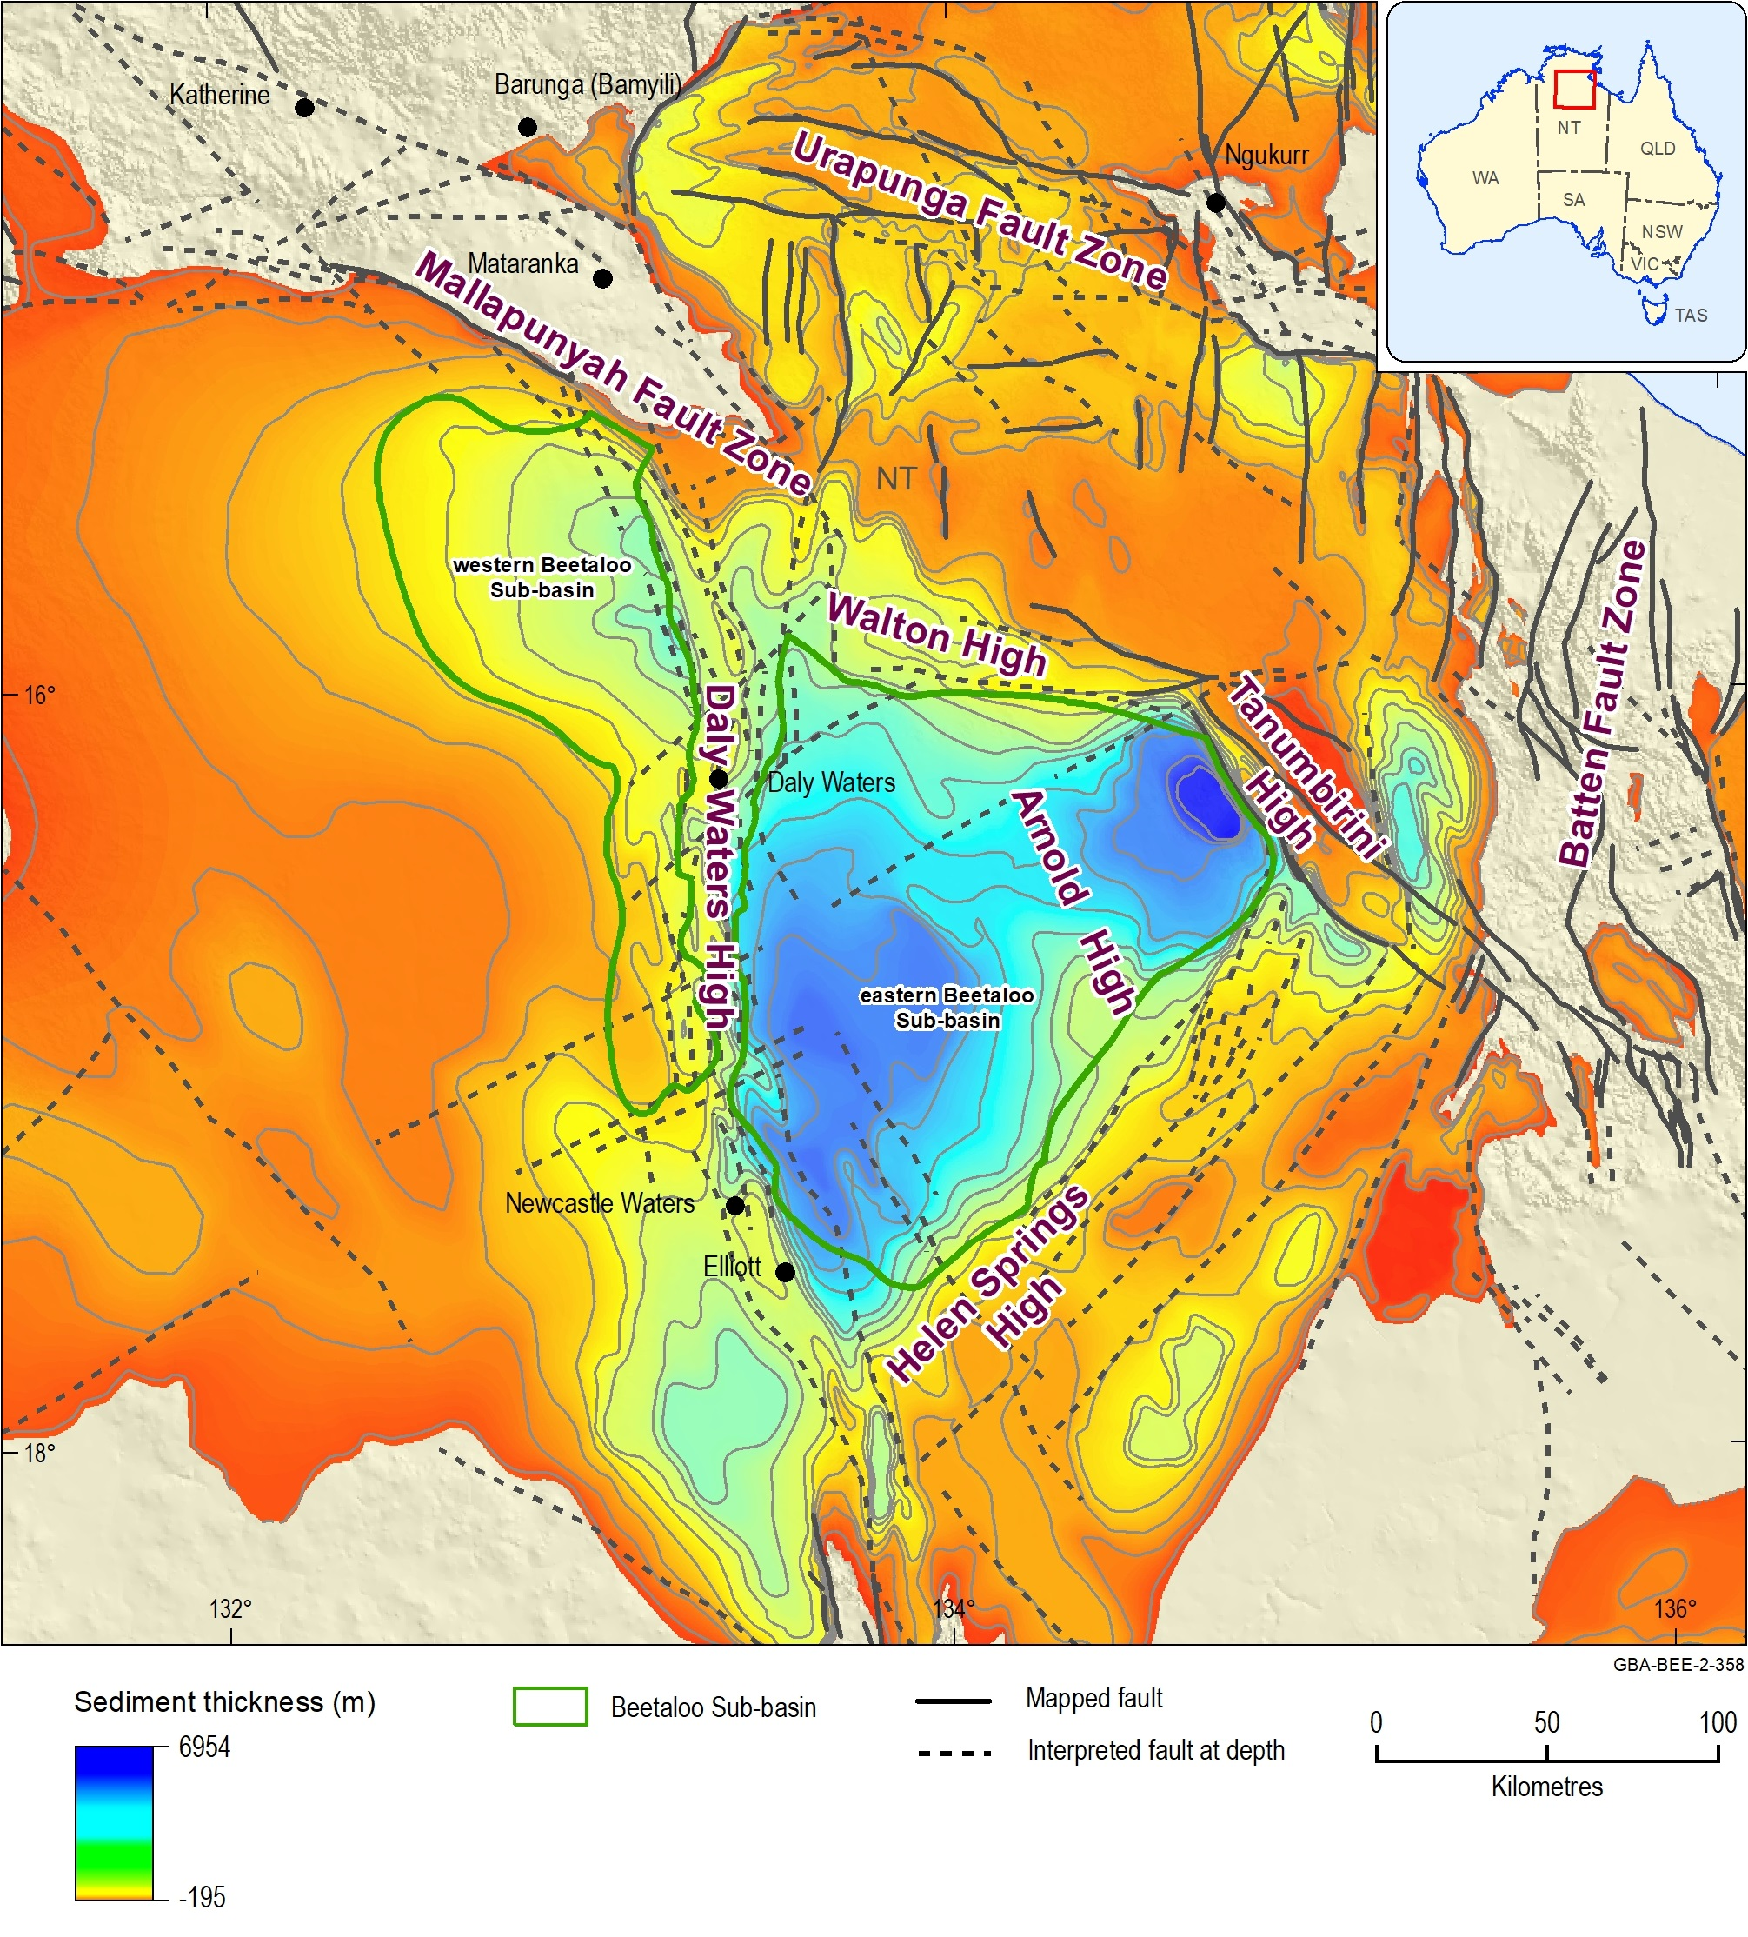
Figure 3 Structural elements map of the Beetaloo Sub-basin showing major faults, overlain on the total sediment thickness from the base of the Mesoproterozoic Roper Group
Source: Major faults and sediment thickness from Frogtech Geoscience (2018); structural elements from Plumb and Wellman (1987), Silverman et al. (2007) and Munson (2016)
Element: GBA-BEE-2-358

Conventional and unconventional petroleum
Naturally occurring oil and gas accumulations may be differentiated by the terms ‘conventional’ and ‘unconventional’, depending on how the petroleum is trapped in the geological formation (Figure 4).
GBA-BEE-2-169
Figure 4 The different types of conventional and unconventional petroleum accumulations
Unconventional play types considered for the Beetaloo GBA region are shown in dark blue. Liquids includes oil and gas condensate.
Source: After Cook et al. (2013)
Element: GBA-BEE-2-169
‘Conventional’ petroleum accumulations (Figure 4 and Figure 5) are so called because they have the longest association with petroleum exploration and production, and are considered the norm (i.e. conventional) by the industry. These accumulations were the first to be exploited historically as they are relatively easy to find and develop, and have produced the majority of oil and gas worldwide to date. However, they are relatively rare and represent only a small part of the petroleum continuum.
‘Conventional’ petroleum accumulations occur as discrete accumulations trapped by a geological structure and/or stratigraphic feature, typically bounded by a down-dip contact with water and capped by impermeable rock (Schmoker, 2002; Schmoker et al., 1995) (Figure 4). The petroleum was not formed in situ; but migrated from the source rocks into a trap containing porous and permeable reservoir rocks.
The term ‘unconventional’ is used to refer to the collection of petroleum accumulations that are characterised by low permeability and require reservoir stimulation to develop. They include shale oil and gas, oil shales, tight sands, basin-centred gas, coal seam gas, deep coal gas, methane hydrates and biogenic gas (Figure 4 and Figure 5). While, ‘unconventional' and 'conventional' petroleum accumulations can form from the same source rocks (Schmoker, 2002; Law and Spencer, 1993; Schmoker et al., 1995), due to differences in expulsion, transport, and trap mechanisms, different extraction methods are required. In the Beetaloo Sub-basin, unconventional gas accumulations including shale gas, tight gas and oil have been identified. These play types are described below.
Shale gas is natural gas hosted in sedimentary rocks (commonly shales) with low to moderate porosity (with a pore size of 0.005–0.1 µm (Nelson, 2009) and very low permeability. Shales are a common petroleum source rock and may retain more petroleum than they expel during the thermal maturation process of organic matter. Once the gas has generated, some of it remains trapped in the shale, either adsorbed on to the organic matter in a free state in the pores and fractures of the rock. Shale gas plays usually occur at depths greater than 1000 m to 1500 m below the earth’s surface. Shale reservoirs occur with significant (10–100 km) lateral continuity and can be of considerable thickness (>100 m). Where shales act as both the petroleum source and reservoir rock, they are sometimes referred to as ‘self-sourcing reservoirs’.
Tight gas is natural gas trapped in siltstone and sandstone reservoirs characterised by low porosity (<8–10%) and permeability (<0.1 mD). Tight gas reservoirs have been exploited for several decades in Australia. Tight gas may occur in discrete reservoirs, where migrated gas accumulates in rocks with low porosity and permeability, in a similar manner to conventional accumulations (e.g. Shanley and Robinson (2004)). Alternatively, tight gas may occur in distributed gas accumulations which have been referred to in the United States as basin-centred tight gas (Law and Curtis, 2002; Schmoker et al., 1995). They are low-permeability gas reservoirs which are commonly abnormally overpressured, lack an apparent down-dip water contact and are pervasively gas saturated (Fall et al., 2002; Law and Curtis, 2002).
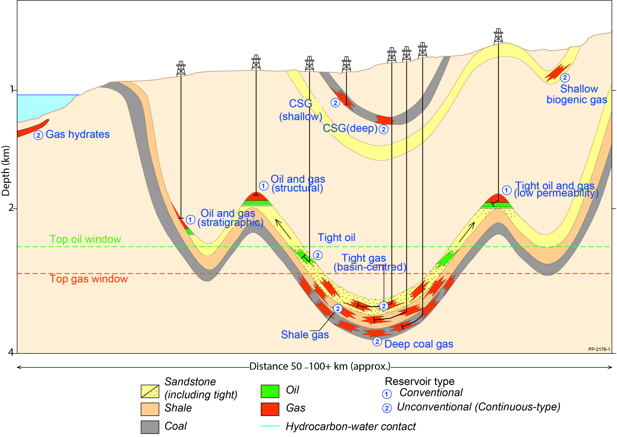
Figure 5 Schematic showing some of the typical types of oil and gas accumulations. These types of conventional and unconventional petroleum accumulations are commonly observed in sedimentary basins, except for gas hydrates, which are located in sediments on the deep continental shelf
The ‘oil window’ refers to the maturity range in which oil is generated from oil-prone organic matter. Below is the ‘gas window’, which refers to the maturity range in which gas is generated from organic matter.
Source: after Schenk and Pollastro (2002); Cook et al. (2013); Schmoker et al. (1995)
Element: GBA-BEE-2-148
Gas may be referred to as dry gas or liquids-rich gas depending on its composition. Dry gas is natural gas that is dominated by methane (greater than 95% by volume) with little or no condensate or liquid hydrocarbons. Liquids-rich gas (also known as wet gas) contains less methane than dry gas and more ethane and other more complex hydrocarbons (propane, butane, pentane, hexane and heptane).
The composition of the gas is important for understanding future development scenarios in the Beetaloo Sub-basin, as liquids-rich gas resources are currently more favourable to develop from an economic perspective. Figure 6 shows petroleum resources nomenclature in terms of chemical composition, commercial product and physical state in both the subsurface and at the surface.
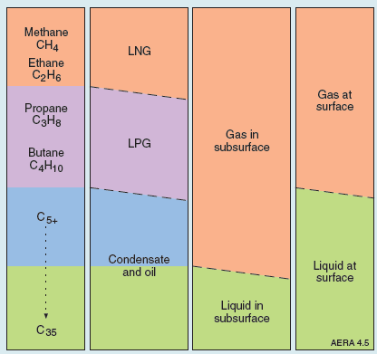
Figure 6 Petroleum resources nomenclature in terms of chemical composition, commercial product, physical state in the subsurface and physical state at the surface
Source: Geoscience Australia and BREE (2014)
Element: GBA-BEE-2-195

Petroleum prospectivity of the Beetaloo Sub-basin
The Beetaloo Sub-basin is prospective for petroleum and is estimated to contain significant technically recoverable gas and liquids resources, particularly from shale gas plays within the Kyalla Formation and Amungee Member of the Velkerri Formation of the Mesoproterozoic Roper Group (Revie, 2017c). There is active exploration for petroleum resources in the Beetaloo Sub-basin, with most of the sub-basin extent covered by exploration permits (Figure 7).
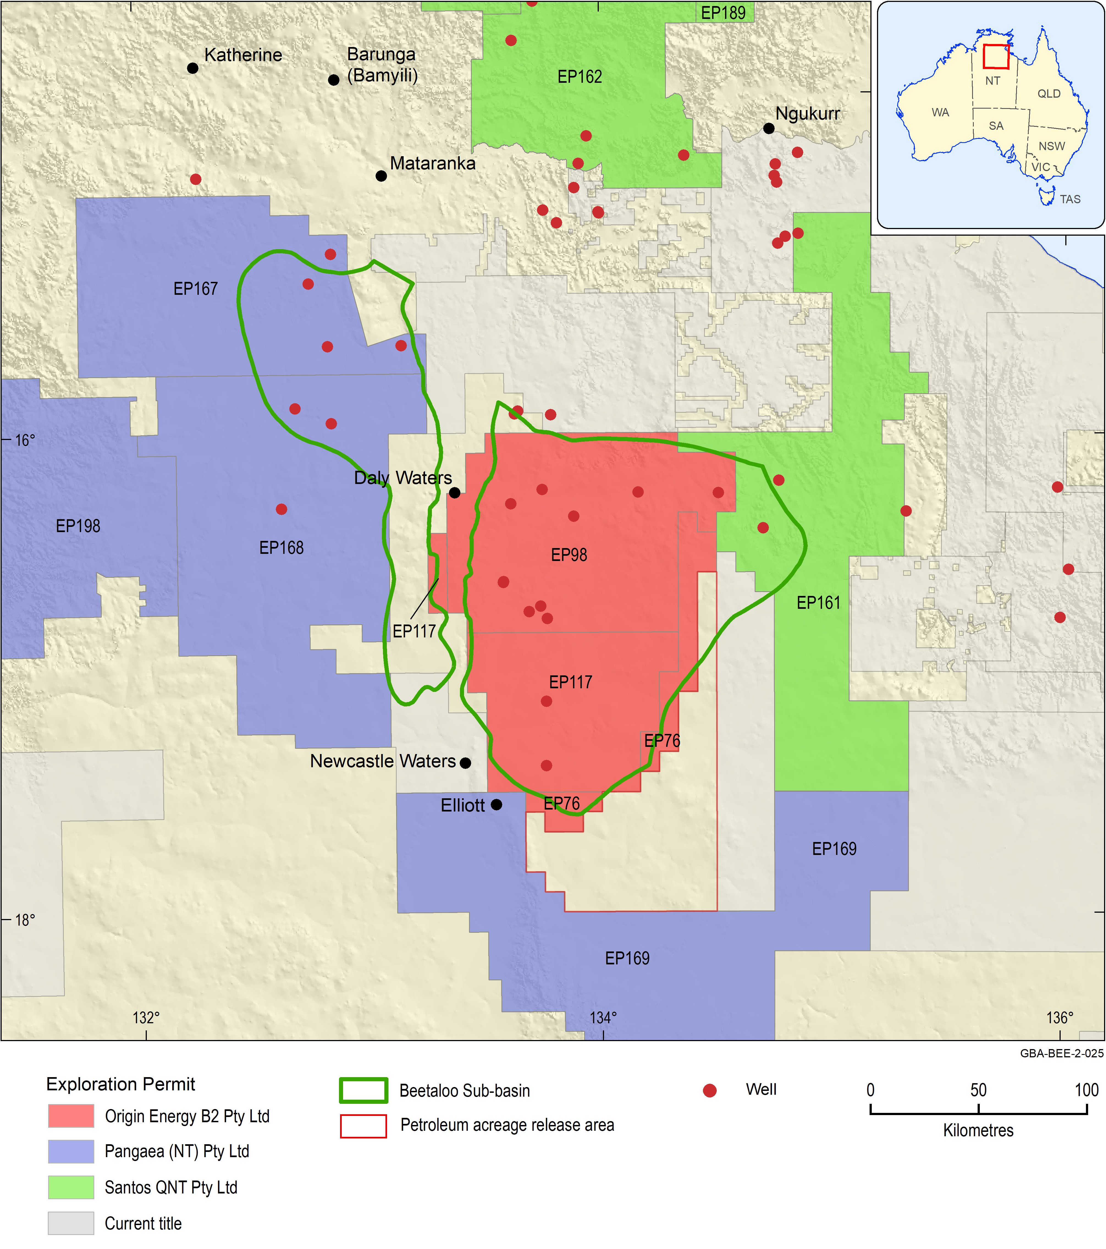
Figure 7 Beetaloo Sub-basin exploration, retention and production permit operators
The Beetaloo Sub-basin outline is the area of interest of the shale and tight gas prospectivity assessment.
Source: Beetaloo Sub-basin outline from Department of Primary Industry and Resources (NT) (2017a).
Data: Permit operators and outlines are provided from GPinfo petroleum database, Petrosys Pty Ltd (2019). Beetaloo Sub-basin outline from Department of Primary Industry and Resources (NT) (2017a).
Element: GBA-BEE-2-025
Exploration has focused in the lower Kyalla Formation and the Amungee Member of the Velkerri Formation (Figure 2). Further details on the exploration history, resources, infrastructure and regional petroleum systems are outlined below (Table 1).
Table 1 Beetaloo GBA region petroleum prospectivity summary
Petroleum systems | Proven (Paleoproterozoic–Mesoproterozoic; Tawallah, McArthur and Uragungan)
Prospectivity | High
Play types | Shale gas, shale oil, tight gas, tight oil
No of wells | 19 wells lie within the Beetaloo Sub-basin outline defined by NTGS (excluding re-entries); (western sub-basin: Birdum Creek 1, Tarlee 1-3, Wyworrie 1; eastern sub-basin: Amungee NW1, Balmain 1, Beetaloo W1, Burdo 1, Chanin 1, Elliot 1, Kalala 1, Jamison 1, Mason 1, McManus 1, Ronald 1, Shenandoah 1, Shortland 1, Tanumbirini 1)
Seismic lines | 8818 line km, two-dimensional seismic reflection data
Hydrocarbon tests | Amungee NW 1H well
Hydrocarbon production | None to date
2P reserves | None reported (Geoscience Australia, 2018)
Contingent (2C) resources | - 6.6 Tcf shale gas over an area of 1968 km2 (Origin Energy, 2017)  - No conventional 2C resources reported (Geoscience Australia, 2018)
Undiscovered resource estimates | - Fully risked (F50) undiscovered mean resources of 6.1 Tcf of gas and 205 MMbbl of natural gas liquids in the middle Velkerri Formation shale gas assessment area; 1.6 Tcf of gas and 65 MMbbl of natural gas liquids in the lower Kyalla Formation shale gas assessment area; and 429 MMbbl of oil, 0.26 Tcf of gas and 8 MMbbl of natural gas liquids in the lower Kyalla Formation shale oil assessment area (Schenk et al., 2019)  - Unrisked P50 prospective resource estimate of 11.1 Tcf for the Velkerrie, Kyalla, Barney Creek and Wollogorang formations (Empire Energy, 2018)  - 496 Tcf OGIP in the Middle Velkerri ‘B’ shale, of which 85 Tcf is estimated to be technically recoverable (prospective area 16,145 km²) (Falcon Oil and Gas, 2017)  - P50 estimate of 202 Tcf undiscovered gas-in-place and 96 MMbbl undiscovered oil-in-place in the Amungee Member shales (Revie, 2017c; Weatherford Laboratories, 2017)  - 772 MMbbl (P50) oil-in-place was estimated for the Kyalla Formation (P10: 1163 MMbbl; P90: 414 MMbbl) (Weatherford Laboratories, 2017; Revie, 2017c, 2017b)  - Best estimate of recoverable shale gas resource of 3 Tcf for the lower Kyalla Formation (prospective area 898 km²) and 16 Tcf for the Amungee Member (prospective area 6092 km²) (AWT International, 2013)  - P50 estimate of potentially recoverable shale gas of 37.29 Tcf for the lower Kyalla Formation and 74.50 Tcf for the Amungee Member (prospective area unknown) (RPS, 2013)  - Technically recoverable shale gas of 22 Tcf for the lower Kyalla Formation (prospective area - associated gas 4100 mi², 2400 mi² wet gas, 1310 mi² dry gas) and 22 Tcf for the Amungee Member (prospective area - associated gas 2650 mi², 2130 mi² wet gas, 2480 mi² dry gas) (EIA, 2013)  - No conventional prospective resources (Geoscience Australia, 2018)
mi² = mile squared

Exploration history
The following review of exploration history in the Beetaloo Sub-basin and surrounds has been updated from Munson (2014); Carr et al. (2016); Revie (2017c).
Exploration for hydrocarbons in the greater McArthur Basin began in the 1960s, but intensified from the 1980s, when a joint venture between Amoco Australia Petroleum Company and Kennecott Copper Corporation completed field mapping, stratigraphic drilling and geophysical surveys. The first discovery of live oil in the region was made during stratigraphic drilling of the Urapunga 4 well by the Bureau of Mineral Resources (now Geoscience Australia), with volatile hydrocarbons bleeding from shales of the Velkerri Formation (Jackson et al., 1986).
This was followed by another period of activity from 1984 to the mid-1990s, when CRA Exploration Pty Ltd (as Pacific Oil and Gas Ltd) acquired aerial photography and undertook field mapping, ground geophysics, acquisition of greater than 2500 km of two-dimensional seismic reflection data, and a significant drilling program.
In 2002, a deep seismic reflection program, was undertaken by Geoscience Australia that assisted in the reinterpretation of the basin architecture of the Batten Fault Zone of the McArthur Basin, east of the Beetaloo Sub-basin (Rawlings et al., 2004).
In the mid-2000s, the Beetaloo Sub-basin was the focus of exploration by Sweetpea Petroleum Pty Ltd, which included two-dimensional seismic survey data and drilling of the Shenandoah 1 well. Falcon Oil and Gas Australia Ltd (Falcon) deepened this well to 2714 m in 2011 and renamed it Shenandoah 1A. A joint venture between Falcon and Hess Australia (Beetaloo) Pty Ltd acquired 3490 km of two-dimensional seismic in 2011 and 2012 (Falcon Oil and Gas, 2019).
In 2013, Pangaea Resources Pty Ltd completed a gravity gradiometry survey and a ~1400 line km two-dimensional seismic survey in the western part of the Beetaloo Sub-basin, followed by an additional ~385 km of seismic data and the drilling of seven petroleum wells over the following two years (Hoffman, 2015, 2014). Also in 2013, in a farm-in arrangement with Tamboran Resources Ltd, Santos Ltd acquired ~500 line km of two-dimensional seismic data in the eastern Beetaloo Sub-basin, and in 2014 drilled the Tanumbirini 1 well to a total depth of 3945 m (Santos Ltd, 2019). Continued exploration interest in 2015 led to encouraging results by Origin Energy and joint venture partner Falcon Oil and Gas Ltd in the Kalala South 1 and Beetaloo W1 wells, and production testing at Amungee NW 1H (Falcon Oil and Gas, 2019; Côté et al., 2018; Close et al., 2017a; Close et al., 2016).
While there has been no commercial gas production to date in the Beetaloo Sub-basin, significant exploration activity is underway (Pepper et al., 2018). In total, more than 30 petroleum wells have been drilled in the Beetaloo Sub-basin and surrounding areas of the greater McArthur Basin (Figure 8, Figure 9). Approximately half of these wells have been drilled in the last ten years. Nineteen of these wells are located within the Beetaloo Sub-basin outline as defined by the NTGS. Five wells are located within the western sub-basin (Birdum Creek 1, Tarlee 1-3, Wyworrie 1) and 14 are located within the eastern sub-basin (Amungee NW1, Balmain 1, Beetaloo W1, Burdo 1, Chanin 1, Elliot 1, Kalala 1, Jamison 1, Mason 1, McManus 1, Ronald 1, Shenandoah 1, Shortland 1, Tanumbirini 1).
Currently, Santos, Origin Energy and Falcon Oil and Gas, and Pangaea Resources are all continuing to investigate key unconventional targets in the Beetaloo Sub-basin (Figure 7) (e.g. Côté et al. (2018); Connors and Krassay (2015); Silverman and Ahlbrandt (2010); Revie and Edgoose (2015a, 2015b); Revie (2017c, 2017b); Close (2014); Scrimgeour (2019)). The Velkerri and Kyalla formations (Roper Group) have been identified as hosting the primary shale plays with the greatest potential for commercial production (Munson, 2014; Revie, 2017b; Origin Energy, 2017). In addition, there is potential for a tight gas and liquids-rich play within the Hayfield sandstone member in the overlying Neoproterozoic units (Munson, 2014; Côté et al., 2018).
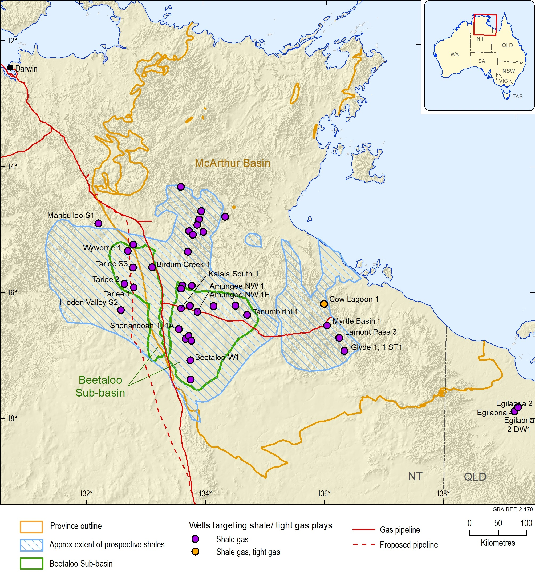
Figure 8 Wells targeting shale and/or tight gas plays in the Beetaloo Sub-basin and adjacent areas of the greater McArthur Basin
Source: Beetaloo Sub-basin outline from Department of Primary Industry and Resources (NT) (2017b). Approximate areas within which key prospective shales are likely to be present sourced from Bruna et al. (2015); Revie (2017b); (Revie, 2017c)
Data: McArthur Basin outline from Raymond et al. (2018) that is currently in revision. Well locations from Department of Primary Industry and Resources (NT) (2018a)
Element: GBA-BEE-2-170
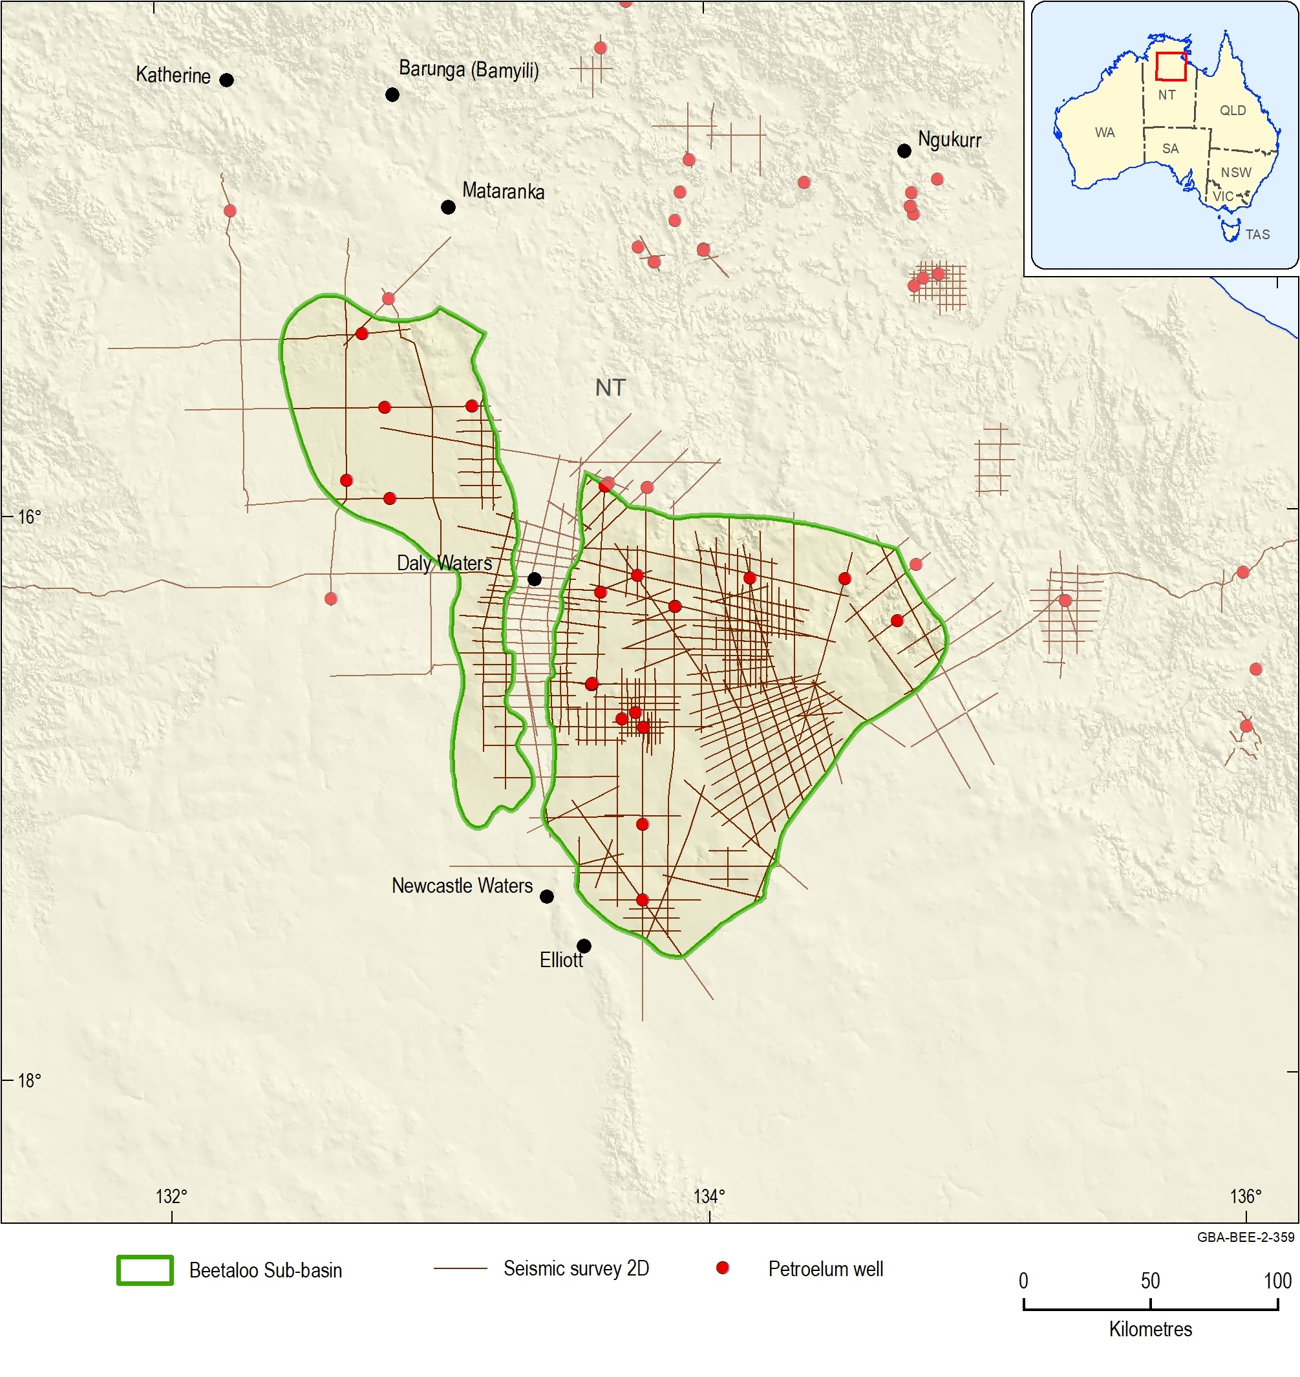
Figure 9 Two-dimensional seismic data coverage across the Beetaloo Sub-basin and surrounding areas
Data: Seismic survey lines from Department of Primary Industry and Resources (NT) (2018b), petroleum well distribution from Department of Primary Industry and Resources (NT) (2018a)
Element: GBA-BEE-2-359

Reserves and resources

Reserves
To date, no reserves have been booked for any petroleum resource type for the Beetaloo Sub-basin (Table 1) (Geoscience Australia, 2018).

Contingent resources
In 2017, following completion of extended production testing at the Amungee NW 1H exploration well (Origin Energy, 2016b), Origin Energy reported 2C Contingent Resources of 6.6 Tcf for the “B shale” unit of the Amungee Member over an area of 1968 km2, across permits EP76, EP98 and EP117 in the Beetaloo Sub-basin (Origin Energy, 2017).
It is important to note these 2C Contingent Resources have been reported based on the results from one well, assuming homogeneity in the geological characteristics of the play across the entire region. However, experience in the United States highlights that there is commonly a large degree of heterogeneity in production rates from shale gas plays, even across small areas. In particular, the recovery factor for Amungee NW 1H was reported to be 16% (Revie, 2017c), comparable with well explored shale gas plays in the US. Nevertheless, further wells are required to increase confidence in the long-term development of the play (Revie, 2017c).

Prospective resources
A range of regional-scale prospective resource estimates have been published for shale gas in the Velkerri and Kyalla formations in the greater McArthur Basin, including the Beetaloo Sub-basin, which are listed below.
- The US Geological Survey estimated technically recoverable mean resources of 429 MMbbl of continuous oil and 8 Tcf of continuous gas for the Beetaloo Sub-basin (Schenk et al., 2019). This comprises:
  - 6.1 Tcf of gas and 205 MMbbl of natural gas liquids in the middle Velkerri Formation shale gas assessment area
  - 1.6 Tcf of gas and 65 MMbbl of natural gas liquids in the lower Kyalla Formation shale gas assessment area; and
  - 429 MMbbl of oil, 0.26 Tcf of gas and 8 MMbbl of natural gas liquids in the lower Kyalla Formation shale oil assessment area.
- Empire Energy reported an unrisked P50 prospective resource estimate of 11.1 Tcf for the Velkerrie, Kyalla, Barney Creek and Wollogorang formations in the greater McArthur Basin (Empire Energy, 2018).
- Falcon Oil and Gas (2017) estimated 496 Tcf OGIP in the Beetaloo Sub-basin Middle Velkerri B shale. 85 Tcf of this is estimated to be technically recoverable, assuming a 16% recovery factor (prospective area 16,145 km²) (Falcon Oil and Gas, 2017).
- The Northern Territory Geological Survey estimated the following in-place resources in the Beetaloo and Broadmere sub-basins (Weatherford Laboratories, 2017; Revie, 2017c, 2017b):
  - Amungee Member gas-in-place of 202 Tcf (P50) (range: 293 Tcf (P10) to 118 Tcf (P90))
  - Amungee Member oil-in-place of 94 MMbbl (P50) (range: 128 MMbbl (P10) to 72 MMbbl (P90)) and
  - Kyalla Formation oil-in-place of 772 MMbbl (P50) of oil-in-place (range: 1163 MMbbl (P10) to 414 MMbbl (P90)).
- RPS reported a P50 estimated of potentially recoverable shale gas resource to be 37.29 Tcf for the lower Kyalla Formation and 74.50 Tcf for the Amungee Member in the Beetaloo Sub-basin (prospective area unknown; RPS (2013). In addition, they reported P50 estimate of potentially recoverable basin-centred gas resources of 5.9 Tcf for the Moroak Sandstone and 44.31 Tcf for the Bessie Creek Sandstone; RPS (2013).
- The US Energy Information Administration (EIA) reported that that the technically recoverable shale gas in the Beetaloo Sub-basin is 22 Tcf for the lower Kyalla Formation (prospective area - associated gas 4100 mi2, 2400 mi2 wet gas, 1310 mi2 dry gas) and 22 Tcf for the Amungee Member (prospective area - associated gas 2650 mi2, 2130 mi2 wet gas, 2480 mi2 dry gas) (EIA, 2013).
- AWT International have reported their best estimate of recoverable shale gas resource to be 3 Tcf for the lower Kyalla Formation (prospective area 898 km2) and 16 Tcf for the Amungee Member in the Beetaloo Sub-basin (prospective area 6092 km2) (AWT International, 2013).
Although these results highlight the presence of potentially significant petroleum resources in the Beetaloo Sub-basin and surrounds, the full extent of these resources is still poorly understood and quantified, and any estimates of potential resources have a high degree of uncertainty associated with them. In particular, recovery factors are very poorly understood and vary significantly between each resource assessment.

Market access and infrastructure
Table 2 provides a summary of market and access infrastructure for the remote and sparsely populated area of the Beetaloo Sub-basin. The communities of Mataranka (population of 400) and Elliot (population of 355) are located on highways in close proximity to the Beetaloo Sub-basin (Figure 10). The nearest town, Katherine (population of around 10,000) is 75 km from the northern-most boundary of the Beetaloo Sub-basin. Sealed arterial roads traverse across the Beetaloo Sub-basin, including the Stuart Highway from Darwin to the northwest and the Carpentaria Highway heading eastwards towards Borroloola. The Alice Springs-Darwin railway is located over the western Beetaloo Sub-basin. The region is also serviced by the Daly Waters to McArthur River Pipeline and the Amadeus Gas Pipeline to Darwin (Figure 10).
Table 2 Summary of market access and infrastructure
Gas market | Northern Territory Gas Market
Proximity to gas pipelines | Daly Waters to McArthur River Pipeline – capacity 16 TJ/day  Amadeus Gas Pipeline – capacity 120 TJ/day
Gas processing facilities | None
Approx. distance from existing pipelines to prospective area | 0–200 km
Road and rail access | Poorly to moderately well serviced
Approximate development time frame | 5–10 years
Source: Hall et al. (2018). Pipeline information from Jemena (2017); Australian Energy Regulator (AER) (2017). Oil and gas infrastructure from Geoscience Australia (2017) and Australian Energy Regulator (AER) (2017)
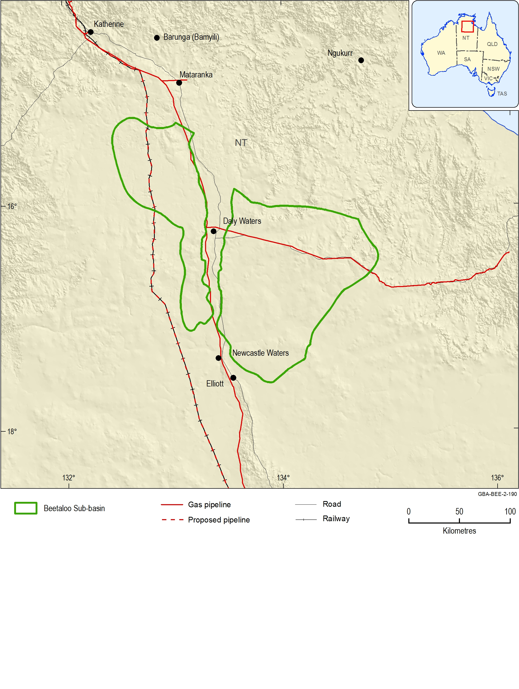
Figure 10 Beetaloo Sub-basin infrastructure and pipelines
Source: Beetaloo Sub-basin outline from Department of Primary Industry and Resources (NT) (2017a). Gas infrastructure from Petrosys Pty Ltd (2019)
Element: GBA-BEE-2-190

Regional petroleum systems

Introduction
The Beetaloo Sub-basin has long been recognised as having potential for petroleum (e.g. Muir (1980)), with oil and gas occurrences both known. Oil shows are common, and bitumen and pyrobitumen have been reported from many units, including the Paleoproterozoic and Mesoproterozoic sedimentary rocks and the overlying Paleozoic sedimentary rocks (e.g. Muir (1980); Knutson et al. (1979)). Interest was stimulated by the first discovery of live oil in the basin, which was made during stratigraphic drilling of the Urapunga 4 well by the Bureau of Mineral Resources (now Geoscience Australia), with volatile hydrocarbons bleeding from shales of the Velkerri Formation (Jackson et al., 1986).
The petroleum systems of the Beetaloo Sub-basin and surrounds are summarised below and in Table 3. For a more extensive review of the regional petroleum systems, see Munson (2014).
Table 3 Petroleum systems elements
Play types | - Conventional: oil and gas hosted in sandstone reservoirs with structural traps, diagenetic traps, pinch out plays on basin margins and breccia traps  - Unconventional: shale gas, shale oil, tight gas, tight oil
Reservoirs | - Tawallah Group: Wollogorang Formation  - McArthur Group: Teena Dolostone, Coxco Dolostone Member of the Teena Dolostone, breccia units within the Barney Creek Formation, Yalco Formation, Stretton Sandstone, Looking Glass Formation and lower Balbirini Dolostone  - Roper Group: Hodgson Sandstone, Bessie Creek Sandstone, Moroak Sandstone, Jamison sandstone, Bukalara Sandstone and thin sandstone units within Velkerri and Kyalla formations  - Unnamed group: Hayfield sandstone member
Seals | - McArthur Group: Barney Creek Formation, Lynott Formation, Donnegan Member, intraformational within Stretton Sandstone  - Roper Group: Velkerri Formation, Kyalla Formation  - Antrim Plateau Volcanics
Source rocks | - McArthur Group: Barney Creek Formation, Lynott Formation and Donnegan Member  - Roper Group: Velkerri Formation, Kyalla Formation, and minor contributions from Mainoru and Corcoran formations
Hydrocarbon shows | - Tawallah Group: Dermott Formation, Wollogorang Formation  - McArthur Group: Barney Creek Formation, Coxco Dolostone Member and Lynott Formation  - Roper Group: Bessie Creek Sandstone, Velkerri Formation, Moroak Sandstone, Kyalla Formation, Jamison sandstone and Bukalara Sandstone  - Unnamed group: Hayfield sandstone member
First major discovery | Amungee NW 1H currently undergoing production testing
Production | None
Source: From Munson (2014); Carr et al. (2016)

Petroleum systems elements
Work on the prospective petroleum systems is focused principally on source rocks within the McArthur and Roper groups in the southern parts of the McArthur Basin. The petroleum systems in the McArthur Group are included within the McArthur Supersystem of Bradshaw et al. (1994) and those of the Roper Group are within the Urapungan Supersystem (Bradshaw, 1993; Laurie, 2012). An older petroleum system is present within the Tawallah Group, since hydrocarbon shows are known in the McDermott and Wollogorang formations (Munson, 2014).
There have been several studies on source rocks in the Beetaloo Sub-basin and surrounds, with key papers including Jackson et al. (1986); Jackson et al. (1988), Powell et al. (1987), Taylor et al. (1994), Warren et al. (1998) and Silverman et al. (2007). A geochemical summary on oil from the Jamison 1 well was undertaken by Summons et al. (2002). An extensive review is provided in Munson (2014). The Mesoproterozoic Roper Group is deposited throughout the southern McArthur Basin, including the Beetaloo Sub-basin, and contains the Velkerri and Kyalla formations, which are the main source rock targets (Figure 11; Figure 12). Another minor source rock in the Roper Group include the Mainoru Formation.
There is evidence for multiple episodes of hydrocarbon and brine migration, with late stage oil migration indicated by solid bitumen occurring within secondary porosity and as coatings on secondary minerals. Dutkiewicz et al. (2007) estimated that the most significant oil migration episode for the Roper Group occurred in the Mesoproterozoic, following compaction, cementation and contact metamorphism during structural inversion between about 1300–1000 Ma (Figure 11). The presence of hydrocarbons in the Bukalara Sandstone in the well Walton 1 also indicates that migration must have also occurred in post-Mesoproterozoic times
There are at least seven reservoir units known to occur in the Beetaloo GBA region, including the Bukalara Sandstone, Hayfield sandstone member of the Hayfield mudstone, Jamison sandstone, Kyalla Formation, Moroak Sandstone, Velkerri Formation and Bessie Creek Sandstone (Table 3; Figure 12; Figure 12). The Bukalara Sandstone has very good reservoir properties, with porosities of 19–24% and permeabilities in the range 50–1000 mD (Lanigan et al., 1994; Law et al., 2010). The Moroak Sandstone is another significant economic reservoir target, with porosities from about 6% to 15%. The Bessie Creek Sandstone also has reported porosities up to 14% and permeabilities up to 50 mD. Reduction of initial porosity due to the diagenetic deposition of quartz and clay minerals in pore spaces, and compaction and pressure solution, are likely to be detrimental to reservoir properties in more deeply buried sections (Lanigan et al., 1994).
Important seals include the Velkerri Formation, the Kyalla Formation and Hayfield mudstone (Figure 11; Figure 12).

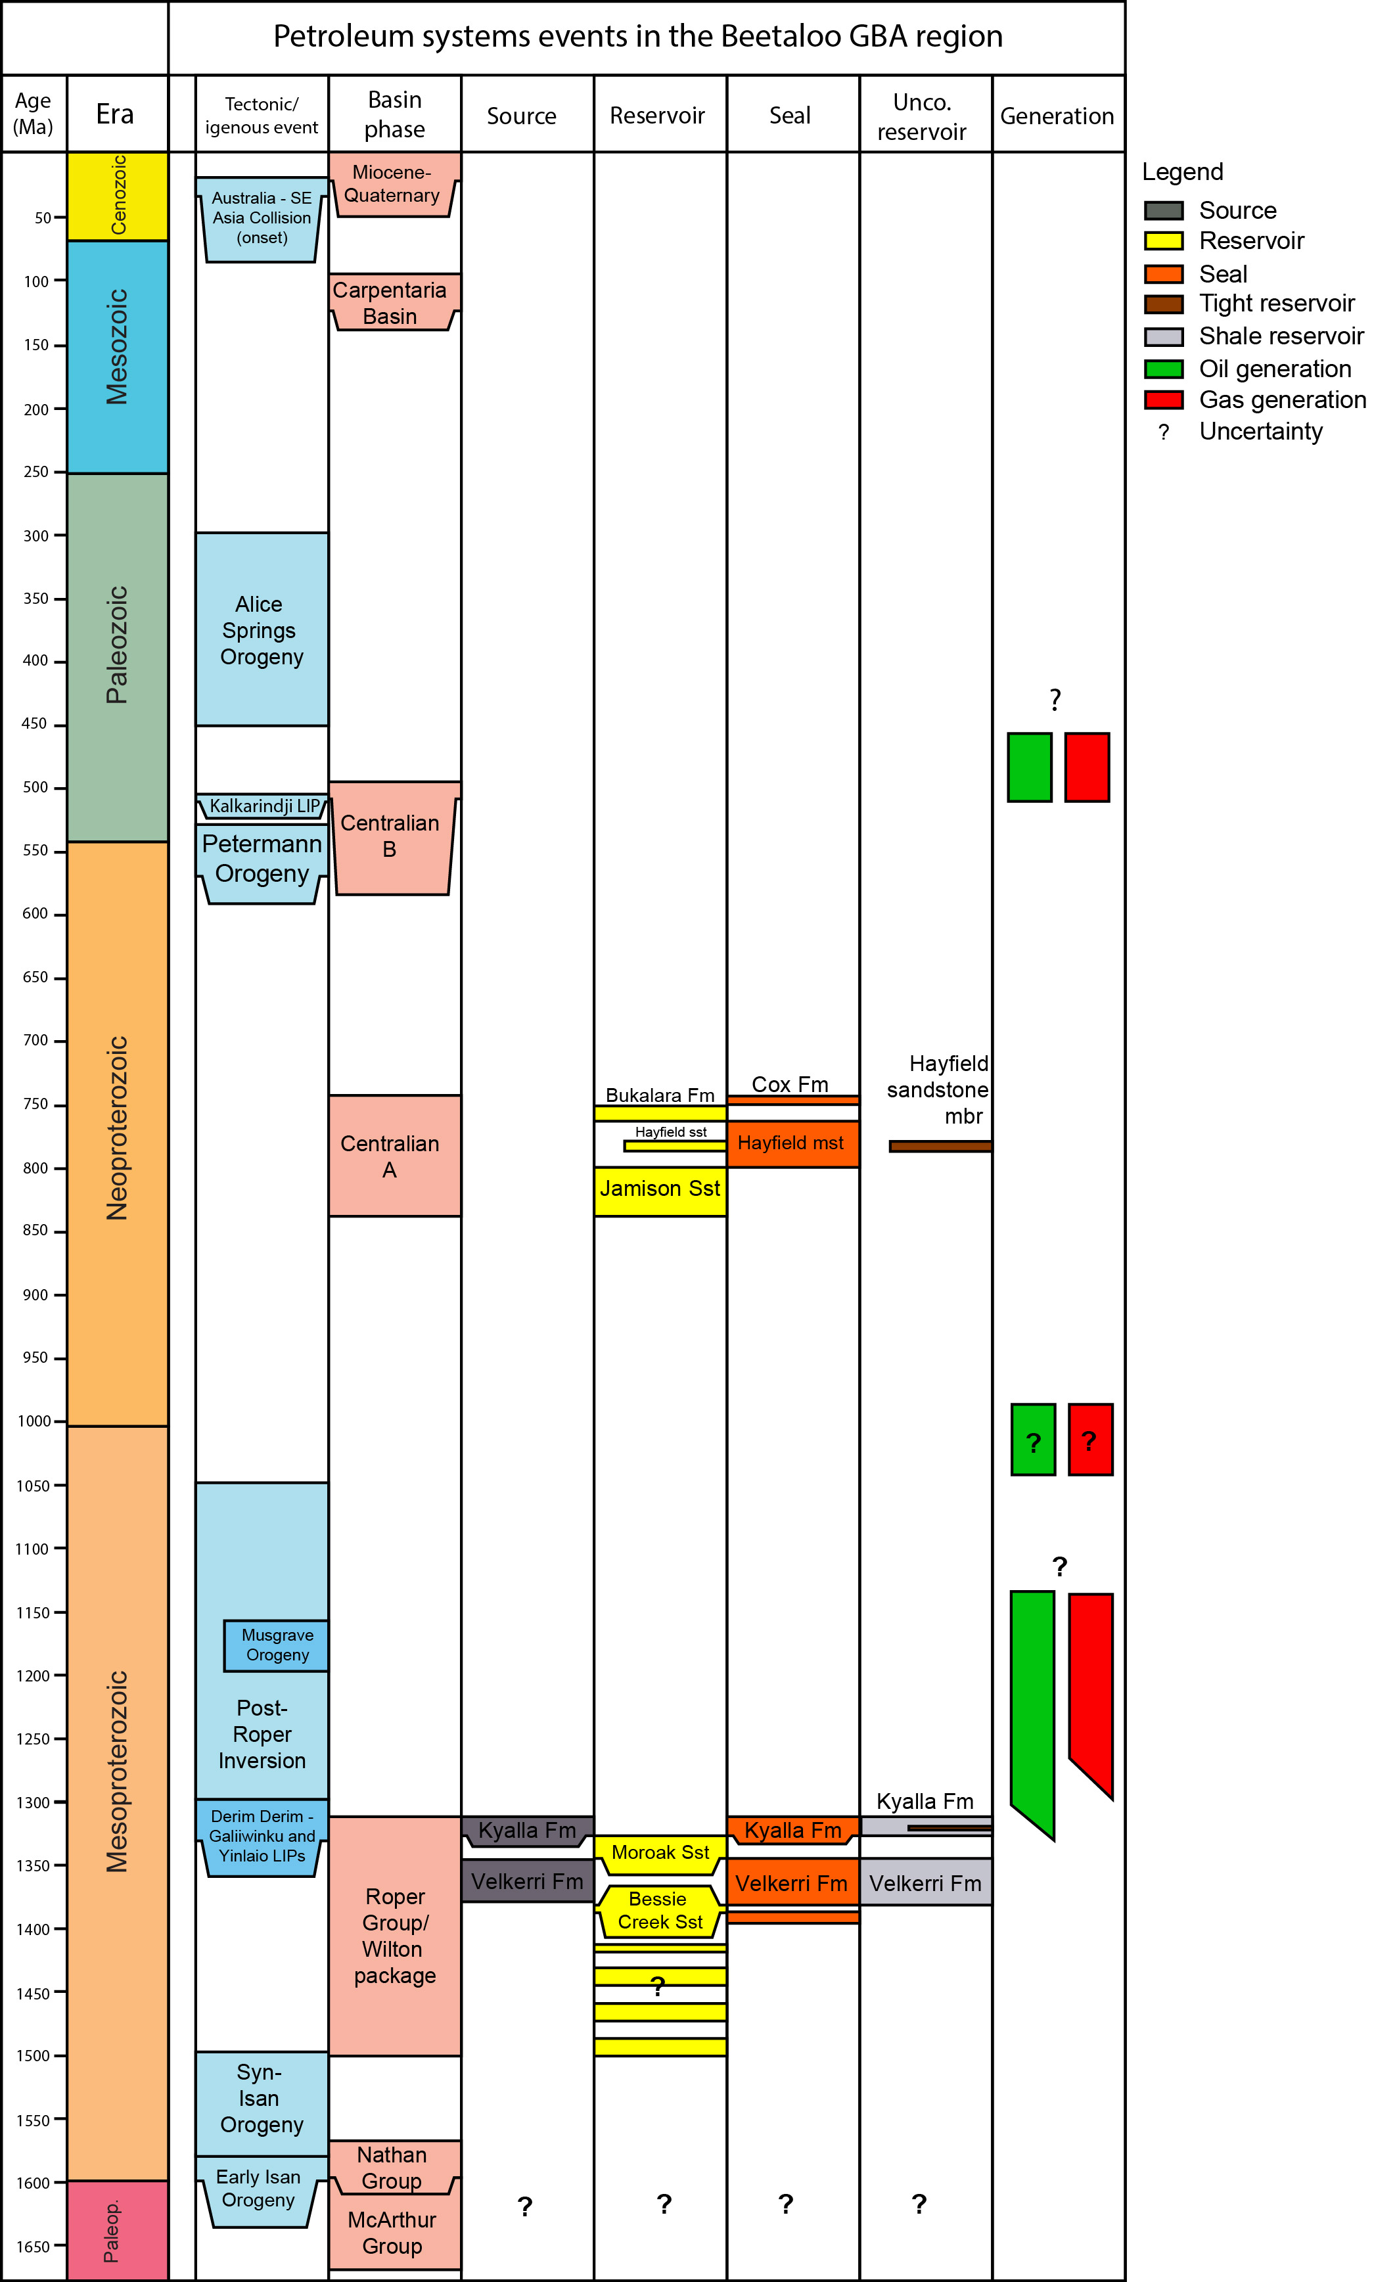
Figure 11 Petroleum systems element chart for the Beetaloo Sub-basin
Source: Orr et al. (2020) and this report
Element: GBA-BEE-2-321
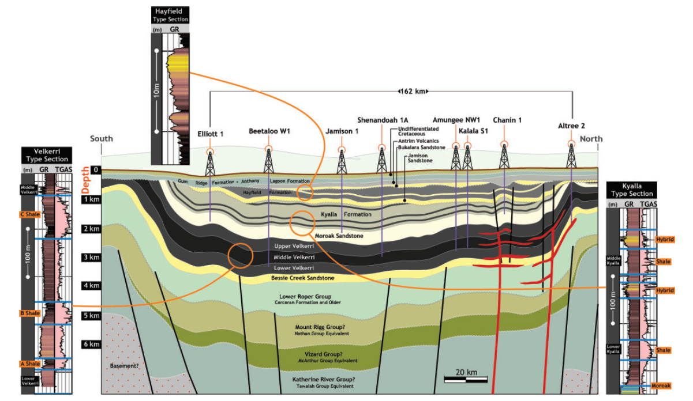
Figure 12 Schematic and type sections of the identified plays within and over the Beetaloo Sub-basin. GR= gamma ray. TGAS= total mud gas
Source: Côté et al. (2018). This figure is covered by a Third Party Creative Commons Attribution licence
Element: GBA-BEE-2-171Petroleum play types
Unconventional petroleum resources are key targets within the Beetaloo Sub-basin (Connors and Krassay, 2015; Revie and Edgoose, 2015a, 2015b). The Velkerri and Kyalla formations have been identified as the primary shale gas plays, having the greatest potential for commercialisation, and are currently being explored and evaluated (Figure 12) (Close et al., 2017a; Côté et al., 2018). In addition, the Hayfield sandstone member oil/condensate play in the overlying Neoproterozoic sedimentary rocks is also under evaluation (Figure 12) (Côté et al., 2018).

Velkerri Formation
The Velkerri Formation shale dry gas play is the most mature resource play in the Beetaloo Sub-basin (Close et al., 2017a; Côté et al., 2018). The Velkerri Formation formally subdivided into the Kalala, Amungee and Wyworrie members, which correspond to the previously used lower, middle and upper Velkerri Formation respectively (Munson and Revie, 2018).
Within the Amungee Member of the Velkerri Formation, there are three well defined target intervals, informally known as the A, B and C shales or organofacies (Figure 13) (Close et al., 2017a; Côté et al., 2018; Warren et al., 1998). Although only the B shale has been tested with a horizontal, hydraulically fracture stimulated well, the A and C shales are also considered to be viable targets (Côté et al., 2018). Additionally, a liquids-rich gas play has been identified in the Velkerri Formation along the northern and south-eastern limits of the eastern Beetaloo Sub-basin, as well as in the western sub-basin (Côté et al., 2018; Faiz et al., 2016; Faiz et al., 2018).
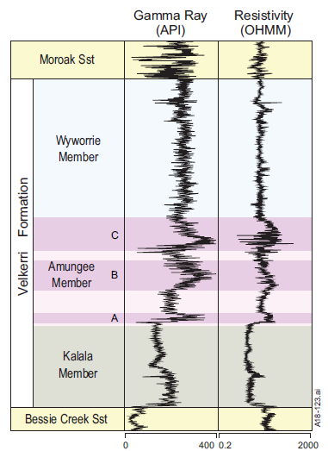
Figure 13 Formal sub-division of Velkerri Formation displayed on composite gamma ray and resistivity logs from Pacific Oil and Gas Ltd drillholes in the Beetaloo Sub-basin
Source: Munson and Revie (2018)
Element: GBA-BEE-2-196

Kyalla Formation
There are three well defined source rock intervals in the Kyalla Formation. The lower and middle Kyalla Formation shales are identified to be prospective for liquids-rich gas in deepest sections of both the eastern and western sub-basins (Côté et al., 2018). Oil is likely to be hosted in the upper shale, as well as the lower and middle shales towards the sub-basin margins.
In addition, two prospective hybrid target intervals have also been identified within the Kyalla Formation, which host an additional potential liquids-rich gas play (Altmann et al., 2018). These hybrid lithologies consist of porous and permeable sandstone, interbedded with siltstone and shales. This play is restricted to the south of the eastern Beetaloo Sub-basin and would most likely be developed as a stacked play in association with the adjacent Kyalla Formation shale intervals (Côté et al., 2018).

Hayfield sandstone member
The prospective Hayfield sandstone member oil/condensate play is described below following Côté et al. (2018). The Hayfield sandstone member play is thought to be a thin but regionally extensive sandstone confined to an area over the central part of the eastern Beetaloo Sub-basin. This play was identified during the drilling of Amungee NW 1, when a strong wet gas show across the Hayfield sandstone member was observed. The play’s trapping mechanism is likely to be a structural-stratigraphic trap containing migrated hydrocarbons from either the Kyalla or Velkerri formation source rocks. Whether this is a gas condensate, volatile oil, or a buoyancy driven play with a gas-condensate cap and a volatile oil leg is still to be determined (Côté et al., 2018).

Other plays
The Bessie Creek Sandstone and the Moroak Sandstone are potential tight gas reservoirs where the sub-basin enters the gas window below 1500 m. Commercial production would most likely be contingent on horizontal drilling and hydraulic fracturing (Munson, 2014).
There are numerous other potential unconventional shale targets across the broader greater McArthur Basin, including the Barney Creek Formation, Yalco Formation and Caranbirini Member of the Lynott Formation (Crick et al., 1998).

Petroleum play characterisation

Introduction to petroleum play characterisation
Several companies are pursuing a range of unconventional petroleum plays in the Beetaloo Sub-basin within the Mesoproterozoic succession. The amount of gas and liquids present within a play, as well as the proportion of hydrocarbons that can be produced, depends on the play type and the specific geological characteristics of both the source and reservoir rock.
The plays most likely to be developed in a five to ten year time frame are the shale plays in the Mesoproterozoic Velkerri and Kyalla formations and the tight oil/condensate play in the Neoproterozoic Hayfield sandstone member (Côté et al., 2018). To underpin further work on understanding likely development scenarios and recovery factors, the key physical formation properties required for each of these plays to be successful were identified and characterised. The physical properties evaluated, which vary by play type, include formation depths and extents, source rock properties (net thickness, TOC, quality and maturity), reservoir characteristics (porosity, permeability, gas saturation and brittleness), regional stress regime and overpressure. These characteristics, combined with published studies, were used to map the relative prospectivity of each of these plays across the sub-basin at a regional scale.

Characteristics by formation

Velkerri Formation
Key characteristics of the Velkerri Formation are summarised below in Table 4.
Table 4 Key features of the Velkerri Formation
 | Kalala Member - Velkerri Formation | Amungee Member- Velkerri Formation | Wyworrie Member - Velkerri Formation
Unconventional play type | Shale liquids-rich and dry gas plays
Age | Mesoproterozoic; 1361 ± 21 Ma, 1417 ± 29 Ma (Revie, 2017a; Abbott et al., 2001; Creaser and Kendall, 2007); 1308 ± 41 Ma (Yang et al., 2018)
Top depth | -109–2937 m MSL
Gross formation thickness | <50–1784 m
Lithology | Varying portions of siltstone, claystone and sandstone
Depositional environment | Shallow to distal marine shelf (Revie, 2017a; Abbott et al., 2001)
Net source rock thickness (present day) ª | 0–31 m | 52–246 m | 0–34 m
Total organic carbon (present day) | Mean 0.9 wt%  Range 0–7 wt% | Mean 3.4 wt%  Range 0–30 wt% | Mean 0.9 wt%  Range 0–11 wt%
Hydrogen Index (present day) | 4–233 mg HC/g TOC | 1–800 mg HC/g TOC | 8–461 mg HC/g TOC
Source rock thermal maturity | Immature to dry gas
Average permeability ^{b} | 5.7 x 10⁻⁵ mD  (1 sample only) | Mean 1.6 x 10⁻⁵ mD  Range 1.9 x 10⁻⁵–6.3 x 10⁻⁴ mD | Mean 8.1 x 10⁻⁵ mD  Range 1.6 x 10⁻⁵–1.6 x 10⁻⁴ mD
Average porosity ^{c} | 7.0% (1 sample only) | Mean 7.3%  Range 4.1–11.0% | Mean 8.9%  Range 7.7–10.3%
Average water saturation ^{d} | 96.1% (1 sample only) | Mean 55.3%  Range 33.9–69.9% | Mean 58.2%  Range 53.2–65.6%
Average oil saturation ^{d} | 1.8% (1 sample only) | Mean 5.2%  Range 0.5–11.3% | Mean 5.0%  Range 2.4–8.4%
Average gas saturation ^{e} | 2.1% (1 sample only) | Mean 39.5%  Range 28.7–63.7% | Mean 36.8%  Range 32.0–42.6%
Average brittleness ^{f} | Brittle (0.475)
Pressure regime | Indications of overpressure
HC = hydrocarbons; mD = milliDarcy; MSL = mean sea level; TOC = total organic carbon; wt% = weight %
All public domain Velkerri Formation samples have been analysed; no distinction has been made between the properties of reservoir versus non-reservoir units. aNet source rock thickness represents the cumulative thickness of organically rich shale with a present day TOC content > 2 wt % based on available well intersections. b As-received pressure decay permeability by well. c Average porosity represents the dry helium porosity as a % of bulk rock volume by well. d As received saturation as a % of the pore volume by well. e As received gas saturation as a % of pore volume by well. f The brittleness index (BI) was calculated from mineral content using the method of Jarvie et al. (2007).

Age and stratigraphic relationships
The Velkerri Formation is early Mesoproterozoic in age. Organic-rich shales of the Velkerri Formation in the Urapunga region returned Re-Os dates of 1361±21 Ma and 1417±29 Ma (Kendall et al., 2009). These currently constrain the depositional ages of the Amungee Member C and A organofacies of the Velkerri Formation (Munson and Revie, 2018).
The Velkerri Formation is part of the Maiwok Subgroup of the Roper Group. It conformably overlies the Bessie Creek Sandstone and is conformably overlain by the Moroak Sandstone. The Velkerri Formation is formally divided into the Kalala, Amungee and Wyworrie members (Figure 13) (Munson and Revie, 2018). These correspond respectively to the previously used lower, middle and upper Velkerri Formation.

Extent, depth and gross formation thickness
The Velkerri Formation is present across the Beetaloo Sub-basin, however, surface outcrop is limited to poor exposures present to the north of the sub-basin. Within the Beetaloo Sub-basin, the maximum depth of the top Velkerri Formation (based on well intersections) reaches 2437 m in Tanumbirini 1 in the eastern sub-basin and 1095 m in Birdum Creek 1 in the western sub-basin (Figure 14).
The maximum thickness of the Velkerri Formation based on well intersections is approximately 1483 m (Tanumbirini 1) in the eastern Beetaloo Sub-basin and 734 m (Birdum Creek 1) in the western sub-basin (Figure 15) (Munson and Revie, 2018). The geological model derived from seismic interpretation (Orr et al., 2020) suggests the formation thickness reaches 1784 m (Figure 15).
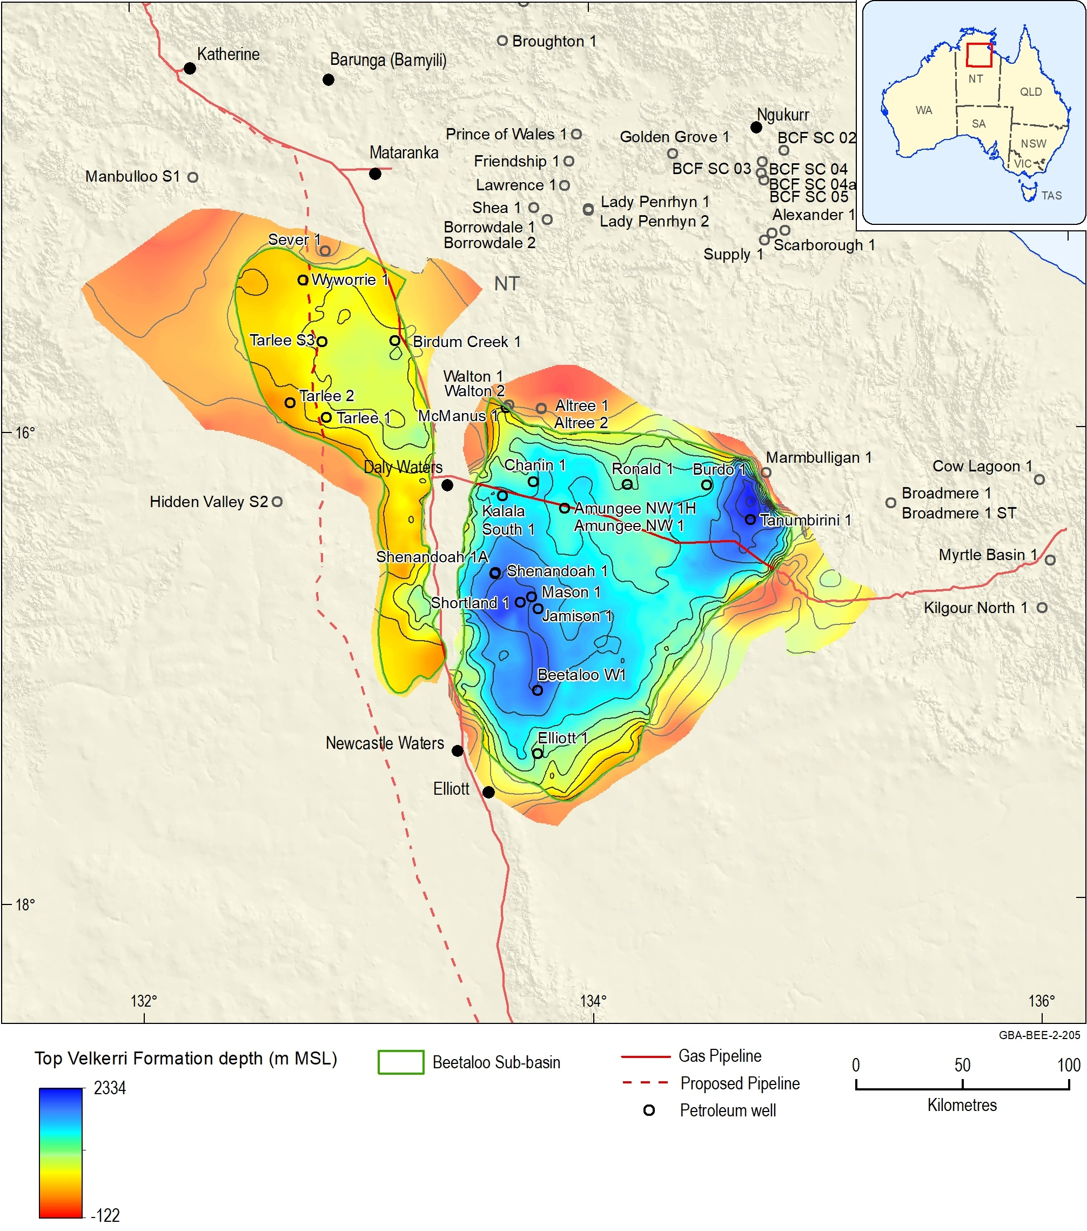
Figure 14 Velkerri Formation top depth (m MSL)
Contour interval = 250 m; MSL = mean sea level
Source: Orr et al. (2020)
Data: Geological and Bioregional Assessment Program (2019b); GBA derived dataset based on Williams (2019) and Northern Territory Government (2018b)
Element: GBA-BEE-2-205

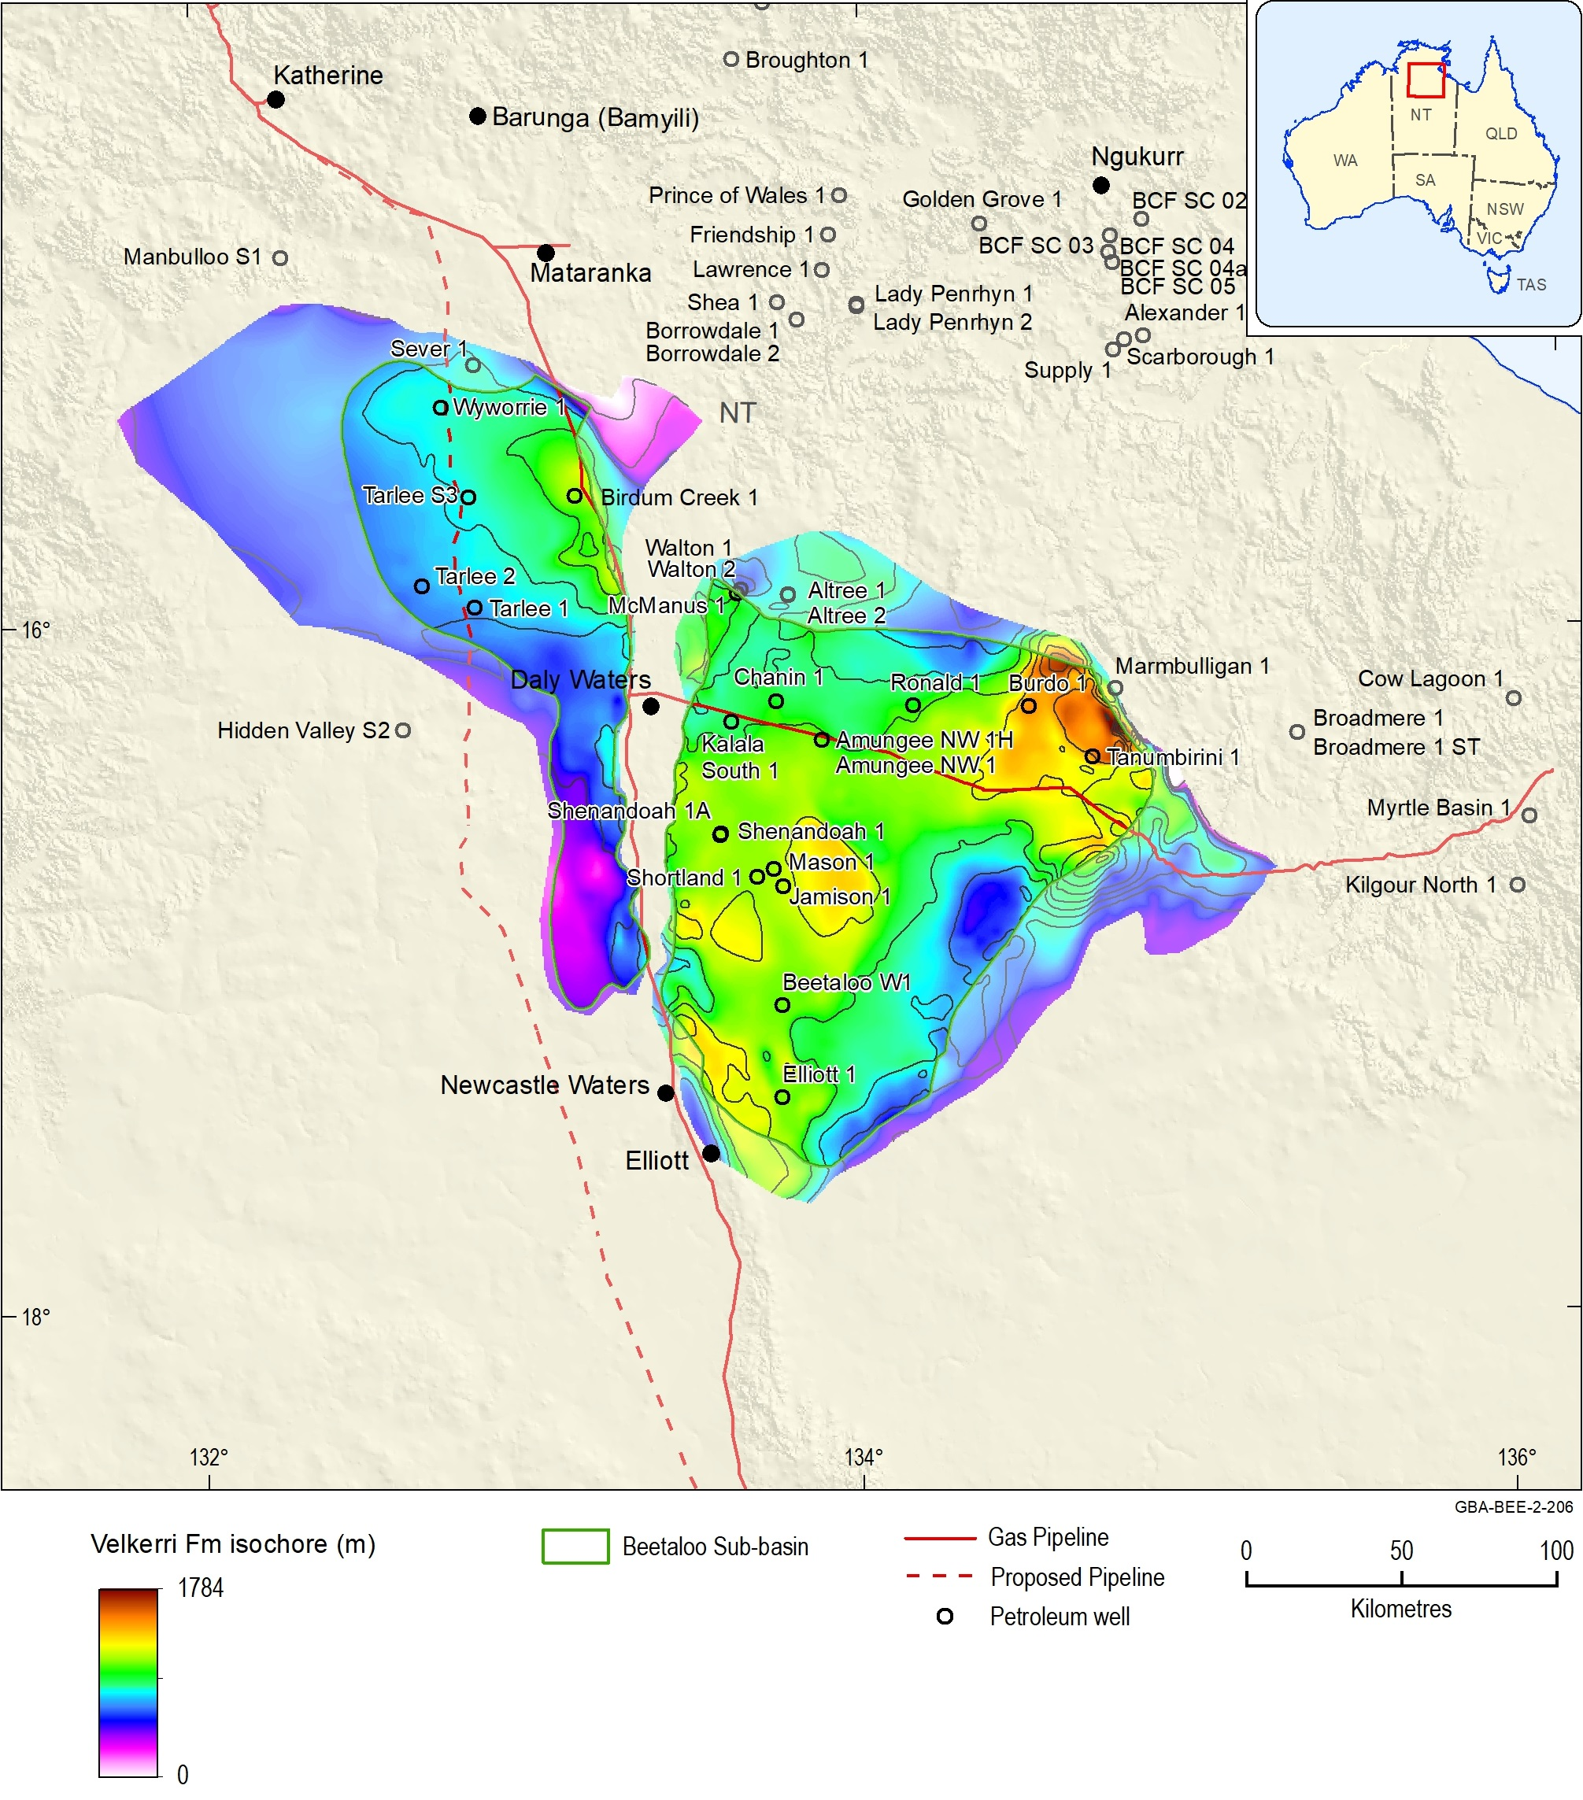
Figure 15 Velkerri Formation total vertical thickness (m)
Contour interval = 250 m
Source: Orr et al. (2020)
Data: Geological and Bioregional Assessment Program (2019b); Velkerri Formation isochore grid GBA derived dataset based on Williams (2019) and Northern Territory Government (2018b)
Element: GBA-BEE-2-206

Lithology and palaeoenvironment
The Velkerri Formation is a medium-grey to black laminated shale, with thin interbeds of siltstone and fine-grained sandstone (Munson, 2016). The Kalala Member is a grey to blue claystone with silty mudstone and interbedded sandstones; the Amungee Member is an organic-rich dark grey to black claystone, mudstone and siltstone; and the Wyworrie Member is a grey mudstone and siltstone with fine sandstone towards the top of the unit (Munson, 2014; Munson and Revie, 2018; Lanigan et al., 1994). The Amungee Member is the most organically rich and therefore the most prospective interval in the Beetaloo Sub-basin (Munson, 2014; Munson and Revie, 2018). Further details are provided in the accompanying geology technical appendix (Orr et al., 2020).
The facies variations within the Velkerri Formation, coupled with its great thickness, has provided ample discussion on the depositional setting (Abbott and Sweet, 2000; Abbott et al., 2001; Donnelly and Crick, 1988; Gorter and Grey, 2012; Jackson et al., 1987; Jackson and Raiswell, 1991; Johns et al., 2017; Powell et al., 1987) . The presence of acritarchs and glauconite confirms a marine depositional environment (Grey, 2015). Munson (2016) synthesised the Velkerri Formation depositional environments from previous interpretations as marine, sub-tidal, sub-wave base and generally quiet, but affected by regular current activity. The Amungee Member represents the deepest and most distal environments with the highest proportion of fine-grained sediments (Munson, 2016).
Three organically rich intervals are present within the Amungee Member, separated by organically lean sections. The organically rich shale intervals are informally named the A, B and C shales or organofacies, in ascending stratigraphic order (Close et al., 2017a; Côté et al., 2018; Munson and Revie, 2018). They have a distinct log character which has been identified in all well intersections of the Velkerri Formation (Hoffman, 2015; Warren et al., 1998) and are a primary targets for shale gas exploration in the Beetaloo Sub-basin (Close et al., 2017a; Côté et al., 2018). The Amungee Member A, B and C shales are inferred to have been deposited without a major break in sedimentation. Given the low biotic diversity of the Precambrian, the organic matter is likely to be derived from similar organisms (Côté et al., 2018).

Source rock characteristics
The principal petroleum source rocks of the Velkerri Formation are the organic-rich shale units. Jarrett et al. (2019) reviewed the source rock geochemistry and maturity of all known source rock units and associated data from the greater McArthur Basin, including the Velkerri Formation, based on the dataset of Revie and Normington (2018). This study builds on the assessment of Jarrett et al. (2019) by incorporating additional well data for Tarlee 1, 2 and 3, Birdum Creek 1 and Wyworrie 1 provided by Pangaea (Pangaea NT Pty Ltd, 2019). In addition, the source rock distribution, quality and type were characterised separately for all three members of the Velkerri Formation. Statistics were calculated based on a quality controlled dataset, filtered using the screening criteria defined in Jarrett et al. (2018); see also methods snapshot below.
Methods snapshot: Rock-Eval data quality assurance
Rock-Eval pyrolysis is the screening method of choice for source rock evaluation; however, data have to be checked for quality before starting interpretation. Indeed, some data can be unreliable for a number of reasons such as contamination of cuttings with drilling fluid or low TOC content (Carvajal-Ortiz and Gentzis, 2015; Peters, 1986; Dembicki, 2009). To ensure the integrity of the Rock-Eval pyrolysis data, the following data were excluded from analysis:
• Rock-Eval pyrolysis data derived from kerogens
• Internally inconsistent Rock-Eval pyrolysis data, with indices entered into the database not relating correctly to the measured parameters (e.g. HI does not equal S2/TOC *100)
• Rock-Eval pyrolysis data where S2 < 0.1 mg HC/g rock: Rock-Eval pyrolysis results may be unreliable for organically lean samples as they yield low and poorly defined S2 peaks resulting in unreliable Tmax and HI values
• Rock-Eval pyrolysis data where Tmax < 380°C: low values may imply an incorrect programmatical selection of the S2 peak, or the S1 peak is broad due to the presence of non-indigenous free hydrocarbons, either migrated hydrocarbons or drilling fluid contaminants
• Rock-Eval pyrolysis data where OI > 350 mg CO₂/g TOC: high OI values may be unreliable due to either thermal breakdown of carbonates, the presence of oxidised organic matter or the presence of drilling fluid contaminants.
Both oil staining due to migration and contamination from mud additives and oil-based drilling fluids affect the Rock-Eval pyrolysis data. Cuttings samples and side-wall cores are typically more prone to drilling fluid contamination than whole-core samples. Contamination or hydrocarbon migration may result in high PI and low Tmax values (Peters, 1986; Peters and Cassa, 1994). The primary focus of this study are in-situ source rocks, therefore Rock-Eval pyrolysis data meeting the following criteria were flagged as possibly being affected by either migrated hydrocarbons or drilling fluid contaminants, and were removed from the analysis:
• PI > 0.2 with Tmax < 435°C
• PI > 0.3 with Tmax between 435–445°C.
To estimate the extent of the petroleum-generation process and the total generative capacity in an already mature source rock, information on the TOC and HI of organic matter prior to the onset of hydrocarbon generation is required (Jarvie, 2012; Peters et al., 2005). Although source rock statistics and maps presented here reflect the present day measured values, original TOC values were estimated for key wells assuming a Type I kerogen (original HI of 750 mg HC/g TOC) and a Type II kerogen (original HI of 450 mg HC/g TOC). Further analysis of original TOC and HI are outside the scope of this study, but would be an important consideration for any future petroleum systems analysis study in the region.
The net source rock thickness, represented by the net thickness of organically rich material with a total organic carbon (TOC) content of > 2 wt%, was also estimated for wells where Schlumberger LithoScanner log data are available. This high-precision element capture spectroscopy well logging technology provides a continuous measurement of total carbon content down well. A continuous TOC profile may then be calculated by subtracting the inorganic carbon associated with carbonate minerals from the total carbon content. Due to the reduction in TOC with increasing maturity discussed above, using a present day TOC cut off of 2 wt% provides a minimum estimate of the original source rock thickness in regions where significant oil and gas generation has already occurred.

Total Velkerri Formation
Figure 16 and Figure 17 show example sections through the Velkerri Formation for 2 wells in the western sub-basin and 2 wells in the eastern sub-basin, highlighting the down well variability in lithology, source rock properties and maturity.
Source rock statistics for the entire Velkerri Formation are summarised in Table 5 based on a dataset of 2734 TOC samples and 741 Rock-Eval pyrolysis samples. The present day organic richness of the Velkerri Formation varies from 0 to 31 wt% TOC, with a mean of 2.3 wt% TOC, demonstrating excellent source rock richness (Table 5; Figure 18; Figure 19). Present day hydrogen indices range from 1 mg HC/g TOC to 800 mg HC/g TOC (Table 5; Figure 18), indicating excellent source rock quality (Figure 18).
The present day net organically rich ratio (NORR), representing the fraction of the formation with a TOC greater than 2 wt%, was calculated for eight wells. The average NORR of the Velkerri Formation is 0.3068 (Table 6; 0.333 in the eastern sub-basin and 0.2631 in the western sub-basin). Figure 20a shows the distribution of NORR data by well, along with a NORR grid across the Beetaloo Sub-basin, interpolated from the well data using a simple minimum curvature gridding algorithm.
The present day net source rock thickness, equivalent to the net thickness of organically rich shales with a TOC > 2 wt%, was calculated using the product of the NORR and the gross formation thickness. Net source rock thickness was calculated for eight wells, using the total intersected formation thickness as the gross thickness. The net source rock thickness by well ranges between 89 m and 724 m, with an average of 300 m (Table 6; Figure 20b). For all wells except Tanumbirini 1, these net source rock thicknesses represent minimum values as total depth was reached in the Velkerri Formation and the entire gross formation thickness was not penetrated.
A net source rock thickness grid was also calculated using the product of the NORR grid and the total formation thickness from the three-dimensional geological model (Orr et al., 2020) (Figure 20b). Further work is required to link source rock properties, including thickness and organic richness, to facies variations across the basin.
Organic petrology and other thermal maturity indicators (e.g. Tmax) indicate that the Velkerri Formation is mature for liquids-rich gas to dry gas (Figure 16; Figure 17). Source rock maturity for the Velkerri Formation is discussed in further detail in Section 4.3, which describes the use of one-dimensional petroleum systems modelling to map the distribution of the oil, wet gas and dry gas windows across the Beetaloo Sub-basin.

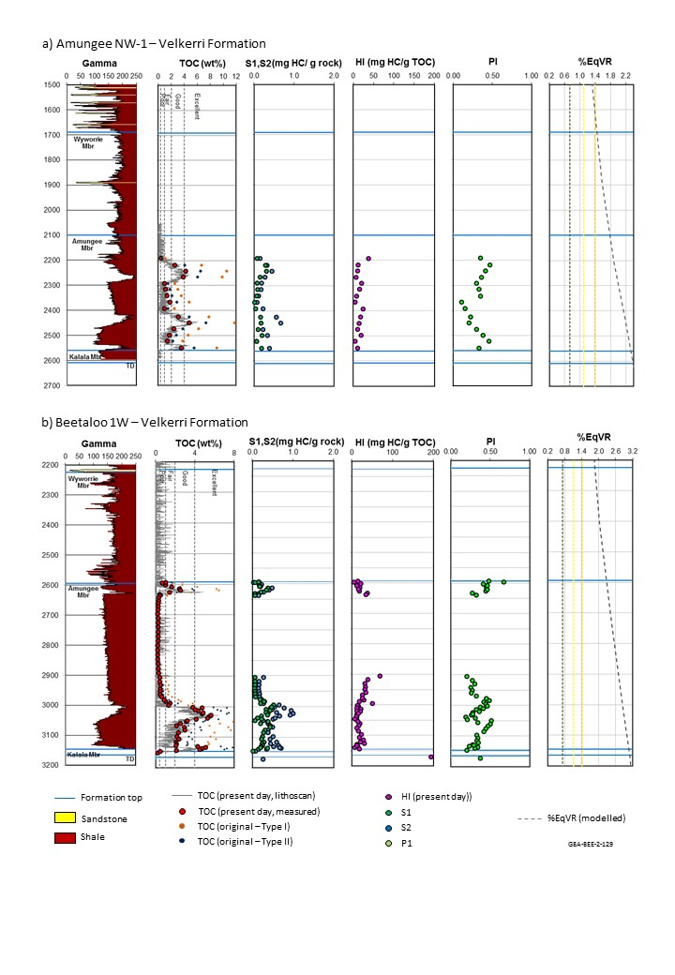
Figure 16 Velkerri Formation source rock characteristics in the a) Amungee NW1 and b) Beetaloo W1 wells in the eastern Beetaloo Sub-basin
TD = total depth; TOC = total organic carbon; HI = hydrogen index; S1, S2, S3 = Rock-Eval parameters; PI = production index; %EqVR = vitrinite reflectance equivalent; ppm = parts per million; wt% = weight as a percentage. Two sets of original TOC data are estimated assuming original HIs of 750 mg HC/g TOC) and 450 mg HC/g TOC, using the equation of Peters et al. (2005). Modelled maturity is sourced from one-dimensional petroleum system model presented in Section 4.3.
Data: Revie and Normington (2018)
Element: GBA-BEE-2-361
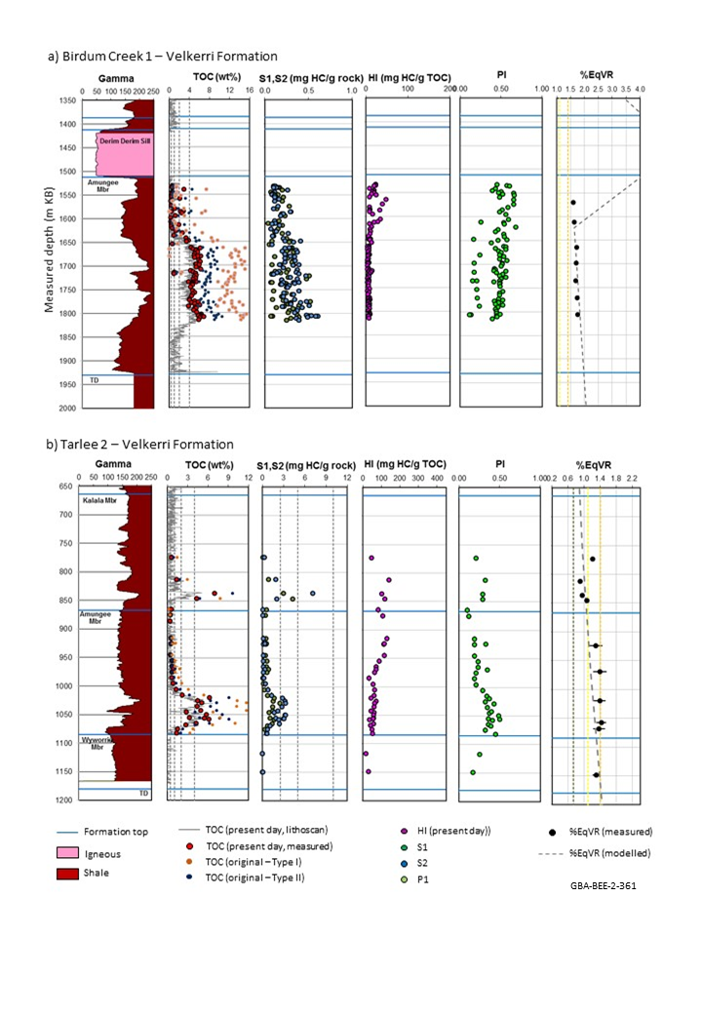
Figure 17 Velkerri Formation source rock characteristics in the a) Birdum Creek 1 and b) Tarlee 2 wells in the western Beetaloo Sub-basin
TD = total depth; TOC = total organic carbon; HI = hydrogen index; S1, S2, S3 = Rock-Eval parameters; PI = production index; %EqVR = vitrinite reflectance equivalent; ppm = parts per million; wt% = weight as a percentage. Two sets of original TOC data are estimated assuming original HIs of 750 mg HC/g TOC) and 450 mg HC/g TOC, using the equation of Peters et al. (2005). Modelled maturity is sourced from one-dimensional petroleum system model presented in Section 4.3.
Data: Revie and Normington (2018); Pangaea NT Pty Ltd (2019)
Element: GBA-BEE-2-130
Table 5 Velkerri Formation source rock properties. Statistics are based on the analysis of 2734 TOC samples and 741 Rock-Eval pyrolysis samples. Rock-Eval pyrolysis data was quality controlled prior to calculating statistics using the screening criteria defined in Jarrett et al. (2018)
 | Mean | Min | Max | Stdev | P10 | P50 | P90
TOC (wt%) | 2.3 | 0.0 | 31.0* | 2.5 | 0.3 | 1.5 | 5.3
S1 (mg HC/g rock) | 1.4 | 0.0 | 6.5 | 1.3 | 0.1 | 1.2 | 3.2
S2 (mg HC/g rock) | 8.6 | 0.1 | 78.7 | 11.5 | 0.2 | 5.0 | 19.6
S3 (mg HC/g rock) | 0.5 | 0.0 | 6.5 | 0.7 | 0.1 | 0.3 | 1.0
Tmax (°C) | 454 | 390 | 618 | 39 | 430 | 442 | 506
HI (mg HC/g TOC) | 193 | 1 | 800 | 149 | 9 | 184 | 398
OI (mg CO₂/g TOC) | 19 | 0 | 347 | 32 | 2 | 10 | 41
PI (unit less) | 0.2 | 0.0 | 0.7 | 0.1 | 0.1 | 0.2 | 0.4
mg CO2/g TOC = milligrams of CO2 per gram of total organic carbon; mg HC/g TOC = milligrams of hydrocarbons per gram of total organic carbon; TOC = Total Organic Carbon; S1, S2, S3 and Tmax = Rock-Eval pyrolysis parameters; HI = Hydrogen Index; OI = Oxygen Index; PI = Production Index; stdev: standard deviation; P10: 10th percentile; P50: 50th percentile; P90: 90th percentile; wt% = weight as a percentage.
*TOC values greater than 10% may represent graphite formed in association with local igneous intrusions.
Data: Revie and Normington (2018); Pangaea NT Pty Ltd (2019)
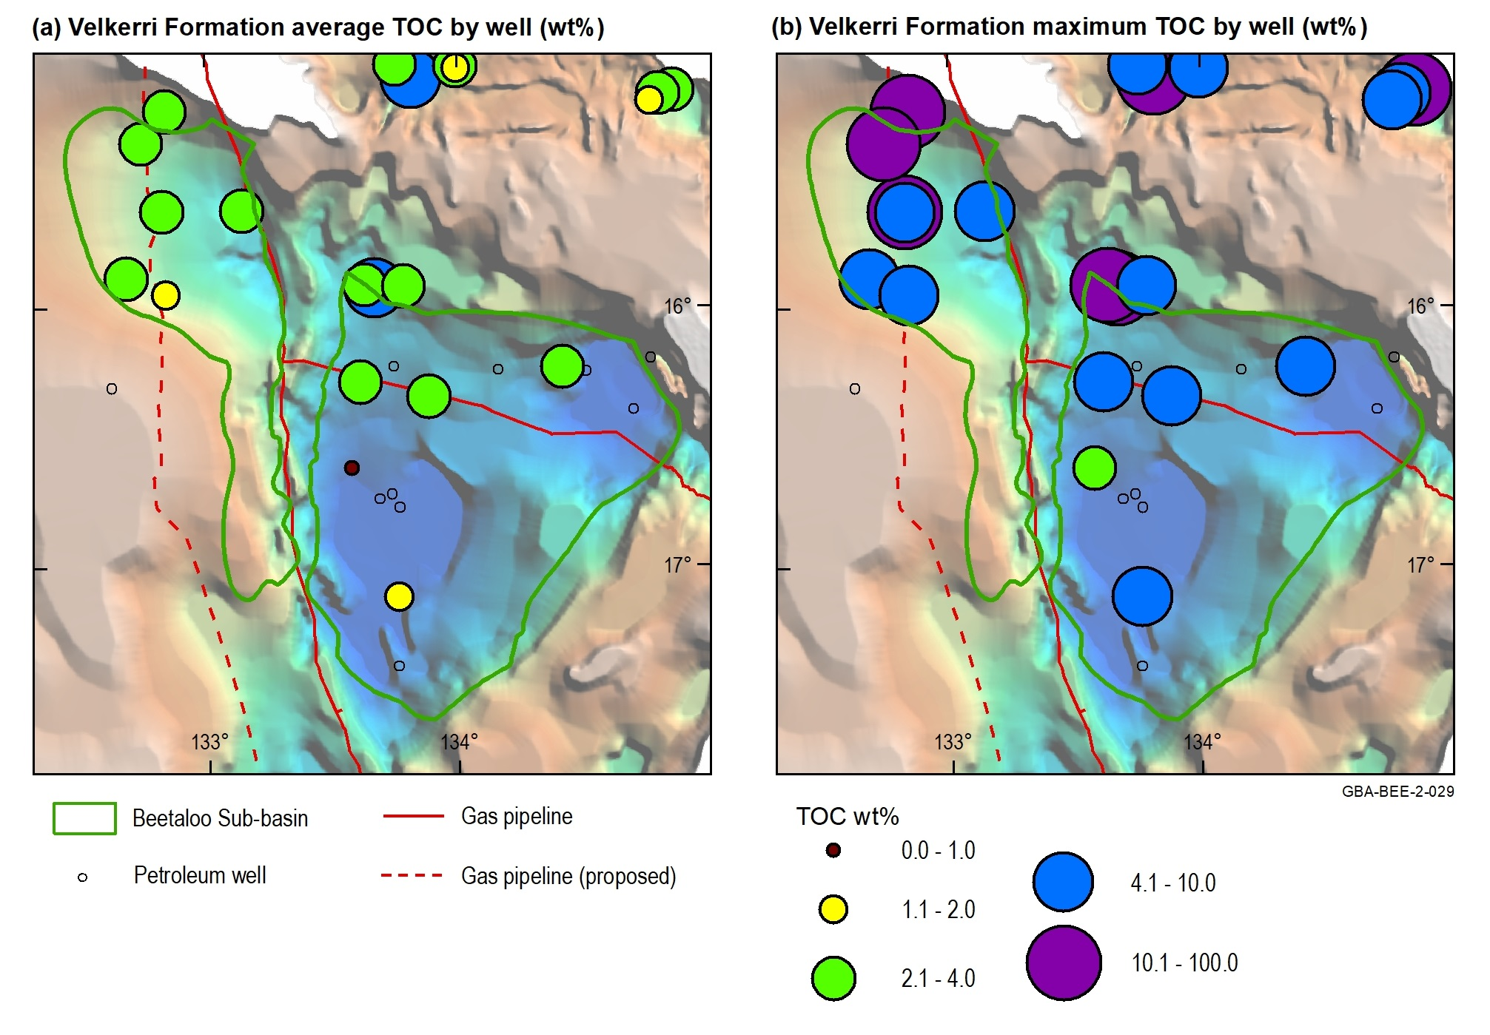
Figure 18 Velkerri Formation TOC distribution shown over the depth to base Roper Group
TOC = total organic carbon; wt% = weight as a percentage
Source: modified from Jarrett et al. (2019); depth to base Roper Group (Wilton package) sourced from Frogtech Geoscience (2018)
Data: TOC data from Revie and Normington (2018); Pangaea NT Pty Ltd (2019)
Element: GBA-BEE-2-029
Figure 19 Rock-Eval pyrolysis data plots for the Velkerri Formation: (a) TOC carbon vs S2 yield; (b) Tmax vs present day HI
TOC = total organic carbon; S2 and Tmax = Rock-Eval pyrolysis parameters; HI = hydrogen index; wt% = weight as a percentage; HC = hydrocarbons; %Ro = vitrinite reflectance maturity
Source: modified from Jarrett et al. (2019)
Data: Revie and Normington (2018); Pangaea NT Pty Ltd (2019)
Element: GBA-BEE-2-113
Table 6 Net organically rich ratio (NORR) of the Velkerri Formation shales in the Beetaloo Sub-basin
Beetaloo Sub-basin region | Well | Net organically rich ratio (fraction) | Total formation thickness (m)* | Net thickness of organically rich section (m)*
Eastern | Amungee NW1 | 0.31 | 919 | 287
Eastern | Beetaloo W1 | 0.10 | 940 | 89
Western | Birdum Creek 1 | 0.25 | 834 | 204
Eastern | Kalala S1 | 0.24 | 776 | 190
Eastern | Tanumbirini 1 | 0.49 | 1483 | 734
Western | Tarlee 1 | 0.40 | 540 | 219
Western | Tarlee 2 | 0.14 | 516 | 72
Western | Wyworrie 1 | 0.52 | 597 | 309
 | Average | 0.31 | 991 | 301
*Note all wells except Tanumbirini reach total depth in the Velkerri Formation, therefore for both the total formation thickness and the net thickness of organically rich material represent minimum values for these wells.
Data: Revie and Normington (2018)
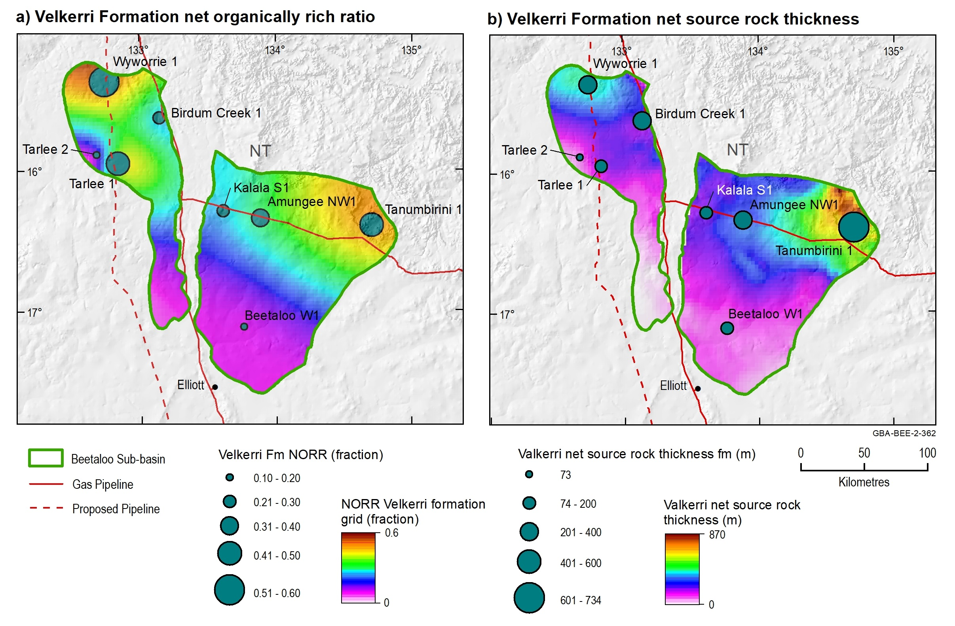
Figure 20 a) Net organically rich ratios of the Velkerri Formation shales and b) net Velkerri Formation source rock thickness in the Beetaloo Sub-basin and surrounds
*Note all wells except Tanumbirini 1 reach total depth in the Velkerri Formation, therefore the net thickness source rock thickness represent minimum values all wells except Tanumbirini 1.
Data: Revie and Normington (2018)
Element: GBA-BEE-2-362

Kalala Member
Source rock statistics for the Kalala Member are summarised in Table 7 based on a dataset of 505 TOC samples and 75 Rock-Eval pyrolysis samples sourced from Revie and Normington (2018) and Pangaea NT Pty Ltd (2019). The organic richness of the Kalala Member varies from 0 to 7 wt%, with mean of 0.9 wt% TOC (Table 7). Samples with TOC > 2 wt% are restricted to the northern boundaries of both the eastern and western Beetaloo Sub-basin (Figure 21). Kalala Member present day hydrogen indices range from 4 mg HC/g TOC to 233 mg HC/g TOC (Table 7), indicating predominantly gas-prone kerogens (Figure 22). Although two samples show excellent source rock quality (HI > 500 mg HC/g TOC), the data suggests possible staining due to migration, so they are excluded from this data analysis.
The present day net source rock thickness, equivalent to the net thickness of organically rich shales with a TOC > 2 wt%, was calculated using the product of the NORR and the gross thickness of the Kalala Member. Net source rock thickness was calculated for six wells, using the total intersected formation thickness as the gross thickness. The distribution of NORR varies significantly, from 0 to 0.6, with an average of 0.2 (Table 8). For all wells except Tanumbirini 1, these net source rock thicknesses represent minimum values as total depth was reached in the Kalala Member and therefore the entire gross formation thickness was not penetrated.
Table 7 Kalala Member source rock properties. Statistics are based on the analysis of 505 TOC samples and 75 Rock-Eval pyrolysis samples. Rock-Eval pyrolysis data was quality controlled prior to calculating statistics using the screening criteria defined in Jarrett et al. (2018)
 | Mean | Min | Max | Stdev | P10 | P50 | P90
TOC (wt%) | 0.9 | 0.0 | 7.0 | 1.2 | 0.1 | 0.4 | 2.7
S1 (mg HC/g rock) | 0.6 | 0.0 | 2.9 | 0.7 | 0.1 | 0.3 | 1.5
S2 (mg HC/g rock) | 2.5 | 0.1 | 11.6 | 2.9 | 0.2 | 0.9 | 6.9
S3 (mg HC/g rock) | 0.3 | 0.0 | 2.6 | 0.5 | 0.0 | 0.2 | 0.8
Tmax (°C) | 456 | 390 | 576 | 30 | 426 | 453 | 476
HI (mg HC/g TOC) | 92 | 4 | 233 | 61 | 17 | 89 | 180
OI (mg CO₂ g TOC) | 23 | 1 | 264 | 43 | 2 | 9 | 48
PI (unit less) | 0.2 | 0.0 | 0.6 | 0.1 | 0.1 | 0.2 | 0.4
mg CO2/g TOC = milligrams of CO2 per gram of total organic carbon; mg HC/g TOC = milligrams of hydrocarbons per gram of total organic carbon; TOC = Total organic carbon; S1, S2, S3 and Tmax = Rock-Eval pyrolysis parameters; HI = Hydrogen Index; OI = Oxygen Index; PI = Production Index; stdev: standard deviation; P10: 10th percentile; P50: 50th percentile; P90: 90th percentile; wt% = weight as a percentage.
Data: Revie and Normington (2018); Pangaea NT Pty Ltd (2019)

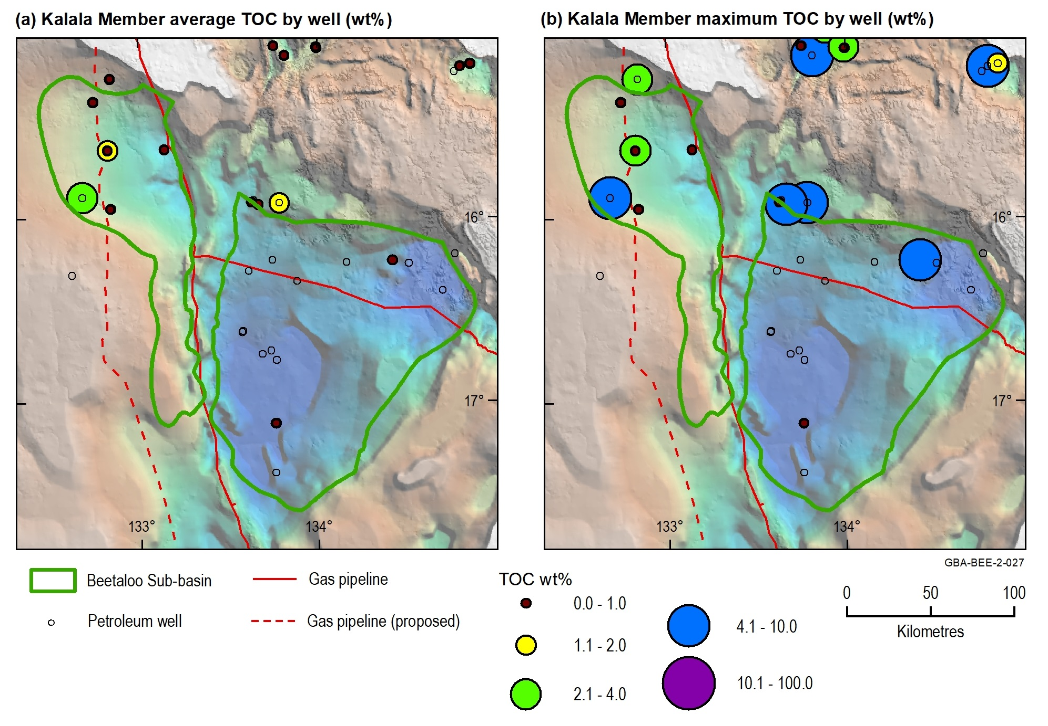
Figure 21 Kalala Member (Velkerri Formation) TOC distribution show over the depth to base Roper Group
TOC = total organic carbon; wt% = weight as a percentage
Source: modified from Jarrett et al. (2019); depth to base Roper Group (Wilton package) sourced from Frogtech Geoscience (2018)
Data: Revie and Normington (2018); Pangaea NT Pty Ltd (2019)
Element: GBA-BEE-2-027
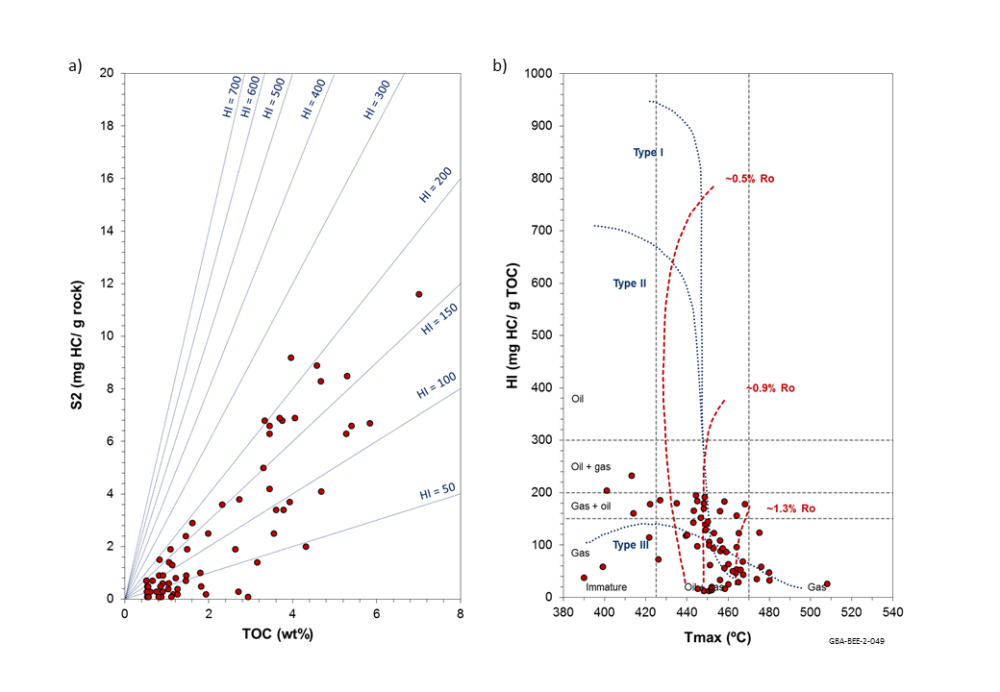
Figure 22 Rock-Eval pyrolysis data plots for the Kalala Member of the Velkerri Formation, modified from Jarrett et al. (2019): (a) TOC content vs S2 yield; (b) Tmax vs HI
TOC: total organic carbon; HI: hydrogen index; wt%: weight %; HC: hydrocarbons; Ro: maturity
Source: modified from Jarrett et al. (2019)
Data: Revie and Normington (2018); Pangaea NT Pty Ltd (2019)
Element: GBA-BEE-2-049
Table 8 Net organically rich ratio (NORR) of the Kalala Member shales in the Beetaloo Sub-basin
Beetaloo Sub-basin region | Well | Net organically rich ratio (fraction) | Total formation thickness (m)* | Net thickness of organically rich section (m)*
Eastern | Amungee NW1 | 0 | 57 | 0
Eastern | Kalala S1 | 0 | 49 | 0
Western | Tarlee 1 | 0.62
Western | Tarlee 2 | 0.08 | 100 | 8
Western | Wyworrie 1 | 0.51 | 60 | 31
 | Average | 0.20
All wells reach total depth within the Kalala Member, therefore for the total formation thickness and the net thickness of organically rich material represent minimum values.
Data: Revie and Normington (2018)

Amungee Member
Source rock statistics for the Amungee Member are summarised in Table 9 based on a dataset of 1520 TOC samples and 525 Rock-Eval pyrolysis samples sourced from Revie and Normington (2018) and Pangaea NT Pty Ltd (2019). Amungee Member TOC varies from 0.1 to 30 wt%, with a mean value of 3.4 wt% TOC, demonstrating excellent source rock richness (Table 9).
Samples with TOC content > 2 wt% are distributed across both the eastern and western Beetaloo Sub-basin, demonstrating the presence of excellent quality source rock facies across the sub-basin (Figure 23). Amungee Member present day hydrogen indices range from 1 mg HC/g TOC to 800 mg HC/g TOC (Table 9). The very high hydrogen indices indicate excellent source rock quality and the presence of liquid-prone kerogens (Figure 24; Table 9) (Taylor et al., 1994; Summons et al., 1994).
The NORR of the Amungee Member, representing the fraction of formation with a TOC greater than 2 wt%, was calculated for eight wells. The NORR ranges from 0.16 to 0.53 with the average of 0.35 (Table 10). Figure 25a shows the distribution of Amungee Member NORR by well, along with a NORR grid across the Beetaloo Sub-basin, interpolated from the well data using a simple minimum curvature gridding algorithm. However, further work is required to link source rock properties, including thickness and organic richness, to facies variations across the basin.
The present day net source rock thickness, equivalent to the net thickness of organically rich shales with a TOC > 2 wt%, was calculated using the product of the NORR and the gross formation thickness. Net source rock thickness was calculated for eight wells, using the total intersected formation thickness as the gross thickness. The net source rock thickness by well ranges between 52 m and 246 m, with an average of 157 m (Table 10; Figure 25b). A net source rock thickness grid was also calculated using the product of the NORR grid and the total formation thickness from the three-dimensional geological model (Orr et al., 2020) (Figure 25b).
Table 9 Amungee Member source rock properties. Statistics based on analysis of 1520 TOC samples and 525 Rock-Eval pyrolysis samples. Rock-Eval pyrolysis data was quality controlled prior to calculating statistics using the screening criteria defined in Jarrett et al. (2018)
 | Mean | Min | Max | Stdev | P10 | P50 | P90
TOC (wt%) | 3.4 | 0.1 | 29.9* | 2.6 | 0.6 | 3.1 | 6.1
S1 (mg HC/g rock) | 1.7 | 0.0 | 6.5 | 1.3 | 0.1 | 1.6 | 3.6
S2 (mg HC/g rock) | 10.5 | 0.1 | 78.7 | 12.5 | 0.2 | 7.3 | 22.7
S3 (mg HC/g rock) | 0.5 | 0.0 | 5.5 | 0.7 | 0.1 | 0.3 | 1.1
Tmax (°C) | 458 | 395 | 618 | 43 | 430 | 442 | 528
HI (mg HC/g TOC) | 210 | 1 | 800 | 159 | 7 | 208 | 415
OI (mg CO₂/g TOC) | 14 | 0 | 94 | 14 | 2 | 9 | 34
PI (unit less) | 0.2 | 0.0 | 0.7 | 0.2 | 0.1 | 0.2 | 0.5
mg CO2/ g TOC = milligrams of CO2 per gram of total organic carbon; mg HC/g TOC = milligrams of hydrocarbons per gram of total organic carbon; TOC = total organic carbon; S1, S2, S3 and Tmax = Rock-Eval pyrolysis parameters; HI = Hydrogen Index; OI = Oxygen Index; PI = Production Index; stdev: standard deviation; P10: 10th percentile; P50: 50th percentile; P90: 90th percentile; wt% = weight as a percentage. *TOC values > 10% may represent graphite formed in association with local igneous intrusions.
Data: Revie and Normington (2018); Pangaea NT Pty Ltd (2019)
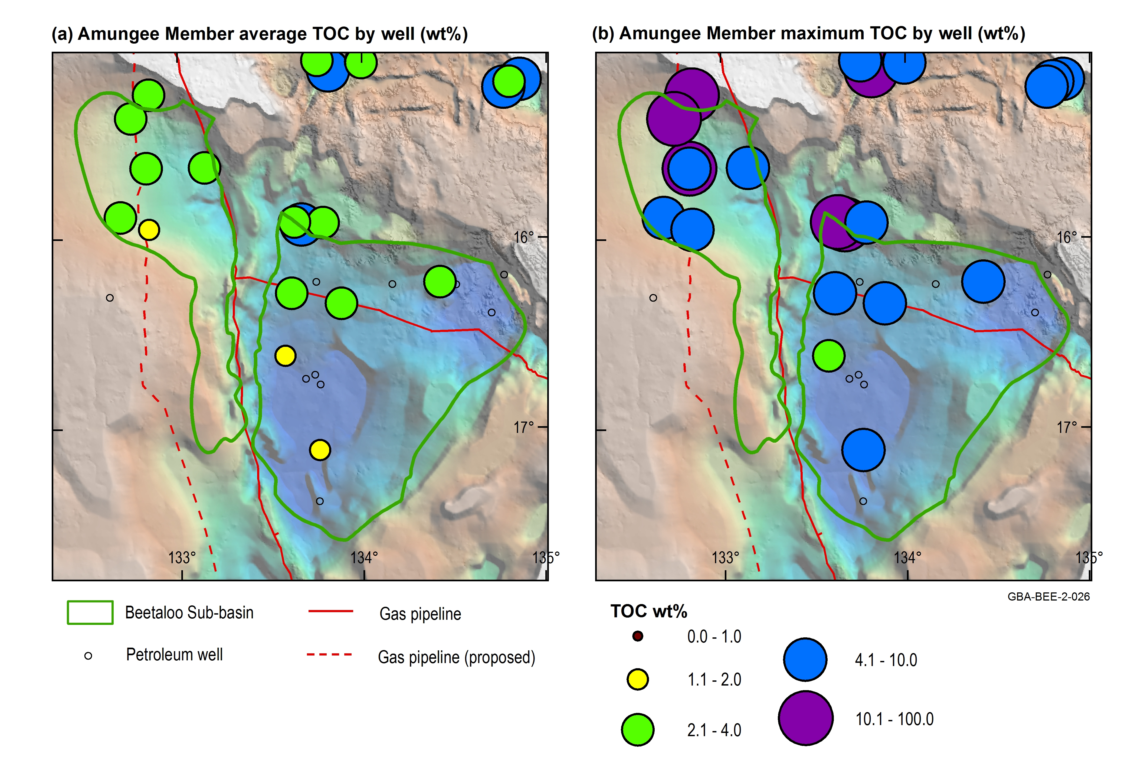
Figure 23 Amungee Member (Velkerri Formation) TOC distribution shown over the depth to base Roper Group
TOC = total organic carbon; wt% = weight as a percentage
Source: modified from Jarrett et al. (2019); depth to base Roper Group (Wilton package) sourced from Frogtech Geoscience (2018)
Data: Revie and Normington (2018); Pangaea NT Pty Ltd (2019)
Element: GBA-BEE-2-026

Figure 24 Rock-Eval pyrolysis data plots for the Amungee Member of the Velkerri Formation: (a) TOC content vs S2 yield; (b) Tmax vs HI
TOC = total organic carbon; S2 and Tmax = Rock-Eval pyrolysis parameters; HI = hydrogen index; wt% = weight as a percentage; HC = hydrocarbons; %EqVR = vitrinite reflectance maturity
Source: modified from Jarrett et al. (2019)
Data: Revie and Normington (2018); Pangaea NT Pty Ltd (2019)
Element: GBA-BEE-2-050
Table 10 Net organically rich ratio (NORR) of the Amungee Member shales in the Beetaloo Sub-basin
Beetaloo Sub-basin region | Well | Net organically rich ratio (fraction) | Total unit thickness (m)* | Net thickness of organically rich section (m)*
Eastern | Amungee NW1 | 0.35 | 460 | 159
Eastern | Beetaloo W1 | 0.16 | 553 | 88
Western | Birdum Creek 1 | 0.37 | 554 | 207
Eastern | Kalala S1 | 0.27 | 508 | 135
Eastern | Tanumbirini 1 | 0.49 | 497 | 246
Western | Tarlee 1 | 0.51 | 347 | 176
Western | Tarlee 2 | 0.24 | 217 | 52
Western | Wyworrie 1 | 0.53 | 369 | 196
 | Average | 0.36 |  | 157
Data: Revie and Normington (2018)
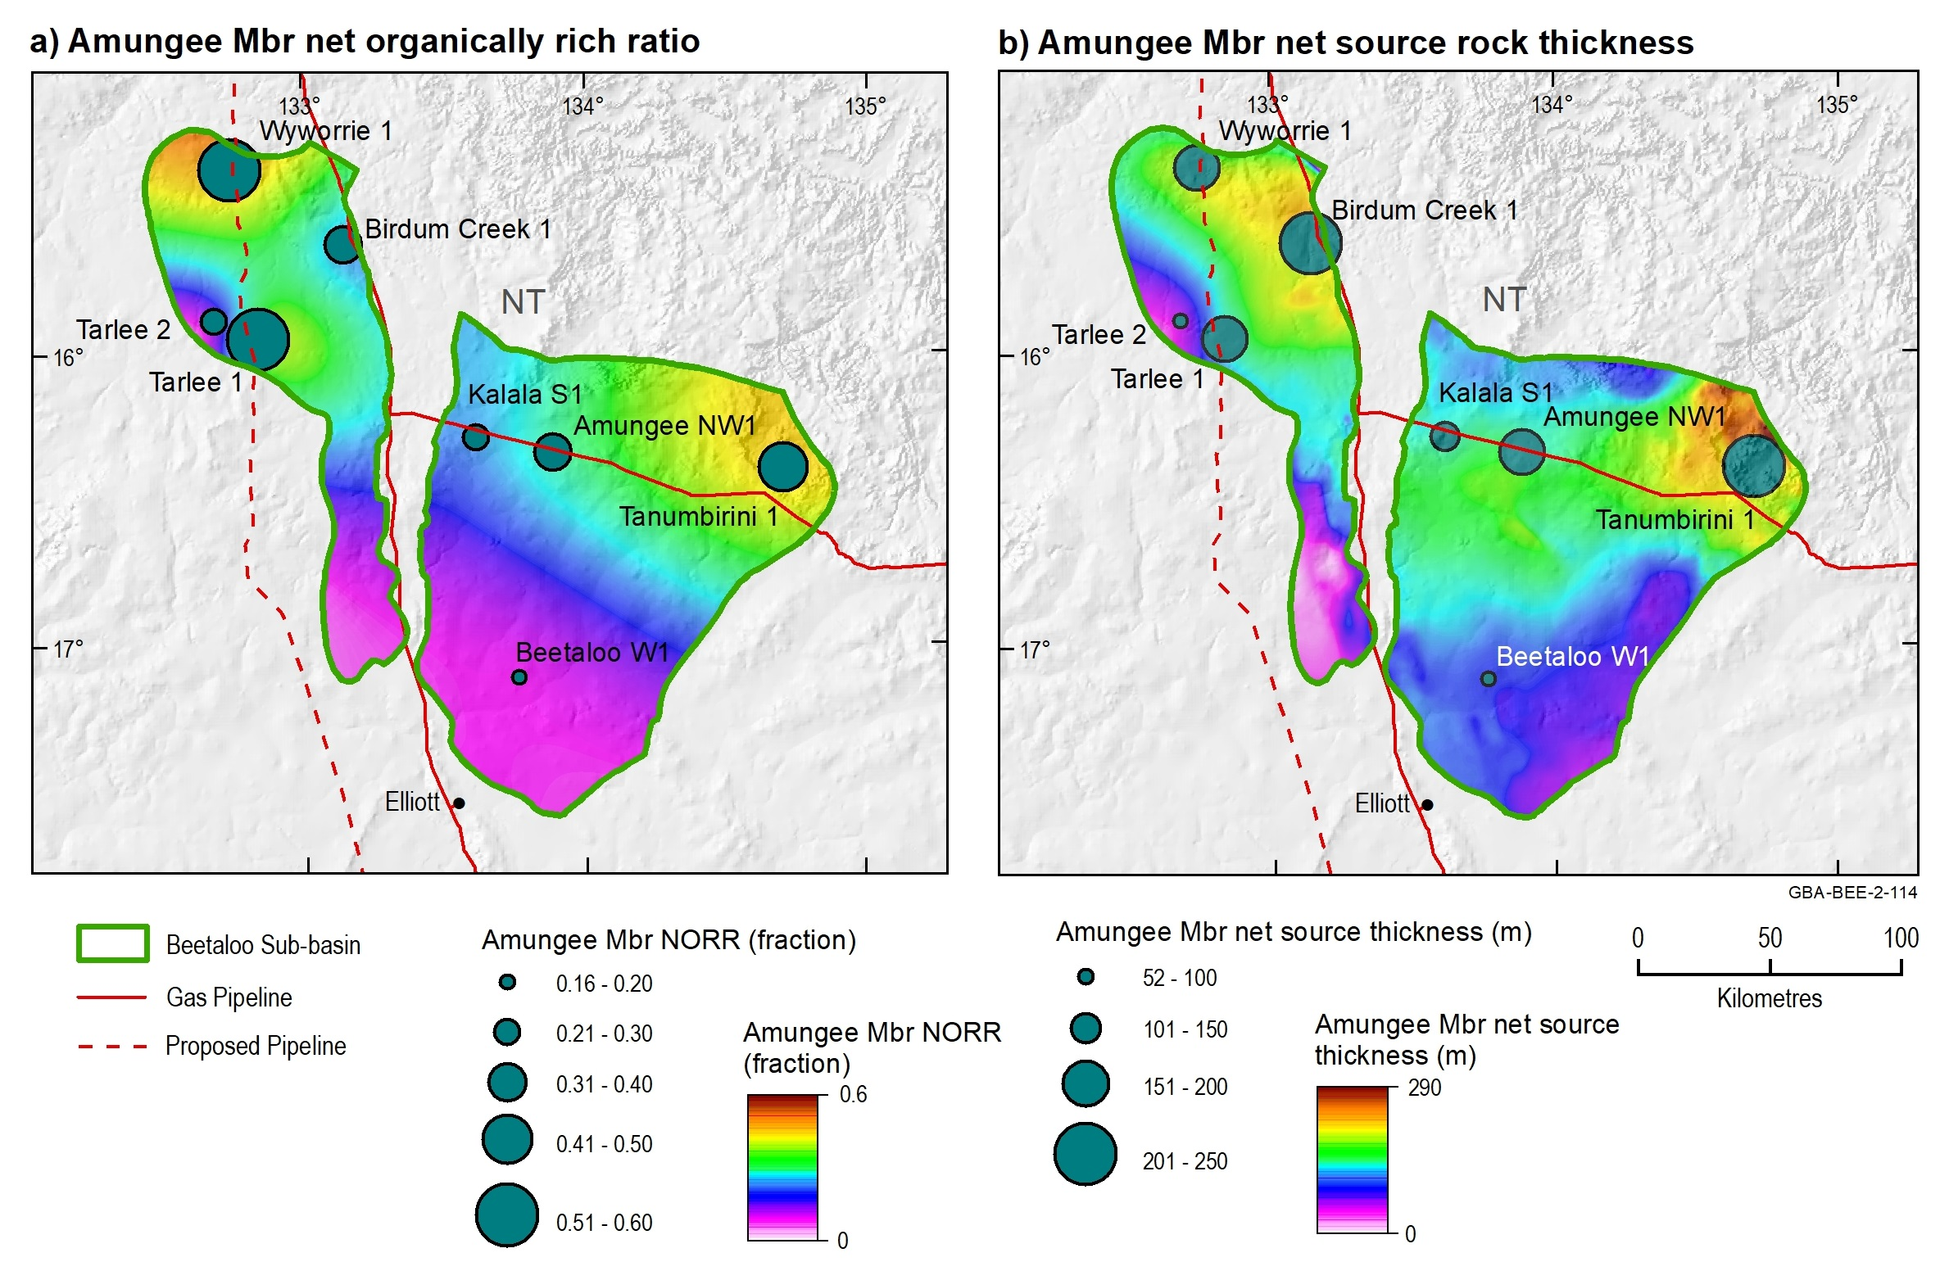
Figure 25 a) Net organically rich ratios of the Amungee Member shales and b) net Amungee Member source rock thickness in the Beetaloo Sub-basin
Data: Revie and Normington (2018)
Element: GBA-BEE-2-114

Wyworrie Member
Source rock statistics for the Wyworrie Member are summarised in Table 11 based on a dataset of 669 TOC samples and 117 Rock-Eval pyrolysis samples sourced from Revie and Normington (2018) and Pangaea NT Pty Ltd (2019). The organic richness of Wyworrie Member varies from 0.1 to 11 wt%, with a mean of 0.9 wt% TOC (Table 11). Samples with TOC > 2 wt% are restricted to the northern boundaries of both the eastern and western Beetaloo Sub-basin (Figure 26). Wyworrie Member present day hydrogen indices range from 8 mg HC/g TOC to 461 mg HC/g TOC (Table 11). The high hydrogen indices (> 300 mg HC/g TOC) indicate excellent source rock quality and the presence of liquid-prone kerogens (Figure 27).
The present day net source rock thickness, equivalent to the net thickness of organically rich shales with a TOC > 2 wt%, was calculated using the product of the NORR and the gross formation thickness. Net source rock thickness was calculated for six wells, using the total intersected formation thickness as the gross thickness. The distribution of NORR varies significantly, from 0 to 0.27, with an average of 0.048 (Table 12). This corresponds to a range in net source rock thickness from 0 to 34 m, with an average of 8 m. For most wells, these net source rock thicknesses represent minimum values as the lithoscanner log data does not cover the entire gross thickness of the Wyworrie Member. There was insufficient data density to map the NORR.

Table 11 Wyworrie Member source rock properties. Statistics are based on the analysis of 669 TOC samples and 117 Rock-Eval pyrolysis samples. Rock-Eval pyrolysis data was quality controlled prior to calculating statistics using the screening criteria defined in Jarrett et al. (2018)
 | Mean | Min | Max | Stdev | P10 | P50 | P90
TOC (wt%) | 0.9 | 0.1 | 10.6 | 1.0 | 0.3 | 0.7 | 1.6
S1 (mg HC/g rock) | 0.7 | 0.0 | 3.4 | 0.8 | 0.1 | 0.3 | 2.1
S2 (mg HC/g rock) | 3.1 | 0.2 | 27.9 | 4.5 | 0.3 | 1.5 | 7.3
S3 (mg HC/g rock) | 0.5 | 0.0 | 6.5 | 0.7 | 0.1 | 0.2 | 1.0
Tmax (°C) | 440 | 415 | 488 | 7 | 434 | 439 | 446
HI (mg HC/g TOC) | 183 | 8 | 461 | 116 | 32 | 175 | 353
OI (mg CO₂/g TOC) | 45 | 1 | 347 | 59 | 6 | 20 | 115
PI (unit less) | 0.2 | 0.0 | 0.4 | 0.1 | 0.1 | 0.2 | 0.3
mg CO2/g TOC = milligrams of CO2 per gram of total organic carbon; mg HC/g TOC = milligrams of hydrocarbons per gram of total organic carbon; TOC = total organic carbon; S1, S2, S3 and Tmax = Rock-Eval pyrolysis parameters; HI = Hydrogen Index; OI = Oxygen Index; PI = Production Index; stdev: standard deviation; P10: 10th percentile; P50: 50th percentile; P90: 90th percentile; wt% = weight as a percentage.
All public domain samples have been analysed; no distinction has been made between the properties of reservoir versus non-reservoir units.
Production Index; Stdev = standard deviation; P10 = 10th percentile; P50 = 50th percentile; P90 = 90th percentile
Data: Revie and Normington (2018); Pangaea NT Pty Ltd (2019)
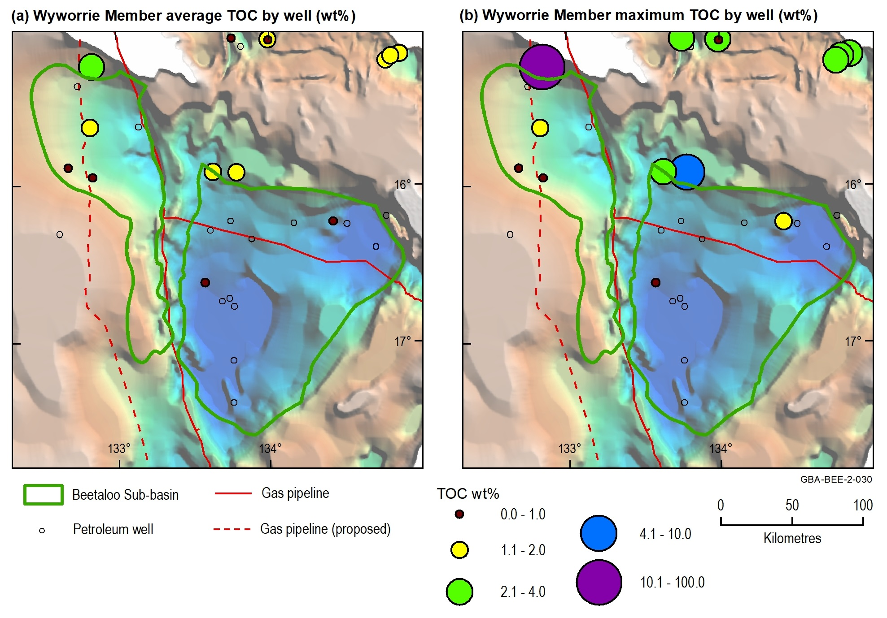
Figure 26 Wyworrie Member of the Velkerri Formation TOC (wt%) distribution show over the depth to base Roper Group
TOC = total organic carbon; wt% = weight as a percentage
Source: modified from Jarrett et al. (2019); depth to base Roper Group (Wilton package) sourced from Frogtech Geoscience (2018)
Data: Revie and Normington (2018); Pangaea NT Pty Ltd (2019)
Element: GBA-BEE-2-030

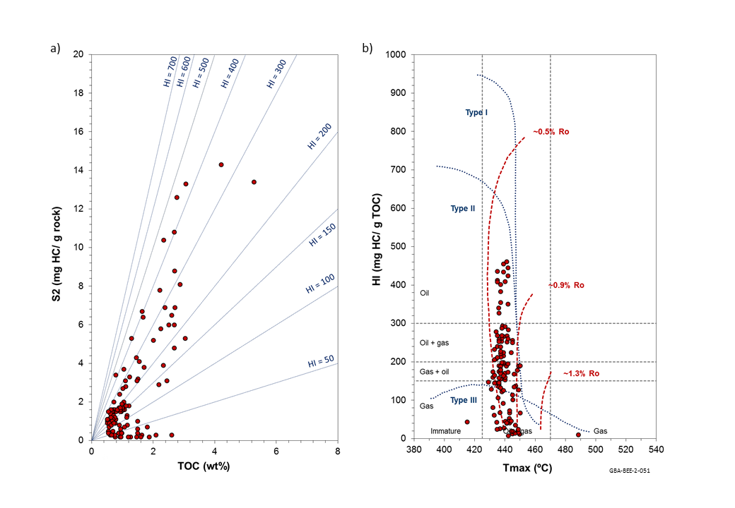
Figure 27 Rock-Eval pyrolysis data plots for the Wyworrie Member of the Velkerri Formation: (a) TOC content vs S2 yield; (b) Tmax vs HI
TOC: Total Organic Carbon; S2 and Tmax: Rock-Eval pyrolysis parameters; HI: hydrogen index; wt%: weight %; HC: hydrocarbons; Ro: vitrinite reflectance maturity
All public domain samples have been analysed; no distinction has been made between the properties of reservoir versus non-reservoir units.
Source: modified from Jarrett et al. (2019)
Data: Revie and Normington (2018); Pangaea NT Pty Ltd (2019)
Element: GBA-BEE-2-051

Table 12 Net organically rich ratio (NORR) of the Wyworrie Member shales in the Beetaloo Sub-basin
Beetaloo Sub-basin region | Well | Net organically rich ratio (fraction) | Total formation thickness (m) | Net thickness of organically rich section (m)
Eastern | Amungee NW1 | 0 | 404 | 0
Eastern | Beetaloo W1 | 0.0016 | 364 | 1
Western | Birdum Creek 1 | 0.0011 | 281 | <1
Eastern | Kalala S1 | 0 | 213 | 0
Western | Tarlee 1 | 0.276 | 124 | 34
Western | Tarlee 2 | 0.0608 | 203 | 12
 | Average | 0.0565 |  | 8
Data: Revie and Normington (2018)

Shale reservoir characteristics

Petrophysical properties
Porosity, permeability and fluid saturation are three of the key petrophysical input parameters required for characterising shale plays. Based on laboratory tests (as-received basis) on 99 rock samples from 11 wells the Beetaloo Sub-basin and surrounds, the Velkerri Formation shales have an average total porosity (helium porosity of dry samples) of 7.29%, average bulk density of 2.489 gm/cc, average water saturation of 55.12%, average gas saturation of 39.80%, average gas-filled porosity of 3.05% and average permeability of 1.535 X 10⁻⁴ mD. Table 13 and Figure 28 show the details of above parameters by well. Among the 99 Velkerri Formation shale samples, there are only 3 samples (McManus 1, Lady Penrhyn 2, Scarborough 1) from the Wyworrie Member and 1 sample (Scarborough 1) from the Kalala Member.
Table 14, Table 15 and Table 16 show the averaged as-received laboratory measured shale rock properties the Wyworrie, Amungee and Kalala members in the Beetaloo Sub-basin and surrounds. Four shale samples from the Amungee Member B shale in Shenandoah 1/1A were tested, and the averaged shale rocks properties include as-received bulk density of 2.613 g/cc, water saturation of 53.93%, oil saturation of 1.40%, gas saturation of 44.67%, gas-filled porosity of 1.76%, and pressure decay permeability of 9.09 x 10⁻⁵ mD, and the dry helium porosity of 4.06%.
Table 13 Average laboratory measured as-received shale rock properties of the entire Velkerri Formation for key wells in the Beetaloo Sub-basin and surrounds
Well (number of tests) | A-R Bulk Density (g/cc) | Dry Helium Porosity (% of BV) | A-R Water Saturation (% of PV) | A-R Oil Saturation (% of PV) | A-R Gas Saturation (% of PV) | A-R Gas - Filled Porosity (% of BV) | A-R Pressure Decay Permeability (mD)
Altree 2 (4) | 2.4 | 7.5 | 50.6 | 11.3 | 38.1 | 3.7 | 1.288 x 10⁻⁴
Birdum Creek 1 (5) | 2.5 | 6.0 | 69.9 | 1.2 | 28.9 | 2.0 | 4.197 x 10⁻⁵
Lady Penrhyn 2 (1) | 2.6 | 7.7 | 53.2 | 4.2 | 42.6 | 3.3 | 1.610 x 10⁻⁴
McManus 1 (54) | 2.4 | 10.3 | 44.3 | 6.3 | 49.4 | 5.0 | 3.333 x 10⁻⁴
Scarborough 1 (7) | 2.5 | 9.1 | 61.9 | 8.0 | 30.2 | 2.8 | 2.947 x 10⁻⁵
Sever 1 (4) | 2.5 | 6.5 | 33.9 | 2.4 | 63.8 | 4.2 | 6.260 x 10⁻⁴
Shea 1 (1) | 2.4 | 6.5 | 61.4 | 9.9 | 28.7 | 1.9 | 1.860 x 10⁻⁵
Shenandoah 1/1A (8) | 2.6 | 4.1 | 65.4 | 0.8 | 33.8 | 1.4 | 4.761 x 10⁻⁵
Tanumbirini 1 (5) | 2.6 | 6.4 | 56.4 | 0.5 | 43.1 | 2.8 | 8.124 x 10⁻⁵
Tarlee S3 (6) | 2.6 | 5.1 | 59.1 | 2.0 | 38.9 | 2.2 | 8.015 x 10⁻⁵
Walton 2 (4) | 2.3 | 11.0 | 50.3 | 9.4 | 40.4 | 4.5 | 1.409 x 10⁻⁴
Average | 2.5 | 7.3 | 55.1 | 5.1 | 39.8 | 3.1 | 1.535 x 10⁻⁴
A-R = as received; BV = bulk volume; g/cc = grams per centimetre cubed; PV = pore volume; mD = millidarcies
All public domain samples have been analysed; no distinction has been made between the properties of reservoir versus non-reservoir units.
Data: Revie and Normington (2018)
Table 14 Average laboratory measured as-received shale rock properties of the Wyworrie Member of the Velkerri Formation for key wells in the Beetaloo Sub-basin and surrounds
Well (number of tests) | A-R Bulk Density (g/cc) | Dry Helium Porosity (% of BV) | A-R Water Saturation (% of PV) | A-R Oil Saturation (% of PV) | A-R Gas Saturation (% of PV) | A-R Gas - Filled Porosity (% of BV) | A-R Pressure Decay Permeability (mD)
Lady Penrhyn 2 (1) | 2.59 | 7.69 | 53.22 | 4.18 | 42.61 | 3.27 | 1.61 x 10⁻⁴
McManus 1 (1) | 2.44 | 10.31 | 55.65 | 8.40 | 35.94 | 0.28 | 6.64 x 10⁻⁵
Scarborough 1 (1) | 2.54 | 8.71 | 65.64 | 2.39 | 31.97 | 2.79 | 1.61 x 10⁻⁵
Average | 2.52 | 8.90 | 58.17 | 4.99 | 36.84 | 2.11 | 8.12 x 10⁻⁵
A-R = as received; BV = bulk volume; g/cc = grams per centimetre cubed; PV = pore volume; mD = millidarcies
All public domain samples have been analysed; no distinction has been made between the properties of reservoir versus non-reservoir units.
Data: Revie and Normington (2018)

Table 15 Average laboratory measured as-received shale rock properties of the Amungee Member of the Velkerri Formation for key wells in the Beetaloo Sub-basin and surrounds
Well (number of tests) | A-R Bulk Density (g/cc) | Dry Helium Porosity (% of BV) | A-R Water Saturation (% of PV) | A-R Oil Saturation (% of PV) | A-R Gas Saturation (% of PV) | A-R Gas - Filled Porosity (% of BV) | A-R Pressure Decay Permeability (mD)
Altree 2 (4) | 2.45 | 7.48 | 50.57 | 11.30 | 38.14 | 3.67 | 1.29 x 10⁻⁴
Birdum Creek 1 (5) | 2.55 | 6.02 | 69.90 | 1.16 | 28.94 | 1.98 | 4.20 x 10⁻⁵
McManus 1 (53) | 2.41 | 10.33 | 44.32 | 6.30 | 49.39 | 4.98 | 3.33 x 10⁻⁴
Scarborough 1 (5) | 2.42 | 9.12 | 61.87 | 7.98 | 30.15 | 2.80 | 2.95 x 10⁻⁵
Sever 1 (4) | 2.53 | 6.50 | 33.89 | 2.36 | 63.75 | 4.18 | 6.26 x 10⁻⁴
Shea 1 (1) | 2.39 | 6.49 | 61.40 | 9.89 | 28.71 | 1.86 | 1.86 x 10⁻⁵
Shenandoah 1/1A (8) | 2.61 | 4.13 | 65.38 | 0.83 | 33.80 | 1.36 | 4.76 x 10⁻⁵
Tanumbirini 1 (5) | 2.57 | 6.36 | 56.41 | 0.49 | 43.10 | 2.75 | 8.12 x 10⁻⁵
Tarlee S3 (6) | 2.57 | 5.10 | 59.11 | 2.02 | 38.87 | 2.17 | 8.01 x 10⁻⁵
Walton 2 (4) | 2.25 | 11.01 | 50.29 | 9.35 | 40.36 | 4.51 | 1.41 x 10⁻⁴
Average | 2.47 | 7.25 | 55.31 | 5.17 | 39.52 | 3.03 | 1.53 x 10⁻⁴
A-R = as received; BV = bulk volume; g/cc = grams per centimetre cubed; PV = pore volume; mD = millidarcies
All public domain samples have been analysed; no distinction has been made between the properties of reservoir versus non-reservoir units.
Data: Revie and Normington (2018)

Table 16 Average laboratory measured as-received shale rock properties of the Kalala Member of the Velkerri Formation for key wells in the Beetaloo Sub-basin and surrounds
Well (number of tests) | A-R Bulk Density (g/cc) | Dry Helium Porosity (% of BV) | A-R Water Saturation (% of PV) | A-R Oil Saturation (% of PV) | A-R Gas Saturation (% of PV) | A-R Gas - Filled Porosity (% of BV) | A-R Pressure Decay Permeability (mD)
Scarborough 1 (1) | 2.62 | 7.01 | 96.11 | 1.80 | 2.09 | 0.15 | 5.74 x 10⁻⁷
A-R = as received; BV = bulk volume; g/cc = grams per centimetre cubed; PV = pore volume; mD = millidarcies
All public domain samples have been analysed; no distinction has been made between the properties of reservoir versus non-reservoir units.
Data: Revie and Normington (2018)
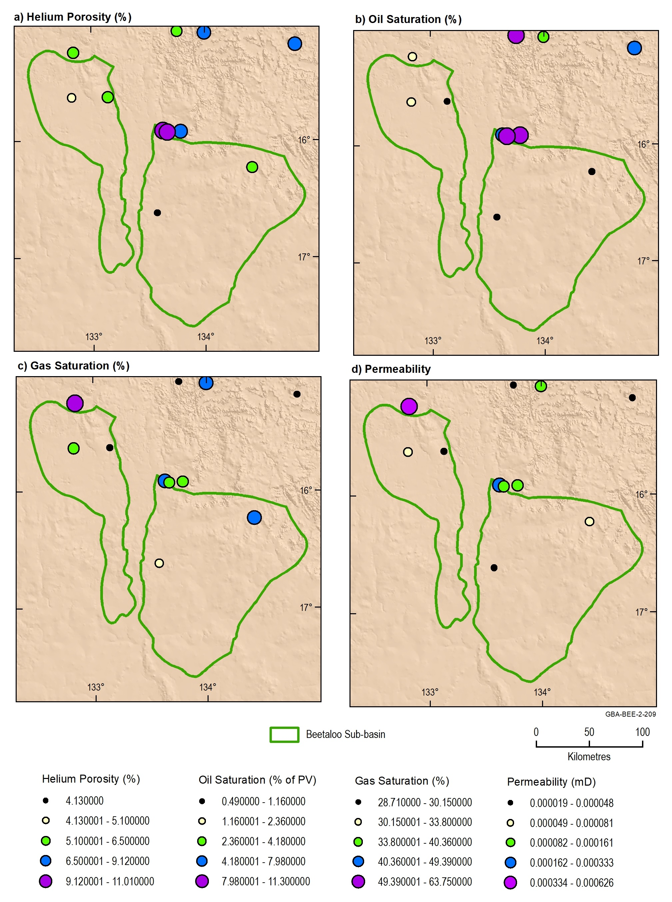
Figure 28 Petrophysical properties of the Velkerri Formation: (a) Averaged dry helium porosity, (b) as-received oil saturation, (c) gas saturation and (d) pressure decay permeability (PDPM)
mD = millidarcies; PV = pore volume
Data: Revie and Normington (2018)
Element: GBA-BEE-2-209

Total gas content and total gas storage capacity
Gas in shale is stored as adsorbed gas on the organic matter, free gas stored in the pore spaces and dissolved gas in the formation water. Eighteen air-dry core samples from the Amungee Member in Shenandoah 1/1A, Tarlee 1 and Tarlee 2 were tested for gas content. The averaged total gas content was 3.31 scc/g in the Shenandoah 1/1A, 1.25 scc/g in Tarlee 1 and 3.97 scc/g in Tarlee 2 (Table 17) (Falcon Oil and Gas, 2012; Pangaea NT Pty Ltd, 2019)
Table 17 Desorbed gas content test results of the shale samples from the Amungee Member in Shendandoah 1/1A (“B Shale”), Tarlee 1 and Tarlee 2
Sample ID | Top (m) | Bottom (m) | Lost Gas Content (scc/g) | Measured Gas Content (scc/g) | Residual Gas Content (scc/g) | Total Gas Content (scc/g)
Shenandoah 1/1A | 2,511.40 | 2,511.70 | 1.25 | 1.25 | 0.56 | 3.06
 | 2,513.40 | 2,513.70 | 2.08 | 1.19 | 0.63 | 3.90
 | 2,515.40 | 2,515.70 | 0.76 | 0.39 | 1.83 | 2.98
 | Average |  | 1.36 | 0.94 | 1.01 | 3.31
Tarlee 1 | 1023.8 | 1024.1 | 0.24 | 0.69 | 0.68 | 1.61
 | 1052.3 | 1052.6 | 0.15 | 0.62 | no data | 0.77
 | 1092.84 | 1093.14 | 0.15 | 0.48 | no data | 0.63
 | 1116.8 | 1117.1 | 0.13 | 0.45 | no data | 0.57
 | 1141.05 | 1141.35 | 0.12 | 0.44 | no data | 0.55
 | 1160.56 | 1160.86 | 0.23 | 0.4 | no data | 0.63
 | 1189.84 | 1190.15 | 0.05 | 0.3 | no data | 0.35
 | 1200.82 | 1201.11 | 0.49 | 0.49 | 0.77 | 1.75
 | 1227.29 | 1227.58 | 0.1 | 0.51 | 0.74 | 1.35
 | 1239.9 | 1240.2 | 0.45 | 1.83 | 0.74 | 3.01
 | 1259.16 | 1259.48 | 0.44 | 0.86 | 0.7 | 2
 | 1277.06 | 1277.35 | 0.5 | 0.59 | 0.71 | 1.8
 | Average |  | 0.25 | 0.64 | 0.72 | 1.25
Tarlee 2 | 1055.8 | 1056.2 | 1.42 | 0.86 | 2.38 | 4.65
 | 1049.3 | 1049.7 | 1.1 | 0.61 | 0.82 | 2.53
 | 1028.5 | 1028.9 | 2.06 | 1.52 | 1.14 | 4.73
 | Average |  | 1.53 | 1 | 1.45 | 3.97
Average (3 wells) |  |  | 1.05 | 0.86 | 1.06 | 2.84
scc/g = cubic centimetre at standard condition per gram
No distinction has been made between the properties of reservoir versus non-reservoir units.
Source: Falcon Oil and Gas (2012)
Data: Pangaea NT Pty Ltd (2019); Revie and Normington (2018)
In addition to data from the direct desorbed gas content tests, methane isotherm test data were compiled for 25 Amungee Member shale samples from 10 wells and used to describe the adsorbed gas storage capacity of these shales, which can indicate the approximate adsorbed gas content. Table 18 lists the averaged methane isotherm test results of these samples (under the reservoir temperature), including the total organic content (wt%), crushed sample density (g/cc), Langmuir storage capacity (as-received, scc/g), Langmuir pressure (kPa) and adsorbed gas storage capacity (as-received, scc/g).
Table 18 Averaged methane isotherm test data of 23 samples from the Amungee Member in the Beetaloo Sub-basin and surrounds
Well (number of tests) | Total Organic Content (wt%) | Crushed Sample Density (g/cc) | Langmuir Storage Capacity, As-Received (scc/g) | Langmuir Pressure (kPa) | Adsorbed Gas Storage Capacity, As-Received (scc/g)
Birdum Creek 1 (5) | 3.56 | 2.61 | 2.91 | 10988 | 2.27
Kalala S1 (1) | 4.22 | 2.62 | 4.67 | 12928 | 3.17
Tanumbirini 1 (2) | 3.82 | 2.70 | 2.57 | 6201 | 2.19
Tarlee 1 (1) | 0.32 | 2.68 | 0.78 | 11942 | 0.41
Tarlee S3 (2) | 2.43 | 2.65 | 1.07 | 4911 | 0.84
Wyworrie 1 (1) | 1.37 | 2.62 | 3.11 | 30358 | 1.07
Beetaloo W1 (4) | 3.61 | 2.64 | 3.53 | 14410 | 2.5
Tanumbirini 1 (3) | 1.52 | 2.76 | 1.81 | 16550 | 1.48
Shenandoah 1/1A (4) | 1.78 | 2.64 | 2.41 | 9245 | 1.82
Tarlee 1 (2) | 4.46 | 2.54 | 2.04 | 4246 | 1.59
Average | 2.71 | 2.65 | 2.49 | 12178 | 1.73
g/cc = grams per cubic centimetre; kPa = kilopascals; scc/g = cubic centimetre at standard condition per gram; wt% = weight %
No distinction has been made between the properties of reservoir versus non-reservoir units.
Data: Pangaea NT Pty Ltd (2019); Revie and Normington (2018)
Two samples from the Amungee Member B shale in Shenandoah 1/1A were tested and analysed for total gas storage capacity. Table 19 shows the averaged gas storage capacities of different storage mechanisms and total gas storage capacity of the B shale in Shenandoah 1/1A. The main gas storage mechanism is the adsorbed storage in the B shale, and the total gas storage capacity of the two B shale samples is 2.027scc/g.
Table 19 Averaged gas storage capacities of different storage mechanisms of two Amungee Member shale samples from Shenandoah 1/1A in the Beetaloo Sub-basin
Formation | Gas storage capacity
Dissolved Gas-in-Water Storage Capacity (scc/g) | 0.024
Dissolved Gas-in-Water Fraction (vol%) | 1.27
Free Gas Storage Capacity (scc/g) | 0.115
Free Gas Fraction (vol%) | 4.48
Adsorbed Gas Storage Capacity (scc/g) | 1.889
Adsorbed Gas Fraction (vol%) | 94.26
Total Gas Storage Capacity (scc/g) | 2.027
scc/g = cubic centimetre at standard condition per gram; vol% = volume %
Data: Revie and Normington (2018)

Mineralogy and brittleness
The mineral assemblage and brittleness of the Velkerri Formation shales were described using XRD analyses of 185 shale samples from seven wells in the Beetaloo Sub-basin (29 samples from the Wyworrie Member, 134 samples from the Amungee Member and 22 samples from the Kalala Member (Table 20) (Revie and Normington, 2018)
The Velkerri Formation comprises quartz, kaolinite, mica/illite, feldspar, chlorite, siderite, rutile and anatase (Revie, 2017c). Figure 29 shows the ternary plots of the dominant mineral content of the Amungee Member, including contents of total clay, carbonates and other; the “other” included all the minerals other than clay or carbonate minerals. The brittleness index (BI) was calculated from mineral composition using the method of Jarvie et al. (2007). In a case study in the Barnett Shale by Perez Altamar and Marfurt (2014), the following brittleness classifications were applied: Brittle: BI > 0.48; Less brittle: BI = 0.32–0.48; Less ductile: BI = 0.16–0.32; and Ductile: BI < 0.16. Overall, the Velkerri Formation shales are classified as ‘brittle’, with an average BI of 0.533 (Table 20). The averaged brittleness indices of the Wyworrie, Amungee and Kalala Member shales are 0.441, 0.556 and 0.514 respectively.
Table 20 Main mineral assemblage statistics of the Wyworrie, Amungee and Kalala members analysed by XRD and average brittleness indices estimated from mineral assemblages using the method of Jarvie et al. (2007)
Well | Total clay (wt%) | Carbonates (wt%) | Other (wt%) | Brittleness index (fraction)
Altree 2 (41) | 33.5 | 7.0 | 59.4 | 0.518
McManus 1 (30) | 33.3 | 8.8 | 57.9 | 0.501
Sever 1 (39) | 32.1 | 2.6 | 65.3 | 0.588
Shenandoah 1/1A (27) | 38.7 | 1.5 | 60.0 | 0.554
Tanumbirini 1 (5) | 41.2 | 2.2 | 56.6 | 0.475
Tarlee S3 (16) | 38.5 | 0.3 | 61.3 | 0.536
Walton 2 (27) | 37.1 | 1.8 | 61.1 | 0.560
Average | 36.3 | 3.4 | 60.2 | 0.533
wt% = weight %
Data: Revie and Normington (2018)

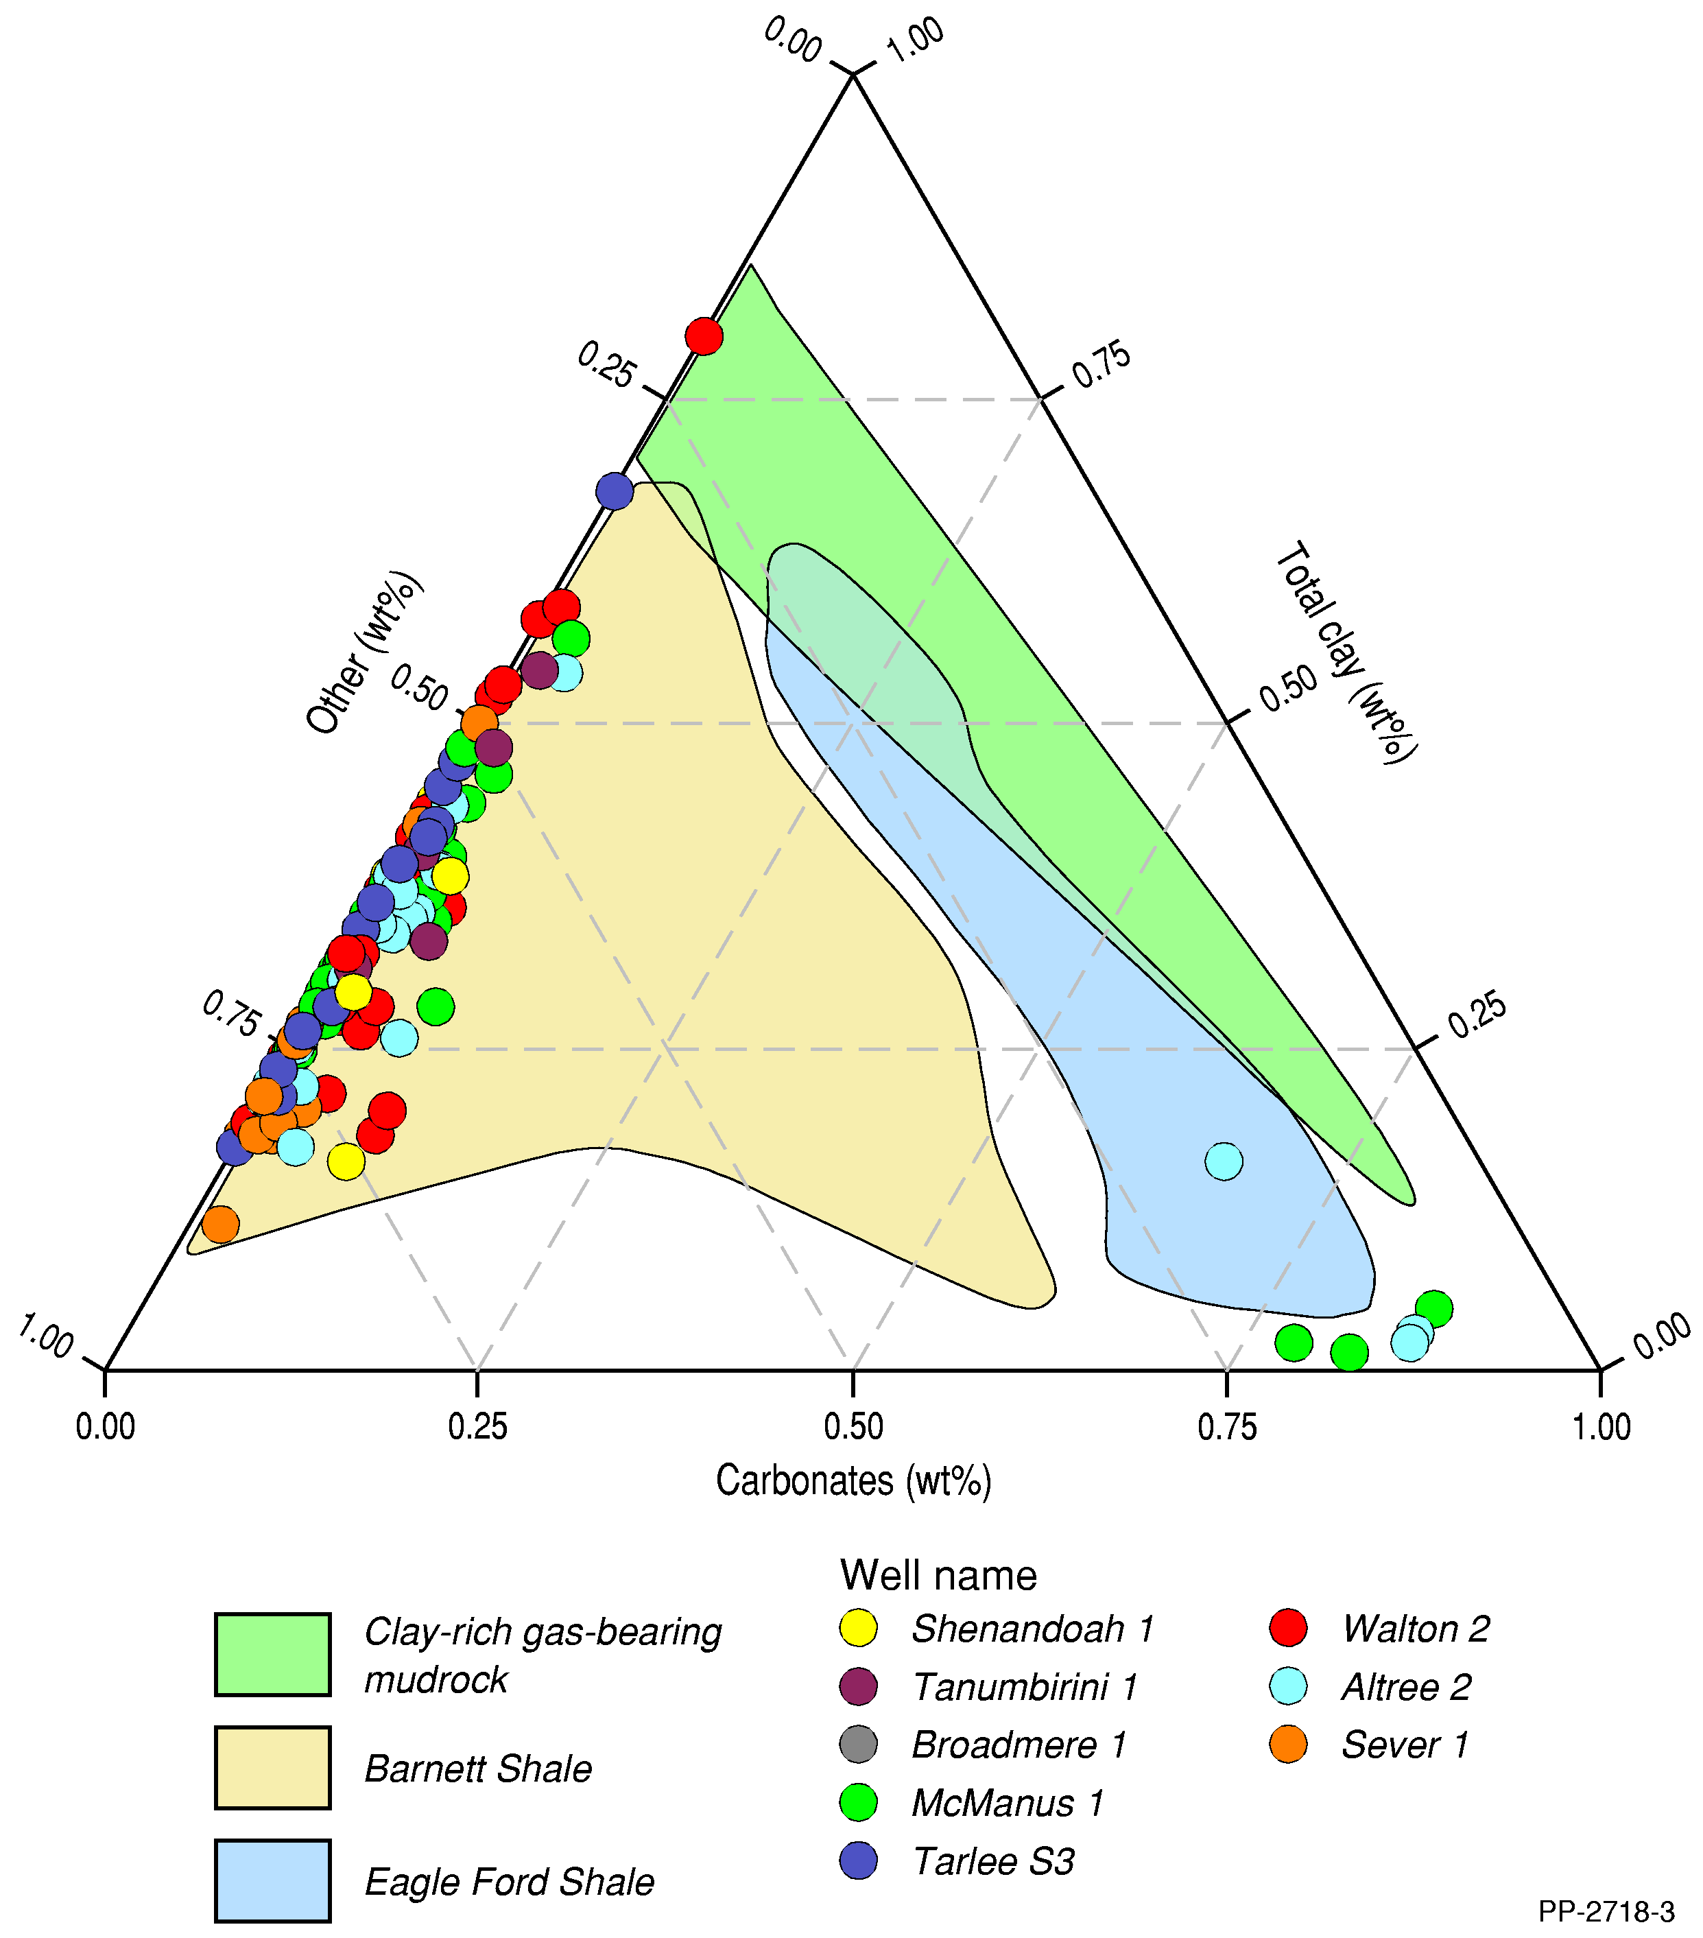
Figure 29 Ternary plot of mineral content (wt% fraction) for shales of the Amungee Member, previously known as the middle Velkerri Formation (Revie, 2017c)
wt% = weight %
For comparison producing USA shale plays (the Barnett and Eagle Ford shales) are shown after Passey et al. (2010)
Source: updated from Revie (2017c)
Data: Revie and Normington (2018)
Element: GBA-BEE-2-077

Gas composition
Two desorbed gas samples from the middle Velkerri “B Shale” in Shenandoah 1/1A were tested with gas chromatography (Revie, 2017a; Falcon Oil and Gas, 2012). Table 21 shows the results of gas compositions.
Table 21 Integrated contaminant-corrected gas composition of the Amungee Member B shale from Shenandoah 1/1A
Mid-depth (m) | Methane (mol%) | Ethane (mol%) | Propane (mol%) | Oxygen (mol%) | Nitrogen (mol%) | Carbon dioxide (mol%) | Hydrogen (mol%)
2513.6 | 88.34 | 6.38 | 0.52 | 0 | 0 | 4.76 | 0
2515.6 | 92.32 | 3.15 | 0.22 | 0 | 0 | 4.31 | 0
Average | 90.33 | 4.77 | 0.37 | 0 | 0 | 4.54 | 0
mol% = molar percentage of total gas component
Source: Falcon Oil and Gas (2012)
Data: Revie and Normington (2018)
Mud logging entails gathering qualitative and semi-quantitative data from hydrocarbon gas detectors that record the level of natural gas returned to the surface in the drilling fluid. Chromatographs are used to determine the chemical makeup of the gas by separating the gas stream into fractions according to molecular weight.
Table 22 shows the averaged hydrocarbon (gas) compositions of the Velkerri Formation from mud logging data in the Beetaloo Sub-basin (Origin Energy, 2015b, 2015a, 2016a; Santos Ltd, 2014; Falcon Oil and Gas, 2012).
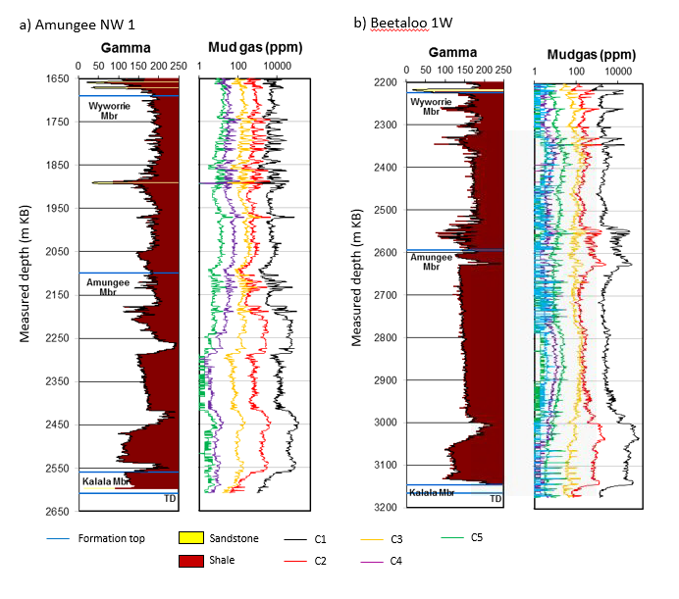
Figure 30 Velkerri Formation mud gas data for a) Amungee NW-1 and b) Beetaloo W1
ppm = parts per million
Data: Revie and Normington (2018)
Element: GBA-BEE-2-197

Table 22 Averaged hydrocarbon (gas) compositions (mol%) of the whole Velkerri Formation derived from mud logging data in the Beetaloo Sub-basin
Well | Methane (%) | Ethane (%) | Propane (%) | Isobutane (%) | n-Butane (%) | Isopentane (%) | n-Pentane (%)
Kalala S1 | 95.10 | 4.38 | 0.44 | 0.02 | 0.05 | 0.01 | 0.01
Amungee NW1 | 93.89 | 5.14 | 0.79 | 0.04 | 0.12 | 0.02 | 0.01
Beetaloo W1 | 94.77 | 4.03 | 0.97 | 0.05 | 0.13 | 0.02 | 0.02
Shenandoah 1/1A | 92.82 | 6.28 | 0.78 | 0.03 | 0.07 | 0.01 | 0.00
Tanumbirini 1 | 96.22 | 3.20 | 0.49 | 0.04 | 0.05 | 0.00 | 0.00
Average | 94.56 | 4.61 | 0.69 | 0.03 | 0.08 | 0.01 | 0.01
Source: Falcon Oil and Gas (2012); Origin Energy (2015b, 2016a, 2015a); Santos Ltd (2014)
Data: Revie and Normington (2018)
Seven canister desorbed gas samples from the Amungee Member shales in Tarlee 1 were analysed by gas chromatography. The average gas composition includes 65.66% methane, 14.06% ethane, 3.87% propane, 13.27% heavier hydrocarbon (butane plus) and 3.14% of carbon dioxide (Figure 19) (Pangaea NT Pty Ltd, 2019).
Table 23 N₂ and O₂ set to zero gas compositions of the desorbed gas samples from the Amungee Member shales in Tarlee 1 (Pangaea NT Pty Ltd, 2019)
Sample number | Top (m) | Bottom (m) | Methane (mol%) | Ethane (mol%) | Propane (mol%) | Butane plus (mol%) | Carbon dioxide (mol%)
TL1_DS5 | 1023.80 | 1024.10 | 30.68 | 14.57 | 12.00 | 41.09 | 1.67
TL1_DS8 | 1116.80 | 1117.10 | 47.48 | 9.36 | 6.28 | 33.98 | 2.91
TL1_DS10 | 1160.56 | 1160.86 | 72.47 | 6.56 | 1.57 | 16.06 | 3.35
TL1_DS12 | 1200.82 | 1201.11 | 78.29 | 12.53 | 2.19 | 4.25 | 2.75
TL1_DS13 | 1227.29 | 1227.58 | 78.75 | 11.87 | 1.44 | 3.77 | 4.16
TL1_DS14 | 1239.90 | 1240.20 | 81.52 | 13.96 | 1.04 | 0.65 | 2.83
TL1_DS16 | 1277.06 | 1277.35 | 66.67 | 25.50 | 2.61 | 0.92 | 4.30
Average |  |  | 65.66 | 14.06 | 3.87 | 13.27 | 3.14
mol% = molar percentage of total gas component
Data: Pangaea NT Pty Ltd (2019)

Kyalla Formation
Key characteristics of the Kyalla Formation are summarised below in Table 24.
Table 24 Key features of the Kyalla Formation
Unconventional play types | Shale and hybrid liquids-rich gas and oil/ condensate plays
Age | Mesoproterozoic (Ectasian); 1313±47 Ma (Yang et al., 2018)
Top depth | 0−1112 m
Gross formation thickness | <30−960 m
Lithology | Claystone interbedded with siltstone and sandstone
Depositional environment | Storm-dominated marine shelf (Abbott et al., 2001; Revie, 2017c)
Net source rock thickness (present day) ª | 5−93 m
Total organic carbon (present day) | Mean 1.1 wt%; range 0–9 wt%
Hydrogen Index (present day) | 6−777 mg HC/g TOC
Thermal maturity | Immature to liquids-rich gas
Average permeability ^{b} | Mean 7.9 x 10⁻⁵ mD; range 1.1 x 10⁻⁵ –1.1 x 10⁻⁴ mD
Average porosity ^{c} | Mean 5.9%; range 3.5–6.1%
Average effective water saturation | Mean 62%; range 56–71%
Average oil saturation ^{d} | Mean 5.7%; range 0.9–10.1%
Average gas saturation ^{e} | Mean: 33%; range 28–34%
Average brittleness | Brittle (0.406^{f})
Pressure regime | Indications of overpressure
HC = hydrocarbons; mD = milliDarcy; TOC = total organic carbon; wt% = weight %
All public domain Kyalla Formation samples have been analysed; no distinction has been made between the properties of reservoir versus non-reservoir units. A net source rock thickness represents the cumulative thickness of organically rich shale with a present day TOC content > 2 wt % based on available well intersections. b As-received pressure decay permeability by well. c Average porosity by well represents the dry helium porosity as a % of bulk rock volume. d As received saturation as a % of the pore volume. e As received gas saturation by well as a % of pore volume. f The brittleness index (BI) was calculated from mineral content using the method of Jarvie et al. (2007), however, recent petrophysical, core and geomechanical analyses demonstrate that the Kyalla Formation completion quality more is favourable than that suggested by mineralogy alone (Altmann et al., 2018; Baruch et al., 2018).

Age and stratigraphic relationships
The Kyalla Formation is Ectasian in age. Zircon geochronology provides an age date of 1313±47 Ma (Yang et al., 2018). The Kyalla Formation is part of the Roper Group. It conformably overlies the Sherwin Formation or Moroak Sandstone Formation, and is disconformably overlain by the Bukalorkmi Formation.

Extent, depth and gross formation thickness
The Kyalla Formation is present across the Beetaloo Sub-basin (Figure 31). The sub-basin has been defined based on a top Kyalla Formation depth of 400 m below ground surface (Northern Territory Government, 2018a). Within the Beetaloo Sub-basin, the maximum depth of the top Kyalla Formation (based on well intersections) is 1061.3 m (Tanumbirini 1) in the eastern sub-basin and 639 m in Birdum Creek 1 in the western sub-basin (Figure 31). The maximum thickness of the Kyalla Formation based on well intersections is approximately 786 m (Beetaloo West 1). The geological model derived from seismic interpretation (Orr et al., 2020) suggests the formation reaches a maximum thickness of 960 m (Figure 32).

Lithology and palaeoenvironment
The Kyalla Formation is medium-grey to black laminated shale with interbeds of thin siltstone and fine-grained sandstone (Munson, 2016). The Kyalla Formation has been subdivided informally into upper, middle and lower units (Baruch et al., 2018). A prominent sandstone interval in the lower Kyalla Formation appears to be continuous across the wells of the eastern Beetaloo Sub-basin, and has been informally termed the “Elliot Sandstone member” (Gorter and Grey, 2013).
The interbedded and interlaminated nature of the Kyalla Formation, along with diagnostic sedimentary structures (Abbott et al., 2001), suggests deposition in a storm-dominated marine shelf environment (Munson, 2016).

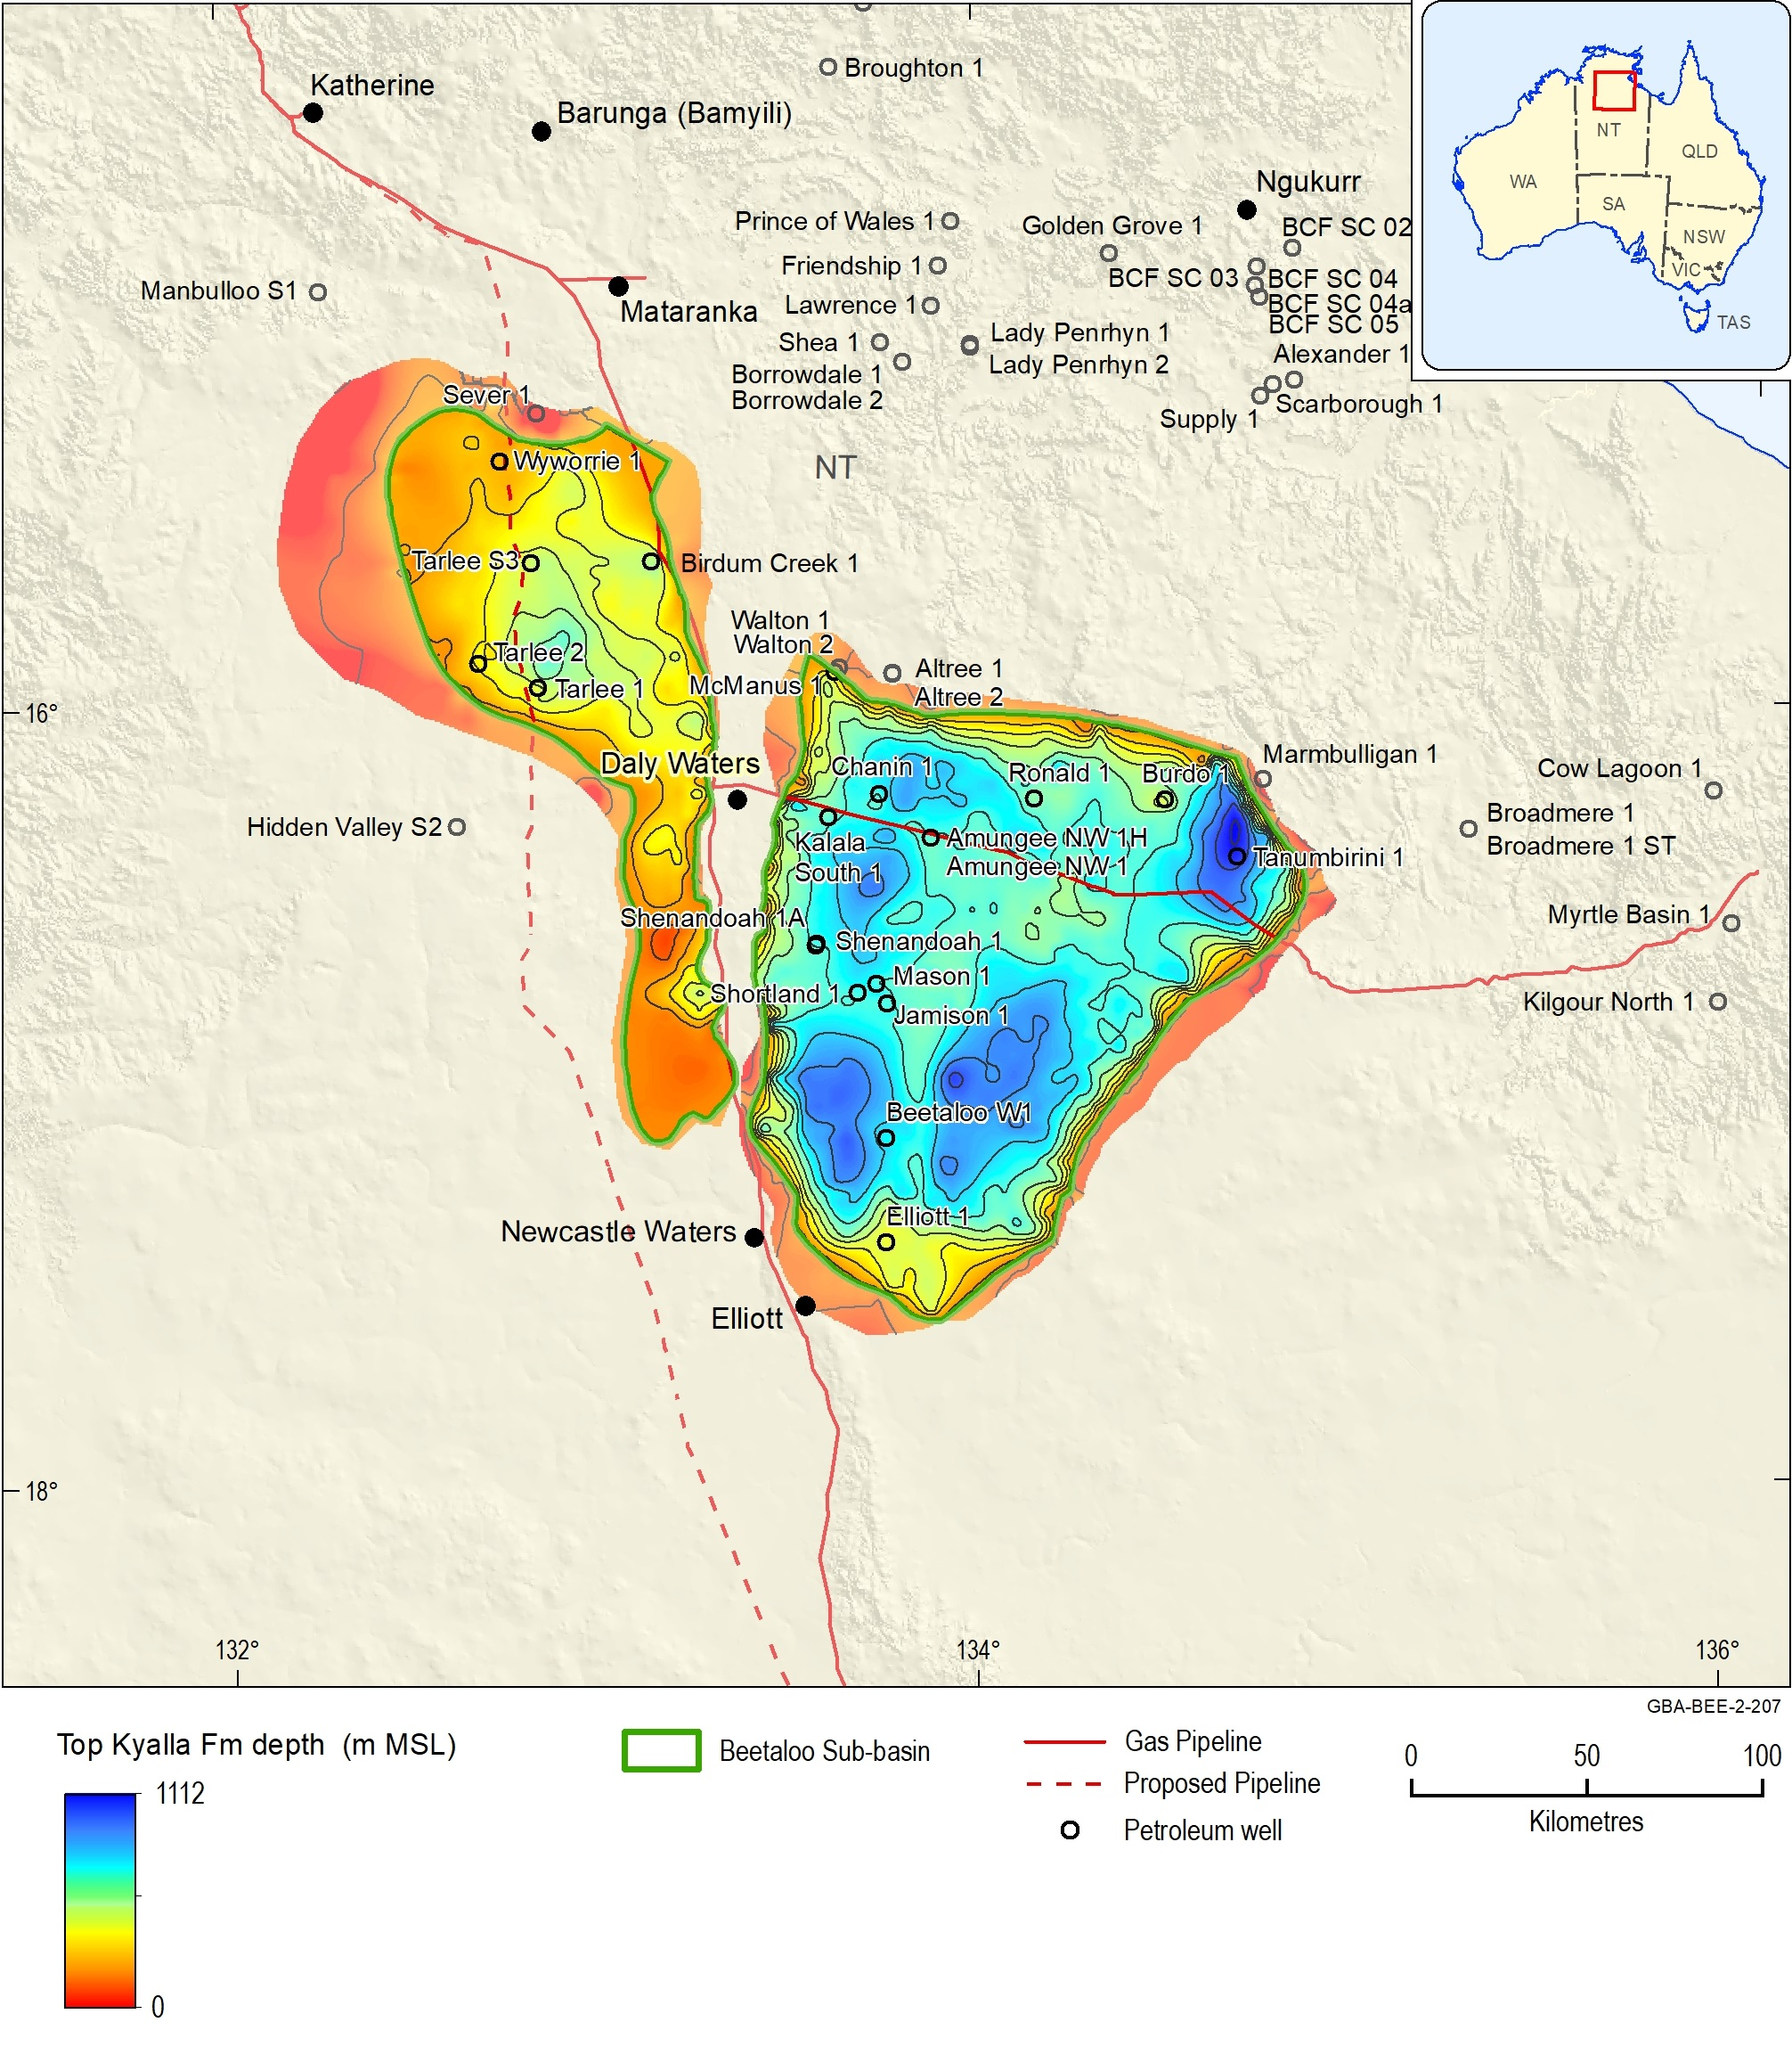
Figure 31 Kyalla Formation top depth (m)
Source: Orr et al. (2020)
Data: Geological and Bioregional Assessment Program (2019b); GBA derived dataset based on Williams (2019) and Northern Territory Government (2018b)
Element: GBA-BEE-2-207

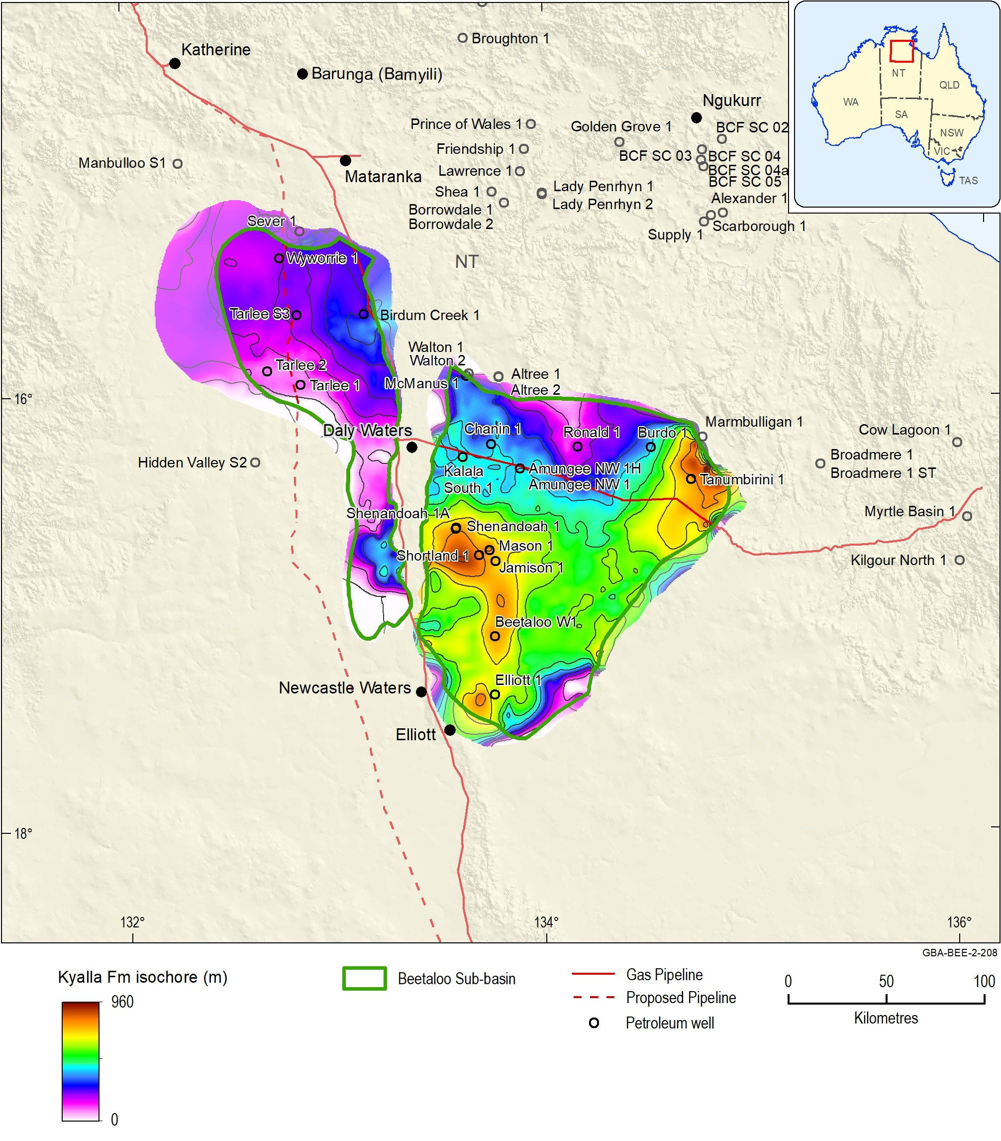
Figure 32 Kyalla Formation total vertical thickness (m)
Source: Orr et al. (2020)
Data: Geological and Bioregional Assessment Program (2019b); GBA derived dataset based on Williams (2019) and Northern Territory Government (2018b)
Element: GBA-BEE-2-208

Source rock properties
Figure 33 and Figure 34 show type sections through the Kyalla Formation for 2 example wells in the western sub-basin and 2 in the east, highlighting the variation in lithology, source rock properties and maturity down well.
The principal petroleum source rocks of the Kyalla Formation are shales. Drilling of the Kyalla Formation in, for example, the Jamison 1, Balmain 1 and Shenandoah 1A wells, has resulted in reports of strong petroliferous odours and oil bleeds.
Jarrett et al. (2019) reviewed the source rock geochemistry and maturity of all known source rock units and associated data from the greater McArthur Basin, including the Kyalla Formation, based on the dataset of Revie and Normington (2018). This study builds on the assessment of Jarrett et al. (2019) by incorporating additional well data for Tarlee 1, 2 and 3, Birdum Creek 1 and Wyworrie 1 provided by Pangaea (Pangaea NT Pty Ltd, 2019).
Source rock statistics for the Kyalla Formation are summarised in Table 25, based on a dataset of 960 TOC samples and 520 Rock-Eval pyrolysis samples. As was done for the Velkerri Formation, statistics were calculated on a quality controlled data filtered using the screening criteria defined in Jarrett et al. (2018).
The organic richness of Kyalla Formation source rocks varies from 0 to 9 wt% TOC, with a mean of 1.1 wt% TOC (Table 25). Samples with TOC content > 2 wt% are distributed across both the eastern and western Beetaloo Sub-basin, demonstrating the presence of source rock facies across the sub-basin (Figure 35).
Kyalla Formation present day hydrogen indices range from 6 mg HC/g TOC to 777 mg HC/g TOC (Table 25; Figure 36). Plots of the Rock-Eval pyrolysis data indicate there are two relatively distinct groups of samples (Figure 36). A set of samples characterised by high TOC content and very high HI values (> 500 mg HC/g TOC) represent well preserved, oil-prone kerogen containing filamentous algae and/or cyanobacterial biomass (Revie, 2017c). A second set of samples have lower HI values of < 500 mg HC/g TOC and much higher OI values of > 30 mg CO2/g TOC. These are likely to represent lower-quality organic matter that has been partially oxidised prior to preservation (Revie, 2017c).
As was done for the Velkerri Formation, the net thickness of organically rich Kyalla Formations shales was calculated using the product of net organically rich ratio (NORR) with TOC greater than 2 wt% and gross formation thickness (EIA, 2013). Table 26 lists the NORRs of the Kyalla Formation in the Beetaloo Sub-basin calculated for 4 wells. The average NORR is 0.3034 and the average total thickness of organically rich material is 44.6 m. There was insufficient data density to map the NORR.
Organic petrology and other maturity indicators (e.g. Tmax) indicate that the Kyalla Formation is mature for oil or liquids-rich gas (Figure 33, Figure 34). Source rock maturity for the Kyalla Formation is discussed in further detail in Section 4.3, which describes the use of one-dimensional petroleum systems modelling to map the distribution of the oil, wet gas and dry gas windows across the Beetaloo Sub-basin.
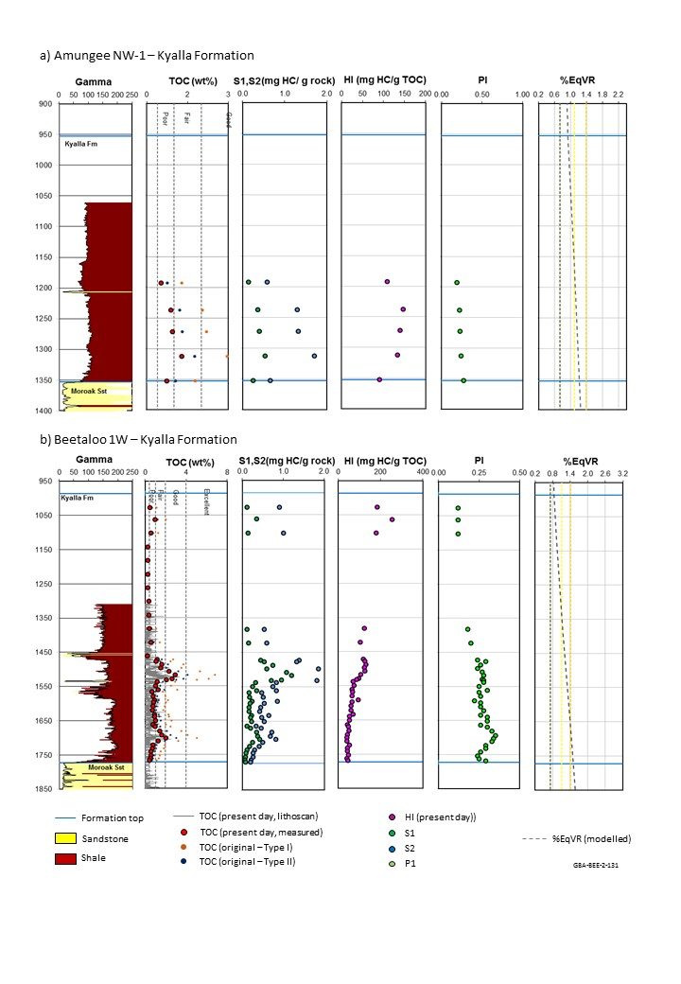
Figure 33 Kyalla Formation source rock characteristics in the a) Amungee NW 1 and b) Beetaloo W1 wells in the eastern Beetaloo Sub-basin
TD = total depth; TOC = total organic carbon; HI = hydrogen index; S1, S2, S3 = Rock-Eval parameters; PI = production index; %EqVR = vitrinite reflectance equivalent; wt% = weight as a percentage. Two sets of original TOC data are estimated assuming original HIs of 750 mg HC/g TOC and 450 mg HC/g TOC, using the equation of Peters et al. (2005). Modelled maturity is sourced from one-dimensional petroleum system model presented in Section 4.3.
Data: Revie and Normington (2018); Pangaea NT Pty Ltd (2019)
Element: GBA-BEE-2-131
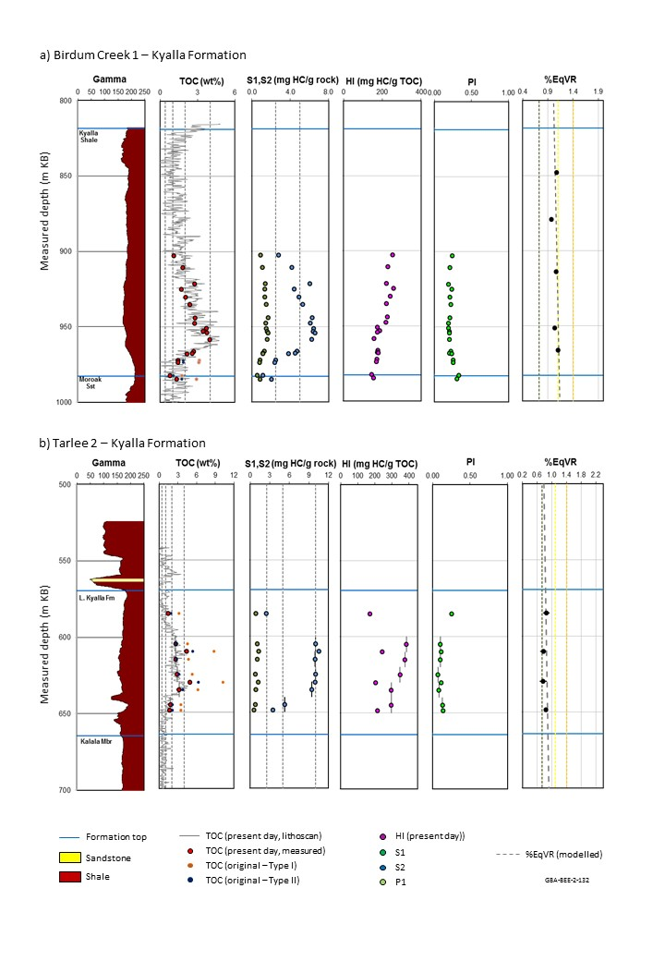
Figure 34 Kyalla Formation source rock characteristics in the a) Birdum Creek 1 and b) Tarlee 2 wells in the western Beetaloo Sub-basin
TD = total depth; TOC = total organic carbon; HI = hydrogen index; S1, S2, S3 = Rock-Eval parameters; PI = production index; %EqVR = vitrinite reflectance equivalent; wt% = weight as a percentage. Two sets of original TOC data are estimated assuming original HIs of 750 mg HC/g TOC and 450 mg HC/g TOC, using the equation of Peters et al. (2005). Modelled maturity is sourced from one-dimensional petroleum system model presented in Section 4.3.
Data: Revie and Normington (2018); Pangaea NT Pty Ltd (2019)
Element: GBA-BEE-2-132
Table 25 Kyalla Formation source rock properties. Statistics are based on analysis of 960 TOC samples and 520 Rock-Eval pyrolysis samples. Rock-Eval pyrolysis data was quality controlled prior to calculating statistics using the screening criteria defined in Jarrett et al. (2018)
 | Mean | Min | Max | Stdev | P10 | P50 | P90
TOC (wt%) | 1.1 | 0.0 | 9.0 | 0.9 | 0.3 | 0.8 | 2.4
S1 (mg HC/g rock) | 0.5 | 0.0 | 3.6 | 0.5 | 0.1 | 0.3 | 1.3
S2 (mg HC/g rock) | 3.0 | 0.1 | 22.8 | 4.4 | 0.2 | 1.1 | 9.9
S3 (mg HC/g rock) | 0.5 | 0.0 | 5.9 | 0.7 | 0.1 | 0.3 | 1.2
Tmax (°C) | 453 | 411 | 530 | 19 | 435 | 448 | 482
HI (mg HC/g TOC) | 172 | 6 | 777 | 176 | 25 | 96 | 469
OI (mg CO₂/g TOC) | 48 | 0 | 343 | 66 | 5 | 20 | 148
PI (unit less) | 0.3 | 0.0 | 0.8 | 0.1 | 0.1 | 0.2 | 0.5
mg CO2/g TOC = milligrams of CO2 per gram of total organic carbon; mg HC/g TOC = milligrams of hydrocarbons per gram of total organic carbon; TOC = total organic carbon; S1, S2, S3 and Tmax = Rock-Eval pyrolysis parameters; HI = Hydrogen Index; OI = Oxygen Index; PI = Production Index; stdev: standard deviation; P10: 10th percentile; P50: 50th percentile; P90: 90th percentile; wt% = weight as a percentage.
Data = Revie and Normington (2018); Pangaea NT Pty Ltd (2019)
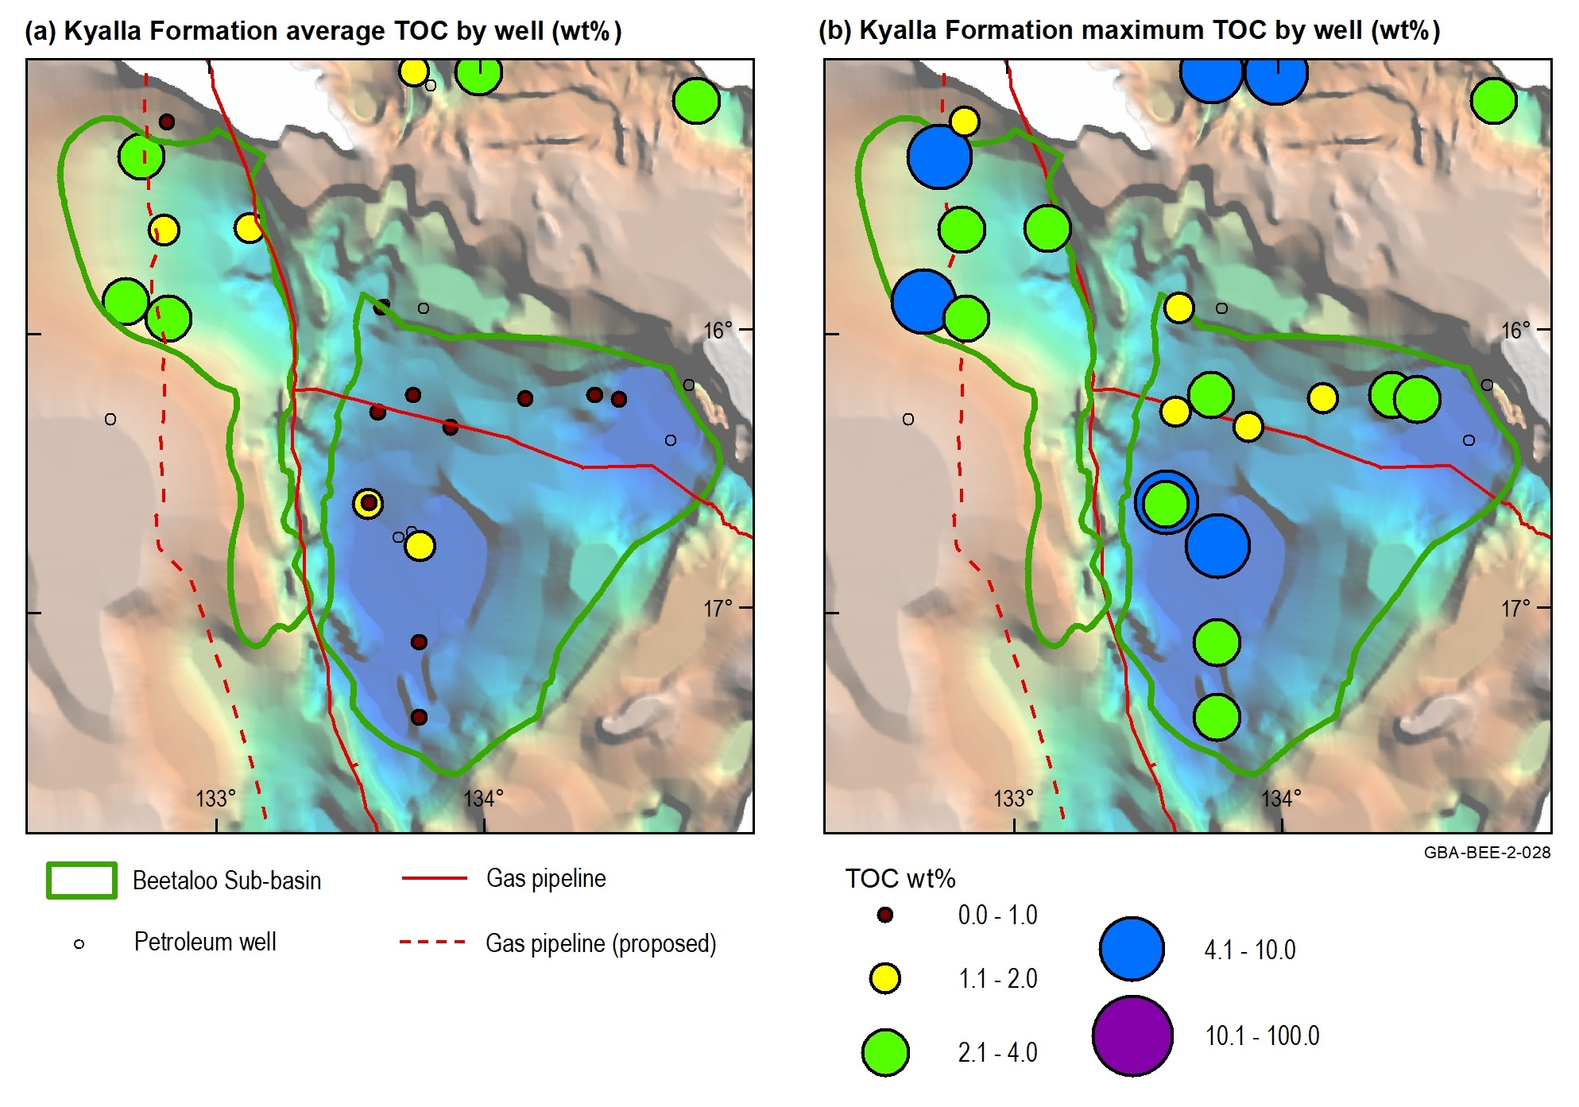
Figure 35 Total organic carbon distribution of the Kyalla Formation
TOC = total organic carbon; wt% = weight %
Source: modified from Jarrett et al. (2019); depth to base Roper Group (Wilton package) sourced from Frogtech Geoscience (2018)
Data: Revie and Normington (2018); Pangaea NT Pty Ltd (2019)
Element: GBA-BEE-2-028

Figure 36 Rock-Eval pyrolysis data plots for the Kyalla Formation: (a) TOC content vs S2 yield; (b) Tmax vs HI
HC = hydrocarbons; HI = hydrogen index; S2 and Tmax = Rock-Eval pyrolysis parameters; TOC = total organic carbon; wt% = weight as a percentage; %EqVR = vitrinite reflectance maturity
Source: modified from Jarrett et al. (2019)
Data: Revie and Normington (2018); Pangaea NT Pty Ltd (2019)
Element: GBA-BEE-2-052
Table 26 Present day net organically rich ratio (NORR) of the Kyalla Formation shales in the Beetaloo Sub-basin and surrounds
Beetaloo Sub-basin region | Well | Net organically rich ratio (fraction) | Total formation thickness (m) | Total thickness of organically rich section (m)
Eastern | Beetaloo W1 | 0.01 | 787 | 5
Western | Birdum Creek 1 | 0.37 | 249 | 93
Western | Tarlee 1 | 0.42 | 98 | 41
Western | Tarlee 2 | 0.42 | 95 | 40
 | Average | 0.30 | 307 | 45
Data: Revie and Normington (2018)

Shale reservoir characteristics

Petrophysical properties
Porosity, permeability and fluid saturation are three of the key petrophysical input parameters required for characterising shale plays. Based on laboratory tests (as-received basis) on 14 Kyalla Formation shale rock samples from 3 wells the Beetaloo Sub-basin and surrounds, the Kyalla Formation shales have an average total porosity (helium porosity of dry samples) of 5.9%, average as-received bulk density of 2.59 gm/cc, average water saturation of 61.5%, average oil saturation of 5.9%, average gas saturation of 32.6%, average gas-filled porosity of 1.95% and average permeability (as-received samples) of 7.9 x 10⁻⁵ mD. Table 27 and Figure 37 show the details of above parameters in different wells in the Beetaloo Sub-basin and surrounds.
Table 27 Average laboratory measured as-received shale rock properties of Kyalla Formation for key wells in the Beetaloo Sub-basin
Well | Number of tests | A-R Bulk Density (g/cc) | Dry Helium Porosity (% of BV) | A-R Water Saturation (% of PV) | A-R Oil Saturation (% of PV) | A-R Gas Saturation (% of PV) | A-R Gas - Filled Porosity (% of BV) | A-R Press Decay Permeability (mD)
Elliott 1 | 1 | 2.935 | 3.50 | 71.49 | 0.86 | 27.65 | 0.97 | 1.100 x 10⁻⁵
Jamison 1 | 5 | 2.578 | 5.65 | 55.56 | 10.07 | 34.36 | 1.98 | 4.772 x 10⁻⁵
Shenandoah 1/1A | 8 | 2.603 | 6.08 | 67.50 | 1.64 | 30.85 | 1.91 | 1.107 x 10⁻⁴
Average |  | 2.590 | 5.87 | 61.53 | 5.86 | 32.61 | 1.95 | 7.923 x 10⁻⁵
A-R = as received basis; BV = bulk volume; g/cc = grams per cubic centimetre; mD = milliDarcy; PV = pore volume
No distinction has been made between the properties of reservoir versus non-reservoir units.
Data: Revie and Normington (2018)

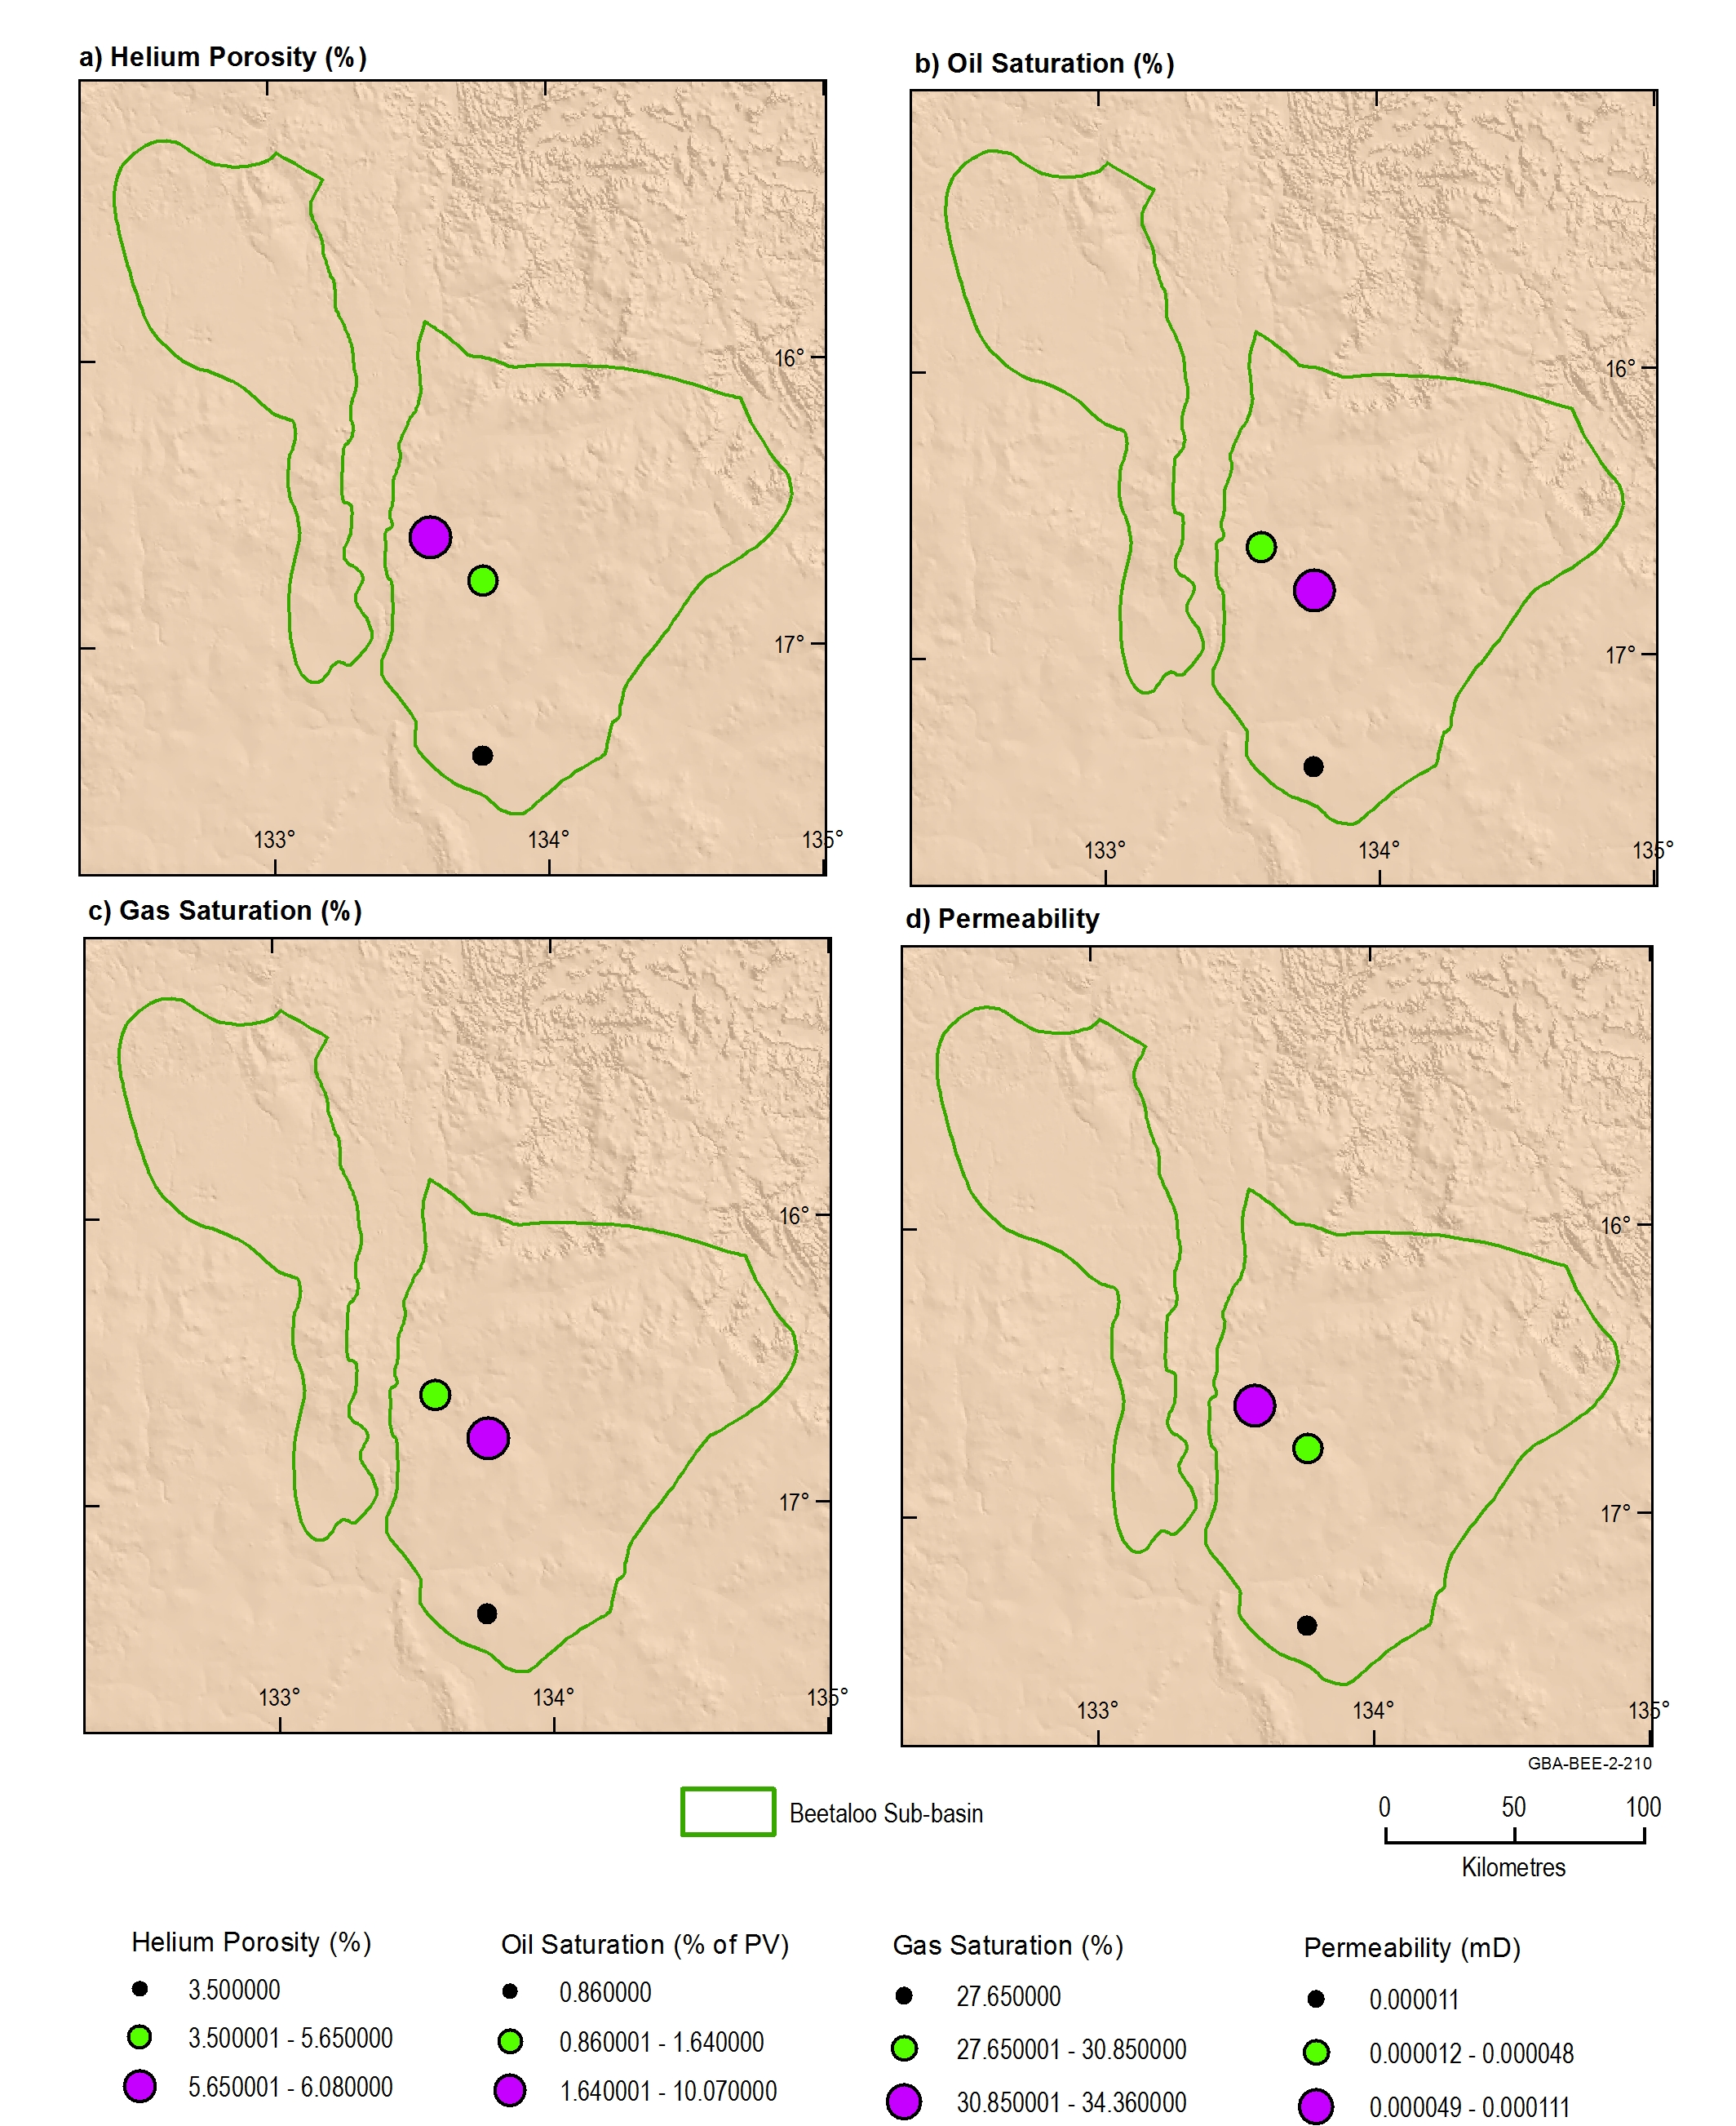
Figure 37 Petrophysical properties of the Kyalla Formation: (a) averaged dry helium porosity, (b) as-received oil saturation, (c) gas saturation and (d) pressure decay permeability
mD: millidarcies; PV = pore volume
Data: Revie and Normington (2018)
Element: GBA-BEE-2-210

Total gas content and total gas storage capacity
Gas in shale is stored as adsorbed gas on the organic matter, free gas stored in the pore spaces and dissolved gas in the formation water. Seven air-dry core samples from the Kyalla Formation shales in Shenandoah 1/1A and Tarlee 1 (Falcon Oil and Gas, 2012; Pangaea NT Pty Ltd, 2019) were tested for gas content analysis, resulting the averaged total gas content of the Kyalla Formation shales of 2.82 scc/g in Shenandoah 1/1A and 1.29 scc/g in Tarlee 1 (Table 28).
Table 28 Desorbed gas content test results of the lower Kyalla Formation shales in Shendandoah 1/1A and Tarlee 1
Sample ID | Top (m) | Bottom (m) | Lost Gas Content (scc/g) | Measured Gas Content (scc/g) | Crushed Sample Gas Content (scc/g) | Total Gas Content (scc/g)
Shenandoah 1/1A | 1586.7 | 1587 | 0.76 | 0.83 | 0.48 | 2.07
 | 1589.7 | 1590 | 1.23 | 0.98 | 1.62 | 3.83
 | 1592.7 | 1593 | 0.82 | 0.96 | 0.79 | 2.57
 | Average |  | 0.94 | 0.92 | 0.96 | 2.82
Tarlee 1 | 670.8 | 671.15 | 0.13 | 0.43 | 0.26 | 0.82
 | 701.05 | 701.35 | 0.15 | 1.26 | 0.42 | 1.84
 | 721.05 | 721.35 | 0.10 | 1.05 | 0.38 | 1.53
 | 742.3 | 742.6 | 0.16 | 0.52 | 0.29 | 0.97
 | Average |  | 0.14 | 0.82 | 0.34 | 1.29
Average (2 wells) |  |  | 0.54 | 0.87 | 0.65 | 2.06
scc/g = cubic centimetre at standard condition per gram
No distinction has been made between the properties of reservoir versus non-reservoir units.
Source: Falcon Oil and Gas (2012); Pangaea NT Pty Ltd (2019)
Data: Revie and Normington (2018)
In addition to the direct desorbed gas content test, the methane isotherm test data were collected for 7 Kyalla Formation shale samples from Shenandoah 1/1A, Tanumbirini 1 and Tarlee 1 (Table 29). These data were used to describe the adsorbed gas storage capacity of shales, which provides an approximation for adsorbed gas content.
The adsorbed gas storage capacity of the Kyalla Formation shales is much smaller than that of the Velkerri Formation shales (Table 18). However, the methane isotherm test of the lower Kyalla Formation shale sample from Tanumbirini 1 between 2050–2055 m (measured depth) shows that the adsorbed gas storage capacity (as-received) could be up to 2.02 scc/g (Table 29).The averaged total organic content (wt%), crushed sample density (g/cc), and adsorbed gas storage capacity (as-received, scc/g) of the Kyalla Formation shales are respectively 1.854 wt%, 2.625 g/cc and 0.73 scc/g.
Table 29 Methane isotherm test data of 7 Kyalla Formation shale samples from Shenandoah 1/1A, Tanumbirini 1 and Tarlee 1 in the Beetaloo Sub-basin and surrounds
Well | Top (m) | Bottom (m) | Total Organic Content (wt%) | Crushed Sample Density (g/cc) | Langmuir Storage Capacity, As-Received (scc/g) | Langmuir Pressure (kPa) | Adsorbed Gas Storage Capacity, As-Received (scc/g)
Shenandoah 1/1A | 1585.0 | 1585.1 | 1.25 | 2.65 | 0.43 | 3604 | 0.37
 | 1590.3 | 1590.4 | 1.22 | 2.628 | 0.38 | 7740 | 0.27
 | 1595.4 | 1595.5 | 1.55 | 2.63 | 0.60 | 4397 | 0.49
 | 1593.1 | 1593.1 | 1.1 | 2.67 | 0.79 | 25804 | 0.34
 | Average |  | 1.28 | 2.64 | 0.55 | 10386 | 0.37
Tanumbirini 1 | 1785.0 | 1790.0 | 0.34 | 2.68 | 0.97 | 45698 | 0.42
 | 2050.0 | 2055.0 | 1.41 | 2.68 | 3.20 | 22953 | 2.02
 | Average |  | 0.87 | 2.68 | 2.085 | 34326 | 1.22
Tarlee 1 | 721.35 | 721.45 | 3.41 | 2.55 | 1.36 | 10639 | 0.59
Average (3 wells) |  |  | 1.85 | 2.625 | 1.33 | 18450 | 0.73
g/cc = grams per cubic centimetre; kPa = kilopascals; scc/g = cubic centimetre at standard condition per gram; wt% = weight %
No distinction has been made between the properties of reservoir versus non-reservoir units.
Data: Revie and Normington (2018), Pangaea NT Pty Ltd (2019)
Two samples from the Kyalla Formation shale in Shenandoah 1/1A were tested and analysed for total gas storage capacity. Table 30 shows the averaged gas storage capacities of different storage mechanisms and total gas storage capacity of the Kyalla Formation shale in Shenandoah 1/1A. The main gas storage mechanism is the free gas storage in the Kyalla Formation shale in the Shenandoah 1/1A, and the total gas storage capacity of the two Kyalla Formation shale samples is 1.266 scc/g.
Table 30 Averaged gas storage capacities of different storage mechanisms of two Kyalla Formatino shale samples from Shenandoah 1/1A in the Beetaloo Sub-basin
Formation | Gas storage capacity
Dissolved Gas-in-Water Storage Capacity (scc/g) | 0.012
Dissolved Gas-in-Water Fraction (vol%) | 1.12
Free Gas Storage Capacity (scc/g) | 0.951
Free Gas Fraction (vol%) | 74.56
Adsorbed Gas Storage Capacity (scc/g) | 0.303
Adsorbed Gas Fraction (vol%) | 24.32
Total Gas Storage Capacity (scc/g) | 1.266
scc/g: cubic centimetre at standard condition per gram; vol% = volume percent
Data: Revie and Normington (2018)

Mineralogy and brittleness
The mineral assemblage and brittleness of the Kyalla Formation shales were described using XRD analyses of 61 shale samples from seven wells in the Beetaloo Sub-basin (Table 31) (Revie and Normington, 2018).
The Kyalla Formation is composed of quartz, clay minerals, feldspar and carbonate minerals (Table 31) with minor contents or traces of pyrite, barite, anatase, apatite, jarosite, gypsum, pyroxene/diopside and magnetite. The main clay minerals include kaolinite, illite/muscovite, chlorite and mix layer illite/smectite. The carbonate minerals could be calcite, dolomite, ankerite and siderite.
Figure 38 shows a ternary plot of the dominant mineral content of the Kyalla Formation shales, including contents of total clay, carbonates and other, and the “other” included all the minerals other than clay or carbonate minerals (Revie, 2017c).
The brittleness index (BI) was calculated from mineral content using the method of Jarvie et al. (2007). This assessment indicates that the Kyalla Formation shale is classified as ‘less brittle’, with an average BI of 0.406 (Table 31) (Perez Altamar and Marfurt, 2014). However, recent petrophysical, core and geomechanical analyses demonstrate that the Kyalla Formation completion quality more is favourable than that suggested by mineralogy alone (Altmann et al., 2018; Baruch et al., 2018).
Table 31 Main mineral assemblage statistics of the Kyalla Formation analysed by XRD and average brittleness indices estimated from mineral assemblages using the method of Jarvie et al. (2007)
Well | Number of samples | Quartz (wt%) | Clays (wt%) | Carbonates (wt%) | Others (wt%) | Brittleness index (fraction)
Balmain 1 | 5 | 35.00 | 59.00 | 0.80 | 5.20 | 0.370
Burdo 1 | 6 | 49.83 | 42.33 | 1.83 | 6.00 | 0.537
Chanin 1 | 1 | 36.00 | 59.00 | 1.00 | 4.00 | 0.375
Elliott 1 | 10 | 36.50 | 49.20 | 2.00 | 12.40 | 0.427
Jamison 1 | 14 | 26.84 | 67.52 | 1.16 | 4.45 | 0.283
Ronald 1 | 3 | 36.67 | 47.33 | 2.00 | 14.00 | 0.432
Shenandoah 1/1A | 22 | 38.91 | 53.32 | 1.48 | 6.50 | 0.420
Average |  | 37.11 | 53.96 | 1.47 | 7.51 | 0.406
wt% = weight as a percentage
Data: Revie and Normington (2018)
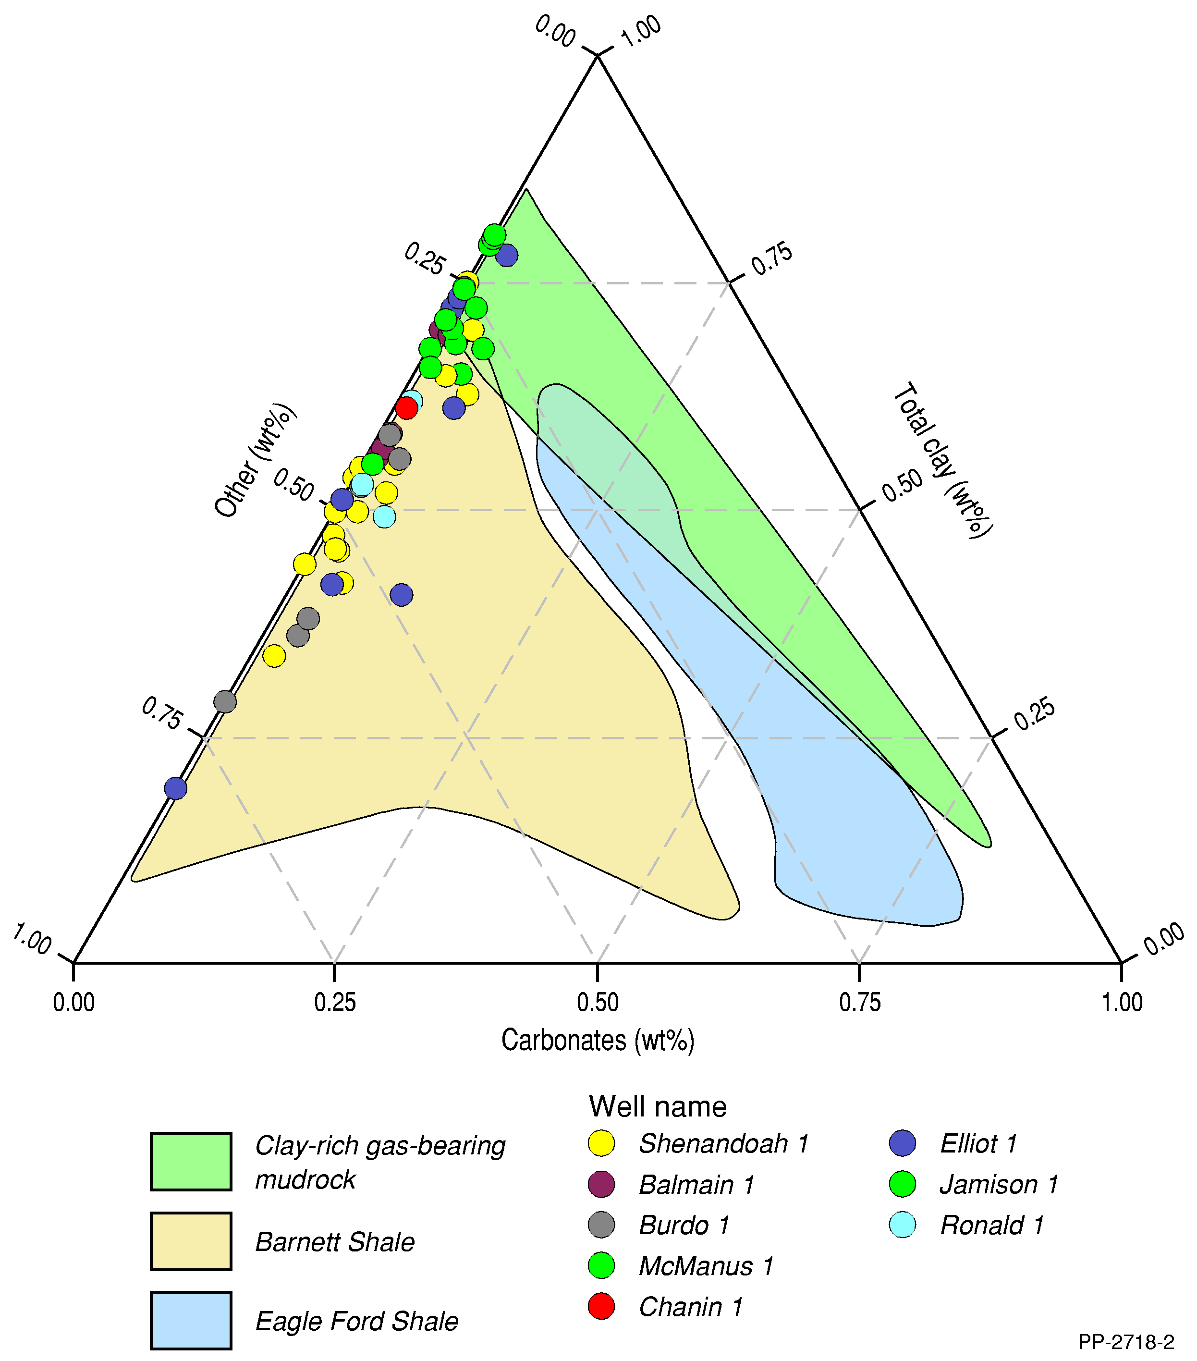
Figure 38 Ternary plot of XRD mineral content (wt% fraction) for shales of the Kyalla Formation in the Beetaloo Sub-basin
For comparison producing USA shale plays (the Barnett and Eagle Ford shales) are shown after Passey et al. (2010)
Source: updated from Revie (2017c)
Data: Revie and Normington (2018)
Element: GBA-BEE-2-355

Gas composition
Two desorbed gas samples from the lower Kyalla Formation shales in Shenandoah 1/1A were tested with gas chromatography (Revie, 2017a; Falcon Oil and Gas, 2012). Table 32 shows the results of gas composition.
Table 32 Integrated contaminant-corrected gas composition of Kyalla Formation shale
Mid-depth (m) | Methane (mol%) | Ethane (mol%) | Propane (mol%) | Oxygen (mol%) | Nitrogen (mol%) | Carbon dioxide (mol%) | Hydrogen (mol%)
1589.8 | 40.42 | 21.23 | 34.14 | 0 | 0 | 4.21 | 0
1592.8 | 48.6 | 18.02 | 30.29 | 0 | 0 | 3.08 | 0
Average | 44.51 | 19.63 | 32.22 | 0 | 0 | 3.65 | 0
mol% = molar fraction of total gas component
Source: Falcon Oil and Gas (2012)
Data: Revie and Normington (2018)
Mud logging entails gathering qualitative and semi-quantitative data from hydrocarbon gas detectors that record the level of natural gas returned to the surface in the drilling fluid (mud). Chromatographs are used to determine the chemical makeup of the gas by separating the gas stream into fractions according to molecular weight. Table 33 shows the averaged hydrocarbon (gas) composition of the Kyalla Formation from mud logging data in the Beetaloo Sub-basin (Origin Energy, 2015b, 2015a, 2016a; Santos Ltd, 2014; Falcon Oil and Gas, 2012).
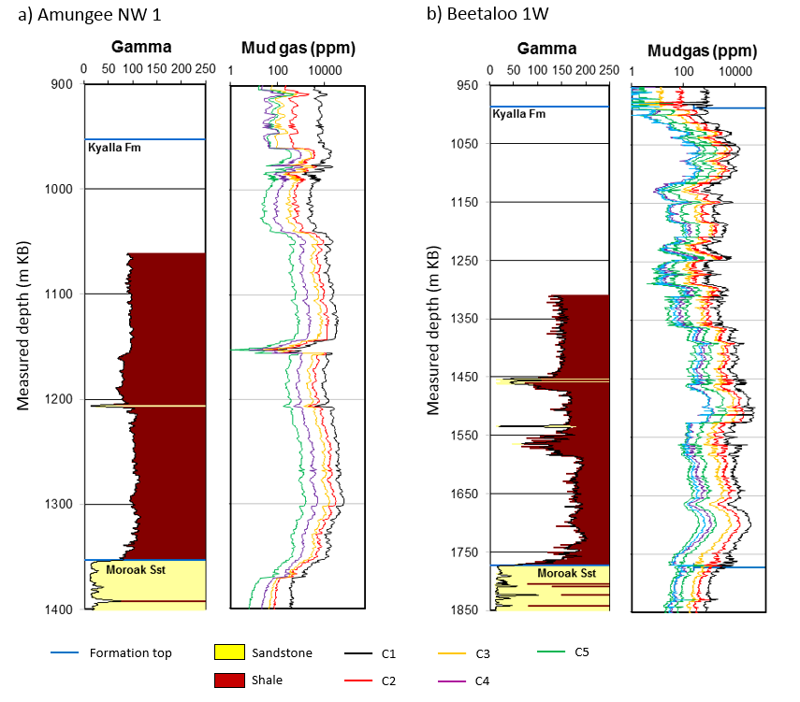
Figure 39 Kyalla Formation mud gas data for a) Amungee NW-1 and b) Beetaloo W1
ppm = parts per million
Data: Revie and Normington (2018)
Element: GBA-BEE-2-198
Table 33 Averaged hydrocarbon (gas) compositions (mole %) of the whole Kyalla Formation derived from mud logging data in the Beetaloo Sub-basin
Well | Methane (%) | Ethane (%) | Propane (%) | Isobutane (%) | n-Butane (%) | Isopentane (%) | n-Pentane (%)
Kalala S1 | 62.01 | 18.69 | 11.33 | 1.54 | 3.93 | 1.33 | 1.16
Amungee NW1 | 56.08 | 22.93 | 12.83 | 1.43 | 4.22 | 1.26 | 1.25
Beetaloo W1 | 56.14 | 22.78 | 12.58 | 1.79 | 4.15 | 1.38 | 1.17
Shenandoah 1A | 56.90 | 24.21 | 11.74 | 1.96 | 3.35 | 1.12 | 0.71
Tanumbirini 1 | 77.68 | 13.99 | 4.83 | 1.32 | 1.22 | 0.32 | 0.64
Average | 61.76 | 20.52 | 10.66 | 1.61 | 3.37 | 1.08 | 0.99
Source: Falcon Oil and Gas (2012); Origin Energy (2015b, 2016a, 2015a); Santos Ltd (2014)
Data: Revie and Normington (2018)
Three canister desorbed gas samples from the Kyalla Formation shales in Tarlee 1 were analysed by gas chromatography (Pangaea NT Pty Ltd, 2019). The average gas compositions include 26.20% methane, 14.85% ethane, 16.03% propane, 42.23% heavier hydrocarbon (butane plus) and 0.68% carbon dioxide (Table 34).
Table 34 N₂ and O₂ set to zero gas compositions of the desorbed gas samples from the Kyalla Formation shales in Tarlee 1
Sample number | Top (m) | Bottom (m) | Methane (mol%) | Ethane (mol%) | Propane (mol%) | Butane plus (mol%) | Carbon dioxide (mol%)
TL1_DS1 | 670.8 | 671.15 | 25.13 | 10.62 | 16.15 | 47.28 | 0.83
TL1_DS2 | 701.05 | 701.35 | 28.12 | 17.20 | 15.88 | 38.16 | 0.65
TL1_DS4 | 742.3 | 742.6 | 25.37 | 16.74 | 16.07 | 41.25 | 0.57
Average |  |  | 26.20 | 14.85 | 16.03 | 42.23 | 0.68
mol%: molar percentage
Data: Pangaea NT Pty Ltd (2019)
The hydrocarbon resource in the Kyalla Formation shales is mainly liquid-rich wet gas in the eastern part (Table 32 and Table 33) and light oil in the western part of Beetaloo Sub-basin (Table 34).

Hayfield sandstone member
Key characteristics of the Hayfield sandstone member are summarised below in Table 35.
Table 35 Key features of the Hayfield sandstone member
Unconventional play type | Tight oil/ condensate and liquids-rich gas (Côté et al., 2018)
Age | Neoproterozoic; maximum depositional age 1092±15 Ma (Munson et al., 2018)
Base depth | -193–964 m MSL
Gross formation thickness | Poorly determined
Lithology | Mudstone interbedded with siltstone and sandstone
Depositional environment | Bathyal/abyssal to continental shelf
TOC | Not a source rock
Mean original HI | Not a source rock
Thermal maturity | Not a source rock
Average permeability | No data – unassessed
Average porosity | No data – unassessed
Average water saturation | No data – unassessed
Average oil saturation | No data – unassessed
Average gas saturation | No data – unassessed
Average brittleness ª | Brittle (0.472)
Pressure regime | No data
MSL = mean sea level
ªThe brittleness index (BI) was calculated from mineral content using the method of Jarvie et al. (2007)

Age and stratigraphic relationships
The age of the Hayfield sandstone member of the Hayfield mudstone is poorly constrained and was first dated by Munson and Revie (2018) as having a maximum depositional age of 1092 ± 15 Ma. The Hayfield mudstone is conformably underlain by the Jamison sandstone.

Extent, depth and gross formation thickness
The Hayfield mudstone is widely intersected in wells drilled in the Beetaloo Sub-basin namely in Amungee NW 1, Balmain 1, Beetaloo West 1, Burdo 1, Chanin 1, Jamison 1, Mason 1, Ronald 1, Shenandoah 1, Shortland 1, Tanumbirini 1, Tarlee 1 and Tarlee 2. It is reinterpreted as present in McManus 1 (Munson, 2016) and it is potentially in Kalala South 1. The extent of the Hayfield sandstone member remains more poorly defined, although well intersections indicate it is restricted to the central part of the eastern sub-basin (Côté et al., 2018).
The depth to the base of the Hayfield mudstone (equivalent to the top of the Jamison sandstone) ranges from -194 m to 964 m below sea level (Figure 40). The Hayfield sandstone member occurs about 60 m above the base of the Hayfield mudstone and reaches a maximum thickness of approximately 12 m in Shenandoah 1 (Munson, 2016).
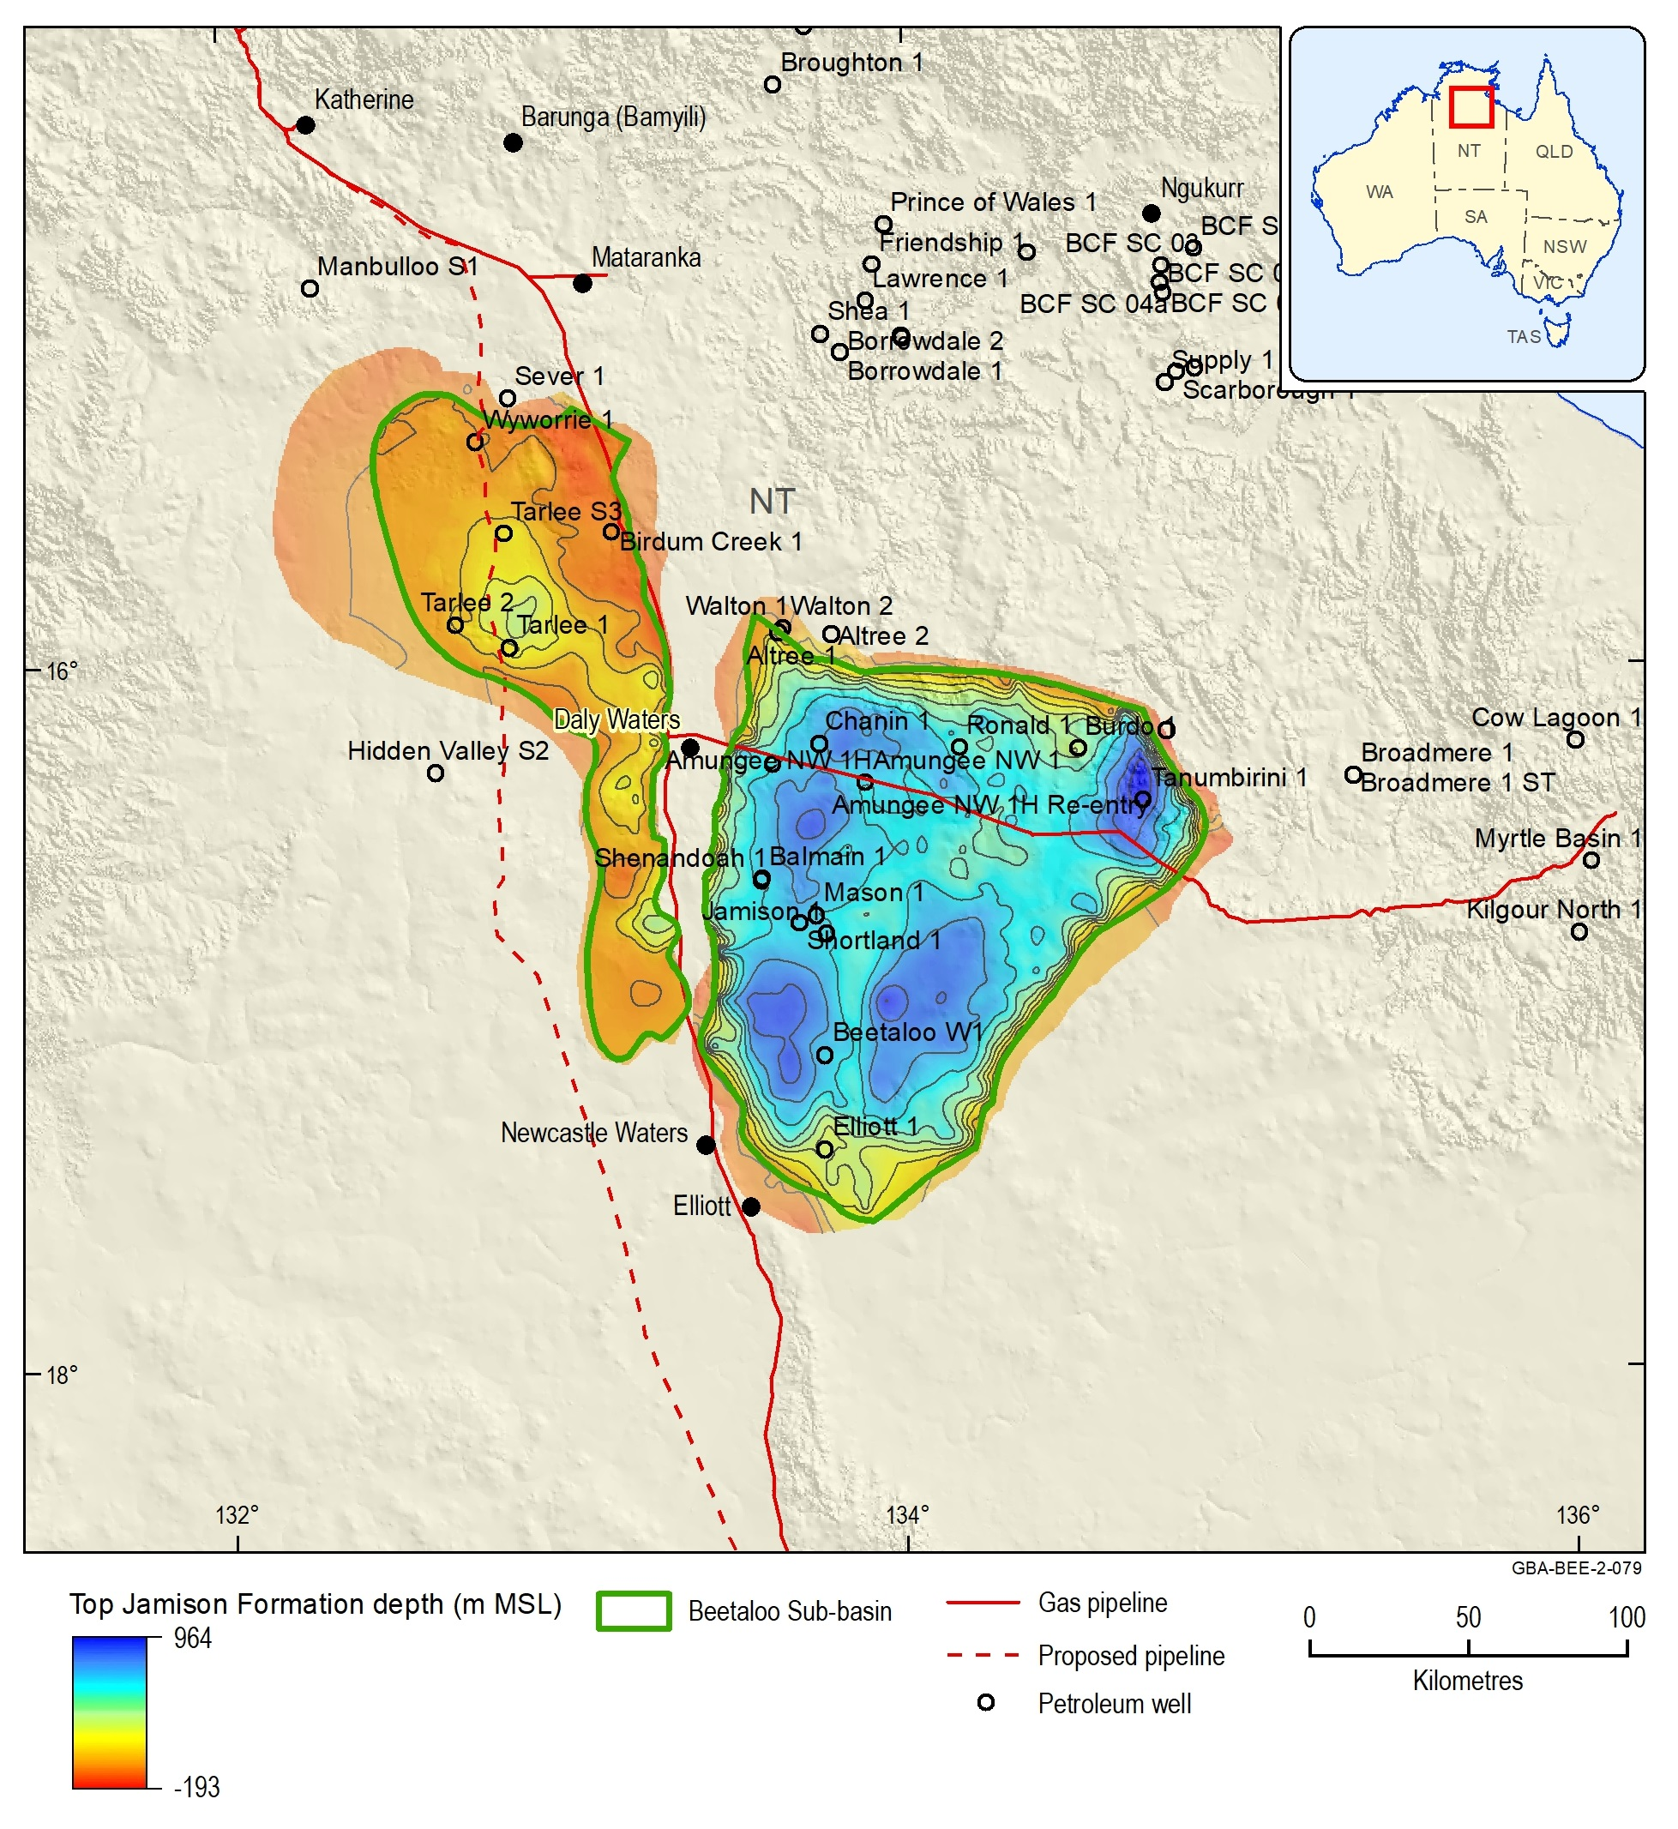
Figure 40 Jamison sandstone top depth (m), equivalent to base of the Hayfield mudstone
Source: Orr et al. (2020)
Data: Geological and Bioregional Assessment Program (2019b); GBA derived dataset based on Williams (2019) and (Northern Territory Government, 2018b)
Element: GBA-BEE-2-079

Lithology and palaeoenvironment
The Hayfield mudstone is a mudrock-rich unit. It comprises claystone with thinly interbedded siltstone and sandstone (Munson, 2016). Sandstone is more common towards the base of the unit. A laterally persistent sandstone interval dominates lower part of the Hayfield mudstone, about 60 m above the base, informally termed the “Hayfield sandstone member” (Munson, 2016). It comprises medium- and fine-grained sandstone, siltstone and minor claystone; the sandstone is similar to the Jamison sandstone, with a feldspathic component similarly indicating immaturity relative to the underlying Roper Group (Munson, 2016).
The fine-grained nature of the Hayfield mudstone, and the presence of glauconite and marine palynomorphs, indicate a sub-tidal shallow-marine shelf setting (Munson, 2016). The thicker sandstone intervals, such as the Hayfield sandstone member, indicate shallowing to a nearshore environment (Munson, 2016). Both fining- and coarsening-upward sediment cycles indicate variations in water depth through the Hayfield mudstone (Munson, 2016).

Source rock characteristics
The Hayfield mudstone is not a petroleum source rock. Instead, the origin of oil and gas in the Hayfield sandstone member is thought to be the result of migration from source rocks in either the Kyalla or Velkerri formations (Côté et al., 2018).

Reservoir characteristics
The thin but regionally extensive Hayfield sandstone member forms the reservoir of Hayfield sandstone member oil/condensate play (Côté et al., 2018). There was insufficient public domain well data available to characterise the porosity, permeability, gas and oil saturation of the Hayfield sandstone member reservoir.
The mineral assemblage and brittleness of the Hayfield sandstone member were described using XRD analyses from 3 shale rock samples from 1 well (Revie and Normington, 2018). The Hayfield sandstone member comprises quartz, kaolinite, mica/illite, feldspar, chlorite, siderite, rutile and anatase. The Hayfield sandstone member has a high degree of quartz overgrowths. Although these overgrowths reduce the porosity and permeability, secondary porosity networks and natural fractures partly compensate for this reduction (Côté et al., 2018).
Average brittleness indices (BI) were calculated from the mineral composition using the method of Jarvie et al. (2007). Limited available data indicates the Hayfield sandstone member is classified as ‘brittle’, with a total average BI of 0.472 Table 36.
Table 36 Main mineral assemblage statistics of the Hayfield sandstone member analysed by XRD and average brittleness indices estimated from mineral assemblages using the method of Jarvie et al. (2007)
Well | Quartz (wt%) | Clays (wt%) | Carbonates (wt%) | Others (wt%) | Brittleness Index (fraction)
Shenandoah 1/1A (3 samples) | 37.67 | 40.67 | 1.67 | 20.67 | 0.472
wt%: weight percent
Data: Revie and Normington (2018)

Trap and seal
Although not fully understood, the play’s trapping mechanism is considered to be a structural-stratigraphic trap, sealed by the overlying Hayfield mudstone (Côté et al., 2018).

Gas composition
Mud logging entails gathering qualitative and semi-quantitative data from hydrocarbon gas detectors that record the level of natural gas returned to the surface in the drilling fluid (mud). Chromatographs are used to determine the chemical makeup of the gas by separating the gas stream into fractions according to molecular weight. Table 37 shows the averaged hydrocarbon (gas) compositions of the Hayfield mudstone from mud logging data in the Beetaloo Sub-basin (Origin Energy, 2015b, 2016a).
Table 37 Averaged hydrocarbon (gas) compositions (mole %) of the Hayfield mudstone derived from mud logging data in the Beetaloo Sub-basin
Well | Methane (%) | Ethane (%) | Propane (%) | Isobutane (%) | n-Butane (%) | Isopentane (%) | n-Pentane (%)
Amungee NW1 | 84.51 | 8.03 | 3.61 | 0.83 | 1.51 | 0.81 | 0.70
Beetaloo W1 | 78.10 | 15.55 | 4.24 | 0.35 | 1.10 | 0.27 | 0.39
Average | 81.31 | 11.79 | 3.92 | 0.59 | 1.30 | 0.54 | 0.55
Data: Revie and Normington (2018)

Source rock maturity

Introduction
The burial and thermal history of 18 wells across the Beetaloo Sub-basin was reviewed to better constrain the likely distribution of the oil, wet gas and dry gas windows for the Velkerri and Kyalla formation plays.
Only limited burial and thermal history modelling has been undertaken on the Roper Group succession of the Beetaloo Sub-basin. Burial history models have been published for McManus 1, Jamison 1 (Silverman et al., 2007) and Kalala 1 (Faiz et al., 2016; Faiz et al., 2018) in the eastern sub-basin and Tarlee 3 in the western sub-basin (Hoffman, 2016). These results indicated that the Amungee Member source rocks reached the oil to wet gas window during the Mesoproterozoic depositional event with additional primary and secondary cracking of hydrocarbons during the Neoproterozoic and/or Cambrian-Ordovician. However, while these one-dimensional modelling studies provide important insights into the source rock maturity and generation history, the spatial variation of source rock maturity across the Velkerri and Kyalla formations remains poorly constrained.

Input data
One-dimensional burial and thermal history models were set up for 18 wells across the Beetaloo Sub-basin (Figure 41), using the Zetaware Inc. Genesis (version 5.6x) software (Zetaware, 2019). The input parameters used to construct the burial history models (i.e. the time-depth history of the basin) include age, present day thickness and lithology of the stratigraphic units, information on major unconformities and the amount of missing section (Allen and Allen, 2005). Basin architecture, stratigraphic ages and lithologies are based on the three-dimensional geological model, stratigraphic chart and associated stratigraphic unit descriptions in Orr et al. (2020). The timing of major erosion events included in the model are shown in Table 38.
The thermal or time-temperature history was constrained from the subsidence history, taking into consideration changes in surface temperature through time, lithospheric structure changes through time and the thermal properties of the sediments and crust (Allen and Allen, 2005; Beardsmore and Cull, 2001; Hantschel and Kauerauf, 2009; Peters et al., 2012). The thermal model used for burial and thermal history modelling was ‘transient, fixed temperature at base lithosphere’ using a temperature of 1330°C (Zetaware, 2019). A constant mean average surface temperature of 26°C was applied (Bureau of Meteorology, 2019). Upper crustal radiogenic heat production was estimated from Frogtech Geoscience (2018). A heat flow pulse was applied to the late Mesoproterozoic to correspond with the Derim Derim Dolerite sill emplacement at 1324 Ma, as modelled by Hoffman (2015).
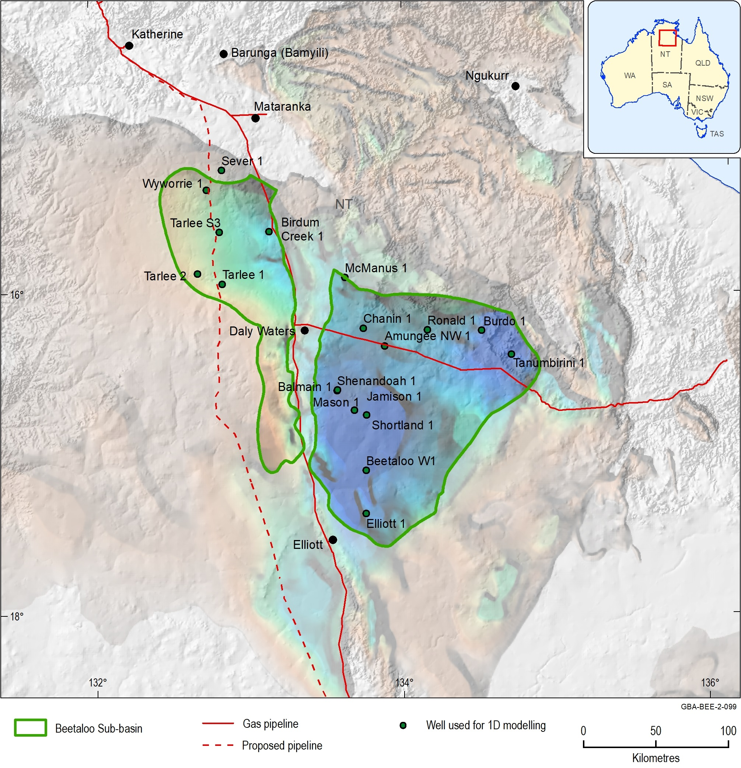
Figure 41 Location of wells used for the burial and thermal history modelling review
Source: depth to base Roper Group from Frogtech Geoscience (2018)
Element: GBA-BEE-2-099
Table 38 Amounts of erosion for major unconformities of the Beetaloo Sub-basin at modelled well locations
Unconformity | Estimated erosion amount
Mesoproterozoic unconformity (Top Roper Gp) | 500 m
Neoproterozoic unconformity (Top Hayfield mudstone) | 500 m
Paleozoic unconformity (Top Georgina Basin) | 1200–1500 m
Mesozoic unconformity (Top Carpentaria Basin) | 500 m
Source: Unconformities are sourced from the stratigraphic chart and associated references presented in Orr et al. (2020). Estimated erosion amounts are discussed in the methods snapshot below.
Methods snapshot: modelling erosion and maximum burial depth
Erosion events are modelled for the following unconformities: top Mesoproterozoic, top Neoproterozoic, Paleozoic, and Mesozoic (Table 38). The amount of erosion associated with each event, determines when source rocks reached their maximum depth of burial and hence the timing of hydrocarbon generation and maturation.
In this study, the maximum erosion and hence maximum depth of burial was modelled to occur in the Paleozoic based on the most recently published burial history model presented in Faiz et al. (2018). This is consistent with the presence of hydrocarbons in the Bukalara Sandstone in the well Walton 1 which indicates significant migration occurred in post-Mesoproterozoic times. An estimated erosion amount of 1500 m from Faiz et al. (2018) was used as a starting point for each one-dimensional model, which was then adjusted for each well to better fit the observed calibration data. Constant erosion amounts of 500 m were applied to the Top Roper Group and Mesozoic unconformities (Faiz et al., 2018).
Other models have been proposed which place maximum depth of burial at different times in the sub-basin’s history. Dutkiewicz et al. (2007) estimated that the most significant oil migration episode for the Roper Group occurred in the Mesoproterozoic, following compaction, cementation and contact metamorphism during structural inversion between about 1300–1000 Ma. In contrast, a reinterpretation of the burial history of the Roper Group, based on two-dimensional seismic data and paleothermal studies (Duddy et al., 2003; Silverman and Ahlbrandt, 2010) indicates that peak hydrocarbon generation may have occurred in the early Mesozoic, much later than reported in these previous studies and this would greatly increase the potential for preservation of conventional traps. However, further work is required to test these scenarios and their impact on source rock maturation and generation.

Model calibration
Model input parameters were adjusted to calibrate the results with observed temperature and maturity data. All one-dimensional models were calibrated using present day bottom hole temperature measurements sourced from the OZTemp database (Holgate and Gerner, 2010) and supplementary data supplied by Pangaea NT Pty Ltd (2019). Wherever possible temperature data was Horner corrected to provide the best estimate of subsurface conditions undisturbed by drilling (Beardsmore and Cull, 2001).
Thermal maturity in the Proterozoic rocks of the Beetaloo Sub-basin cannot be determined by conventional vitrinite reflectance because these predate the evolution of land plants from which vitrinite is derived. Alginite has been identified as the dominant maceral present in the Kyalla and Velkerri formations, with minor occurrences of telalginite and fluorescing lamalginite are also present (Revie, 2017c). These macerals are derived from sapropelic algal organic matter, deposited in subaquatic muds under oxygen-restricted conditions (Revie, 2017c). Bitumen occurrences are also common in the Roper Group petrographic samples (Revie, 2017c).
For this study, a compilation of alginate and bitumen reflectance (Pangaea NT Pty Ltd, 2019; Revie and Normington, 2018) was converted relative to equivalent vitrinite values using the equation of Jacob (1989) as a measure of source rock maturity.
The Rock-Eval pyrolysis parameter Tmax, used in conjunction with Hydrogen Index and Production Index, has also been used as a proxy for the level of thermal maturity with some degree of success (Revie and Normington, 2018; Pangaea NT Pty Ltd, 2019). However, Tmax is prone to suppression (Summons et al., 1994). Down well Tmax profiles in the Beetaloo Sub-basin results are highly variable (Jarrett et al., 2019).

Maturity windows
Vitrinite reflectance can be generally correlated to the stage of oil and gas generation, where maturity is the main control on oil vs gas (i.e. where all other factors are constant). A variety of generic phases defining empirical relationships for primary oil and gas generation have been published (Hantschel and Kauerauf, 2009). However, the kinetics of oil and gas generation (i.e. the relationship between temperature and transformation of organic matter to hydrocarbons) can vary significantly by basin so this generic correlation may not always be appropriate.
A compilation of bulk kinetics for the Beetaloo Sub-basin sourced from Revie and Normington (2018) were analysed by Jarrett et al. (2019) to show the relationship between transformation ratio and maturity (Figure 42). The Beetaloo Sub-basin specific kinetic relationships indicate that the onset of generation, represented by a transformation ratio of 10%, occurs at maturities between 0.44 %EqVR and 0.82 %EqVR (mean value 0.73 %EqVR). This shows that in the Beetaloo Sub-basin the onset of oil generation occurs at higher maturities than indicated by the generic value of 0.5 %EqVR presented for Type I and/or Type II kerogens (Pepper and Corvi, 1995).
The Beetaloo Sub-basin specific kinetics data also indicate that peak generation occurs between 0.51 % Ro and 1.37 % Ro and an average value of 0.95 %EqVR was used in this study to represent the end of the peak oil window. This is slightly higher the generic value of 0.9 %EqVR presented for Type I and/or Type II kerogens.
The Beetaloo Sub-basin kinetic relationships are used to customise the generic Type I and Type II oil and gas maturity windows used by Weatherford Laboratories (2017), to be more appropriate to the characterisation of source rocks of the Beetaloo Sub-basin.
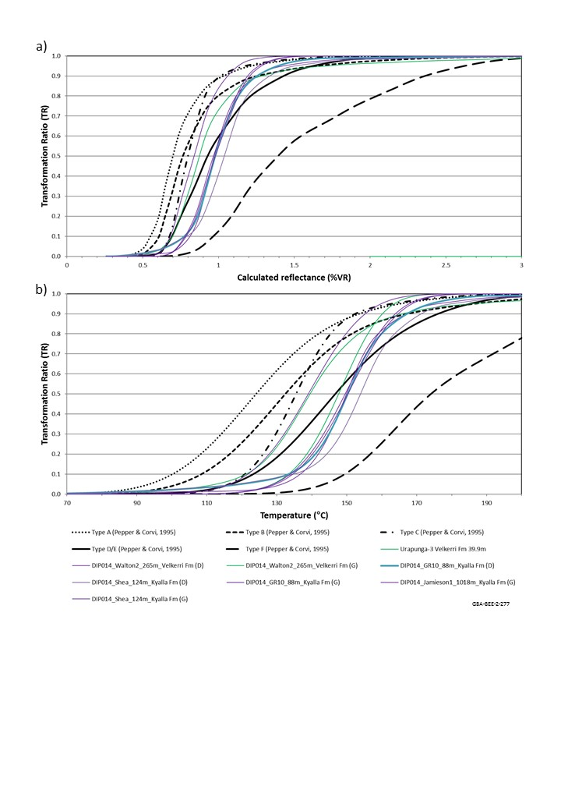
Figure 42 Transformation ratio (TR) curves calculated using bulk kinetics. A) TR plotted against maturity (calculated vitrinite reflectance equivalent; %VR) and B) TR plotted against temperature (°C)
TR = transformation ratio; %VR = calculated vitrinite reflectance maturity
Source: Generic kinetics (type A-F) from Pepper and Corvi (1995)
Data: Beetaloo Sub-basin specific kinetics from Revie and Normington (2018)
Element: GBA-BEE-2-277
Table 39 Thermal maturity windows
Maturity window | Thermal maturation for generic Type I and Type II kerogen (Weatherford Laboratories, 2017) | Maturity windows - this study | Source of value used in this study
Immature | < 0.5 %EqVR | < 0.73 %EqVR | < 10% TR (Figure 39)
Early oil | 0.5–0.65 %EqVR | 0.73–0.8 %EqVR | 10–20% TR (Figure 39)
Peak oil | 0.65–0.9 %EqVR | 0.8–0.95 %EqVR | 20–50% TR (Figure 39)
Late oil | 0.9–1.1 %EqVR | 0.95–1.1 %EqVR | 50–90% TR (Figure 39); Weatherford Laboratories (2017)
Liquids-rich gas | 1.1–1.4 %EqVR | 1.1–1.4 %EqVR | Weatherford Laboratories (2017)
Dry gas | > 1.4 %EqVR | > 1.4 %EqVR | Weatherford Laboratories (2017)
TR = transformation ratio; %EqVR = vitrinte reflectance maturity

Results
Figure 43, Figure 44 and Figure 45 show examples of the calibrated burial and thermal history modelling results for Tarlee 3, Birdum Creek 1 and Jamison 1. Maximum depth of burial was reached in the early Paleozoic, placing the Kyalla Formation in the liquids-rich gas window (1.1–1.4 %EqVR) and the Amungee Member of the Velkerri Formation in the dry gas window (> 1.4 %EqVR). The model also shows the effect of emplacement of the Derrim Derrim sill on the maturity of the adjacent sediments.
Maturity maps were generated from the one-dimensional modelling results by extracting the modelled maturity for each well at the mid-depth of the stratigraphic unit of interest and interpolating between points using the respective depth grids from the three-dimensional geological model as trending surfaces.
The Amungee Member maturity map is shown in Figure 46. The Amungee Member is in the dry gas window across the majority of the central eastern sub-basin and over about half of the western sub-basin. The flanks of the eastern sub-basin and the majority of the western sub-basin sit within the liquids-rich gas windows. These results are consistent with the observations made in previous one-dimensional modelling studies (Hoffman, 2016; Faiz et al., 2016; Faiz et al., 2018; Silverman and Ahlbrandt, 2010). Côté et al. (2018) note that the organic matter within the A, B and C shales are derived from similar biomass of low biotic diversity. As a result, these source maturity variations are likely to have a stronger control on the liquids potential of the Amungee Member play than variations in organic matter type.
The Kyalla Formation maturity map is shown in Figure 47. The Kyalla Formation reaches the liquids-rich gas window in the central part of the eastern sub-basin and around Birdum Creek 1 in the western sub-basin. Elsewhere the Kyalla Formation sits within the oil window.
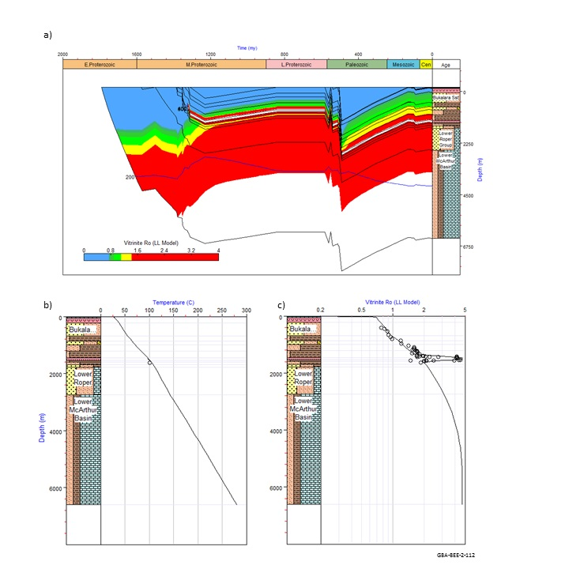
Figure 43 Modelled burial history for Tarlee 3 a) burial history, showing temperature contours and coloured by thermal maturity; b) modelled present day temperature-depth profile, with bottom hole temperature measurement; c) modelled maturity-depth profile. Bitumen reflectance data converted to equivalent vitrinite reflectance values using the conversion equation of Jacob (1989)
Source: modified from Hoffman (2015)
Data: Pangaea NT Pty Ltd (2019); Revie and Normington (2018); Holgate and Gerner (2010)
Element: GBA-BEE-2-112
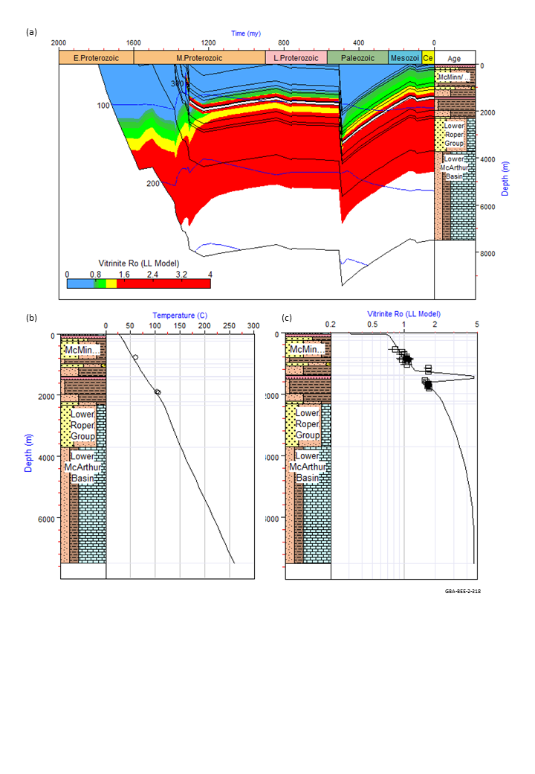
Figure 44 Modelled burial history for Birdum Creek 1 a) burial history, showing temperature contours and coloured by thermal maturity; b) modelled present day temperature-depth profile, with corrected bottom hole temperature measurement; c) modelled maturity-depth profile, with measured bitumen reflectance data converted to equivalent vitrinite reflectance values using the conversion equation of Jacob (1989)
Data: Pangaea NT Pty Ltd (2019); Revie and Normington (2018); Holgate and Gerner (2010)
Element: GBA-BEE-2-318
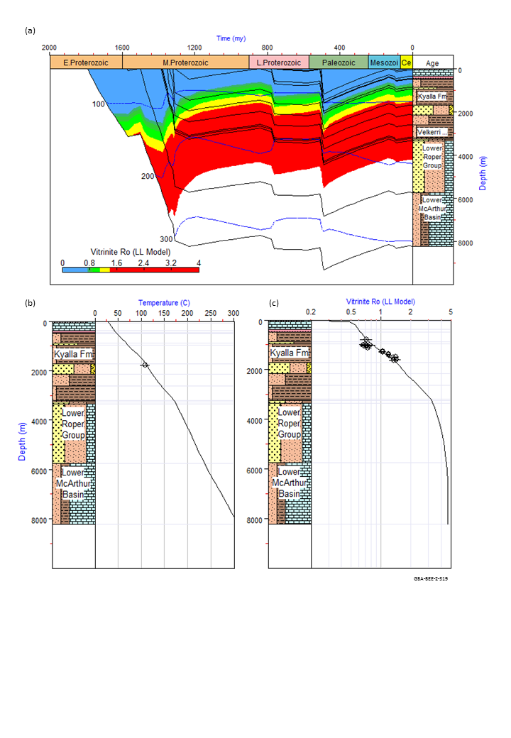
Figure 45 Modelled burial history for Jamison 1 a) burial history, showing temperature contours and coloured by thermal maturity; b) modelled present day temperature-depth profile, with correct bottom hole temperature measurement; c) modelled maturity-depth profile, with measured bitumen reflectance data converted to equivalent vitrinite reflectance values using the conversion equation of Jacob (1989)
Data: Revie and Normington (2018); Holgate and Gerner (2010)
Element: GBA-BEE-2-319

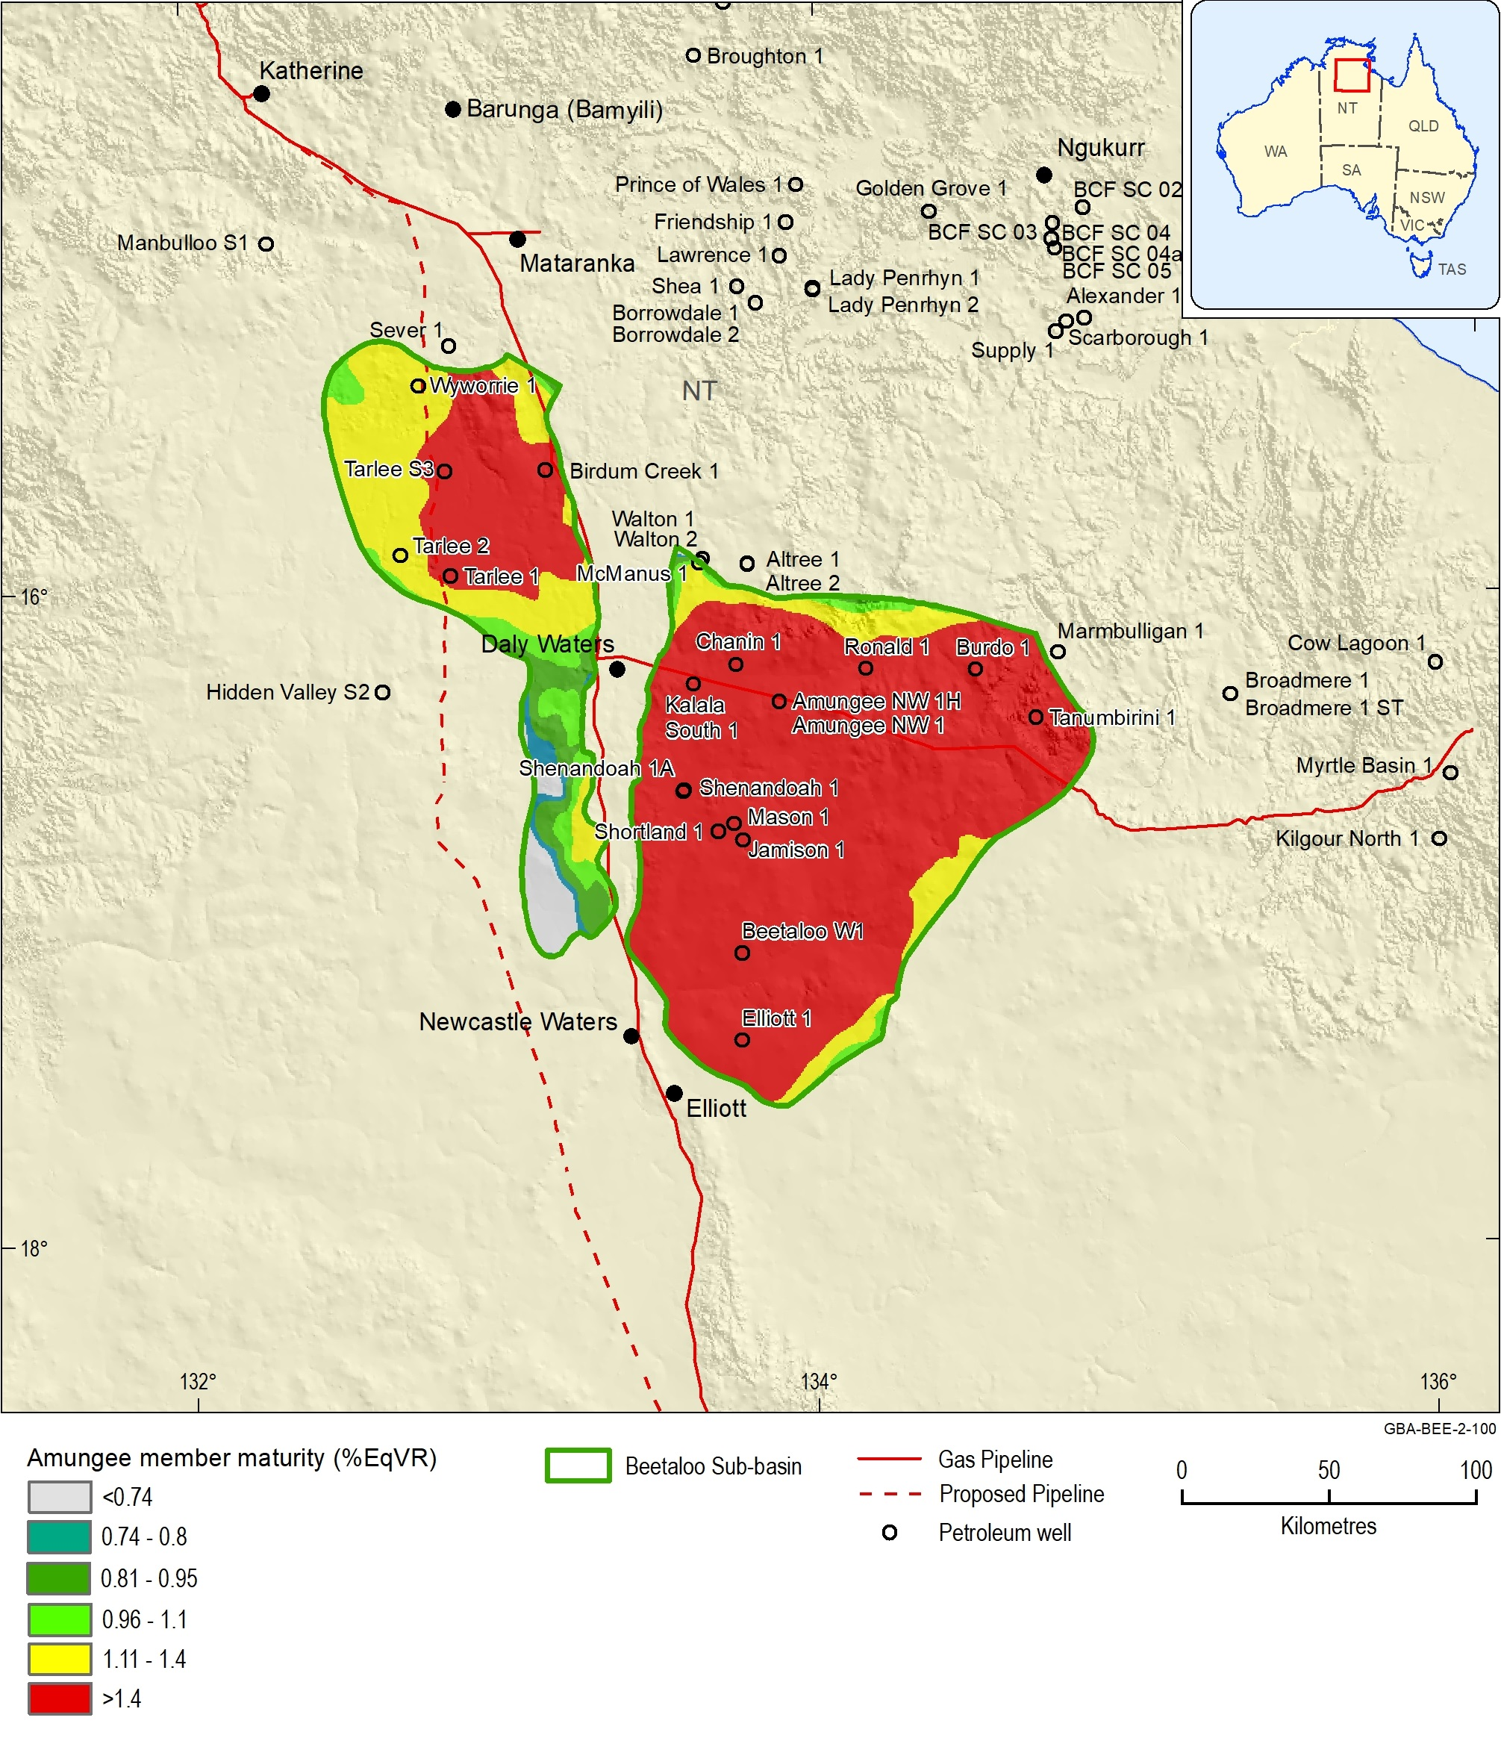
Figure 46 Source rock maturity map for the mid-depth of the Amungee Member of the Velkerri Formation
Data: Geological and Bioregional Assessment Program (2019a)
Element: GBA-BEE-2-100

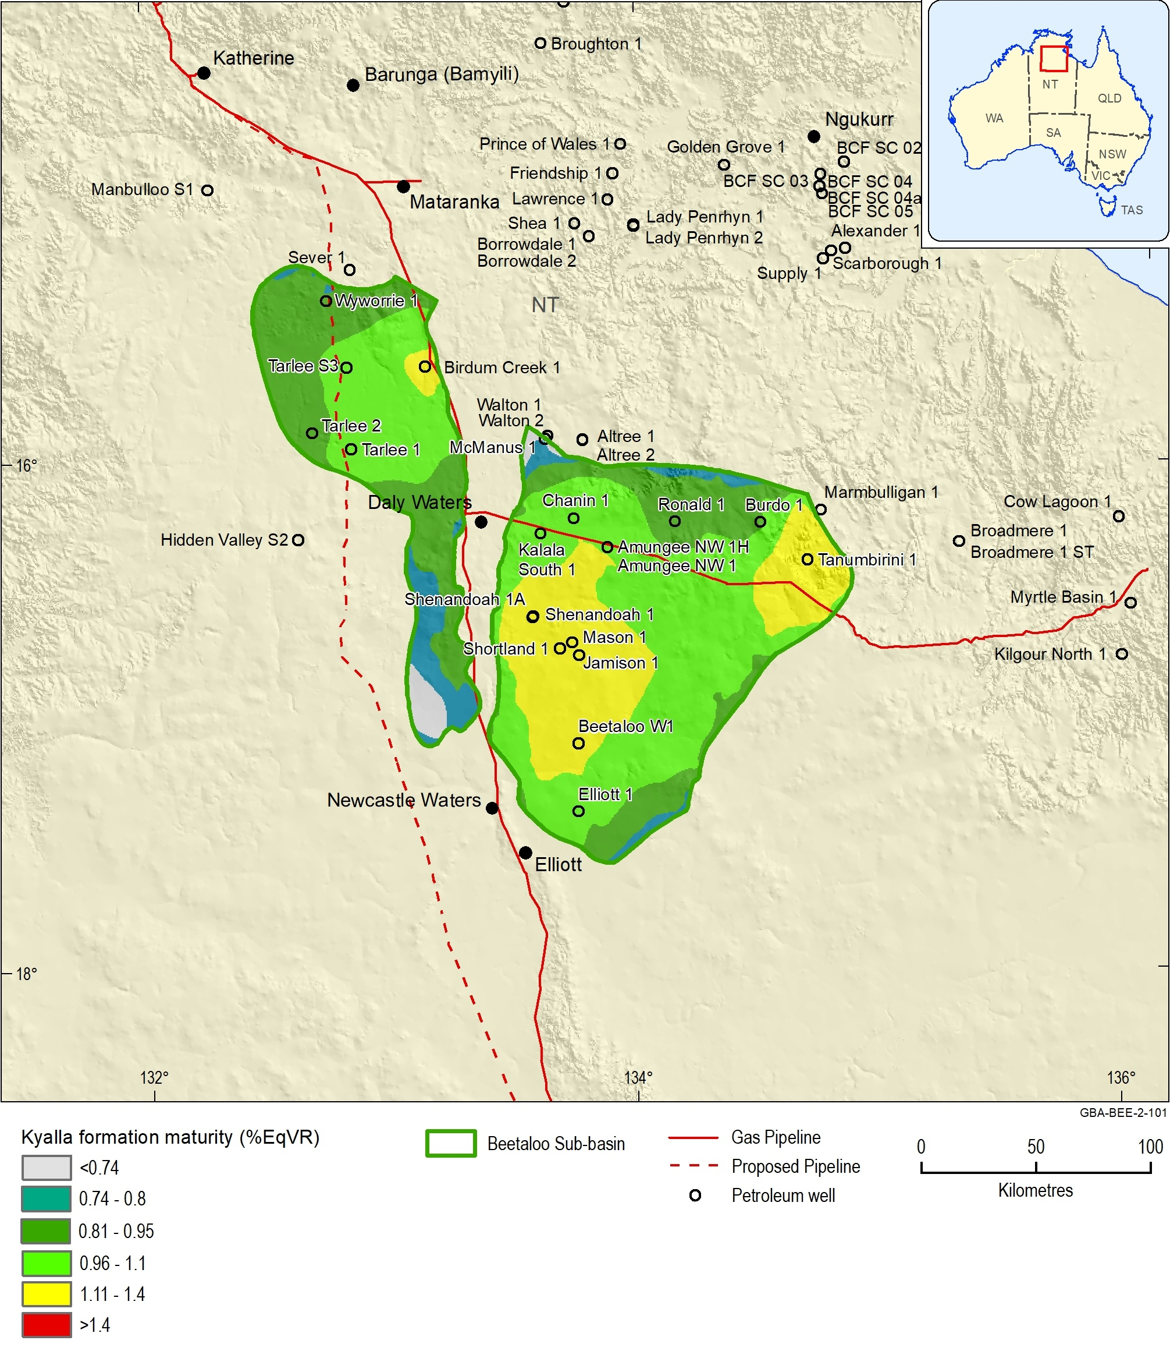
Figure 47 Source rock maturity map for the mid-depth of the Kyalla Formation
Data: Geological and Bioregional Assessment Program (2019a)
Element: GBA-BEE-2-101

Uncertainties
Due to the complex nature of burial-thermal histories in the Beetaloo Sub-basin, modelling uncertainties are high. Uplift and erosion estimates, and hence maximum burial depths, are poorly constrained. In addition, hydrothermal events may have resulted in erratic maturity reflectance profiles at local scale. The one-dimensional modelling approach presented here is useful in areas of minimal data where rapid assessment is required to predict the timing of thermal maturity of the source rock and petroleum generation as a function of depth. However this modelling cannot properly predict migration pathways, the locations and volumes of accumulations, or three-dimensional lateral heat transfer. To more accurately represent the full petroleum system, a more detailed three-dimensional modelling study of the basin would be required.

Regional stress and overpressure

Regional stress regime
Contemporary patterns of tectonic stress in the brittle crust act as a control over neotectonic deformation and seismicity, and acts as a primary control over both the formation and propagation of natural fractures and of hydraulically induced fractures (Bailey et al., 2017; Bell, 1996b, 2006; Fisher and Warpinski, 2012; Hillis et al., 2008; King et al., 2010; Lund Snee and Zoback, 2016; Olsen et al., 2007; Palano, 2014; Palmer, 2010; Pitcher and Davis, 2016; Rajabi et al., 2017; Sandiford et al., 2004; Seeber and Armbruster, 2000; Sibson, 1992; Sibson et al., 2012; Sibson et al., 2011; Stein, 1999). The extraction of fluids from low-permeability reservoirs, such as shales and tight sandstones, typically requires the creation of fracture pathways through hydraulic stimulation in order to enable adequate flows of hydrocarbons from the reservoir to the well (Bell, 1990; Bell and Babcock, 1986).
Tectonic stress regimes are defined by the relative orientations and magnitude of three orthogonal principal stresses, namely a maximum (σ1), minimum, (σ3), and intermediate (σ2). One stress is generally vertical due to the mass of overburden (σv), constraining the two remaining stresses to the horizontal plane (Anderson, 1951; Bell, 1996b; Sibson, 1977; Zoback, 2007). These are referred to as the maximum (σH) and minimum (σh) horizontal stresses (Bell, 1996a) (Figure 48), and are usually expressed in terms of stress gradients at a given depth (e.g. MPa/km or psi/ft).
Under a given stress regime, the type of failure defined by that regime will typically dominate, though pre-existing structures can exhibit hybrid failure modes (Heidbach and Höhne, 2008; Sibson, 1977). For further information regarding the definition of lithospheric stresses, see: Bell (1996b, 1990, 1996a); Chan et al. (2014); Couzens-Schultz and Chan (2010); Plumb et al. (2000); (Zoback, 2007). Stress patterns in the Beetaloo Sub-basin are reviewed to determine what impact the present day stress regime may have on potential hydraulic stimulation of formations for gas exploration.
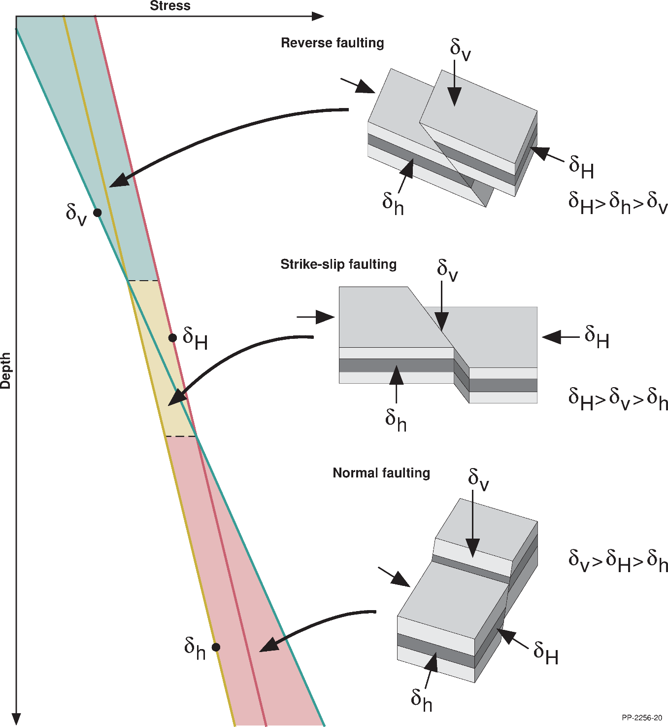
Figure 48 Tectonic stress regimes as defined by Anderson (1951), highlighting the relative magnitudes of the three principle stresses. Vertical stress is shown in green, maximum horizontal stress in red, and minimum horizontal stress in brown
Source: After Brooke‐Barnett et al. (2015)
Element: GBA-BEE-2-059

Present day stress in the Beetaloo Sub-basin
Currently, there is no regional-scale understanding of present day stresses within the Beetaloo Sub-basin. Limited stress data are available from within the Beetaloo Sub-basin and it has to date been considered only as a part of the greater McArthur Basin in continent-scale stress studies. Given the nature of recent interest in the Beetaloo Sub-basin as a potential shale gas province, increasing amounts of stress data are being acquired and analysed. Many of the petroleum exploration wells drilled within the Beetaloo Sub-basin feature modern wireline logs, including image logs, and well tests that allow for a reasonable understanding of present day stresses to be assembled.
The published literature includes little on the regional stress regimes in the Beetaloo Sub-basin, instead focusing on those within the target intervals. For example, the middle Velkerri is interpreted by Close et al. (2017b); Close et al. (2017a) as hosting a strike-slip or normal stress regime. More detail is provided in the Santos Ltd (2017) submission to the Scientific Inquiry in to Hydraulic Fracturing in the Northern Territory, which discusses the stress state interpreted at the Tanumbirini 1 well location. Tanumbirini 1 is a shale gas exploration well drilled in 2014 by Santos Ltd in the Beetaloo Sub-basin to a depth of 3946.0 m. The primary aim of the well was to provide control for the Roper Group shale play, by targeting the basin centre in order to maximise overpressures in the middle Velkerri Formation target and to intersect the full shale section of the Kyalla Formation (Santos Ltd, 2014). As a shale-specific exploration well, extensive suites of data were acquired over the target intervals that allow for interpretation of geomechanical properties and an assessment to be made of the present day stress state.
The stress state within the sedimentary section intersected by Tanumbirini 1 is interpreted as a thrust regime transitioning to borderline thrust to strike-slip with depth (Santos Ltd, 2017); consistent with the analysis of regional-scale stress regimes within the overlying Georgina Basin undertaken by Bailey et al. (2017). However, significantly reduced stress anisotropy is interpreted within the Velkerri shale unit, resulting in the interpretation of a normal faulting stress regime. This is consistent with the stress states modelled for similar shales in the McArthur Basin (Johnson and Titus, 2014; Mildren et al., 2013) and in the Isa Superbasin (Bailey et al., 2019; Johnson and Titus, 2014) , as well as previous studies within the shale units of the Beetaloo Sub-Basin (Close et al., 2017b; Close et al., 2017a; Theologou, 1991).

Maximum horizontal stress azimuth
The Australian Stress Map project includes the Beetaloo Sub-basin within the McArthur Region stress province, one of the 30 defined stress provinces for continental Australia and Papua New Guinea (Figure 49). The McArthur Region stress province is characterised by a σH orientation of 026°N, in line with much of northern Australia where NE-SW to NNE-SSW σH orientations are observed on the continental-scale (Figure 49). Close et al. (2017a) note that average breakout orientations observed in image log data indicate a σH orientation of 045°N, or NE-SW. This is reinforced by interpretation of fracture orientations on image log data, with the primary direction of fracture growth observed to align with breakout orientation (Close et al., 2017a). These results are consistent with previous geomechanical studies within the region; Bailey et al. (2017) interpret a σH orientation of 044°N within the overlying Georgina Basin and its surrounds and Theologou (1991) demonstrate an approximately 020°N σH orientation from hydraulic fracture tests within the Velkerri Formation.

Implications for fracture propagation
Mechanical properties control the amount of stress which can be supported by a given lithology (Figure 50). The concept of mechanical stratigraphy, where variation in rock properties of a given lithology can be defined by discrete mechanical properties, is noted as a significant control over the formation and propagation of fractures within the subsurface (Laubach et al., 2009). Where there are contrasts between these mechanical units, natural barriers to fracture propagation are formed (Zoback, 2007). Typically, a significant change in stresses from unit to unit will result in the termination of fracture propagation.
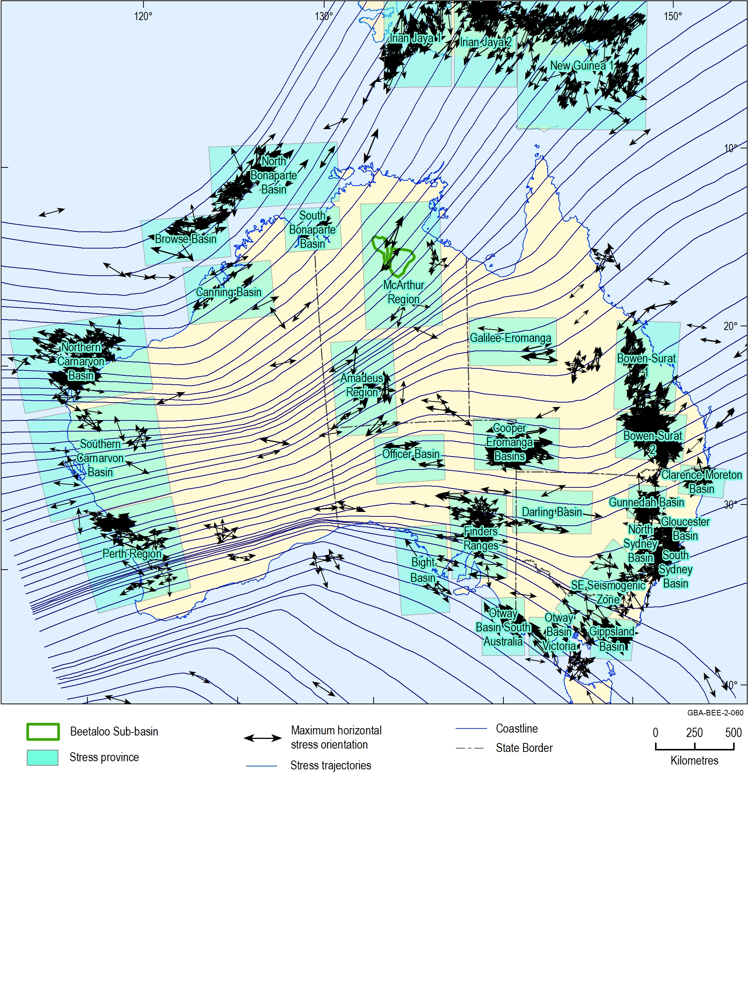
Figure 49 Australian Stress Map data (Rajabi et al., 2017) showing the 30 defined stress provinces and continent-scale stress orientations. The location of the Beetaloo Basin, as well as local stress orientations not currently provided in the ASM, are also displayed
Source: Rajabi et al. (2017)
Element: GBA-BEE-2-060
Fundamentally, low Poisson’s Ratio rocks with a high Young’s Modulus support anisotropic horizontal stresses (i.e. lower magnitudes in the minimum horizontal stress direction and elevated magnitudes in the maximum horizontal stress direction); whereas rocks with a high Poisson’s Ratio and low Young’s Modulus are incapable of supporting those anisotropic stresses and so tend towards more isotropic stresses (i.e. higher magnitudes in the minimum horizontal stress direction and lower magnitudes in the maximum horizontal stress direction) (Plumb et al., 2000) (Figure 50). Typically, it is grain-supported facies such as sandstones or carbonates that exhibit anisotropic horizontal stresses and clay supported facies such as mudstones and shale that approach isotropic stress conditions (Plumb et al., 2000; Zoback, 2007) (Figure 50). An understanding of mechanical stratigraphy, and the variation of in-situ stresses that results from varying mechanical properties, allows for induced fractures to be naturally constrained.
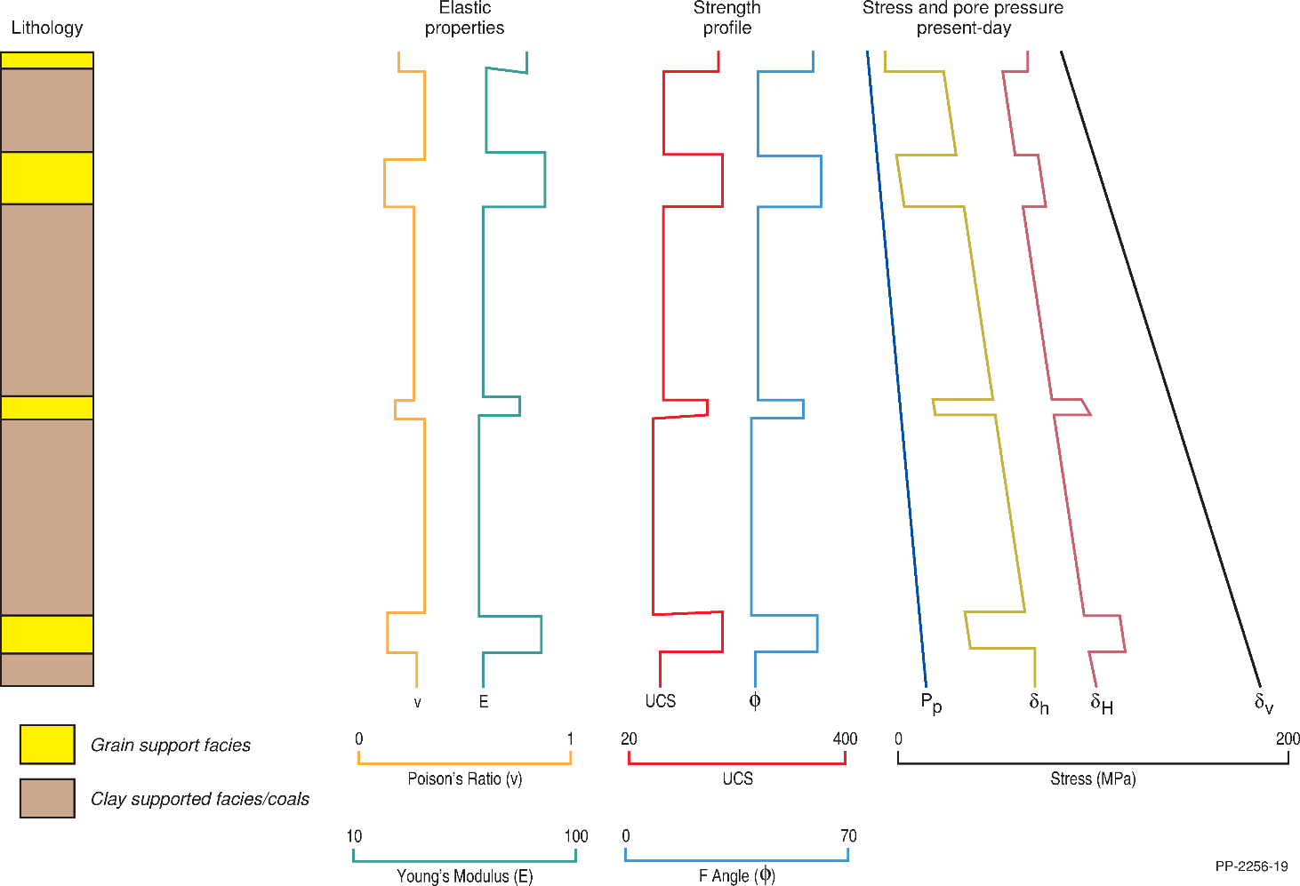
Figure 50 Schematic mechanical earth model showing lithology, mechanical stratigraphy, and calculated stress profiles
Source: After Plumb et al. (2000)
Element: GBA-BEE-2-062
In the Beetaloo Sub-basin, significant variation of stress magnitudes, and possibly stress regime, with depth is likely to act as an impediment to fracture propagation. Given the nature of the target shale intervals, both inter-formational and intra-formation fracture barriers are likely to exist in the form of sand- and siltstone interbeds, particularly within the Velkerri Formation. Mechanical earth models constructed for the well Tanumbirini 1 by Santos Ltd (Figure 51) do not extend over shallow aquifer intervals; however, shallow well tests and regional studies suggest that a reverse faulting stress regime exists from the surface through to the upper Kyalla Formation (Bailey et al., 2017; Santos Ltd, 2017). Below this, significant variations in stress regime are interpreted.
As previously mentioned, any significant change of stress between mechanical units will typically act as a barrier to fracture propagation and these changes are often referred to as stress containment boundaries. The interpreted stress state is dominated by a strike-slip faulting stress regime from the upper Kyalla Formation through to the top of the middle Velkerri Formation, however, there is a modelled interval of reverse faulting stress regime in the overlying upper Moroak Sandstone (Santos Ltd, 2017). Lower horizontal stresses are modelled for the middle Velkerri Formation, resulting in a transition to a normal faulting stress regime through most of the underlying interval. However, where competent sand interbeds exist, variations in stress magnitude and, hence, stress regime, are also observed.
The Tanumbirini 1 one-dimensional MEM (Figure 51) demonstrates that within the Beetaloo Sub-basin both inter- and intra-formational fracture barriers exist that are likely to constrain induced fractures (Santos Ltd, 2017). The organic-rich target intervals of the Kyalla and Velkerri formations are subject to lower stresses than the sandstones and siltstones that bound them and a number of significant stress contrasts exist that are likely to provide containment on any vertical fracture propagation, ensuring that induced fractures remain within the target zone. Flewelling et al. (2013) demonstrated that it is implausible for a hydraulic connection to be created through induced fracturing between deep unconventional formations and overlying shallow potable aquifers due to the limited amount of fracture height growth that is observed at depth, and the containment provided by the rotation of the minimum principal stress to the vertical plane with changing stress regimes.
The Kyalla Formation is subject to a strike-slip faulting stress regime, where fractures will propagate vertically. However, it is overlain by Neoproterozoic to Paleozoic units where a reverse faulting stress regime exists. Under reverse faulting conditions fractures will propagate horizontally, hence, these formations will act as a stress containment boundary and inhibit fracture growth.
The upper Velkerri Formation is overlain by the Moroak Sandstone, which while dominated by a strike-slip faulting stress regime, hosts an interval where high rock strength and high Young’s Modulus results in a reverse faulting stress regime. Below this, a strike-slip faulting stress regime is present through to the top Amungee Member, however, an additional stress containment boundary is present within the upper Velkerri Formation in the form of organic-lean siltstones and sandstones with high rock strength and Young’s Modulus. A distinct change in horizontal stress magnitude can be observed at the base of these lithologies and this is likely to form an intraformational containment boundary. The primary targets within the Velkerri Formation are the organic-rich A, B, and C shales of the Amungee Member; the Amungee Member is demonstrated to host a normal faulting stress regime and is mechanically contained by the strike-slip faulting stress regime of the overlying Wyworrie Member. Again, organically lean siltstone interbeds are likely to form intraformational seals to further contain fracture propagation (Santos Ltd, 2017).
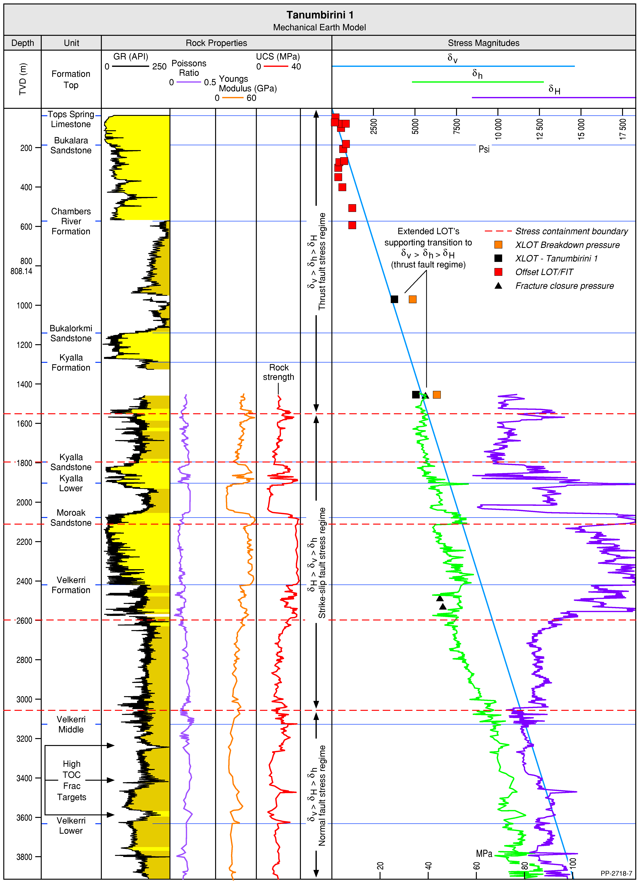
Figure 51 One-dimensional mechanical earth model (1D MEM) constructed for the Santos well Tanumbirini 1 by Santos Ltd., highlighting variations in stress regime within the subsurface as well as significant stress containment boundaries likely to act as natural barriers to induced fracture propagation
Source: After Santos Ltd (2017)
Element: GBA-BEE-2-061

Overpressure
The term overpressure describes an in-situ pore fluid pressure that exceeds the hydrostatic value (Tingate et al., 2001), which ranges from 9.8 MPa/km for fresh water to 11.3 MPa/km for completely salt saturated water. Typically, formation water produced in the Beetaloo Sub-basin has salt concentrations of approximately 50,000 mg/L (range 50,000–150,000 mg/L) (Evans et al., 2020). A reasonable estimate of hydrostatic pore pressure within the Beetaloo Sub-basin is 9.8 to 11.1 MPa/km (0.433 to 0.49 psi/ft), although sample density is quite low. In order to exceed this hydrostatic gradient, a mechanism other than the buoyancy force of a continuous column of static fluid is required (Osborne and Swarbrick, 1997). The most common mechanisms through which this is achieved are: a) disequilibrium compaction, b) generation of hydrocarbons, c) fluid expansion, and, d) tectonic loading (Bowers, 1995; Grauls and Baleix, 1994; Tingay et al., 2003; Tingay et al., 2007, 2009; Wangen, 2001). Knowledge of overpressure and accurate pore pressure prediction is essential to ensure safe drilling, proper well design, and for reservoir planning and reserve estimation (Tingate et al., 2001; Tingay et al., 2009) . Overpressure forms a potential control over seal integrity, fracture reactivation, reservoir quality, and the effective magnitude of in-situ stresses (van Ruth et al., 2004; Zoback, 2007).
To date, there have been no detailed studies of formation pressure within the Beetaloo Sub-basin, published, however, there have been several wells drilled where formation tests were carried out; drill stem tests (DST) suggest a pore pressure gradient mostly in line with the hydrostatic gradient (Figure 52). There are several test results that demonstrate pore pressure gradients as high as 11.79 MPa/km (Figure 52). Both Origin (Close et al., 2017a) and Santos (Santos Ltd, 2017) suggest that there are overpressured formations within the Beetaloo Sub-basin based on interpreted diagnostic fracture injection test (DFIT) data from several wells. Close et al. (2017b) and Close et al. (2017a) report DFIT data from the wells Kalala S-1 and Amungee NW-1 that indicates a pore pressure gradient of 11.8 to 12.4 MPa/km (0.52-0.55 pst/ft) in the middle Velkerri Formation, whereas (Santos Ltd, 2017) report identified pore pressures of 17.0 MPa/km (0.75 psi/ft) from offset wells. Falcon Oil and Gas noted, while drilling Shenandoah 1A that elevated drilling mud densities were required when coring the Velkerri B shale in order to balance increased formation fluid pressures. DFITs carried out prior to the fracture treatments of Shenandoah 1 identified elevated pore pressures in the middle Velkerri Formation that range from 12.6 to 15.0 MPa/km (0.556–0.662 psi/ft). Further DFITs carried out in the Moroak Sandstone (11.2–12.4 MPa/km, or 0.493–0.550 psi/ft) and the lower Kyalla Formation (12.6–14.8 MPa/km, or 0.556–0.653 psi/ft) also indicate overpressure within these formations (Shenandoah WCR). In their assessment of the Kyalla Formation, Altmann et al. (2018) describe efforts by Falcon Oil and Gas (Burgess, 2010) to run a DST over the lower Kyalla Source Rock Reservoir in order to understand pressure and productivity from this interval. The authors note that the packing seat failed after the tool was open and the test was abandoned without assessing reservoir pressures. Due to the lack of reliable direct measurements, Altmann et al. (2018) consider formation pressure to be the most significant technical risk pertaining to the lower Kyalla shale play. Indications from DFITs in both the shale plays of interest, the Velkerri and the Kyalla formations, are that they are overpressured. Overpressure is considered a critical success indicator for North American shale gas plays (Close et al., 2017a).
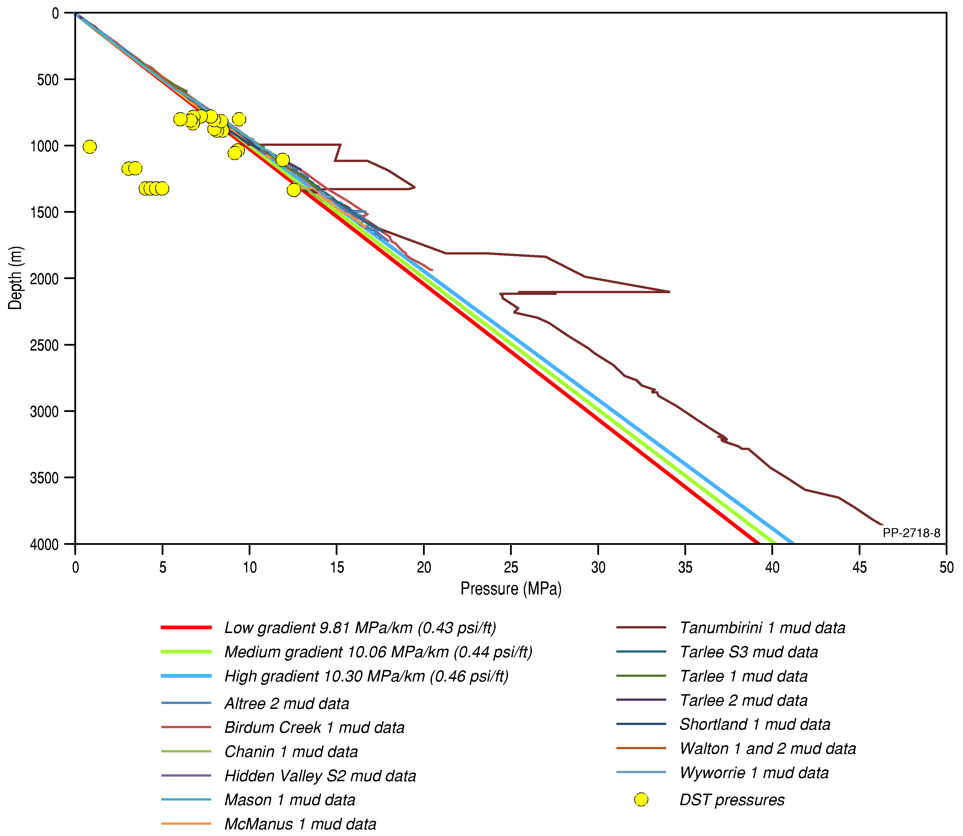
Figure 52 Pore pressure measurements from drill stem tests (DSTs – blue circles) plotted alongside mud weight data from 13 Beetaloo Sub-basin petroleum wells
Also displayed is a range of hydrostatic gradients (red, green, and blue straight lines) showing the likely range of hydrostatic values. Note, diagnostic fracture injection test (DFIT) data discussed in text is not plotted.
Element: GBA-BEE-2-064

Prospectivity mapping
Play fairway mapping was used to map the distribution of petroleum plays likely to be developed in a five to ten year time frame. This process aims to address the geological factors likely to assist in identifying whether a viable petroleum play is likely to be present, and makes no attempt to factor economics, politics, or social factors into the assessment.

Plays to be assessed
The five plays in the Beetaloo GBA region most likely to be developed within the next five to ten years are as follows (Côté et al., 2018):
- Velkerri Shale (Amungee Member) – Dry Gas Play
- Velkerri Shale (Amungee Member) – Liquids-Rich Gas Play
- Kyalla Shale – Liquids-Rich Gas Play
- Kyalla Hybrid Lithology – Liquids-Rich Gas Play
- Hayfield Sandstone – Oil/Condensate Play (possible structural/stratigraphic trap, tight reservoir; requires further exploration and technical viability assessment using a horizontal fracture stimulated well).
Of the above plays, there is only sufficient public domain data available to independently assess the dry and liquids-rich gas plays of the Amungee Member shales of the Velkerri Formation, and the liquids-rich gas in the Kyalla Formation shale.
No additional exploration targets (conventional or unconventional; oil or gas) have been clearly identified and publicly documented, to date, within the sub-basin. Although there is significant oil/condensate potential in the Kyalla Formation, successfully development of this play type would be dependent on further advancements in enhanced oil recovery technology.

Workflow
The shale play criteria used herein are primarily based on previous work undertaken by US federal agencies, e.g. EIA (2013); Charpentier and Cook (2011), with additional feedback from state government agencies, universities and relevant industry staff (Table 40). Parameters used included formation depth, net source rock thickness and thermal maturity.
Each input parameter was assigned a ranking between zero and one (Zero 0, Med 0.5, High 1). Prospectivity associated with each individual parameter was multiplied together to determine a composite map, highlighting the relative prospectivity of each play across the basin (Figure 53). A workflow was developed for each play type using the equation below to develop the final relative prospectivity confidence maps that are displayed in the results sections for each play type.
$$Prospectivity (C)=c_{1}×c_{2}×c_{3}×…×c_{n}$$
The results are a reflection of relative prospectivity across the region rather than a statistical probability of success of any play or prospect.
The workflow was set up as a batch task file using the Petrosys software (Petrosys Pty. Ltd., Version 17.7sp6).
Table 40 Summary of shale gas play specific input parameters and classifying criteria used to develop play fairway maps.
Parameter (P) | Zero (0) | Medium (0.5) | High (1) | Map source
Mid-formation depth (m) | < 700 m | 700–1000 m | > 1000 m | Three-dimensional geological model (Orr et al., 2019)
Net shale thickness greater than 2 wt% TOC | < 15 m | 15–30 m | > 30 m | Gross stratigraphic thickness from three-dimensional geological model (Orr et al., 2019) * net organically rich ratio (Section 3.2 – this report)
Thermal maturity (liquids-rich gas) OR | < 1.1 OR > 1.4 %EqVR | n/a | 1.1–1.4 %EqVR | Source rock maturity map (Section 3.4 – this report)
Thermal maturity (dry gas) | 1.4 %EqVR | n/a | > 1.4 %EqVR | Source rock maturity map (Section 3.4 – this report)
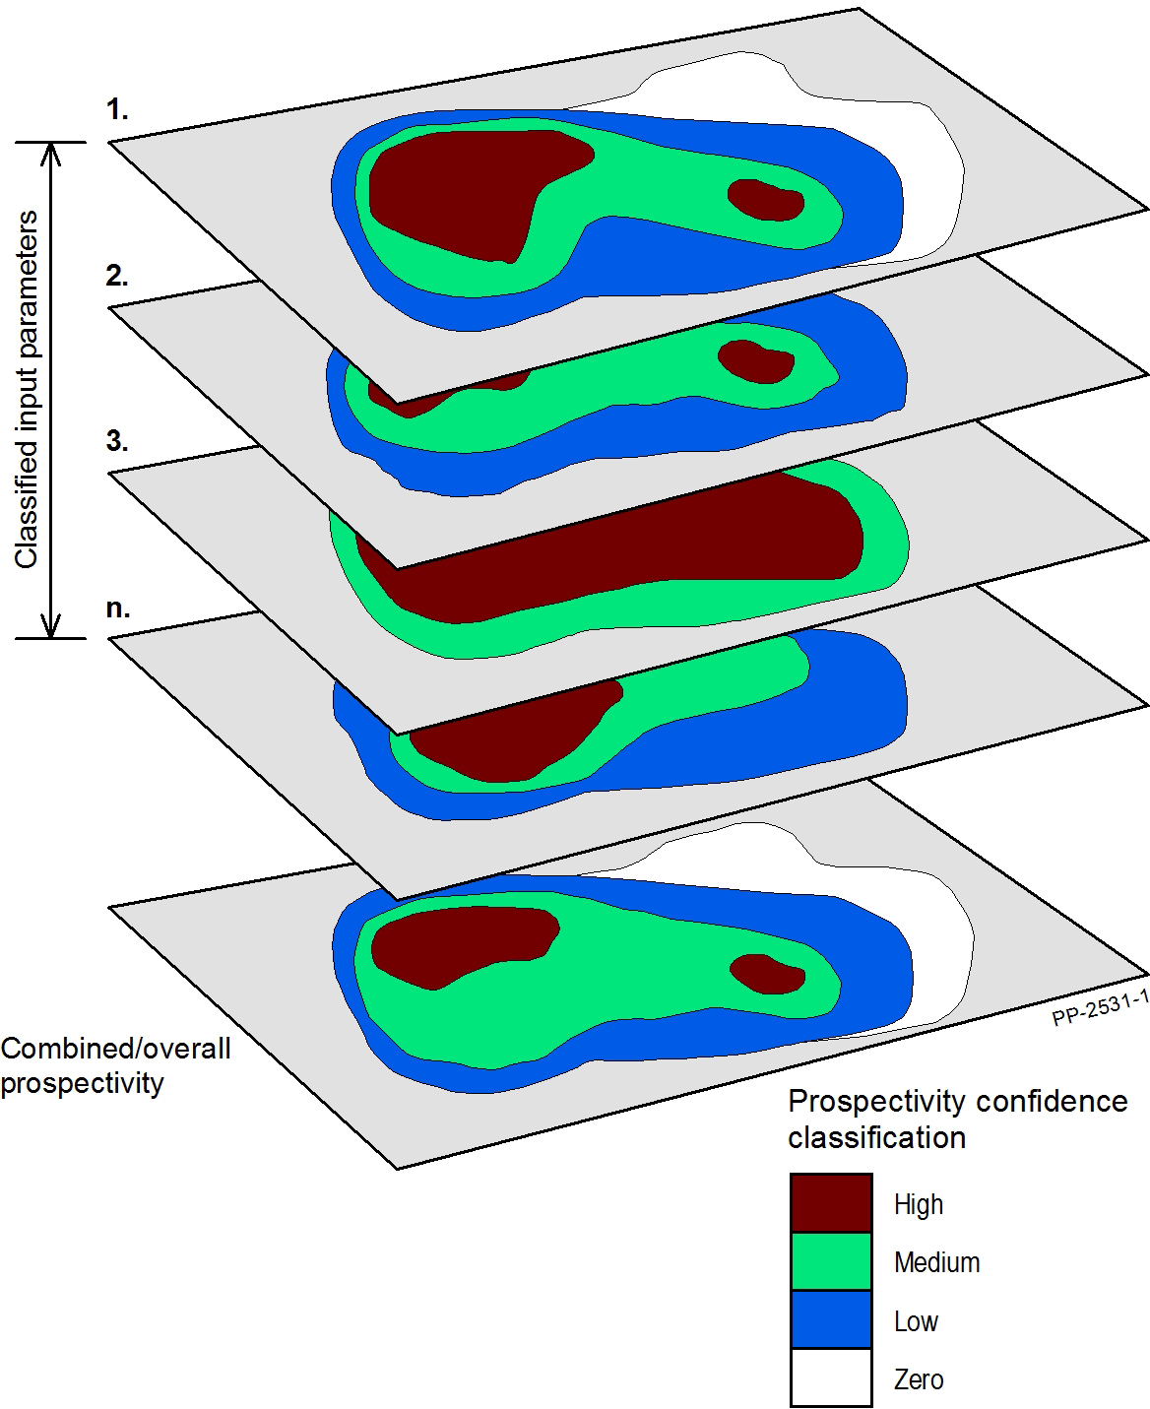
Figure 53 Schematic workflow for combining classified prospectivity confidence input parameter maps to obtain the overall combined relative prospectivity of a formation or play
Element: GBA-BEE-2-199

Results

Velkerri Formation

Amungee Member
Classified individual parameter maps for the Amungee Member shale dry gas play are shown in Figure 54 and the relative prospectivity confidence is shown in Figure 55. The Amungee Member dry gas play is predominantly located in the central part of the eastern sub-basin (Figure 46). The Amungee Member dry gas play extent presented here is very similar to that of the Velkerri dry gas play published by Côté et al. (2018) for the majority of the eastern sub-basin. Minor differences in play extent between this work and Côté et al. (2018) away from the wells, are likely to relate to the variations in seismic interpretation and associated structural surfaces used for each study. A small area around Birdum Creek in the central western sub-basin may also be prospective for dry gas in the Amungee Member.
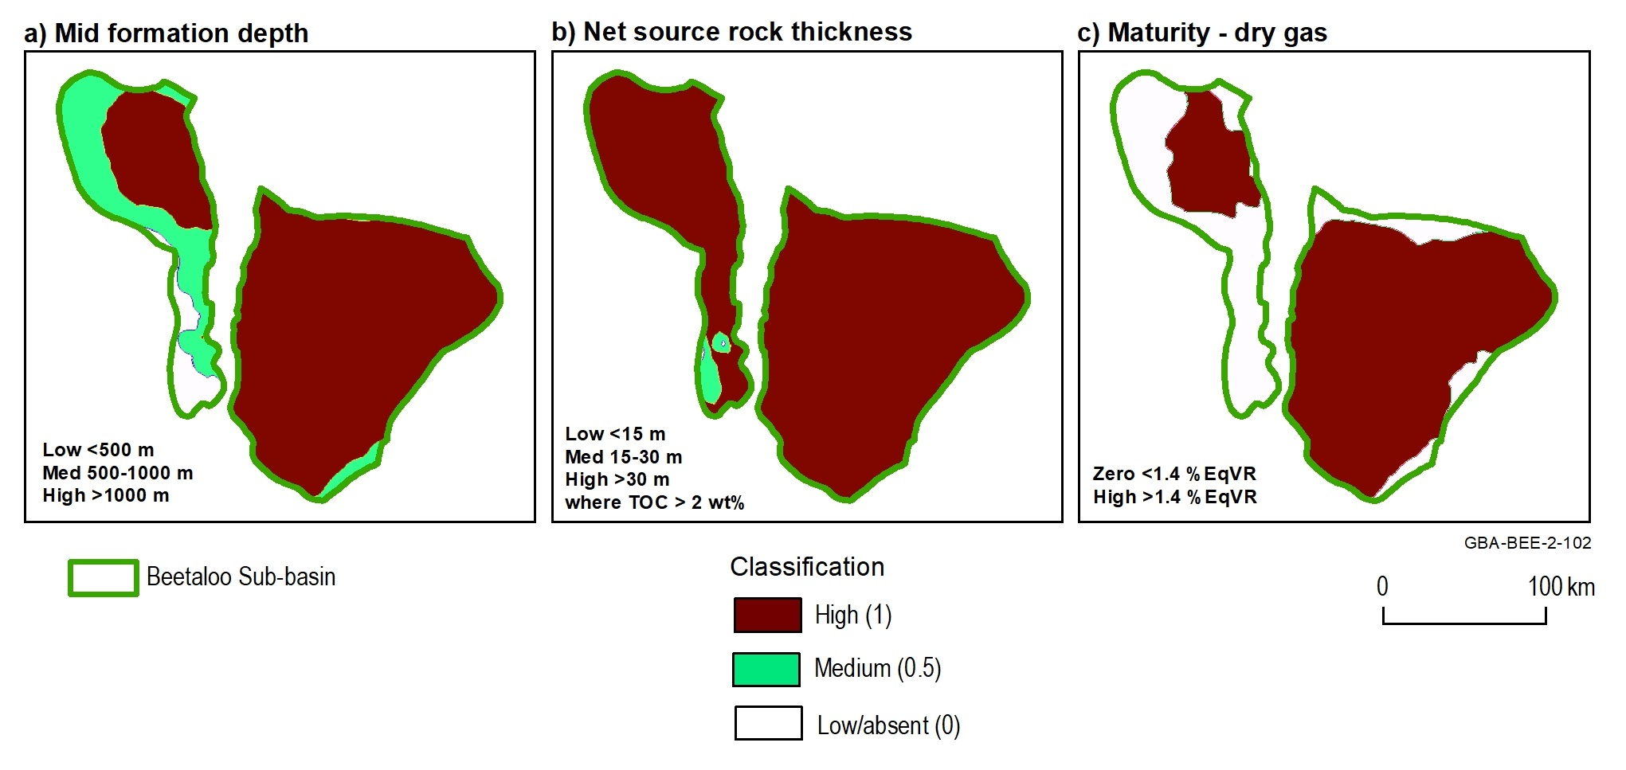
Figure 54 Classified input parameters maps used to generate the Amungee Member shale dry gas play relative prospectivity map
Data: Geological and Bioregional Assessment Program (2019c)
Element: GBA-BEE-2-102
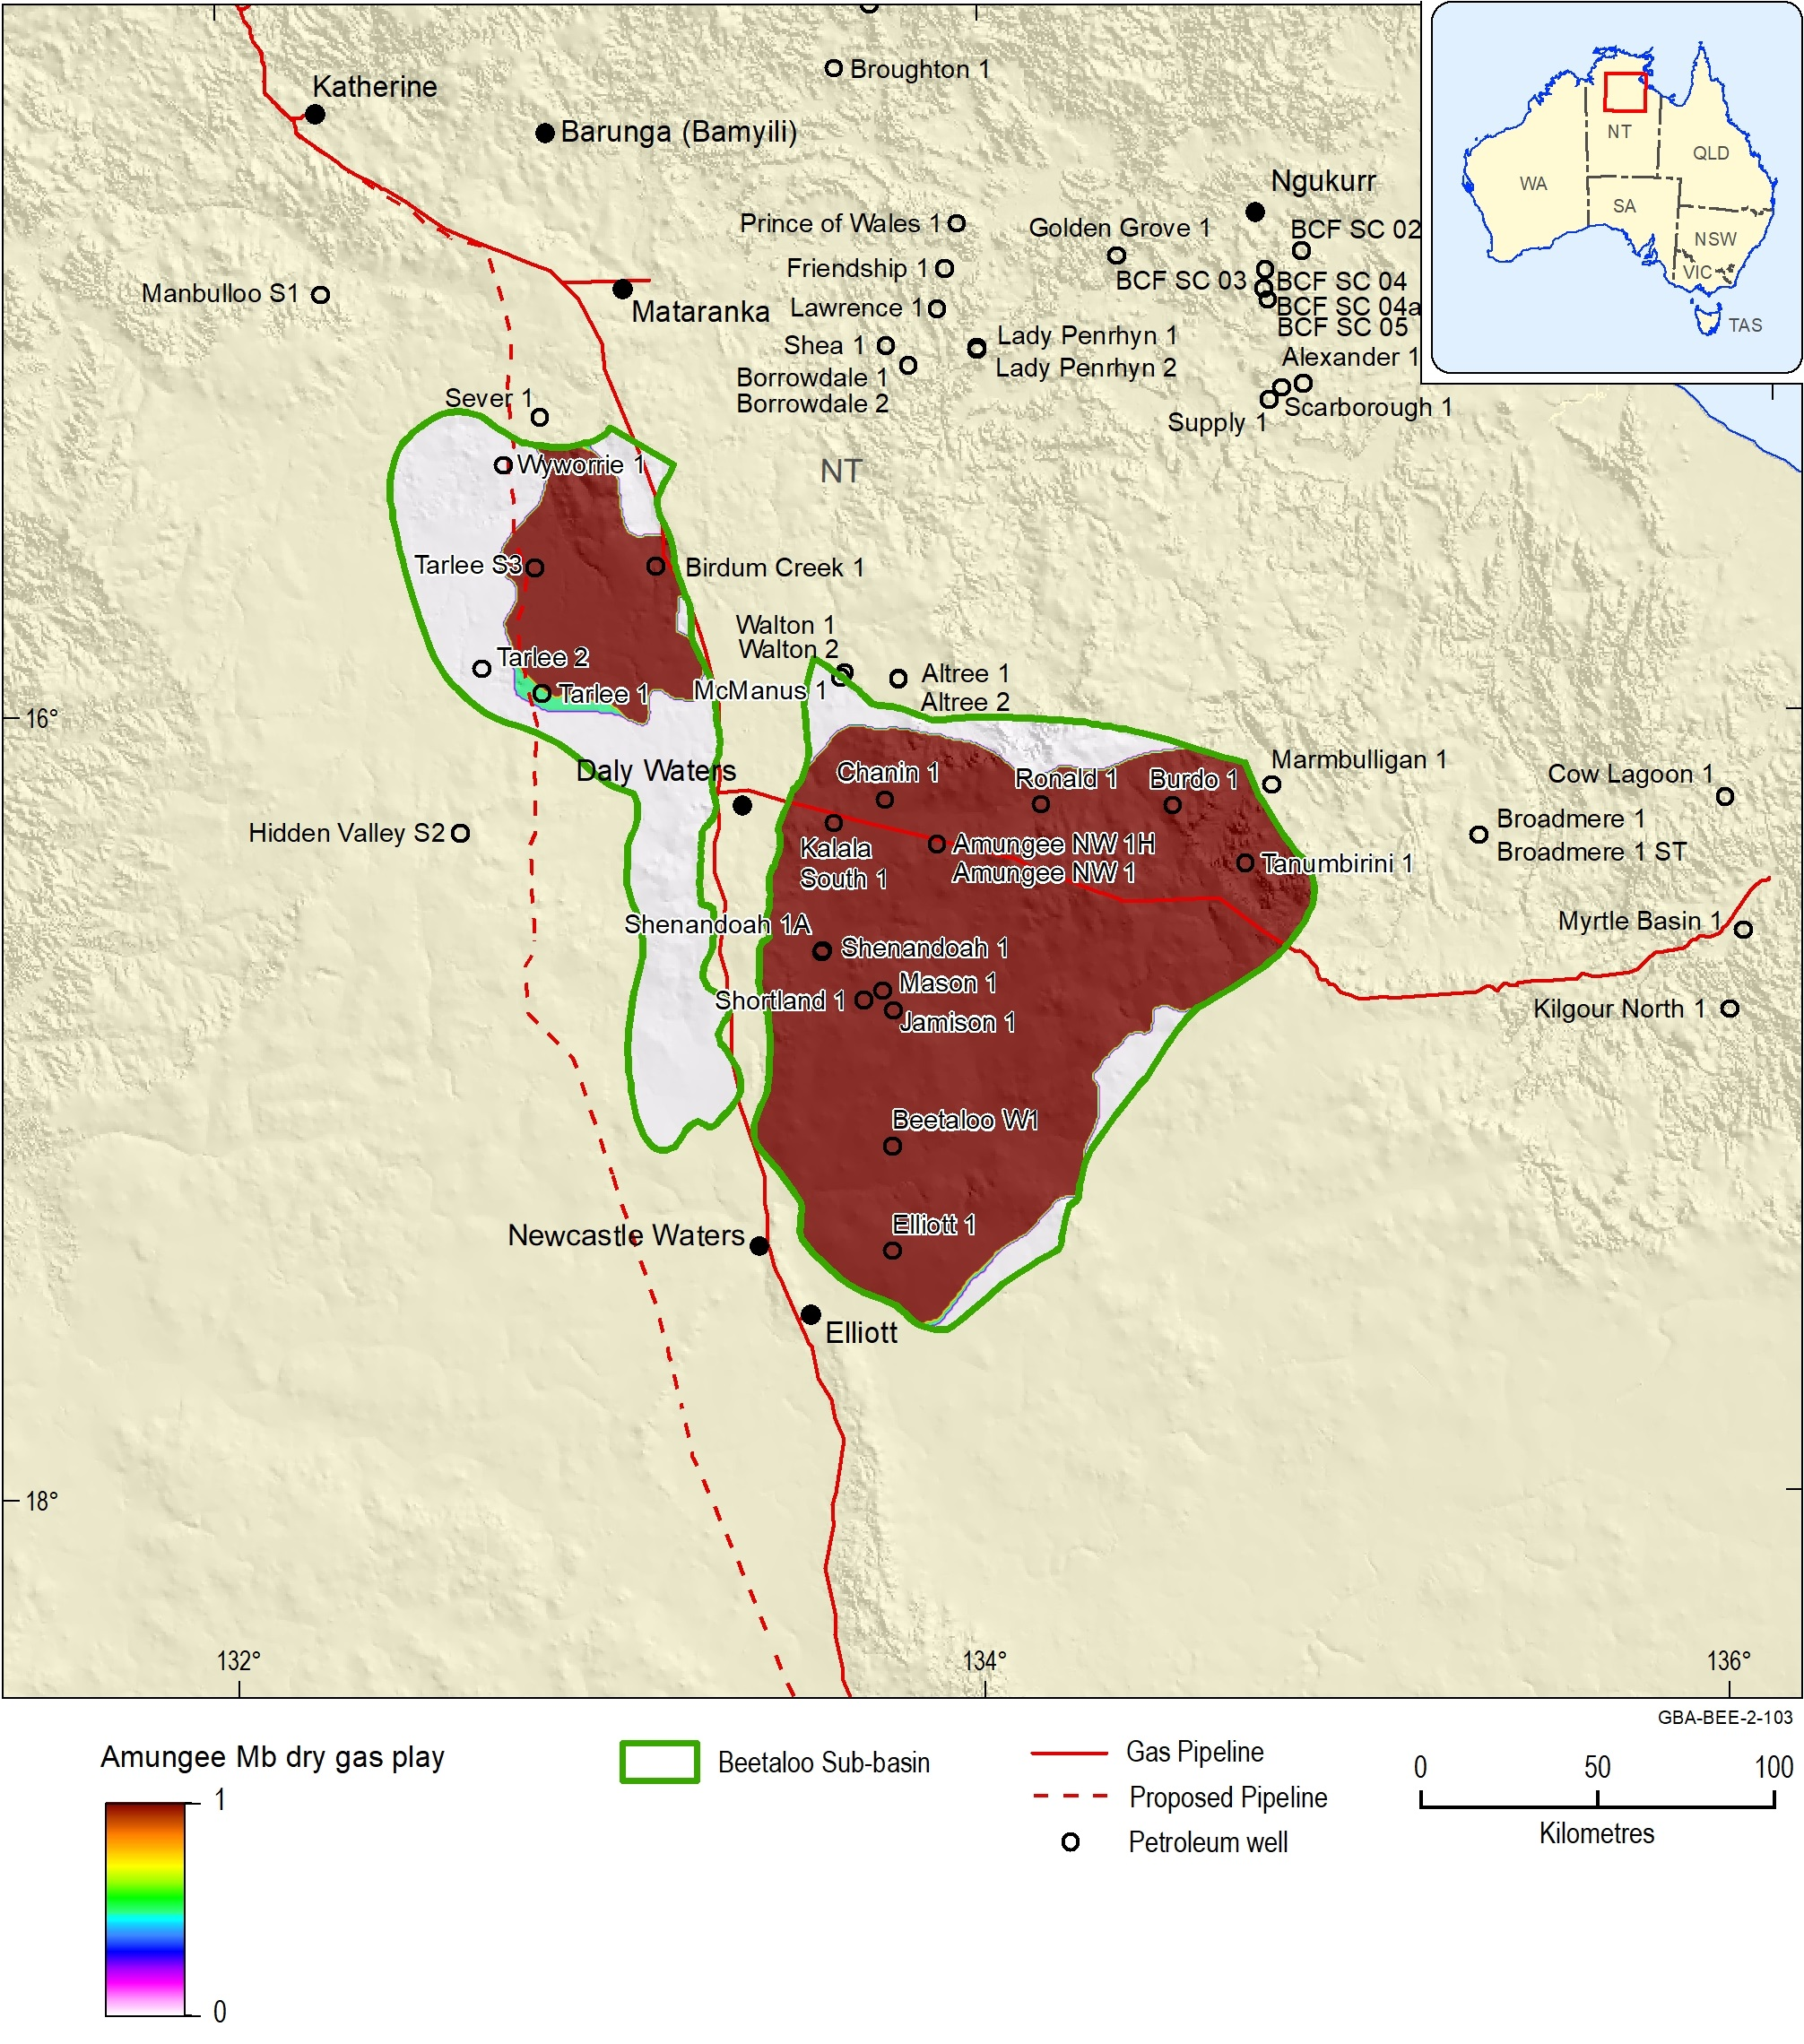
Figure 55 Play fairway map showing the variation in relative prospectivity of the Amungee Member shale dry gas play across the Beetaloo Sub-basin
Data: Geological and Bioregional Assessment Program (2019c)
Element: GBA-BEE-2-103

Classified individual parameter maps for the Amungee Member shale liquids-rich gas play are shown in Figure 56 and the relative prospectivity confidence map is shown in Figure 57. In the eastern Beetaloo Sub-basin, the Amungee Member liquids-rich gas play is located along the northern and south-eastern limits of the sub-basin. Again this follows a similar distribution to the Velkerri liquids-rich gas play of Côté et al. (2018). In the western sub-basin, the liquids-rich play extends across the central part of the depocentre between Tarlee and Birdum Creek 1.
The limiting factor on play extent in the eastern sub-basin is maturity, while net source rock thickness and formation depth restrict play extent in the west.

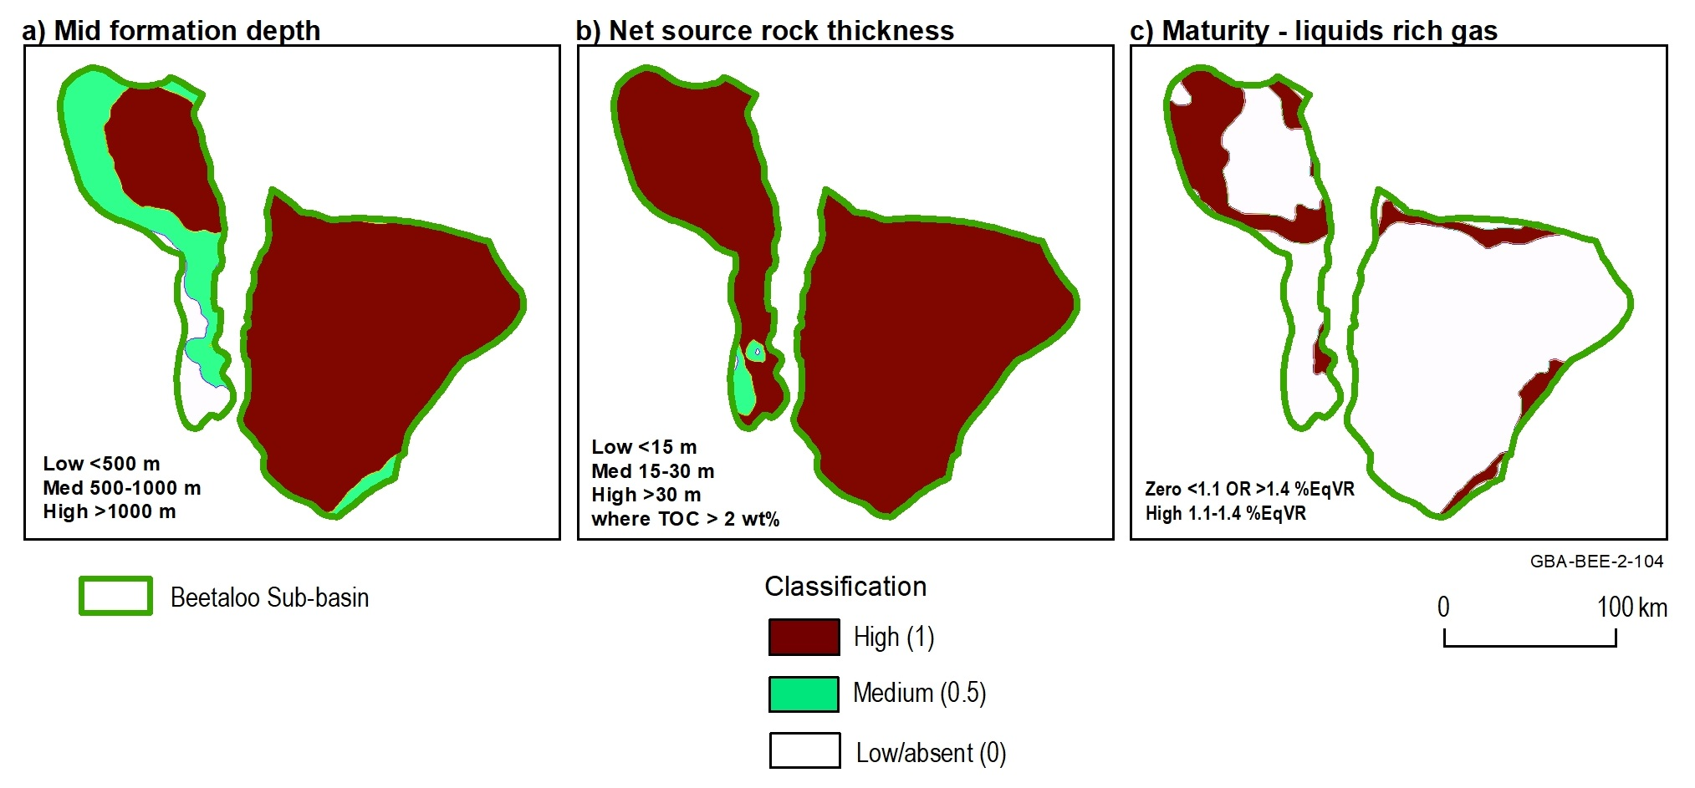
Figure 56 Classified input parameters maps used to generate the Amungee Member shale liquids-rich gas play relative prospectivity map
Data: Geological and Bioregional Assessment Program (2019c)
Element: GBA-BEE-2-104
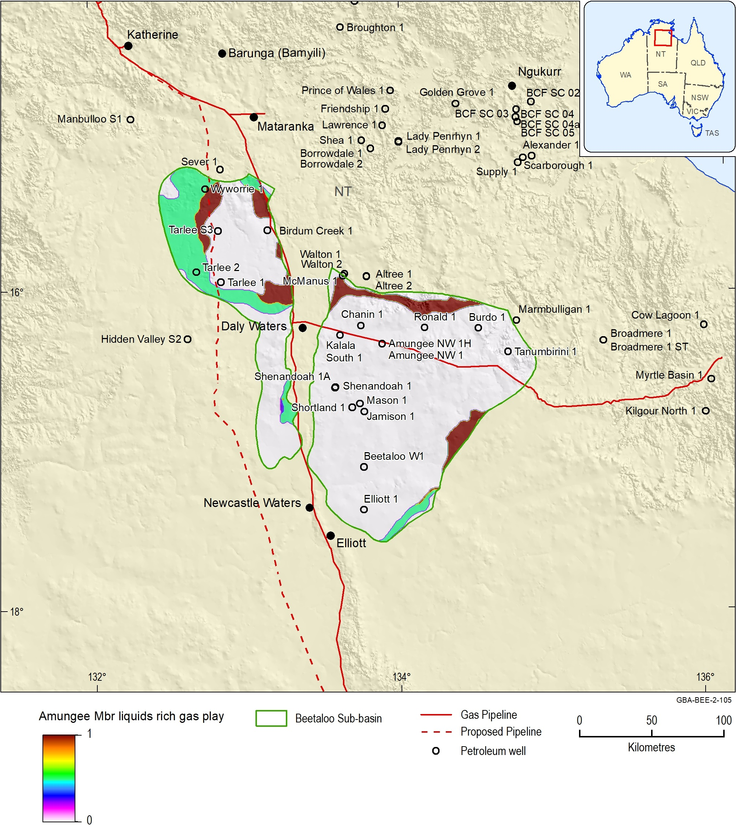
Figure 57 Play fairway map showing the variation in relative prospectivity of the Amungee Member shale liquids-rich gas play across the Beetaloo Sub-basin
Data: Geological and Bioregional Assessment Program (2019c)
Element: GBA-BEE-2-105

Kyalla Formation
Classified individual parameter maps for the Kyalla Formation liquids-rich gas play are shown in Figure 56 and the relative prospectivity confidence map is shown in Figure 57. In the eastern Beetaloo Sub-basin, Kyalla Formation liquids-rich gas play is located in the central part of the sub-basin. Again this follows a similar distribution to the Kyalla Formation liquids-rich gas play of Côté et al. (2018). In the western sub-basin, the liquids-rich play extent is focused around Birdum Creek 1, although the shallow depths result in a lower relative prospectivity in this region.

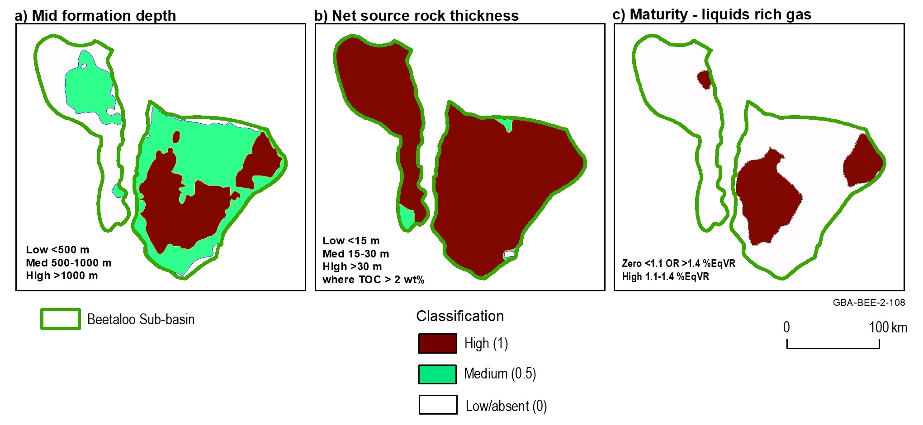
Figure 58 Classified input parameters maps for the Kyalla Formation shale liquids-rich gas play
Data: Geological and Bioregional Assessment Program (2019c)
Element: GBA-BEE-2-108
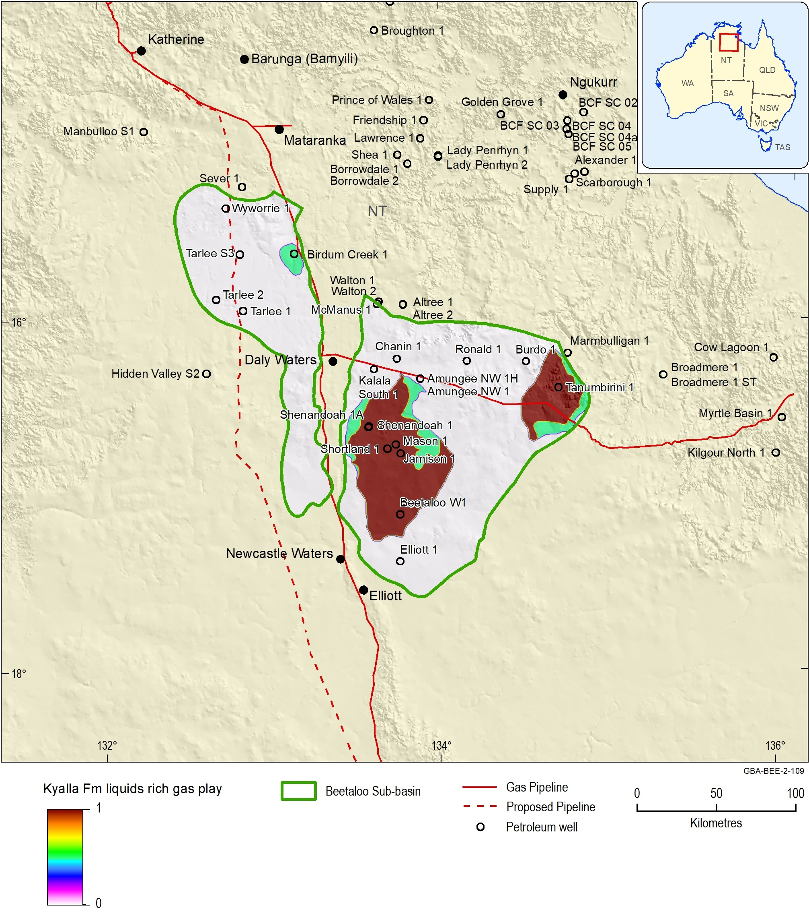
Figure 59 Play fairway map showing the variation in relative prospectivity of the Kyalla Formation shale liquids-rich gas play across the Beetaloo Sub-basin
Data: Geological and Bioregional Assessment Program (2019c)
Element: GBA-BEE-2-109

Hayfield sandstone member
The Hayfield sandstone member liquids play covers a much smaller area than the Kyalla Formation and Amungee Member shale gas plays and is located over the central part of the eastern Beetaloo Sub-basin (Figure 60). This extent is derived from Côté et al. (2018), as there are insufficient public domain data to assess the play distribution.
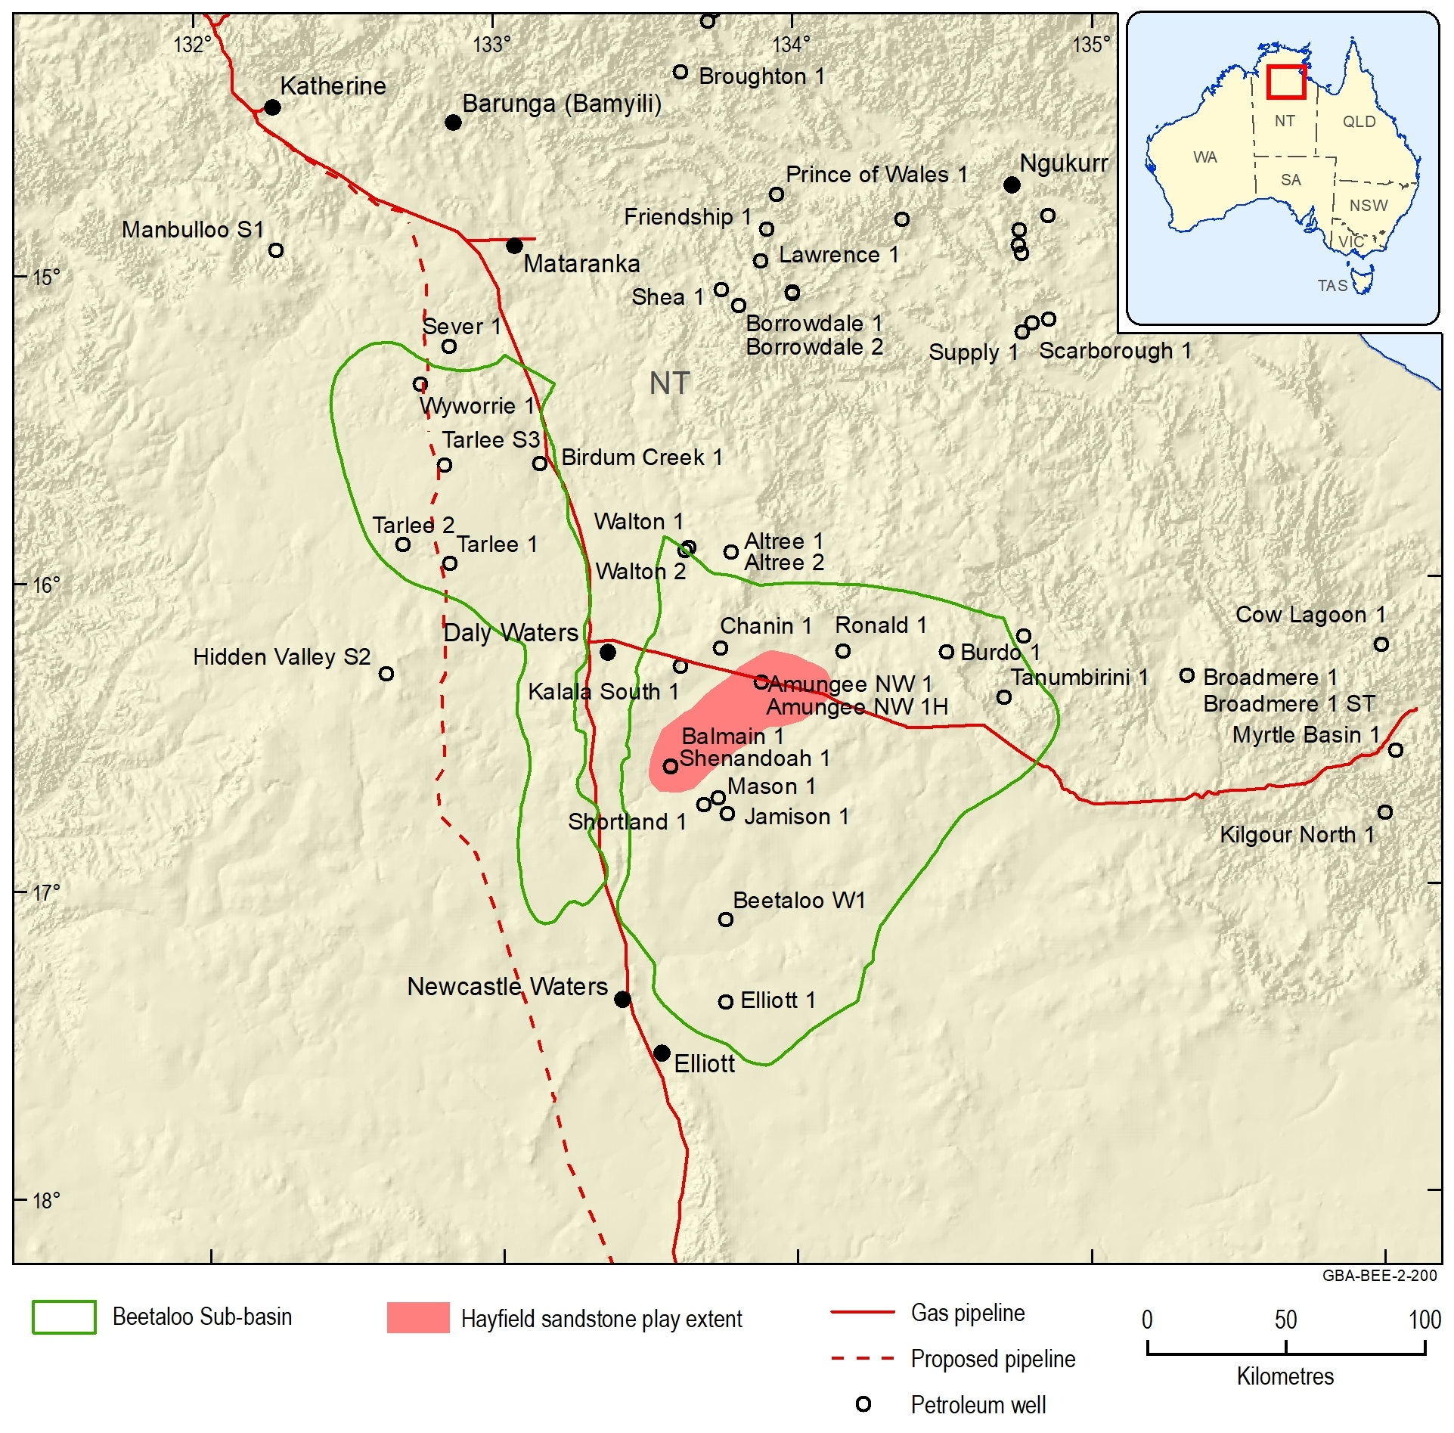
Figure 60 Hayfield sandstone member play extent
Source: Côté et al. (2018)
Element: GBA-BEE-2-200

Conclusions

Key findings
This appendix presents a review of the petroleum prospectivity of the Beetaloo Sub-basin, along with the characterisation and analysis of petroleum plays in the Beetaloo GBA region likely to be targeted for development in a five to ten year time frame. These plays include dry and liquids-rich gas plays within the Velkerri Formation and liquids-rich gas in the Kyalla Formation of the Beetaloo Sub-basin, and liquids-rich gas and oil/condensate in the Hayfield sandstone member in the overlying Neoproterozoic units.
Play fairway analysis has been used to map the relative prospectivity of these play types across the Beetaloo Sub-basin area. Criteria used to map the play fairways are limited to depth, thermal maturity (based on current depth below the surface) and net thickness of organically rich shale.
Key results of the play fairway mapping are as follows:
- The Amungee Member has a high relative prospectivity for dry gas plays across most of the eastern sub-basin, as well as the central part of the western sub-basin.
- The Amungee Member has a high relative prospectivity for liquids-rich gas play along the northern and south-eastern limits of the eastern sub-basin. The area of high relative prospectivity for liquids-rich gas also extends around the shallower regions of the western sub-basin.
- Source rock maturity is the main controlling factor on the Amungee Member play extent in the eastern sub-basin, while net source rock thickness and formation depth restrict play extent in the west.
- The Kyalla Formation has a high relative prospectivity for liquids-rich gas play in the central and western parts of the eastern sub-basin.
- Formation depth and maturity are the main controlling factors on the extent of the Kyalla Formation liquids-rich gas play.
- The Hayfield sandstone liquids play covers a much smaller area than the Kyalla and Amungee shale plays and is located over the central part of the eastern Beetaloo Sub-basin. This is extent is derived from Côté et al. (2018), as there are insufficient public domain data to assess this independently.
- There is also significant oil and condensate potential in the Kyalla Formation, however, successful development of this is dependent on further advancements in enhanced oil recovery technology.
The extents of the petroleum plays defined here inform where those plays are most likely to be located with respect to overlying assets, which in turn aids assessment of potential connectivity to overlying surface water – groundwater systems and associated assets.

Gaps, limitations and opportunities
A number of limitations and assumptions were identified as part of the Beetaloo GBA region petroleum prospectivity assessment. Data and knowledge gaps, along with potential opportunities for further work, are outlined below.
Only a limited number of petroleum exploration wells have been drilled within the Beetaloo Sub-basin and currently published contingent resource estimate is based on extended production testing for only one well. Future application of new well data, including full wireline log suites as well as geochemical, petrophysical and gas content properties will increase confidence in the petroleum prospectivity of the region. In addition, very few wells penetrate the stratigraphy beneath the Roper Group. Additional drilling would be required before the petroleum prospectivity of the older stratigraphy, equivalent in age to the Isa Superbasin, could be assessed.
Fault systems over the assessment area are relatively complex and somewhat poorly understood three-dimensional structures with multiple phases of reactivation and fluid flow. The role of faults in either locally enhancing shale gas prospectivity through generating zones of enhanced fracture permeability or reducing permeability through producing conduits for mineralisation of organic-rich shales is unknown and not incorporated into the assessment. Acquisition of three-dimensional seismic data within the identified play fairways by industry would help to better understand the enhancing or constraining nature of the faults on prospectivity. In addition, three-dimensional seismic imaging of fault systems may help to identify if there are areas where these structures form potential leakage pathways into groundwater aquifers.
The play fairway analysis was undertaken based on the regional-scale geological conceptualisation detailed in the geology technical appendix (Orr et al., 2020). Results identify areas where further data acquisition and geological modelling could be undertaken. However, this regional analysis is not suitable for individual play or prospect-scale evaluations. Due to local geological variations, which may not be captured by the regional-scale input datasets, not all the areas identified as a having a high relative likelihood of play fairway presence will result in oil or gas discoveries. The maps of source rock total organic content and maturity could be improved with a more detailed burial and thermal history modelling study, incorporating spatial variations of uplift and erosion and facies changes.
Only limited regional stress information is available to frame the Beetaloo Sub-basin within the Australian continent. Acquisition of new data appropriate for assessing the regional stress regime would allow for both a more detailed understanding of in-situ stresses within the Beetaloo Sub-basin and as a broader region within the Australian continent. Acquisition of suitable wireline data and laboratory and field tests as suggested above would allow for a formation by formation assessment of stress magnitudes and, hence, increase the quality of fracture growth and propagation models to assist in understanding natural fracture barriers within the subsurface.
Only limited public domain pore pressure data are available. As a significant component in planning the development of hydrocarbon systems, it is essential to understand formation pressures within the potential plays. This is a limiting factor to understanding the prospectivity of shale gas plays in the Beetaloo Sub-basin.
The play fairway maps use simple geological criteria to assess where shale gas intervals are likely to occur. Limitations to the economic viability or accessibility of these resources are not considered. For example, a maximum depth for economic exploration of shale gas resources has not been used in the selection criteria, as this will vary with time depending on exploration and development technology and energy prices.
Due to the large capital expenditure required to extract these resources, if and how a petroleum play is developed is entirely dependent on its economic viability. Therefore, to inform future development scenarios, associated hazards and impacts, it is essential to consider development of each play in the context of likely economic outcomes. While the prospectivity maps presented in this report inform where the plays are most likely to be located with respect to overlying assets, they do not provide any economic context and hence are insufficient to effectively inform future development scenarios alone. To place this work in an economic context, at a minimum the following additional work is required:
- Resource assessments to estimate of total volume of gas-in-place for priority play types, based on the geological understanding of the plays outlined in this report;
- Estimation of the proportion of gas-in-place that is technically recoverable based on and;
- Economic analysis to understand what would be economic to produce, based on market conditions.

References
Abbott ST and Sweet IP (2000) Tectonic control on third-order sequences in a siliciclastic ramp-style basin: An example from the Roper Superbasin (Mesoproterozoic), northern Australia. Australian Journal of Earth Sciences 47(3), 637-657. Doi: 10.1046/j.1440-0952.2000.00795.x.
Abbott ST, Sweet IP, Plumb KA, Young DN, Cutovinos A, Ferenczi PA, Brakel A and Pietsch BA (2001) Roper Region: Urapunga and Roper River Special, Northern Territory (Second Edition). 1:250 000 geological map series explanatory notes, SD 53-10, 11. Northern Territory Geological Survey and Geoscience Australia (National Geoscience Mapping Accord), Darwin.
Allen AA and Allen AR (2005) Basin Analysis: Principles and Applications, 2nd edition. Blackwell Publishing, Malden, MA.
Altmann C, Baruch E, Close D, Mohinudeen FM, Richards B and Côté A (2018) Could the Mesoproterozoic Kyalla Formation emerge as a viable gas condensate source rock reservoir play in the Beetaloo Sub-basin? In: Australasian Exploration Geoscience Conference (AEGC) 2018 Proceedings, Sydney.
Anderson EM (1951) The dynamics of faulting and dyke formation with application to Britain, 2nd edition. Oliver and Boyd, Edinburgh.
Australian Energy Regulator (AER) (2017) State of the energy market, May 2017. Viewed 16 January 2018, https://www.aer.gov.au/publications/state-of-the-energy-market-reports/state-of-the-energy-market-may-2017.
AWT International (2013) Shale gas prospectivity potential. Viewed 16 January 2018, http://acola.org.au/wp/PDF/SAF06Consultants/AWTShale%20Gas%20Prospectivity%20Potential%20Jan2013.pdf.
Bailey A, Tenthorey E and Ayling B (2017) Characterising the present-day stress regime of the Georgina Basin. Australian Journal of Earth Sciences 64(1), 121-136. Doi: 10.1080/08120099.2017.1268206.
Bailey AHE, Wang L, Henson PA and Hall L (2019) Rock properties and in-situ stress state of the Egilabria prospect, Lawn Hill Platform, Queensland. The APPEA Journal 59, 383-393. Doi: 10.1071/AJ18260.
Baruch ET, Altmann CM, Close DI, Mohinudeen FM, Richards BA and Côté A (2018) The Kyalla Formation prospectivity from a mineralogical and sedimentological perspective. In: Annual Geoscience Exploration Seminar (AGES) 2018 Proceedings. Northern Territory Geological Survey, 40-48.
Beardsmore GR and Cull JP (2001) Crustal heat flow: a guide to measurement and modelling. Cambridge University Press, Cambridge; New York.
Bell J and Babcock E (1986) The stress regime of the Western Canadian Basin and implications for hydrocarbon production. Bulletin of Canadian Petroleum Geology 34(3), 364-378.
Bell J (1990) Investigating stress regimes in sedimentary basins using information from oil industry wireline logs and drilling records. Geological Society, London, Special Publications 48(1), 305-325. Doi: 10.1144/GSL.SP.1990.048.01.26
Bell J (1996a) Petro Geoscience 1. In situ stresses in sedimentary rocks (part 1): measurement techniques. Geoscience Canada 23(2), 85-100.
Bell J (1996b) Petro Geoscience 2. In situ stresses in sedimentary rocks (part 2): applications of stress measurements. Geoscience Canada 23(3), 135-153.
Bell J (2006) In-situ stress and coal bed methane potential in Western Canada. Bulletin of Canadian Petroleum Geology 54(3), 197-220.
Betts P, Armit R and Ailleres L (2015) Geophysical and structural interpretation of the greater McArthur Basin. Northern Territory Geological Survey, Digital Information Package DIP 015 (March 2015). Viewed 12 September 2018, https://geoscience.nt.gov.au/gemis/ntgsjspui/handle/1/81754. GBA data repository GUID: 63EF1068-8F4A-4AC6-84D3-512747596069.
Bowers GL (1995) Pore pressure estimation from velocity data: Accounting for overpressure mechanisms besides undercompaction. SPE Drilling & Completion 10(02), 89-95.
Bradshaw MT (1993) Australian petroleum systems. PESA Journal 21, 43-53.
Bradshaw MT, Bradshaw J, Murray A, Needham DJ, Spencer L, Summons R, Wilmont J and Winn S (1994) Petroleum systems in west Australian basins In: Purcell PG and Purcell RR (eds), The sedimentary basins of Western Australia. Proceedings of the PESA Symposium, Perth, Western Australia, 14–17 August 1994. Petroleum Exploration Society of Australia, Perth.
Brooke‐Barnett S, Flottmann T, Paul PK, Busetti S, Hennings P, Reid R and Rosenbaum G (2015) Influence of basement structures on in situ stresses over the Surat Basin, southeast Queensland. Journal of Geophysical Research: Solid Earth 120(7), 4946-4965. Doi: 10.1002/2015JB011964.
Bruna P-O, Dhu T, Owen N, Revie D, Munson TJ and Close D (2015) 3D architecture of the Wilson package throughout the greater McArthur Basin: structural implications for petroleum systems at various investigation scales. In: Annual Geoscience Exploration Seminar (AGES) 2015 Proceedings. Northern Territory Geological Survey, Record 2015-002, 26-30.
Bureau of Meteorology (2019) Average annual & monthly maximum, minimum, & mean temperature. Viewed 28 February 2019, http://www.bom.gov.au/jsp/ncc/climate_averages/temperature/index.jsp.
Burgess LEL (2010) Shenandoah-1A Interim Well Report (Re-entry and deepening of Shenandoah-1). Falcon Oil & Gas Australia Pty Ltd.
Carr L, Korsch R, Palu T and Reese B (2016) Onshore Basin Inventory: the McArthur, South Nicholson, Georgina, Wiso, Amadeus, Warburton, Cooper and Galilee basins, central Australia. Geoscience Australia (GA) Record 2016/04. Canberra.
Carvajal-Ortiz H and Gentzis T (2015) Critical considerations when assessing hydrocarbon plays using Rock-Eval pyrolysis and organic petrology data: Data quality revisited. International Journal of Coal Geology(0). Doi: 10.1016/j.coal.2015.06.001.
Chan A, Hauser M, Couzens-Schultz B and Gray G (2014) The role of shear failure on stress characterization. Rock mechanics and rock engineering 47(5), 1641-1646.
Charpentier RR and Cook TA (2011) USGS methodology for assessing continuous petroleum resources. U.S. Geological Survey Open-File Report 2011–1167, 75.
Close D, Baruch ET, Altmann CM, Côté AJ, Mohinudeen FM, Richards B and Stonier S (2016) Unconventional gas potential in Proterozoic source rocks: Exploring the Beetaloo Sub-basin. In: Annual Geoscience Exploration Seminar (AGES) 2016 Proceedings. Northern Territory Geological Survey, 91-94.
Close D, Côté AJ, Baruch ET, Altmann CM, Mohinudeen FM, Richards B and Ilett R (2017a) Proterozoic shale gas plays in the Beetaloo Basin and the Amungee NW-1H discovery. In: Annual Geoscience Exploration Seminar (AGES) 2017 Proceedings. Northern Territory Geological Survey, 91-97.
Close D, Côté A, Baruch E, Altmann C, Mohinudeen F, Richards B, Ilett R, Evans R and Stonier S (2017b) Exploring the Beetaloo: will Australia’s first viable shale play be sourced by billion year old gas? The APPEA Journal 57(2), 716-721.
Close DF (2014) The McArthur Basin: NTGS' approach to a frontier petroleum basin with known base metal prospectivity. In: Annual Geoscience Exploration Seminar (AGES) 2014 Proceedings. Northern Territory Geological Survey, Record 2014-001, 85-89.
Connors K and Krassay A (2015) Understanding unconventional petroleum resources of the greater McArthur Basin from potential field, well and seismic data. In: Annual Geoscience Exploration Seminar (AGES) 2015 Proceedings. Northern Territory Geological Survey, Record 2015-002, 31-33.
Cook P, Beck V, Brereton D, Clark R, Fisher B, Kentish S, Toomey J and Williams J (2013) Engineering energy: unconventional gas production - a study of shale gas in Australia, final report. Australian Council of Learned Academies (ACOLA), Melbourne, Victoria. Viewed 13 September 2017, https://acola.org.au/wp/PDF/SAF06FINAL/Final%20Report%20Engineering%20Energy%20June%202013.pdf.
Côté A, Richards B, Altmann C, Baruch E and Close D (2018) Australia's premier shale basin: five plays, 1 000 000 000 years in the making. APPEA Journal 58(2), 799-804. Doi: 10.1071/AJ17040.
Couzens-Schultz BA and Chan AW (2010) Stress determination in active thrust belts: An alternative leak-off pressure interpretation. Journal of Structural Geology 32(8), 1061-1069.
Creaser RA and Kendall B (2007) Re-Os geochronology of organic-rich shales; placing absolute time pins in ancient sedimentary basins. In: American Geophysical Union, Fall Meeting, 2007 Proceedings. Viewed 18 December 2018, http://adsabs.harvard.edu/abs/2007AGUFM.V31G..01C.
Crick IH, Boreham CJ, Cook AC and Powell TG (1998) Petroleum geology and geochemistry of Middle Proterozoic McArthur Basin, Northern Territory II: Assessment of source rock potential. American Association of Petroleum Geologists Bulletin 72(12), 1495–1514.
Dembicki HJ (2009) Three common source rock evaluation errors made by geologists during prospect or play appraisals. AAPG Bulletin 93, 341-356.
Department of Primary Industry and Resources (NT) (2017a) Submission 479 to the Scientific Inquiry into Hydraulic Fracturing in the Northern Territory. Northern Territory Government. Viewed 11 January 2019, https://frackinginquiry.nt.gov.au/?a=464723.
Department of Primary Industry and Resources (NT) (2017b) STRIKE tenure and geoscience information - Concealed Geological Boundaries. Viewed 23 April 2018, http://www.ntlis.nt.gov.au/metadata/export_data?type=xml&metadata_id=5EFEB9B61E918EA1E050CD9B2144457E. GBA data repository GUID: 8DF22E22-0284-4288-9F1A-60683048F1E8.
Department of Primary Industry and Resources (NT) (2018a) Northern Territory Statewide Wells and Drillholes. Viewed 15 October 2018, https://dpir.nt.gov.au/mining-and-energy/STRIKE/accessing-nt-datasets/nt-wide-geoscience-datasets. GBA data repository GUID: 89932245-A9F0-41D5-BBFE-889EE85F970D.
Department of Primary Industry and Resources (NT) (2018b) Northern Territory Statewide Geophysics - Seismic Lines. Viewed 06 September 2018, https://dpir.nt.gov.au/mining-and-energy/STRIKE/accessing-nt-datasets/nt-wide-geoscience-datasets. GBA data repository GUID: E5D39C55-CA33-4972-BBFA-C3F54B43933D.
Donnelly TH and Crick IH (1988) Depositional environment of the Middle Proterozoic Velkerri Formation in northern Australia: geochemical evidence. Precambrian Research 42, 165-172.
Duddy IR, Green PF, Gibson HJ and Hegarty KA (2003) Regional palaeo-thermal episodes in northern Australia. Proceedings of the Timor Sea Symposium 2003. In: Ellis GK, Baillie PW and Munson TJ (eds), Timor Sea Petroleum Geoscience. Northern Territory Geological Survey, Special Publication 1, 567–591.
Dutkiewicz A, Volk H, Ridley J and George SC (2007) Precambrian inclusion oils in the Roper Group: A review. In: Munson TJ and Ambrose GJ (eds), Proceedings of the Central Australian Basins Symposium (CABS) 2005, Northern Territory Geological Survey, Special Publication 2, 326–334.
EIA (2013) Technically recoverable shale oil and shale gas resources: An assessment of 137 shale formations in 41 countries outside the United States. United States Energy Information Administration. Viewed 23 January 2018, https://www.eia.gov/analysis/studies/worldshalegas/pdf/overview.pdf.
Empire Energy (2018) Unlocking Australia's Energy Future. Viewed 24 April 2019, http://empireenergygroup.net/wp-content/uploads/18.09.05-SEAAOC-Conference-September-2018.pdf.
Evans TJ, Radke BM, Martinez J, Buchanan S, Cook SB, Raiber M, Ransley TR, Lai ECS, Skeers N, Woods M, Evenden C, Cassel R and Dunn B (2020) Hydrogeology of the Beetaloo GBA region. Technical appendix for the Geological and Bioregional Assessment: Stage 2. Department of the Environment and Energy, Bureau of Meteorology, CSIRO and Geoscience Australia, Australia.
Faiz M, Altmann C, Dunne M, Baruch E, Close D, Côté A, Richards B and Ranasinghe P (2016) Precambrian Organic Matter and Thermal Maturity of the Beetaloo Basin, Northern Territory, Australia. In: Australian Earth Sciences Convention (AESC) 2016 Abstracts, 133.
Faiz MF, Zoitsas A, Altmann C, Baruch E and Close D (2018) Compositional variations and carbon isotope reversal in coal and shale gas reservoirs of the Bowen and Beetaloo basins, Australia. In: Dowey P, Osborne M and Volk H (eds), Application of Analytical Techniques to Petroleum Systems. Geological Society, London, Special Publications 484. Doi: 10.1144/SP484.3.
Falcon Oil and Gas (2012) Well completion report: Shenandoah-1A, EP38, Beetaloo Basin, NT, Australia.
Falcon Oil and Gas (2017) Declaration of Material Gas Resource. Viewed 24 April 2019, https://falconoilandgas.com/declaration-of-material-gas-resource/.
Falcon Oil and Gas (2019) Beetaloo Sub-basin, Australia. Viewed 15 July 2019, https://falconoilandgas.com/beetaloo-australia/.
Fall A, Eichhubl P, Cumella SP, Bodnar RJ, Laubach SE and Becker SP (2002) Testing the basin-centered gas accumulation model using fluid inclusion observations: Southern Piceance Basin, Colorado. AAPG Bulletin 96(12), 2297–2318.
Fisher MK and Warpinski NR (2012) Hydraulic-fracture-height growth: Real data. SPE Production & Operations 27(01), 8-19.
Flewelling SA, Tymchak MP and Warpinski N (2013) Hydraulic fracture height limits and fault interactions in tight oil and gas formations. Geophysical Research Letters 40(14), 3602-3606.
Frogtech Geoscience (2018) SEEBASE® study and GIS for greater McArthur Basin. Northern Territory Geological Survey, Digital Information Package DIP 017 (ESRI file format, March 2018). Viewed 25 May 2018, https://geoscience.nt.gov.au/gemis/ntgsjspui/handle/1/87064. GBA data repository GUID: 563A5349-DC7F-42B8-B6CC-892B3B4C3C3F.
Geological and Bioregional Assessment Program (2019a) Maturity maps for the Kyalla Formation and Amungee Member, Beetaloo Sub-basin. Viewed 02 July 2019, https://repo.bioregionalassessments.gov.au/metadata/1C4BC069-2208-4A15-92AA-33109FC79346. GBA data repository GUID: 1C4BC069-2208-4A15-92AA-33109FC79346.
Geological and Bioregional Assessment Program (2019b) Regional Three-Dimensional Geological Model for the Beetaloo Sub-basin. Viewed 21 June 2019, https://repo.bioregionalassessments.gov.au/metadata/9F604AFA-40E4-4E5A-91DD-0A695A3465A8. GBA data repository GUID: 9F604AFA-40E4-4E5A-91DD-0A695A3465A8.
Geological and Bioregional Assessment Program (2019c) Shale gas prospectivity maps for the Kyalla Formation and Amungee Member of the Velkerri Formation, Beetaloo Sub-basin. Viewed 08 October 2019, https://repo.bioregionalassessments.gov.au/metadata/F469F595-51BA-4459-AC4C-08A7F5A6AB02. GBA data repository GUID: F469F595-51BA-4459-AC4C-08A7F5A6AB02.
Geoscience Australia and BREE (2014) Australian Energy Resource Assessment. 2nd Ed. Geoscience Australia, Canberra.
Geoscience Australia (2017) National Oil and Gas Infrastructure WMS. Viewed 05 November 2018, http://pid.geoscience.gov.au/dataset/ga/89930. GBA data repository GUID: 0A207978-0A06-4105-B881-2A215AB43734.
Geoscience Australia (2018) Australian Energy Resources Assessment (AERA) interim report. Geoscience Australia. Viewed 16 January 2018, https://aera.ga.gov.au/.
Gorter J and Grey K (2012) Velkerri Formation Depositional Model - Beetaloo Sub-basin, Northern Territory, Australia: Biostratigraphy and Organic Enrichment. In: Central Australian Basins Symposium (CABS) III Proceedings. Petroleum Exploration Society of Australia.
Gorter JD and Grey K (2013) Middle Proterozoic biostratigraphy and log correlations of the Kyalla and Chambers River Formations Beetaloo Sub-basin, Northern Territory, Australia. West Australian Basins Symposium (WABS) 4 Poster. Petroleum Exploration Society of Australia.
Grauls D and Baleix J (1994) Role of overpressures and in situ stresses in fault-controlled hydrocarbon migration: A case study. Marine and Petroleum Geology 11(6), 734-742.
Grey K (2015) Mesoproterozoic biostratigraphic correlation in the Beetaloo Sub-basin, Northern Territory, Australia, and potential for correlation with other northern Australian basins. In: Annual Geoscience Exploration Seminar (AGES) 2015 Proceedings. Northern Territory Geological Survey, Record 2015-002, 33-41.
Hall L, Buchanan S, Totterdell J, Lai E, Langford R, Sundaram B, Ransley T, Glenn K, Heugh A, Inskeep C, Zhu R, Lech M, Skeers N and Stewart G (2018) Rapid regional prioritisation for tight and shale gas potential of eastern and northern Australian basins. Geological and Bioregional Assessments Program: Stage 1. Prepared by Geoscience Australia for the Department of the Environment and Energy. Australia. Viewed 06 August 2018, https://www.bioregionalassessments.gov.au/assessments/geological-and-bioregional-assessment-program/rapid-regional-prioritisation/rapid-regional-prioritisation-report.
Hantschel T and Kauerauf AI (2009) Fundamentals of basin and petroleum systems modelling. Springer, Berlin; London.
Heidbach O and Höhne J (2008) CASMI—a visualization tool for the World Stress Map database. Computers & Geosciences 34(7), 783-791.
Hillis RR, Sandiford M, Reynolds SD and Quigley MC (2008) Present-day stresses, seismicity and Neogene-to-Recent tectonics of Australia's ‘passive’margins: intraplate deformation controlled by plate boundary forces. Geological Society, London, Special Publications 306(1), 71-90.
Hoffman TW (2014) New insights into the expanse of the McArthur Superbasin. In: Annual Geoscience Exploration Seminar (AGES) 2014 Proceedings. Northern Territory Geological Survey, Record 2014-001, 91-93.
Hoffman TW (2015) Recent drilling results provide new insights into the western Palaeoproterozoic to Mesoproterozoic McArthur Basin. In: Annual Geoscience Exploration Seminar (AGES) 2015 Proceedings. Northern Territory Geological Survey, Record 2015-002, 50-55.
Hoffman TW (2016) Roper Basin burial history modelling: Inferences for the timing of hydrocarbon generation. In: Annual Geoscience Exploration Seminar (AGES) 2016 Proceedings. Northern Territory Geological Survey, 100-110.
Holgate FL and Gerner EJ (2010) OZTemp Well Temperature Data. Viewed 18 February 2019, http://pid.geoscience.gov.au/dataset/ga/70604. GBA data repository GUID: 65CF9145-483A-45E5-9349-CC66647731F1.
Jackson MJ, Powell TG, Summons RE and Sweet IP (1986) Hydrocarbon shows and petroleum source rocks in sediments as old as 1.7 x 109 years. Nature 322, 727-729.
Jackson MJ, Muir MD and Plumb KA (1987) Geology of the southern McArthur Basin, Northern Territory. Bureau of Mineral Resources (BMR) Bulletin 220. Canberra. Viewed 03 December 2018, http://pid.geoscience.gov.au/dataset/ga/18.
Jackson MJ, Sweet IP and Powell TG (1988) Studies on petroleum geology and geochemistry, Middle Proterozoic McArthur Basin, northern Australia I: Petroleum potential. APEA Journal 28, 282-302.
Jackson MJ and Raiswell R (1991) Sedimentology and carbon-sulphur geochemistry of the Velkerri Formation, a mid-Proterozoic potential oil source in northern Australia. Precambrian Research 54, 81-108. Doi: 10.1016/0301-9268(91)90070-Q.
Jacob H (1989) Classification, structure, genesis and practical importance of natural solid oil bitumen (“migrabitumen”). International Journal of Coal Geology 11(1), 65-79. Doi: 10.1016/0166-5162(89)90113-4.
Jarrett AJM, Cox GM, Southby C, Hong Z, Palatty P, Carr L and Henson P (2018) Source rock geochemistry of the McArthur Basin, northern Australia: Rock-Eval pyrolysis data release. Geoscience Australia Record 2018/024. Geoscience Australia Canberra. Viewed 20 February 2019, http://pid.geoscience.gov.au/dataset/ga/121137.
Jarrett AJM, MacFarlane S, Palu TJ, Boreham CJ, Hall LS, Edwards DS, Cox G, Brocks J, Munson TJ, Carr L and Henson P (2019) Source rock geochemistry and petroleum systems of the greater McArthur Basin and links to other northern Australian Proterozoic basins. In: Annual Geoscience Exploration Seminar (AGES) 2019 Proceedings. Northern Territory Geological Survey
Jarvie DM, Hill R, J. and Ruble TE (2007) Unconventional shale-gas systems: The Mississipian Barnett Shale of north-central Texas as one model for thermogenic shale-gas assessment. AAPG Bulletin 91, 475-499.
Jarvie DM (2012) Shale resource systems for oil and gas: Part 1 - Shale-gas resource systems. In: Breyer JA (ed), Shale reservoirs - giant resources for the 21st century, 69-87.
Jemena (2017) Northern gas pipeline. Viewed 8 October 2019, http://jemena.com.au/industry/pipelines/northern-gas-pipeline.
Johns DR, Schoemaker B, Menpes S and Johnson HD (2017) Depositional setting and stratigraphic architecture of the Roper Group (McArthur Basin): insights from a sedimentological analysis of core and well data. In: Annual Geoscience Exploration Seminar (AGES) 2017 Proceedings. Northern Territory Geological Survey, Darwin, 98-99.
Johnson RL and Titus L (2014) Observations and Recommendations From a Hydraulic Fracturing Case in the Pre-Cambrian Lawn Hill Shale, Isa Superbasin, Australia. SPE Asia Pacific Oil & Gas Conference and Exhibition. Society of Petroleum Engineers.
Kendall B, Creaser RA, Gordon GW and Anbar AD (2009) Re–Os and Mo isotope systematics of black shales from the Middle Proterozoic Velkerri and Wollogorang Formations, McArthur Basin, northern Australia. Geochimica et Cosmochimica Acta 73(9), 2534-2558. Doi: 10.1016/j.gca.2009.02.013.
King RC, Neubauer M, Hillis RR and Reynolds SD (2010) Variation of vertical stress in the Carnarvon Basin, NW Shelf, Australia. Tectonophysics 482(1-4), 73-81.
Knutson J, Ferguson J, Roberts WB, Donnelly TH and Lambert L (1979) Petrogenesis of the copper-bearing breccia pipes, Redbank, NT, Australia. Economic Geology 74, 814-216.
Lanigan K, Hibbird S, Menpes S and Torkington J (1994) Petroleum Exploration in the Proterozoic Beetaloo Sub-basin, Northern Territory. APEA Journal 34(1), 674-691.
Laubach SE, Olson JE and Gross MR (2009) Mechanical and fracture stratigraphy. AAPG Bulletin 93(11), 1413-1426.
Laurie JR (2012) Pre-Ordovician Source Rocks In Australia: A Compilation. In: Ambrose GJ and Scott J (eds), Central Australian Basins Symposium (CABS) III. Petroleum Exploration Society of Australia.
Law B, Ahlbrandt T and Hoyer D (2010) Source and reservoir rock attributes of Mesoproterozoic shale, Beetaloo Basin, Northern Territory, Australia (Search and Discovery article #110130). Viewed 14 January 2019, http://www.searchanddiscovery.com/documents/2010/110130law/ndx_law.pdf
Law BE and Spencer CW (1993) Gas in Tight Reservoirs-An Emerging Major Source of Energy. In: Howell DG (ed), The Future of Energy Gasses. US Geological Survey, Denver, 233-252.
Law BE and Curtis JB (2002) Introduction to unconventional petroleum systems. AAPG Bulletin 86, 1851-1852.
Lund Snee JE and Zoback MD (2016) State of stress in Texas: Implications for induced seismicity. Geophysical Research Letters 43(19).
Mildren S, Clarke R, Holford S and Titus L (2013) Characterisation of fracture permeability at Cow Lagoon-1, McArthur Basin, Northern Territory, Australia and recommendations for development of the Greater Cow Lagoon Structure. SPE Unconventional Resources Conference and Exhibition, Asia Pacific Society of Petroleum Engineers.
Muir MD (1980) Palaeontological evidence for the Early Cambrian age of the Bukalara Sandstone, McArthur Basin, NT. BMR Journal of Australian Geology & Geophysics 5, 159-160.
Munson TJ (2014) Petroleum geology and potential of the onshore Northern Territory, 2014. Northern Territory Geological Survey (NTGS) Report 22. Darwin. Viewed 31 August 2018, https://geoscience.nt.gov.au/gemis/ntgsjspui/handle/1/81558.
Munson TJ (2016) Sedimentary characterisation of the Wilton package, greater McArthur Basin, Northern Territory. Northern Territory Geological Survey (NTGS) Record 2016-003. Darwin. Viewed 21 September 2018, https://geoscience.nt.gov.au/gemis/ntgsjspui/handle/1/83806.
Munson TJ and Revie D (2018) Stratigraphic subdivision of the Velkerri Formation, Roper Group, McArthur Basin, Northern Territory. Northern Territory Geological Survey (NTGS) Record 2018-006. Darwin. Viewed 28 November 2018, https://geoscience.nt.gov.au/gemis/ntgsjspui/handle/1/87322.
Munson TJ, Thompson JM, Zhukova I, Meffre S, Beyer EE and Woodhead JD (2018) Summary of results. NTGS laser ablation ICP–MS U–Pb and Lu–Hf geochronology project: Roper Group (McArthur Basin), overlying ungrouped units (Beetaloo Sub-basin), Renner Group (Tomkinson Province), and Tijunna Group (Birrindudu Basin). Northern Territory Geological Survey (NTGS) Record 2018-007. Darwin. Viewed 28 November 2018, https://geoscience.nt.gov.au/gemis/ntgsjspui/handle/1/87656.
Nelson P (2009) Pore-throat sizes in sandstones, tight sandstones and shales. AAPG Bulletin 93(3), 329-340.
Northern Territory Government (2018a) Fracking moratorium lifted - strict laws to be in place before exploration or production can occur. Viewed 24 January 2019, http://newsroom.nt.gov.au/mediaRelease/25488.
Northern Territory Government (2018b) Geoscience Exploration and Mining Information System (GEMIS) - Petroleum Wells (PEX Wells). Viewed 16 November 2018, https://geoscience.nt.gov.au/gemis/ntgsjspui/handle/1/79187.
Olsen TN, Bratton TR, Tanner KV and Koepsell R (2007) Application of indirect fracturing for efficient stimulation of coalbed methane. In: Rocky Mountain Oil & Gas Technology Symposium. Society of Petroleum EngineersDoi: 10.2118/107985-MS.
Origin Energy (2015a) Kalala S-1 Basic Well Completion Report. Origin Energy Resources Ltd.
Origin Energy (2015b) Amungee NW-1H Basic Well Completion Report. Origin Energy Resources Ltd.
Origin Energy (2016a) Beetaloo W-1 Basic Well Completion Report. Origin Energy Resources Ltd.
Origin Energy (2016b) Beetaloo extended production test successfully completed. Viewed 11 January 2019, https://www.originenergy.com.au/content/origin-ui/en/about/investors-media/media-centre/beetaloo-extended-production-test-successfully-completed.html.
Origin Energy (2017) Beetaloo Basin drilling results indicate material gas resources. Viewed 10 January 2019, https://www.originenergy.com.au/about/investors-media/media-centre/beetaloo-basin-drilling-results-indicate-material-gas-resource.html.
Orr ML, Bernardel G, Owens RJ, Hall LS, Skeers N, Reese B and Woods M (2020) Geology of the Beetaloo GBA region. Technical appendix for the Geological and Bioregional Assessment: Stage 2. Department of the Environment and Energy, Bureau of Meteorology, CSIRO and Geoscience Australia, Australia.
Osborne MJ and Swarbrick RE (1997) Mechanisms for generating overpressure in sedimentary basins: A reevaluation. AAPG Bulletin 81(6), 1023-1041.
Palano M (2014) On the present-day crustal stress, strain-rate fields and mantle anisotropy pattern of Italy. Geophysical Journal International 200(2), 969-985.
Palmer I (2010) Coalbed methane completions: a world view. International Journal of Coal Geology 82(3-4), 184-195.
Pangaea NT Pty Ltd (2019) Total Organic Carbon, Rock-Eval Pyrolysis, Bottom Hole Temperatures, gas composition, organic petrology for Birdum Creek 1 Wyworrie 1 Tarlee 1, Tarlee 2 and Tarlee S3. https://www.pangaea.net.au/. GBA data repository GUID: 76944BC6-9C2A-4712-A55B-A3FAB58DE914.
Passey QR, Bohacs KM, Esch WL, Klimentidis R and Sinha S (2010) From oil-prone source rock to gas-producing shale reservoir: geologic and petrophysical characterization of unconventional shale-gas reservoirs: SPE paper 131350. In: International Oil and Gas Conference and Exhibition. Viewed 16 November 2018, https://www.onepetro.org/conference-paper/SPE-131350-MS.
Pepper A and Corvi P (1995) Simple kinetic models of petroleum formation. Part I: oil and gas generation from kerogen. Marine and Petroleum Geology 12, 291-319.
Pepper R, Anderson A, Ashworth P, Beck V, Hart B, Jones D, Priestly B, Ritchie D and Smith R (2018) Final report of the scientific inquiry into hydraulic fracturing in the Northern Territory. Viewed 08 March 2019, https://frackinginquiry.nt.gov.au/inquiry-reports/final-report.
Perez Altamar R and Marfurt K (2014) Mineralogy-based brittleness prediction from surface seismic data: Application to the Barnett Shale. Interpretation 2(4), T255-T271.
Peters KE (1986) Guidelines for evaluating petroleum source rock using programmed pyrolysis. AAPG Bulletin 70, 318-329.
Peters KE and Cassa MR (1994) Applied source rock geochemistry. In: Magoon LB and Dow WG (eds), The petroleum system- from source to trap. AAPG Memoir, 93-120.
Peters KE, Walters CC and Moldowan JM (2005) The Biomarker Guide: Volume 1, Biomarkers and isotopes in the environment and human history. Cambridge University Press, Cambridge.
Peters KE, Curry DJa and Kacewicz M (2012) An overview of basin and petroleum system modeling: Definitions and concepts. In: Peters KE, Curry DJa and Kacewicz M (eds), Basin Modeling: New Horizons in Research and Applications. AAPG Hedberg Series, 1-16.
Petrosys Pty Ltd (2019) Oil and gas field outlines and pipeline routes from the GPinfo petroleum database [spatial]. Viewed 05 August 2019, http://www.gpinfo.com.au/. GBA data repository GUID: A7CD2D93-7BDD-40CB-B8D4-D77BB9837A06.
Pitcher T and Davis TL (2016) Geomechanical analysis of in-situ stress and its influence on hydraulic fracturing at the Wattenberg Field, Colorado. First Break 34(3), 45-50.
Plumb KA and Wellman P (1987) McArthur Basin, Northern Territory: mapping of deep troughs using gravity and magnetic anomalies. BMR Journal of Australian Geology & Geophysics 10(3), 243-251.
Plumb R, Edwards S, Pidcock G, Lee D and Stacey B (2000) The mechanical earth model concept and its application to high-risk well construction projects. In: IADC/SPE Drilling Conference. Society of Petroleum Engineers. Viewed 16/11/18, https://www.onepetro.org/conference-paper/SPE-59128-MS.
Powell T, Jackson MJ, Sweet IP, Crick I, Boreham C and Summons R (1987) Petroleum geology and geochemistry, middle Proterozoic McArthur Basin. Bureau of Mineral Resources (BMR) Record 1987/048. Canberra. Viewed 17 December 2018, http://pid.geoscience.gov.au/dataset/ga/14176.
Rajabi M, Tingay M, Heidbach O, Hillis R and Reynolds S (2017) The present-day stress field of Australia. Earth-Science Reviews 168, 165-189.
Rawlings D, Korsch R, Goleby B, Gibson G, Johnstone D and Barlow M (2004) The 2002 southern McArthur Basin seismic reflection survey. Geoscience Australia (GA) Record 2004/17.
Raymond OL, Totterdell JM, Stewart AJ and Woods MA (2018) Australian Geological Provinces, 2018.01 edition. Viewed 06 May 2018, http://pid.geoscience.gov.au/dataset/ga/116823. GBA data repository GUID: 686747D2-44B0-4ECD-A880-58C8FC7F4110.
Revie D and Edgoose CJ (2015a) Unlocking potential for unconventional petroleum resources in the frontier McArthur Basin, Northern Territory. In: Annual Geoscience Exploration Seminar (AGES) 2015 Proceedings. Northern Territory Geological Survey, Record 2015-002, 48-50.
Revie D and Edgoose CJ (2015b) Unlocking potential for unconventional petroleum resources in the frontier McArthur Basin, Northern Territory, Australia. AAPG/SEG International Conference & Exhibition 2015. Melbourne, Australia.
Revie D (2017a) Shale analysis methodology of the greater McArthur Basin shale study: a compilation of analytical methodologies used by Weatherford Laboratories (Australia) Pty Ltd. Northern Territory Geological Survey (NTGS) Record 2017-001. Darwin. Viewed 11 January 2019, https://geoscience.nt.gov.au/gemis/ntgsjspui/handle/1/84278.
Revie D (2017b) Volumetric resource assessment of the lower Kyalla and middle Velkerri formations of the McArthur Basin. In: Annual Geoscience Exploration Seminar (AGES) 2017 Proceedings. Northern Territory Geological Survey, 86-90.
Revie D (2017c) Unconventional petroleum resources of the Roper Group, McArthur Basin. Northern Territory Geological Survey (NTGS) Record 2017-002. Department of Primary Industries and Resources, Darwin.
Revie D and Normington VJ (2018) Shale resource data from the greater McArthur Basin. Northern Territory Geological Survey, Digital Information Package DIP 014. Viewed 16 November 2018, https://geoscience.nt.gov.au/gemis/ntgsjspui/handle/1/82595. GBA data repository GUID: B79A7C0E-C89B-44DC-8C18-8E6E2C5047E3.
RPS (2013) Evaluation of the hydrocarbon resource potential pertaining to certain acreage interest in the Beetaloo Sub-basin, onshore Australia and Mako Trough, onshore Hungary. Report prepared for Falcon oil and gas. Viewed 10 January 2019, http://www.falconoilandgas.com/uploads/pdf/UCV02226_Falcon_Combined_CPR_release_Main_Body.pdf.
Sandiford M, Wallace M and Coblentz D (2004) Origin of the in situ stress field in south‐eastern Australia. Basin Research 16(3), 325-338.
Santos Ltd (2014) Tanumbirini 1: Basic well completion report. Santos Ltd.
Santos Ltd (2017) Submission 168 to the Scientific Inquiry into Hydraulic Fracturing in the Northern Territory. Viewed 25 March 2019, https://frackinginquiry.nt.gov.au/submission-library.
Santos Ltd (2019) Tanumbirini-1. Viewed 15 July 2019, https://www.santos.com/what-we-do/activities/northern-territory/mcarthur-basin/tanumbirini-1/.
Schenk CJ and Pollastro RM (2002) Natural gas production in the United States. U.S. Geological Survey Fact Sheet FS–113–01. Viewed 13 April 2018, http://pubs.usgs.gov/fs/fs-0113-01/.
Schenk CJ, Mercier TJ, Woodall CA, Finn TM, Marra KR, Brownfield ME, Leathers-Miller HM and Drake RM (2019) Assessment of Continuous Oil and Gas Resources in the Beetaloo Basin, Australia, 2018. U.S. Geological Survey Fact Sheet 2019–3013. Doi: 10.3133/fs20193013.
Schmoker JW, Crovelli RA and Balay RH (1995) Potential additions to technically recoverable resources for each continuous-type (unconventional) play of the U.S. Geological Survey 1995 National Assessment of United States Oil and Gas Resources - Graphical and tabular presentations. Open-file Report 95-75E. US Geological Survey.
Schmoker JW (2002) Resource assessment perspectives for unconventional gas systems. AAPG Bulletin 86(11), 1993-1999.
Scrimgeour IR (2019) Overview of mineral and petroleum exploration and production in 2018. In: Annual Geoscience Exploration Seminar (AGES) 2019 Proceedings. Northern Territory Geological Survey
Seeber L and Armbruster JG (2000) Earthquakes as beacons of stress change. Nature 407(6800), 69.
Shanley KW and Robinson JW (2004) Factors controlling prolific gas production from low-permeability sandstone reservoirs: Implications for resource assessment, prospect development, and risk analysis. AAPG Bulletin 88(8), 1083–1121.
Sibson R (1977) Fault rocks and fault mechanisms. Journal of the Geological Society 133(3), 191-213.
Sibson R (1992) Implications of fault-valve behaviour for rupture nucleation and recurrence. Tectonophysics 211(1-4), 283-293.
Sibson R, Ghisetti F and Ristau J (2011) Stress control of an evolving strike-slip fault system during the 2010–2011 Canterbury, New Zealand, earthquake sequence. Seismological Research Letters 82(6), 824-832.
Sibson R, Ghisetti F and Crookbain R (2012) Andersonian wrench faulting in a regional stress field during the 2010–2011 Canterbury, New Zealand, earthquake sequence. Geological Society, London, Special Publications 367(1), 7-18.
Silverman MR, Landon SM, Leaver JS, Mather TJ and Berg E (2007) No fuel like an old fuel: Proterozoic oil and gas potential in the Beetaloo Basin, Northern Territory, Australia. In: Central Australian Basins Symposium (CABS) 2005 Proceedings, Northern Territory Geological Survey (NTGS) Special Publication 2, 205–215.
Silverman MR and Ahlbrandt T (2010) Mesoproterozoic unconventional plays in the Beetaloo Basin, Australia: the world’s oldest petroleum systems. In: AAPG International Conference and Exhibition 2010 Proceedings. Viewed 14 January 2018, http://www.searchanddiscovery.com/documents/2011/10295silverman/ndx_silverman.pdf.
Stein RS (1999) The role of stress transfer in earthquake occurrence. Nature 402(6762), 605.
Summons RE, Taylor D and Boreham CJ (1994) Geochemical tools for evaluating petroleum generation in middle Proterozoic sediments of the McArthur Basin, Northern Territory, Australia. The APEA Journal 34(1), 792–706.
Summons RE, Zumberge JE, Boreham CJ, Bradshaw MT and Edwards DS (2002) Oils of eastern Australia: petroleum geochemistry and correlation. Geoscience Australia, Canberra. Viewed 08 May 2018, http://pid.geoscience.gov.au/dataset/ga/68754.
Taylor D, Kontorovich AE, Larichev AI and Gikson M (1994) Petroleum source rocks in the Roper Group of the McArthur Basin: source characterization and maturity determinations using physical and chemical methods. The APEA Journal 34, 279–296.
Theologou PN (1991) In-situ Stress Regime of the McArthur Basin, Northern Territory. Thesis. University of South Australia.
Tingate P, Khaksar A, Van Ruth P, Dewhurst D, Raven M, Young H, Hillis R and Dodds K (2001) Geological controls on overpressure in the Northern Carnarvon Basin. The APPEA Journal 41(1), 573-594.
Tingay MR, Hillis RR, Morley CK, Swarbrick RE and Okpere EC (2003) Pore pressure/stress coupling in Brunei Darussalam—implications for shale injection. Geological Society, London, Special Publications 216(1), 369-379.
Tingay MR, Hillis RR, Swarbrick RE, Morley CK and Damit AR (2007) ‘Vertically transferred’overpressures in Brunei: Evidence for a new mechanism for the formation of high-magnitude overpressure. Geology 35(11), 1023-1026.
Tingay MR, Hillis RR, Swarbrick RE, Morley CK and Damit AR (2009) Origin of overpressure and pore-pressure prediction in the Baram province, Brunei. AAPG Bulletin 93(1), 51-74.
van Ruth P, Hillis R and Tingate P (2004) The origin of overpressure in the Carnarvon Basin, Western Australia: Implications for pore pressure prediction. Petroleum Geoscience 10(3), 247-257.
Wangen M (2001) Communication between overpressured compartments. Geofluids 1(4), 273-287.
Warren JK, George SC, Hamilton PJ and Tingate P (1998) Proterozoic source rocks: Sedimentology and organic characteristics of the Velkerri Formation, Northern Territory, Australia. AAPG Bulletin 82(3), 442-463.
Weatherford Laboratories (2017) Kyalla and middle Velkerri Resource Assessment: Gorrie, Beetaloo, OT Downs, and Broadmere Sub-basins. Study Project No. AB-74329. Northern Territory Geological Survey (NTGS) Record 2017-003. Darwin.
Williams B (2019) Definition of the Beetaloo Sub-basin. Northern Territory Geological Survey (NTGS) Record 2019-015. Darwin.
Yang B, Smith TM, Collins AS, Munson TJ, Schoemaker B, Nicholls D, Cox G, Farkas J and Glorie S (2018) Spatial and temporal variation in detrital zircon age provenance of the hydrocarbon-bearing upper Roper Group, Beetaloo Sub-basin, Northern Territory, Australia. Precambrian Research 304, 140-155. Doi: 10.1016/j.precamres.2017.10.025.
Zetaware (2019) ZetaWare, Inc. Interactive Petroleum System Tools. Viewed 5 October 2019, http://www.zetaware.com/.
Zoback M (2007) Reservoir geomechanics. Cambridge University Press, Cambridge.

Glossary
The register of terms and definitions used in the Geological and Bioregional Assessment Program is available online at https://w3id.org/gba/glossary (note that terms and definitions are respectively listed under the 'Name' and 'Description' columns in this register). This register is a list of terms, which are the preferred descriptors for concepts. Other properties are included for each term, including licence information, source of definition and date of approval. Semantic relationships (such as hierarchical relationships) are formalised for some terms, as well as linkages to other terms in related vocabularies. Many of the definitions for these terms have been sourced from external glossaries – several from international sources; spelling variations have been preserved to maintain authenticity of the source.
2C: best estimate of contingent resources
accumulation: in petroleum geosciences, an ‘accumulation’ is referred to as an individual body of moveable petroleum
activity: for the purposes of Impact Modes and Effects Analysis (IMEA), a planned event associated with unconventional gas resource development. For example, activities during the exploration life-cycle stage include drilling and coring, ground-based geophysics and surface core testing. Activities are grouped into ten major activities, which can occur at different life-cycle stages.
adsorbed gas: the gas accumulated on the surface of a solid material, such as a grain of a reservoir rock, or more particularly the organic particles in a shale reservoir. Measurement of adsorbed gas and free gas, which is the gas contained in pore spaces, allows calculation of gas in place in a reservoir.
anticline: an arch-shaped fold in rock in which rock layers are upwardly convex. The oldest rock layers form the core of the fold and, outward from the core, progressively younger rocks occur.
API gravity: a specific gravity scale developed by the American Petroleum Institute (API) for measuring the relative density of various petroleum liquids, expressed in degrees
aquifer: rock or sediment in a formation, group of formations, or part of a formation that is saturated and sufficiently permeable to transmit quantities of water to bores and springs
aquitard: a saturated geological unit that is less permeable than an aquifer, and incapable of transmitting useful quantities of water. Aquitards commonly form a confining layer over an artesian aquifer.
artesian aquifer: an aquifer that has enough natural pressure to allow water in a bore to rise to the ground surface
as-received: a sample (e.g. rock, gas, water) as it is received by the laboratory analysing the sample
asset: an entity that has value to the community and, for the purposes of geological and bioregional assessments, is associated with a GBA region. An asset is a store of value and may be managed and/or used to maintain and/or produce further value. An asset may have many values associated with it that can be measured from a range of perspectives; for example, the values of a wetland can be measured from ecological, sociocultural and economic perspectives.
associated gas: a natural gas found in contact with or dissolved in crude oil in the reservoir. It can be further categorised as Gas-Cap Gas or Solution Gas
barrel: a standard unit of measurement for all production and sales of oil. It has a volume of 42 US gallons [0.16 m³].
basement: the oldest rocks in an area; commonly igneous or metamorphic rocks of Precambrian or Paleozoic age that underlie other sedimentary formations. Basement generally does not contain significant oil or gas, unless it is fractured and in a position to receive these materials from sedimentary strata.
basin-centred gas: a type of tight gas that occurs in distributed basin-centred gas accumulations, where gas is hosted in low permeability reservoirs which are commonly abnormally overpressured, lack a down dip water contact and are continuously saturated with gas. This is also sometimes referred to as 'continuous' and 'pervasive' gas.
bed: in geosciences, the term 'bed' refers to a layer of sediment or sedimentary rock, or stratum. A bed is the smallest stratigraphic unit, generally a centimetre or more in thickness. To be labeled a bed, the stratum must be distinguishable from adjacent beds.
biogenic gas: hydrocarbon gases (which are overwhelmingly (greater than or equal to 99%) methane) produced as a direct consequence of bacterial activity
bore: a narrow, artificially constructed hole or cavity used to intercept, collect or store water from an aquifer, or to passively observe or collect groundwater information. Also known as a borehole or piezometer.
brittleness: a material is brittle if, when subjected to stress, it breaks without significant plastic deformation
brittleness index: brittleness index (BI) is used to calculate the ease at which a shale rock breaks. It can be estimated from the normalised Young’s modulus and Poisson’s ratio
burial history: the depth of a sedimentary layer versus time, usually corrected for compaction
casing: a pipe placed in a well to prevent the wall of the hole from caving in and to prevent movement of fluids from one formation to another
charge: in petroleum geoscience, a 'charge' refers to the volume of expelled petroleum available for entrapment
cleat: the vertical cleavage of coal seams. The main set of joints along which coal breaks when mined.
coal: a rock containing greater than 50 wt.% organic matter
coal seam gas: coal seam gas (CSG) is a form of natural gas (generally 95% to 97% pure methane, CH₄) extracted from coal seams, typically at depths of 300 to 1000 m. Also called coal seam methane (CSM) or coalbed methane (CBM).
compression: lateral force or stress (e.g. tectonic) that tends to decrease the volume of, or shorten, a substance
conceptual model: an abstraction or simplification of reality that describes the most important components and processes of natural and/or anthropogenic systems, and their response to interactions with extrinsic activities or stressors. They provide a transparent and general representation of how complex systems work, and identify gaps or differences in understanding. They are often used as the basis for further modelling, form an important backdrop for assessment and evaluation, and typically have a key role in communication. Conceptual models may take many forms, including descriptive, influence diagrams and pictorial representations.
condensate: condensates are a portion of natural gas of such composition that are in the gaseous phase at temperature and pressure of the reservoirs, but that, when produced, are in the liquid phase at surface pressure and temperature
confined aquifer: an aquifer saturated with confining layers of low-permeability rock or sediment both above and below it. It is under pressure so that when the aquifer is penetrated by a bore, the water will rise above the top of the aquifer.
consequence: synonym of impact
context: the circumstances that form the setting for an event, statement or idea
contingent resources: those quantities of petroleum which are estimated, on a given date, to be potentially recoverable from known accumulations but which are not currently considered to be commercially recoverable
conventional gas: conventional gas is obtained from reservoirs that largely consist of porous sandstone formations capped by impermeable rock, with the gas trapped by buoyancy. The gas can often move to the surface through the gas wells without the need to pump.
Cooper Basin: the Cooper Basin geological province is an Upper Carboniferous – Middle Triassic geological sedimentary basin that is up to 2500 m thick and occurs at depths between 1000 and 4400 m. It is overlain completely by the Eromanga and Lake Eyre basins. Most of the Cooper Basin is in south-west Queensland and north-east SA, and includes a small area of NSW at Cameron Corner. It occupies a total area of approximately 130,000 km², including 95,740 km² in Queensland, 34,310 km² in SA and 8 km² in NSW.
crude oil: the portion of petroleum that exists in the liquid phase in natural underground reservoirs and remains liquid at atmospheric conditions of pressure and temperature. Crude oil may include small amounts of non-hydrocarbons produced with the liquids.
crust: the outer part of the Earth, from the surface to the Mohorovicic discontinuity (Moho)
dataset: a collection of data in files, in databases or delivered by services that comprise a related set of information. Datasets may be spatial (e.g. a shape file or geodatabase or a Web Feature Service) or aspatial (e.g. an Access database, a list of people or a model configuration file).
deep coal gas: gas in coal beds at depths usually below 2000 m are often described as ‘deep coal gas’. Due to the loss of cleat connectivity and fracture permeability with depth, hydraulic fracturing is used to release the free gas held within the organic porosity and fracture system of the coal seam. As dewatering is not needed, this makes deep coal gas exploration and development similar to shale gas reservoirs.
deformation: folding, faulting, shearing, compression or extension of rocks due to the Earth’s forces
depocentre: an area or site of maximum deposition; the thickest part of any specified stratigraphic unit in a depositional basin
deposition: sedimentation of any material, as in the mechanical settling of sediment from suspension in water, precipitation of mineral matter by evaporation from solution, and accumulation of organic material
depositional environment: the area in which, and physical conditions under which, sediments are deposited. This includes sediment source; depositional processes such as deposition by wind, water or ice; and location and climate, such as desert, swamp or river.
development: a phase in which newly discovered oil or gas fields are put into production by drilling and completing production wells
disconformity: see unconformity
discovered: the term applied to a petroleum accumulation/reservoir whose existence has been determined by its actual penetration by a well, which has also clearly demonstrated the existence of moveable petroleum by flow to the surface or at least some recovery of a sample of petroleum. Log and/or core data may suffice for proof of existence of moveable petroleum if an analogous reservoir is available for comparison.
dolomite: a rhombohedral carbonate mineral with the formula CaMg(CO₃)₂
dolostone: a carbonate sedimentary rock that contains over 50% of the mineral dolomite [CaMg(CO₃)₂]
dome: a type of anticline where rocks are folded into the shape of an inverted bowl. Strata in a dome dip outward and downward in all directions from a central area.
drill bit: a drilling tool that cuts through rock by a combination of crushing and shearing
drill stem test: an operation on a well designed to demonstrate the existence of moveable petroleum in a reservoir by establishing flow to the surface and/or to provide an indication of the potential productivity of that reservoir. Drill stem tests (DSTs) are performed in the open hole to obtain reservoir fluid samples, static bottomhole pressure measurements, indications of productivity and short-term flow and pressure buildup tests to estimate permeability and damage extent.
drilling fluid: circulating fluid that lifts rock cuttings from the wellbore to the surface during the drilling operation. Also functions to cool down the drill bit, and is a component of well control.
dry gas: natural gas that is dominated by methane (greater than 95% by volume) with little or no condensate or liquid hydrocarbons
effect: for the purposes of Impact Modes and Effects Analysis (IMEA), a change to water or the environment, such as changes to the quantity and/or quality of surface water or groundwater, or to the availability of suitable habitat. An effect is a specific type of an impact (any change resulting from prior events).
effective porosity: the interconnected pore volume or void space in a rock that contributes to fluid flow or permeability in a reservoir. Effective porosity excludes isolated pores and pore volume occupied by water adsorbed on clay minerals or other grains. Effective porosity is typically less than total porosity.
effective water saturation: the fraction of water in the pore space corresponding to the effective porosity. It is expressed in volume/volume, percent or saturation units. Unless otherwise stated, water saturation is the fraction of formation water in the undisturbed zone. The saturation is known as the total water saturation if the pore space is the total porosity, but is called effective water saturation if the pore space is the effective porosity. If used without qualification, the term water saturation usually refers to the effective water saturation.
erosion: the wearing away of soil and rock by weathering, mass wasting, and the action of streams, glaciers, waves, wind, and underground water
exploration: the search for new hydrocarbon resources by improving geological and prospectivity understanding of an area and/or play through data acquisition, data analysis and interpretation. Exploration may include desktop studies, field mapping, seismic or other geophysical surveys, and drilling.
exploration approvals: all operational approvals under the Schedule and all environmental approvals under the Petroleum Environment Regulations granted on an exploration permit for an exploration activity
expulsion: the process of primary migration, whereby oil or gas escapes from the source rock due to increased pressure and temperature. Generally involves short distances (metres to tens of metres).
extraction: the removal of water for use from waterways or aquifers (including storages) by pumping or gravity channels. In the oil and gas industry, extraction refers to the removal of oil and gas from its reservoir rock.
facies: the characteristics of a rock unit that reflect the conditions of its depositional environment
fairway: a term used in geology to describe a regional trend along which a particular geological feature is likely to occur, such as a hydrocarbon fairway. Understanding and predicting fairways can help geologists explore for various types of resources, such as minerals, oil and gas.
fault: a fracture or zone of fractures in the Earth’s crust along which rocks on one side were displaced relative to those on the other side
field: in petroleum geoscience, a 'field' refers to an accumulation, pool, or group of pools of hydrocarbons or other mineral resources in the subsurface. A hydrocarbon field consists of a reservoir with trapped hydrocarbons covered by an impermeable sealing rock, or trapped by hydrostatic pressure.
fold: a curve or bend of a formerly planar structure, such as rock strata or bedding planes, that generally results from deformation
footwall: the underlying side of a fault, below the hanging wall
formation: rock layers that have common physical characteristics (lithology) deposited during a specific period of geological time
formation fluid: any fluid within the pores of the rock. It may be water, oil, gas or a mixture. Formation water in shallow aquifers can be fresh. Formation water in deeper layers of rock is typically saline.
formation water: water that occurs naturally in sedimentary rocks
fracking: see hydraulic fracturing
fracture: a crack or surface of breakage within rock not related to foliation or cleavage in metamorphic rock along which there has been no movement. A fracture along which there has been displacement is a fault. When walls of a fracture have moved only normal to each other, the fracture is called a joint. Fractures can enhance permeability of rocks greatly by connecting pores together, and for that reason, fractures are induced mechanically in some reservoirs in order to boost hydrocarbon flow. Fractures may also be referred to as natural fractures to distinguish them from fractures induced as part of a reservoir stimulation or drilling operation. In some shale reservoirs, natural fractures improve production by enhancing effective permeability. In other cases, natural fractures can complicate reservoir stimulation.
free gas: the gaseous phase present in a reservoir or other contained area. Gas may be found either dissolved in reservoir fluids or as free gas that tends to form a gas cap beneath the top seal on the reservoir trap. Both free gas and dissolved gas play important roles in the reservoir-drive mechanism.
gas cap: part of a petroleum reservoir that contains free gas
gas hydrate: naturally occurring 'ice-like' combinations of natural gas and water that have the potential to provide an immense resource of natural gas from the world’s oceans and polar regions. Gas hydrates are known to be widespread in permafrost regions and beneath the sea in sediments of outer continental margins. It is generally accepted that the volume of natural gas contained in the world's gas hydrate accumulations greatly exceeds that of known gas reserves.
gas-in-place: the total quantity of gas that is estimated to exist originally in naturally occurring reservoirs
gas-oil ratio: the ratio of produced gas to produced oil
gas saturation: the relative amount of gas in the pores of a rock, usually as a percentage of volume
geological architecture: the structural style and features of a geological province, like a sedimentary basin
geological formation: stratigraphic unit with distinct rock types, which is able to mapped at surface or in the subsurface, and which formed at a specific period of geological time
groundwater: water occurring naturally below ground level (whether stored in or flowing through aquifers or within low-permeability aquitards), or water occurring at a place below ground that has been pumped, diverted or released to that place for storage there. This does not include water held in underground tanks, pipes or other works.
groundwater system: see water system
hanging wall: the overlying side of a fault, above the footwall
hazard: an event, or chain of events, that might result in an effect (change in the quality and/or quantity of surface water or groundwater)
horizontal drilling: drilling of a well in a horizontal or near-horizontal plane, usually within the target hydrocarbon-bearing formation. Requires the use of directional drilling techniques that allow the deviation of the well on to a desired trajectory.
hydraulic fracturing: also known as ‘fracking’, ‘fraccing’ or ‘fracture simulation’. This is a process by which geological formations bearing hydrocarbons (oil and gas) are ‘stimulated’ to increase the flow of hydrocarbons and other fluids towards the well. In most cases, hydraulic fracturing is undertaken where the permeability of the formation is initially insufficient to support sustained flow of gas. The process involves the injection of fluids, proppant and additives under high pressure into a geological formation to create a conductive fracture. The fracture extends from the well into the production interval, creating a pathway through which oil or gas is transported to the well.
hydraulic fracturing fluid: the fluid injected into a well for hydraulic fracturing. Consists of a primary carrier fluid (usually water or a gel), a proppant such as sand and chemicals to modify the fluid properties.
hydrocarbon show: a surface observation of hydrocarbons, usually observed as fluorescent liquid on cuttings when viewed with an ultraviolet or black light (oil show) or increased gas readings from the mud logger's gas-detection equipment (gas show)
hydrocarbons: various organic compounds composed of hydrogen and carbon atoms that can exist as solids, liquids or gases. Sometimes this term is used loosely to refer to petroleum.
hydrogen index: the amount of hydrogen relative to the amount of organic carbon present in kerogen (organic matter). Gross trends of hydrogen indices (HIs) can be used as an indication of maturity.
hydrogeology: the study of groundwater, including flow in aquifers, groundwater resource evaluation, and the chemistry of interactions between water and rock
hydrostatic pressure: equal pressure in all direction, equivalent to the pressure which is exerted on a portion of a column of water as a result of the weight of the fluid above it
immature: a hydrocarbon source rock that has not fully entered optimal conditions for generation of hydrocarbons
impact: the difference between what could happen as a result of activities and processes associated with extractive industries, such as shale, tight and deep coal gas development, and what would happen without them. Impacts may be changes that occur to the natural environment, community or economy. Impacts can be a direct or indirect result of activities, or a cumulative result of multiple activities or processes.
impact cause: an activity (or aspect of an activity) that initiates a hazardous chain of events
impact mode: the manner in which a hazardous chain of events (initiated by an impact cause) could result in an effect (change in the quality and/or quantity of surface water or groundwater). There might be multiple impact modes for each activity or chain of events.
Impact Modes and Effects Analysis: a systematic hazard identification and prioritisation technique based on Failure Modes and Effects Analysis
injection: the forcing or pumping of substances into a porous and permeable subsurface rock formation. Examples of injected substances can include either gases or liquids.
intrusion: the process of emplacement of magma into pre-existing rock
kerogen: insoluble (in organic solvents) particulate organic matter preserved in sedimentary rocks that consists of various macerals originating from components of plants, animals, and bacteria. Kerogen can be isolated from ground rock by extracting bitumen with solvents and removing most of the rock matrix with hydrochloric and hydrofluoric acids.
kerogen type: kerogens are classified into five types: I, II, IIS, III, and IV
kinetics: study of the rates of biological, physical and chemical changes
known accumulation: the term accumulation is used to identify an individual body of moveable petroleum. The key requirement to consider an accumulation as known, and hence contain reserves or contingent resources, is that each accumulation/reservoir must have been penetrated by a well. In general, the well must have clearly demonstrated the existence of moveable petroleum in that reservoir by flow to surface or at least some recovery of a sample of petroleum from the well. However, where log and/or core data exist, this may suffice, provided there is a good analogy to a nearby and geologically comparable known accumulation.
life-cycle stage: one of five stages of operations in unconventional gas resource development considered as part of the Impact Modes and Effects Analysis (IMEA). These are exploration, appraisal, development, production, and rehabilitation. Each life-cycle stage is further divided into major activities, which are further divided into activities.
light oil: crude oil that has 35 to 45 ° API gravity
likelihood: probability that something might happen
lithology: the description of rocks, especially in hand specimen and in outcrop, on the basis of characteristics such as colour, mineralogic composition and grain size
lithosphere: the outermost shell of the solid Earth, consisting of approximately 100 km of crust and upper mantle
mantle: the region of the Earth composed mainly of solid silicate rock that extends from the base of the crust (Moho) to the core–mantle boundary at a depth of approximately 2900 km
material: pertinent or relevant
mature: a hydrocarbon source rock that has started generating hydrocarbons
metamorphic rock : a rock formed from pre-existing rock due to high temperature and pressure in the Earth’s crust, but without complete melting
methane: a colourless, odourless gas, the simplest parafin hydrocarbon, formula CH₄. It is the principal constituent of natural gas and is also found associated with crude oil. Methane is a greenhouse gas in the atmosphere because it absorbs long-wavelength radiation from the Earth's surface.
migration: the process whereby fluids and gases move through rocks. In petroleum geoscience, 'migration' refers to when petroleum moves from source rocks toward reservoirs or seep sites. Primary migration consists of movement of petroleum to exit the source rock. Secondary migration occurs when oil and gas move along a carrier bed from the source to the reservoir or seep. Tertiary migration is where oil and gas move from one trap to another or to a seep.
Moho: the Mohorivicic discontinuity (seismic reflector) at the base of the crust
mud gas: gases in the drilling mud that originate from formations in a well
mudstone: a general term for sedimentary rock made up of clay-sized particles, typically massive and not fissile
natural gas: the portion of petroleum that exists either in the gaseous phase or is in solution in crude oil in natural underground reservoirs, and which is gaseous at atmospheric conditions of pressure and temperature. Natural gas may include amounts of non-hydrocarbons.
net thickness: the accumulated thickness of a certain rock type of a specified quality which is found within a specific interval of formation
normal fault: a fault in which the hanging wall appears to have moved downward relative to the footwall, normally occurring in areas of crustal tension
oil: a mixture of liquid hydrocarbons and other compounds of different molecular weights. Gas is often found in association with oil. Also see petroleum.
oil-in-place: the total quantity of oil that is estimated to exist originally in naturally occurring reservoirs
oil-prone: organic matter that generates significant quantities of oil at optimal maturity
oil shale: organic-rich shale that contains significant amounts of oil-prone kerogen and liberates crude oil upon heating, as might occur during laboratory pyrolysis or commercial retorting
oil window: the maturity range in which oil is generated from oil-prone organic matter
operator: the company or individual responsible for managing an exploration, development or production operation
organic matter: biogenic, carbonaceous materials. Organic matter preserved in rocks includes kerogen, bitumen, oil and gas. Different types of organic matter can have different oil-generative potential.
outcrop: a body of rock exposed at the surface of the Earth
overpressure: occurs when the pore pressure is higher than the hydrostatic pressure, caused by an increase in the amount of fluid or gas in the rock, or changes to the rock that reduce the amount of pore space. If the fluid cannot escape, the result is an increase in pore pressure. Overpressure can only occur where there are impermeable layers preventing the vertical flow of water, otherwise the water would flow upwards to equalise back to hydrostatic pressure.
P10: in terms of petroleum resource classification, P10 indicates a 10% probability that this volume of oil or gas will be found or exceeded
P50: in terms of petroleum resource classification, P50 indicates a 50% probability that this volume of oil and gas will be found or exceeded
P90: in terms of petroleum resource classifications, P90 indicates a 90% probability that at least this much oil or gas can be found in place
palaeoenvironment: an ancient depositional environment
percentile: a specific type of quantile where the range of a distribution or set of runs is divided into 100 contiguous intervals, each with probability 0.01. An individual percentile may be used to indicate the value below which a given percentage or proportion of observations in a group of observations fall. For example, the 95th percentile is the value below which 95% of the observations may be found.
permeability: the measure of the ability of a rock, soil or sediment to yield or transmit a fluid. The magnitude of permeability depends largely on the porosity and the interconnectivity of pores and spaces in the ground.
petroleum: a naturally occurring mixture consisting predominantly of hydrocarbons in the gaseous, liquid or solid phase
petroleum system: the genetic relationship between a pod of source rock that is actively producing hydrocarbon, and the resulting oil and gas accumulations. It includes all the essential elements and processes needed for oil and gas accumulations to exist. These include the source, reservoir, seal, and overburden rocks, the trap formation, and the hydrocarbon generation, migration and accumulation processes. All essential elements and processes must occur in the appropriate time and space in order for petroleum to accumulate.
play: a conceptual model for a style of hydrocarbon accumulation used during exploration to develop prospects in a basin, region or trend and used by development personnel to continue exploiting a given trend. A play (or group of interrelated plays) generally occurs in a single petroleum system.
play fairway analysis: sometimes referred to as play fairway mapping, play fairway analysis is used to identify areas where a specific play is likely to be successful, and where additional work on a finer scale is warranted in order to further develop an understanding of a prospect. The phrasing 'fairway' is used as prospective areas on the map are often visually similar to fairways on a golf course. Play fairway maps are created at a regional scale, often tens to hundreds of kilometres in scale, from multiple input sources that vary based on what information is available and relevant based on the requirements of the creator.
porosity: the proportion of the volume of rock consisting of pores, usually expressed as a percentage of the total rock or soil mass
producing: a well or rock formation from which oil, gas or water is produced
production: in petroleum resource assessments, 'production' refers to the cumulative quantity of oil and natural gas that has been recovered already (by a specified date). This is primarily output from operations that has already been produced.
production well: a well used to remove oil or gas from a reservoir
proppant: a component of the hydraulic fracturing fluid system comprising sand, ceramics or other granular material that 'prop' open fractures to prevent them from closing when the injection is stopped
prospective resources: estimated volumes associated with undiscovered accumulations. These represent quantities of petroleum which are estimated, as of a given date, to be potentially recoverable on the basis of indirect evidence but have not yet been drilled. This class represents a higher risk than contingent resources since the risk of discovery is also added.
prospectivity assessment: the assessment of an area to determine the likelihood of discovering a given resource (e.g. oil, gas, groundwater) by analysing the spatial patterns of foundation datasets. The key objective is to identify areas of increased likelihood of discovering previously unrecognised potential. Sometimes referred to as ‘chance of success’ or ‘common risk segment’ analysis.
prospectivity confidence: the relative certainty of hydrocarbons being found (on a scale of zero to one) based on prospectivity mapping
prospectivity mapping: mapping or visualisation component of a prospectivity analysis which is used to determine the likelihood of discovering a given resource within a chosen area. See prospectivity assessment.
reserves: quantities of petroleum anticipated to be commercially recoverable in known accumulations from a given date forward under defined conditions. Reserves must further satisfy four criteria: they must be discovered, recoverable, commercial and remaining (as of the evaluation date) based on the development project(s) applied.
reserves, probable: the sum of proved reserves plus probable reserves. Those unproved reserves, which analysis of geological and engineering data suggests are more likely than not (greater than 50% probability) to be recoverable.
reservoir: a subsurface body of rock having sufficient porosity and permeability to store and transmit fluids and gases. Sedimentary rocks are the most common reservoir rocks because they have more porosity than most igneous and metamorphic rocks and form under temperature conditions at which hydrocarbons can be preserved. A reservoir is a critical component of a complete petroleum system.
reservoir rock: any porous and permeable rock that contains liquids or gases (e.g. petroleum, water, CO₂), such as porous sandstone, vuggy carbonate and fractured shale
reverse fault: a fault in which the hanging wall appears to have moved upward relative to the footwall. Common in compressional regimes.
ridge: a narrow, linear geological feature that forms a continuous elevated crest for some distance (e.g. a chain of hills or mountains or a watershed)
risk: the effect of uncertainty on objectives (ASNZ ISO 3100). This involves assessing the potential consequences and likelihood of impacts to environmental and human values that may stem from an action, under the uncertainty caused by variability and incomplete knowledge of the system of interest.
Rock-Eval pyrolysis: a commercially available pyrolysis instrument used as a rapid screening tool in evaluating the quantity, quality and thermal maturity of rock samples
sandstone: a sedimentary rock composed of sand-sized particles (measuring 0.05–2.0 mm in diameter), typically quartz
seal: a relatively impermeable rock, commonly shale, anhydrite or salt, that forms a barrier or cap above and around reservoir rock such that fluids cannot migrate beyond the reservoir. A seal is a critical component of a complete petroleum system.
sediment: various materials deposited by water, wind or glacial ice, or by precipitation from water by chemical or biological action (e.g. clay, sand, carbonate)
sedimentary rock: a rock formed by lithification of sediment transported or precipitated at the Earth’s surface and accumulated in layers. These rocks can contain fragments of older rock transported and deposited by water, air or ice, chemical rocks formed by precipitation from solution, and remains of plants and animals.
sedimentation: the process of deposition and accumulation of sediment (unconsolidated materials) in layers
seismic survey: a method for imaging the subsurface using controlled seismic energy sources and receivers at the surface. Measures the reflection and refraction of seismic energy as it travels through rock.
shale: a fine-grained sedimentary rock formed by lithification of mud that is fissile or fractures easily along bedding planes and is dominated by clay-sized particles
shale gas: generally extracted from a clay-rich sedimentary rock, which has naturally low permeability. The gas it contains is either adsorbed or in a free state in the pores of the rock.
shear: a frictional force that tends to cause contiguous parts of a body to slide relative to each other in a direction parallel to their plane of contact
sill: a small body of intrusive igneous rock injected between layers of sedimentary rock
siltstone: a sedimentary rock composed of silt-sized particles (0.004 to 0.063 mm in diameter)
source rock: a rock rich in organic matter which, if heated sufficiently, will generate oil or gas. Typical source rocks, usually shales or limestones, contain about 1% organic matter and at least 0.5% total organic carbon (TOC), although a rich source rock might have as much as 10% organic matter. Rocks of marine origin tend to be oil-prone, whereas terrestrial source rocks (such as coal) tend to be gas-prone. Preservation of organic matter without degradation is critical to creating a good source rock, and necessary for a complete petroleum system. Under the right conditions, source rocks may also be reservoir rocks, as in the case of shale gas reservoirs.
spring: a naturally occurring discharge of groundwater flowing out of the ground, often forming a small stream or pool of water. Typically, it represents the point at which the watertable intersects ground level.
stratigraphy: the study of the history, composition, relative ages and distribution of stratified rock strata, and its interpretation to reveal Earth’s history. However, it has gained broader usage to refer to the sequential order and description of rocks in a region.
stress: the force applied to a body that can result in deformation, or strain, usually described in terms of magnitude per unit of area, or intensity
stressor: chemical or biological agent, environmental condition or external stimulus that might contribute to an impact mode
strike-slip fault: a type of fault whose surface is typically vertical or nearly so. The motion along a strike-slip fault is parallel to the strike of the fault surface, and the fault blocks move sideways past each other. A strike-slip fault in which the block across the fault moves to the right is described as a dextral strike-slip fault. If it moves left, the relative motion is described as sinistral.
structure: a geological feature produced by deformation of the Earth’s crust, such as a fold or a fault; a feature within a rock, such as a fracture or bedding surface; or, more generally, the spatial arrangement of rocks
subsidence: the sudden sinking or gradual downward settling of the Earth's surface with little or no horizontal motion. The movement is not restricted in rate, magnitude, or area involved.
surface water: water that flows over land and in watercourses or artificial channels and can be captured, stored and supplemented from dams and reservoirs
tectonic stress regime: defined by the relative orientations and magnitude of three principal stresses that are orthogonal (at right angles to each other), namely a maximum (σ1), minimum, (σ3) and intermediate (σ2). These are referred to as the maximum (σH) and minimum (σh) horizontal stresses and are usually expressed in terms of stress gradients at a given depth (e.g. MPa/km or psi/ft).
tectonics: the structural behaviour of the Earth’s crust
thermal maturity: the degree of heating of a source rock in the process of transforming kerogen (derived from organic matter) into hydrocarbon. Thermal maturity is commonly evaluated by measuring vitrinite reflectance or by pyrolysis.
tight gas: tight gas is trapped in reservoirs characterised by very low porosity and permeability. The rock pores that contain the gas are minuscule, and the interconnections between them are so limited that the gas can only migrate through it with great difficulty.
total organic carbon: the quantity of organic matter (kerogen and bitumen) is expressed in terms of the total organic carbon (TOC) content in mass per cent. The TOC value is the most basic measurement for determining the ability of sedimentary rocks to generate and expel hydrocarbons.
total porosity: total porosity is the total void space in the rock whether or not it contributes to fluid flow (i.e.the total pore volume per unit volume of rock). It is measured in volume/volume, percent or porosity units. The total porosity is the total void space and as such includes isolated pores and the space occupied by clay-bound water. It is the porosity measured by core analysis techniques that involve disaggregating the sample. It is also the porosity measured by many log measurements, including density, neutron porosity and nuclear magnetic resonance logs.
transformation ratio: the difference between the original hydrocarbon potential of a sample before maturation and the measured hydrocarbon potential divided by the original hydrocarbon potential. Ranges from 0 to 1.0.
trap: a geologic feature that permits an accumulation of liquid or gas (e.g. natural gas, water, oil, injected CO₂) and prevents its escape. Traps may be structural (e.g. domes, anticlines), stratigraphic (pinchouts, permeability changes) or combinations of both.
Type I kerogen: in petroleum geochemistry, this refers to highly oil-prone kerogen (organic matter) showing Rock-Eval pyrolysis hydrogen indices over 600 mg hydrocarbon/ g total organic carbon (TOC) when thermally immature. Contains algal and bacterial input dominated by amorphous liptinite macerals. Common in, but not restricted to, lacustrine settings.
Type II kerogen: in petroleum geochemistry, this refers to oil-prone kerogen (organic matter) showing Rock-Eval pyrolysis hydrogen indices in the range 400 to 600 mg hydrocarbon/ g total organic carbon (TOC) when thermally immature. Contains algal and bacterial organic matter dominated by liptinite macerals, such as exinite and sporinite. Common in, but not restricted to, marine settings.
unconfined aquifer: an aquifer whose upper water surface (watertable) is at atmospheric pressure and does not have a confining layer of low-permeability rock or sediment above it
unconformity: a surface of erosion between rock bodies that represents a significant hiatus or gap in the stratigraphic succession. Some kinds of unconformities are (a) angular unconformity – an unconformity in which the bedding planes above and below the unconformity are at an angle to each other; and (b) disconformity – an unconformity in which the bedding planes above and below the stratigraphic break are essentially parallel.
unconventional gas: unconventional gas is generally produced from complex geological systems that prevent or significantly limit the migration of gas and require innovative technological solutions for extraction. There are numerous types of unconventional gas such as coal seam gas, deep coal gas, shale gas and tight gas.
vitrinite: one of the primary components of coal and most sedimentary kerogen. Vitrinite is a type of maceral, where 'macerals' are organic components of coal analogous to the 'minerals' of rocks. It is derived from the cell-wall material or woody tissue of plants.
vitrinite reflectance: a maturation parameter for determining organic matter in fine-grained rocks
volatile oil: type of crude oil that contains a significant portion of dissolved gasses and typically is lower viscosity than other types of crude oil. When produced, dissolved gases separate from the liquid and, hence, volatile oil reservoirs can produce mainly gas with a relatively low liquid content.
water saturation: the fraction of water in a given pore space. It is expressed in volume/volume, percent or saturation units. Unless otherwise stated, water saturation is the fraction of formation water in the undisturbed zone. The saturation is known as the total water saturation if the pore space is the total porosity, but is known as effective water saturation if the pore space is the effective porosity. If used without qualification, the term usually refers to the effective water saturation.
water system: a system that is hydrologically connected and described at the level desired for management purposes (e.g. subcatchment, catchment, basin or drainage division, or groundwater management unit, subaquifer, aquifer, groundwater basin)
watertable: the upper surface of a body of groundwater occurring in an unconfined aquifer. At the watertable, pore water pressure equals atmospheric pressure.
weathering: the breakdown of rocks and other materials at the Earth’s surface caused by mechanical action and reactions with air, water and organisms. Weathering of seep oils or improperly sealed oil samples by exposure to air results in evaporative loss of light hydrocarbons.
well: typically a narrow diameter hole drilled into the earth for the purposes of exploring, evaluating, injecting or recovering various natural resources, such as hydrocarbons (oil and gas), water or carbon dioxide. Wells are sometimes known as a ‘wellbore’.
well barrier: envelope of one or several dependent barrier elements (including casing, cement, and any other downhole or surface sealing components) that prevent fluids from flowing unintentionally between a bore or a well and geological formations, between geological formations or to the surface.
well integrity: maintaining full control of fluids (or gases) within a well at all times by employing and maintaining one or more well barriers to prevent unintended fluid (gas or liquid) movement between formations with different pressure regimes, or loss of containment to the environment


www.bioregionalassessments.gov.au
