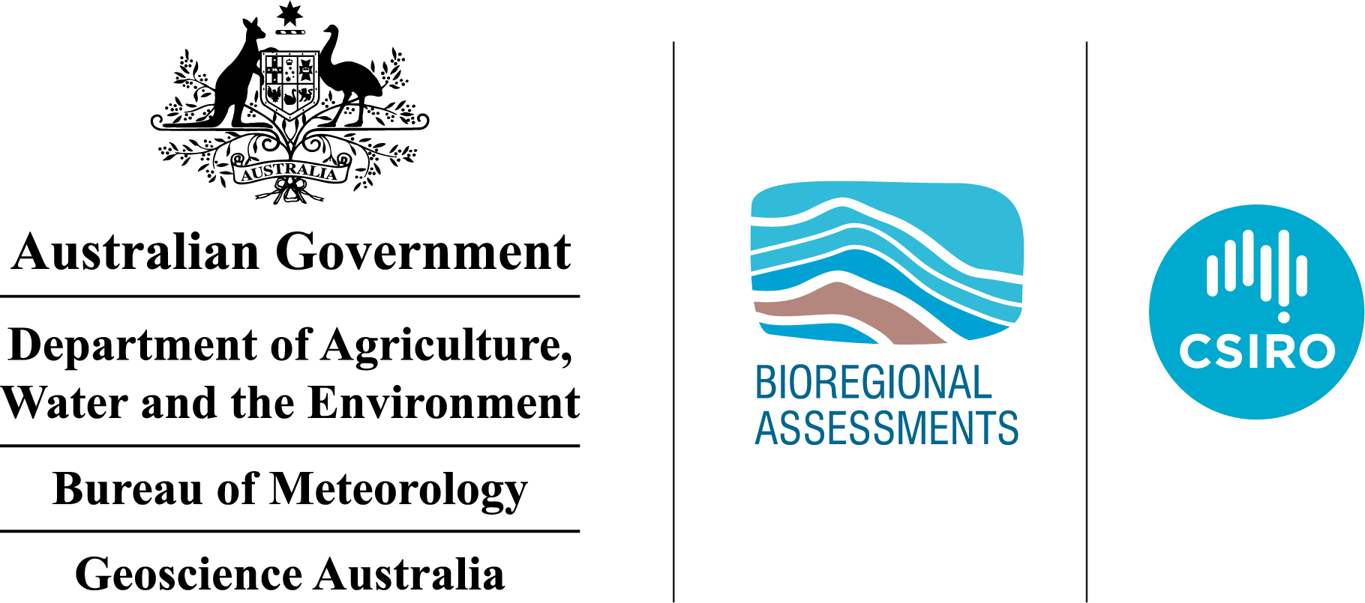

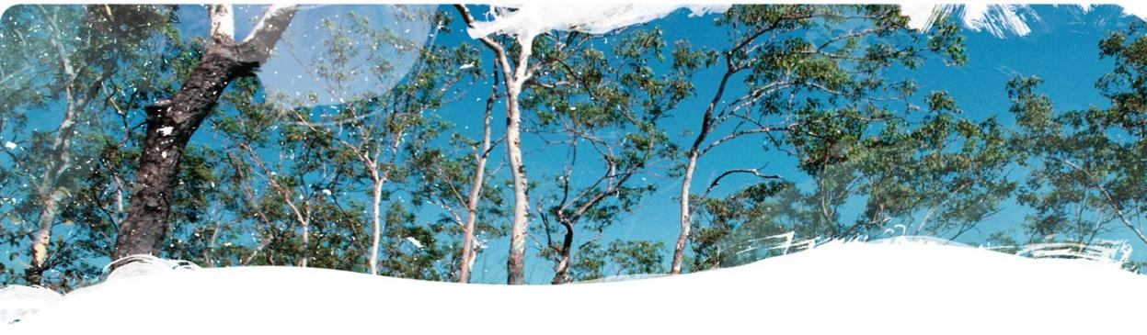
Hydrogeology of the Beetaloo GBA region
Technical appendix for the Geological and Bioregional Assessment: Stage 2
2020

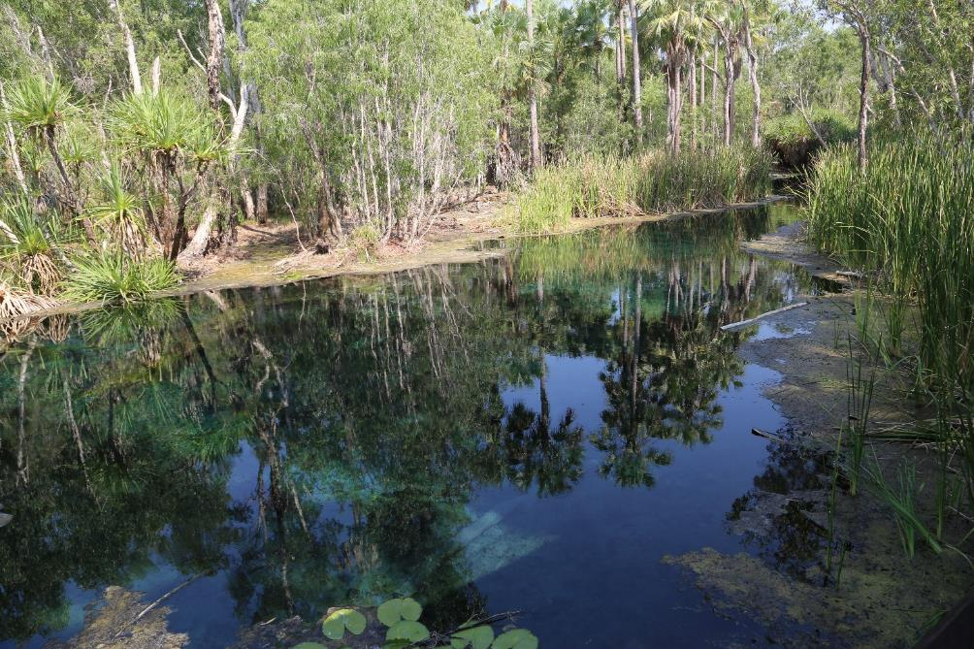
The Geological and Bioregional Assessment Program
The Geological and Bioregional Assessment Program will provide independent scientific advice on the potential impacts from development of selected unconventional hydrocarbon plays on water and the environment. The geological and environmental data and tools produced by the Program will assist governments, industry, landowners and the community to help inform decision making and enhance the coordinated management of potential impacts.
The Program is funded by the Australian Government Department of the Environment and Energy. The Department of the Environment and Energy, Bureau of Meteorology, CSIRO and Geoscience Australia are collaborating to undertake geological and bioregional assessments. For more information, visit http://www.bioregionalassessments.gov.au.
Department of the Environment and Energy
The Department designs and implements Australian Government policy and programs to protect and conserve the environment, water and heritage, promote climate action, and provide adequate, reliable and affordable energy. For more information visit http://www.environment.gov.au.
Bureau of Meteorology
The Bureau of Meteorology is Australia’s national weather, climate and water agency. Under the Water Act 2007, the Bureau is responsible for compiling and disseminating Australia's water information. The Bureau is committed to increasing access to water information to support informed decision making about the management of water resources. For more information, visit http://www.bom.gov.au/water/.
CSIRO
Australia is founding its future on science and innovation. Its national science agency, CSIRO, is a powerhouse of ideas, technologies and skills for building prosperity, growth, health and sustainability. It serves governments, industries, business and communities across the nation. For more information, visit http://www.csiro.au.
Geoscience Australia
Geoscience Australia is Australia’s national geoscience agency and exists to apply geoscience to Australia’s most important challenges. Geoscience Australia provides geoscientific advice and information to the Australian Government to support current priorities. These include contributing to responsible resource development; cleaner and low emission energy technologies; community safety; and improving marine planning and protection. The outcome of Geoscience Australia’s work is an enhanced potential for the Australian community to obtain economic, social and environmental benefits through the application of first-class research and information. For more information, visit http://www.ga.gov.au.
ISBN-PDF 978-1-76003-277-7
Citation
Evans TJ, Radke BM, Martinez J, Buchanan S, Cook SB, Raiber M, Ransley TR, Lai ÉCS, Skeers N, Woods M, Evenden C, Cassel R and Dunn B (2020) Hydrogeology of the Beetaloo GBA region. Technical appendix for the Geological and Bioregional Assessment: Stage 2. Department of the Environment and Energy, Bureau of Meteorology, CSIRO and Geoscience Australia, Australia.
Authorship is listed in relative order of contribution.
On 1 February 2020 the Department of the Environment and Energy and the Department of Agriculture merged to form the Department of Agriculture, Water and the Environment. Work for this document was carried out under the then Department of the Environment and Energy. Therefore, references to both departments are retained in this report.
Copyright
 © Commonwealth of Australia 2020
With the exception of the Commonwealth Coat of Arms and where otherwise noted, all material in this publication is provided under a Creative Commons Attribution 4.0 International Licence https://creativecommons.org/licenses/by/4.0/. The Geological and Bioregional Assessment Program requests attribution as ‘© Commonwealth of Australia (Geological and Bioregional Assessment Program http://www.bioregionalassessments.gov.au)’.
Disclaimer
The information contained in this report is based on the best available information at the time of publication. The reader is advised that such information may be incomplete or unable to be used in any specific situation. Therefore, decisions should not be made based solely on this information or without seeking prior expert professional, scientific and technical advice.
The Geological and Bioregional Assessment Program is committed to providing web accessible content wherever possible. If you are having difficulties with accessing this document please contact bioregionalassessments@awe.gov.au.
Cover photograph
Mataranka Thermal Pools, Beetaloo GBA extended region, October 2018.
Credit: Alf Larcher (CSIRO)
Element: GBA-BEE-2-381

Executive summary
This investigation reviews the existing datasets and literature to develop a regional hydrogeological conceptualisation of the Beetaloo Geological and Bioregional Assessment region. The region is located approximately 500 km south-east of Darwin, in the Northern Territory, Australia, and covers approximately 28,000 km2.
The hydrogeology is characterised by a complex series of stacked sedimentary basins that include the Beetaloo Sub-basin (Roper Group); the Georgina, Wiso, and Daly basins; and the Carpentaria Basin. Within these basins, four primary groundwater and aquitard sub-systems have been identified. A brief summary of these is provided below.
Mesoproterozoic Roper Group: The group is host to the main hydrocarbon plays of the Velkerri and Kyalla formations. While the Roper Group typically exhibits aquitard properties, the Moroak Sandstone can locally act as a fractured rock aquifer near structures. It has produced groundwater inflows to petroleum wells during drilling. Due to depth and hypersaline conditions, the Moroak Sandstone is not utilised as a groundwater resource within the Beetaloo GBA region. Outside the Beetaloo GBA region, however, where these rocks occur near surface, the Moroak and other sandstones in the Roper Group are utilised and may also be a source aquifer for some springs.
Neoproterozoic units: Overlying the Roper Group are the Jamison sandstone aquifer, Hayfield mudstone and Kiana Group. Outside the region the Jamison sandstone is utilised as a groundwater source. While this unit is being considered as an option for water supply for future petroleum drilling operations within the region, a couple of water quality samples suggest at least parts of it could be highly saline.
The overlying Hayfield mudstone is a regional aquitard found across the majority of the Beetaloo GBA region, except for small regions in the extreme north and south. The Kiana Group consists of Bukalara Sandstone and Cox Formation. The Bukalara Sandstone has a discontinuous distribution, within and adjacent to, the Beetaloo GBA region. This unit is a good local aquifer where it outcrops to the north of the region. The Bukalara Sandstone is being considered as an option for future water supplies. Limited information from petroleum wells drilled within the Beetaloo GBA region suggests that parts of the Bukalara Sandstone have potentially relatively good hydraulic conductivity and porosity. There is no information on water quality.
Antrim Plateau Volcanics: While considered to be a regional aquitard across much of the Beetaloo GBA region, it is used as a local aquifer where groundwater supply from the Cambrian Limestone Aquifer is not sufficient.
Cambrian Limestone Aquifer: The Cambrian Limestone Aquifer (CLA) is the most important aquifer in the Beetaloo GBA region, due to its relatively shallow nature, high yields and good water quality. The CLA stratigraphy is complex, karstic in nature and includes a number of variably hydraulically connected sequences: The Cambrian Antrim Plateau Volcanics underlies the CLA.
There are two regional groundwater flow systems recognised in the CLA: groundwater flow from the Wiso Basin into the Daly Basin, and groundwater flow from the Georgina Basin into the Daly Basin. Inferred regional groundwater flow for both systems are north-westward, across the Beetaloo GBA region, into the Daly Basin and discharges at spring complexes such as Mataranka and Flora River Springs located outside the GBA region. Groundwater flow on a more local scale is, however, poorly defined. Within the CLA, the velocity of groundwater flow can be highly variable and is in part dependent on the degree of connectivity and size of karst porosity.
Cretaceous Carpentaria Basin and Cenozoic sediments: These are generally unsaturated and provide only limited quantities of low to moderately saline groundwater. Within the Beetaloo GBA region, local perched aquifers in the Cenozoic could potentially be used as a water source by vegetation.
Hydraulic connectivity: Hydraulic connectivity and potential impact propagation between the prospective Roper Group units and the upper aquifers are expected to be limited by variably extensive and thick aquitards, particularly the Hayfield mudstone and Antrim Plateau Volcanics. The degree of inter-aquifer connectivity is not well characterised.
The thickness of Carpentaria Basin sedimentary rocks and distribution of near-surface karst have a bearing on degree of leakage/recharge that can reach the underlying CLA. This has implications for hazards such as spills, because recharge/leakage is impeded where overlying Carpentaria Basin sedimentary is thick.
A number of groundwater-dependent ecosystems have been identified within the Beetaloo GBA region; however, due to depth these are expected to be related to shallow perched aquifers, rather than the regional watertable.
Beetaloo GBA Stage 3: Stage 3 will include further work on the stratigraphic model and fault interpretation; updating the thickness map of the Carpentaria Basin in the Beetaloo GBA region aims to improve the understanding of groundwater connectivity, recharge pathways and processes. A field study will be conducted to investigate the potential of any deeper water sources discharging at Mataranka and whether this potential causal pathway presents a greater risk to Mataranka Thermal Pools and the CLA aquifer in general from petroleum resource development.
In future exploration programs beyond the GBA Program, consideration should be given to include activities that improve the knowledge base and understanding of the hydrogeology and geology of sequences that overlie the Roper Group. These could include running at relatively shallow depths (e.g. CLA or Antrim Plateau Volcanics) suites of well logs or pressure surveys, undertaking geological seismic interpretation, or collecting water samples from prospective deep aquifers, such as Jamison or Bukalara sandstones. Dedicated monitoring bores in Jamison and Bukalara sandstones would provide valuable information on waterlevels, water quality and degree of inter-aquifer connectivity.

Contents
Executive summary i
Contributors to the Program ix
Acknowledgements x
Abbreviations and acronyms xi
The Geological and Bioregional Assessment Program xii
1 Introduction 1
1.1 Beetaloo GBA region 1
2 Groundwater data inventory 5
2.1 Source datasets 5
2.2 Key derived datasets 7
3 Groundwater system conceptualisation 13
3.1 Section summary 13
3.2 Hydrostratigraphic framework 16
3.3 Hydrodynamics 34
3.4 Hydrochemistry 74
4 Potential hydrological connections 99
4.1 Potential connectivity pathways 103
4.2 Summary and future work 111
5 Conclusions 115
5.1 Regional groundwater systems 115
5.2 Inter-aquifer connectivity 117
5.3 Surface water – groundwater interactions 118
5.4 Gaps, limitations and future directions 118
References 122
Glossary 133

Figures
Figure 1 Beetaloo GBA region and its relationship to major geological provinces in the Northern Territory 3
Figure 2 Compiled temperature data for the Proterozoic from the Beetaloo GBA region 9
Figure 3 Conceptual model of groundwater systems in the Beetaloo GBA region 15
Figure 4 Hydrostratigraphic column for the Beetaloo GBA region 17
Figure 5 Structural elements map of the Beetaloo Sub-basin, overlain on the total sediment thickness from base of the Roper Group to the surface 21
Figure 6 Distribution of the Antrim Plateau Volcanics (Kalkarindji igneous province) and Bukalara Sandstone drillhole intercepts in the Beetaloo GBA region 25
Figure 7 Relationship between the Antrim Plateau Volcanics and the overlying Cambrian Limestone Aquifer 26
Figure 8 Distribution of major hydrostratigraphic units that make up the Cambrian Limestone Aquifer in the Beetaloo GBA region 30
Figure 9 Areas with sinkholes and near-surface structures identified on 1:250,000 geological map sheets in the Beetaloo GBA region 31
Figure 10 Carpentaria Basin – elevation of bottom of Carpentaria Basin and vertical thickness 33
Figure 11 Pressure data from Proterozoic units compiled from petroleum exploration drilling 37
Figure 12 Temperature data from petroleum wells for Proterozoic sequences 38
Figure 13 Groundwater inflows to petroleum wells from Roper Group, and calculated hydraulic head levels derived from drill stem test pressure data 40
Figure 14 Groundwater inflows to petroleum wells from Jamison and Bukalara sandstones, and calculated hydraulic head levels derived from drill stem test pressure data 44
Figure 15 Groundwater bores and inflows to the Antrim Plateau Volcanics from petroleum wells 46
Figure 16 Flow systems of the Cambrian Limestone Aquifer system 49
Figure 17 Watertable contours for the northern Wiso Basin and environs 52
Figure 18 Depth to groundwater in registered groundwater bores 54
Figure 19 Department of Environment and Natural Resources (NT) and Origin Energy groundwater monitoring network 56
Figure 20 Cumulative mass residual rainfall curves for the Beetaloo GBA region and surrounds 57
Figure 21 Groundwater hydrograph for well RN022002 58
Figure 22 Groundwater hydrograph for well RN020509 59
Figure 23 Groundwater hydrograph for well RN030695 60
Figure 24 Groundwater hydrograph for well RN035926 61
Figure 25 Groundwater hydrograph for well RN034032 62
Figure 26 Groundwater hydrograph for well RN029012 63
Figure 27 Groundwater hydrograph for well RN036471.11 64
Figure 28 Groundwater hydrograph for well RN036471.12 65
Figure 29 Regional groundwater model domains 72
Figure 30 Water balance for Georgina and southern Daly basins to Mataranka Thermal Pools 73
Figure 31 Spatial distribution of electrical conductivity (EC) measured in springs and dissolved methane (CH₄) in groundwater across the Beetaloo GBA extended region with representation of the footprint of the alluvium and groundwater-dependent ecosystems 77
Figure 32 Cluster membership of aquifers and surface water in the Beetaloo GBA extended region 78
Figure 33 Spatial distribution of different clusters for groundwater and surface water samples across the Beetaloo GBA extended region 80
Figure 34 Groundwater salinity in the Proterozoic units and Bukalara Sandstone 82
Figure 35 Piper diagram of stratigraphic units in the Beetaloo GBA region 83
Figure 36 Salinity levels in the Cambrian Limestone Aquifer and Antrim Plateau Volcanics and equivalents 86
Figure 37 Colour-coded Piper diagram of the Cambrian Limestone Aquifer (CLA) 87
Figure 38 Total dissolved solids (salinity levels) in Cenozoic and Cretaceous sediments (Carpentaria Basin) 89
Figure 39 Location of springs near the Beetaloo GBA region, colour coded by the temperature of groundwater 92
Figure 40 Groundwater-dependent ecosystems 93
Figure 41 Filtered Water Observations from Space (WOfs) for the Beetaloo GBA region 94
Figure 42 90th percentile Tasselled Cap Wetness (TCW) for the Beetaloo GBA region 97
Figure 43 Beetaloo GBA region – surface geology, structures, footprint of Figure 44, Figure 45 and Figure 46 102
Figure 44 Cross-section C-C’ with west–east orientation through the western Beetaloo GBA region and highlighting the potential for stratigraphic contact between possible gas play stressors and overlying aquifers and assets 105
Figure 45 Cross-section A-A’ with north-west – south-east orientation through Beetaloo GBA region, intersecting major geological structures within the Beetaloo GBA region, including Daly Waters High and five potential hydrological connections for water or gas migration 108
Figure 46 Cross-section B-B’, with west–east orientation, across the Beetaloo GBA region, showing five potential hydrological connections for water or gas migration 109

Tables
Table 1 Calculated hydraulic head from available drill stem test data 10
Table 2 Water flows recorded into petroleum wells for the Proterozoic units 39
Table 3 Water flows recorded into petroleum wells for the Jamison and Bukalara sandstones 43
Table 4 Water information from petroleum wells for the Antrim Plateau Volcanics 45
Table 5 Groundwater well aquifer designation statistics for Figure 18 55
Table 6 Hydrochemistry of groundwater samples from the Beetaloo GBA region and surrounds 75
Table 7 Median values of the variables considered in the hierarchical cluster analysis for each sample group 76
Table 8 Summary of potential hydrological connections, potential impacts on water and the environment, evidence base, questions and recommended investigations in the extended Beetaloo GBA region 113

Contributors to the Program
The following individuals have contributed to the Geological and Bioregional Assessment Program.
Role or team | Contributor(s)
Program Director | Department of the Environment and Energy: Anthony Swirepik
Program Implementation Board | Department of the Environment and Energy: Beth Brunoro, Nicholas Post  Bureau of Meteorology: Kirsten Garwood, Kate Vinot  CSIRO: Jane Coram, Warwick MacDonald  Geoscience Australia: Stuart Minchin, Richard Blewett
Basin Leader | CSIRO: Kate Holland, Cameron Huddlestone-Holmes, Paul Wilkes  Geoscience Australia: Steven Lewis
Program management | CSIRO: Karen Barry, Emanuelle Frery, Linda Merrin, Ruth Palmer  Department of the Environment and Energy: Mitchell Bouma, Rod Dann,  Andrew Stacey, David Thomas, Alex Tomlinson
Product integration and stakeholder engagement | CSIRO: Clare Brandon, Justine Lacey, Michelle Rodriquez, Sally Tetreault-Campbell
Analysis and visualisation | CSIRO: Dennis Gonzalez, Steve Marvanek  Geoscience Australia: Adrian Dehelean, Chris Evenden, Chris Lawson, Bianca Reese, Nigel Skeers, Murray Woods
Basin geology and prospectivity | Geoscience Australia: Lisa Hall (Discipline Leader), Adam Bailey, George Bernardel, Barry Bradshaw, Donna Cathro, Merrie-Ellen Gunning, Amber Jarrett, Megan Lech, Meredith Orr, Ryan Owens, Tehani Palu, Martin Smith, Liuqu Wang
Chemical assessment | CSIRO: Jason Kirby (Discipline Leader), Simon Apte, Lisa Golding, Rai Kookana,  Dirk Mallants, Michael Williams
Data management and transparency | Bureau of Meteorology: Andre Zerger (Discipline Leader), Derek Chen,  Trevor Christie-Taylor, Donna Phillips  CSIRO: Nicholas Car, Philip Davies, Stacey Northover, Matt Stenson  Geoscience Australia: Matti Peljo
Hydrogeology | Geoscience Australia: Tim Ransley (Discipline Leader), Sam Buchanan, Scott Cook, Prachi Dixon-Jain, Bex Dunn, Tim Evans, Éamon Lai, Bruce Radke,  Baskaran Sundaram
Impact analysis | CSIRO: David Post (Discipline Leader), Brent Henderson, Dane Kasperczyk,  James Kear, Regina Sander
Impacts on protected matters | CSIRO: Anthony O'Grady (Discipline Leader), Alexander Herr, Craig MacFarlane, Justine Murray, Chris Pavey, Stephen Stewart
Spatial analysis | CSIRO: Dennis Gonzalez, Steve Marvanek  Geoscience Australia: Adrian Dehelean, Murray Woods, Nigel Skeers
Water quantity | CSIRO: Russell Crosbie (Discipline Leader), Jorge Martinez Praveen Kumar Rachakonda, Matthias Raiber, Yongqiang Zhang, Hongxing Zheng

Acknowledgements
This technical product was reviewed by several groups:
- Internal Peer Review Group:
  - CSIRO: Allison Hortle
  - Geoscience Australia: Stephen Hostetler, Sam Buchanan
- Technical Peer Review Group: Andrew Boulton, Peter McCabe, Catherine Moore, Jenny Stauber
- State and Territory Government Science Technical Review: This group includes scientists from the Northern Territory Government.

Abbreviations and acronyms
Abbreviation/acronym | Definition
middle Velkerri Formation | Amungee Member
CSG | Coal seam gas
DEA | Digital Earth Australia
DEM | Digital elevation model
DST | Drill stem test
GBA | Geological and Bioregional Assessment
GDE | Groundwater-dependent ecosystem
lower Velkerri Formation | Kalala Member
TCI | Tasselled Cap Index
TDS | Total Dissolved Solids
TOC | Total organic carbon

The Geological and Bioregional Assessment Program
The $35.4 million Geological and Bioregional Assessment Program is assessing the potential environmental impacts of shale and tight gas development to inform regulatory frameworks and appropriate management approaches. The geological and environmental knowledge, data and tools produced by the Program will assist governments, industry, landowners and the community by informing decision making and enabling the coordinated management of potential impacts.
In consultation with state and territory governments and industry, three geological basins were selected based on prioritisation and ranking in Stage 1: Cooper Basin, Isa Superbasin and Beetaloo Sub-basin. In Stage 2, geological, hydrological and ecological data were used to define ‘GBA regions’: Cooper GBA region in Queensland, SA and NSW, the Isa GBA region in Queensland and the Beetaloo GBA region in NT.
The GBA Program will assess the potential impacts of selected shale and tight gas development on water and the environment and provide independent scientific advice to governments, landowners and the community, business and investors to inform decision making. Geoscience Australia and CSIRO are conducting the assessments. The Program is managed by the Department of the Environment and Energy and supported by the Bureau of Meteorology.
The GBA Program aims to:
- inform government and industry and encourage exploration to bring new gas supplies to the East Coast Gas Market within five to ten years
- increase understanding of the potential impacts on water and the environment posed by development of shale and tight gas resources
- increase the efficiency of assessment and ongoing regulation, particularly through improved reporting and data provision/management approaches
- improve community understanding of the industry.
The GBA Program commenced in July 2017 and comprises three stages:
- Stage 1 Rapid regional basin prioritisation identified and prioritised geological basins with the greatest potential to deliver shale and/or tight gas to the East Coast Gas Market within the next five to ten years.
- Stage 2 Geological and environmental baseline assessments is compiling and analysing available data for the three selected regions to form a baseline and identify gaps to guide collection of additional baseline data where needed. This analysis includes a geological basin assessment to define structural and stratigraphic characteristics and an environmental data synthesis.
- Stage 3 Impact analysis and management will analyse the potential impacts to water resources and matters of environmental significance to inform and support Commonwealth and State Territory management and compliance activities.
The PDF of this report and the supporting technical appendices are available at https://www.bioregionalassessments.gov.au/geological-and-bioregional-assessment-program.
About this report
Presented in this technical appendix is a review of the hydrogeology for the Beetaloo GBA region. It provides more detailed information regarding a groundwater data inventory, groundwater system conceptualisation, and conceptual models of potential connectivity pathways. The structure and focus of the synthesis report and technical appendices reflect the needs of government, industry, landowners and community groups.
Technical appendices
Other technical appendices that support the geological and environmental baseline assessment for the Beetaloo GBA region are:
- Orr ML, Bernardel G, Owens R, Hall LS, Skeers N, Reese B and Woods M (2020) Geology of the Beetaloo GBA region.
- Hall LS, Wang L, Bailey AHE, Orr ML, Owens R, Jarrett, A, Lech ME, Skeers N, Reese B and Woods M (2020) Petroleum prospectivity of the Beetaloo Sub-basin.
- Pavey C, Herr A, MacFarlane CM, Merrin LE and O’Grady AP (2020) Protected matters for the Beetaloo GBA region.
- Kirby JK, Golding L, Williams M, Apte S, Mallants D, King J, Otalega I and Kookana R (2020) Qualitative (screening) environmental risk assessment of drilling and hydraulic fracturing chemicals for the Beetaloo GBA region.
- Kear J and Kasperczyk D (2020) Hydraulic fracturing and well integrity review for the GBA regions.
All maps for the Beetaloo GBA region use the Map Grid of Australia (MGA) projection (zone 53) and the Geocentric Datum of Australia 1994 (GDA 1994).

Introduction
This appendix presents the technical findings from the Stage 2 Geological and Bioregional Assessment Program, in relation to the hydrogeology and groundwater systems of the Beetaloo GBA region.
The Beetaloo Sub-basin is prospective for hydrocarbons and has high potential to contain significant shale gas and tight gas resources, particularly within the Kyalla and middle Velkerri formations of the Roper Group (Hall et al., 2020). Shale gas production is considered feasible in the Beetaloo Sub-basin within five to ten years with further exploration, appraisal and infrastructure development. Future development of the resources could result in delivery of gas to the East Coast Gas Market over this time frame. The Beetaloo Sub-basin has existing geological, hydrogeological and environmental data available of the type, quality and density to enable a baseline geological and bioregional assessment to be undertaken.
The aims of this appendix are to:
- provide details of the groundwater systems as they are currently understood
- describe potential connectivity between these systems, with reference to potential changes in system connectivity under shale gas development
- provide baseline datasets to underpin the assessment and management of future potential development of shale gas activities
- provide recommendations for future data collection and assessment to improve the system understanding.
The Beetaloo Sub-basin is a structural component of the greater McArthur Basin in the NT, it is located about 500 kilometres south-east of Darwin (Figure 1). It includes the major Paleoproterozoic to Mesoproterozoic sedimentary sequences that are distributed broadly over the amalgamated basement of the North Australian Craton. It is entirely under the cover of younger sedimentary and volcanic rocks.

Beetaloo GBA region
The Beetaloo GBA region (Figure 1) is defined by the spatial extent of the geological Beetaloo Sub-basin (part of the greater McArthur Basin), which extends from the top of the Kyalla Formation at a depth of approximately 400 m below the topographic surface (Department of Primary Industry and Resources (NT), 2017). The Beetaloo Sub-basin is buried at variable depths beneath younger sedimentary basin cover in this area. For the purposes of this assessment, the Beetaloo GBA region has been defined on geological criteria and data availability. These are:
- maximum extent of preserved and relatively continuous sedimentary deposits
- the limit defined where the sedimentary fill becomes extensively folded and faulted, with many of the potential shale gas intervals either exhumed or cropping out at the surface
- the limit of available subsurface (well and seismic) data required as basis for the assessment of shale gas resources.
Further information about the geology of the Beetaloo GBA region is detailed in (Orr et al., 2020).

Beetaloo GBA extended region
A broader region, referred to as the ‘Beetaloo GBA extended region’, has also been defined (Figure 1). This larger region is used to constrain additional data discovery and to allow impacts immediately adjacent to the Beetaloo GBA region to be considered. The Beetaloo GBA extended region has been developed in consultation with the Northern Territory Government and defines the area for a Strategic Regional Environmental Baseline Assessment (SREBA) for the Beetaloo Sub-basin (see Section 1.5.2.10 in (Huddlestone-Holmes et al., 2020)) and follows the principles in the SREBA guidelines (in draft form at time of writing). The Beetaloo GBA extended region captures appropriate catchment or subcatchment boundaries, biogeographical boundaries and wetlands listed in A directory of important wetlands in Australia (DIWA), such as Mataranka Thermal Pools in the north and Lake Woods in the south.
To date, there has been limited exploration for petroleum resources in the Beetaloo Sub-basin, with exploration permits currently operated by Origin Energy, Santos and Pangaea Resources. Recently, Origin Energy and Santos have recommenced exploration activities in the sub-basin.
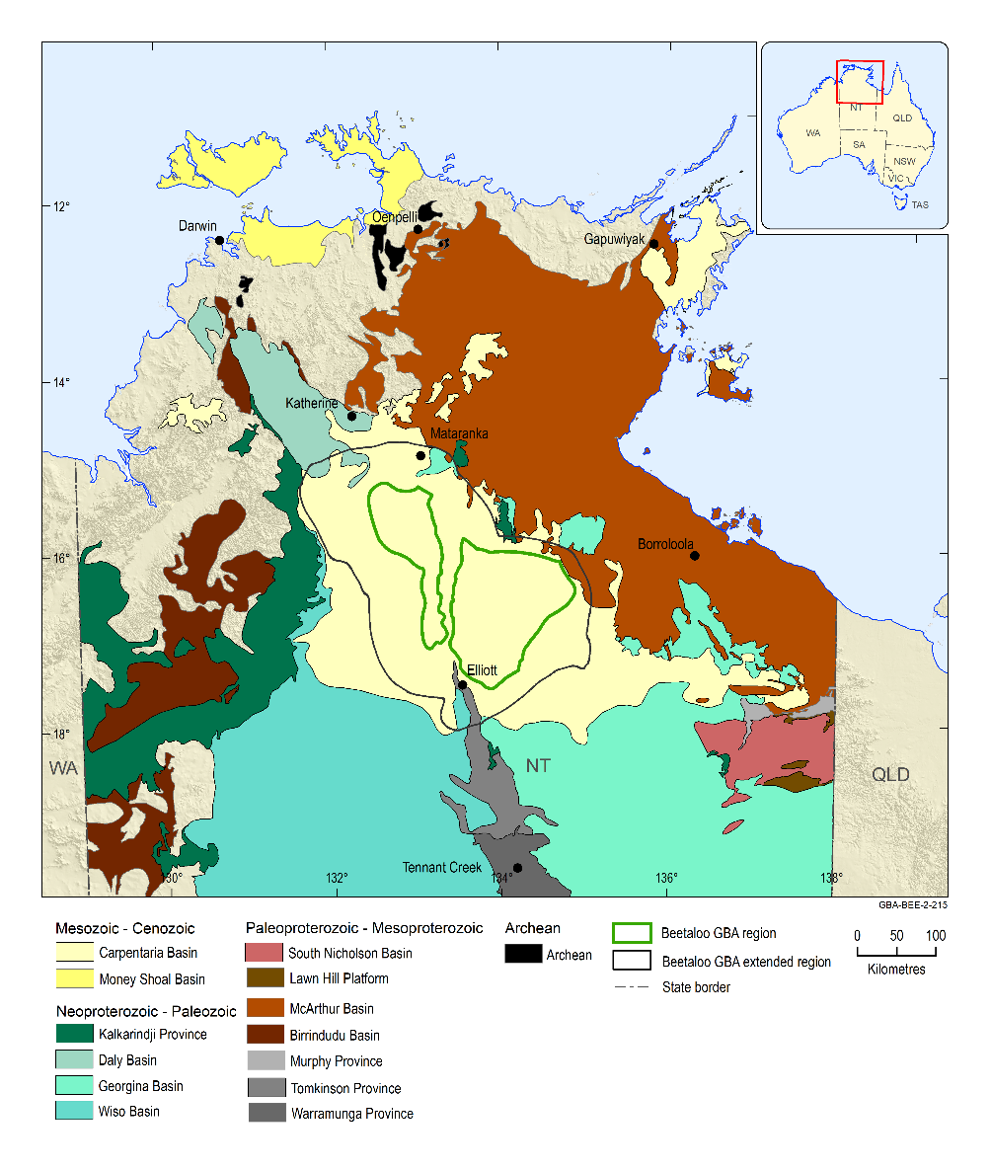
Figure 1 Beetaloo GBA region and its relationship to major geological provinces in the Northern Territory
The Beetaloo GBA region corresponds to the geological limits of the Beetaloo Sub-basin as detailed in Section 1.1. The Beetaloo GBA extended region is defined in Section 1.1.1.
Data: geology (Department of Primary Industry and Resources (NT), 2018)
Element: GBA-BEE-2-215

Groundwater data inventory

Source datasets

Petroleum well data
Information about petroleum well datasets has been outlined in (Orr et al., 2020). Petroleum well data of interest for hydrogeological studies include well stratigraphy, formation pressure, temperature, water analyses, porosity-permeability measurements and well logs (geophysical and rock properties logs).

Digital Earth Australia – Landsat archive
Remote sensing information provides a nationally consistent tool for understanding the spatial and temporal patterns of surface water across Australia. Geoscience Australia has recently developed products from Earth observation data as part of Digital Earth Australia (DEA) (Haines et al., 2013). DEA is an analysis platform for satellite imagery and other Earth observation data based on the Australian Geoscience Data Cube (Lewis et al., 2017). DEA holds an archive of 30 years of corrected and processed Landsat data. In addition to other Earth observation time-series datasets, DEA provides data interaction tools through the Australian National Computational Infrastructure (NCI) high-performance computing environments.
Published DEA products to date based on remotely sensed data include Water Observations from Space (WOfS), which show where water has been identified in the landscape over time (Mueller et al., 2016). Other products derived from the DEA, such as Tasselled Cap Wetness (TCW), can be used to assess the persistence of surface water in the landscape. DEA products are presented and analysed for the Beetaloo GBA region in Section 3.

Groundwater data
Key datasets consulted for the groundwater sections of this report are summarised in the following sections. They are generally limited to those considered appropriate and available at the end of December 2018.

Lithology and hydrostratigraphy
The Department of Environment and Natural Resources (NT) (2018a) summarises groundwater bores registered with the Northern Territory Government and includes a range of information used in the current study (e.g. standing water levels, borehole yield and links to online borehole logs).
In addition to Department of Environment and Natural Resources (NT) (2018a), DENR provided the following interpreted layer files that were used in hydrogeological conceptualisation (note that many of these files are periodically updated):
- Department of Environment and Natural Resources (NT) (2018c), which shows the interpreted extent of the Gum Ridge Formation and its equivalents (Montejinni Limestone in the Wiso Basin and Tindall Limestone Formation in the Daly Basin) and the Anthony Lagoon Formation and its equivalents (Hooker Creek Formation in the Wiso Basin and Jinduckin Formation in the Daly Basin). It includes elevation contours for the base of these systems relative to Australian Height Datum (AHD). DENR indicated that basal elevations in the southern Wiso Basin (from approximately 60 km north of Newcastle Waters) may not be reliable due to density of data in the area.
- Department of Environment and Natural Resources (NT) (2020), which shows the interpreted lateral extent of Cretaceous sediments in the Beetaloo GBA area.
- Department of Environment and Natural Resources (NT) (2015), which shows the interpreted lateral extents of aquifers in the NT.
- Department of Environment and Natural Resources (NT) (2013), which shows the locations of springs in the NT. In addition to geographic location, the database includes a range of information for several springs (e.g. flow rate, temperature, electrical conductivity, pH, hardness).

Hydrochemistry data
Hydrochemistry data were compiled from a number of sources, including:
- Department of Environment and Natural Resources (NT) (2018a), which includes groundwater quality information for groundwater bores across the NT held by the Northern Territory Government.
- Origin Energy (2019), which includes groundwater quality information for several groundwater bores in the central parts of the Beetaloo GBA region and surrounds. The dataset mostly focuses on groundwater bores located east of the western sub-basin.
- Pangaea Resources (2019), which includes groundwater quality information for several groundwater bores in the north-west of the Beetaloo GBA region and surrounds.
- Wilkes et al. (2019), which presents groundwater sampling results from an isotopes study focusing predominantly on the eastern Beetaloo GBA region and northern areas.

Hydrostratigraphic formation picks for groundwater bores
Fulton and Knapton (2015b) included formation designations for many groundwater bores in the study area. Origin Energy provided the database of these designations as Origin Energy (2019). This was supplemented during the current study with information from borehole logs listed in Department of Environment and Natural Resources (NT) (2018a) within the groundwater bore data extraction area. The formation designations for the were only crosschecked if there were discrepancies.
The revised database is included as Geological and Bioregional Assessment Program (2019i) in the online data repository. It was used in assessing groundwater chemistry and monitoring well hydrographs. Groundwater bores screened in sands interbedded with the Antrim Plateau Volcanics (known as the Jindare Formation) have been designated as Antrim Plateau Volcanics for the current study. There may be merit in considering them separately in future study phases. Due to time constraints, the entire Fulton and Knapton (2015b) database could not be checked for this project, but it is recommended that it be reviewed in future work stages since some errors were noted when compared to Origin Energy (2019).

Groundwater levels and hydrographs
Department of Environment and Natural Resources (NT) (2018a) includes water levels measured during drilling and pump testing, which were used to assess depth to groundwater in the Beetaloo GBA extended region. In addition, time-series groundwater level information was compiled from:
- DENR – Information was provided in separate files for the Beetaloo GBA extended region. Department of Environment and Natural Resources (NT) (2018a) lists DENR’s current nearby groundwater monitoring wells in the region and provides spatial context. Associated data were provided separately in Department of Environment and Natural Resources (NT) (2018b). Department of Environment and Natural Resources (NT) (2018b) also includes water levels for several groundwater bores in the Beetaloo GBA extended region that are not included in Department of Environment and Natural Resources (NT) (2018a). These water levels were not considered in the current study but could be included in future work.
- Origin Energy – Information was provided in Origin Energy (2019). The database includes barometric pressure measurements covering some of the period of water level logging.

Rainfall data
Department of Environment and Science (Qld) (2018) presents climate data sourced from the Queensland Government’s Scientific Information for Landowners website (https://data.qld.gov.au/dataset/silo-climate-api) for stations 14902 Katherine Council, 14642 Mataranka Station, 14618 Daly Waters and 15086 Newcastle Waters. The website files include interpolated rainfall readings for dates when measurements were not made at particular stations by the Bureau of Meteorology.

Key derived datasets

Hydrochemistry database
Hydrochemistry data within the Beetaloo GBA extended region from Department of Environment and Natural Resources (NT) (2018a), Origin Energy (2019), Pangaea Resources (2019), and Wilkes et al. (2019) were collated into a single database (Geological and Bioregional Assessment Program, 2019i). Groundwater bores where aquifer designation is ambiguous or screened area was open to multiple aquifer units, were excluded from the dataset. Analyses with charge balance errors >10% were removed to create the derived database (Geological and Bioregional Assessment Program, 2019h) for interpretation.

Standing water levels
DENR indicated that a standing water level entry of ‘0’ in their groundwater well database (Department of Environment and Natural Resources (NT), 2018a) signifies that a standing water level was not recorded. Department of Environment and Natural Resources (NT) (2018a) was therefore filtered to include only those wells with a standing water level other than ‘0’ in the Beetaloo GBA extended region. The resulting database is Geological and Bioregional Assessment Program (2019g).

Pressure, temperature and and groundwater level data
Pressure and temperature data collected from drill stem tests (DST) and wireline geophysical logging of petroleum wells were compiled into a single dataset (Geological and Bioregional Assessment Program, 2019f). Corrected hydraulic head (groundwater level) was derived from the final shut-in pressures (Geological and Bioregional Assessment Program, 2019f) (see methods snapshot below). The data are of suitable quality for this assessment. However, further data evaluation is required for use in more local scale interpretations.

Methods snapshot: Freshwater equivalent hydraulic head
In order to accurately compare hydraulic head data, corrections need to be made for water density variations caused by changes in temperature and salinity. The following methodology was used to convert raw pressure data from Proterozoic units to an equivalent freshwater hydraulic head. Groundwater from younger units is not subject to the same temperature and salinity extremes and was therefore not corrected.
• Quality control: For DSTs, only those classed as ‘successful’ by the operator were used. Only data-complete DSTs were used. Only DSTs where the final shut-in pressure was less than final hydrostatic pressure were used. For wireline pressure data, only tests classified as ‘good’ in the relevant well completion report was utilised. While compiled in the dataset for completeness, wireline pressures tests reported as ‘curtailed’, ‘no seal’ or other issue were not converted to equivalent hydraulic head. Further detail on formation test quality control methods are outlined in Hortle et al. (2013).
• Where data passed quality assurance checking, pressure measurements reported in pounds per square inch absolute (PSIA) were converted to PSI gauge pressure (PSIG) according to the equation PSIG = PSIA – 14.7.
• Pressures were converted to environmental hydraulic head and equivalent freshwater hydraulic head using methods in Post et al. (2007). The density calculation component in Post et al. (2007) incorporated formulas derived from McCutcheon et al. (1993). While not explicitly discussed, there are potentially some limitations with the McCutcheon et al. (1993) equations, including that they are, in part, derived from the equations for the ‘state of seawater’ (UNESCO, 1981) The equations in UNESCO (1981) are valid to temperatures of 40 °C. Often groundwater temperatures in the Beetaloo GBA region exceed this threshold. However, this method is considered of sufficient quality for general interpretation and use in this regional study.
Pressure data were converted to hydraulic head utilising gauge temperature data and an estimated salinity (Table 1).
Temperature data include uncorrected bottom hole temperature measurements from geophysical well logs, corrected bottom hole temperatures reported in well completion reports and pressure gauge temperature (Figure 2).
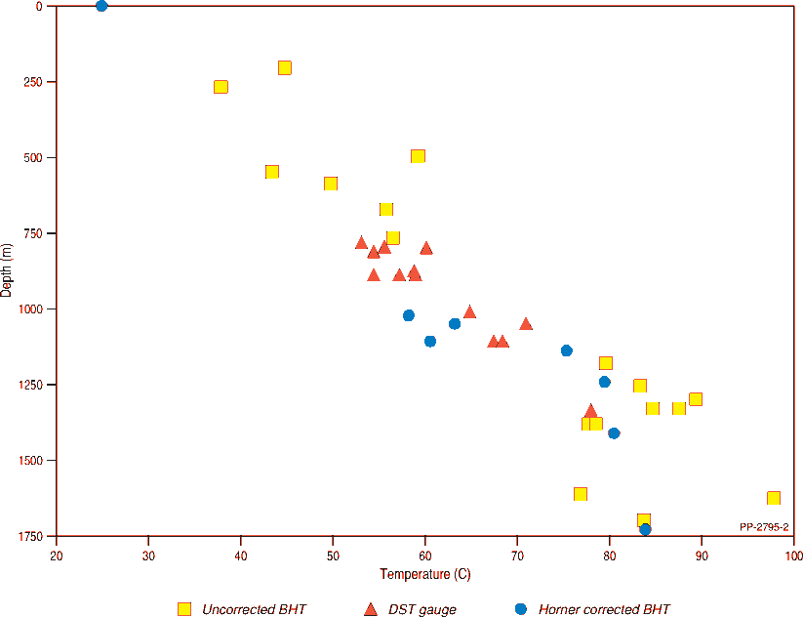
Figure 2 Compiled temperature data for the Proterozoic from the Beetaloo GBA region
BHT = bottom hole temperature. These data are sourced from downhole geophysical logs and is the highest temperature recorded at the bottom of the logging run (which often equates to the bottom of the hole at the time of logging).
DST = drill stem test. Temperature of the pressure gauge sourced from DST reports in well completion reports.
Horner corrected BHT – A method for determining bottom hole temperature (BHT), which includes a correction for localised cooling of the rock mass caused by circulating drilling fluids. As indicated on Figure 2, the surface temperature used as a base for the calculation of Horner corrected temperatures was 25 °C.
Data: Geological and Bioregional Assessment Program (2019f)
Element: GBA-BEE-2-360

Table 1 Calculated hydraulic head from available drill stem test data
Well | Height  (Kellybush - mAHD) | DST test number | Formation tested | Depth to top of Proterozoic rocks in well  (m) | DST gauge depth  (m below KB) | Final pressure (PSIG) | Temperature  (°C) | Salinity estimate (g/kg) | Calculated environmental hydraulic head (mAHD) | Freshwater hydraulic head equivalent  (mAHD) | DST result/comment
Balmain 1 | 230.5 | 1 | Hayfield mst | 404 | 780.97 | 1198 | 53.2 | 50 | 273 | 293 | Pulled 25.64 m column (29 L) of liquid, approximately 4 m (4.5 L) oil and 21.64 (24.5 L) of oil cut rat hole mud
Balmain 1 | 230.5 | 2 | Jamison sst | 404 | 883.96 | 1231 | 57.2 | 50 | 194 | 213 | Recovered 80.5 L foetid salty formation water
Elliott 1 | 246.3 | 3 | Kyalla Fm | 524 | 1104.77 | 1726 | 67.5 | 100 | 294 | 356 | 15 ml oil and 98.3 L drilling mud
Elliott 1 | 246.3 | 5 | Moroak Sst | 524 | 1333.71 | 1833 | 78 | 100 | 142 | 202 | Approximately 5200 L of highly saline formation water
Jamison 1 | 263.4 | 1 | Hayfield mst | 501 | 813.25 | 1219 | 54.4 | 50 | 288 | 308 | 13 L mud. Gas RTSTM
Jamison 1 | 263.4 | 2 | Hayfield mst | 501 | 873.00 | 1167 | 58.9 | 50 | 195 | 212 | 470 L oil and gas cut mud. Gas RTSTM
Jamison 1 | 263.4 | 4 | Jamison sst | 501 | 886.00 | 1187 | 54.4 | 50 | 194 | 213 | 687 m water, 5cm oil
Jamison 1 | 263.4 | 3 | Hayfield mst | 501 | 889.26 | 1187 | 59.05 | 50 | 192 | 210 | 448 m oil and gas cut mud and Fm water
Mason 1 | 265.7 | 1 | Hayfield mst | 472 | 807.25 | 1149 | 54.4 | 50 | 248 | 267 | 12 m drilling mud, small inflow of gas
Mason 1 | 265.7 | 2 | Jamison sst | 472 | 887.19 | 1197 | 57.2 | 50 | 203 | 221 | 15 m drilling mud, oil/emulsion smears on tools
Ronald 1 | 254.3 |  | Moroak Sst | 559 | 1047.00 | na | na | na | 74 | na | Not a DST test. The value was measured rather than calculated.  Large volumes of water inflow encountered below 1045 m. Had to utilise mud pumps to control water volumes while add drill pipe. Flow into well ‘killed itself’ i.e. essentially stopped flowing when water level in hole reached about  180 m KB (about 176 m below ground level)
Ronald 1 | 254.3 | 1 | Moroak Sst | 559 | 1050.64 | 1358 | 71.1 | 100 | 112 | 159 | 3108 L saline formation water and minor gas
Shortland 1 | 267.7 | 1 | Hayfield mst | 487 | 830.98 | 950 | 55.8 | 50 | 90 | 105 | 8 L of formation water cut with rat hole mud
Walton 2 | 192 | 2 | Velkerri Fm | 86 | 777.00 | 1129 | 64.4 | 100 | 167 | 209 | 7.5 L rat hole mud with slight oil cut
DST = drill stem test; na = not applicable; RTSM = Rate too small to measure; Fm = Formation; Sst or sst = sandstone, mst = mudstone
KB = Kellybush, mAHD = metres above Australian Height Datum.
Caveats associated with calculations of hydraulic head are outlined in the method snapshot box.
Well locations are outlined on Figure 5.
Data: Geological and Bioregional Assessment Program (2019f)

Groundwater system conceptualisation

Section summary
The hydrogeology is characterised by a complex series of stacked sedimentary basins, which include the Beetaloo Sub-basin; the Georgina, Wiso, and Daly basins; and the Carpentaria Basin. Within these basins, four primary groundwater and aquitard sub-systems have been identified.
- Mesoproterozoic Roper Group. This group is host to the primary unconventional hydrocarbon plays of the Velkerri and Kyalla formations. Sandstones and mudstones of the Roper Group are thought to predominantly have low permeability, which is typical of aquitards. Exceptions may be parts of the Moroak and Bessie Creek sandstones, which in places could be locally fractured rock aquifers. Collectively, these Mesoproterozoic sandstones are not seen as effective groundwater systems. However, there are areas of higher permeability and porosity associated with regional structures that contain pressured groundwater systems. The Derim Derim Dolerite, where present, is likely to act as an aquitard in the sequence.
- Neoproterozoic units. Overlying the Roper Group is the regionally extensive Jamison sandstone aquifer. The sandstone is considered prospective as a potential water supply for future drilling operations. The overlying Hayfield mudstone is a regional aquitard and is present across most of the Beetaloo GBA region except in small regions in the extreme north and south of the region. The Bukalara Sandstone, also considered an aquifer, is used as a groundwater resource outside the Beetaloo GBA region. However, little is known about it within the region.
- Cambrian Limestone Aquifer (CLA) and Antrim Plateau Volcanics. The CLA is the most extensive and well-characterised aquifer system in the Beetaloo GBA region. It provides a significant, good quality, groundwater resource for the pastoral industry and communities within the region. At least two major groundwater flow systems are recognised in the CLA in the Beetaloo GBA region: (i) from the Georgina Basin into the Daly Basin and (ii) from the Wiso Basin into the Daly Basin. The inferred regional groundwater flow direction from potentiometric contours is generally to the north-west. However, there are possible significant deviations to this trend, at least at a local scale, as a result of structure and discrete karst systems.
Within the CLA, there is a lower (Gum Ridge Formation and equivalents) and upper (Anthony Lagoon Formation and equivalents) aquifer system, and each lies within the coeval limestone units of the adjoining Georgina, Wiso and Daly basins that merge under the Dunmarra region. Connectivity between the upper and lower parts of the CLA is variable regionally and not well understood. Although groundwater pressures are similar, they sometimes vary. Connectivity between lower and upper aquifers appears to be variably limited and may require longer time intervals for equilibration in places.
Underlying the CLA is the Cambrian Antrim Plateau Volcanics. These volcanics provide a widespread regional aquitard, but where fractured, can act as a local-scale fractured rock aquifer. A north-west to south-east oriented broad zone of lineaments across the north-western part of region suggests either some structural disruption or some other feature such as palaeo-topography. This aquitard broadly covers the Beetaloo Sub-basin but is incomplete, leaving several windows for direct contact of overlying aquifers with the underlying Neoproterozoic units.
- Carpentaria Basin and Cenozoic sediments. Over the eastern Beetaloo GBA region the Carpentaria Basin is relatively thick and predominantly unsaturated. Only in its deepest parts does a small area occur where sandstones at the base of the Carpentaria Basin are saturated and hydraulically connected to the underlying CLA. In contrast, in the western Beetaloo GBA region the Cretaceous sequence is much thinner, and the basal sandstone is predominantly exposed, which increases the likelihood of recharge into sinkholes of the CLA. As a result, the western Beetaloo GBA region experiences much higher recharge rates compared to the eastern Beetaloo GBA region. In overlying surficial Cenozoic units and regolith, a small number of bores within the eastern Beetaloo GAB region intercept saturated units, indicating the presence of perched aquifers. However, beyond these specific sites the distribution and prevalence of such aquifers is unknown.
Figure 3 presents these aquifer systems and illustrates the most significant flowpaths between the systems. Further details, including the hydrostratigraphic framework, hydrodynamics, and hydrochemistry and surface water – groundwater interactions are provided in the following subsections.
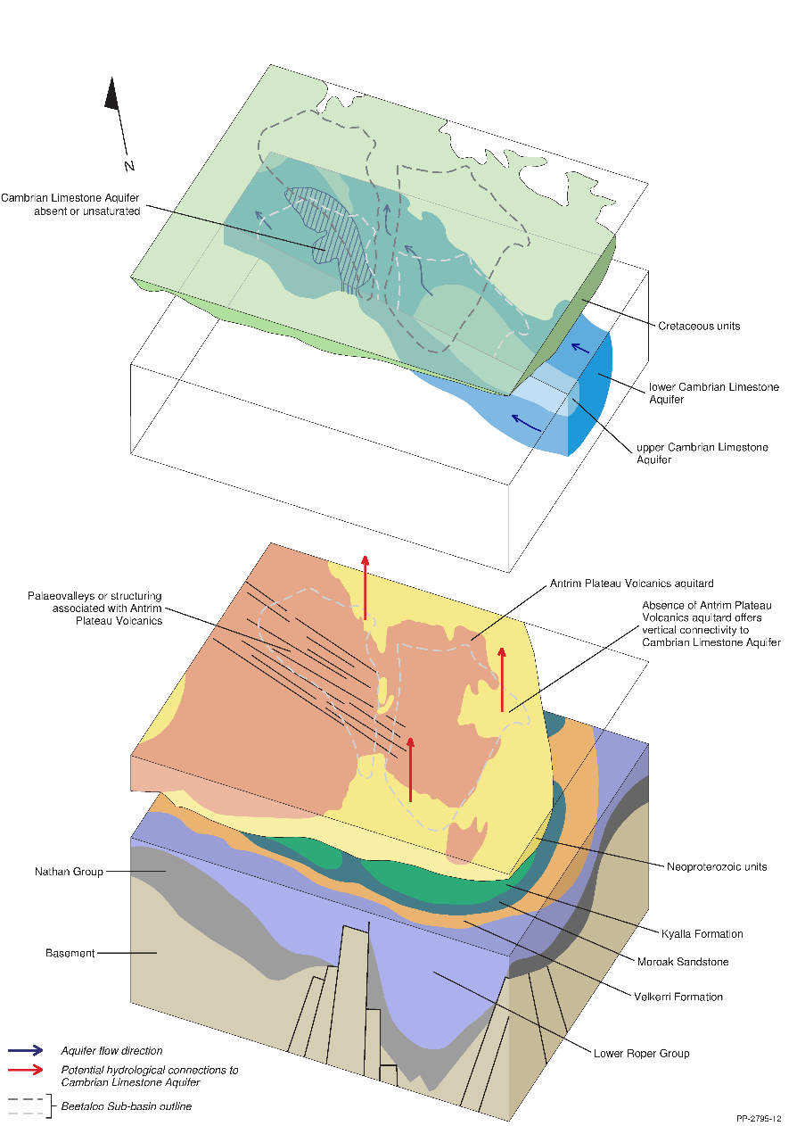
Figure 3 Conceptual model of groundwater systems in the Beetaloo GBA region
This conceptual diagram (not to scale) depicts the hydrostratigraphy across the Beetaloo GBA region. The Mesoproterozoic Roper Group hosts two prospective formations for tight gas, shale gas (Velkerri and Kyalla formations), which are separated by the Moroak Sandstone, which is also prospective. Overlying the Roper Group are the Neoproterozoic sequences, of which the Hayfield mudstone acts as a regional seal (aquitard) for underlying sequences. At shallower levels, another regional aquitard, the Antrim Plateau Volcanics, for the most part, separates underlying sequences from the Cambrian Limestone Aquifer. This in turn is overlaid and in places confined the Cretaceous sequence.
Element: GBA-BEE-2-325

Hydrostratigraphic framework
For this report, the base of hydrostratigraphy equates to the base of Roper Group. Outcrop of Roper Group and other Proterozoic rocks occur to the north and north-east of the Beetaloo GBA region. Within the Beetaloo GBA region, the Roper Group and other Proterozoic rocks are completely buried by younger geological sequences outlined in Figure 3 and Orr et al. (2020).

Figure 4 Hydrostratigraphic column for the Beetaloo GBA region
The Cambrian Limestone Aquifer stratigraphy for the three basins is as follows: Georgina Basin - Gum Ridge Formation, Anthony Lagoon Formation; Daly Basin - Tindall Limestone, Jinduckin Formation and Oolloo Dolostone; Wiso Basin - Montejinni Limestone, Hooker Creek Formation and Point Wakefield beds. ‘Gum Ridge Formation and equivalents’ includes the Gum Ridge Formation, Tindall Limestone and the Montejinni Limestone. ‘Anthony Lagoon Formation and equivalents’ includes the: Anthony Lagoon Formation, Jinduckin Formation, Hooker Creek Formation and Point Wakefield beds. The chart breaks at 1300 to 840 Ma and 480 to 120 Ma are for display purposes. This figure has been optimised for printing on A3 paper (420 mm x 297 mm).
Source: Munson (2016), Rawlings (1999), Abbott et al. (2001), Munson and Revie (2018), Munson et al. (2013a), Betts et al. (2015), Page et al. (2000), Collins et al. (2018), Ahmad et al. (2013), Kruse et al. (2013), Kruse and Munson (2013b), Munson et al. (2013b), Edgoose and Ahmad (2013) and Munson (2014)
Element: GBA-BEE-2-053

Roper Group
The Roper Group comprises the Collara and Maiwok subgroups (Figure 4). With little groundwater data available from deep drilling within the Beetaloo Sub-basin, or even in the greater McArthur Basin, Fulton and Knapton (2015b) used lithology to infer the hydrogeological character of the Roper Group. In this approach, they used a basic subdivision of the Roper Group formations into aquifers (coarse-grained clastics) or aquitards (fine-grained clastics) (after Silverman et al. (2007) and Rawlings (1999)). Accordingly, the level of confidence in such an assessment is significantly lower than in the Cambrian and Mesozoic sequence of the Beetaloo GBA region in which groundwater occurrences are better documented.
A further complication in the classification of a unit as an aquifer or otherwise, is that porosity and permeability tend to be higher near structures (Orr et al., 2020). In ‘on structure’ regions, better porosity and permeability appear to have been preserved (or created through tectonic processes), while elsewhere, only some fracture porosity exists in well-indurated sandstones. In ‘off structure’ regions, while more competent cemented sandstones may have some fracture porosity, both sandstones and finer grained rocks are expected to have greatly reduced permeability and act as aquitards.
The coarser grained units of the Roper Group initially had high porosity and permeability but as part of their geological history were subject to diagenetic effects with burial–compaction, pressure solution and authigenic cementation. They were then subject to hydraulic and tectonic fracturing after their embrittlement through induration. Observations have been made by several authors (Silverman et al., 2007) that ‘on structure’, where earlier hydrocarbon migration and entrapment had occurred through buoyancy-driven conventional accumulation, some porosity and permeability had been preserved. So structurally high regions may retain better potential for connectivity, while the more indurated ‘off structure’ regions may have a much-reduced porosity and permeability, available only through fracturing and jointing of brittle cemented rocks.
Collara Subgroup
Little drilling information is available for the Collara Subgroup in the Beetaloo GBA region as it is deeply buried and has not been the primary target for petroleum exploration. In the Collara Subgroup, coarse clastic formations include the Phelp, Limmen, Arnold and Hodgson sandstones (see Figure 4). Outside the Beetaloo GBA region, the Abner Sandstone is the equivalent of the Arnold Sandstone-Jalboi Formation-Hodgson Sandstone sequence found within the Beetaloo GBA region. The Abner Sandstone is used as a local aquifer outside the Beetaloo GBA region.
Fine-grained clastic rocks in the Collara Subgroup include: Mantangula, Mainoru and Jalboi formations. While there is no information, their lithology suggests that they are likely to be regional aquitards.
Maiwok Subgroup
The Bessie Creek and Moroak sandstones are nominally classed as partial aquifers (Figure 4), as they are sandstone dominated. To date, the Bessie Creek Sandstone is the deepest unit intersected by petroleum exploration drilling within the Beetaloo Sub-basin, however, only along the northern margins of the basin, with known thickness ranging from 60 m in Sever-1 to 417 m in Altree-2 (see Figure 5 for well locations). The Bessie Creek Sandstone outcrops just outside this north-eastern margin of the Beetaloo Sub-basin and seismic imagery indicates it has a basin-wide extent. The Bessie Creek Sandstone consists of fine to coarse quartz sandstone and rare clasts of mudstone, in massive to planar beds that are cross-bedded and in thin beds. The sandstone is mineralogically and texturally mature. Visible compaction, pressure solution and joint fracturing are evident. Original porosity has been destroyed largely by silica, chlorite and authigenic clay cements (Silverman et al., 2007; Lanigan et al., 1994). ‘On structure’, good porosity and permeability appear to have been preserved, while elsewhere, only fracture porosity exists in well-indurated rocks. Compaction and pressure solution effects have detrimentally affected reservoir properties at greater burial depths.
The Moroak Sandstone (for distribution see Figure 13 or Orr et al. (2020)) comprises a sequence of medium to fine-grained sandstone quartz rich sandstones. The formation displays characteristic fracturing which contributes to permeability of the indurated sandstone (Silverman et al., 2007). Porosity and permeability are predominantly secondary, derived mainly from fracturing. A region of higher permeability is considered to exist ‘on structure’ over the Arnold High in the east of the eastern sub-basin where core porosity generally ranges from 6% to 15%, occasionally reaching 19% at depths near 700 m. In Elliott-1, the unit has 57.9 m of sandstone at >10% (average 13.4%) porosity (RobSearch, 1997).
The extent and thickness of the Moroak Sandstone is documented in Silverman and Ahlbrandt (2011) and Orr et al. (2020). It outcrops to the north-east of the Beetaloo GBA region. Like the underlying Velkerri Formation, the Moroak Sandstone is eroded on the southern margin on the Helen Springs High, where it is unconformably overlain by the Jamison sandstone. Elsewhere, the Moroak Sandstone is conformably overlain by the Kyalla Formation.
The Velkerri and Kyalla formations are regional aquitards (Figure 4). The Velkerri Formation, one of the primary targets for unconventional gas exploration, is a thick upward-coarsening shale succession (for distribution see Section 4.3.1.2 in Orr et al. (2020)). It is a very thick regional aquitard with a mean porosity of 6% (Fulton and Knapton, 2015b). In the western Beetaloo Sub-basin, the Velkerri Formation is 732 m thick in Birdum Creek-1. In the eastern Beetaloo Sub-basin, the thickest complete intersection was intersected in Tanumbirini-1 (1483 m). Seismic sections (see Orr et al. (2020)) indicate the Velkerri Formation extends to the southern margin where it is eroded and unconformably overlain by the Jamison sandstone. Outside the Beetaloo GBA region the Velkerri Formation outcrops (previously mapped as the Cobanbirini Formation (Paine, 1963) and overlies the Bessie Creek Sandstone.
The Kyalla Formation is extensive (for distribution see Section 4.3.1.4 in Orr et al. (2020)) and can be considered regionally to be an aquitard, although it has considerable intra-formational variation in hydrogeological character due to the occurrence of significant sandstone interbeds. The Kyalla Formation is at its thickest in the eastern part of the Beetaloo Sub-basin, reaching up to 843 m in Jamison-1. The Kyalla Formation appears to have been eroded in some parts of the basin including across the Arnold High and is absent along the north-eastern margin of the Walton High (see Figure 5 for locations of structures).
The clay-mineral content of the Kyalla and Velkerri formations has a variable content of non-water absorbing clay minerals, with porosities in the range of 3% to 7%. But with compaction, fluid expulsion occurred from the lower and upper periphery of the shalier zones. As a result, fluids migrated up and down into the coarser grained adjoining rocks. These resultant compacted shaly margins created pressure barriers to the central zone, preventing further fluid escape. Consequently, with either compaction disequilibria or hydrocarbon generation, greater than hydrostatic fluid pressures were potentially generated within the medial portions of the thick Roper Group fine-grained clastic units (Revie, 2017).
Where present the Derim Derim Dolerite, (for distribution see Figure 31 in Orr et al. (2020)) is likely to act as an effective aquitard. This is afforded by the impermeable dolerite, especially where sills are thick, as well as from contact metamorphism and induration of the adjoining intruded sedimentary rock.
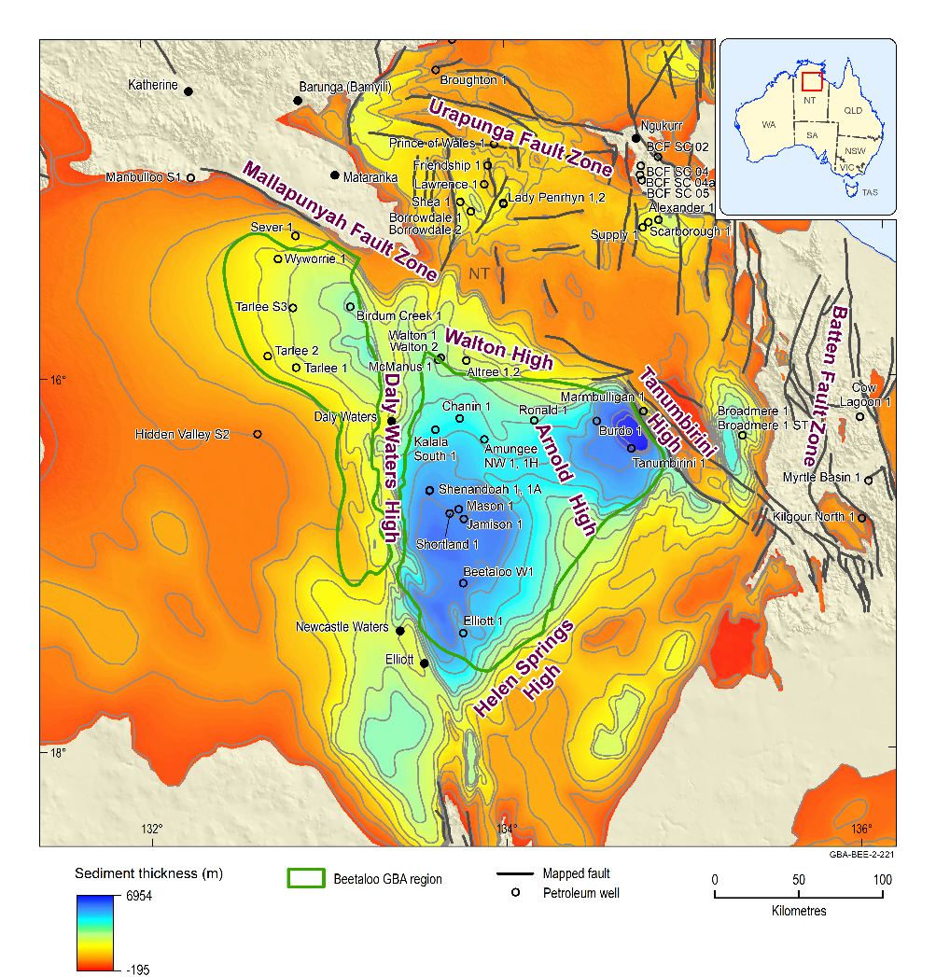
Figure 5 Structural elements map of the Beetaloo Sub-basin, overlain on the total sediment thickness from base of the Roper Group to the surface
Contour interval (C.I.) = 500 m
Data: major faults and sediment thickness from Frogtech Geoscience (2018b); structural elements from Plumb and Wellman (1987), Silverman et al. (2007) and Munson (2016)
Element: GBA-BEE-2-221

Jamison sandstone, Hayfield mudstone and Kiana Group
The Jamison sandstone, Hayfield mudstone and Kiana Group are part of the Centralian A Superbasin (see Section 3.4.6 in Orr et al. (2020)). These units are the focus of research, and their stratigraphic relationships may be updated as part of the Northern Territory Geological Survey’s current four-year (2018 to 2022) ‘Resourcing the Territory’ program. This program, and the previous (2014 to 2018) ‘Creating opportunities for resource exploration’ program (CORE), have the goal of creating a robust stratigraphic framework across the greater McArthur Basin (Munson, 2019). Changes to the stratigraphy of these units may have implications for their extent, connectivity and potential as a regional aquifer. Further information on these units is available in Orr et al. (2020).
Jamison sandstone and Hayfield mudstone
Younger Proterozoic rocks above the Roper Group in the Beetaloo GBA region include the Jamison sandstone and overlying Hayfield mudstone (Figure 4).
The Jamison sandstone includes minor shale interbeds and is an aquifer to partial aquifer. In the western Beetaloo Sub-basin, it is thickest mid-basin around Tarlee-1 (110 m) and Birdum Creek-1 (97 m), thinning northward (57 m in Wyworrie-1) and southward to be absent at Hidden Valley-S2. In the eastern Beetaloo Sub-basin, nine intercepts indicate the unit is thickest in the south-eastern two-thirds of the sub-basin (up to 163 m thick). The unit thins north-westwards from approximately 100 m in Ronald-1 and Balmain-1 to approximately 70 m (Chanin-1) and is absent over the Walton High.
In the western Beetaloo Sub-basin, the Hayfield mudstone is only present in Tarlee-1&2, where it has a maximum thickness of 160 m in the latter. In the eastern Beetaloo Sub-basin, this mudstone sequence is absent through erosion along the Walton High and northern margin, as well as in the southernmost region. The thickest preserved section is in the central part of the sub-basin, extending from Balmain-1 and Shenandoah-1 (449 m) eastwards to Tanumbirini-1 (569 m).
The Hayfield mudstone and Jamison sandstone have not suffered as much deformation as the underlying Roper Group. Several deep-seated faults that offset the Roper Group do not penetrate these overlying units. The implication of less faulting and deformation is that potentially there are fewer secondary paths for connectivity.
Kiana Group (Bukalara Sandstone and Cox Formation)
The Bukalara Sandstone is the basal member of the Neoproterozoic Kiana Group (Figure 4), and its distribution in the Beetaloo GBA region is obscured by the overlying Antrim Plateau Volcanics (Figure 6). The formation comprises thick-bedded quartz feldspathic and lithic sandstone with pebble conglomerates and minor interbedded shale. The Bukalara Sandstone is considered porous and permeable due to minimal occlusion by cements (Lanigan et al., 1994), which suggests that a proportion of the primary porosity is preserved. This unit is strongly jointed where it outcrops (Kruse et al., 2013). These fine-scale structures represent secondary porosity and potentially provide permeable pathways for groundwater flow.
It has a discontinuous distribution (see Section 4.3.2.1 in Orr et al. (2020)) within and adjacent to the Beetaloo GBA region. The Bukalara Sandstone is intersected in 11 petroleum wells in the Beetaloo GBA region (Figure 6) and is up to 390 m thick subsurface.
The Bukalara Sandstone appears to occur in the central parts of the western Beetaloo GBA region, reaching up to 135 m in thickness in Wyworrie-1 (Figure 6). In the eastern Beetaloo GBA region, it thickens eastwards, from Shenandoah-1 and Balmain-1 (58 m) through Amungee NW-1 (105 m) to Tanumbirini-1 (390 m). The Bukalara Sandstone is up to 72 m in thickness further north on parts of the Walton High (along the margin) and presumably continuous northwards towards outcropping areas outside the region. Where it outcrops to the north of the Beetaloo GBA region on Nutwood Downs Station, it has an estimated thickness of 60 m.
The sandstone unit is thin (less than 25 m in Jamison-1, Shortland-1) to absent in southern parts of the eastern Beetaloo GBA region.
The Cox Formation is only recognised in two petroleum wells in the Beetaloo GBA region (McManus-1 and Tarlee-S3, see Figure 6 for locations of wells). EcOz Environmental Consultants (2015) reports that thin discontinuous intersections of Cox Formation occur in the southern part of the western Beetaloo GBA region. It may be that this unit is not widespread, or alternatively, it has not been recognised as of February 2019 in the stratigraphic logs. The Kiana Group is unconformably overlain by the Antrim Plateau Volcanics.
The Bukalara Sandstone is considered porous and permeable due to minimal occlusion by cements and hence, where the unit is present, could act as a vertical or horizontal conduit. However, the Cox Formation, as a leaky aquitard, is expected to act as a barrier to connectivity where present.

Kalkarindji Province and Georgina, Daly and Wiso basins
Units of the Kalkarindji Province, and those of the overlying Georgina, Daly and Wiso basins are part of the Centralian B Superbasin (Orr et al., 2020) and make up much of the extensive cover over the Roper Group in the Beetaloo Sub-basin. From petroleum well intercepts, these sequences cumulatively vary in thickness from 102 to 554 m, with an average thickness of 344 m (for further detail see Section 4.3.3 in Orr et al. (2020)).

Kalkarindji Igneous Province
The Antrim Plateau Volcanics (Bultitude, 1976), Nutwood Downs Volcanics and Helen Springs Volcanics are subsets of the extensive flood basalts of the late Early Cambrian Kalkarindji Igneous Province (Ahmed and Munson, 2013). This volcanic sequence contains a series of predominantly fine-grained massive basalt flows with a vesicular zone at the top of individual flows. Sedimentary rocks found between basalt flows include aeolian sandstone, chert and minor limestone (Brown, 1986). Thicker sections of the Antrim Plateau Volcanics may have negligible primary porosity as the vesicular spaces are often infilled with chalcedony, agate, prehnite, amethyst or zeolites. Locally, bands of bitumen are known to be stratiform within the flows (Glass et al., 2013). Outcrop of the Antrim Plateau Volcanics is found outside the Beetaloo GBA region (Figure 6). Within the region the Antrim Plateau Volcanics is unconformably overlain and completely covered by the Cambrian Limestone Aquifer (CLA) and the Carpentaria Basin.
The Antrim Plateau Volcanics are readily identified on magnetic imagery (Clifton, 2008) and can be up to 440 m thick. In the eastern Beetaloo GBA region, they are thickest in the central part of the northern margin and thinnest immediately south in the depocentre over Amungee NW-1, Balmain-1 and Shenandoah-1. In the western Beetaloo GBA region, the volcanics sequence exceeds 100 m thickness and increases westwards to over 150 m in Tarlee-2, Tarlee-S3 and Hidden Valley-S2, but are absent in the north-eastern and southernmost regions (Figure 6). Two significant areas where the volcanics are absent lie in the southern and easternmost regions of the Beetaloo GBA region (Figure 6). These are areas where the CLA is in direct contact with underlying units, which would increase the potential for connectivity.
The thick basalts form a regional aquitard. However, in some areas the volcanics are used as a local aquifer to supply water for local communities and the pastoral industry. Aquifer development generally relies on secondary porosity, such as fault-related fracturing (Randal, 1973; Yin Foo, 2002), open and interconnected vesicular bands, interbedded sandstone layers within the volcanic sequence or porosity in the deep weathering profile (Randal, 1973). Where present and saturated though, the CLA is the preferred water source.
Using geophysical techniques, Knapton (2000) delineated regional-scale faulting and fracturing in the western Beetaloo GBA region (Sturt Plateau), including the Birdum Creek Fault (outlined on Figure 7, and in Section 3.2.3.2). Regional geophysics information such as aeromagnetics images (Figure 7) suggests there are also more local-scale features, including lineaments (possible faults, fractures) and as well as possible collapse structures relating to volcanism (see Foss and Dhu (2016)). A series of regular north-west trending lineaments were postulated to be related to variations in palaeo-topography of the Antrim Plateau Volcanics (Yin Foo and Matthews, 2001). These variations could be caused by presence of aeolian sandstones interbedded with the volcanics (Cambrian aged sand dunes). It is uncertain whether these lineaments also have some structural control, and it is not known whether they influence aquifer interconnectivity or hydraulic characteristics of the Antrim Plateau Volcanics.
In parts of the Beetaloo GBA region where the Antrim Plateau Volcanics do not underlie the CLA (Figure 6) there is potential for leakage between the CLA and the underlying Bukalara Sandstone aquifer. Similarly, there is potential for leakage between the CLA and the Roper Group in discrete areas near the margins of the Beetaloo GBA region, where the Hayfield mudstone and Jamison sandstone are absent or thin towards the sub-basin’s margin (see Figure 44, Figure 45 and Figure 46 for examples).
In summary, while the volcanics are generally considered to be a regional aquitard, they are utilised as a local fractured rock aquifer (Fulton and Knapton, 2015b), primarily in the north-western part of the Beetaloo GBA region. There is also potential that where present, the intra-volcanic sandstones would also contribute groundwater to bores.
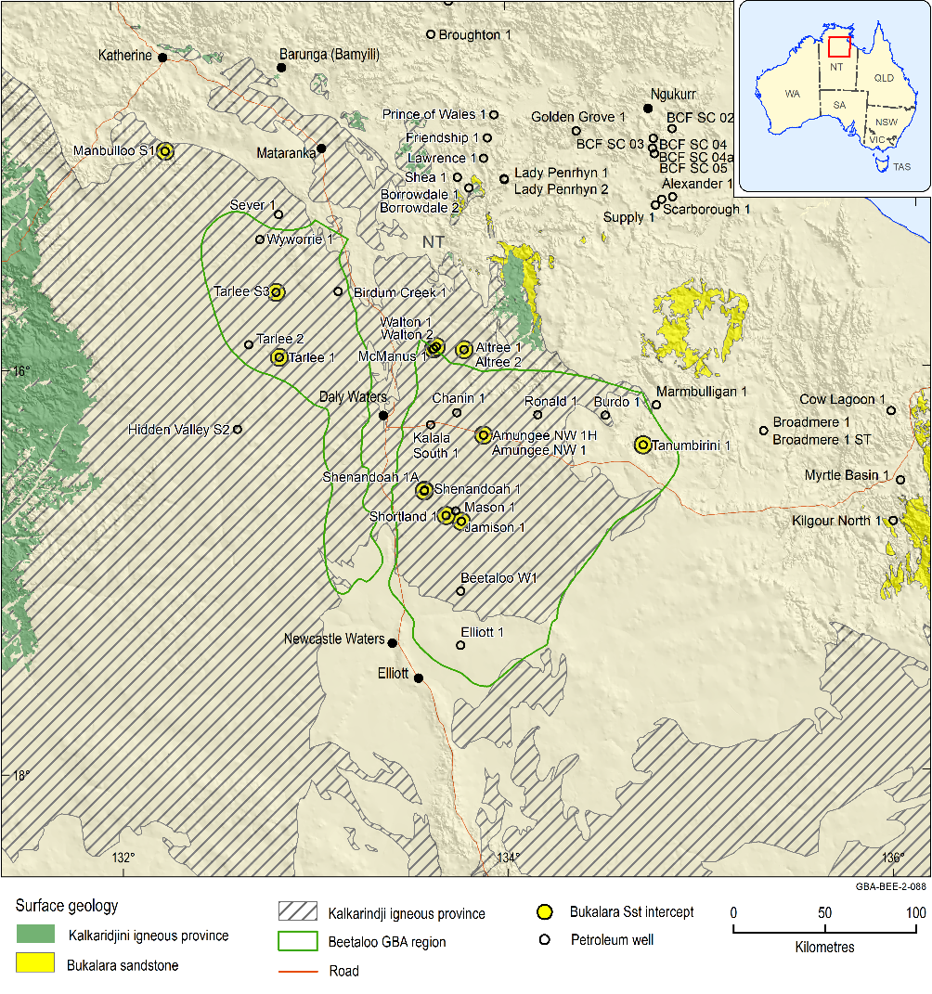
Figure 6 Distribution of the Antrim Plateau Volcanics (Kalkarindji igneous province) and Bukalara Sandstone drillhole intercepts in the Beetaloo GBA region
Where the Antrim Plateau Volcanics are not present in the Beetaloo GBA region, i.e. areas where striping is not present) are areas where there is potential for direct vertical connectivity between the Neoproterozoic Kiana Group and the overlying Cambrian Limestone Aquifer..
Data: surface geology (Geoscience Australia, 2012); well intercepts (Geological and Bioregional Assessment Program, 2019f) and Northern Territory Government (2018); interpreted Kalkarindji Suite Volcanics extent from Frogtech Geoscience (2018b)
Element: GBA-BEE-2-088
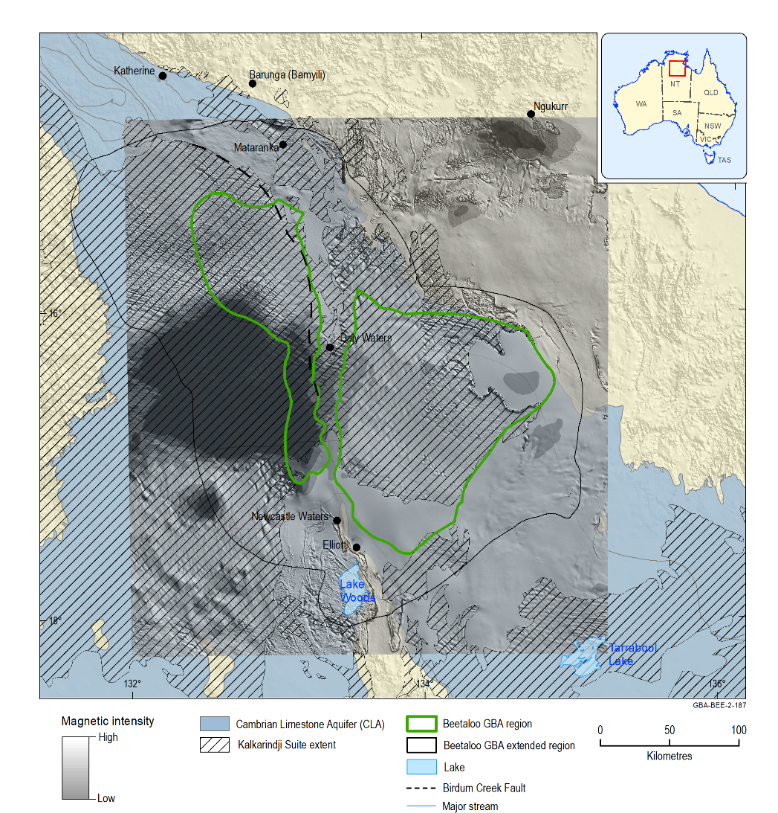
Figure 7 Relationship between the Antrim Plateau Volcanics and the overlying Cambrian Limestone Aquifer
Where the Antrim Plateau Volcanics aquitard are absent in the Beetaloo GBA region (i.e. areas with no striping), there is potential for direct vertical connectivity between the Neoproterozoic Kiana Group and the overlying Cambrian Limestone Aquifer. Within the volcanics, aeromagnetics images suggest there are geological features such as lineaments (faults, fractures, palaeo-topographic features) and localised collapse features.
Data: Kalkarindji Suite Volcanics extent from (Frogtech Geoscience, 2018b); aeromagnetics image (Geological and Bioregional Assessment Program, 2019e)
Element: GBA-BEE-2-187

Cambrian Limestone Aquifer
The CLA (Fulton and Zaar, 2009) is a significant regional aquifer system of variably fractured and karstic rocks that extend across the Georgina, Wiso and Daly basins (Figure 8). The Montejinni Limestone, Hooker Creek Formation and Point Wakefield beds in the Wiso Basin; Tindall Limestone, Jinduckin Formation and Oolloo Dolostone in the Daly Basin; and Gum Ridge and Anthony Lagoon formations of the Georgina Basin (Figure 4) make up the extensive CLA system that hosts the principal accessible groundwater resource in the Beetaloo GBA region. Broadly, the aquifer system is informally divided into an upper CLA sequence and a lower CLA sequence which, on Figure 4, are referred to as the ‘Gum Ridge Formation and equivalents’ (Gum Ridge Formation, Tindall Limestone, Montejinni Limestone) and the ‘Anthony Lagoon Formation and equivalents’ (Anthony Lagoon Formation, Jinduckin Formation, Hooker Creek Formation and Point Wakefield beds). Overlying the Jinduckin Formation is the Oolloo Dolostone, which is found well to the north of the Beetaloo GBA region in the Daly Basin.
Some minor discrepancies in terminology are apparent between the stratigraphic and hydrostratigraphic units that overlie the Montejinni Limestone in the Wiso Basin and their correlatives in the Daly Basin. The Montejinni Limestone is conformably overlain by the Hooker Creek Formation and Lothari Hill Sandstone (Kruse and Munson, 2013a). In Wiso Basin, these three units collectively are described as ‘middle Cambrian sequence 1’. This is, in turn, unconformably overlain by the Point Wakefield beds (middle Cambrian sequence 2). Sequence 1 in the Wiso Basin stratigraphically corresponds with the Tindall Limestone, which is described as ‘middle Cambrian sequence 1’ in the Daly Basin (Kruse et al., 2013). Sequence 2 in the Daly Basin comprises Jinduckin Formation and Oolloo Dolostone. However, from a hydrostratigraphic perspective, the Hooker Creek Formation confines the underlying Montejinni Limestone and is considered to be a hydrostratigraphic equivalent of the Jinduckin Formation, which confines the Tindall Limestone in the Daly Basin (Tickell, 2005). For this report, the Hooker Creek Formation is considered to be the hydrostratigraphic equivalent of the Jinduckin Formation, despite the apparent inconsistencies with the Wiso Basin lithostratigraphy outlined in Kruse et al. (2013).
The limestone sequences include minor siltstone layers. Using geophysical logs (gamma logs) Chapman (2019) identified that some of these siltstone layers are regionally correlatable across the Georgina, Wiso and Daly basins. Chapman (2019) delineated three correlatable siltstone marker horizons in the Gum Ridge and equivalent sequences, while four siltstone marker beds were identified in the Anthony Lagoon and equivalent sequences. Potentially, these marker horizons could be used to refine the stratigraphic and structural understanding of the CLA and help identify more local-scale structures that may influence groundwater flow and karst development. This information could also potentially be used to refine groundwater level assessments by grouping groundwater bores based on well screen stratigraphy.
Where present, the Jinduckin, Hooker Creek and Anthony Lagoon formations (Figure 8) can confine the underlying limestone aquifers. However, where significant thicknesses of these formations occur below the level of the regional watertable they can also be viable aquifers in their own right (Knapton, 2006).
The Anthony Lagoon Formation is a fractured rock aquifer comprising silicified limestone, dolomitic siltstone, fine-grained sandstone and dolomite. Dolostones tend to have greater inter-crystalline porosity and more vughs than are present in tighter limestone (Randal, 1973). Like the underlying Gum Ridge Formation, the Anthony Lagoon Formation has dissolution and karst overprints that significantly enhance permeability. The distinction between the two limestone aquifers is difficult to pick from many bore logs due to loss of sampling drilling fluid circulation while drilling. Consequently, crossover between bore and water quality statistics is to be expected with these formations (Fulton and Knapton, 2015b).
The Jinduckin Formation of the Daly Basin comprises interbedded sandstone, siltstone, dolostone and dolomitic limestone in thin to medium flaggy beds that are in part silicified. Overlying the Jinduckin Formation approximately 60 km to the north of the Beetaloo GBA region is the unconfined Oolloo Dolostone aquifer.
As indicated in previous paragraphs, a distinctive feature of the CLA is the presence of karst (e.g. caves, cavities, sinkholes), which form where either surface water or groundwater dissolves the limestone matrix. In the CLA, karst is often evident at the surface as sinkholes and other features. Karstic limestone aquifers are characterised by highly variable underground drainage systems that in areas can have very high hydraulic conductivity and surface recharge enhanced by the presence of large conduits (sinkholes) near surface. Porosity and permeability is highly dependent on the development of secondary dissolution (karst) features, and the occurrence of fractures and other structures. Karst development is widespread but not necessarily interlinked so aquifer permeability is difficult to correlate spatially (Randal, 1973). Karst development can be enhanced along structures and influence groundwater flow direction (see Section 3.3.3).
In the Beetaloo GBA region the Cambrian Limestone Aquifer is overlain by the Carpentaria Basin (see Sections 3.2.4). Carpentaria Basin rocks can impede recharge to the underlying CLA in areas where the basin sequence is sufficiently thick and dominated by siltstone.
Karstic features can be apparent in outcrop or be obscured and infilled by younger sediments. Areas with abundant sinkholes near surface (a karst feature) from the 1:250,000 map sheets are shown on Figure 9. It should be noted that the sinkhole areas are indicative only, as it is not apparent how comprehensive and systematic the regional mapping of sinkholes was at the time of mapping (1960s to early 1970s). Also, limestone is not mapped as outcropping in these areas; rather, it is obscured by a cover of Cretaceous and Cenozoic sediments of variable thickness. It is likely that more sinkhole features will be identified in the future, particularly if other data such as remote sensing or LiDAR are utilised. For instance, karst-related features are extensive in areas of outcrop (for examples see Karp (2008) or Tickell (2005)), but these are not identified on Figure 9. Further work to refine distribution of near-surface karst, thickness of the Carpentaria Basin and their influence on recharge pathways and processes will be undertaken in Stage 3.
Overall, broad structural controls on the distribution of the different limestone sequences are evident (Figure 8). A structural high is situated underneath the confluence of the three basins (see sections in Chapman (2019)). Here, occurrence of the Anthony Lagoon or equivalent units are absent. Structures and conjugate fracture systems are evident in this region, which affects both the limestone and the Antrim Plateau Volcanics (Yin Foo and Matthews, 2001; EcOz Environmental Consultants, 2015; Knapton, 2000). The most significant of these is the Birdum Creek Fault (Figure 8) in the Daly Basin. There is approximately 200 m offset across this fault, which is downthrown to the east (Yin Foo, 2002; Knapton, 2000). To the east of this fault is the Tindall Limestone and a portion of the Jinduckin Formation (in the vicinity of Mataranka and Katherine). To the west of the fault the limestone sequence is much thinner (Figure 8). To the south of the Daly Basin this fault follows the Daly River Arch and is coincident with deeper Proterozoic structures (EcOz Environmental Consultants, 2015). It may be that the Birdum Creek Fault formed in part through reactivation of deeper structures.
Other smaller scale structures identified on the LARRIMAH and DALY WATERS 1:250,000 geological map sheets in the Beetaloo GBA region (Figure 9) show north-east or north-west trends. The north-east trending structures also approximate trends of some of the regional drainage and broad flat-bottomed valleys that are evident in topography on the NEWCASTLE WATERS, TANUMBIRINI and BEETALOO geological map sheets. This suggests that there is some degree of structural control on these larger topographic features, even though in these areas the Carpentaria Basin sequence is relatively thick (Figure 10). The degree to which these north-east trending features have influenced karst development and groundwater flow directions at depth in the CLA is unknown.
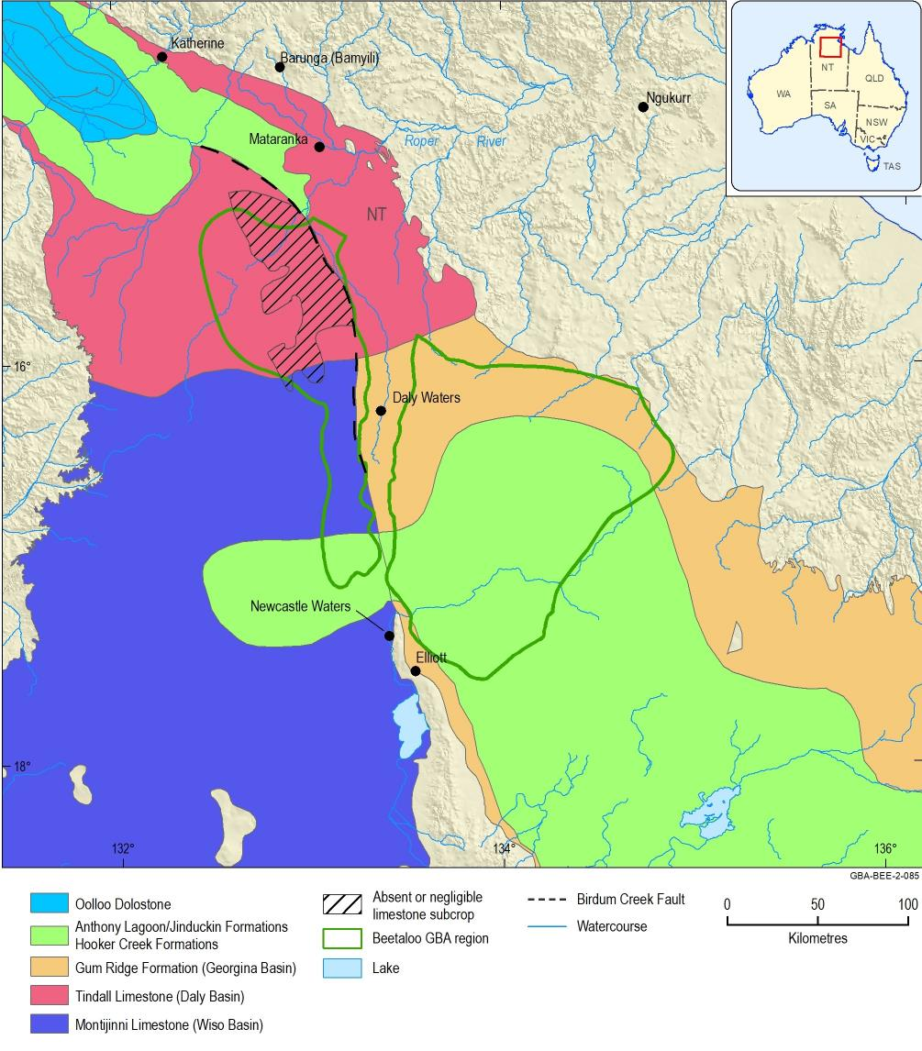
Figure 8 Distribution of major hydrostratigraphic units that make up the Cambrian Limestone Aquifer in the Beetaloo GBA region
Data: Gum Ridge Formation and equivalents and Anthony Lagoon Formation and equivalents (Department of Environment and Natural Resources (NT), 2018c); Limestone subcrop (Department of Environment and Natural Resources (NT), 2008)
Element: GBA-BEE-2-085
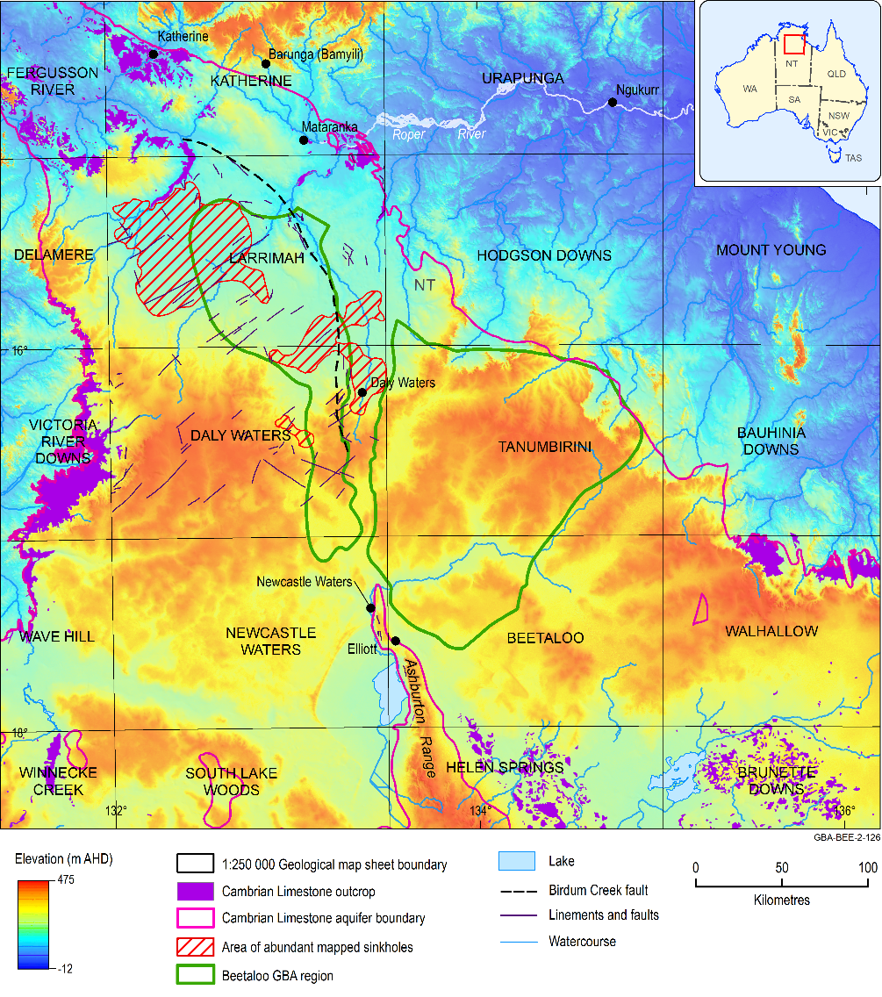
Figure 9 Areas with sinkholes and near-surface structures identified on 1:250,000 geological map sheets in the Beetaloo GBA region
Note: Locations of sinkhole areas on this map are indicative only and derived from the 1:250,000 geological map sheets. The accuracy and consistency of sinkhole identification on the different map sheets is unknown. More karst-related features are evident than what is shown on this map, particularly in areas of CLA outcrop or where sequences overlying the CLA are thin.
Data: geological sheets: LARRIMAH (Randal et al., 1969); DALY WATERS (Brown and Randall, 1969)
Element: GBA-BEE-2-126

Carpentaria Basin
The Carpentaria Basin covers much of Beetaloo GBA region. Structure contours (Figure 10), derived from Randal (1973) indicate that that depocentres exist either side of the Daly Waters High. The eastern depocentre for the Carpentaria Basin sequence occurs in the eastern Beetaloo GBA region overlying the Georgina Basin. Here it can be up to around 132 m thick. The western depocentre is situated outside the Beetaloo GBA region, to the north-west of Newcastle Waters (Figure 10b). Except for some isolated pockets, over much the Daly Basin the Cretaceous sequence is less than 45 m thick. It should be noted that that the thicknesses and depths for the Carpentaria Basin, as outlined on Figure 10, need to be revised with more recent data. Further work to refine the thickness of the Carpentaria Basin, and its influence on recharge pathways and processes, will be undertaken in Stage 3.
The regional Carpentaria Basin sequence (until recently known as the Mullaman beds but now called the Walker River Formation) is divided into three informal units (units A, B and C; Ahmed and Munson (2013)). The distribution of the three units has not been clearly mapped (Munson et al., 2013b). Units B and C predominantly consist of a sequence of siltstone and claystone, and where the Carpentaria Basin thickens, are likely to form much of the sequence. Unit A is of variable thickness, usually in the order of 3 to 25 m, with a maximum thickness of 37 m. In areas of thin Cretaceous cover, sinkholes that have developed in the underlying limestone are evident at the surface (see Figure 9).
Around Mataranka and the Roper River area, Carpentaria Basin sequence has been deformed into an open syncline (Karp, 2008), and the Roper River in part flows eastwards along the axis of the fold. As outlined on Figure 9, north-east trending lineaments with a similar orientation to some of the major drainage lines that have cut back into the plateau have been mapped at the surface.
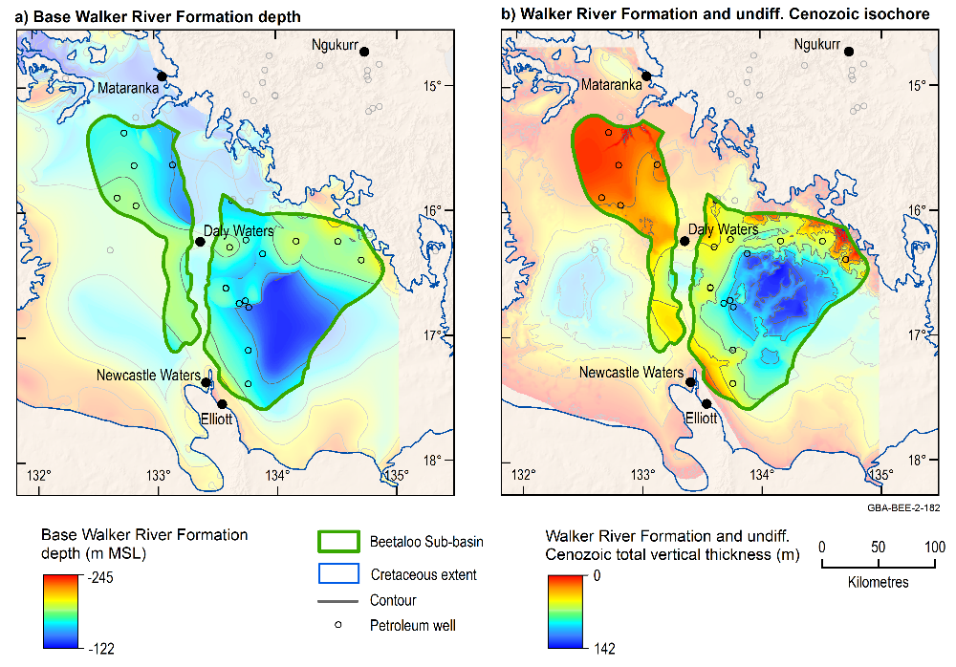
Figure 10 Carpentaria Basin – elevation of bottom of Carpentaria Basin and vertical thickness
Contour interval (C.I.) = 25 m. Depth and thickness maps after Randal (1973).
Source: depth and thickness information (Randal, 1973); extent (Department of Environment and Natural Resources (NT), 2020)
Data: Walker River Formation base depth and isochore grids GBA derived dataset (Geological and Bioregional Assessment Program, 2019a)
Element: GBA-BEE-2-182

Cenozoic
Interspersed across the Beetaloo GBA region is a thin cover of Cenozoic sediments and regolith. The broad grassed plains that are a feature of parts of the tablelands include Quaternary black soil plains, alluvial and colluvial deposits, sand plains and minor freshwater limestone (Golliger beds).
Lateritic regolith developed during the Cenozoic on the top of the Cretaceous sequence, comprises a massive and permeable ferrugunised and pisolitic upper section, and a strongly kaolinised impermeable lower section. Laterite profiles of up to 24 m thickness have been recorded in water bores in the west of the Beetaloo GBA region.
The Golliger beds are Miocene freshwater limestone of up to 3 m thickness, with very limited exposure near the eastern boundary of the Beetaloo GBA region. Freshwater limestone (tufa) deposits deposited by spring discharge from the CLA occur outside the Beetaloo GBA region at areas such as Mataranka Thermal Pools and Flora River springs. These deposits can be up to a few metres thick.
Quaternary alluvial deposits of sand, gravel and clay occur across the region in drainage lines, floodouts, swamps and lakes, and one of the thickest occurrences (up to 24 m) adjoins the Ashburton Range (Fulton and Knapton (2015b); see Figure 9 for location of Ashburton Range). Thin colluvial deposits also occur on the flanks of this range, as well as around Proterozoic rocks in the north-east of the Beetaloo GBA region. In the western Beetaloo GBA region, Cenozoic sediments are generally less than 25 m thick (EcOz Environmental Consultants, 2015). Extensive deposits of tufa (freshwater limestone) up to 5 m thick occur around Mataranka Thermal Pools and Elsey National Park (Karp, 2008).
Black soil plains are evident as grassy downs and are found to the south of the Beetaloo GBA region on the Barkly Tablelands. Black soil can be up to 6 m thick (Randal, 1973).
Randal (1973) notes occurrence of waterholes (both perennial and ephemeral, see Figure 6 in Randal (1973)) that are not situated in defined watercourses across the region. These waterholes are situated within sub-circular or elliptical depressions towards which drainage from a small surrounding area is directed. They could represent the surface expression of karstic collapse in the CLA (i.e. buried sinkholes) beneath the Carpentaria Basin (Randal, 1973) or Cenozoic sediments.

Hydrodynamics
Within the Beetaloo GBA region, groundwater bores draw water primarily from aquifers in the Georgina, Wiso and Daly basins. For older Proterozoic rock sequences such as the Roper Group and Jamison sandstone and Bukalara Sandstone, the hydrodynamics can only be inferred from sparse petroleum well data (Section 2).

Roper Group
The Roper Group comprises the Collara and Maiwok subgroups (Figure 4). Aquifers in these rocks are utilised as local water supplies north of the Beetaloo GBA region in the Roper River catchment area. However, caution is required when inferring hydraulic conditions for the Roper Group in the Beetaloo GBA region from other areas, as the Roper Group within the Beetaloo GBA region has experienced much less tectonism than that outside the Beetaloo GBA region in the rest of McArthur Basin (Silverman et al., 2007). Furthermore, in the Beetaloo GBA region, the Roper Group is far more deeply buried by overlying sequences of the Georgina, Wiso, Daly and Carpentaria basins. Depth of burial, structural style, degree of diagenesis, geothermal gradients and potential for connectivity with overlying aquifers can influence the hydrodynamics of the deeper Proterozoic sequence within the Beetaloo Sub-basin, in contrast to that outside of the region.
Structures can act as either conduits or barriers to flow (Bense et al., 2013), as well as provide porosity for groundwater storage. In the Beetaloo Sub-basin, structural offsets, structurally derived permeability and porosity modify regional hydrodynamics and groundwater flow. Depth of burial and diagenetic effects including compaction, deposition of pore infilling cements (e.g. quartz, carbonates) and clays, also influence hydrogeological properties of the rockmass and groundwater hydrodynamics.
The buried Proterozoic sequence of the Beetaloo Sub-basin is largely flat-lying and relatively undeformed, except for areas around basin margins and major structural elements within the basin such as the Helen Springs High, Daly Waters High, Walton High and the Arnold High (see Figure 5 for location). Silverman et al. (2007) noted that seismic imagery indicates that faults and related fractures do not generally extend above the Roper Group into the Hayfield mudstone.

Collara Subgroup
No petroleum wells have intersected Collara Subgroup within the Beetaloo GBA region. However, outside the Beetaloo GBA region, it is likely that some springs are supplied by groundwater from the Collara Subgroup (Figure 13 and Section 3.4.3). Also, there are bores that draw groundwater from it (Zaar, 2009a). For instance, at Borroloola located about 170 km east of the Beetaloo GBA region, sandstones in the Collara Subgroup (e.g. the Abner Sandstone) are tapped as the water supply for the township. Individual bore yields of up to 12 L/second have been recorded, and aquifer transmissivity is estimated to be between 34-85 m2/day with a storativity in an estimated range of 8.2 x 10-6 to 1.7 x 10-5 (Woodford and Yin Foo, 1995). Here permeability is attributed to the effects of weathering and dissolution of carbonate cements in the sandstone. In outcrop, the Abner Sandstone has been classified as a fractured rock and weathered rock aquifer with a local flow scale system and a likely yield range of 0.5 to 5 L/second (Zaar, 2009a).

Maiwok Subgroup
Petroleum drilling data that is pertinent to understanding the hydrogeology of the Maiwok Subgroup are available and have been compiled for this report (See Section 2.2, Table 1, Table 2, Figure 11 and Figure 12). Outcrop of the Maiwok Subgroup occurs to the north and east of Beetaloo GBA region (Figure 13). As was the case with the Collara Subgroup, outside the Beetaloo GBA region the Maiwok Subgroup is locally used as aquifer and may also be a source aquifer(s) for some springs (Section 3.4.3). In the Beetaloo GBA region the main units within the Maiwok Subgroup that may potentially have some aquifer properties (i.e. enough permeability to transmit reasonable quantities of groundwater) are the Moroak and Bessie Creek sandstones.
To date, the Bessie Creek Sandstone has only been intersected by a few wells (Orr et al., 2020). Indications are that on structure, there may be some porosity and permeability (Silverman et al., 2007). There is also potential for basin-centred tight gas plays (Hall et al., 2020); (Silverman et al., 2007). These observations have bearing on its hydrodynamics, as at shallower levels, in discrete structural corridors, the unit may have enough permeability to act locally as an aquifer (Fulton and Knapton, 2015b). However, where basin-centred tight gas plays prevail (Hall et al., 2020), the sandstone would have lower permeability and porosity would be more likely to be gas saturated with little groundwater. Thus, it is more likely to act as an aquitard.
The Moroak Sandstone is an extensive, basin-wide, sandstone dominated unit up to 498 m thick (Orr et al., 2020). It is confined by the underlying Velkerri Formation and the overlying Kyalla Formation. Porosity and permeability are predominantly secondary, derived mainly from fracturing (Fulton and Knapton, 2015b; RobSearch, 1997). Core porosities generally range from 6% to 15% and occasionally up to 19% at depths near 700 m. In Elliott-1, the unit has 57.9 m of sandstone greater than 10% (average 13.4%). Permeability values range from 0.01 (Silverman and Ahlbrandt, 2011) to 55 to 274 millidarcys (Tulloch et al., 2015);(Fulton and Knapton, 2015b), which equates to approximately 0.05 to 0.23 m/day.
Some water flows of groundwater have been documented to occur from Moroak Sandstone to petroleum wells (Table 2). The wells outlined in Table 2 are located in regions of higher permeability that are considered to exist ‘on structure’ (see Section 3.2.1 for an explanation). As an example, over the Arnold High (Figure 5), relatively high water flows up to 7 L/second, occur at depths greater than 1000 m (Table 2) (Silverman and Ahlbrandt, 2011; Fulton and Knapton, 2015b). These authors noted there were water flows in wells in the vicinity of the Walton and Helen Springs Highs (see Figure 5 for location of structures). Areas of higher permeability are inferred to exist in other significantly structured areas, such as over the Daly River Arch. Cross-sections outlined in Fulton and Knapton (2015b) suggest that the Moroak Sandstone is significantly faulted in this region; however, there is no drill data here to provide permeability estimates.
Groundwater hydraulic head calculated from DST shut-in pressures (Table 1) suggests that while pressures in the Moroak Sandstone at the well sites are sub-artesian, there is enough potential to lift water levels above level of the top of the Proterozoic unconformity. Hence, in the vicinity of the well in which measurements were taken (Figure 13), it is possible there in some areas there is enough potential for groundwater to flow vertically from Moroak Sandstone upward into overlying aquifers, if a suitable connective pathway were to exist. Groundwater from the Moroak Sandstone is highly saline (see Section 3.3.1 and Fulton and Knapton (2015b) with temperatures in the order of 70 to 90 °C (Figure 12) at depths of 1100 to 1700 m.
As with the Bessie Creek Sandstone, the Moroak Sandstone may contain basin-centred tight gas plays (Hall et al., 2020); (Silverman et al., 2007)). Such plays would be characterised by low permeability, high gas saturation and no down-dip gas/water contact. Under such conditions they are likely to contain minimal free groundwater and consequently act as an aquitard rather than an aquifer.
The Kyalla and Velkerri formations are regional aquitards. With the high gas saturation in the Velkerri Formation, any intra-formational sand/siltstone zones would likely have very low free water saturation and thus cannot really be considered in terms of an aquifer/aquitard concept. Compartmentalisation of the Velkerri Formation is also anticipated where the Derim Derim Dolerite (sills and dykes) are present (see Figure 30 in (Orr et al., 2020)). While in-situ temperature will naturally vary with depth, the Kyalla and Velkerri formations are generally around 60 °C or hotter below 1000 m. Temperatures increase to 75 °C and higher, below about 1200 m.
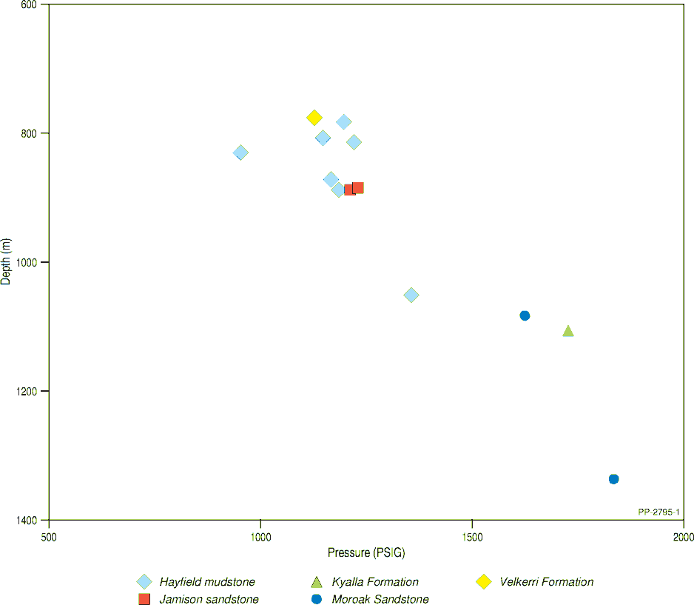
Figure 11 Pressure data from Proterozoic units compiled from petroleum exploration drilling
Data: Geological and Bioregional Assessment Program (2019f)
PSIG = PSI gauge pressure
Element: GBA-BEE-2-364

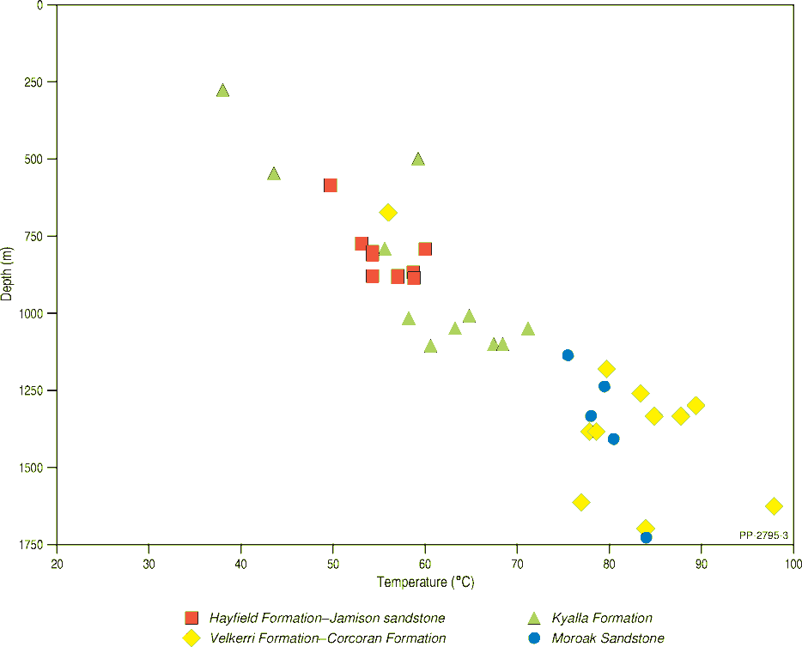
Figure 12 Temperature data from petroleum wells for Proterozoic sequences
Temperature data are ‘as reported’ in well completion reports. Not all of it has been corrected for localised cooling effects due to circulating drilling fluids (see Figure 2)
Data: Geological and Bioregional Assessment Program (2019f)
Element: GBA-BEE-2-365
Table 2 Water flows recorded into petroleum wells for the Proterozoic units
Well | From  (m) | To  (m) | Flow | Flow unit (as reported in WCR) | Flow (L/sec) | Formation | Comment
Amungee NW 1 | 1499 |  | 30 | barrels/hour | 1 | Moroak Sst
Amungee NW 1 | 1512 |  | 112 | barrels/hour | 5 | Moroak Sst
Burdo 1 |  |  |  |  |  | Moroak Sst | Significant water flows of very high salinity water
Chanin 1 | 1328 |  |  |  |  | Moroak Sst | Initially significant water flows produced at top of formation until the well was filled with mud
Elliott 1 | 1333 |  | 5200 | L in 98 minutes | 1 | Moroak Sst | ‘encouraging potential for flow from secondary fractures’ (p. 16 of well completion report)
Kalala 1 | 1558 |  | 397 | L/min | 7 | Moroak Sst | Calculated water inflow for open hole section from 1305–1558 m.
Ronald 1 | 1047 | 1069 | 3000 | barrels/day | 6 | Moroak Sst | Large volumes of water inflow encountered below 1045 m. Flow into well would ‘kill itself’ (i.e. essentially stopped flowing in) when water level in well reached about 180 m below Kelly bush (equates to 176 m below ground level)
1 barrel = 159 litres
Sst = Sandstone; WCR = well completion report
Whether an inflow to a petroleum well occurs or not is in part dependent on drilling method and condition of the hole at time of drilling. For instance, in a well where no inflows are recorded, the drilling mud density could have been have been high enough to impede inflows, or alternatively the formation was naturally tight with low permeability, which reduces the ability of groundwater to flow at a noticeable rate.
Data: Geological and Bioregional Assessment Program (2019f)
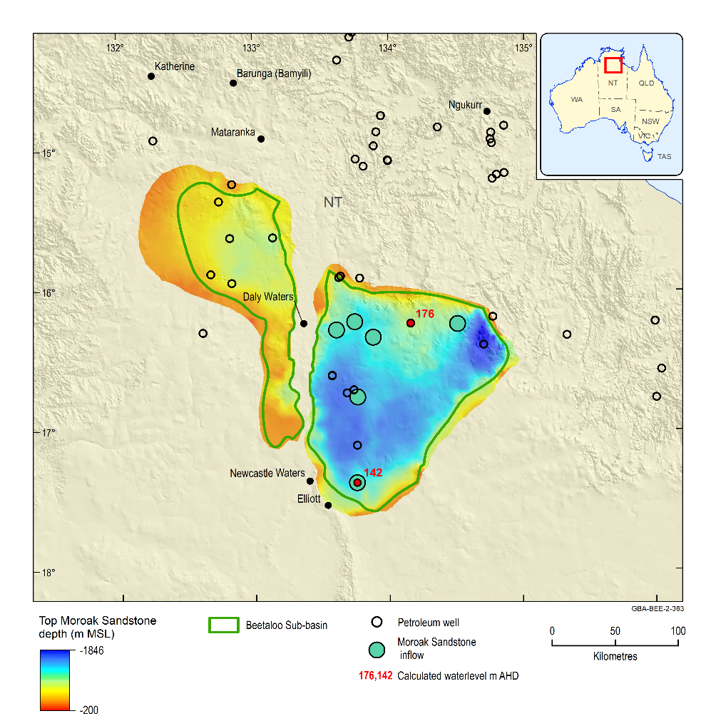
Figure 13 Groundwater inflows to petroleum wells from Roper Group, and calculated hydraulic head levels derived from drill stem test pressure data
AHD = Australian Height Datum; MSL = metres above sea level
Whether an inflow to a petroleum well occurs or not is in part dependent on drilling method and condition of the hole at time of drilling. For instance, in a well where no inflows are recorded, the drilling mud density could have been have been high enough to impede inflows, or alternatively the formation was naturally tight with low permeability, which reduces the ability for groundwater to flow at a noticeable rate.
Data: groundwater inflows: (Geological and Bioregional Assessment Program, 2019f), top of Moroak Sandstone (Geological and Bioregional Assessment Program, 2019a)
Element: GBA-BEE-2-363

Jamison sandstone, Hayfield mudstone and Kiana Group
Available temperature and formation pressure data for the Jamison sandstone and Hayfield mudstone are outlined in Figure 11 and Figure 12. From Figure 12, for temperatures between 500 to 1000 m, the temperatures of the Jamison sandstone and Hayfield mudstone are in the order of 50 to 60°C.
The Jamison sandstone occurs across much of the Beetaloo GBA region. It is usually confined between the overlying Hayfield mudstone and underlying Kyalla Formation. An exception though is where it unconformably overlies the Moroak Sandstone in southern parts of the eastern sub-basin towards the Helen Springs High, where it is in direct contact with either the Antrim Plateau Volcanics and/or the Gum Ridge Formation and equivalents ((Fulton and Knapton, 2015b) and (Hall et al., 2020)). It is also in direct contact with Antrim Plateau Volcanics around the northern margin. In such areas there is potential for connectivity between the Jamison and Moroak sandstone aquifers and shallower aquifers of the Georgina Basin (Figure 6). It could be prospective as a water supply for future drilling operations.
Porosity versus depth and porosity versus permeability plots for the Jamison sandstone suggest that most of the porosity is secondary in nature (Fulton and Knapton, 2015b); however, in trap situations where hydrocarbon accumulation preceded potential occlusion by silica and carbonate cements, existing early porosity has been preserved. Porosities generally range from 6% to 18% with occasional samples to 21%. The upper section of the formation has the best aquifer/reservoir properties where 53.5 m of sandstone has porosity >10% (average 12.6%) in Elliott-1 (Silverman et al., 2007). Permeability is usually less than a few millidarcys but can reach 124 mD (0.1 m/day) in discrete intervals.
Some water inflows have been recorded during drilling (Table 3) and salty formation water has been recovered in drill stem tests of the Jamison sandstone (Section 2.2 and Fulton and Knapton (2015b)). As was the case with Moroak Sandstone, calculated hydraulic head measurements (Table 1, Figure 14) for the Jamison sandstone suggest there is adequate potential for vertical groundwater flow towards shallower aquifers if a suitable connective pathway were to exist.
The Hayfield mudstone is a regional aquitard as well as a regional seal to underlying petroleum systems (Hall et al., 2020).
Information is limited about the degree of inter-aquifer leakage between the Roper Group, Jamison sandstone and Hayfield mudstone. Some aspects to consider with regards to potential leakage include:
- Presence of major structures or significant fracturing could act as either conduit or barrier (or both in different areas of a fault) depending on the local stress regime.
- Secondary fracture porosity is probably the most significant component of porosity in the Proterozoic units.
- Formation waters are highly saline (Section 3.4 and Figure 34), which suggests that interactions have been limited with shallower aquifers, evident in the areas where the samples were obtained (Section 3.4.2.1 and Figure 34).
- At the southern end of the eastern Beetaloo Sub-basin the Hayfield and Kyalla formations are absent, as are the Antrim Plateau Volcanics. This stratigraphic configuration enables the Jamison sandstone (and indirectly the Moroak Sandstone) to be in direct contact with shallower aquifers (Figure 6).
- The degree of connectivity between Roper Group outcrop located outside the Beetaloo GBA region, to Roper Group within the Beetaloo Sub-basin is unknown. However, as this sequence extends across different structural domains with different geological histories, and there is significant structuring around basin margins, it is probable that such dislocation would limit groundwater interaction between outcrop and basin.
- Calculated hydraulic head values indicate there is enough potential for upward leakage to occur from the Roper Group into overlying sequences (Table 1 and Figure 14) in some areas, if a suitably connective pathway were to exist.

Kiana Group
This section will focus on the Bukalara Sandstone as there is no hydrogeological information available for the Cox Formation. Groundwater bore information for the Bukalara Sandstone (detailed in Section 3.3.4 and Figure 34) occur predominantly to the north of the Beetaloo GBA region (Figure 34) on HODGSON DOWNS geological map sheet (Figure 9). Here, groundwater bores penetrate the overlying Antrim Plateau Volcanics, which forms a confining layer over the Bukalara Sandstone. Completion depths of bores screening the Bukalara Sandstone range from 32 to 150 m (average 89 m), and airlift estimates of bore yield range from 0.3 to 5 L/second (Fulton and Knapton, 2015b). Two pump tests indicate that aquifer transmissivity ranges from 18 to 79 m²/day. Storage coefficient estimates are not available. Groundwater levels in water bores screened in this unit range from 3 to 34 m below ground level (BGL) with an average of 17 mBGL. Groundwater flow is indicated to be to the north (Fulton and Zaar, 2009). North-west trending joint patterns are noted in the Bukalara Sandstone on the HODGSON DOWNS geological map sheet. The joints may locally enhance the hydraulic conductivity of the sandstone.
While the Bukalara Sandstone is a good local aquifer where it outcrops to the north, its characteristics are much less known within the Beetaloo GBA region. Within the Beetaloo GBA region, isolated inflows of up to 25 L/second are reported from some petroleum wells (Table 3, see Figure 14 for locations), which suggests that some parts of the Bukalara Sandstone have relatively good hydraulic conductivity and porosity. However, there is no water quality, formation pressure, or hydraulic property data available. Furthermore, as noted in Section 3.2.2, stratigraphic relationships between Bukalara Sandstone and other related units are under review. Changes to the stratigraphic relationship of the Bukalara Sandstone with other units may have implications for its potential as a water supply. For instance, this aquifer may become more widespread if it was found to be an equivalent of the Jamison sandstone rather than younger than it (Figure 4). While little is known, high flow rates suggest it has potential as a deep groundwater supply, particularly where the CLA is thin or absent in the western portions of the Beetaloo GBA region.

Table 3 Water flows recorded into petroleum wells for the Jamison and Bukalara sandstones
Well | From  (m) | To  (m) | Flow | Flow unit (as reported in WCR) | Flow (L/sec) | Formation | Comment
Amungee NW 1 | 321 | na | 1500 | L/min | 25 | Bukalara Sst
Tanumbirini 1 | 192 | na | na | na | na | Bukalara Sst | Changed drilling technique to cope with strong water inflows
Kalala 1 | 407 | 410 | 600 | L/min | 10 | Bukalara Sst | Strong water inflow
Tarlee S3 | 280 | na | na | na | na | Bukalara Sst | Water influx increased once Buckalara Sst was intersected
Shanandoah Shenandoah 1 | 360 | na | na | na | na | Bukalara Sst | Strong water inflows
Ronald 1 | 831.7 | 871.7 | na | na | na | Jamison Sst | Influxes of small volumes of formation water from basal parts of Jamison sandstone
1 barrel = 159 litres
na = not applicable; Sst = Sandstone
Whether an inflow to a petroleum well occurs or not is in part dependent on drilling method and condition of the hole at time of drilling. For instance, in a well where no inflows are recorded, the drilling mud density could have been have been high enough to impede inflows, or alternatively the formation was naturally tight with low permeability, which reduces the ability for groundwater to flow at a noticeable rate.
Data: Geological and Bioregional Assessment Program (2019f)
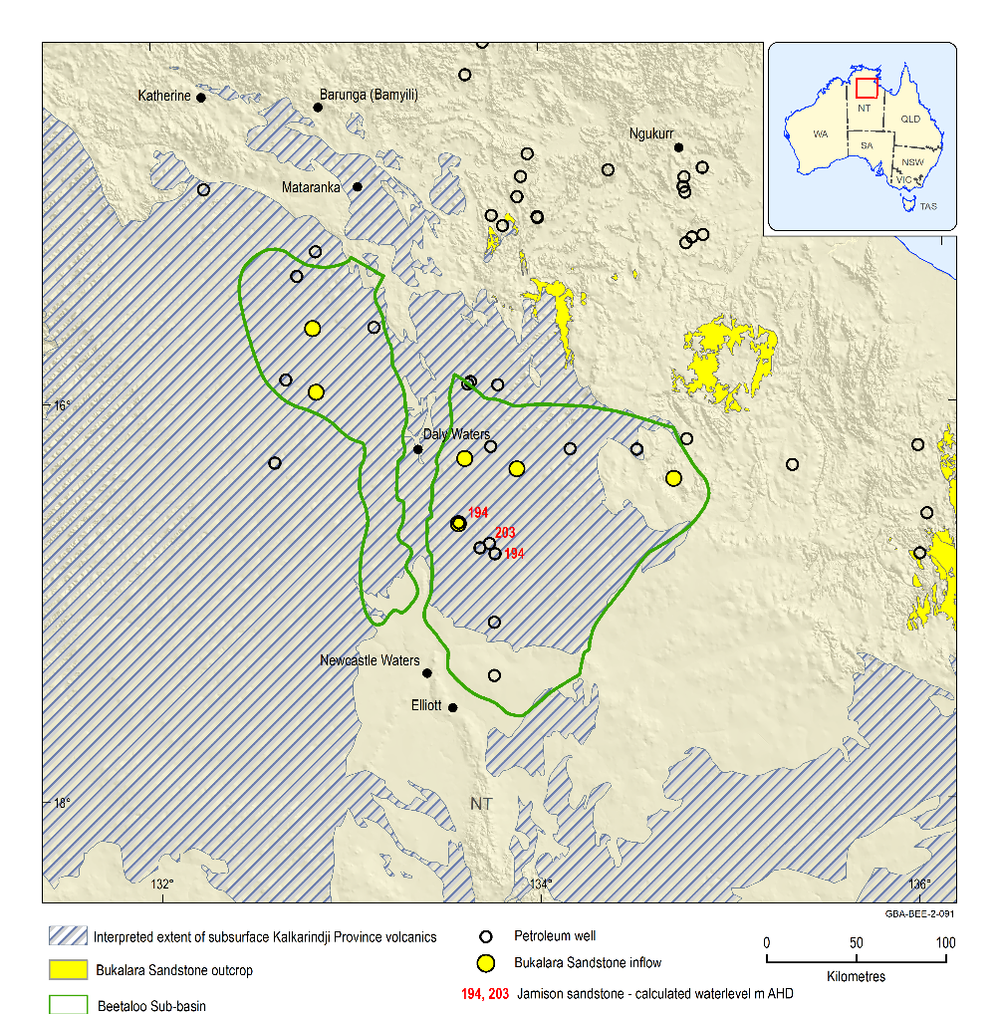
Figure 14 Groundwater inflows to petroleum wells from Jamison and Bukalara sandstones, and calculated hydraulic head levels derived from drill stem test pressure data
Whether an inflow to a petroleum well occurs is in part dependent on drilling method and condition of the hole at time of drilling. For instance, in a well where no inflow was recorded, the drilling mud densities could have been such that any inflows are impeded, or alternatively the formation could be naturally tight with low permeability, reducing the ability for groundwater to flow.
Data: groundwater inflows (Geological and Bioregional Assessment Program, 2019f); Kalkarindji Suite Volcanics extent (Frogtech Geoscience, 2018b)
Element: GBA-BEE-2-091

Kalkarindji Province and Georgina, Daly and Wiso basins

Antrim Plateau Volcanics
The Antrim Plateau Volcanics is utilised as a water supply in the Beetaloo GBA region, where insufficient groundwater is available from the CLA or the aquifer is unsaturated (see Section 3.2.3.2 and Figure 16). This is primarily the case in the north-western part of the Beetaloo GBA region (Figure 15, Figure 16). Water quality information for Antrim Plateau Volcanics is detailed in Section 3.3.4 and Figure 36. Fulton and Knapton (2015b) found that water bore completion depths in this unit range from 61 to 240 mBGL (average 115 mBGL) and bore yields are estimated at between 0.3 to 5 L/second (average 1.5 L/second). Groundwater levels in the basalt aquifer range from 14 to 89 mBGL (average 59 mBGL).
Some isolated inflows to petroleum wells (Table 4, Figure 15) are reported from well completion reports, including intersection of 1.5 m deep cavity at the base of the volcanics where inflow of 28 L/second was recorded.
In parts of the Beetaloo GBA region where the Antrim Plateau Volcanics do not underlie the CLA (Figure 15) there is potential for leakage between the CLA and the underlying Bukalara Sandstone aquifer, similar potential for leakage between the CLA and Roper Group exists in discrete areas near the margins of the Beetaloo GBA region, where the Hayfield mudstone and Jamison sandstone are absent or thin towards the sub-basin’s margin. Whether leakage between units actually occurs is difficult to ascertain, without pressure or hydraulic head data, or hydrochemistry from aquifers below the CLA, where the Antrim Plateau Volcanics are absent.
Table 4 Water information from petroleum wells for the Antrim Plateau Volcanics
Well | From  (m) | Flow | Flow unit (as reported in WCR) | Flow (L/second) | Formation | Comment
McManus 1 | 227 |  |  |  | Antrim Plateau Volcanics | Strong water inflows
Tarlee S3 | 235 |  |  |  | Antrim Plateau Volcanics | No noticeable increase in water flow at base of basalt suggests that the volcanics and underlying units are tight here
Walton 2 | 120 | 1,500 | gal/hour | 2 | Antrim Plateau Volcanics | Significant water inflow
Sever 1 | 151.47 | 100,000 | L/hour | 28 | Antrim Plateau Volcanics | Intersected a 1.5 m deep cavity with some sand at base of volcanics. Drilling technique was changed to cope with strong water inflows
Whether an inflow to a petroleum well occurs or not is in part dependent on drilling method and condition of the hole at time of drilling. For instance, in a well where no inflows are recorded, the drilling mud density could have been have been high enough to impede inflows, or alternatively the formation was naturally tight with low permeability, which reduces the ability for groundwater to flow at a noticeable rate.
Data: Geological and Bioregional Assessment Program (2019f)
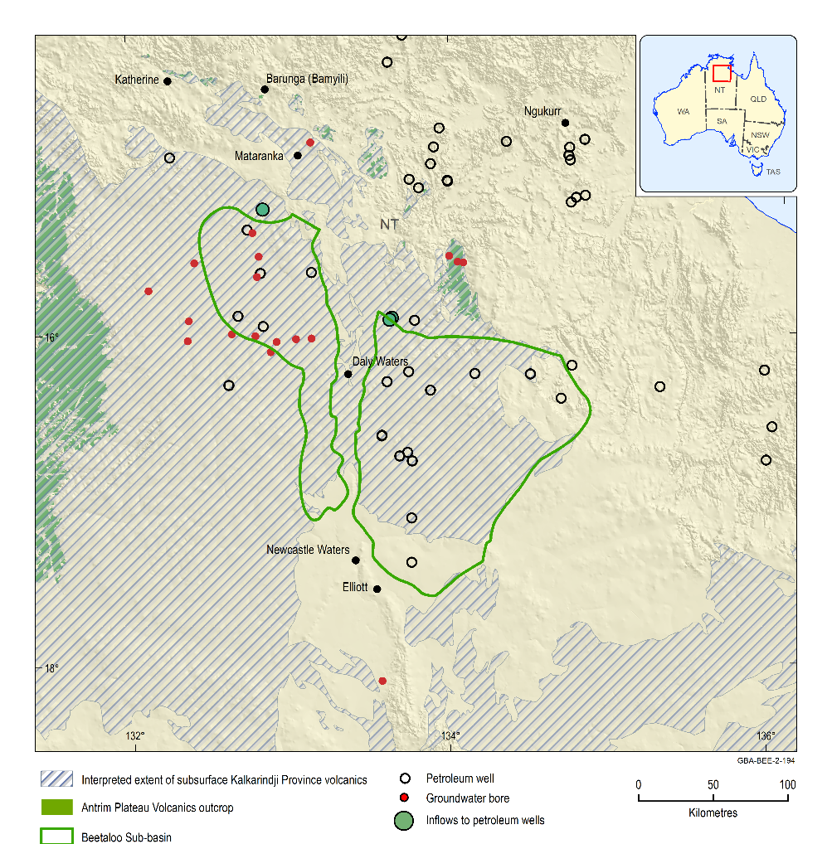
Figure 15 Groundwater bores and inflows to the Antrim Plateau Volcanics from petroleum wells
Where the Antrim Plateau Volcanism are not present in the Beetaloo GBA region (i.e. areas without striping), the CLA is in direct contact with Bukalara Sandstone or other underlying units. Depending on local hydraulic conditions direct leakage could occur across the boundary with the CLA.
Whether an inflow to a petroleum well occurs is in part dependent on drilling method and condition of the hole at time of drilling. For instance, in a well where no inflow was recorded, the drilling mud densities could have been such that any inflows are impeded, or alternatively the formation could be naturally tight with low permeability, reducing the ability for groundwater to flow.
Data: groundwater inflows to petroleum wells (Geological and Bioregional Assessment Program, 2019f); groundwater bores screened in the Antrim Plateau Volcanics (Origin Energy, 2019); Kalkarindji Suite Volcanics extent (Frogtech Geoscience, 2018b)
Element: GBA-BEE-2-194

Cambrian Limestone Aquifer

Overview
Figure 16 outlines some of the regional-scale features that influence the hydrodynamics and groundwater flow in the CLA across the Beetaloo GBA region. These features include:
- At least two major groundwater flow systems are recognised in the CLA in the Beetaloo GBA region: from the Georgina Basin into the Daly Basin, and from the Wiso Basin into the Daly Basin. The inferred regional groundwater flow direction from potentiometric contours is generally north-westwards. However, there are possible significant deviations to this trend, at least at a local scale, as a result of structure and discrete karst systems.
- Eastern Beetaloo Sub-basin is overlain by the CLA system that is within the Georgina Basin, whereas the western Beetaloo Sub-basin is predominantly overlain by the CLA system within the Wiso and adjoining Daly basins (Figure 8).
- Regional groundwater divides segregate flow in different parts of the aquifer. A north-west trending groundwater divide separates the Georgina-Daly and Wiso-Daly basin systems. This divide results from a combination of the Birdum Creek Fault and Daly Waters High (see Figure 8 for location of fault). In the Daly Basin there are several groundwater divides which largely associate with surface water catchment boundaries (Figure 16 and Tickell (2005)). Within the Beetaloo GBA region, a key divide in the Daly Basin approximates the catchment divide between the King and Roper rivers (north-west of Mataranka). This east-trending groundwater divide segregates groundwater flow into north and south-directed flow components along the eastern side of the Daly Basin. The south-directed groundwater flow discharges at Mataranka Thermal Pools.
- Holes that occur in the CLA are the result of erosion or faulting, resulting in inliers of older rocks (e.g. Antrim Plateau Volcanics) subcrop or outcrop (Figure 16). These would influence inferred groundwater flow.
- The Cambrian limestone is unsaturated in some areas. In the north of the western Beetaloo GBA region, a relatively large area exists west of the Birdum Creek Fault, where the shallowest regional groundwater is present in the Antrim Plateau Volcanics and not in the CLA. A substantial unsaturated area of limestone is also present to the west of the Beetaloo GBA region. The Antrim Plateau Volcanics and the Birdum Creek Fault may impede flow, so these features could partially confine northward groundwater migration in the CLA to discrete pathways (Figure 16).
- The generally upward-tilted margins of the CLA can be unsaturated to a variable degree. The degree of saturation is in part dependent on local groundwater conditions and climate variability. For instance, during periods of high rainfall groundwater levels may rise by several metres, which would have the effect of increasing the saturated area both horizontally as well as vertically.
- Mataranka Thermal Pools and Roper River are fed by regional groundwater discharge from the CLA. In the Daly Basin, regional groundwater flow is driven largely by local recharge as well as by a contribution out of the Georgina Basin to the south (Section 3.3.3.2.9). Southward directed flow in the Daly Basin from the King/Roper groundwater divide discharges at Mataranka Thermal Pools and Roper River.
- For the Tindall Limestone aquifer, the Flora River and associated springs are the regional groundwater discharge zone for flow northward out of the Wiso Basin in the Beetaloo GBA region into the western side of the Daly Basin. Inferred flow also continues northwards of the Flora River further into the Daly Basin.
Understanding the occurrence of large groundwater divides and other potential barriers to flow (e.g. major faults) are important for understanding how an aquifer system works. Essentially these types of boundaries compartmentalise groundwater flow in an aquifer. They can act as a barrier to flow, minimising interactions (and spread of potential impacts) between different aquifer systems. It should be kept in mind that groundwater flow divides may migrate, if groundwater is pumped excessively. Whether, and if, a groundwater divide moves depends on a number of factors, including the geology, as well as the duration and volume of groundwater pumping.
Some discrepancies are apparent in the regional groundwater flow patterns as outlined on Figure 16. For instance, springs located along the south-western margin of the CLA are situated in an area where regional groundwater flow is apparently directed away from the limestone margins. This cannot be the case as these springs are thought to source water from the CLA (Department of Environment and Natural Resources (NT), 2013). In the CLA some groundwater flow would need to be directed towards the margins to a groundwater source for the springs. This suggests that that there are other factors influencing groundwater flow, such as another regional groundwater divide occurring near the margin of the systems. These aspects are discussed further in Section 3.3.3.2.2 (and illustrated in Figure 17).
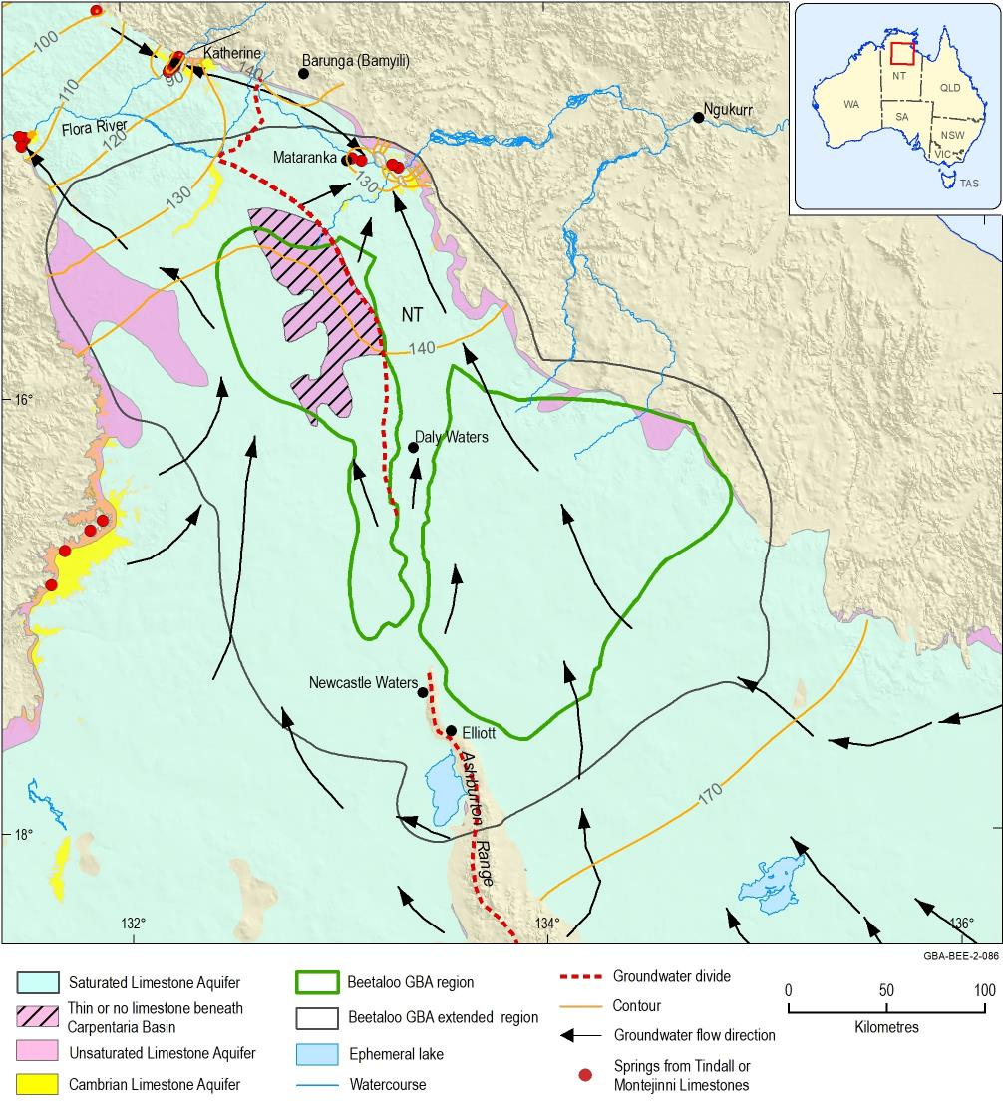
Figure 16 Flow systems of the Cambrian Limestone Aquifer system
Many of the bores on Figure 18 draw water from the Cambrian Limestone Aquifer.
Data: regional watertable contours and flow arrows after Fulton and Knapton (2015a); limestone extent from: Department of Environment and Natural Resources (NT) (2018c); limestone subcrop from: Department of Environment and Natural Resources (NT) (2008)
Element: GBA-BEE-2-086

Discrepancies between different generations of potentiometric surfaces for the Cambrian Limestone Aquifer
The regional watertable outlined in Figure 16 is one of the more recent iterations for the CLA. Watertable maps have been derived for other regional studies, including Randal (1973) and Origin Energy (2019). Potentiometric contours have also been produced as part of more detailed studies focused on specific areas of the CLA. Examples here include Mataranka Thermal Pools (Karp, 2008); Georgina Basin (Tickell and Bruwer, 2017) and Daly Basin (Tickell, 2005).
From these various studies, there is collective agreement around general aspects of the hydrodynamics such as the regional groundwater flow trends and flat hydraulic gradients in regions such as the Georgina Basin. Additionally, Mataranka Thermal Pools is a major discharge point for CLA for the southern Daly and Georgina basins. However, differences become apparent at semi-regional scales. For instance, in some areas the magnitude of potentiometric contours does not coincide.
As an example, the CLA potentiometric surface across the Beetaloo Sub-basins of Tickell and Bruwer (2017), Tickell (2003) and Fulton and Knapton (2015b) has a comparable but smoother north-westward gradient over the Sturt Plateau, but differs from the surface of Randal (1973).
On the established basis of connectivity between the Paleozoic and Cretaceous (Carpentaria Basin) aquifers in the region, Randal (1973) produced a regional watertable from 300 bores in the Wiso Basin and environs. The Randal (1973) watertable encompasses much the CLA in the Wiso western Daly basins, as well as areas where the watertable resides in either the overlying Cretaceous or underlying Antrim Plateau Volcanics (Figure 17). Broadly, there is a regional north-north-westward slope in the potentiometric surface as per subsequent interpretations (i.e. northerly directed potential flow), but there are also several inferred second-order directions of groundwater flow (Randal, 1973). For instance, mounding in the watertable has created a groundwater divide along the western flank of the CLA, which is not evident in the potentiometric contours detailed in Figure 16. This groundwater divide directs inferred flow westwards towards springs located at the contact of limestone and the Antrim Plateau Volcanics along the western margin, as well as eastwards and northwards into the Wiso and Daly basins. Another groundwater divide directing flow and recharge into the Wiso and Georgina basins coincides with the Ashburton Range, to the south of Newcastle Waters. This groundwater divide equates to the ‘western recharge area’ for the Georgina Basin, as outlined in Tickell and Bruwer (2017).
Due to sparse data available at time of production (i.e. Randal (1973)), the contours shown in Figure 17 diverge from more recent iterations (Figure 16) in the eastern half of the CLA – particularly around the Katherine Mataranka region and to the east of Newcastle Waters and Daly Waters. Contours in the eastern sections of Figure 17 are not considered to be reliable due to paucity of data at time it was drawn (Randal, 1973) and in the light of more recent studies.
Aside from the occurrence of second order features that may influence groundwater potentiometry (i.e. the groundwater divides), there are valid reasons why the various generations of contours do not coincide in some areas. These include:
- variable contour spacing intervals
- density of bore data at time of production of the watertable surface (Randal, 1973)
- different scale or focus of the various studies (e.g. regional versus local, Sturt Plateau versus Georgina Basin)
- time range of the water level data used to map the watertable (e.g. measurements for last ten years, or just one year).
In some areas, the large changes evident in monitoring bore hydrographs (e.g. greater than six months in one year) suggest that incorporating water level data over too large a time period could create spurious contours. Conversely, selecting data to a particular year limits the number of bores available for contour generation. This may produce overly smoothed contours that do not pick out semi-regional variance in potentiometry and potential groundwater flow, which are important for conceptualising groundwater flow in the CLA.
There is an influx of new data and understanding derived from monitoring bores installed as part of recent studies for water allocation plans, agriculture and petroleum exploration. Consideration should be given to producing an updated and more nuanced potentiometric surface for the CLA that encompasses western Beetaloo GBA region and the groundwater divides detailed in Figure 17.
This could be facilitated by:
- Ensuring all groundwater bores have an assigned hydrostratigraphy. For instance, 30% of bores with depth to water level measurements currently have no recorded hydrostratigraphy (Section 2).
- Identify areas where sinkholes are likely to be present near surface, which may influence preferential recharge in Beetaloo GBA region.
- Selecting water level data within certain multi-year date range for watertable mapping. Date ranges could be based on trends in residual rainfall curves (Figure 20). For example, picking water level measurements that were taken there is a multi-year rising rainfall trend in the residual rainfall curve (e.g. 1995–2010), or range of years where residual rainfall trends are stable (i.e. relatively flat).
- In areas where little variation is evident in hydrographs, archival water level data could be picked over larger date ranges, which would provide more data points for interpolation. Conversely, where hydrographs show evidence of large yearly changes, then date ranges could be narrowed when utilising archival water data in those areas.
- Where possible, barometric pressure corrections should be applied to water level logger data.
- Depending on the length of the screened/open hole intervals, the siltstone marker horizons outlined in Section 3.2.3.2 could potentially be used as a way to group water level data for analysis. Another way to interrogate the water level data may be to first group it, with regards to what part of the stratigraphy the bore screen is situated, then investigate the grouped data to see if there are meaningful trends.
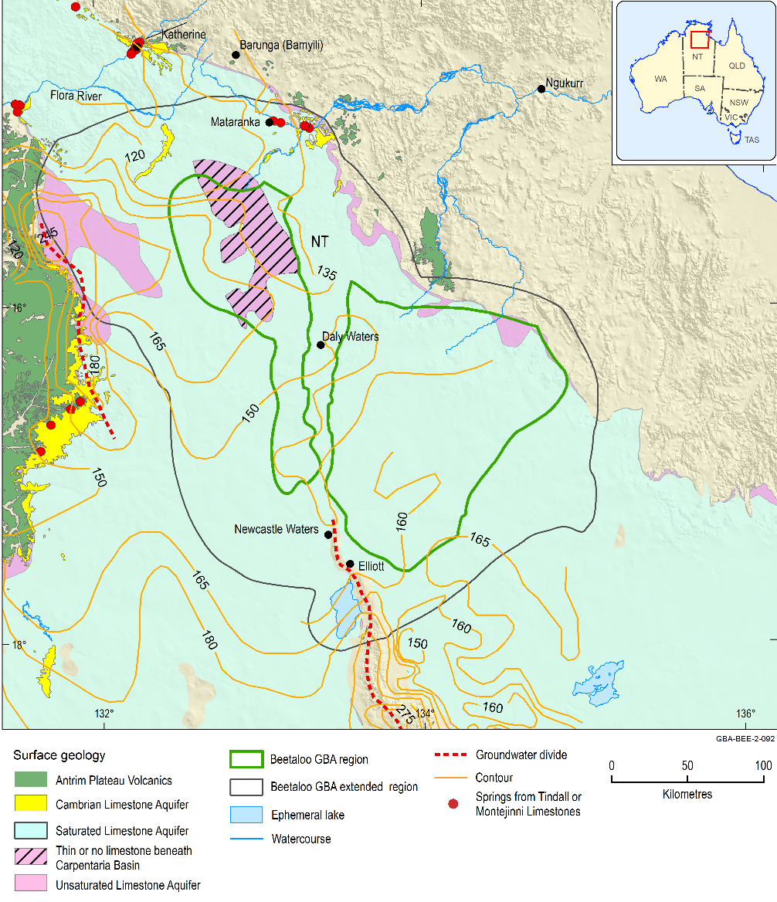
Figure 17 Watertable contours for the northern Wiso Basin and environs
Data: watertable contours (Randal, 1973)
Element: GBA-BEE-2-092

Depth to groundwater
Standing water levels are recorded for many groundwater bores (presented in Figure 18). The majority of water level measurements are from the CLA (Table 5), with a few from other formations (e.g. Proterozoic, Antrim Plateau Volcanics and Carpentaria Basin) locally present. Although there are likely to be differences in groundwater levels between these formations, Randal (1973) thought they were regionally hydraulically interconnected as water levels had a common potentiometric surface, forming a regional watertable. To assess general groundwater depth trends, it is therefore still useful to examine groundwater levels at the 20 m depth intervals as provided in Figure 18. However, it should be kept in mind that potential homogenisation of water level measurements can occur if groundwater bores are constructed with a large screen length open interval across different aquifers (‘blended hydraulic head’).
Figure 18 indicates there is a clear correlation between topography and groundwater level. Water depths in excess of 100 m are encountered in the elevated areas of the central southern parts of the Beetaloo GBA extended region. Water levels are closer to surface in the south along the Ashburton Range and Lake Woods (recharge zones), and to the north where surface elevation falls towards discharge areas (e.g. Mataranka Thermal Pools). Local recharge is possible through karst features. Water depths are shallow near known springs to the north of the Beetaloo GBA region and towards the edges of the Sturt Plateau.
Although Figure 18 provides useful information on water depths for the main formations currently exploited for groundwater, shallower perched groundwaters are known to be present locally. As an example, groundwater is reportedly within 1 m of surface at times in the Cenozoic aquifers monitored by Origin Energy (2019) in monitoring bores BET-MB001, BET-MEB002 and BET-MB003 in the north-west of the Eastern Beetaloo GBA region (Figure 19), whereas on Figure 18 the depth to regional groundwater table in the CLA is in excess of 100 m deep in the same area. In addition to shallow perched systems, groundwater levels also vary substantially over time in the deeper units, as discussed in Section 3.3.3.2.4. Consequently, although Figure 18 is useful to illustrate regional trends, it does not provide a time-invariant illustration of groundwater depths and does not capture local, perched groundwater systems.
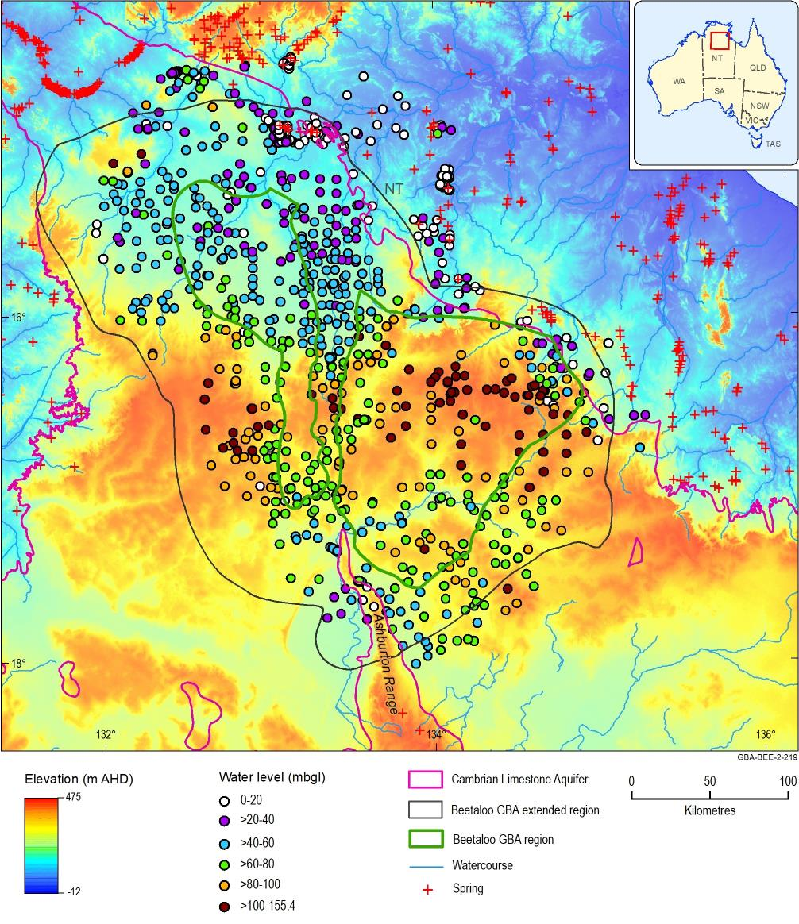
Figure 18 Depth to groundwater in registered groundwater bores
AHD = Australian Height Datum; mbgl = metres below ground level
Data: depth to groundwater (Geological and Bioregional Assessment Program, 2019g)
Element: GBA-BEE-2-219
Table 5 Groundwater well aquifer designation statistics for Figure 18
Formation | Number of wells | Percentage of total  (%)
Cenozoic | 6 | 1%
Cretaceous | 25 | 2%
Cambrian Limestone Aquifer | 592 | 57%
Antrim Plateau Volcanics | 58 | 6%
Proterozoic | 44 | 4%
Unknown | 315 | 30%
Total | 1040 | 100%
Data: Geological and Bioregional Assessment Program (2019g)

Groundwater hydrographs
The NT Department of Environment and Natural Resources (DENR) and Origin Energy provided groundwater level time series (see Section 2.1.3.2.2) to the GBA assessment team for their network of monitoring wells in the Beetaloo GBA extended region (Figure 19). Groundwater levels are measured using a combination of pressure transducer data loggers and dip meters in the Antrim Plateau Volcanics and overlying formations, with most monitoring focusing on the Cambrian limestone units. Hydrographs were examined for groundwater bores with two or more water level readings (Figure 19) to provide a preliminary assessment of groundwater variations over time. These hydrographs provide an opportunity for detailed interpretation in Stage 3. It is noted that the Department of Environment and Natural Resources (NT) (2018b) includes water levels for several other wells not shown on Figure 19 because DENR do not identify them on their current list of monitoring sites.
To assist with hydrograph interpretation, cumulative mass residual rainfall curves are included (Figure 20) for the four rainfall stations shown on Figure 19. These curves are based on rainfall data included in Department of Environment and Science (Qld) (2018). The residual rainfall was calculated by subtracting the rainfall in a given year from long-term average yearly rainfall. Summing these differences reveals periods when rainfall has been below (declining trend) at (flat) or above (increasing trend) average levels. Figure 20 shows that rainfall was generally below average from 1900 until the late 1960s. With the exception of below average period of rainfall from the mid-1980s to mid-1990s, rainfall has generally been above average from the early 1970s until the present.
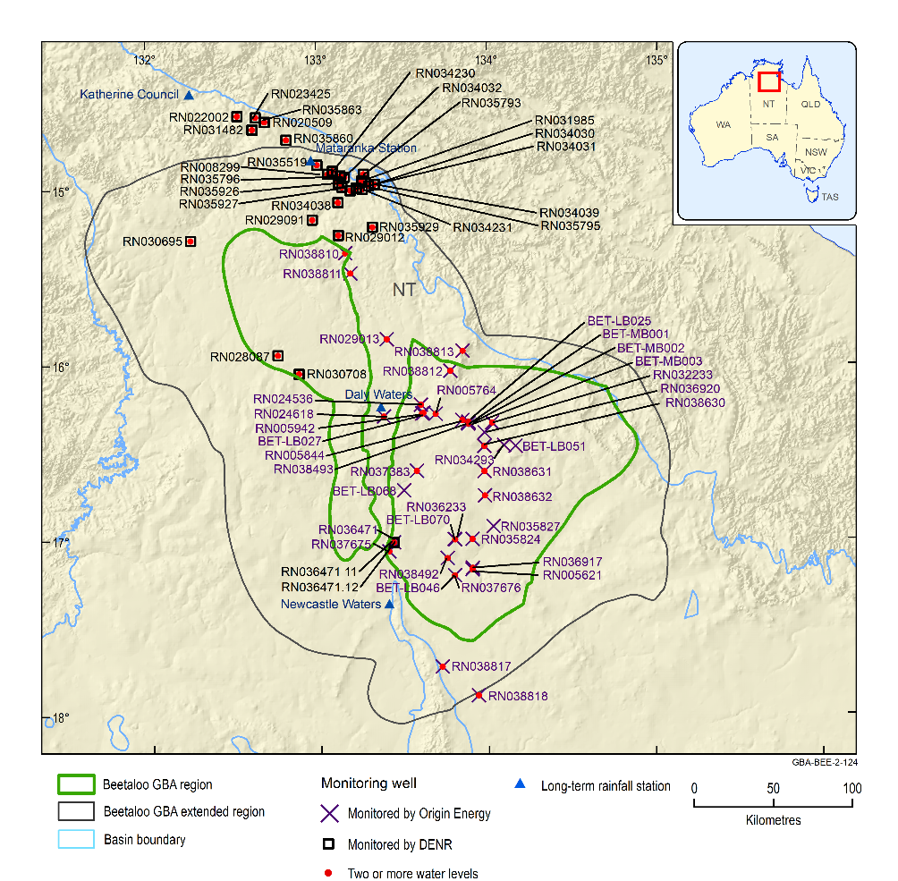
Figure 19 Department of Environment and Natural Resources (NT) and Origin Energy groundwater monitoring network
Data: monitoring bore locations (Origin Energy, 2019; Department of Environment and Natural Resources (NT), 2018a)
Element: GBA-BEE-2-124
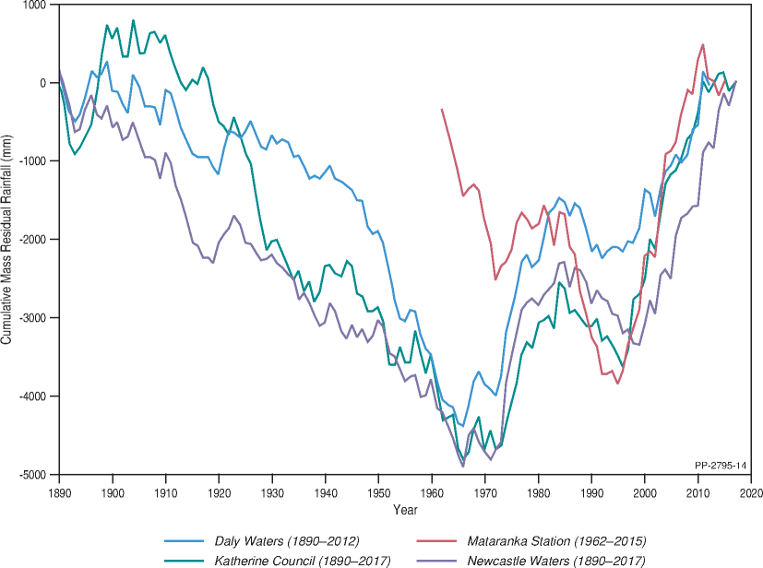
Figure 20 Cumulative mass residual rainfall curves for the Beetaloo GBA region and surrounds
Refer to Figure 19 for rainfall station locations.
Data: Department of Environment and Science (Qld) (2018)
Element: GBA-BEE-2-329
Representative groundwater hydrographs are included as Figure 21 to Figure 28. Only DENR hydrographs are shown due to the potential limitations of Origin Energy’s data outlined below. Most DENR hydrographs are for wells in the north of the Beetaloo GBE extended region. Several longer term hydrographs show increasing water levels starting at around 1996 to 1998 and continuing until approximately 2012, corresponding to increases in cumulative mass residual rainfall (Figure 20). Increases in groundwater level are substantial in some wells (e.g. approximately 9 m in RN022002 and 16 m in RN020509; Figure 21 and Figure 22). There is evidence of similar increases in RN030695 (Figure 23) and RN028087 (water levels have risen by approximately 4.5 m in this well since monitoring commenced in 1999) in the north-west of the western Beetaloo GBA region. However, the full extent of increasing water levels is currently uncertain because most DENR hydrographs do not cover the full date range of interest and Origin Energy did not provide water levels prior to 2014.
Some authors (e.g. Tickell (2009)) report that groundwater levels in the region have been increasing since the 1970s due to increases in rainfall (Figure 20), but hydrographs are not available in the Beetaloo GBA extended region to confirm this. A comparison to historical groundwater levels suggests that despite the post-1996 rises, the general pattern of depth to groundwater has probably remained similar to what is outlined in Figure 18.
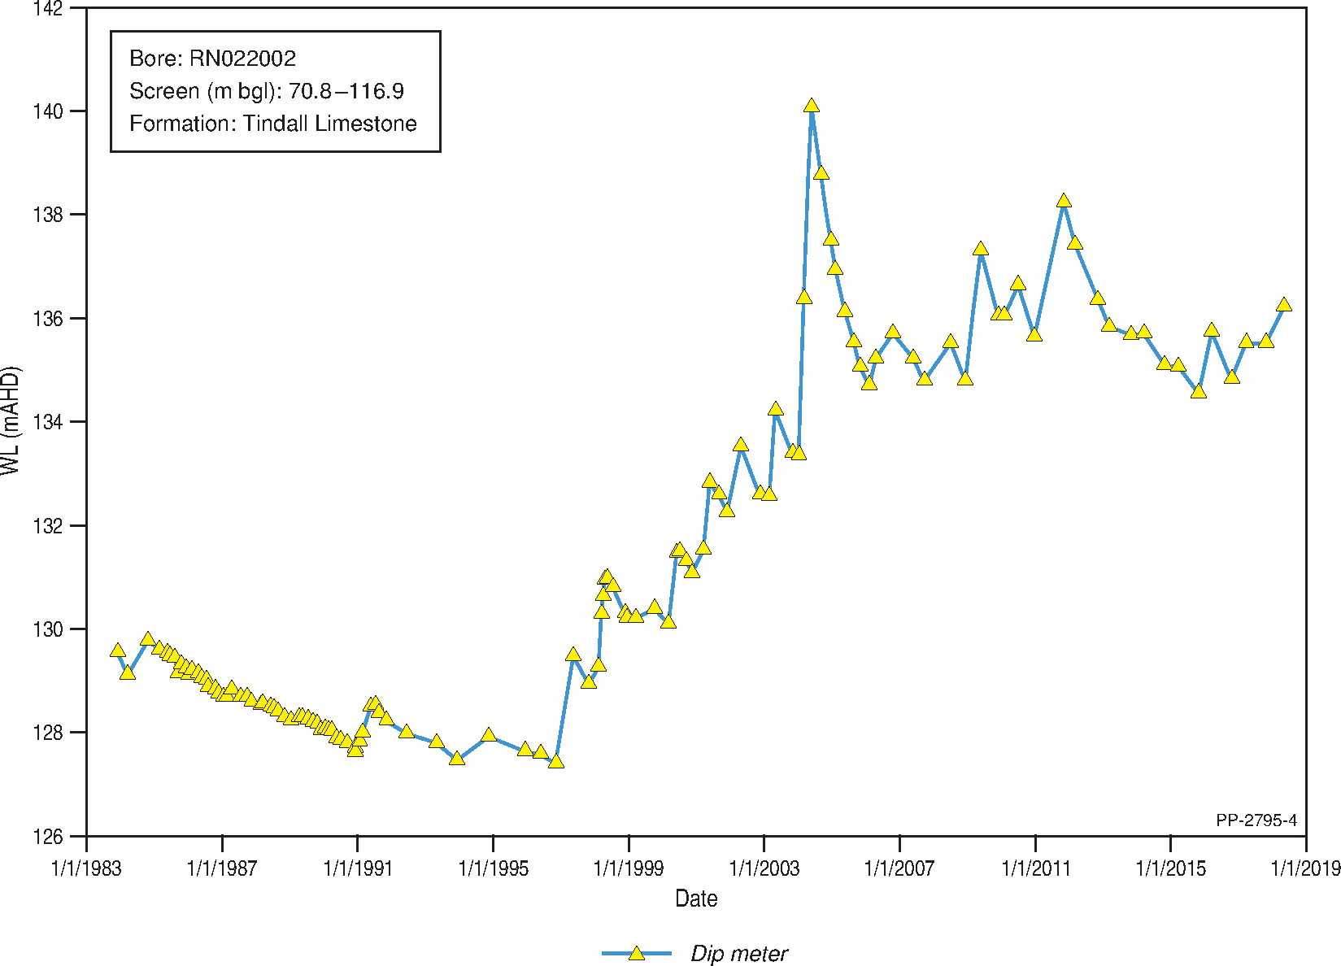
Figure 21 Groundwater hydrograph for well RN022002
Bore location is outlined on Figure 19.
m bgl = metres below groundwater level; WL (mAHD) = water level (metres above Australian Height Datum)
Data: Department of Environment and Natural Resources (NT) (2018b)
Element: GBA-BEE-2-330
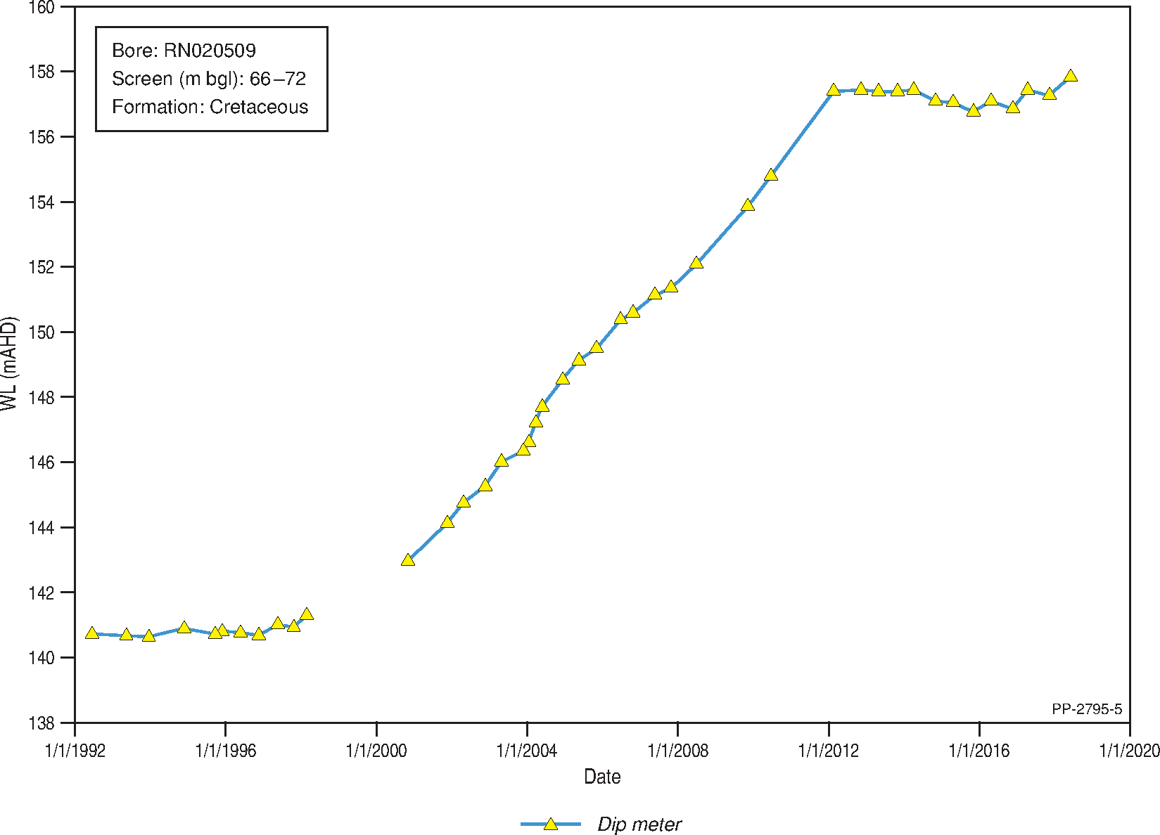
Figure 22 Groundwater hydrograph for well RN020509
Bore location is outlined on Figure 19.
m bgl = metres below groundwater level; WL (mAHD) = water level (metres above Australian Height Datum)
Data: Department of Environment and Natural Resources (NT) (2018b)
Element: GBA-BEE-2-331
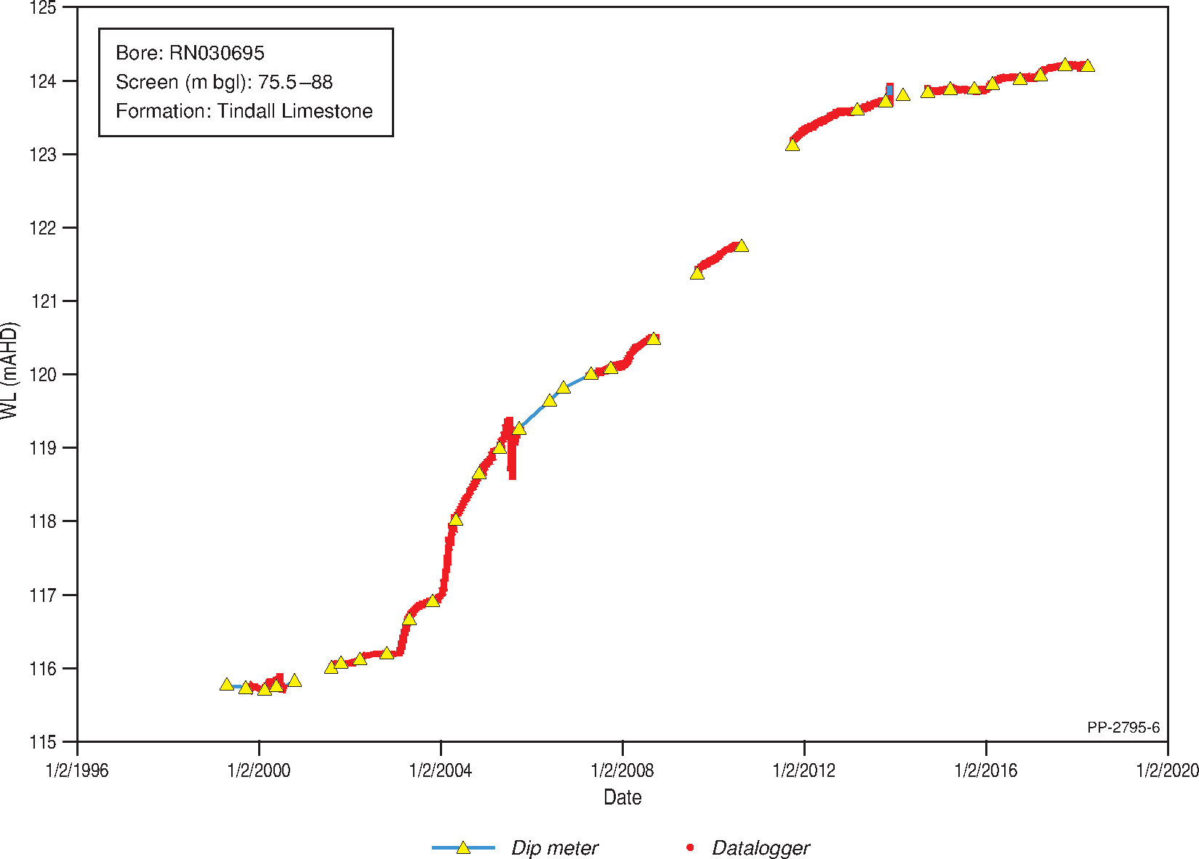
Figure 23 Groundwater hydrograph for well RN030695
Bore location is outlined on Figure 19.
m bgl = metres below groundwater level; WL (mAHD) = water level (metres above Australian Height Datum)
Data: Department of Environment and Natural Resources (NT) (2018b)
Element: GBA-BEE-2-332
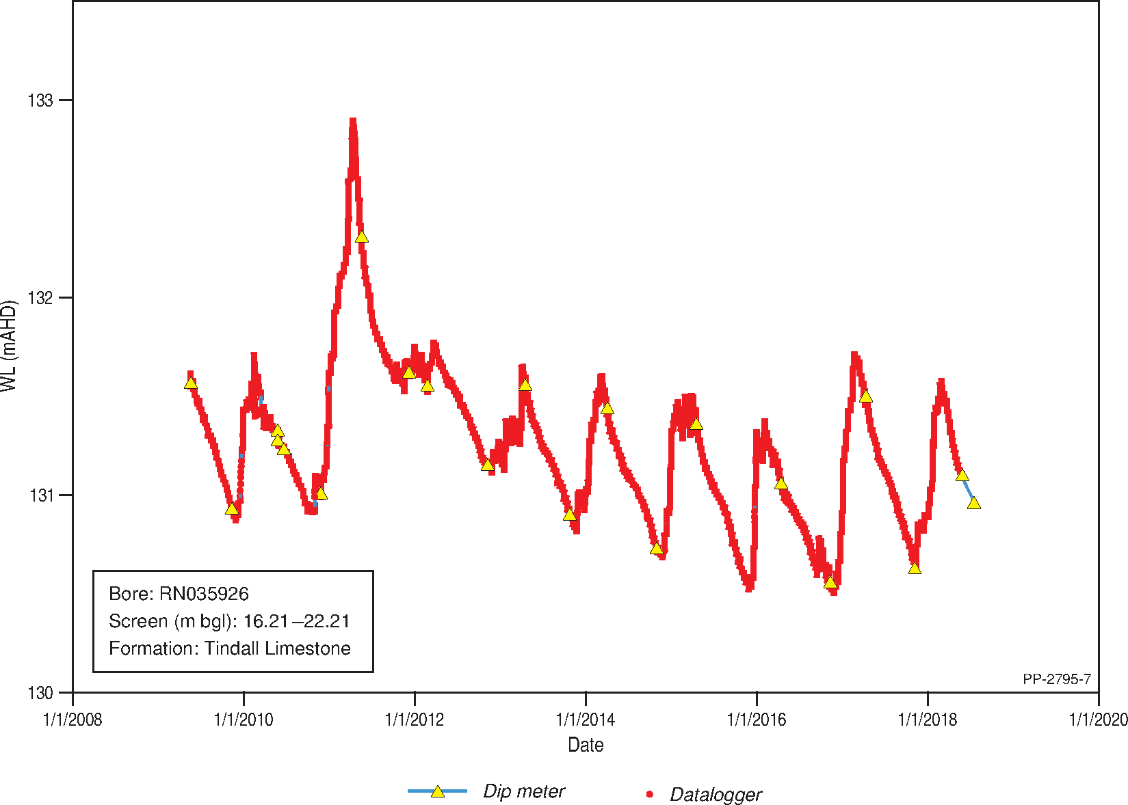
Figure 24 Groundwater hydrograph for well RN035926
Bore location is outlined on Figure 19.
m bgl = metres below groundwater level; WL (mAHD) = water level (metres above Australian Height Datum)
Data: Department of Environment and Natural Resources (NT) (2018b)
Element: GBA-BEE-2-333

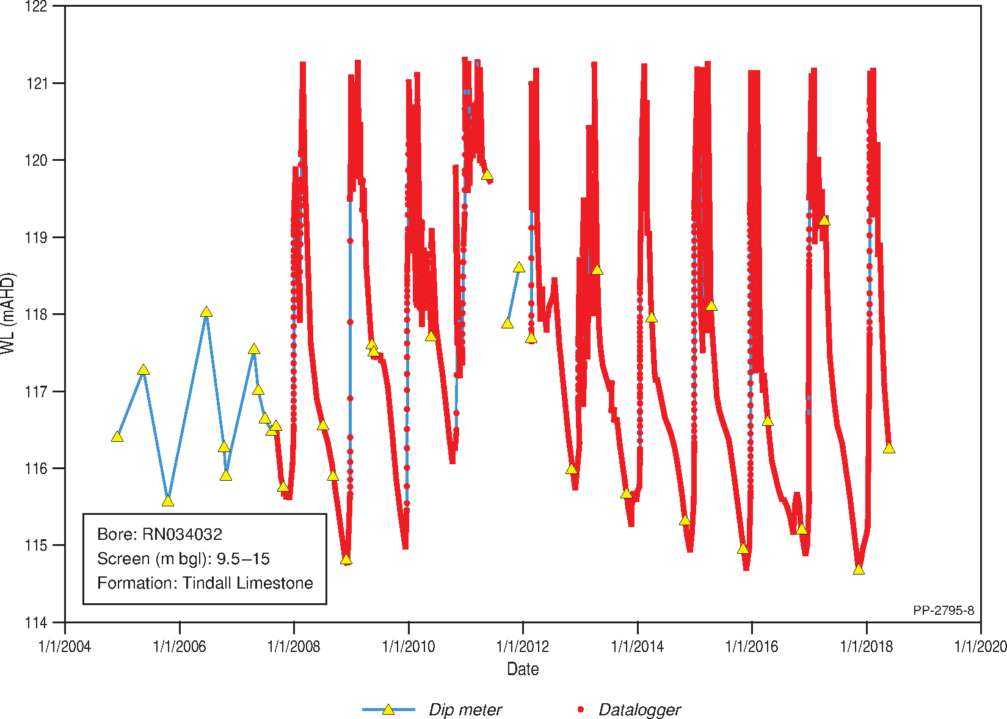
Figure 25 Groundwater hydrograph for well RN034032
Bore location is outlined on Figure 19.
m bgl = metres below groundwater level; WL (mAHD) = water level (metres above Australian Height Datum)
Data: Department of Environment and Natural Resources (NT) (2018b)
Element: GBA-BEE-2-334
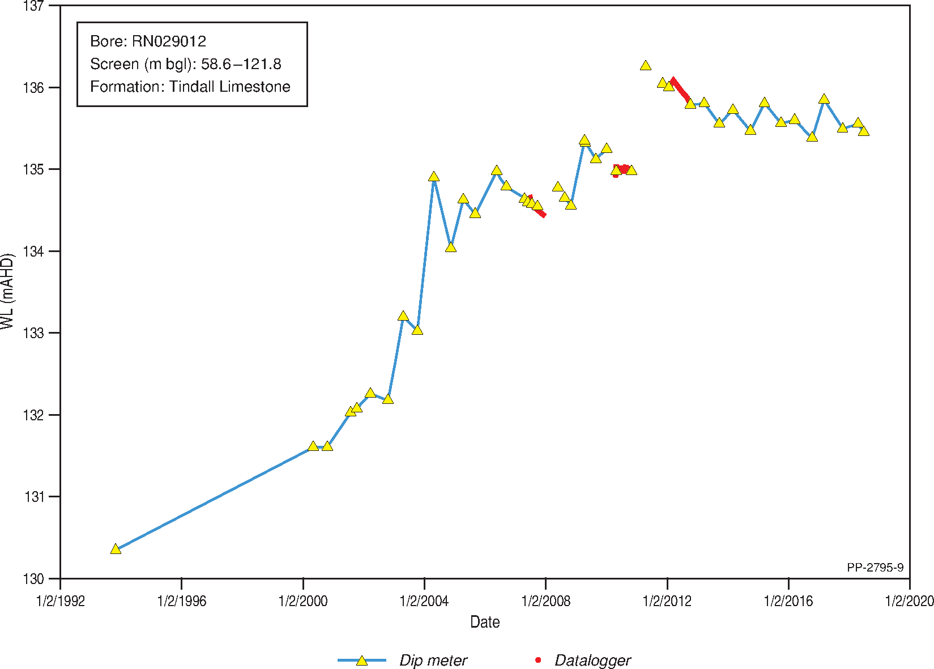
Figure 26 Groundwater hydrograph for well RN029012
Bore location is outlined on Figure 19.
m bgl = metres below groundwater level; WL (mAHD) = water level (metres above Australian Height Datum)
Data: Department of Environment and Natural Resources (NT) (2018b)
Element: GBA-BEE-2-335
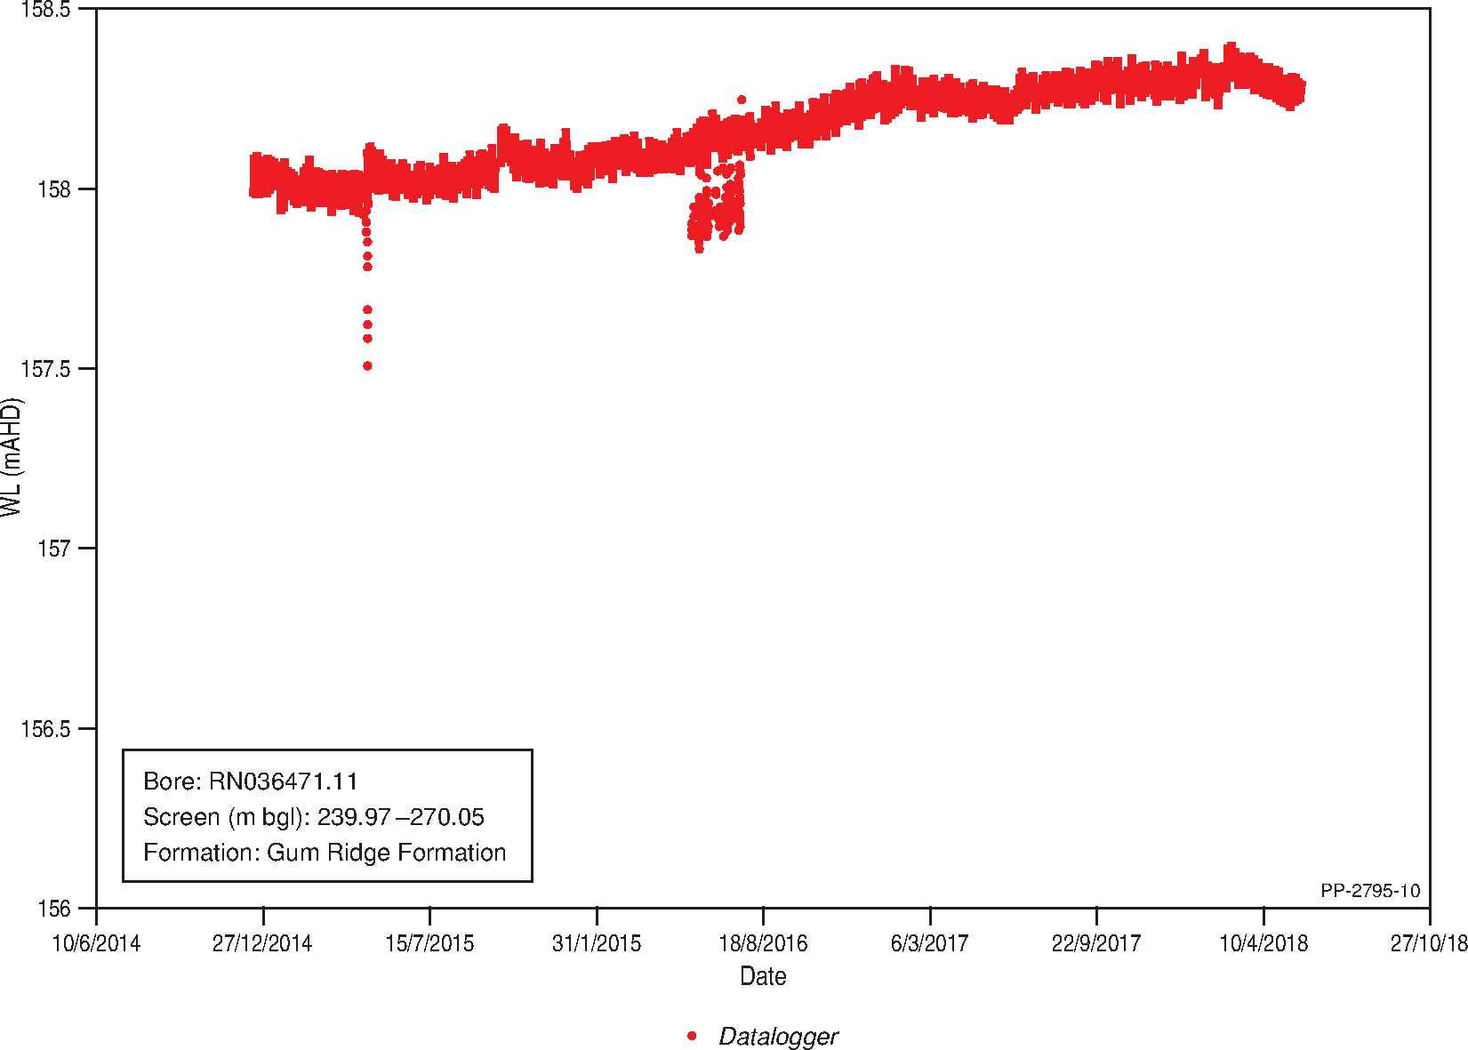
Figure 27 Groundwater hydrograph for well RN036471.11
Bore location is outlined on Figure 19.
m bgl = metres below groundwater level; WL (mAHD) = water level (metres above Australian Height Datum)
Data: Department of Environment and Natural Resources (NT) (2018b)
Element: GBA-BEE-2-336
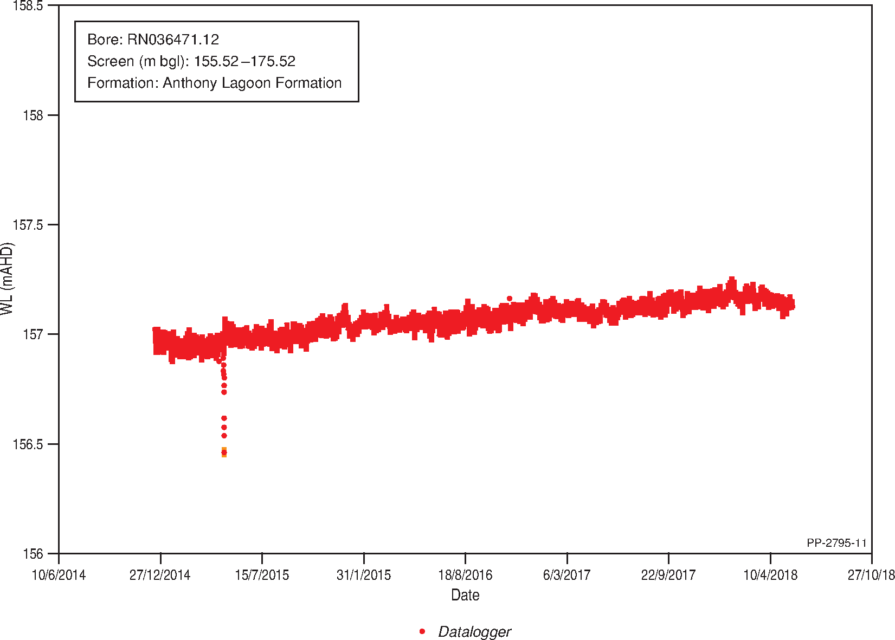
Figure 28 Groundwater hydrograph for well RN036471.12
Bore location is outlined on Figure 19.
m bgl = metres below groundwater level; WL (mAHD) = water level (metres above Australian Height Datum)
Data: Department of Environment and Natural Resources (NT) (2018b)
Element: GBA-BEE-2-337
DENR hydrographs in the north of the Beetaloo GBA extended region commonly show seasonal fluctuations of between approximately 0.5 and 2 m depending on the monitoring well. Seasonal fluctuations in groundwater well RN034032 close to the Roper River (Figure 25), are particularly pronounced regularly exceeding 6 m in response to rainfall in the November to April wet season. Groundwater responses in individual wells are a function of local conditions (e.g. proximity to rivers, karst features, degree of hydraulic confinement, groundwater extraction, etc.), and may be interpreted at specific locations in later investigation phases if required. It is important to consider frequency of water level measurements when making such assessments, since some wells are only dipped occasionally while others have loggers installed to gather more frequent measurements.
Hydrographs for the nested wells RN036471.11 (Gum Ridge Formation) and RN036471.12 (Anthony Lagoon Formation) in the south-west of the eastern Beetaloo GBA region (Figure 19) are included as Figure 27 and Figure 28. Water levels are only available from September 2014 to May 2018, over which time the hydrographs show limited seasonal fluctuation. The hydraulic head in RN036471.11 generally remained 1 m higher than in RN036471.12, indicating a potential for upward flow at this location (noting that there is a vertical difference of 89.49 m between screen centres). No other nested wells are monitored in the Beetaloo GBA region, so the distribution of relative head differences is unknown from available hydrographs.
Origin Energy’s monitoring has focused on the eastern Beetaloo GBA region (Figure 19). Most of their hydrographs commence in 2015 or 2016, so long-term trends are uncertain. Logger hydrographs have not had barometric pressure removed, and many include potentially anomalous data points. It is difficult to make definitive interpretations without longer term data, although it does appear that seasonal fluctuation in some of Origin Energy’s monitoring bores may be less than in monitoring bores further north.

Karst, fracture porosity and groundwater flow paths
While regional groundwater flow is generally northwards (Figure 16), the groundwater flow configuration in the CLA varies between the different basins (Tickell and Bruwer, 2017). For instance, groundwater flow in the Gum Ridge Formation (Georgina Basin) is largely confined, and is from basin margin to basin centre, then northwards into the Daly Basin. Whereas, in the vicinity of unconfined areas of the Tindall aquifer in the Daly Basin, groundwater flow tends to parallel basin margins, discharging to rivers that crosscut the aquifer (Tickell and Bruwer, 2017).
The variable and relatively unpredictable degree of karstification and fracturing throughout the CLA are likely to influence both groundwater flow direction and flow rates, at least at local to intermediate scales (i.e. tens of kilometres). This is especially the case in areas where the CLA is not confined by the overlying Carpentaria Basin, and/or the Jinduckin or Anthony Lagoon formations. As an example, Karp (2005) provides a detailed description of recharge and discharge pathways to unconfined portions of the Tindall Limestone aquifer in the vicinity of Katherine. Here, several north-west trending cave systems are noted, which are in part structurally controlled by fracturing parallel to the strike of bedding (i.e. north-west). A series of dye tracer tests from a sinkhole to springs located at 2.5 km and 4 km along the south-west trending Katherine River, demonstrated that recharge and groundwater flow could be rapid (Tickell, 2005), taking two and seven days respectively to reach the spring discharge points (570–1250 m/day). Tickell (2005) suggests that while groundwater may move relatively slowly through fracture networks and small solution cavities, once it reaches larger karst there are marked increases in conductivity and flow rates. The caves oriented perpendicular to the trend of the river reaches are acting as drainage conduits fast tracking flow towards rivers and springs. High flow rates could exacerbate the spread and dispersion of contaminants. Low levels of contaminants (pesticides) have been detected at Mataranka Thermal Pools (Schult, 2016), which are probably derived from groundwater discharge from the CLA.
Tickell (2005) suggests that shale interbedded in the Tindall Limestone may not, on a regional scale, impede vertical groundwater movement and that the karst provides pathways for groundwater to connect between different limestone layers. Surface runoff in the Daly Basin has been observed to pour directly down sinkholes in the Katherine area (Karp, 2008) and parts of western Beetaloo GBA region on the Sturt Plateau (Yin Foo and Matthews, 2001). Direct recharge could provide relatively quick pathways for any potential contamination at surface to reach the CLA. However, this is not likely to be the case for much of the Beetaloo GBA region, especially where the CLA is covered by relatively thick cover of Carpentaria Basin.
The influence of karstification and fracturing on aquifer characteristics is noted in limestone aquifers outside the Daly Basin. For instance, in the Georgina Basin Tickell (2003) documents numerous instances of bores intersecting cavities or losing circulation in limestone aquifers. Furthermore, the Gum Ridge Formation exhibits a large range of transmissivities (5–3030 m²/day), which is indicative of a karstic aquifer (Tickell and Bruwer, 2017) and a variable degree karst and fracturing was found, at some sites, to influence degree of connectivity between Gum Ridge Formation and overlying Anthony Lagoon Formation. In some places the Anthony Lagoon Formation has potential to leak into the underlying Gum Ridge Formation, whereas in others it acted as a competent aquitard.
From carbon isotopes, Suckow et al. (2018) noted that apparent groundwater ages became younger northward along an inferred regional flow path trend, from the Georgina Basin to Daly Basin. This is the opposite of what is usually expected, which is that groundwater becomes older along a confined flow path. One explanation for the apparent carbon age trend is that recent recharge is occurring in the northern part of the trend, with older groundwater at the southern end of the flow path in the Georgina Basin. Other interpretations and complicating factors, put forward by Suckow et al. (2018) are: there is not a continuous regional flow path (flow paths are more localised), unknown processes are influencing the carbon isotope results, or that flow velocity is high enough along the flow path that not enough time is available for significant radioactive decay to occur in carbon isotopic system. As part of Stage 3 of the Beetaloo GBA, further work will be undertaken to improve recharge pathways and processes (see Section 5.4.1), which will assist interpretation of hydrochemistry data.

Recharge and inflow
Annual rainfall falls in two climatic zones (wet-dry tropics and semi-arid) across the CLA and is strongly seasonal and varies markedly geographically, reducing from north to south (Knapton, 2006). Aside from rainfall and other climate variables, recharge is influenced by soil type, geology (e.g. thickness of overlying Carpentaria Basin), vegetation, topography and degree of near-surface karst development. Accordingly, there is no direct relationship between groundwater recharge and amount of rainfall (EcOz Environmental Consultants, 2015). Recharge to aquifers occurs in the wet season at times when rainfall intensity and duration are enough to exceed evapotranspiration rates. Recharge leads to a rise in groundwater levels and an increase in discharge to rivers and springs. Within the Beetaloo GBA region, recharge needs to pass through the overlying Carpentaria Basin to reach the underlying CLA. Another input (‘recharge’) component to the CLA in the Beetaloo GBA region is throughflow from the south, out of the Wiso and Georgina basins (see Figure 16 and Section 3.3.3.2.9).
Four mechanisms of recharge were identified (Fulton and Knapton, 2015b) for areas of near-surface karst:
- direct recharge when surface water exceeds soil moisture deficits and evapotranspiration, occurring by vertical percolation through the unsaturated zone
- macropores – channelled precipitation through root casts and regolith solution tubes, with the rapidly infiltrated water having limited interaction with sediment and rocks in the unsaturated zone
- local indirect recharge where surface water is channelled into karstic features such as dolines (sinkholes) in areas where the Mesozoic cover is relatively thin. Tickell (2005), Knapton (2006) and Fulton and Knapton (2015b) consider this to be a poorly understood component of recharge
- localised indirect recharge occurs along ephemeral drainage lines such as Dry River and the tributaries that feed Elsey Creek.
The eastern and western portions of the Beetaloo GBA region appear to have a distinctly different proportionality of the above recharge processes, largely because of the differing permeability of limestone aquifers and thickness of Cretaceous cover. Generally, recharge is minimal where significant thicknesses of Cretaceous mudstone (‘Units B and C’ – see Section 3.2.4) are present. Recharge is more likely to occur where the Carpentaria Basin cover is relatively thin or absent (Figure 10) and karstic features such as sinkholes are present (Figure 9). These aspects will be investigated further as part of Stage 3. Within the CLA itself, significant thicknesses of Anthony Lagoon Formation and equivalents (the upper CLA, see Section 3.2.3.2) have the tendency to impede leakage or recharge to limestone aquifers that occur in the lower CLA sequences (Gum Ridge Formation and equivalents).
For the Wiso and Georgina basins, recharge along Daly Waters High and margins of limestone aquifer occur to the south of the Beetaloo GBA region. Episodic leakage from ephemeral Lake Woods can provide recharge to the underlying Montejinni Limestone in the Wiso Basin (de Caritat et al., 2019). For development of a regional groundwater model Knapton (2006) inferred that recharge rates through the Cretaceous cover to the Montejinni Limestone were very low.
For the Georgina Basin groundwater resourced estimate, recharge was presumed to occur only where the Cretaceous cover was less than 25 m in thickness, and additionally, for the Gum Ridge Formation, significant recharge was only considered possible where the overlying Anthony Lagoon Formation was absent (Tickell and Bruwer, 2017). Recharge to the Gum Ridge Formation is likely to only occur through infrequent significant recharge events, separated by decades during which little or no recharge occurs (Tickell and Bruwer, 2017). Using the chloride mass balance method of Healy (2010), Tickell and Bruwer (2017) estimated average recharge rates for the Gum Ridge Formation of 1.9 mm/year at Dunmarra, and 1.9 to 8 mm/year at Elliott. By the same methodology, recharge to the overlying Anthony Lagoon Formation at Dunmarra was 2 mm/year (Tickell and Bruwer, 2017).
Recharge to the Tindall Limestone and other aquifers in the Daly Basin varies considerably and is dependent on a number of factors including occurrence and thickness of overlying Jinduckin Formation, Cretaceous sedimentary rocks and climate. The Jinduckin Formation occurs to the north of Beetaloo GBA region (Figure 8). Where the Tindall Limestone aquifer is not confined by Jinduckin Formation, Knapton (2006) estimated recharge ranges from 0.002- to 0.2 mm/day. An initial rate of diffuse recharge of 150 mm/year was used for exposed CLA and 40 mm/year for the Cretaceous cover by Knapton (2006).
Macropore and indirect recharge through sinkholes are dominant recharge processes that account for about 70% of total recharge (Wilson et al., 2006) in the Daly Basin region of the CLA. Here, the Cretaceous cover is thinner, generally less than 30 m (Figure 10).
The Sturt Plateau (see Figure 4 in Huddlestone-Holmes et al. (2020) for location) is a upland plateau that formed across much of the Beetaloo GBA region. Mean annual recharge across the Sturt Plateau physiographic region to the CLA is estimated at between 6 to 18 mm/year, based on a groundwater chloride mass balance, and represents around 1% to 3% of annual rainfall. Point estimates of recharge using hydrograph analysis in the central Sturt Plateau yielded a recharge rate of 9 mm/year. Recharge rates in the southern region are largely unknown where recharge is limited by overlying Cretaceous clays of the Carpentaria Basin (Yin Foo and Matthews, 2000). The region is variably covered by sinkhole fields on the LARRIMAH 1:250 000 geological map sheet (Figure 9), especially over the central Sturt Plateau and concentrated in a band running east-west from Middle Creek to the Dry River (Yin Foo and Matthews, 2000). One of the largest known sinkholes on the Sturt Plateau (Chowung waterhole) is about 800 m in length.
From an initial investigation using environmental tracers, Suckow et al. (2018) identified patterns in noble gas tracers (e.g. He, Ne, Ar, Kr, Xe) which suggest that infiltration and recharge to the karstic CLA are dynamic and rapid. Suckow also noted that karstic nature of recharge pathways may be complicating results from other tracers (3H, SF6 and bromo-trifluoromethane (H1301)). These results have implications for the degree to which surface activities such as spills or leaks, could impact water quality in underlying Cambrian limestone aquifers. Identifying the occurrence of near-surface karstic features, would assist in understanding recharge pathways and in determining the degree of risk from near-surface activities to limestone aquifers. For example, if karstic features are near surface in areas of operation then risks could be higher. Conversely, risk potentially decreases if thick sequences of fine-grained Carpentaria Basin sedimentary rocks are present, due to their tendency to impede recharge. Further work will be undertaken as part of Stage 3 to improve understanding of recharge pathways and other related aspects (see Section 5.4).

Discharge and outflow
For the CLA, the depth to regional watertable (Figure 18) precludes discharge to surface via features in the Beetaloo GBA region (Figure 16). For the Beetaloo GBA region, discharge from the CLA can take the form of throughflow out of the region, pumping from bores or leakage to underlying aquifers. Leakage to other aquifers in the Beetaloo GBA region could occur, particularly where the Antrim Plateau Volcanics is fractured or missing (see Figure 6) or where inliers of other older rocks (e.g. Bukalara Sandstone) are abutted against saturated portions of the CLA (Figure 8).
Major discharge zones for CLA occur to the north of the Beetaloo GBA region around Flora River and Mataranka Thermal Pools (Figure 16). Further detail on the springs and surface water – groundwater interactions are outlined in Section 3.4.3. Outside the GBA region discharge could also occur as evapotranspiration in areas of outcrop or thin cover, where the depth groundwater is shallow enough to be accessed by vegetation (generally less than 20 m (Lewis et al., 2018) and Figure 18).

Aquifer characteristics
Tindall Limestone, Montejinni Limestone and Gum Ridge Formation
Tickell and Bruwer (2017) regard the Gum Ridge Formation to be a regional-scale, high transmissivity aquifer that has been shown to be capable of producing bore yields of over 20 L/second with only relatively small drawdown. Although untested at high pumping rates, suitably constructed bores should be able to produce up to 60 L/second in many areas. Such pumping scenarios indicate bores screened in karst zones of this aquifer. Uncertainty remains as to how such representative high yields from karst zones are for the Gum Ridge Formation overall.
Groundwater modelling by Knapton (2006) assumed a regional aquifer transmissivity for the Gum Ridge Formation of 5000 m2/day with a reduction in the Venn region near Katherine to (Tindall Limestone) to 2000 m2/day. Confined regions of the aquifer were assigned a single value of 100 m3/d/m. An unconfined aquifer storage coefficient was taken as 0.04, as an average of an indicated range of 0.01 to 0.07. A confined aquifer storage coefficient was assigned 0.0001 based on typical aquifer storage coefficients.
Transmissivity of the CLA in the northern Georgina Basin was assumed to be 1000 to 2000 m²/day (Fulton and Knapton, 2015b). Groundwater gradient is approximately 0.0001 (Tickell, 2003) across a section 200 km wide, so the estimated throughflow is 20,000 to 40,000 m³/day (230 to 460 L/second or 7.2 to 14.5 GL/year. Lowest transmissivity values (<50 m²/day) occur in the north-west of Beetaloo GBA region where the aquifer has very limited saturation thickness and aquifer development is restricted to the unconformity with the underlying Antrim Plateau Volcanics (Yin Foo, 2002).
Over 415 operational and abandoned water bores screen the Gum Ridge aquifer and equivalents in the eastern Beetaloo GBA region. Bore depths range from 34 to 221 m (average 105 m). Reported airlift yields range from 0.3 to 20 L/second (average 3.5 L/second). At Elliot, the Gum Ridge aquifer and equivalents yield 10 L/second for the town water supply.
The standing water level in the Gum Ridge aquifer ranges from 23 to 155 mBGL. The shallowest water levels (<50 mBGL) occur along the north-east margin and in the north-west of the eastern Beetaloo Sub-basin. The deepest groundwater levels (>125 mBGL) occur along the Carpentaria Highway on Amungee-Mungee and Tanumbirini stations (Fulton and Knapton, 2015b).
Anthony Lagoon, Hooker Creek, Point Wakefield beds and Jinduckin formations
Where sufficiently thick and not compromised by karst or weathering, the Anthony Lagoon, Hooker Creek and Jinduckin formations can act as aquitards, impeding leakage to underlying Gum Ridge, Montejinni and Tindall limestones. These units can act as local aquifers where sufficient saturated thicknesses occur at levels below the regional watertable.
The Point Wakefield beds ((Kennewell and Huleatt, 1980); formerly known as the Merrina beds) was deemed to be a good aquifer in the Wiso Basin region.
Outcrop of the Anthony Lagoon Formation occurs some 50 to 100km south-east of the Beetaloo GBA region. This aquifer contains the principal water resource as the uppermost aquifer in the south of the eastern Beetaloo GBA region. It consists of numerous stratified intermediate-scale, aquifer horizons, but no studies have been undertaken to determine the degree of connectivity between them (Tickell and Bruwer, 2017). This aquifer has produced up to 20 L/second where sufficient thickness of aquifer has been present but is considered by Tickell and Bruwer (2017) to be only suitable for local small-scale irrigation.
Over 78 bores have been completed in the Anthony Lagoon Formation at depths from 63 to 175 m (average 109 m) below ground level (mBGL). Estimates of bore yield from air lifting range from 1 to 10 L/second (average 2.9 L/second). The standing water level in the aquifer ranges from 42 to 115 mBGL (average 76 mBGL) and is closest to the surface where the aquifer outcrops to the south (see Figure 9 for location. Results from 11 pump tests indicate significant variation in aquifer transmissivity from 13 to 1400 m2/day (Fulton and Knapton, 2015b), and most of these tests were around Elliott and in the Helen Springs region (Paul, 2003), just south of the Beetaloo GBA region. Storage coefficients for the Anthony Lagoon Formation were reported to be between 2.5 x 10-3 and 9.7 x 10-5 (Paul, 2003).
Naturally occurring radionuclides, including 226Ra have been noted in groundwater from the Jinduckin Formation as well as some springs around Katherine (Queresi and Noller, 1994). These may have a bearing on interpretation of some environmental tracers. Also, depending on concentrations, it could impose limits on use of groundwater from some parts of the aquifer. No information was available as of June 2019, as to whether this occurs in other aquifer units of the CLA.

CLA groundwater models
Two publicly available regional groundwater models, which encompass parts of the Beetaloo GBA region, have been constructed for the CLA. The Knapton (2006) FEFLOW model encompasses parts of the CLA in the northern Wiso and Georgina basins as well as the whole of the Daly Basin (CLA model, part of which is outlined on Figure 29). This model encompasses some 159,000 km2 including the known extent of the Tindall Limestone and incorporated discharge to several rivers including Roper, Katherine, King, Flora and Douglas rivers. Objectives of this model were to develop a regional steady state model that would provide a regional framework for a more local transient model. The transient model focused on the assessment of pumping scenarios on dry-season flows in the Katherine River.
The Knapton (2009) FEFLOW model(s) is in part based on the Knapton (2006) model, was undertaken as part of the Gulf Water Study (Zaar, 2009b), which included the development of an integrated surface and groundwater model for the Roper River catchment (Roper River Catchment on Figure 29). The integrated Roper River catchment model encompasses the whole of the Roper River catchment (approximately 81,800 km2. The purpose of this integrated model was to provide quantitative information for water allocation plans (Knapton, 2009). However, this time objectives of the Knapton (2009) FEFLOW model(s) were to provide a model framework to understand discharge to Roper River from the CLA as well as contributions from Meso-Proterozoic aged dolostone aquifers (Dook Creek Formation). This framework was used to assess impacts on baseflow from groundwater pumping. The CLA component of the Knapton (2009) model is largely based on the Knapton (2006) model.
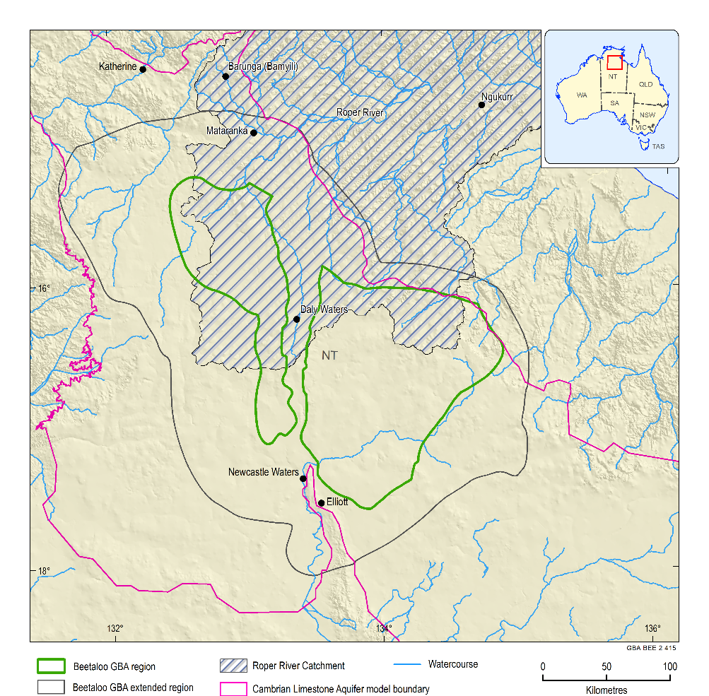
Figure 29 Regional groundwater model domains
Data:NGIS (Bureau of Meteorology, 2012); model boundary for the Cambrian Limestone Aquifer (Geological and Bioregional Assessment Program, 2019j)
Element: GBA-BEE-2-415

Water balance estimates
A water balance for the Cambrian Limestone Aquifer in the area encompassed by the Beetaloo GBA region is complicated by the fact that the area includes several regional groundwater flow systems segregated by groundwater divides (Section 3.3.3.2.1). Also, previous water balance calculations cover different portions of the CLA (Tickell and Bruwer, 2017; Fulton and Knapton, 2015b; Knapton, 2006).
A water balance estimate for the Cambrian limestone aquifers in the Georgina Basin to southern Daly Basin (Tickell and Bruwer, 2017), which overlie the eastern Beetaloo Sub-basin, is outlined in Figure 30. Throughflow from the Georgina Basin to southern Daly Basin is estimated to be approximately 2 GL/year. The water balance suggests there is a net gain in both basins which, if the case, would result in rising groundwater levels. Tickell and Bruwer (2017) have established a mean rise of 0.85 m took place in the northern Georgina Basin over the periods 1950-1973 and 2012-2017.
The water balance for the southern Daly Basin component (Figure 30) does not appear to include groundwater pumping. Also, discharge to Roper River (30 GL/year) is lower than previous estimates, such as Knapton (2006), who estimated discharge to the Roper River at end of dry season to be 3.1 m3/second, (98 GL/year). This apparent discrepancy is primarily because the Knapton (2006) value represents total discharge to the Roper River from all groundwater flow components in the CLA, whereas the Tickell and Bruwer (2017) estimate only takes into account discharge from the south out of the Georgina Basin (i.e. north directed flow only).
A water balance is not available for the Daly-Wiso basins portion of the CLA in the Beetaloo GBA region.
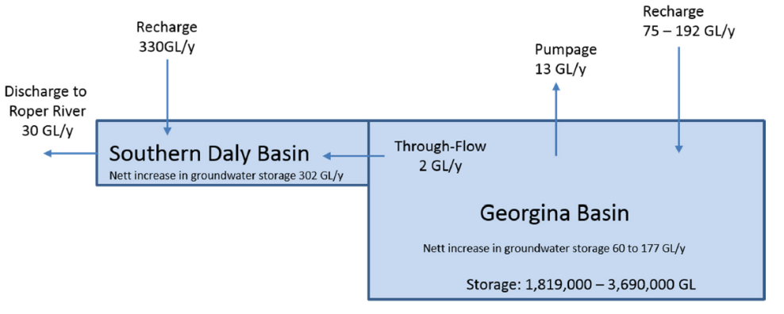
Figure 30 Water balance for Georgina and southern Daly basins to Mataranka Thermal Pools
Source: after Tickell and Bruwer (2017)
Element: GBA-BEE-2-338

Carpentaria Basin
Over much of the Beetaloo GBA region, Carpentaria Basin sedimentary rocks are unsaturated as they occur predominantly above the regional watertable. The thickness and lithology of the Carpentaria Basin can significantly influence recharge. Generally, the upper claystone and mudstone units ‘Units B and C’ (see Section 3.2.4) tend to act as aquitards, impeding diffuse recharge downwards to the underlying CLA. However, where the upper claystone units are absent and the basal sandstone (Unit A) is exposed, recharge can percolate into the underlying CLA (Yin Foo, 2002). Outside the Beetaloo GBA region this is case for parts of the Tindall Limestone aquifer in the Daly Basin, where it is not overlain by the Jinduckin Formation (Knapton, 2006). This also appears to be the case for the north-western part of the Beetaloo GBA region; however, the distribution of Unit A is generally poorly known. Due to its influence on recharge, the thickness and lithological makeup of the Carpentaria Basin could influence (lessen?) any impacts from surface activities and hazards such as spills.
Only in one area is it known to contain a groundwater resource in the central area of the eastern Beetaloo GBA region where the basal sandstone (Unit ‘A’) forms a saturated aquifer that is exploited for stock and domestic water supply on Beetaloo Station. In this small area, this basal sandstone unit is in hydraulic contact with the underlying CLA and lies below the regional watertable. Bore depths here range from 71 to 145 mBGL (average 91 mBGL) and bore yields are estimated at between 0.3 to 4 L/second (average 2.4 L/second). A transmissivity of 41 m2/day was established from pump tests at Beetaloo Station. The standing water level in this aquifer ranges from 56 to 80 mBGL (average 64 mBGL), the groundwater gradient is flat and there is no clear apparent flow direction within this local aquifer (Fulton and Knapton, 2015b). Further information on water quality and bore locations is detailed in Section 3.3.4 and Figure 38.

Cenozoic
There is the potential for the development of transient and localised perched aquifer systems where the lateritic profile is well developed or within sandier alluvial sequences that overlie less permeable Cretaceous siltstones (Fulton and Knapton, 2015b). The alluvium is likely to be largely saturated in the vicinity of spring discharge points and the Roper River downstream of Mataranka Thermal Pools. Some of the tufa (freshwater limestone) deposits are saturated in the vicinity of springs. For instance, they form part of the discharge zone for the Tindall Limestone aquifer at Mataranka Thermal Pools where it thins towards the Roper River (Tickell, 2005). Most detailed studies investigating shallow groundwater in the Beetaloo GBA region would be around Lake Woods (de Caritat et al., 2019) and investigations around Mataranka Thermal Pools (e.g. Karp (2008)).

Hydrochemistry
Table 6 summarises the hydrochemical data from Geological and Bioregional Assessment Program (2019h), showing total dissolved solids (TDS), pH, and major ion concentrations from groundwater samples from the major lithostratigraphic groups in the Beetaloo GBA extended region.
The following sections provide a detailed discussion on the hydrochemical characteristics of the major lithostratigraphic groups of the region based on the most recent sampling data available (383 samples). Table 6 also includes maximum and minimum values for the full dataset of 751 samples for completeness (all results are included in Geological and Bioregional Assessment Program (2019h)). The hydrochemistry of several lithostratigraphic units is somewhat uncertain across the Beetaloo GBA extended region due to lack of data. It is therefore important to note that the results presented below may not necessarily represent hydrochemical conditions for an aquifer across the whole of the Beetaloo GBA region.

Table 6 Hydrochemistry of groundwater samples from the Beetaloo GBA region and surrounds
Values in brackets are average analyte values.
 |  | No. of samples | TDS  (mg/L) | pH |  | Major ion concentration (mg/L)
 | Lith. Group | No. of samples | TDS  (mg/L) | pH | Ca | Mg | Na | K | HCO₃ | CO₃ | Cl | SO₄
 | Cenozoic All | 1 | 270 | 7.8 | 34 | 23 | 30 | 5 | 220-585 | 0 | 41 | 10
Carpentaria Basin | Cretaceous  (Most recent) | 9 | 170–8610 (1614) | 6.5–8.4  (7.6) | 13–120  (54) | 8.3–710 (119) | 27.3–2090 (353) | 10–110  (26) | 114–1021 (340) | 0–32  (4) | 12.7–2940 (488) | 5–2380 (399)
Carpentaria Basin | All | 16 | 170–8610 | 6.5–8.4 | 12–222 | 8.3–710 | 27.3–2090 | 10–110 | 114–1424 | 0–32 | 12.7–2940 | 5–2380
Daily, Wiso and Georgina basins | Upper CLA  (Most recent) | 91 | 221–2239 (922) | 6.2–8.7  (7.5) | 12–259  (88) | 26–114  (56) | 6–331  (135) | 3–80  (20) | 132–525 (358) | 0–0  (0) | 7–539  (191) | 0.5–797 (207)
Daily, Wiso and Georgina basins | All | 215 | 221–3020 | 6.2–8.7 | 12–441 | 25–185 | 6–412 | 3–221 | 86–536 | 0–0 | 6–570 | 0.5–1514
Daily, Wiso and Georgina basins | Lower CLA  (Most recent) | 229 | 93–1990 (820) | 6–9.52  (7.4) | 1–204  (94) | 1–124  (51) | 1–438  (115) | 1–76  (21) | 5–764  (473) | 0–81  (0) | 2–620  (146) | 0.5–650 (134)
Daily, Wiso and Georgina basins | All | 427 | 93–3881 | 6–9.52 | 1–400 | 0.5–155 | 1–575 | 0.5–76 | 5–764 | 0–81 | 2–1080 | 0–1140
Unnamed | Antrim PV  (Most recent) | 18 | 210–872 (496) | 6.5–8.6  (7.5) | 8–138  (61) | 2–92  (30) | 6–243  (72) | 1–16  (5) | 149–695 (366) | 0–5  (0) | 4–327  (73) | 0.5–164 (40)
Unnamed | All | 34 | 210–1359 | 6.3–8.6 | 8–138 | 2–94 | 6–472 | 1–16 | 149–695 | 0–5 | 4–660 | 0.5–176
Unnamed | Bukalara Sandstone  (Most recent) | 12 | 73–1510 (577) | 6.3-7.9  (7.3) | 3–120  (54) | 2–98  (33) | 14–224  (84) | 3–36  (16) | 38–447 (238) | 0–0  (0) | 10–340 (107) | 8–665  (141)
Unnamed | All | 14 | 73–1510 | 6.3-7.9 | 3–120 | 2–98 | 14–224 | 3–36 | 38–447 | 0–0 | 10–340 | 7–665
McArthur Basin | Roper Group/Proterozoic (Most recent) | 23 | 30–1410 (339) | 5.5-8.5  (7.2) | 1–93  (36) | 1–100  (31) | 2–376  (33) | 1–32  (10) | 12–576 (253) | 0–0  (0) | 2–427 (40) | 1–325 (40)
McArthur Basin | All | 44 | 30–1410 | 5.5-9.0 | 1–97 | 1–100 | 2–376 | 1–32 | 12–576 | 0–28 | 2–427 | 0.5–325
Data: Geological and Bioregional Assessment Program (2019h)

Hierachical cluster analysis
Hierarchical cluster analysis (HCA) is a method that allows the incorporation of any user-defined combination of chemical and physical constituents including non-numerical parameters and allows the incorporation of any number of variables (Güler et al., 2002). HCA is now routinely used in groundwater hydrochemical studies to understand the physical and chemical processes that control groundwater evolution (e.g. Güler et al. (2002); Raiber et al. (2012)). The selection of variables in the present study is generally a trade-off between inclusion of a sufficient number of variables to ensure an accurate representation of groundwater quality and selecting a representative subset of variables that is large enough to capture the spatial variability of groundwater chemistry and the processes that control it. In the hierarchical cluster analysis, nine variables (Ca, Mg, Na, K, HCO3, Cl, SO4, electrical conductivity and pH) were selected for multivariate statistical analysis. Prior to the multivariate statistical analysis, all variables except for pH were log-transformed to ensure that each variable more closely follows a normal distribution. The multivariate statistical technique is described in more detail by Raiber et al. (2012) and Raiber et al. (2016).
Where sufficient data from the different components of the groundwater and surface water systems are available, hydrochemistry can also be used to determine connectivity between bedrock, alluvia and streams (e.g. Cartwright et al. (2010); King et al. (2014); Martinez et al. (2017); Raiber et al. (2019)). Hydrochemistry, in combination with dissolved methane concentrations, can also provide additional insight to potential migration pathways.
The multivariate statistical analysis of groundwater and surface water chemistry data (Figure 32 and Table 7) shows that there are multiple hydrochemistry clusters with distinct median values for different parameters. For example, the hydrochemical assessment of 857 groundwater bores and 21 surface water samples suggests there are five distinct clusters with median electrical conductivity (EC) values ranging between 118 and 1860 µS/cm and with distinct ionic ratios (Table 7and Figure 32).
Table 7 Median values of the variables considered in the hierarchical cluster analysis for each sample group
Cluster | Number of cases | EC (µS/cm) | pH | Mg (mg/L) | Na (mg/L) | K  (mg/L) | Ca (mg/L) | Cl (mg/L) | SO₄  (mg/L) | HCO₃ (mg/L)
1 | 229 | 985 | 7.8 | 41 | 75 | 16 | 58 | 88 | 71 | 351
2 | 211 | 1490 | 7.1 | 53 | 124 | 18 | 121 | 165 | 140 | 511
3 | 43 | 118 | 6.4 | 3 | 12 | 3 | 4 | 7 | 7 | 40
4 | 215 | 1860 | 7.7 | 63 | 205 | 26 | 100 | 270 | 244 | 397
5 | 162 | 701 | 7.265 | 35 | 10 | 3 | 77 | 10 | 15 | 426
Data: Geological and Bioregional Assessment Program (2019d)

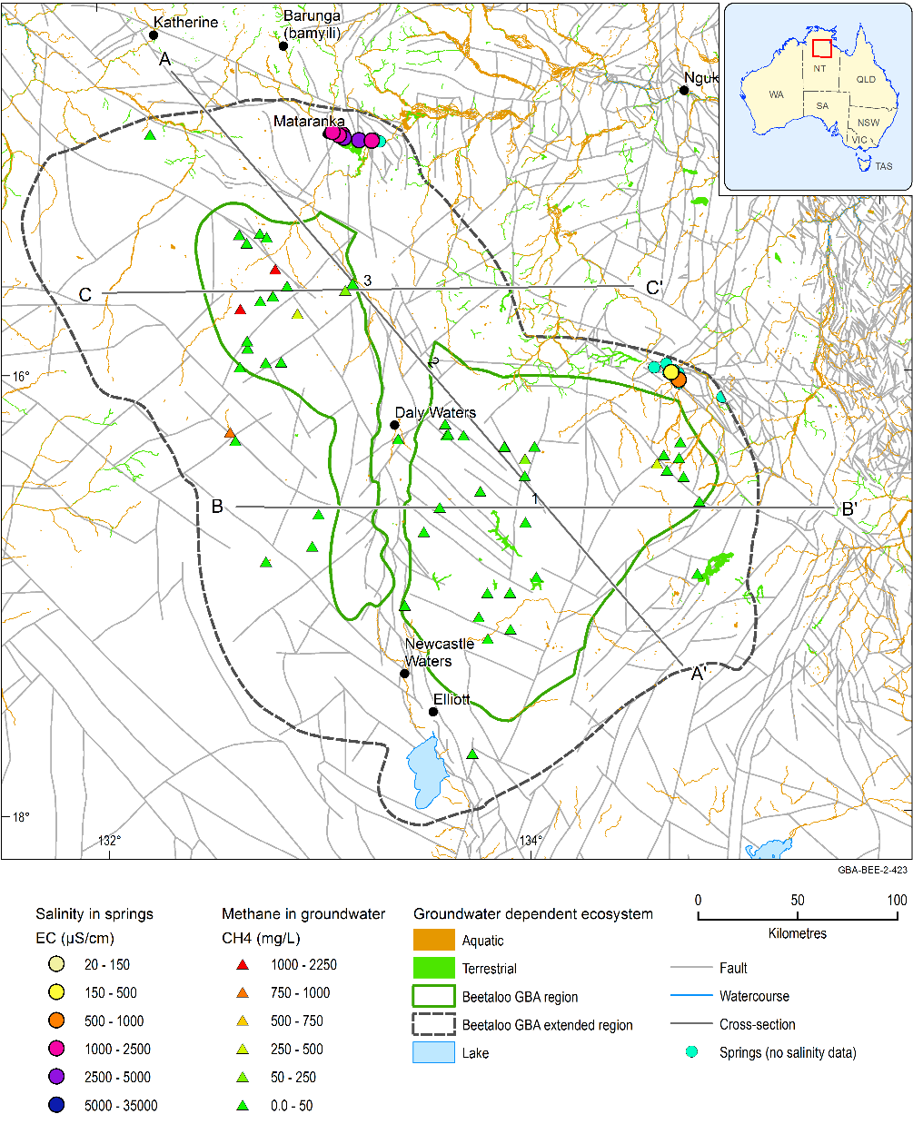
Figure 31 Spatial distribution of electrical conductivity (EC) measured in springs and dissolved methane (CH4) in groundwater across the Beetaloo GBA extended region with representation of the footprint of the alluvium and groundwater-dependent ecosystems
Cross-sections A, B, and C can be found in Figure 45, Figure 44 and Figure 46.
Data: methane data from Wilkes et al. (2019), springs EC values obtained from Department of Environment and Natural Resources (NT) (2013), faults from Betts et al. (2015)
Element: GBA-BEE-2-423
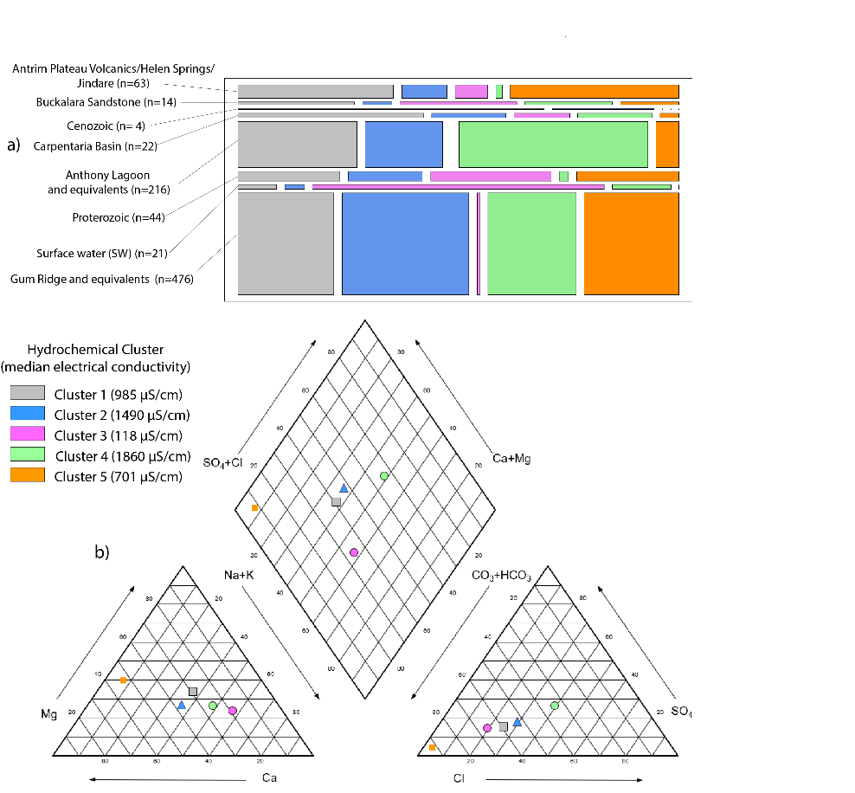
Figure 32 Cluster membership of aquifers and surface water in the Beetaloo GBA extended region
(a) The width of the bars represents the relative percentage of groundwater records assigned to each cluster. The numbers in brackets behind the hydrostratigraphic unit corresponds to the number of records for each formation.
(b) The piper plot shows the median concentrations of the different clusters as outlined in Table 7.
Samples from Bukalara Sandstone and Proterozoic are from shallow bores that are not located in the Beetaloo GBA region. The values may not necessarily be representative of the hydrochemistry of these units at depth
Data: Geological and Bioregional Assessment Program (2019d)
Element: GBA-BEE-2-349
Approximately 29% of all samples available for this study were sourced from the CLA system; they are mostly assigned to two clusters, with approximately 17% of the hydrochemical records attributed to Cluster 2 corresponding to lower CLA aquifers (Tindall, Gum Ridge and Montejinni) and 12% of samples assigned to Cluster 4 originating from the upper CLA (Jinduckin, Anthony Lagoon and Hooker Creek).
As described above, 203 sample records from the combined CLA system (upper and lower) are assigned to Cluster 4, which has the highest median electrical conductivity (EC) (1860 µS/cm), the lowest HCO3/Cl ratio, a predominance of Na over Ca and Mg, and the highest SO4 among all clusters (Figure 32).
Cluster 2 has the second highest median salinity among all samples (EC of 1490 µS/cm) and is represented predominantly by samples from the lower CLA (148 samples). It is characterised by a dominance of Cl over HCO3 and SO4 and Na + K over Ca and Mg.
Majority of samples in HCA clusters 1 and 5 are from the CLA, corresponding to approximately 13% each of all samples (n=112 and 110, respectively). Cluster 1 has the third highest median salinity (EC of 985 µS/cm) and similar ionic ratios to Cluster 2 (Figure 32). The largest number of samples (n=24) from the Antrim Plateau Volcanics are assigned to Cluster 2. This suggests that it would be difficult to differentiate using chemistry alone, waters from the Antrim Plateau Volcanics from those in the lower CLA.
Cluster 5 has the second freshest median EC value (701 µS/cm), with very strong dominance of HCO3 over Cl/SO4 and dominance of Ca+Mg over Na+K, which indicates the influence of recharge and less potential for mixing and interaction with underlying Proterozoic units.
Cluster 3 presents the lowest mean EC value among all groups (118 µS/cm) and is dominated by surface water samples (n=15 out of 21), Proterozoic (n=13) and Bukalara Sandstone (n=4). Groundwaters in this cluster are characterised by dominance of ions Na+K and HCO3. As discussed in Section 3.4.2.1, groundwater chemistry data obtained from the Proterozoic system is predominantly from bores located near areas of outcrop, outside of the Beetaloo GBA region.
There also appears to be a spatial control on the distribution of hydrochemical clusters in the Beetaloo GBA region (Figure 33). The great majority (94%) of samples assigned to Cluster 5 is located in Wiso Basin in the western part of the Beetaloo GBA region. Furthermore, the great majority of the samples from this cluster (~70%) are attributed to the lower CLA aquifer.
Similarly, samples assigned to clusters 2 and 4, the clusters with the highest median EC values among the five groups, are predominantly located near the southern and eastern margins of the Beetaloo GBA region, along the Daly Waters High and near the Mataranka Thermal Pools.
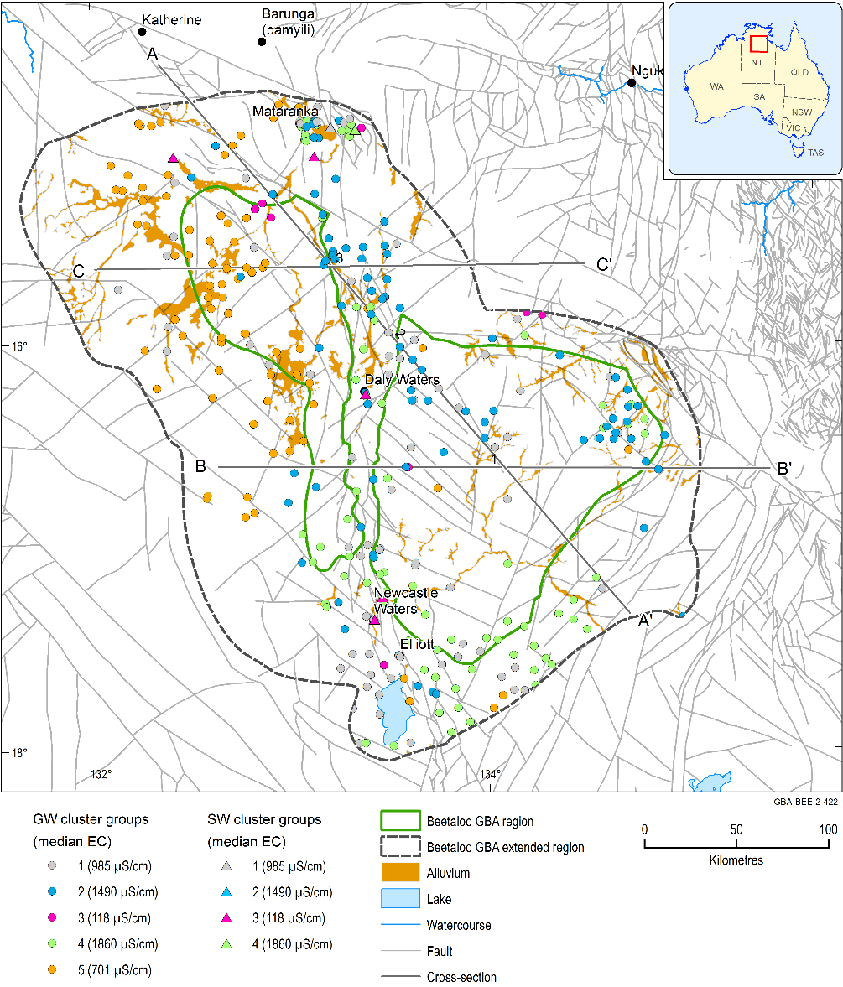
Figure 33 Spatial distribution of different clusters for groundwater and surface water samples across the Beetaloo GBA extended region
EC = electrical conductivity; GW = groundwater; SW = surface water
Data: alluvium footprint from Geoscience Australia (2012); hydrochemistry data used for cluster analysis from Geological and Bioregional Assessment Program (2019d), faults from Betts et al. (2015)
Element: GBA-BEE-2-422

Groundwater quality

Roper Group and other Proterozoic rocks below the Bukalara Sandstone
Drill stem tests (DST) in the Jamison sandstone, Hayfield mudstone and the Moroak Sandstone indicate extreme variability in Proterozoic salinity levels in the Beetaloo GBA region and surrounds. Fulton and Knapton (2015b) report that EC ranges from 32,000 to 159,000 μS/cm in these units, with a mean of 114,000 μS/cm. In comparison, seawater has an approximate EC of 55,000 μS/cm, equating to a TDS concentration of 32,500 mg/L assuming an EC to TDS conversion factor of 0.64 (Cook et al., 2013). EcOz Environmental Consultants (2015) reported that salinity is influenced by local processes such as secondary porosity and groundwater recharge volumes. Without secondary porosity and dilution from recharge, salts entrained during sedimentation may remain present in Proterozoic formations in significant concentrations.
Fulton and Knapton (2015b) report that the Proterozoic formation waters have a strong Na-Cl signature in their investigation area and therefore can clearly be distinguished from CLA groundwater. This difference supports the conceptual model that aquitard formations have generally inhibited extensive mixing between Proterozoic rocks and overlying sequences in the Beetaloo GBA region.
None of the water quality measurements for the Proterozoic units reported in Table 6 are taken from bores located within the Beetaloo GBA region (Figure 34). It is evident that there are significant differences in hydrochemistry of water samples obtained from Proterozoic rocks at depth in the Beetaloo GBA region and from Proterozoic rocks near surface, situated outside the region. Proterozoic aquifers are much closer to the surface thus more likely to receive recharge, resulting in substantially reduced salinity. TDS concentrations in these samples range from 30 to 1410 mg/L (average of 309 mg/L), so they can be considered non-saline (FAO, 1992). They generally show lower salinity than the other lithostratigraphic groups. The ionic composition of Proterozoic groundwater samples in Table 6 is typically Mg-Ca Na - HCO3 (Figure 35), possibly indicating interaction with the overlying CLA in places. However, these samples are not considered likely to be representative of groundwater in Proterozoic units of the Beetaloo GBA region based on DST data.
In summary, due to sample numbers and data distribution, there is great uncertainty in understanding groundwater chemistry of the Proterozoic units within the Beetaloo GBA region compared to some other aquifers.
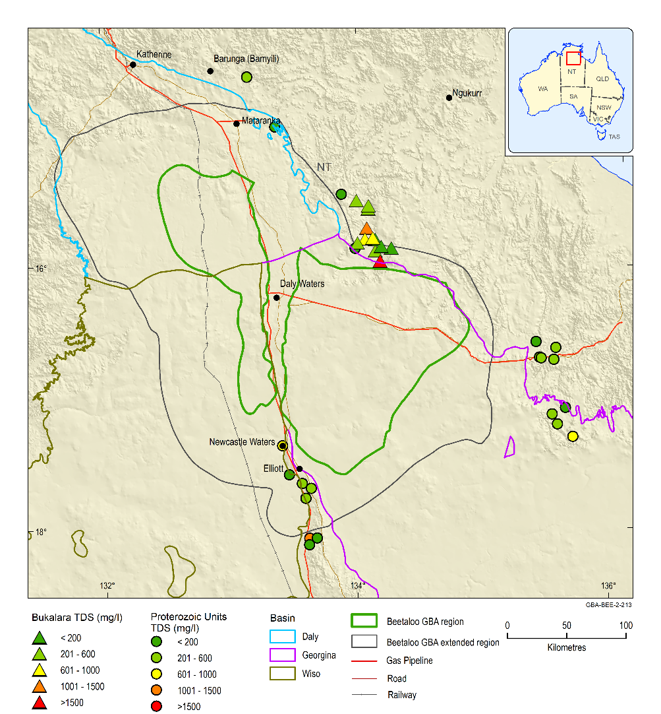
Figure 34 Groundwater salinity in the Proterozoic units and Bukalara Sandstone
TDS = total dissolved solids
Data: Geological and Bioregional Assessment Program (2019h)
Element: GBA-BEE-2-213

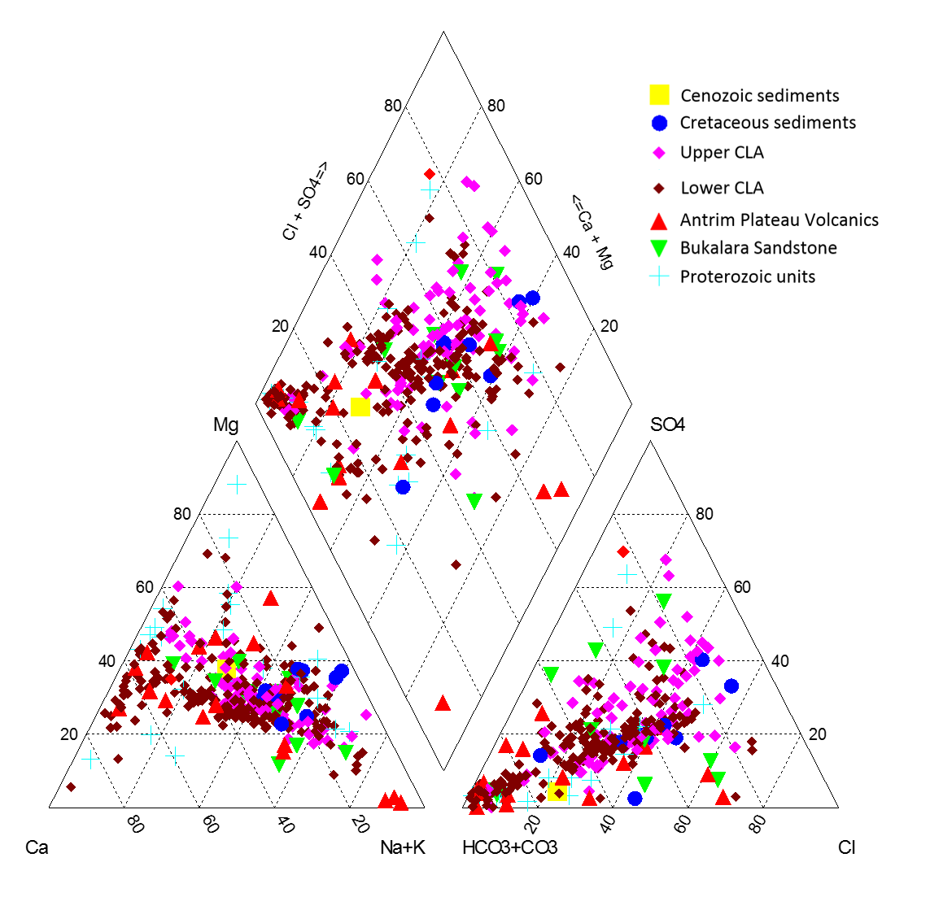
Figure 35 Piper diagram of stratigraphic units in the Beetaloo GBA region
Data: Geological and Bioregional Assessment Program (2019h)
Element: GBA-BEE-2-339

Bukalara Sandstone
Groundwater analyses for the Bukalara Sandstone are only available outside the Beetaloo GBA region, to the north-east (Figure 34). It is uncertain if they are representative of groundwater quality in the Beetaloo GBA region itself. Salinity levels (TDS) range from 73 mg/L to 1510 mg/L with an average of 577 mg/L. There is substantial variability in TDS within this unit, with some of the highest concentration samples (>1500 mg/L) in proximity (~10 km) to the lowest concentration samples (<200 mg/L). Waters of the Bukalara Sandstone show mixed Na-Mg-Ca cationic signature and generally a mixed HCO3- SO4-Cl anionic signature (Figure 35).

Antrim Plateau Volcanics
Most groundwater samples for the Antrim Plateau Volcanics are from the northern parts of the region (Figure 36), and it is unknown if they are representative of groundwater further south. Where information is available, groundwater quality is typically non-saline (FAO, 1992), with TDS ranging from 210-872 mg/L (average 496 mg/L). Figure 36 presents the available information for this unit, with no distinct spatial trends evident. Groundwaters of the Antrim Plateau Volcanics and equivalents show a general Ca-Na cationic and HCO3 anionic-dominated signature (Figure 35). Chemistry may possibly be commensurate with interaction with the CLA, at least in areas where fracturing/weathering has occurred, and the formation exhibits aquifer properties.

Cambrian Limestone Aquifer
Although there are abundant hydrochemistry data for the CLA systems, Figure 37 shows that groundwater chemistry is variable and spatial coverage is localised in both the upper and lower CLA. The discussions below pertain to the locations where data are available, and detailed chemistry may vary elsewhere.

Gum Ridge Formation and equivalents (lower CLA)
Salinity levels (TDS) in the lower CLA ranged from 93 to 1990 mg/L (average of 820 mg/L), and are generally classed as slightly saline (FAO, 1992). TDS groundwater concentrations for these units are presented in Figure 36, while Figure 37 presents a colour-coded piper diagram showing ionic composition variations.
Salinity levels in the waters of the Tindall Limestone (Daly Basin) and Montejinni Limestone (Wiso Basin) are typically of better quality (TDS~500 mg/L) than the waters of the Gum Ridge Formation (Georgina Basin) where salinity generally ranges from 500-1500 mg/L. Lower salinity in the Tindall Limestone and Montejinni Limestone is thought to be a result of increased direct recharge due to erosion of overlying Cretaceous material and the presence of sinkholes in the landscape.
Groundwater from the Montejinni Limestone (Wiso Basin) and the western portion of the Tindall Limestone (Daly Basin), show an Mg - Ca cationic and HCO3 anionic signature. This area of the CLA aquifer is shown spatially by the red-shaded samples presented in the colour-coded piper diagram (Figure 37). The high proportion of Mg and Ca and HCO3 is characteristic of groundwater influenced by the limestone and dolomitic aquifer systems. In contrast, these waters are geochemically distinct from the groundwater of the Georgina Basin to the east, which show a more mixed groundwater signature (as shown by the sharp change in colouring in Figure 37 along the basin boundary). This demonstrates the groundwater divide that exists between the Wiso and Georgina basins, and adds weight to the groundwater flow interpretation in Section 3.3.3.2.
A cluster of higher salinity bores (TDS>1500 mg/L) is present around the southern boundary of the western Beetaloo GBA region (Figure 36). In this region, the groundwater exhibits a general Na-Cl dominated signature (Figure 37). In this region, the Antrim Plateau Volcanics are absent, which may indicate a degree of mixing between the CLA and the underlying Na-Cl groundwater of the Proterozoic rocks (Fulton and Knapton, 2015b). However, further work is required to confirm this possibility. It is also noted that DENR suggest that these higher salinity bores may in fact be installed in the Anthony Lagoon Formation, further emphasising that the aquifer designations in (Fulton and Knapton, 2015b) require careful checking in future.
The slightly elevated salinity of the Gum Ridge Formation has been attributed to the northward flow of water from the Georgina Basin and groundwater with progressively changing hydrochemistry through intermixture of the poorer quality groundwater from the Anthony Lagoon Formation (EcOz Environmental Consultants, 2015).

Anthony Lagoon Formation and equivalents (upper CLA)
Salinity levels in the Anthony Lagoon Formation (Georgina Basin) and equivalents (Hooker Creek Formation- Wiso Basin, Jinduckin Formation- Daly Basin), collectively known as the upper CLA, range from 221 mg/L to 2239 mg/L (TDS) with an average of 922 mg/L.
The elevated salinity of the upper CLA, when compared to the lower CLA (average TDS 822 mg/L), has been thought to be due to the presence of evaporite beds (Yin Foo and Matthews, 2001). However, a recent groundwater study of the Lake Woods region (de Caritat et al., 2019) showed that that gypsum dissolution was not an important process and that the dominant single source of S with a δ34S value of approximately +20%, derived from sea water through precipitation, specifically during summer monsoons.
The available hydrochemistry data (Figure 37) show spatial similarities between the upper CLA and lower CLA. The groundwater of the Jinduckin Formation (the four samples in the ‘upper CLA’ area in the Daly Basin on Figure 37), for example, has an Mg-Ca cationic and HCO3 anionic signature that is very similar to the underlying Tindall Limestone (‘lower CLA’). Further, groundwater of the Anthony Lagoon Formation shows a dominance of Na-Mg cations and HCO3-Cl anions (typically light purple and blue colours) is similar to the signature of underlying Gum Ridge Formation groundwater further to the north. Such features could suggest a degree of mixing between aquifers in places, but care is required in interpretation given the presence of possible confining units (e.g. siltstones) through parts of these sequences.

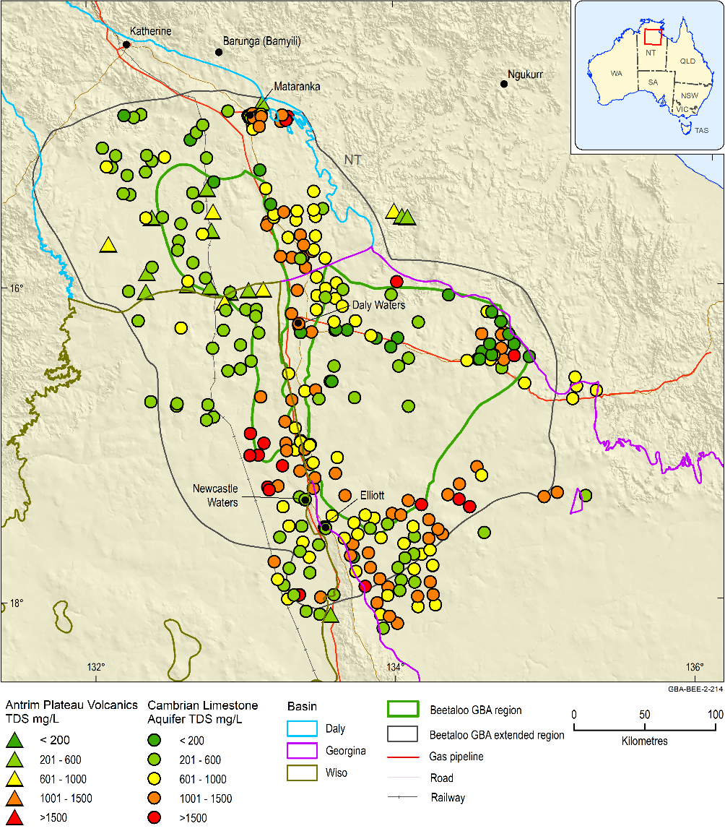
Figure 36 Salinity levels in the Cambrian Limestone Aquifer and Antrim Plateau Volcanics and equivalents
TDS = total dissolved solids
Data: Geological and Bioregional Assessment Program (2019h)
Element: GBA-BEE-2-214

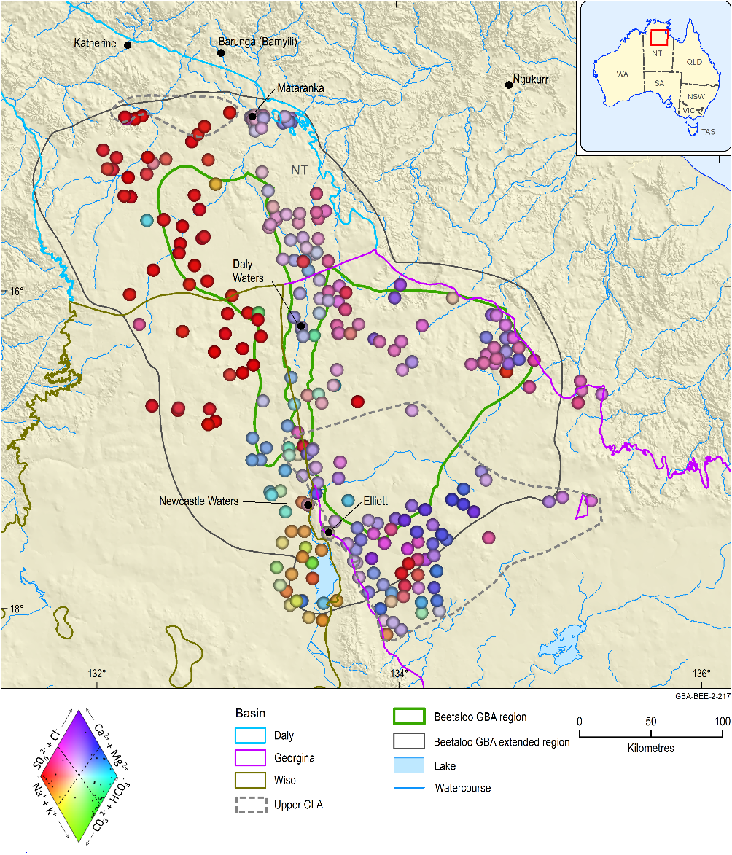
Figure 37 Colour-coded Piper diagram of the Cambrian Limestone Aquifer (CLA)
Source: after Peeters (2014)
Data: Geological and Bioregional Assessment Program (2019h)
Element: GBA-BEE-2-217

Carpentaria Basin
Due to their typically unsaturated nature, groundwater samples from Cretaceous sedimentary rocks of the Carpentaria Basin are limited to the southern portion of the Beetaloo GBA region, and the far north near Mataranka Thermal Pools (Figure 38). Salinity levels (TDS) range from 170 mg/L to 8610 mg/L, with an average of 1614 mg/L and are generally classed as moderately saline (FAO, 1992). Groundwater geochemistry typically shows a Na cationic and HCO3-Cl mixed anionic signature.

Cenozoic sediments
While Cenozoic sediments are widespread across the basin, they are typically unsaturated; therefore, only one sample was available (Figure 38), and it was from outside the Beetaloo GBA region. The salinity level in this sample was 270 mg/L, classed as non-saline (FAO, 1992). Groundwater geochemistry shows an Mg-Ca cationic and HCO3 anionic signature. It is unknown if this sample is representative of groundwater chemistry in perched groundwater systems elsewhere. Perched groundwater is known to be present in three groundwater monitoring bores installed by Origin Energy in the north-west of the eastern Beetaloo GBA region (see Section 2.1.3.2). However, chemical analyses were not available at the time of writing.
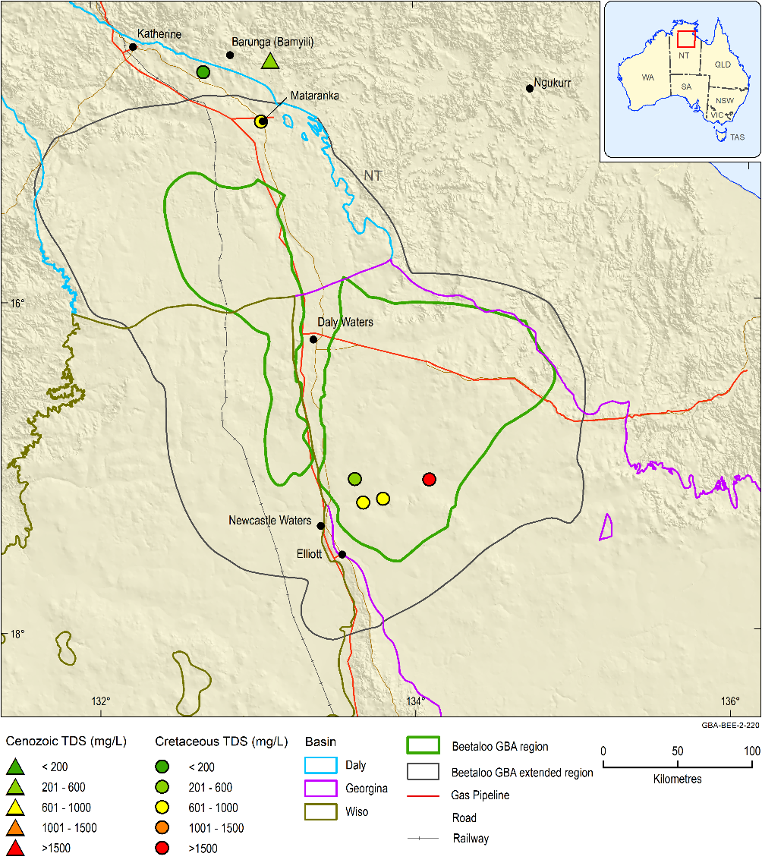
Figure 38 Total dissolved solids (salinity levels) in Cenozoic and Cretaceous sediments (Carpentaria Basin)
TDS = total dissolved solids
Data: Geological and Bioregional Assessment Program (2019h)
Element: GBA-BEE-2-220

Springs with Proterozoic source aquifers
No springs are located within the Beetaloo GBA region in the NT Springs dataset (Department of Environment and Natural Resources (NT), 2013). The closest group of springs is situated approximately 10 km to the north-east of the Beetaloo GBA region, in the headwaters to the Cox River catchment. Beauty Creek springs is situated in the aptly named ‘Hot Springs Valley’, where it discharges freshwater (310mg/L, see Table 7.6 in Zaar (2009a)) at 60°C. Geologically, this spring occurs near the contact of the Maiwok and Collara subgroups on the western flank of an anticlinal dome – between Hodgson Sandstone to the east and Bessie Creek Sandstone-Corcoran Formation to the west. The source aquifer(s) for these springs is unknown, but depending on structural control and geology at depth, they may be part of the Roper Group (e.g. the Hodgson or Bessie Creek sandstones). Lagoon Creek springs are present in an adjacent valley to the west. They occur primarily on Maiwok Subgroup substrate (Bessie Creek Sandstone and Corcoran Formation) in a structurally complex zone. Lagoon Creek springs also yield hot but relatively fresh groundwater (Zaar, 2009a).
The petroleum well Marmbulligan 1, drilled 19km south-east of the Beauty Creek and Lagoon Creek springs, has at depth of 675 m a bottom hole temperature of 56 ºC (uncorrected for cooling effects of drilling). This suggests that hot springs with temperatures up to 60 ºC would require groundwater circulation down to at least 650 m (Figure 12), along with good permeability. Surface geology suggests there is likely to be a high degree of structural control on groundwater flow paths. As discussed in Section 3.2.1, the degree of connectivity between areas of Roper Group outcrop and Roper Group at depth in the Beetaloo Sub-basin is speculative. More hydrochemistry data and environmental tracers would be required to determine flow paths and to pinpoint source aquifer(s) for springs in these areas.
Other springs found to the north of the eastern Beetaloo GBA region are predominantly associated with Proterozoic outcrop. Further detail on some of these springs can be found in Zaar (2009a).

Springs from Cambrian Limestone aquifers and river baseflow
Mataranka Thermal Pools are situated in the Roper River catchment in Elsey National Park, some 50 km north of the Beetaloo GBA region (Figure 39). They include spring pools, significant tufa deposits, and large wetlands, and they provide baseflow to the Roper River. The Roper River is one of the few rivers in northern Australia that exhibits perennial flows. As outlined in Section 3.3.3.2, a groundwater divide (Figure 16), separates northerly regional flow in the Tindall Limestone aquifer towards Katherine from southerly directed regional flow towards Mataranka Thermal Pools and the Roper River. Further south, groundwater from the Georgina Basin flows northward from the Beetaloo GBA region through the southern portions of the Daly Basin to discharge at Mataranka Thermal Pools on the Roper River (Tickell and Bruwer, 2017).
Downstream of Mataranka Thermal Pools at Roper River gauge station G9030176, Knapton (2006) estimated the end of dry-season cumulative discharge from baseflow and spring discharge to be 3.1 m3/second, which equates to approximately 268 ML/day. Fulton and Knapton (2015b) estimated end of dry-season cumulative discharge to be in the order of 3 to 4 m3/second (260–345 ML/day). Tickell and Bruwer (2017) reported discharge estimates from the southern Daly and Georgina basins (i.e. the northward flow component) to be 0.95 m3/second (82 ML/day). These estimates suggest that the southward and eastward flow components in the Tindall Limestone aquifer contribute around 186 ML/day, approximately two-thirds of total spring discharge.
From major ion hydrochemistry, Karp (2008) inferred that groundwater discharging at springs in the Mataranka area consisted of a mixture of waters from aquifers in the Daly and Georgina basins. Some springs (e.g. Botanic Walk springs) were considered to predominantly include groundwater with an Anthony Lagoon Formation (Georgina Basin) signature, whereas others (e.g. Springvale and Katherine Hot springs) showed evidence of a Tindall Limestone aquifer (Daly Basin) signature. Bitter Springs and Rainbow Spring were thought to be situated in a mixing zone for discharge from the Georgina and Daly basins. Spring discharge temperatures ranged from 25 to 33°C. Aside from major ion chemistry, other testing has detected low levels of pesticides at Mataranka Thermal Pools, which are probably derived from groundwater discharge (Schult, 2016).
The western Beetaloo GBA region is overlain by Cambrian Limestone aquifers of the Wiso and Daly basins. Regional groundwater flow in the CLA, out of the Beetaloo GBA region, is north-westward in this area (Figure 16). The nearest potential discharge points are the Flora River Springs (EcOz Environmental Consultants, 2015), which are located approximately 115 km north-west of the Beetaloo GBA region (Figure 39). Here, estimated discharge is in the order of 2.3 m³/second (199 ML/day) at the end of the dry season (Knapton, 2006). The Flora River gains about 2 to 5 m³/second (172–432 ML/day) where it crosses the Tindall Limestone (Tickell, 2005).
A groundwater divide that coincides with the catchment divide, between the King and Katherine rivers (Tickell, 2005; Knapton, 2009), separates the Katherine springs groundwater flow system from flow to Mataranka Thermal Pools. For the Daly Basin, Knapton (2006) estimates discharge (including spring discharge) around Katherine from the Tindall aquifer to be in the order of 1.33 m³/second (115 ML/day) at end of the dry season.
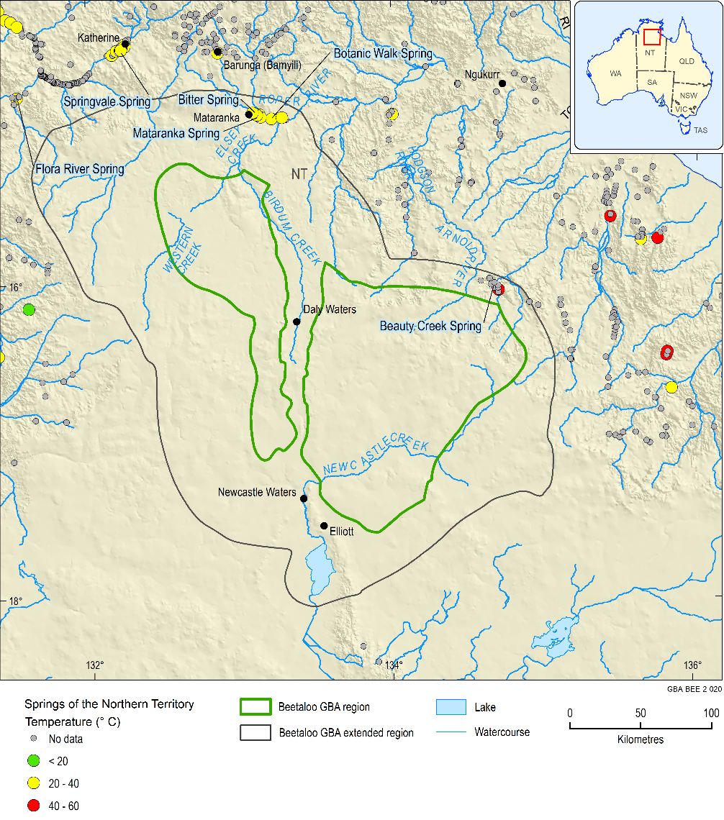
Figure 39 Location of springs near the Beetaloo GBA region, colour coded by the temperature of groundwater
Data: Northern Territory springs database (Department of Environment and Natural Resources (NT), 2013)
Element: GBA-BEE-2-020

Groundwater-dependent ecosystems and remote sensing water in the landscape
Watercourses and wetlands with known or moderate to high probability of being groundwater-dependent ecosystems (GDEs) listed in the GDE Atlas (Bureau of Meteorology, 2017) are shown in Figure 40. Most of these are confined to streamlines outside the Beetaloo GBA region. Mataranka Thermal Pools is identified as a terrestrial GDE area. Some terrestrial GDEs located to the south-east of Daly Waters are defined by the occurrence of Melaleuca species and low woodlands in alluvial valleys. Aquatic GDEs are also identified locally along various drainage features. Given the depth to regional groundwater shown in Figure 18, most of the potential GDEs shown in the GBA Beetaloo region must be related to shallow perched groundwater systems if they are groundwater related.
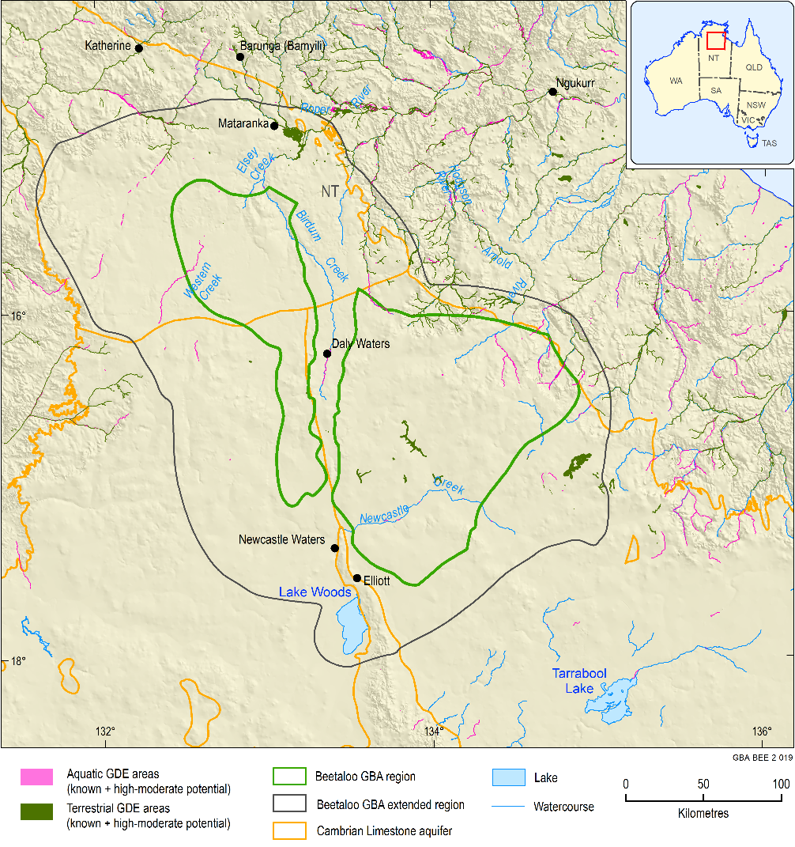
Figure 40 Groundwater-dependent ecosystems
Data: GDE Atlas Bureau of Meteorology (2017)
Element: GBA-BEE-2-019

Water Observations from Space
The Water Observations from Space (WOfS) statistic on Figure 41 is based on the 25 m x 25 m pixel resolution Landsat archive from 1986 to 2018. The figure shows the percentage of observations in which surface water was detected relative to the total number of clear surface observations for each pixel. An unfiltered WOfS product including less certain observations is available online at https://nationalmap.gov.au, from which observations are deleted to generate Figure 41, based on characteristics such as topography and shadow (Mueller et al., 2016). The unfiltered product appears very similar to Figure 41 and is not included here.
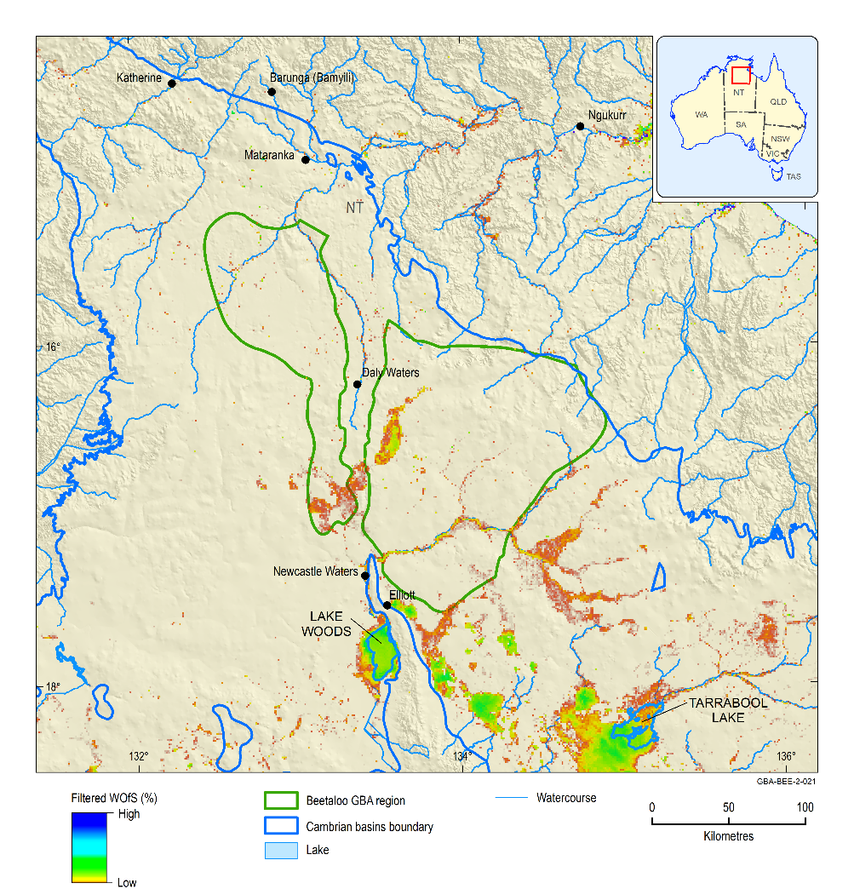
Figure 41 Filtered Water Observations from Space (WOfs) for the Beetaloo GBA region
Data: Water Observations from Space (Geoscience Australia, 2018)
Element: GBA-BEE-2-021
WOfS provides insight into the behaviour of surface water over time. Applications of WOfS include assessing the degree of perenniality of watercourses, the nature of floods and floodplain extents, the size and nature of wetlands, land surface processes and groundwater recharge (Mueller et al., 2016). The 25 m x 25 m pixel resolution limits the size of surface water features that can be confidently detected using this technique. The minimum area repeatedly detectable as surface water is typically 2 x 2 pixels and features smaller than a pixel may not always be reliably observed. Further, Landsat observations are only available from 1986 onwards, and images during flooding may be unclear due to cloud cover. Thus, surface water may be present in the landscape at times and locations not identified by WOfS. Despite these caveats, the analysis does provide very useful information, particularly on where surface water persists during drier times.
Figure 41 shows that surface water was identified by WOfS along creek lines, surface depressions (many probably karst-related), lakes, farm dams and near known GDEs. In the southern parts of the Beetaloo GBA region, surface water was detected in floodplains that appear to form part of a closed surface water drainage system south of Daly Waters. Most of the floodplain areas are wet in <10% of observations, but locally surface water has been observed to be present >50% of the time (e.g. in depressions along the eastern margin of the northernmost floodplain). The floodplain system appears to drain southwards in part to meet Newcastle Creek. South from the confluence, Newcastle Creek is known as Newcastle Waters Creek. Newcastle Waters Creek terminates in Lake Woods.
Water was observed across much of Lake Woods <15% of the time, but local values exceed 40% near the lake margins. Newcastle Waters Creek contains water in >80% of observations for over 10 km upstream from its discharge to Lake Woods. A recent hydrochemical study (de Caritat et al., 2019) showed that Lake Woods is predominantly fed by surface water from wet-season rains, and acts as a recharge area for the Montejinni Limestone aquifer of the Wiso Basin. WOfS imagery suggests that water tends to pool in the lake for extended periods before loss through either evaporation or recharge to the underlying aquifers. Other lakes to the east (e.g. Lake Tarrabool) provide recharge to aquifers of the underlying Georgina Basin (Tickell and Bruwer, 2017).
Surface water features identified by WOfS are generally larger in the south of the GBA Beetaloo region than in the north (e.g. no floodplains are highlighted on Figure 41 in the northern areas). The fact that rivers drain off the Sturt Plateau in the north is probably a major factor, but this difference may be partly related to recharge. While shallow formations of relatively low permeability are present to the south, a lack of thicker confining cover and the presence of sinkholes in the north may preclude water remaining at surface for long periods following rainfall.
There is evidence of relatively high surface water persistence in some areas: several depressions (potentially karst-related) and pools along drainage lines have WOfS values exceeding 70%. As discussed in Section 3.4.5, the regional groundwater level is generally >20 m deep in the Beetaloo GBA region. If many of these features are groundwater dependent, it is most likely via perched, shallow groundwater systems. It is further noted that several aquatic GDEs on Figure 40 do not correspond to areas with high WOfS values. GDEs will require more detailed assessment at a local scale before any development works.

Tasselled Cap Wetness
The Tasselled Cap Index (TCI) is produced by reducing six bands of satellite data (blue, green, red, NEAR INFRARED, SWIR1, SWIR2) to three bands using Principal Components Analysis and Procrustes Rotation (Roberts et al., 2018). The three bands are designed to correlate with the Brightness, Greenness, and Wetness of the landscape. The ‘Tasselled Cap’ refers to the shape of the distribution of the transformed data in two dimensions (Kauth and Thomas, 1976), which resembles a hat with a tassel.
The Wetness band of the TCI was isolated in the current project to provide an overview of surface water in the landscape for comparison to WOfS data. There may be merit in examining additional bands in future if further analysis is required. For each pixel in the investigation area, the Tasselled Cap Wetness (TCW) value was calculated for each clear Landsat observation. For each pixel, the 10th and 90th percentile TCW statistics were reported for analysis. Without site-specific values, the continuous TCW indices are provisionally interpreted here as (note that wetness increases with increasing index value):
- <–1200: wetness decreasing with decreasing index value
- ≥–1200 to –600: wetness increasing (e.g. boggy ground, wet vegetation)
- ≥–600: wet (open water and wet vegetation)
The TCW figures use TCW = –1200 as a cut-off below which little wetness has been detected. The colour scale is stretched from -1200 to 0; all values >0 are classified in the maximum wetness category, while all values below –1200 are classified in the minimum wetness category.
Within the above wetness interpretation, the TCW results for the 10th percentile can be used to show areas where wetness is persistent in the landscape, while the 90th percentile results incorporate areas that are wet infrequently. The wet areas of these percentiles roughly correspond to the WOfS >90% and >10% statistics, respectively (noting that the percentiles represent the value of the pixel in the distribution of observations as opposed to the percentage of observations in which the pixel was wet). However, the TCW results include areas where soil and vegetation are wet, so smaller surface water bodies may be identifiable using this technique.
Except for a few small localised features, there is little apparent at the 10th percentile in the Beetaloo GBA region. Some exceptions include several of the pools along Newcastle Creek noted to contain persistent water (Section 3.4.5.1). In the surrounding area, the 10th percentile TCW analysis identifies further persistent features noted in the WOfS assessment, including the reach of Newcastle Waters Creek leading to Lake Woods and several surface watercourses near known springs (e.g. Mataranka).
Figure 42 shows many of the same features identified by WOfS values >10% in Section 3.4.5.1. The lighter coloured (less wet) TCW areas across the broader region on Figure 42 appear to relate to wet vegetation, having values <–600. The results can be analysed in detail at individual locations in future research phases.
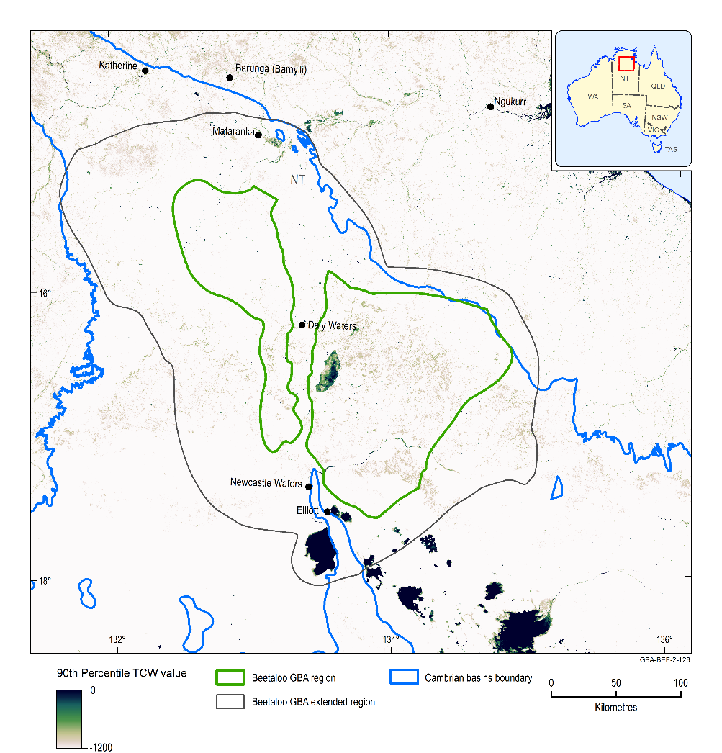
Figure 42 90th percentile Tasselled Cap Wetness (TCW) for the Beetaloo GBA region
Data: TCW image (Geological and Bioregional Assessment Program, 2019c)
Element: GBA-BEE-2-128

Potential hydrological connections
For groundwater, five potential connective pathways between hydrogeological systems could occur in the Beetaloo GBA region. These are:
1. via direct stratigraphic contact
2. via faults
3. through porous/karst aquifers
4 through partial aquifers/aquitards reaching overlying aquifers
5. via groundwater discharge from CLA aquifer to springs.
Some of these pathways can provide connectivity between shallow aquifers (such as the CLA) and environmental assets such as springs. Various combinations of these pathways would influence how and to what degree, a hazard (e.g. a spill, drawdown) may impact upon a hydrogeological-related asset (such as an aquifer or spring). Others could result in connectivity between the deeply buried Maiwok Subgroup (part of the Roper Group and the primary target for shale gas, tight gas and shale oil exploration) and shallower aquifers.
While these five potential hydrological connections are currently considered possible based on the existing data, it is important to note that further data collection, modelling and assessment is being conducted as part of Stage 3 of the GBA Program. These further assessments may allow some of these pathways to be discounted as plausible pathways for impact, if they indicate that activities conducted as part of unconventional shale gas development are unlikely to result in impacts on environmental assets.
Based on the limited available baseline data for deeper formations, hydrochemistry and dissolved gas concentrations provide evidence of potential connectivity between the different hydrogeological system components in some locations. The assessment highlights that considerable data and knowledge gaps exist. In particular, the absence of nested groundwater observation bore sites where multiple aquifers are monitored simultaneously means that there is currently insufficient evidence to rule in or out some pathways. This section outlines some of the key knowledge gaps and hypotheses that will be tested as part of Stage 3 of the Beetaloo GBA or may be considered in future studies to determine the likelihood of identified pathways from stressors to assets.
The potential connectivity pathways described above are unlikely to occur simultaneously and are also unlikely to create conditions that link the stressors to environmental assets in a human timescale. Nevertheless, considering existing numerous knowledge gaps, it is important to take a precautionary approach when assessing such processes and consider the possibility that fluid migration from one compartment of the basin to another may occur at different timescales, eventually impacting assets.
Multiple datasets are integrated in this section to understand the potential for hydrogeological connections between stressors associated with petroleum development in the Beetaloo Sub-basin and existing assets (e.g. aquifers, springs, surface water and ecosystems dependent on groundwater). The assessment of the derived geological framework is based on the use of key horizons and structural features in the three-dimensional geological model summarised in Section 3.2 and described in further detail in Orr et al. (2020). Within the Beetaloo Sub-basin, the primary targets for petroleum exploration are the Kyalla and Velkerrie formations (Hall et al., 2020).
Several two-dimensional cross-sections, extending from the Beetaloo Sub-basin at depth to surface (see Figure 43 for location of sections) were constructed to integrate currently available fault zone architecture information into the context of the regional stratigraphic framework and compare geological architecture and structure with the spatial distribution of assets.
On the basis of the cross-sections, conceptual models of potential flow paths were constructed with the aim to identify areas where there is greater likelihood of hydrogeological connection. The conceptual models are represented on sections as potential flow arrows. The potential for hydrogeological connection is qualitatively assessed on a combination of factors, including:
- extent, thickness and depth to petroleum targets in Kyalla and Velkerrie formation (see Hall et al. (2020) for detail). The extent is outlined in Figure 43
- separation difference and potential for connectivity between petroluem plays and overlying aquifers such as the Jamison sandstone, Bukalara Sandstone, through to the karstic/fracture systems of the Cambrian Limestone Aquifer, basal sandstone of Carpentaria Basin, Cenozoic aquifer and near-surface assets
- hydraulic gradients between the Kyalla and Velkerrie formations and overlying hydrostratigraphic sequences (see Section 3.1)
- general stress regime associated with the geological structures conducive to fault reactivation and enhancement
- spatial distribution of thickness and hydraulic properties of the aquitard/seals (e.g. Hayfield mudstone and Antrim Plateau Volcanics) positioned between the hydrocarbon plays and the identified overlying assets
- anomalies identified in physical-chemical, hydrochemical measurements in groundwater, springs and surface water samples (Section 3.4), and several gas measurements from water bores
- spatial location and extent of environmental assets, including GDEs, springs, reaches where baseflow to streams is likely to occur and groundwater bores used for water supply.
The major potential development-related stressors identified in the Beetaloo GBA region that could lead to hydrological connectivity related impacts are from the extraction of gas and oil from reservoir depths and the extraction of groundwater to provide water for petroleum activities. These stressors could lead to changes in permeability, groundwater flow directions and hydraulic gradients, which may result in changes to hydrological connectivity.
The primary targets for gas and oil production are the shales of the late Mesoproterozoic Velkerri and Kyalla formations. These formations have low permeability. The Moroak Sandstone is a tight gas play stratigraphically situated between Velkerri and Kyalla formations. In some areas the Moroak Sandstone can locally exhibit some of the properties of a fractured rock aquifer (see Section3.2.1). While information is limited, the Moroak Sandstone in the Beetaloo Sub-basin is unlikely to be an effective groundwater system. Limited sampling suggests the water quality is highly saline, and the cross-sections suggest it may be for the most part isolated from shallower aquifer systems, which minimises potential for inter-aquifer leakage.
Groundwater, extracted under licence, is likely to be the main source of water for any future petroleum development in the Beetaloo GBA region due to legislated restrictions on the use of surface water sources. The extraction of groundwater, in some circumstances, can cause drawdown in aquifers, at least in close proximity to extraction bores, and is considered as a possible stressor that may impact on water volume or quality of these aquifers and associated assets. The aquifers considered include the Jamison sandstone, Bukalara Sandstone, CLA, the saturated basal intervals of the overlying Cretaceous and perched aquifers within the Cenozoic sediments.
The surface assets that may be impacted include:
- Springs (Section 3.4.3). The closest springs are located approximately 10 km to the northeast of the limits of the Beetaloo GBA region (e.g. Lagoon Creek and Beauty Creek Springs). Mataranka Thermal Pools is located to the north of the Beetaloo GBA region but is potentially indirectly connected through groundwater flow out of the region. At present, the understanding on potential contributions from different source aquifers is limited due to a lack of baseline monitoring data (e.g. hydrochemistry and environmental tracers) particularly from formations below the CLA. Hydrochemistry and environmental tracer field sampling campaigns conducted as part of Stage 3 will help to improve this system understanding.
- GDEs (see Section 3.4.5). Only those watercourses and wetlands with known or moderate to high probability of being groundwater-dependent ecosystems (GDEs) in the Groundwater Dependent Ecosystems Atlas (Bureau of Meteorology, 2017) were considered for the assessment, as shown in Figure 40. GDEs may depend on associated shallow perched groundwater systems as well as discharges from deeper regional groundwater systems such as the CLA. For instance, Mataranka Thermal Pools, identified as a terrestrial GDE area, is known to be reliant on discharge from the CLA.
Data (e.g. environmental tracers and hydrochemistry) collected as part of Stage 3 and by CSIRO’s GISERA will help to better understand connections between aquifers and GDEs and reduce uncertainties on the understanding of the hydrogeological and hydrological systems.
- streams and wetlands – including Roper, Daly and Limmen Bight rivers, Wiso and the Barkly regions and Lake Woods (south).
- shallow groundwater bores – used for stock and domestic water supply, as registered in the Department of Environment and Natural Resources (NT) groundwater databases (see Section 2 for detail). Within the Beetaloo GBA region these bores draw groundwater predominantly from the CLA, Antrim Plateau Volcanics or Carpentaria Basin.
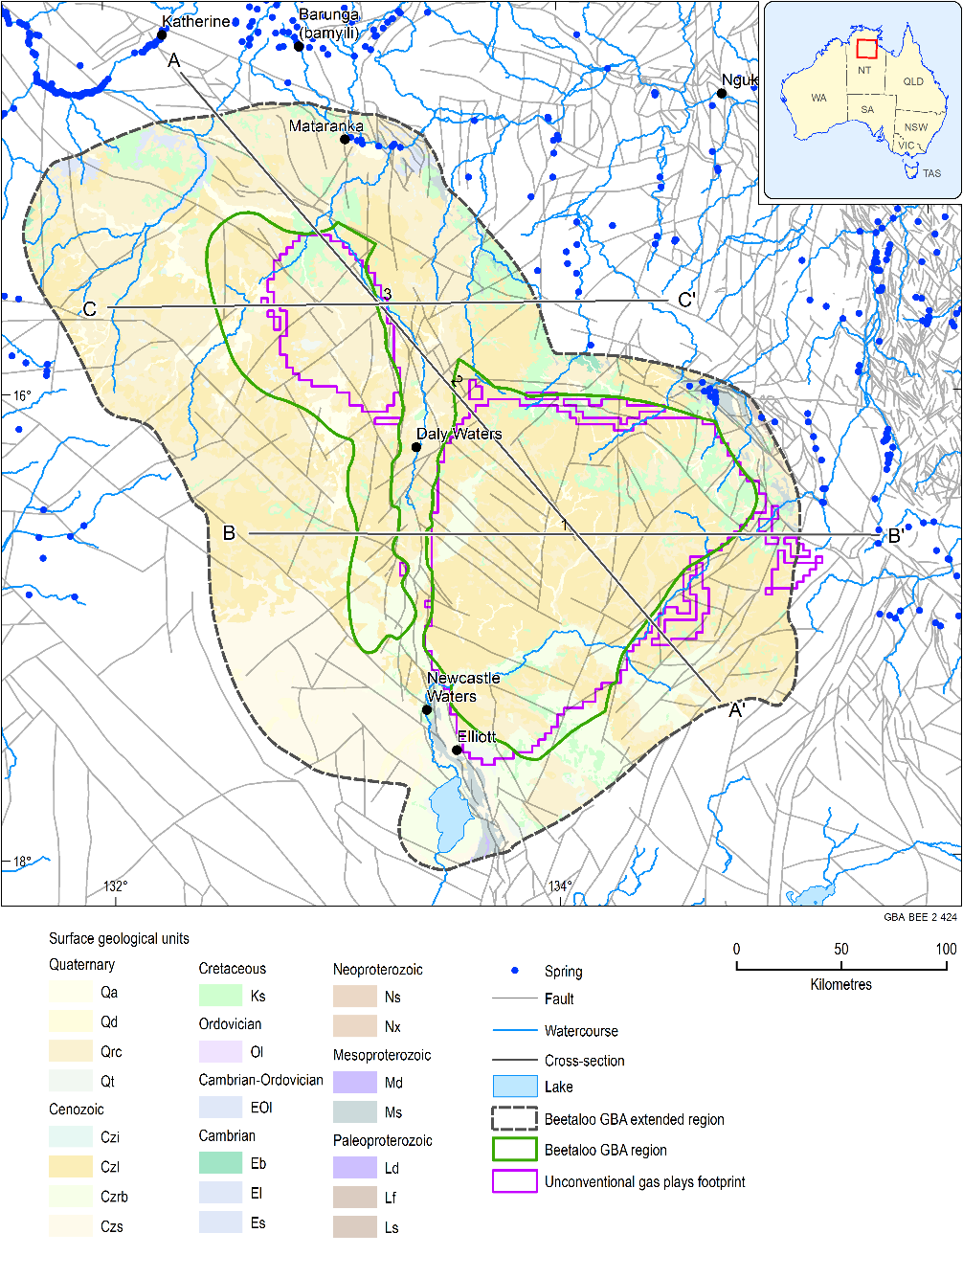
Figure 43 Beetaloo GBA region – surface geology, structures, footprint of Figure 44, Figure 45 and Figure 46
Data: faults sourced from Betts et al. (2015); unconventional gas plays footprints from Geological and Bioregional Assessment Program (2019b); springs from Department of Environment and Natural Resources (NT) (2013) and geology from Geoscience Australia (2012)
Element: GBA-BEE-2-424

Potential connectivity pathways
Over much of the eastern portion of the Beetaloo GBA region, the CLA is separated from the underlying prospective Neo and Mesoproterozoic units by multiple aquitards including uppermost, the Antrim Plateau Volcanics and the underlying Hayfield mudstone (see Section 3.2 and Orr et al. (2020)). The thickness of the Hayfield mudstone can reach 569 m, as recorded in exploration hole Tanumbirini-1. These collectively form a thick barrier to minimise mixing of deeper hydrocarbons and brines in the Roper Group with the lower salinity groundwater in the CLA and other shallow aquifers. However, in a few areas where these intervening aquitards are absent, thinner or are fractured along faults, there may be the potential for groundwater interconnectivity between the CLA and Neoproterozoic reservoirs such as the Jamison sandstone.
Based on currently available baseline data, five potential hydrological connections could possibly form pathways for groundwater and gas from deep shale gas, tight gas and shale oil plays, or from aquifer systems under pumping (hydraulic stress) in the Beetaloo Sub-basin, to near-surface assets. Therefore, without further investigation some of these pathways cannot be ruled in or out. The development of any hydrological connectivity is influenced by the natural geological framework of the Beetaloo GBA region, including the geometry of aquifers and aquitards and their internal architecture, proximity of assets to faults, vertical continuity of faults and geological heterogeneity near the basin margins. Evidence considered for this initial assessment also included hydrochemical records from groundwater and surface water (see Section 3.4).
The five possible hydrological connections are:
- via direct stratigraphic contact
- via faults
- through porous/karst aquifers
- through partial aquifers/aquitards reaching overlying aquifers
- via groundwater discharge from CLA aquifer to springs.
It is important to point out that a combination of pathways may be required to allow migration of fluids or pressure from the hydrocarbon plays to near-surface assets, and that if these conditions occur they may not manifest on a human timescale. Through the five pathways, the key areas of potential concern for groundwater include:
- connectivity issues associated with gas and petroleum production from prospective Roper Group formations, whereby impacts could propagate to overlying groundwater systems (pathways 1 and 2)
- connectivity issues associated with extracting groundwater from units above the Roper Group for use in petroleum resource development, whereby impacts may spread to existing groundwater users and the environment through shallow groundwater systems (pathways 1, 2 and 3)
- connectivity through shallow aquifers (e.g. karst features in the CLA) enabling migration of contamination due to infiltration of surface spills from petroleum development or production. Effects from points 1 and 2 above may also follow this pathway (pathways 3, 4 and 5).
Furthermore, it is important to highlight that the limited available baseline data and groundwater observation bore infrastructure (i.e. the absence of multi-level groundwater observation sites where aquifers at different depths are monitored simultaneously) means that some pathways cannot be ruled in or out at present. However, additional collection of hydrochemical data and environmental tracers, along with modelling conducted during Stage 3 may allow some of the pathways to be ruled out if the assessment indicates that activities associated with unconventional gas development are unlikely to result in actual impacts along a potential hydrological connection.

① Potential connection via direct stratigraphic contact
Two possible scenarios of hydraulic connection may occur where a direct stratigraphic contact exists between the potential unconventional gas plays and adjacent overlying environmental assets (aquifers and associated surface features e.g. springs).
An evident connectivity pathway ‘gas plays – asset aquifer’ may be represented by the contact between the Velkerri and Kyalla formations with overlying units such as the Moroak Sandstone and Jamison sandstone. Groundwater quality can be relatively poor in these hydrostratigraphic units and they have highly variable hydraulic properties due to predominance of secondary porosity. The Kyalla Formation is also in direct contact with other overlying formations, including the Bukalara Sandstone, Antrim Plateau Volcanics and CLA, in discrete areas near the margins of the Beetaloo GBA region (see Figure 44, Figure 45 and Figure 46 for examples).
As noted in Figure 44, the thickness of the Undifferentiated Neoproterozoic, a hydrostratigraphic unit positioned between the shale gas bearing Kyalla Formation and the aquitard Antrim Plateau Volcanics is significantly reduced (<50 m) in the north-west corner of the western portion of the Beetaloo Sub-basin. In fact, the Kyalla Formation is possibly in direct contact with Antrim Plateau Volcanics near the zone represented in the cross-section, which may explain the occurrence of measurable methane (CH4) in this highly fractured unit and in the CLA. It is important to note that no mapped faults appear to be in proximity to samples with CH4 concentration above 50 µg/L in the western part of the Beetaloo GBA region, which is consistent with the hypothesis that the dissolved gas in groundwater is the result of direct stratigraphic contact (gas play – aquitard/aquifer), enhanced by fractured zones in Antrim Plateau Volcanics and karstic conditions in the CLA.
There is evidence of upward hydraulic gradients from the Roper Group towards overlying sequences (Origin Energy, 2019). Actual vertical fluid movement can only occur where a conductive pathway exists. Whether upward directed pressure gradients occur where aquitards are missing is not known. However, if they were this could allow for the movement of groundwater from deeper aquifers. This marks an additional conducive factor to fluid migration along zones where stratigraphic contacts exist. It should be noted that such connectivity can be further enhanced by the presence of geological structures, as described by connectivity pathway 2.

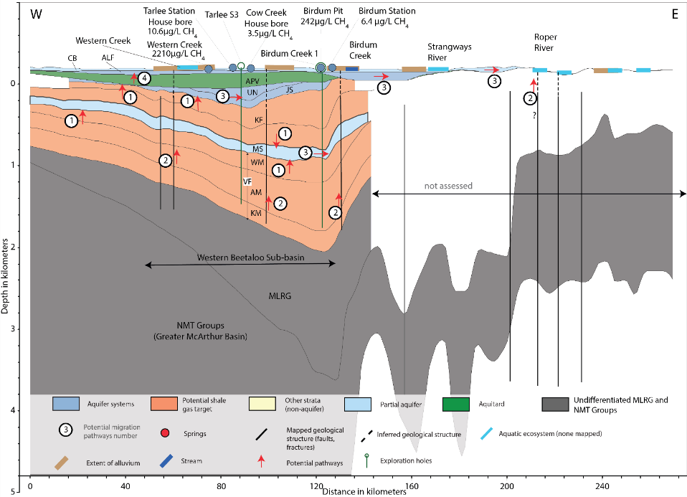
Figure 44 Cross-section C-C’ with west–east orientation through the western Beetaloo GBA region and highlighting the potential for stratigraphic contact between possible gas play stressors and overlying aquifers and assets
The five potential hydrological connections are: 1. via direct stratigraphic contact; 2. via faults; 3. through porous/karst aquifers; 4. through partial aquifers/aquitards reaching overlying aquifers; 5. via groundwater discharge from CLA aquifer to springs.
NMT – Nathan/McArthur/Tawallah Groups; MLRG – Middle to Lower Roper Group; VF – Velkerri Formation (WM – Wyworrie Member, AM – Amungee Member; KM – Kalala Member); MS – Moroak Sandstone; KF – Kyalla Formation; JS – Jamison sandstone; HM – Hayfield mudstone; UKM – Upper Kyalla Member; UN – Undifferentiated Neoproterozoic (including Bukalara Sandstone); APV – Antrim Plateau Volcanics; GRF+ – Gum Ridge Formation and equivalents (lower CLA); ALF+ - Anthony Lagoon Formation and equivalents (upper CLA)
Data: faults sourced from Betts et al. (2015), unconventional gas plays footprints from Geological and Bioregional Assessment Program (2019b), springs from Department of Environment and Natural Resources (NT) (2013) and geology from Geological and Bioregional Assessment Program (2019a) and Frogtech Geoscience (2018a); methane data from Wilkes et al. (2019)
Element: GBA-BEE-2-421
Detection of dissolved methane in aquifers can also be an indicator for the presence of seal (aquitard) bypass systems (further discussed in pathways 2 and 4), and it can be considered a precursor of other organic or even inorganic contaminants derived from coal or other hydrocarbon sources. However, it can also be due to biogenic processes in shallower formations, and integrated approaches that consider multiple tracers are required to determine the origin of the gas. The presence of dissolved methane in sedimentary basins is not unusual; for example, concentrations measured in the Eromanga Basin within the Cooper GBA region ranged from 150 to 216,500 µg/L (Holland et al., 2020), and concentrations of up to approximately 20,000 µg/L are common in productive aquifers of the Surat Basin (Mallants et al., 2016).
Measured concentrations of dissolved methane in the Beetaloo GBA region from groundwater in the CLA and Antrim Plateau Volcanics ranged from <0.001 to 2210 µg/L (Wilkes et al., 2019), which is low compared to other sedimentary basins. This may suggest that the influence of vertical connectivity is relatively limited at these locations. However, more baseline data including concentrations of dissolved CH4 and isotopes of CH4 from different aquifers are required to understand the source of the CH4 and its implications for the degree of connectivity..
As noted in Section 3.2.2, the Hayfield mudstone can form an effective aquitard because of its substantial thickness of fine-grained rocks, even though it has thin prospective reservoir sandstones towards its base. However, there are discrete areas near the margins of the Beetaloo GBA region where the regional aquitards are absent (discussed in pathway 4). In these areas Neoproterozoic units may have direct stratigraphic contact with the base of the CLA.

② Potential connection via faults
Fault zones can result in vertical hydraulic connections between different hydrostratigraphic layers, and/or where strata are compartmentalised horizontally. These conditions could potentially connect shale gas, tight gas and shale oil plays in the Velkerri Formation and Kyalla Formation with adjacent and overlying Proterozoic aquifers of the Moroak Sandstone, Jamison sandstone, and the CLA, in the southeast of the eastern portion of the Beetaloo GBA region. Such structures may extend further up in the vertical stratigraphic profile, potentially reaching the Cretaceous Carpentaria Basin, Cenozoic and alluvial aquifers, or surficial assets such as perched watertables, GDEs and springs.
The tectonic and depositional history of the Beetaloo GBA region as described by Orr et al. (2020), is complex and protracted and includes at least three major tectonic events and four major depositional events from 1750 and 300 Ma, highlighting the structural complexity of this region. The Beetaloo Sub-basin is generally bounded by large fault zones, including the Mallapunyah Fault as well as faults associated with Daly Waters High (see Figure 5). According to Frogtech Geoscience (2018a), the fault zones bounding the Beetaloo Sub-basin are prone to fault reactivation, and the Daly Waters High corresponds to an underlying zone of less competent basement.
A combination of the Birdum Creek Fault (Figure 9) and Daly Waters High is expected to influence the connectivity and groundwater flow within the CLA and is responsible for a groundwater divide with a north-west trend in the CLA (see Section 3.2).
No springs have been identified within the Beetaloo GBA region. However, the Roper Group (which includes the prospective Velkerri and Kyalla Formations) is potentially a source aquifer for springs located just outside the Beetaloo GBA region (Figure 39). Some of these springs are quite hot, with temperatures up to 60 °C. As discussed in Section 3.4.3, hot groundwater discharge would require active circulation down to at least 650 m (Figure 12) along conduits with relatively good permeability. According to the NT Springs database (Department of Environment and Natural Resources (NT), 2013), the source aquifer of three springs within the Beetaloo GBA region is attributed to Paleoproterozoic units that are associated (closely overlying or underlying) with the gas plays of Velkerri Formation. Moroak Spring, located 76 km north-east of the western Beetaloo Sub-basin, is classified to source water from Roper Group, whereas two springs approximately 30 km east of the eastern Beetaloo Sub-basin are identified to source water from the Bessie Creek Formation and Hodgson Sandstone, both underlying the major gas plays of Velkerri Formation.

Surface geology suggests there is likely to be a high degree of structural control on groundwater flow paths. As discussed in Section 3.2.1, the degree of connectivity between areas of Roper Group outcrop and Roper Group at depth in the Beetaloo Sub-basin is speculative. More hydrochemistry data and environmental tracers would be required to determine flow paths and to pinpoint source aquifer(s) for springs in these areas and would assist in determining the degree of connectivity between Roper Group outcrop. It is noticeable in cross-section B-B’ (Figure 46) that the shallowness of the gas plays in the east part of the eastern Beetaloo Sub-basin coincides with a fault zone where a high frequency of mapped faults occurs. This indicates a higher likelihood for connectivity between these springs to the Paleoproterozoic geological units.
As an additional line of evidence, 23 groundwater samples with dissolved CH4 measurements ranging from 0.2 to 56 µg/L were recorded in the eastern Beetaloo GBA region (Wilkes et al., 2019). One outlier sample, with 379.7 µg/L, was collected from the upper CLA (Anthony Lagoon Formation) in very close proximity to some faults in the western portion of the Beetaloo GBA region (see Figure 31 for location). Whether this minor anomaly relates to migration of gases from depth or alternatively, was generated from organic matter in the CLA is unknown. More baseline data are required to confirm the source of this methane as its occurrence can be due to a number of mechanisms.
Finally, eight water samples collected along a 300 km line extending from Mataranka, through Daly Waters and along the Carpentaria Highway (Suckow et al., 2018), indicate that a component of ‘old’ water may be present in the chemical and isotopic composition (¹⁴C, ¹³C, total dissolved inorganic carbon, Cl, Na, Mg and Ca) of CLA groundwaters. Suckow et al. (2018) estimated that the tritium results suggest that 75% of the samples demonstrate residence time higher than 60 years, which differs from SF6 and H1301 results. This is consistent with the hypothesis that a mixture of young and old waters may be the sources for these groundwaters. Such mixing may be indicative of the occurrence of this potential hydrological pathway.
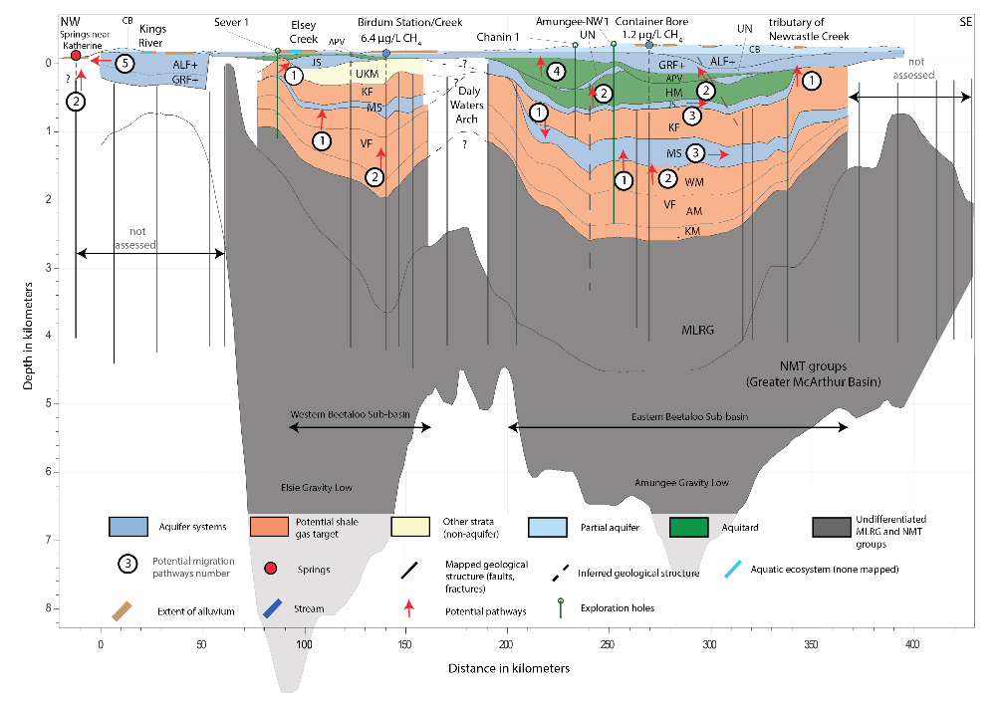
Figure 45 Cross-section A-A’ with north-west – south-east orientation through Beetaloo GBA region, intersecting major geological structures within the Beetaloo GBA region, including Daly Waters High and five potential hydrological connections for water or gas migration
The five potential hydrological connections are: 1. via direct stratigraphic contact; 2. via faults; 3. through porous/karst aquifers; 4. through partial aquifers/aquitards reaching overlying aquifers; 5. via groundwater discharge from CLA aquifer to springs.
NMT – Nathan/McArthur/Tawallah Groups; MLRG – Middle to Lower Roper Group; VF – Velkerri Formation (WM – Wyworrie Member, AM – Amungee Member; KM – Kalala Member); MS – Moroak Sandstone; KF – Kyalla Formation; JS – Jamison sandstone; HM – Hayfield mudstone; UKM – Upper Kyalla Member; UN – Undifferentiated Neoproterozoic (including Bukalara Sandstone); APV – Antrim Plateau Volcanics; GRF+ - Gum Ridge Formation and equivalents (lower CLA); ALF+ - Anthony Lagoon Formation and equivalents (upper CLA).
Data: faults sourced from Betts et al. (2015), unconventional gas plays footprints from Geological and Bioregional Assessment Program (2019b), springs from Department of Environment and Natural Resources (NT) (2013) and geology from Geological and Bioregional Assessment Program (2019a) and Frogtech Geoscience (2018a); methane data from Wilkes et al. (2019)
Element: GBA-BEE-2-347
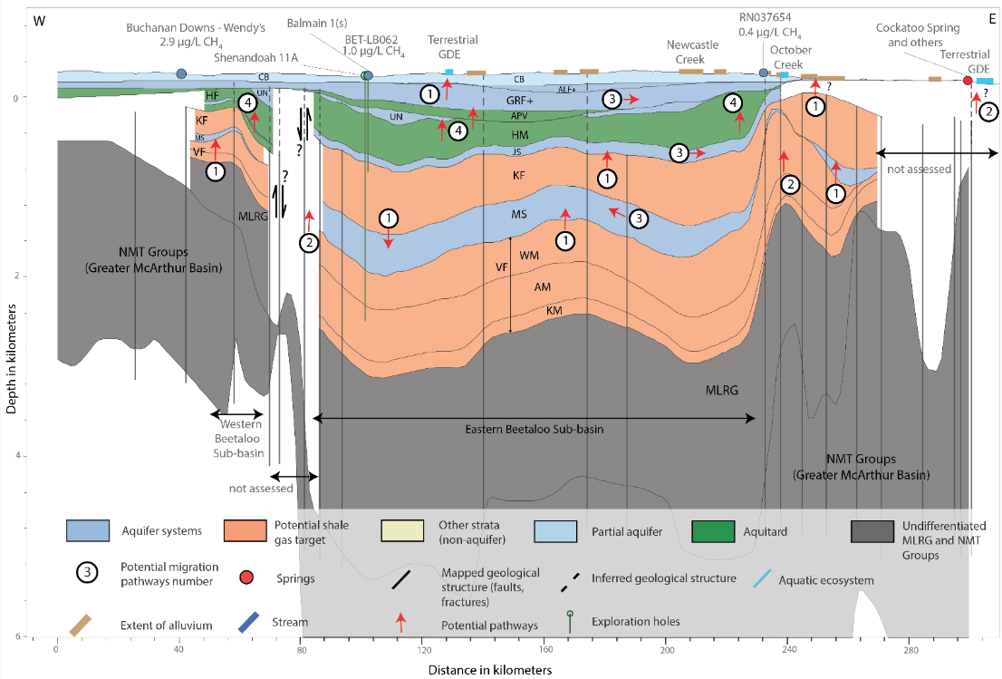
Figure 46 Cross-section B-B’, with west–east orientation, across the Beetaloo GBA region, showing five potential hydrological connections for water or gas migration
The five potential hydrological connections are: 1. via direct stratigraphic contact; 2. via faults; 3. through porous/karst aquifers; 4. through partial aquifers/aquitards reaching overlying aquifers; 5. via groundwater discharge from CLA aquifer to springs.
NMT – Nathan/McArthur/Tawallah Groups; MLRG – Middle to Lower Roper Group; VF – Velkerri Formation (WM – Wyworrie Member, AM – Amungee Member; KM – Kalala Member); MS – Moroak Sandstone; KF – Kyalla Formation; JS – Jamison sandstone; HM – Hayfield mudstone; UKM – Upper Kyalla Member; UN – Undifferentiated Neoproterozoic (including Bukalara Sandstone); APV – Antrim Plateau Volcanics; GRF+ - Gum Ridge Formation and equivalents (lower CLA); ALF+ - Anthony Lagoon Formation and equivalents (upper CLA) .
Data: faults sourced from Betts et al. (2015) , unconventional gas plays footprints from Geological and Bioregional Assessment Program (2019b), springs from Department of Environment and Natural Resources (NT) (2013) and geology from Geological and Bioregional Assessment Program (2019a) and Frogtech Geoscience (2018a); methane data from Wilkes et al. (2019)
Element: GBA-BEE-2-348

③ Potential connection through porous/karst aquifers
Groundwater moving through an aquifer can be a connective pathway that may allow changes to water quality or groundwater pressure to propagate away from a source. The degree to which changes can occur is dependent on many factors including: configuration of the aquifer, its lithology, extent and degree of confinement, hydraulic properties (primarily hydraulic conductivity), hydraulic gradients, flow rates, chemistry and connectivity with other aquifers.
In the Beetaloo GBA region the Roper Group is deeply buried and is not used as a groundwater supply. However, at depth groundwater and fluid/gas flow may occur, particularly in areas that are ‘on structure’, as described in Section 3.2.1. Another factor influencing the lateral flow in the Roper Group is the level of induration caused by diagenetic processes and secondary porosity such as fracturing. Groundwater flow in this sequence is unlikely to be extensive (as discussed in Section 3.3.1.2), unless through other pathways (Magoon and Dow (1994), for instance).
On the other hand, in the CLA, lateral connectivity and groundwater flow is inferred from hydraulic gradients derived from waterlevel data. As previously described in Section 3.3.3.2, the porosity and permiability is primarily controlled by the formation of karst. Flow rates through karstic porosity and permeability can be extremely variable, including flow rates over 1000 m/day in areas to the north of the Beetaloo GBA region.
Two major groundwater flow systems can be identified within the Beetaloo GBA region in the CLA; one from the Georgina Basin into the Daly Basin and the other from the Wiso Basin into the Daly Basin. At a local scale, the presence of structures (pathway 2) and karst patterns may cause deviation in the general groundwater flow rate and direction. Figure 15 and Figure 16 illustrate the inferred groundwater flow direction in the CLA and the groundwater divide formed by the influence of geological structures.
Groundwater movement is also expected to occur in the Kiana Group, as represented in the cross-sections (e.g. Figure 45). However, groundwater information from which to infer flow directions is very limited. According to Section 3.3.2.1, limited information suggests that the Bukalara Sandstone can have good porosity with minimum cementation, which would potentially allow for horizontal or vertical flow.

④ Potential connection through partial aquifers/aquitards reaching overlying aquifers
Leakage across aquitards can occur over time. As described for pathway 1, the Hayfield mudstone is deemed an effective aquitard because of its substantial thickness, reaching thicknesses of 449 m (Balmain-1 and Shenandoah-1 petroleum wells) and 569 m (Tanumbirini-1). Where the Hayfield mudstone thins or is compromised by faults (as discussed in Orr et al. (2020)), migration of fluids between petroleum plays in the Kyalla Formation through the Hayfield mudstone to overlying sequences is a possible pathway. All the cross-sections (Figure 44, Figure 45 and Figure 46) show some evidence of extension of deep-seated faults to the surface with creeks coincident with the surface projection of these faults along with the occurrence of dissolved gas (Figure 31) in shallow groundwater in their vicinity (see pathway 2 for further discussion of faults).
The Antrim Plateau Volcanics is classified (Section 3.2.3.1) as a thick regional-scale aquitard. However, as shown in Figure 6, the unit is absent from the southern and eastern parts of the Beetaloo GBA region and while the Hayfield mudstone is present in these areas, it thins considerably towards the southern and eastern tips of the eastern part of the sub-basin. Again, in these locations, leakage through an aquitard could be possible mechanism that allows vertical connectivity.
The Cox Formation, another leaky aquitard, should be considered a potential connectivity barrier where present. However, knowledge of this unit in the Beetaloo GBA region is sparse and it has not been differentiated in the three-dimensional geological model used for the development of conceptual models in this assessment.

⑤ Potential connection via groundwater discharge from CLA aquifer to springs
As previously described in Section 3.3.3.2, groundwater flow divides segregate the CLA into at least two major groundwater flow systems (Figure 16). One of these systmes, the Georgina-Daly system has a northerly regional flow component out of the Beetaloo GBA region towards the Mataranka Thermal Pools and the Roper River. As suggested by Tickell and Bruwer (2017), more localised flowpaths in the Daly Basin are also expected to discharge to the Mataranka Thermal Pools on the Roper River. A possible connectivity pathway is groundwater flow through the CLA and northwards out of the Beetaloo GBA region towards the springs. Whether impacts can actually propagate that far will be determined as part of Stage 3. The relative contributions from different flowpaths (local versus regional) to the springs is likely to lessen the degree of any potential impact.
The carbonate-dominant CLA has a diverse range of permeability, which is difficult to characterise spatially. Some karst systems appear to be influenced by structure but remain localised and are not regionally interconnected (see Section 3.3.3.2.5). Over parts of the Beetaloo GBA region, the Carpentaria Basin is significantly eroded and only the permeable sandstone of basal ‘Unit A’ lies at or near ground level enabling localised recharge into the underlying CLA through dolines (see Section 3.3.4). The degree of vertical karst connectivity as well as thickness of the overlying Carpentaria Basin, will influence degree of connectivity from surface to the CLA. This will influence the potnetial for near surface impacts (e.g. spills) to reach the CLA. Where cover is thin and compromised by sinkholes, there is greater potential for spills to reach an aquifer when compared to areas where the cover is thick.

Summary and future work
The potential connectivity pathways described above are unlikely to occur simultaneously and are also unlikely to create conditions that link the stressors to environmental assets in a human timescale. Nevertheless, considering the existing knowledge gaps, it is important to take a precautionary approach when assessing such processes and consider the possibility that fluid migration from one compartment of the basin to another may occur at different timescales, eventually impacting assets. This will be further assessed during Stage 3, in which potential impacts of this identified pathway can be determined.
From the analysis of existing datasets and an integrated assessment of the structural geology and hydrogeological characterisation of the extended Beetaloo GBA region, a set of knowledge and data gaps were identified. Further investigations required to test potential impact pathways from stressors to the assets are summarised in Table 8.
While a number of separate possible flow paths are described, combinations of these flow paths could result in a diffuse connectivity network across hydrogeological sequences. The potential for cumulative impact along multiple flowpaths will be further assessed in Stage 3 of the Beetaloo GBA.
Table 8 Summary of potential hydrological connections, potential impacts on water and the environment, evidence base, questions and recommended investigations in the extended Beetaloo GBA region
Potential hydrological connections | Potential impacts on water and the environment | Evidence base | Questions | Recommended investigations
① Direct stratgraphic contact  Potential connection via direct stratigraphic contact between shale and tight gas plays in the Roper Group and adjacent aquifers Jamison sandstone (JS), Bukalara Sandstone, Antrim Plateau Volcanics or the Cambrian Limestone Aquifer (CLA). | Water bores that access Antrim Plateau Volcanics, the CLA and the shallower groundwater systems associated with Carpentaria Basin (CB) and Cenozoic deposits, surface water bodies (including Lake Woods), waterholes (e.g. Grainger Hole, Mungabroom and Chowyung Waterholes), GDEs and springs | Extended zones of direct stratigraphic contact between stressors and the potential assets (aquifers) are identified in cross-sections through both sub-basins (Figure 44, Figure 45 and Figure 46)  Dissolved methane in groundwater samples from the Antrim Plateau Volcanics and CLA in areas of possible direct contact with underlying Kyalla Formation may confirm the possible connectivity between the hydrocarbon bearing gas play unit and overlying aquifer assets | What is the travel distance and travel time for water and/or gas to migrate from the shale and tight gas reservoirs in the Roper Group into the adjacent/overlying aquifers?  Is there evidence of upward hydraulic gradients that would facilitate/drive such processes?  Do faults intersecting gas plays in the Roper Group, influence connectivity with adjacent or overlying aquifers that are in direct contact with the reservoir formations? | Stage 3  - Simple groundwater models to estimate travel times for scenario from the Roper Group through to overlying aquifers.  - Collect hydraulic data from both unconventional gas plays and overlying aquifers along the zone of greater connectivity potential (aquitard windows and thinner intervals) to rule out the hypothesis of upward hydraulic gradient  - Update regional structural and stratigraphic framework, through additional seismic interpretation  - Hydrochemical and isotopic fingerprinting of groundwater and dissolved gases at representative bores in different hydrostratigraphic units (subject to bore availability) for inter-aquifer/ reservoir-aquifer connectivity assessment, including helium, methane, and tracers such as ⁸⁷Sr/⁸⁶Sr  Future  - Collate and assess borehole image logs from exploration wells to analyse in-situ stress orientations  - An assessment using existing water bores located near to each other that target different formations of interest (a proxy for nested wells) could be a first attempt for this hydrochemical and isotopic characterisation  - Update the Beetaloo GBA geological model to incorporate faults, to determine areas where aquifers are displaced against aquitards
② Faults  Potential connection through deep-seated faults striking shale gas reservoirs in the Velkerri and Kyalla formations and adjacent /overlying aquifers | Antrim Plateau Volcanics, CLA aquifer, springs and associated surface water bodies | Aquifer source of springs located approximately 10 km east from the Eastern Beetaloo Sub-basin (i.e. Lagoon Creek and Beauty Creek Springs) are inferred to be potentially linked to the Roper Group due to their position near rock outcrops from the Collara Subgroup and Maiwok Subgroup, evidenced by spring water temperature  Hydrocarbon shows are reported to occur in the Neoproterozoic units (Jamison sandstone, Hayfield mudstone and Bukalara Sandstone), indicating previous hydrocarbon migration pathways from the underlying source rocks that may act as pathways to assets closer to the surface  Hydrochemical clusters spatial distribution are correlated to the location of geological structures, corroborated by dissolved gas in groundwater | What is the likelihood for vertical fluid or gas migration through deep-seated faults from unconventional gas plays to overlying aquifers and near-surface assets?  How likelyis it that the gas plays are directly connected to the near-surface environmental assets via the mapped/inferred faults considering the proximity between stressors and assets near the Beetaloo GBA region’ margins? | Stage 3  - Simple groundwater models to estimate travel times for scenario from the Roper Group through to overlying aquifers  - Update regional structural and stratigraphic framework, through additional seismic interpretation  - Hydrochemical and isotopic fingerprinting of groundwater and dissolved gases at representative bores in different hydrostratigraphic units for inter-aquifer connectivity assessment and surface water – groundwater interactions, including helium, methane and tracers such as ⁸⁷Sr/⁸⁶Sr  - Carry out a sampling campaign to constrain the sources of springs located in proximity to mapped faults with a focus on tracers to detect contribution from deeper hydrogeological units (e.g. Helium)  - Conduct a synoptic surface water chemistry and tracer survey along Roper River, which exhibits perennial flows to assess surface water – groundwater interactions and alluvium and bedrock connectivity  Future  - Shallow geophysical survey (e.g. time domain electromagnetic (TEM)) to locate and characterise structural elements in the top 100 m near sensitive environmental assets
③ Aquifers  Potential connection through the porous aquifers of Moroak Sandstone, Jamison sandstone, UN, CB and alluvium and karstic systems of CLA (GRF+ALF) | Water bores that access these aquifers and potentially associated springs | Groundwater flow is confirmed to occur in the CLA system (Figure 16) with northward direction | Can this act as a potential hydrological connection between two sub-vertical fault systems?
④ Partial aquitards  Migration through aquitards into the CLA and basal sandstone zones of Carpentaria Basin (CB) | Water bores in the aquifer systems Undifferentiated Neoproterozoic (UN e.g. Bukalara Sandstone), CLA and saturated sandstone found in the base of CB | Hydraulic heads measurements in the Moroak Sandstone indicate enough potential to lift water above the top of the Proterozoic.  In addition, the higher hydraulic permeability in Moroak Sandstone is inferred to occur near geological structures.  The presence of oil shows in the Bukalara Sandstone suggest the occurrence of pathways connected to underlying source rocks | Is there evidence to confirm that fluids or gases migrate vertically and horizontally through the Hayfield mudstone aquitard due to the influence of geological structures?
⑤ Groundwater discharge  Migration through the karstic CLA aquifer into springs and associated surface water bodies | Springs that source water from CLA aquifer, including associated surface water bodies and groundwater-dependent ecosystems  Users of groundwater from the CLA. | Hydrological connections inferred from subsurface geometry as shown in cross-section C-C’ (Figure 44)  Discharges from CLA aquifer to Mataranka Thermal Pools  Sinkholes are known areas of localised recharge where CLA outcrops to the north of the Beetaloo GBA region | Is there sufficient evidence (hydrochemical and environmental tracers) data to confirm connectivity between the CLA system and Mataranka Thermal Pools?  What are relative source contributions from different parts of CLA to the Mataranka Thermal Pools?  Where are preferential recharge pathways to CLA likely to occur? | Stage 3  - Carry out a sampling campaign to constrain the aquifer sources and groundwater flow to the Mataranka Thermal Pools  - Identify areas where sinkholes are likely to be present near surface in Beetaloo GBA region  - Indicate thickness of cover (i.e. Carpentaria Basin above the Cambrian Limestone Aquifer) across the Beetaloo GBA region  - Assessment of spill and contaminate transport
CB = Carpentaria Basin; CLA = Cambrian Limestone Aquifers; GDE = groundwater-dependent ecosystem; UN = undifferentiated Proterozoic; GRF = Gum Ridge Formation and equivalents (lower CLA); ALF = Anthony Lagoon Formation and equivalents (upper CLA)

Conclusions
This investigation has involved collation, analysis and interpretation of the existing geoscience datasets and literature to develop a regional-scale understanding of groundwater systems in the extended Beetaloo GBA region. It provides information on the extent of aquifers and aquitards, groundwater processes and flow dynamics, groundwater hydrochemistry, inter-aquifer connectivity, and surface water – groundwater interactions. Key project conclusions are provided in the following sections.

Regional groundwater systems
The hydrogeology of the Beetaloo GBA region is characterised by a complex series of stacked sedimentary basins in which four individual groundwater sub-systems have been identified. They are:
- Sedimentary rocks of the Paleoproterozoic Roper Group (host to shale gas hydrocarbon plays of the Velkerri and Kyalla formations). While the group typically exhibits aquitard properties, the Moroak Sandstone has been identified as a potential aquifer. These units are intruded in places by the Derim Derim Dolerite
- Neoproterozoic aquifers (Jamison and Bukalara sandstones) and regional aquitards (Hayfield mudstone and the Cox Formation)
- The Cambrian Antrim Plateau Volcanics regional aquitard, and the principal groundwater source in Beetaloo GBA region, the overlying Cambrian Limestone Aquifer system
- Cretaceous Carpentaria Basin sedimentary rocks and Cenozoic sediments, which are generally unsaturated. Local aquifer may occur near surface perched above the regional watertable.

Roper Group
The sandstones and mudstones of the Roper Group are generally of low permeability and are typically aquitards. The exceptions to this are the Moroak Sandstone and the Bessie Creek Sandstone, which is considered a local fractured indurated rock aquifer with variable hydrogeological character. Collectively, these sandstones are not seen as effective groundwater systems but do contain locally anomalous higher permeability and pressured systems, potentially with upward directed pressure gradients in areas ‘on structure’.
The Velkerri and Kyalla formations are regional aquitards (Figure 5) and represent the main shale gas targets in the Beetaloo Sub-basin. Where present, these formations would confine the Bessie Creek and Moroak sandstones respectively. In general, limited information exists on the hydrogeological characteristics of the Roper Group sequence as it occurs at significant depths and it is not used as a source of groundwater.
Aquifer temperatures are in the order of 70 to 90°C at 1100 to 1750 m. From limited groundwater quality data, the very high salinities suggest there has been minimal interaction by downward leakage from less saline groundwater in overlying aquifers. However, number of samples is limited in distribution.

Jamison sandstone, Hayfield mudstone and Kiana Group
The Jamison sandstone and Hayfield mudstone overlie the Maiwok Subgroup and are classed as an aquifer and aquitard, respectively. Regionally, the Hayfield mudstone forms a seal (up to 300 m thickness) separating the Jamison sandstone from overlying aquifers. The Jamison sandstone may be in contact with overlying aquifers where the Hayfield mudstone is absent around parts of the Beetaloo GBA region.
The Bukalara Sandstone is an aquifer with reported significant groundwater inflows and can be over 100 m thick. However, its extent within the Beetaloo GBA region appears to be sporadic and poorly defined. The overlying, potentially confining Cox Formation is a leaky aquitard, and its extent is also poorly defined. Groundwater data for this unit is sparse.

Kalkarindji Suite volcanics
The extent of the Antrim Plateau Volcanics is relatively well-defined, covering most of the Beetaloo GBA region. Where absent, the CLA is in direct contact with underlying Proterozoic units, including the Bukalara and Jamison sandstones.
While the Antrim Plateau Volcanics is classed as a regional aquitard, it is used as a local fractured rock aquifer where the overlying CLA is absent or unsaturated, with modest groundwater yields. Groundwater depths in the Antrim Plateau Volcanics range from 14 to 89 mBGL (average 59 mBGL). Groundwater quality of the Antrim Plateau Volcanics is generally good (average TDS is 715 mg/L).

Cambrian Limestone Aquifer
The CLA is the most extensive and regionally significant aquifer system in the Beetaloo GBA region. It provides a significant water resource for the pastoral industry and communities within the region and is also the source for numerous springs (e.g. Mataranka Thermal Pools and Flora River) that are located down hydraulic gradient from Beetaloo GBA region. The aquifer has been informally divided into a lower and upper CLA sequence: the lower CLA, the ‘Gum Ridge Formation and equivalents’ (Gum Ridge Formation, Tindall Limestone and Montejinni Limestone); and the upper CLA, the ‘Anthony Lagoon Formation and equivalents’ (Anthony Lagoon Formation, Jinduckin Formation and Hooker Creek Formation and Point Wakefield beds).
There are two major groundwater flow systems recognised in the Beetaloo GBA region: groundwater flow from the Wiso Basin into the Daly Basin, and groundwater flow from the Georgina Basin into the Daly Basin. Inferred regional groundwater flow for both systems is north-westward across the Beetaloo GBA region, into the Daly Basin and discharging at spring complexes such as Mataranka and Flora River Springs. However, groundwater flow on more local scales are poorly defined.
Recharge predominantly occurs during the wet season and can be high, particularly where karstic features such as sinkholes are present at surface or the Carpentaria Basin cover is relatively thin. Recharge rates are highly variable throughout the Beetaloo GBA region, ranging from around 150 mm/year in areas of exposed karst to less than 1 mm/year in areas where thick claystone and mudstone of the Carpentaria Basin are present.
Groundwater salinity in the CLA is non-saline to slightly saline (typically TDS <1500 mg/L), making it suitable for agricultural, domestic and industrial uses.
Large karstic pathways (i.e. cave systems and large cavities), where present in the CLA, are likely to act as preferential, relatively high-velocity flow paths. If contaminants (e.g. chemical spills) were to intercept the CLA, then potentially they could be transported and dispersed relatively quickly along large pathways. For instance, a study by Tickell (2005) showed groundwater flow velocities of up to 1250 m/day can occur in the CLA in the vicinity of Katherine, 100 km to the north of the Beetaloo GBA region. High flow rates could exacerbate the spread and dispersion of contaminants.
However, for much of the Beetaloo GBA region, the CLA is covered by variable thickness of Carpentaria Basin sedimentary rocks. The overlying Carpentaria Basin (where sufficiently thick and clay dominated) decreases recharge to the CLA. It is also likely to lessen the potential for spills to reach the CLA from surface.

Carpentaria Basin and Cenozoic sediments
The Carpentaria Basin is extensive. It overlies the CLA within the Beetaloo GBA region and is up to 170 m thick. The Carpentaria Basin sequence is largely unsaturated because the regional groundwater table usually lies below its basal contact. However, in the southern parts of the Beetaloo GBA region, its basal units are saturated, and are utilised as an aquifer. In this area the Carpentaria Basin can be shown to be hydraulically connected with the underlying CLA.
Groundwater recharge is thought to be significantly impeded where Carpentaria Basin cover is thick. Groundwater in Carpentaria Basin is typically classed as slightly to moderately saline, with an average salinity of 1548 mg/L.
Near-surface aquifers perched aquifers the regional watertable may occur in the Beetaloo GBA region in Cenozoic sediments or weathered regolith overlying Carpentaria Basin.

Inter-aquifer connectivity
Over much of the Beetaloo Sub-basin, the CLA is separated from the underlying prospective Roper Group by multiple aquitards, including uppermost the Antrim Plateau Volcanics, and the underlying Hayfield mudstone. Where these intervening aquitards are absent, thinner, or are fractured along faults, there is the potential for groundwater interconnection between the CLA and Neoproterozoic reservoirs such as the Jamison sandstone. The degree of inter-aquifer connectivity is not well characterised.
Key pathways for connectivity that may be of concern include:
- connectivity issues associated with development and production of prospective Roper Group formations; whereby potential impacts could spread to overlying groundwater systems
- connectivity issues associated with extracting groundwater above the Roper Group for petroleum resource development, whereby impacts may spread to other groundwater users and the environment through shallow systems.
- shallow aquifer (e.g. the CLA) contamination due to infiltration of surface spills from petroleum development or production. Effects from points 1 and 2 above may spread through shallow aquifer pathways.

Surface water – groundwater interactions
- GDEs do occur within the Beetaloo GBA region. Given that regional groundwater is typically greater than 40 m deep, if they are connected to groundwater they are more likely to interact with the shallow perched groundwater systems rather than the regional watertable.
- There are no mapped springs within the Beetaloo GBA region, but a number are recorded in extended Beetaloo GBA region. To the north, significant springs discharging groundwater from the Beetaloo GBA region include Mataranka Thermal Pools and Flora River.
- South of the Beetaloo GBA region, ephemeral lakes (including Lake Woods) are likely to be places were episodic recharge occurs to the CLA.

Gaps, limitations and future directions
Key data and knowledge gaps identified and potential future work to improve regional hydrogeological conceptualisation of the Beetaloo GBA region are provided in the following sections.

Groundwater and baseline data
The amount of available hydrogeological data varies greatly for different groundwater systems in the Beetaloo GBA region. There is also a corresponding variation in the level of understanding for the different groundwater systems. While there are still some significant knowledge gaps, the CLA is a relatively well-studied and understood groundwater system, when compared to the limited hydrogeological information available for the deeper Proterozoic groundwater systems.
Identified data and knowledge gaps:
- A significant proportion of groundwater bores with water level and/or hydrochemistry data available have not been assigned to a hydrostratigraphic unit.
- There are limited baseline groundwater level and hydrochemistry data for all aquifers below the CLA, for example, the Bukalara Sandstone.
- There is a lack of fit-for-purpose groundwater data to assess characterise groundwater flow in aquifers below the CLA.
Stage 3 work:
- Review existing groundwater bores and their screened aquifers to establish if there are any additional bores available for groundwater sampling in the Proterozoic units or Antrim Plateau Volcanics.
- Undertake hydrochemical sampling of selected bores screened in aquifers other than the CLA in the Beetaloo GBA region. Sampling should include environmental tracers as well as hydrochemical parameters to provide hydrochemical baseline and lead to better understanding of groundwater recharge mechanisms, groundwater age, flow paths and surface water interactions.
- Characterise groundwater flow paths and sources to Mataranka Thermal Pools using hydrochemistry and environmental tracers.
Future work:
- Assign hydrostratigraphy to bores with existing water level or hydrochemistry data. The hydrostratigraphy of CLA in bores could potentially be refined (depending on the length of the screened/open hole intervals), using siltstone marker horizons as outlined in Section 3.2.3.2 as a method to group waterlevel data for analysis.
- Regional groundwater mapping of the watertable for Beetaloo GBA should be updated and extended to provide more complete coverage of the CLA and environs. Potentially archival data could be used in conjunction with more recent data. Suggestions for how to segregate or group archival waterlevel data (see Section 3.3.3.2.2 for details) may assist with interrogation and identification of trends in groundwater table. Also, investigations into the occurrence of perched aquifers in the Beetaloo GBA region should be considered.
- Undertake a systematic groundwater monitoring program for Proterozoic groundwater bores (only available outside the Beetaloo GBA region) and the CLA to help establish baseline conditions, including connectivity and seasonal dynamics.
- Consider drilling monitoring bores into Proterozoic rock aquifers such as Bukalara Sandstone or Jamison sandstone to better understand hydrogeological characteristics in the Beetaloo GBA region.
- Further study of pressure differences using nested monitoring wells would assist with understanding direction of vertical and horizontal groundwater flow and degree of connectivity between different hydrostratigraphic units that comprise the CLA, as well as degree of connectivity with deeper aquifers (e.g. Bukalara Sandstone).
- As petroleum exploration continues, consideration should be given to include activities that improve understanding of the hydrogeology and geology of the Beetaloo region, above the Roper Group. Activities could include running suites of well logs or pressure surveys or extending geological seismic interpretation to relatively shallow depths (e.g. up to CLA or Antrim Plateau Volcanics), or collecting water samples from prospective deep aquifers, such as Jamison or Bukalara sandstones.

Intra- and inter-basin groundwater connectivity
Identified data gaps:
- There is a lack of detailed information on the thickness and structure of the Antrim Plateau Volcanics and Bukalara Sandstone and equivalents in the Beetaloo GBA region.
- Thickness and hydraulic properties of Carpentaria Basin units are needed to better understand recharge to the CLA.
- There is poor understanding of the distribution of near-surface karst in the CLA and its role in preferential flow.
- There is limited understanding of structural and stratigraphic connectivity between the Roper Group and overlying aquifers.
Stage 3 work:
- Identify areas where sinkholes are likely to be present near surface (consult with industry where appropriate) and map the occurrence of preferential recharge in the Beetaloo GBA region.
- Indicate thickness of cover (i.e. Carpentaria Basin above the Cambrian Limestone Aquifer) across the Beetaloo GBA region including identification of major lithological packages (e.g. the sandstone near the base of the Carpentaria).
- Sampling and environmental tracer studies to investigate groundwater flow patterns both within and between aquifer systems and to identify flow paths.
Suggested future work:
- Update the regional structural and stratigraphic framework using geophysical data such as seismic surveys and ground-calibrated aerial electromagnetic induction.
- Refine the stratigraphy of the Carpentaria Basin in the Beetaloo GBA by surface mapping, lithological logs and downhole geophysics. Consider drilling monitoring bores targeted into Carpentaria Basin aquifers to better establish hydrogeological characteristics.
- Conduct groundwater sampling and environmental tracer studies to investigate groundwater flow patterns both within and between aquifer systems and to identify flow paths.
- Undertake future work activities as outlined under the ‘Baseline data’ in Section 5.4.1.

Surface water – groundwater interactions
Identified data gaps:
- The source of many of the springs associated with Proterozoic units located proximal to the Beetaloo GBA region, such as Beauty Creek springs, which remain largely speculative.
- Groundwater discharge to the Mataranka Thermal Pools and nearby streams that underpin dry-season flows in the Roper River. This water is sourced from the CLA, but it is not known if there is a minor component from deeper sources.
Stage 3 work:
- A field study will be conducted in Stage 3 to investigate the potential of any deeper water sources discharging at Mataranka and whether this potential causal pathway presents a risk to Mataranka Thermal Pools from the development of petroleum resources.
Further work to understand recharge sources and processes as outlined in Section 3.2.3.2.
Suggested future work:
- Hydrochemistry to determine source aquifers and pathways for springs on Proterozoic outcrop near the margin of the Beetaloo GBA region (e.g. Beauty Creek Springs).

References
Abbott ST, Sweet IP, Plumb KA, Young DN, Cutovinos A, Ferenczi PA, Brakel AT and Pietsch BA (2001) Roper Region – Urapunga and Roper River Special, Northern Territory (Second Edition) combined explanatory notes. SD 53-10, 11. Northern Territory Geological Survey and Geoscience Australia (National Geoscience Mapping Accord), Darwin. Viewed 29 November 2019, https://geoscience.nt.gov.au/gemis/ntgsjspui/handle/1/81859.
Ahmad M, Dunster JN and Munson TJ (2013) Chapter 15: McArthur Basin. In Ahmad M and Munson TJ (eds). Geology and mineral resources of the Northern Territory. Geology and mineral resources of the Northern Territory. Special Publication 5. Northern Territory Geological Survey, Darwin, NT, Australia, 73.
Ahmed M and Munson TJ (2013) Geology and mineral resources of the Northern Territory. Northern Territory Geological Survey.
Bense VF, Gleeson T, Loveless SE, Bour O and Scibek J (2013) Fault zone hydrogeology. Earth-Science Reviews 127, 171-192. Doi: 10.1016/j.earscirev.2013.09.008.
Betts P, Armit R and Ailleres L (2015) Potential-field interpretation mapping of the greater McArthur Basin. PGN Geoscience Report 15/2014. Northern Territory Geological Survey, Darwin. Viewed 24 October 2019, https://geoscience.nt.gov.au/gemis/ntgsjspui/handle/1/81754.
Brown MC and Randall MA (1969) Explanatory Notes, 1:250 000 SE 53-06 Geological series-Explanatory Notes, Beetaloo, Northern Territory. Canberra. Viewed 20 March 2020, https://geoscience.nt.gov.au/gemis/ntgsjspui/handle/1/81756.
Brown MC (1986) Early Cambrian aeolian dune sandstones in the Northern Territory. In: Sediments Down-Under. 12th International Sedimentological Congress - Abstracts International Sedimentological Congress, Canberra, 46
Bultitude RJ (1976) Flood basalts of probable early Cambrian age in northern Australia. In: Johnson RW (ed), Volcanism in Australia. Elsevier, Amsterdam, 1–20.
Bureau of Meteorology (2012) Geofabric Surface Cartography. [spatial]. Viewed 29 January 2018, http://www.bom.gov.au/water/geofabric/documents/v2_1/ahgf_dps_surface_cartography_V2_1_release.pdf. GBA data repository GUID: 319C8AAA-4EBD-438F-BD11-968DFA030CF5.
Bureau of Meteorology (2017) Groundwater Dependent Ecosystems Atlas. [spatial]. Viewed 04 October 2018, http://www.bom.gov.au/water/groundwater/gde/index.shtml. GBA data repository GUID: 25207635-859C-4170-BEE1-21A456DB9754.
Cartwright I, Weaver T, Cendon D and Swane I (2010) Environmental isotopes as indicators of inter-aquifer mixing, Wimmera region, Murray Basin, Southeast Australia. Chemical Geology 277(3–4), 214–226. Doi: 10.1016/j.chemgeo.2010.08.002.
Chapman S (2019) Borehole gamma log stratigraphy of the northern Georgina Basin. Technical Report 3/2019, Northern Territory Department of Environment and Natural Resources. Northern Territory Government, Australia.
Clifton R (2008) Magnetic map of the Northern Territory. Northern Territory Geological Survey, Darwin. Viewed 24 October 2019, https://geoscience.nt.gov.au/gemis/ntgsjspui/handle/1/82589.
Collins A, Farkas J, Glorie S, Cox G, Blades M, Yang B, Nixon A, Bullen M, Foden J, Dosseto A, Payne J, Denyszyn S, J Edgoose C, Close D, Munson T, Menpes S, Spagnuolo S, Gusterhuber J, Sheridan M and Close D (2018) Orogens to oil: government–industry–academia collaboration to better understand the greater McArthur Basin. In: Annual Geoscience Exploration Seminar (AGES) 2018 Proceedings. Northern Territory Geological Survey. Viewed 29 November 2019, https://www.researchgate.net/publication/324000194.
Cook S, Dixon-Jain P, Hocking M, Sundaram B, Morgan LK, Ivkovic K, Werner A, Norman R, Caruana L and Garlapati N (2013) A national-scale vulnerability assessment of SWI intrusion: Vulnerability Factor Analysis. Geoscience Australia, Canberra and National Centre for Groundwater Research and Training, Adelaide.
de Caritat P, Bastrakov E, Jaireth S, English P, Clarke J, Mernagh T, Wygralak A, Dulfer H and Trafford J (2019) Groundwater geochemistry, hydrogeology and potash mineral potential of the Lake Woods region, Northern Territory, Australia. Australian Journal of Earth Sciences, 1-20. Doi: 10.1080/08120099.2018.1543208.
Department of Environment and Natural Resources (NT) (2008) Northern Territory Groundwater Aquifers 2M. [spatial]. Viewed 28 April 2020, http://www.ntlis.nt.gov.au/metadata/export_data?type=html&metadata_id=535D1EECEB0F528AE040CD9B21446C20. GBA data repository GUID: 81355DDF-AB96-40A3-8E7E-DFBC88199762.
Department of Environment and Natural Resources (NT) (2013) Springs of the Northern Territory. [spatial]. Viewed 20 March 2019, http://www.ntlis.nt.gov.au/metadata/export_data?type=html&metadata_id=E9D78F668FC02B33E040CD9B214403C3. GBA data repository GUID: 1D351848-02FB-4E90-9390-4E2F895B9F89.
Department of Environment and Natural Resources (NT) (2015) NT Groundwater Aquifers 2M. [spatial]. Viewed 25 March 2020, http://www.ntlis.nt.gov.au/metadata/export_data?type=html&metadata_id=535D1EECEB0F528AE040CD9B21446C20. GBA data repository GUID: 528B8454-9C18-412A-AD0E-8FD9076FDFA4.
Department of Environment and Natural Resources (NT) (2018a) NT Groundwater Monitoring Bores Database. [spatial]. Viewed 28 April 2020, https://denr.nt.gov.au/. GBA data repository GUID: 527F422D-52CD-4D50-A5FA-923CBBB36C60.
Department of Environment and Natural Resources (NT) (2018b) Waterlevels from monitoring bores in Beetaloo GBA region. [spatial]. Viewed 27 April 2020, https://denr.nt.gov.au/. GBA data repository GUID: F2B1B357-6F0E-4E33-8DFA-6F6FD1A95DEF.
Department of Environment and Natural Resources (NT) (2018c) Base of the Jinduckin and Tindall Formations. [ArcGIS shape file]. Viewed 27 March 2020, https://denr.nt.gov.au/land-resource-management/info-systems/natural-resource-maps/spatial-data-requests. GBA data repository GUID: F44AB442-944E-40B8-8EEE-06991E0D1184.
Department of Environment and Natural Resources (NT) (2020) Cretaceous extent in the Beetaloo GBA region. [spatial]. Viewed 27 March 2020, https://denr.nt.gov.au/. GBA data repository GUID: D1AD3D5A-FA13-4F6C-AD1C-5BCDE9167F73.
Department of Environment and Science (Qld) (2018) Climate data for rainfall stations in the Beetaloo GBA area from the Queensland Government’s Scientific Information for Land Owners website. [Space delimited txt file]. Viewed 24 October 2018, https://data.qld.gov.au/dataset/silo-climate-api. GBA data repository GUID: E808103C-7DA8-4173-8027-C94AAA8CCBCE.
Department of Primary Industry and Resources (NT) (2017) Submission 479 to the Scientific Inquiry into Hydraulic Fracturing in the Northern Territory. Northern Territory Government. Viewed 11 January 2019, https://frackinginquiry.nt.gov.au/?a=464723.
Department of Primary Industry and Resources (NT) (2018) Northern Territory Geological Regions 2500K. ANZLIC Identifier: FA83D24C788060ABE040CD9B2144317B.
EcOz Environmental Consultants (2015) Surface and groundwater characterisation report – Sturt Plateau Region NT. Report prepared for Pangaea Resources for submission to the NT fracking inquiry. Darwin. Viewed 28 November 2019, https://frackinginquiry.nt.gov.au/?a=424269.
Edgoose CJ and Ahmad M (2013) Chapter 42: Cenozoic geology and regolith. In: Ahmad M and Munson TJ (compilers). Geology and mineral resources of the Northern Territory. Special Publication 5. Northern Territory Geological Survey, Darwin, 44.
FAO (1992) The use of saline waters for crop production - FAO irrigation and drainage paper 48. Rome: FAO. Food and Agriculture Organization of the United Nations, Rome. Viewed 24 October 2019, http://www.fao.org/docrep/T0667E/T0667E00.htm.
Foss C and Dhu T (2016) The bark without a dog; magnetic anomalies over holes in a volcanic sheet in the greater McArthur Basin, NT. In: ASEG-PESA-AIG 2016; 25th geophysical conference and exhibition; interpreting the past, discovering the future. CSIRO Publishing for the Australian Society of Exploration Geophysicists: Collingwood, Victoria, Australia, Collingwood, Victoria
Frogtech Geoscience (2018a) SEEBASE study and GIS for Greater McArthur Basin. Northern Territory Geological Survey, Digital Information Package DIP 017 (ESRI file format, March 2018). Viewed 25 May 2018, https://geoscience.nt.gov.au/gemis/ntgsjspui/handle/1/87064. GBA data repository GUID: 563A5349-DC7F-42B8-B6CC-892B3B4C3C3F.
Frogtech Geoscience (2018b) SEEBASE® study and GIS for greater McArthur Basin: Supplementary Data. Northern Territory Geological Survey, Digital Information Package DIP 018. Viewed 18 February 2019, https://geoscience.nt.gov.au/gemis/ntgsjspui/handle/1/87062. GBA data repository GUID: EC6D7486-30C9-4D19-92C6-57879C00A363.
Fulton S and Zaar U (2009) Gulf water study : Dunmarra and Hodgson River Region. Darwin. Viewed 28 November 2019, http://www.territorystories.nt.gov.au/jspui/handle/10070/241906.
Fulton S and Knapton A (2015a) Water table contours and flow direction arrows from water table mapping for the cambrian limestone aquifer used in Beetaloo hydrogeological assessment report. Viewed 24 April 2020, https://repo.bioregionalassessments.gov.au/metadata/4BCBE081-EE77-474D-9451-0CF52A6BEFA4. GBA data repository GUID: 4BCBE081-EE77-474D-9451-0CF52A6BEFA4.
Fulton S and Knapton A (2015b) Beetaloo Basin hydrogeological assessment. Cloud GMS. Origin Energy Report 1 for Fracking Enquiry NT. Viewed 28 November 2019, https://frackinginquiry.nt.gov.au/?a=410609.
Geological and Bioregional Assessment Program (2019a) Impact Modes and Effects Analysis: Shale gas, tight gas and shale oil Beetaloo Sub-basin. [tabular]. Viewed 05 April 2019, https://repo.bioregionalassessments.gov.au/metadata/B7C9EE99-5A13-4312-89DA-794C082F8345. GBA data repository GUID: B7C9EE99-5A13-4312-89DA-794C082F8345.
Geological and Bioregional Assessment Program (2019b) Unconventional gas plays footprint within the Beetaloo GBA region. [spatial]. Viewed 27 September 2019, https://repo.bioregionalassessments.gov.au/metadata/8AFD2AA4-8361-4D6D-B64B-125C58F14EC6. GBA data repository GUID: 8AFD2AA4-8361-4D6D-B64B-125C58F14EC6.
Geological and Bioregional Assessment Program (2019c) Tasseled Cap Index wetness Index - Beetaloo GBA region. Viewed 19 April 2019, https://repo.bioregionalassessments.gov.au/metadata/FE2AAF5B-9204-4771-998E-9F002FEDE3BA. GBA data repository GUID: FE2AAF5B-9204-4771-998E-9F002FEDE3BA.
Geological and Bioregional Assessment Program (2019d) Beetaloo GBA Groundwater and surface water sample locations included in hydrochemical cluster analysis by CSIRO. [tabular]. Viewed 28 February 2020, https://repo.bioregionalassessments.gov.au/metadata/52556C6B-A44C-4AD4-8FB4-F9F609B1E228. GBA data repository GUID: 52556C6B-A44C-4AD4-8FB4-F9F609B1E228.
Geological and Bioregional Assessment Program (2019e) Beetaloo GBA region - Total Magnetic Intensity (TMI) georeferenced image. Viewed 19 May 2019, http://www.ga.gov.au/news-events/news/latest-news/latest-editions-of-magnetic-anomaly-grid-and-radiometric-map-released. GBA data repository GUID: 47E424DC-7489-42AA-ADB2-E3BAEC3E36EB.
Geological and Bioregional Assessment Program (2019f) Beetaloo formation pressure and temperature data compiled from petroleum well completion reports. Viewed 08 March 2019, https://repo.bioregionalassessments.gov.au/metadata/65CF9145-483A-45E5-9349-CC66647731F1. GBA data repository GUID: 65CF9145-483A-45E5-9349-CC66647731F1.
Geological and Bioregional Assessment Program (2019g) Standing water levels in the Beetaloo GBA groundwater bore data extraction area. [ArcGIS shapefile]. Viewed 10 October 2018, https://repo.bioregionalassessments.gov.au/metadata/EB77B337-F46B-4B30-AC44-88357E8061FB. GBA data repository GUID: EB77B337-F46B-4B30-AC44-88357E8061FB.
Geological and Bioregional Assessment Program (2019h) Groundwater chemistry in the Beetaloo GBA groundwater bore data extraction area. Viewed 03 April 2019, https://repo.bioregionalassessments.gov.au/metadata/A0654187-3282-4DB6-B5A4-668A897D4D79. GBA data repository GUID: A0654187-3282-4DB6-B5A4-668A897D4D79.
Geological and Bioregional Assessment Program (2019i) Beetaloo basin GDE. [spatial]. Viewed 12 October 2018, https://repo.bioregionalassessments.gov.au/metadata/E4C2B147-8338-4821-BC5E-DE300E9B6362. GBA data repository GUID: E4C2B147-8338-4821-BC5E-DE300E9B6362.
Geological and Bioregional Assessment Program (2019j) Regional groundwater model boundary for the Cambrian Limestone Aquifer, Model describe in Knapton (2006) and Knapton (2009). See stage 2 Beetaloo technical report for further detail. Viewed 6 November 2019, https://repo.bioregionalassessments.gov.au/metadata/1AB02C99-D8E9-48C5-8629-E049F85FF2AB. GBA data repository GUID: 1AB02C99-D8E9-48C5-8629-E049F85FF2AB.
Geoscience Australia (2012) Surface geology of Australia 1:1 million. [spatial]. Viewed 27 March 2018, http://pid.geoscience.gov.au/dataset/ga/74619. GBA data repository GUID: A74CCABD-CB40-4741-A301-DAC9F53CEAE1.
Geoscience Australia (2018) Water Observations from Space (WOfS) summary statistic classified as percentages. [spatial]. Viewed 18 December 2018, http://pid.geoscience.gov.au/dataset/ga/121054. GBA data repository GUID: 756F0C06-3794-46D0-ABC0-608F9578D45B.
Glass L, Ahmad M and Dunster J (2013) Chapter 30: Kalkarindji Province. In: Ahmad M and Munson T (eds), Geology and mineral resources of the Northern Territory. Northern Territory Geological Survey, Darwin, NT, Australia.
Güler C, Thyne GD, McCray JE and Turner AK (2002) Evaluation of graphical and multivariate statistical methods for classification of water chemistry data. Hydrogeology Journal 4, 455-474.
Haines SS, Diffendorfer JE, Balistrieri L, Berger B, Cook T, DeAngelis D, Doremus H, Gautier DL, Gallegos T, Gerritsen M, Graffy E, Hawkins S, Johnson KM, Macknick J, McMahon P, Modde T, Pierce B, Schuenemeyer JH, Semmens D, Simon B, Taylor J and Walton-Day K (2013) A Framework for Quantitative Assessment of Impacts Related to Energy and Mineral Resource Development. Natural Resources Research 23(1), 3-17. Doi: 10.1007/s11053-013-9208-6.
Hall LS, Wang L, Bailey AHE, Orr ML, Owens R, Jarrett AJM, Lech ME, Skeers N, Reese B and Woods M (2020) Petroleum prospectivity of the Beetaloo Sub-basin. Technical appendix for the Geological and Bioregional Assessment: Stage 2. Department of the Environment and Energy, Bureau of Meteorology, CSIRO and Geoscience Australia, Australia.
Healy RW (2010) Estimating Groundwater Recharge. Cambridge University Press, Cambridge.
Holland KL, Brandon C, Crosbie RS, Davies P, Evans T, Golding L, Gonzalez D, Gunning ME, Hall LS, Henderson B, Kasperczyk D, Kear J, Kirby J, Lech ME, Macfarlane C, Martinez J, Marvanek S, Merrin LE, O’Grady A, Owens R, Pavey C, Post D, Rachakonda P, Raiber M, Sander R, Stewart S, Sundaram B, Tetreault-Campbell S, Williams M, Zhang Y and Zheng H (2020) Geological and environmental baseline assessment for the Cooper GBA region. Geological and Bioregional Assessment Program: Stage 2. Department of the Environment and Energy, Bureau of Meteorology, CSIRO, Geoscience Australia, Australia.
Hortle A, Otto C and Underschultz J (2013) A Quality Control System to Reduce Uncertainty in Interpreting Formation Pressures for Reservoir and Basin Pressure System Analysis. Journal of Petroleum Geology 36(2), 163-177. Doi: doi:10.1111/jpg.12549.
Huddlestone-Holmes CR, Frery E, Wilkes P, Bailey AHE, Bernadel G, Brandon C, Buchanan S, Cook SB, Crosbie RS, Evans T, Golding L, Gonzalez D, Gunning ME, Hall LS, Henderson B, Herr A, Holland KL, Jarrett A, Kear J, Kirby J, Lech ME, Lewis S, Macfarlane C, Martinez J, Murray J, Northover S, O'Grady A, Orr ML, Owens R, Pavey C, Post D, Sundaram B, Rachakonda P, Raiber M, Ransley TR, Tetreault-Campbell S and Wang L (2020) Geological and environmental baseline assessment for the Beetaloo GBA region. Geological and Bioregional Assessment Program: Stage 2. Department of the Environment and Energy, Bureau of Meteorology, CSIRO and Geoscience Australia, Australia.
Karp D (2005) Evaluation of groundwater flow by dye tracing Katherine region. Department of Natural Resources, Environment, the Arts and Sport (NT).
Karp D (2008) Surface and groundwater interaction the Mataranka area. Department of Natural Resources, Environment, the Arts and Sport (NT).
Kauth RJ and Thomas G (1976) The tasselled cap-a graphic description of the spectral-temporal development of agricultural crops as seen by Landsat. LARS Symposia, 159.
Kennewell PJ and Huleatt MB (1980) Geology of the Wiso Basin, Northern Territory. Bureau of Mineral Resources, Australia, Bulletin 205.
King A, Raiber M and Cox M (2014) Multivariate statistical analysis of hydrochemical data to assess alluvial aquifer–stream connectivity during drought and flood: Cressbrook Creek, southeast Queensland, Australia. Hydrogeology Journal 22, 481–500. Doi: 10.1007/s10040-013-1057-1.
Knapton A (2000) Water Resource Assessment of the Sturt Plateau - Geophysical Investigations. Department of Infrastructure, Planning and Environment, Department of Infrastructure, Planning and Environment. Viewed 28 November 2019, https://frackinginquiry.nt.gov.au/submission-library?a=433159.
Knapton A (2006) Regional Groundwater Modelling of the Cambrian Limestone Aquifer System of the Wiso Basin, Georgina Basin and Daly Basin. Department of Natural Resources, Environment and the Arts (Northern Territory), Alice Springs. Viewed 28 November 2019, http://www.territorystories.nt.gov.au/jspui/bitstream/10070/228069/1/WRA06029.pdf.
Knapton A (2009) Gulf water study. An integrated surface - groundwater model of the Roper River Catchment, Northern Territory. Part C - Feflow groundwater model. Department of Natural Resources, Environment, the Arts and Sport (NT). Viewed 28 November 2019, http://dev.territorystories.nt.gov.au/jspui/handle/10070/246988?mode=full.
Kruse PD and Munson TJ (2013a) Chapter 32: Wiso Basin. In: Ahmad M and Munson TJ (eds). Geology and mineral resources of the Northern Territory. Northern Territory Geological Survey, Special Publication 5, Darwin, 12.
Kruse PD and Munson TJ (2013b) Chapter 31: Daly Basin. In: Ahmad M and Munson TJ (eds). Geology and mineral resources of the Northern Territory. Northern Territory Geological Survey, Special Publication 5, Darwin, 14.
Kruse PD, Dunster JN and Munson TJ (2013) Chapter 28: Georgina Basin. In: Ahmad M and Munson TJ (eds). Geology and mineral resources of the Northern Territory. Northern Territory Geological Survey, Special Publication 5.
Lanigan K, Hibbird S, Menpes S and Torkington J (1994) Petroleum exploration in the Proterozoic Beetaloo Sub-basin, Northern Territory. The APEA Journal 34, 674–691.
Lewis A, Oliver S, Lymburner L, Evans B, Wyborn L, Mueller N, Raevksi G, Hooke J, Woodcock R, Sixsmith J, Wu W, Tan P, Li F, Killough B, Minchin S, Roberts D, Ayers D, Bala B, Dwyer J, Dekker A, Dhu T, Hicks A, Ip A, Purss M, Richards C, Sagar S, Trenham C, Wang P and Wang L-W (2017) The Australian Geoscience Data Cube — Foundations and lessons learned. Remote Sensing of Environment 202, 276-292. Doi: 10.1016/j.rse.2017.03.015.
Lewis S, Evans T, Pavey C, Holland K, Henderson B, Kilgour P, Dehelean A, Karim F, Viney N, Post D, Schmidt R, Sudholz C, Brandon C, Zhang Y, Lymburner L, Dunn B, Mount R, Gonzalez D, Peeters L, O’Grady A, Dunne R, Ickowicz A, Hosack G, Hayes K, Dambacher J and Barry S (2018) Impact and risk analysis for the Galilee subregion. Product 3-4 for the Galilee subregion from the Lake Eyre Basin Bioregional Assessment. Department of the Environment and Energy, Bureau of Meteorology, CSIRO and Geoscience Australia, Australia. Viewed 10 May 2019, https://www.bioregionalassessments.gov.au/assessments/3-4-impact-and-risk-analysis-galilee-subregion.
Magoon L and Dow W (1994) The petroleum system. In: Magoon L and Dow W (eds), The petroleum system - from source to trap. AAPG Memoir 60. American Association of Petroleum Geologists, Boulder, Tulsa, OK, USA, 3-24.
Mallants D, Raiber M and Davies P (2016) Decision support system for investigating gas in water bores and links to coal seam gas development. Project report prepared by the Commonwealth Scientific and Industrial Research Organisation (CSIRO) for the Queensland Department of Natural Resources and Mines.
Martinez JL, Raiber M and Cendón DI (2017) Using 3D geological modelling and geochemical mixing models to characterise alluvial aquifer recharge sources in the upper Condamine River catchment, Queensland, Australia. Science of The Total Environment 574, 1-18. Doi: 10.1016/j.scitotenv.2016.09.029.
McCutcheon SC, Martin JL and Barnwell TO, Jr (1993) Chapter 11: Water Quality. In: Maidment DR (ed), Handbook of Hydrology. McGraw-Hill, New York.
Mueller N, Lewis A, Roberts D, Ring S, Melrose R, Sixsmith J, Lymburner L, McIntyre A, Tan P, Curnow S and Ip A (2016) Water observations from space: mapping surface water from 25 years of Landsat imagery across Australia. Remote Sensing of Environment 174, 341–352. Doi: 10.1016/j.rse.2015.11.003.
Munson TJ, Kruse PD and Ahmad M (2013a) Chapter 22: Centralian Superbasin. In: Ahmad M and Munson TJ (eds). Geology and mineral resources of the Northern Territory. Northern Territory Geological Survey, Special Publication 5, Darwin, 639–657.
Munson TJ, Ahmad M and Dunster JN (2013b) Chapter 39: Carpentaria Basin: in Ahmad M and Munson TJ (eds). Geology and mineral resources of the Northern Territory. Northern Territory Geological Survey, Special Publication 5., Geology and Mineral Resources of the Northern Territory. Northern Territory Geological Survey, Darwin, 18.
Munson TJ (2014) Petroleum geology and potential of the onshore Northern Territory, 2014. Northern Territory Geological Survey, Report 22. Northern Territory Geological Survey, Darwin. Viewed 31 August 2018, https://geoscience.nt.gov.au/gemis/ntgsjspui/handle/1/81558.
Munson TJ (2016) Sedimentary characterisation of the Wilton package, greater McArthur Basin, Northern Territory. NTGS Record 2016-003. Northern Territory Geological Survey. Viewed 28 November 2019, https://geoscience.nt.gov.au/gemis/ntgsjspui/handle/1/83806.
Munson TJ and Revie D (2018) Stratigraphic subdivision of the Velkerri Formation, Roper Group, McArthur Basin, Northern Territory. NTGS Record 2018-006. Northern Territory Geological Survey, Darwin. Viewed 29 November 2019, https://geoscience.nt.gov.au/gemis/ntgsjspui/handle/1/87322.
Munson TJ (2019) Detrital zircon geochronology investigations of the Glyde and Favenc packages: Implications for the geological framework of the greater McArthur Basin, Northern Territory: in Annual Geoscience Exploration Seminar (AGES) Proceedings, Alice Springs, Northern Territory, 19–20 March 2019. Northern Territory Geological Survey, Darwin.
Northern Territory Government (2018) Geoscience Exploration and Mining Information System (GEMIS) – Petroleum Wells (PEX Wells). Viewed 16 November 2018, https://geoscience.nt.gov.au/gemis/ntgsjspui/handle/1/79187.
Origin Energy (2019) Origin Data Package. [tabular]. Viewed 24 April 2020, https://www.originenergy.com.au/. GBA data repository GUID: 0BE0A3FE-7C2E-48EF-B890-F42C38EEF24F.
Orr ML, Bernardel G, Owens R, Hall LS, Skeers N, Reese B and Woods M (2020) Geology of the Beetaloo GBA region. Technical appendix for the Geological and Bioregional Assessment: Stage 2. Department of the Environment and Energy, Bureau of Meteorology, CSIRO and Geoscience Australia, Australia.
Page RW, Jackson MJ and Krassay AA (2000) Constraining sequence stratigraphy in north Australian basins: SHRIMP U-Pb zircon geochronology between Mt Isa and McArthur River. Australian Journal of Earth Sciences 47(3), 431-459. Doi: 10.1046/j.1440-0952.2000.00797.x.
Paine A (1963) Tanumbirini, Northern Territory (First Edition). 1:250 000 geological map series explanatory notes, SE 53-02. Bureau of Mineral Resources, Australia, Canberra.
Pangaea Resources (2019) Pangaea Resources Groundwater Quality Dataset. [tabular]. Viewed 24 April 2020, https://www.pangaea.net.au/. GBA data repository GUID: FE6B6C2F-B2AA-40EB-9EEB-5DA12ECDFAAC.
Paul RJ (2003) Helen Springs Groundwater Investigation, 2000. Department of Infrastructure, Planning and Environment (Northern Territory), Alice Springs. Viewed 28 November 2019, http://www.territorystories.nt.gov.au/bitstream/10070/246897/1/Helen_Springs_Groundwater_Investigation_2000.pdf.
Peeters L (2014) A background color scheme for Piper plots to spatially visualize hydrochemical patterns. Groundwater 52(1), 2–6. Doi: doi:10.1111/gwat.12118.
Plumb KA and Wellman P (1987) McArthur Basin, Northern Territory: mapping of deep troughs using gravity and magnetic anomalies. BMR Journal of Australian Geology & Geophysics 10(3), 243–251.
Post V, Kooi H and Simmons C (2007) Using Hydraulic Head Measurements in Variable-Density Ground Water Flow Analyses. Groundwater 45(6), 664-671. Doi: doi:10.1111/j.1745-6584.2007.00339.x.
Queresi H and Noller BN (1994) Assessment of naturally occurring radionuclides in groundwater at Katherine, Northern Territory Australia. Water down under; Volume 2; Part A,. Groundwater papers. Preprints of papers.from 25th congress of the International Association of Hydrogeologists; Management to sustain shallow groundwater systems; pp 209-214.
Raiber M, White PA, Daughney CJ, Tschritter C, Davidson P and Bainbridge SE (2012) Three-dimensional geological modelling and multivariate statistical analysis of water chemistry data to analyse and visualise aquifer structure and groundwater composition in the Wairau Plain, Marlborough District, New Zealand. Journal of Hydrology 436–437, 13–34. Doi: 10.1016/j.jhydrol.2012.01.045.
Raiber M, Cui T, Pagendam D, Rassam D, Gilfedder M, Crosbie R, Marvanek S and Hartcher M (2016) Observations analysis, statistical analysis and interpolation for the Clarence-Moreton bioregion. Product 2.1-2.2 from the Clarence-Moreton Bioregional Assessment. Department of the Environment and Energy, Bureau of Meteorology, CSIRO and Geoscience Australia, Australia. Viewed 19 May 2019, http://data.bioregionalassessments.gov.au/product/CLM/CLM/2.1-2.2.
Raiber M, Lewis S, Cendón D, Cui T, ME C, Gilfedder M and Rassam D (2019) Significance of the connection between bedrock, alluvium and streams: a spatial and temporal hydrogeological and hydrogeochemical assessment from Queensland, Australia. Journal of Hydrology 569, 666–684. Doi: 10.1016/j.jhydrol.2018.12.020.
Randal MA, Brown MC, Smith KG, Perry WJ and Skwarko SK (1969) Larrimah 1:250 000 Sheet SD 53-13. Bureau of Minearl Resources, Geology and Geophysics.
Randal MA (1973) Groundwater in the Northern Wiso Basin and environs, Northern Territory. Bureau of Mineral Resources, Canberra. Viewed 25 October 2019, http://www.ga.gov.au/metadata-gateway/metadata/record/100/.
Rawlings DJ (1999) Stratigraphic resolution of a multiphase intracratonic basin system: The McArthur Basin, northern Australia. Australian Journal of Earth Sciences 46(5), 703-723. Doi: 10.1046/j.1440-0952.1999.00739.x.
Revie D (2017) Unconventional petroleum resources of the Roper Group, McArthur Basin. Record 2017-002. Northern Territory Geological Survey.
Roberts D, Dunn B and Mueller N (2018) Open Data Cube Products Using High-Dimensional Statistics of Time Series. International Geoscience and Remote Sensing Symposium. Valencia, Spain: IEEE Geoscience and Remote Sensing Society.
RobSearch (1997) Technical review of EP 18 and EP(A) 70, Beetaloo Basin, Northern Territory, Australia, prepared for Mataranks Oil NL. Robsearch Project No. 3972.
Schult J (2016) Pesticide and nutrient monitoring in the Roper River region during the 2015 dry season. Northern Territory Department of Environment and Natural Resources, Palmerston, NT. Viewed 25 October 2019, https://denr.nt.gov.au/__data/assets/pdf_file/0011/384392/Schult_2016_pesticides_Roper.pdf.
Silverman MR, Landon SM, Leaver JS, Mather TJ and Berg E (2007) No fuel like an old fuel: proterozoic oil and gas potential in the Beetaloo Basin, Northern Territory, Australia. In: Proceedings of the Central Australian Basins Symposium (CABS), Northern Territory Geological Survey (NTGS) Special Publication 2, 205–215
Silverman MR and Ahlbrandt T (2011) Mesoproterozoic unconventional plays in the Beetaloo Basin, Australia: the world’s oldest petroleum systems. In: AAPG International Conference and Exhibition Viewed 12 November 2018, www.searchanddiscovery.com/pdfz/documents/2011/10295silverman/ndx_silverman.pdf.html.
Suckow A, Deslandes A, Gerber C and Lamontagne S (2018) Environmental tracers in the Beetaloo Sub-basin. CSIRO Land and Water, Australia.
Tickell SJ (2003) Water resource mapping of the Barkly Tablelands. Department of Infrastructure, Planning and Environment (Northern Territory), Darwin.
Tickell SJ (2005) Groundwater resources of the Tindall Limestone. Report 34/2005. Department of Natural Resources, The Environment and The Arts Natural Resources Division.
Tickell SJ (2009) Daly Basin Drilling, 2009. Northern Territory Government Department of Natural Resources the Environment The Arts and Sport, Technical Report No. 08/2010D.
Tickell SJ and Bruwer Q (2017) Georgina Basin Groundwater Assessment: Daly Waters to Tennant Creek. Northern Territory Department of Environment and Natural Resources. Viewed 20 April 2020, http://www.territorystories.nt.gov.au/jspui/handle/10070/304921.
Tulloch A, Barnes M, Ringma J, Fuller R and Watson J (2015) Understanding the importance of small patches of habitat for conservation. Journal of Applied Ecology 53, 418-429.
UNESCO (1981) Background papers and supporting data on the International Equation of State of Seawater, 1980. Viewed 28 November 2019, https://unesdoc.unesco.org/ark:/48223/pf0000047363.
Wilkes P, Rachakonda PK, Larcher A and Woltering M (2019) Baseline assessment of groundwater characteristics in the Beetaloo Sub-basin, NT. Geochemistry Analysis report to the Gas Industry Social and Environmental Research Alliance (GISERA). CSIRO, Canberra. Viewed 20 November 2019, https://gisera.csiro.au/wp-content/uploads/2019/09/GISERA-W16-Task-4-Report_.pdf.
Wilson D, Cook P, Hutley L, Tickell S and Jolly P (2006) Effect of land use on evapotranspiration and charge in the Daly River catchment. Department of Natural Resources the Environment and the Arts (NT). Viewed 28 November 2019, http://www.territorystories.nt.gov.au/jspui/bitstream/10070/251081/1/Effect%20of%20Land%20Use%20on%20Evapotranspiration%20and%20Recharge%20in%20the%20Daly%20River%20Catchment%20-%20WRD06017.pdf.
Woodford JC and Yin Foo D (1995) Borroloola Groundwater Investigations 1995. Power and Water Authority, Water Resources Division, Technical Report No 59/1995D.
Yin Foo D and Matthews I (2000) Water Resources Assessment of the Sturt Plateau Technical Data Report. Natural Resources Division, Department of Lands Planning and Environment, Darwin. Report No: 31/2000D.
Yin Foo D and Matthews I (2001) Hydrogeology of the Sturt plateau 1:250 000 scale map explanatory notes. Department of Infrastructure, Planning and Environment (NT), Darwin. Viewed 28 November 2019, http://www.territorystories.nt.gov.au/jspui/handle/10070/228887.
Yin Foo D (2002) Water Resources of the Sturt Plateau region, overview report. Department of Infrastructure, Planning and Environment (Northern Territory), Darwin. Viewed 18 October 2019, http://www.territorystories.nt.gov.au/handle/10070/229643.
Zaar U (2009a) Gulf water study: water resources of the Limmen Bight and the Macarthur Rivers region. Department of Natural Resources, Environment the Arts and Sport (NT), Darwin. Viewed 28 November 2019, http://www.territorystories.nt.gov.au/jspui/handle/10070/243633.
Zaar U (2009b) Gulf water study - water resources of the Roper River region. Department of Natural Resources, Environment the Arts and Sport (NT). Viewed 10 March 2020, https://www.territorystories.nt.gov.au/bitstream/10070/235217/1/Roper.pdf.

Glossary
The register of terms and definitions used in the Geological and Bioregional Assessment Program is available online at https://w3id.org/gba/glossary (note that terms and definitions are respectively listed under the 'Name' and 'Description' columns in this register). This register is a list of terms, which are the preferred descriptors for concepts. Other properties are included for each term, including licence information, source of definition and date of approval. Semantic relationships (such as hierarchical relationships) are formalised for some terms, as well as linkages to other terms in related vocabularies. Many of the definitions for these terms have been sourced from external glossaries – several from international sources; spelling variations have been preserved to maintain authenticity of the source.
accumulation: in petroleum geosciences, an ‘accumulation’ is referred to as an individual body of moveable petroleum
activity: for the purposes of Impact Modes and Effects Analysis (IMEA), a planned event associated with unconventional gas resource development. For example, activities during the exploration life-cycle stage include drilling and coring, ground-based geophysics and surface core testing. Activities are grouped into ten major activities, which can occur at different life-cycle stages.
aeolian: relating to or arising from the action of wind
anticline: an arch-shaped fold in rock in which rock layers are upwardly convex. The oldest rock layers form the core of the fold and, outward from the core, progressively younger rocks occur.
API gravity: a specific gravity scale developed by the American Petroleum Institute for measuring the relative density of various petroleum liquids, expressed in degrees
aquifer: rock or sediment in a formation, group of formations, or part of a formation that is saturated and sufficiently permeable to transmit quantities of water to bores and springs
aquitard: a saturated geological unit that is less permeable than an aquifer, and incapable of transmitting useful quantities of water. Aquitards commonly form a confining layer over an artesian aquifer.
artesian aquifer: an aquifer that has enough natural pressure to allow water in a bore to rise to the ground surface
asset: an entity that has value to the community and, for the purposes of geological and bioregional assessments, is associated with a GBA region. An asset is a store of value and may be managed and/or used to maintain and/or produce further value. An asset may have many values associated with it that can be measured from a range of perspectives; for example, the values of a wetland can be measured from ecological, sociocultural and economic perspectives.
barrel: a standard unit of measurement for all production and sales of oil. It has a volume of 42 US gallons [0.16 m³].
baseflow: the portion of streamflow that comes from shallow and deep subsurface flow, and is an important part of the groundwater system
basement: the oldest rocks in an area; commonly igneous or metamorphic rocks of Precambrian or Paleozoic age that underlie other sedimentary formations. Basement generally does not contain significant oil or gas, unless it is fractured and in a position to receive these materials from sedimentary strata.
basin-centred gas: a type of tight gas that occurs in distributed basin-centred gas accumulations, where gas is hosted in low permeability reservoirs which are commonly abnormally overpressured, lack a down dip water contact and are continuously saturated with gas. This is also sometimes referred to as 'continuous' and 'pervasive' gas.
bed: in geosciences, the term 'bed' refers to a layer of sediment or sedimentary rock, or stratum. A bed is the smallest stratigraphic unit, generally a centimetre or more in thickness. To be labeled a bed, the stratum must be distinguishable from adjacent beds.
biogenic gas: hydrocarbon gases (which are overwhelmingly (greater than or equal to 99%) methane) produced as a direct consequence of bacterial activity
bore: a narrow, artificially constructed hole or cavity used to intercept, collect or store water from an aquifer, or to passively observe or collect groundwater information. Also known as a borehole or piezometer.
casing: a pipe placed in a well to prevent the wall of the hole from caving in and to prevent movement of fluids from one formation to another
causal pathway: for the purposes of geological and bioregional assessments, the logical chain of events ‒ either planned or unplanned ‒ that link unconventional gas resource development and potential impacts on water and the environment
charge: in petroleum geoscience, a 'charge' refers to the volume of expelled petroleum available for entrapment
clastic: sedimentary rock that consists of fragments or clasts of pre-existing rock, such as sandstone or shale
cleat: the vertical cleavage of coal seams. The main set of joints along which coal breaks when mined.
coal: a rock containing greater than 50 wt.% organic matter
coal seam gas: coal seam gas (CSG) is a form of natural gas (generally 95% to 97% pure methane, CH₄) extracted from coal seams, typically at depths of 300 to 1000 m. Also called coal seam methane (CSM) or coalbed methane (CBM).
compression: lateral force or stress (e.g. tectonic) that tends to decrease the volume of, or shorten, a substance
conceptual model: an abstraction or simplification of reality that describes the most important components and processes of natural and/or anthropogenic systems, and their response to interactions with extrinsic activities or stressors. They provide a transparent and general representation of how complex systems work, and identify gaps or differences in understanding. They are often used as the basis for further modelling, form an important backdrop for assessment and evaluation, and typically have a key role in communication. Conceptual models may take many forms, including descriptive, influence diagrams and pictorial representations.
confined aquifer: an aquifer saturated with confining layers of low-permeability rock or sediment both above and below it. It is under pressure so that when the aquifer is penetrated by a bore, the water will rise above the top of the aquifer.
conglomerate: a sedimentary rock dominated by rounded pebbles, cobbles, or boulders
consequence: synonym of impact
context: the circumstances that form the setting for an event, statement or idea
conventional gas: conventional gas is obtained from reservoirs that largely consist of porous sandstone formations capped by impermeable rock, with the gas trapped by buoyancy. The gas can often move to the surface through the gas wells without the need to pump.
Cooper Basin: the Cooper Basin geological province is an Upper Carboniferous – Middle Triassic geological sedimentary basin that is up to 2500 m thick and occurs at depths between 1000 and 4400 m. It is overlain completely by the Eromanga and Lake Eyre basins. Most of the Cooper Basin is in south-west Queensland and north-east SA, and includes a small area of NSW at Cameron Corner. It occupies a total area of approximately 130,000 km², including 95,740 km² in Queensland, 34,310 km² in SA and 8 km² in NSW.
craton: the old, geologically stable interior of a continent. Commonly composed of Precambrian rocks at the surface or covered only thinly by younger sedimentary rocks.
crude oil: the portion of petroleum that exists in the liquid phase in natural underground reservoirs and remains liquid at atmospheric conditions of pressure and temperature. Crude oil may include small amounts of non-hydrocarbons produced with the liquids.
crust: the outer part of the Earth, from the surface to the Mohorovicic discontinuity (Moho)
cumulative impact: for the purposes of geological and bioregional assessments, the total environmental change resulting from the development of selected unconventional hydrocarbon resources when all past, present and reasonably foreseeable actions are considered
dataset: a collection of data in files, in databases or delivered by services that comprise a related set of information. Datasets may be spatial (e.g. a shape file or geodatabase or a Web Feature Service) or aspatial (e.g. an Access database, a list of people or a model configuration file).
deep coal gas: gas in coal beds at depths usually below 2000 m are often described as ‘deep coal gas’. Due to the loss of cleat connectivity and fracture permeability with depth, hydraulic fracturing is used to release the free gas held within the organic porosity and fracture system of the coal seam. As dewatering is not needed, this makes deep coal gas exploration and development similar to shale gas reservoirs.
deformation: folding, faulting, shearing, compression or extension of rocks due to the Earth’s forces
depocentre: an area or site of maximum deposition; the thickest part of any specified stratigraphic unit in a depositional basin
deposition: sedimentation of any material, as in the mechanical settling of sediment from suspension in water, precipitation of mineral matter by evaporation from solution, and accumulation of organic material
depositional environment: the area in which, and physical conditions under which, sediments are deposited. This includes sediment source; depositional processes such as deposition by wind, water or ice; and location and climate, such as desert, swamp or river.
development: a phase in which newly discovered oil or gas fields are put into production by drilling and completing production wells
disconformity: see unconformity
discovered: the term applied to a petroleum accumulation/reservoir whose existence has been determined by its actual penetration by a well, which has also clearly demonstrated the existence of moveable petroleum by flow to the surface or at least some recovery of a sample of petroleum. Log and/or core data may suffice for proof of existence of moveable petroleum if an analogous reservoir is available for comparison.
dolomite: a rhombohedral carbonate mineral with the formula CaMg(CO3)2
dolostone: a carbonate sedimentary rock that contains over 50% of the mineral dolomite [CaMg(CO₃)₂]
dome: a type of anticline where rocks are folded into the shape of an inverted bowl. Strata in a dome dip outward and downward in all directions from a central area.
drawdown: a lowering of the groundwater level (caused, for example, by pumping)
drill bit: a drilling tool that cuts through rock by a combination of crushing and shearing
drill stem test: an operation on a well designed to demonstrate the existence of moveable petroleum in a reservoir by establishing flow to the surface and/or to provide an indication of the potential productivity of that reservoir. Drill stem tests (DSTs) are performed in the open hole to obtain reservoir fluid samples, static bottomhole pressure measurements, indications of productivity and short-term flow and pressure buildup tests to estimate permeability and damage extent.
drilling fluid: circulating fluid that lifts rock cuttings from the wellbore to the surface during the drilling operation. Also functions to cool down the drill bit, and is a component of well control.
ecosystem: a dynamic complex of plant, animal, and micro-organism communities and their non-living environment interacting as a functional unit. Note: ecosystems include those that are human-influenced such as rural and urban ecosystems.
effect: for the purposes of Impact Modes and Effects Analysis (IMEA), a change to water or the environment, such as changes to the quantity and/or quality of surface water or groundwater, or to the availability of suitable habitat. An effect is a specific type of an impact (any change resulting from prior events).
effective porosity: the interconnected pore volume or void space in a rock that contributes to fluid flow or permeability in a reservoir. Effective porosity excludes isolated pores and pore volume occupied by water adsorbed on clay minerals or other grains. Effective porosity is typically less than total porosity.
effective water saturation: the fraction of water in the pore space corresponding to the effective porosity. It is expressed in volume/volume, percent or saturation units. Unless otherwise stated, water saturation is the fraction of formation water in the undisturbed zone. The saturation is known as the total water saturation if the pore space is the total porosity, but is called effective water saturation if the pore space is the effective porosity. If used without qualification, the term water saturation usually refers to the effective water saturation.
Eromanga Basin: an extensive geologic sedimentary basin formed from the Early Jurassic to the Late Cretaceous that can be over 2500 m thick. It overlies several older geological provinces including the Cooper Basin, and is in part overlain by the younger Cenozoic province, the Lake Eyre Basin. The Eromanga Basin is found across much of Queensland, northern SA, southern NT, as well as north-western NSW. The Eromanga Basin encompasses a significant portion of the Great Artesian Basin.
erosion: the wearing away of soil and rock by weathering, mass wasting, and the action of streams, glaciers, waves, wind, and underground water
exploration: the search for new hydrocarbon resources by improving geological and prospectivity understanding of an area and/or play through data acquisition, data analysis and interpretation. Exploration may include desktop studies, field mapping, seismic or other geophysical surveys, and drilling.
expulsion: the process of primary migration, whereby oil or gas escapes from the source rock due to increased pressure and temperature. Generally involves short distances (metres to tens of metres).
extraction: the removal of water for use from waterways or aquifers (including storages) by pumping or gravity channels. In the oil and gas industry, extraction refers to the removal of oil and gas from its reservoir rock.
facies: the characteristics of a rock unit that reflect the conditions of its depositional environment
fault: a fracture or zone of fractures in the Earth’s crust along which rocks on one side were displaced relative to those on the other side
field: in petroleum geoscience, a 'field' refers to an accumulation, pool, or group of pools of hydrocarbons or other mineral resources in the subsurface. A hydrocarbon field consists of a reservoir with trapped hydrocarbons covered by an impermeable sealing rock, or trapped by hydrostatic pressure.
floodplain: a flat area of unconsolidated sediment near a stream channel that is submerged during or after high flows
fold: a curve or bend of a formerly planar structure, such as rock strata or bedding planes, that generally results from deformation
footwall: the underlying side of a fault, below the hanging wall
formation: rock layers that have common physical characteristics (lithology) deposited during a specific period of geological time
formation water: water that occurs naturally in sedimentary rocks
fracking: see hydraulic fracturing
fracture: a crack or surface of breakage within rock not related to foliation or cleavage in metamorphic rock along which there has been no movement. A fracture along which there has been displacement is a fault. When walls of a fracture have moved only normal to each other, the fracture is called a joint. Fractures can enhance permeability of rocks greatly by connecting pores together, and for that reason, fractures are induced mechanically in some reservoirs in order to boost hydrocarbon flow. Fractures may also be referred to as natural fractures to distinguish them from fractures induced as part of a reservoir stimulation or drilling operation. In some shale reservoirs, natural fractures improve production by enhancing effective permeability. In other cases, natural fractures can complicate reservoir stimulation.
free gas: the gaseous phase present in a reservoir or other contained area. Gas may be found either dissolved in reservoir fluids or as free gas that tends to form a gas cap beneath the top seal on the reservoir trap. Both free gas and dissolved gas play important roles in the reservoir-drive mechanism.
gas cap: part of a petroleum reservoir that contains free gas
gas saturation: the relative amount of gas in the pores of a rock, usually as a percentage of volume
geological architecture: the structural style and features of a geological province, like a sedimentary basin
geological formation: stratigraphic unit with distinct rock types, which is able to mapped at surface or in the subsurface, and which formed at a specific period of geological time
geothermal gradient: the rate of increase in temperature with depth in the Earth
groundwater: water occurring naturally below ground level (whether stored in or flowing through aquifers or within low-permeability aquitards), or water occurring at a place below ground that has been pumped, diverted or released to that place for storage there. This does not include water held in underground tanks, pipes or other works.
groundwater-dependent ecosystem: ecosystems that require access to groundwater on a permanent or intermittent basis to meet all or some of their water requirements
groundwater discharge: water that moves from a groundwater body to the ground surface or surface water body (e.g. a river or lake)
groundwater recharge: replenishment of groundwater by natural infiltration of surface water (precipitation, runoff), or artificially via infiltration lakes or injection
groundwater system: see water system
hanging wall: the overlying side of a fault, above the footwall
hazard: an event, or chain of events, that might result in an effect (change in the quality and/or quantity of surface water or groundwater)
hydraulic fracturing: also known as ‘fracking’, ‘fraccing’ or ‘fracture simulation’. This is a process by which geological formations bearing hydrocarbons (oil and gas) are ‘stimulated’ to increase the flow of hydrocarbons and other fluids towards the well. In most cases, hydraulic fracturing is undertaken where the permeability of the formation is initially insufficient to support sustained flow of gas. The process involves the injection of fluids, proppant and additives under high pressure into a geological formation to create a conductive fracture. The fracture extends from the well into the production interval, creating a pathway through which oil or gas is transported to the well.
hydraulic fracturing fluid: the fluid injected into a well for hydraulic fracturing. Consists of a primary carrier fluid (usually water or a gel), a proppant such as sand and chemicals to modify the fluid properties.
hydrocarbon show: a surface observation of hydrocarbons, usually observed as fluorescent liquid on cuttings when viewed with an ultraviolet or black light (oil show) or increased gas readings from the mud logger's gas-detection equipment (gas show)
hydrocarbons: various organic compounds composed of hydrogen and carbon atoms that can exist as solids, liquids or gases. Sometimes this term is used loosely to refer to petroleum.
hydrogeology: the study of groundwater, including flow in aquifers, groundwater resource evaluation, and the chemistry of interactions between water and rock
hydrostatic pressure: equal pressure in all direction, equivalent to the pressure which is exerted on a portion of a column of water as a result of the weight of the fluid above it
impact: the difference between what could happen as a result of activities and processes associated with extractive industries, such as shale, tight and deep coal gas development, and what would happen without them. Impacts may be changes that occur to the natural environment, community or economy. Impacts can be a direct or indirect result of activities, or a cumulative result of multiple activities or processes.
impact cause: an activity (or aspect of an activity) that initiates a hazardous chain of events
impact mode: the manner in which a hazardous chain of events (initiated by an impact cause) could result in an effect (change in the quality and/or quantity of surface water or groundwater). There might be multiple impact modes for each activity or chain of events.
Impact Modes and Effects Analysis: a systematic hazard identification and prioritisation technique based on Failure Modes and Effects Analysis
injection: the forcing or pumping of substances into a porous and permeable subsurface rock formation. Examples of injected substances can include either gases or liquids.
intrusion: the process of emplacement of magma into pre-existing rock
kerogen: insoluble (in organic solvents) particulate organic matter preserved in sedimentary rocks that consists of various macerals originating from components of plants, animals, and bacteria. Kerogen can be isolated from ground rock by extracting bitumen with solvents and removing most of the rock matrix with hydrochloric and hydrofluoric acids.
Lake Eyre Basin: a geologic province containing Cenozoic terrestrial sedimentary rocks within the Lake Eyre surface water catchment. It covers parts of northern and eastern SA, south-eastern NT, western Queensland and north-western NSW. In the Cooper GBA region, the basin sedimentary package is less than 300 m thick.
leaky aquitard: a semi-permeable geological material that can transmit groundwater. Although regionally non-productive, it may be classed as a very low yielding aquitard that is sometimes used to produce groundwater where no other source is available.
life-cycle stage: one of five stages of operations in unconventional gas resource development considered as part of the Impact Modes and Effects Analysis (IMEA). These are exploration, appraisal, development, production, and rehabilitation. Each life-cycle stage is further divided into major activities, which are further divided into activities.
light oil: crude oil that has 35 to 45 ° API gravity
likelihood: probability that something might happen
liquid rich gas: natural gas that contains typically less than 85% methane and more ethane and other more complex hydrocarbons including propane, butane, pentane, hexane and heptane. Also referred to as 'wet gas' or 'natural gas liquids'.
lithology: the description of rocks, especially in hand specimen and in outcrop, on the basis of characteristics such as colour, mineralogic composition and grain size
material: pertinent or relevant
mature: a hydrocarbon source rock that has started generating hydrocarbons
metamorphic rock: a rock formed from pre-existing rock due to high temperature and pressure in the Earth’s crust, but without complete melting
methane: a colourless, odourless gas, the simplest parafin hydrocarbon, formula CH4. It is the principal constituent of natural gas and is also found associated with crude oil. Methane is a greenhouse gas in the atmosphere because it absorbs long-wavelength radiation from the Earth's surface.
migration: the process whereby fluids and gases move through rocks. In petroleum geoscience, 'migration' refers to when petroleum moves from source rocks toward reservoirs or seep sites. Primary migration consists of movement of petroleum to exit the source rock. Secondary migration occurs when oil and gas move along a carrier bed from the source to the reservoir or seep. Tertiary migration is where oil and gas move from one trap to another or to a seep.
Moho: the Mohorivicic discontinuity (seismic reflector) at the base of the crust
mudstone: a general term for sedimentary rock made up of clay-sized particles, typically massive and not fissile
natural gas: the portion of petroleum that exists either in the gaseous phase or is in solution in crude oil in natural underground reservoirs, and which is gaseous at atmospheric conditions of pressure and temperature. Natural gas may include amounts of non-hydrocarbons.
oil: a mixture of liquid hydrocarbons and other compounds of different molecular weights. Gas is often found in association with oil. Also see petroleum.
oil-prone: organic matter that generates significant quantities of oil at optimal maturity
organic matter: biogenic, carbonaceous materials. Organic matter preserved in rocks includes kerogen, bitumen, oil and gas. Different types of organic matter can have different oil-generative potential.
outcrop: a body of rock exposed at the surface of the Earth
overpressure: occurs when the pore pressure is higher than the hydrostatic pressure, caused by an increase in the amount of fluid or gas in the rock, or changes to the rock that reduce the amount of pore space. If the fluid cannot escape, the result is an increase in pore pressure. Overpressure can only occur where there are impermeable layers preventing the vertical flow of water, otherwise the water would flow upwards to equalise back to hydrostatic pressure.
partial aquifer: a permeable geological material with variable groundwater yields that are lower than in an aquifer and range from fair to very low yielding locally
percentile: a specific type of quantile where the range of a distribution or set of runs is divided into 100 contiguous intervals, each with probability 0.01. An individual percentile may be used to indicate the value below which a given percentage or proportion of observations in a group of observations fall. For example, the 95th percentile is the value below which 95% of the observations may be found.
permeability: the measure of the ability of a rock, soil or sediment to yield or transmit a fluid. The magnitude of permeability depends largely on the porosity and the interconnectivity of pores and spaces in the ground.
petroleum: a naturally occurring mixture consisting predominantly of hydrocarbons in the gaseous, liquid or solid phase
petroleum system: the genetic relationship between a pod of source rock that is actively producing hydrocarbon, and the resulting oil and gas accumulations. It includes all the essential elements and processes needed for oil and gas accumulations to exist. These include the source, reservoir, seal, and overburden rocks, the trap formation, and the hydrocarbon generation, migration and accumulation processes. All essential elements and processes must occur in the appropriate time and space in order for petroleum to accumulate.
play: a conceptual model for a style of hydrocarbon accumulation used during exploration to develop prospects in a basin, region or trend and used by development personnel to continue exploiting a given trend. A play (or group of interrelated plays) generally occurs in a single petroleum system.
porosity: the proportion of the volume of rock consisting of pores, usually expressed as a percentage of the total rock or soil mass
producing: a well or rock formation from which oil, gas or water is produced
production: in petroleum resource assessments, 'production' refers to the cumulative quantity of oil and natural gas that has been recovered already (by a specified date). This is primarily output from operations that has already been produced.
production well: a well used to remove oil or gas from a reservoir
proppant: a component of the hydraulic fracturing fluid system comprising sand, ceramics or other granular material that 'prop' open fractures to prevent them from closing when the injection is stopped
recharge: see groundwater recharge
reservoir: a subsurface body of rock having sufficient porosity and permeability to store and transmit fluids and gases. Sedimentary rocks are the most common reservoir rocks because they have more porosity than most igneous and metamorphic rocks and form under temperature conditions at which hydrocarbons can be preserved. A reservoir is a critical component of a complete petroleum system.
reservoir rock: any porous and permeable rock that contains liquids or gases (e.g. petroleum, water, CO₂), such as porous sandstone, vuggy carbonate and fractured shale
reverse fault: a fault in which the hanging wall appears to have moved upward relative to the footwall. Common in compressional regimes.
ridge: a narrow, linear geological feature that forms a continuous elevated crest for some distance (e.g. a chain of hills or mountains or a watershed)
risk: the effect of uncertainty on objectives (ASNZ ISO 3100). This involves assessing the potential consequences and likelihood of impacts to environmental and human values that may stem from an action, under the uncertainty caused by variability and incomplete knowledge of the system of interest.
runoff: rainfall that does not infiltrate the ground or evaporate to the atmosphere. This water flows down a slope and enters surface water systems.
sandstone: a sedimentary rock composed of sand-sized particles (measuring 0.05–2.0 mm in diameter), typically quartz
seal: a relatively impermeable rock, commonly shale, anhydrite or salt, that forms a barrier or cap above and around reservoir rock such that fluids cannot migrate beyond the reservoir. A seal is a critical component of a complete petroleum system.
sediment: various materials deposited by water, wind or glacial ice, or by precipitation from water by chemical or biological action (e.g. clay, sand, carbonate)
sedimentary rock: a rock formed by lithification of sediment transported or precipitated at the Earth’s surface and accumulated in layers. These rocks can contain fragments of older rock transported and deposited by water, air or ice, chemical rocks formed by precipitation from solution, and remains of plants and animals.
sedimentation: the process of deposition and accumulation of sediment (unconsolidated materials) in layers
seismic survey: a method for imaging the subsurface using controlled seismic energy sources and receivers at the surface. Measures the reflection and refraction of seismic energy as it travels through rock.
shale: a fine-grained sedimentary rock formed by lithification of mud that is fissile or fractures easily along bedding planes and is dominated by clay-sized particles
shale gas: generally extracted from a clay-rich sedimentary rock, which has naturally low permeability. The gas it contains is either adsorbed or in a free state in the pores of the rock.
shear: a frictional force that tends to cause contiguous parts of a body to slide relative to each other in a direction parallel to their plane of contact
siliciclastic: clastic, non-carbonate rocks dominated by quartz or silicate minerals
sill: a small body of intrusive igneous rock injected between layers of sedimentary rock
siltstone: a sedimentary rock composed of silt-sized particles (0.004 to 0.063 mm in diameter)
source rock: a rock rich in organic matter which, if heated sufficiently, will generate oil or gas. Typical source rocks, usually shales or limestones, contain about 1% organic matter and at least 0.5% total organic carbon (TOC), although a rich source rock might have as much as 10% organic matter. Rocks of marine origin tend to be oil-prone, whereas terrestrial source rocks (such as coal) tend to be gas-prone. Preservation of organic matter without degradation is critical to creating a good source rock, and necessary for a complete petroleum system. Under the right conditions, source rocks may also be reservoir rocks, as in the case of shale gas reservoirs.
spring: a naturally occurring discharge of groundwater flowing out of the ground, often forming a small stream or pool of water. Typically, it represents the point at which the watertable intersects ground level.
stratigraphy: the study of the history, composition, relative ages and distribution of stratified rock strata, and its interpretation to reveal Earth’s history. However, it has gained broader usage to refer to the sequential order and description of rocks in a region.
stress: the force applied to a body that can result in deformation, or strain, usually described in terms of magnitude per unit of area, or intensity
stressor: chemical or biological agent, environmental condition or external stimulus that might contribute to an impact mode
structure: a geological feature produced by deformation of the Earth’s crust, such as a fold or a fault; a feature within a rock, such as a fracture or bedding surface; or, more generally, the spatial arrangement of rocks
subcrop: 1 - A subsurface outcrop, e.g. where a formation intersects a subsurface plane such as an unconformity. 2 - In mining, any near-surface development of a rock or orebody, usually beneath superficial material.
surface water: water that flows over land and in watercourses or artificial channels and can be captured, stored and supplemented from dams and reservoirs
syncline: a concave-upward fold in rock that contains stratigraphically younger strata toward the center
tight gas: tight gas is trapped in reservoirs characterised by very low porosity and permeability. The rock pores that contain the gas are minuscule, and the interconnections between them are so limited that the gas can only migrate through it with great difficulty.
total organic carbon: the quantity of organic matter (kerogen and bitumen) is expressed in terms of the total organic carbon (TOC) content in mass per cent. The TOC value is the most basic measurement for determining the ability of sedimentary rocks to generate and expel hydrocarbons.
total porosity: total porosity is the total void space in the rock whether or not it contributes to fluid flow (i.e.the total pore volume per unit volume of rock). It is measured in volume/volume, percent or porosity units. The total porosity is the total void space and as such includes isolated pores and the space occupied by clay-bound water. It is the porosity measured by core analysis techniques that involve disaggregating the sample. It is also the porosity measured by many log measurements, including density, neutron porosity and nuclear magnetic resonance logs.
trap: a geologic feature that permits an accumulation of liquid or gas (e.g. natural gas, water, oil, injected CO₂) and prevents its escape. Traps may be structural (e.g. domes, anticlines), stratigraphic (pinchouts, permeability changes) or combinations of both.
unconfined aquifer: an aquifer whose upper water surface (watertable) is at atmospheric pressure and does not have a confining layer of low-permeability rock or sediment above it
unconformity: a surface of erosion between rock bodies that represents a significant hiatus or gap in the stratigraphic succession. Some kinds of unconformities are (a) angular unconformity – an unconformity in which the bedding planes above and below the unconformity are at an angle to each other; and (b) disconformity – an unconformity in which the bedding planes above and below the stratigraphic break are essentially parallel.
unconventional gas: unconventional gas is generally produced from complex geological systems that prevent or significantly limit the migration of gas and require innovative technological solutions for extraction. There are numerous types of unconventional gas such as coal seam gas, deep coal gas, shale gas and tight gas.
water allocation: the specific volume of water allocated to water access entitlements in a given season, defined according to rules established in the relevant water plan
water saturation: the fraction of water in a given pore space. It is expressed in volume/volume, percent or saturation units. Unless otherwise stated, water saturation is the fraction of formation water in the undisturbed zone. The saturation is known as the total water saturation if the pore space is the total porosity, but is known as effective water saturation if the pore space is the effective porosity. If used without qualification, the term usually refers to the effective water saturation.
water system: a system that is hydrologically connected and described at the level desired for management purposes (e.g. subcatchment, catchment, basin or drainage division, or groundwater management unit, subaquifer, aquifer, groundwater basin)
watertable: the upper surface of a body of groundwater occurring in an unconfined aquifer. At the watertable, pore water pressure equals atmospheric pressure.
weathering: the breakdown of rocks and other materials at the Earth’s surface caused by mechanical action and reactions with air, water and organisms. Weathering of seep oils or improperly sealed oil samples by exposure to air results in evaporative loss of light hydrocarbons.
well: typically a narrow diameter hole drilled into the earth for the purposes of exploring, evaluating, injecting or recovering various natural resources, such as hydrocarbons (oil and gas), water or carbon dioxide. Wells are sometimes known as a ‘wellbore’.
well barrier: envelope of one or several dependent barrier elements (including casing, cement, and any other downhole or surface sealing components) that prevent fluids from flowing unintentionally between a bore or a well and geological formations, between geological formations or to the surface.
well integrity: maintaining full control of fluids (or gases) within a well at all times by employing and maintaining one or more well barriers to prevent unintended fluid (gas or liquid) movement between formations with different pressure regimes, or loss of containment to the environment

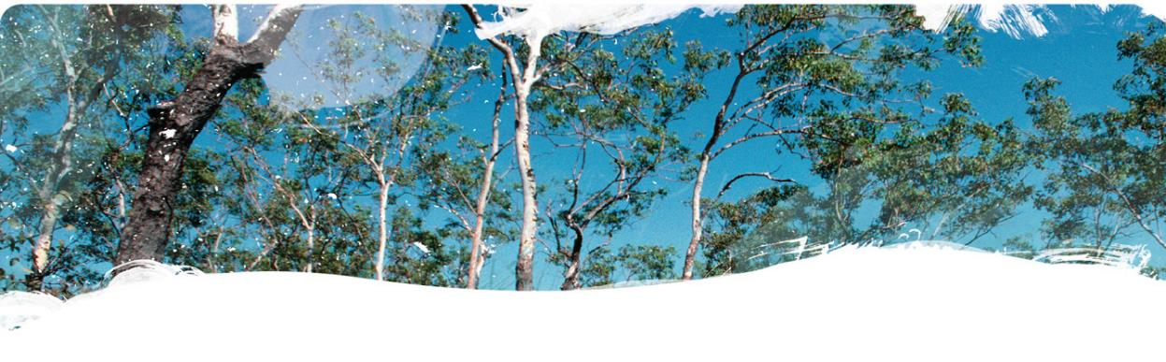

www.bioregionalassessments.gov.au
