Aboriginal Cultural Water Values
– Galilee subregion
A report for the Bioregional Assessment Programme
Researched and prepared by Corporate Culcha for the Department of the Environment
for The Department for the Environment, CSIRO and Geoscience Australia

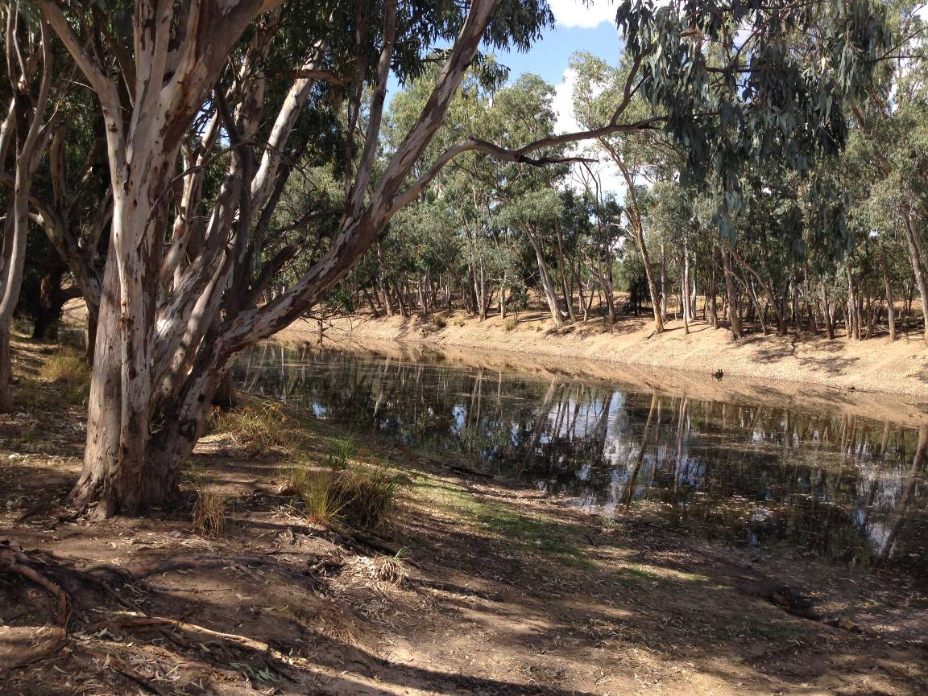

Corporate Culcha
Corporate Culcha is an Aboriginal owned and operated consultancy practice specialising in engagement with Aboriginal and Torres Strait Islander organisations and communities. Corporate Culcha works with a range of Indigenous and non-Indigenous consultants, many of whom are leaders in their individual fields. Access to this pool of expertise, allows Corporate Culcha to deliver a diverse range of services to their clients including research and evaluation, cultural capability programs and education, mentoring and capacity building.

About the Authors

Janis Constable is a well-regarded Indigenous research consultant with extensive social research and program evaluation expertise, built on senior policy and research roles for federal and state governments. Janis has been a senior advisor to two federal Aboriginal and Torres Strait Islander Social Justice Commissioners on Indigenous human rights issues where she led a number of national research projects. As a freelance research consultant Janis has undertaken a number of key strategic research projects focussing on improved social and economic outcomes for Aboriginal and Torres Strait Islander peoples.

Karen Love has extensive experience in ecological restoration, specialising in high conservation areas with bio-diverse vegetation. Her roles have incorporated advanced flora and fauna monitoring, ecological assessments and spatial mapping. Working alongside state and within local government agencies Karen has delivered a range of services, including scientific monitoring, program evaluation, strategy development and water education advice. Karen is a proud Maori woman, now an Australian citizen living on the North Coast of NSW.

Citation
Constable, J. and Love, K. (2015) Aboriginal water values Galilee subregion (Qld), a report for the Bioregional Assessment Programme.
Copyright
 © Commonwealth of Australia 2015
All material in this publication, except for information sourced from the Native Title Report 2008 and Desert Channels Queensland, is provided under a Creative Commons Attribution 3.0 Australia Licence <http://www.creativecommons.org/licenses/by/3.0/au/deed.en>.

Disclaimer
The views and opinions expressed in this publication are those of the authors and do not necessarily reflect those of the Australian Government or the Minister for the Environment.
While reasonable efforts have been made to ensure that the contents of this publication are factually correct, the Commonwealth does not accept responsibility for the accuracy or completeness of the contents, and shall not be liable for any loss or damage that may be occasioned directly or indirectly through the use of, or reliance on, the contents of this publication.
Cover photograph
Alice River, Queensland (Source: Love, K. 2014)

Acknowledgement of Traditional Owners
Acknowledgement is paid to Aboriginal and Torres Strait Islander peoples past, present
and future. We acknowledge the unique relationship that Aboriginal and Torres Strait Islander people have with their traditional lands and waters, as well as their history and diverse cultures and customs. We thank all Aboriginal people who have shared their knowledge and time so generously, without their participation this report would not have been possible. Particular thanks are given to James Hill, Gerry Fogarty, Sheryl Lawton and Floyd Robinson for graciously sharing their extensive knowledge with us.

Terms for Aboriginal and Torres Strait Islander
For the purposes of this report, the terms ‘Aboriginal people’, ‘Aboriginal and Torres Strait Islander people’ and ‘Indigenous’ are used interchangeably to refer to Aboriginal and Torres Strait Islander peoples of Australia. However, we recognise that this approach is not without contention. Aboriginal and Torres Strait Islander people generally prefer the use of Aboriginal as opposed to Indigenous. Indigenous is deemed a formal term often used by governments as inclusive of all Aboriginal and Torres Strait Islander peoples.

As this report is focussed on the relationship of Aboriginal people of the Galilee basin, we will refer to either Aboriginal people or their distinct groups i.e. Yirendali. The report also employs the term Indigenous when referring to relevant government programmes, policies or resources.

Acknowledgement of Traditional Owners 3
Terms for Aboriginal and Torres Strait Islander 3
1. Introduction 6
1.1 Aboriginal people of the Galilee basin region 7
1.2 Governance 8
2. Methodology 11
2.1 Desktop research 11
2.2 Community Engagement 12
2.3 Mapping Methodology 13
3. Consultation outcomes – values and assets 14
3.1 Categorising cultural assets 16
3.1.1 Cultural Heritage Sites 16
3.1.2 Yirendali words for Water 17
3.1.3 Bidjara words for Water 17
3.2 Cultural Water Assets Identified 18
Table 1: Aboriginal Cultural Water Assets, Galilee basin - Customary 18
Table 2: Aboriginal Cultural Water Assets, Galilee subregion - Spiritual 21
Table 3: Aboriginal Cultural Water Assets, Galilee subregion - Economic 22
Table 4: Aboriginal Cultural Water Assets, Galilee subregion - Ecology 23
3.3 Accompanying narratives 25
3.2.1 Torrens Creek (GA2) 25
3.2.2 Fishers Waterhole (GA21) 25
3.2.3 Cape River (GA24) 25
3.2.4 Tower Hill Creek (GA29) 25
3.2.5 Kuttaburra, the Black Duck story - Landsborough (GA27), Tower Hill (GA29) and Torrens Creek (GA2) 26
3.2.6 Lloyd Jones Weir and Alice River (GA30 and GA31) 27
3.2.7 Barcoo River (GA32) 27
3.2.8 Aramac Springs (GA33) 28
3.2.9 Lake Dunn (GA34) 28
3.2.10 Lake Nuga Nuga (GA36) 28
3.2.11 Carnarvon Range and Carnarvon Gorge (GA 37 and 38) 29
3.2.12 Ward River (GA44) 29
3.2.13 Black’s Palace (GA45) 30
3.2.14 Hoganthulla - Carolines Crossing (GA46) 30
4. Summary 31
5. References 32
References not cited (but assisted in informing the research) 32
6. Appendices 34
Appendix 1: Complete list of narratives provided by participating Elders. 34
Appendix 2: Interview questions for participants 42
Appendix 3 – Consultation participants 43

List of tables, maps and photographs

Map 1: Galilee Sub-Region (page 8)
Map 2: Native Title Determinations Queensland (page 10)
Map 3: Indigenous Land Use Agreements (page 11)
Map 4: Kati Thanda/Lake Eyre Basin (page 30)

Chart 1: Indigenous Population Galilee Subregion -2011 (page 9)

Table 1: Aboriginal Cultural Water Assets, Galilee Basin – Customary (page 18)
Table 2: Aboriginal Cultural Water Assets, Galilee Subregion – Spiritual (page 23)
Table 3: Aboriginal Cultural Water Assets, Galilee Subregion – Economic (page 25)
Table 4: Aboriginal Cultural Water Assets, Galilee Subregion – Ecology (page 27)

Pic 1: Gumbi Gumbi Mural on Charleville and Western Areas Aboriginal and Torres Strait Islander Health Limited (page 16)
Pic 2: Lloyd Jones Weir and Alice River (page 31)
Pic 3: Lake Dunn (page 32)
Pic 4: Ward River (page 33)
Pic 5: Marker Tree (page 34)

Introduction
Aboriginal water values is a term used to describe the relationship between Aboriginal and Torres Strait Islander peoples and water. Aboriginal and Torres Strait Islander people’s relationship with water is intrinsic in nature, with water not only being fundamental for survival, but an indivisible, interwoven and intrinsic element of cultural and spiritual life.

Tom Calma, the former Aboriginal and Torres Strait Islander Social Justice Commissioner wrote:

Indigenous peoples are connected to and responsible for our lands and waters and in turn, Indigenous peoples obtain and maintain our spiritual and cultural identity, life and livelihoods from our lands, waters and resources. These cultural and customary rights and responsibilities include:

- a spiritual connection to lands, waters and natural resources associated with water places
- management of significant sites located along river banks, on and in the river beds, and sites and stories associated with the water and natural resources located in the rivers and their tributaries, and the sea
- protection of Indigenous cultural heritage and knowledge associated with water and water places
- access to cultural activities such as hunting and fishing, and ceremony.

As the custodians of water resources on country, Aboriginal people have a significant interest in the way water is shared and used on country, and an important role in monitoring potential impacts of activities that may effect water quality and/or the health of flora and fauna that rely on specific water resources.

This report provides the data collected through community consultation for the Aboriginal Water Values Project, which will be used to inform the bioregional assessment for the Galilee subregion. The report includes an overview of the Indigenous population of the Galilee basin and surrounds; description of the methodology employed; description of the data collected, including narratives associated with identified water assets. An Asset Register, providing asset characteristics, including spatial data accompanies this report.

The Australian Government is undertaking a programme of bioregional assessments in order to better understand the potential impacts of coal seam gas and large coal mining developments on water resources and water-dependent assets. The Bioregional Assessment Programme draws on the best available scientific information and knowledge from many sources, including government, industry and regional communities, to produce bioregional assessments that are independent, scientifically robust, relevant and meaningful at a regional scale.

The Programme is a collaboration between the Department of the Environment, the Bureau of Meteorology, CSIRO and Geoscience Australia. The Programme is seeking input from the Aboriginal community on water-dependent cultural values (also referred to as assets). For more information, visit http://www.bioregionalassessments.gov.au.

1.1 Aboriginal people of the Galilee basin region
There are a number of Aboriginal groups whose traditional lands exist within the Galilee subregion. Those groups include the Yirendali, Wangan-Jagalingou, Bidjara and the Iningai peoples. The Iningai People, the Traditional Owners of the land surrounding the Thomson River, and beyond, have long since disappeared; renewed efforts are currently underway to try to find their descendants (Desert Channels Queensland).

Map 1: Galilee subregion (Bioregional Assessment Programme, Commonwealth of Australia, 2014)

The number of Aboriginal people inhabiting the area prior to European colonisation is unknown. However, it has been estimated that at the time of settlement the national Indigenous population was somewhere between 500,000 to 1 million (ABS). As at the 2011 Census, the Aboriginal and Torres Strait Islander population of Australia is estimated at 669,900 people, or approximately 3% of the total Australian population (ABS).

The total Indigenous population of the Galilee subregion (including bordering surrounds) is 1276 or 8.2 per cent of the total population (15,422) of the region, with the largest populations residing in Charleville (530) and Longreach (287). The number of Bidjura, Wangan Jagalingou and Yirendali people included in these figures is unknown, as tribal identities are not counted in the Census. The diaspora of Aboriginal people post-colonisation has resulted in many Aboriginal people not formally residing on their traditional country, however many Aboriginal people maintain strong ties to their homelands.

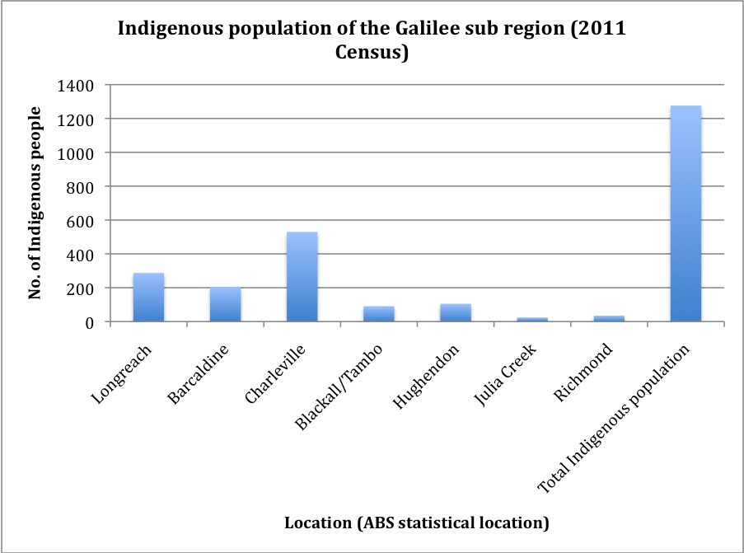

Chart 1 – Indigenous population Galilee subregion (2011) (Source: ABS)

1.2 Governance
In Queensland, Aboriginal lands councils represent large regions, as opposed to New South Wales where most Aboriginal communities have local land councils which deliver a range of services to the community. Queensland Land Councils represent local communities mainly in matters of Native Title and Indigenous Land use Agreements. Some discreet communities in Queensland are represented by Aboriginal Shire Councils such as Hopevale, Palm Island, Cherbourg etc.

Queensland South Native Title Services (QSNTS) also represent Aboriginal communities in the South East and Central Queensland, and were consulted as part of the research process, as several of the groups from the Galilee subregion are located within their jurisdiction. QSNTS assisted in identifying relevant individuals and groups, and, as stakeholder contact information was confidential, forwarded on our behalf, information about the project to those identified as potential research participants.

None of the groups in the Galilee subregion have Native Title over any of their lands (see map 2). Nor are there any Indigenous Land Use Agreements in place in the Galilee subregion (see map 3).

Map 2: Native Title Determinations Queensland (Source: National Native Title Tribunal)
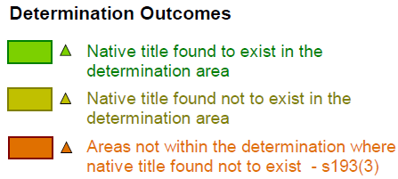

Map 3: Indigenous Land Use Agreements - Qld (Source: National Native Title Tribunal)
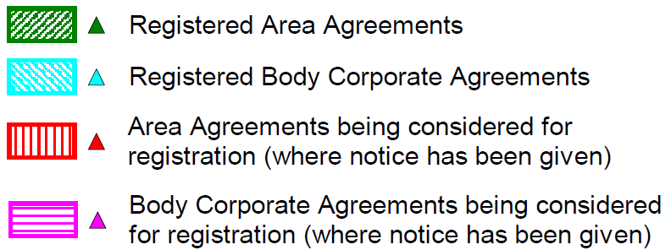

Local Aboriginal organisations, delivering a range of services to their communities, play a vital role in the health and wellbeing of their communities. They also play an important role in matters of governance – providing advice on cultural matters and representing their communities on a range of non government organisation boards and local, state and federal government groups and forums.

Representative organisations identified for the region:

- Yirendali Aboriginal Corporation
- Wangan Jagalingou Traditional Owners Aboriginal Corporation
- Bidjara Aboriginal Housing and Land Co Pty Ltd
- Central West Aboriginal Corporation (CWAC)

Organisations were approached and invited to participate in the research. Appropriate knowledge holders were identified by the organisations, and according to cultural protocols, meetings were set up to speak about Aboriginal water values with the research team.

2. Methodology
This section provides details on the following methodology employed throughout the project.

The methodology for this project included:

- Desktop research:
  - Relevant reports
  - Investigate current discourse on Aboriginal Cultural Water Values
  - Identify relevant organisations
- Contact by telephone individuals and organisations identified as being potential participants:
  - Introduce the project and the researchers
  - Discuss possibility of involvement in project
  - Arrange visit
- Initial field visits:
  - Face to face discussions and provide information
  - Identify other potential participants (Elders, knowledge holders)
  - Arrange next visit
- Second field visit:
  - Obtain consent
  - Commence data collection on site
    - Identifying locations of assets
    - Record special data (GPS mapping)
    - Interview knowledge holder
- Third field visit:
  - Continue and finalise data collection on site
  - Record spatial data
- Analyse data:
  - Record location data on asset register
  - Document associated narratives for assets
- Write report and obtain endorsement from participants.

2.1 Desktop research
Desktop research was undertaken to gain an initial understanding of, and to identify:
- publically available data
- current discourse on Aboriginal cultural water values
- key stakeholders (organisations and individuals)

A range of publications were identified which assisted in understanding relevant issues pertinent to the region and Aboriginal cultural water values generally. The reports and websites sourced indicate significant activity in relation to Aboriginal communities and water – specifically in relation to conservation and water sharing plans. These resources are listed at Chapter 5 – References.

2.2 Community Engagement
Initial discussions were held with Traditional Owner groups, as identified with the assistance of the Queensland South Native Title Services and through Corporate Culcha professional and personal networks.

Initial meetings provided an opportunity to discuss the objectives of the project with key stakeholders. These meetings also provided an opportunity to obtain contact details for other significant community members, with face-to-face or telephone meetings being arranged with those people soon thereafter.

Stakeholders were assured the process for gathering the data would be undertaken respectfully and with cultural safety as a priority. Information about the impetus of the broader Bioregional Assessment Programme, and the proposed use of the data collected through it, including the Aboriginal cultural water values mapping, was described as forming but one layer, of many layers of baseline data that will be assembled, to develop a comprehensive map of the Galilee subregion. The results will enable improved decision making in relation to coal mining and coal seam gas. Stakeholders were advised that maps and reports developed, as a result of this research, would be available to them as a community resource.

Stakeholders were also advised their participation was voluntary and no adverse action would occur if the group chose not to participate, and they could withdraw consent at any stage of the research process.

Unstructured interviews were undertaken with participants, as well as note taking by the interviewer. In some instances photographs were taken, with permission, of the sites. The interview questions can be found at Appendix 2.

Aboriginal organisations and communities consulted:

- Yirendali Aboriginal Corporation (Hughendon)
- Wangan Jagalingou Traditional Owners Aboriginal Corporation (Barcaldine)
- Bidjara Aboriginal Housing and Land Co Pty Ltd (Charleville)
- Central West Aboriginal Corporation (CWAC) (Barcaldine and Longreach)

Other key groups consulted about the research were:

- Desert Channels Queensland (Longreach)
- Georgina Diamantina Coopers Aboriginal Group (GDCAC) – consisting of representatives from:
  - Wankamana people
  - Mailwali people
  - Wongkamurra people
  - Boonthamurra people
  - Wangkanurru people
  - Waluewarra people
  - Mithaka people
  - Indjiandji people
  - Pitta Pitta people
  - Yirendali people
  - Koa people
  - Iningai (custodian)
  - Wongka yutjurru people
  - Kalkadoon people
  - Kungarri people
  - Bidjara people

Many of the above groups are not traditionally located in the Galilee subregion, however they have interests in neighbouring subregions, and the Lake Eyre Basin. The Georgina Diamantina Coopers Aboriginal Group indicated an interest in learning more about the project extending an invitation to the project team to deliver a presentation at a scheduled forum to be held at Desert Channels Queensland in Longreach. The project team met with Diamantina Coopers Aboriginal Group again on 29 October 2014 to discuss the project further.

2.3 Mapping Methodology
In all instances mapping on country utilised Motion X-GPS and coordinates were cross-referenced with maps downloaded into the Avenza Maps PDF application. Maps used were a mixture of Geoscience Australia, State of Queensland Wetland Maps and Hema Maps. Remote mapping was done using the same system with GPS coordinates obtained on country as the reference point.

3. Consultation outcomes – values and assets

Overwhelmingly, the research was received with enthusiasm, and knowledge holders spent considerable time with the research team, discussing water values and taking the team on country to visit examples of water assets. While on-site, researchers recorded spatial coordinates of the assets, and documented the associated cultural values, which included dreamtime stories and songlines, and knowledge and uses of asset reliant flora and fauna.

The following section outlines discussions with Aboriginal people in relation to cultural water values. The water values identified largely pertain to customary and spiritual associations, ecological value - relating to fish and animal species, or economic value in terms of fishing and other water-reliant bush foods. However, there is an overarching value based on the principle that healthy water translates to overall wellbeing for everything – people, animals, plants, earth and air.

James Hill, Yirendali Elder writes:

Water is sacred and honoured as the life force that is an inherent property embodying our spiritual, social and emotional sense of belonging. This sense of belonging is culturally ingrained in our identity and way of life enhancing our compassion through thought, feelings, sight, smell, taste, touch and sound. These sensations are a part of our make-up and biological relationship attaining a sense of being one and the same.

It is because of this sense of belonging that any adversity or stress to any creatures, land and sea country is felt by Aboriginal people causing social and emotional un-wellness.

It is through this spiritual and cultural connection with land and water that bestows Aboriginal people with the role of custodian. As custodians of water, Aboriginal people develop ways to conserve and protect important assets. As one Elder stated:
“That’s why the tribes moved around, so you never stripped the land. We always moved around to each waterhole following the rivers and came back later once it was replenished”. (Floyd Robinson)

Dreamtime story of Moonda Nurra as told by Jim Hill (Yirendali Elder)
One example of water and dreamtime is the story of Moonda Nurra. This story comes from the female rainbow serpent aka Moonda Nurra who created the Yirendali landscape. Moonda Nurra used her breath to blow the winds, the Barrookka, which spewed up the fish, animals, insects, plants and everything that belong to country. Her tongue is the lightning that we see, flashing in anger as her tears, flow down her face and onto country, and her tear drops are the rain water or Kooma, and her colours are seen in the Woggurree rainbow.

Moonda Nurra also travelled across Ngawun country, down the Flinders River and across into Mitakoodi country, and down the Gilliat Channels, resting in the water hole near where the main highway crossing is. She went in search for a mate, until she finally came across a Pitta Pitta serpent, from the Burke River. He stood tall, and wore red and white warrior paint markings and had long white whiskers. She met him at a place near Tooleybuc station in Yalanna country. This is where they made love, and she tried to persuade him to come home with her to Yirendali country, but he refused and left. And in spite, Moonda Nurra spat out her eggs along the way home - these eggs are the big round rocks we see along country from Julia creek, Richmond and Hughenden country.

Moonda Nurra was angry because her lover did not want to marry her and she could not find her people. Her anger, heard as the hard rumble of Koro (thunder) and Pilmunno (lightning) – is seen in the wet season when Moonda Nurra spits out her lightning tongue and cries in sadness for her family and her lover.

Ecological Cultural Water Assets
There are two noteworthy plant species used in ceremony as they are critical to creation stories. As both plants are equally important to Yirendali and Bidjara people, a regional significance is implied. In addition to being creation stories, Gumbi Gumbi and False Sandalwood are used medicinally.

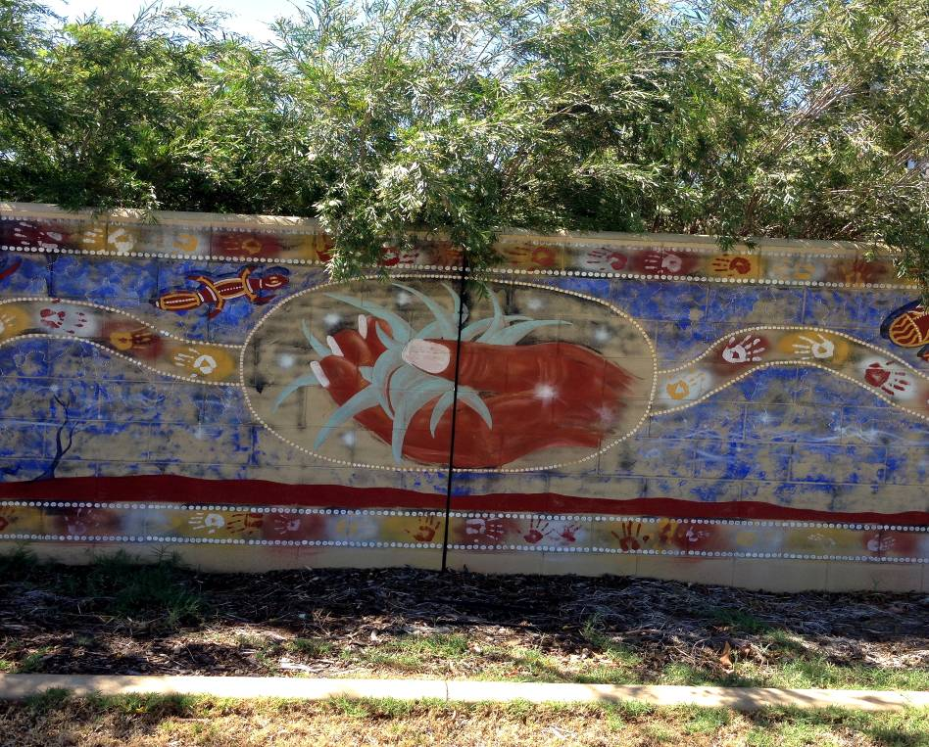

Pic 1: Gumbi Gumbi mural on Charleville and Western Areas Aboriginal and Torres Strait Islander Community Health Limited (Source: Love, K. 2014)

As shown above at Pic 1, Gumbi Gumbi is the emblem of the Charleville and Western Areas Aboriginal and Torres Strait Islander Community Health Limited (CWAATSICH) and is used as their logo as well as representing the health centre.

3.1 Categorising cultural assets

The assets identified here are of cultural significance to the Aboriginal people of the Galilee subregion, the values, purpose and meaning attached to each asset has been identified through consultation. Most assets have more than one value attached, for example a creek bed being a place of ceremony as well as a place where food can be harvested.

The purpose and meaning of cultural water assets have been categorised into the following groups:

- Customary – ceremony, meeting place, men’s business, women’s business, totems, dance, rites, song, birth, death)
- Spiritual (dreaming, stories, songlines)
- Ecological (flora and fauna)
- Economic (trade routes, food source – fishing/hunting, employment/income – tourism, farming)
- Recreational – family gatherings, swimming holes

The total number of Aboriginal cultural water assets in the Galilee subregion detailed in this report is not exhaustive. The data collated is a sample of the most significant cultural water assets, as identified by the relevant Traditional Owner groups, within specific areas of the subregion.

The data collection undertaken in the subregion has been limited by:
- Extensive geography of each subregion, and time required to cover extensively (within the time constraints of the project);
- Elders and other knowledge holders availability to undertake field work (within the time constraints of the project);
  - It is a necessary requirement of the data collection that an Elder or knowledge holder accompany researchers in the field so as to identify water assets and convey their associated cultural value.

Traditional Owners participating in the research have expressed interest in undertaking further cultural mapping work on country so as to provide a detailed and comprehensive understanding of cultural values associated with water.

3.1.1 Cultural Heritage Sites
Registered assets for the Galilee subregion include thirty two cultural heritage sites, of which ten are managed by Queensland National Parks (QNP), and one by Bush Heritage Australia. The on-going management of these sites is critically important to the Yirendali and Bidjara people as most of them are valued as important customary sites, with creations stories connected to them. It is envisaged that further sites identified during this project will also be listed in the near future or are currently in the process of listing.

3.1.2 Yirendali words for Water
Water is associated with the Moonda Nurra or Moond Gurra, the rainbow serpent that created our water, plants, animals and landscape.

~ Water or rain in Yirendali is traditionally called Kamoo or Paggury
~ Rainbow is traditionally called Woggurree
~ Lightening is traditionally called Pilmunno
~ Thunder is traditionally called Koro
~ Clouds (new cloud) is traditionally called Mur rarra utchee ummoo
~ Rain Clouds is traditionally called kamoo oondookoopakka
~ Wind is traditionally called Barrookka

(Source: James Hill, Yirendali Elder)

3.1.3 Bidjara words for Water

Yunnabae – Deep Water
Gamoo – Water or rain
Woggurree - Rainbow
Wanganwangan – Running water

(Source: Floyd Robinson, Bidjara Elder)

3.2 Cultural Water Assets Identified
The following tables contain the data collected through consultation with Aboriginal people with knowledge and connection to the Galilee subregion. The tables have been divided by group i.e. Customary (Table 1), Spiritual (Table 2), Economic and Recreation (Table 3) and Ecological (Table 4). Table 4 contains different headings from Tables 1, 2 and 3.

Table 1: Aboriginal Cultural Water Assets, Galilee basin - Customary
Identifier | Name | Traditional name | Type | Country | Value | Explanation
GA1 | Prarie Creek |  | Creek | Yirendali | Customary | Yirendali creation story/Duck Story/Birth of Yirendali
GA2 | Torrens Creek | Booraman | Creek | Yirendali | Customary | Birthplace of Yirendali people/Burial place
GA7 | Wowra | Wowra | Spring | Yirendali | Customary | Healing place
GA9 | Butterbush | Gumbi Gumbi | Plant | Yirendali and Bidjara | Customary | Significant across all groups/medicinal plant/relates to Yirendali creation story/brown snake and goanna
GA10 | Roys Camp | Roys Camp | Site | Yirendali | Customary | Creation story for Yirendali
GA11 | Narkool | Narkool | Waterhole | Yirendali | Customary | Central Camp site/Ceremonial Site/Burial site/Scar Tree
GA12 | False Sandalwood |  | Plant | Yirendali and Bidjara | Customary | Ceremonial plant used by all groups in the region for smoking Ceremonies/medicinal
GA14 | Pilmunny | Pilmunny | Waterhole | Yirendali | Ceremony | Ceremony site
GA21 | Aberfoyle | Fishes Water Hole | Waterhole | Yirendali | Customary | Survival site/last known water in drought/crucial food, medicinal, ceremony/massacre
GA25 | White Mountains National Park | White Mountains | Headwaters | Yirendali | Customary | Storyline of "Pilmunno"/Creation story/headwaters of Torrens, Bullock, Warrigal Creeks
GA31 | Alice River | Alice River | River | Bidjara | Economic | Major river/resources/hunting/soaks
GA36 | Lake Nuga Nuga | Lake Nuga Nuga | Lake | Bidjara | Customary | Rainbow serpent creation story/principles and customary
GA37 | Carnarvon Range | Carnarvon Range | Springs and Creeks | Bidjara | Customary | Creation story for Bidjara/Woman's place/Carpet Snake Mountain/White Cockatoo
GA38 | Carnarvon Gorge | Carnarvon Gorge | River | Bidjara | Customary | Woman's first law/Creation story/Headwaters of the Warrego River
GA39 | Carpet Snake Mountain | Gubbilgubbilgorgarra | River | Bidjara | Customary | Carpet Snake Mountain story/Art work depicting carpet snake going down the creek
GA40 | Sandy Creek | Sandy Creek | Creek | Bidjara | Customary | Ceremony place/Meeting place/
GA41 | Carnarvon Creek | Carnarvon Creek | Creek | Bidjara | Customary | Men's Business/Where it meets Moolayember Creek
GA42 | Carnarvon Station | Seven Springs | Springs | Bidjara | Customary | Seven springs relates to the Seven sisters.
GA43 | Warrego River | Warrego River | River | Bidjara | Customary | Pinnacle Rocks are initiation rocks/Men's business
GA45 | Black's Palace | Black's Palace | River | Bidjara | Customary | Women's business/meeting place at confluence
GA48 | Dingo | Kobbera | Mammal | Yirendali and Bidjara | Customary | Creation story
GA49 | Brown Snake | Brown snake | Reptile | Bidjara | Customary | Creation story
GA50 | Carpetsnake | Carpetsnake | Reptile | Bidjara | Customary | Creation story
GA51 | Curlew | Curlew | Bird | Yirendali | Customary | Creation story
GA52 | Wombat | Weareah | Mammal | Yirendali | Customary | Creation story
GA53 | Eucalyptus microtheca s. lat | Coolibah | Plant | Yirendali | Customary | Creation story/healing
GA54 | Split Jack |  | Plant | Yirendali | Customary | Creation story
GA55 | Desert Bloodwood | Dooloo kamboona | Plant | Yirendali | Customary | Creation story
GA56 | Grevillia Sp. | Grevillia | Plant | Yirendali | Customary | Creation story/healing/food
GA57 | Goanna | Pyeburra | Reptile | Yirendali and Bidjara | Customary | Creation story
GA58 | Galah | Bankarra (Galah) | Bird | Yirendali | Customary | Creation story
GA59 | White Cockatoo | Tiggery (Yirendali) Tiggardi (Bidjara) | Bird | Yirendali and Bidjara | Customary | Creation story
GA60 | Willy Wagtail | Teegungra (Willy Wagtail) | Bird | Yirendali | Customary | Creation story
GA61 | Banded grunter/trumpet fish |  | Fish | Yirendali | Customary | Creation story
GA62 | Silver Perch/Black Bream |  | Fish | Yirendali and Bidjara | Customary | Creation story
GA63 | Crayfish | Karkoora or Munya | Crustacean | Yirendali and Bidjara | Customary | Creation story
GA64 | Red Kangaroo | Tiggera (Yirendali) Boda (Bidjara) | Mammal | Yirendali and Bidjara | Customary | Creation story
GA65 | Possum | Kuttera | Mammal | Yirendali | Customary | Creation story
GA66 | Echidna | Bubbera | Mammal | Yirendali and Bidjara | Customary | Creation story
GA67 | Fresh Water Mussell | Bidgee | Crustacean | Yirendali | Customary | Women's business
GA68 | Tawny Frogmouth Owl | Mopo | Bird | Bidjara | Customary
GA69 | Emu | Goalberry | Bird | Yirendali Bidjara | Customary | Creation story

Table 2: Aboriginal Cultural Water Assets, Galilee subregion - Spiritual
Identifier | Name | Traditional name | Type | Country | Value | Explanation
GA3 | Kookoorinya | Kookoorinya | Waterhole | Yirendali | Spiritual | Spirit place/'Yarraby" lives there. No swimming
GA4 | Baroota | Baroota | Waterhole | Yirendali | Spiritual | Blue Lily (Wondoobra)/Birthplace
GA22 | Moorinya National Park | Moorinya National Park | Waterholes | Yirendali | Spiritual | Critical resource site/medicinal plants/grinding stones
GA23 | Moorinya National Park | Moorinya National Park | Channels | Yirendali | Spiritual | Ceremonial resource site/food/water
GA24 | Cape River | Boorala | River | Yirendali | Spiritual | Storyline place/created by serpent 'Moonda Nurra' or 'Moond Gurra'
GA26 | Porcupine Gorge National Park | Porcupine Gorge | Headwaters | Yirendali | Spiritual | Masscare site/headwaters of Prarie Creek/Galah Creek
GA27 | Landsborough Creek | Landsborough Creek | Creek | Yirendali | Spiritual | Storyline of emu "Goolberri"/Joined by Towerhill Creek and meets the Thomson River/three significant waterholes
GA28 | Dunraven | Dunraven | Creek | Yirendali | Spiritual | Stewart Creek - Burial site and main camp site
GA29 | Towerhill Creek | Towerhill Creek | Creek | Yirendali | Spiritual | Waterholes individually mapped along Towerhill Creek/Joins Landborough becoming Thomson River
GA30 | Lloyd Jones Weir | The Weir | Creek | Bidjara | Spiritual | "The Farm" - spirit place/ teaching/resources and family place
GA33 | Aramac Springs | Aramac Springs | Springs | Bidjara | Spiritual | All springs near Aramac are critical/good water source for the local area/rock art - Heritage sites
GA46 | Hoganthulla | Caroline's Crossing | Creek | Bidjara | Spiritual | Crossing at Chesterton Creek (Caroline's Crossing)/Camp ground/Massacre site/Burial site/Birth site

Table 3: Aboriginal Cultural Water Assets, Galilee subregion - Economic
Identifier | Name | Traditional name | Type | Country | Value | Explanation
GA5 | Lake Buchanan | Lake Buchanan | Lake | Yirendali | Economic | Resources including Timber/Habitat -Birds, Black ducks
GA6 | Lake Galilee | Mucka Mucka | Lake | Yirendali | Economic | Resources – Timber/Habitat Birds, Black ducks
GA8 | Webb Lake | Boburra aka Koburra | Lake | Yirendali | Economic | Dingo Story/Resource site
GA13 | Newjenna | Newjenna | Waterhole | Yirendali | Economic | Garden area for food
GA15 | Narrkooroo | Narkooroo | Waterhole | Yirendali | Economic | Water and resource site
GA16 | Turrumminna | Turrumminna | Waterhole | Yirendali | Economic | Water and resource site
GA17 | Mattamundukka | Mattamundukka | Waterhole | Yirendali | Economic | Water and resource site
GA18 | Teekalamungga | Teekalamungga | Waterhole | Yirendali | Economic | Water and resource site
GA19 | Teekaloonda | Teekaloonda | Waterhole | Yirendali | Economic | Water and resource site
GA20 | Bogunda | Bogunda | Waterhole | Yirendali | Economic | Water and resource site
GA31 | Alice River | Alice River | River | Bidjara | Economic | Major river/resources/hunting/soaks
GA 32 | Barcoo River | Barcoo River | River | Bidjara | Economic | Annual Indigenous Regional Fishing Comp/Several waterholes (Moodberri and Omar)/always has water/survival
GA34 | Lake Dunn | Lake Dunn | Lake | Bidjara | Economic | Always has water in the middle/gathering place during holidays/recreation/feeds Reedy Creek
GA35 | Moonderri | Moonderri | Waterhole | Bidjara | Economic | Historic waterhole/Fishing and camping/important for survival/always has water.
GA44 | Ward River | Ward River | River | Bidjara | Economic | Food and water source for survival-never dries up.
GA47 | Augathella | Augathella | Soak | Bidjara | Economic | Always has water /food

Table 4: Aboriginal Cultural Water Assets, Galilee subregion - Ecology
Identifier | Scientific Name | Common name | Traditional name | Language Group | Value | Explanation
GA9 | Pittosporum angustifellium | Butterbush | Gumbi Gumbi | Yirendali and Bidjara | Ecology/Ceremony | Creation/Brown snake and Goanna
GA12 | Eremophila mitchelii | False Sandalwood | Budda | Yirendali and Bidjara | Ecology/Ceremony | Ceremony/ Smoking
GA48 | Canis familiaris | Dingo | Kobbera | Yirendali and Bidjara | Ecology/Ceremony | Creation story
GA49 | Pseudonaja nuchalis | Brown snake |  | Bidjara | Ecology/Ceremony | Creation story
GA50 | Morelia spilota metcalfei | Carpet snake |  | Bidjara | Ecology/Ceremony | Creation story
GA51 | Burhinus grallarius, | Curlew |  | Yirendali | Ecology/Ceremony | Totem
GA52 | Lasiorhinus krefftii | Wombat | Weareah | Yirendali | Ecology/Ceremony | Totem
GA53 | Eucalyptus microtheca s. lat | Coolibah | Coolibah | Yirendali | Ecology/Ceremony | Totem
GA54 | Capparis lasiantha | Split jack |  | Yirendali | Ecology/Ceremony | Totem
GA55 | Corymbia opaca | Desert Bloodwood | Dooloo kamboona | Yirendali | Ecology/Ceremony | Totem
GA56 | Grevillia Sp. | Grevillia | Grevillia | Yirendali | Ecology/Ceremony | Totem
GA57 | Varanus gouldii | Goanna | Pyeburra | Yirendali and Bidjara | Ecology/Ceremony | Totem
GA58 | Cacatua roseicapilla | Galah | Bankarra | Yirendali | Ecology/Ceremony | Totem
GA59 | Cacutua galerita | White Cockatoo | Tiggery/Tiggardi | Yirendali and Bidjara | Ecology/Ceremony | Creation story
GA60 | Rhipidura leucophrys | Willy Wagtail | Teegungra | Yirendali | Ecology/Ceremony | Totem
GA61 | Amniataba percoides | Trumpet fish |  | Yirendali | Ecology/Ceremony | Totem
GA62 | Bidyanus bidyanus | Perch/Bream |  | Yirendali and Bidjara | Ecology/Ceremony | Totem/fishing
GA63 | Cherax destructor | Crayfish | Karkoora/Munya | Yirendali and Bidjara | Ecology/Ceremony | Totem/food
GA64 | Macropus rufus | Red Kangaroo | Tiggera / Boda | Yirendali and Bidjara | Ecology/Ceremony | Creation story
GA65 | Trichosurus vulpecula | Possum | Kuttera | Yirendali | Ecology/Ceremony | Totem
GA66 | Tachyglossus aculeatus | Echidna | Bubbera | Yirendali and Bidjara | Ecology/Ceremony | Totem
GA67 | Velesunio ambiguous | Fresh water mussell | Bidgee | Yirendali | Ecology/Ceremony | Women's business
GA68 | Podargus strigoides | Tawny Frogmouth owl | Mopo | Bidjara | Ecology/Ceremony | Totem
GA69 | Dromaius novaehollandiae | Emu | Goalberry | Yirendali and Bidjara | Ecology/Ceremony | Creation story

3.3 Accompanying narratives
The following stories were provided by community members, when describing each asset. Each story is aligned with an identification number cited in the above tables.

3.3.1 Torrens Creek (GA2)
Torrens creek is traditionally called ‘Boorooman’, the name for a deep soak. Torrens Creek runs out of the White Mountains and it flows in to a significant water hole near the old Aberfoyle homestead.

Torrens Creek is a significant occupational site. It is the birth site of my great-great grandfather Richard Hill, and my grandfather Bunji Hill. My grandfather’s parents are buried not far from the river. It is also significant to many other Yirendali who were born here. (James Hill, Yirendali Elder)

3.3.2 Fishers Waterhole (GA21)
The Aberfoyle waterhole is called the ‘Fishers waterhole ‘. It holds very strong significance as the last place of water during a long drought. It provides water, fish, bush-tucker and bush- medicine and is also a place of ceremony.

Fishers waterhole holds a terrible history, as a place of conflict between Yirendali and western settlers. The early settlers tried to chase Yirendli away from the waterhole. The Yirendali refused and retaliated resulting in the death of several settlers. The government troopers were called in to deal with the Yirendali people, and a punitive raid in reprisal was sanctioned. The troopers attacked the Yirendali people at Bannockburn station, and chased them to Uanda, the main campsite about eight miles from Torrens Creek, and killed all members of the group that were present that night.

3.3.3 Cape River (GA24)
Cape River is traditionally called ‘Boorala’. Cape River is the eastern boundary and it is the story line place for ‘Borrommo’, the butterfly. This river is created from the serpent ‘Moonda Nurra’, who lives at a place called the ‘Native Well’ on Gorge Creek.

3.3.4 Tower Hill Creek (GA29)
Tower Hill Creek is a significant water resource for Yirendali people. It has many important cultural water sites:
- Pilmunny - near Ironbark camp, it is a traditional ceremony ground
- Barootta - is the place of the blue water lilly which is traditionally called ‘Wondoobra’.
- Marrikanna - is a traditional waterhole
- Narkool – a main camp waterhole, ‘Lammermoor’ belonging to King Narkool aka King Barney
- Newjenna - is a waterhole down from Narkool, which is the old homestead garden ‘Turramminna’ which is next to a sand hill, just above the waterhole
- Teekalamungga: is a traditional waterhole
- Teekaloonda - a traditional waterhole
- Kooroorinya - is known as the falls, which is eight miles down from Lammermoor homestead it is the home of the ‘Yarraby’ or spirit.
- Bogunda - is a traditional waterhole
- Woodeeooroorina - is also known as Gardiners Creek

3.3.5 Kuttaburra, the Black Duck story - Landsborough (GA27), Tower Hill (GA29) and Torrens Creek (GA2)
The black duck is traditionally called ‘Kuttaburra’. The wood duck is traditionally called the ‘Now Now’, or “Now Wow’.

The waterways of the Galilee subregion– the Tower Hill and Torrens Creek (and their tributaries) come together as a part of the ‘Kuttaburra story’, or ‘Duck story’. The Duck story is also associated with the Thompson and Cooper Rivers, which run into KatiThanda /Lake Eyre. These stories (songlines) run on top of the ground and disappear underground and then come back up, from under the ground springs to feed into KatiThanda /Lake Eyre.

The Duck story originates from the big dreamtime story out of Kati Thanda/Lake Eyre and travels north to Yirendali country and into Fink River country, then into my Mother’s country on the Georgina River basin. This river system is the last duck hunting site and freshwater turtle hunting site before you get to the Thompson River. The importance of this Duck story is witnessed by Arente Elder Uncle Felix Armstrong as the same story line that connects his country to Kati Thanda /Lake Eyre and Yirendali water country. (James Hill, Yirendali Elder)

The map below shows the rivers of Yirendali country and south Arunta country and how they connect with Kati Thanda/Lake Eyre.

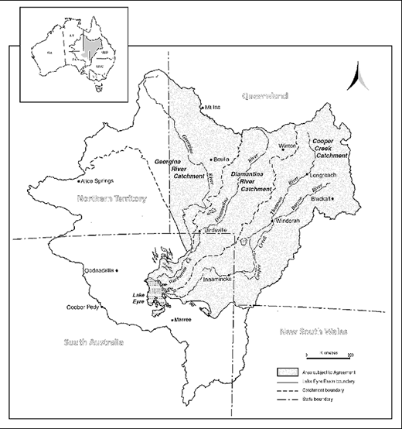

Map 4: Kati Thanda/Lake Eyre basin (Source: Department of Environment)

3.3.6 Lloyd Jones Weir and Alice River (GA30 and GA31)
The weir is very important to our family’s culture. We spent a lot of time there as kids, going out with our parents and grandparents fishing and hunting. It was built in 1952 and before it was built the river was mostly dry but now the water goes 3-4 km back so it’s a good fishing hole. We also have a ‘spirit place’ out there called “the farm” where we take the kids and teach them about culture, hunting and fishing – tell them stories about our people and camp there. So the Alice River is very important to us and our culture. It starts on the other side of Jericho and runs into the Barcoo River which joins the Thomson at Windoura going all the way to Lake Eyre. Our water stories tell us that even when there is no water running, when the river is dry, we can still get water from the Alice. You just dig a hole about 3-4 ft deep, and then there is water. It’s underneath, we used to drink that water. (Gerry Fogarty, Bidjara Elder)
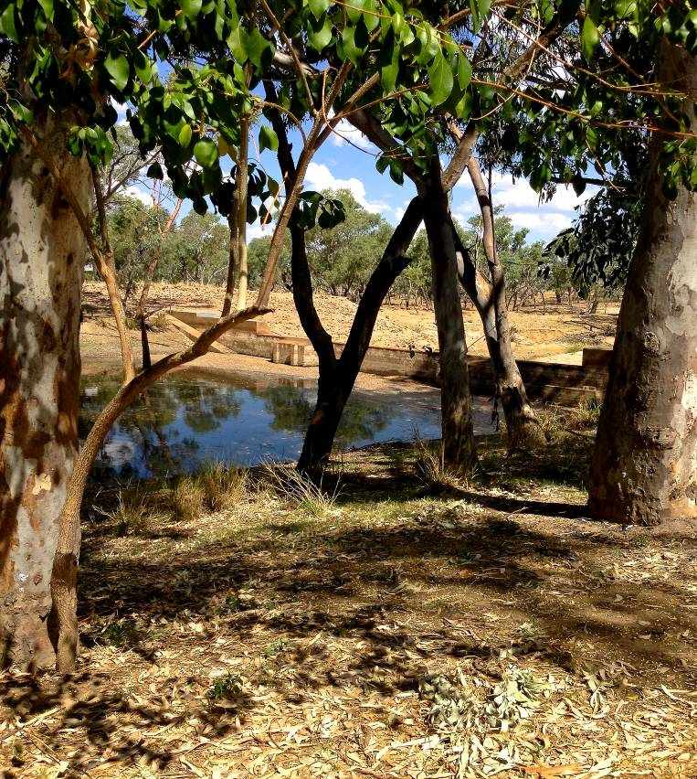

Pic 2: Lloyd Jones Weir and Alice River (Source: Love, K.)

3.3.7 Barcoo River (GA32)
The Barcoo is a very significant water asset for the Bidjara people. Located near Isisford there are several waterholes that are used for fishing and camping. The Moonderri waterhole (half way between Barcaldine and Blackall) and Omah waterhole (near Isisford) is about four kilometers long and six meters deep.

These waterholes never go dry so they would have always been used. We have a big fishing competition at the waterhole near Isisford, it’s been going for about eight or nine years. There is usually around 1000 people and we catch “yellow belly”. (Gerry Fogarty, Bidjara Elder)

3.3.8 Aramac Springs (GA33)
Several natural springs are located at Aramac. There are also carvings and paintings in the area. The springs are an important water source for the Bidjara and Wangan and Jagalingou. Gerry Fogarty advised that some of the springs are a habitat for a rare fish, which should be protected by heritage.

3.3.9 Lake Dunn (GA34)
Lake Dunn is located just south of Lake Galilee and 60 kilometers north of Aramac. It is important as it feeds Reedy Creek. Water can always be sourced at Lake Dunn, even when seemingly dry there is water to be found in the middle. At the time of the field visit it was approximately 80 per cent full. Lake Dunn is an important recreational source for Aboriginal people used for camping and fishing.

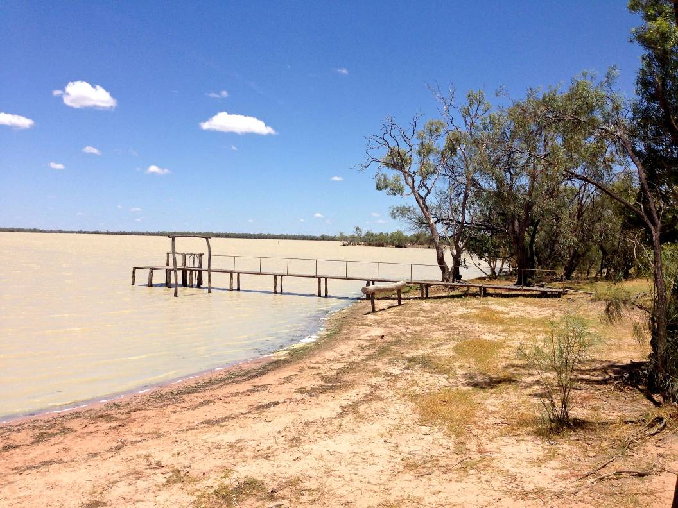

Pic 3: Lake Dunn (Source: Love, K.)

3.3.10 Lake Nuga Nuga (GA36)
Lake Nuga Nuga is the resting place of the rainbow serpent ‘Mundagudda’ who created country. It is creation story place of the Bidjara people where lores and principles come from.

‘Mundagudda’ - Rainbow Serpent
The rainbow serpent represents water in our country, the core of our country, bringing the lores and principles. There is a creation story from Carnarvon (Home of the Rivers) about the Rainbow Serpent “Mundagudda” who came from the stars and we came with him and landed in Carnarvon and now rests at Lake Nuga Nuga. Uncle Rusty Fraser told me we were birds before we were people so there are a couple of mountains up there, a place of the Wedge-tailed Eagle (Gooldathalla), Carpet Snake Mountain and Red Kangaroo Mountain. (Floyd Robinson, Bidjara Elder)

3.3.11 Carnarvon Range and Carnarvon Gorge (GA 37 and 38)
Creation Story - a place of woman’s business. The story tells of a little girl lost. Her mother could not find her, but she could hear her. The land is alive and is represented by a stone spirit, which relates to men’s lore in Bidjara cultures. The gorge used to be a creek – but the land rose, with the woman and became the gorge (Carnarvon). When the woman saw her little girl - the girl turned into a white cockatoo. The lore story is about keeping your children close when travelling on country. There’s a place called ‘Balloon Cave’, which is a burial place that is also associated with this story and the carpet snake story.

3.3.12 Ward River (GA44)
This river has never dried up and is important for fishing. There are big waterholes there that always have water. When it goes down you can see big caves in the side of it and this is where the fish are so you know where to come back to fish for yellow belly, catfish and cod. There are scar trees there that point to men’s and woman’s business. At this place on the Ward River the m en’s tree points east to west, and the Women’s tree points up the river. (Floyd Robinson, Bidjura Elder)

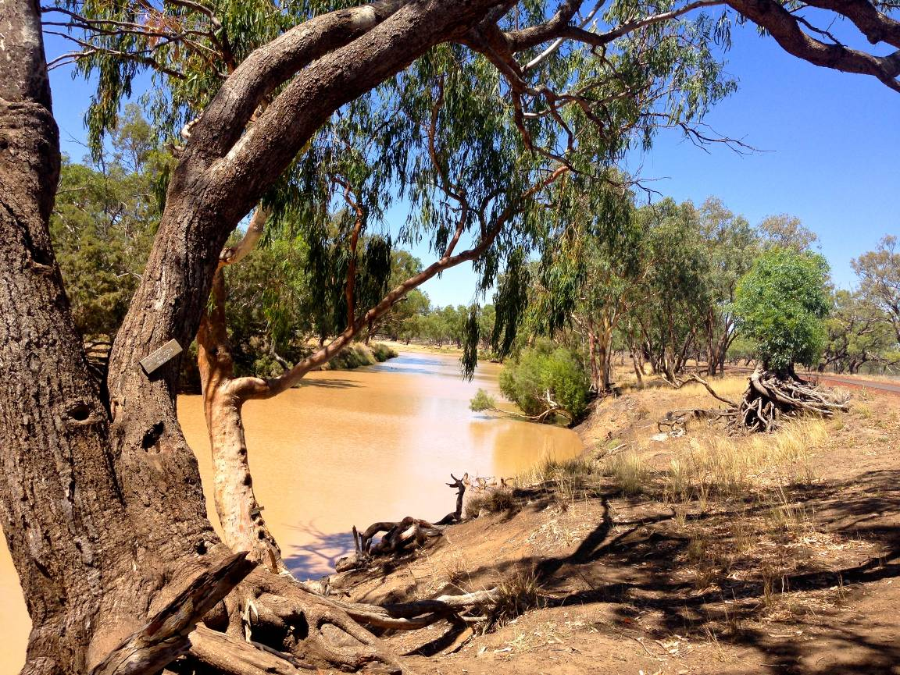

Pic 4: Ward River (Source: Love, K.)

3.3.13 Black’s Palace (GA45)
On the Ward River there is a marker pointing to a place of women’s business. Everyone comes from all over to meet there. The picture below shows a marker indicating the way up the river. It also has a pointer indicating up the river to Woman’s business. (Floyd Robinson, Bidjura Elder)

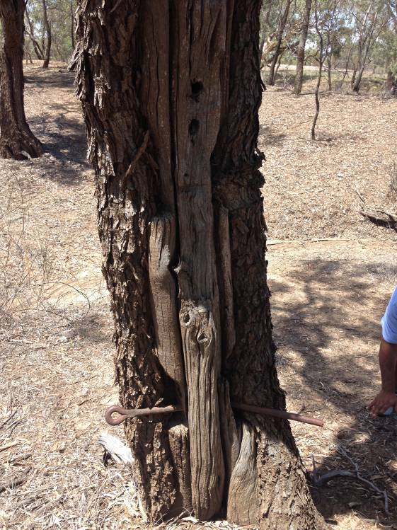

Pic 5: Marker tree (Source: Love, K.)

3.3.14 Hoganthulla - Carolines Crossing (GA46)
Hoganthulla is the birthplace and burial place for many Bidjara people. One story tells of a big camp on the banks where two Bidjara men fought to the death and are buried under an Ironbark tree there (Floyd Robinson, Bidjura Elder).

4. Summary

This report provides rich examples of Aboriginal water values existing in the Galilee subregion. The information was collated with the generous assistance of the Yirendali, Wangan Jagalingou and Bidjara people. However, although rich it is not exhaustive, as documenting water values for the entire region will require more time than was permitted for this research project. It is the expressed hope of the participants, that the project can continue, and a thorough mapping for the region can be undertaken for water resources and their associated cultural values.

Nevertheless, what is provided here is exemplary of the relationship the Yirendali, Wangan Jagalingou and Bidjara people have with water, in what is mostly an arid environment. There are water resources, known to only a few, that continue to nourish and provide Aboriginal people with an ongoing connection to their cultural traditions. Water is an intrinsic part of creation, the story of Lake Nuga Nuga as the resting place of the rainbow serpent ‘Moondagadda’ who created Yirendali country, is a fine example of the importance of water in spiritual and cultural life.

Another story illustrating the importance of water in the region, is the creation story of ‘Kuttaburra’. Three main rivers of the Galilee basin – the Landsborough, Tower Hill and Torrens Creek (and their tributaries) come together as a part of the ‘Kuttaburra story’, or ‘Duck story’. These stories and songlines, run on top of the ground, then disappear underground, then come back up from under the ground springs to feed into Kati Thanda /Lake Eyre. The story originates from the big dreamtime story out of Kati Thanda/Lake Eyre and travels north to Yirendali country and into Finke River country. The river system is also the last duck hunting site and freshwater turtle hunting site before you get to the Thompson River.

The Yirendali and Bidjara also spoke of the importance of water to the life of flora and fauna. For example, scar trees, that point to the places of men’s and woman’s business, rely on the water of the creeks and rivers, to sustain their life, and hence sustain cultural knowledge of the local people. Elders also told of waterholes that always have water, and even when the water subsides, the surrounding caves still have water in them, “this is where the fish are so you know where to come back to fish for yellow belly, catfish and cod.”

There was concern expressed by some participants about the impact on water of coal seam gas and other mining activities. One Elder said, he had been told by an Elder (from another region), that water levels had dropped as a result of coal seam gas exploration. He knew this as it had only happened since exploration had commenced. Participants expressed optimism that the process of mapping water values will provide some knowledge that will help decision makers understand the value of water to remote Aboriginal communities. The communities involved in this research look forward to the outcomes of the project.

5. References

Australian Bureau of Statistics http://www.abs.gov.au/ausstats/abs@.nsf/0/415B7843ACA11A17CA25773700169C5F?opendocument (accessed 1 December 2014).

Australian Bureau of Statistics, 3238.0.55.001 - Estimates of Aboriginal and Torres Strait Islander Australians, June 2011.

Australian Bureau of Statistics, 2011 Census of Population and Housing, Aboriginal and Torres Strait Islander Peoples(Indigenous) Profile (Cat. No. 2002.0) – for Charleville (315031409); Longreach (R) (LGA34710); Blackall/Tambo (LGA 30760) ;Richmond (Qld) (Cat. No. 2001.0) Basic Community Profile; Julia Creek, (Cat. No. 2001.0) Basic Community Profile; Hughendon (Cat. No. 2001.0) Basic Community Profile.

Australian Institute of Aboriginal and Torres Strait Islander Studies, http://lryb.aiatsis.gov.au/people-health-and-homes.html, (accessed 3 December, 2014).

Australian Museum http://australianmuseum.net.au/Indigenous-Australia-Introduction, accessed 1 December, 2014.

Calma T. (2008) Aboriginal and Torres Strait Islander Social Justice Commissioner, Native Title Report 2008, Chapter 6 – Indigenous Peoples and Water, Human Rights and Equal Opportunity Commission, Sydney.

Evans T, Tan KP, Magee J, Karim F, Sparrow A, Lewis S, Marshall S, Kellett J and Galinec V (2014) Context statement for the Galilee subregion. Product 1.1 from the Lake Eyre Basin Bioregional Assessment. Department of the Environment, Bureau of Meteorology, CSIRO and Geoscience Australia, Australia.

Desert Channels Queensland (2011) Searching for the lost, media release, 26 July, viewed 14 January 2015, www.dcq.org.au/searching-lost.

National Native Title Tribunal - http://www.nntt.gov.au/Maps/QLD_NTDA_Schedule.pdf accessed 23 December 2014.

National Native Title Tribunal - http://www.nntt.gov.au/Maps/ILUAs_map.pdf (accessed 23 December. 2014).

References not cited (but assisted in informing the research)

Collings, N. (2012), Indigenous Cultural and Spiritual Values in Water Quality Planning, Department of Sustainability, Environment, Water, Population and Communities, Australian Government, Canberra, ISBN 978-1-921733-64-2.

Desert Channels Queensland www.dcq.org.au.

Desert Channels Queensland, Draft Environmental Values for Water Quality in the Thomson and Barcoo Catchments, Queensland, July 2013.

Far South West Aboriginal Natural Resource Management Group (2012) Caring for Water on Country in South West Queensland, http://www.southwestnrm.org.au/sites/default/files/uploads/managed/Caring%20for%20Water%20on%20Country%20Report_from%20workshop%20with%20TOs_final.pdf (accessed 20 September 2014).

Jackson, S. E. , Palmer, L. R. (2012). Modernising Water: Articulating Custom in Water Governance in Australia and East Timor. The International Indigenous Policy Journal, 3(3) . Retrieved from: http://ir.lib.uwo.ca/iipj/vol3/iss3/.

Jackson, S., et al. Principles and guidelines for good practice in Indigenous engagement in water planning. J. Hydrol. (2012), doi:10.1016/j.jhydrol.2011.12.015.

Sveiby, K.E. (2009) Aboriginal Principles for Sustainable Development As Told in Traditional Law Stories, Sustainable Development. 17, 341–356 (2009) Published online 10 March 2009 in Wiley InterScience (www.interscience.wiley.com) DOI: 10.1002/sd.389.

6. Appendices

Appendix 1: Complete list of narratives provided by participating Elders.
Identifier | Narrative | Author/Source
GA1 | Prairie Creek - The Plains Homestead water hole on the Prairie river, is the creation place for the Yirendali people, it is associated with the ceremonial bush medicine, common name gumbi gumbi. It is the story about the gumbi gumbi bush spirit, a women who lived alone by the water hole, and one day while out gathering food, she came across a male bush spirit. They courted and fell in love, and when the gumbi gumbi spirit lady fell pregnant, she gave birth, and the baby came out of the seed pod. This was the birth of the Moongaburra people, of the Yirendali people. | James Hill (Yirendali)
GA2 | Torrens Creek - Torrens Creek is traditionally called Boorooman name for deep soak. Torrens Creek run out of the White Mountains and it flows in to a significant water hole near the old Aberfoyle homestead. Torrens Creek is a significant occupational site, and it is the birth site of my great-great grandfather Richard Hill, and my grandfather Bunji Hill. My grandfather’s parents are buried here not far from the river. It is also hold significance; to many other Yirendali family members who were born here.  Nine mile waterhole is a significant waterhole north of Torrens creek town site is marked with significant engraving/art. | James Hill (Yirendali)
GA3 | Kooroorinya is known as the falls, which is 8 miles down from Lammermoor homestead it is the home of the Yarraby or spirit. | James Hill (Yirendali)
GA4 | Barootta is the place of the Blue water Lilly which is traditionally called Wondoob | James Hill (Yirendali)
GA7 | Lake Galilee is traditionally called Mucka Mucka. | James Hill (Yirendali)
GA8 | Lake Webb is traditionally called Coboro or koboro. | James Hill (Yirendali)
GA9 | This dreamtime story is about the Brown Snake (Boonga) and Goanna (Duckungs) and they had a fight and brown snake got a bite on the Goanna, so the Goanna is staggering away and goes over to a plant and eats some of the leaves and then drops to the ground. So the Brown Snake thinks he’s dead. But after a couple of minutes he gets back up, shakes himself and goes back to the Brown Snake and kills him. So that’s how we know about Gumbi Gumbi. It’s the symbol for the health centre. | Floyd Robinson (Bidjara)
GA11 | Narkool is a main camp waterhole, Lammermoor, belong to King Narkool aka King Barney. | James Hill (Yirendali)
GA13 | Newjenna is the waterhole down from Narkool, which is the old homestead garden. | James Hill (Yirendali)
GA14 | Pilmunny - is near Ironbark camp, it is a traditional ceremony ground. | James Hill (Yirendali)
GA16 | Turramminna is next to a sandhill just above the waterhole. | James Hill (Yirendali)
GA17 | Mattamundukka is known as the 4 mile. | James Hill (Yirendali)
GA18 | Teekalamungga is a traditional waterhole. | James Hill (Yirendali)
GA19 | Teekaloonda is a traditional waterhole. | James Hill (Yirendali)
GA20 | Bogunda is a traditional waterhole. | James Hill (Yirendali)
GA21 | The Aberfoyle Waterhole is also known as the Fishers Waterhole. It holds very strong significance as the last place of water during the long drought. It provides water, fish, bush-tucker and bush- medicine and place of ceremony.  It holds a terrible history, as a place of conflict with western settlers, who fought over the waterhole. The early settlers tried to chase the Yirendali people away from the waterhole. The Yirendali people retaliated and some of the settlers were killed in conflict. Government troopers were called in, to deal with the Yirendali people, and a punitive raid in reprisal was sanctioned. The troopers attacked the Yirendali people at Bannockburn station, and chased them to Uanda the main campsite about eight miles from Torrens Creek, and killed them. The rest of the Yirendali family group got away from the troopers and fled up the Torrens creek to a place called the 12 Mile Creek, north of Torrens Creek Town site. The troopers eventually tracked them down, and massacred the group. | James Hill (Yirendali)

GA24 | Cape River - traditionally called Boorala. Cape River is the eastern boundary and it is the story line place for Borrommo the ‘Butterfly’ This river is created from the serpent Moonda Nurra who lives at a place called the native well on Gorge Creek. | James Hill (Yirendali)
GA25 | White Mountain is the story place for the Pilmunno the Lightning story.  This story comes from the female rainbow serpent aka Moonda Nurra, who created the Yirendali landscape, and she used her breath to blow out the winds, Barrookka which spewed up the fish, animals, insects, plants and everything that belong to country.  Her tongue is the lightning that we see, flashing in anger as her tears, flow down her face and onto country, and her tear drops are the rain water or Kooma and her colours are seen in the Woggurree rainbow. She also travelled across Ngawun country down the Flinders River and across into Mitakoodi country and down the Gilliat Channels, resting in the water hole near where the main highway crossing is, she went in search for a mate, until she finally came across a Pitta Pitta serpent from the Burke River. He stood tall, and he wore red and white warrior paint markings and had long white whiskers. She met him at a place near Tooleybuc station in Yalanna country.  This is where they made love, and she tried to persuade him to come home with her to Yirendali country, but he refused and left. And in spite Moonda Nurra spat out her eggs along the way home, these eggs are the big round rocks we see along country from Julia creek, Richmond and Hughenden country. Her anger, heard as the hard rumble of koro (thunder) and Pilmunno (lightning) - is from not finding her people and because her lover the serpent from the Pitta Pitta country down on the Burke River, did not want to marry and live with her. This is why we see her in the wet season spitting out her lightning tongue and crying in sadness for her family and her lover. | James Hill (Yirendali)
GA26 | Porcupine Gorge /Galah Creek  Moonda Nurra created this country leaving in her trail the gorge, and rivers and gullies in search for her mob. There is many recorded evidence of her markings and records that celebrate and honour her.  There are many significant waterholes on, and connected to this gorge, and there are many stories mapped and etched in stone. Her picture is painted on the walls of the White Mountains. | James Hill (Yirendali)
GA27 | Landsborough Creek - The Emu who is traditionally called Goolberri came across the plains to the Landsborough, and then travelled up the river and across to the table top of Mt Walker.  Mt Walker is traditionally called Coo Burri.  Coo Burri or Mt Walker is a ceremonial site, with a significant waterhole at the bottom of the hill. The Goolberri emu then travelled to a small river site, near where the Hughenden rodeo ground is. This small river flows into the Flinders River and main waterhole is the emu’s track. | James Hill (Yirendali)
GA27 | Landsborough Creek - The Landsborough water system has several significant waterholes. Yantibobbery, Booroonsoolganna and Harri-Unga.  Landsborough, Tower Hill and Torrens Creeks and tributaries come together as a part of the Duck Story.  The black duck is traditionally called Kuttaburra. The wood duck is traditionally called the Now Now, or Now Wow.  The Duck story runs together to form the Thompson River, along Cooper River and then into Lake Ayr, these story run on top of the ground and disappear underground and then come back up, from under the ground springs to feed into Lake Eyre. On this same river system is the last duck hunting site and freshwater turtle hunting site before you get to the Thompson River.  The importance of this Duck story is witnessed by senior lore man - Elder Uncle Felix Armstrong (Southern Arunta, Northern Territory) as the same story line that connects his country to Lake Eyre and Yirendali water country.  Uncle Felix is boss man for his country – his nephew Harry Armstrong is married to my sister Fiona Hill.  Uncle Felix told my Brother Paul, a big story, of how the Duck story is the same like his story, in South Arunta country and how we as countrymen, family and story are connected to Lake Eyre as one mob.  The Duck story runs along the Finke River and then the also run along under the ground and comes back up through the springs, and also comes back up into Lake Eyre. The Duck story comes from the big dream time story out of Lake Eyre and travels north to Yirendali country and to Fink river country and also into my Mothers country on the Georgina River basin. | James Hill (Yirendali)
GA28 | Dunravin Station, Stewart Creek - This is a significant burial site and main camp site, where ancestral remains were taken by unknown source, and given to the University of Queensland. | James Hill (Yirendali)
GA29 | Birricania Station, Towerhill Creek - This is a significant burial site and main camp site, where ancestral remains were taken by unknown source, and given to the University of Queensland. | James Hill (Yirendali)
GA30 | Lloyd Jones Weir and Alice River  The weir is very important to our family’s culture. We spent a lot of time there as kids, going out with our parents and grandparents fishing and hunting. It was built in 1952 and before it was built the river was mostly dry but now the water goes 3-4 km back so it’s a good fishing hole. We also have a ‘spirit place’ out there called “the farm” where we take the kids and teach them about culture, hunting and fishing – tell them stories about our people and camp there. So the Alice River is very important to us and our culture. It starts on the other side of Jericho and runs into the Barcoo River which joins the Thomson at Windoura going all the way to Lake Eyre. Our water stories tell us that even when there is no water running, when the river is dry, we can still get water from the Alice. You just dig a hole about 3-4 ft deep, and then there is water. It’s underneath, we used to drink that water. | Gerry Fogarty (Bidjara and Wangan Jagalingou)
GA32 | Barcoo River  The Barcoo is also very important, just near Isisford there are several waterholes we still go to for fishing and camping. There’s Moonderri waterhole (half way between Barcaldine and Blackall) and Omah waterhole (near Isisford) which is about 4kms long and 20ft deep. These waterholes never go dry so they would have always been used. We have a big fishing competition at the waterhole near Isisford, it’s been going for about 8-9 years. There is usually around 1000 people and we catch yellow belly. | Gerry Fogarty (Bidjara and Wangan Jagalingou)
GA33 | Aramac Springs  There are lots of good natural springs around Aramac, some have carvings and paintings around them and should be listed on the heritage list. The springs are really important and we are worried about the mining because Donny Rowlands told me the ones down near the border (SA and QLD) a lot of springs have dried up because of CSG, there’s no water in them anymore. So we are really concerned about what will happen here with the springs. There is a property near Aramac that has springs with a rare fish, a little fella and it has heritage. | Gerry Fogarty (Bidjara and Wangan Jagalingou)
GA34 | Lake Dunn – is 60km north of Aramac which feeds Reedy Creek. It’s a fresh water lake just south of Lake Galilee. There is always water in the middle of it and it’s about 80% full right now. Lots of people go there in the holidays and there is some fish. It’s about 7-8ft deep. | Gerry Fogarty (Bidjara and Wangan Jagalingou)
GA35 | Moonderri Waterhole  This waterhole never runs dry and is important historically. We go there for fishing and camping. | Gerry Fogarty (Bidjara and Wangan Jagalingou)
Entire region and GA36 | Lake Nuga Nuga is the resting place of the rainbow serpent ‘Mundagudda’. Creation story of the Bidjara people where lores and principles come from. Mundagudda created country. Overlooks the Carnarvon Gorge. Nuga Nuga means look there.  Rainbow Serpent  The rainbow serpent represents water in our country, the core of our country, bringing the lores and principles. There is a creation story from Carnarvon (Home of the Rivers) about the Rainbow Serpent “Mundagudda” who came from the stars and we came with him and landed in Carnarvon and now rests at Lake Nuga Nuga (GA36). Uncle Rusty Fraser told me we were birds before we were people so there are a couple of mountains up there, a place of the Wedgetail Eagle (Gooldathalla), Carpet Snake Mountain and Red Kangaroo Mountain. | Floyd Robinson (Bidjara)
GA37 and 38 | Carnarvon Range and Carnarvon Gorge  Creation story - a story about woman’s business/lore; told to me by my cousin (Patricia Fraser) who was told by Aunty Book; There was a little girl lost and her mum couldn’t find her but could hear her. The land isalive and represented by a stone spirit in Bidjara culture. So the land rose with the woman and they became the gorge (Carnarvon). It used to just be a creek at this time, but when the land rose with the woman it became a gorge. When the woman saw her little girl the girl turned into a white cockatoo. So there are some laws about keeping your children close when travelling on country. There’s a place called ‘Balloon Cave’ that’s a burial place associated with this story and the carpet snake story.  The carpet snake is also connected to the rainbow serpent and is illustrated by the white dots you see up there in the sandstone country. He starts in the Carnarvon range and he follows the rainbow serpent and connects the lands to the north of us, also the tribes south and west. He relates to my great grand pop John Fraser who was Gurraguilla but his totem was the Red Kangaroo, what we call Boda. | Floyd Robinson (Bidjara)
GA39 | Carpet Snake Mountain  Near Carnarvon station at the head of the Warrego River, beside that mountain there are caves with art that depict the carpet snake going down Carnarvon Creek following the rainbow serpent. | Floyd Robinson (Bidjara)
GA40 | Sandy Creek  There is a story about the ‘Lost City’ on Sandy Creek and it relates to ceremony all to do with the little girl (White Cockatoo) which we call Diggardi. At Goat Rock there is lots of art, footprints, lots of footprints coming from the west and the south so lots of people would have come there. They would have all related to the red kangaroo or carpet snake or the white cockatoo and birds. | Floyd Robinson (Bidjara)
GA41 | Carnarvon Creek  Where Moolayember Creek meets the Carnarvon Creek is related to men’s business and where the water comes together in a ‘V’ that’s what the Bidjara man would wear. A ‘V’ signifies water coming together. | Floyd Robinson (Bidjara)
GA42 | Carnarvon Station  The white dingo story brings the story of the seven sisters who came from the stars and passed down the stories. The seven sisters were protected by two white dingos and the seven springs above Carnarvon station relate to that. The springs were last looked after by Clara Houghton who lived up there in the caves and she always had the best fruits. | Floyd Robinson (Bidjara)
GA43 | Warrego River  Warrego River is the ‘River of Sand’ and the pinnacle rocks relate to men’s business. The square cut rocks is where initiation ceremony was held. This happens during the dingo mating time so during the day there would be hunting and at night you can hear the dingo. | Floyd Robinson (Bidjara)
GA44 | Ward River  This river has never dried up and is important for fishing. There are big waterholes there that always have water. When it goes down you can see big caves in the side of it and this is where the fish are so you know where to come back to fish for yellow belly, catfish and cod. There a scar trees on the Ward that point to men’s and woman’s business. Men’s tree points east to west, women’s tree points up the river. | Floyd Robinson (Bidjara)
GA45 | Black’s Palace  On the Ward River there is a marker pointing to where the women have woman’s business. Everyone comes from all over to meet there. This is a marker on as tree showing the way up the river. It has a pointer pointing up the river to woman’s business. | Floyd Robinson (Bidjara)
GA46 | Hoganthulla (Carolines Crossing)  Lots of Bidjara people born there and died there. There was a big camp there and a story where two Bidjara men fought to the death and are buried under an Ironbark tree there. | Floyd Robinson (Bidjara)
GA47 | Augathella (Tumbuthalla)  We used to go out there for the whole day and never have to worry about water because there was always water if you dig down. Those soaks (Warrego River) are connected to the rainbow serpent. | Floyd Robinson (Bidjara)
GA48 | White Dingo and Red Dingo Story  The white dingo came to the people and said, “Everytime the red dingo eats the white dingo he gets bigger, he must be a spirit dog.” So we said, “bring him our way” and when he came our way the land rose and we trapped him. So now the white dingo helps the Bidjara people. If you come on country without permission the white dingo will get you. The white Dingo is associated with women’s business and is a protector of woman’s business. That’s why the seven sisters, when they came here had two white dingo’s with them | Floyd Robinson (Bidjara)

Appendix 2: Interview questions for participants

Aboriginal Water Values Project
Interview Questions for Traditional Owners

- What is the traditional use of this particular water resource?
- How is it connected to other water resources?
- Is it significant to the whole of your people, or just a particular group or family?
- Do you know if other language groups have a relationship with this particular water resource?
- Does it hold special meaning to:
  - Women
  - Men
  - Old people
  - Young people
- Is the water resource important or significant to any particular flora or fauna species?
  - If so, what are they?
- Is there any economic value (or potential economic value) associated with this water resource? i.e. fishing, aquaculture, tourism, bush food etc.
- Are there any particular Dreamtime stories associated with this water resource?
- How does the knowledge of this water resource get transferred from one generation to the next?
- In your opinion, what impact would it have on the community if this water resource was damaged by mining or other development?

Appendix 3 – Consultation participants

Galilee Subregion Consultation List
James Hill | Yirendali Aboriginal Corporation
Gerry Fogarty | Bidjara Elder and representative of Wangan and Jagalingou Aboriginal Corporation and Board member Desert Channels Queensland
Members general | Central West Aboriginal Co-op (Barcaldine)
Sharon McAvoy | South Qld Native Title Services
Geoff Doring | South Qld Native Title Services
Floyd Robinson | Bidjara (Charleville)
Sheryl Lawton | Bidjara (Charleville)
Barry Miller | Upper Cooper Wankamarra
John Maris | Murrawurri, Northern Rivers
Vol Norris | Bidura group (Charleville)
Jocelyn Eattes | Winton
Tanya Willis | Dugalunji Organisation (Camooweal)
Kylie Dalzell | Desert Channels (Longreach)
Simon Wiggins | Hydrologist - Desert Channels
Keith Marshall | Waluwarra (GDCAC Forum)
Dot Gorring | Mithara (GDCAC Forum)
Natalie Mogg | Wang kamurra (GDCAC Forum)
Judith Harrison | Mailwali (GDCAC Forum)
Ramona McIvor | Kungarri (GDCAC Forum)
Martina Jacobs | Yirendali (GDCAC Forum)
Elizabeth Jacobs | Koa (GDCAC Forum)
Don Rowlands | Wankangurru (GDCAC Forum)
Waylon Punch | Waluwarra (GDCAC Forum)
Jarrod Slater | Waanyi (GDCAC Forum)
Frederick Ah-one | Waluwuurra (GDCAC Forum)
Dylan Quinlan | Kalkadoon (GDCAC Forum)
Sophie Gilbay | Aylwarra (GDCAC Forum)
Barbara Olsen | Boonthamurra (GDCAC Forum)

Calma T. (2008) Aboriginal and Torres Strait Islander Social Justice Commissioner, Native Title Report 2008, Chapter 6 – Indigenous Peoples and Water, Human Rights and Equal Opportunity Commission, Sydney.
Desert Channels Queensland (2011) Searching for the lost, media release, 26 July, viewed 14 January 2015, www.dcq.org.au/searching-lost
A discrete Indigenous community refers to a geographic location, bounded by physical or cadastral (legal) boundaries, and inhabited or intended to be inhabited by predominantly Indigenous people, with housing or infrastructure that is either owned or managed on a community basis. (Australian Institute Health and Welfare)
As at 31 December 2014
This obligation to custodianship is reiterated in the Charter Of Yirendali Cultural Value And Pattern, James Hill; Yirendali, Ngawun, Waluwarra 2007.
While not located in the subregion, the Gorge is located just to the east of the subregion, and is associated with Warrego River.
Appendix 1 contains full list of narratives provided.

