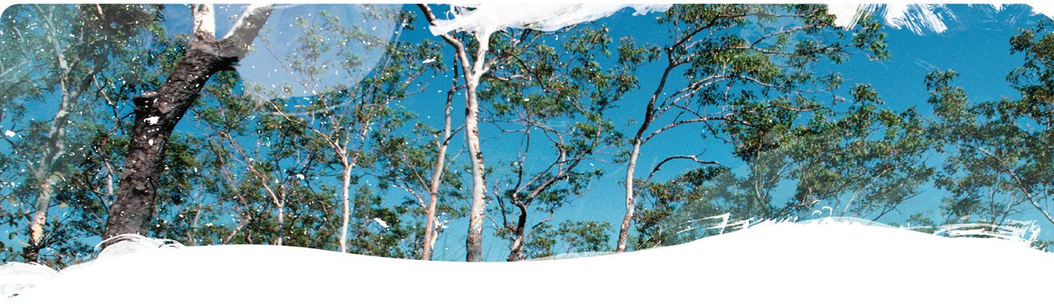
Geological and Bioregional
Assessment Program

Fact sheet 9

Application of the chemical screening framework
Figure 1 Contaminant pathways and dilution factors for solute transport vertically through the unsaturated zone and laterally through the saturated zone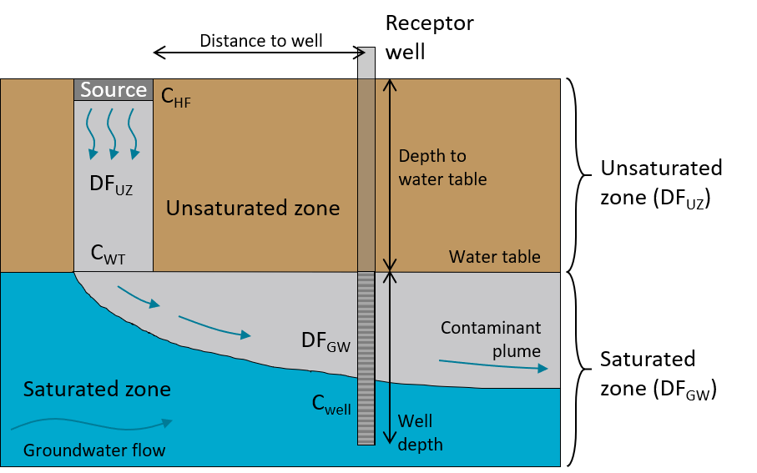
A chemical screening framework was developed based on unsaturated and saturated zone transport modelling (Figure 1). The likelihood that accidental chemical releases at the soil surface would reach groundwater in concentrations that exceeded predicted no-effect concentrations (PNECs) was assessed, and the framework was applied over large geological basins (tens to hundreds of thousands of square kilometres). This approach used chemical dilution and attenuation modelling as a conservative conceptualisation of chemical transport. Empirical equations for dilution factors were developed: the ratio of chemical concentration in the aquifer compared with that at the release site. These equations were applied spatially, based on soil characteristics, depth to watertable and groundwater flow velocities. Areas that may require more detailed investigation using reactive chemical transport modelling to estimate the potential for aquifer or groundwater-dependent asset contamination from accidental chemical release were identified.
With many areas in the Cooper GBA region having a shallower watertable compared with the Beetaloo GBA region, there are more areas that are potentially susceptible to a contaminant plume arriving at the watertable if remediation does not occur within 10 years, shown as green and blue areas in Figure 2.
Figure 2 Potential susceptibility to groundwater contamination (plume reaching groundwater table) from offsite surface spills if soil remediation does not occur within 10 years of a spill in the (a) Cooper GBA region; (b) Beetaloo GBA region
b
a
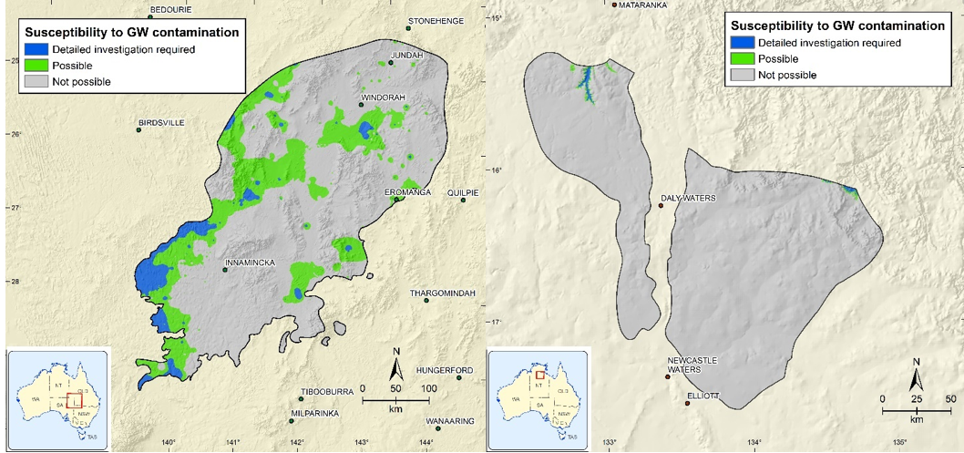
The Beetaloo GBA region showed only a small area that is potentially susceptible to a contaminant plume reaching the groundwater. However, the high groundwater velocity (therefore low groundwater dilution) meant that there were areas with potential long-term impacts on groundwater-dependent receptors (dilution factor (DF) <1,000), which may require additional data, analysis and/or avoidance measures (Figure 3).
The GBA assessment determined with high confidence that all potential impacts on aquifers and groundwater dependent receptors from unconventional gas resource development can be mitigated through ongoing compliance with existing regulatory and management controls.
Figure 3 Combined groundwater and unsaturated zone dilution factors (DF) for offsite spills in the (a) Cooper GBA region and (b) Beetaloo GBA region
DF <1,000 indicates potential for risk to groundwater-dependent receptor
b
a
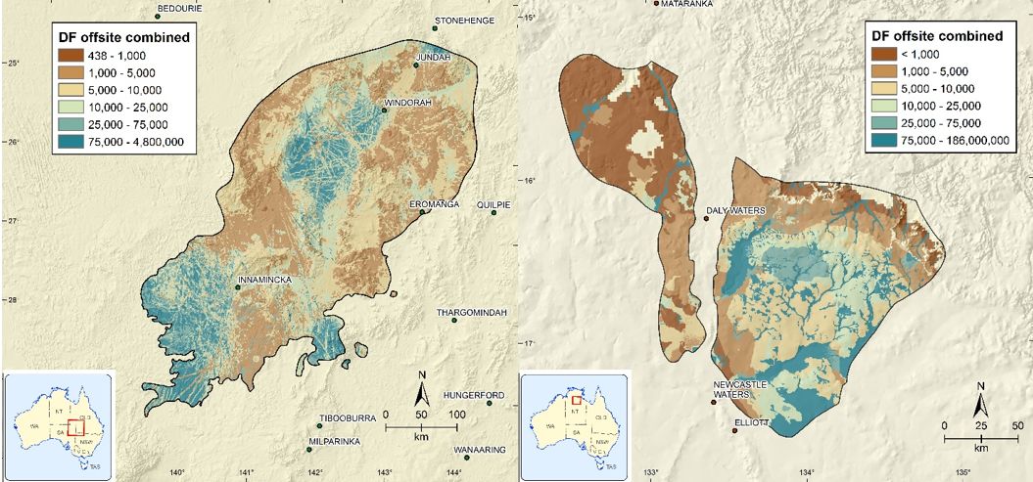

The GBA Program
The $35.4 million Geological and Bioregional Assessment (GBA) Program is assessing the potential impacts of shale and tight gas development on water and the environment to inform regulatory frameworks and appropriate management approaches. The geological and environmental knowledge, data and tools produced by the GBA Program will assist governments, industry, land users and the community by informing decision-making and enabling the coordinated management of potential impacts.

How to cite
Geological and Bioregional Assessment Program (2021) Fact sheet 9: Chemical screening framework [online document]. Fact sheet for the Geological and Bioregional Assessment Program.

Find out more
- Mallants D, Bekele E, Schmid W, Miotlinski K, Taylor A, Gerke K and Gray B (2020) A generic method for predicting environmental concentrations of hydraulic fracturing chemicals in soil and shallow groundwater. Water 12(4), 941.
Datasets that support this work are available at data.gov.au:
- Geological and Bioregional Assessment Program (2021) Contaminant screening modelling. [data]
More information is available at bioregionalassessments.gov.au/gba.

