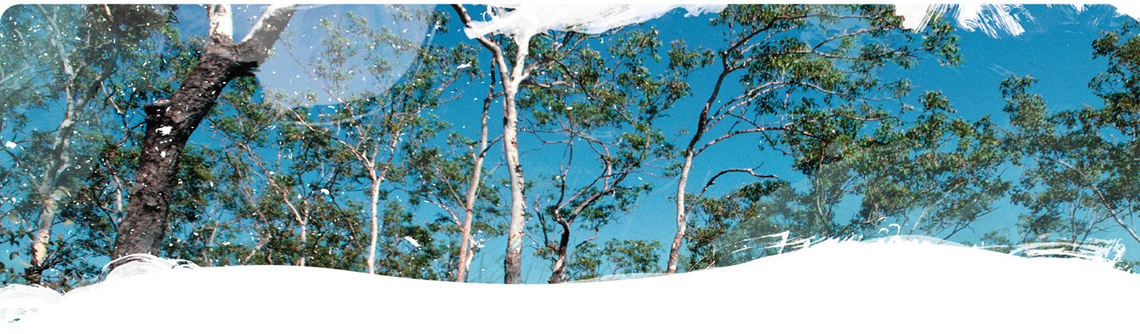Geological and Bioregional  
Assessment Program

Fact sheet 7  
Characterising the connectivity between permanent waterholes and groundwater

The Cooper GBA region contains more than 3,000 waterholes but it is the permanent waterholes that provide refuge for aquatic flora and fauna throughout dry periods. Some of these waterholes are formally recognised as nationally and internationally important, while others are of immense cultural and economic importance. Numerous scientific studies have been conducted on waterholes in the region, but the focus has centred on their geomorphology, surface water hydrology and ecological diversity. Only 3 studies have investigated the connectivity of waterholes with groundwater and each were conducted at a local scale (i.e. individual waterholes). This investigation sought to characterise the connectivity with groundwater of a subset of permanent waterholes across areas prospective for unconventional gas resource development. The findings will assist the evaluation of potential impacts from development on these important ecosystems.

Water observations derived from satellite imagery identified 48 waterholes that are inundated more than 90% of the time in the area prospective for the development of unconventional gas resources. Water sampling for chemistry and environmental tracers (natural and anthropogenic compounds present in groundwater) was undertaken at 17 of these waterholes (Figure 1). Sampling was conducted 3 months after cease-to-flow occurred in Cooper Creek and 3 years after the last flood. In addition, regional groundwater was sampled in multiple aquifers below Cooper Creek.

Figure Field sampling at Cullyamurra waterhole

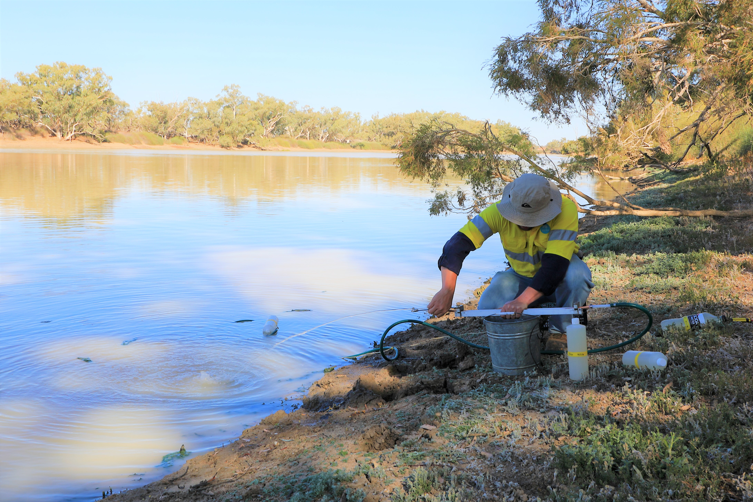

This sampling showed that waterholes contain fresh water, low concentrations of radon, and an evaporated isotopic signature. In comparison, groundwater was brackish to saline, contained low to moderate concentrations of radon and had a depleted or partially enriched isotopic signature (similar to heavy rainfall or a mixture of rainfall and evaporated surface water). Depth to groundwater measurements, while static and sparse, indicate that the 17 waterholes investigated are perched above the regional watertable. Water balance analyses for 2 key waterholes (Cullyamurra and Nappa Merrie) provided no evidence for groundwater inputs. Overall, the investigations suggest that the permanent waterholes coincident with areas prospective for future development are surface water fed and provide conduits for ephemeral groundwater recharge (see Figure 2 for waterhole locations). This finding is consistent with other field-based investigations of surface water – groundwater connectivity in Cooper Creek to date.

Figure Permanent waterholes in the Cooper GBA region including those investigated with field sampling

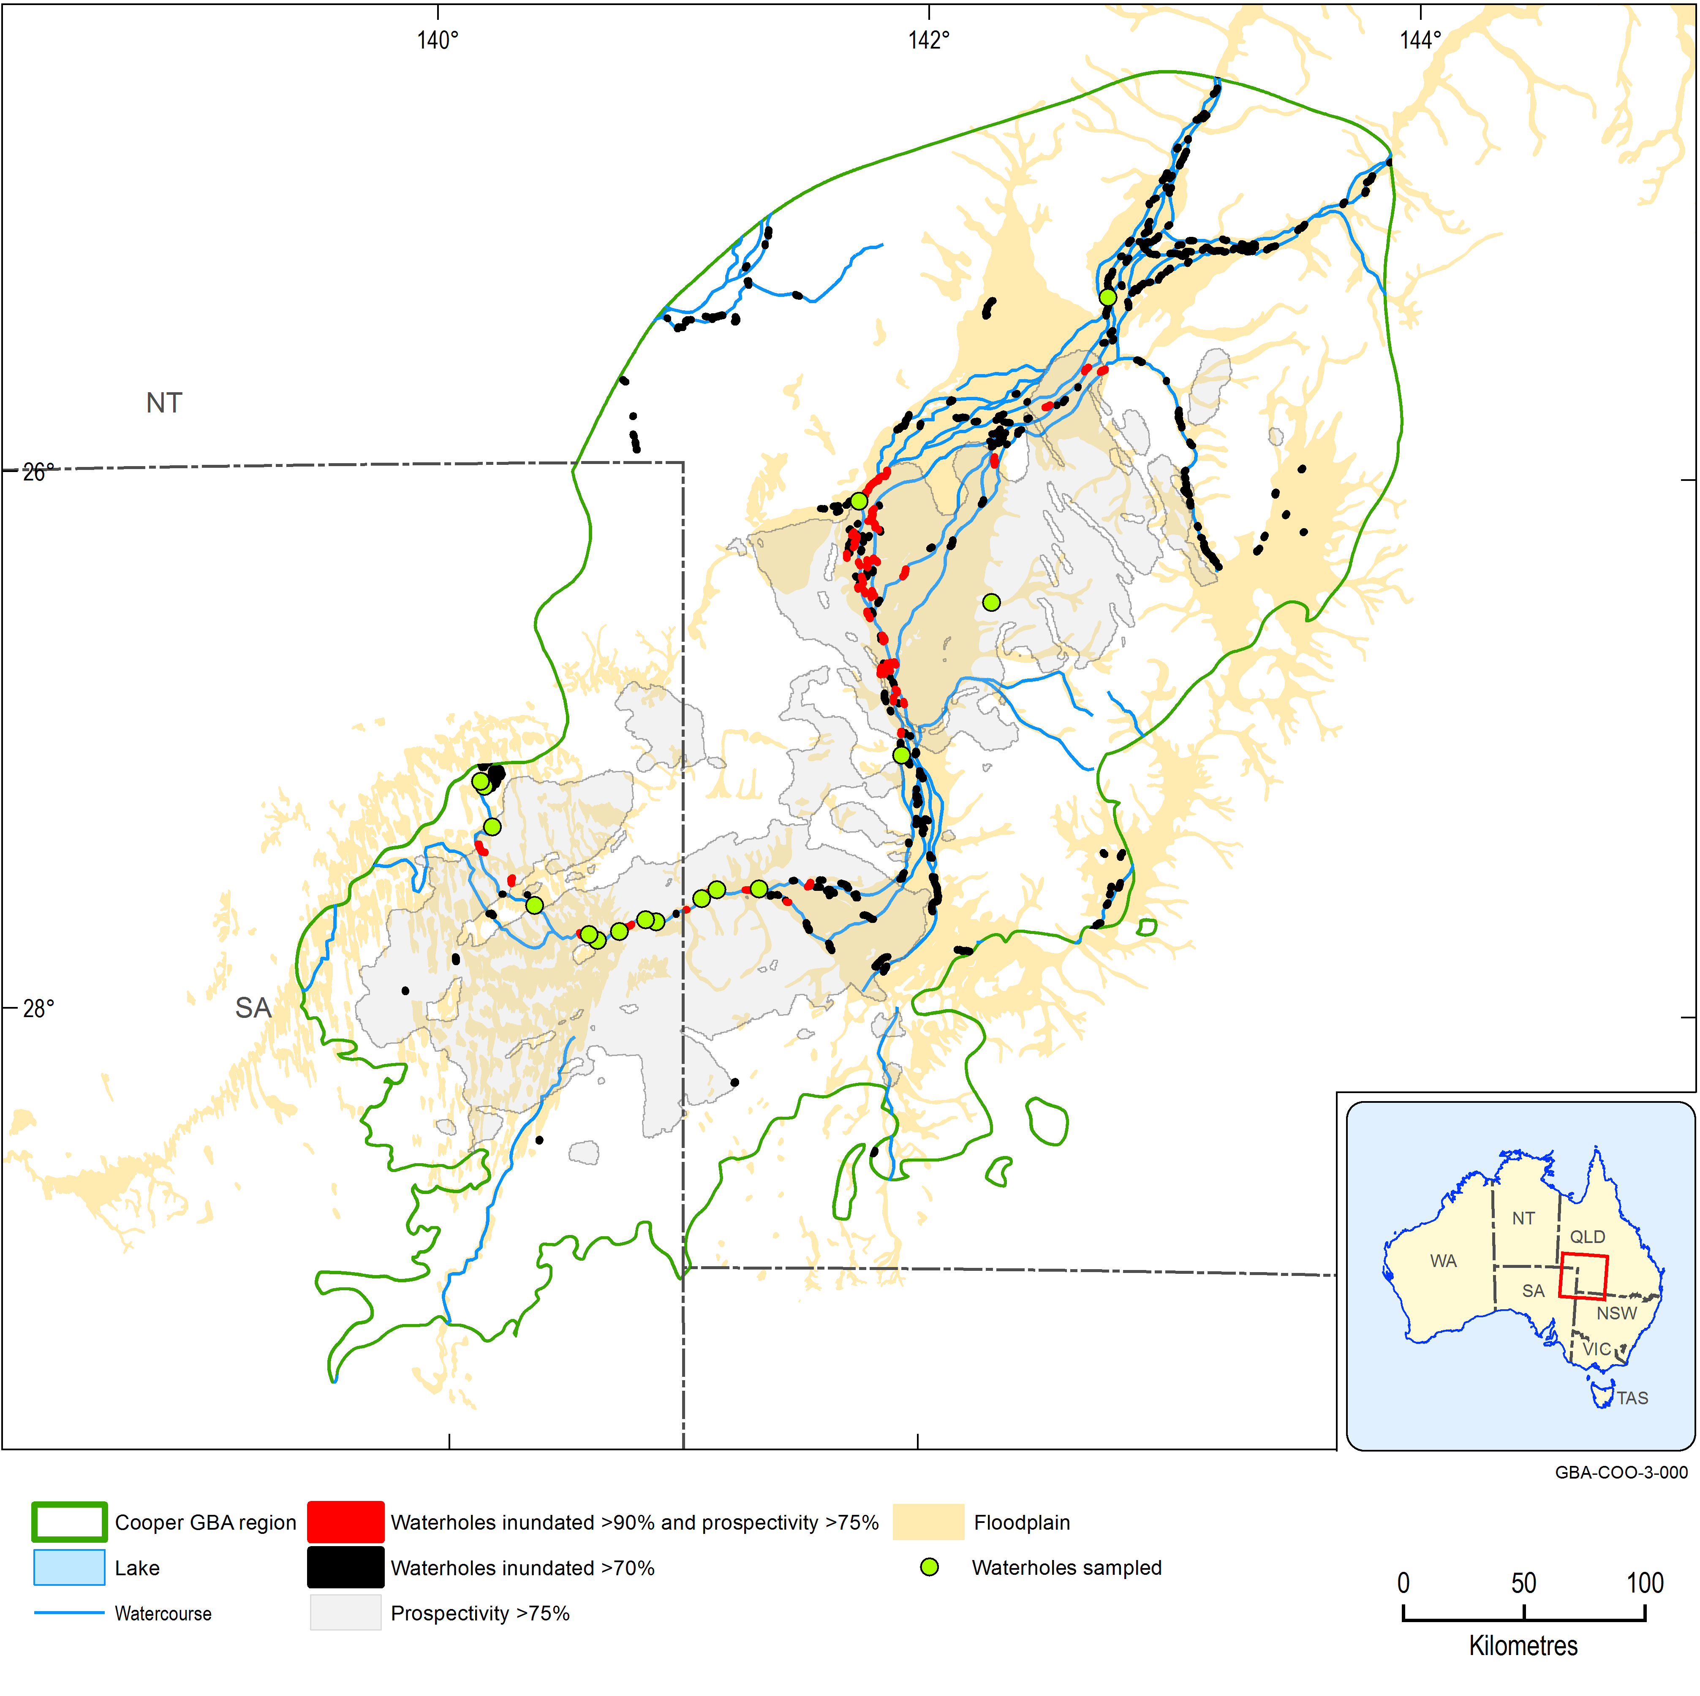

The GBA Program

The $35.4 million Geological and Bioregional Assessment (GBA) Program is assessing the potential impacts of shale and tight gas development on water and the environment to inform regulatory frameworks and appropriate management approaches. The geological and environmental knowledge, data and tools produced by the GBA Program will assist governments, industry, land users and the community by informing decision-making and enabling the coordinated management of potential impacts.

How to cite

Geological and Bioregional Assessment Program (2021) Fact sheet 7: Characterising the connectivity between permanent waterholes and groundwater [online document]. Fact sheet for the Geological and Bioregional Assessment Program.

Find more information

* Taylor AR, Crosbie RS, Cotrel C, Holland KL, Peeters LJM, Raiber M, Martinez J, Evans T and Vaze J (2021) Characterising the connectivity between permanent waterholes and groundwater: an integrated regional conceptualisation – Cooper Creek, Australia. In preparation for Journal of Hydrology: Regional Studies.

Datasets that support this work are available at [data.gov.au](https://www.data.gov.au/):

* Geological and Bioregional Assessment Program (2020) [Hydrogeochemistry and environmental tracer composition of a sub-set of perennial Cooper Creek waterholes](https://data.gov.au/data/dataset/1e5627fc-8634-4d05-8a35-56c974f65445) [data].
* Geological and Bioregional Assessment Program (2020) [Permanent waterholes of Cooper Creek](https://data.gov.au/data/dataset/56852eb5-4f64-40cb-9a8e-0c0595d31c1d) [spatial].
* Geological and Bioregional Assessment Program (2020) [Water balance of Cullyamurra and Nappamerrie waterholes in the Cooper GBA region](https://data.gov.au/data/dataset/daac1ac2-cd42-49d6-b06e-a06c6e0000a4) [tabular].

More information is available at [bioregionalassessments.gov.au/gba](https://www.bioregionalassessments.gov.au/gba).