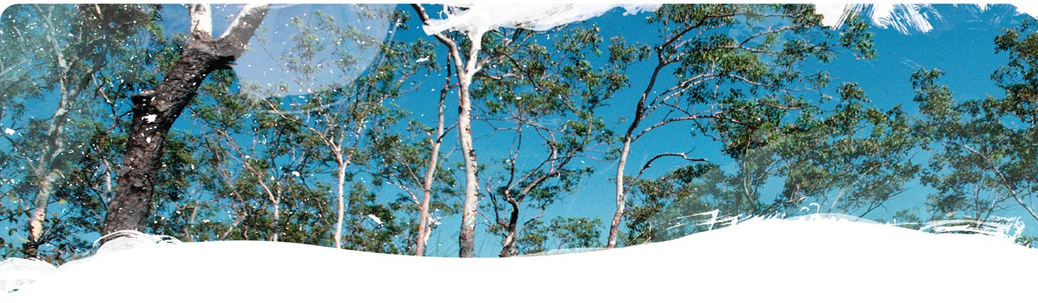
Geological and Bioregional
Assessment Program

Fact sheet 6
Beetaloo GBA recharge pathways – Geology of the Carpentaria Basin and Cenozoic sediments
The Beetaloo GBA recharge pathways project aims to improve understanding of the pathways that groundwater can take to reach aquifers in the region. There are three parts to this project: (i) this fact sheet, (ii) sinkholes and their influence on recharge to aquifers (Fact sheet 4) and (iii) summary (Fact sheet 5). In the Beetaloo GBA region, the Cambrian Limestone Aquifer (CLA) is completely covered by the Carpentaria Basin, which in turn is overlain by sediments deposited by rivers and lakes (Cenozoic sediments). The types and thicknesses of the overlying rocks affect how much potential recharge can reach underlying aquifers. For example, thick mudstones are more likely to impede recharge than sandstone due to the differences in permeability.
Data from drillholes and Airborne electromagnetic (AusAEM) geophysical surveys (Geological and Bioregional Assessment Program (2021a,b) were used to determine the thickness and types of rocks present above the CLA in the Beetaloo GBA region. The thickness and lithology of Carpentaria Basin sediments is highly variable (Figure 1a). In some areas the Carpentaria Basin consists primarily of mudstone that can be over 100 m thick (for example in the east of the Beetaloo GBA region). Elsewhere the sequence thins to less than 40 m thick and contains more sandstone. Sandstone layers are at thickest in the southern parts of the Beetaloo GBA region.
Figure 1(a) Carpentaria Basin cover thickness as determined from drillhole data and percentage of sandstone; (b) distribution of Cenozoic sediments and examples of abandoned river channels
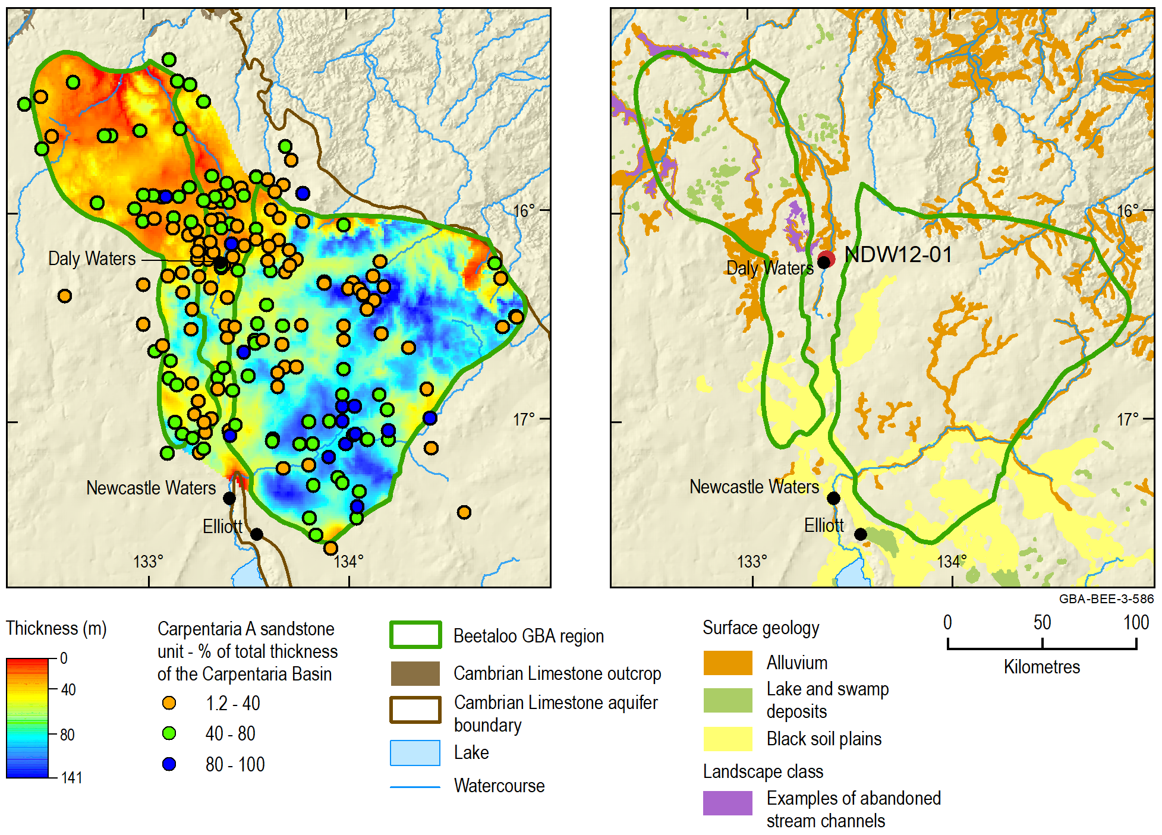
Estimates of Carpentaria Basin thickness derived from drillhole and AusAEM data are not always consistent (Figure 1a). This is partly due to the methods used to estimate thickness (one from calculated electrical conductivity, the other a downhole measurement from drilling). For instance, where the Carpentaria Basin consists primarily of sandstone, the Carpentaria Basin will not be highlighted by the AusAEM data. However, the AusAEM data provides information where there are no drillholes and provides a consistent estimate of the thickness of the mudstone.
Cenozoic sediments are often difficult to identify from the drillhole data. Infilled river changes and valleys are evident in the surface geology (Figure 1b). These features have potential to locally increase recharge if filled with sand, or impede recharge (if filled with clay, as observed in drillhole NDW12-01) or contain small aquifers perched above the regional watertable.

The GBA Program
The $35.4 million Geological and Bioregional Assessment (GBA) Program is assessing the potential impacts of shale and tight gas development on water and the environment to inform regulatory frameworks and appropriate management approaches. The geological and environmental knowledge, data and tools produced by the GBA Program will assist governments, industry, land users and the community by informing decision-making and enabling the coordinated management of potential impacts.

How to cite
Geological and Bioregional Assessment Program (2021) Fact sheet 6: Beetaloo GBA recharge pathways project – geology of the Carpentaria Basin and Cenozoic sediments [online document]. Fact sheet for the Geological and Bioregional Assessment Program.

Find out more
- Geological and Bioregional Assessment Program (2021) Fact sheet 4: Beetaloo GBA recharge pathways – Sinkholes and their influence on recharge to aquifers [online document]. Fact sheet for the Geological and Bioregional Assessment Program.
- Geological and Bioregional Assessment Program (2021) Fact sheet 5: Beetaloo GBA groundwater recharge pathways – Summary [online document]. Fact sheet for the Geological and Bioregional Assessment Program.
Datasets that support this work are available at data.gov.au:
- Geological and Bioregional Assessment Program (2021a) Beetaloo GBA – Carpentaria Basin geological models derived from AusAEM (airborne electromagnetics) [data].
- Geological and Bioregional Assessment Program (2021b) Examples of abandoned stream channels – Beetaloo GBA region [data].
More information is available at bioregionalassessments.gov.au/gba.

