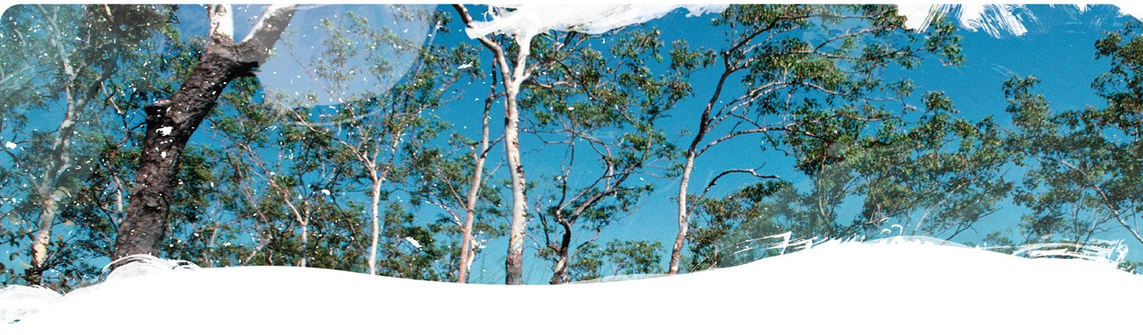Geological and Bioregional   
Assessment Program

Fact sheet 5  
Beetaloo GBA groundwater recharge pathways – Summary

The Beetaloo GBA recharge pathways project aims to improve understanding of the pathways that groundwater can take to reach aquifers in the region. There are three parts to this project: (i) geology of the Carpentaria Basin and Cenozoic sediments (Fact sheet 6), (ii) sinkholes and their influence on recharge to aquifers (Fact sheet 4) and (iii) this fact sheet. While the Cambrian Limestone Aquifer (CLA) is the primary focus, factors outlined below are also applicable to other aquifers including the Carpentaria A sandstone or Antrim Plateau Volcanics.

Recharge to aquifers ultimately comes from rainfall. However, geological factors influence the possible recharge pathways in an area. Domains 1 and 2 in Figure 1 contain multiple possible recharge pathways, whereas recharge in domain 3 is likely to be intercepted by sandstone aquifers in the Carpentaria Basin and in domain 4 is likely to be significantly impeded by thick mudstone sequences in the Carpentaria Basin.

Figure 1 Recharge pathway domains in the Beetaloo GBA region

Data: Geological and Bioregional Assessment Program (2021a)

* Sinkholes are most common the the north-west of the Beetaloo GBA region near the towns of Katherine and Mataranka. 
  Carpentaria Basin sediment thickness varies spatially, generally increasing from the north west to the south east.
  Domain 1 is located in the north western part of Beetaloo GBA region.
  Domain 2 is located south of Domain 1 in the central western part of Beetaloo GBA region.
  Domain 3 is located south east of Domain 2 in the south eastern part of Beetaloo GBA region.
  Domain 4 is located east of Domain 2 in the north eastern part of Beetaloo GBA region and a small area south west of Domain 3.
  Domain 5 is a small area south of Domain 2 and west of Domain 3 along the south western edge of the Beetaloo GBA region.
  Points sho thickness of the Carpentaria A sandstone unit as a percentage of the total thickness of the Carpentaria Basin. Values variy spatially, generally increasing from 40-60% in the north west to 80-100% in the south east.
  Domain 1. Carpentaria Basin is thin (less than 40 m) and includes a relatively high proportion of sandstone. Numerous sinkholes and waterholes are present and depth to the regional watertable is less than 60 m. Presence of waterholes and abandoned channels suggest there could also be perched aquifers.
* Domain 2. Similar to Domain 1, except Carpentaria Basin rocks are thicker and regional watertable is 60 – 100 m below the surface.
* Domain 3. Carpentaria Basin sequence is sandstone dominated, but can be over 80 m thick. The CLA and sandstones in the Carpentaria Basin are used as aquifers.
* Domain 4. Unlikely to be significant deep recharge to the CLA due to occurrence of thick mudstone sequences in Carpentaria Basin and depth to regional watertable in excess of 100 m.
* Domain 5. Carpentaria Basin is thin. Some potential for recharge through runoff from the Ashburton Ranges.

Important geological factors affecting recharge to aquifers in the Beetaloo GBA region:

* The CLA is completely buried and the thickness of overlying rocks varies considerably across the region (Geological and Bioregional Assessment Program, 2021a). Potential recharge to the CLA will need to follow a longer path in areas where an aquifer is more deeply buried (Figure 1).
* Recharge is less likely to percolate down to aquifers if overlying rocks are clay rich (e.g. mudstone). In contrast, recharge to an aquifer is more likely if overlying rocks are porous (e.g. sandstone) (Geological and Bioregional Assessment Program, 2021a).
* Sinkholes are pipelike features that form when soil and rock collapse into subsurface cavities. An open hole or a depression may be apparent where subsurface collapse has occurred. The Beetaloo GBA region includes sinkholes, conduits and circular depressions developed in Carpentaria Basin rocks, as well as the underlying CLA. Sinkholes are particularly prevalent in the west of the region (Figure 1), forming part of the surface drainage in areas not associated with present day stream channels (Geological and Bioregional Assessment Program, 2021b).
* Sinkholes and depressions may be sealed and contain waterholes and ephemeral wetlands. Potentially, some ponded water may percolate into the subsurface. Shallow perched aquifers occur near surface in parts of the Beetaloo GBA region could intercept and divert recharge to waterholes. Potentially, abandoned river channels could also intercept and divert recharge out of the region.

The GBA Program

The $35.4 million Geological and Bioregional Assessment (GBA) Program is assessing the potential impacts of shale and tight gas development on water and the environment to inform regulatory frameworks and appropriate management approaches. The geological and environmental knowledge, data and tools produced by the GBA Program will assist governments, industry, land users and the community by informing decision-making and enabling the coordinated management of potential impacts.

How to cite

Geological and Bioregional Assessment Program (2021) Fact sheet 5: Beetaloo GBA groundwater recharge pathways – Summary [online document]. Fact sheet for the Geological and Bioregional Assessment Program.

Find out more

* Geological and Bioregional Assessment Program (2021) Fact sheet 4: Beetaloo GBA recharge pathways – Sinkholes and their influence on recharge to aquifers [online document]. Fact sheet for the Geological and Bioregional Assessment Program.
* Geological and Bioregional Assessment Program (2021) Fact sheet 6: Beetaloo GBA recharge pathways – Geology of the Carpentaria Basin and Cenozoic sediments [online document]. Fact sheet for the Geological and Bioregional Assessment Program.

Datasets that support this work are available at [data.gov.au](https://www.data.gov.au/):

* Geological and Bioregional Assessment Program (2021a) [Groundwater bore hole stratigraphy for Beetaloo GBA region](https://data.gov.au/data/dataset/6EA25C4E-8C5E-4796-8E55-F94364427606).
* Geological and Bioregional Assessment Program (2021b) [Sinkholes and waterholes interpreted from remote Sensing – Beetaloo GBA](https://data.gov.au/data/dataset/c452d602-db54-4e08-9a4c-4d8e469732e2) [data].

More information is available at [bioregionalassessments.gov.au/gba](https://www.bioregionalassessments.gov.au/gba).