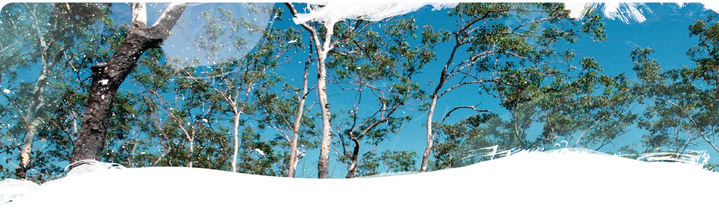
Geological and Bioregional
Assessment Program

Fact sheet 4
Beetaloo GBA recharge pathways – Sinkholes and their influence on recharge to aquifers
The aim of the Beetaloo GBA recharge pathways project is to improve understanding of the pathways that groundwater can take to reach aquifers in the region. There are three parts to this project: (i) geology of the Carpentaria Basin and Cenozoic sediments (Fact sheet 6), (ii) this Fact sheet and (iii) Summary (Fact sheet 5). This investigation identified sinkholes, waterholes and depressions at the surface using processed remote sensing data from satellites (Figure 1).
Sinkholes are pipelike features that form when soil and rock collapse into subsurface cavities leaving an open hole or a depression at the surface. If open, sinkholes may provide more rapid recharge pathways to aquifers than might otherwise occur. Cavities, sinkholes and conduits facilitate groundwater flow in the Cambrian Limestone Aquifer (CLA) that underlies the Carpentaria Basin in the Beetaloo GBA region. Another system of sinkholes occurs in Carpentaria Basin rocks and forms a network of conduits separate to those in the CLA. Sinkholes constitute a part of the surface drainage in areas away from present-day stream channels. Sinkhole collapses can be a hazard for infrastructure (Twidale, 1987).
Figure 1 Distribution of sinkholes, depressions and thickness of Carpentaria Basin sediments in the Beetaloo GBA region
Blue colours represent areas where the Carpentaria Basin sequence is thicker and warm colours where the sequence thins. Most sinkholes occur where the Carpentaria Basin is less than 40 m thick.
Data: Sinkholes and waterholes interpreted from remote sensing (Geological and Bioregional Assessment Program, 2021a)
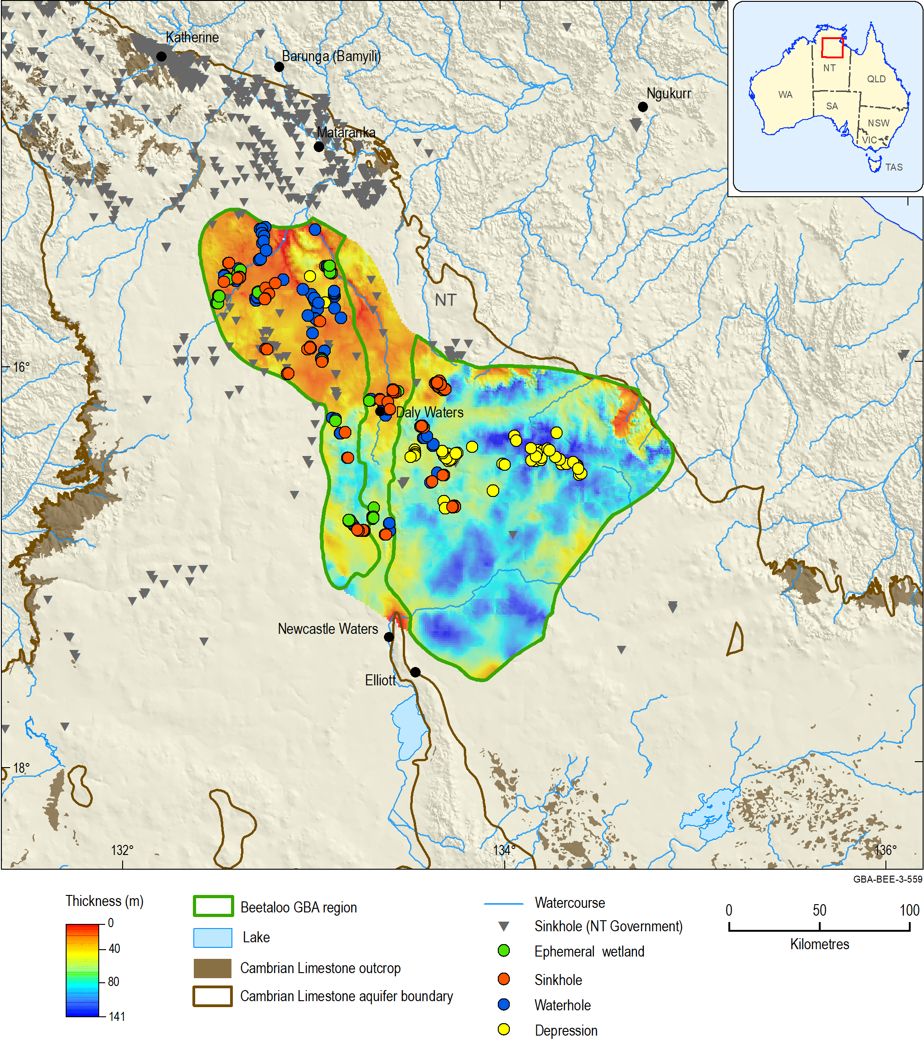
Figure 1 shows the sinkholes, waterholes and depressions identified using remote sensing data in the Beetaloo GBA region (Geological and Bioregional Assessment Program, 2021a). However, not all sinkholes or waterholes can be identified using remote sensing due to the resolution of available data. In addition, the depth of the sinkholes, waterholes and depressions is difficult to determine without high resolution elevation data. These features are particularly prevalent in the north-western portion of the Beetaloo GBA region, which coincides with where the Carpentaria Basin sequence is thin and where the Carpentaria A sandstone is near the surface. Sinkholes and depressions are often partially filled with sediment, and the depressions can form waterholes. It is possible that some of this ponded water percolates into the subsurface.
In the CLA, groundwater flow and bore yield (Geological and Bioregional Assessment Program, 2021b) are partly controlled by the occurrence of voids and fractures. Individual voids up to 18 m deep have been intercepted by drilling and 10% of groundwater bores have yields greater than 8 L/second. The occurrence of sinkhole features at the surface rarely coincides with high bore yields from the CLA. The CLA is not always fully saturated with groundwater. This could be a complicating factor that needs be considered to better understand groundwater flow systems in the CLA.

The GBA Program
The $35.4 million Geological and Bioregional Assessment (GBA) Program is assessing the potential impacts of shale and tight gas development on water and the environment to inform regulatory frameworks and appropriate management approaches. The geological and environmental knowledge, data and tools produced by the GBA Program will assist governments, industry, land users and the community by informing decision-making and enabling the coordinated management of potential impacts.
How to cite
Geological and Bioregional Assessment Program (2021) Fact sheet 4: Beetaloo GBA recharge pathways – Sinkholes and their influence on recharge to aquifers [online document]. Fact sheet for the Geological and Bioregional Assessment Program.

Find out more
- Geological and Bioregional Assessment Program (2021) Fact sheet 5: Beetaloo GBA recharge pathways – Summary [online document]. Fact sheet for the Geological and Bioregional Assessment Program.
- Geological and Bioregional Assessment Program (2021) Fact sheet 6: Beetaloo GBA recharge pathways – Geology of the Carpentaria Basin and Cenozoic sediments [online document]. Fact sheet for the Geological and Bioregional Assessment Program.
- Twidale C (1987) Sinkholes (dolines) in lateritised sediments, western Sturt plateau, Northern Territory, Australia. Geomorphology 1(1), 33-52.
Datasets that support this work are available at data.gov.au:
- Geological and Bioregional Assessment Program (2021a) Sinkholes and waterholes interpreted from remote Sensing – Beetaloo GBA [data].
- Geological and Bioregional Assessment Program (2021b) Bore yields for the Cambrian Limestone Aquifer - Beetaloo GBA region [data]

More information is available at bioregionalassessments.gov.au/gba.

