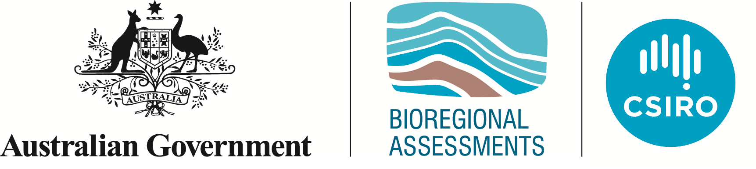Geological and Bioregional  
Assessment Program

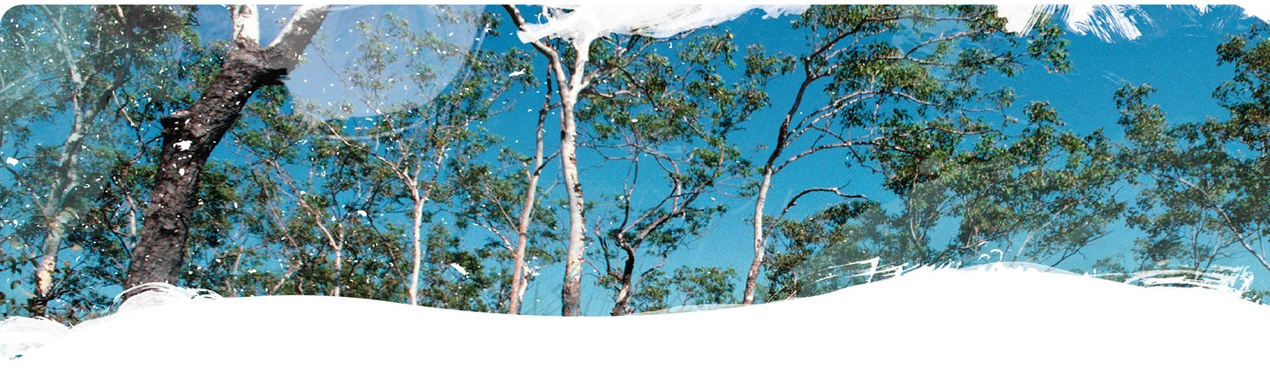Fact sheet 2  
Assessing hydraulic fracture risks to groundwater

The risks that hydraulic fracturing activities may pose to groundwater resources is a common issue of concern raised both domestically and internationally by local residents and stakeholders. For contamination to occur, there needs to be a pathway for the contaminants to travel through, a source of contaminants, a driving force or pressure, and insufficient dilution or degradation of the solutes along the pathway to exceed a contaminant threshold at the point where they enter the aquifer. Hydraulic fracture stimulation, also referred to as hydraulic fracturing, is commonly used to increase the productivity of petroleum wells. Hydraulic fracturing fluid is injected at enough pressure and flow rate to propagate hydraulic fractures in the reservoir. These created fractures effectively increase the permeability of the reservoir and ultimately the gas production from the well.

In the Cooper GBA region, a pathway for aquifer contamination due to hydraulic fracturing of the Toolachee Formation (the shallowest unconventional gas play) is only possible if a fracture propagates through the Nappamerri Group aquitard into the overlying Cadna-owie – Hooray aquifer. This investigation sought to identify if there were locations in the Cooper GBA region where hydraulic fracture propagation though the Nappamerri Group aquitard could occur. The size of the created hydraulic fractures is determined by many parameters including the material properties of the rock layers, stresses in the rock layers, nature of the interfaces between different rock layers, prevalence of natural faults and fractures in the rock layers, and design of the hydraulic fracturing treatment.

Hydraulic fracture modelling identified areas where the likelihood of hydraulic fractures propagating though the Nappamerri Group aquitard into an overlying aquifer is (i) not possible or ‘very low risk’; (ii) unlikely or ‘low risk’; (iii) possible or ‘medium risk’; and (iv) likely or ‘high risk’. Over 90% of the area prospective for unconventional gas resource development in the Cooper GBA region is of ‘very low risk’ or ‘low risk’, shown as yellow and green areas in Figure 1. This is where the thickness of the Nappamerri Group aquitard is greater than the maximum hydraulic fracture extent of 151 m. While it is theoretically possible for hydraulic fractures to intersect the Cadna-owie – Hooray aquifer system in these areas, fracture growth is limited by other factors, making it highly unlikely that any intersection with the overlying aquifer would occur. This risk is further reduced by risk control measures used by the operators and the existing regulatory requirements in Queensland and South Australia.

Less than 10% of the prospective area is classified as ‘medium risk’ or ‘high risk’, shown as orange and red areas in Figure 1. Careful design and monitoring of hydraulic fracturing treatments is needed in these areas, including site-specific hydraulic fracture risk assessments using more advanced hydraulic fracture modelling, analysis and/or monitoring techniques. While fracture growth is an important aspect of understanding the risk of aquifer contamination, other aspects such as dilution, pore pressures and permeability of different strata provide greater understanding of the overall risks.

Aquifer contamination is a key concern for agricultural communities who rely heavily on groundwater for irrigation and livestock farming. Traditional assessment approaches focus on the consequences of either ‘typical’ or ‘worst case’ scenarios. This approach gives land users, community groups and regulators a way to better understand risks from development at a regional scale and at a meaningful spatial resolution.

Figure Potential for vertical fracture growth to propagate through the Nappamerri Group aquitard

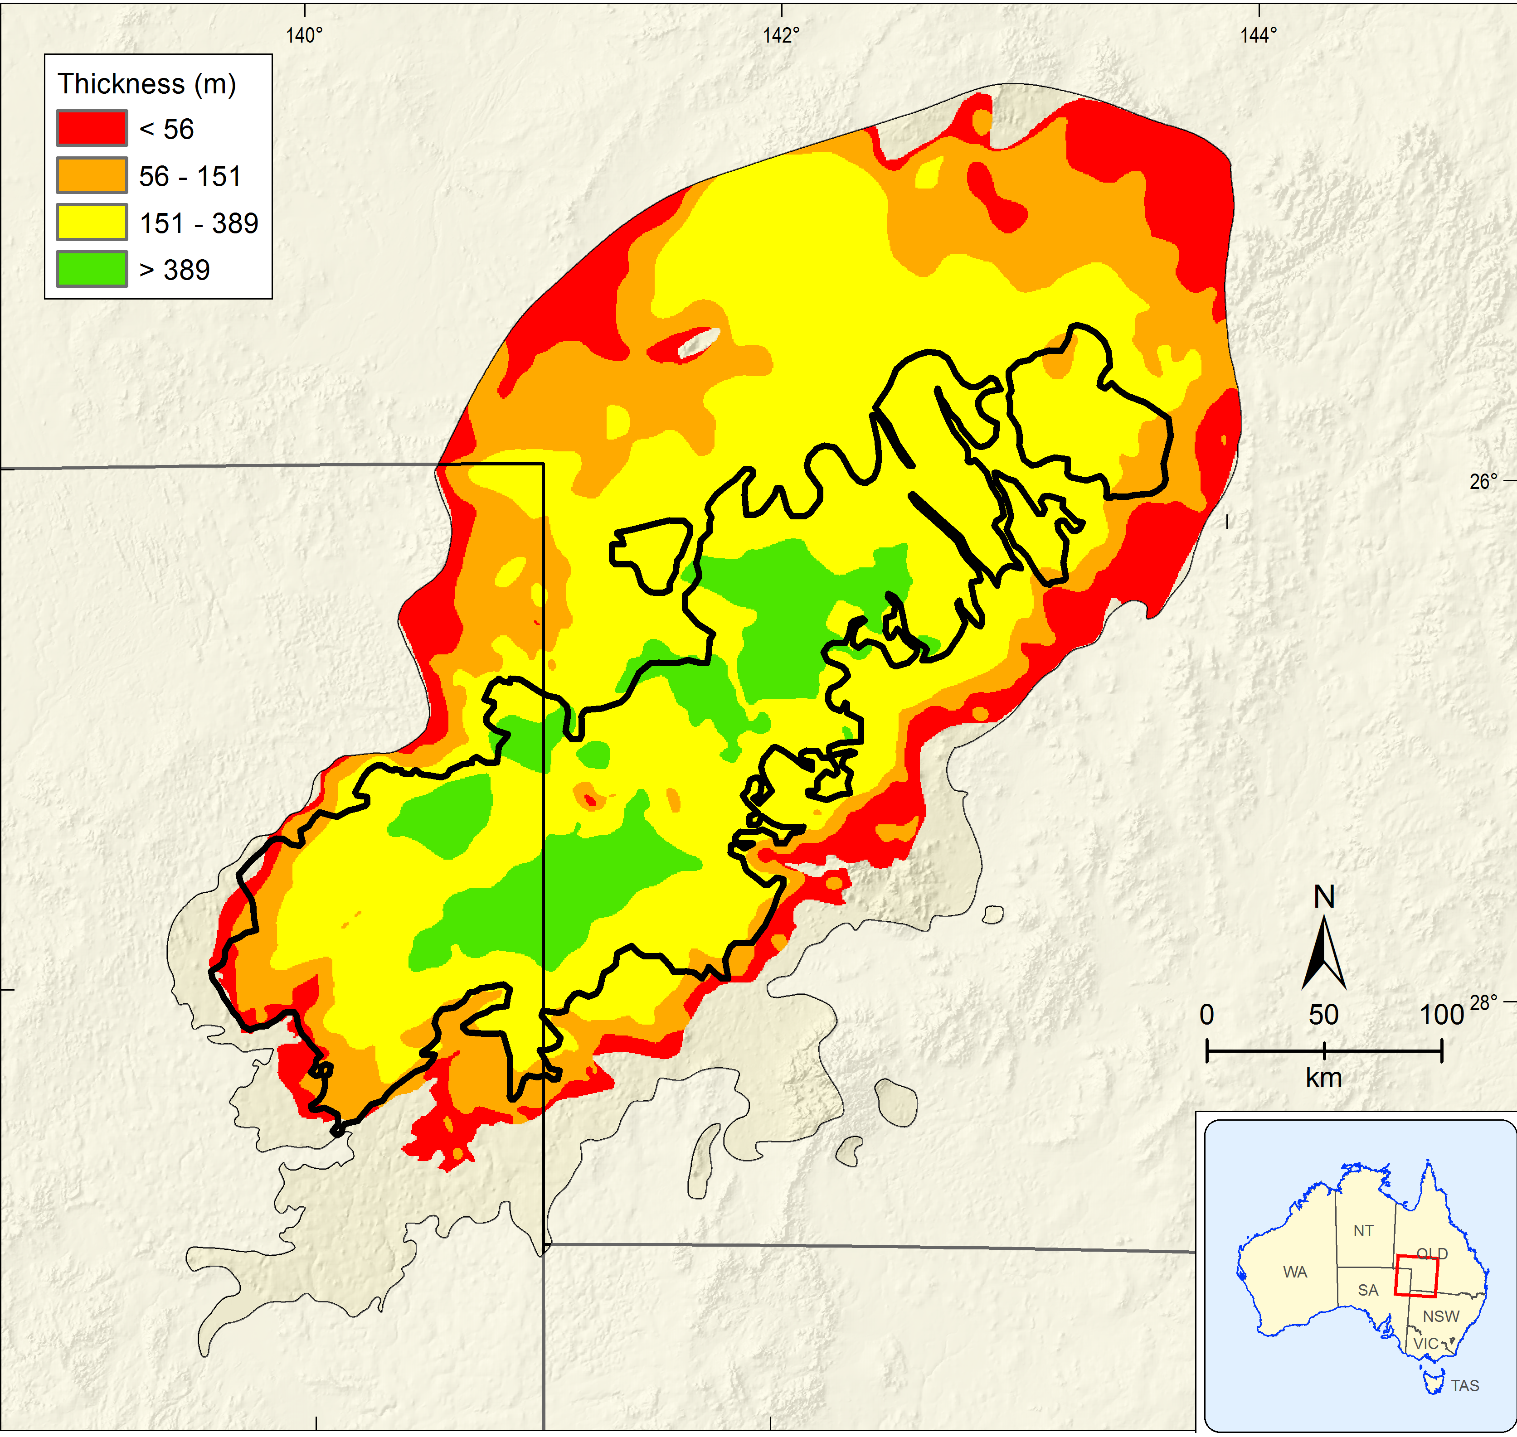

The GBA Program

The $35.4 million Geological and Bioregional Assessment (GBA) Program is assessing the potential impacts of unconventional gas resource development on water and the environment to inform regulatory frameworks and appropriate management approaches. The geological and environmental knowledge, data and tools produced by the GBA Program will assist governments, industry, land users and the community by informing decision making and enabling the coordinated management of potential impacts.

How to cite

Geological and Bioregional Assessment Program (2021) Fact sheet 2: Assessing hydraulic fracture risks to groundwater [online document]. Fact sheet for the Geological and Bioregional Assessment Program.

Find out more

* Kear J, Arjomand E, Movassagh A, Peeters L and Kasperczyk D (2021) Spatial analysis approach to hydraulic fracturing risk assessment*.* In 55th US Rock Mechanics / Geomechanics Symposium 2021.

Datasets that support this work are available at [data.gov.au](https://www.data.gov.au):

* Geological and Bioregional Assessment Program (2021) [Probability bounds analysis of hydraulic fracture height growth in the Cooper GBA region](https://data.gov.au/data/dataset/8fdc8e21-1b72-4211-bf2b-33ea61082d9f) [data].

More information is available at[bioregionalassessments.gov.au/gba](https://www.bioregionalassessments.gov.au/gba).