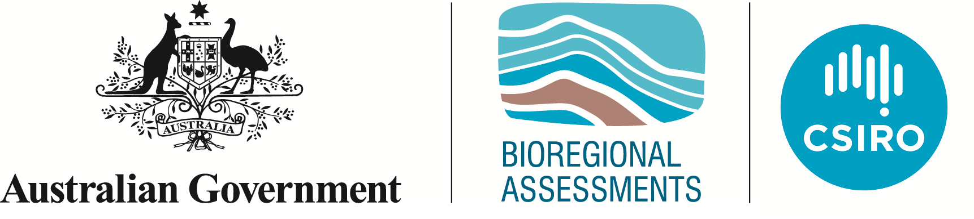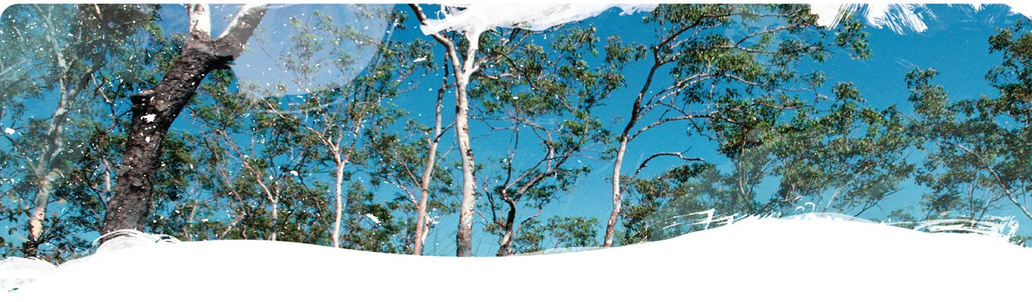Geological and Bioregional  
Assessment Program

Fact sheet 28  
Development scenarios for unconventional gas resource development

To assess potential impacts, it is important to explore scenarios of what unconventional gas resource development in the Beetaloo and Cooper GBA regions may look like over the next 50 years. The scenarios include information on the amount of gas that may be produced, how many wells would need to be drilled, how many well pads and how much water would be needed to support drilling and hydraulic fracturing operations (Figure 1).

What the development will actually look like is very hard to predict as it not only depends on the geology of the basins, but mainly on the national and global demand for natural gas and the global economy. The scenarios developed in this study are therefore not intended as a forecast, but to give an order of magnitude estimate of what development might look like.

In the Cooper GBA region, the fast development scenario matches current conventional gas production of 92 petajoules per year and the slow development scenario is a quarter of this rate (23 petajoules per year). As there is not an existing gas industry in the Beetaloo GBA region, the gale scenario of 1000 terajoules per day (or 365 petajoules per year), developed for the [Final report of the scientific inquiry into hydraulic fracturing in the Northern Territory](https://frackinginquiry.nt.gov.au/) was used.

Figure Resource development scenarios for the Beetaloo and Cooper GBA regions

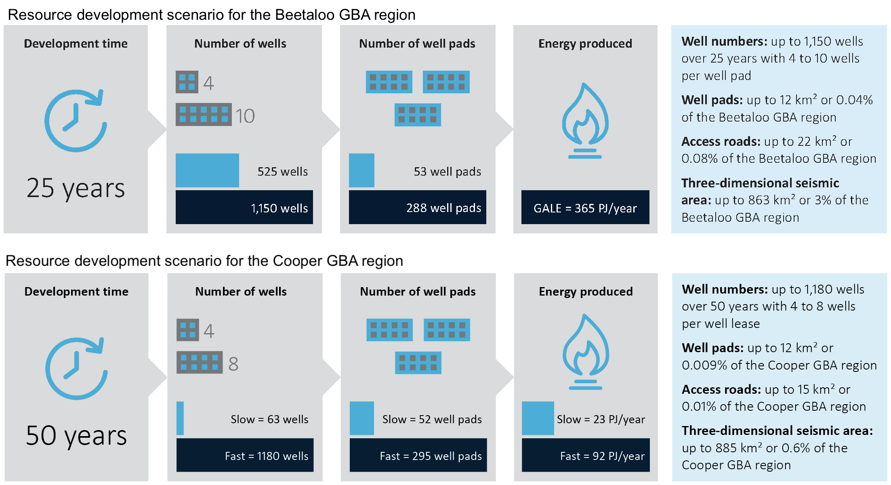

Hypothetical arrangement of wells, well pads, access roads and three-dimensional seismic survey areas. Total encompassed area includes all well pads and access roads between well pads. 
Shows arrangement of 8 wells on a 4 ha well pad. Sub-surface well directions also shown.The number of wells needed to produce this much gas depends on the properties of the unconventional gas reservoir, and other technical and commercial considerations. The gas production of a single well increases rapidly, reaching a peak in the first couple of years, after which it slowly decreases and new wells are needed to maintain gas production rates. This means that most wells are drilled in the first years of development, with fewer new wells drilled in the later years of the development.

Figure 2 Schematic spatial footprint of unconventional gas resource development

Red lines are traces of wells in the sub-surface

Most wells are likely to be drilled horizontally, such that multiple wells are drilled from the same well pad. The spatial footprint of the gas resource development is not just limited to the well pads, it also includes access roads that connect the well pads, borrow pits used to source the building materials, as well as other infrastructure, such as pipelines, laydown yards and accommodation (Figure 2).

The GBA Program

The $35.4 million Geological and Bioregional Assessment (GBA) Program is assessing the potential impacts of shale and tight gas development on water and the environment to inform regulatory frameworks and appropriate management approaches. The geological and environmental knowledge, data and tools produced by the GBA Program will assist governments, industry, land users and the community by informing decision-making and enabling the coordinated management of potential impacts.

How to cite

Geological and Bioregional Assessment Program (2021) Fact sheet 28: Development scenarios for unconventional gas resource development [online document]. Fact sheet for the Geological and Bioregional Assessment Program.

Find out more

Datasets that support this work are available at [data.gov.au](https://www.data.gov.au/):

* Pan Z, Heryanto D, Sander R and Connell LD (2021) Cooper and Beetaloo GBA region development scenarios. Geological and Bioregional Assessment Program: Stage 3. Department of Agriculture, Water and the Environment, Bureau of Meteorology, CSIRO and Geoscience Australia, Australia.

More information is available from [bioregionalassessments.gov.au/gba](https://www.bioregionalassessments.gov.au/gba).