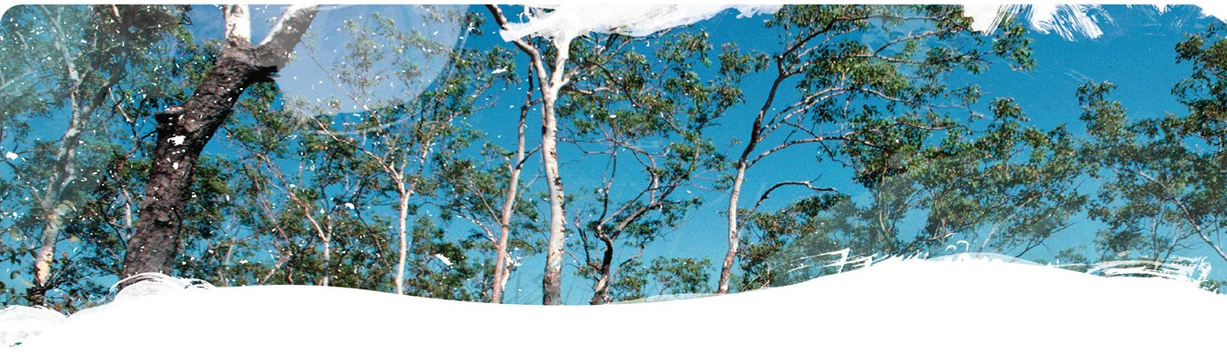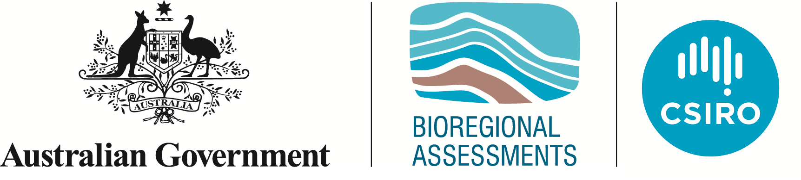Geological and Bioregional  
Assessment Program

Fact sheet 27  
Modelling persistence of biodiversity at a regional scale

Australia is home to a diverse array of plant and animal species. To support the persistence of this unique biodiversity into the future, it is important to consider new developments in the context of ongoing change in the capacity of a region to support biodiversity. To meet this need, we assessed how the capacity of habitat to support biodiversity has changed in the Beetaloo and Cooper GBA regions over the past two decades.

Our approach combines an annual time-series of habitat condition for each region (Figure 1), with models of the expected patterns in plant diversity before European settlement. When these data are combined, we are able to estimate the consequences of ongoing habitat loss and modification on long-term persistence of species. For example, where habitat loss occurs in a very rare environment, this approach will predict a greater impact on the persistence of biodiversity than where the same habitat loss occurs in a common environment.

Figure 1 Modelled biodiversity persistence in the Cooper GBA region showing a) annual rainfall at Innamincka; b) temporal variation in annual biodiversity habitat condition from 2001 to 2018; and c) spatial variation in 2018

A: Annual rainfall between 2001 and 2018 for Innamincka in South Australia (in the south-west of the Cooper GBA region) was less than 400 millimetres in all years except 2010, when the rainfall was closely to 600 millimetres. 
B: The biodiversity habitat condition of the Cooper GBA region remained largely stable between 2001 and 2018, with improvements generally coinciding with years of higher rainfall. 
C: The biodiversity habitat condition varies spatially across the Cooper GBA region, with higher values in the north, north-east and central parts (around Windorah in Queensland) and stretching south along watercourses almost to the South Australia border. There is another area of high biodiversity habitat condition straddling the Queensland–South Australia border just north of Innamincka (in South Australia). 

Data: Geological and Bioregional Assessment Program (2021); Geological and Bioregional Assessment Program (2020)  
Element: GBA-COO-3-688

**Outcomes for habitat condition**

For the GBA Program, we used the *Compere* vegetation condition method (see Fact sheet 14) to estimate the habitat condition for biodiversity across both the Beetaloo and Cooper GBA regions. This was done for each year from 2001 to 2018.

The estimated habitat condition in the Beetaloo GBA region was in general greater than that for the Cooper GBA region, being on average 0.93 in the Beetaloo and 0.74 in the Cooper. Change in habitat condition over time was greater in the Cooper GBA region, where rainfall is lower and wetter years enable a larger response in vegetation recovery. At the broader scale for both regions, there was no discernible trend over the 18-year period of improvement or decline in habitat condition (Figure 1b). However, within each basin, some areas have seen systematic improvements and degradation in habitat condition for biodiversity.

Outcomes for biodiversity persistence

When we combine the maps of habitat condition with our understanding of expected biodiversity patterns, we can estimate the likely persistence of all plant species in each region. For the Cooper GBA region, our analyses suggest that 92.5% of species originally occurring in the region are expected to persist in the long term, given degradation in habitat condition to date. In contrast, for the Beetaloo GBA region we estimate that 97.8% of species originally occurring in the region are expected to persist in the long term, given current levels of habitat condition.

In general, our biodiversity assessment highlights the importance of broadscale landscape management actions (grazing, fire) in influencing region-wide biodiversity persistence. While intense localised impacts on habitat condition are important (roads, fence lines, exploration lines), for large regions such as the Cooper and Beetaloo GBA regions, these are dwarfed by the effects of land management across vast areas.

The GBA Program

The $35.4 million Geological and Bioregional Assessment (GBA) Program is assessing the potential impacts of shale and tight gas development on water and the environment to inform regulatory frameworks and appropriate management approaches. The geological and environmental knowledge, data and tools produced by the GBA Program will assist governments, industry, land users and the community by informing decision-making and enabling the coordinated management of potential impacts.

How to cite

Geological and Bioregional Assessment Program (2021) Fact sheet 27: Modelling persistence of biodiversity at a regional scale [online document]. Fact sheet for the Geological and Bioregional Assessment Program.

Find out more

Datasets that support this work are available at [data.gov.au](https://www.data.gov.au):

* Geological and Bioregional Assessment Program (2020) [Habitat condition time-series for the Cooper region](https://data.gov.au/data/dataset/18aef82c-faf7-4c6b-9cac-d95ce99ea135) [spatial].
* Geological and Bioregional Assessment Program (2021) [Ecosystem accounts](https://data.gov.au/data/dataset/b0459d84-1960-4f93-9b31-%20112176ff2851). [Spreadsheet].

More information is available at[bioregionalassessments.gov.au/gba](https://www.bioregionalassessments.gov.au/gba).