Geological and Bioregional  
Assessment Program

Fact sheet 25  
Groundwater sources to the Mataranka Springs Complex

The Cambrian Limestone Aquifer (CLA) is a major water resource for the Northern Territory and provides dry season baseflow for the Roper River, in particular at the Mataranka Springs Complex in Elsey National Park (Figure 1). Previous studies have indicated that both a CLA groundwater flow path from the north (Daly) and from the south (Georgina) contribute to the spring flow (Figure 2). However, the contribution to spring flow from other deeper aquifers is unclear. Additional groundwater extraction from the Georgina flow path of the CLA has been proposed for irrigated agriculture and for hydraulic fracturing for unconventional gas resource development in the Beetaloo GBA region. Whether these additional extractions could eventually impact on the spring flow is a key concern for the NT Government and for local communities.

Figure 1 Pool along Elsey Creek

Credit: Sebastien Lamontagne, CSIRO

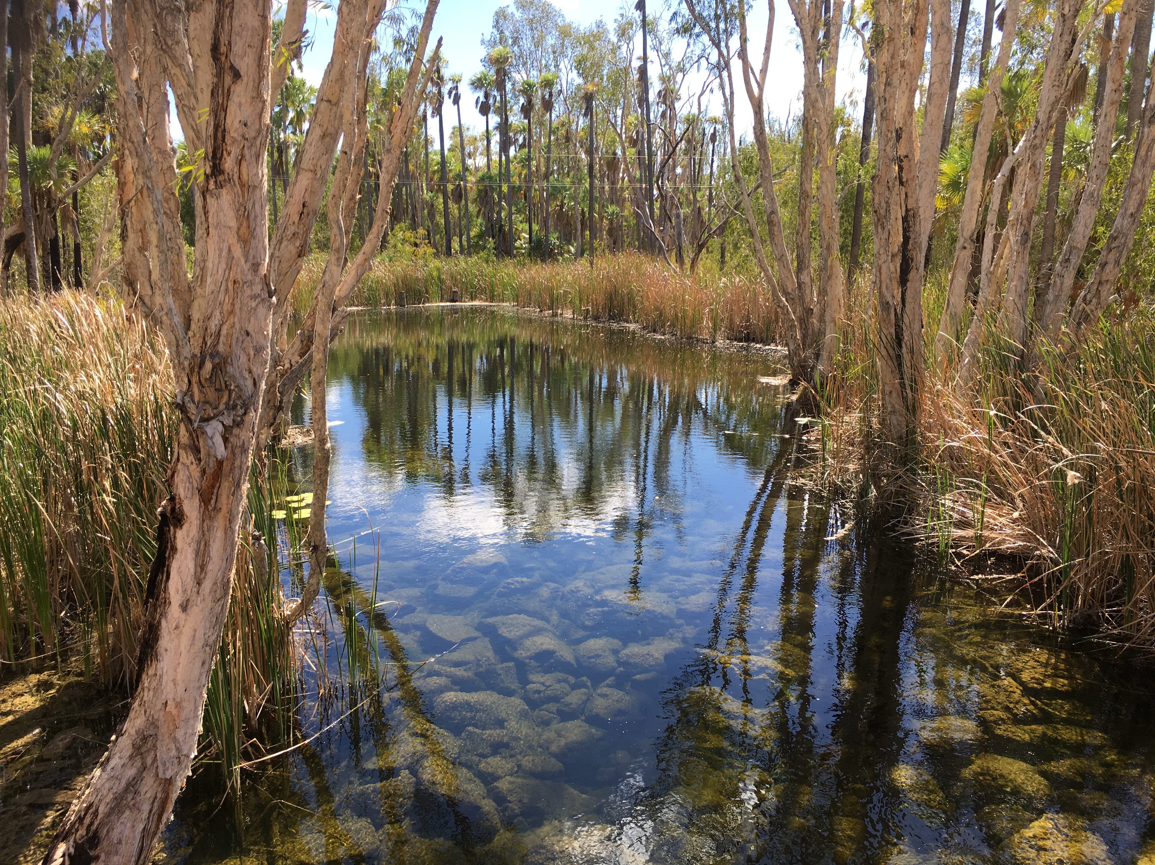

Environmental tracer study

Spring and groundwater samples were collected from the Mataranka Spring complex in October 2019 at the end of the dry season to confirm the origin of the water at the springs. Environmental tracers are compounds dissolved in groundwater or some property of the water molecule that provide information about the origin of the water, how it entered the groundwater system, and when. Tracers used in this study included dissolved salts, strontium, stable isotopes of the water molecule, tritium, carbon-14, noble gases, and radiogenic helium-4 (helium that naturally accumulates in very old groundwater).

Figure 2 Location of the Mataranka Springs Complex and associated regional flow paths from the Cambrian Limestone Aquifer

Location map shows location of study area near Mataranka to the south east of Katerherin and north of Daly Waters. 
Study area overlies Daly and Georgina basins in the Cambrian Limestone Aquifer. The Wiso Basin is to the south west.
Study area map shows location of springs and wells sampled, including sites along Roper River, Elsey Creek and Roper Highway in the Elsey National Park. Groundwater flow paths generally flow toward Roper River. A south-west to north east trending transect connects several sampled wells.

Key findings

* The Daly flow path of the CLA is a major source of water for Rainbow Spring and the Georgina flow path is a major source for Bitter Spring. Other smaller springs in the complex that were investigated (Warloch Pond and Fig Tree) had chemical signatures similar to the Georgina flow path (Figure 3)
* With the exception of Fig Tree Spring, there was limited evidence for ‘young’ (post-1950) locally recharged groundwater contributing to the springs, demonstrating much of the groundwater originated from farther away in the CLA.
* The noble gas content in the springs indicated they are warm due to high soil temperatures at the time of groundwater recharge, not from geothermal heating of groundwater.

Figure 3 Stable isotope composition of springs and groundwater in the complex (full symbols) and elsewhere in the CLA (open symbols). Groundwater from the Daly and Georgina flow paths of the CLA have distinct isotopic signatures owing to different climatic conditions where groundwater recharge occurs

Plot of oxygen-18 (delta-18O) and deuterium concentrations (delta-2H) in per mille Vienna Standard Mean Ocean Water (VSMOW).
Meteoric water lines (MWL) for Darwin, Alice Springs and Georgina and isotopic composition of water samples from Daly, Georgina and Wiso basins and 4 springs  are shown.


* High amounts of radiogenic helium-4 in Rainbow Spring, Bitter Spring, and many nearby groundwater bores demonstrated an additional deeper source (or sources) of groundwater to the complex.
* A combination of groundwater use by trees and a higher salinity in the deeper groundwater source(s) could explain the increase in spring and groundwater salinity from west to east in the complex.

Implications

* Groundwater extraction in the Georgina Basin of the CLA will have to be carefully managed because it is a major water source for the Mataranka Springs Complex
* The environmental tracer signature for potential deeper groundwater sources needs to be characterised in order to estimate this contribution to the spring flow.
* Additional questions about the springs are being investigated via a monitoring program in partnership with Charles Darwin University, Elsey National Park and the Mangarrayi rangers.

The GBA program

The $35.4 million Geological and Bioregional Assessment (GBA) Program is assessing the potential impacts of shale and tight gas development on water and the environment to inform regulatory frameworks and appropriate management approaches. The geological and environmental knowledge, data and tools produced by the GBA Program will assist governments, industry, land users and the community by informing decision-making and enabling the coordinated management of potential impacts.

How to cite

Geological and Bioregional Assessment Program (2021) Fact sheet 25: Groundwater sources to the Mataranka Springs Complex [online document]. Fact sheet for the Geological and Bioregional Assessment Program.

Find out more

Datasets that support this work are available at [data.gov.au](https://www.data.gov.au/):

* Geological and Bioregional Assessment Program (2020) [Environmental tracer data 2019](https://data.gov.au/data/dataset/3aa021a8-f4cf-45cb-abf1-63742efb48df) [tabular]

More information is available from [bioregionalassessments.gov.au/gba](https://www.bioregionalassessments.gov.au/gba).

Acknowledgements

We acknowledge the traditional owners as the custodian of the land and springs at Mataranka (including the Mangarrayi and Yangman) and are grateful for the support they provided for accessing the springs, including at sacred sites. We thank Elsey National Park and the NT Department of Environment, Parks and Water Security for granting access to the springs and bores and the Northern Land Council for facilitating the collaboration with Traditional Owners.