Geological and Bioregional   
Assessment Program

Fact sheet 22  
Seismic surveys

Seismic surveys are a commonly acquired geophysical dataset used to image the subsurface. Data collection typically results in local disturbance of the ground and environment (Figure 1). This review of seismic acquisition technology summarises the current and future innovations and implications for the environmental disturbance that may be seen from use of these technologies for exploration for unconventional gas resources. With seismic surveys having been acquired in the Cooper GBA region since the 1960s, data analysis of historical seismic surveys provides insight into acquisition geometries used in the region.

Seismic acquisition and environmental impacts

* 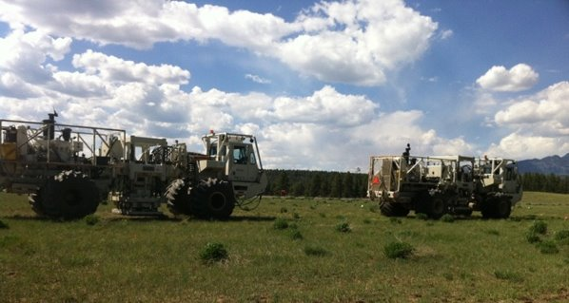**Seismic acquisition technology:** Cable-less sensing (i.e. nodal geophones) and wireless recording innovations are replacing the historical standard equipment consisting of cable-connected sensors and recording devices. Autonomous (for example drone) technology is unlikely to be commercially viable in the near-future.

Figure 1 Commonly used seismic source equipment used for seismic surveys

* **Minimising environmental impact:** Nodal technology decreases the need for vehicles to transport geophone and communication cables making helicopter or foot deployment more practical. Modern strategies to prepare seismic lines (for example narrow paths that weave around vegetation) are replacing historical practices where practical (for example, wide-swath linear bulldozing and vegetation clearing).
* **External factors:** Case studies show seismic surveys should be tailored to the local environment to minimise impact, where data acquisition strategies are often adopted, adapted, or created based on the local landscape and regulations.

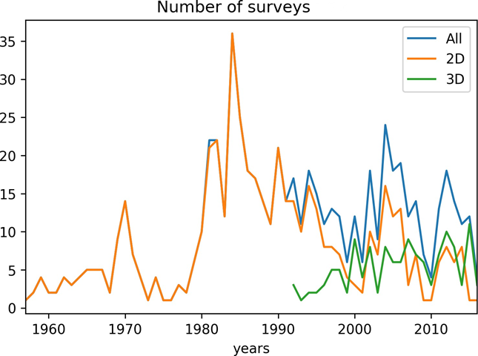Future seismic surveys

Figure 2 Number of seismic surveys acquired in the Cooper GBA region each year from 1960 to 2020, broken down by 2D and 3D surveys where data is available

* Exploration and development of conventional gas resources in the Cooper GBA region has resulted in numerous seismic data surveys (Figure 2). Seismic surveys are likely to continue being conducted in the Cooper GBA region to assist in optimising well locations and planning well trajectories as part of unconventional gas resource exploration and development projects.
* Seismic surveys are likely to be collected in support of exploration and development of unconventional resources in the Beetaloo GBA region.
* New seismic surveys may occur in areas with no previous seismic coverage and also as infill surveys to complement existing data in both the Cooper and Beetaloo GBA regions.

The GBA Program

The $35.4 million Geological and Bioregional Assessment (GBA) Program is assessing the potential impacts of shale and tight gas development on water and the environment to inform regulatory frameworks and appropriate management approaches. The geological and environmental knowledge, data and tools produced by the GBA Program will assist governments, industry, land users and the community by informing decision-making and enabling the coordinated management of potential impacts.

**How to cite**

Geological and Bioregional Assessment Program (2021) Fact sheet 22: Seismic surveys [online document]. Fact sheet for the Geological and Bioregional Assessment Program.

Find out more

Datasets that support this work are available at [data.gov.au](https://www.data.gov.au):

* Martinez C (2020) [A review of land seismic survey technology and mitigating environmental impact](https://data.gov.au/data/dataset/2a6e7d47-2a24-4d9e-b75c-3c894ee2b28a).
* Geological and Bioregional Assessment Program (2021) [Spatiotemporal data analysis of seismic survey occurrence in the Cooper Basin](https://data.gov.au/data/dataset/5584c08a-ca3a-4829-90d3-d604e01323d4) [data].

More information is available at [bioregionalassessments.gov.au/gba](https://www.bioregionalassessments.gov.au/gba).