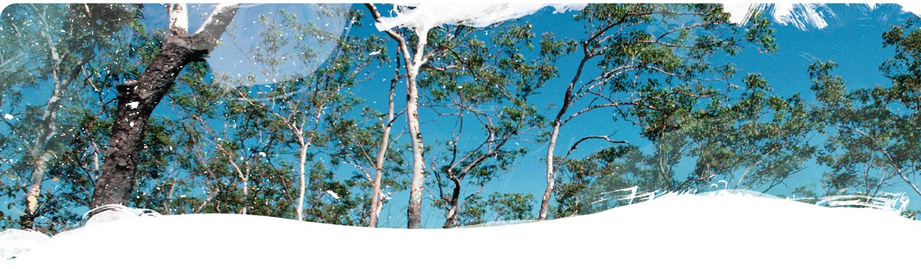Geological and Bioregional   
Assessment Program

Fact sheet 20

Regional tracer results from the Cambrian Limestone Aquifer

Figure 1 A typical farm well in the Beetaloo GBA region

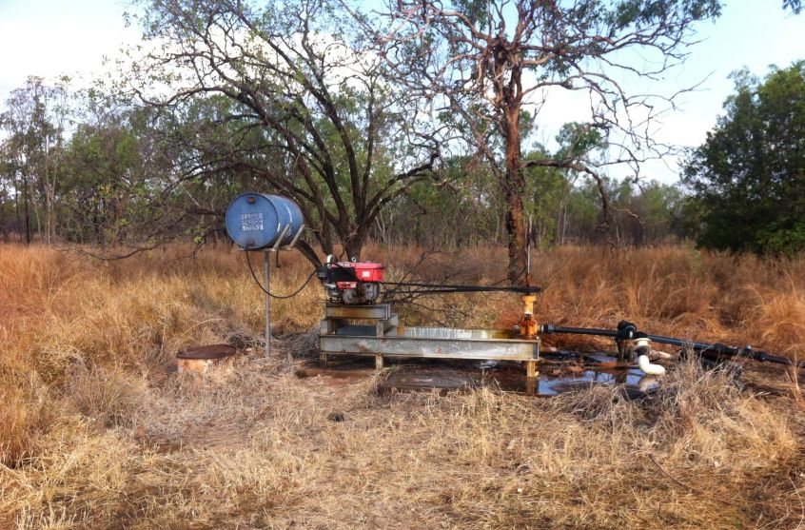

This project was a collaboration between the GBA project partners (CSIRO and Geoscience Australia), as well as the Gas Industry Social and Environment Research Alliance (GISERA), Charles Darwin University and the University of Science and Technology of China. We investigated the regional flow system of the Cambrian Limestone Aquifer (CLA), which occurs across three sedimentary basins: the Georgina, Wiso, and Daly geological basins. The CLA extends over 1500 km from the semi-arid climate in the south-east to the monsoon-dominated tropical climate in the north-west. It is the main water source for the pastoral industry of the region, and discharge from this aquifer is a significant contributor to water flow in the headwaters of the Roper River, including the culturally important Mataranka Springs. A robust water balance for the CLA together with a detailed understanding of the flow system is needed to manage the cumulative impacts of current and future groundwater extraction.

The project used environmental tracers, anthropogenic or natural substances and isotopes that are part of the water cycle, sampled from farm wells (Figure 1) and springs in the Cambrian Limestone Aquifer. The purpose was to investigate the groundwater recharge mechanisms and flow velocities in the CLA. Other parts of the study investigated the variability of natural isotope geochemistry of rock samples (GBA fact sheet 12), groundwater recharge mechanisms (GBA fact sheet 19), the origin of water in Mataranka Springs (GBA fact sheet 25), and a time series of tracers in these springs (GBA fact sheet 17).

Results

Tracer findings in the CLA are counter-intuitive and highlight several unusual aspects of the CLA flow system:

* Radiocarbon (14C) is often used to infer groundwater flow direction and velocity and its concentration typically decreases along a flow path. However, along the Georgina flow path of the CLA, which flows from south to north (see Evans et al 2020 for detail), 14C concentrations increase in the direction of groundwater flow (Figure 2).
* Tracers for modern groundwater (that is, groundwater that recharged an aquifer after 1950), such as tritium (3H), CFCs, SF6 and H1301, show contradicting results. Tritium (3H) is low but detectable in the northern section of the flow path, suggesting very limited recharge. In contrast, CFCs, SF6 and H1301 show high concentrations throughout the aquifer, suggesting more recent recharge. For explanation of recharge processes see GBA fact sheet 19.
* The noble gas helium, produced by natural decay of uranium and thorium in the aquifer and indicative of the input of old groundwater, was detected in several bores from the CLA and two springs, suggesting upward flow of old groundwater from another aquifer below the CLA.

Implications

Figure 2 Distribution of radiocarbon in groundwater from the Cambrian Limestone Aquifer

* Radiocarbon values are generally greatest in the Daly Basin in the north west and in the south western part of the Georgina Basin.
  Lower radiocarbon values occur in the eastern part of the Beetaloo GBA region in the north western part of the Georgina Basin.The differences between tritium and other modern environmental tracers demonstrate a complex recharge environment, including the potential for preferential recharge via sinkholes.
* Recharge rates for the Georgina groundwater flow path increase from south to north, consistent with the climate gradient, and are smaller in areas of the Georgina Basin with Cretaceous cover over the CLA.
* Groundwater transit time through the Georgina Basin portion of the CLA is less than several thousand years.
* The relatively short timescale of groundwater flow along the Georgina flow path precludes the CLA as the source of the helium found in some springs and bores – it must originate from a deeper source (or sources). This is important because it demonstrates a connection to deeper parts of the basin.
* Future research is required to understand the nature of the vertical connectivity demonstrated by helium, to quantify the groundwater flow between the CLA and deeper geological formations and to better quantify effective recharge using the most reliable tracer, tritium.

The GBA Program

The $35.4 million Geological and Bioregional Assessment (GBA) Program is assessing the potential impacts of shale and tight gas development on water and the environment to inform regulatory frameworks and appropriate management approaches. The geological and environmental knowledge, data and tools produced by the GBA Program will assist governments, industry, land users and the community by informing decision-making and enabling the coordinated management of potential impacts.

How to cite

Geological and Bioregional Assessment Program (2021) Fact sheet 20: Regional tracer results from the Cambrian Limestone Aquifer [online document]. Fact sheet for the Geological and Bioregional Assessment Program.

Find out more

Datasets that support this work are available at [data.gov.au](https://www.data.gov.au):

* Geological and Bioregional Assessment Program (2020) [Environmental tracer data 2019](https://data.gov.au/data/dataset/3aa021a8-f4cf-45cb-abf1-63742efb48df) [tabular].

More information is available at [bioregionalassessments.gov.au/gba](https://www.bioregionalassessments.gov.au/gba).

Acknowledgements

We acknowledge the Traditional Owners as the custodian of the land and springs at Mataranka (including the Mangarrayi and Yangman people) and are grateful for their support during the survey. We thank Elsey National Park and the NT Department of Environment, Parks and Water Security for granting access to some of the bores and the Northern Land Council for facilitating our collaboration with Traditional Owners.