Geological and Bioregional  
Assessment Program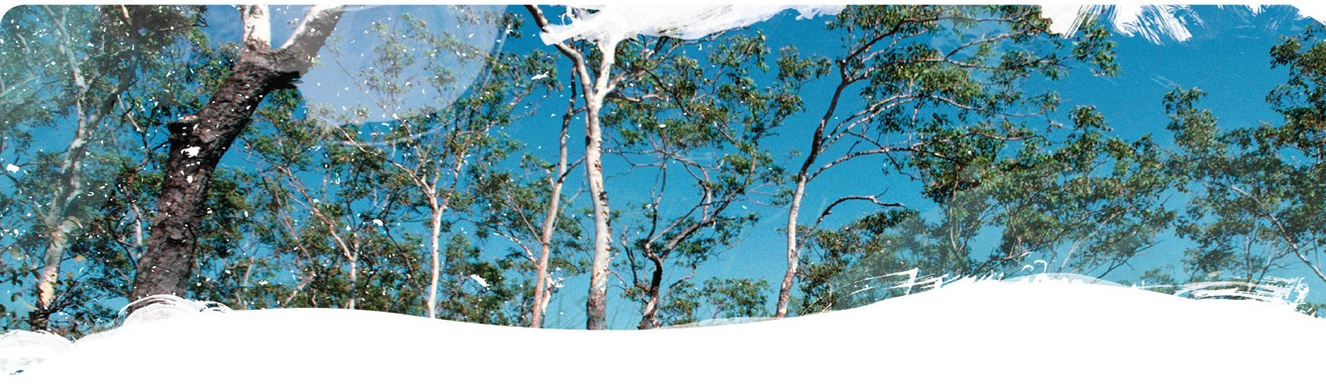

Fact sheet 1

Actual evapotranspiration in the Cooper Creek floodplain: transmission losses and groundwater recharge

This investigation sought to investigate the water balance of the alluvium of Cooper Creek using the actual evapotranspiration from MODIS-Landsat blended CMRSET. Previous research has shown that the river red gum and coolibah trees in the riparian zone are using both soil moisture and groundwater, whereas the rest of the floodplain vegetation is limited to using soil moisture fed from rainfall and overbank flooding. This allows us to classify areas based on their actual evapotranspiration and therefore water sources: open water > riparian areas > floodplain > rain-fed areas (Figure 1).

Transmission losses are very high in Cooper Creek with 81% of the water flowing into the system from the Barcoo and Thompson rivers lost by the time it reaches the Queensland/South Australian border. This water is either lost to the floodplain through overbank flooding or to groundwater recharge. There is no regional freshwater resource and the freshwater lenses around waterholes are consumed by the riparian vegetation within hundreds of metres of the waterholes. Using the remotely sensed actual evapotranspiration data enables vegetation water use to be split by water source. For the period 2000 to 2018, 77% of water lost from Cooper Creek was lost to the floodplain where it supports the pasture growth critical to the pastoral industry. The remaining 23% was lost to evapotranspiration by the riparian vegetation or as open water evaporation in waterholes.

The waterholes act as recharge features of the landscape while Cooper Creek is in flood, through scouring of the bed of the channels, and then self-seal when the velocity of the flow decreases. When sealed, there is no leakage to groundwater. Local-scale recharge can be inferred for each waterhole using a groundwater balance based on transpiration of groundwater from the riparian zone vegetation. Of the 80 waterholes that hold water more than 95% of the time, the calculated recharge rate was between 130 and 970 mm/year over the area of the waterhole. These recharge estimates suggest recharge occurs through the bed of the channels, as well as from the waterholes, the area-weighted average recharge rate for these 80 waterholes was 260 mm/year.

Figure 1 Classification of areas within the alluvium of Cooper Creek catchment based on water use

Areas within the alluvium of Cooper Creek catchment are classified as open water, riparian, floodplain and dryland. Streamflow gauge locations are located near Innamincka (1) and Windorah (2).
Based on water use, most vegetation is classified as floodplain, with smaller areas classified as open water, riparian and dryland vegetation. 
Inset maps show detailed mapping near Currareva Waterhole near Windorah in Queensland, Cullyamurra Waterhole to the east and Lake Coongie to the west of Innamincka in South Australia. Areas classified as riparian vegetation follow watercourses and include large areas to the south of Windorah in Queensland.

The GBA Program

The $35.4 million Geological and Bioregional Assessment (GBA) Program is assessing the potential impacts of shale and tight gas development on water and the environment to inform regulatory frameworks and appropriate management approaches. The geological and environmental knowledge, data and tools produced by the GBA Program will assist governments, industry, land users and the community by informing decision-making and enabling the coordinated management of potential impacts.

How to cite

Geological and Bioregional Assessment Program (2021) Fact sheet 1: Actual evapotranspiration in the Cooper Creek floodplain: transmission losses and groundwater recharge [online document]. Fact sheet for the Geological and Bioregional Assessment Program.

Find out more

* Journal paper: Crosbie RS, Holland KL and McVicar TR (2021) Actual evapotranspiration in the Cooper Creek floodplain: transmission losses and groundwater recharge. Submitted to Ecohydrology. (URL to come)

Datasets that support this work are available at [data.gov.au](https://www.data.gov.au):

* Geological and Bioregional Assessment Program (2021) [Groundwater use of riparian vegetation along Cooper Creek](https://data.gov.au/data/dataset/33f84fba-b374-4e46-a277-a39b6f95b46b) [data].

More information is available at [bioregionalassessments.gov.au/gba](https://www.bioregionalassessments.gov.au/gba).