
Geological and Bioregional
Assessment Program

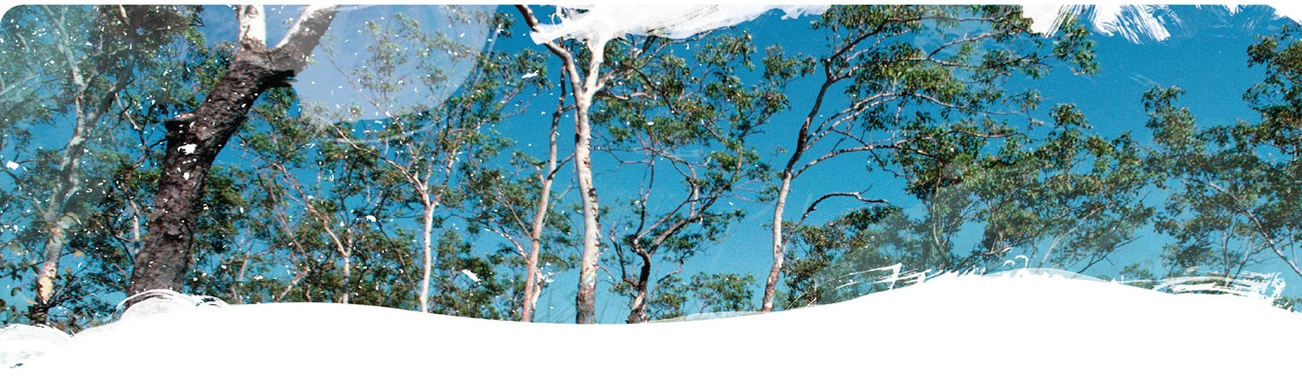
Fact sheet 19
Groundwater recharge processes in the Beetaloo GBA region
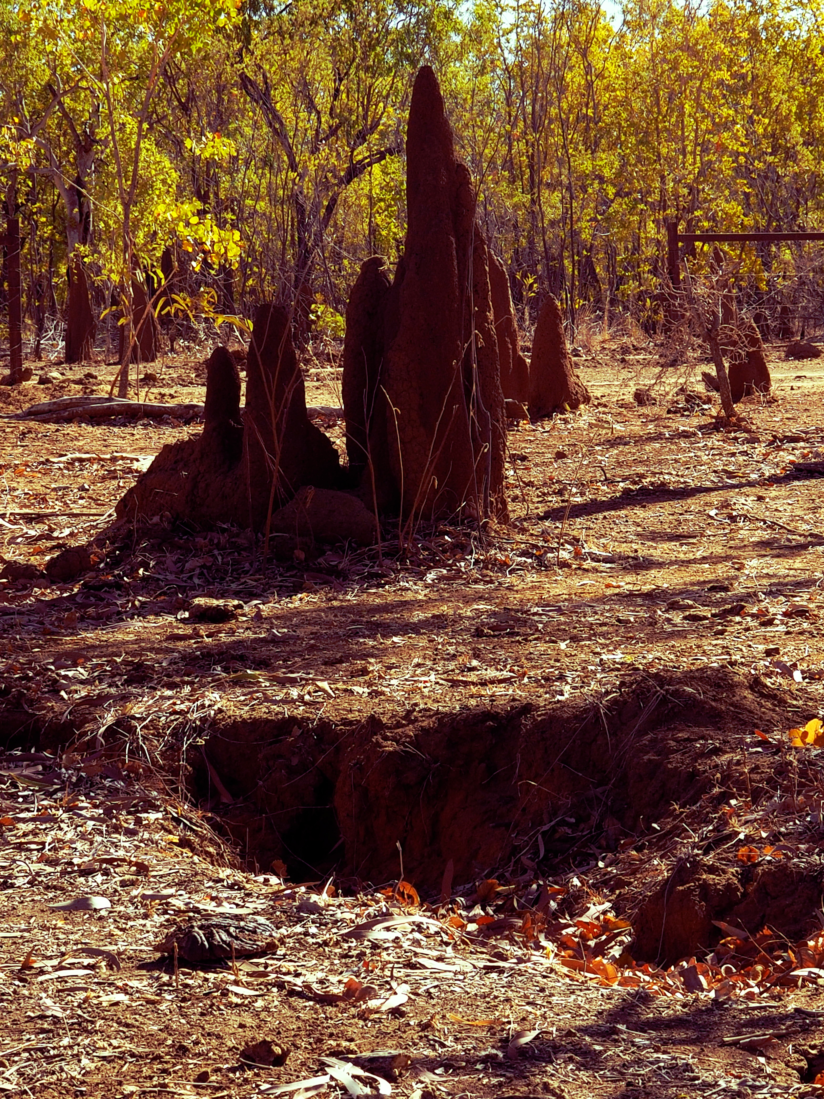
The Cambrian Limestone Aquifer (CLA) provides key water resources for regional areas of the Northern Territory and dry-season baseflow to several iconic rivers. Irrigated agriculture and the resources industry are potential additional users of these water resources. The CLA has a complex hydrogeology: strong north-south rainfall gradient, extensive karst features (such as sinkholes and caves, Figure 1), a thick unsaturated zone, and partial confinement of the aquifer. Understanding recharge processes in the CLA is key to quantify groundwater recharge and assess potential risks to groundwater from development (e.g. surface spills). This is currently limited by the scarcity of data in the region (Deslandes et al., 2019).
Figure 1 Recharge through sinkholes is an important process in the CLA
Credit: Christoph Gerber, CSIRO

What we did
To address this, we sampled water for environmental tracers including major and minor ions, ¹⁸O and ²H, ¹⁴C, tritium, CFCs, SF₆, Halon-1013, dissolved stable noble gases, and the radioactive noble gas isotopes ⁸⁵Kr and ³⁹Ar. We improved the understanding of recharge processes by modelling tracer concentrations. To investigate the role of sinkholes, we evaluated tracer patterns with respect to the distance to sinkholes.

Key results
Figure 2 Location of sinkholes and tritium concentrations of water samples
Data: Geological and Bioregional Assessment Program (2020, 2021); Deslandes et al. (2019); Suckow et al. (2018)
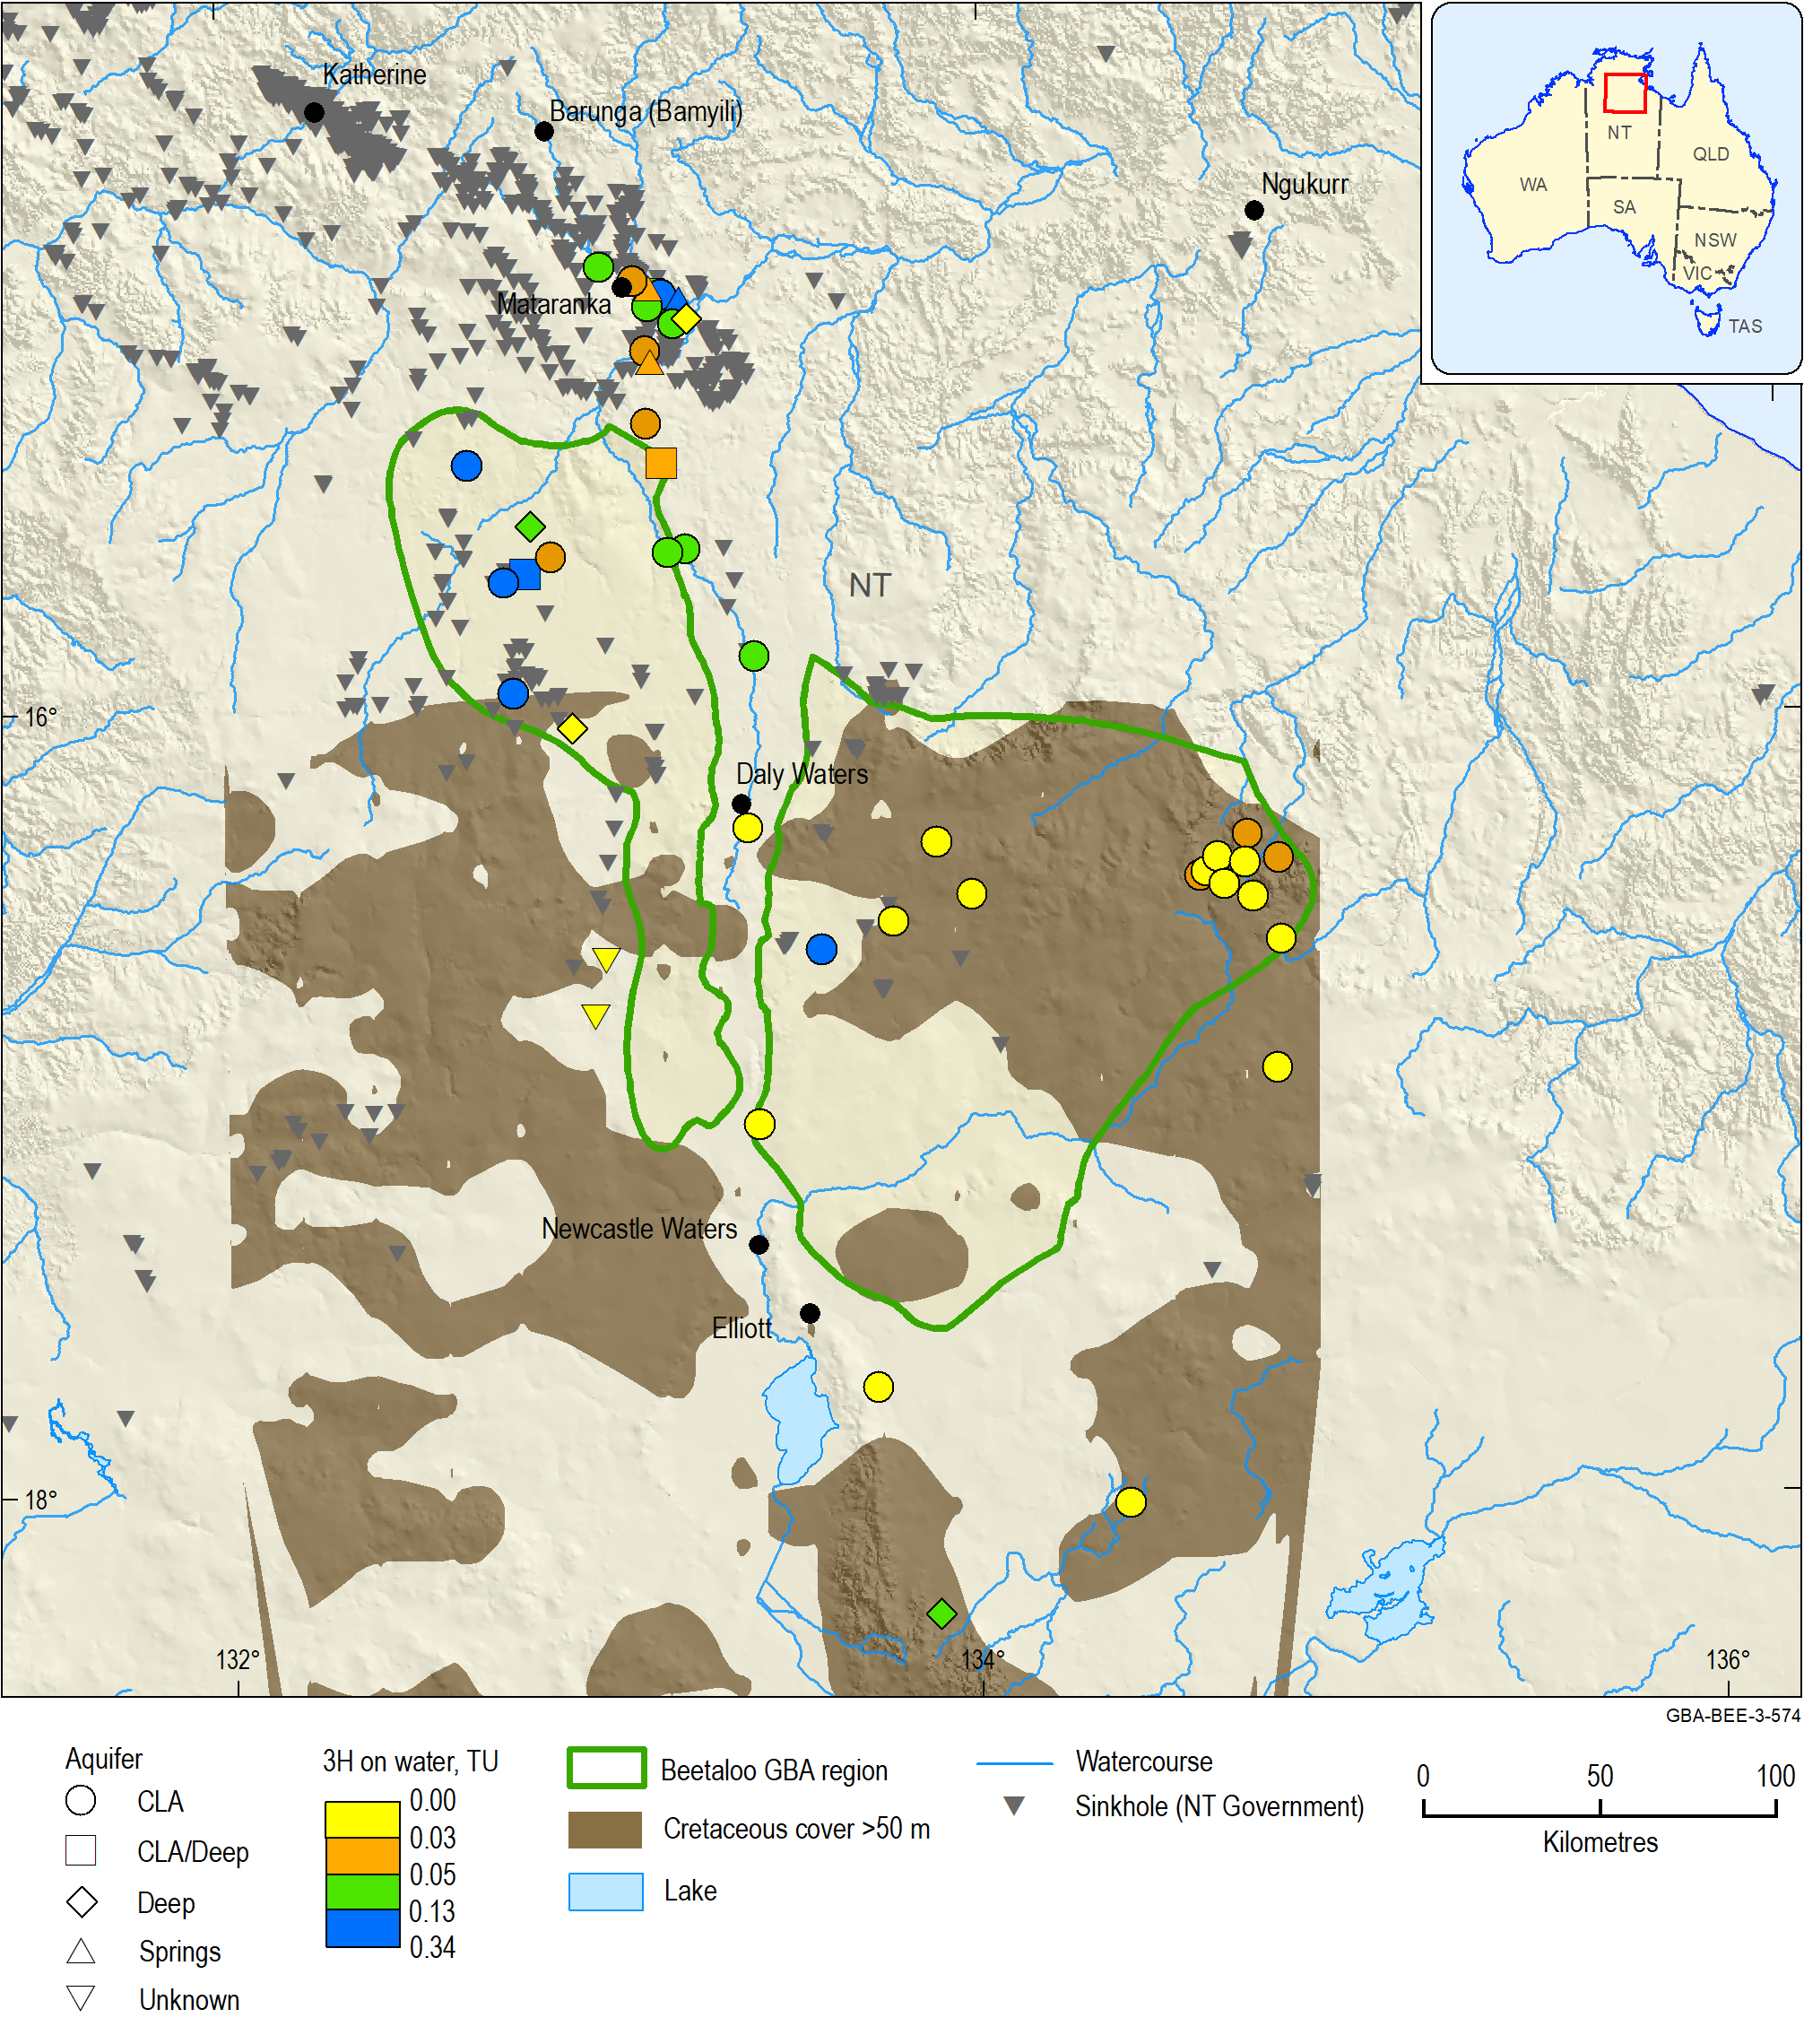
- Traditional tracers: Confirmation of the discrepancy between low tritium concentrations and high gas tracer concentrations (SF₆, CFCs, Halon-1301) observed in earlier studies (Deslandes et al., 2019).
- Radioactive noble gas tracers: The new tracers ⁸⁵Kr and ³⁹Ar agree better with tritium than other gas tracers because they are less affected by the exchange of gas between soil air and the water.
- Water-air gas exchange modelling: Multiple air entrapment events after groundwater recharge are required to explain observed concentrations of stable noble gases, SF₆, and tritium with a single consistent model.
- Role of sinkholes: The higher sinkhole density north of Daly Waters correlates with higher tritium concentrations.

Implications
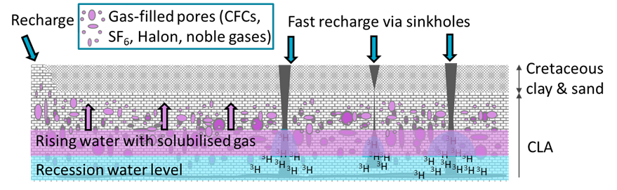
- Recharge: The tritium spatial pattern (Figure 2) indicates that recharge increases from south to north as expected from the rainfall gradient. The residence time of water in the unsaturated zone is longer in the south due to less recharge, a thicker unsaturated zone, and less preferential recharge through sinkholes. It is difficult to isolate the effects of sinkhole density and rainfall gradient as their patterns of occurrence are highly correlated.
Figure 3 Conceptual model of recharge processes
- Water-air gas exchange: Tritium and gas tracers suggest gas exchange after recharge. Preferential recharge through sinkholes causes large water level fluctuations that entrap and dissolve air (Figure 3). Therefore, pollutants, such as from a spill may quickly bypass the unsaturated zone and be mixed into groundwater.
- Future research: Tritium and ³⁹Ar are the best tracers to better quantify recharge. Detailed 3D mapping with tritium, including the unsaturated zone, could quantify the relative importance of the identified processes and reveal the spatial variability of recharge to improve groundwater management and protection.

The GBA program
The $35.4 million Geological and Bioregional Assessment (GBA) Program is assessing the potential impacts of shale and tight gas development on water and the environment to inform regulatory frameworks and appropriate management approaches. The geological and environmental knowledge, data and tools produced by the GBA Program will assist governments, industry, land users and the community by informing decision-making and enabling the coordinated management of potential impacts.

How to cite
Geological and Bioregional Assessment Program (2021) Fact sheet 19: Groundwater recharge processes in Beetaloo GBA region [online document]. Fact sheet for the Geological and Bioregional Assessment Program.

Find out more
- Deslandes A, Gerber C, Lamontagne S, Wilske C, Suckow A (2019) Environmental Tracers in the Beetaloo Basin - Aquifer and groundwater characterization, Technical Report. CSIRO, Adelaide, Australia.
- Suckow A, Deslandes A, Gerber C, Lamontagne S (2018) Environmental Tracers in the Beetaloo Sub-Basin. Historical Data and a first reconnaissance study of eight samples, Technical Report. CSIRO, Adelaide, Australia.
Datasets that support this work are available at data.gov.au:
- Geological and Bioregional Assessment Program (2020) Environmental tracer data 2019 [tabular]
- Geological and Bioregional Assessment Program (2021) Sinkholes and waterholes interpreted from remote Sensing – Beetaloo GBA [data]
More information is available at bioregionalassessments.gov.au/gba.

Acknowledgements
We acknowledge the Traditional Owners as the custodian of the land and springs at Mataranka (including the Mangarrayi and Yangman people) and are grateful for their support during the survey. We thank Elsey National Park and the NT Department of Environment, Parks and Water Security for granting access to some of the bores and the Northern Land Council for facilitating our collaboration with traditional owners.

