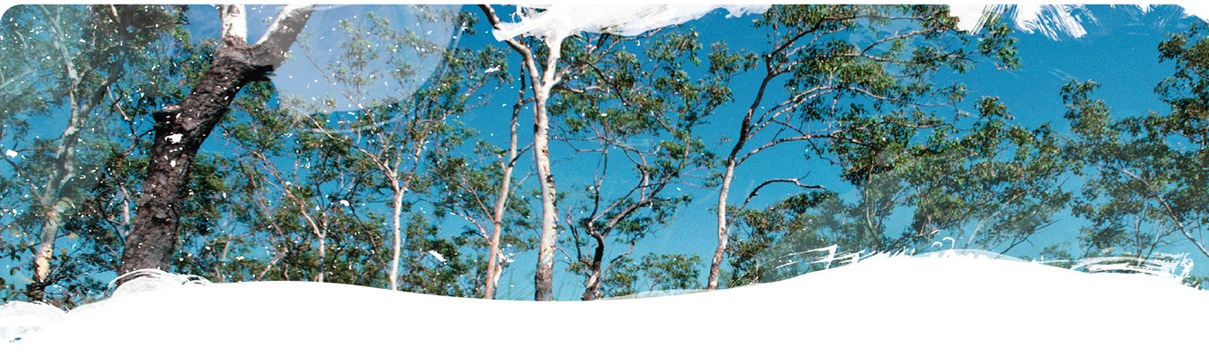

Geological and Bioregional
Assessment Program
Figure 1 A side branch of the Bitter Spring pool
Credit: Axel Suckow, CSIRO
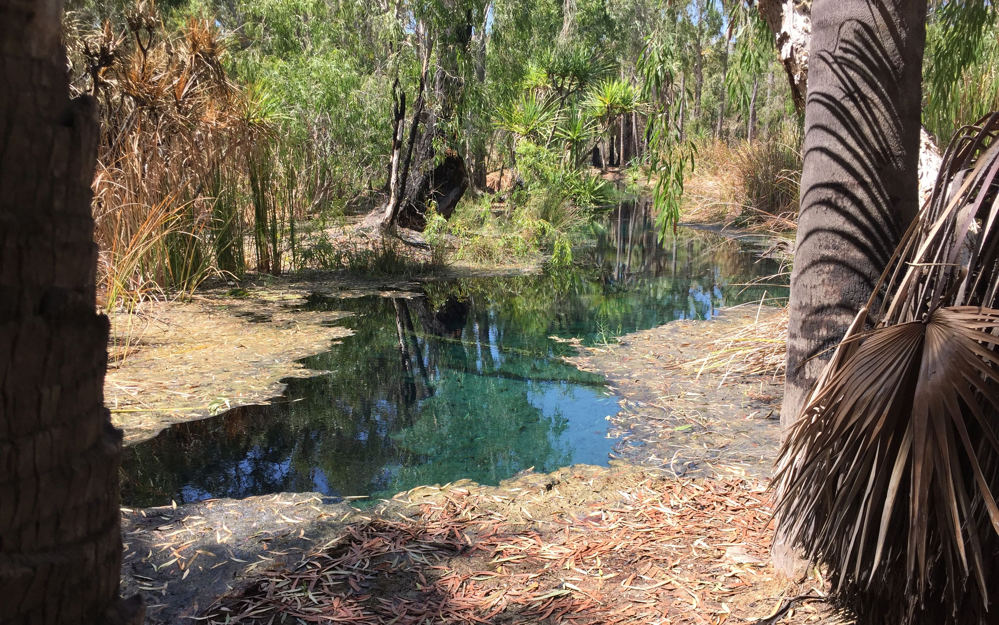

Fact sheet 17
Hydrochemistry, ¹⁸O, ²H and Radon time series of the Mataranka Springs
This cooperation between CSIRO, Charles Darwin University, Elsey National Park, and the Mangarrayi Rangers investigated the origin of water flowing to the culturally important Mataranka Springs. These springs are a main tourist attraction in the area and the main source of dry season baseflow to the Roper River. Proposed groundwater pumping in the Cambrian Limestone Aquifer (CLA) for irrigated agriculture and for shale gas in the Beetaloo Sub-basin may impact on the springs. A fortnightly monitoring program for selected chemicals evaluated the presence of fast-flushing sources, complemented by a sampling campaign in October 2019 at the end of the dry season (see Fact Sheet 25). This is important to assess the vulnerability of these springs to both local groundwater use and accidental groundwater contamination events such as fuel spills. Fortnightly samples were taken by the Mangarrayi Rangers from Rainbow Spring, Bitter Spring (Figure 1) and Fig Tree Spring in Elsey National Park and analysed for major ions, stable isotopes of water and dissolved radon. Rainfall samples were also collected at Mataranka by the Elsey National Park rangers.

Results
Inflows to Rainbow and Bitter Spring are sourced from a regional flow system throughout the year because the measured parameters show no significant seasonal variation (Figure 2), indicating flow times of at least several years from the recharge area to the spring. In contrast, Fig Tree Spring is at least partly fed by a quick local flow system, indicated by variation in the noble gas radon, which has a half-life of only 3.8 days and therefore originates from within a few kilometres around the spring. Also, deuterium (δ²H), a stable isotope of the water molecule, indicates a seasonal input of partly evaporated water. Significant nitrate peaks were observed in Fig Tree Spring early in 2020 and 2021, consistent with very dry conditions (including nearby bushfires) during the previous year. The source of nitrate is in the soils above the water table, also demonstrating a very fast flushing component of groundwater flow at Fig Tree Spring.

Implications
- The results demonstrate that local input of water and chemicals to groundwater around Elsey National Park can find their way very quickly into some of the springs (Fig Tree Spring) and the Roper River.
- The two main springs of the Mataranka Spring Complex (Bitter Spring and Rainbow Spring) are connected to the regional groundwater system. While they seem not to be susceptible to local inputs, their flow is dependent on the regional groundwater levels of the Cambrian Limestone Aquifer.
Figure 2 Time series of chloride (A), radon (B), deuterium (C) and nitrate (D) concentrations in 3 of the Mataranka Springs
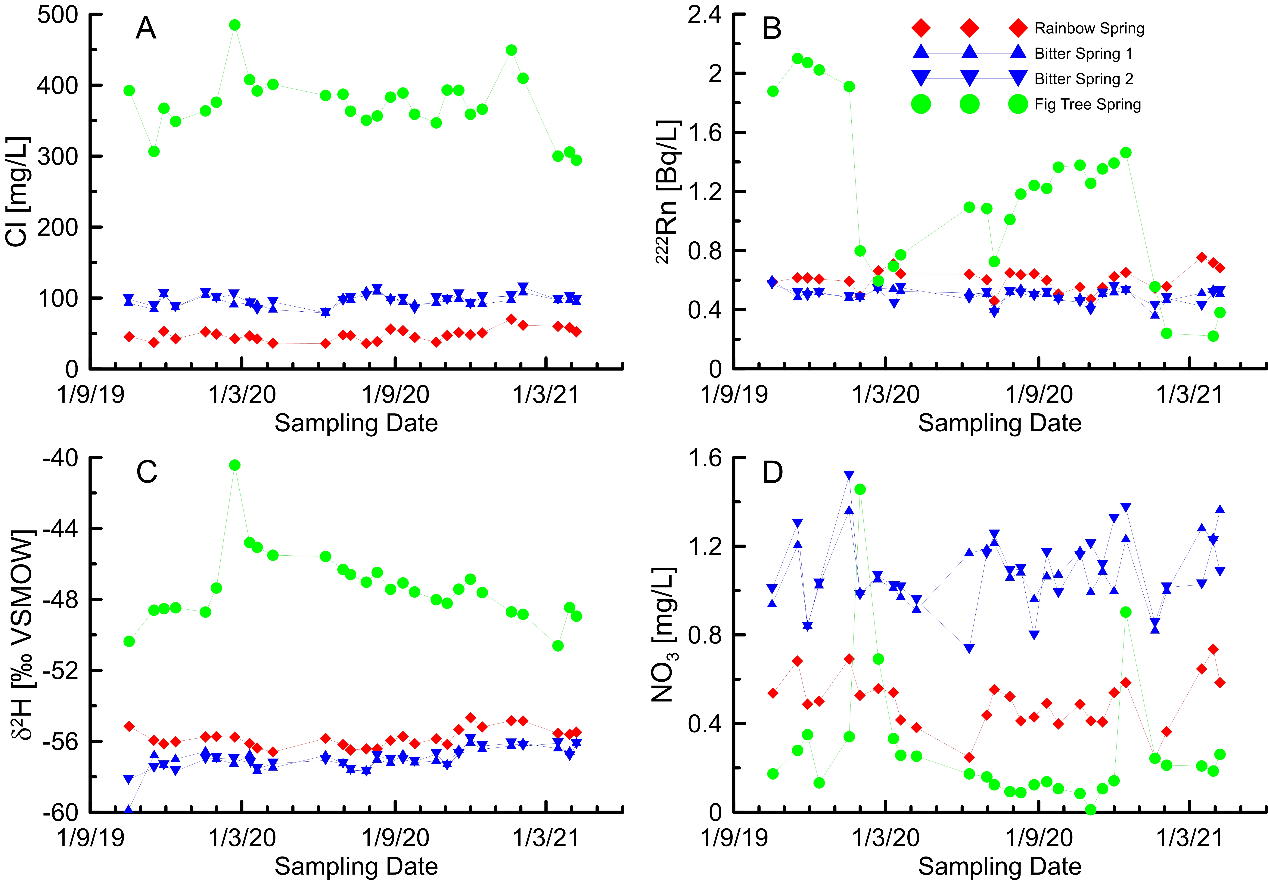

The GBA Program
The $35.4 million Geological and Bioregional Assessment (GBA) Program is assessing the potential impacts of shale and tight gas development on water and the environment to inform regulatory frameworks and appropriate management approaches. The geological and environmental knowledge, data and tools produced by the GBA Program will assist governments, industry, land users and the community by informing decision-making and enabling the coordinated management of potential impacts.

How to cite
Geological and Bioregional Assessment Program (2021) Fact sheet 17: Hydrochemistry, ¹⁸O, ²H and radon time series of the Mataranka Springs [online document]. Fact sheet for the Geological and Bioregional Assessment Program.

Find out more
The dataset that supports this work are available at data.gov.au:
- Geological and Bioregional Assessment Program (2020) Mataranka Springs hydrochemistry time series. [tabular].
More information is available on the bioregionalassessments.gov.au/gba.

Acknowledgements
We acknowledge the traditional owners as the custodian of the land and springs at Mataranka (including the Mangarrayi and Yangman people) and are grateful for their support during the survey. We thank Elsey National Park and the NT Department of Environment, Parks and Water Security for granting access to some of the bores and the Northern Land Council for facilitating our collaboration with traditional owners. Continuous sampling was performed by the Mangarrayi Rangers, Charles Darwin University, and Elsey National Park (NT Department of Parks and Water Security).

