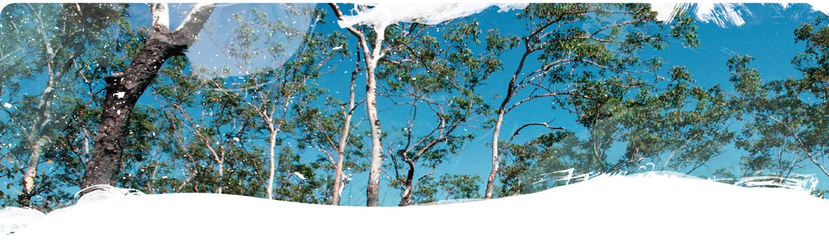
Geological and Bioregional
Assessment Program

Fact sheet 15
Groundwater recharge across the Cambrian Limestone Aquifer
This investigation sought to quantify groundwater recharge over the entirety of the Cambrian Limestone Aquifer (CLA) footprint using the chloride mass balance method (Figure 1). The uncertainty in the chloride mass balance estimates of recharge were constrained using baseflow in the regional rivers as a lower constraint and a water mass balance using remotely sensed evapotranspiration as an upper constraint. This study found recharge over the footprint of the eastern Beetaloo Sub-basin was 12 mm/year and the western side was considerably higher at 48 mm/year (Table 1).

Journal paper abstract
Regional-scale estimates of groundwater recharge are inherently uncertain, but this uncertainty is rarely quantified. Quantifying this uncertainty provides an understanding of the limitations of the estimates, and being able to reduce the uncertainty makes the recharge estimates more useful for water resources management. This paper describes the development of a method to constrain the uncertainty in upscaled recharge estimates using a rejection sampling procedure for baseflow and remotely sensed evapotranspiration data to constrain the lower and upper end of the recharge distribution, respectively. The recharge estimates come from probabilistic chloride mass-balance estimates from 3,575 points upscaled using regression kriging with rainfall, soils and vegetation as covariates. The method is successfully demonstrated for the 570,000-km² Cambrian Limestone Aquifer in northern Australia. The method developed here is able to reduce the uncertainty in the upscaled chloride mass-balance estimates of recharge by nearly a third using data that are readily available. The difference between the 5th and 95th percentiles of unconstrained recharge across the aquifer was 31 mm/year (range 5–36 mm/year) which was reduced to 22 mm/year for the constrained case (9–31 mm/year). The spatial distribution of recharge was dominated by the spatial distribution of rainfall but was comparatively reduced in areas with denser vegetation or finer textured soils. Recharge was highest in the north-west in the Daly Basin with an average of 82 (49–156) mm/year and lowest in the south-east Georgina Basin with an average of 9 (5–18) mm/year.
Table 1 Estimated recharge for each region expressed as the 5th, 50th and 95th percentiles
Geological regions | Constrained recharge estimates (mm/y)
Percentiles | 5th | 50th | 95th
Daly Basin | 49 | 82 | 156
Wiso Basin | 9 | 17 | 31
Georgina Basin | 5 | 9 | 18
Beetaloo Sub-basin East | 7 | 12 | 23
Beetaloo Sub-basin West | 27 | 48 | 92
Note: recharge is over the footprint of the region, not recharge to the basin as the Beetaloo Sub-basin does not outcrop
Figure 1 Constrained recharge across the Cambrian Limestone Aquifer
Main image shows 50th percentile estimates, top right shows 5th percentile estimates, bottom right shows 95th percentile estimates.
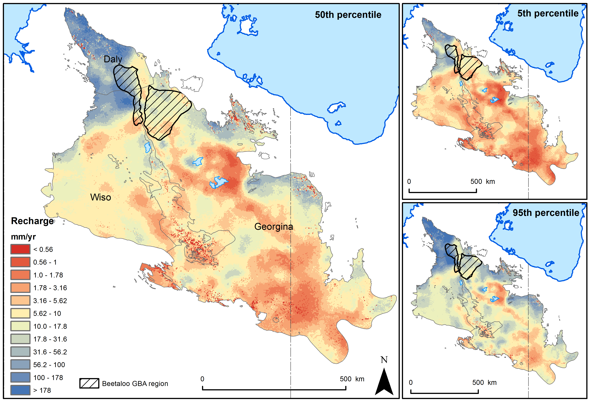

The GBA Program
The $35.4 million Geological and Bioregional Assessment (GBA) Program is assessing the potential impacts of shale and tight gas development on water and the environment to inform regulatory frameworks and appropriate management approaches. The geological and environmental knowledge, data and tools produced by the GBA Program will assist governments, industry, land users and the community by informing decision-making and enabling the coordinated management of potential impacts.

How to cite
Geological and Bioregional Assessment Program (2021) Fact sheet 15: Groundwater recharge across the Cambrian Limestone Aquifer [online document]. Fact sheet for the Geological and Bioregional Assessment Program.

Find out more
- Journal paper: Crosbie RS and Rachakonda PK (2021) Constraining probabilistic chloride mass balance recharge estimates using baseflow and remotely sensed evapotranspiration: The Cambrian Limestone Aquifer northern Australia. Hydrogeology Journal (2021) DOI 10.1007/s10040-021-02323-1.
Datasets that support this work are available at data.gov.au:
- Geological and Bioregional Assessment Program (2020) Recharge across the Cambrian Limestone Aquifer. [Data].
More information is available at bioregionalassessments.gov.au/gba.

