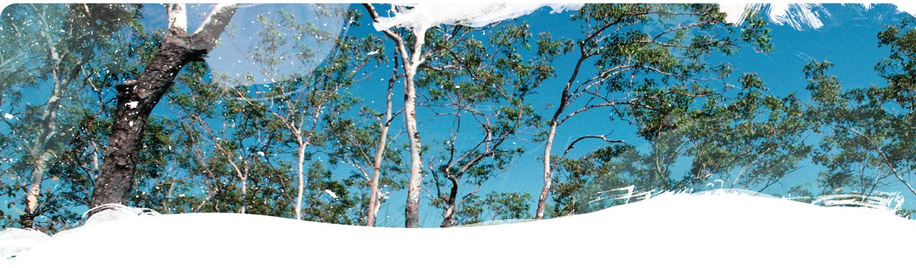Geological and Bioregional  
Assessment Program

Fact sheet 14

Gas extraction and vegetation condition

Have gas extraction activities had a measurable impact on the condition of vegetation cover across the Cooper GBA region? That is the question we sought to answer in this investigation. To do this we used satellite imagery from 2001 to 2018 to estimate vegetation condition, which we defined as the capacity of landscapes to produce and maintain vegetation cover from available water. This is linked to land degradation processes such as over-grazing, soil erosion and loss of productivity. We assessed the effect of gas extraction by examining changes in condition associated with the presence of well infrastructure.

Figure 1 Effect of gas extraction wells on vegetation cover condition

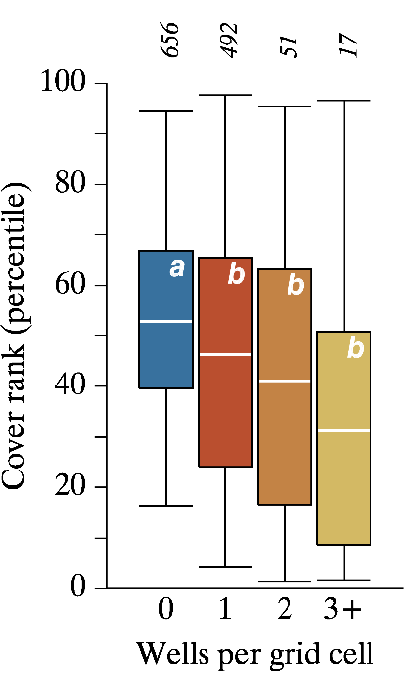

The coloured boxes show the middle 50% of values for each category, with white bars showing the means. The tails show the minimums and maximums. When the letters are different between boxes, it means the averages of those boxes are statistically different.

Compere – a relative benchmarking framework

To calculate condition we used Compere, which is a relative benchmarking framework that separates the management-driven impacts on ecosystem resources from the natural dynamics in those resources. It works by identifying locations in a region that share similar biophysical properties to a target location. Taking an attribute of interest, it then compares the value of the target location to those of all its biophysically equivalent locations, with any differences being attributed to the effects of management activities.

We used Compere to assess the relative differences between satellite-derived measures of total ground cover, which is the fraction of ground covered by live vegetation and litter and which is an excellent proxy for the health of agricultural landscapes. For each grid cell across the region, we ranked that location’s ground cover value against the same values of all the surrounding, biophysically equivalent locations, referred to as cover rank (percentile) in Figure 1. This ranking is directly interpreted as condition, with a ranking of 100 percentiles being the highest condition possible and 0 being the lowest.

Impact of gas extraction activities on cover condition

The impact of gas extraction activities was identified by looking at cover condition associated with the presence of gas extraction wells. Cover condition in grid cells that contained wells was significantly lower than in cells without. wells, with 12% to 41% decreases in condition (Figure 1). We also examined for how long the effect on condition lasted. Cover condition decreased in the first year after a well was established (Figure 2). After about 4 years, vegetation started recovering and by 5 to 7 years had reached the same conditions as it was prior to well establishment.

Using satellite-derived fire occurrence data, we also examined the effect of fires on vegetation cover condition and how long this effect lasted. Fires had a much greater impact on cover condition than did well presence, with rapid decreases of up to 60% and with recovery being much slower, probably taking over a decade (Figure 3). Given this finding, we expect that the biggest direct impact that the unconventional gas resource industry is likely to have on vegetation cover condition is through any effects it has on fire regimes.

Figure 3 Effect of fire on vegetation cover condition in the years following fire occurrence

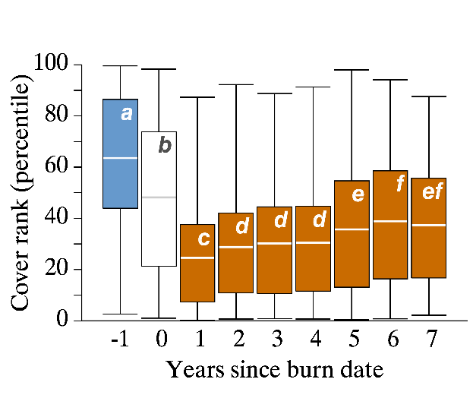

See Figure 1 for an explanation of the boxplots.

Figure 2 Effect of gas wells on cover condition in the years following well establishment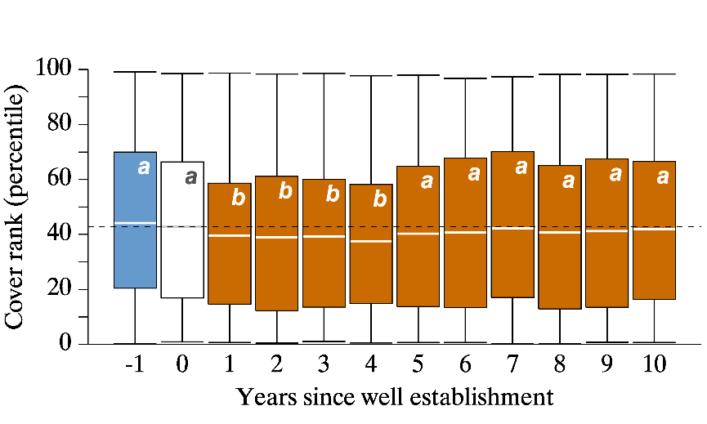

Dashed horizontal line is the mean cover condition (rank) for the year of well establishment. See Figure 1 for an explanation of the boxplots.

The GBA Program

The $35.4 million Geological and Bioregional Assessment (GBA) Program is assessing the potential impacts of shale and tight gas development on water and the environment to inform regulatory frameworks and appropriate management approaches. The geological and environmental knowledge, data and tools produced by the GBA Program will assist governments, industry, land users and the community by informing decision-making and enabling the coordinated management of potential impacts.

How to cite

Geological and Bioregional Assessment Program (2021) Fact sheet 14: Gas extraction and vegetation condition [online document]. Fact sheet for the Geological and Bioregional Assessment Program.

Find out more

* Journal paper: Donohue RJ, Mokany K, McVicar TR, O’Grady AP (2021) Identifying management-driven dynamics in vegetation cover: applying the Compere framework to the Cooper Creek, Australia. Submitted to Ecological Monographs.

Datasets that support this work are available at [data.gov.au](https://www.data.gov.au):

* Geological and Bioregional Assessment Program (2021) [Cover condition of the Beetaloo region](https://data.gov.au/data/dataset/52f24756-f88d-448a-93e7-7b733496e67b) [spatial].
* Geological and Bioregional Assessment Program (2021) [Vegetation cover condition (Cooper region)](https://data.gov.au/data/dataset/6cfb35e7-48b3-4af2-bec2-5f9d06e79bd8) [spatial].

More information is available at [bioregionalassessments.gov.au/gba](https://www.bioregionalassessments.gov.au/gba).