Geological and Bioregional  
Assessment Program

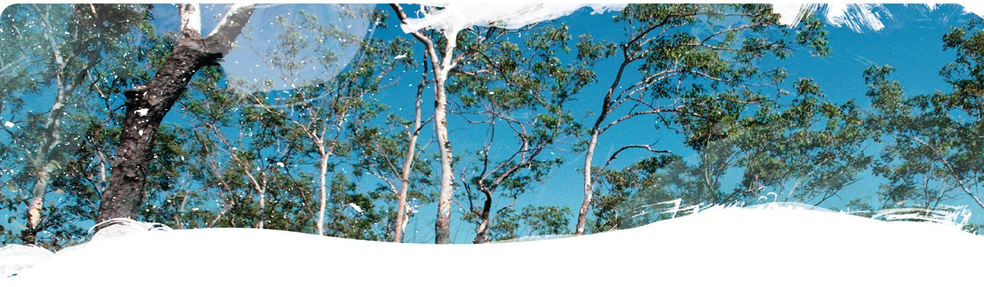Fact sheet 11  
Environmental fate of hydraulic fracturing chemicals

Scientific investigations are ongoing to improve understanding of the risks from unconventional gas resource development to water and the environment. We developed a generic risk assessment methodology to derive estimates of natural attenuation of chemicals associated with leakage to groundwater from accidental release of chemicals used for shale and tight gas exploration. Quantitative assessments of the environmental fate of hydraulic fracturing chemicals involved calculating leaching through the deep unsaturated zone of key landscape classes (Figure 1) and subsequent migration in surficial aquifers.

A generic groundwater risk assessment framework

Figure 1 Framework for calculating dilution factor maps

Framework consisting of 3 steps.
Step 1 shows conceptualisation underlying calculation of dilution factors from contaminated soil through contaminant leaching in unsaturated zone and then contaminant plume migration in groundwater to the receptor or well.
Step 2 shows example plots of dilution factors relative to groundwater pore velocity for different landscape classes.
Step 3 shows maps of landscape classes used to map dilution factors at a regional scale. Figure 1 outlines the framework for calculating dilution factor maps: Step 1 calculates a total dilution factor (DFT) by combining dilution in unsaturated zone (DFUZ) and groundwater (DFGW). In Step 2 total dilution factors are expressed per landscape class and groundwater velocity. Step 3 converts landscape classes and groundwater velocities into a dilution factor map used to assess risks to water and the environment.

The quantitative risk assessments accounted for key landscape parameters that determine natural attenuation of chemicals, namely: soil type, depth to groundwater and groundwater velocity. The framework was applied to both Beetaloo and Cooper GBA regions, by discretising their entire surface area into 1 by 1 km2 grids for which the unsaturated zone and groundwater dilution factors were derived (Figure 1).

The combined vadose zone (from the surface to the regional groundwater table) groundwater dilution factors were used to determine under which conditions concentrations of hydraulic fracturing chemicals or flowback water accidentally released into the environment would decrease to levels that are no longer considered harmful to the environment.

When the method was applied to 39 hydraulic fracturing chemicals scheduled for stimulation of a shale gas well, ecotoxicological risk quotients (RQ) were small enough (i.e. RQ <1) to indicate all but 2 chemicals were of no environmental concern. This work contributes to increasing the efficiency of quantitative impact assessments and provides a framework to develop effective monitoring and management practices to support regulation and management of the gas industry.

The GBA Program

The $35.4 million Geological and Bioregional Assessment (GBA) Program is assessing the potential impacts of unconventional gas resource development on water and the environment to inform regulatory frameworks and appropriate management approaches. The geological and environmental knowledge, data and tools produced by the GBA Program will assist governments, industry, land users and the community by informing decision making and enabling the coordinated management of potential impacts.

How to cite

Geological and Bioregional Assessment Program (2021) Fact sheet 11: Environmental fate of hydraulic fracturing chemicals [online document]. Fact sheet for the Geological and Bioregional Assessment Program.

Find out more

* Journal paper: Mallants D, Doble R and Beiraghdar Y (2021) Fate and transport modelling framework for assessing risks to soil and groundwater from chemicals accidentally released during surface operations: Example application from shale gas developments. In review. Journal of Hydrology.

Datasets that support this work are available at [data.gov.au](https://www.data.gov.au):

* Geological and Bioregional Assessment Program (2021) [Contaminant screening modelling](https://data.gov.au/data/dataset/d5bd13f6-beea-4fd5-8289-62ae9408ca16) [data]**.**

More information is available at [bioregionalassessments.gov.au/gba](https://www.bioregionalassessments.gov.au/gba).