Aboriginal Cultural Water Values
– Clarence-Moreton (Queensland) bioregion
A report for the Bioregional Assessment Programme
Researched and prepared by Corporate Culcha for the
the Department for the Environment

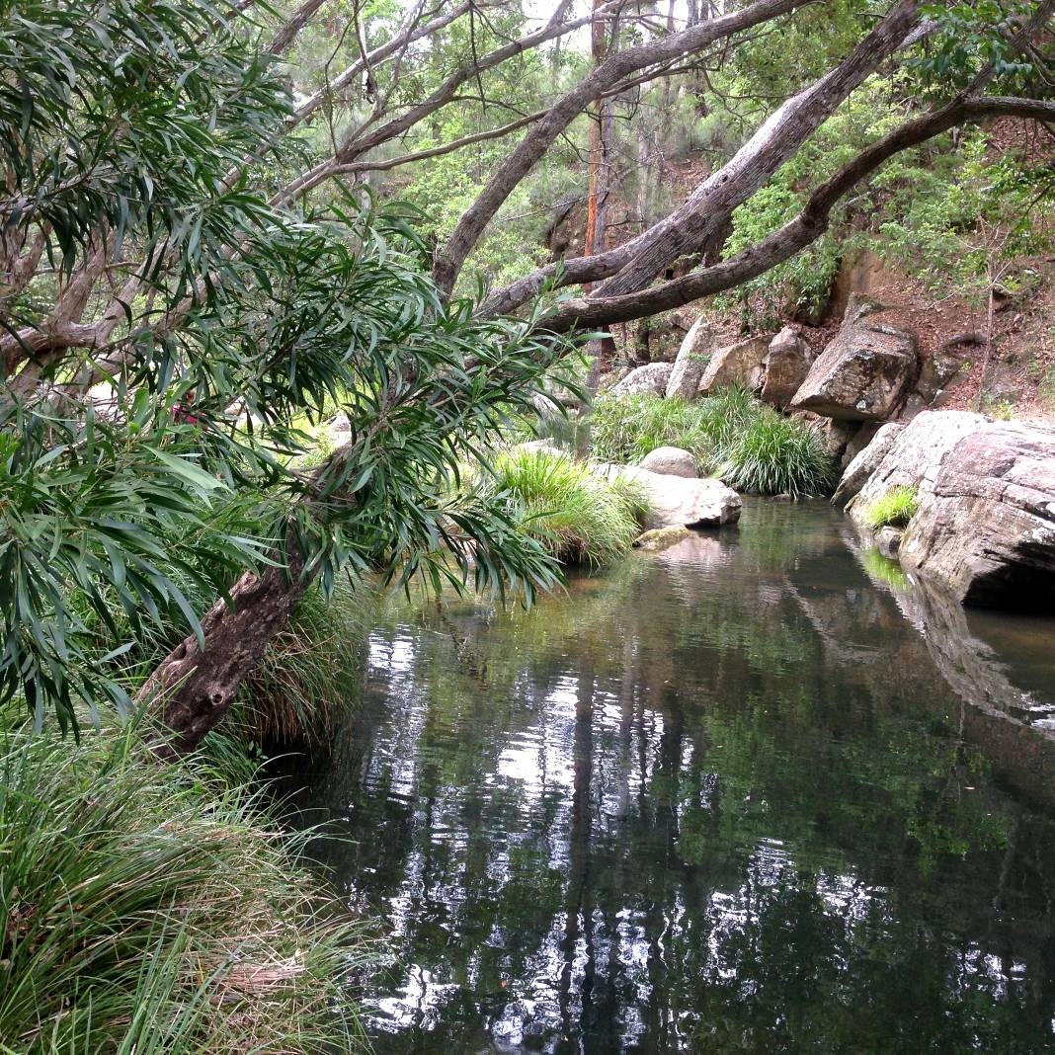

Corporate Culcha
Corporate Culcha is an Aboriginal owned and operated consultancy practice specialising in engagement with Aboriginal and Torres Strait Islander organisations and communities. Corporate Culcha works with a range of Indigenous and non-Indigenous consultants, many of whom are leaders in their individual fields. Access to this pool of expertise, allows Corporate Culcha to deliver a diverse range of services to their clients including research and evaluation, cultural capability programs and education, mentoring and capacity building.

Lead Researcher and Author
Janis Constable is a well-regarded Indigenous research consultant with extensive social research and program evaluation expertise, built on senior policy and research roles for federal and state governments. Janis has been a senior advisor to two federal Aboriginal and Torres Strait Islander Social Justice Commissioners on Indigenous human rights issues where she led a number of national research projects. As a freelance research consultant Janis has undertaken a number of key strategic research projects focussing on improved social and economic outcomes for Aboriginal and Torres Strait Islander peoples.

Mapping
Karen Love has extensive experience in ecological restoration, specialising in high conservation areas with bio-diverse vegetation. Her roles have incorporated advanced flora and fauna monitoring, ecological assessments and spatial mapping. Working alongside state and within local government agencies Karen has delivered a range of services, including scientific monitoring, program evaluation, strategy development and water education advice.

Citation
Constable, J. and Love, K. (2015) Aboriginal water values Clarence-Moreton bioregion (Qld), a report for the Bioregional Assessment Programme.
Copyright
 © Commonwealth of Australia 2015
All material in this publication except for information sourced from the Native Title Report 2008, is provided under a Creative Commons Attribution 3.0 Australia Licence <http://www.creativecommons.org/licenses/by/3.0/au/deed.en>.

Disclaimer
The views and opinions expressed in this publication are those of the authors and do not necessarily reflect those of the Australian Government or the Minister for the Environment.
While reasonable efforts have been made to ensure that the contents of this publication are factually correct, the Commonwealth does not accept responsibility for the accuracy or completeness of the contents, and shall not be liable for any loss or damage that may be occasioned directly or indirectly through the use of, or reliance on, the contents of this publication.
Cover photograph – Logan River (Source: K. Love 2015)

Acknowledgement of Traditional Owners
Acknowledgement is paid to Aboriginal and Torres Strait Islander peoples past, present and future. We acknowledge the unique relationship that Aboriginal and Torres Strait Islander people have with their traditional lands and waters, as well as their history and diverse cultures and customs. We thank all Aboriginal people who have shared their knowledge and time so generously, without their participation this report would not have been possible.

Terms for Aboriginal and Torres Strait Islander
For the purposes of this report, the terms ‘Aboriginal people’, ‘Aboriginal and Torres Strait Islander people’ and ‘Indigenous’ are used interchangeably to refer to Aboriginal and Torres Strait Islander peoples of Australia. However, we recognise that this approach is not without contention. Aboriginal and Torres Strait Islander people generally prefer the use of Aboriginal as opposed to Indigenous. Indigenous is deemed a formal term often used by governments as inclusive of all Aboriginal and Torres Strait Islander peoples.

As this report reflects the cultural water values of Aboriginal people of the Clarence-Moreton bioregion, we will refer to either Aboriginal people or their distinct groups i.e. Turbal, Jagera. The report also employs the term Indigenous when referring to relevant government programmes, policies or resources.

1. Introduction 6
2. Methodology 7
2.1 Desktop research 7
2.2 Community Engagement 8
2.3 Mapping Methodology 9
3. The Clarence-Moreton bioregion 10
3.1 Aboriginal people of the Clarence-Moreton bioregion 11
4. Consultation outcomes – values and assets 12
4.1 Categorising cultural assets 12
4.2 Registered Cultural Heritage Sites 13
4.2.1 Bremer River 13
4.2.2 Coomera River 13
4.2.3 Lockyer Creek 13
4.2.4 Logan River 13
4.2.5 Albert River 14
4.3 Cultural Water Assets Identified 15
4.3.1 Aboriginal Cultural Water Assets, Clarence Moreton-basin 15
4.4 Accompanying narratives 16
The Warrajum 16
Fishes Waterhole (CM1) 16
Purga Mission (CM2) 16
Bundamba Lagoon (CM3) 16
Woollaman Creek (CM4) 17
Bromelton House Lagoon (CM5) 19
Bunyip Lagoon (CM6) 19
Sandy Creek (CM7) 19
Dahgulumba (Logan) River (CM8) and Lake Maroon (CM9) 19
Minjellah-Dahgum (Happy Place) (CM10) 19
Kaiee (Mt Barney) (CM11) 20
A River story 20
5. Summary 21
6. References 22
7. Appendix 22
Appendix 1 – Consultation participants 22

List of tables, maps and photographs

Figure 1: Clarence-Moreton bioregion (Source: Context statement for the Clarence-Moreton bioregion) 10
Figure 2: Woollaman Creek (Source: K. Love 2015) 17
Figure 3: Woollaman Creek, cooking holes (Source: K. Love 2015) 18
Figure 4: Woollaman Creek, cooking hole (Source: K. Love 2015) 18
Figure 5: Minjellah-Dahgum (Source: K.Love 2015) 19
Figure 6: Kaiee (Mt Barney) (Source: K. Love 2015) 20

Table 1: Indigenous Population of Major Population centres located in Clarence-Moreton bioregion 11

1. Introduction
The term ‘Aboriginal water values’ is used to describe the relationship between Aboriginal and Torres Strait Islander peoples and water and the importance of water and water-dependent resources. Aboriginal and Torres Strait Islander people’s relationship with water is intrinsic in nature, with water not only being fundamental for survival, but an indivisible, interwoven and central element of cultural and spiritual life.

Tom Calma, former Aboriginal and Torres Strait Islander Social Justice Commissioner wrote:

Indigenous peoples are connected to and responsible for our lands and waters and in turn, Indigenous peoples obtain and maintain our spiritual and cultural identity, life and livelihoods from our lands, waters and resources. These cultural and customary rights and responsibilities include:

- a spiritual connection to lands, waters and natural resources associated with water places
- management of significant sites located along river banks, on and in the river beds, and sites and stories associated with the water and natural resources located in the rivers and their tributaries, and the sea
- protection of Indigenous cultural heritage and knowledge associated with water and water places
- access to cultural activities such as hunting and fishing, and ceremony.

As custodians of water resources on country, Aboriginal people have a significant interest in the way water is shared and used on country, and an important role in monitoring potential impacts of activities that may effect water quality and/or the health of flora and fauna that rely on specific water resources.

This report provides the data collected through community consultation for the Aboriginal Water Values Project, which will be used to inform the bioregional assessment for the Clarence-Moreton bioregion. The report includes a description of the methodology employed; an overview of the Indigenous peoples of the Clarence-Moreton bioregion; description of the data collected, including narratives associated with each identified water asset. Accompanying this report is an Asset Register, which provides spatial data; aligned cultural values; associated Aboriginal language groups and a brief description for each identified water and water dependent asset.

Researchers from Corporate Culcha have conducted community consultations with Aboriginal Communities in the Queensland side of the Clarence-Moreton bioregion boundary. Aboriginal water values in NSW will be captured in a report prepared by the NSW Office of Water through the Aboriginal Water Initiative.

The Australian Government is undertaking a programme of bioregional assessments in order to better understand the potential impacts of coal seam gas and large coal mining developments on water resources and water-dependent assets. The Bioregional Assessment Programme draws on the best available scientific information and knowledge from many sources, including government, industry and regional communities, to produce bioregional assessments that are independent, scientifically robust, relevant and meaningful at a regional scale.

The Programme is a collaboration between the Department of the Environment, the Bureau of Meteorology, CSIRO and Geoscience Australia. The Programme is seeking input from the Aboriginal community on water-dependent cultural values (also referred to as assets). For more information, visit http://www.bioregionalassessments.gov.au.

2. Methodology
This section provides details on the following methodology employed throughout the project.

The methodology for this project included:

- Desktop research:
  - Relevant reports
  - Investigate current discourse on Aboriginal Cultural Water Values
  - Identify relevant Aboriginal people and organisations
- Contact above identified individuals and organisations:
  - Introduce the project and the researchers
  - Discuss involvement in project
  - Arrange visit
- Initial field visits:
  - Face to face discussions and provide information
  - Identify other potential participants (Elders, knowledge holders)
  - Arrange next visit
- Second field visit:
  - Obtain consent
  - Commence data collection on site
    - Identifying locations of assets
    - Record special data (GPS mapping)
    - Interview knowledge holder
- Third field visit:
  - Continue and finalise data collection on site
  - Record spatial data
- Analyse data:
  - Record location data on asset register
  - Document associated narratives for assets
- Write report and obtain endorsement from participants.

2.1 Desktop research
Desktop research was undertaken to gain an initial understanding of, and to identify:
- publically available data
- current discourse on Aboriginal cultural water values
- key stakeholders (organisations and individuals)

Publications were identified which assisted in understanding relevant issues pertinent to the region and Aboriginal cultural water values generally. The reports and websites sourced indicate significant activity in relation to Aboriginal communities and water – specifically in relation to conservation and water sharing plans.

2.2 Community Engagement
Initial discussions were held with Traditional Owner groups providing an opportunity to discuss the objectives of the project with key stakeholders. These meetings also provided an opportunity to obtain contact details for other significant community members, with face-to-face or telephone meetings being arranged with those people soon thereafter.

Stakeholders were assured the process for gathering the data would be undertaken respectfully, with cultural safety as a priority. Information about the impetus of the broader Bioregional Assessment Programme, and the proposed use of the data collected through it, including the Aboriginal cultural water values mapping, was described as forming but one layer, of many layers of baseline data that will be assembled, to develop a comprehensive map of the Clarence-Moreton bioregion. The results will enable improved decision making in relation to coal mining and coal seam gas. Stakeholders were advised that maps and reports developed, as a result of this research, would be available to them as a community resource.

Stakeholders were also advised their participation was voluntary and no adverse action would occur if the group chose not to participate, and they could withdraw consent at any stage of the research process.

Unstructured interviews were undertaken with participants, as well as note taking by the interviewer. In some instances photographs were taken, with permission, of the sites.

Aboriginal organisations consulted in Queensland in the Clarence-Moreton bioregion were:

- Ngaran Goori (Jagera)
- Ugarapul Traditional Owners
- Turbal People Redland Bay
- Western Waka Waka group
- Mununjali Aboriginal Elders Group

The following groups located in Queensland were also invited to participate in the research, however no appropriate representatives were available to meet with the researchers within the consultation period.

- Yugambeh Land Enterprises Beaudesert
- Kombumerri Aboriginal Corporation
- Goolburri Aboriginal Corporation
- Munanjal
- Quandamooka peoples
- Waka Waka Elders
- Kurbungui

Other key groups consulted about the research in Queensland were:

- Queensland South Native Title Services
- Department of Aboriginal and Torres Strait Islander Partnerships, Cultural Heritage Unit

2.3 Mapping Methodology
In all instances mapping on country utilised Motion X-GPS and coordinates were cross-referenced with maps downloaded into the Avenza Maps PDF application. Maps used were Geoscience Australia and State of Queensland Wetland maps with datum GDA94. Remote mapping was done using the same system with GPS coordinates obtained on country as the reference point.

The Clarence-Moreton bioregion
The Clarence-Moreton bioregion is located in the northeast New South Wales (around Lismore and Grafton) and in the southeast of Queensland. The basin covers 16000 square kilometers.

Only those sections of the Clarence river basin and Brisbane river basin, which overlap with the Clarence-Moreton Basin, are part of the Clarence-Moreton bioregion. This research project only covered the Queensland side of the bioregion.

Major population centres located in the bioregion in Queensland are:

- Ipswich
- Lockyer Valley
- Logan City
- Scenic Rim
- Southern Downs

Figure 1: Clarence-Moreton bioregion (Source: Context statement for the Clarence-Moreton bioregion)

Aboriginal people of the Clarence-Moreton bioregion
The Aboriginal and Torres Strait Islander population of the Clarence-Moreton bioregion is difficult to accurately assess, as the bioregion partially encompasses several statistical regions.

The following table is provided as an approximation of the Indigenous population of the Clarence-Moreton bioregion only.

Table 1: Indigenous Population of Major Population centres located in Clarence-Moreton bioregion

Statistical area | Indigenous Pop. | Total Pop. | % Indigenous Pop
Beaudesert | 611 | 12,380 | 4.9
Gold Coast Hinterland | 208 | 17,136 | 1.2
Ipswich | 9,992 | 281,791 | 3.5
Lockyer Valley | 424 | 17,694 | 2.3
Scenic Rim | 613 | 12,523 | 4.8
Logan | 259 | 6,262 | 4.1
Toowoomba (statistical area covers part of the Clarence-Morton bioregion and also the Maranoa-Balonne-Condamine subregion) | 4,734 | 140,220 | 3.3
Total | 16,841 | 488,006 | 3.4

The number of people belonging to Traditional Owner groups included in these figures is unknown, as tribal identities are not counted in the Census. The diaspora of Aboriginal people post-colonisation has resulted in many Aboriginal people not formally residing on traditional country, however many Aboriginal people maintain strong ties to their homelands.

4. Consultation outcomes – values and assets

Preliminary discussions were had with representatives from Jagera, Mununjal, Turbal and Ugarapul Traditional Owner groups of the region. Efforts were made to consult with other Traditional Owner groups in the region, however for a range of reasons (i.e. illness; non-responsive to requests for a meeting; unable to identify relevant knowledge holders) researchers were not able to meet with appropriate representatives from the other groups.

For those groups initially agreeing to participate, only one group, the Ugarapul were able to facilitate an, ‘on country’ field trip with researchers within the project’s timeframe. Consultations with Traditional Owners from Turbal revealed their cultural assets were located outside the bioregion’s parameters.

The following section summarises the fieldwork undertaken with the Ugarapul knowledge holders. The cultural values identified pertain to customary and spiritual associations, ecological value - relating to fish and animal species, or economic value in terms of fishing, water-reliant bush foods and current or potential economic development opportunities. However, the overarching cultural value is based on the principle that water is vital to the wellbeing of every living thing – people, animals, plants, earth and air.

4.1 Categorising cultural assets
The assets identified here are of cultural significance to the Ugarapul people of the Clarence-Moreton bioregion, the values, purpose and meaning attached to each asset has been identified through consultation. Most assets have more than one value attached, for example a creek bed being a place of ceremony as well as a place where food can be harvested.

The purpose and meaning of cultural water assets have been categorised into the following groups:

- Customary – ceremony, meeting place, men’s business, women’s business, totems, dance, rites, song, birth, death)
- Spiritual (dreaming, stories, song lines)
- Ecological (flora and fauna)
- Economic (trade routes, food source – fishing/hunting, employment/income – tourism, farming)
- Recreational – family gatherings, swimming holes

The total number of Aboriginal cultural water assets in the Clarence-Moreton bioregion detailed in this report is not exhaustive. What was provided was a sample of the cultural assets that have been able to be mapped within the available timeframes and their associated value to Aboriginal people of the region.

4.2 Registered Cultural Heritage Sites
The Queensland Government’s Department of Aboriginal and Torres Strait Islander Policy maintains an Indigenous Cultural Heritage Register, comprising data for over forty thousand cultural heritage assets across the state. Researchers approached the Cultural Heritage Registrar seeking assistance in identifying water dependent assets within the Clarence-Moreton bioregion.

The five major rivers / creeks (listed below) on the Queensland side of the Clarence-Moreton bioregion were used to search for water dependent cultural heritage sites, previously recorded with the Cultural Heritage Register, Queensland Department of Aboriginal and Torres Strait Islander Policy. Shape files supplied by the Environmental Resources Information Network (ERIN) Science Division of the Department of Environment utilised a 100 metre buffer on each side of specific water bodies for the search.

For more details to be provided on each asset, consent is required from the registered parties. As consent has not been obtained within the project’s timeframe, the information provided below is limited to indicating the number of recorded Indigenous cultural heritage assets for each river.

4.2.1 Bremer River
Four recorded sites were located within 100 metres of the Bremer River including one cultural site/story place. The statutory Aboriginal party for this area is Jagera peoples.

4.2.2 Coomera River
The headwaters of the Coomera River fall inside the bioregion boundaries and ten sites are recorded within 100 metres of the river. Of these, six sites are within the statutory Aboriginal party area of the Gold Coast Native Title Group. (Yugambeh / Kombumerri peoples). The remaining sites are within an area that does not have any statutory Aboriginal party or registered cultural heritage body under the Aboriginal cultural heritage legislation.

4.2.3 Lockyer Creek
There are seven registered sites located within the 100 metre buffer along Lockyer Creek, including one cultural site. All sites are within the statutory Aboriginal party area of Jagera peoples.

4.2.4 Logan River
Recorded sites along the Logan River include four artefact scatters within the area covered by Gold Coast Native Title Group (Yugambeh / Kombumerri peoples), and one artefact scatter is in the area of the Jagera peoples. The remaining five sites lie within areas that do not currently have any statutory Aboriginal party or registered cultural heritage body under the Aboriginal cultural heritage legislation. Aboriginal parties with a potential interest in these areas include:

- Githabul
- Gold Coast Native Title Group (Yugambeh / Kombumerri)
- Jagera

4.2.5 Albert River
There are 11 recorded sites within the 100 metre buffer along the Albert River. One of these sites is within the area covered by Gold Coast Native Title Group (Yugambeh / Kombumerri) and the remainder lie within areas that do not currently have any statutory Aboriginal party or registered cultural heritage body under the Aboriginal cultural heritage legislation.

4.3 Cultural Water Assets Identified
The following table contains data collected through consultation with knowledge holders Aboriginal people with knowledge and connection to the Clarence-Moreton bioregion.

The assets listed in the table below are also being considered as part of a tourism trail, which when developed will be an important economic asset to the Ugarapul people.

4.3.1 Aboriginal Cultural Water Assets, Clarence-Moreton basin

ID | Name | Aboriginal Name | Type | Group | Value | Description
CM1 | Teviot Brook | Fishes Waterhole | Waterhole | Ugarapul | Spiritual | Warrajum breathing hole/traditional camp ground/fishing
CM2 | Purga Mission |  | Creek | Ugarapul | Spiritual | Warrajum breathing hole/old mission site/fishing
CM3 | Bundamba Lagoon |  | Lagoon | Ugarapul | Spiritual | Sacred Lagoon / Warrajum breathing hole / Child story
CM4 | Woollaman Creek |  | Creek | Ugarapul | Spiritual | Sacred woman's business / Birthing place / cooking place (in holes along the bank)
CM5 | Bromelton House Lagoon |  | Lagoon | Ugarapul | Spiritual | Warrajum breathing hole / Sacred lagoon / sink hole
CM6 | Bunyip Lagoon |  | Lagoon | Ugarapul | Spiritual | Warragum resides here / Bora ring
CM7 | Sandy Creek |  | Creek | Ugarapul | Customary | Traditional Ugarapul community
CM8 | Logan River | Dahgulumba River | River | Ugarapul | Spiritual | Creation story of Lake Moroon mountain
CM9 | Lake Maroon |  | Lake | Ugarapul | Spiritual | Creation story of the mountain and resting place of Walmaroo (sand goanna) Warrajum resides there.
CM10 | Minjellah-Dahgum |  | River | Ugarapul | Customary | Property owned and operated by local Aboriginal People / name means Happy Place
CM11 | Mt Barney | Kaiee | River | Ugarapul | Spiritual | Women's place/Kaiee is a keeper of the Lore/headwater of Dahgulumba

4.4 Accompanying narratives
John Long, Ugarapal knowledge holder, provided the following narratives.

The Warrajum
Stories were passed down to us about the Warrajum (Bunyip) by our parents, grandparents and great grandparents. Our traditional Ugarapul people witnessed the Warrajum as it occasionally surfaced from the depth of the deep lagoons within the Coochin Valley. Coochin is the English pronunciation for “Goodgeen” which is an Ugarapul word that means ‘red’.

The Warrajum had a purpose in the life of our traditional Ugarapul people and could be either male or female. It maintained discipline in the waterways to make sure everyone abided by the rules of hunting as well as to not destroy what was given to us by the creator for the purpose of survival. It is a physical creature with a spiritual purpose.

The Warrajum protects the waters and keeps it clean, it travels underground and you can hear it moving – it sounds like thunder when it moves along the mountains, what we call Woombal woombal. The Warrajum keeps you humble it represents honesty and respect.

Fishes Waterhole (CM1)
John Long explains:

We used to camp here and fish here but we weren’t allowed to swim – it’s sacred. It’s where the Warrajum comes up to breathe. My father told me about it so we never went into the water. I heard the Warrajum here, I heard the bubbling and it sounded like a whale coming up for a breath when it pushes out the water.

The water here has all changed since they put that dam (Wyaralong) upstream. Now there aren’t any fish – it’s like the water is dead, not healthy. There’s been a lot of algae and all the fish have disappeared.

If the water isn’t healthy then the people get sick. You can’t separate the spiritual and physical, everything’s connected. If they poison the water, then everyone will be ill as well as the trees and the earth.

Purga Mission (CM2)
The mission is on the creek and my Mum and Dad were here for a bit, but there is also another place where the Warrajum comes up for a breath so we only fish here and don’t go into the water. It’s part of the Warrajum route. (John Long, Ugarapal Elder)

Bundamba Lagoon (CM3)
There have been sightings of the Warrajum here and a story told of a woman fishing who bought up a live baby out of the Lagoon. This is a sacred lagoon even though we can’t access it now (on private property). (John Long, Ugarapal Elder)

Woollaman Creek (CM4)
This is a woman’s place, a place where women would come to give birth. It was also a place where they would cook in the depressions (rock pools). We would also play in the pools as children. (John Long, Ugarapal Elder)

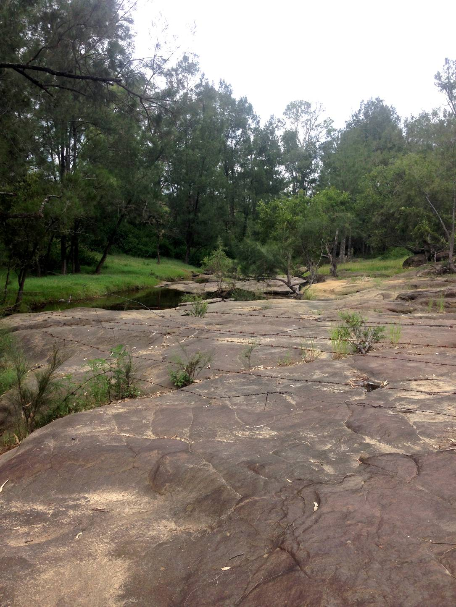

Figure 2: Woollaman Creek (Source: K. Love 2015)
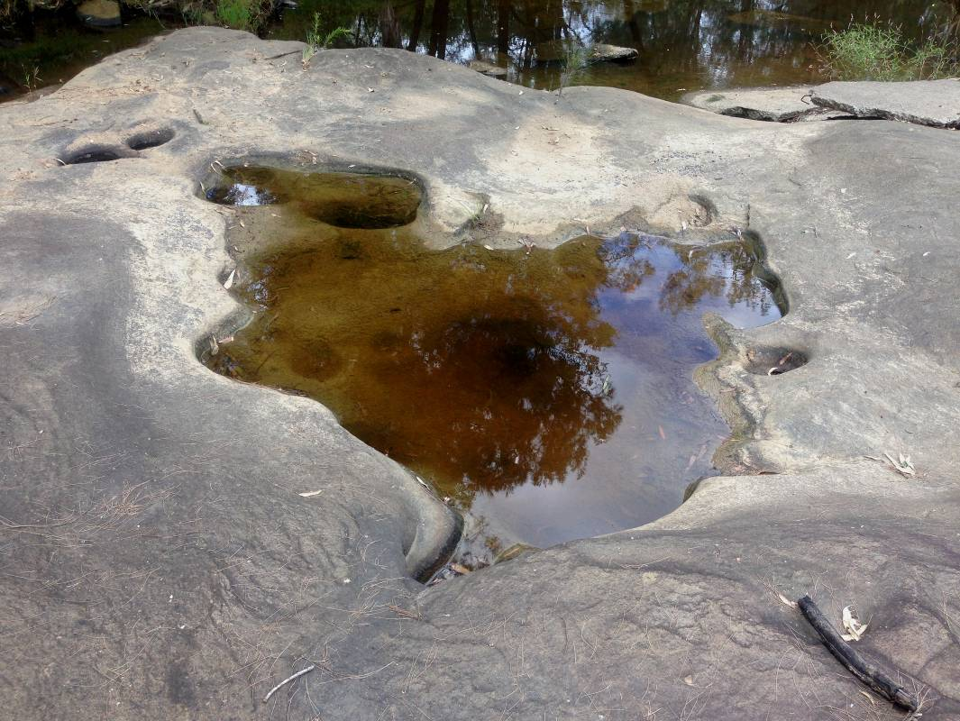
Figure 3: Woollaman Creek, cooking holes (Source: K. Love 2015)

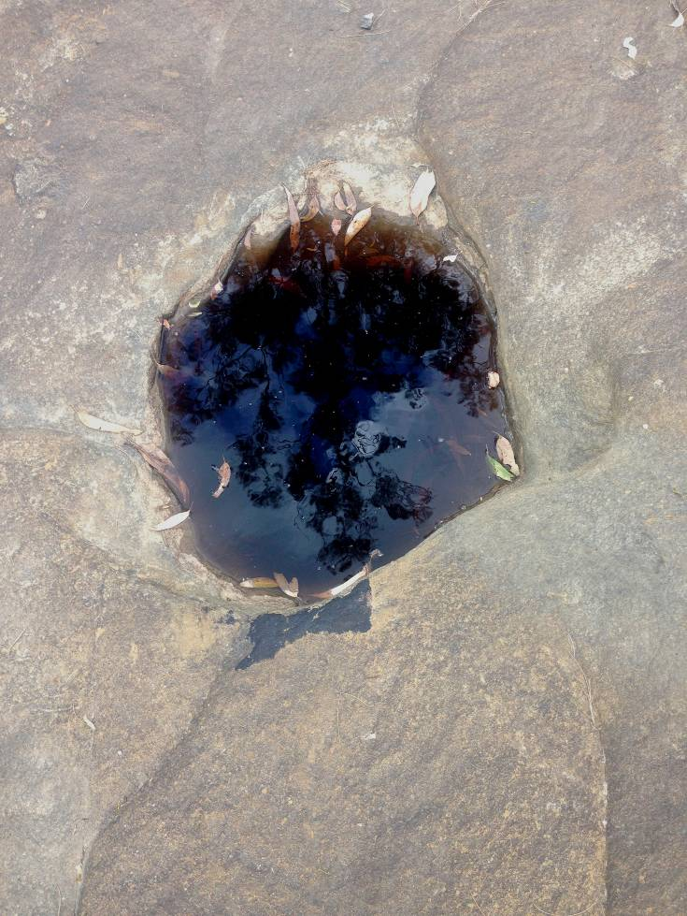

Figure 4: Woollaman Creek, cooking hole (Source: K. Love 2015)

Bromelton House Lagoon (CM5)
This is a sacred Lagoon and the Warrajum comes up to breath here. They say it’s very deep, a sinkhole – no one is sure how deep it is. It’s part of the Warrajum route. (John Long, Ugarapal Elder)

Bunyip Lagoon (CM6)
This is where the Warrajum resides. They tried to fill it in but my brother and I stopped them. This place is very important to us, as there is a Bora ring here right next to the lagoon. (John Long, Ugarapal Elder)

Sandy Creek (CM7)
I grew up traditionally up there in the hills on Sandy Creek. We were taught you should look after the earth the same way you look after your body. The earth is like your skin and the grass is like hair. The water is the arteries and trees are the veins. (John Long, Ugarapal Elder)

Dahgulumba (Logan) River (CM8) and Lake Maroon (CM9)
The salt-water animals and the fresh water animals had a big fight on the Dahgulumba River. The salt-water animals were coming inland and encroaching on the fresh water animals’ country. So they fought and the fresh water animals won. You can see where Walmaroo (Sand Goanna) died over by Lake Maroon; he is the mountain there.

This is also another place where Warrajum comes up to breath. The Warrajum in there is so big; it breaks all the fishing lines and even rope!

We want to re-name the Logan River to Dahgulumba, because Logan killed a lot of our people – him and Flinders. So it shouldn’t be the Logan River, it’s Dahgulumba. (John Long, Ugarapal Elder)

Minjellah-Dahgum (Happy Place) (CM10)
Minjellah-Dahgum is a 1000 acre property (see picture below) that is owned and operated by local Aboriginal people. The idea is to bring people here for healing and spiritual learning. It is on the banks of the Dahgulumba (Logan) River at the base of Kaiee (Mt Barney) and backs onto Mt Barney National Park. (John Long, Ugarapal Elder)

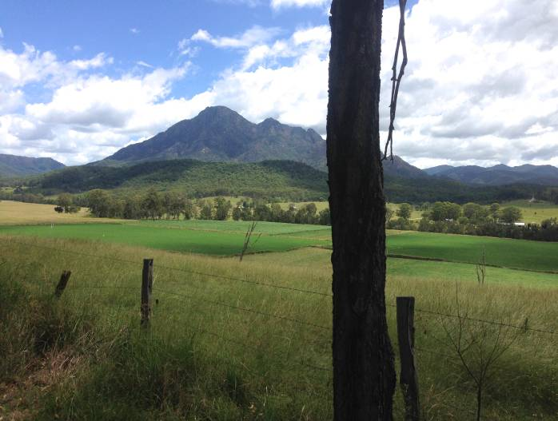
Figure 5: Minjellah-Dahgum (Source: K. Love 2015)

Kaiee (Mt Barney) (CM11)
Kaiee means ‘wait for me (you are going too fast)’. This is a women’s place and Kaiee is lying down, so you can see she is a pregnant woman waiting in profile (see below) - she is a keeper of the Lore. The headwaters of Dahgulumba are on her flank. (John Long, Ugarapal Elder)

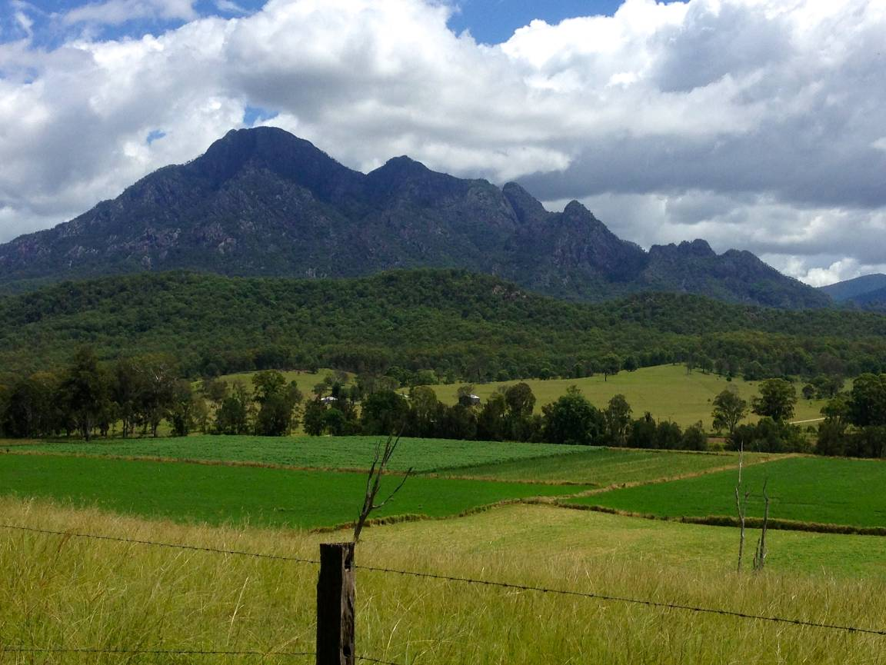
Figure 6: Kaiee (Mt Barney) (Source: K. Love 2015)

A River story
During Nuddabah (ancient times) there was a happy tribe that had 1000 warriors defending them. The warriors had to go away somewhere else to fight and left the tribe, thinking they would be safe. While the warriors were away, a stranger came into the camp. A wise man was watching over the camp and noticed this stranger from a distance. While he was watching, he noticed she started whispering into people’s ears and the people began to have arguments and started fighting with each other. So the wise man sent for a messenger boy and told the boy to go quickly to find the warriors and bring them back to the camp.

The warriors came back and saw the stranger in the camp from a hilltop, but when she realised the warriors had returned she fled. The warriors chased her all the way to the river and because she didn’t like water she didn’t cross and was caught. The warriors threw their spears at her and she had 1000 spears in her back. She crawled into the river and they could see her under the water because of all of the spears. When she got to the other side of the river, she had turned into an echidna.

Summary

The identified water assets and the narratives connected with those assets although limited to one Traditional Owner group, the Ugarapal, exemplifies the rich and ancient connection between Aboriginal people and water. The creation stories of water Warrajum and Walmaroo represent the unique spiritual and cultural links local Aboriginal groups have with rivers in the region, and further, the importance of water remaining healthy and accessible. Many of the water resources were unable to be accessed due to them now being on private property, with other water resources being destroyed or negatively impacted by infrastructure or industry i.e. weirs, agricultural run-off etc. Some people researchers spoke with throughout the consultative process for this report voiced their concerns about the impact on precious water resources by coal seam gas exploration, and other mining activities.

More positively however, the Ugarapal people are currently exploring the benefits of developing the Indigenous walking trail of the Scenic Rim, as a tourism venture. The trail will include the Ugarapal assets identified in this report and could potentially be an important economic asset insofar as providing employment opportunities, as well as a source of revenue for the community.

The poor engagement outcomes with other groups in the region exemplifies the importance of having adequate time to develop relationships with Aboriginal people, so as to create trust between the group and the researchers, engender an understanding of the purpose and process of the research, and identify capacity building opportunities research activities can deliver to the community. This is especially so when the nature of the research relies on Aboriginal people (and in this case Elders and knowledge holders) to share their stories and knowledge for what is a government sponsored research project, and although the researchers are themselves Indigenous does not guarantee immediate trust.

Nevertheless, with the assistance of the Cultural Heritage Registrar (DATSIP) water and water dependent assets were identified, and although consent was not garnered to use the location details of this data, it does indicate that there are many assets that could be added to the bioregional assessment asset register if consent is granted in the future.

6. References

Australian Bureau of Statistics, 2011 Census of Population and Housing, Aboriginal and Torres Strait Islander Peoples (Indigenous) Profile (Cat. No. 2002.0) – for Beaudesert; Gold Coast Hinterland; Ipswich; Lockyer Valley; Nerang; Warwick; Scenic Rim; Logan and Toowoomba.

Calma T. (2008) Aboriginal and Torres Strait Islander Social Justice Commissioner, Native Title Report 2008, Chapter 6 – Indigenous Peoples and Water, Human Rights and Equal Opportunity Commission, Sydney.

Rassam D, Raiber M, McJannet D, Janardhanan S, Murray J, Gilfedder M, Cui T, Matveev V, Doody T, Hodgen M and Ahmad ME (2014) Context statement for the Clarence-Moreton bioregion. Product 1.1 from the Clarence-Moreton Bioregional Assessment. Department of the Environment, Bureau of Meteorology, CSIRO and Geoscience Australia, Australia.

7. Appendix

Appendix 1 – Consultation participants

Name | Organisation
Robyn Currie | Yugambeh Land Enterprises Beaudesert
Sharon McAvoy | Queensland South Native Title Services
Louisa Bonner | Ngaran Goori
George Currie | Mununjal
Ken Markwell | Mununjal
Maroochy Baramba | Turrbal People
Margaret McCleod | Western Waka Waka
John Long | Ugarapal
Brett Leavy | Immersive Heritage Specialist
Louise Orr | SEQ Catchments - Community Partnerships
Jill Farrell | DATISMA Cultural Heritage Unit
Stephen Nichols | Director, Cultural Heritage Unit, DATISMA Brisbane

Calma T. (2008) Aboriginal and Torres Strait Islander Social Justice Commissioner, Native Title Report 2008, Chapter 6 – Indigenous Peoples and Water, Human Rights and Equal Opportunity Commission, Sydney.
The final summary report will be prepared at the conclusion of all bioregion research and subsequent reports. It will provide an overarching analysis of the project.
Australian Bureau of Statistics, 2011 Census of Population and Housing, Aboriginal and Torres Strait Islander Peoples (Indigenous) Profile (Cat. No. 2002.0) – for Beaudesert; Gold Coast Hinterland; Ipswich; Lockyer Valley; Nerang; Warwick; Scenic Rim; Logan and Toowoomba.
See Appendix 2 for full list of consultation participants.
A shape file stores nontopological geometry and attribute information for the spatial features in a data set. The geometry for a feature is stored as a shape comprising a set of vector coordinates. (Source: Environmental Systems Research Institute)

