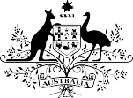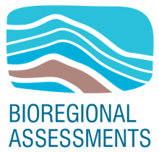**The GBA Program**



The Geological and Bioregional Assessment (GBA) Program is assessing the potential environmental impacts of shale and tight gas development to inform regulatory frameworks and appropriate management approaches. The geological and environmental knowledge, data and tools produced by the GBA Program will assist governments, industry, landowners and the community by informing decision making and enabling the coordinated management of potential impacts.

A series of independent scientific studies in three geological basins – the Cooper Basin in Queensland and SA, the Isa Superbasin in Queensland and the Beetaloo Sub-basin in the NT – are being conducted by CSIRO and Geoscience Australia, supported by the Bureau

of Meteorology and managed by the Department of Agriculture, Water and the Environment. These scientific studies aim to provide baseline information that:

identifies and evaluates areas of high potential for shale and tight gas for future development and any potential connections with water resources

# Beetaloo GBA region

The Beetaloo GBA region (see figure below) is located about 500 km south of Darwin and is sparsely populated, with Daly Waters and Elliott the highest populated settlements. The Beetaloo GBA region

has been defined specifically for GBA purposes as the Sub-basin defined by the Northern Territory

Geological Survey and covers an area of about 28,000 km2 in the NT. An additional boundary - the Beetaloo GBA extended region, is used to allow potential environmental and hydrological impacts immediately adjacent to the Beetaloo GBA region to be investigated.

collates and summarises key information about geological structure, groundwater movement through geological layers, surface water systems and ecological systems

evaluates possible ways that unconventional gas resource development might impact the things we value, such

as the safety of communities, groundwaters, protected species, as well as culturally and ecologically important matters.

Katherine Mataranka

Numbulwar Ngukurr

**Beetaloo GBA extended region**

Daly Waters

**Beetaloo GBA region**

Ellio�

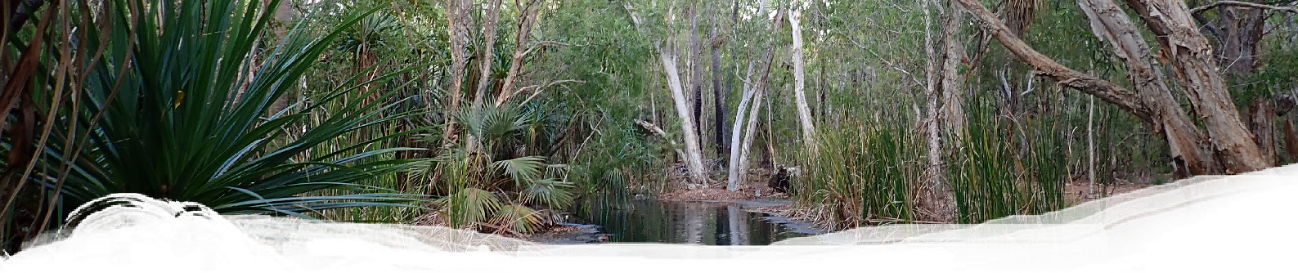



**Find out more**

[www.bioregionalassessments.gov.au/geological-and-bioregional-assessment-program](http://www.bioregionalassessments.gov.au/geological-and-bioregional-assessment-program)

Kilometers

0 25 50 100 150 200

# Beetaloo GBA region Baseline Survey Program

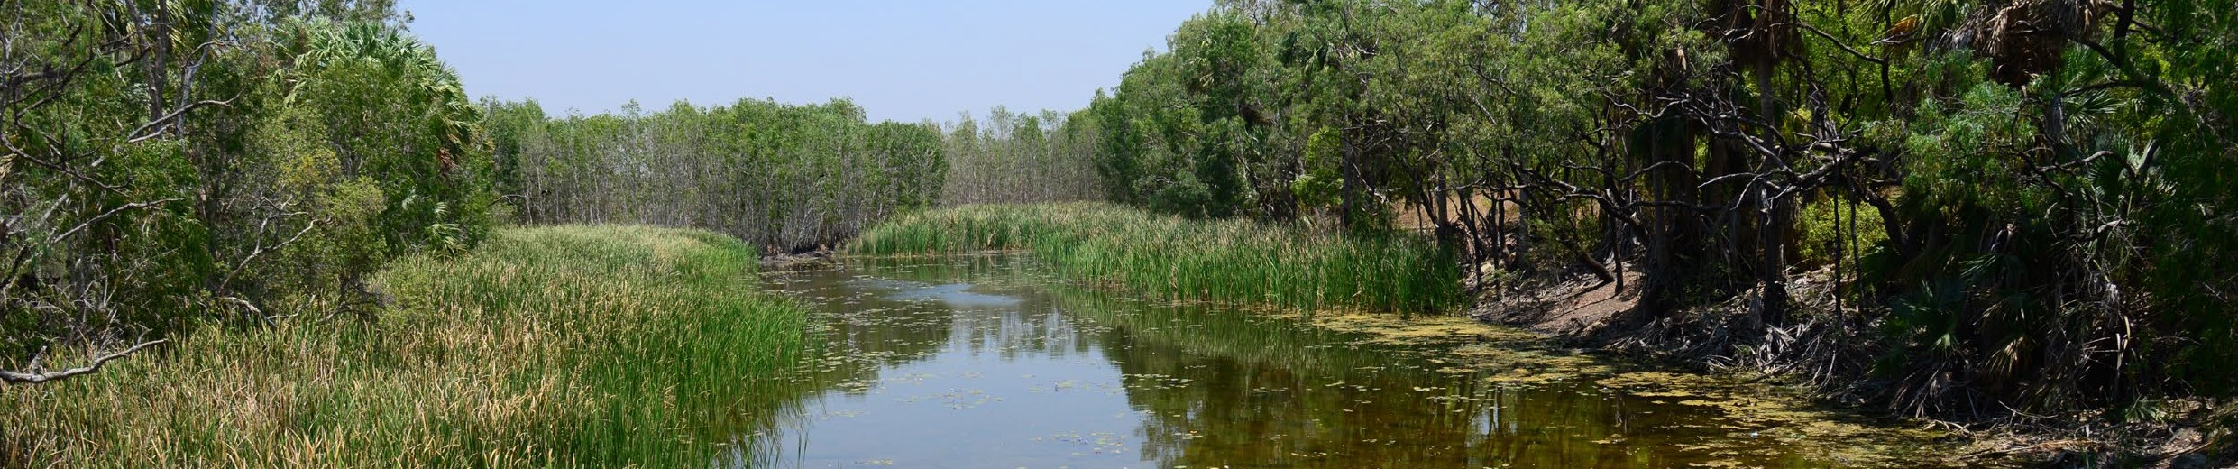

The objective of the Beetaloo GBA region Baseline Survey Program is to compile a comprehensive baseline dataset of terrestrial and aquatic biodiversity distribution in the region. These data can be used

as baseline information against which assessments of ecological change over time, including those in response to human activities, can be made.

The program is being delivered through the collaboration of researchers at Charles Darwin University (CDU), Griffith University (GU) and the NT Department of Environment and Natural Resources (DENR). The program has been developed in consultation with NT DENR to ensure that it informs the broader Strategic Regional Environmental and Baseline Assessment (SREBA) as recommended by the Scientific Inquiry into Hydraulic Fracturing in the Northern Territory.

The biodiversity of the Beetaloo GBA region is relatively understudied in comparison to other parts of Australia.

While this program cannot describe the entire range of environmental and ecological variability that exists

across the region, it does represent a very valuable first step in obtaining the biodiversity information needed to protect important species and ecosystems, and to develop the baseline against which ecological changes over time, and in response to human activities, can be assessed. To meet the requirements of SREBA, further studies are being planned by the Northern Territory Government to fully characterise terrestrial and aquatic biodiversity.

**We need your help**

With help from local communities, Traditional Owners, and pastoralists, the GBA Program is seeking permission to access and sample selected springs, streams, billabongs and waterholes across the region.

For more information, please contact: Dr. Erica Garcia [Erica.gar](mailto:Erica.garcia@cdu.edu.au)[cia@cdu.edu.au](mailto:cia@cdu.edu.au)

+61 8 89467445

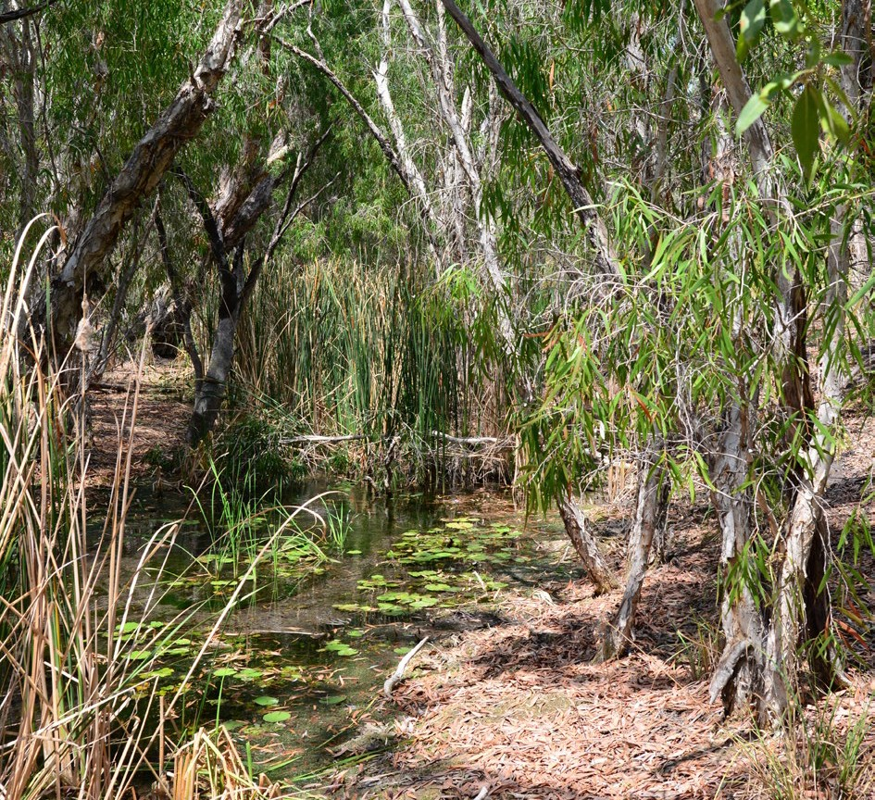

# Aquatic Biodiversity Baseline

**Field Survey**

Field observations and measurements of surface waters from properties across the Beetaloo GBA region will help the GBA Program and Northern Territory Government to better understand the region’s aquatic ecosystems and the flora and fauna that live within them.

Fieldwork and modelling, planned for 2020 and 2021, will address knowledge gaps related to two components:

1. Aquatic ecosystems, water quality, vegetation and fauna (fish, reptiles, amphibians and selected invertebrate groups)
2. Aquatic Ecological Protected Matters including models of predicted distributions based on survey records and habitat preferences of aquatic organisms.

We will employ a variety of trapping techniques such as cast nets, seine nets, fyke nets, dip nets, cathedral traps, angling, Direct Current (DC) electrofishing (both

boat mounted and backpack) to ensure that we capture a comprehensive and accurate list of species present

at a site. We will not employ all trapping techniques at all sites. We will also measure relevant environmental attributes at each site (including water body type,

size and depth, water quality, and riparian vegetation cover).