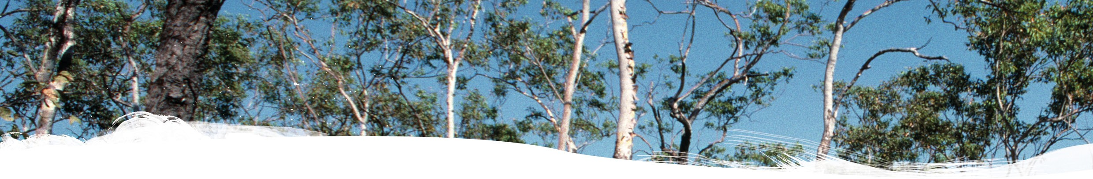

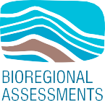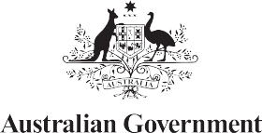Impact assessment for the Cooper GBA region



# Geological and Bioregional Assessment Program

The $35.4 million Geological and Bioregional Assessment (GBA) Program is assessing the potential impacts of shale and tight gas development on water and the environment. The geological and environmental knowledge, data and tools produced by the program will assist governments, industry, land users and the community by informing decision-making and enabling the coordinated management of potential impacts.

A series of independent scientific studies were conducted in 3 geological basins: the Cooper Basin in Queensland and South Australia, the Isa Superbasin in Queensland and the Beetaloo Sub-basin in the Northern Territory (referred to throughout as GBA regions). These studies have been conducted by CSIRO and Geoscience

Australia, supported by the Bureau of Meteorology and managed by the Department of Agriculture, Water and the Environment.

Assessments identified potential impacts on water and the environment. Causal networks were used to determine where potential impacts cannot be ruled out. Governments, industry and the community can then focus on areas that are potentially impacted and apply local-scale modelling when making regulatory, water management and planning decisions.

# User panels

The GBA Program has been informed by a series of user panels that provide a forum for the discussion and inclusion of user needs in each region. The user panel for the Cooper GBA region included people from local government, natural resource management bodies, Queensland and South Australian state governments, Traditional Owner groups, pastoralists, industry and other land user groups. The GBA Program team is grateful for the contributions of the user panel members over the course of this program.

# Cooper GBA region

The Cooper GBA region covers an area of over 130,000 km2. The Cooper GBA region (Figure 1) is in south-west Queensland and in the north-east of South Australia. It is primarily located in the Cooper Creek catchment, which extends from north of Windorah in Queensland to south of Innamincka in South Australia. Conventional oil

and gas production has been underway for over 50 years and the region continues to yield new onshore gas discoveries.

# Key findings

The GBA Program developed a robust methodology using causal networks to assess the regional-scale risks of unconventional gas resource development on water and the environment. The methodology allows consistent analysis of risks at each step in a chain of events – called pathways – from gas resource development activities to protected environmental and water-related values. The methodology can be applied to other regional-scale assessments in the future.

The GBA Program has developed a publicly accessible online tool (the [GBA Explorer](https://gba-explorer.bioregionalassessments.gov.au/)), which allows users to simplify the complex causal network supporting the assessment. The tool enables anyone to focus on the matters of relevance to them and examine the underlying scientific evidence in more detail.

A scientific collaboration between the Department of Agriculture, Water and the Environment, Bureau of Meteorology, CSIRO and Geoscience Australia



**Key finding:** The potential impacts due to future unconventional gas resource development on water and the environment were evaluated along 2,815 pathways.

Potential impacts could occur in 27% of the Cooper GBA region, the area of ‘potential concern’ in Figure 1. These can be mitigated through ongoing compliance with existing regulatory and management controls. Potential impacts in remaining areas are either not possible or change does not exceed a defined threshold.

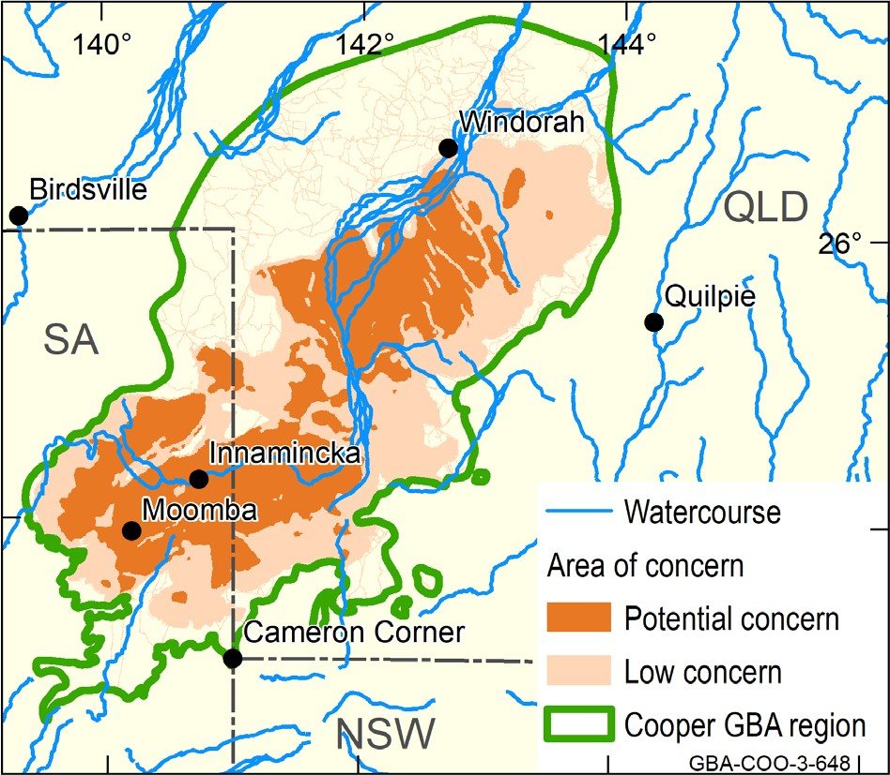**FIGURE 1** Area of potential concern in the Cooper GBA region



**Assessment:** Spanning the borders of southwest Queensland and northeast South Australia, the Cooper GBA region covers an area of approximately 130,000 km2 (Figure 1).

The maximum development scenario is projected to increase existing disturbance by up to 27 km2, spread over less than

6% of the Cooper GBA region. This area is 3% more than the footprint of the

existing oil and gas industry in the Cooper GBA region.

Of the potential impacts that could occur, most are at the surface and can be mitigated by existing controls.

Element: GBA-COO-3-648

**Surface water:** Development activities could potentially obstruct the flow of water across about 6% of the Cooper Creek floodplain. Ongoing careful design and existing management controls can mitigate these impacts.



**Groundwater:** Below the surface, natural barriers protect overlying aquifers. Less than 1% of the aquifer extent in the Cooper GBA region could potentially be impacted. Potential impacts in this area can be managed through mitigation and compliance with existing regulatory controls.

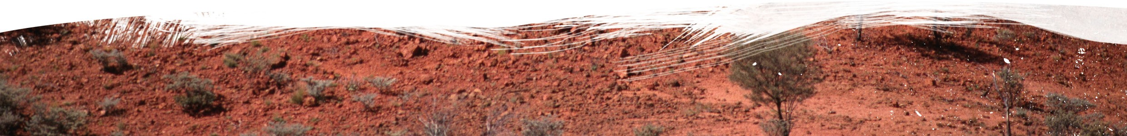

BIO764.0721



**Environment:** Invasive predators and weeds, and broadscale landscape changes due to fire or intensive grazing have the strongest influence on threatened species and protected areas in the Cooper GBA region.

**Protected fauna and flora:** The assessment prioritised 7 protected fauna and 5 protected flora based on the importance of the

Cooper GBA region to each species.

# Find out more

Holland KL et al. (2021) Impact assessment for the Cooper GBA region. Geological and Bioregional Assessment Program: Stage 3 synthesis. Department of Agriculture, Water and the Environment, Bureau of Meteorology, CSIRO and Geoscience Australia, Australia.

More information is available at [bioregionalassessments.gov.au/gba](https://www.bioregionalassessments.gov.au/geological-and-bioregional-assessment-program)