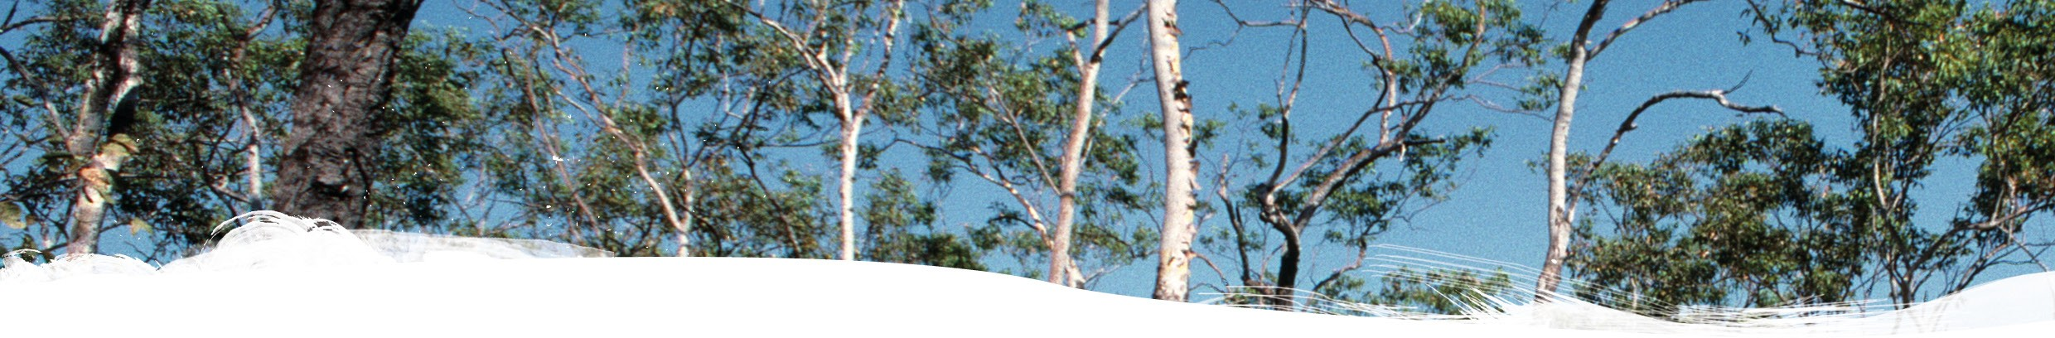

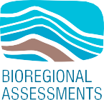Introduction to causal networks



# Geological and Bioregional Assessment Program

The $35.4 million Geological and Bioregional Assessment (GBA) Program is assessing the potential impacts of shale and tight gas development on water and the environment to inform regulatory frameworks and appropriate management approaches. The geological and environmental knowledge, data and tools produced by the program will assist governments, industry, land users and the community by informing decision-making and enabling the coordinated management of potential impacts.

A series of independent scientific studies were conducted in 3 geological basin: the Cooper Basin in Queensland and South Australia, the Isa Superbasin in Queensland and the Beetaloo Sub-basin in the Northern Territory (referred to throughout as GBA regions). These studies have been conducted by CSIRO and Geoscience Australia, supported by the Bureau of Meteorology and managed by the Department of Agriculture, Water

and the Environment.

Assessments identified potential impacts on water and the environment. Causal networks were used to determine where potential impacts cannot be ruled out. Governments, industry and the community can then focus on areas that are potentially impacted and apply local-scale modelling when making regulatory, water management and planning decisions.

# Introduction to causal networks

Assessing potential impacts of development activities requires tools to evaluate both direct and indirect impacts on ecological, economic and/or social values that are to be protected – referred to as endpoints. The GBA Program developed a new methodology for such impact assessment, based on causal networks.

Causal networks are pictorial models that show the pathways between development activities and the values to be protected, for example, threatened species such as the grey grasswren or nationally protected areas such as wetlands and waterholes. A causal network consists of nodes connected by links (Figure 1). Nodes represent the different components of the system. Links – represented by lines – show the hypothesised cause-and-effect relationships between nodes, based on the current understanding of the system.

# GBA Explorer

Presenting and communicating the information captured by the causal network is challenging. The innovative [GBA Explorer](https://gba-explorer.bioregionalassessments.gov.au/) is a publicly accessible online tool that allows simplification of the complex causal network supporting the assessments. Selecting a pathway of interest provides more detailed context and supporting evidence for evaluations. Detailed information for each node, the evaluation of the links and the justification for each evaluation are captured in a series of node descriptions. These descriptions summarise the relevant literature, GBA investigations, legislation and protocols to support the evaluation of each link starting from that node in the causal network.

Figure 1 shows how outputs are presented: (i) areas where more detailed local-scale assessment is required;

(ii) activities, stressors and processes of concern; and (iii) maps showing the location of potential impacts on the assessed endpoints, for example, landscapes, wetlands, aquifers, surface water, protected fauna and flora, and groundwater.

A scientific collaboration between the Department of Agriculture, Water and the Environment, Bureau of Meteorology, CSIRO and Geoscience Australia

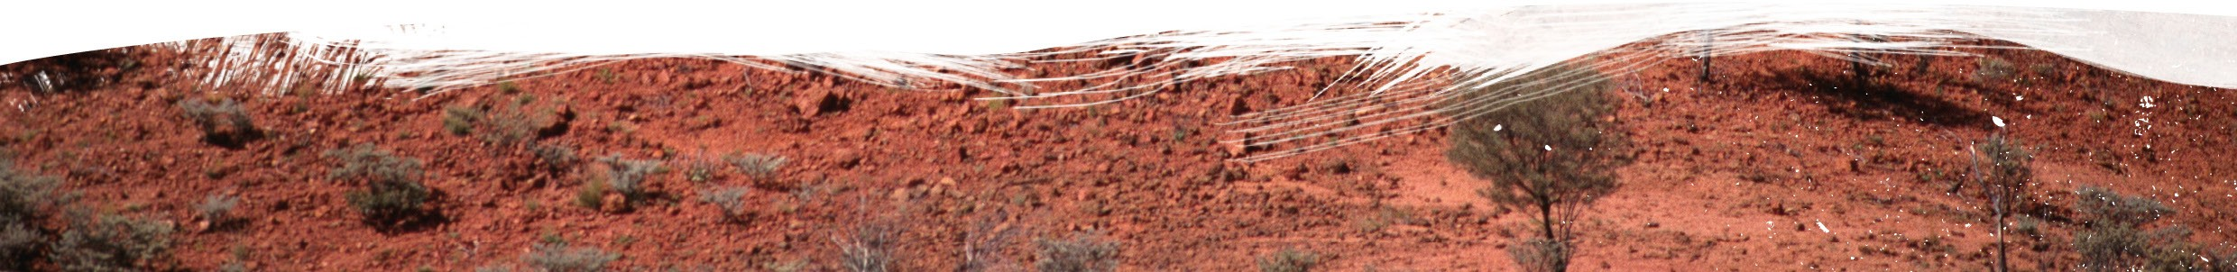

BIO764.0721

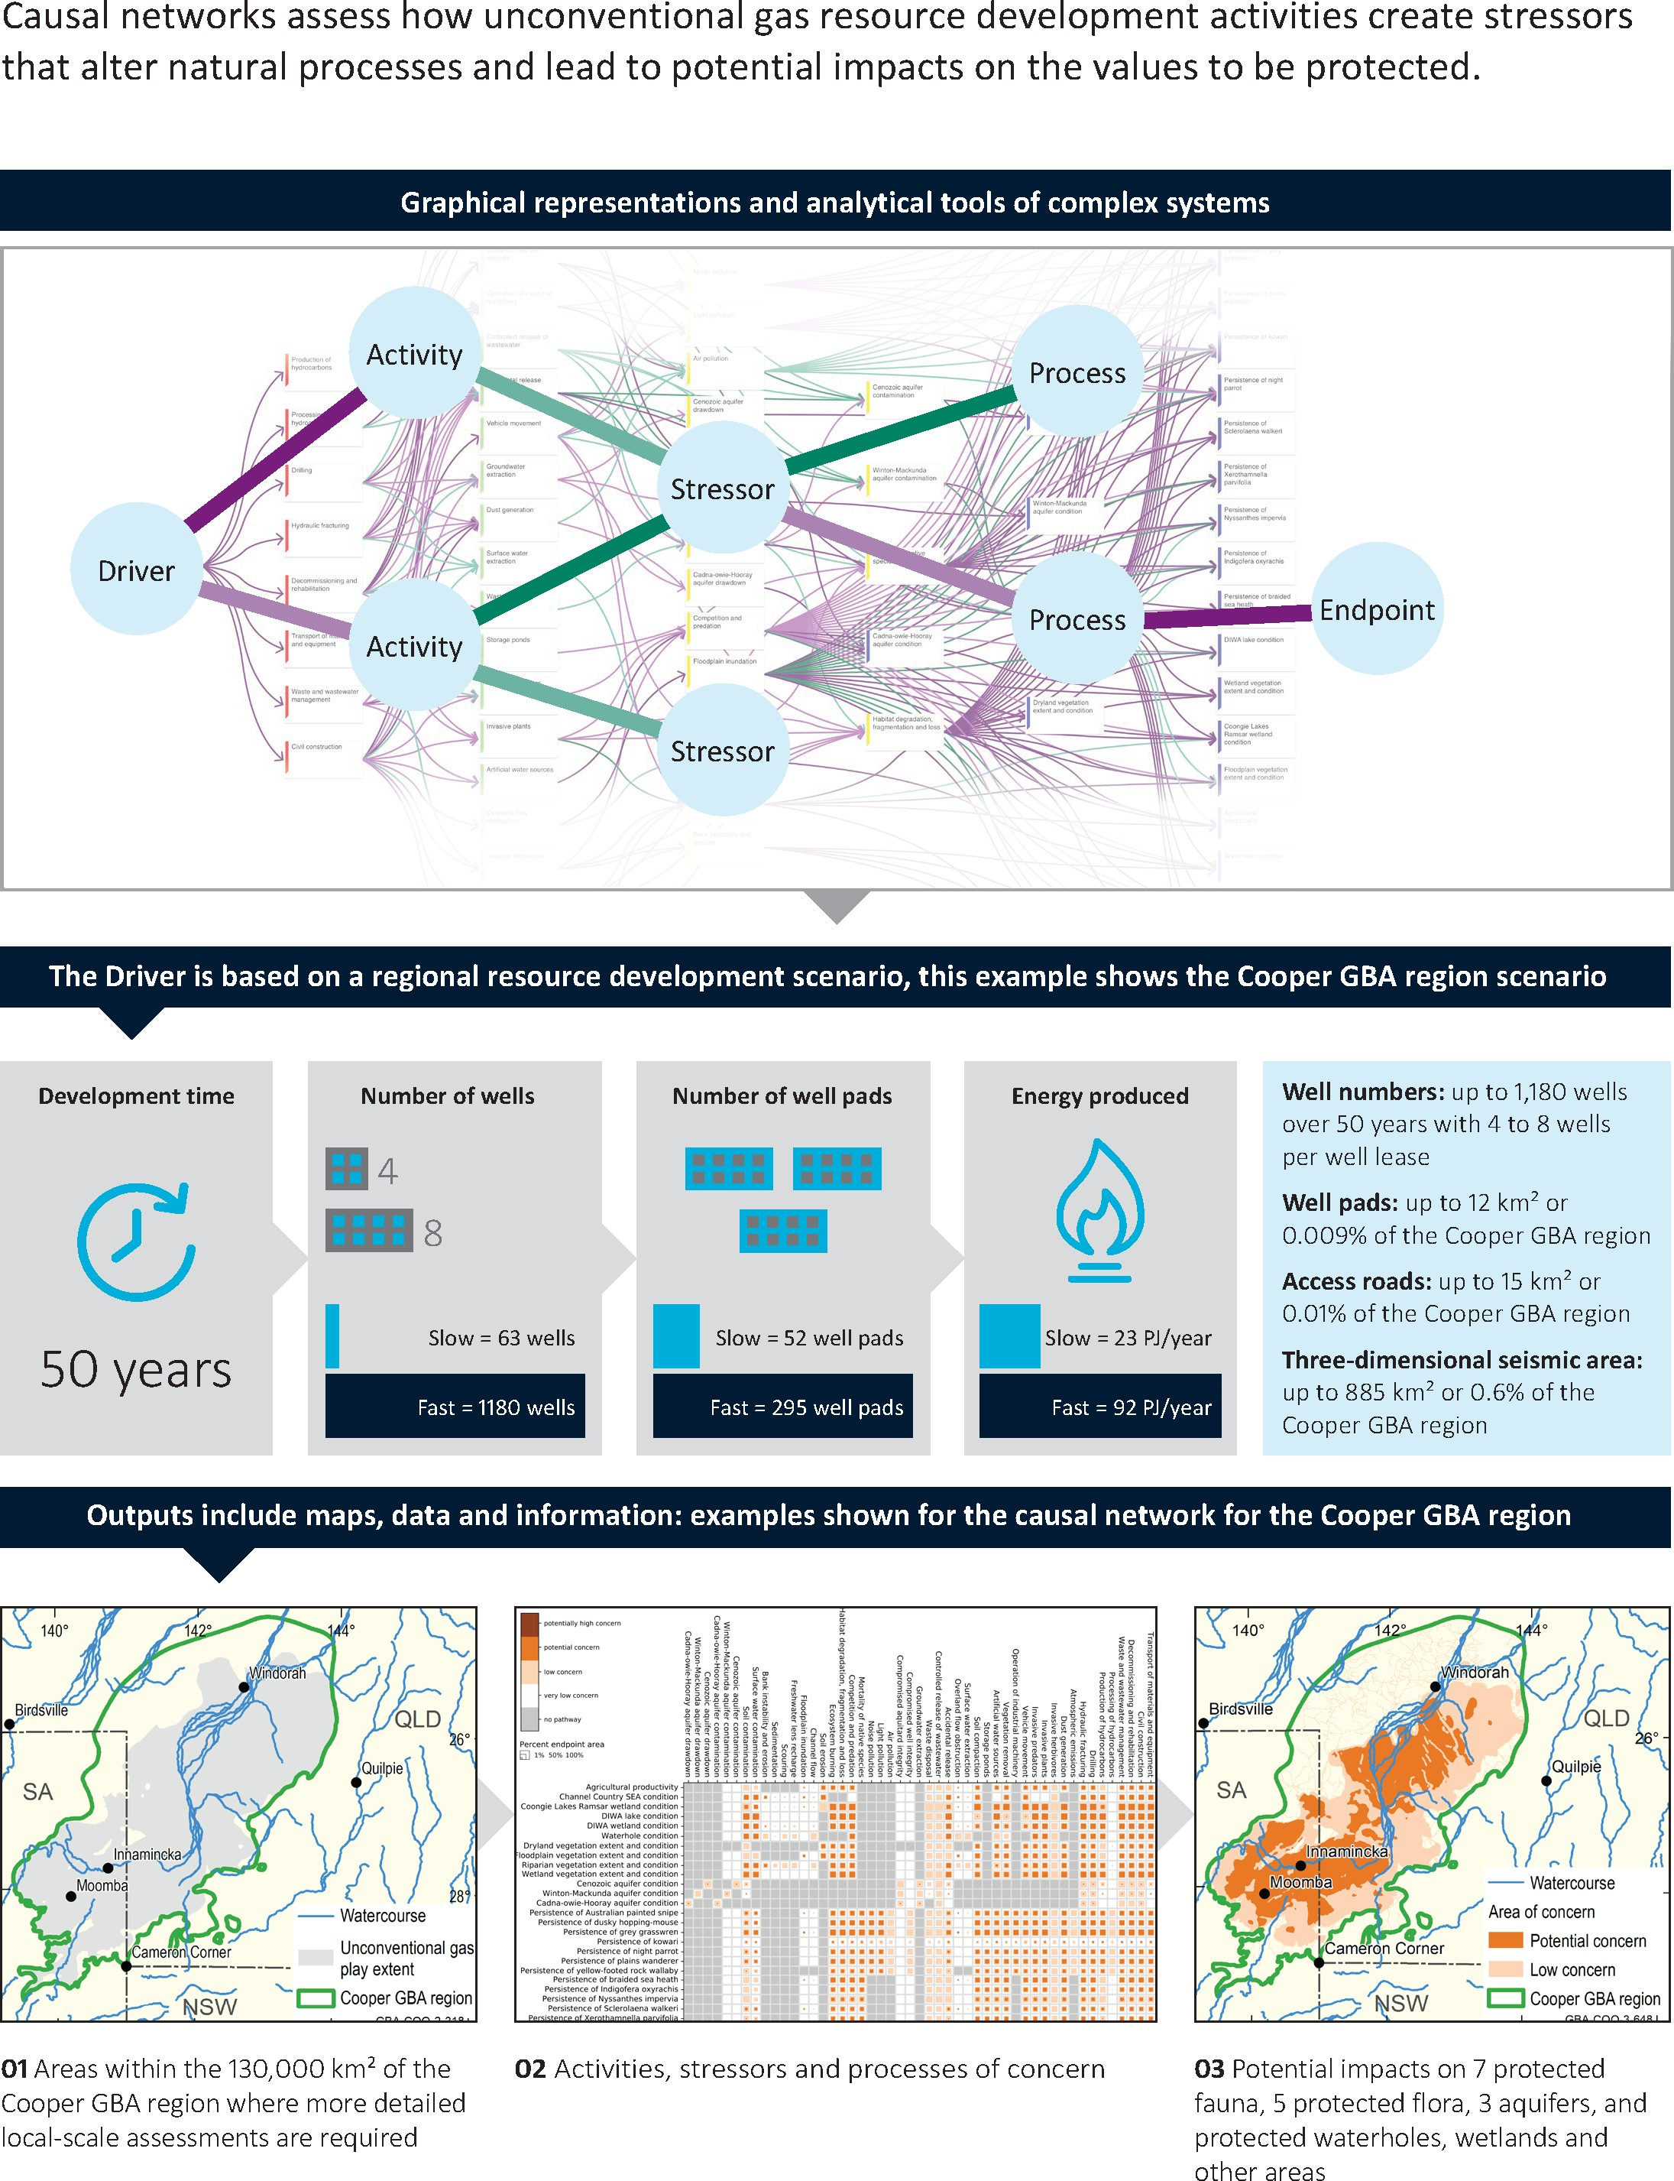**FIGURE 1** Causal networks explained

Element: GBA-ALL-3-011

# Find out more

Journal paper: Peeters LJM, Holland KL, Huddlestone-Holmes CR and Boulton AJ (2022) A spatial causal network approach for multi-stressor risk analysis and mapping for environmental impact assessments.Science of the Total Environment 802. Doi: [10.1016/j.scitotenv.2021.149845](https://doi.org/10.1016/j.scitotenv.2021.149845).

Publication: Peeters LJM, Holland KL, Huddlestone-Holmes CR, Brandon C, Lawrence E and Tetreault-Campbell S (2021) [Introduction to causal networks](https://www.bioregionalassessments.gov.au/gba/introduction-causal-networks). Geological and Bioregional Assessment Program: Stage 3. Department of Agriculture, Water and the Environment, Bureau of Meteorology, CSIRO and Geoscience Australia, Australia.

More information is available at [bioregionalassessments.gov.au/gba](https://www.bioregionalassessments.gov.au/geological-and-bioregional-assessment-program).