
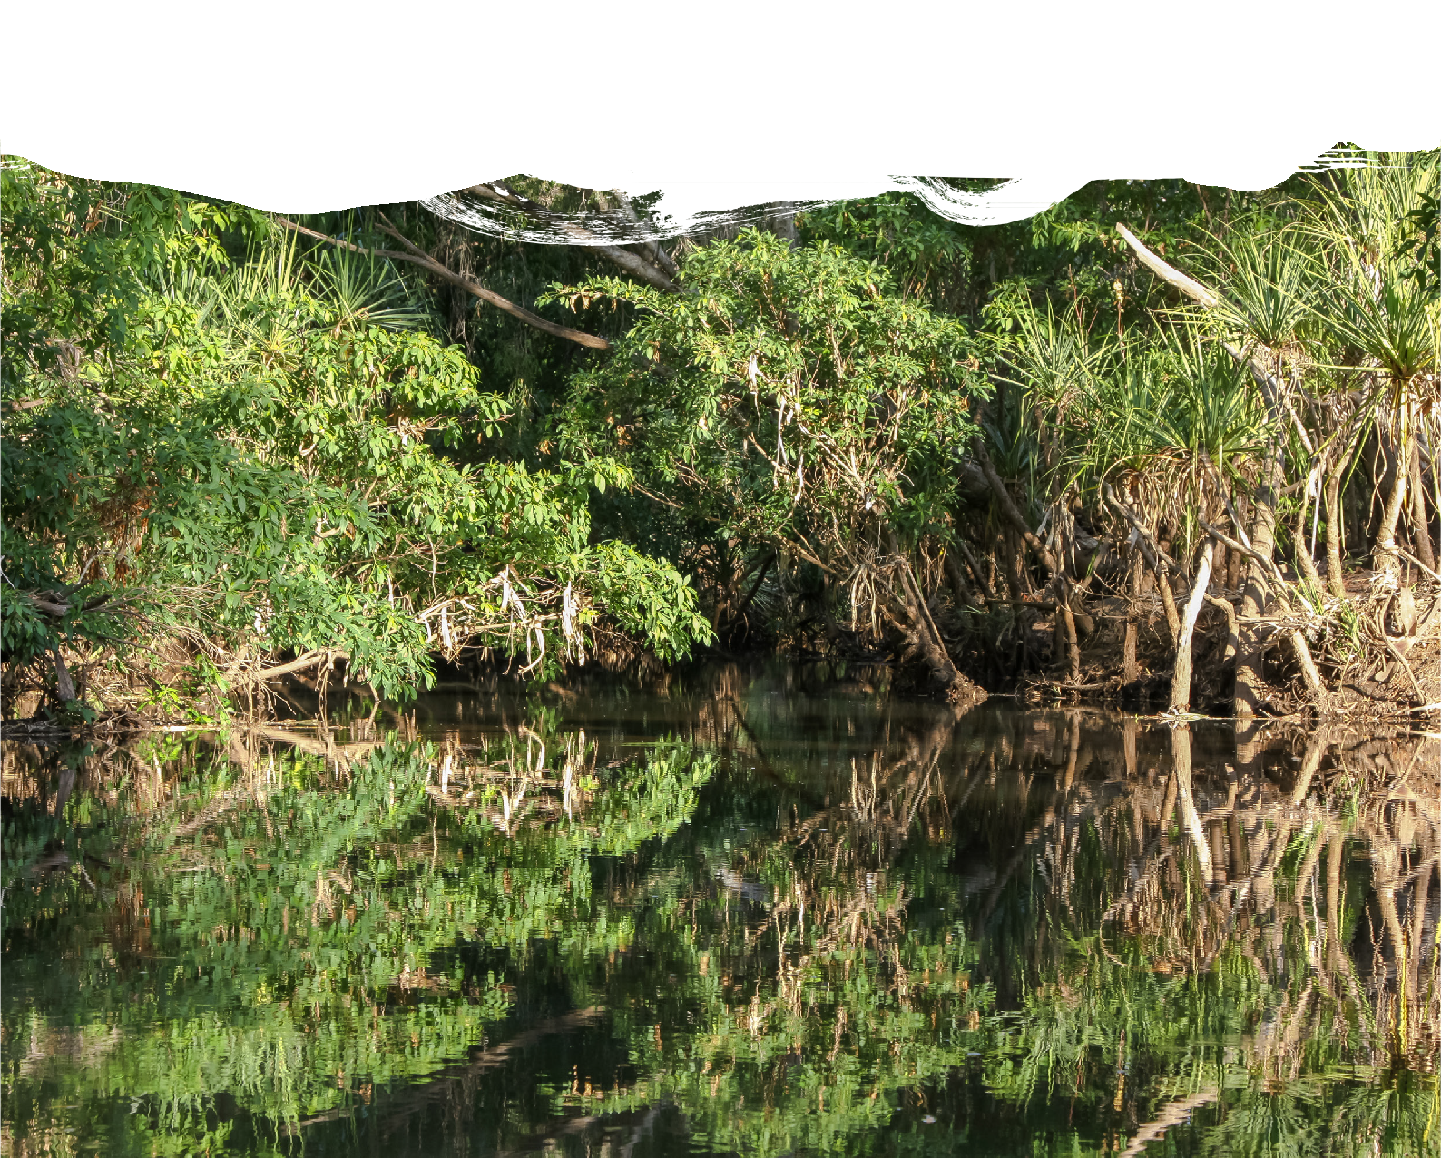





Geological and Bioregional Assessment Program Introduction to causal networks

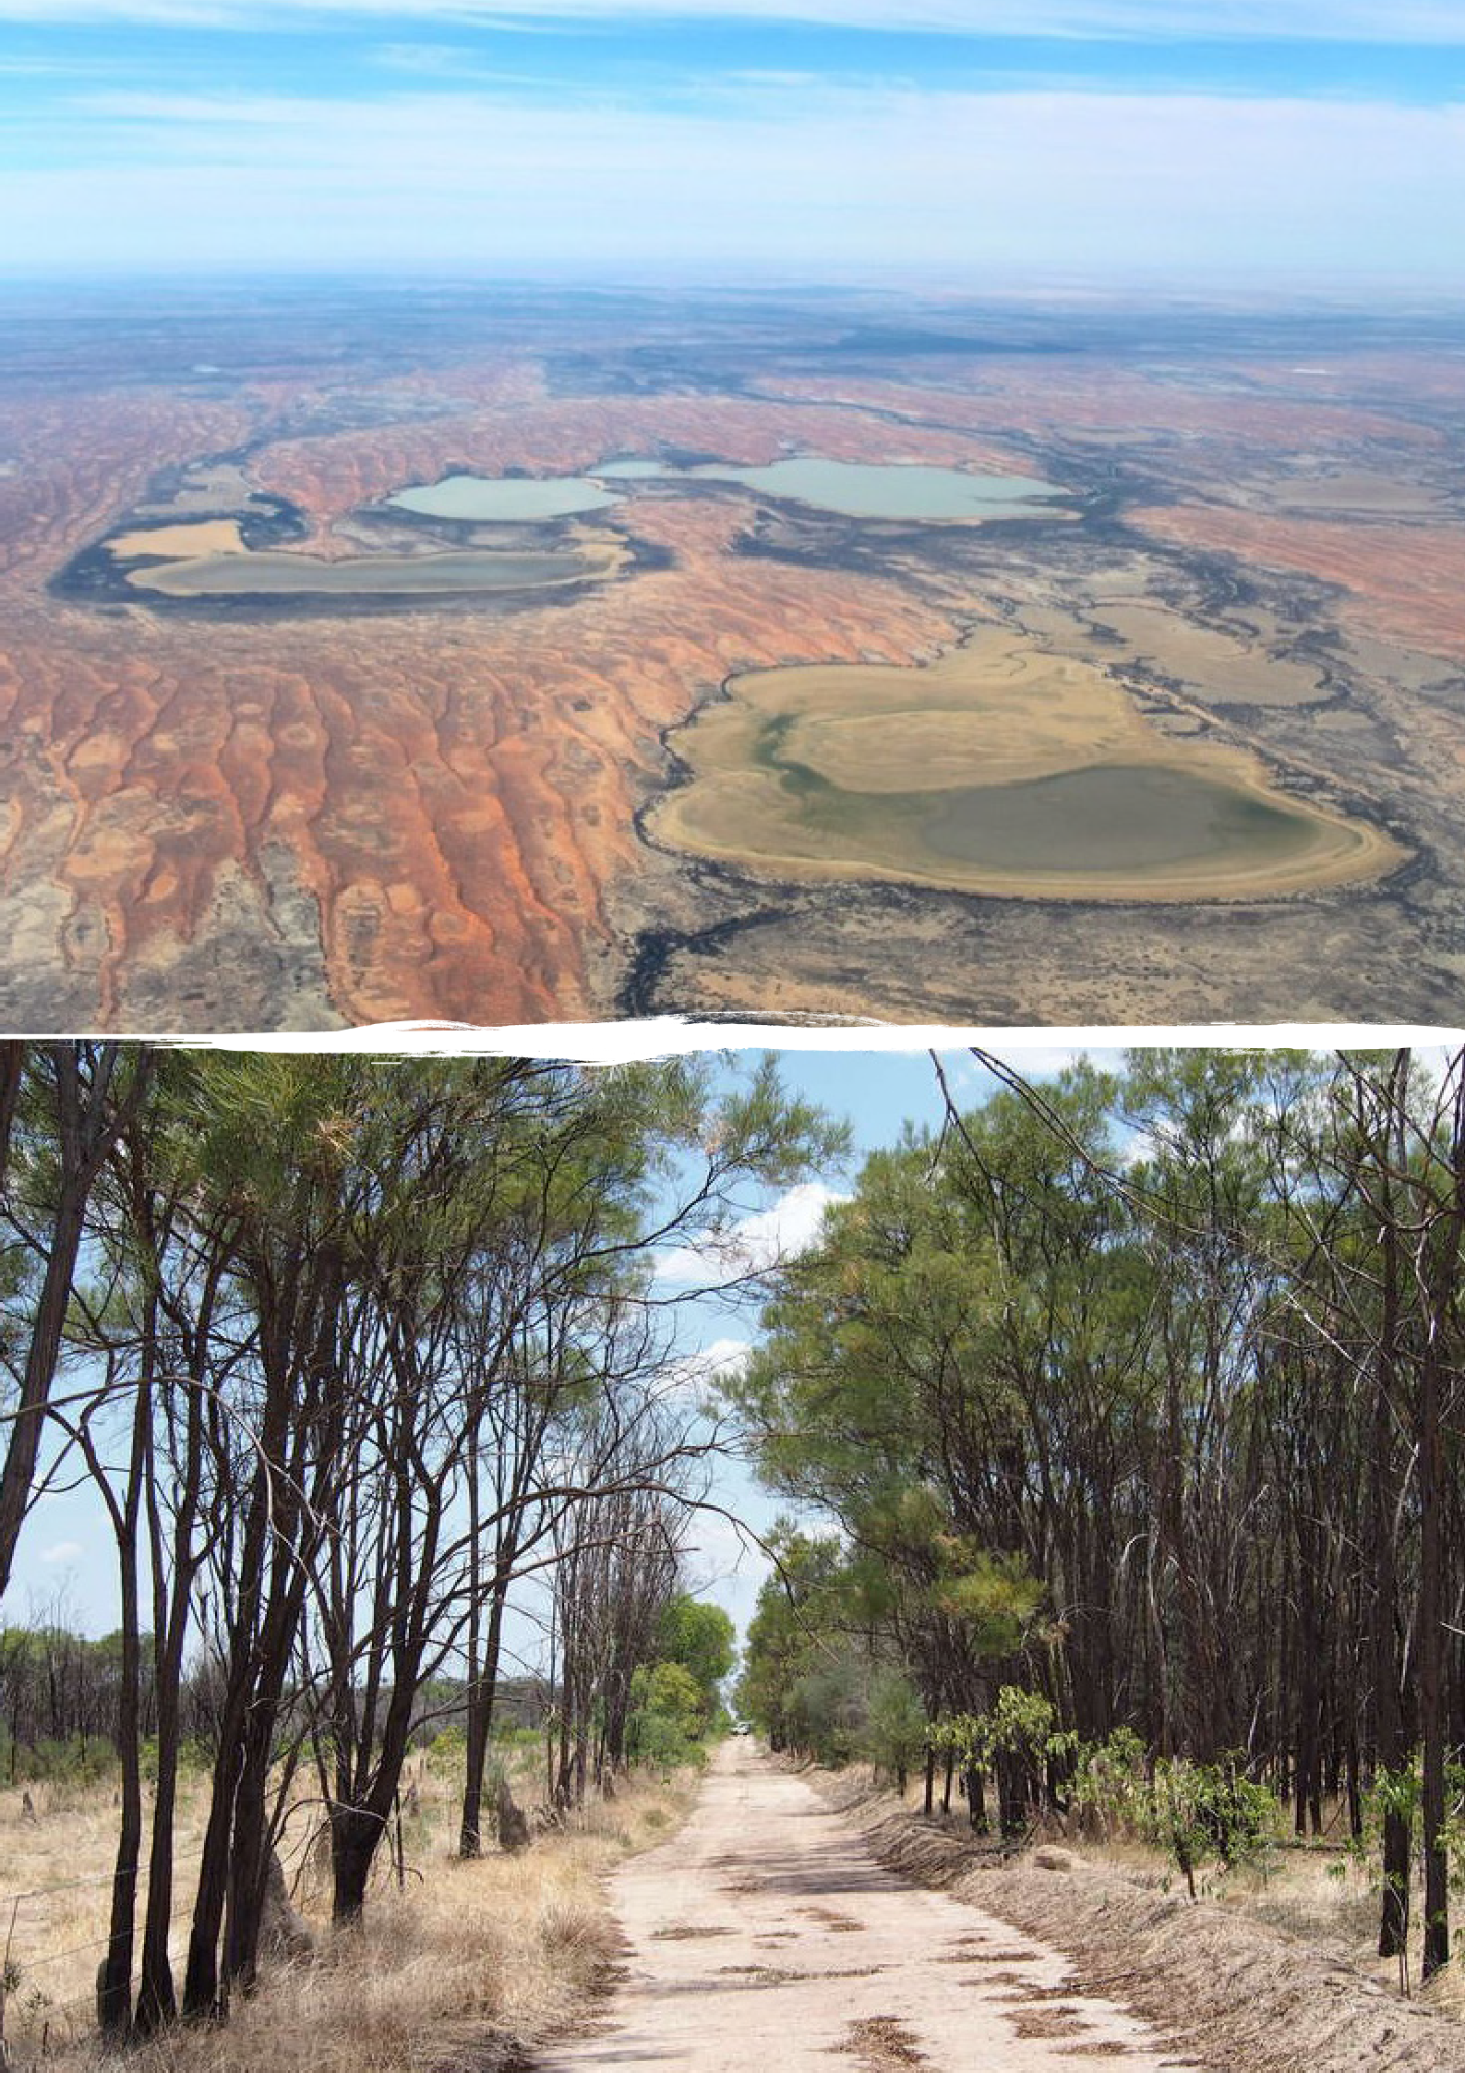

Coongie Lakes © CSIRO

Lancewood vegetation in the vicinity of Bullwaddy Nature Reserve © CSIRO

Introduction to causal networks

About the Program
The $35.4 million Geological and Bioregional Assessment (GBA) Program is assessing the potential impacts of unconventional gas resource development on water and the environment to inform regulatory frameworks and appropriate management approaches. The geological and environmental knowledge, data and tools produced by the GBA Program will assist governments, industry, land users and the community by informing decision-making and
enabling the coordinated management of potential impacts. The final stage of the GBA Program is undertaking assessments in 2 regions: the Beetaloo Sub-basin in Northern Territory and the Cooper Basin in Queensland and South Australia (referred to throughout as ‘GBA regions’).

Tools to assess direct and indirect impacts
Assessing potential impacts of development activities requires tools to assess both direct and indirect impacts on ecological, economic and/or social values that are to be protected – referred to as endpoints. The GBA Program developed a new methodology for such impact assessment, based on causal networks. This document explains how the method works and
how it can be used in environmental impact assessment. A causal network provides a consistent way to understand and evaluate impacts on these values due to development activities.
Priorities for management, mitigation and monitoring can be identified where the pathway of cause-and-effect relationships from development activities to endpoints could have a material impact and are therefore ‘of concern’. A material impact is a change that exceeds defined thresholds in terms of magnitude, extent, duration, timing or frequency that is likely to require local-scale assessment, mitigation and monitoring.
A causal network provides a transparent, robust and repeatable tool to capture the necessary level of detail at a regional scale to support overall confidence in the assessment.
Causal networks are graphical models that describe the cause-and-effect relationships linking development activities with endpoints. A causal network consists of nodes connected by links. Nodes (blue circles, Figure 1) represent the different components of the system – drivers, activities, stressors, processes and endpoints (Table 1). Links – represented by arrows – show the hypothesised cause-and-effect relationships between nodes, based on the current understanding of the system. While development activities can have both adverse and beneficial impacts, only adverse impacts are assessed, in line with the Environment Protection and Biodiversity Conservation Act 1999 (Cth) (EPBC Act).

Regional-scale assessments
The impact assessment method considers activities associated with future development of unconventional gas resources in a generic way at a regional scale. The assessment is based on a resource development scenario that focuses on areas that are more prospective and estimates of the amount and rate at which the resource could be produced. Development in the region
is assumed to adhere to existing regulation and practices, but specific projects or development footprints are not assessed. This contrasts with an environmental impact assessment for a specific project, where the specific activities, development footprints, endpoints, engineering controls and their effectiveness are considered in a defined area. Activity-based environmental impact assessments address the question: ‘what might happen if the proposed activities occur?’ This question is relatively straightforward to address at a local scale or when development plans are well-defined. However, it is more difficult to answer where development is in the exploration phase and potential impacts are assessed at a regional scale.
To make risk assessment more robust when development scenarios are uncertain, the assessment question can be changed to: ‘what needs to happen for a set of activities to impact on a set of endpoints?’ By answering this question at a regional scale, local-scale assessment, management and monitoring can focus on potential impacts that are of greatest concern in the region.

TABLE 1 Node types and examples
Node type Driver | Description  Major external driving forces (human or natural) that have large-scale influences on natural systems | Examples  Resource development
Activity | A planned event associated with unconventional gas resource development | Civil construction  Transport of materials and equipment
Stressor | Physical, chemical or biological agent, environmental condition or external stimulus caused by activities | Dust generation Vehicle movement
Process | A naturally occurring mechanism that could change a characteristic of an endpoint | Air pollution  Habitat degradation, fragmentation and loss
Endpoint | A value pertaining to water and the environment that may be impacted by development activities | Aquifer condition  Floodplain vegetation extent and condition

FIGURE 1 Hypothetical causal network illustrating nodes (A to L), evaluation codes (1 to 4)
and spatial grids associated with each link

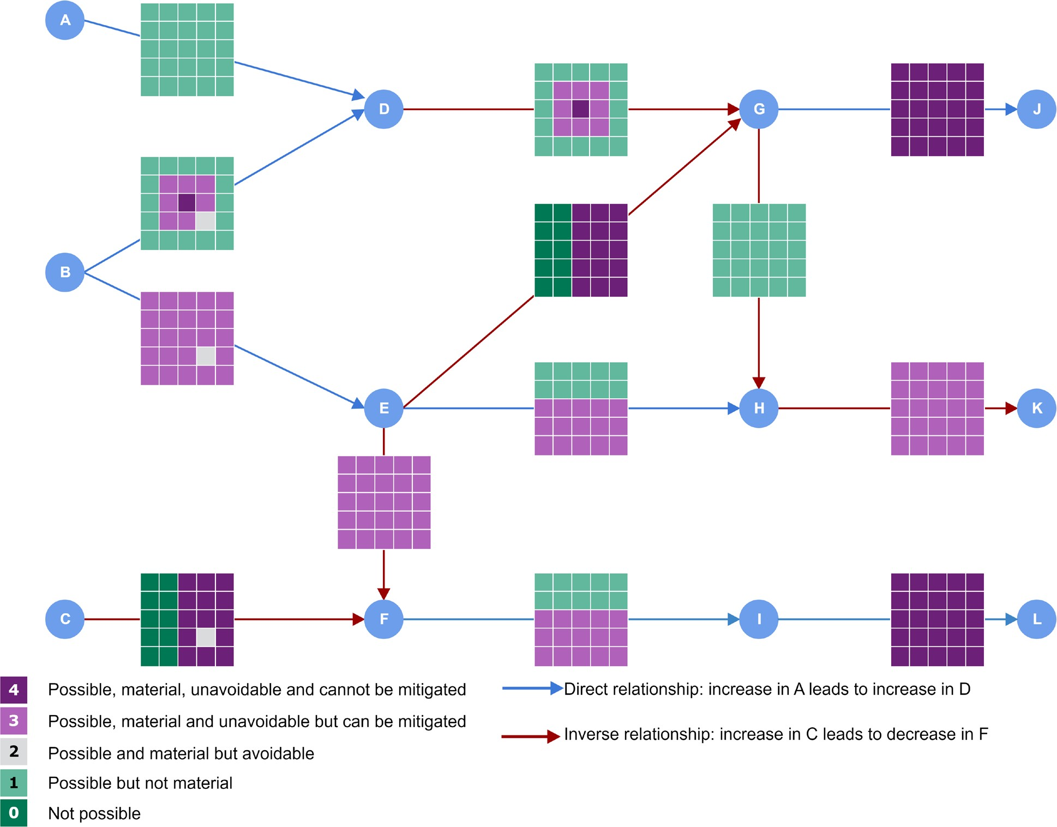

Grids represent the spatial distribution of cause-and-effect relationships in a region and are used to assess potential impacts on endpoints at a regional scale. The evaluation code and colour of each grid cell corresponds to the link evaluations in the decision tree in Figure 2 and descriptions in Table 2.
Element: GBA-All-3-001

What about cumulative impacts?
Cumulative impact assessment requires quantification of the relative contribution by each stressor to the impacts. As the impact assessment method is qualitative, it is limited to assessing potential impacts from multiple stressors. There are 4 different aspects to consider when assessing cumulative impacts:
► single stressor from multiple developments for a single industry
► multiple stressors from multiple developments for a single industry
► multiple stressors from multiple developments for multiple industries
► multiple stressors from all anthropogenic activities.
The impact assessment method is designed to assess the first 2 aspects of multi-stressor impacts. The third and fourth aspects of multi-stressor impacts deal with potential impacts that are not related to development of a single industry. Multiple industries (for example, pastoralism and tourism) are distinguished from all anthropogenic activities, which includes potential impacts from climate change. While in theory the causal network can assess potential cumulative impacts from multiple industries, this requires comprehensive and quantitative estimates of baseline conditions and future projections for development of each industry, as well as other anthropogenic activities, which is beyond the scope of the GBA Program.

How do causal networks work?
Links represent either a direct or inverse relationship between 2 nodes. In Figure 1, the blue links show direct relationships, where the starting node and the next node both increase or decrease together: an increase in node A increases node D or a decrease in node A decreases node D. For example, an increase in groundwater extraction leads to an increase in groundwater drawdown. The red links represent inverse relationships, which are like a seesaw where if one node increases then the other node decreases: an increase in node C leads to a decrease in node F or a decrease in node C leads to an increase in node F. As an example, an increase in sedimentation in a waterhole leads to a decrease in the amount of water that can infiltrate
to groundwater.
The causal network is not only a visual depiction of how activities are linked to endpoints; it also provides a structure to systematically explore direct and indirect effects. For example, there is a direct pathway from node B to node K in Figure 1:

B → E → H → K
There are also 2 other indirect pathways from node B to node K:

B → E → G → H → K B → D → G → H → K

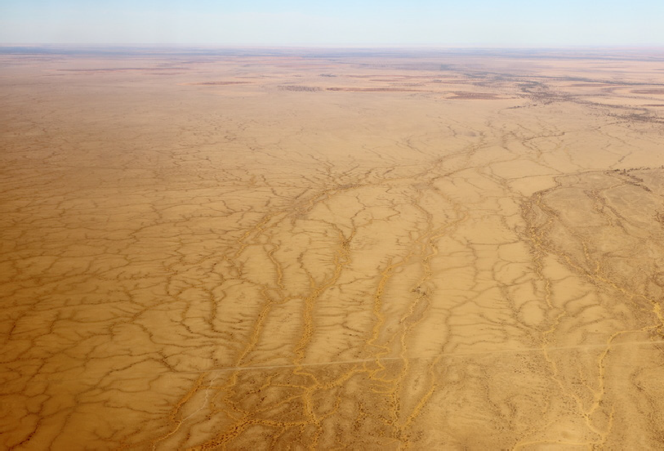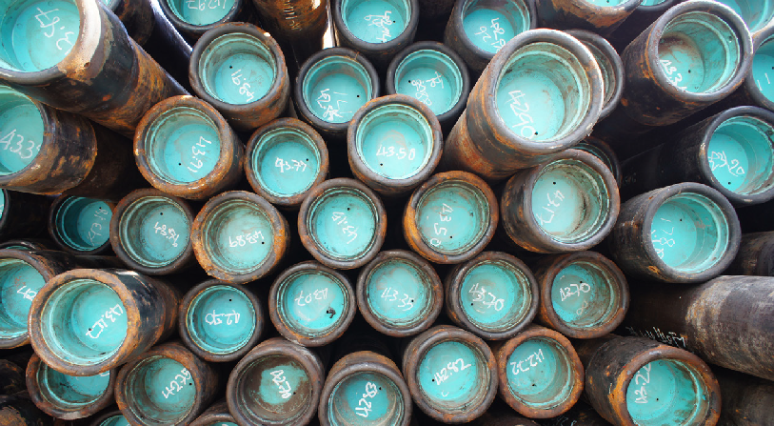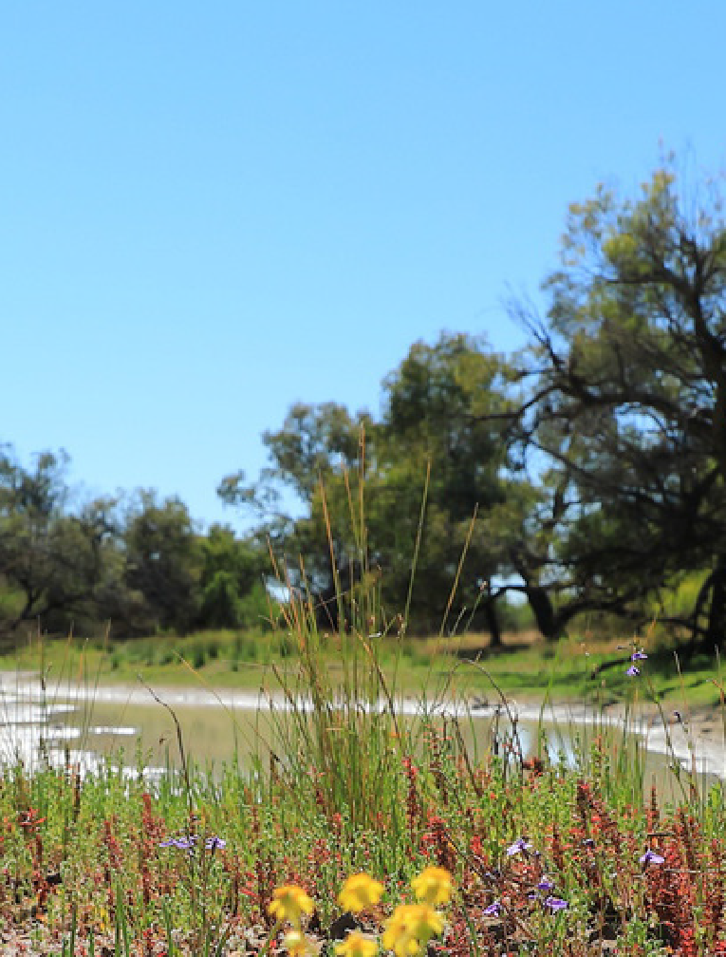In the context of unconventional gas resource development, this could be the effect of road construction on habitat of a protected species. A direct effect is the vegetation removal needed to make the road, leading to a decrease in habitat. An indirect effect could be that road
© CSIRO
Channel Country © CSIRO
construction increases access by invasive herbivores to the habitat and the subsequent increased grazing pressure leads to a deterioration of habitat.
The causal network also identifies when there is no pathway between an activity and an endpoint, and so it is not possible for that activity to have an impact on that endpoint.
For example, in Figure 1, there is no pathway between node A and node L, which means that it is not possible for a change in node A to cause a change in node L. An intuitive example of where a pathway between an activity and an endpoint does not exist is between the activity, transport of materials and equipment, and the endpoint, Great Artesian Basin aquifer condition, which is hundreds of metres below the surface.
To assess environmental impacts at a regional scale, a complex causal network consisting of many nodes and links is needed to represent all the cause-and-effect relationships. Analysis of complex causal networks needs algorithms and software to systematically and automatically list all possible pathways in the network. The next section explains the evaluation in detail and how the evaluation of cause-and-effect relationships are combined to assess potential impacts on endpoints, using the hypothetical causal network shown in Figure 1.

Evaluating potential impacts
It is challenging to assess whether the impact of an activity on an endpoint is possible, whether the change is considered to be material, and whether it can be mitigated or avoided, or is unavoidable. In assessing impacts on an endpoint, this type of question is difficult to answer with high confidence:

‘Will civil construction for unconventional gas resource development lead to an impact on groundwater and, if so, can such change be avoided or mitigated?’ (for example, civil construction → aquifer condition).

Addressing this question becomes more manageable when it is split into a series of questions along a pathway of cause-and-effect relationships, where each question represents a link
in a causal pathway. For example, the question above can be split into the following series of questions:
- Will civil construction for unconventional gas resource development require groundwater?
(for example, civil construction → groundwater extraction).
- If groundwater is required, will groundwater pumping cause groundwater drawdown?
(for example, groundwater extraction → groundwater drawdown).
- If groundwater drawdown occurs, will groundwater drawdown cause an impact on springs
or existing bores? (for example, groundwater drawdown → aquifer condition).
- If so, can the changes due to one or more links be avoided or mitigated? (for example, civil
construction → groundwater extraction → groundwater drawdown → aquifer condition).
The evaluation of the first 2 questions examines the likelihood (is it possible or not) and the consequence (is it material or not) of each link. The next 2 questions identify the avoidance (can it be avoided or not) and mitigation (can it be mitigated or not) strategies for each link. To do this in a formal and systematic way, each link in the causal network is evaluated using 4 questions (Table 2) that lead to one of 5 answers, represented by a numerical code, from 0
for ‘not possible’ to 4 for ‘possible, material, unavoidable and cannot be mitigated’ (Figure 2).

TABLE 2 Link evaluation questions and key questions to be addressed for each link in the causal network

Link evaluation questions | Key questions to be addressed
Q1: Is it possible?  Could a change in A cause a change in B? | What causes the change? How could the change occur? Is the change extremely unlikely ª?
Q2: If a link is possible, is it material?  Could a change in A cause a material change in B? | Does the extent, duration, magnitude and/or frequency of the change exceed the definition of material change?
Q3: If a link is possible and material, could it  be avoided? Could a material change in B due to a change in A be avoided in the GBA region? | Can the action associated with A leading to the material change in B be moved out of the GBA region so that the change in B is avoided?
Q4: If a link is possible, material and unavoidable,  could it be mitigated? Could a material change  in B due to a change in A be minimised or mitigated in the GBA region? | Is there a strategy or protocol that can effectively minimise the change in B such that it is below the material change thresholds for the GBA region?
a ‘Extremely unlikely’ means having a probability of less than 1 in 1,000.

FIGURE 2 Decision tree of link evaluation questions and their associated scores for the causal network
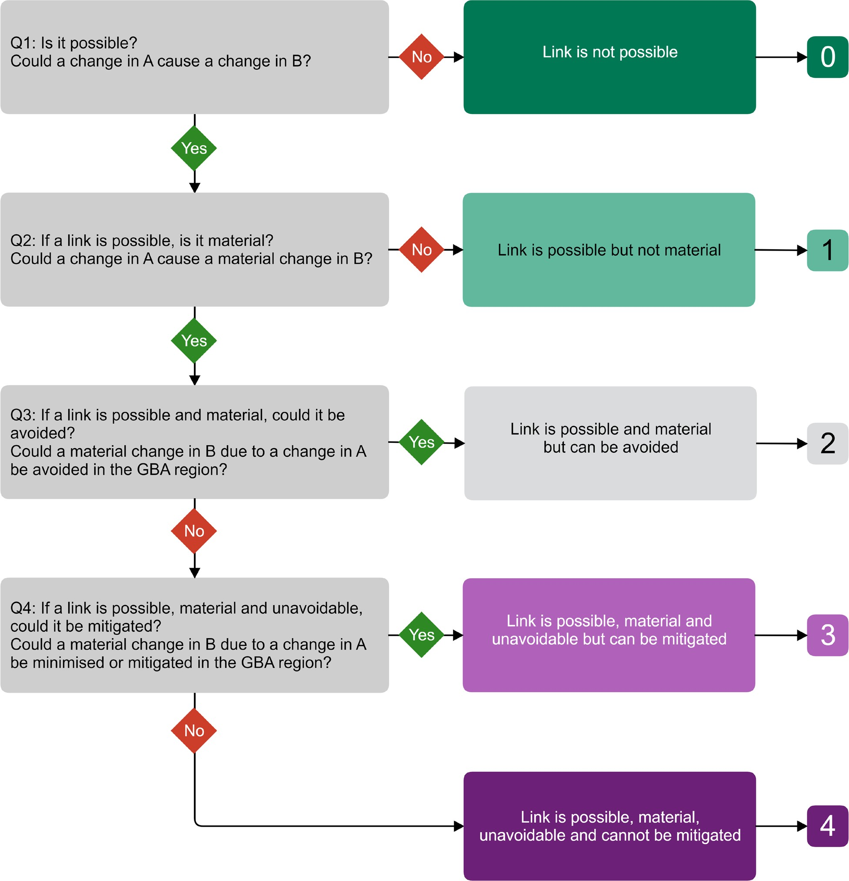
Element: GBA-All-3-002

Q1: Is it possible? Could a change in A cause a change in B?
This question may appear trivial at first; if a cause-and-effect relationship between 2 nodes is identified and included in the causal network, then it should be possible. However, it may be that a cause-and-effect relationship is inferred based on theoretical grounds or experience outside the region. This question evaluates if and where in the region the link is possible.
For example, streamflow depletion due to groundwater extraction is common in Australia. However, impacts can only occur where groundwater contributes to surface flow. Detailed hydrogeological investigations identify where groundwater contributes to
surface waters and, therefore, where the link is possible. If groundwater does not contribute to surface waters in the region, then the link is not possible in that region even though it may be common outside the region.
This question also helps to make the cause-and-effect relationships spatially explicit. A self-evident example is the link from water extraction to surface water extraction.
Surface water extraction can only occur where surface water is present. Where and when there is no surface water, surface water extraction is not possible.
Links that are physically not possible are the strict, absolute interpretation of what is not possible. In the assessment, relationships or events that are extremely unlikely are also considered to be not possible. It is assumed that extremely unlikely means having a probability of less than 1 in 1,000, consistent with the hazard identification undertaken in Stage 2 (geological and environmental baseline assessments). There are 2 situations in which extremely
unlikely events are considered not possible: in relation to system understanding and in relation to processes and protocols.
An example of the first situation is a link from hydraulic fracturing to compromised integrity of an aquitard, where the vertical extent of simulated and observed hydraulic fractures is less than the thickness of the aquitard. This evaluation relies on current understanding of the geology and hydraulic fracturing processes. However, it cannot be excluded that there is an ‘unknown unknown’ that might prove current system understanding to be incorrect. Therefore, the link cannot be evaluated as ‘not possible’ in the strict sense but is extremely unlikely and so for the purposes of the assessment is evaluated as ‘not possible’.
An example of the second situation is the link from drilling to aquifer contamination. Theoretically, a worst-case scenario can be envisaged in which all physical barriers between the interior of a well and the aquifer are breached, allowing solutes from within the well to migrate to an aquifer and cause contamination. This scenario requires physical barriers to be breached, as well as non-compliance with operational safeguards and protocols. Again, the link cannot be evaluated as not possible in the strict sense but is extremely unlikely and so for the purposes of the assessment is evaluated as ‘not possible’.
A final category of cause-and-effect relationships that can be considered not possible is activities or actions that are not legal across the GBA region. An example is controlled release of wastewater in surface water, which is not allowed in the Northern Territory, and so for the purposes of the assessment is evaluated as ‘not possible’.

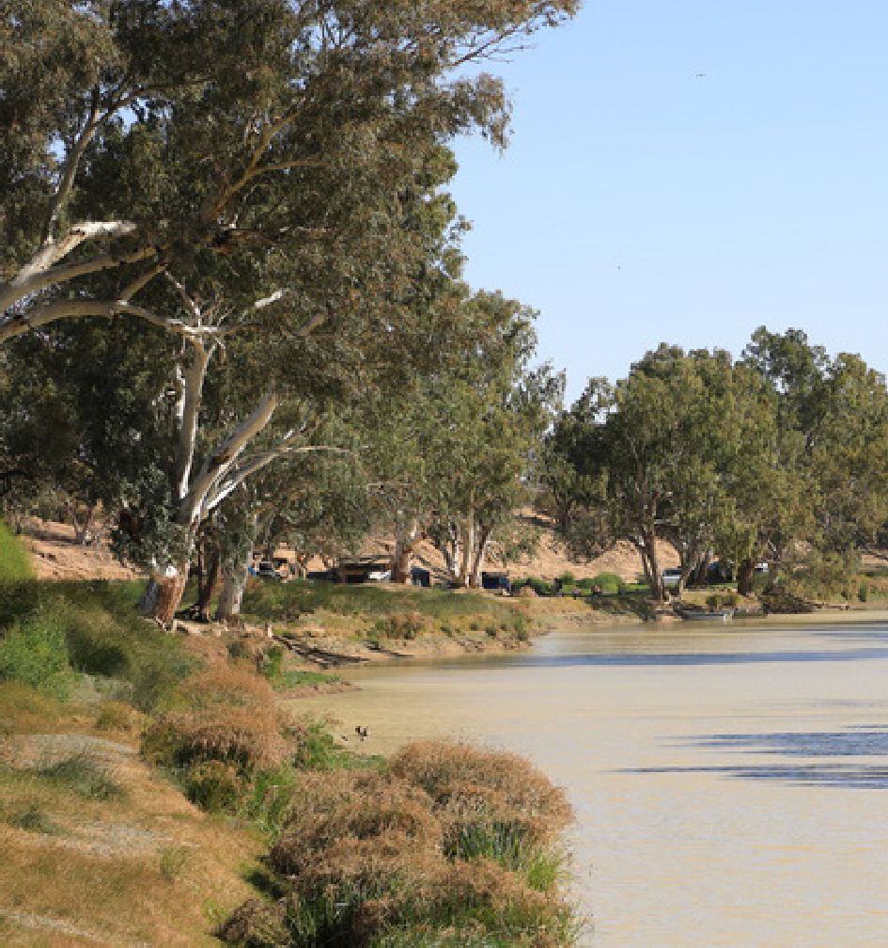Extremely unlikely events with serious consequences do happen. In the context of unconventional gas resource development and production, such extremely unlikely events with potential for severe environmental harm may include a well blowout, a gas pipeline rupture and explosion or a large-scale industrial fire at a processing plant. Such events generally have acute and direct impacts and are managed through project-specific health, safety and environment procedures. The assessment focuses on events that are more likely and also have long-lasting or indirect impacts.
Queerbidie waterhole © CSIRO
Links that are explicitly evaluated as ‘not possible’ are retained in the network to give them visibility in the assessment, to show that they have been considered and to provide a justification for the evaluation.

Q2: If a link is possible, is it material? Could a change in A cause a material change in B?
Establishing that it is possible for a change in A to cause a change in B indicates the likelihood of the cause-and-effect relationship but does not consider the consequence. This question assesses whether a link is material or, to be more precise:

‘If it is possible for a change in A to cause a change in B, will this change exceed the materiality thresholds defined in terms of magnitude, extent, duration, timing or frequency, provided that all the assumptions leading to the change in A are acceptable?’

To address this question about materiality, only the cause-and-effect relationships evaluated as possible (so, not impossible or extremely unlikely) are considered.
The focus of the second assessment question (Q2) shifts to the severity or consequence of the change in B, asking whether the change is material. What constitutes a material change depends on the nature of the cause-and-effect relationship. Evaluation of Q2 for each link includes
a specific definition of material change and any relevant threshold values, along with their justification. Defining materiality can include aspects such as the magnitude, extent, duration, timing or frequency of the change. Table 3 gives some examples of these aspects.

TABLE 3 Examples of aspects included in material change definitions
Aspect | Example link | Material change definition includes:
Magnitude | Atmospheric emissions → Air pollution | National Environment Protection (Ambient Air Quality) Measure (Air NEPM)
Extent | Soil contamination → Habitat fragmentation  and loss | Area of habitat in which soil contamination occurs
Duration | Hydraulic fracturing → Noise and light  pollution | Duration of noise and light exceeding background levels
Frequency | Soil contamination → Aquifer contamination | Frequency that watertable depth is shallower than estimated
The definition of material change is, wherever possible, based on existing guidance values for limits of acceptable change, expert opinion or current system understanding. An example is the material change definition for the link ‘accidental chemical release → soil contamination’:

A material increase in soil contamination due to accidental chemical release occurs when chemicals are unintentionally released on an unsealed surface, beyond any engineered bunding or control leading to a change in soil chemical concentrations or physical properties that exceeds regulatory limits and
would require remediation, according to (but not limited to) such guidelines as the EPBC Act and Significant Impact Guidelines 1.1 – Matters of National Environmental Significance.

There are, however, many links where the knowledge base is currently not available to define robust material change thresholds. An example is the link ‘scouring increases freshwater lens recharge’ in the causal network for the Cooper GBA region. The process of freshwater lens recharge near waterholes during floods due to scouring of the sediment at the bottom of waterholes or channels is well documented in the literature. However, there are no quantitative estimates of historical recharge rates on which to base the magnitude of a material increase in recharge. In such cases, the material change definition acknowledges that the current knowledge base is insufficient to formulate robust materiality thresholds but indicates which aspects of the change and its order of magnitude could be considered. In line with the precautionary principle, the evaluation of links with a material change definition based on a limited knowledge base is biased towards a conservative assessment. The material change definition for ‘scouring increases freshwater lens recharge’ is:

The current data and knowledge base are insufficient to establish robust materiality thresholds for a material increase in freshwater lens recharge due to scouring. However, such thresholds could be defined in terms of increases in volumetric recharge rates during floods.

A final consideration in evaluating the question ‘is it material?’ relates to the assumptions embedded in the causal network and the resource development scenario in the links and nodes that precede the link being evaluated. For example, evaluating if groundwater extraction could cause a material increase in aquifer drawdown requires assumptions on the volume of water required for various unconventional gas resource development activities and the hydrogeology of the region. These assumptions are detailed in the preceding node descriptions and link evaluations. Link evaluations are conditional on these assumptions and the level of confidence in each evaluation.

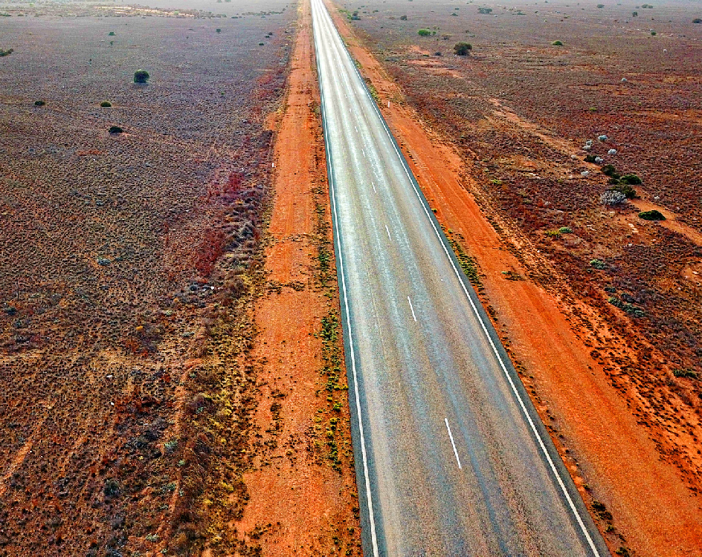Q3: If a link is possible and material, could it be avoided? Could a material change in B due to a change in A be avoided in the GBA region?
A common first step in many risk management strategies is to assess whether a material change can be avoided altogether. In this assessment where the focus is on GBA regions, avoidance means the change can be avoided in the region. However, this is not the same as moving the activity somewhere else in the region (regional mitigation), which is where the activity can be moved to an area where the effect will be less.
In some areas of the GBA region, legislation prevents particular activities and therefore the impact is automatically avoided at a local but not regional scale. An example of a legislated avoidance strategy is resource development in national parks, which is not permitted. As this does not necessarily mean that the activity can be avoided in the rest of the region, the link is evaluated as ‘possible, material and unavoidable’ and the next question (Q4) evaluates the effectiveness of available mitigation strategies.
An example is the link ‘civil construction increases vegetation removal’. Civil construction activities associated with unconventional gas resource development, such as road or well pad construction may involve land clearing. Vegetation removal is not permitted in a national park, so any grid cells in a national park for this link are evaluated as ‘possible and material but can be
avoided’. Outside a national park, vegetation removal for civil construction cannot be avoided but the effect can be minimised or mitigated through careful site selection to minimise the extent of vegetation to be cleared. In the grid for the link ‘civil construction increases vegetation removal’, grid cells outside of national parks are evaluated as ‘possible, material and unavoidable but can be mitigated’.

Q4: If a link is possible, material and unavoidable, could it be mitigated? Could a material change in B due to a change in A be mitigated in the GBA region?
In practice, as shown in the example for vegetation removal, very few effects are regionally unavoidable unless the activity is not undertaken. However, there are many ways of minimising the likelihood and/or severity of these effects. Often there are approval conditions, protocols and strategies in place that aim to minimise or mitigate the potential effects to levels below the materiality thresholds.
An example is the use of double-walled containers in the transport and storage of chemicals.
This minimises the frequency with which accidental chemical release can occur. Another example is managing access by third-party vehicles to the road network developed to access well pads
by signposting or blocking entry. This will minimise the frequency of unintentional accidental ignition of bushfires.
In evaluating mitigation strategies, the assessment is limited to strategies that are publicly accessible, such as guideline documents for approval conditions from state and federal governments or published operational procedures from proponents used to support project approvals.
If the answer to Q4 is ‘no’, a link is considered ‘possible, material, unavoidable and cannot be mitigated’ regionally. Such an evaluation can be self-evident based on the system understanding if there is no avoidance or mitigation strategy possible for that link. For instance, it is unavoidable that a material increase in aquifer drawdown leads to a material decrease in aquifer condition.
Currently there are few, if any, successful examples of rehabilitation of aquifers whose condition has been impacted by drawdown.
A link can also be evaluated as ‘possible, material, unavoidable and cannot be mitigated’ regionally if there is not an avoidance or mitigation strategy that is practical or effective at a regional scale. An example is the spread of invasive fauna along a newly created road
network. While local measures can be effective (for instance, fencing of areas of high ecological significance), they are either prohibitively expensive or not practical at a regional scale.
A third way in which a link can be evaluated as ‘possible, material, unavoidable and cannot be mitigated’ regionally are links that can be avoided locally but not across the entire region. This is generally limited to links into activity nodes, such as drilling, civil construction and hydraulic fracturing. While the location of the activities can be moved, it is unavoidable that it will occur in the region and reducing the effect of these activities (for example, the amount of drilling)
is difficult without compromising the amount of gas potentially produced. In this case, the effect of this link cannot be mitigated. However, there may be mitigation strategies to mitigate effects of subsequent links.
For example, the extent of the road network required for unconventional gas resource development depends, among other things, on the location and number of well pads to be drilled. Reducing this extent while maintaining the same number and location of well pads is difficult. This means the link ‘resource development increases civil construction’ is evaluated as ‘possible, material, unavoidable and cannot be mitigated’ regionally. The subsequent link ‘civil construction increases vegetation removal’ can be mitigated and so is evaluated as ‘possible, material and unavoidable but can be mitigated’ as the extent of vegetation clearing for road construction can be minimised.

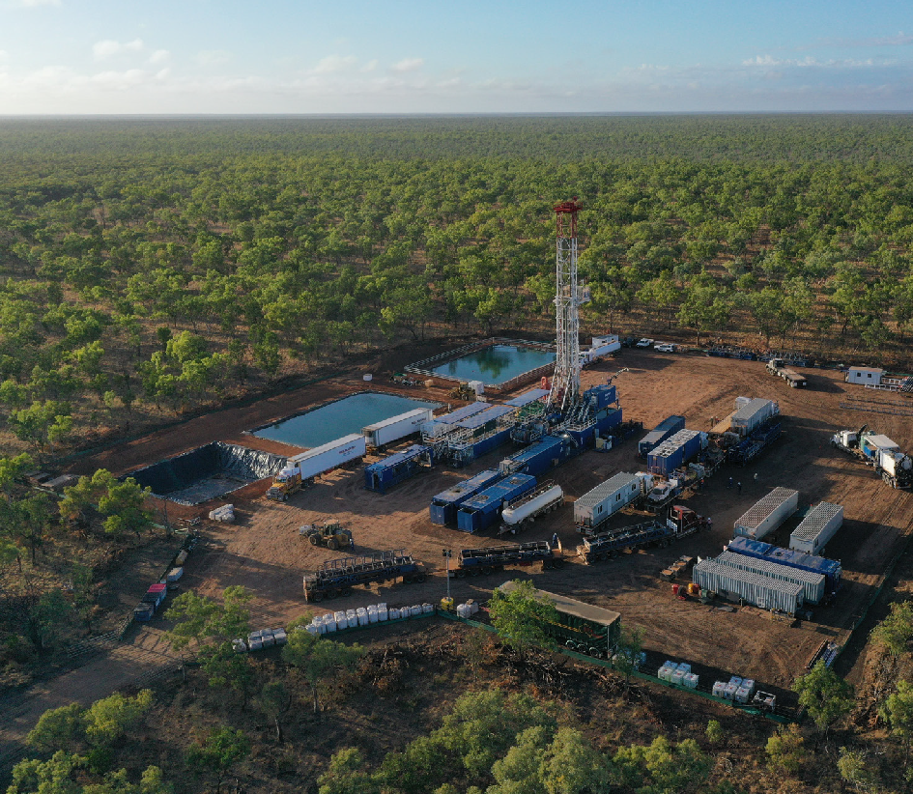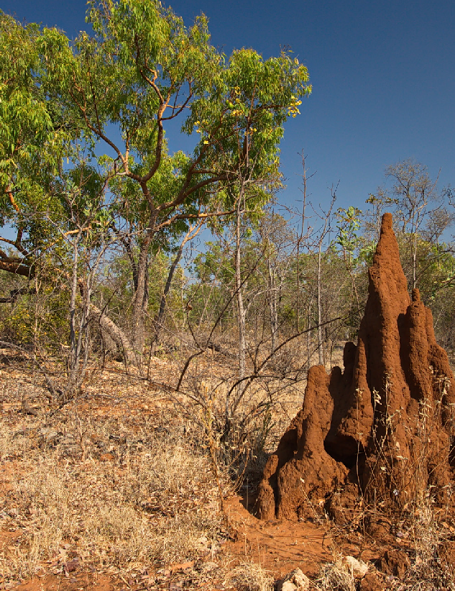Confidence in the link evaluations
© Empire Energy Group
The evaluation of each link using the questions in Figure 2 is based on the best available data and knowledge. There are, however, cause-and-effect relationships in the network for which the knowledge base is limited (for example there is considerable uncertainty associated with the impacts of noise and light pollution on fauna species). This can pertain to the cause-and-effect relationship itself, its direction, the material change definition, or the availability or effectiveness of mitigation strategies. To reflect this uncertainty, each link evaluation is assigned a confidence score – low, medium or high – reflecting the knowledge base underpinning the evaluation
(Table 4).

TABLE 4 Confidence assessment of links
Are we confident that the link is possible? ª | Are we confident that the link is or is not material? ^{b} | Are we confident the link can or cannot be mitigated? ^{c} | Confidence
Yes | Yes / Not applicable | Yes / Not applicable | High
Yes | Yes | No | Medium
Yes | No | Yes | Medium
No | Yes | Yes | Medium
Yes | No | No / Not applicable | Low
No | Yes | No / Not applicable | Low
No | No | Yes | Low
No | No / Not applicable | No / Not applicable | Low
a based on publication(s) with local system relevance or self-evident
b based on publication(s) with local system relevance
c based on publication(s) with local system relevance or publicly documented in approval conditions or proponent protocols

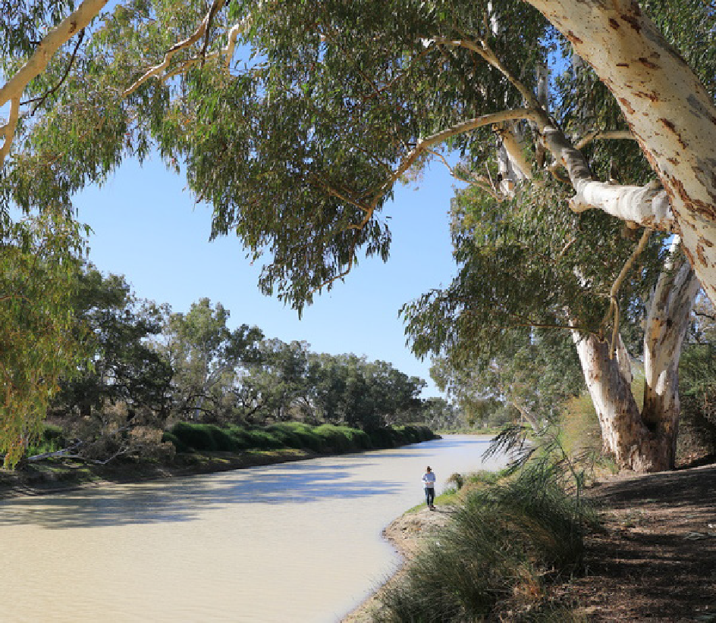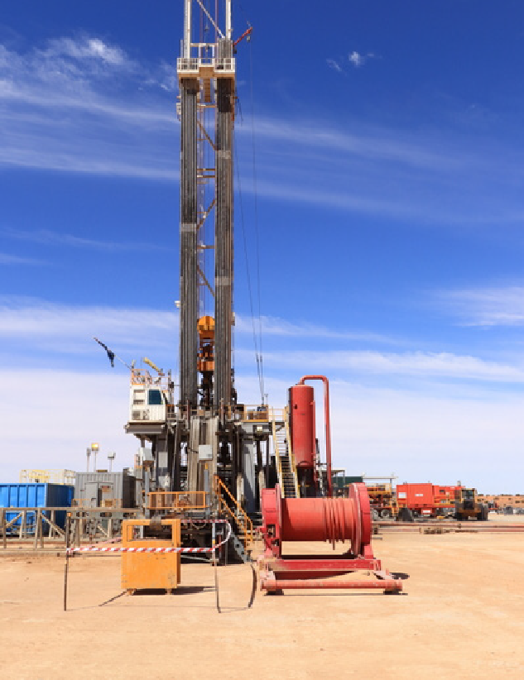Evaluating individual causal pathways
Queerbidie waterhole © CSIRO
The questions in Figure 2 are evaluated for each link individually and for each grid cell in the study region. Figure 3 illustrates how the evaluations for each link along an individual pathway of cause-and-effect relationships from development activities to endpoints are combined spatially for the 9 possible pathways in the hypothetical causal network shown in Figure 1.
The grids associated with each link enable spatial variability for each pathway to be assessed. The algorithm finds the minimum value of each grid cell for each of the 9 pathways in the hypothetical causal network. In the first 2 pathways (A>D>G>J and A>D>G>H>K; Figure 3),
the minimum value for each grid cell along the pathway is scored as 1 and therefore the spatial grid for the pathways A>>J and A>>K is a uniform grid of 1, evaluated as 1 or ‘possible but
not material’.
Consider the pathway B>D>G>J, one of the 2 pathways that exist from B>>J (B>D>G>J and B>E>G>J; Figure 3). The middle cell of grids for links along the pathway B>D>G>J is always a 4 and so is evaluated as 4 or ‘possible, material, unavoidable and cannot be mitigated’. The minimum value of the 8 cells around the middle cell is 3 for links B>D and D>G and 4 for link G>J, so
the pathway B>D>G>J is 3 or ‘possible, material and unavoidable but can be mitigated’.
The exception is the grid cell in the fourth row from the top and fourth column from the left. This grid cell has a value of 2 for link B>D. This the minimum for the grid cell across all grids, so the overall pathway evaluation for this grid cell is 2, ‘possible and material but can be avoided’. The minimum value of the 16 cells around the outside of the grid along the pathway B>D>G>J is 1 for links B>D and D>G and 3 for link G>J, so the pathway B>D>G>J is 1 or ‘possible but not material’. The minimum value for each cell along each of the 9 pathways is shown in the grids in the second column from the right in Figure 3.

© CSIRO

FIGURE 3 Spatial evaluation of individual pathways and all 9 pathways in the hypothetical
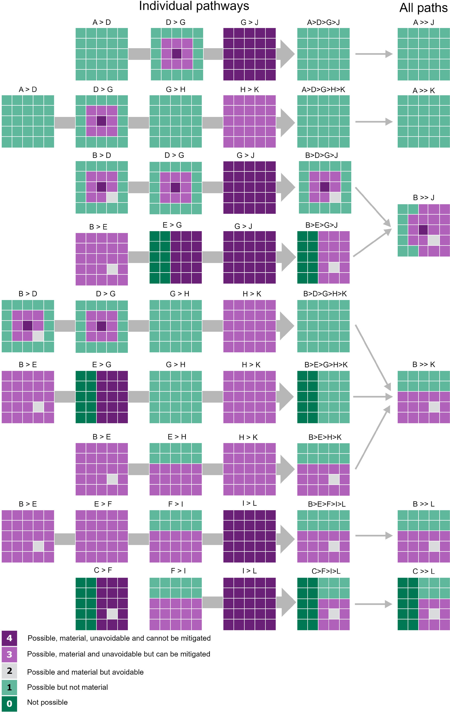
causal network

Evaluation of an individual pathway is the minimum value along the pathway – the critical link. Evaluation of multiple pathways is the maximum of the individual pathways – the strongest pathway. There are 6 overall pathways shown on the right, including 9 individual pathways (large grey background arrows).
Element: GBA-All-3-003

The outcome of the evaluation of an individual causal pathway between an activity and an endpoint is the minimum value of the links that form the pathway – the critical link. As an illustration, one possible pathway between construction of a well pad and habitat loss is:

construction
possible, material unavoidable and cannot be mitigated

possible but not material
noise pollution habitat loss

The outcome of the evaluation of the pathway from construction to habitat loss is ‘possible but not material’.

Evaluating multiple causal pathways from an activity to an endpoint
Multiple pathways can exist between a starting node and an end node, for instance from node B to node K (Figure 1). In the context of unconventional gas resource development, consider a second pathway between construction and habitat loss:

construction
possible, material and unavoidable but can be mitigated
possible, material, unavoidable and cannot be mitigated
vegetation removal habitat loss

As outlined earlier, civil construction is evaluated as ‘possible, material and unavoidable but can be mitigated’. Vegetation removal causes a regional loss of habitat, which is evaluated as ‘possible, material, unavoidable and cannot be mitigated’. The overall pathway between construction and habitat loss due to vegetation removal is evaluated as ‘possible, material and unavoidable but can be mitigated’.
When multiple pathways exist between an activity and an endpoint, the overall outcome of the pathway is the maximum of the individual pathways – the strongest pathway. In the above
example, this means that the evaluation of the pathways between construction and habitat loss is ‘possible, material and unavoidable but can be mitigated’ – the maximum of the 2 pathways.
The maximum value for the middle cell of the grids for the pathways from B>>J is 4, as it is 4 for pathway B>D>G>J and 3 for pathway B>E>G>J (Figure 3). Cells evaluated as 3 are the 8 cells around the middle cell along pathway B>D>G>J and the 15 cells on the right-hand side of the grid for pathway B>E>G>J, with the exception of the cell in the bottom right of the grid, which is evaluated as 2. This could be a national park where vegetation removal is not permitted and so any grid cells for this link are evaluated as 2. The remaining 7 cells on the left-hand side of the grid are evaluated as 1, which is the maximum value from pathways B>D>G>J and B>E>G>J
(Figure 3). The maximum value for each cell for each pathway from A>>J, A>>K, B>>J, B>>K, B>>L and C>>L is shown in the grids in the column on the right in Figure 3.

Describing potential impacts
In the assessment, the causal network with its spatial grids shows where in the landscape different endpoints could be impacted and by which activities. Links are evaluated according to their likelihood (possible, not possible), consequence (material, not material) and management (avoidable, unavoidable but can be mitigated, unavoidable and cannot be mitigated) (Figure 2). While this language is useful when evaluating individual links, it is less suited to describe the overall assessment. Instead, a ‘level of concern’ is used to describe the overall assessment outcome for a causal pathway – the strongest pathway between an activity and an endpoint (Table 5).

TABLE 5 Evaluation language used to describe links in the causal network and the corresponding level of concern used to describe the impact pathway through to endpoints

Evaluation
Not possible | Possible but not material  Possible and material but can be avoided | Possible, material and unavoidable but can be mitigated | Possible, material, unavoidable and cannot be mitigated
Level of concern
Very low concern | Low concern | Potential concern | Potentially high concern
Impacts are not physically possible or are extremely unlikely (having a probability of less than 1 in 1,000) | Impacts can be avoided by current legislation or because the impact does not represent a material change | Impacts can be minimised or mitigated by existing management controls | Impacts cannot be avoided or mitigated at the scale of the GBA region

Evaluating confidence in causal pathways from an activity to an endpoint
The summary of confidence in each link evaluation (Table 4) is based on the confidence in the evaluation of the cause-and-effect relationships, materiality thresholds and mitigation strategies. These confidence evaluations are also propagated through the causal network to
assess confidence in the causal pathways. To retain nuance in these confidence statements for the causal pathways, the confidence is not aggregated but reported separately as confidence in the cause-and-effect relationship, the materiality thresholds and the mitigation strategies for each causal pathway.
Confidence in the cause-and-effect relationship or materiality thresholds is the lowest confidence for all links along a causal pathway. As soon as the confidence in a single link evaluation for cause-and-effect or materiality is low, the confidence in these attributes is low for the entire pathway. Confidence in mitigation strategies is the highest confidence of all links along a pathway because if there is high confidence in a single mitigation strategy, then there is high confidence that potential impacts on an endpoint can be mitigated.

Using the causal network to improve monitoring strategies
Monitoring is critical for evaluating changes in a system associated with specific known impacts, such as those that may occur following development. Measurement endpoints are relevant
and measurable attributes of an endpoint that can be affected by development activities.
By associating measurement endpoints with links in the causal network, it becomes clear how each measurement endpoint is relevant to an endpoint. Monitoring objectives can be prioritised to address specific knowledge gaps identified by the causal network:
  - estimating baseline and trend to establish initial states and detect future trends or changes
  - control and impact monitoring to compare areas of potential impact with areas where no changes occur (control sites)
  - monitoring for compliance with legal requirements, and effectiveness of mitigation strategies required under regulations
  - monitoring to validate and refine the causal network to increase confidence in cause-and-effect relationship or material change thresholds.

How to navigate the causal network
Presenting and communicating the information captured by the causal network is challenging. The GBA Program is using a web interface to communicate the causal network, which allows users to explore and highlight the different pathways between activities and endpoints and any interactions within the network. The web interface also presents the spatial evaluations as grids for each link, the relevant definitions of material change and the overall assessment of potential impact on each endpoint.
This tool gives a high-level overview of the assessment and provides the context for all direct and indirect effects identified in the network. Detailed information for each node, the evaluation of the links and the justification for each evaluation is captured in a series of node descriptions – short documents for each node and link. These descriptions summarise and refer to the relevant literature, GBA investigations, legislation and protocols to support the evaluation of each link starting from that node.
Navigating the network and the node descriptions can be challenging. A good place to get started is with an endpoint and its description, before exploring the nodes and links along each pathway in more detail.

Why develop it?
The causal network provides a means to consistently evaluate impacts on endpoints by considering what constitutes a material change for each link in the network. This makes the assessment transparent, robust and repeatable and suited to multidisciplinary assessments at a regional scale. While the evaluation questions and answers for each link may appear simple, they are supported by evaluations that capture the necessary level of detail for each link and support the overall confidence in the assessment. The causal network systematically accounts for both direct and indirect effects on endpoints, and addresses known shortcomings in reliable estimates of likelihoods, which are particularly hard to estimate for extreme and rare events.

Glossary
Terms and definitions used in the Geological and Bioregional Assessment Program are available online.
activity: for the purposes of geological and bioregional assessments, an activity is a planned event associated with unconventional gas resource development. For example, activities during the exploration life-cycle stage include drilling and coring, ground-based geophysics and surface core testing.
aquifer: rock or sediment in a formation, group of formations, or part of a formation that is saturated and sufficiently permeable to transmit useful quantities of water.
aquitard: a saturated geological unit that is less permeable than an aquifer and incapable of transmitting useful quantities of water. Aquitards commonly form a confining layer over an artesian aquifer.
asset: an entity that has value to the community and, for the purposes of geological and bioregional assessments, is associated with a GBA region. An asset is a store of value and may be managed and/or used to maintain and/or produce further value. An asset may have many values associated with it that can be measured from a range of perspectives; for example, the values of a wetland can be measured from ecological, sociocultural and economic perspectives.
avoidance: averting the risk by deciding not to start or continue with the activity that gives rise to the risk. For the purpose of geological and bioregional assessments, the decision not to start an activity is mandated by the locally relevant legislation.
causal network: graphical models that describe the inferred cause-and-effect relationships linking development activities with ecological, economic and/or social values – referred to as endpoints – that are to be protected.
causal pathway: for the purposes of geological and bioregional assessments, the logical chain of events ‒ either planned or unplanned ‒ that link unconventional gas resource development and potential impacts on water and the environment.
consequence: the outcome of an event and has an effect on objectives.
contamination: an increase in the concentration of a biological, chemical or physical property that has the potential to produce an adverse effect in a biological system.
context: the circumstances that form the setting for an event, statement or idea. conventional gas: conventional gas is obtained from reservoirs that largely consist of porous
sandstone formations capped by impermeable rock, with the gas trapped by buoyancy. The gas can often move to the surface through the gas wells without the need to pump.
Cooper Basin: the Cooper Basin geological province is an Upper Carboniferous – Middle Triassic geological sedimentary basin that is up to 2,500 m thick and occurs at depths between 1,000 and 4,400 m. It occupies a total area of approximately 130,000 km² and is overlain completely by
the Eromanga and Lake Eyre basins. Most of the Cooper Basin is in south-western Queensland (95,740 km²) and north-eastern South Australia (34,310 km²). It includes a small area of New South Wales at Cameron Corner (8 km²).

cumulative impact: for the purposes of geological and bioregional assessments, total impact on endpoints from multiple stressors, and their interactions, due to multiple developments in multiple industries.
dataset: a collection of data in files and/or databases or delivered by services that comprise a related set of information. Datasets may be spatial (for example, a shape file or geodatabase or a Web Feature Service) or aspatial (for example, an Access database, a list of people or a model configuration file).
development: a phase in which newly discovered oil or gas fields are put into production by drilling and completing production wells.
drawdown: a lowering of the groundwater level caused, for example, by pumping.
driver: the major external driving forces that have large-scale influences on natural systems. Drivers can be natural or anthropogenic forces.
effect: a specific type of an impact (any change resulting from prior events). For the purposes of the impact analysis for the geological and bioregional assessments, an effect is the change in node B due to a change in node A; for example, a change in vegetation removal due to a change in civil construction.
endpoint: for the purposes of geological and bioregional assessments, an endpoint is a value pertaining to water and the environment that may be impacted by development of
unconventional gas resources. Endpoints include assessment endpoints – explicit expressions
of the ecological, economic and/or social values to be protected – and measurement endpoints – measurable characteristics or indicators that may be extrapolated to an assessment endpoint as part of the impact and risk assessment.
exploration: the search for new hydrocarbon resources by improving geological and prospectivity understanding of an area and/or play through data acquisition, data analysis and interpretation. Exploration may include desktop studies, field mapping, seismic or other geophysical surveys, and drilling.
extraction: the removal of water for use from waterways or aquifers (including storages) by pumping or gravity channels. In the oil and gas industry, extraction refers to the removal of oil and gas from their reservoir rock.
fracture: a crack or surface of breakage within rock not related to foliation or cleavage in metamorphic rock along which there has been no movement. A fracture along which there has been displacement is a fault. When walls of a fracture have moved only normal to each other, the fracture is called a joint. Fractures can enhance permeability of rocks greatly by connecting pores together and for that reason, fractures are induced mechanically in some reservoirs in order
to boost hydrocarbon flow. Fractures may also be referred to as natural fractures to distinguish them from fractures induced as part of a reservoir stimulation or drilling operation. In some shale reservoirs, natural fractures improve production by enhancing effective permeability.
In other cases, natural fractures can complicate reservoir stimulation.

groundwater: water occurring naturally below ground level (whether stored in or flowing through aquifers or within low-permeability aquitards) or water occurring at a place below ground that has been pumped, diverted or released to that place for storage there. This does not include water held in underground tanks, pipes or other works.
groundwater recharge: replenishment of groundwater by natural infiltration of surface water (precipitation, runoff), or artificially via infiltration lakes or injection.
hazard: an event, or chain of events, that might result in an effect (change in the quality and/or quantity of surface water or groundwater).
hydraulic fracturing: also known as ‘fracking’, ‘fraccing’ or ‘fracture simulation’. This is a process by which geological formations bearing hydrocarbons (oil and gas) are stimulated to increase the flow of hydrocarbons and other fluids towards the well. In most cases, hydraulic fracturing is undertaken where the permeability of the formation is initially insufficient to support sustained flow of gas. The process involves the injection of fluids, proppant and additives under high pressure into a geological formation to create a conductive fracture. The fracture extends from the well into the production interval, creating a pathway through which oil or gas is transported to the well.
hydrogeology: the study of groundwater, including flow in aquifers, groundwater resource evaluation and the chemistry of interactions between water and rock.
impact: the difference between what could happen due to changes associated with development of extractive industries, such as shale gas development, and what would happen without development. For the purposes of the geological and bioregional assessments, impacts are adverse changes to endpoints that represent the ecological, economic and/or social values to be protected. Impacts can be a direct or indirect consequence of single or multiple developments.
For example, an impact of unconventional gas resource development could be a decrease in the persistence of the grey grasswren.
invasive: for the purposes of the geological and bioregional assessments, refers to a species that
(i) has successfully established outside its natural range as a result of human actions, deliberate or inadvertent, that have enabled it to overcome biogeographical barriers; (ii) gone on to has spread rapidly over substantial distances from sites of introduction; and (iii) has the potential to have harmful effects on components of the natural environment.
level of concern: rating that describes assessment of potential impacts on an endpoint in the causal network. This rating is based on evaluation of likelihood and consequence and takes into account compliance with existing regulatory controls and operational practice.
likelihood: the chance that something might happen.
management: for the purposes of geological and bioregional assessments, a coordinated set of activities and methods used to minimise and control risks.

material change: for the purposes of the geological and bioregional assessments, an expression of the severity or consequence of a change. A change that exceeds defined thresholds in
terms of magnitude, extent, duration, timing or frequency that is likely to require local-scale assessment, mitigation and monitoring.
mitigation: minimising the risk by removing the risk source, or changing the likelihood or consequences of the activity that gives rise to the risk.
oil: a mixture of liquid hydrocarbons and other compounds of different molecular weights. Gas is often found in association with oil. Also see petroleum.
petroleum: a naturally occurring mixture consisting predominantly of hydrocarbons in the gaseous, liquid or solid phase.
precautionary principle: a mandate to address uncertainty and to ensure that potential impacts, though not well-defined or understood, are considered in decision making.
process: for the purposes of geological and bioregional assessments, a naturally occurring mechanism (for example, groundwater drawdown) that could change a characteristic of an endpoint.
production: in petroleum resource assessments, ‘production’ refers to the cumulative quantity of oil and natural gas that has been recovered already (by a specified date). This is primarily output from operations that has already been produced.
recharge: see groundwater recharge.
risk: the effect of uncertainty on objectives (AS/NZS ISO 31000:2009). This involves assessing the potential consequences and likelihood of impacts to environmental and human values that may stem from an action, under the uncertainty caused by variability and incomplete knowledge of the system of interest.
sediment: various materials deposited by water, wind or glacial ice, or by precipitation from water by chemical or biological action (for example, clay, sand and carbonate).
sedimentation: the process of deposition and accumulation of sediment (unconsolidated materials) in layers.
severity: magnitude of an impact.
shale: a fine-grained sedimentary rock formed by lithification of mud that is fissile or fractures easily along bedding planes and is dominated by clay-sized particles.
stressor: for the purposes of geological and bioregional assessments, a stressor is a physical, chemical or biological agent, environmental condition or external stimulus that might contribute to an impact.

surface water: surface-expressed waters that are either permanent or ephemeral.
tight gas: tight gas is trapped in reservoirs characterised by very low porosity and permeability. The rock pores that contain the gas are minuscule and the interconnections between them are so limited that the gas can only migrate through it with great difficulty.
unconventional gas: unconventional gas is generally produced from complex geological systems that prevent or significantly limit the migration of gas and require innovative technological solutions for extraction. There are numerous types of unconventional gas such as coal seam gas, deep coal gas, shale gas and tight gas.
well: typically a narrow diameter hole drilled into the earth for the purposes of exploring, evaluating, injecting or recovering various natural resources, such as hydrocarbons (oil and gas), water or carbon dioxide. A well is sometimes known as a ‘wellbore’.
well pad: the area of land on which the surface infrastructure for drilling and hydraulic fracturing operations are placed. The size of a well pad depends on the type of operation (for example, well pads are larger during the initial drilling and hydraulic fracturing than at production).

Find out more
bioregionalassessments.gov.au/gba

Citation
Peeters L, Holland KL, Huddlestone-Holmes C, Brandon C, Lawrence E, Tetreault-Campbell S (2021) Introduction to causal networks. Geological and Bioregional Assessment Program: Stage 3. Department of Agriculture, Water and the Environment, Bureau of Meteorology, CSIRO and Geoscience Australia, Australia.

Funding
The GBA Program is funded by the Australian Government Department of Agriculture, Water and the Environment. The Department of Agriculture, Water and the Environment, Bureau of Meteorology, CSIRO and Geoscience Australia are collaborating to undertake geological and bioregional assessments. For more information, go to bioregionalassessments.gov.au/gba.

Copyright

© Commonwealth of Australia 2021
With the exception of the Commonwealth Coat of Arms and where otherwise noted,
all material in this publication is provided under a Creative Commons Attribution 4.0 Australia Licence. The Geological and Bioregional Assessment Program requests attribution as
‘© Commonwealth of Australia (bioregionalassessments.gov.au/gba)’.

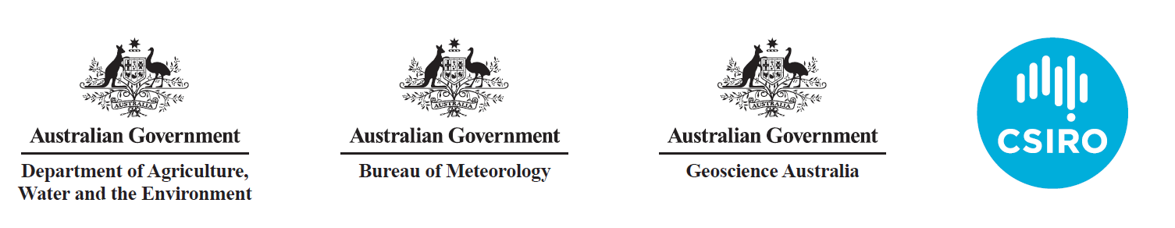

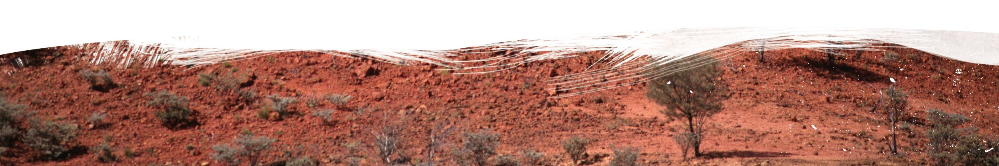

BIO734.0421
Introduction to causal networks
Geological and Bioregional Assessment Program 25

