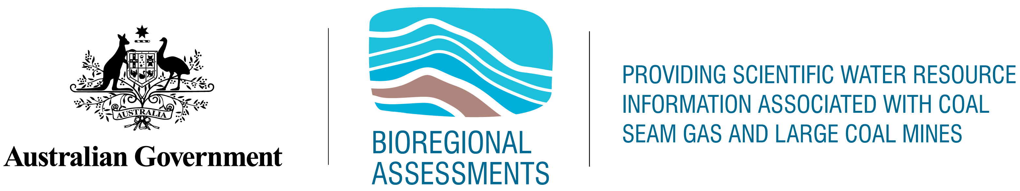

Current Water Account for the Gippsland Basin bioregion

Product 1.5 from the Gippsland Basin Bioregional Assessment

2018



The Bioregional Assessment Programme

The Bioregional Assessment Programme is a transparent and accessible programme of baseline assessments that increase the available science for decision making associated with coal seam gas and large coal mines. A bioregional assessment is a scientific analysis of the ecology, hydrology, geology and hydrogeology of a bioregion with explicit assessment of the potential direct, indirect and cumulative impacts of coal seam gas and large coal mining development on water resources. This Programme draws on the best available scientific information and knowledge from many sources, including government, industry and regional communities, to produce bioregional assessments that are independent, scientifically robust, and relevant and meaningful at a regional scale.

The Programme is funded by the Australian Government Department of the Environment. For more information, visit [http://www.bioregionalassessments.gov.au](http://www.bioregionalassessments.gov.au/).

Department of the Environment

The Office of Water Science, within the Australian Government Department of the Environment, is strengthening the regulation of coal seam gas and large coal mining development by ensuring that future decisions are informed by substantially improved science and independent expert advice about the potential water related impacts of those developments. For more information, visit <http://www.environment.gov.au/coal-seam-gas-mining/>.

Bureau of Meteorology

The Bureau of Meteorology is Australia’s national weather, climate and water agency. Under the Water Act 2007, the Bureau is responsible for compiling and disseminating Australia's water information. The Bureau is committed to increasing access to water information to support informed decision making about the management of water resources. For more information, visit <http://www.bom.gov.au/water/>.

Department of Environment, Land, Water and Planning

The Department of Environment, Land, Water and Planning creates liveable, inclusive and sustainable communities that support jobs and growth in Victoria. We recognise the link between the built and natural environment in the quality of our lives, and work to accommodate population growth while maintaining world class liveability and protecting our heritage for future generations. For more information, visit <http://www.delwp.vic.gov.au>.

**Geological Survey of Victoria**

The Geological Survey of Victoria (GSV) is Victoria’s geoscience agency and leading authority on Victorian geology. The GSV is the custodian of over 160 years of geological knowledge. The GSV provides objective and authoritative geoscientific data and advice, creates and delivers innovative geoscience information, on a wide range of earth resources which underpin sound Victorian government policy, programs and projects. For more information, visit <http://www.energyandresources.vic.gov.au/earth-resources/geology-of-victoria/geological-survey-of-victoria>.

**Department of Economic Development, Jobs, Transport and Resources**

Agriculture Victoria works with the agriculture and fisheries industries on research, development and extension to improve production, connect the sector with international markets, support development and maintain effective biosecurity controls.  For more information, visit <http://agriculture.vic.gov.au>

ISBN: 978-1-925315-89-9

Citation

DELWP (2017) Current Water Account report for the Gippsland Basin bioregion.

Copyright

Creative Commons [logo] © Commonwealth of Australia 2015  
With the exception of the Commonwealth Coat of Arms and where otherwise noted, all material in this publication is provided under a Creative Commons Attribution 3.0 Australia Licence <http://www.creativecommons.org/licenses/by/3.0/au/deed.en>.   
The Bioregional Assessment Programme requests attribution as ‘© Commonwealth of Australia (Bioregional Assessment Programme <http://www.bioregionalassessments.gov.au>)’.

Disclaimer

The information contained in this report is based on the best available information at the time of publication. The reader is advised that such information may be incomplete or unable to be used in any specific situation. Therefore decisions should not be made based solely on this information or without seeking prior expert professional, scientific and technical advice

Cover photograph

Lake Victoria, Victoria, 2013 

Credit: Hashim Carey

Contents

1.5 Current water accounts and water quality for the Gippsland Basin region 7

1.5.1 Current water accounts 8

1.5.1.1 Introduction 8

1.5.1.2 Groundwater management units and reporting boundaries 9

1.5.1.3 A methodology to estimate current groundwater usage 11

1.5.1.4 Current water accounts 13

1.5.1.5 Gaps 21

1.5.2 Groundwater quality 23

1.5.2.1 Introduction 23

1.5.2.2 Total Dissolved Solids 24

1.5.2.2.1 Lower Aquifer System 27

1.5.2.2.2 Middle Aquifer System 28

1.5.2.2.3 Upper Aquifer System 31

1.5.2.3 Summary of analytes from groundwater sampling programme 32

1.5.2.3.1 Ethane, Ethene, Butane, Butene, Propane and Propene 33

1.5.2.3.2 BTEX 33

1.5.2.3.3 Total Petroleum Hydrocarbons (TPH) 33

1.5.2.3.4 Napthalene 33

1.5.2.4 Gaps 33

References 34

Datasets 34

Figures

Figure 1 GMA/WSPAs reported on in State water accounts for the Gippsland Basin bioregion..........................................................................................................................10

Figure 2 State water account reporting regions (excluding Rosedale, Stratford and Yarram)....15

Figure 3 Rosedale water account reporting regions (and associated depths) 16

Figure 4 Stratford and Yarram water account reporting regions (and associated depths) 17

Figure 5 Location of all groundwater extraction bores 18

Figure 6 Total Dissolved Solids distribution and sampled bore locations for the Lower Tertiary Aquifer, here referred to as the Lower Aquifer system (Datasets 1 and 2) 28

Figure 7 Total Dissolved Solids distribution and sampled bore locations for the Upper Mid-Tertiary Aquifer, here referred to as the Middle Aquifer system (1) (Datasets 1 and 2) 29

Figure 8 Total Dissolved Solids distribution and sampled bore locations for the Upper Tertiary Aquifer Fluvial, here referred to as the Middle Aquifer system (2) (Datasets 1 and 2)..............................................................................................................................30

Figure 9 Total Dissolved Solids distribution and sampled bore locations for the Upper Tertiary Quaternary Aquifer, here referred to as the Upper Aquifer system (Datasets 1 and 2) 31

Figure 10 Piper diagram of major ion analyses by aquifer – for three rounds of sampling (December 2014, March 2015 and June 2015) 32

Tables

Table 1 Groundwater bores within each GMA and WSPA reporting region 11

Table 2 Victorian Water Accounts (usage ML) 14

Table 3 Extraction volume for 2012 (ML) 20

Table 4 Extraction volume drawn from each dominant aquifer for 2012 (ML) 21

Table 5 Aquifers in the Gippsland Basin 24

Table 6 Total Dissolved Solids results from the Gippsland Basin sampling program 26

Table 7 Summary of Total Dissolved Solids in the Upper, Middle, and Lower Aquifers 27

Table 8 Total Dissolved Solids by aquifer unit 27



## Current water accounts and water quality for the Gippsland Basin region

This product provides baseline water account and water quality information that will be used in subsequent products in the bioregional assessment.

The water accounts include information about water stores, flows, licensed volumes and use that will be required in the water balance (companion product 2.5) and in the groundwater numerical modelling (companion product 2.6.2).

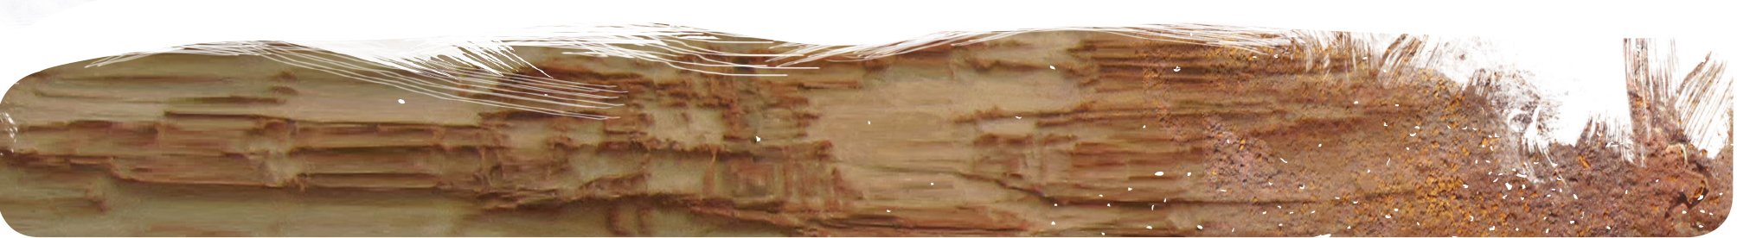Surface water modelling has not been undertaken for this bioregional assessment. Information on use and availability of surface water is available from the Victorian Water Account 2011–12 for each of the river basins (<http://waterregister.vic.gov.au/water-availability-and-use/victorian-water-accounts>).

This product also provides information about groundwater quality based on historical salinity mapping and groundwater sampling undertaken for this assessment.

### Current water accounts

Summary

The Gippsland Basin bioregion includes five river basins and 12 groundwater management areas (GMAs) and water supply protection areas (WSPAs). Most of the groundwater extraction in the basin occurs in the GMAs and WSPAs.

State-wide policies and licensing requirements apply to all groundwater extractions in Victoria. Groundwater take and use is licensed under s. 51 of the *Water Act 1989* (Vic). Stock and domestic use is regulated under s. 8 of the Water Act and while it requires the bore to be registered via a bore construction licence, it does not require a licence to take and use the water.

The extraction of groundwater from Victoria’s aquifers is managed in accordance with permissible consumptive volumes (PCVs) set for each Groundwater management Area (GMA) and Water Supply Protection Area (WSPA). Groundwater take is metered in accordance with national metering standards. State-wide water accounts provide data on groundwater use in accordance with GMAs and WSPAs for each groundwater catchment and river basin.

Within the Gippsland Basin bioregion there are 1448 groundwater extraction bores, 116 mine dewatering bores and 5459 stock and domestic bores. Of the 1448 groundwater bores, approximately 70% have an assigned entltement as of the final quarter of 2012. A nominal usage allowance of 1.5 mega litres per year (ML/year) was attributed to stock and domestic bores.

Groundwater extractions within the Gippsland Basin bioregion from 1990 to 2012 were estimated at 118,290 ML/year, including 77,876 ML/year from licensed groundwater users, 26,009 ML/year from mine dewatering and 8709 ML/year from stock and domestic bores. The largest withdrawals occur from the alluvial aquifers.

#### Introduction

This section provides information on groundwater extractions and an estimate of groundwater usage within the Gippsland Basin bioregion up to the final quarter of 2012. Actual measured historical groundwater usage data often require data infilling based on entitlement and/or licence conditions.

Water accounts are produced annually for Victoria. Groundwater is presented within these annual accounts against the groundwater catchments and groundwater management units. In the Gippsland Basin, there are 12 groundwater management units covering four groundwater catchments (Moe, East Gippsland, Central Gippsland and Seaspray). A summary of the groundwater management areas in the basin is provided below, along with a summary of previous Victorian water accounts which have been used to estimate groundwater usage in the Gippsland Basin bioregion.

Further detail on these groundwater resources can be found in the context statement (see companion product 1.1 for the Gippsland Basin bioregion).

#### Groundwater management units and reporting boundaries

This section outlines the framework for the management and reporting of groundwater resources. In 2012, the Victorian Government developed a new groundwater management framework comprising groundwater basins, catchments and management units. The aim of the framework is to align groundwater management boundaries with groundwater catchments, with a focus to manage connected groundwater resources and reflect the geology beneath the ground.

A groundwater basin comprises one or more groundwater catchments within a geological basin. A groundwater catchment is an area containing a connected groundwater resource(s), bringing together the input (recharge) areas, use (demand) areas and discharge areas.

Within the Gippsland Basin bioregion, there is only one groundwater basin—Gippsland Basin— which covers the East Gippsland, Central Gippsland, Moe and Seaspray groundwater catchments. Figure 1 shows there are 12 Groundwater Management Units (GMUs) located in these groundwater catchments. There are three types of GMU:

* Groundwater management area (GMA) – an area where groundwater has been intensively developed or has the potential to be, is gazetted and managed via local management plans.
* Water supply protection area (WSPA) – an area declared under the *Water Act 1989* (Vic) to protect groundwater or surface water resources through the development of a statutory management plan.
* Unincorporated area (UA) – an area where limited development or use of groundwater has occurred. This is usually because the resource is low-yielding, its quality has limited its use, or there is limited information about resource availability.

Figure 1 shows that of the 12 GMUs in the East Gippsland, Central Gippsland, Moe and Seaspray groundwater catchments, four are WSPAs and eight are GMAs.

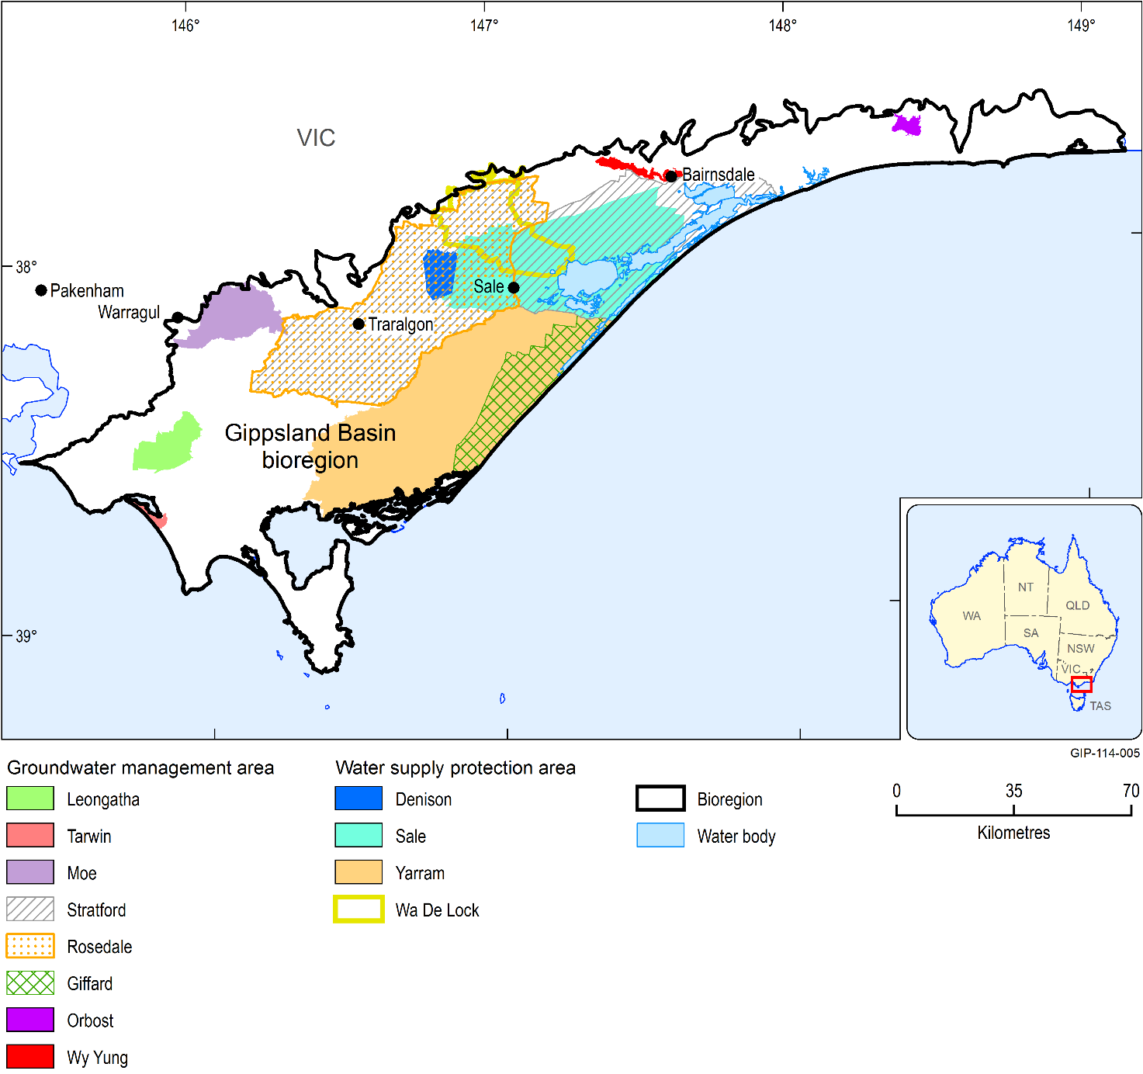

Figure 1 GMA/WSPAs reported on in Victorian Water Accounts for the Gippsland Basin bioregion

Rural water corporations, on behalf of the Minister for Water, manage the groundwater resources and licence use in accordance with statutory management plans for WSPAs or local management plans for GMAs. Local management plans are prepared in accordance with the Local Management Plan Guidelines approved by the Minister.

Licensing is the fundamental basis for allocating groundwater, and the total volume of groundwater that may be taken from a GMU is referred to as the Permissible Consumptive Volume (PCV). PCVs are declared by the Minister for Water through an order published in the government gazette.

Groundwater trade in Victoria is recorded in three categories: temporary, permanent or associated with land transfer (i.e. selling a property on which there is a groundwater bore). Volumes of trades to date remain relatively small, especially when compared with surface water. Full details of groundwater trade in each GMA and WSPA are published in the annual Victorian Water Accounts reports (<http://waterregister.vic.gov.au/water-availability-and-use/victorian-water-accounts>).

State-wide policies and licensing requirements apply to all groundwater extractions in Victoria. Groundwater take and use is licensed under s. 51 of the Water Act. The licensed volume for take and use is the maximum volume that may be taken under an individual licence. Stock and domestic use is regulated under s. 8 of the Act and requires the bore to be registered via a bore construction licence; however, it does not require a licence to take and use the water. A nominal usage allowance of 1.5 ML/year was attributed to stock and domestic bores.

Table 1 lists groundwater usage in ML/year. Table 2 further below provides a breakdown of the number of bores on a per GMU for the Gippsland Basin bioregion.

Table 1 Groundwater bores within each GMA and WSPA reporting region

|  |  |  |  |  |  |  |
| --- | --- | --- | --- | --- | --- | --- |
|  | Depth upper (m) | Depth lower (m) | Licensed pumps | Mine pumps | S&D | Total pumps |
| Denison WSPA | 0 | 25 | 183 | 0 | 118 | 301 |
| Giffard GMA | 500 | 200 | 16 | 0 | 152 | 168 |
| Leongatha GMA | 0 | Basement | 27 | 0 | 130 | 157 |
| Moe GMA | 25 | Basement | 67 | 0 | 249 | 316 |
| Orbost GMA | 20 | 45 | 11 | 0 | 13 | 24 |
| Rosedale GMA Zone 1 | 50 | 150 | 20 | 48 | 19 | 87 |
| Rosedale GMA Zone 2 | 25 | 350 | 229 | 0 | 506 | 735 |
| Rosedale GMA Zone 3 | 200 | 350 | 15 | 0 | 11 | 26 |
| Sale WSPA | 25 | 200 | 413 | 0 | 1,011 | 1,424 |
| Stratford GMA Zone 1 | 150 | Basement | 1 | 8 | 7 | 16 |
| Stratford GMA Zone 2 | 350 | Basement | 5 | 0 | 15 | 24 |
| Tarwin GMA | 0 | 25 | 1 | 0 | 23 | 24 |
| WaDeLock GMA | 0 | 25 | 301 | 0 | 323 | 627 |
| Wy Yung WSPA | 0 | 25 | 110 | 0 | 71 | 181 |
| Yarram WSPA Zone 1 | 0 | Basement | 102 | 0 | 510 | 612 |
| Yarram WSPA Zone 2 | 200 | Basement | 6 | 0 | 17 | 23 |

#### A methodology to estimate current groundwater usage

The estimate provided on current groundwater usage is based on many premises and assumptions, including licensing conditions for take and use licences, and previous modelling and groundwater assessments.

Time series groundwater extraction data was sourced from various independent data sets, namely:

* Southern Rural Water – this data includes groundwater bore locations, bore construction date, entitlement and metered usage.
* GHD mine models – pre-existing simulation model well files sourced to provide site specific groundwater extractions associated with Latrobe Valley coal mines (GHD 2011a, GHD 2011b).
* EcoMarkets data – this data set captured the groundwater usage information incorporated in the East Gippsland and West Gippsland groundwater models developed by GHD Pty Ltd (GHD, 2010a, 2010b) as part of the ecoMarkets project commissioned by the Department of Sustainability and Environment (DSE) in 2008.
* Stock and domestic – Victorian state-wide stock and domestic data was provided by the Department of Environment, Land, Water and Planning (DELWP) and included location, completion date, top of screen and annual extraction volume.

All bores were assigned to aquifers based on the following criteria (in order of priority):

* historical abstraction data prioritised according to data source
* bore construction (screen depth) information in conjunction with an assigned GMU
* bore construction (screen or bore depth) information
* bores without any GMU or construction data were assigned to the uppermost (watertable) aquifer.

A dataset for estimating annual groundwater use (ML/year) was compiled using the following steps:

1. Compile a list of all bores in the Gippsland Basin bioregion using all available groundwater data.
2. Interrogate bore locations and remove duplicate records.
3. For each bore, where data are available, incorporate interpreted stratigraphic picks (i.e. hydrogeological units) for screened intervals into the dataset.
4. For each bore, where data are available, incorporate the recorded standing water level data.
5. For each bore, where data are available, incorporate construction dates into the dataset.
6. From the water licence dataset, incorporate the licensed water allocation volume, bore use and water source area information.
7. Interrogate bore use records. Remove any bore from the dataset that is tagged as a monitoring, abandoned, decommissioned or non-functional bore. It is assumed that monitoring bores are not being used for any purpose other than groundwater monitoring.
8. For those bores without a licensed entitlement, assume 2007–08 usage as an equivalent entitlement.
9. Assign bores to corresponding reporting regions (GMA, WSPA and UA) and CMA. This was necessary for both the data infilling procedure and for cross-checking with the Victorian Water Account groundwater usage data.
10. For those bores that do not have an annual usage record:
    1. Derive and apply a relationship between rainfall and available usage data
    2. Extraction bores within East Gippsland CMA apply the same seasonal usage trends as calculated for all West Gippsland CMA bores.
11. Final check that volumes align with the Victorian Water Account groundwater usage volumes.

While limited monitored groundwater usage data was available for East Gippsland CMA bores from 1970 to 1990, a more complete dataset was available for West Gippsland CMA bores. To address the data deficiency, the annualised West Gippsland CMA groundwater usage trend derived from 1970 to 1990 was assigned to East Gippsland CMA bores with missing data. Bore construction dates were used to ensure that extractions were assigned post-construction. Where data was available, entitlement volumes were used to constrain usage. Importantly, all abstractions within the model domain were scaled to match the Victorian Water Account usage volumes.

#### Current water accounts

The Victorian Water Accounts have reported key water resource management data for Victoria for each financial year since 2003–04.

Table 2 summarises groundwater use from each GMA and WSPA as reported in the Victorian Water Accounts since July 2003. Figure 2, Figure 3 and Figure 4 show the spatial extent and depths of the relevant water account reporting regions. Figure 5 shows the location of all extraction bores. Full details of water entitlements and use from each GMA and WSPA are presented in the Appendix of each annual report (<http://waterregister.vic.gov.au/water-availability-and-use/victorian-water-accounts>).

Table 2 Victorian Water Accounts (usage ML)

| GMA/WSPA | 2003–04 | 2004–05 | 2005–06 | 2006–07 | 2007–08 | 2008-09 | 2009–10 | 2010–11 | 2011–12 |
| --- | --- | --- | --- | --- | --- | --- | --- | --- | --- |
| Denison WSPA | 15,224 | 6,500 | 6,680 | 10,152 | 6,147 | 8,385 | 7,987 | 3,695 | 2,992 |
| Giffard GMA | 2,719 | 2,520 | 3,260 | 3,719 | 3,205 | 3,662 | 1,717 | 865 | 845 |
| Leongatha GMA | 648 | 515 | 441 | 625 | 600 | 344 | 158 | 31 | 72 |
| Moe GMA | 1,098 | 1,084 | 990 | 1,447 | 1,414 | 1,081 | 1,095 | 191 | 330 |
| Orbost GMA | 464 | 270 | 350 | 540 | 490 | 578 | 333 | 95 | 0 |
| Rosedale GMA | 15,457 | 9,920 | 10,860 | 7,539 | 10,678 | 11,540 | 11,009 | 7,543 | 7,739 |
| Sale WSPA | 14,680 | 7,680 | 10,450 | 13,358 | 9,504 | 11,185 | 11,094 | 7,164 | 6,324 |
| Stratford GMA | 27,355 | 17,230 | 17,690 | 19,182 | 24,099 | 26,897 | 27,896 | 24,904 | 26,042 |
| Tarwin GMA | 18 | 14 | 12 | 12 | 2 | 6 | 6 | 9 | 15 |
| Wa De Lock GMA | 12,095 | 9,403 | 8,059 | 10,509 | 7,194 | 9,517 | 10,386 | 4,832 | 3,767 |
| Wy Yung WSPA | 2,438 | 790 | 1,110 | 1,895 | 631 | 1,024 | 798 | 309 | 347 |
| Yarram WSPA | 12,205 | 8,100 | 11,070 | 16,009 | 12,048 | 13,911 | 11,778 | 6,882 | 6,740 |

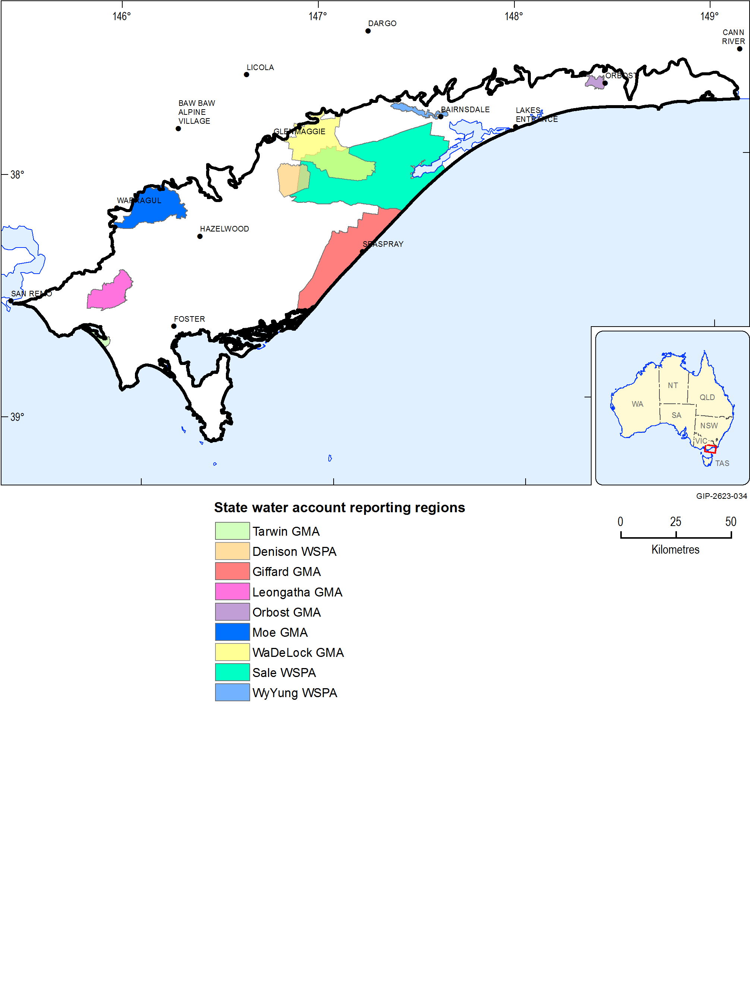

Figure 2 Victorian Water Account reporting regions (excluding Rosedale, Stratford and Yarram)

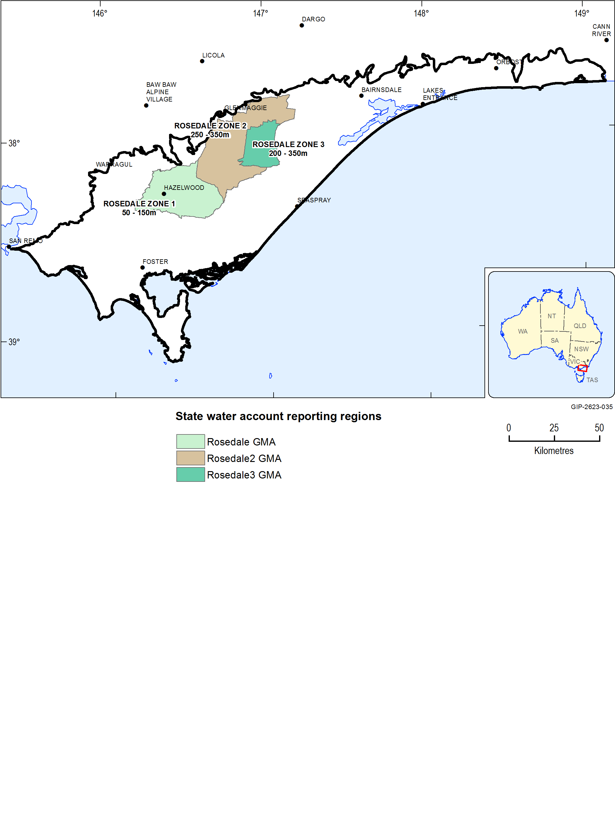

Figure 3  Rosedale water account reporting regions (and associated depths)

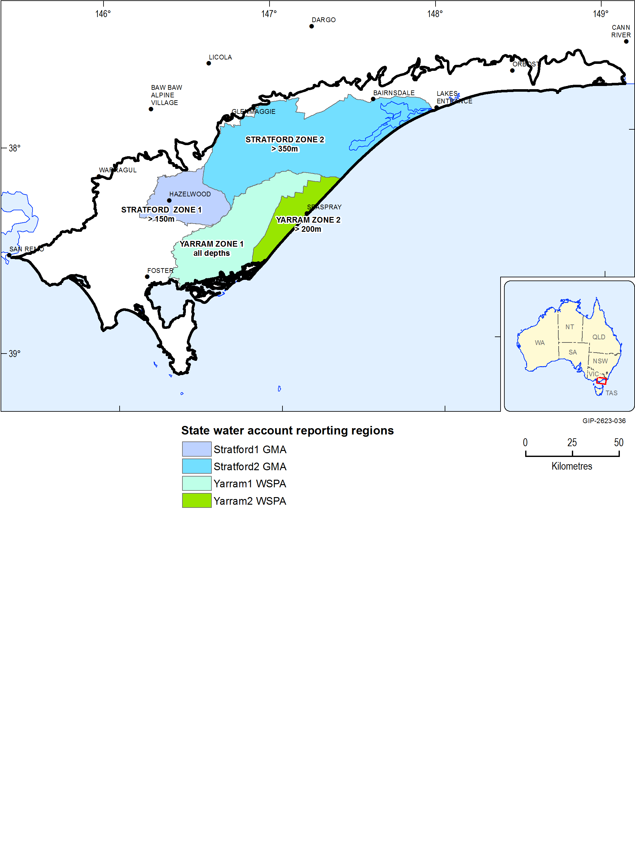

Figure 4  Stratford and Yarram Water Account reporting regions (and associated depths)

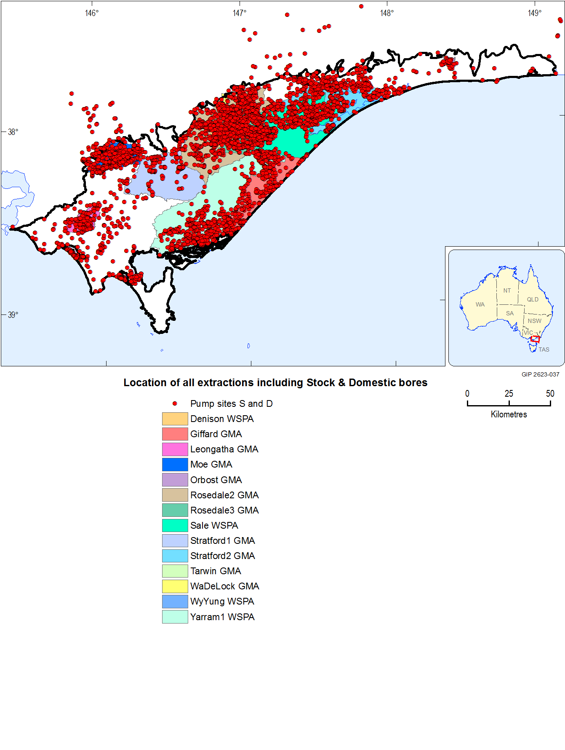

Figure 5  Location of all groundwater extraction bores

Using the methodology previously described, it was estimated that 106,346 ML/year was extracted across the Gippsland Basin bioregion during the 2012 calendar year. Table 3 summarises the number of extraction bores and corresponding 2012 usage for various activities. The estimated extractions for each of the dominant Victorian Aquifer Framework (VAF) (SKM, 2011; GHD, 2012) units are reported in

Table 4. The information reported in Table 2 provides details on the aquifers and formations extracted from. This may differ from the Victorian Water Accounts, which only reports usage against groundwater management areas and river basins.

Within the Gippsland Basin bioregion there are 1448 groundwater extraction bores, 116 mine dewatering bores and 5459 stock and domestic bores (Table 3).

Table 3 Extraction volume for 2012 (ML)

|  |  |  |
| --- | --- | --- |
| Bore type | Number of bores | 2012 extractions (ML) |
| Groundwater usage in the East Gippsland CMA region excluding mine dewatering and stock and domestic bores | 402 | 2,861 |
| Groundwater usage in the West Gippsland CMA region excluding mine dewatering and stock and domestic bores | 1,046 | 79,734 |
| Coal mine dewatering bores | 116 | 14,255 |
| Stock and domestic bores | 5,459 | 9,496 |
| Totals | 7,023 | 106,346 |

Table 4 Extraction volume drawn from each dominant aquifer for 2012 (ML)

|  |  |  |  |
| --- | --- | --- | --- |
| VAF layer no.* | Generalised aquifer or formation description | Alternate references and names relating to coal layers | 2012 extractions (ML) |
| 101 | Quaternary |  | 3,932 |
| 102 | Haunted Hill Formation |  | 35,420 |
| 103 | Nuntin clay |  | 1,419 |
| 105 | Boisdale Formation |  | 10,477 |
| 106 | Jemmy’s Point Formation and upper Hazelwood Formation |  | 2,551 |
| 106 | Yallourn Coal Seam | Y, Y1a, Y1b, Y2, Y1; y_all | 136 |
| 106 | Yallourn Aquifer & interseam | Hazelwood Formation; y_all floor & M1a_all top | 1,985 |
| 107 | Lower M2 interseam, | Balook Formation Tambo River, Wuk Wuk Marl, Gippsland Limestone | 5,012 |
| 107 | M1A coal | Yarragon Formation, M10, M1a, M1b2, ML, M12; M1a_all | 313 |
| 107 | Morwell 1A interseam/aquifer | M1a_all_floor and M1b_top | 161 |
| 107 | Morwell 1B coal | M1b, M1b1, M1b2, ML, M12 | 2,127 |
| 107 | Morwell 1B interseam | Floor M1b_all & M2_all top | 8,591 |
| 107 | Morwell 2 | M2, M2A, M2B coal; M2_all | 3,956 |
| 112 | Thorpdale volcanics |  | 291 |
| 111 | Upper Latrobe Group |  | 10,089 |
| 111 | TP, T1, TRU, TRM, TRL |  | 415 |
| 111 | Floor T1_all & Top T2_all |  | 1,572 |
| 111 | Lower Latrobe Group; T2_all floor |  | 1,451 |
| 111 | Strzelecki top 500 m |  | 979 |
| 114 | Strzelecki > 500 m |  | 15,468 |
| Totals |  |  | 106,346 |

*Victorian Aquifer Framework (VAF) layers are described in companion product 1.1 – Context statement

#### Gaps

Groundwater metering began in some groundwater management units in 2004, and is recorded annually. For other GMUs it was introduced later, with estimates from farm surveys providing the main source of extraction data prior to metering. This means it is difficult to estimate groundwater extraction volumes throughout the basin. This results in a high degree of uncertainty regarding groundwater usage. Additionally, not all bores have bore construction details in the state-wide database making it difficult to ascertain which aquifer groundwater is drawn from.

For these reasons the key information gaps include:

* Stratigraphy and screened intervals for all bores – this would improve the assignment of bores to specific aquifers thereby enabling enhanced groundwater use estimates on a per aquifer basis.
* Actual monthly usage data – this would provide more accurate estimates of groundwater usage and the distribution of usage within regions and aquifers.

### Groundwater quality

Summary

Groundwater salinity is measured frequently to assess risk of salinisation in irrigation areas and to determine beneficial use categories. This data forms the key source of groundwater quality information in this report. Other water quality parameters are measured on an ad-hoc basis for project specific requirements. A water quality sampling program was undertaken that included three rounds of 30 bores across the Gippsland Basin. These bores were sampled for a range of analytes and a summary of the results is provided in this section.

The groundwater sampling results concur with the prior salinity concentrations for each of the principal aquifers. A comparison of the historical and recent sampling is provided in this section.

The groundwater sampling results indicate that groundwater within all aquifers sampled was of sodium chloride types. This is unlike the methane and Semi Volatile Organic Compound (SVOC) results where a trend of lower concentrations in the upper aquifers is observed. The similarity of groundwater above and below the aquitard suggests lateral flow originates from a similar source and undergoes similar processes. Hydrocarbons were found in those aquifers that are in contact with in-situ coals (i.e. due to in-aquifer biogenic processes).

#### Introduction

The Gippsland Basin is an approximate east-west trending sedimentary region bounded by major fault systems from southern and northern margins. Approximately two-thirds of the basin is located offshore. Although oil was found in the 1920s in onshore wells, all producing fields were discovered after 1965 and are located offshore in water depths ranging from 45 m to 450 m (Woolands & Wong, 2001).

The hydrogeology of the Gippsland Basin is complex, with a number of differing hydro‑stratigraphic units inter-fingering other units. The Victorian Aquifer Framework (VAF) (SKM, 2011) simplified the aquifer and aquitard units of Victoria for the purposes of water resource management. The VAF aquifer nomenclature is used throughout this report to describe the aquifers across the Gippsland region, as per Table 5.

Table 5 Aquifers in the Gippsland Basin

| Aquifer name | Aquifer code | Aquifer system | Aquifer number |
| --- | --- | --- | --- |
| Quaternary Aquifer | QA | Upper | 100 |
| Upper Tertiary/Quaternary Aquifer | UTQA | Upper | 102 |
| Upper Tertiary Aquifer (fluvial) | UTAF | Middle | 105 |
| Upper Tertiary Aquitard | UTD | Middle | 106 |
| Upper Mid-Tertiary Aquifer | UMTA | Middle | 107 |
| Upper Mid-Tertiary Aquitard | UMTD | Middle | 108 |
| Lower Tertiary Aquifer | LTA | Lower | 111 |

#### Total Dissolved Solids

Three rounds of groundwater sampling were conducted in the Gippsland region on a total of 30 bores, as shown in

Table 6. Groundwater salinity has been measured according to Total Dissolved Solids (TDS) concentration in milligrams per litre (mg/L). The salinity results for the Upper, Middle and Lower Aquifers are summarised as percentiles in Table 7. The results show that groundwater salinity in the Upper Aquifers has a large range of TDS values (188 – 4,690 mg/L) and the highest average salinity overall (1,269 mg/L). The Middle Aquifer has the lowest average salinity; however, both the Middle and Lower Aquifers contain predominantly fresh groundwater (<500 mg/L).

Table 6 Total Dissolved Solids results from the Gippsland Basin sampling program

| Bore ID | Aquifer | Round 1  TDS (mg/L) | Round 2  TDS (mg/L) | Round 3  TDS (mg/L) |
| --- | --- | --- | --- | --- |
| 105479 | QA | 426 | 578 | 616 |
| 95489 | QA | 151 | 156 | 154 |
| WRK059121 | QA | 923 | 902 | 984 |
| WRK059111 | UTQA | 859 | 722 | 805 |
| 45762 | UTQA | 7,400 | 7,150 | 4,690 |
| 67442 | UTAF | 295 | 219 | 278 |
| 90615* | UTAF | - | - | - |
| 103822* | UTAF | 701 | - | - |
| 140691 | UTAF | 239 | 188 | 168 |
| 140692 | UTAF | 502 | 430 | 421 |
| WRK059127 | UTAF | 667 | 672 | 750 |
| 90148 | UTAF | 361 | 392 | 380 |
| 105484 | UTAF | 1,190 | 1,180 | 1,230 |
| 145092 | UTAF | 465 | 482 | 462 |
| 145093 | UTAF | 5,090 | 4,320 | 4,800 |
| WRK059120 | UTD | 1,250 | 1,260 | 1,270 |
| 110978 | UMTA | 515 | 1,160 | 1,110 |
| 64835 | UMTA | 287 | 165 | 142 |
| 90323 | UMTA | 170 | 251 | 144 |
| WRK059119 | UMTD | 773 | 623 | 731 |
| 47063 | LTA | 3,620 | 3,460 | 3,420 |
| 58937 | LTA | 324 | 351 | 296 |
| 67441 | LTA | 282 | 280 | 286 |
| WRK059126 | LTA | 744 | 728 | 1,030 |
| 105222 | LTA | 271 | 308 | 263 |
| 105483 | LTA | 252 | 240 | 238 |
| 110724 | LTA | 1,010 | 657 | 876 |
| 147173 | LTA | 358 | 230 | 233 |
| WRK059110 | LTA | 568 | 698 | 652 |
| WRK059112 | LTA | 780 | 1,320 | 857 |

*No sample able to be taken from these bores.

Table 7 Summary of Total Dissolved Solids in the Upper, Middle, and Lower Aquifers

| Groundwater unit | 10% percentile value  (mg/L) | 50% percentile value  (mg/L) | 90% percentile value  (mg/L) | Average  (mg/L) |
| --- | --- | --- | --- | --- |
| Upper aquifers | 188 | 626 | 4,690 | 1,269 |
| Middle aquifers | 144 | 287 | 1,110 | 505 |
| Lower aquifers | 238 | 358 | 1,320 | 821 |

Groundwater salinity maps for each aquifer in the VAF have been developed in previous work undertaken by the Victorian Government. The results from this sampling program are presented with these salinity maps to show the distribution of salinity in each aquifer in relation to the sampling results.

The vertical distribution of TDS in the Gippsland Basin is shown in Table 8. The results indicate that the Upper Tertiary/Quaternary Aquifer has the highest average salinity; however, pockets of fresh water are evident in the layer. All aquifers in the Middle and Lower Aquifer systems have reasonably low TDS concentration, with the lowest average value occurring in the Upper Mid‑Tertiary Aquifer (UMTA).

Table 8 Total Dissolved Solids by aquifer unit

| Aquifer name | Number of bores sampled | Aquifer system | min | Max | average |
| --- | --- | --- | --- | --- | --- |
| Quaternary Aquifer | 3 | Upper | 151 | 984 | 543 |
| Upper Tertiary/Quaternary Aquifer | 2 | Upper | 722 | 7,400 | 3,604 |
| Upper Tertiary Aquifer (fluvial) | 10 | Middle | 168 | 5,090 | 1,069 |
| Upper Tertiary Aquitard | 1 | Middle | 1,250 | 1,270 | 1,260 |
| Upper Mid-Tertiary Aquifer | 3 | Middle | 142 | 1,160 | 438 |
| Upper Mid-Tertiary Aquitard | 1 | Middle | 623 | 773 | 709 |
| Lower Tertiary Aquifer | 10 | Lower | 230 | 3,620 | 821 |

##### Lower Aquifer System

The Lower Aquifer system has one primary aquifer in the Gippsland Basin. In this deep aquifer, fresh water (< 500 mg/L) is found in the western parts of the aquifer while higher salinities of 1,000 – 3,500 mg/L are more prevalent in the east, as shown in Figure 6. In the central and north‑west areas of the aquifer, salinity concentration range between 500 – 1,000 mg/L.

The sampling results support the previous mapping, with salinity values falling within the ranges displayed in the Lower Aquifer map.

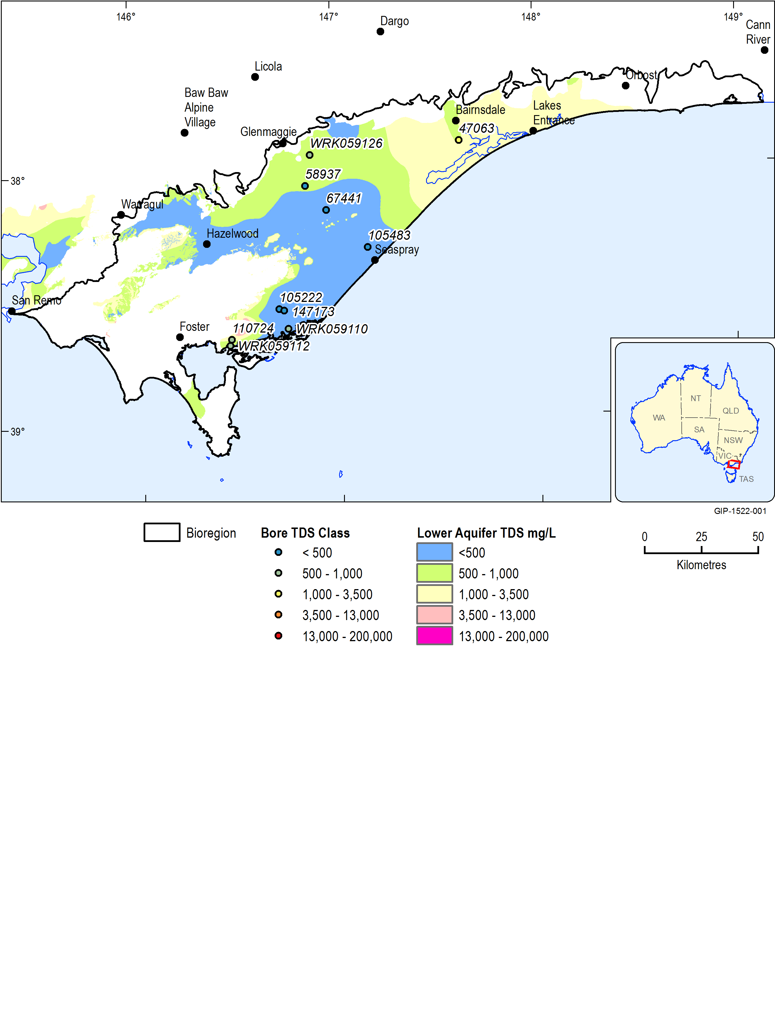

Figure 6  Total Dissolved Solids distribution and sampled bore locations for the Lower Tertiary Aquifer, here referred to as the Lower Aquifer system (Datasets 1 and 2)

##### Middle Aquifer System

The two major aquifers in the Middle Aquifer system are the Upper Mid-Tertiary Aquifer (UMTA) and the Upper Tertiary Aquifer Fluvial (UTAF). Water quality in these two aquifers are quite fresh, with good quality water (< 500 mg/L TDS) found around the centre of the Gippsland Basin, as shown in Figure 7.

The salinity values for bores sampled in the lower unit, the UMTA, were mostly less than 500 mg/L TDS, with the exception of one bore (110978), located on the north-east extent of the aquifer, which had values above 1,000 mg/L TDS in rounds 2 and 3.

Several of the bores sampled in this aquifer are outside the extent of the existing salinity mapping (i.e. 90323, 64835) or are screened in a different unit of the Middle Aquifer system (i.e. WRK059119, WRK059120). These sites support the trend of fresher quality water in the basin centre and poorer quality water along the coastal and northern margins.

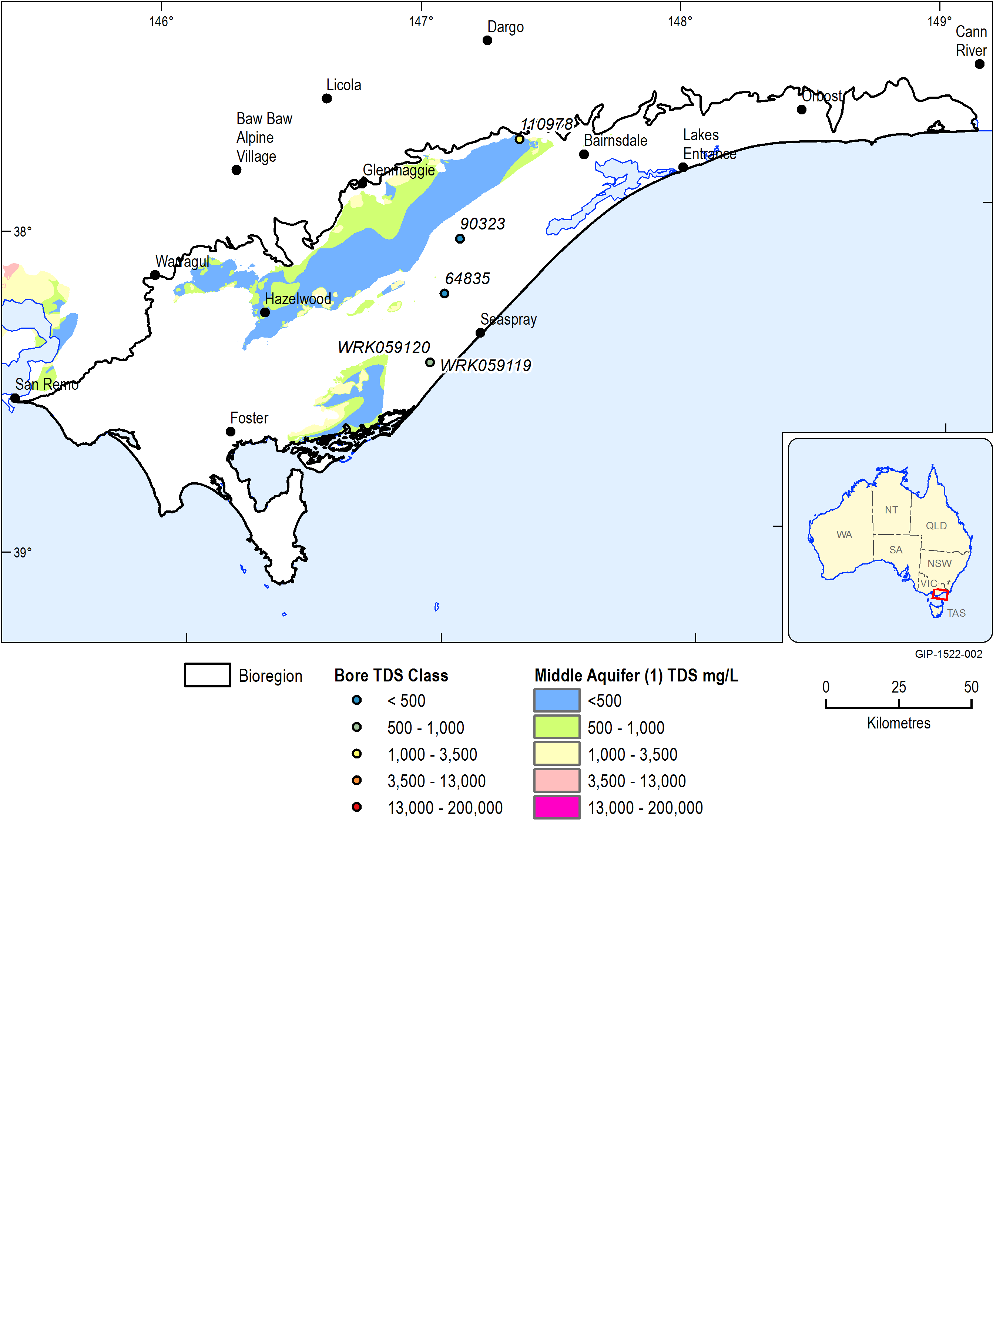

Figure 7  Total Dissolved Solids distribution and sampled bore locations for the Upper Mid-Tertiary Aquifer, here referred to as the Middle Aquifer system (1) (Datasets 1 and 2)

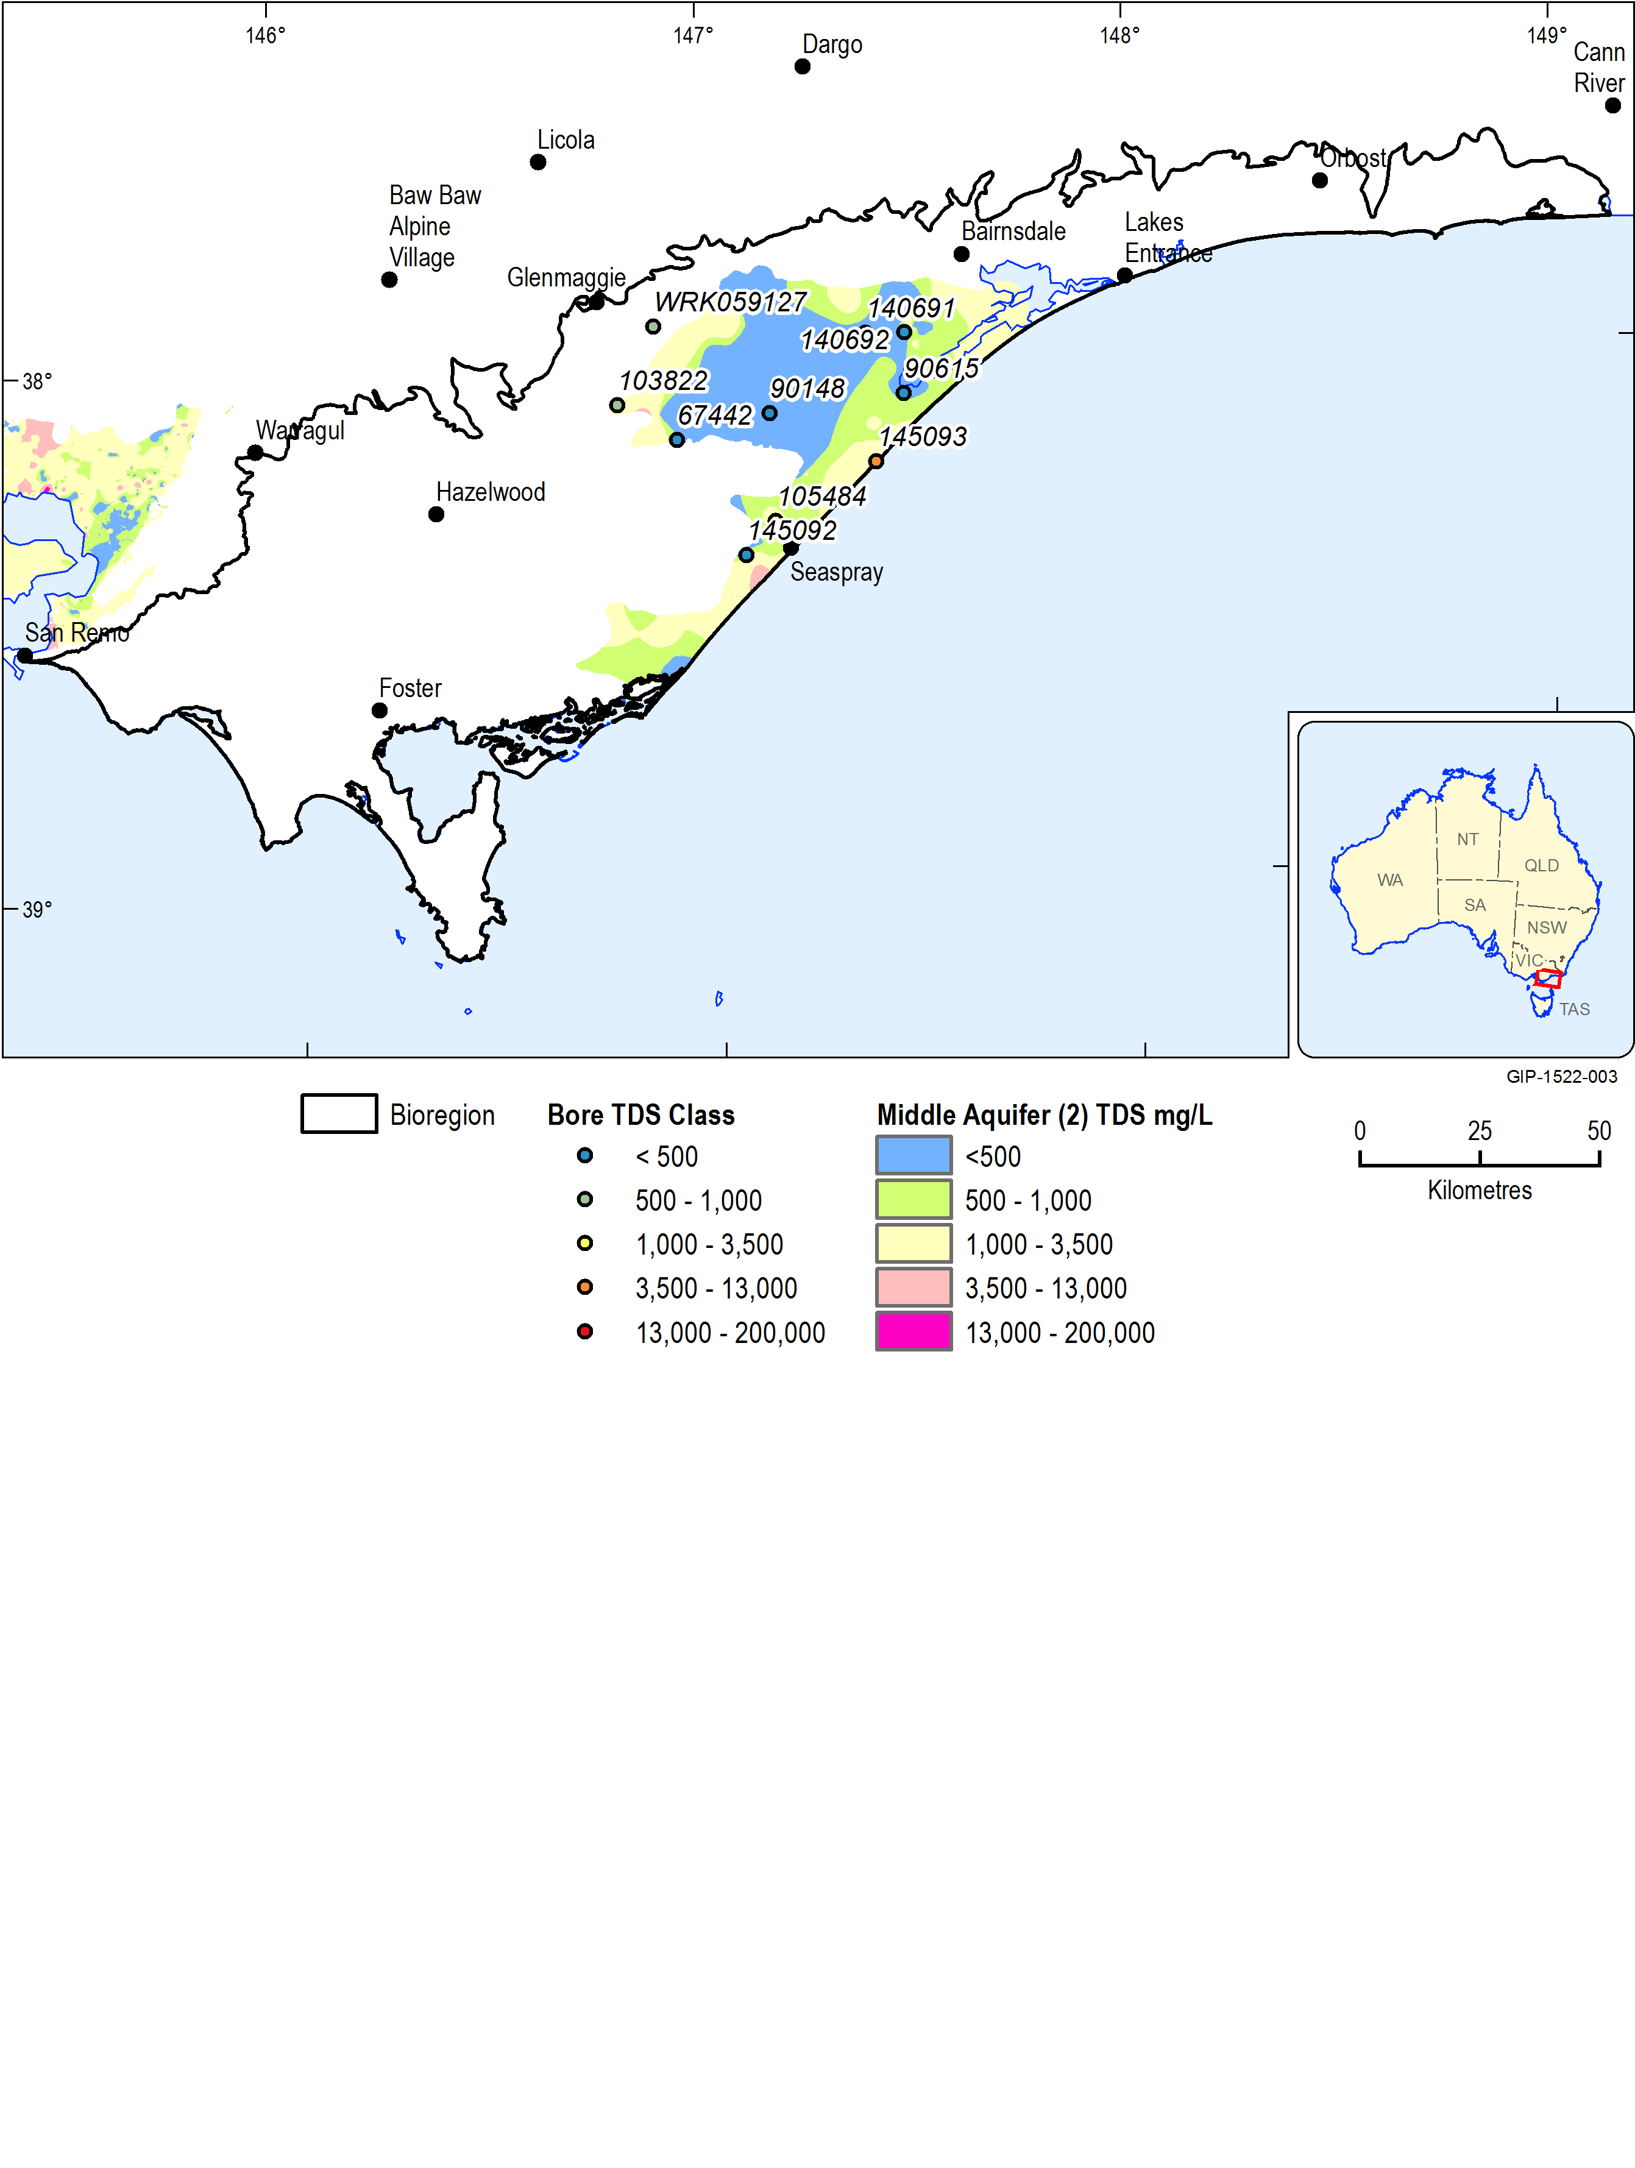The upper unit of the Middle Aquifer system—the UTAF—had slightly higher salinity levels with average values around 1,000 mg/L, as show in Figure 8. One bore (145093) located near the coast recorded a much higher than average value of around 4,700 mg/L. This is likely due to downward leakage from the overlying shallow aquifer shown in Figure 8. The samples with the freshest quality water were taken from bores located in the centre of the basin (140691, 90148).

Figure 8  Total Dissolved Solids distribution and sampled bore locations for the Upper Tertiary Aquifer Fluvial, here referred to as the Middle Aquifer system (2) (Datasets 1 and 2)

##### Upper Aquifer System

Groundwater salinity is variable in the shallow aquifers where it is influenced by features and conditions at the surface. The results from the monitoring program are generally consistent with the salinity maps previously produced.

Samples taken from the uppermost Quaternary Aquifer were quite low with an average salinity of 543 mg/L TDS, as shown in Figure 9. Groundwater in this shallow aquifer tends to be fresher in the northern parts of the basin margin where there is higher potential for recharge from rainfall and river flows.

Zones of higher salinity are found in the Quaternary and Upper Tertiary aquifers in the area of Lake Wellington as well as in isolated locations in coastal zones.

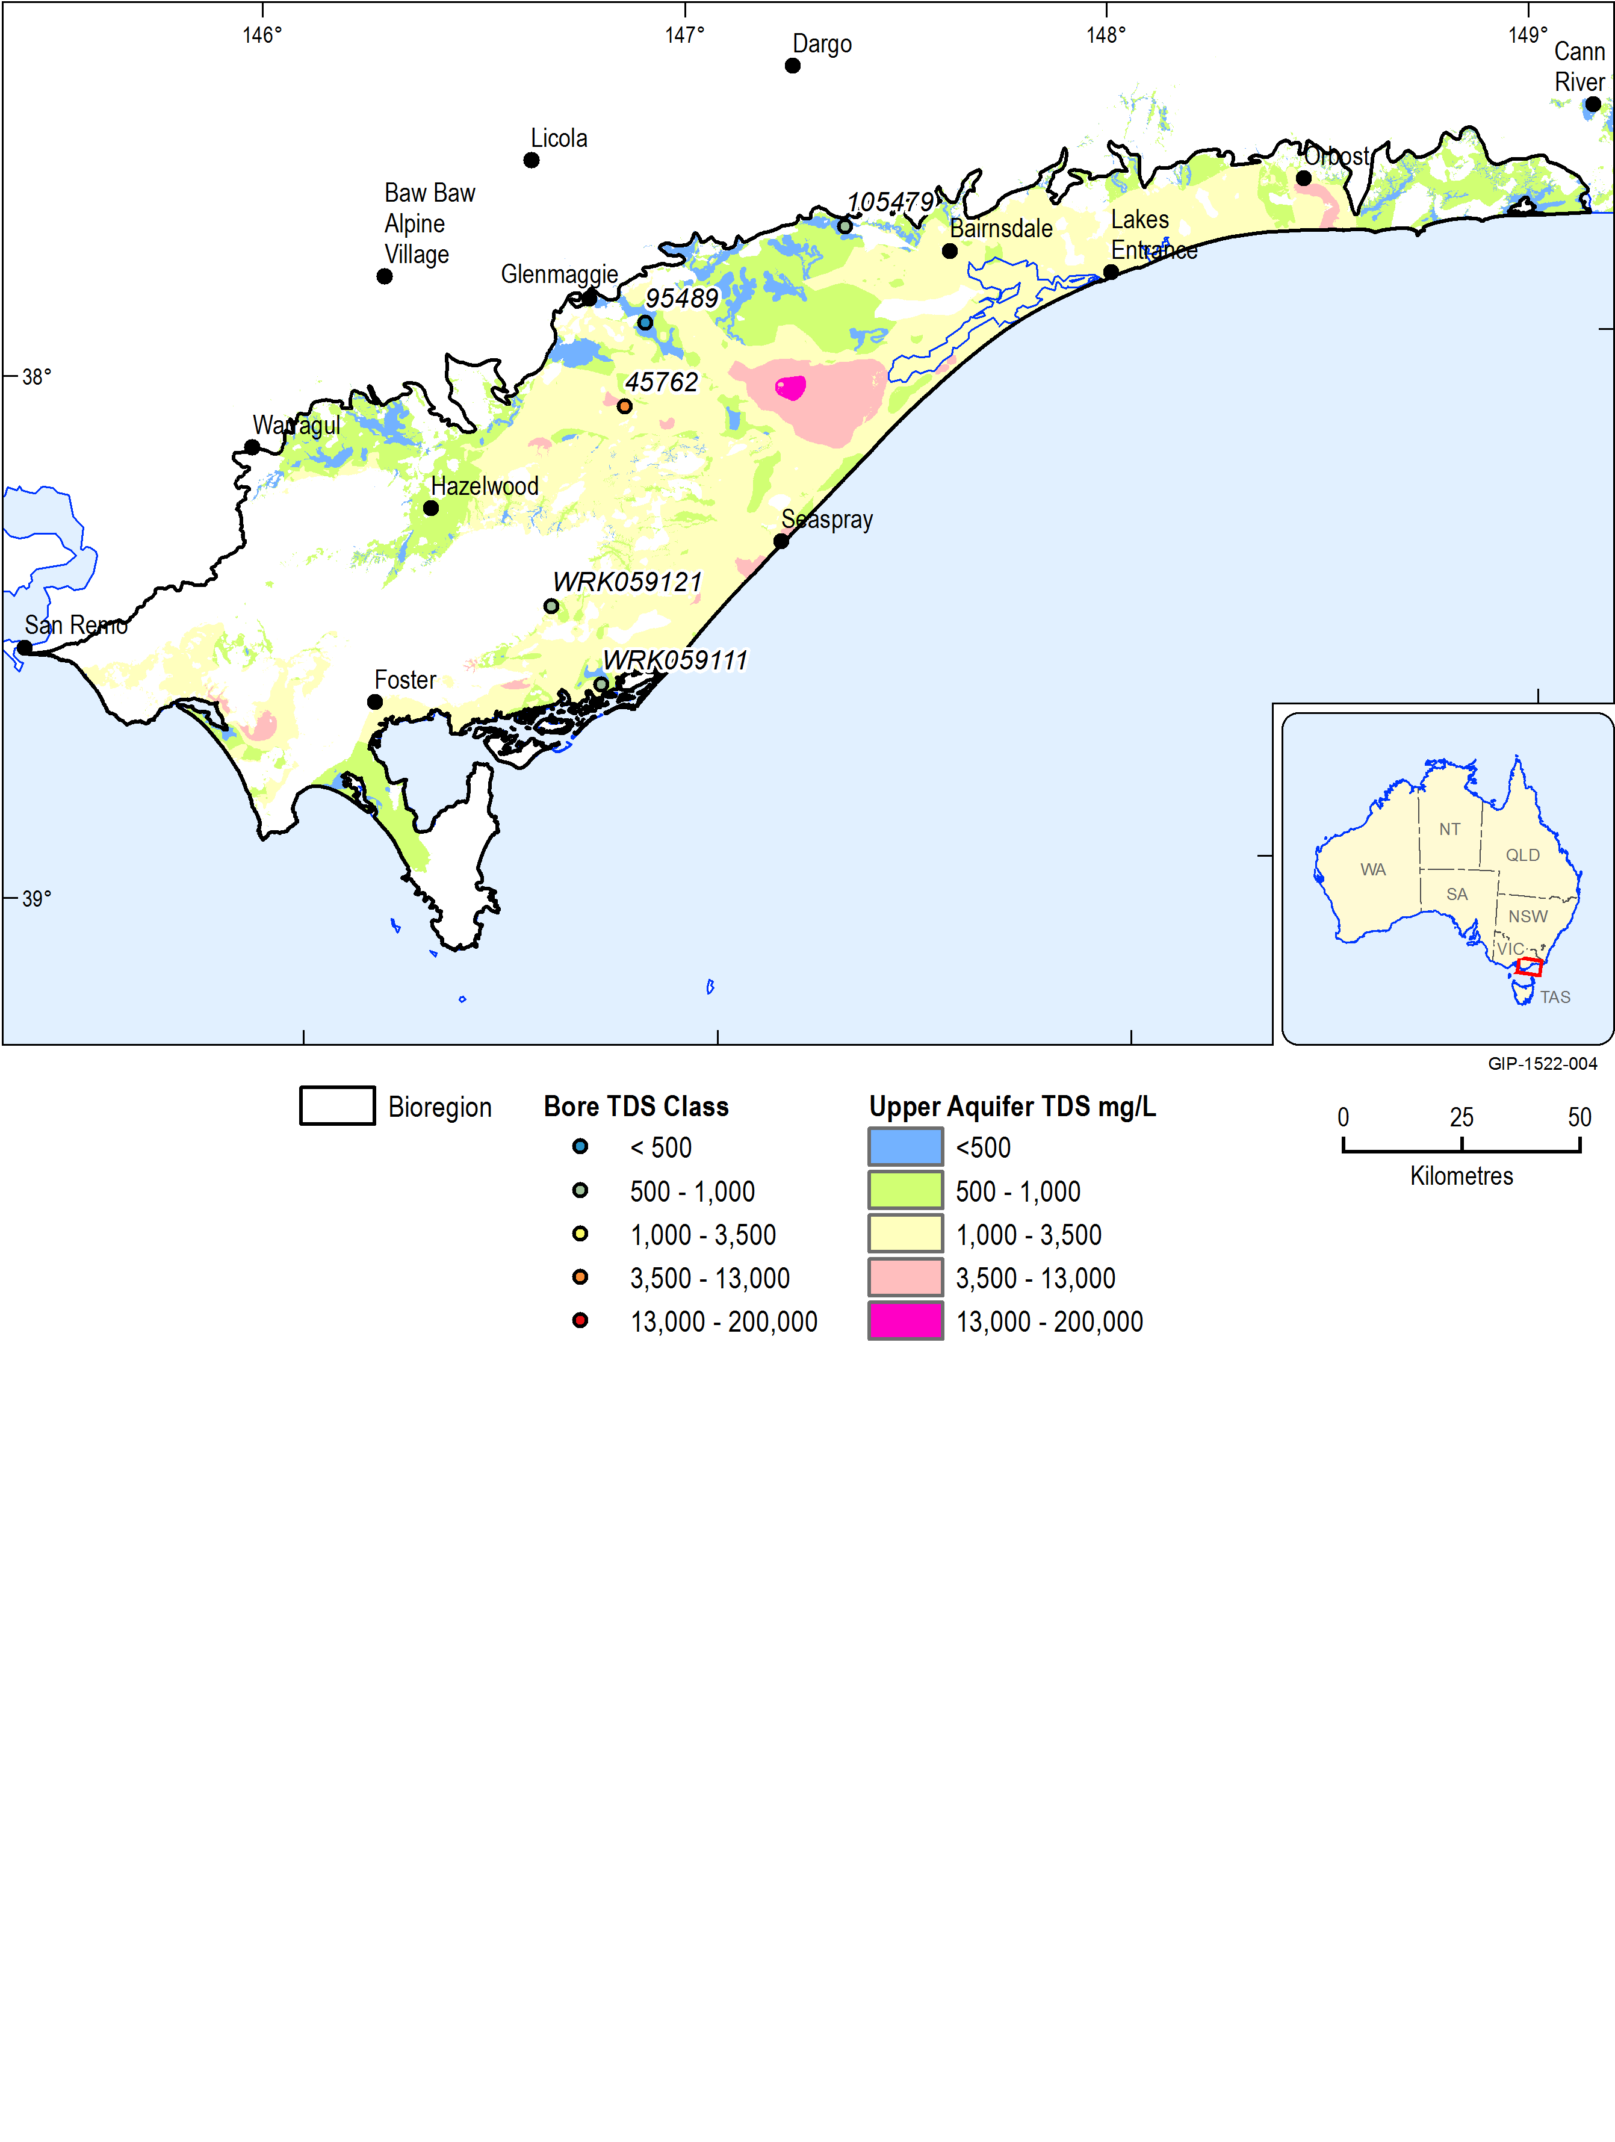

Figure 9  Total Dissolved Solids distribution and sampled bore locations for the Upper Tertiary Quaternary Aquifer, here referred to as the Upper Aquifer system (Datasets 1 and 2)

#### Summary of analytes from groundwater sampling programme

DELWP (2015) concluded that the major ion chemistry for the various aquifers across the Gippsland Basin show a similar range of concentration of ions and similar ion balance, with few outliers. The groundwater is of sodium chloride type. There are no apparent differences in major ion chemistry across the main aquifer groups. This is unlike the methane and SVOC results where a trend of lower concentrations in the upper aquifers is observed. The similarity of groundwater above and below the aquitard suggests lateral flow originates from a similar source and undergoes similar processes.

Figure 10 shows the major ion chemistry for the subsequent sampling rounds indicated similar groundwater character across the aquifers and little variation between sampling rounds.

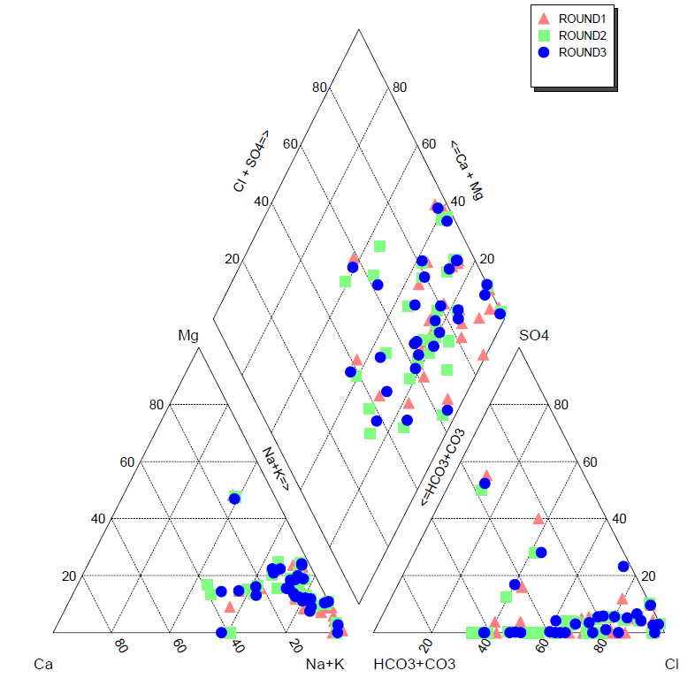

Figure 10  Piper diagram of major ion analyses by aquifer – for three rounds of sampling (December 2014, March 2015 and June 2015)

A review of the results of chemical testing across all three rounds of sampling in the Gippsland Basin leads to the following conclusions:

***Major ions***

* There was no significant variation in major ion chemistry between the sampling rounds.

***Methane***

* Methane concentrations fluctuated between sampling rounds; however, no temporal or spatial trends could be recognised.
* The observation of methane concentrations being highest in the coal bearing units of the Lower Tertiary Aquifer (Latrobe Group) and the Upper Mid-Tertiary Aquifer (Latrobe Valley Coal Measures and Balook Formation) remained true for all three sampling rounds. The methane concentrations in these units are interpreted as most likely to be sourced from the organic material of the coal seams.
* There is a decreasing methane concentration in samples from bores above the coal bearing units. All water table bores had either none detected or very small methane concentration. All nested sites exhibit this trend. Methane concentration in upper aquifers in areas where the Upper Mid-Tertiary Aquitard is absent is slightly higher than in areas where it is present. This is interpreted as suggesting that the Upper Mid-Tertiary Aquitard partially restricts upwards migration of Methane.
* Methane is generally absent from the water table or, where detected, is only found in low concentrations. This suggests that migration upward to the water table is limited.

##### Ethane, Ethene, Butane, Butene, Propane and Propene

* There was no observation of Ethene, Butane, Butene or Propene in any of the samples. This suggests these compounds are not present in any of the sampled aquifers. A single detection of Propane and Ethane was reported in the later sampling rounds, suggesting that these compounds are rare and only found in very low concentrations across the basin.

##### BTEX

* BTEX was detected in the Lower Tertiary Aquifer, the Upper Mid Tertiary Aquifer and the Upper Tertiary Aquifer. No BTEX was reported in samples from the shallower aquifers.

##### Total Petroleum Hydrocarbons (TPH)

* TPH was detected in 11 of the 30 bores sampled and 10 of these bores are screened in the coal bearing units of the Lower Tertiary Aquifer (Latrobe Group) and the Upper Mid-Tertiary Aquifer (Latrobe Valley Coal Measures and Balook Formation).

##### Napthalene

* There was no detection of naphthalene in any sample.

#### Gaps

Generally, water quality is monitored on an ad-hoc basis either for project specific works and/or by the mines around the Latrobe Valley coal mines. Consistent water quality monitoring is required to provide defensible baseline data sets for assessments of mining and other activities on groundwater resources both in and around the mines.

Groundwater sampling for the bioregional assessment was centred on detection of hydrocarbons and cations and anions to characterise the aquifers in the Gippsland Basin. Salinity monitoring is generally centred on irrigation districts and around Lake Wellington to monitor impacts on the Gippsland Lakes. Additional monitoring would provide a higher level of reliability and/or certainty about the data that informs the management of groundwater resources in the basin.

References

GHD (2012) Victorian Aquifer Framework updates for seamless mapping of aquifer surfaces. Prepared by GHD for the Secure Allocation Future Entitlements (SAFE) Project, Department of Sustainability and Environment, Victoria.

SKM (2011) A review of the Victorian Aquifer Framework. Prepared by Sinclair Knight Merz for the Secure Allocation, Future Entitlements (SAFE) Project, Department of Sustainability and Environment, Victoria.

DELWP (2015) Gippsland Region Groundwater Sampling and Characterisation for Hydrocarbons report. A water science studies report prepared by the Victorian Government.

Datasets

Dataset 1 Department of Environment and Primary Industries (2014) Victorian Aquifer Framework – Salinity. Bioregional Assessment Source Dataset. Viewed 15 April 2015, <https://data.bio regionalassessments.gov.au/dataset/dd006fce-bef5-4377-82ae-2c5a14b50e34>

Dataset 2 Victorian Government (2015) Onshore natural gas water science studies, Gippsland Region – Groundwater sampling and characterisation for hydrocarbons, June 2015